CODE WITH HARRY

Features => Anything that you see... For example ears of a cat,eyes of a cat,nose of a cat etc.

UCI machine learning repository => Collection of data is present which we can use for analysis

Steps => 1)Problem identification, 2)Data collection & validation 3)Model Building 4)Feedback

Supervised machine learning => For ex. If we give images of apple, banana etc. To machine along with labels saying that which is apple and which is banana then if machine is able to identify the type of fruit when new image is given then it is supervised learning.

Classification => Same example given above.(Name itself suggests)
Regression => For ex. If we send features like stock trend,current price etc. to the model and if the model is able to predict what would be the price of the stock at different time in a day then we can say such pbm as regression problems.
Or house cost prediction is also an example.
Ex=>Linear regression classifier, decision tree classifier, random forest classifier, naive based classifier etc.

Unsupervised machine learning => It is basically classifying data into separate groups. For Example: our image contains different fruits then unsupervised learning should be able to group all the images. It is not trying to predict something instead it is trying to group fruits one by one.
Or group of customers based on purchasing behaviour. These are ex. For clustering.
For association we can say people that buy X also tend to buy Y.
Ex=>Hierarchial clustering, K-Means clustering.

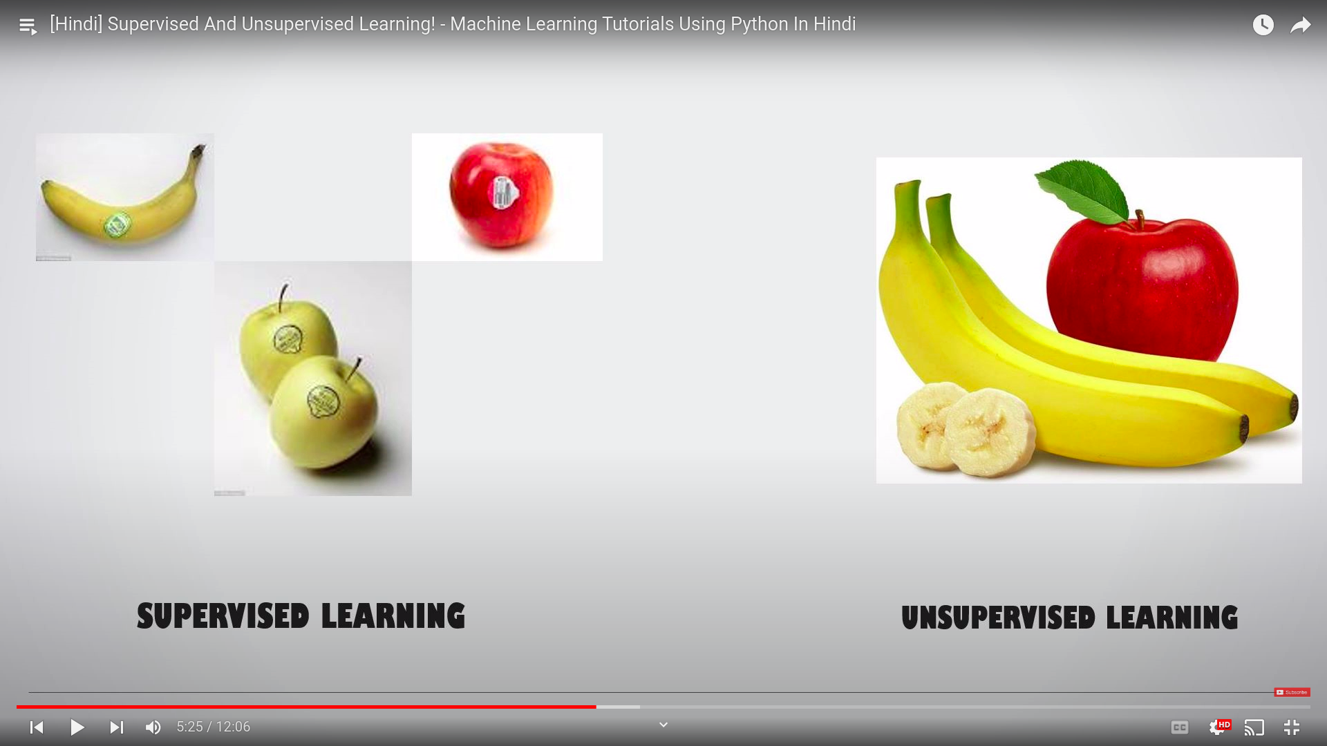

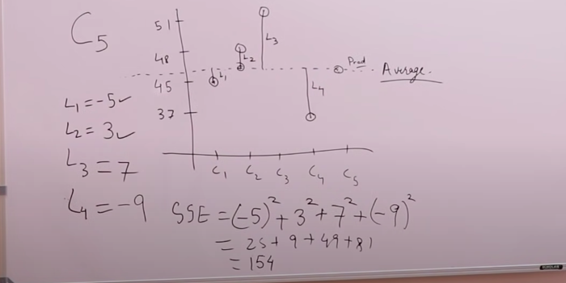
LINEAR REGRESSION

Here Let’s say we have given C1,C2,C3,C4 labels as 45,48,51,37
then what will be the value for C5.

Since input doesn’t have value, instead it has just name associated
with it we can’t consider slant line as it is a 1D pbm.
(Why? Because if we consider a slant line then if order of any one of C1,C2,C3,C4 changes then you will get different slant lines which in turn means different prediction value for C5)

Here, equation of the line will be y = c.
To find c we are calculating the difference between all the points and the line. Then we try to square the difference values that we got.
{Why squaring? Because let’s say we have C1,C2 with values 5,15 then if we consider the resultant line it would y=10 but we know that L1=-5 & L2=5. Instead of squaring if we directly add them then we will get 0 which means the resultant line is passing through both the points but it is not.(We could even have taken abs value and added also) }

Now Let’s consider 2D pbm. Let’s say we have area of C1,C2,C3,C4 given i.e. 75m2,80m2,100m2,70m2 with labels as 45,48,51,37. Then we can have slant line in this case as C1,C2...C4 values are fixed.

Hence we can take values of label along y axis and area along x axis and consider the below equation
y= mx+c

Now we have to find 2 values m and c to determine the exact line by considering mean square error.

Conclusion=>

1D(straight line parallel to x axis) => y = c => f(x)= w0
2D(straight line slant or parallel) => y = mx+c => f(x1) = w0+w1x1 (here w0=c & w1=m)
3D(plane slant or parallel) => f(x1,x2) = w0+w1x1+w2x2
.
.
nD=>f(x1,x2,....) = w0+w1x1+w2x2+....+wnxn

Finding out the values of w0,w1,...wn is considered as learning by considering mean square error which is loss function in this case.

Consider following example with actual value of y for given x value =>
{x,y} = {1,3},{2,2},{3,4}

We know that mean square error, E = Σ(predicted_value-actual_value)²
= Σ((mx+c)-actual_value)²

For our case it would be, E = (1m+c-3)²+(2m+c-2)²+(3m+c-4)²

Since we have to minimize E. So what should be the values of m & c to minimize E?
For this we have to differentiate E w.r.t m & E w.r.t c and then equate to 0.

i.e δE/δm = 0 = 2(1m+c-3)+2(2m+c-2)2+2(3m+c-4)3
= 28m+12c-38 -> (1)

δE/δc = 0 = 2(1m+c-3)+2(2m+c-2)+2(3m+c-4)
= 12m+6m-18 -> (2)

Solving (1) and (2) we have =>
m=0.5, c=2

hence eq of straight line becomes y = 0.5x+2 ,which would fit the points mentioned above.

(Mean square error graph is basically plot of m,c vs mean square error)

Note: The above method doesn’t work always as there might be multiple minimun values for a given task.... Hence we go for concept of gradient descent....

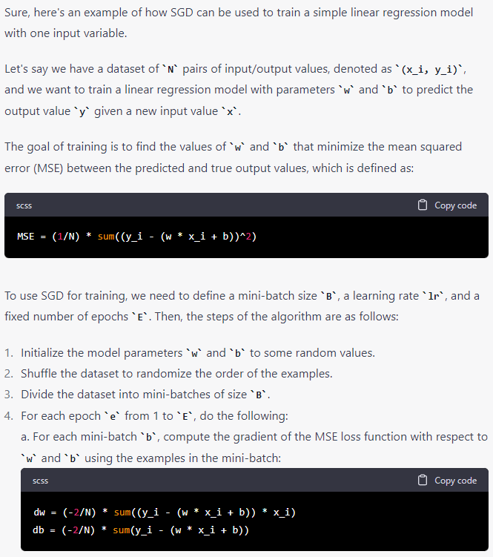

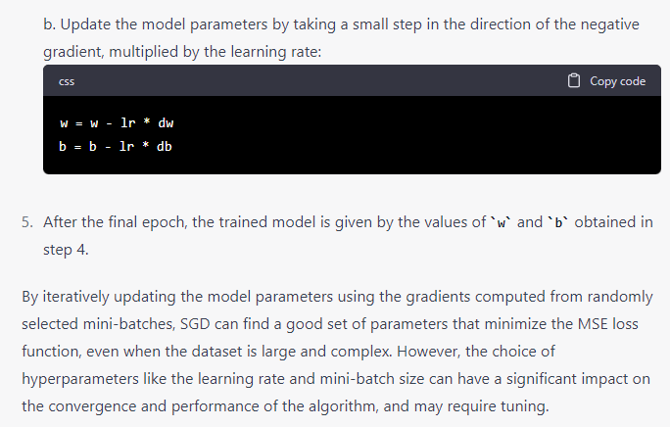

Logistic regression

https://towardsdatascience.com/cross-entropy-loss-function-f38c4ec8643e

Refer above....

