Revision Udemy course

Compiler => Translate High level code to low level. i.e. creates .obj files.
Linked => Links together our code with other binaries and creates executables

Build => Compiling + Linking
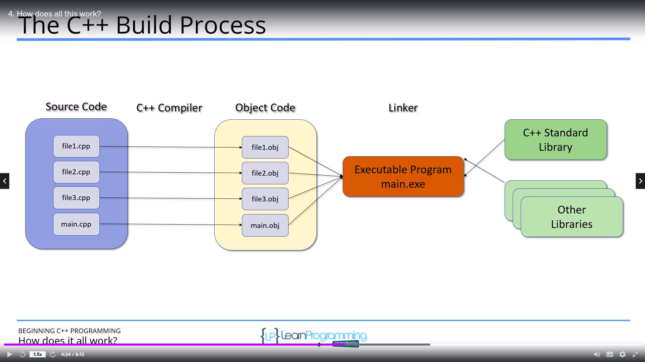

Command to create a.out (executable file) => g++ -Wall -std=c++14 fileName.cpp

Command to create anyName.out (executable file) => g++ -Wall -std=c++14 fileName.cpp -o anyName

g++ => invoke compiler -Wall => show warnings std => select standard

output => a.out will be created

Command to run a.out => ./a.out

preprocessor => It removes all the comments and opens the #include files.....

if main returns 0 then process completed successfully
If main returns any other value then based on the value we can know what went wrong.

Using only one namespace then you can use as following
Ex: using std::cout;

Note: When using cin every input entered will be stored in the buffer and then processed.

Identifier rule => 1) Can contain only digit,letter & underscore. 2) Must begin with letter or underscore.

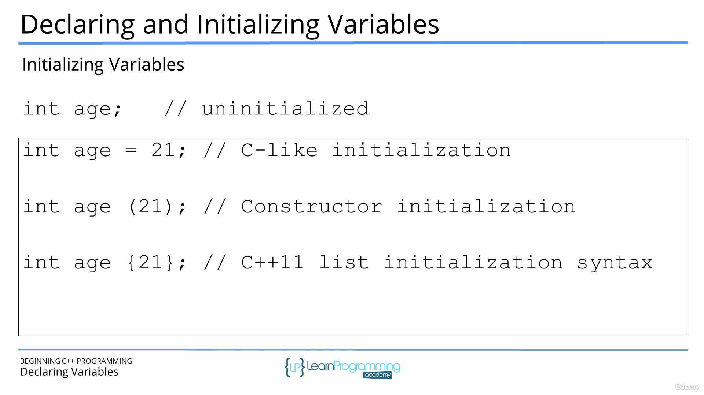
Character variables
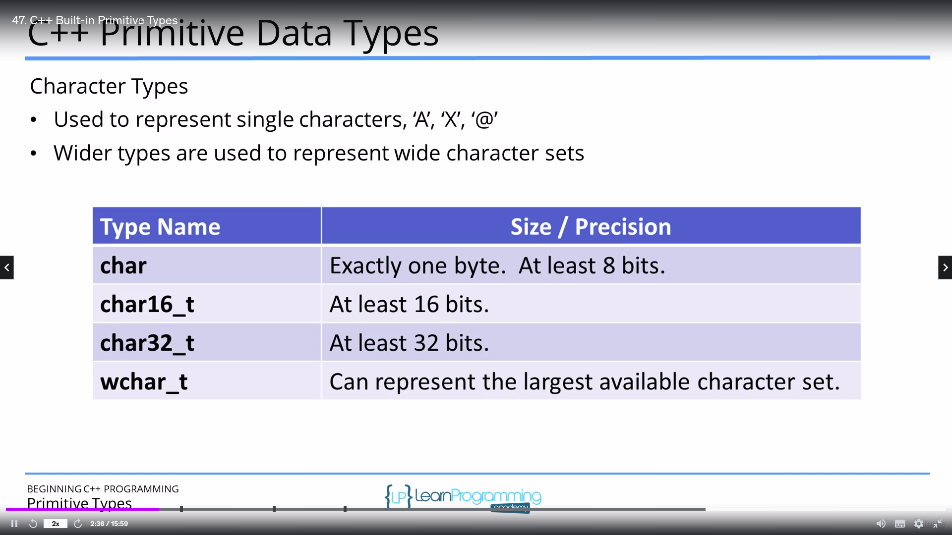

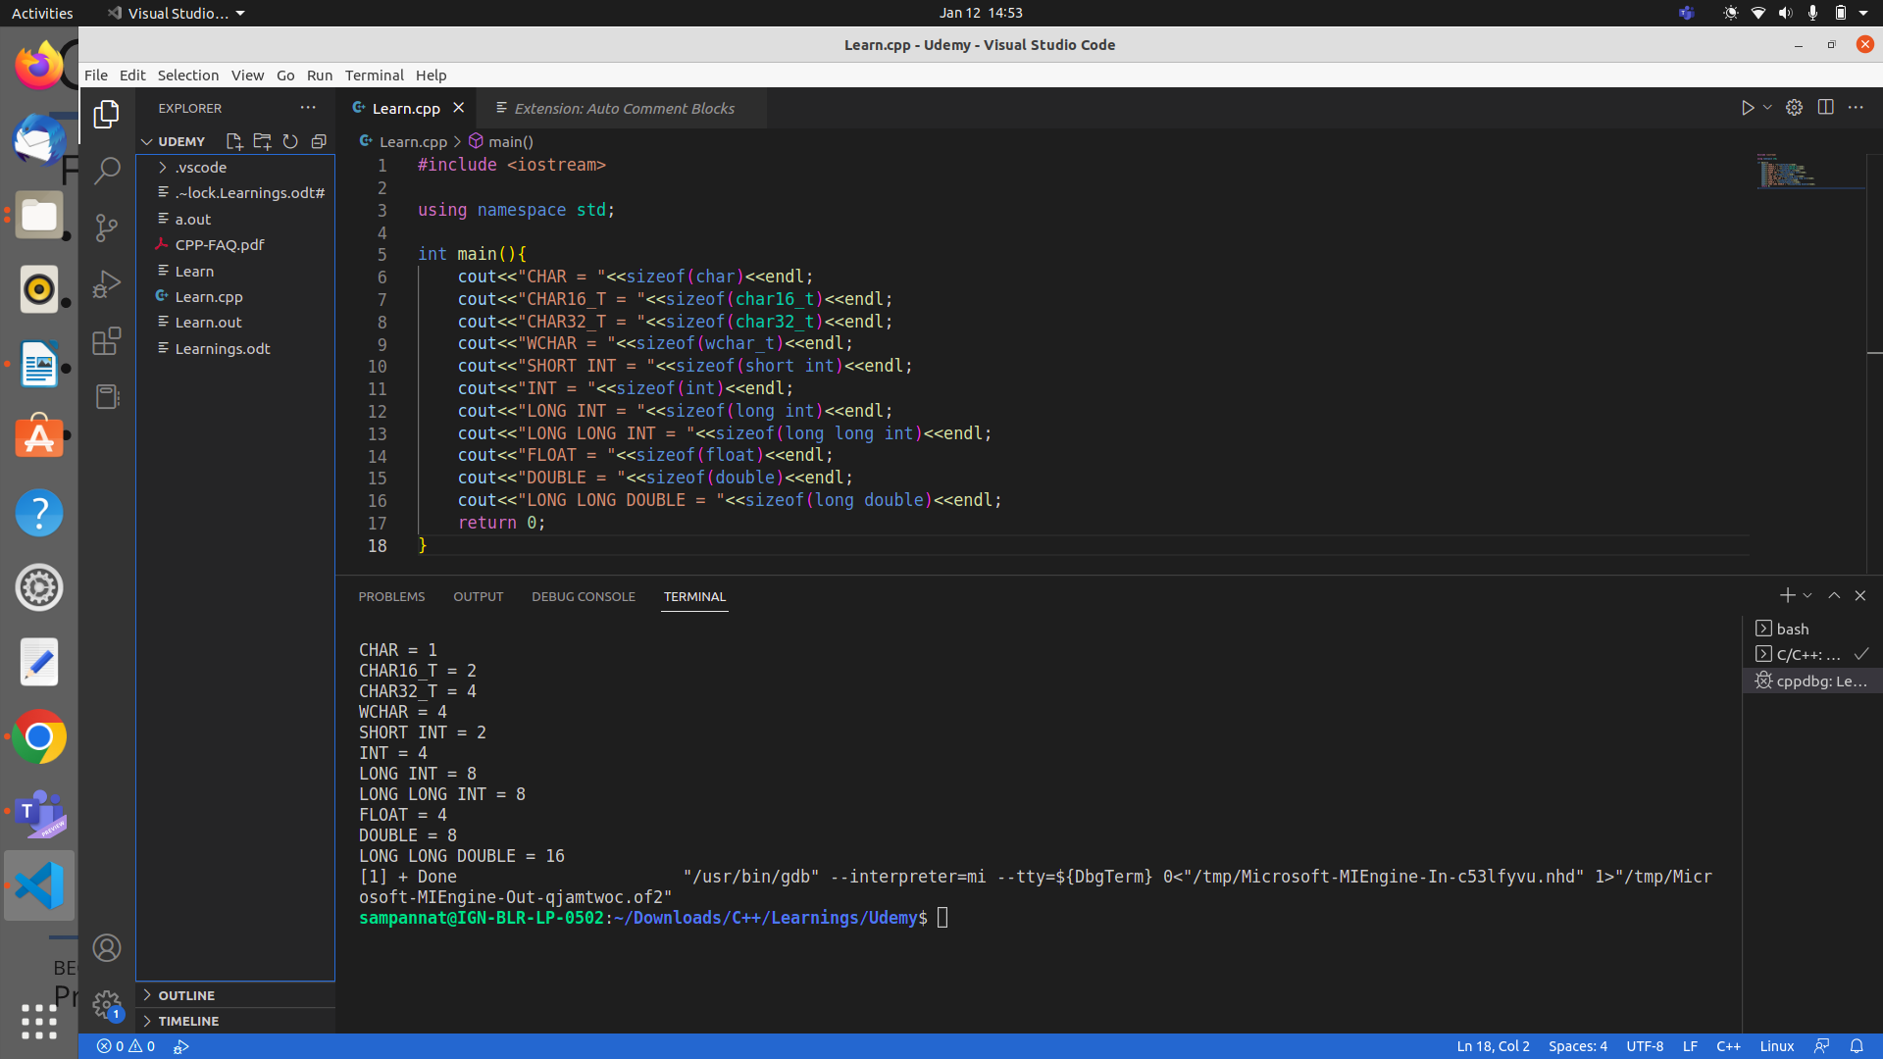
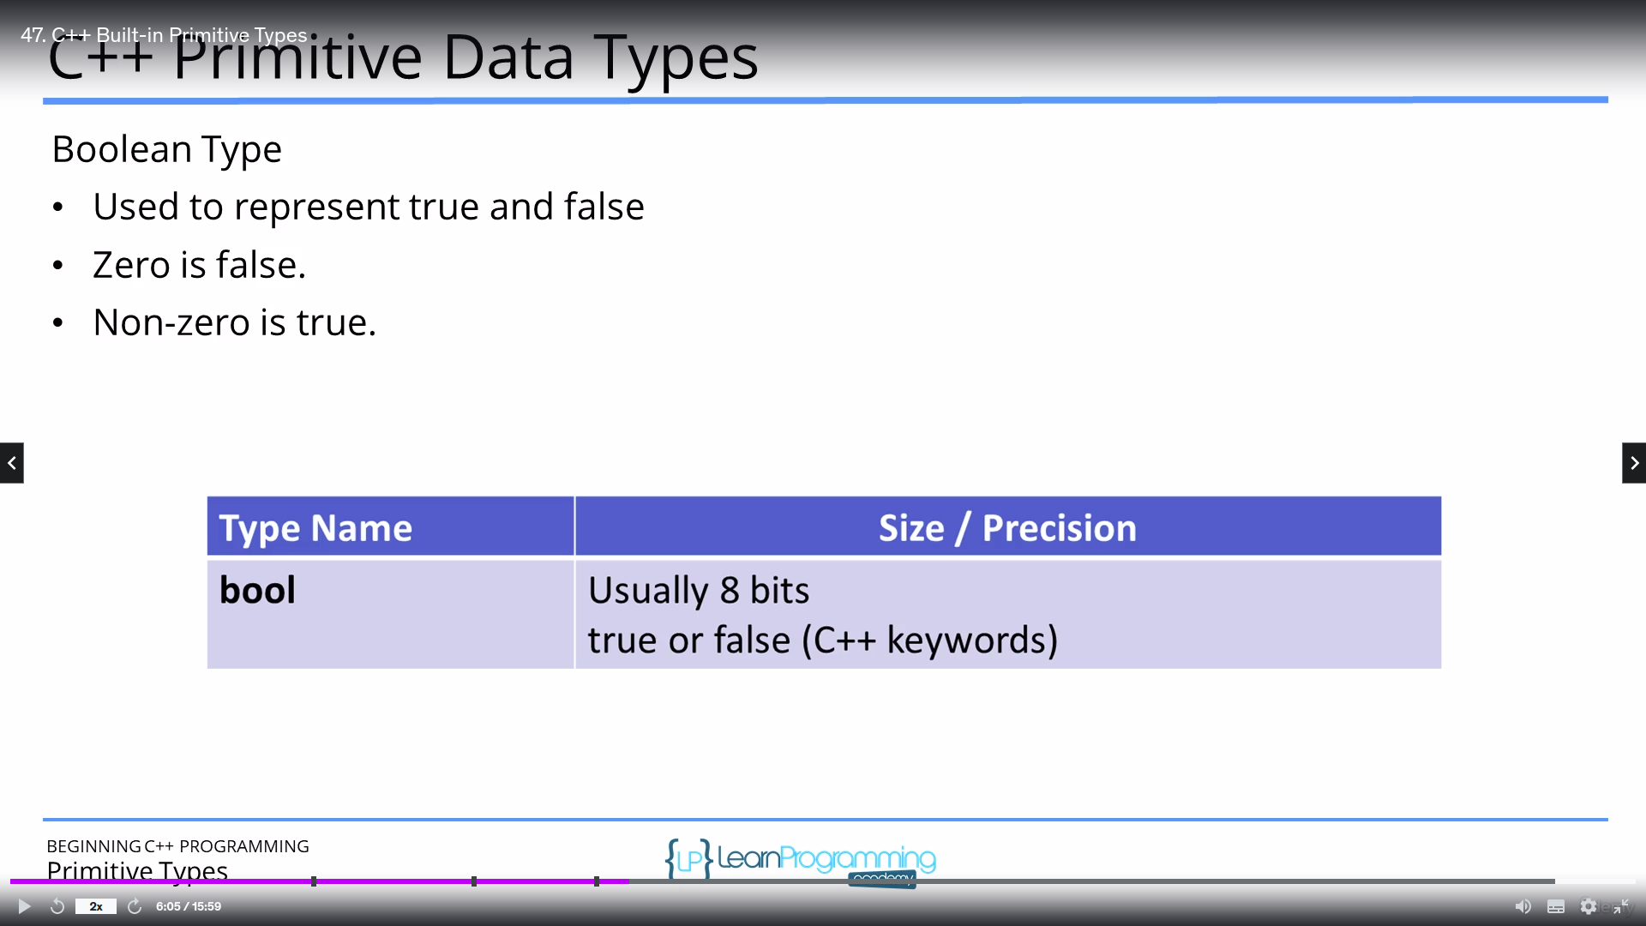
c++14 std allows to use ‘ to represent a big number
Ex: long abc {1’23’000};
Advantage of using list initialization is that in case of the number getting overflown error will be shown.

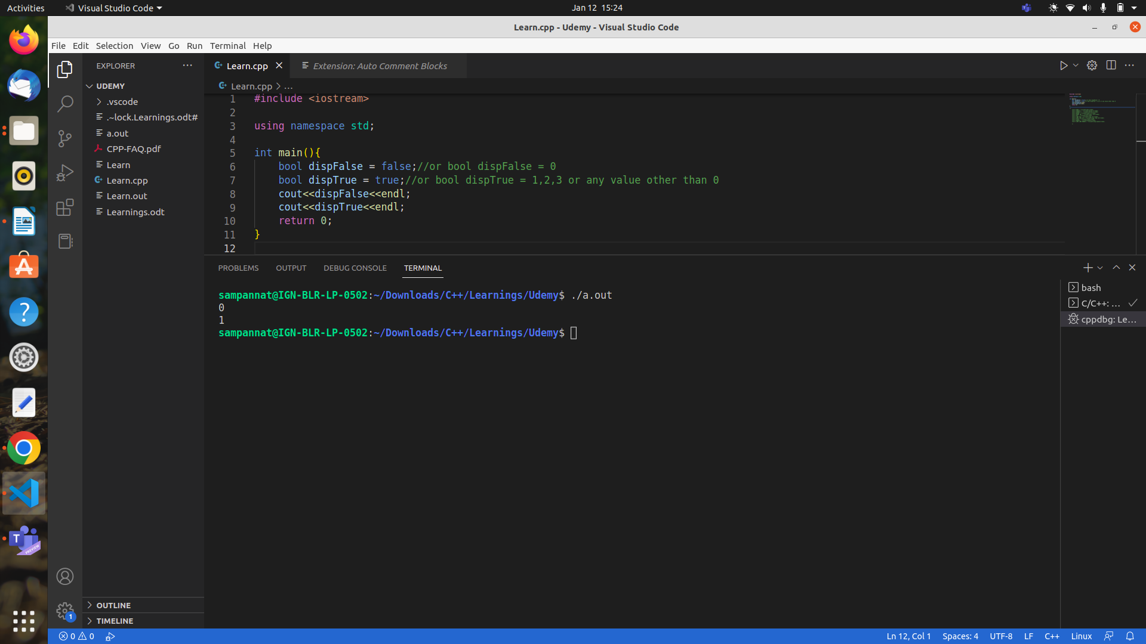

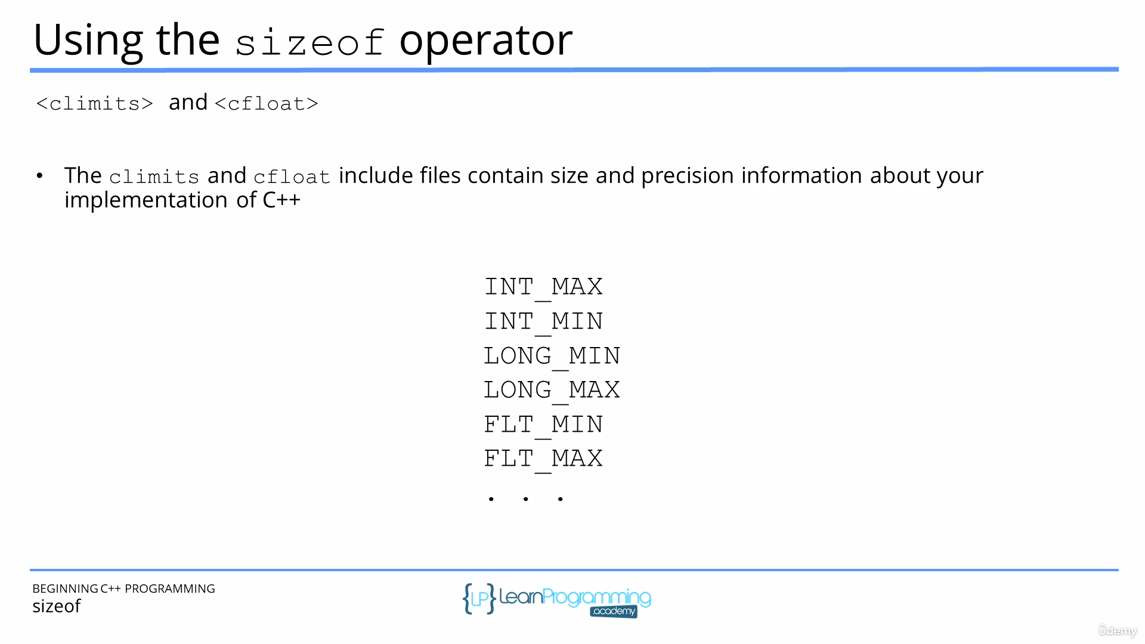
Type constants =>
12 => an integer
12U=> an unsigned integer
12L=> a long integer
12LL=> a long long integer
12.1=> a double
12.1F=> a float
12.1LF=> a long double

sizeof operator when using primitive types returns number of bytes that primitive type holds
Ex: sizeof(int) is 4

sizeof operator when used for array and all it returns number of bits that it holds
Ex: int arr[]{1,2,3}; cout<<sizeof(arr); //output=>24

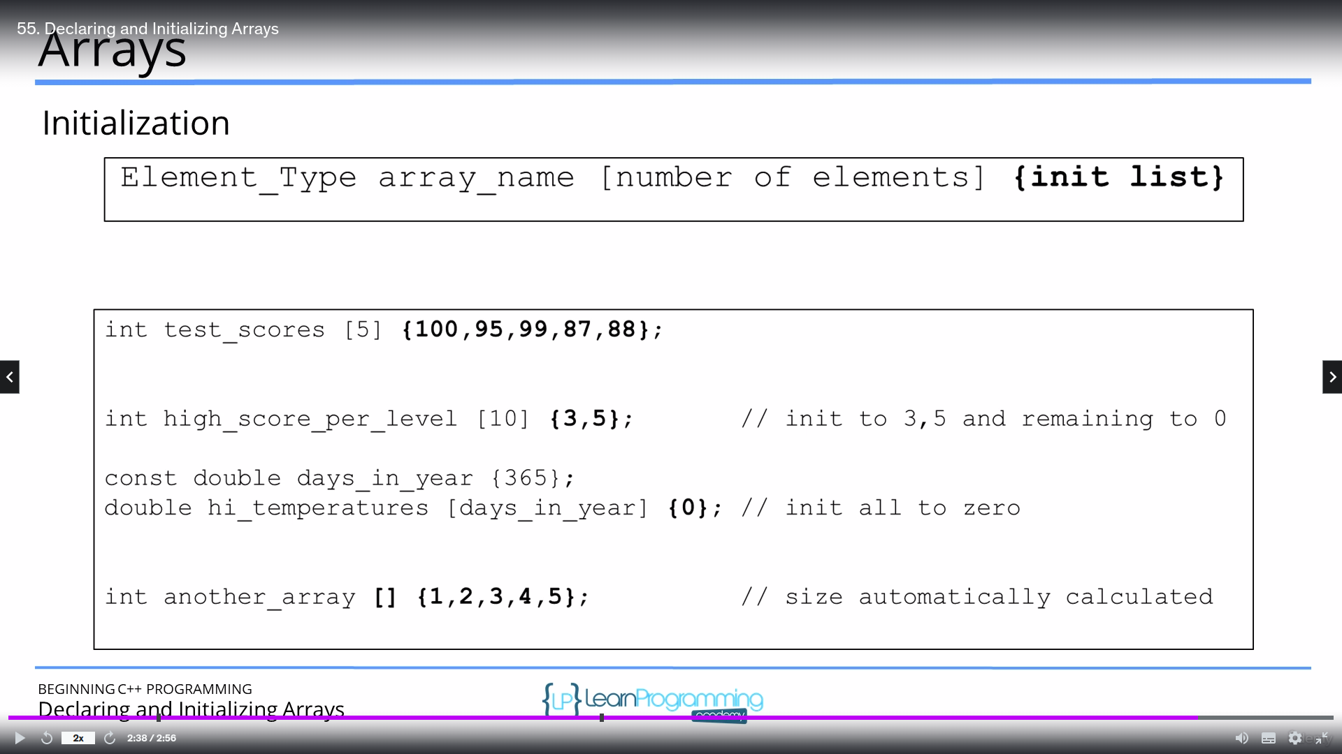
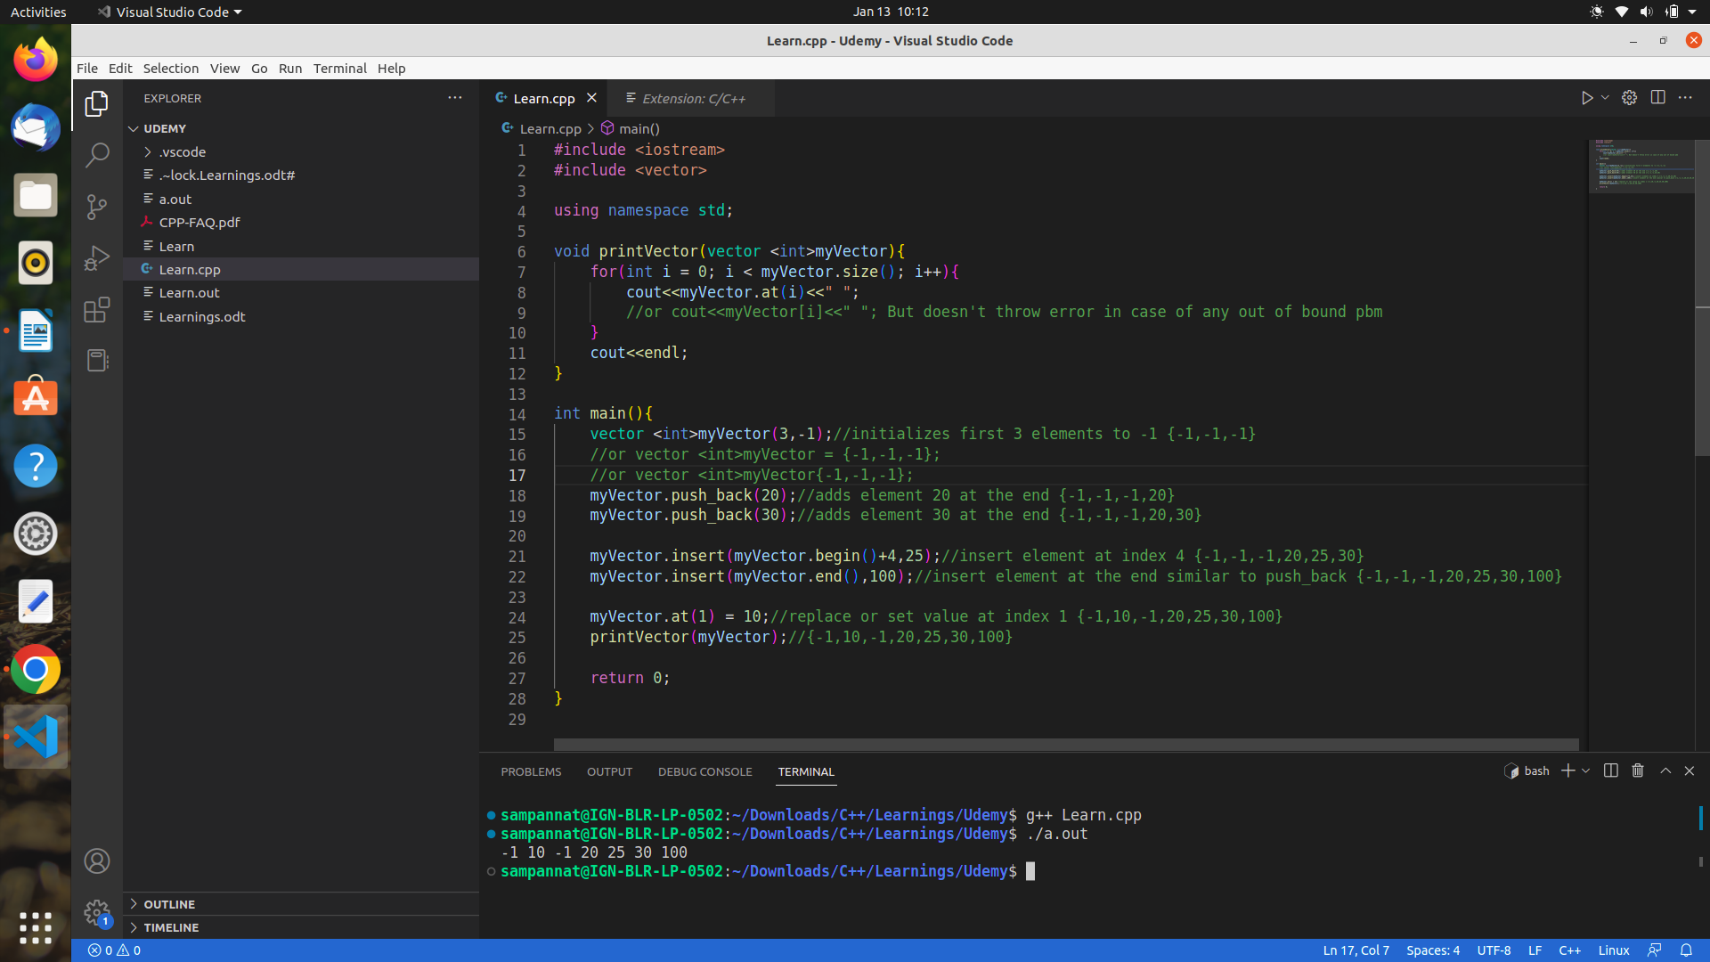
type casing =>
old method Ex: int x = (int)(2.3);
new c++ method Ex: int x = static_cast<int>(2.3);
Advantage of static_cast over normal cast is it throws excpetion in case types are different.

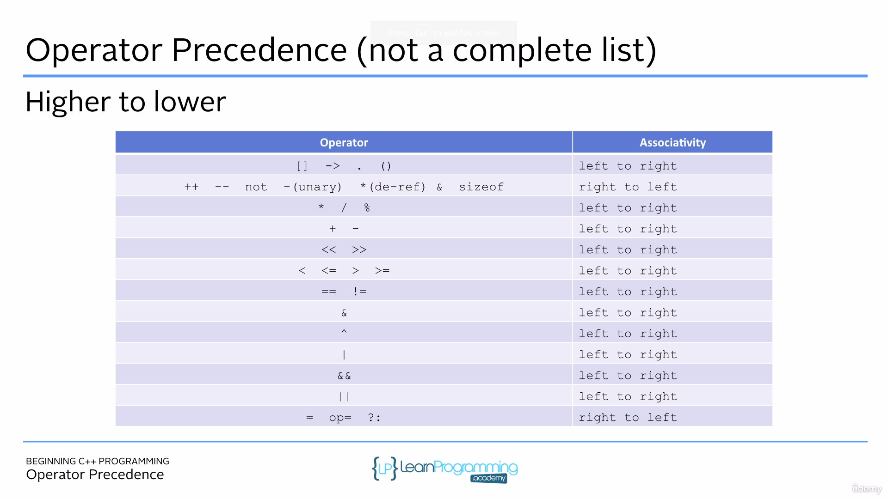
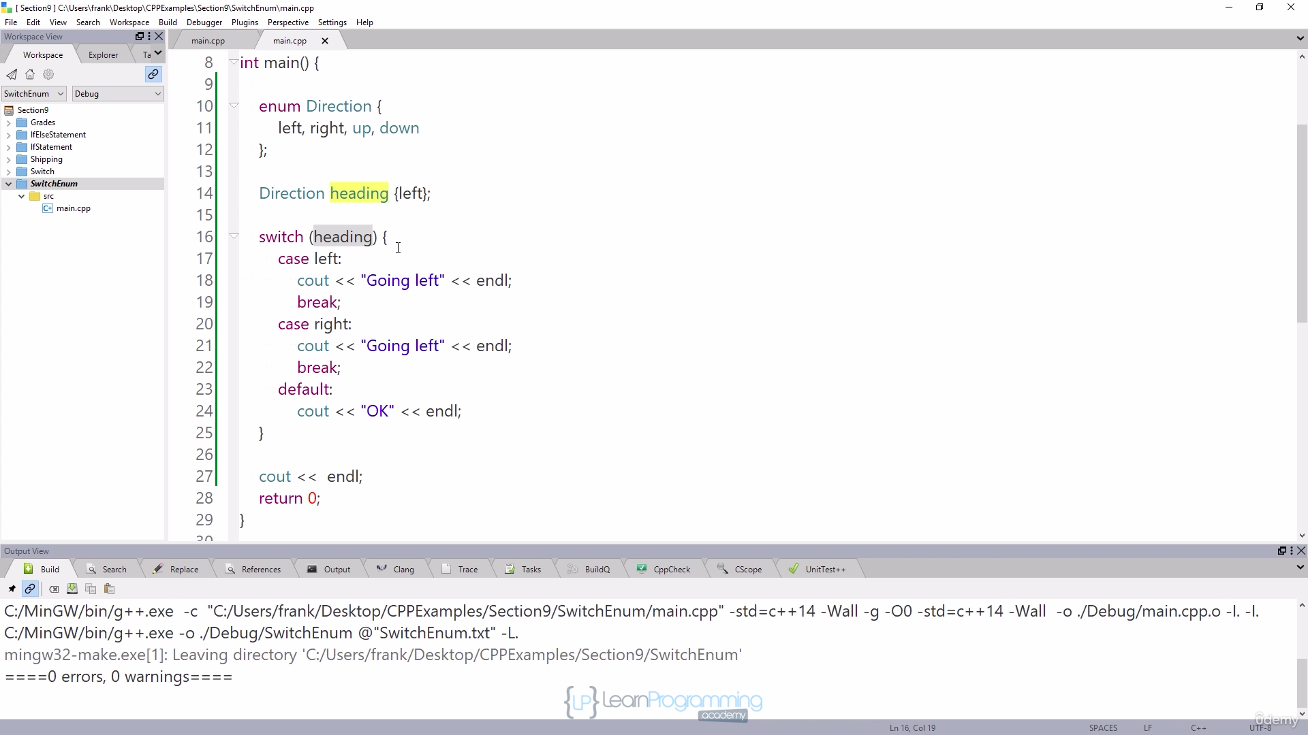

For switch, along with case you can only use constant values as paramter not a variable.

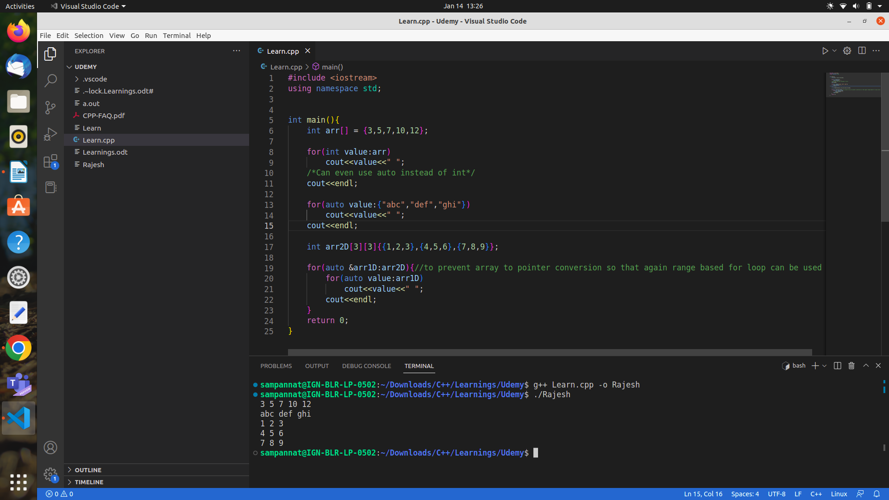
If there is a need to read full line along with space then following type cin can be used=>
cin.getline(variable_name,max_no_of_character)

size_t is a data type which can be any unsigned value of integral type (may be int short long etc.)

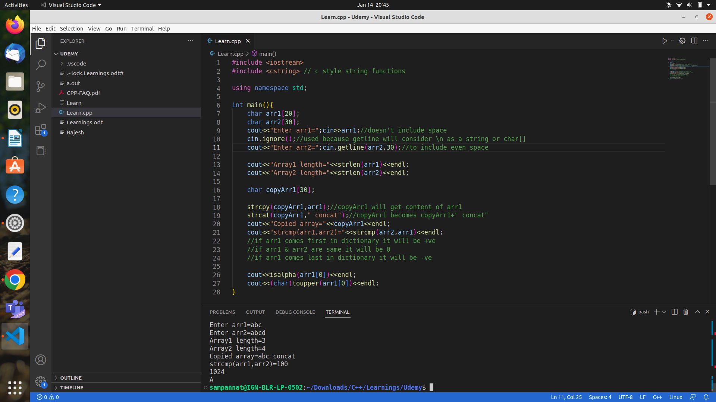
c strings are basically char[] and fixed in size where as c++ string are dynamic & class type.

String initialization
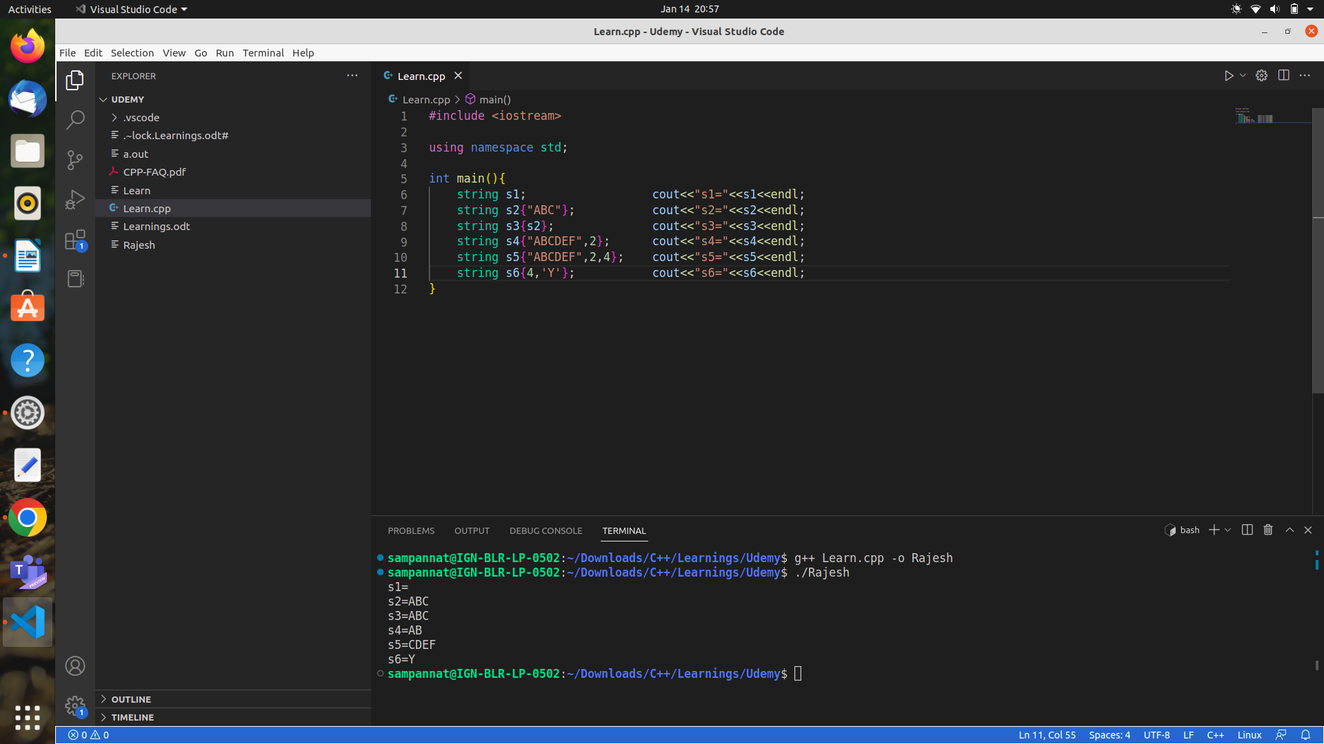
Small mistake in line 11 i.e it should have been string s6(4,’Y’);//o/p=>YYYY

Using different forms of cin
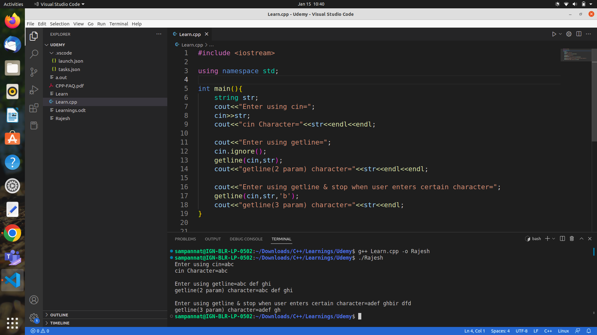
string is a c++ style strings
whereas char[] & string literal(ex:”abc”) are c style strings

String functions
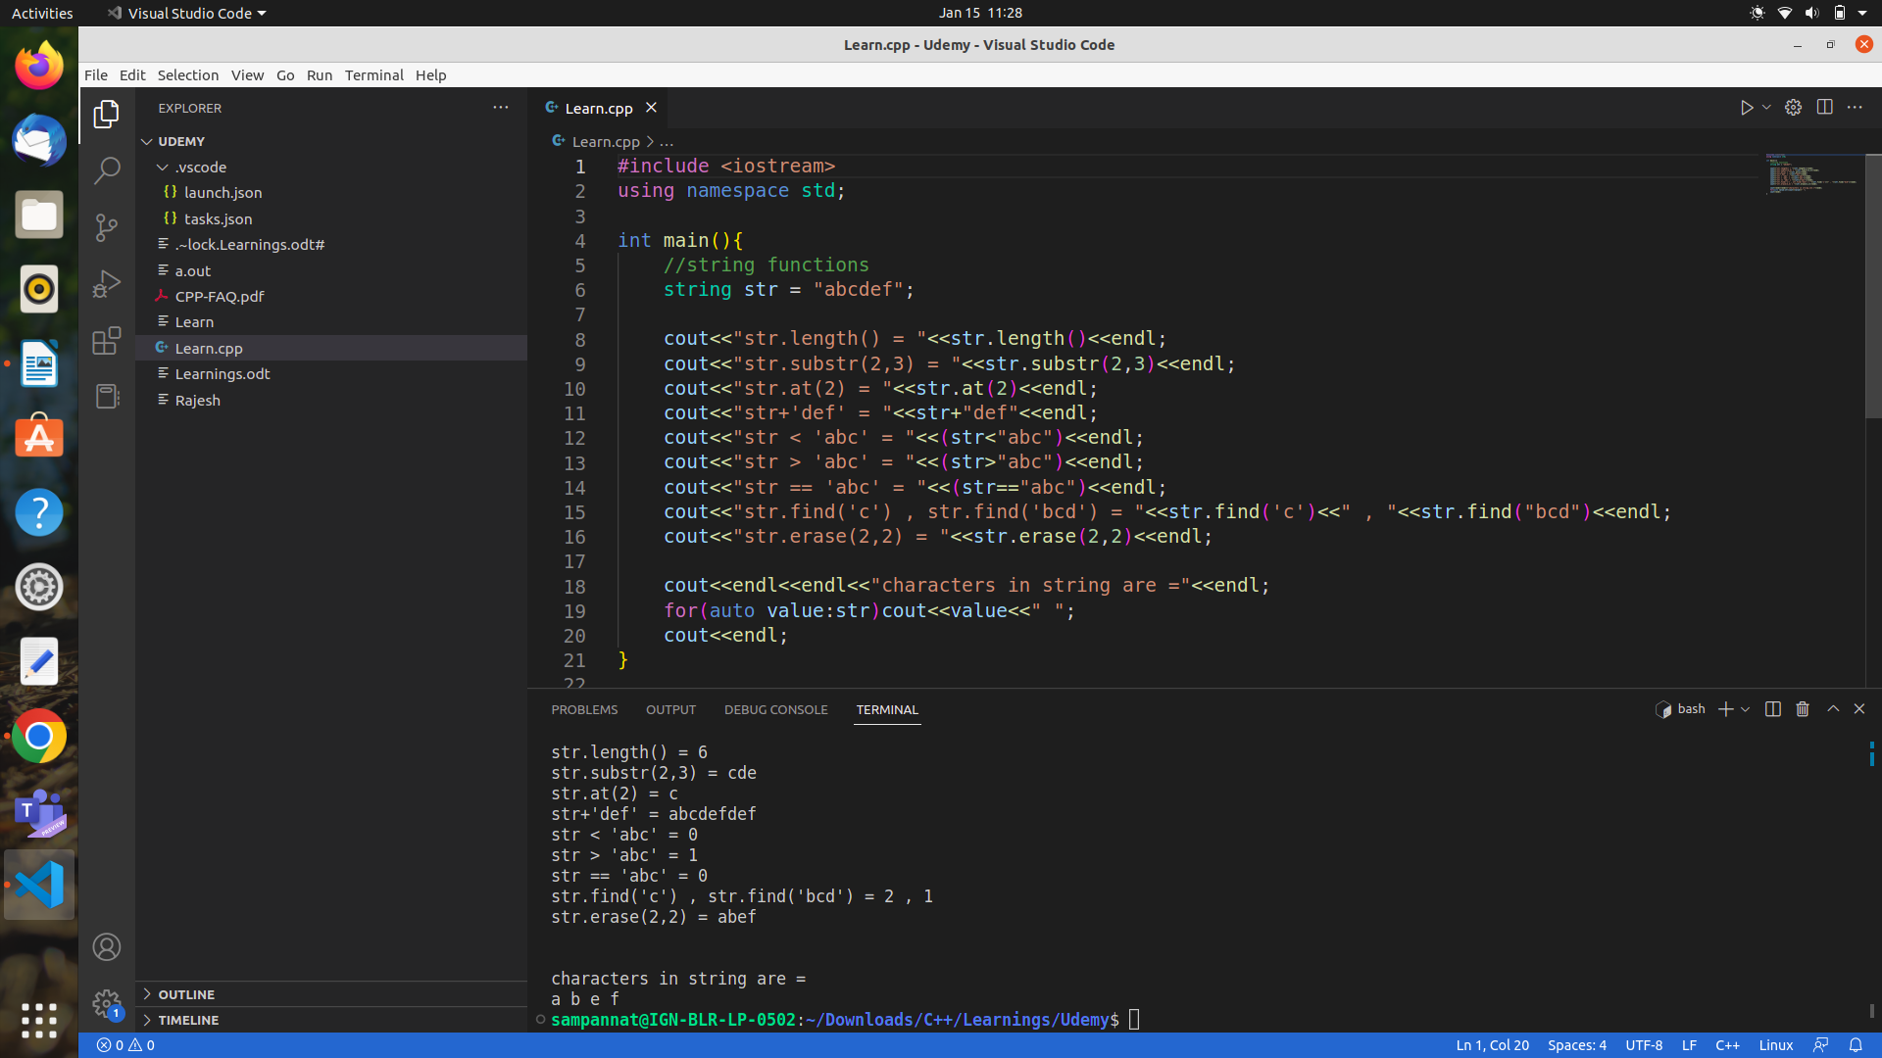
Note : In find function if index is not found then it returns string::npos

cmath functions
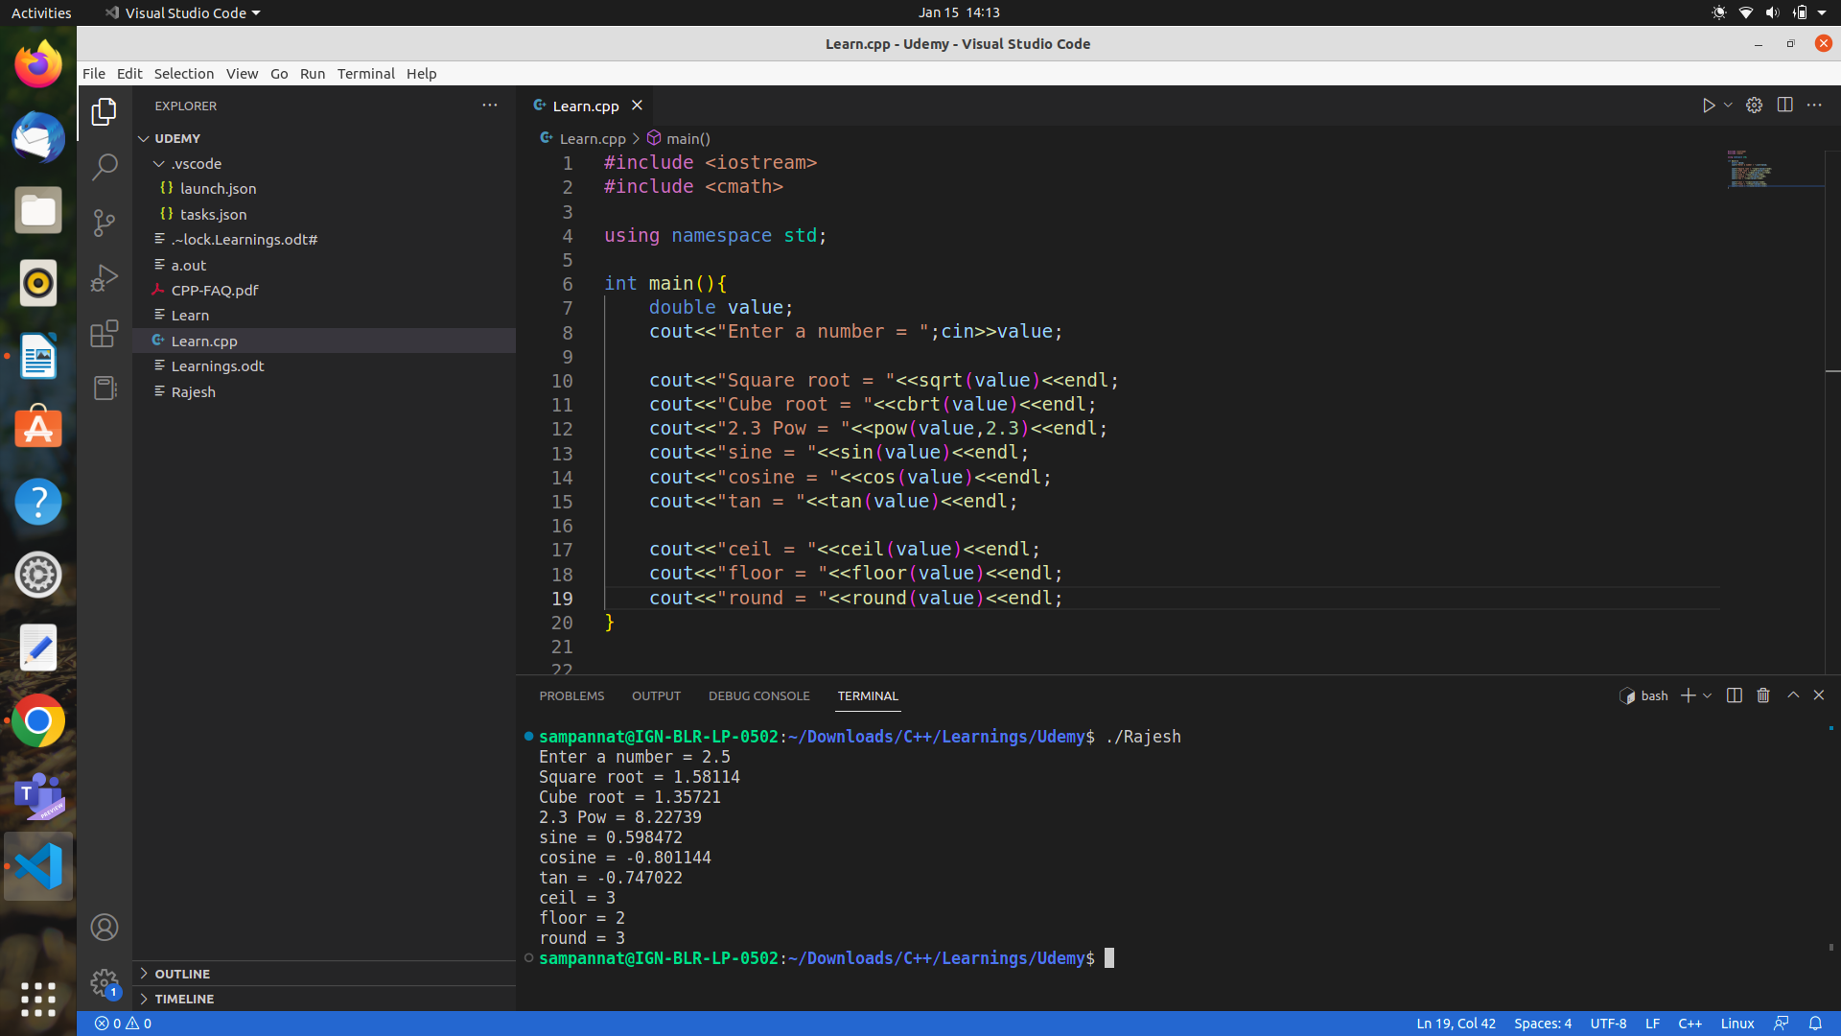
similarly there are functions like log(double), log2(double), log10(double)

Generate number in a given range from any random number
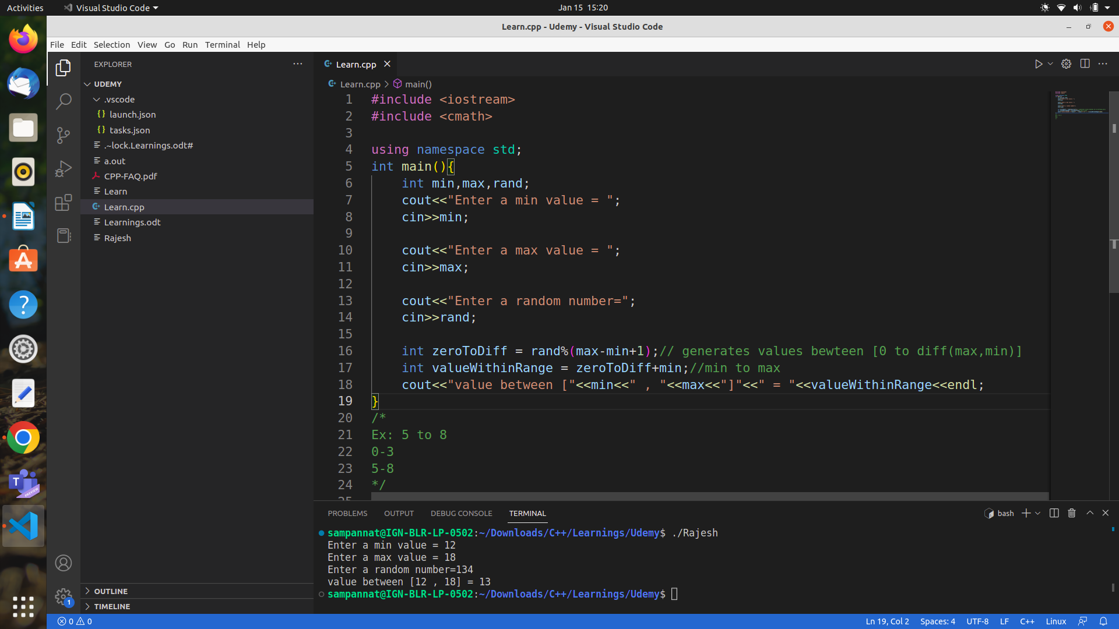

Actually generating a random number between [min-max] range
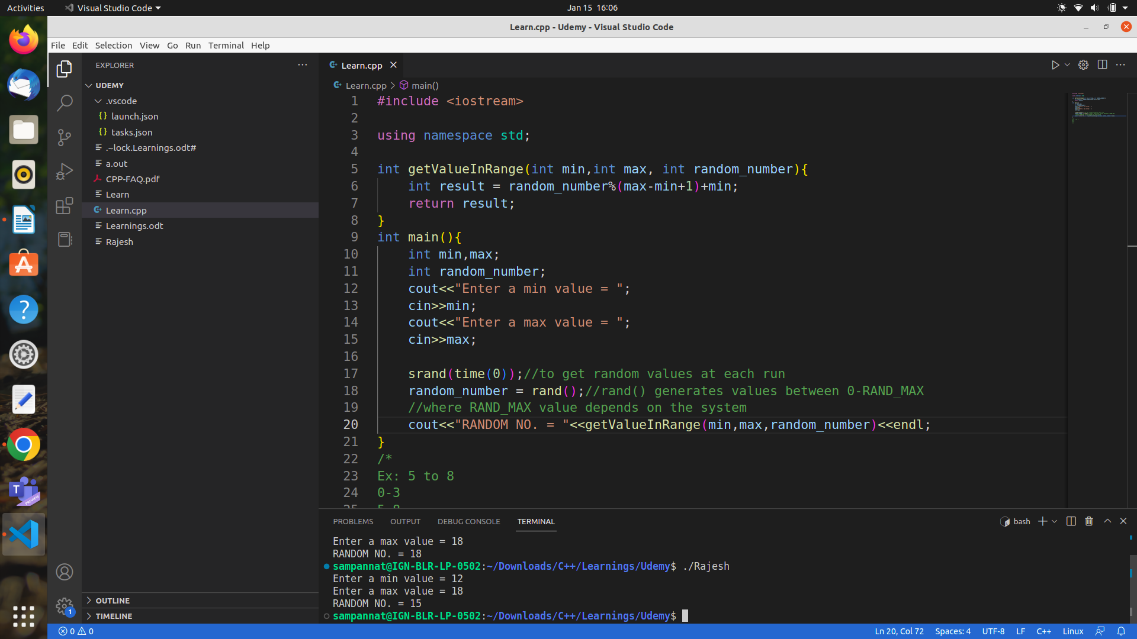

Example for pass by value in any case even vector as well
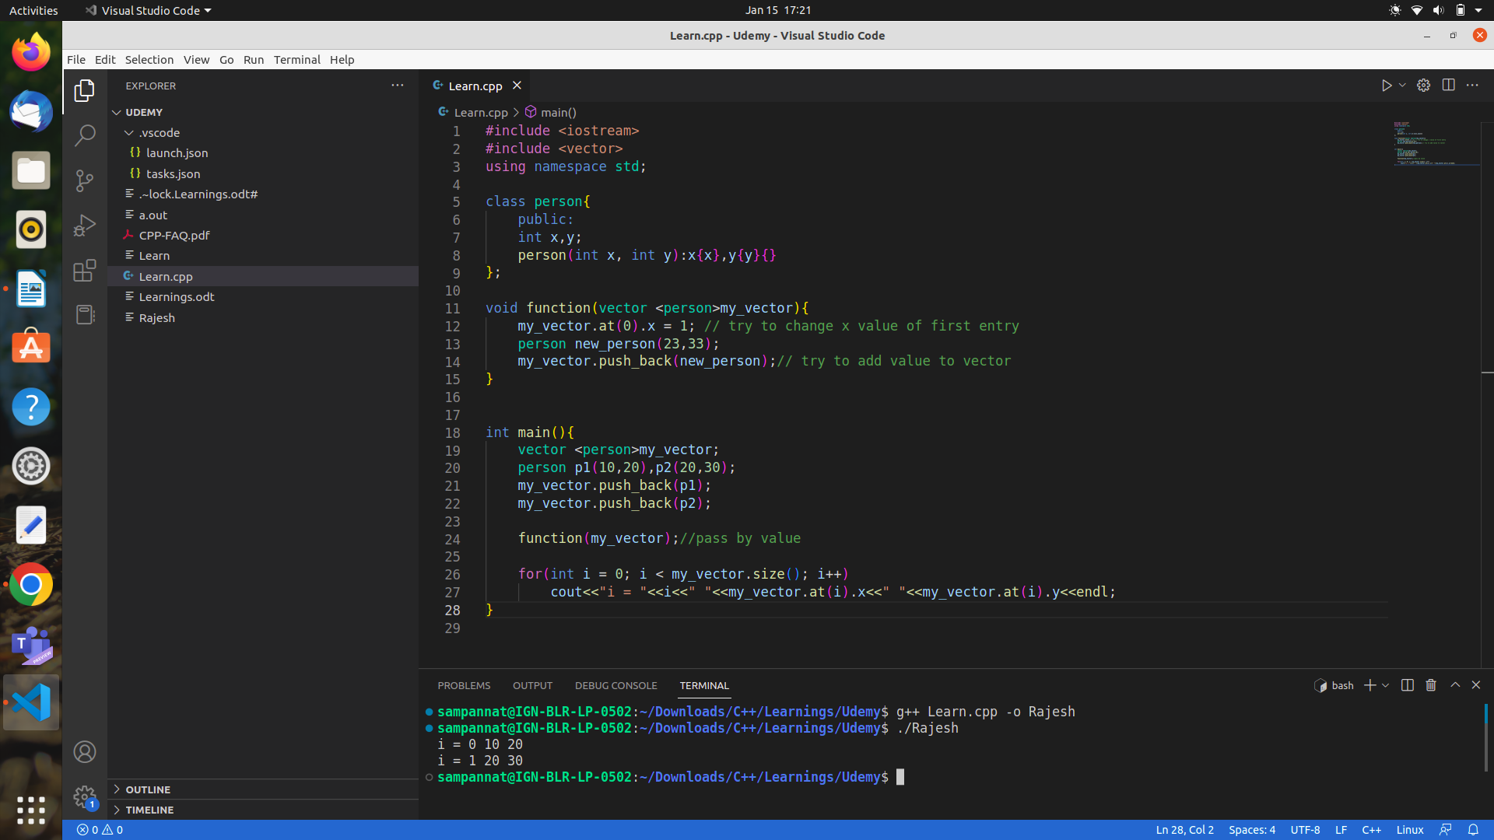

Arrays is an exception case where by default pass by reference happens as shown

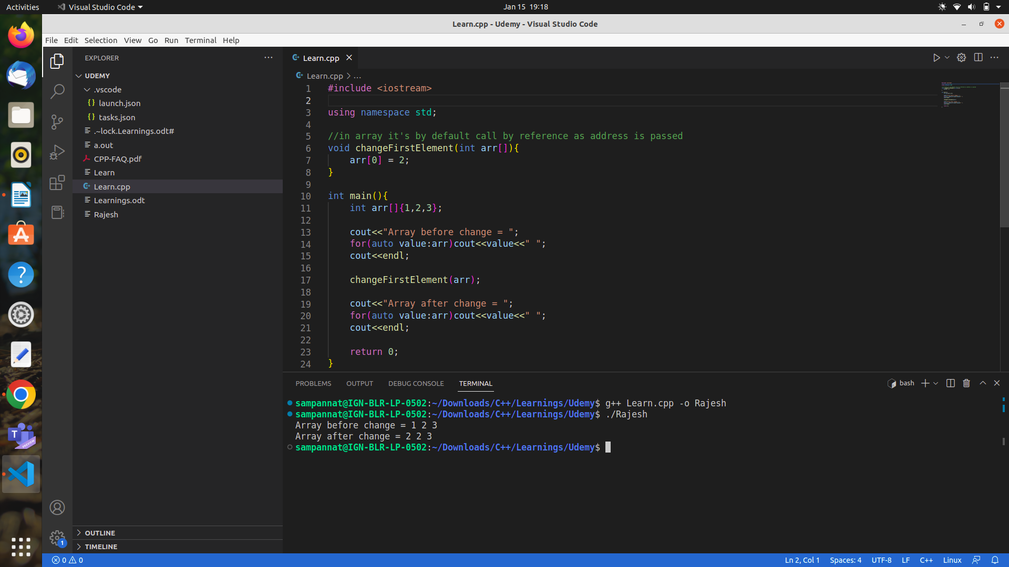
How memory is divided?
Basically memory is divided into code section, static/global variable section,heap section, stack section.

Pointers
Good programming practice => Always try to initialize pointer. i.e int *ptr = nullptr;

Main use of pointers => when memory is allocated dynamically.
Ex: int *ptr = new int[5]; //ptr points to first address of array for 5 elements
delete []ptr; //de allocates the memory

lvalue => value which can be addressable & data can be assigned to it.
Rvalue => opposite of lvalue i.e. value which can’t be addressable & data can’t be assigned to it.

const int *ptr or int const *ptr => value is const & ptr is not constant
int *const ptr => value is not constant but ptr is constant
int *ptr => Both are not constant
const int * const ptr => Both are constant

Debugging

Step1 => insert a break point from where you have to start debugging
Step2 => press debugg option
Step3 => Using
(1)Step over or F10 to go one line at a time
(2)Step into or F11 to go inside a function
(3)Step out or (shift+F11) to complete the function exection at once
(4)Restart or (cntrl+shift+F5) to restart the debugging
(5)Stop or (shift+F5)

OOPS

initializer list is the only way to initialize constant members.

Constructor overloading along with default initializer (OOPS => constructor overloading)
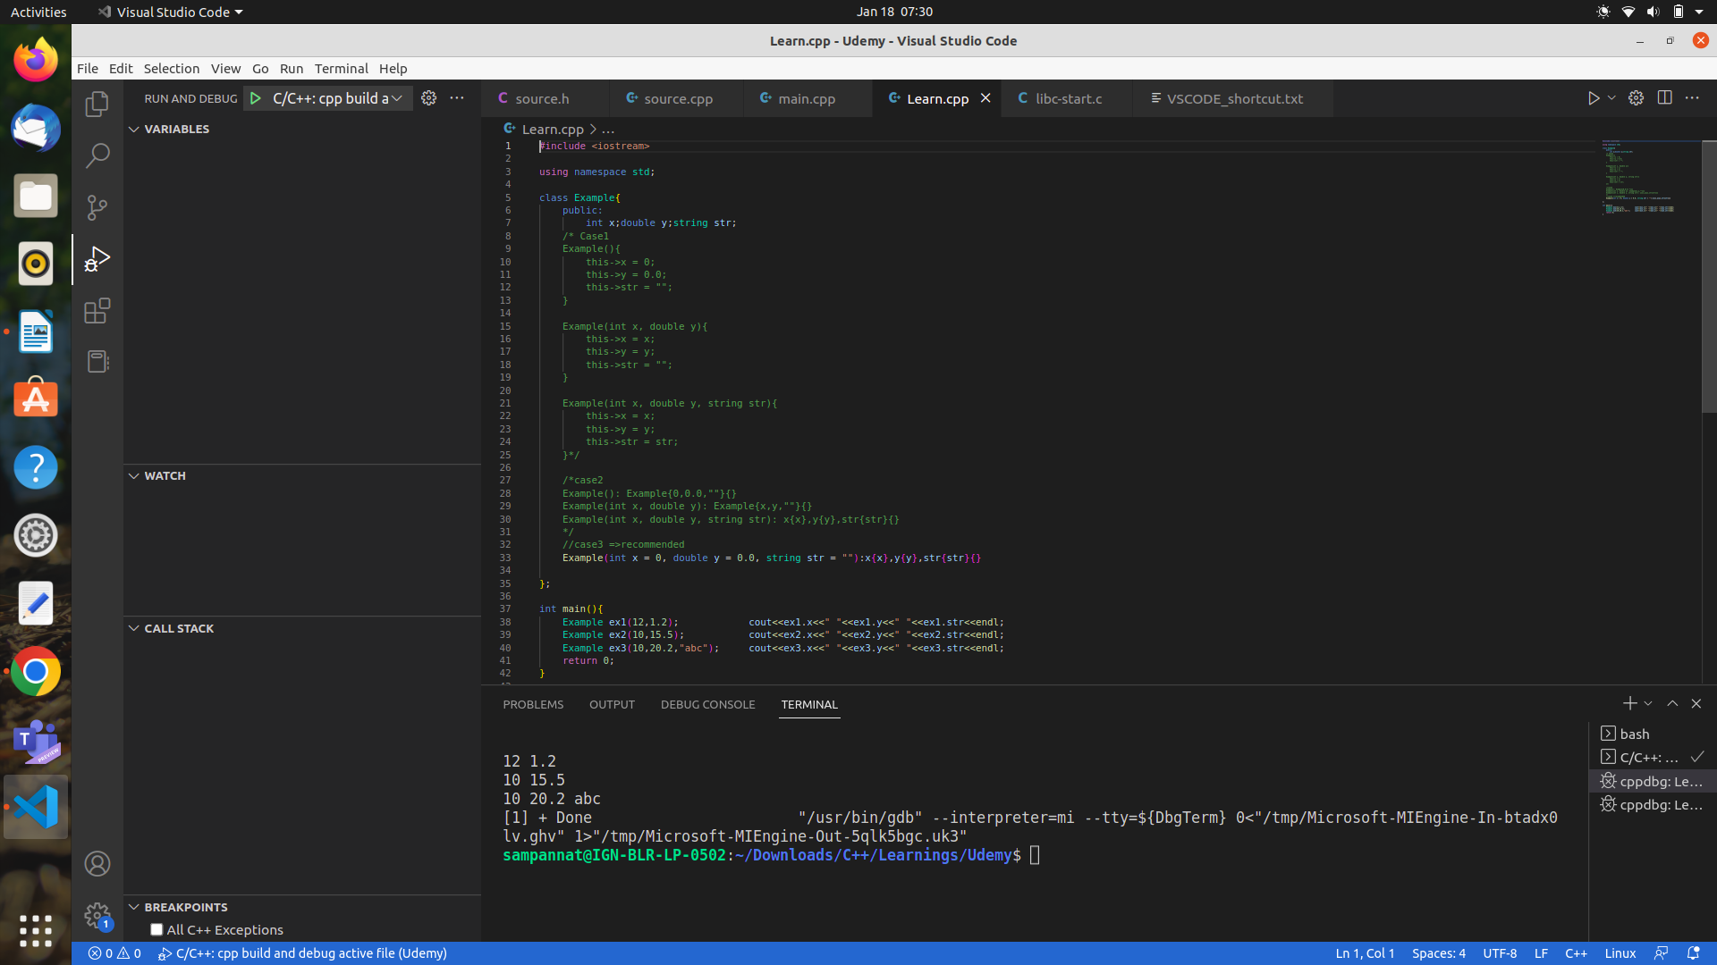
Also check (OOPS => multi-file) just for understanding multi file comilation with .h & .cpp files.

Note: if there is no constructor then default constructor is created by compiler. But if there is atleast one constructor then compiler won’t create default constructor
And if there is no copy constructor then compiler will create copy constructor which does shallow copy.

It is good practice to write copy constructor as follows (Let’s consider Player class)

Player(const &Player){} => & is to avoid constructor call recursively and const is to not allow any modification of passed Player as the purpose is just to copy.

MOVE CONSTRUCTOR

If we declare obj as const then we can’t change the attributes & call functions associated with that obj.
So this would be a pbm as we can’t even use functions that doesn’t modify attributes.
So in order to allow access to certain fucntions then we have to add const key word at the end of function declarion.

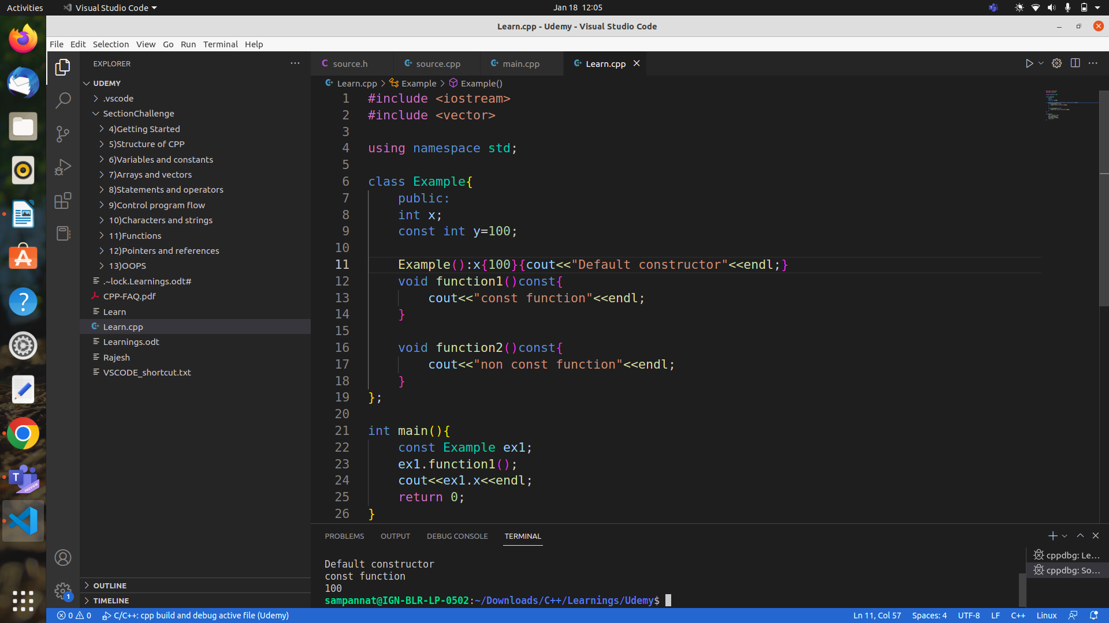

Using static keyword and instance block....
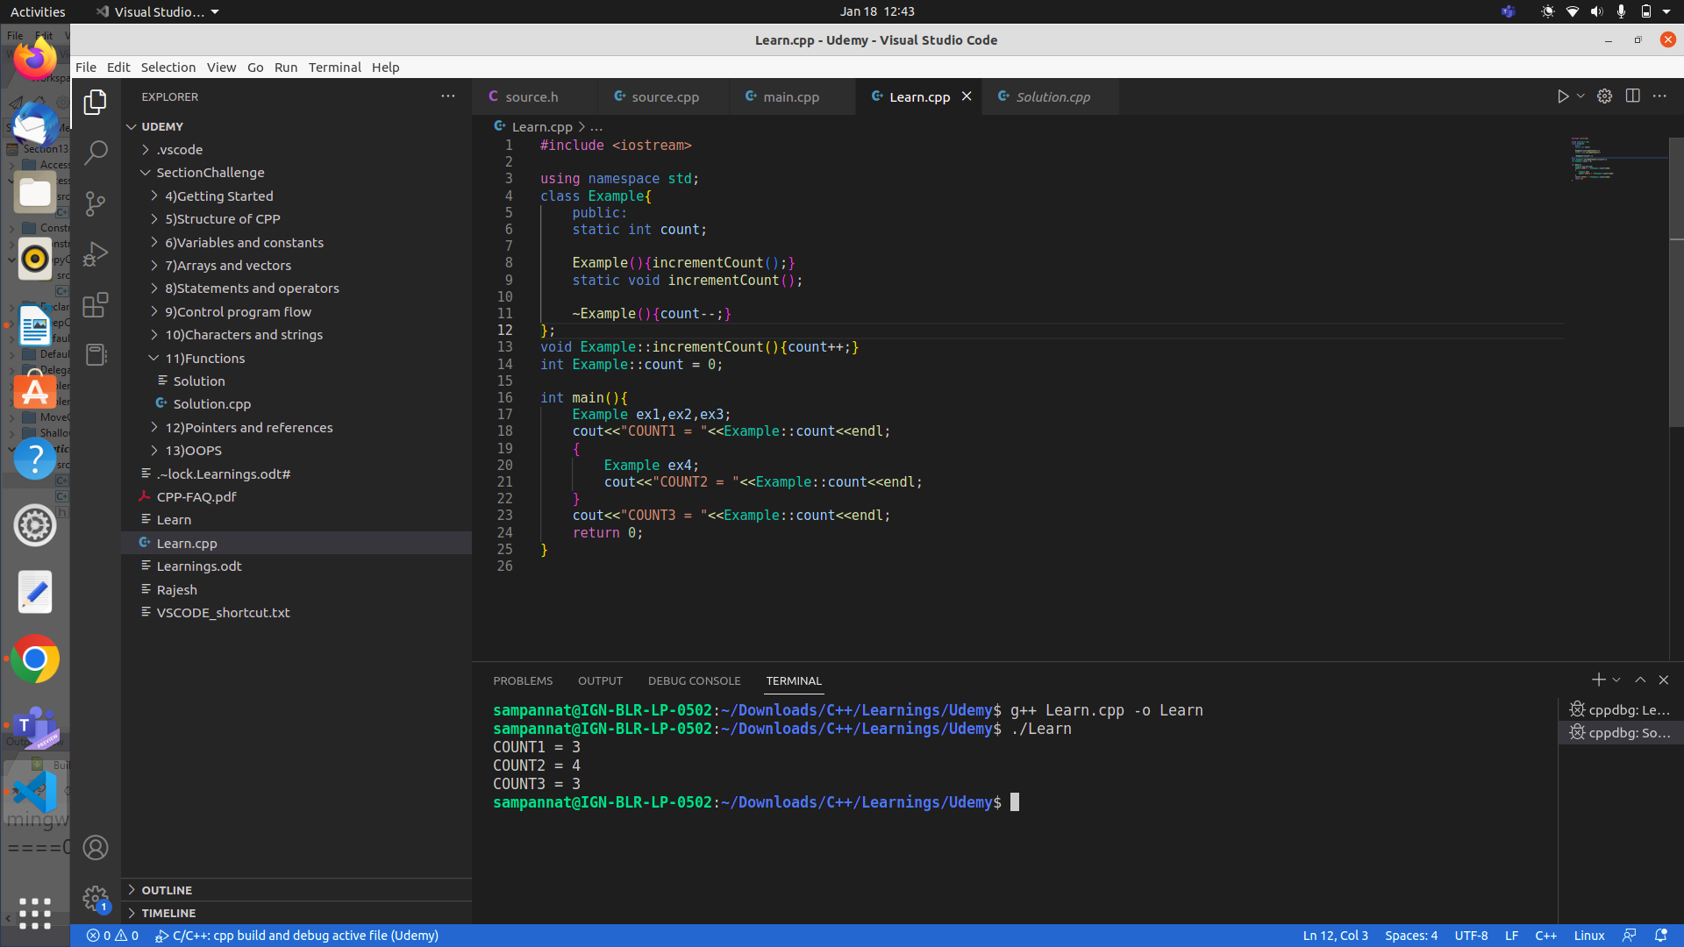
CNN, object detection & object segmentation => imp to learn

Returning reference from a function

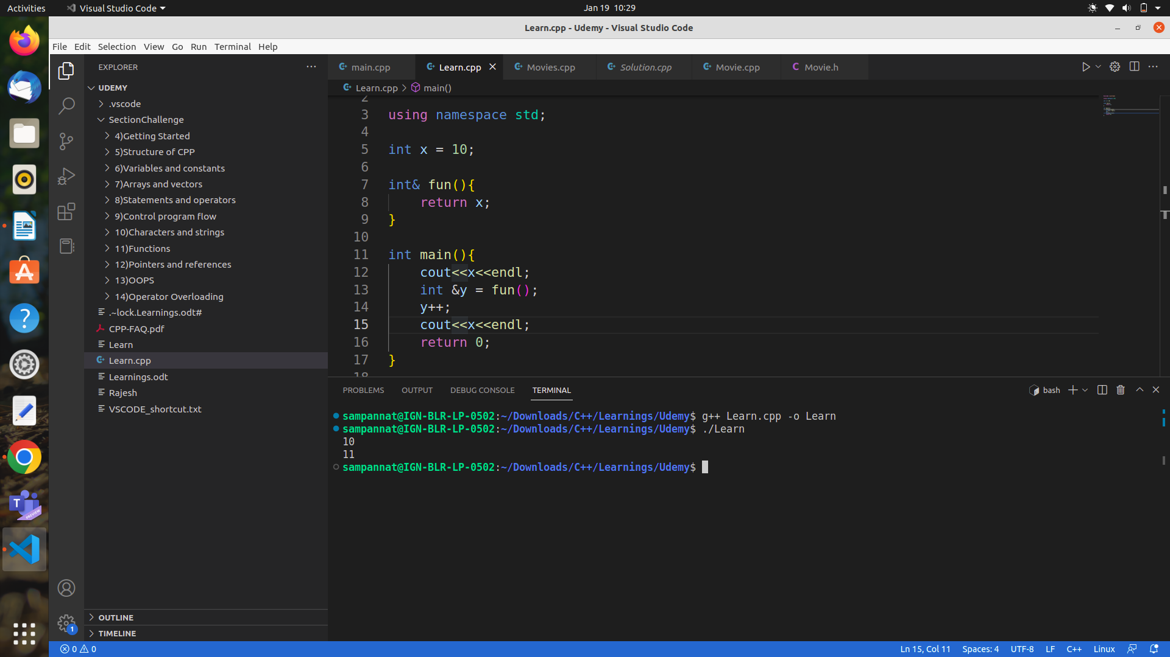
Note: Here make sure that the variable is returned not the address.

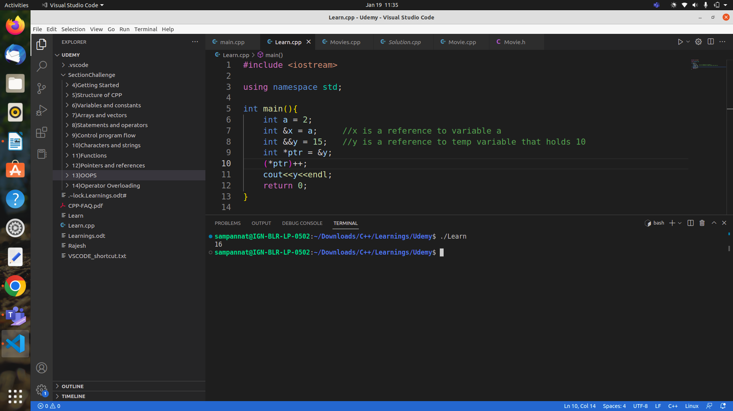
Reference to value held by temporary variable using &&

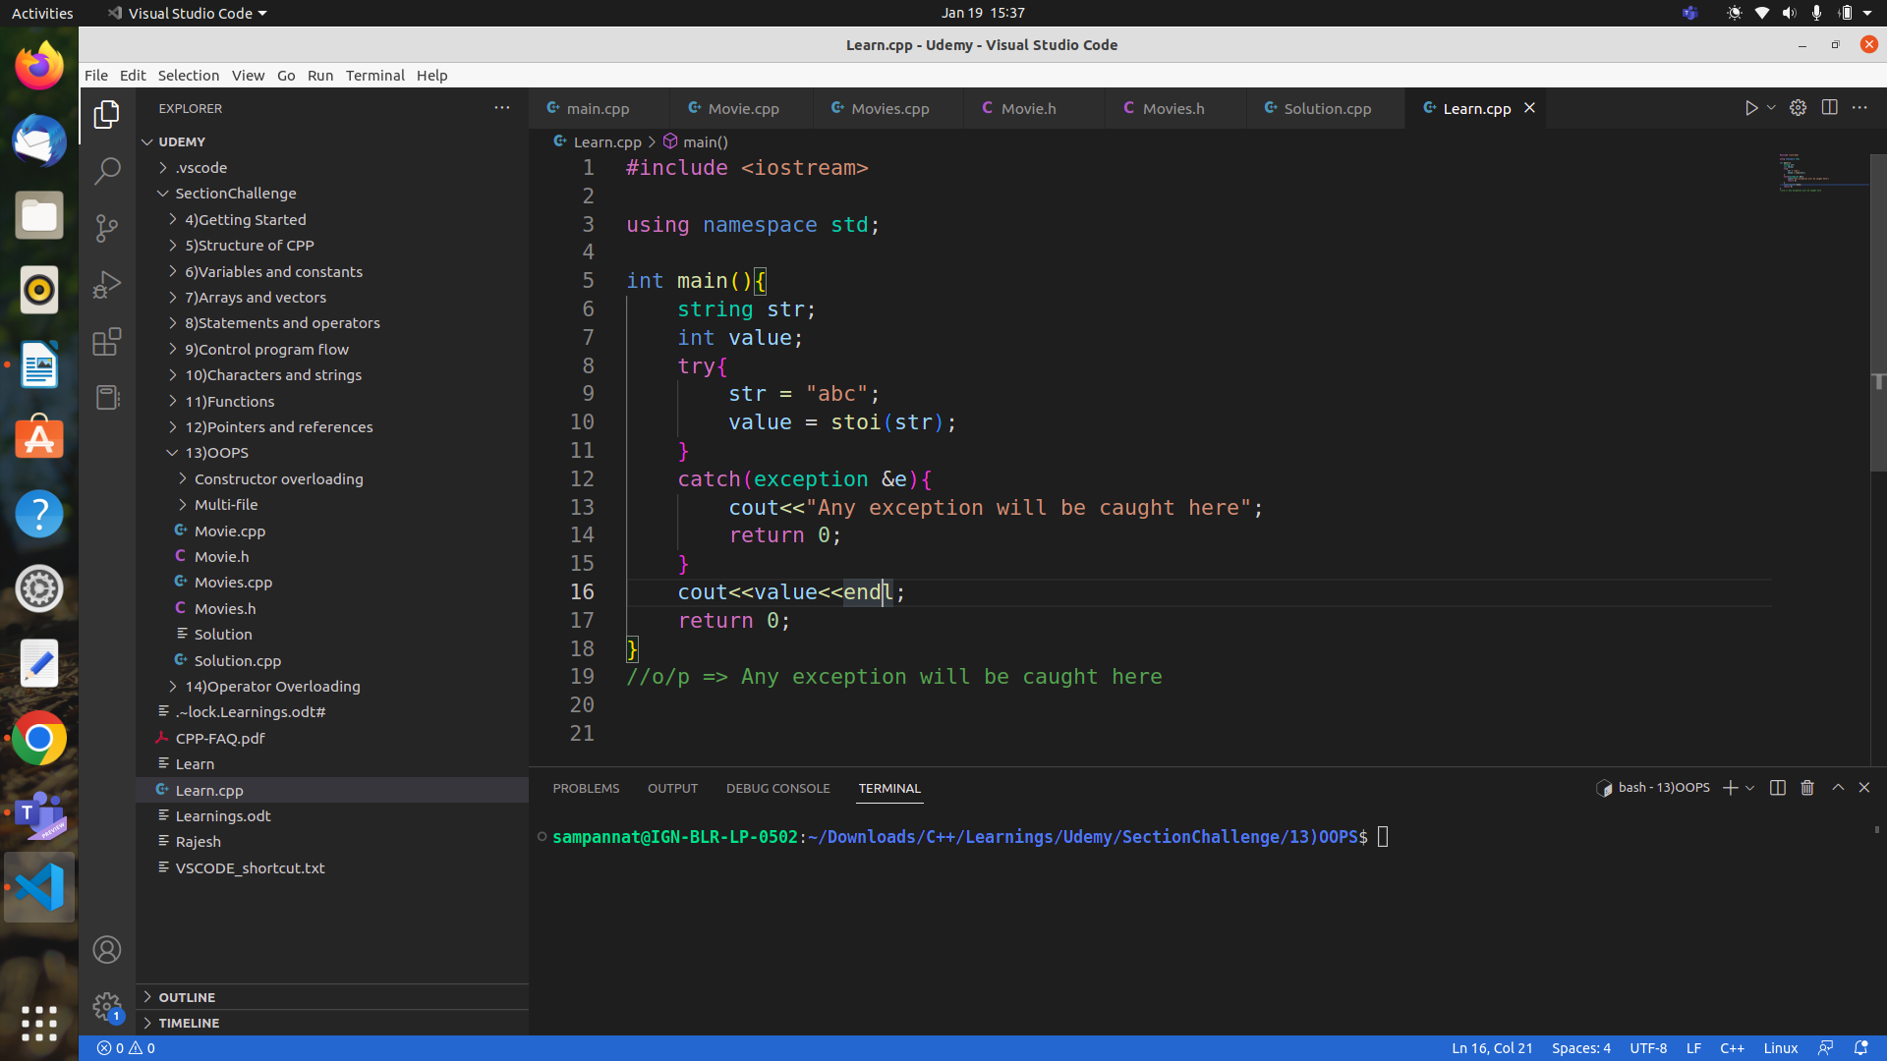
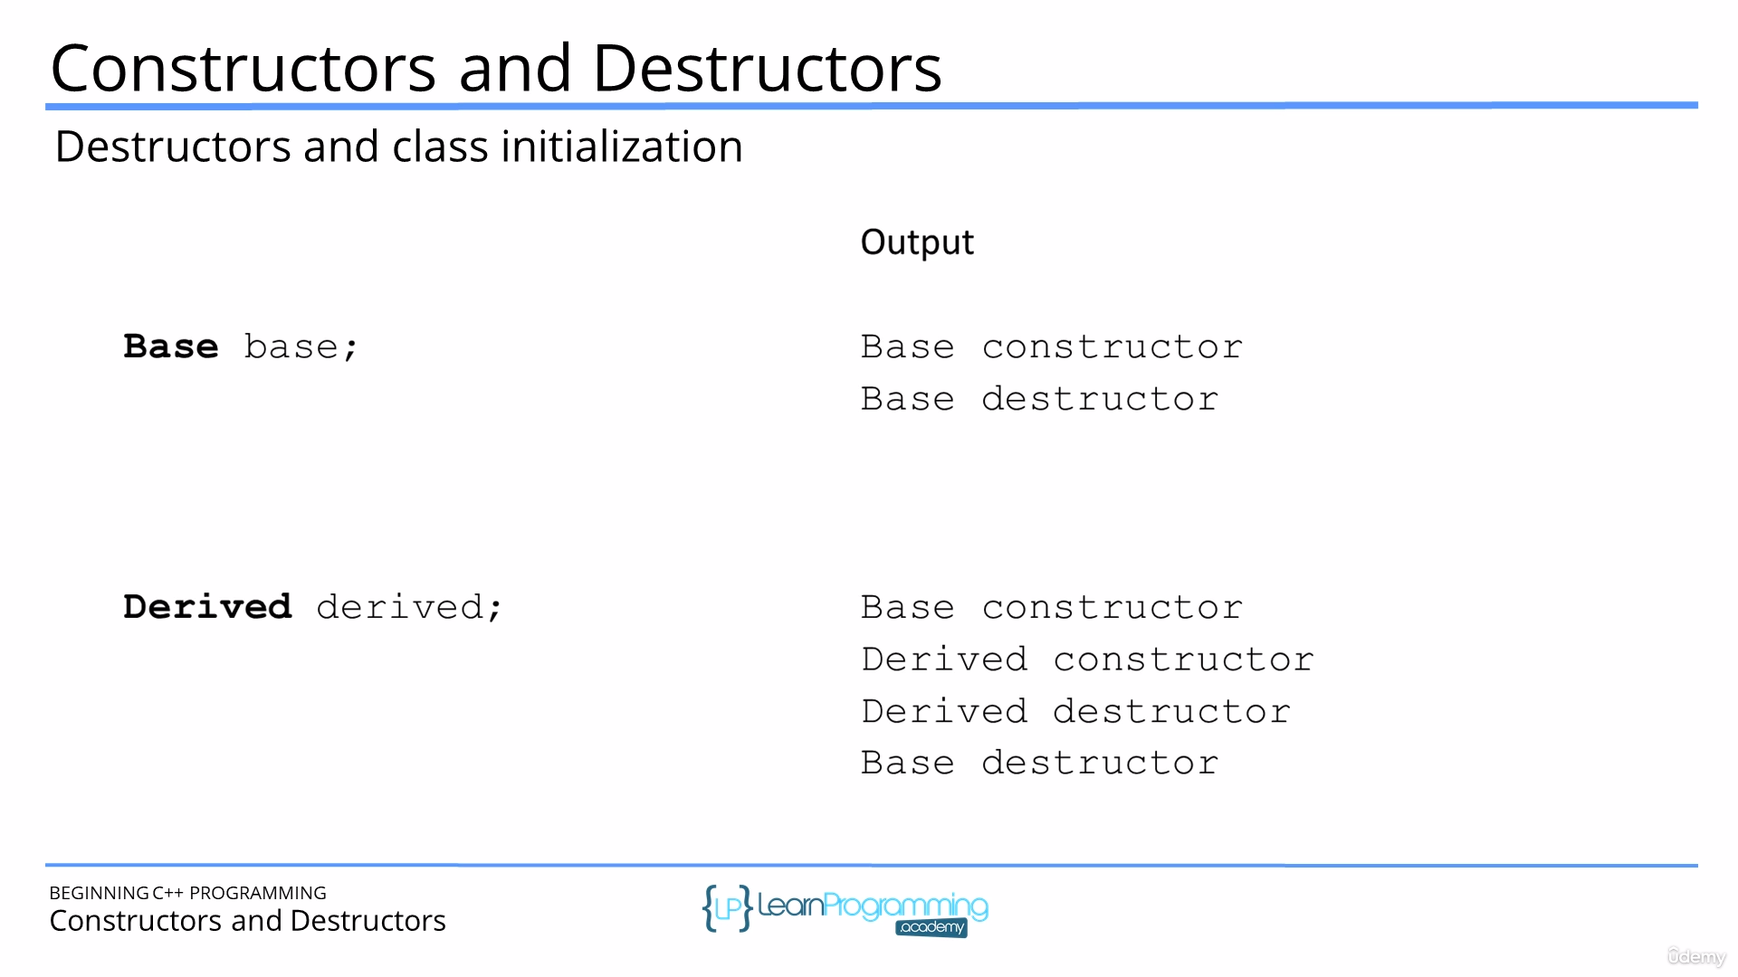
Note : A derived class constructor does not inherit base class constructor, base class destructor, base class overloaded assignment operators & base class friend function

Excpetion handling
Don’t throw Exception in destructor.

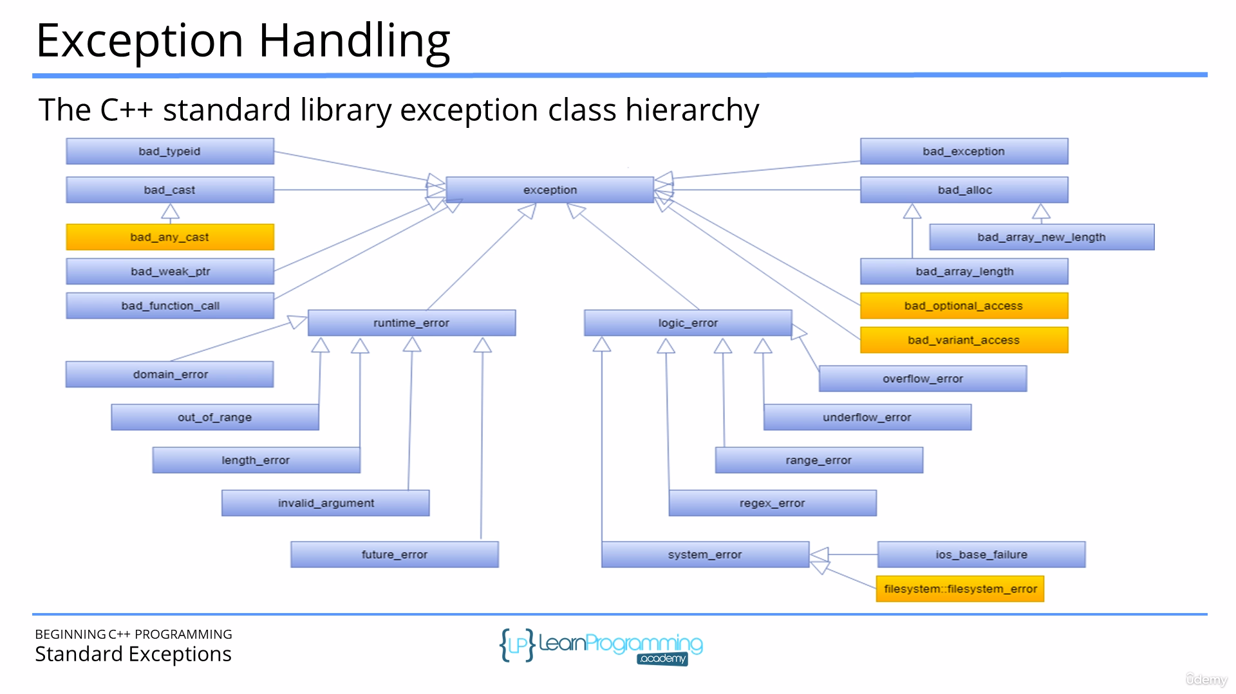

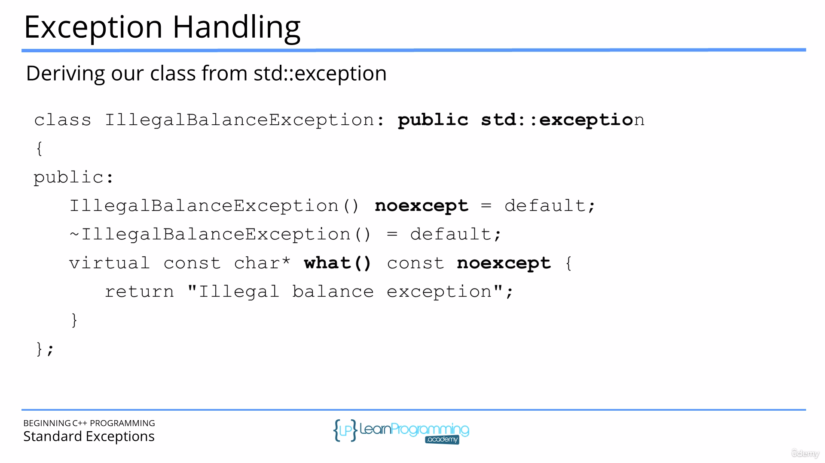
what() is a virtual function that is present in exception class which we can implement by inheriting from exception class.
Noexcept is used to say that the current function can’t throw any exception.

Use of =default is that in case of constructor the attributes will be by default initialized to 0 or 0.0 or so on.
Exception can be thrown in any
Catch(...) => is used to catch any exception

Enumeration
Used mostly to increase the readability of code.

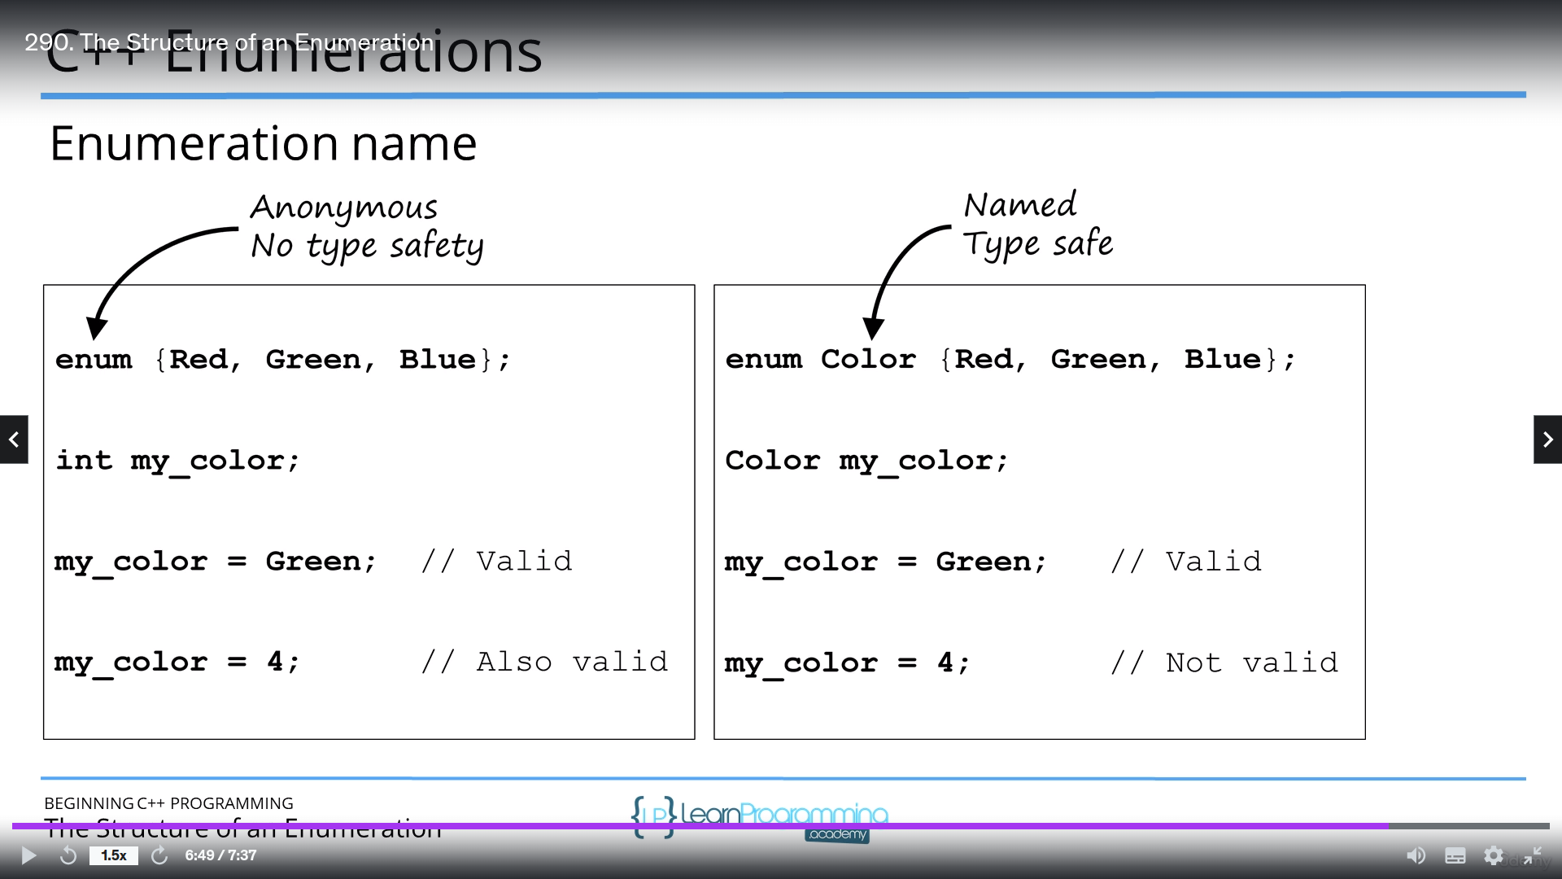
Following is the way to define enum where data type(must be intergral) and name is optional=>
enum_keyword name:data type{att1,att2,att3};

Note: If we try to initialize a value within the enum then every other value after it will be going in a sequence in ascending order that too incremented by 1.
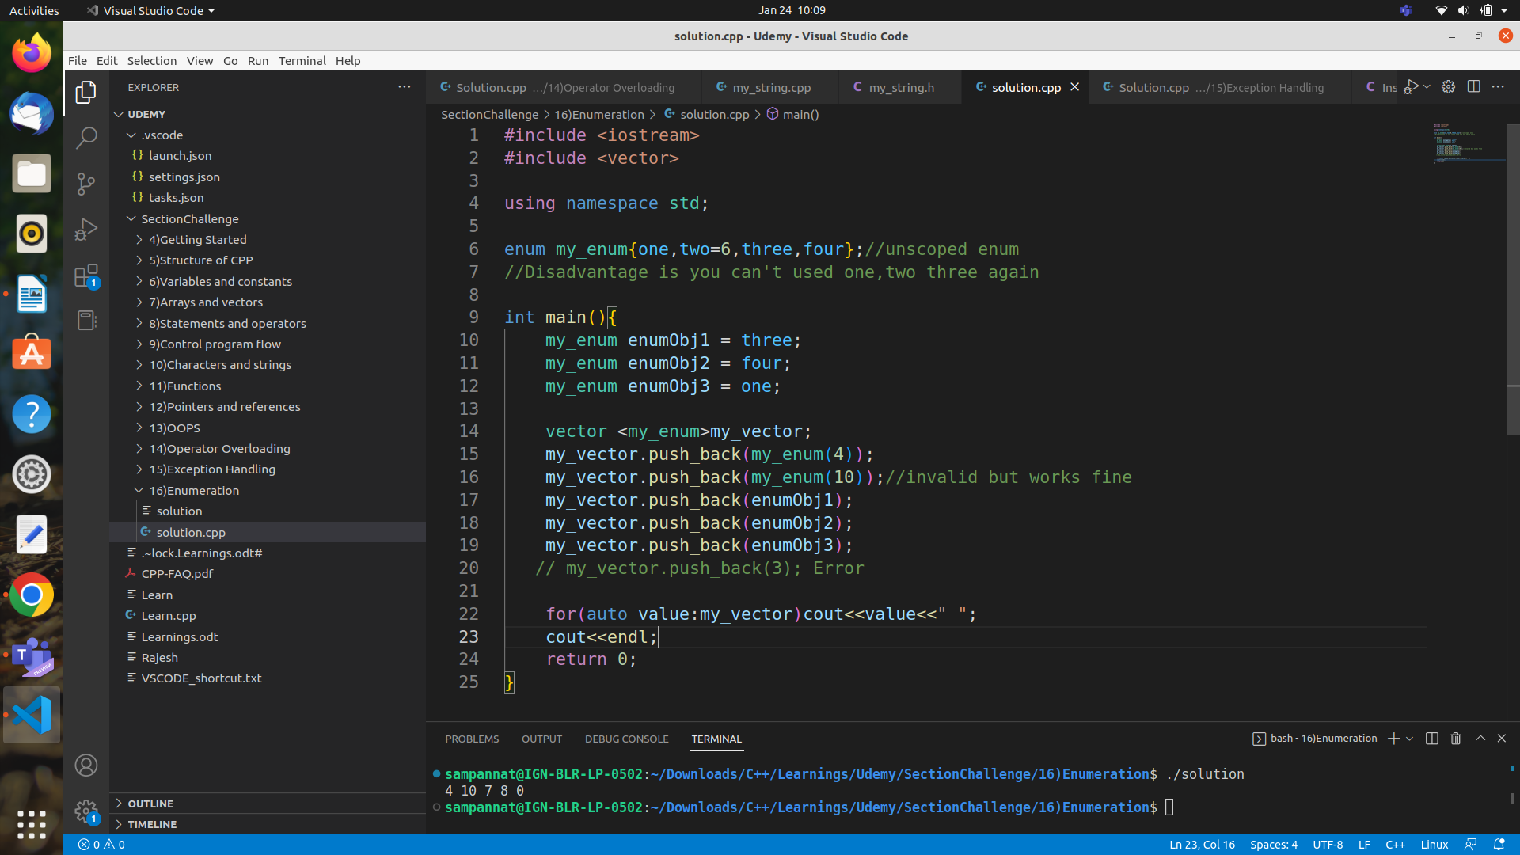
Use of scoped enumeration
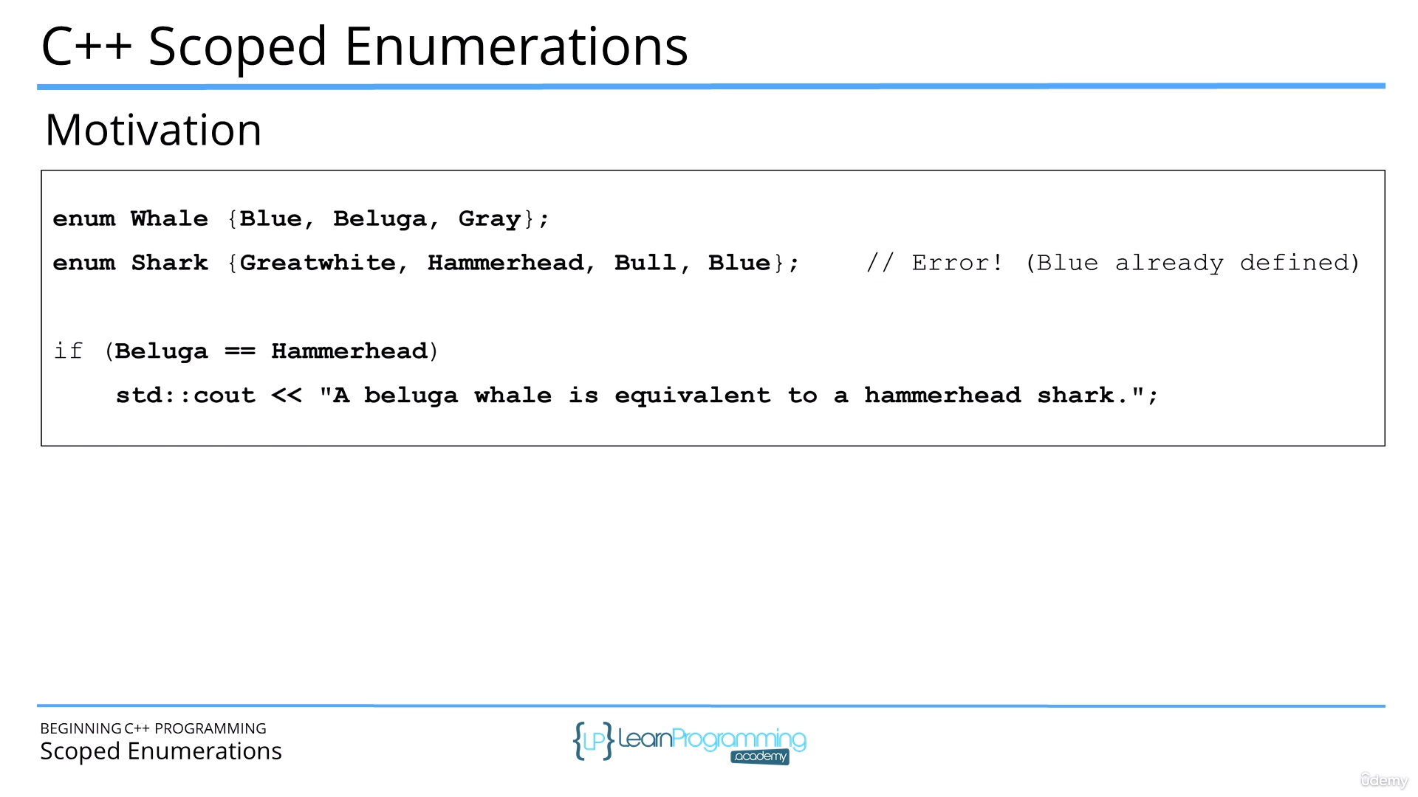
First disadvantage of unscoped enum is that if two enums have same name then it will give compile time error as shown above for Blue.
Second disadvantage of unscoped enum is that if two enums have let’s say Beluga & Hammerhead.. they belong to different enums but still are considered equal as the integral value associated is same. But it shouldn’t be true.

Smart pointers

Issues with raw pointers=>
uninitialized pointers
memory leaks
dangling pointers
Types => Unique pointers (unique_ptr)
Shared pointers (shared_ptr)
Weak pointers (weak_ptr)
Auto pointers (auto_ptr) -> depricated
Note: Make sure to include memory header file

Advantage =>
Automatically deletes the pointed memory block.

Disadvantage =>
Pointer arithmetic not supported.(But * and -> is overloaded)
a unique pointer can’t be assigned to another unique pointer

Unique pointer =>
Every unique_pointer obj created cannot be assigned to new obj
By default dereferencing operator * works
get() returns raw pointer for the obj
-> operator also works

Shared pointer =>
Every shared_pointer obj created can be assigned to new obj
By default dereferencing operator * works
get() returns raw pointer for the obj
-> operator also works
use_count returns number of shared_pointer obj pointing to same memory block

Weak pointer =>
Used rarely i.e in case of circular pointing. Ex: When A class has ptr which points to B class obj & B class has ptr which points to A class obj.

Custom deleter for smart pointers
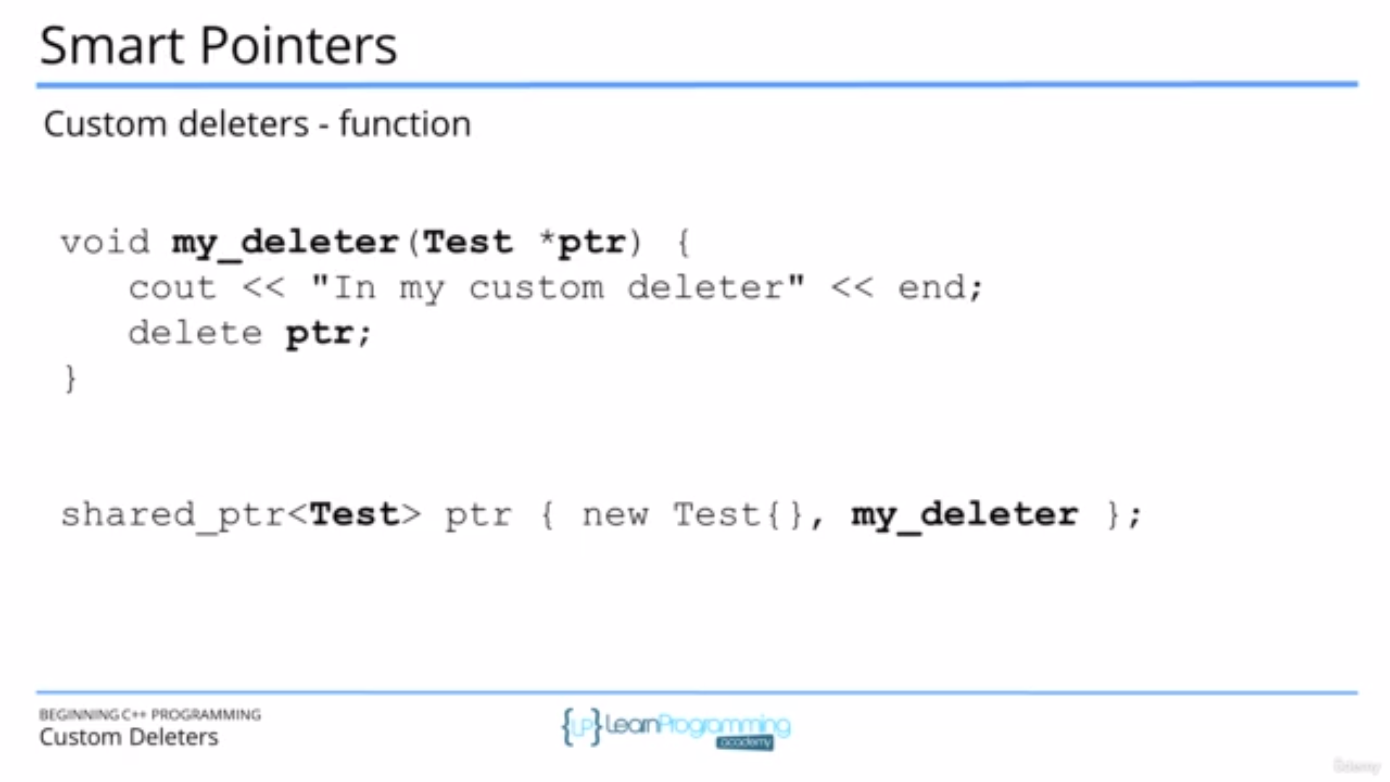
Advantage is for clean up activity whenever the smart pointer needs to be deleted the default deleter function will be called.

Inheritance

Generalization => Here we try to create more general class based on common attributes by combining similar classes.

Specialization => Here we try to create new class from existing generalized classes.

Composition => has a relation
Inheritance => is a realtion

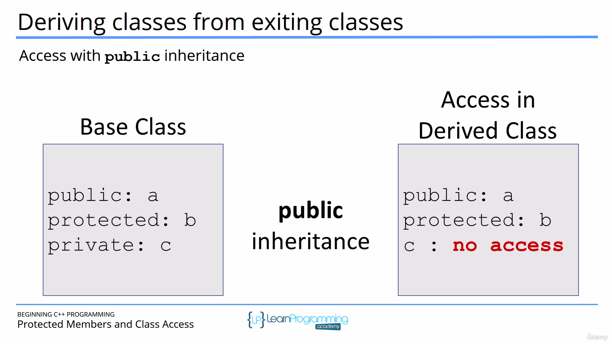
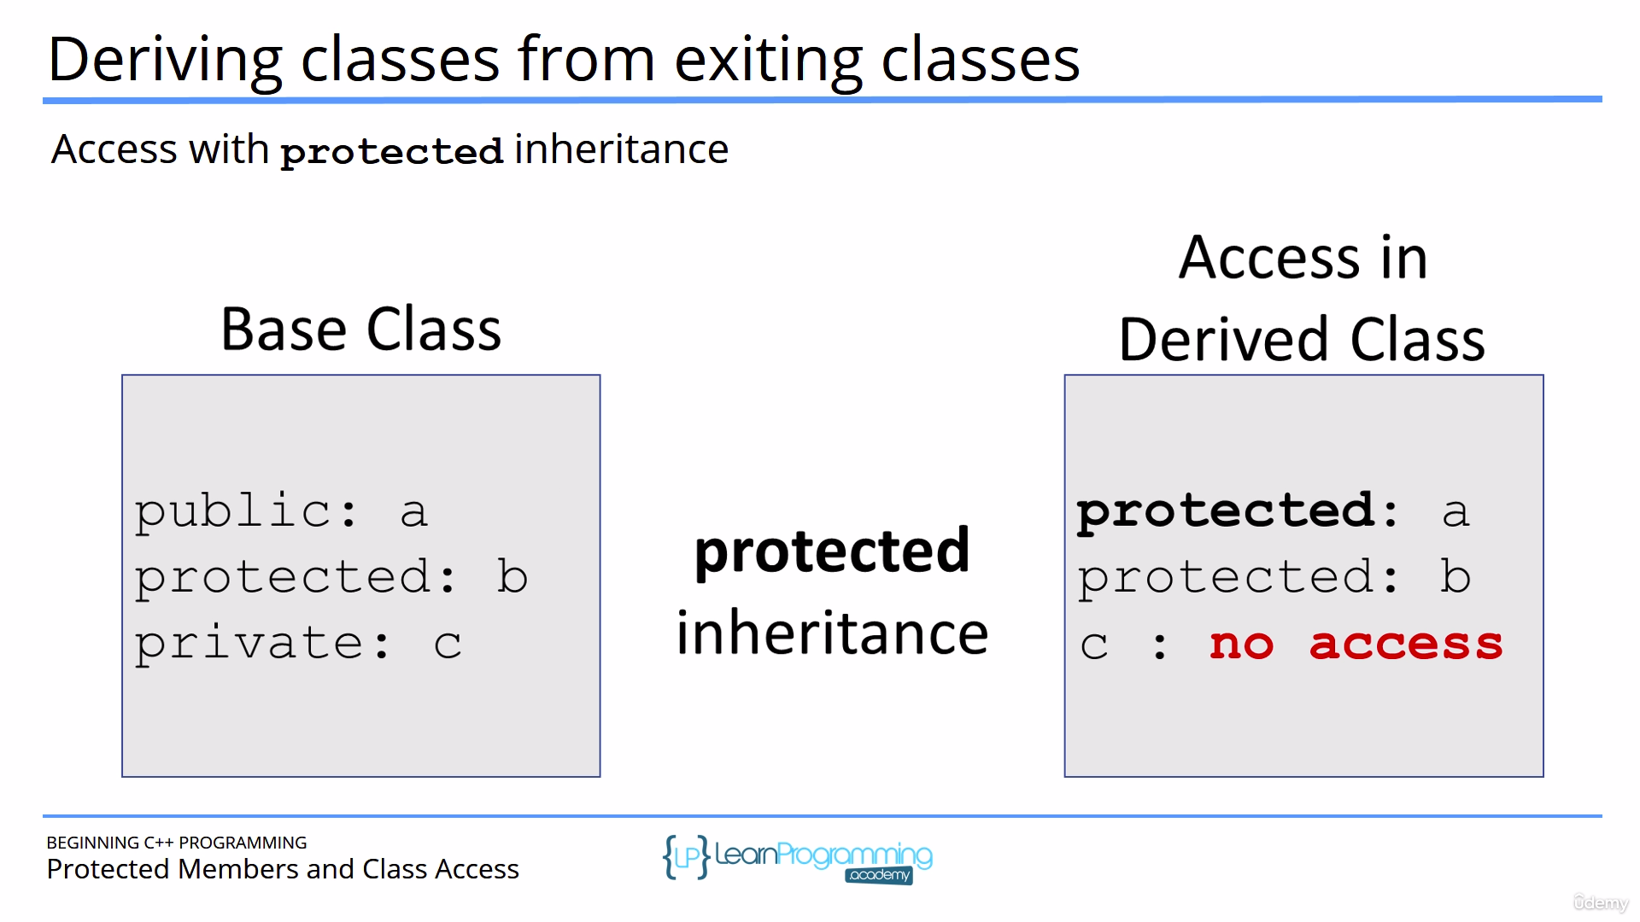

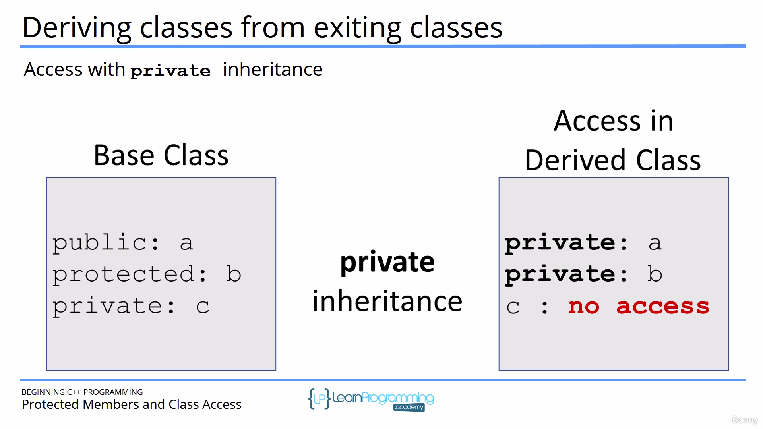

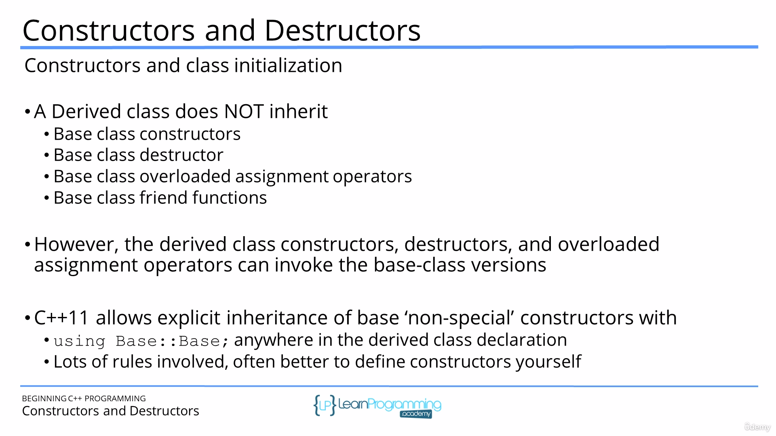

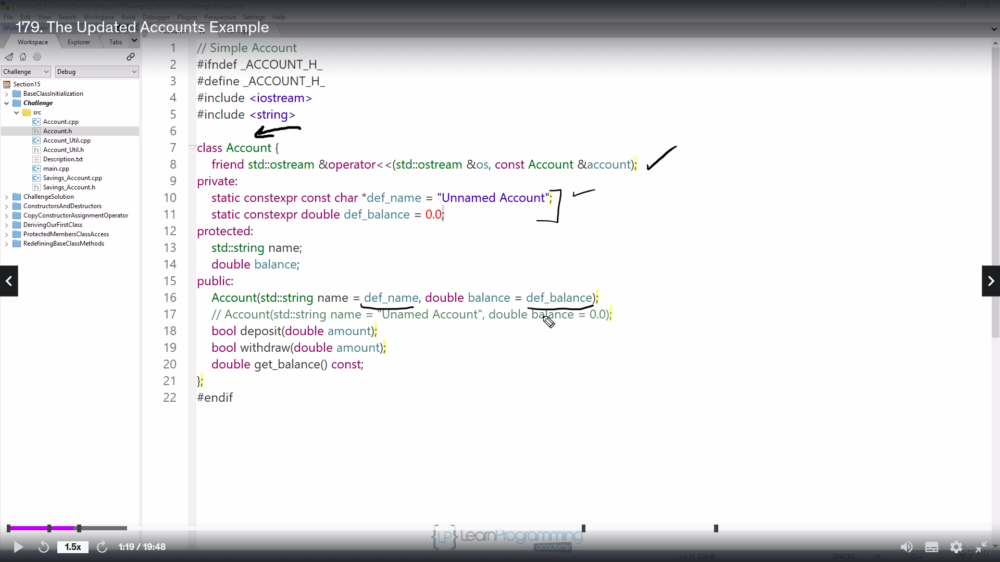
If there are virtual functions then there has to be virtual destructor. Other wise only the parent destructor only will be called ever if parent points to child.

Note: When you override a function use override at the end of function so that you get compile time error if signature doesn’t match.

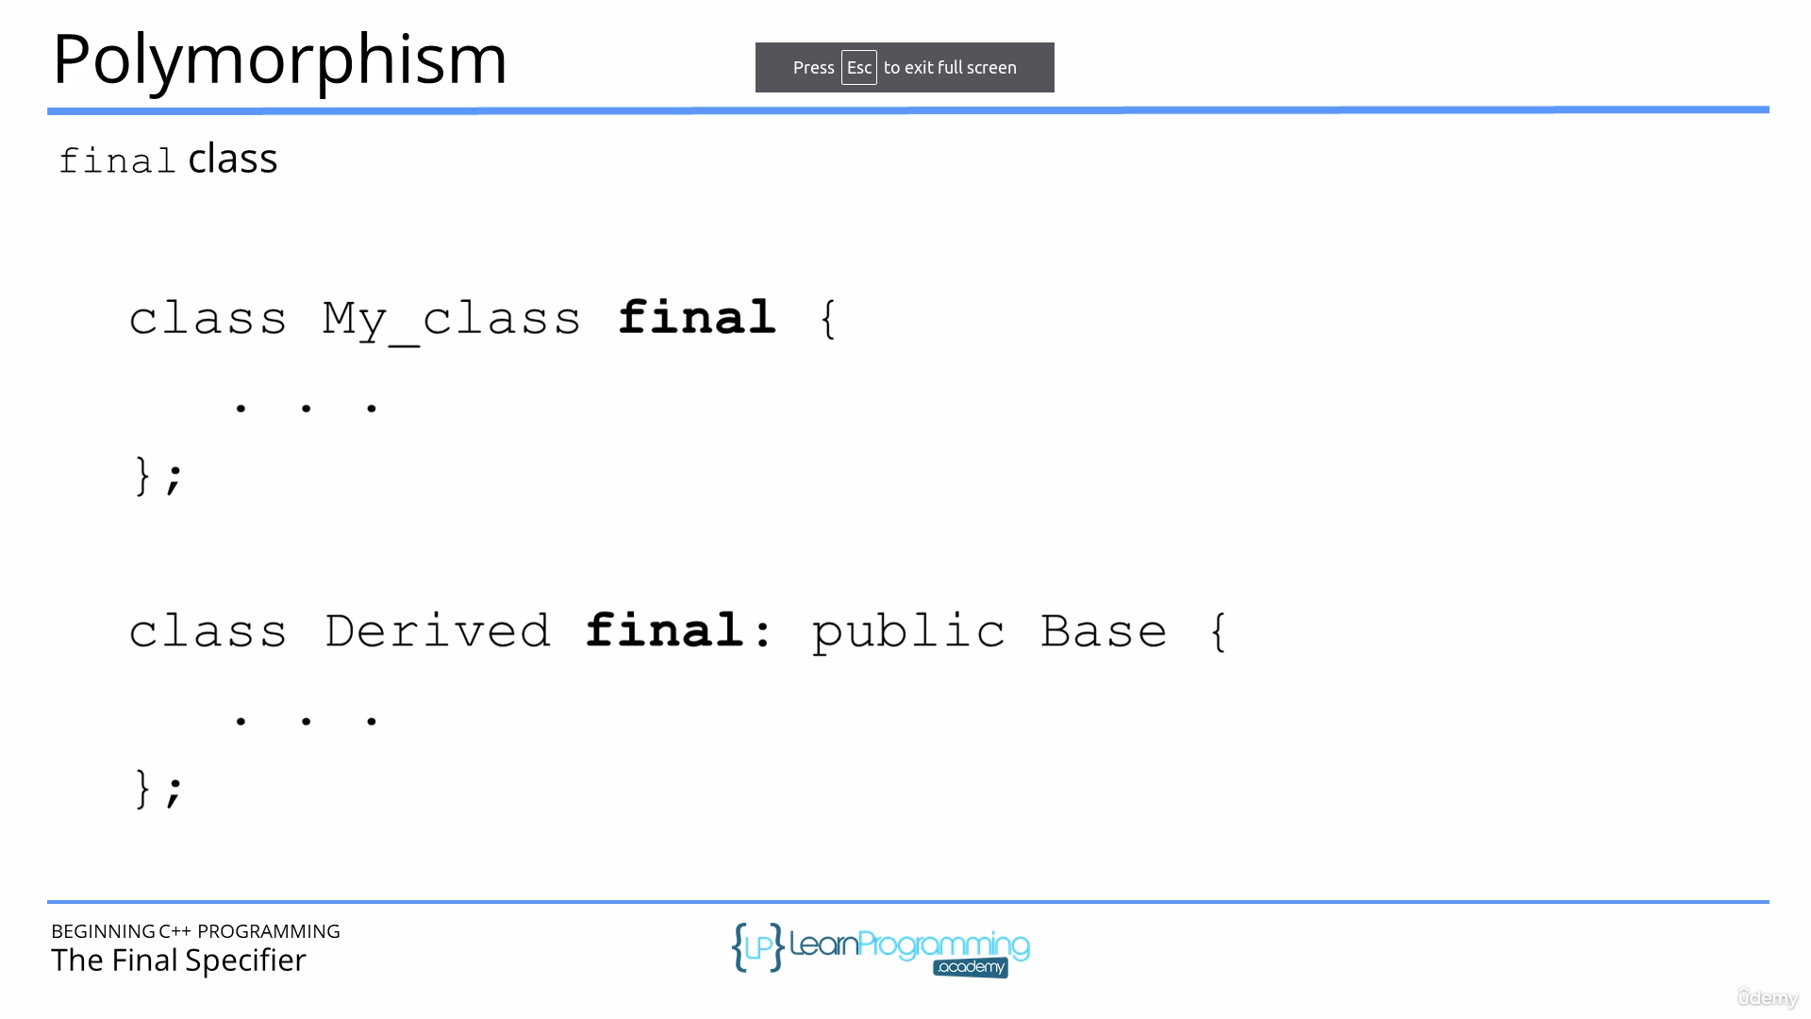
Final classes can’t be derived

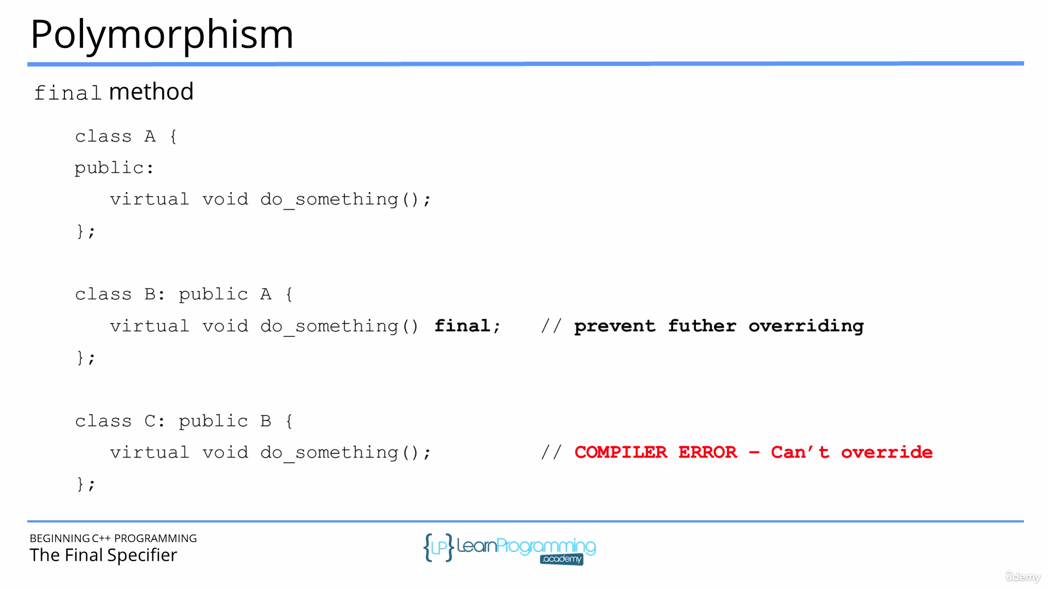
Final methods can’t be overriden

IO & streams
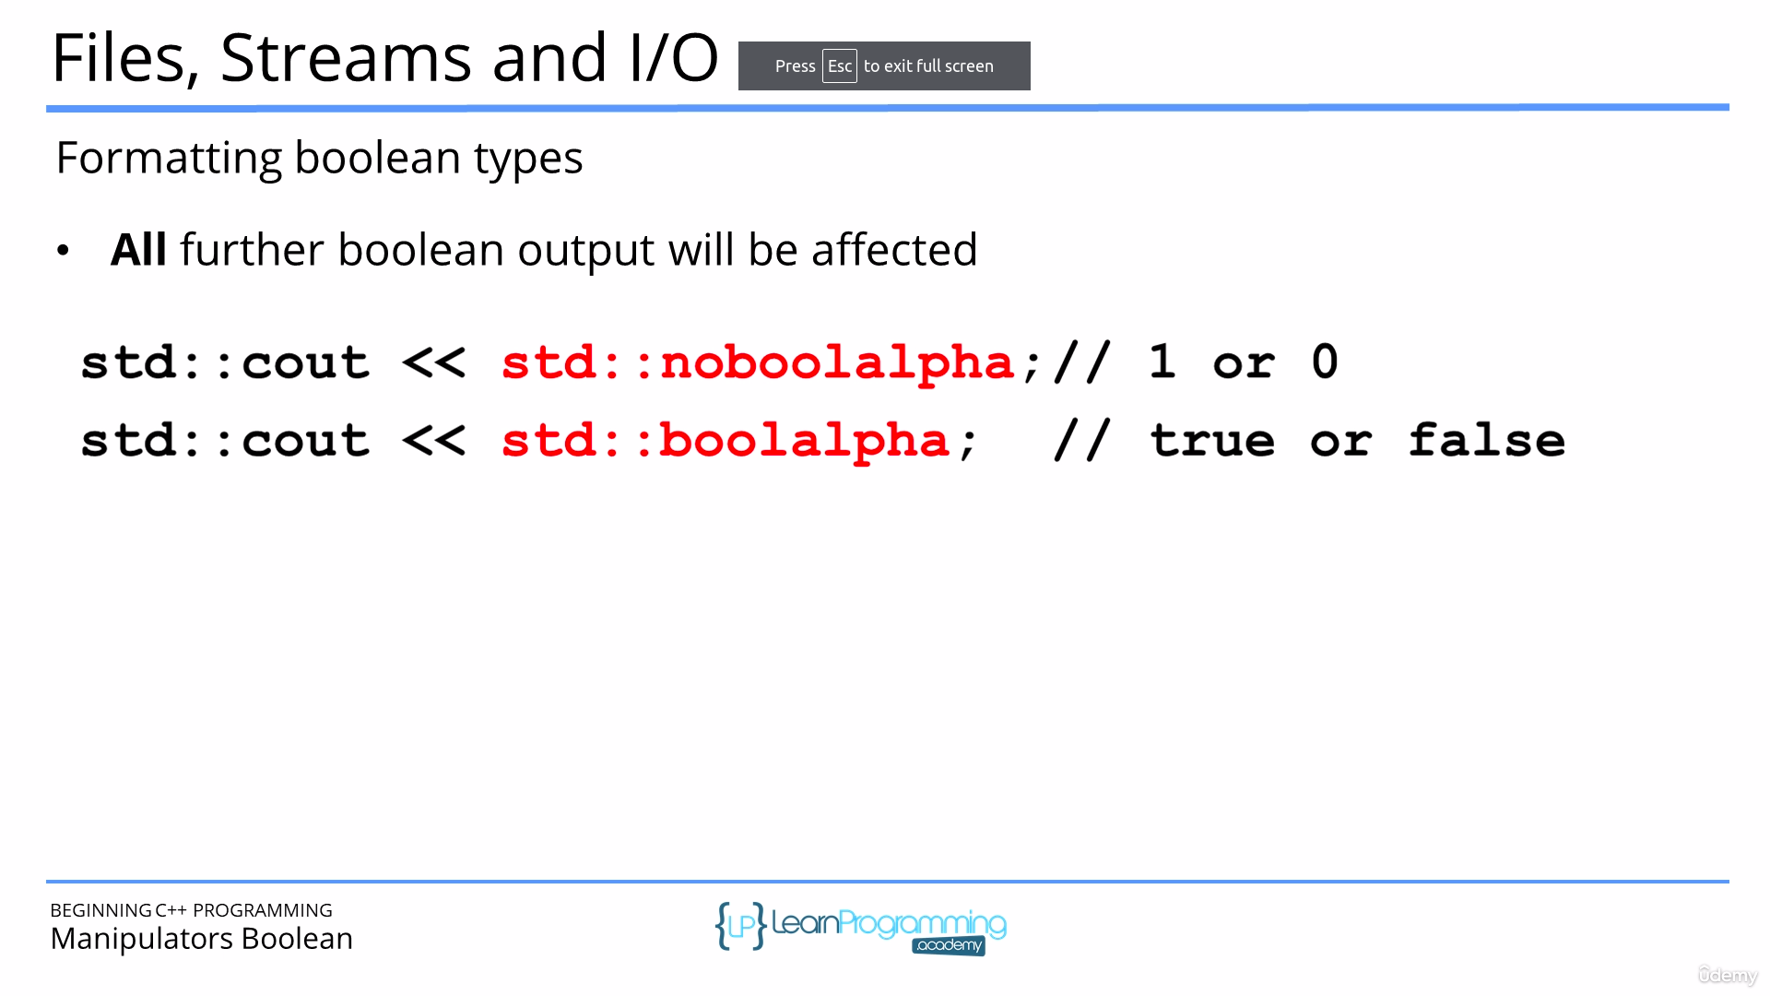

STL(Standard Library)
Contains =>
1) Container => Collection of objects or primitives. Ex. List,set etc.
2) Algorithm => Functions for processing sequence of elements. Ex. Search, sort etc.
3) Iterator => Generate sequece of element for containers.Ex. Forward,reverse etc.

Container =>
1)Sequence container => array, vector, list, forward_list,deque
2)Associative container => set, multi set, map, multi map
3)Continer adapter => stack, queue, priority queue

Iterators =>
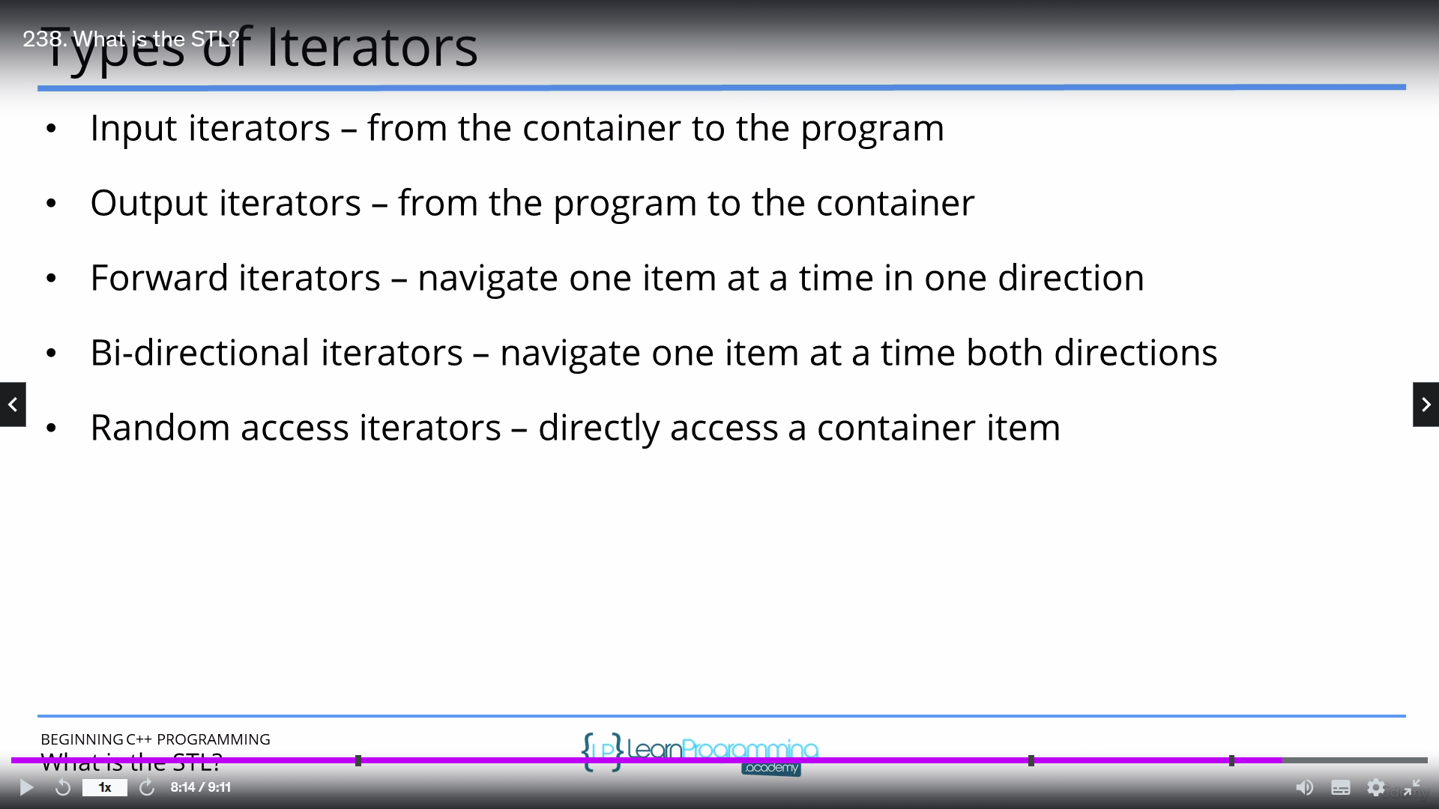
dynamic_cast<type> is used to handle polymorphism i.e. in case of conversion from base to derived or derived to base.



