**ACKNOWLEDGEMENT:**

It could be an enormous delight for us to acknowledge the bolster and commitment that played an awfully important role for effective completion of the given task. I would like to precise my true regard to Er. Ganesh Bhusal, Guide, Softwarica College for his kind support amid the dialog on the matter of concern. I would like to specific my appreciation towards my classmates and companions for their participations as well. At last, I am grateful towards the complete staff and entire member.

**TABLE OF CONTENT:**

|  |  |  |
| --- | --- | --- |
| SN | CONTENT | PAGE |
| 1. | Acknowledgement | 1 |
| 2. | Task 1 | 3-6 |
| 3. | Key terms | 3-4 |
| 4. | Comparison between HDD and SSD and graph including all five components | 5 |
| 5. | Reports and findings | 6 |
| 6. | Task 2 | 7-11 |
| 7. | key terms and subnetting | 7-8 |
| 8. | Figure of network topology | 9 |
| 9. | Table of IP address and cost | 10-11 |
| 10. | Report and finding | 12 |
| 11. | Reference | 13 |
| 12. | Appendix | 14-15 |

**PROBLEM STATEMENT:**

As we need to choose between two secondary storage (HDD and SSD) from different manufacturers integrated with DDR4 RAM and processor which can include different manufacturers like HGST, Toshiba etc. The given task is to be done by analyzing and comparing the architecture and organization of both secondary storage (HDD and SSD). The research overcomes the given result which is shown below.

**Introduction of Computer:**

A computer is electronic machine that can be set to accept data as input, process it into useful information, give output to user and store it away in a secondary storage device for future reuse.

Storage devices are utilized to stock data and instructions forever.Storage devices are also known as medias or storage medias.  Similarly, there are two types of storage devices. They are:

* Primary Storage Device.
* Secondary Storage Device.
* **Primary Storage Device:**

Primary storage is also known as main storage, main memory or internal memory. A computer fetches and preserves the data and records it in the primary storage device until the process is accomplished or data is no longer essential.

It refers to the main storage of the computer because it holds data and applications that are currently in use by the computer.

* **Secondary Storage Device:**

Secondary storage is not retrieved directly by the CPU (Central Processing Unit). Secondary memory is slower compared to primary memory.  It also has the wide storage capacity required to store the operating system and all the programs and files required by a modern computer system.

**Hard Disk Drive (HDD):**

A hard disk drive is also referred as a hard drive. It is a secondary storage device required to stock data forever. It is a non-volatile computer storage device containing magnetic disks. HDDs are slower than SSDs when reading and writing data, but offer greater storage capacity for the price.

**Solid State Drive (SDD):**

SSDs are superfast hard drives.SDD is a hardware component in a computer that reserves data.

**CPI:**

CPI stands for Cycle Per Instruction or Clock Per Instruction. It is the number of computer’s clock speed cycles which happens while a computer instruction is being performed. It is the multiplicative inverse to instruction per cycles.

**DDR4 RAM:**

DDR4 RAM stands for Double Data Rate Fourth Generation Random Access Memory. DDR4 is designed to replace DDR3. It has high speed and efficiency that helps to increases transfer rate and decrease voltage.

**Clock frequency:**

The clock frequency is defined as the frequency and rate at which the clock generator of a processor can generate pulses and is used as a signal of the processor’s speed.

**Access time:**

Access time is the total time delay between a request to an electronic system, and the access being completed or the requested data returned and can be measured in nanoseconds.

**Power Consumption:**

Power consumption is a quantity of energy used per unit time and the battery life of cellphones and laptop(computers) is limited through power consumption*.*

**COMPARISION BETWEEN SSD AND HDD:**

|  |  |  |
| --- | --- | --- |
| FEATURES | HDD (HGSTHTS541010B7E610) | SSD (SK Hynix SC311 SATA 128GB) |
| CLOCK FREQUENCY | 90Hz | 60Hz |
| ACCESS TIME | 5~10s | 0.24s |
| COST | $100 | $58 |
| SPEED  (read/write) | (99.07MB/s)/(103.9MB/s) | (541.696MB/s)/(221.242MB/s) |
| POWER CONSUMPTION | 0.6Watt | 1.25Watt |

**GRAPH OF FIVE COMPONENT:**

**GRAPH OF CLOCK FREQUENCY:**

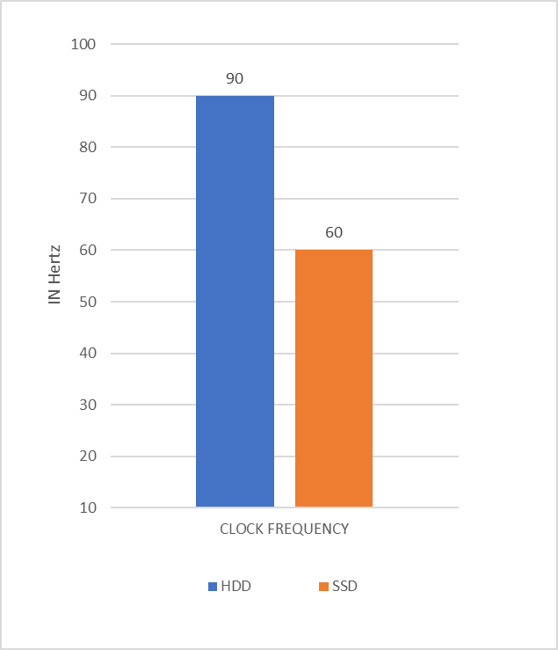

**GRAPH OF ACCESS TIME:**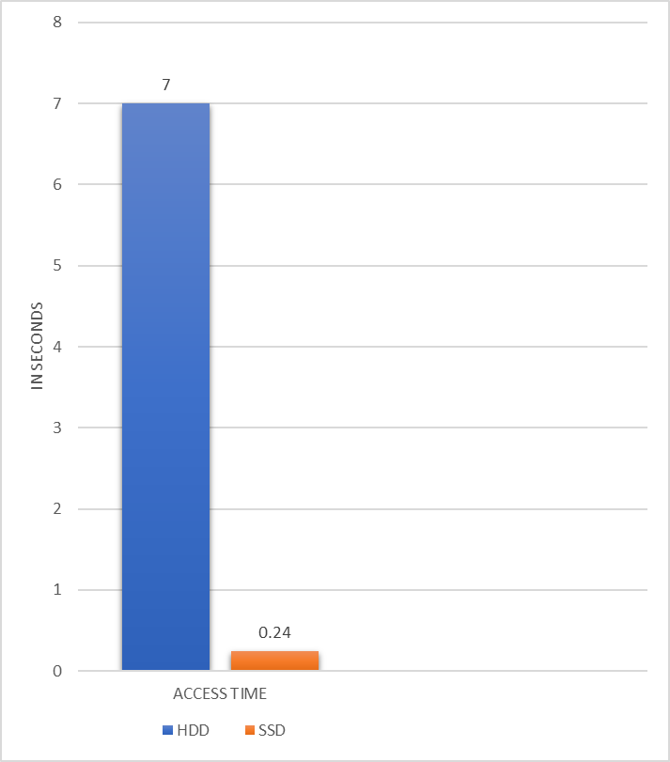

**GRAPH OF COST:**

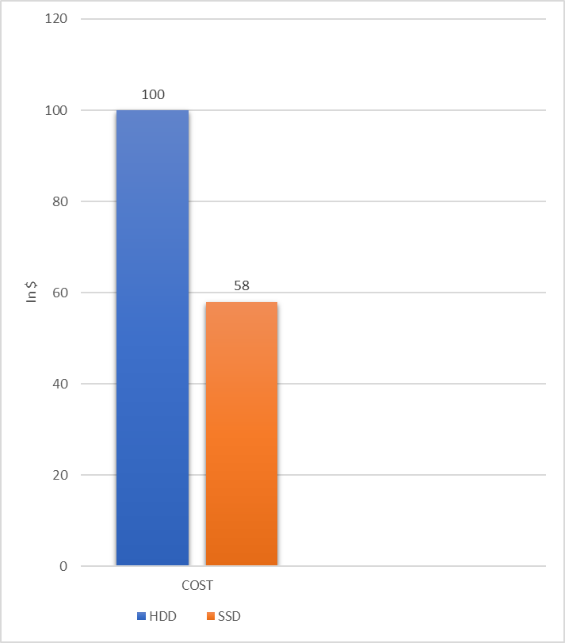

**GRAPH OF SPEED:**

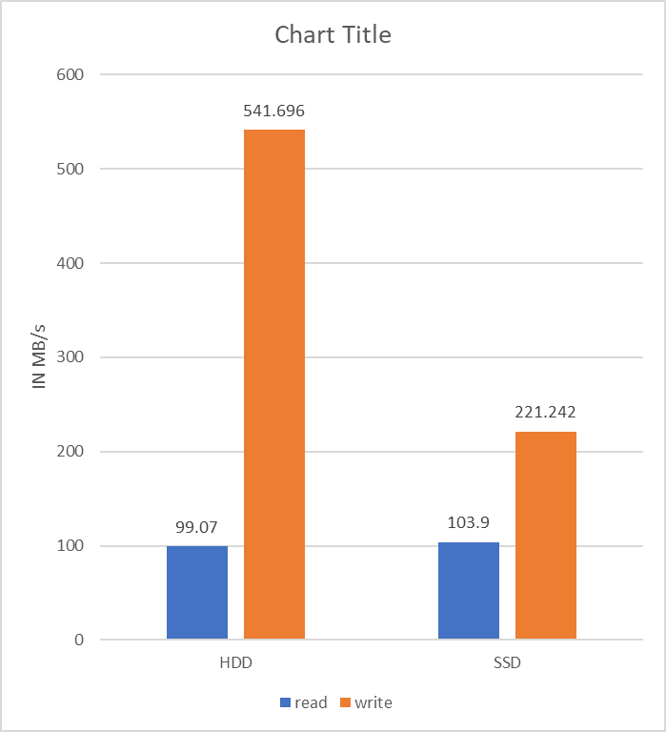

**GRAPH OF POWER CONSUMPTION:**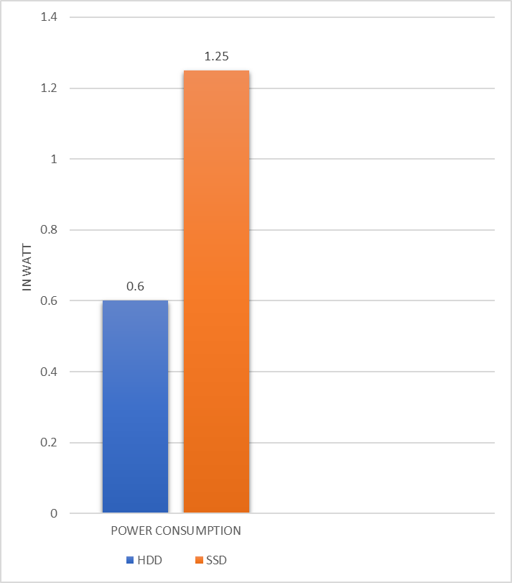

**Report:**

I compare the HDD and SSD in the above research. In the research, I take the HDD named HGSTHTS541010B7E610 and SSD named SK Hynix SC311 SATA 128GB. In the above research, the clock frequency of my HDD is 90 Hertz and clock frequency of my SSD is 60 Hertz. The access time of HDD is 5 to 10 seconds and the access time of my SSD is 0.24 seconds. The HDD is expensive than SSD. The cost of HDD is $100 and cost of SSD is $58. The speed (read/write) of HDD is (99.07MB/s)/(103.9MB/s) whereas the speed (read/write) of SSD is (541.696MB/s)/(221.242MB/s). The power consumption of my HDD is 0.6 Watt where the power consumption of SSD is 1.25 Watt. The above research shows that the clock frequency, access time and cost of HDD is higher than the SSD. Whereas the speed and power consumption of HDD is lower than the SSD.

**Finding/Conclusion:**

After researching about the HDD and SSD, I have found that the laptops or computers which contains HDD only is slower than the laptops or computers which contains SSD. I found that the computer containing SSD is expensive than the computers containing HDD. I have found that the people are using the laptops containing SSD more than the people using HDD’s laptops. I found SSD have high read and write speed than the HDD. Whereas the access time of SSD is low than of HDD. So, I prefer people to use the laptops which have SSD than of HDD only.

**Task 2**

**Problem statement:**

As we are appointed as a technical officer in one of the leading colleges in Nepal based in Kathmandu named as Fountain College. The college contains 1200 students and different department of 100 members. We need to design network topology which need to be flexible which can be extend to others whenever needed. We need to include network topology, cabling, subnetting, used devices, cost etc. The below research and report contain all the needed data as demanded in the above questions

**Router:**  
A router is a networking device that forwards data packets along networks. A router is connected to at least two networks and perform the traffic directing functions on the Internet. A router has a lot more capabilities than other network devices, such as a hub or switch that are only able to perform basic network functions.

**Switch:**

A switch is a physical circuitry component which is required to join several computers together. Switches are extra advanced as compared to hubs and less capable than routers. It also governs the signal flow.

**Firewall:**  
A firewallis a network security system designed to prevent and maintain the security of a private network. The general purpose of a firewall is to reduce the occurrence of unwanted network communications.

**Cable:**

Cable is wires covered in plastic that transmit power or data between devices or locations. There are different types of cables used in topology. Some cables are described below:

**Switch-Switch:**

Switch-switch cable is also known as crossover cable which is used to connect devices directly of same types.   
**Switch-Computer:**

Switch-computer cable is also known as straight cable which is used to connect different types of devices using switch or hub.

**Subnetting:**

Subnetting is a process that helps to divide a single large network in multiple smaller networks. Each and every IP address contains of subnet mask. There are three class types Class A, Class B and Class C that contain the subnet mask which is also referred as default subnet mask.

**Subnetting:**

Address: 191.20.0.9  
Net mask: 255.255.240.0 = 20 11111111.11111111.1111 0000.00000000

Network: 191.20.0.0/20

Broadcast: 191.20.15.255   
Host Min: 191.20.0.1   
Host Max: 191.20.15.254   
Hosts/Net: 4094



**Table for IP address division in five department:**

|  |  |  |  |  |
| --- | --- | --- | --- | --- |
| **DEPARTMENT** | **IP ADDRESS FROM** | **IP ADDRESS TO** | **CIDR (CLASSLESS INTERDOMAIN ROUTING)** | **SUBNET MASK** |
| EXAM | 191.20.16.0 | 191.20.16.31 | 27 | 255.255.255.224 |
| OPERATION | 191.20.16.32 | 191.20.16.63 | 27 | 255.255.255.224 |
| IT | 191.20.16.64 | 191.20.16.79 | 28 | 255.255.255.240 |
| FACULTY | 191.20.16.80 | 191.20.16.111 | 27 | 255.255.255.224 |
| ADMIN | 191.20.16.112 | 191.20.16.143 | 27 | 255.255.255.224 |
| STUDENT | 191.20.0.9 | 191.20.15.254 | 20 | 255.255.240.0 |

**Table for cost of equipment:**

|  |  |  |  |  |
| --- | --- | --- | --- | --- |
| **S. N** | **Items** | **Quantity** | **Rate** | **Cost** |
| 1. | Router | 1 | Rs.75,000 | Rs. 75,000 |
| 2. | Firewall | 1 | Rs. 205,000 | Rs. 205,000 |
| 3. | Switch | 6 | Rs. 95,000 | Rs. 570,000 |
| 4. | Computers | 12 | Rs. 115,000 | Rs. 1,380,000 |
| 5. | Wireless Access point | 2 | Rs. 18,500 | Rs. 37,000 |
| 6. | Cable | 1000m | Rs.35 | Rs.35,000 |

**Report:**

In the above project, a physical topology is change into different logical topology. The above project is done for the subnetting of leading college in Nepal named Fountain college based in Kathmandu. In this project, there are 12000 students and 100 staffs. It has five department. They are exam, operation, IT, faculty and admin. Each department separated into 20 IP address. In my project, the exam department has got IP address from 191.20.16.0 to 191.20.16.31, operation department from 191.20.16.32 to 191.20.16.63, IT from 191.20.16.64 to 191.20.16.79, faculty from 191.20.16.80 to 191.20.16.111 and admin from 191.20.16.112 to 191.20.16.143 respectively. In the above project, the topology contains different equipment. It uses 1 router which costs Rs.75,000, 1 firewall that costs Rs.205,000, 6 switches that costs Rs.570,000, 12 computers of Rs.1,380,000, 2 wireless access point of Rs.37,000 and 1000m cable of Rs.35,000.

**Finding/Conclusion:**According to questions, the network topology designing for the leading college named Fountain College was research individually. Above researched topology is star topology. There are many advantages of star topology as compared to other topology. Star topology is protected and also easy to install. There are no occurs of any interrupts to network topology during adding and removing devices.

## Reference:

## Home - User benchmark (2020) available from <https://www.userbenchmark.com/> [19 February 2020]

## What Is A Solid-State Disk (SSD)? - Definition from Techopedia (2020) available from <https://www.techopedia.com/definition/2296/solid-state-drive-ssd> [19 February 2020]

## What Is A Hard Disk Drive (HDD)? - Definition from Techopedia (2020) available from <https://www.techopedia.com/definition/5288/hard-disk-drive> [19 February 2020]

## SSD Vs HDD | Storagereview.Com - Storage Reviews (2020) available from <https://www.storagereview.com/node/2567> [19 February 2020]

## (2020) available from <https://www.webopedia.com/quick_ref/topologies.asp> [19 February 2020]

## What Is A Router? - Definition from Techopedia (2020) available from <https://www.techopedia.com/definition/2277/router> [19 February 2020]

## What Is A Switch? - Definition from Techopedia (2020) available from <https://www.techopedia.com/definition/2582/router> [19 February 2020]

## APPENDIX:

## 

## 

## 

## 