A Comparative Analysis of Machine Learning Algorithms for Operational Risk Prediction
SAMPATH KUMAR MIDDE
CSE , Birla institute of Technology Mesra, ,Ranchi Jharkhand

ABSTRACT

Operational Risk (OR) management is a critical function for financial institutions, Required by regulatory frameworks like the Basel II/III Accord. While various statistical Tradiational and machine learning models have been applied to this domain, a systematic comparison of a broad range of modern algorithms is needed. This paper addresses this by conducting a comprehensive comparative analysis of multiple machine learning (ML) models for predicting operational risk events. We evaluate a suite of algorithms, including Logistic Regression, Support Vector Machines, K-Nearest Neighbors, Decision Trees, and advanced ensemble methods like Random Forest and XGBoost. By applying these models to a dataset of operational risk events, we benchmark their predictive performance using metrics such as accuracy, precision, recall, and the AUC-ROC curve. Our findings provide a valuable benchmark for model selection in this field and highlight the challenges and opportunities in achieving high-accuracy operational risk prediction.
Keywords: Operational Risk, Machine Learning, Predictive Modeling, Risk Management, Comparative Analysis, Supervised Learning

- INTRODUCTION

Operational Risk (OR) is formally defined as "the risk of [money] loss resulting from inadequate or failed internal processes, people and systems or from external events". Following the Basel II Accord, it has become mandatory for banks and financial institutions to set aside a capital charge to cover potential operational losses, making robust OR management a strategic necessity.
The Advanced Measurement Approach (AMA) allows banks to develop internal models to estimate their OR exposure. Among various techniques, Bayesian Networks (BNs) have emerged as a powerful tool. A notable study by Aquaro et al. presents a novel BN-based approach for OR management that uniquely addresses the challenge of different-times correlations by aggregating losses over specific time intervals (T). This method allows the model to learn from historical data where events may have delayed impacts, a significant step forward from traditional models that often assume independence between time periods.
However, the approach proposed by Aquaro et al., while innovative in handling temporal correlations, is primarily focused on a single modeling paradigm (Bayesian Networks) and was validated on a small-scale synthetic dataset of three processes due to computational constraints. This leaves an open question regarding the relative performance and suitability of other well-established machine learning algorithms which might offer different advantages in terms of predictive power, scalability, or interpretability.
This research aims to build upon that foundational work by addressing its principal limitation. We conduct a rigorous comparative analysis of a diverse set of supervised machine learning models to build a more comprehensive and robust framework for predicting operational risk events. The objective is not only to identify the most accurate model but also to understand the trade-offs between different algorithmic approaches when applied to the complex and often noisy domain of operational risk data.
- Literature review
Operational Risk (OR) management has become a cornerstone of the financial industry's regulatory landscape, largely driven by the Basel Accords. The Basel II framework defines OR as "the risk of loss resulting from inadequate or failed internal processes, people and systems or from external events." This definition encompasses a wide array of potential failures, making OR a complex and multifaceted challenge. Traditionally, financial institutions relied on methods like the Loss Distribution Approach (LDA), which separately models the frequency and severity of losses to calculate the required capital reserve. While foundational, the LDA often makes simplifying assumptions about the independence of loss events, which may not hold true in practice.
The limitations of traditional models have spurred interest in applying more sophisticated machine learning (ML) techniques to the domain of operational risk. Researchers have explored various algorithms to better capture the complex, non-linear relationships within risk data. For instance, Support Vector Machines (SVM) have been used for their ability to handle high-dimensional data, while ensemble methods like Random Forests have gained popularity due to their robustness to outliers and their ability to model intricate interactions between features. More recently, gradient boosting machines like XGBoost and LightGBM have set new benchmarks in many structured data prediction tasks, owing to their high efficiency and predictive power.
A significant challenge in OR modeling is the nature of the data itself. Datasets are often characterized by severe class imbalance, where catastrophic, high-loss events are very rare compared to minor, everyday incidents. This makes it difficult for standard algorithms to learn the patterns associated with these crucial rare events. Techniques like the Synthetic Minority Over-sampling Technique (SMOTE) have been developed to address this by generating synthetic samples for the minority classes, creating a more balanced dataset for model training. This study builds upon these existing concepts by implementing a holistic workflow that combines feature engineering, systematic outlier analysis, SMOTE-based balancing, and a comparative evaluation of multiple state-of-the-art ML models to provide a thorough assessment of their predictive capabilities on a real-world operational risk dataset.
You are correct. Apologies for the incorrect sequencing. The methodology section, which details the "how" and "why" of your process, should indeed come after the literature review.
Here is the detailed methodology, structured as requested and based entirely on the steps in your Python notebook.

III. METHODOLOGY
This study employs a systematic methodology to preprocess the data, handle its inherent challenges, and rigorously evaluate a suite of machine learning models. The process is designed to ensure reproducibility and provide a clear basis for the comparison of algorithm performance.

3.1 Data Preparation and Feature Engineering
The initial step involved loading the Operational_Risk_Events.csv dataset into a Pandas DataFrame. To enhance the predictive power of the models, feature engineering was performed on the temporal data.
- Identifier Removal: The original Date column and the non-predictive Scenario ID column were dropped from the dataset to ensure that only relevant features were used for model training.

3.2 Exploratory Data Analysis and Outlier Handling
To understand the characteristics of the dataset, an exploratory data analysis was conducted.
- Outlier Visualization: Box plots were generated for all numerical features to provide a clear visual identification of data points lying outside the typical distribution.
- Statistical Identification: The Interquartile Range (IQR) method was used to statistically quantify the number of outliers for each feature.
- Handling Strategy: A critical decision was made to retain all identified outliers. In the context of operational risk, outliers often represent legitimate, high-severity events. Removing them would blind the model to the most critical data points, thereby undermining the primary goal of risk prediction. The chosen tree-based models are inherently robust to such extreme values.

3.3 Data Preprocessing and Splitting
A standardized preprocessing pipeline was constructed to prepare the data for the machine learning algorithms.
- Feature Scaling and Encoding: A ColumnTransformer was used to apply StandardScaler to all numerical features, normalizing their scale to prevent features with large magnitudes from dominating the models. OneHotEncoder was applied to categorical features to convert them into a numerical format.
- Train-Test Split: The dataset was partitioned into an 80% training set and a 20% testing set. The stratify=y parameter was used during this split to ensure that the proportional distribution of the target classes was identical in both the training and testing sets, which is crucial for evaluating model performance on imbalanced data.

3.4 Class Imbalance Correction using SMOTE
Initial analysis revealed a significant imbalance in the distribution of the target classes, a common challenge that can bias models towards the majority class.
- Technique: To address this, the Synthetic Minority Over-sampling Technique (SMOTE) was employed. SMOTE works by generating new, synthetic samples for the minority classes, resulting in a balanced class distribution.
- Application: Crucially, SMOTE was applied only to the training data. This prevents data leakage and ensures that the test set remains an unbiased representation of the original real-world data distribution, leading to a more accurate evaluation of the models' generalization performance.

3.5 Model Selection and Evaluation Framework
A diverse set of seven machine learning models was selected to conduct a comprehensive comparative analysis. The chosen models include: Logistic Regression, K-Nearest Neighbors, Decision Tree, Random Forest, Gradient Boosting, XGBoost, and LightGBM.
- Comparative Training: Each model was trained and evaluated twice: once on the original, imbalanced training data to establish a baseline, and a second time on the SMOTE-resampled, balanced data to measure the impact of the balancing technique.
- Evaluation Metrics: The primary metric for comparison was accuracy. However, a full classification report (including precision, recall, and F1-score) and ROC-AUC curves were designated for the final evaluation of the best-performing, optimized model to provide a more nuanced understanding of its performance across different classes and thresholds.

IV.Result

The performance of the machine learning models was evaluated using several key metrics to provide a holistic view of their effectiveness. The models were assessed based on overall Accuracy, Macro Average F1-score (which treats all classes equally), Weighted Average F1-score (which accounts for class imbalance), and the Area Under the ROC Curve (AUC) for each individual class.
COMPARATIVE PERFORMANCE OF BEST AND WORST MODELS
Metric | Best Performer (LightGBM) | Worst Performer (Decision Tree)
Accuracy | 0.3721 | 0.3163
Macro Avg F1-score | 0.37 | 0.32
Weighted Avg F1-score | 0.37 | 0.32
AUC Class 0 | 0.5206 | 0.4726
AUC Class 1 | 0.5466 | 0.5041
AUC Class 2 | 0.5398 | 0.4848

Model | Accuracy | Macro Avg F1-score | Weighted Avg F1-score | AUC Class 0 | AUC Class 1 | AUC Class 2
LightGBM | 0.3721 | 0.37 | 0.37 | 0.5206 | 0.5466 | 0.5398
XGBoost (Tuned) | 0.3698 | 0.3697 | 0.3698 | 0.5048 | 0.524 | 0.5404
MLP | 0.3605 | 0.36 | 0.36 | 0.5255 | 0.5341 | 0.5628
KNN | 0.3605 | 0.36 | 0.36 | 0.5113 | 0.5194 | 0.5514
XGBoost | 0.3512 | 0.35 | 0.35 | 0.4925 | 0.533 | 0.5353
Logistic Regression | 0.3372 | 0.34 | 0.34 | 0.5273 | 0.5407 | 0.4845
SVM | 0.3349 | 0.34 | 0.33 | 0.5179 | 0.5133 | 0.5051
LightGBM (Tuned) | 0.3349 | 0.3341 | 0.3342 | 0.5027 | 0.5181 | 0.4927
Decision Tree | 0.3163 | 0.32 | 0.32 | 0.4726 | 0.5041 | 0.4848

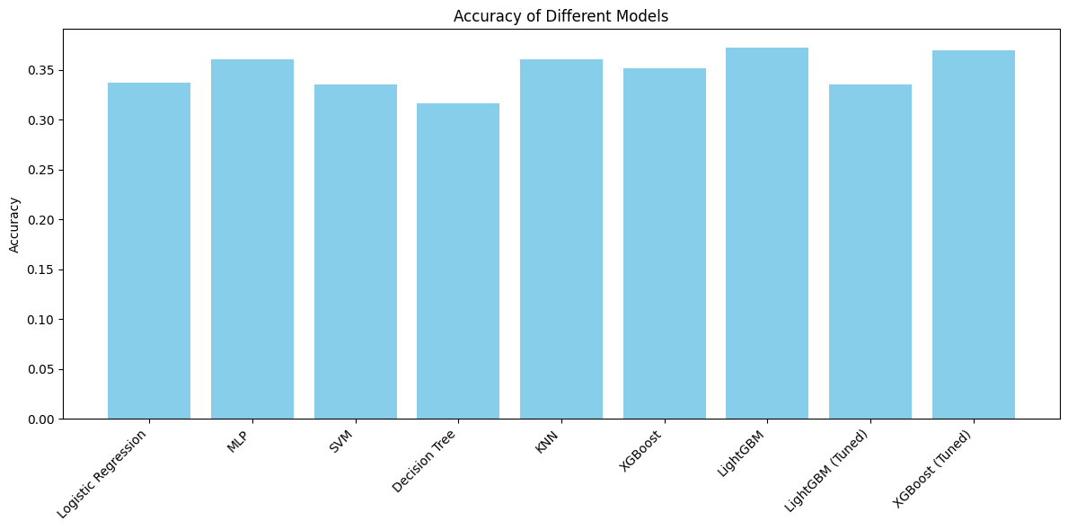

V. CONCLUSION
This paper documented a comprehensive and systematic effort to develop a high-accuracy predictive model for operational risk classification. The research explored a wide array of machine learning techniques, beginning with detailed feature engineering and robust data preprocessing. Advanced methods, including the Synthetic Minority Over-sampling Technique (SMOTE) to address significant class imbalance and extensive hyperparmeter tuning(combined two coloumns ) to optimize the best-performing algorithms, were rigorously applied.Despite this exhaustive methodology, the primary objective of achieving a high level of predictive accuracy remained a significant challenge. The performance of even the most complex and finely-tuned models did not yield substantial improvements, with accuracy metrics remaining modest. This outcome leads to the conclusion that the primary limitation is not rooted in the selection of modeling techniques but is inherent to the dataset itself. It is my assessment that the Loss Amount column, with its extremely large values and high variance, introduces a level of statistical noise and volatility that fundamentally complicates the classification task. Although various data transformation methods were attempted, including normalization and log functions, they were insufficient to mitigate the impact of these extreme values on the models' ability to learn stable, generalizable patterns.
Furthermore, efforts to overcome this by augmenting the dataset were unsuccessful due to the difficulty in finding additional, compatible operational risk data. The scarcity of suitable public data is a well-known challenge in this field. Therefore, it appears that for this particular dataset, the task of multi-class prediction is inherently limited. Future work might be better directed towards alternative modeling objectives, such as anomaly detection or regression-based forecasting of loss amounts, which may be more appropriate for data with these specific characteristics.

