**1. Import the dataset and do usual exploratory analysis steps like checking the structure & characteristics of the dataset:**

**1.Data type of all columns in the "customers" table.**

SELECT COLUMN_NAME, DATA_TYPE

FROM Target.INFORMATION_SCHEMA.COLUMNS

where table_name="customers";

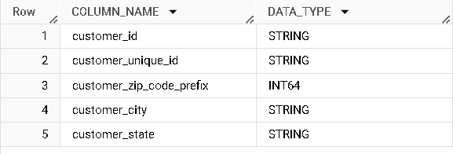

**Insights**: Will get to know about the datatype of each column.

**Recommendation**: As some of the date & time operations are sensitive to datatype, Make sure you are working with the correct datatype.

**2.Get the time range between which the orders were placed.**

select concat(min(order_purchase_timestamp),"   to   ",max(order_purchase_timestamp)) as time_range_for_orders

from Target.orders;

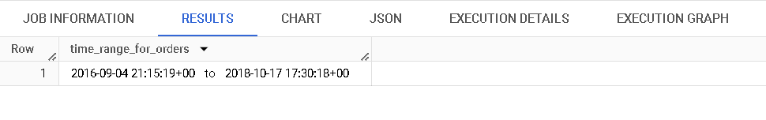

**Insights:** Will provide us the timeframe of data captured.

**Recommendation:** Will help us to make the analysis considering the external factors (like lockdown, natural calamities) occurred during that period.

**3.Count the Cities & States of customers who ordered during the given period.**

select count(distinct customer_city) as count_of_cities,

count(distinct customer_state) as count_of_states

from Target.customers;

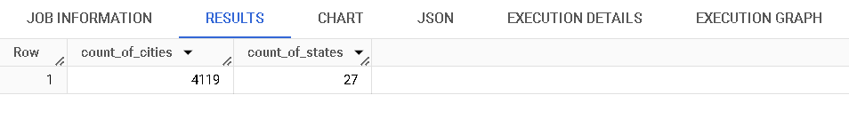

**Insights:** Will let us know the magnitude of services the company is offering.

**Recommendations:** Will help in promoting and advertising.

----------------------------------------------------------------------

**2. In-depth Exploration:**

**1.Is there a growing trend in the no. of orders placed over the past years?**

select extract(year from order_purchase_timestamp) as year,

count(*) as no_of_orders_in_year

from Target.orders

group by extract(year from order_purchase_timestamp)

order by year;

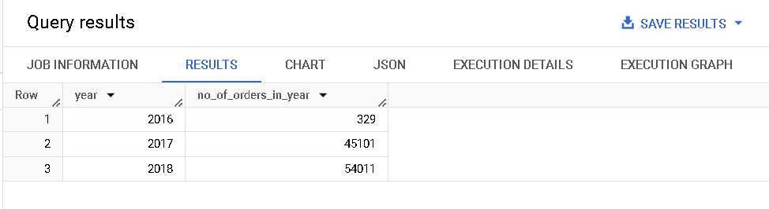

**Insights:** Will provide us the number of orders placed in each year

**Recommendations:**

-Orders in the year 2016 started from 9th month which won’t give a correct measure for comparision.

-But when compared between 2017 and 2018, We can see the orders got increased compared to its previous year.

-As there is an increase in sales, there was no need of major changes in company working model currently. Company can focus on improving customer satisfaction and R&D can happen for deploying any changes in working model.

**2.Can we see some kind of monthly seasonality in terms of the no. of orders being placed?**

select extract(year from order_purchase_timestamp) as year,extract(month from order_purchase_timestamp) as month,count(*) as no_of_orders_in_yearm

from Target.orders

group by extract(year from order_purchase_timestamp),extract(month from order_purchase_timestamp)

order by year,month;

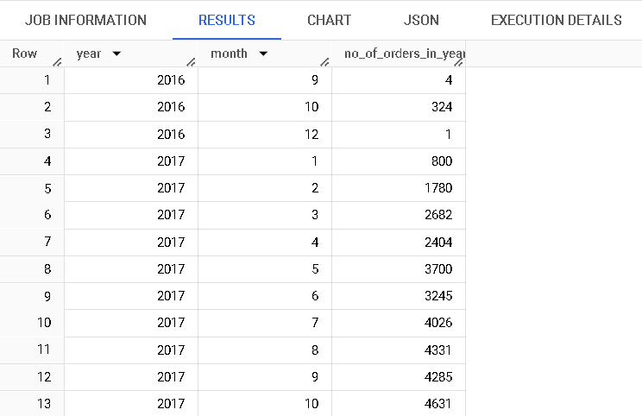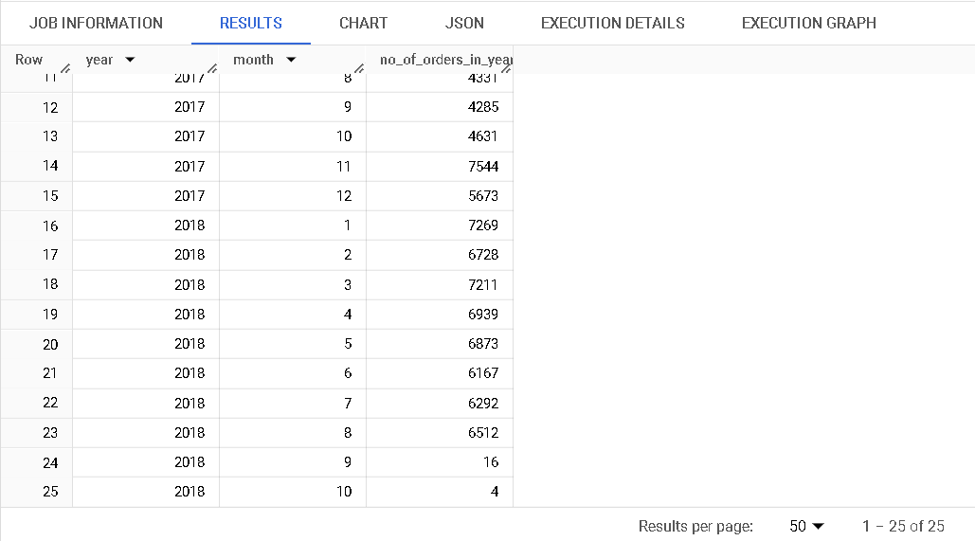

**Insights:** Will provide us the number of orders got placed during each month in a year.

**Recommendations:**

-Unable to withdraw any major conclusions with respect to monthly seasonality as we have only a couple of years to compare. (2017 & 2018)

-Almost an increasing trend has been maintained without any major fluctuations till 8th month of 2018.

-In 9th and 10th month of 2018 a major drop in sales observed.

**3. During what time of the day, do the Brazilian customers mostly place their orders? (Dawn, Morning, Afternoon or Night)**

* + **0-6 hrs : Dawn**
  + **7-12 hrs : Mornings**
  + **13-18 hrs : Afternoon**
  + **19-23 hrs : Night**

select tn,count(*) as no_of_orders

from(

select hour,case

  when hour between 0 and 5  then "Dawn"

  when hour between 6 and 11  then "Mornings"

  when hour between 12 and 17  then "Afternoon"

  when hour between 17 and 23  then "Night"

  end as tn

  from(

select extract(hour from TIMESTAMP_SUB(order_purchase_timestamp, INTERVAL 3 HOUR)) as hour

from Target.orders) as t) t1

group by tn ;

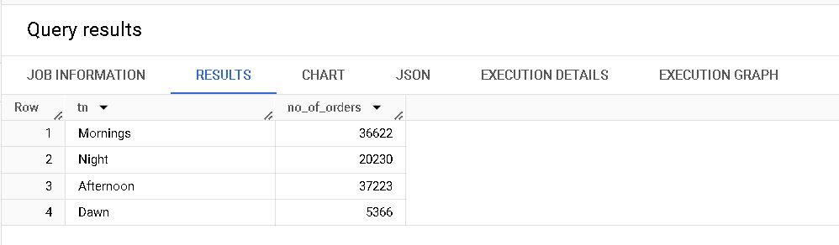

**Insights:**

-Most number of orders have been placed on both in Mornings and Afternoon.

-Least number of orders are placed in Dawn.

**Recommendations:**

-Can try leveraging the delivery charges and providing extra discounts & coupons during the night & dawn period to increase the order count.

**3.Evolution of E-commerce orders in the Brazil region:**

**1.Get the month on month no. of orders placed in each state.**

select customer_state,extract(month from order_purchase_timestamp) as month,count(*) as no_of_orders

from Target.customers

left join Target.orders

using(customer_id)

group by customer_state,extract(month from order_purchase_timestamp)

order by customer_state,month;

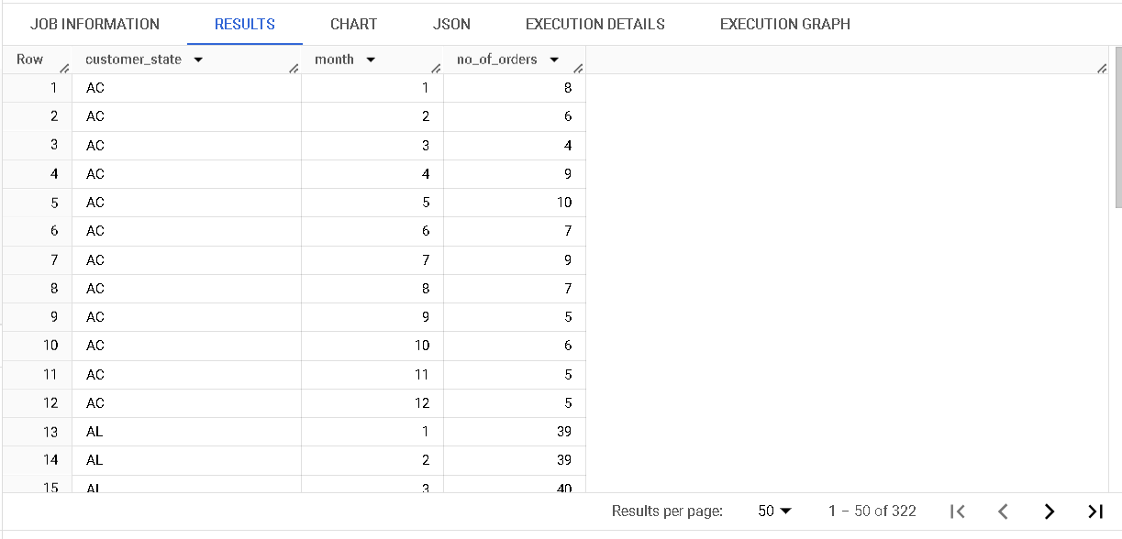

**Insights:** Provide us the month wise orders count for each state.

**Recommendations:**

* Will help us in analyzing what was working in states with highest orders count compared to other states.

**2.How are the customers distributed across all the states?**

select customer_state,count(customer_id) as no_of_customers_in_state

from Target.customers

left join Target.orders

using(customer_id)

group by customer_state

order by customer_state;

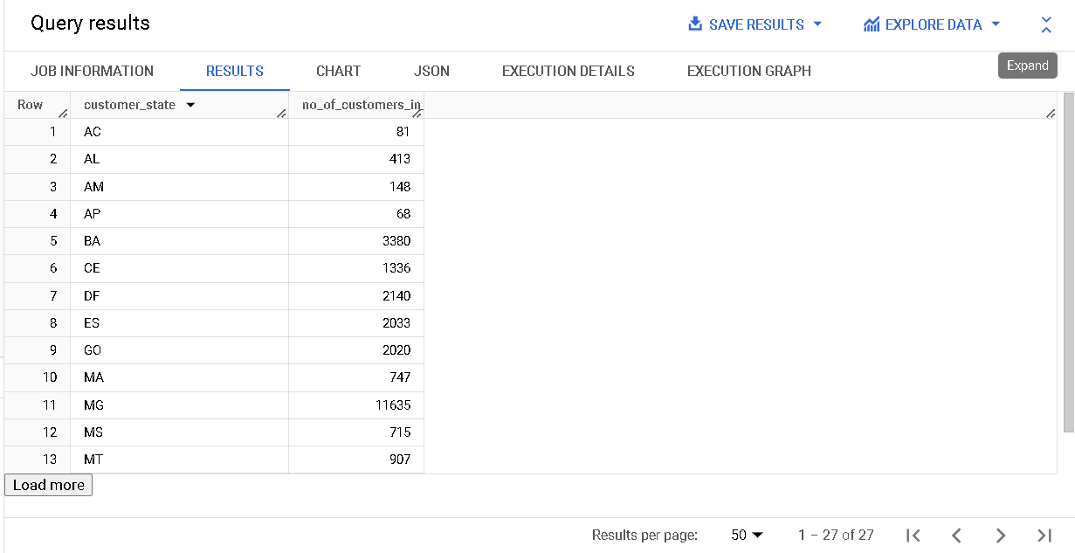

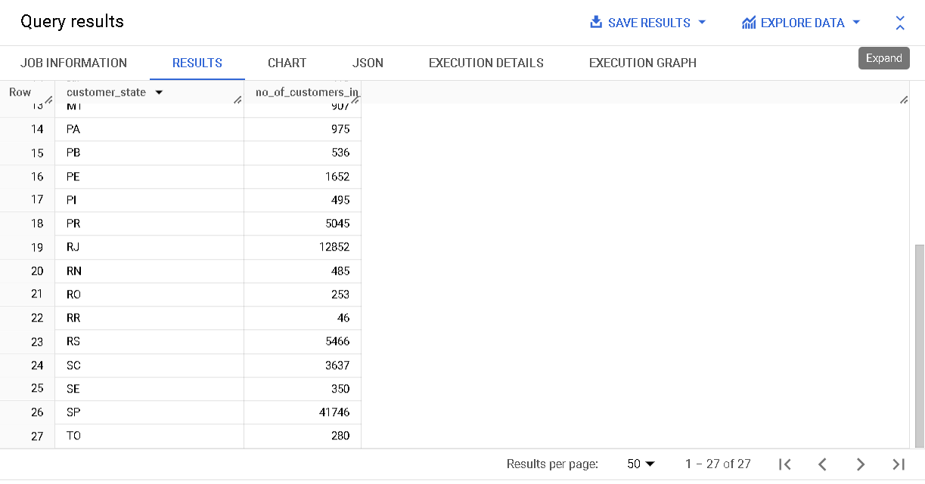

**Insights:** Provide us the number of customers in each state who ordered at least once.

**Recommendations:**

-Helps in promoting and advertisement.

--------------------------------------------------------------------------------------------------------------------------

**4.Impact on Economy: Analyze the money movement by e-commerce by looking at order prices, freight and others.**

1. **Get the % increase in the cost of orders from year 2017 to 2018 (include months between Jan to Aug only).  
   You can use the "payment_value" column in the payments table to get the cost of orders.**

select sum(cost_in_2017) as Total_cost_in_2017,sum(cost_in_2018) as Total_cost_in_2018,Round(((sum(cost_in_2018)-sum(cost_in_2017))/sum(cost_in_2017))*100,2) as percentage_increase

from(

select extract(year from order_purchase_timestamp) as year,case

 when extract(year from order_purchase_timestamp) = 2017 then price

 else 0 end as cost_in_2017,case

 when extract(year from order_purchase_timestamp) = 2018 then price

 else 0 end as cost_in_2018

from Target.order_items

join Target.orders

using(order_id)

where (extract(year from order_purchase_timestamp)=2017 or extract(year from order_purchase_timestamp) =2018) and extract(month from order_purchase_timestamp)!=9 and extract(month from order_purchase_timestamp)!=10 and extract(month from order_purchase_timestamp)!=11 and extract(month from order_purchase_timestamp)!=12) as t;

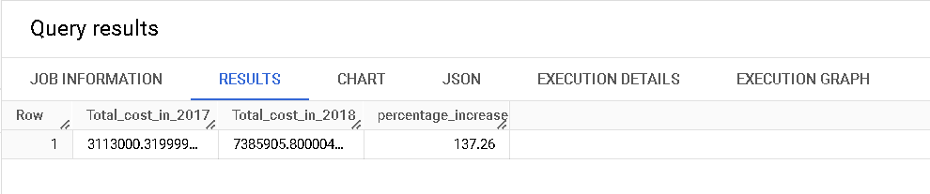

**Insights:** Will give us the percentage increase in cost of orders from 2017 to 2018

**Recommendations:**

Helps in planning for expanding the company market.

**2.Calculate the Total & Average value of order price for each state.**

select customer_state,sum(price) Total_sum_for_each_state,avg(price) Avg_price_for_each_state

from Target.order_items

join Target.orders

using(order_id)

right join Target.customers

using(customer_id)

group by customer_state

order by customer_state ;

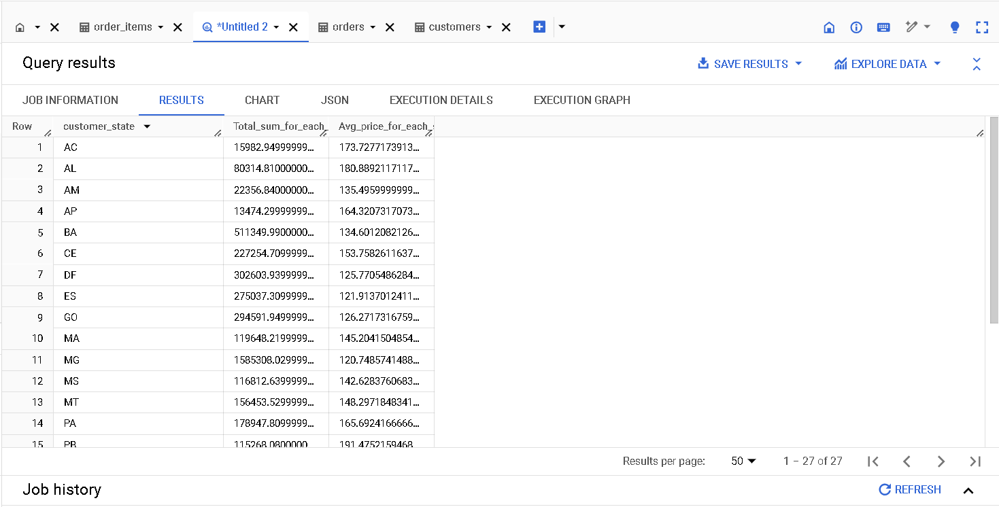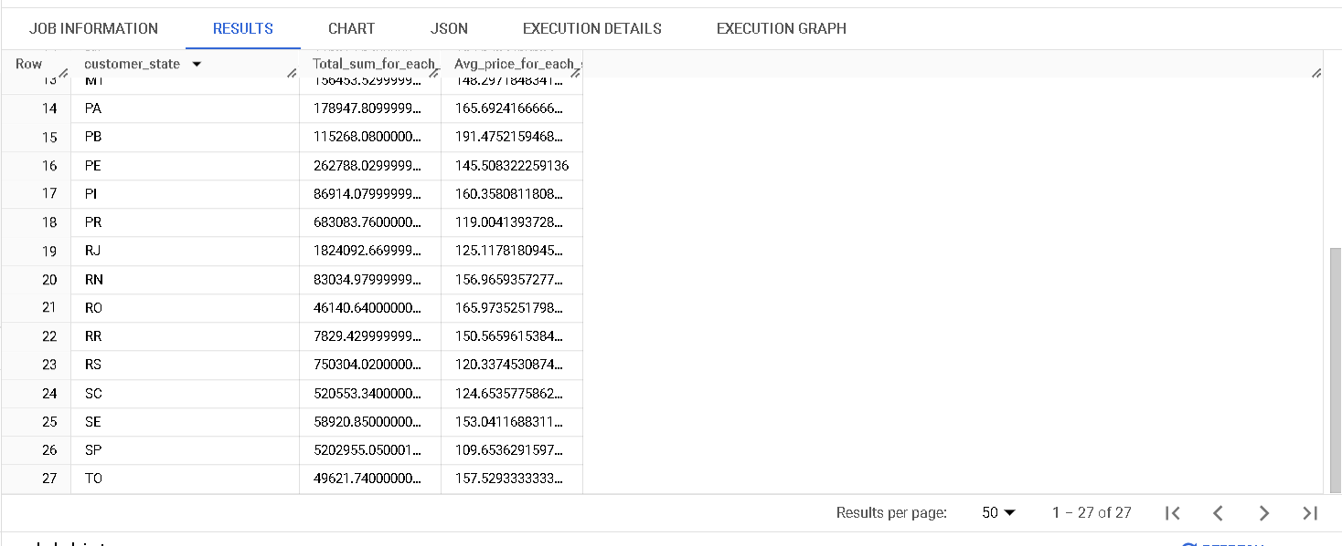

**Insights:** Provide us the total sum & Average order price in each state

**Recommendations:**

* Helps us in targeting which state is spending more amount on orders and from which state the average order price is high.

**3.Calculate the Total & Average value of order freight for each state.**

select customer_state,sum(freight_value) Total_sum_for_each_state,avg(freight_value) Avg_freight_value_for_each_state

from Target.order_items

join Target.orders

using(order_id)

right join Target.customers

using(customer_id)

group by customer_state

order by customer_state ;

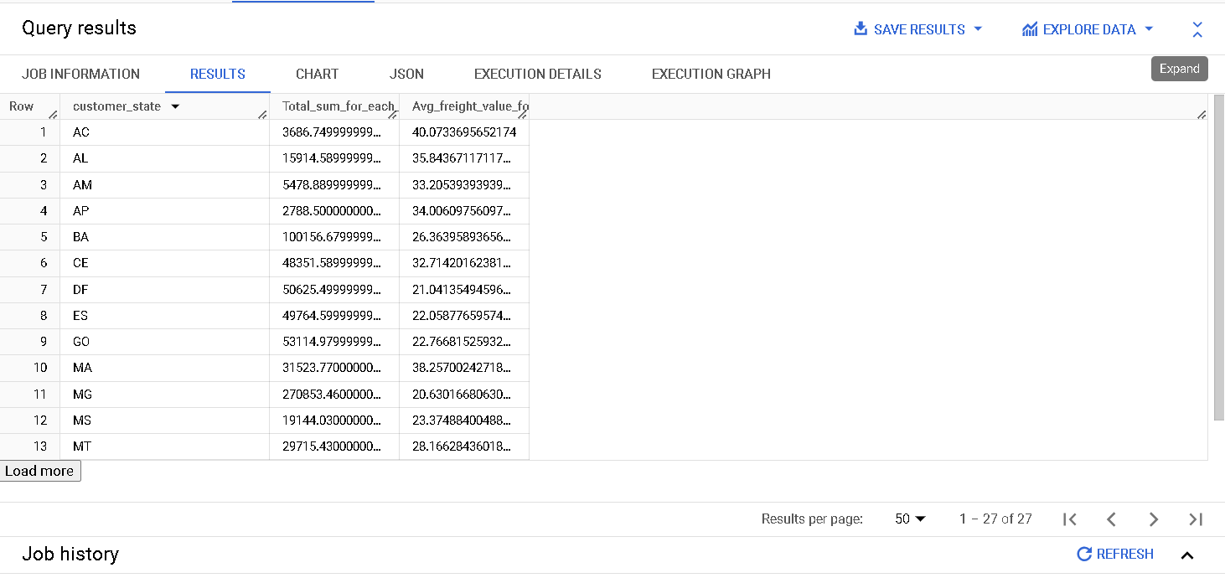

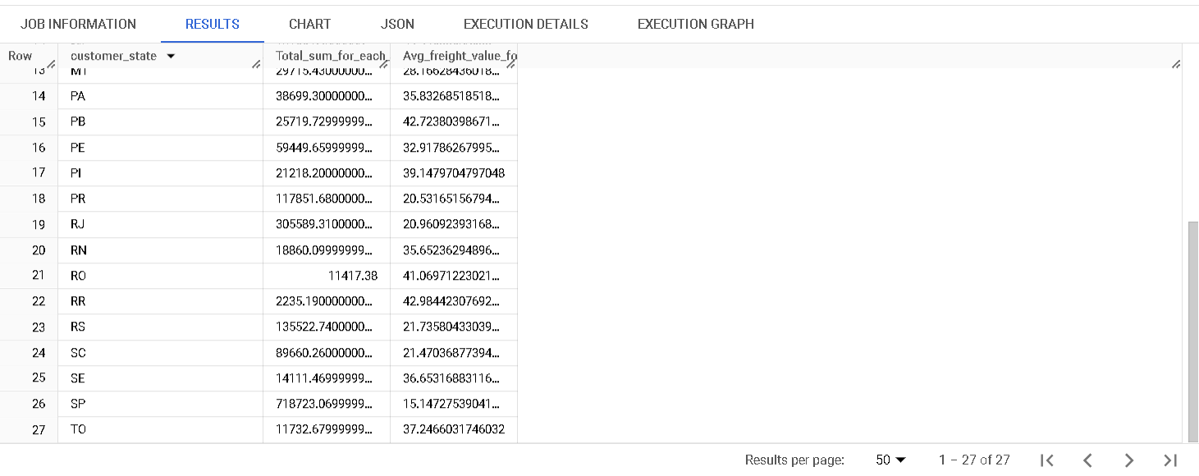

**Insights:** Provide us the Total & Average value of order freight for each state.

**Recommendations:**

-Helps us in comparing the delivery methods for states with highest Average freight value with the one which has least Average freight value.

**5.Analysis based on sales, freight and delivery time.**

**1. Find the no. of days taken to deliver each order from the order’s purchase date as delivery time.  
Also, calculate the difference (in days) between the estimated & actual delivery date of an order.  
Do this in a single query.  
  
You can calculate the delivery time and the difference between the estimated & actual delivery date using the given formula:**

* + **time_to_deliver = order_delivered_customer_date - order_purchase_timestamp**
  + **diff_estimated_delivery = order_delivered_customer_date - order_estimated_delivery_date**

select *,date_diff(order_delivered_customer_date,order_purchase_timestamp, day) as time_to_deliver,date_diff(order_delivered_customer_date, order_estimated_delivery_date,day) as diff_estimated_delivery

from Target.orders

where lower(order_status)="delivered" and order_delivered_customer_date is not null

order by order_purchase_timestamp;

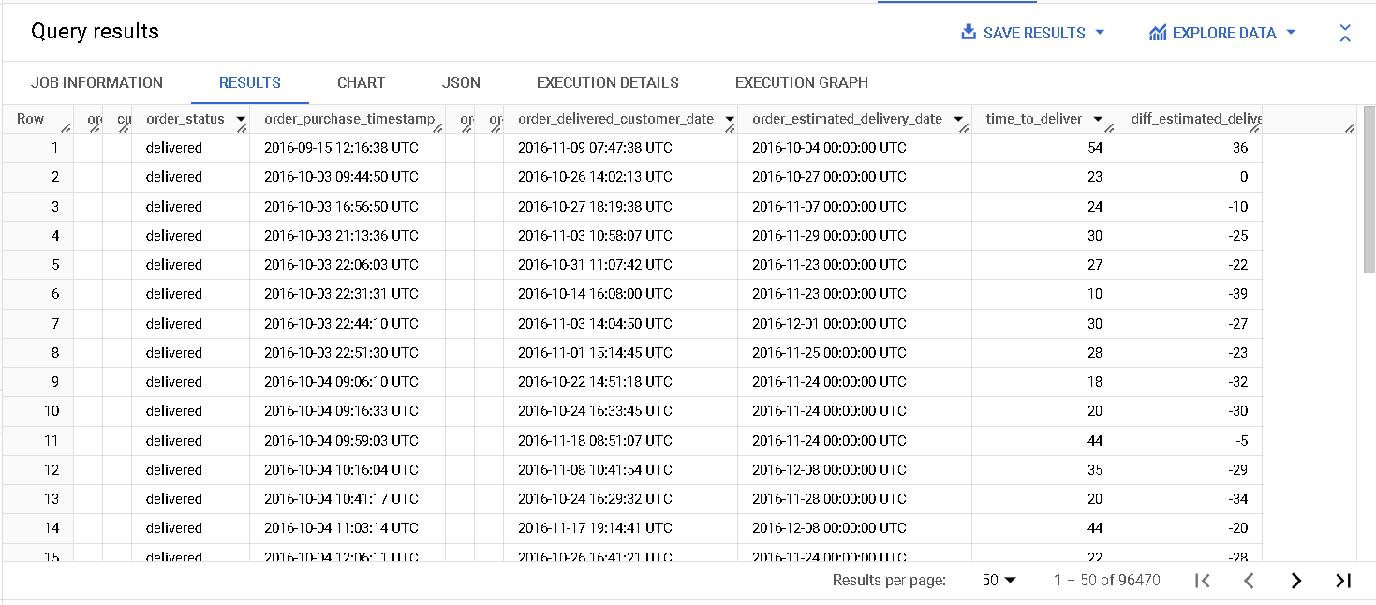

**Insights:** Provide us the comparison between the expected and actual number of days taken for delivering the product.

**Recommendations:**

-Helps in tracking the orders where orders get delayed and try to minimize them

**2. Find out the top 5 states with the highest & lowest average freight value.**

select customer_state,t.Avg_freight_value_for_each_state,r2 as ranking_based_on_avg_freight_value

from(

select customer_state,sum(freight_value) Total_sum_for_each_state,avg(freight_value) Avg_freight_value_for_each_state,

rank() over(order by avg(freight_value) ) r1 ,rank() over(order by avg(freight_value) desc ) r2

from Target.order_items

join Target.orders

using(order_id)

right join Target.customers

using(customer_id)

group by customer_state) as t

where r1<=5 or r2<=5

order by t.Avg_freight_value_for_each_state desc;

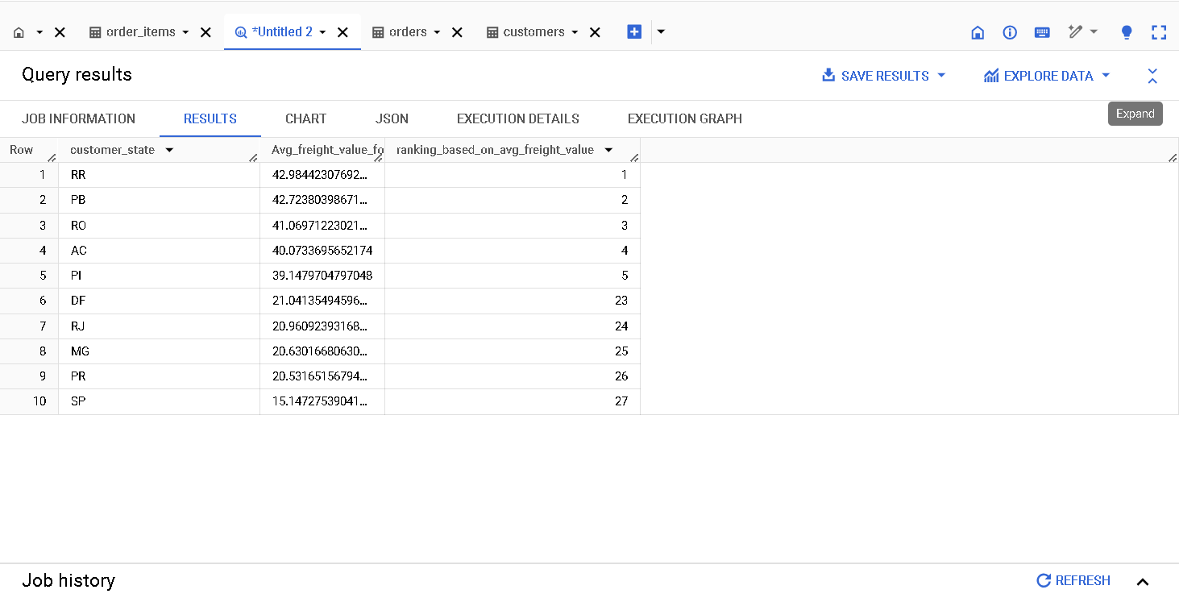

**Insights:** Provide us the top 5 states with the highest & lowest average freight value.

**Recommendations:** Helps us in comparing the delivery models of states with highest average freight value with them of lowest value.

**3.Find out the top 5 states with the highest & lowest average delivery time.**

**select customer_state,avg_delivery_time_in_min,r2 as rank_in_fast_delivery**

**from(**

**select customer_state,avg(timestamp_diff(order_delivered_customer_date,order_purchase_timestamp,minute)) as avg_delivery_time_in_min,rank() over(order by avg(timestamp_diff(order_delivered_customer_date,order_purchase_timestamp,minute)) desc ) as r1,rank() over(order by avg(timestamp_diff(order_delivered_customer_date,order_purchase_timestamp,minute))) as r2**

**from Target.order_items**

**join Target.orders**

**using(order_id)**

**right join Target.customers**

**using(customer_id)**

**group by customer_state) as t**

**where r1<=5 or r2<=5**

**order by rank_in_fast_delivery;**

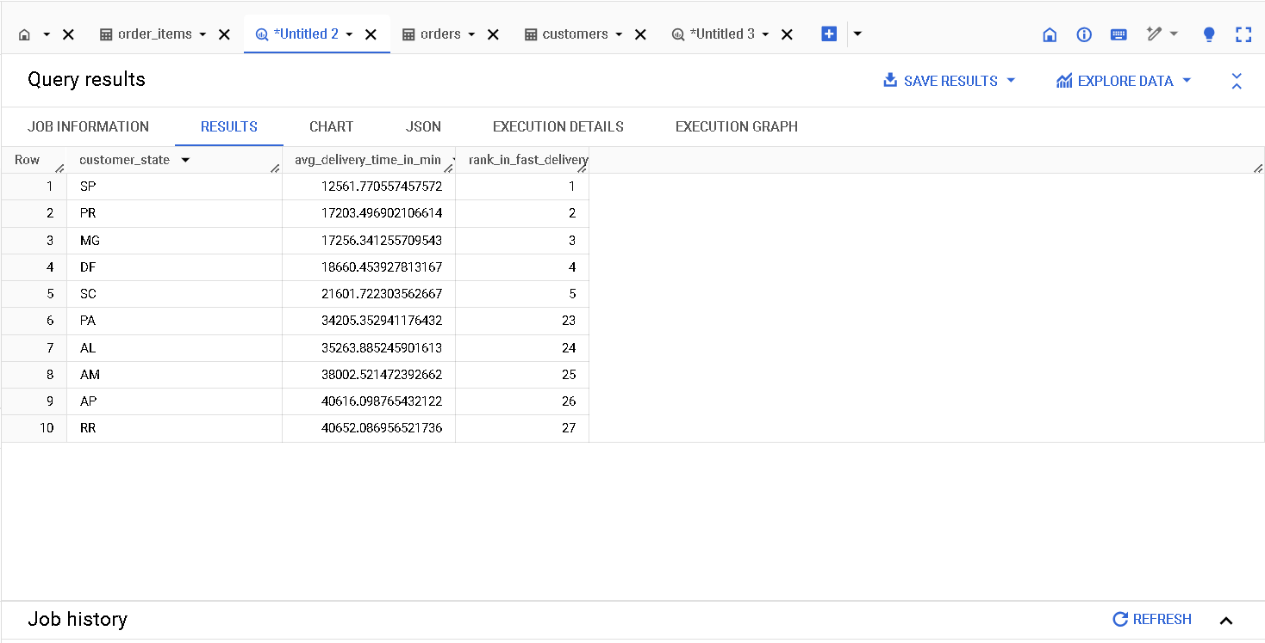

**Insights:** Provide us the top 5 states with the highest & lowest average delivery time

**4. Find out the top 5 states where the order delivery is really fast as compared to the estimated date of delivery.**

**You can use the difference between the averages of actual & estimated delivery date to figure out how fast the delivery was for each state.**

select customer_state,

avg(timestamp_diff(order_delivered_customer_date,order_estimated_delivery_date,minute)) as avg_delivery_time_in_min,

rank() over(order by avg(timestamp_diff(order_delivered_customer_date,order_estimated_delivery_date,minute))) as rank_for_fast_delivery

from Target.order_items

join Target.orders

using(order_id)

right join Target.customers

using(customer_id)

group by customer_state

order by rank_for_fast_delivery

limit 5;

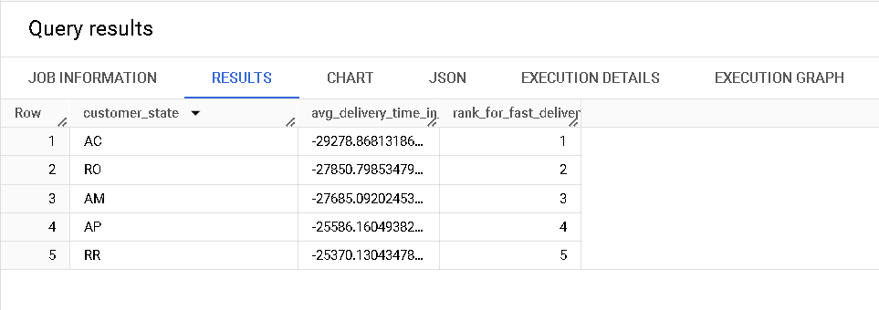

I

**Insights:** Provide us the top 5 states where the order delivery is really fast as compared to the estimated date of delivery.

**Recommendations:**

Helps us in tracking the delivery models in these states and implement them in the states where average delivery time is high.

**6. Analysis based on the payments:**

**1.Find the month on month no. of orders placed using different payment types.**

select extract(year from order_purchase_timestamp) as year,extract(month from order_purchase_timestamp) as month,payment_type,count(8) as no_of_orders

from Target.orders

join Target.payments

using(order_id)

group by extract(year from order_purchase_timestamp),extract(month from order_purchase_timestamp),payment_type

order by year,month,payment_type;

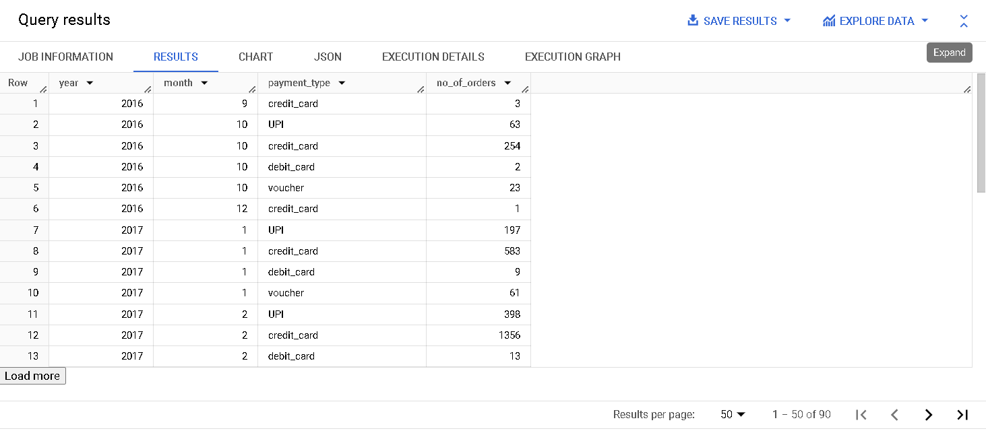

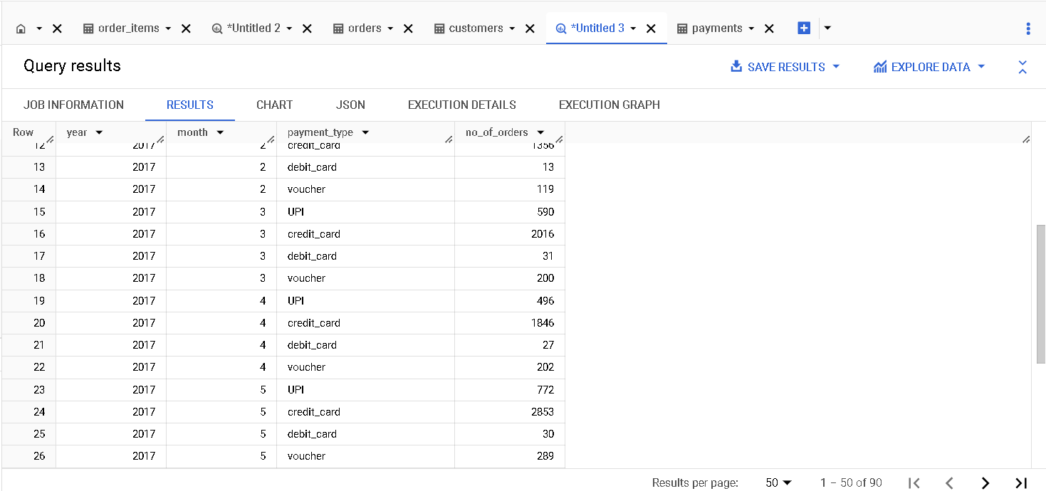

**Insights:** Provide us the month on month no. of orders placed using different payment

Types.

**Recommendations:**

-Helps us tracking which payment method was most used and adding more flexibility to those payment methods.

**2.Find the no. of orders placed on the basis of the payment installments that have been paid.**

select payment_installments,count(*) as no_of_orders

from Target.payments

group by payment_installments

order by payment_installments;

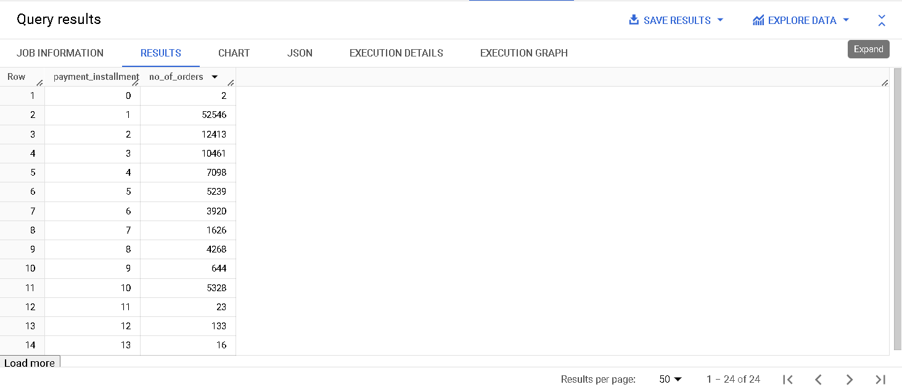

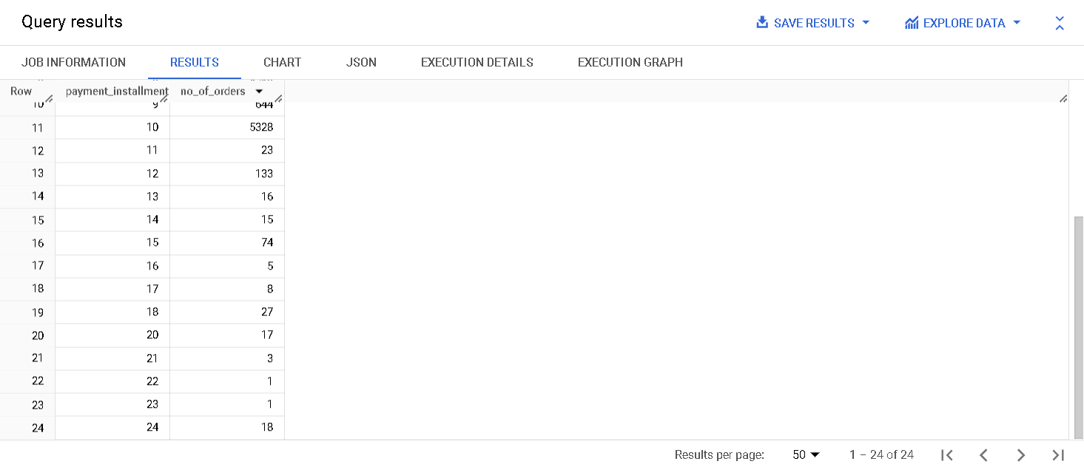

**Insights:** Provide us the number of orders placed on the basis of the payment installments that have been paid.

**Recommendations:**

Here most orders are placed with payment installments from 1 to 10. So provide more flexibility like lesser interest rate or no cost emi to those instalments which can grab more customers.