Task 1: Character Check (Vowel or Consonant)
Write a program:
- Input: a character
- Output:
  - "Vowel" if character is a, e, i, o, u
  - "Consonant" otherwise
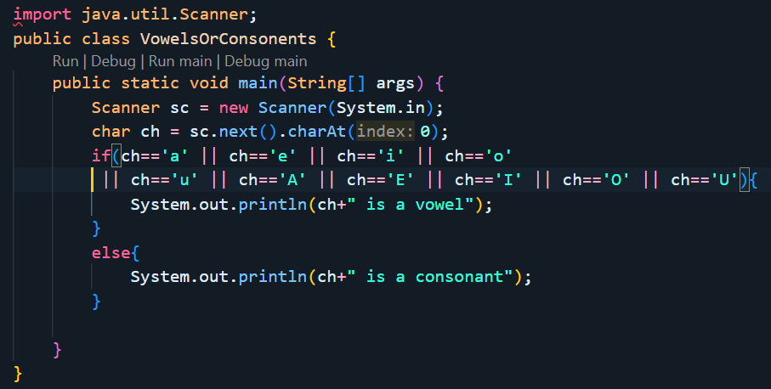

Task 2: Positive or Negative
Write a program:
- Input: a number
- Output:
  - "Positive" if number > 0
  - "Negative" if number < 0
  - "Zero" if number == 0
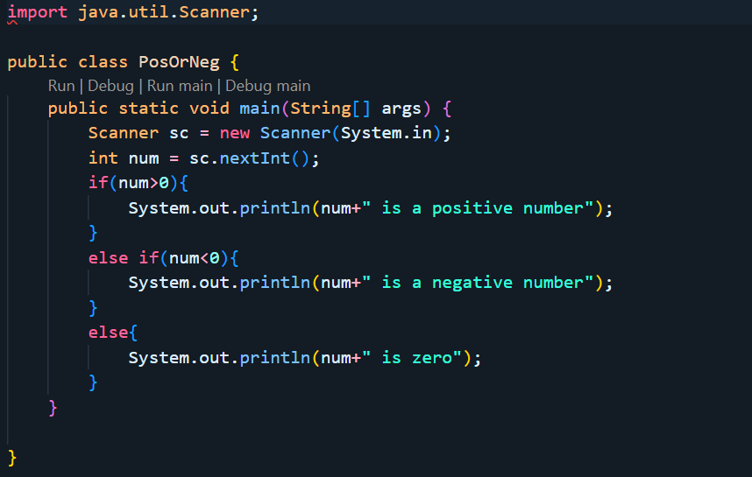

Task 3: Pass or Fail
Write a program:
- Input: student marks
- Output:
  - "Pass" if marks ≥ 40
  - "Fail" otherwise
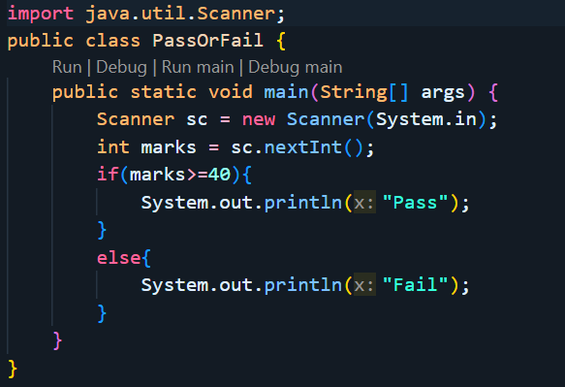

Task 4: Largest of Two Numbers
Write a program:
- Input: two numbers
- Output:
  - Print the larger number
  - If both are equal, print "Equal"
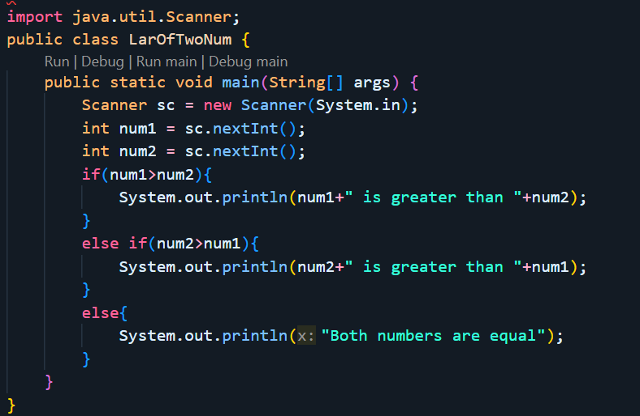

Task 5: Age Eligibility
Write a program:
- Input: age
- Output:
  - "Eligible to vote" if age ≥ 18
  - "Not eligible" otherwise
