The Complete System Design Knowledge Base — Book I: Traditional System Design and Distributed Systems
Table of Contents

Part I — Foundations of System Design Thinking

Chapter 1 — What Is System Design?
Level: 1 · Track: Shared · Estimated reading time: 3.5 h
Every application you have ever used — a photo app, a bank, a search engine — is two things at once. It is code, which tells a computer what to do, and it is a system, which decides where that code runs, where its data lives, how many copies of each exist, what happens when a machine dies at 3 a.m., and how the whole thing keeps working when ten times more people show up next month. This chapter is about the second thing.
We will follow one fictional product through the whole chapter: PhotoShare, a simple photo-sharing app in which people upload photos, follow friends and scroll a feed. PhotoShare starts life on a single rented server with a thousand users. By the end of the chapter it serves ten million daily users across multiple machines and data centers. At every stage you will see why the design had to change, which requirement forced the change, and what it cost. That progression — requirements forcing decisions, decisions carrying costs — is system design.

1.1 Learning objectives
After this chapter you should be able to:
- Define system design, software architecture, high-level design and low-level design, and explain how they differ and overlap.
- Distinguish functional requirements from non-functional requirements, and write each in a testable form.
- Name at least fifteen quality attributes (“-ilities”), state a measurable metric for each, and identify common tensions between them.
- Convert an availability target (for example 99.9%) into an allowed-downtime budget, and compute the availability of components in series.
- Estimate average and peak request rates, storage growth and network egress from a user count, using explicit assumptions.
- Write an Architecture Decision Record (ADR) in Nygard’s format and use a weighted decision matrix to compare options.
- Explain why early architectural decisions are expensive to reverse, using a concrete migration-cost calculation.
- Describe how design documents, design reviews and RFC processes work in industry.
- Describe the structure of a 45–60-minute system design interview and what interviewers evaluate.
- Recognize and avoid the twelve most common beginner mistakes in system design.

1.2 Prerequisites
This chapter assumes no prior system design knowledge. Helpful but not required:
- Basic programming in any language — so that “a function”, “a class” and “a web request” are familiar words.
- A rough idea of what happens when a browser loads a web page — treated fully in §8.5 (The request–response lifecycle end to end); here we only need “a client sends a request, a server sends a response”.
- A rough idea of what a database is — treated fully in Ch 11 (Relational Databases); here we only need “a program that stores data durably and answers queries about it”.
Every other term is defined when it first appears.

1.3 Definition of system design

1.3.1 What a “system” is
DEFINITION
Definition — System. A set of interacting components (programs, machines, data stores, networks and people) that together deliver a capability no single component delivers alone. Components interact only through interfaces: agreed formats and protocols for exchanging requests, responses and data.
DEFINITION
Definition — Component. A unit of a system with a clear responsibility and an interface — for example a web service, a database, a cache, a message queue, a load balancer or a third-party payment provider.

First-principles explanation
Think of a busy restaurant. A single recipe is like a single function in code: it turns inputs (ingredients) into an output (a dish). But a restaurant is not a recipe. It is a system: a front-of-house that takes orders, a ticket rail that queues them, stations for grill and salad, a walk-in fridge (storage), a dishwasher (cleanup), a manager who notices when the grill cook is overwhelmed, and a supplier who delivers flour every Tuesday. The food can be excellent and the restaurant can still fail — because orders get lost, the fridge breaks, or Saturday night brings three times more guests than the kitchen can handle.
Software is the same. The code that resizes a photo can be perfect, and PhotoShare can still fail because the disk filled up, the only server rebooted during a deploy, or a celebrity’s post caused a thousand times the normal traffic in ten seconds.

1.3.2 System design
DEFINITION
Definition — System design. The process of deciding the components of a software system, their responsibilities, their interfaces, how data flows and is stored between them, and how they are deployed — so that the system meets its functional requirements and its non-functional requirements (performance, scalability, availability, durability, security, cost and others) under stated assumptions about load and failure. The output of the process is also called the system design: a set of decisions, diagrams and documents.
Two parts of the definition deserve emphasis.
- “So that it meets its requirements.” A design is never good or bad in the abstract — only good or bad for a stated set of requirements. A single server is an excellent design for 1,000 users and a terrible one for 10 million.
- “Under stated assumptions about load and failure.” Designers must say out loud how much traffic they expect and what kinds of failure they expect to survive. A design that is silent about these is not finished.

Why does this exist?
For most of computing history, a program ran on one machine. Today almost any useful service must handle more data, more users and more failure than one machine can. A modern commodity server fails on the order of once every few years; a fleet of thousands therefore sees failures every day Barroso et al. 2018. Users are spread across continents, and light in optical fiber needs roughly 5 ms per 1,000 km one way, so a single location cannot be fast for everyone (see §7.15 (Latency, bandwidth, BDP, packet loss)). Regulations require some data to stay in certain countries. Each of these forces pushes the system apart into multiple components, and the moment you have multiple components you must decide how they divide the work, how they talk, and what happens when one of them stops. System design exists because those decisions are hard to get right, expensive to get wrong and impossible to avoid.

How it works internally
System design is iterative, but in practice most designers follow a loop like this:
- Understand the problem. Who are the users? What must the system do (functional requirements, §1.6)? How well must it do it (non-functional requirements, §1.7)?
- Quantify. Estimate users, request rates, data sizes and growth (back-of-the-envelope estimation; see §2.11 and Ch 89).
- Propose a simple design. Start with the smallest design that could work: a client, a service, a database.
- Stress the design against the requirements. Where does it break first — CPU, memory, disk, network, a single point of failure, a consistency rule? (See §2.6 (Identifying bottlenecks).)
- Evolve the design. Add or change components to fix the weakest point, noting what each change costs.
- Record decisions and their rationale (ADRs, §1.8), and communicate the design (design docs, §1.10).
- Validate in production with monitoring, load tests and incidents, and feed what you learn back into step 1.

Architecture diagram
Here is PhotoShare on launch day. Everything runs on one rented virtual machine.
Figure 1.1 — PhotoShare v0: a single-server design.
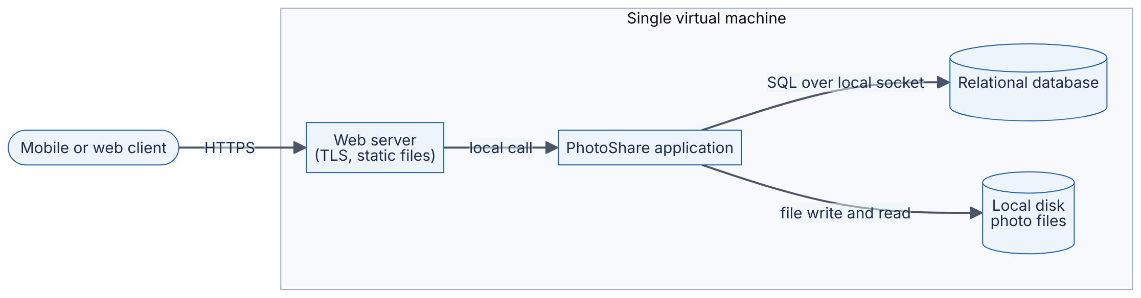
Reading the diagram.
- Components. A client (the mobile app or browser), a web server that terminates HTTPS and serves static files, the PhotoShare application (business logic: sign-up, upload, feed), a relational database holding users, follows and photo metadata, and the local disk holding the photo files themselves.
- Protocols. The client speaks HTTPS to the web server. Inside the machine, the application talks to the database over a local socket using SQL and reads and writes photo files through the operating system’s file system.
- Direction of data flow. Uploads flow left to right: client → web server → application → database row plus file on disk. Feed requests flow the same way and responses return along the same path.
- Synchronous vs asynchronous. Every arrow is solid: every step is synchronous. The client waits while the application stores the photo and generates any thumbnails.
- Storage boundaries. All state — rows and files — lives on one machine’s disk. The subgraph is the deployment boundary: everything inside shares one fate.
- Failure points. The virtual machine is a single point of failure (SPOF): if it reboots, crashes, or its disk fails, PhotoShare is completely down, and photos may be lost if there is no backup.
- Scaling options. The only option without redesign is vertical scaling — renting a bigger machine (see §18.3). That buys time but has a ceiling and does not remove the SPOF.
This design is not a mistake. For a launch with 1,000 users it is the right design: cheap, simple, and easy to change. The rest of the chapter shows which requirements eventually break it.

Mathematical foundations
The first quantitative question in any design is “how much load?” The simplest useful formula converts daily activity into a request rate.
FORMULA
Average and peak request rate
$${\text{RPS}}_{\text{avg}}=\frac{\text{DAU}×r}{86,400} {\text{RPS}}_{\text{peak}}=k×{\text{RPS}}_{\text{avg}}$$
Symbol | Meaning | Units
${\text{RPS}}_{\text{avg}}$ | Average request rate over a day | requests/second
$\text{DAU}$ | Daily active users | users
$r$ | Requests (of the type being estimated) per user per day | requests/user/day
$86,400$ | Seconds in a day | seconds/day
$k$ | Peak factor: ratio of the busiest period’s rate to the daily average (dimensionless; 2–5 is a common assumption for consumer apps) | —
${\text{RPS}}_{\text{peak}}$ | Request rate during the busiest period | requests/second
RPS (requests per second) is the canonical unit in this book; you will also see QPS (queries per second) used as a synonym.
WORKED EXAMPLE
Worked example — PhotoShare on launch day.
Assumptions (stated, as always): 1,000 DAU; each user views 50 photos per day; peak factor $k=3$.
- Daily photo views: $1,000×50=50,000$ views/day.
- Average rate: $50,000/86,400≈0.58$ RPS.
- Peak rate: $3×0.58≈1.7$ RPS.
Interpretation. Under two requests per second at peak. A single small virtual machine running an ordinary web framework typically handles hundreds of such requests per second (an order-of-magnitude assumption; measure your own stack, see §23.10).
Engineering implication. Any design more complex than Figure 1.1 would be over-engineering at this scale: more cost, more moving parts, more ways to fail, and no benefit users can feel.

Code example
Estimation is arithmetic, but writing it as a tiny program makes your assumptions explicit and easy to change. The same script is reused in §1.9 when PhotoShare grows.
"""Back-of-the-envelope estimator for the PhotoShare running example.
Uses SI units: 1 MB = 10**6 bytes, 1 TB = 10**12 bytes.
"""
from dataclasses import dataclass
SECONDS_PER_DAY = 86_400
@dataclass
class Workload:
dau: int # daily active users
views_per_user: float # photo views per user per day
uploads_per_user: float # photo uploads per user per day
stored_bytes_per_upload: int # original + thumbnails, bytes
served_bytes_per_view: int # bytes sent to the client per view
peak_factor: float = 3.0 # peak-hour rate / daily average rate
def estimate(w: Workload) -> dict:
views_per_day = w.dau * w.views_per_user
uploads_per_day = w.dau * w.uploads_per_user
read_rps = views_per_day / SECONDS_PER_DAY
write_rps = uploads_per_day / SECONDS_PER_DAY
storage_per_day = uploads_per_day * w.stored_bytes_per_upload
egress_bits_per_s = views_per_day * w.served_bytes_per_view * 8 / SECONDS_PER_DAY
return {
"read_rps_avg": read_rps,
"read_rps_peak": read_rps * w.peak_factor,
"write_rps_avg": write_rps,
"write_rps_peak": write_rps * w.peak_factor,
"storage_TB_per_day": storage_per_day / 1e12,
"storage_PB_per_year": storage_per_day * 365 / 1e15,
"egress_Gbps_avg": egress_bits_per_s / 1e9,
"egress_Gbps_peak": egress_bits_per_s * w.peak_factor / 1e9,
}
if __name__ == "__main__":
for label, dau in [("v0 launch", 1_000), ("v3 scale", 10_000_000)]:
w = Workload(dau=dau, views_per_user=50, uploads_per_user=0.2,
stored_bytes_per_upload=2_500_000,
served_bytes_per_view=200_000)
print(label)
for key, value in estimate(w).items():
print(f" {key:>20}: {value:,.3f}")
What to notice:
- Every assumption is a named field with a unit in the comment. When a reviewer disagrees with “50 views per user”, they change one number, not your reasoning.
- The peak factor is explicit. Systems are sized for the peak, not the average.
- Egress is converted from bytes to bits (* 8) because network links are rated in bits per second.
- Running it prints about 0.58 average read RPS for v0 and about 5,787 average (17,361 peak) read RPS, 5 TB/day of new storage and about 9.3 Gbit/s average egress for v3. Those v3 numbers drive most of §1.9.

Real-world industry applications
INDUSTRY EXAMPLE
Instagram (2011). About a year after launch, Instagram’s engineering team published a description of its stack: a load balancer in front of Django application servers, PostgreSQL for data (partitioned across multiple database instances, with replicas in a different availability zone), Redis and Memcached for feeds and caching, photos stored in Amazon S3 and served through a CDN, and a task queue for asynchronous work. Their stated principles were to keep things simple, avoid reinventing the wheel, and use proven technologies. The problem (rapid growth with a tiny team) drove an architecture built mostly from well-understood, managed components rather than custom infrastructure. The trade-off: less control and some vendor dependence, in exchange for a very small operations burden. Evidence: Primary — Instagram Engineering 2011

Advantages and disadvantages
Treating design as an explicit activity — rather than letting structure emerge from whatever code is written first — has a clear profile. Advantages: problems are found on a whiteboard instead of in production; trade-offs are chosen deliberately; teams share a mental model; costs are predictable. Disadvantages: design takes time; designs made with poor information can be confidently wrong; and heavy upfront design can delay learning from real users. The practical answer is proportionate design: spend design effort in proportion to how expensive a decision would be to reverse (§1.8, §2.8).

Failure scenarios
Table 1.1 — Failure scenarios for the design process itself.
What goes wrong | Why | Detection | Recovery | Prevention
System collapses under launch traffic | Load never estimated; peak factor ignored | Latency and error rate spike; saturated CPU or connections | Emergency vertical scaling; shed load | Estimate peak load before launch (§1.3.2); load-test
Total outage when one machine fails | Single point of failure nobody named | Health checks fail; users report outage | Restore from backup onto a new machine | List SPOFs in every design review (§1.10)
Months spent building infrastructure for users who never arrive | Design sized for imagined scale | Low utilization; slipped launch | Simplify; delete unused components | Design for 10× current load, not 1,000×
Nobody remembers why a component exists | Decisions not recorded | Repeated debates; fear of changing anything | Reconstruct history from commits and people | ADRs (§1.8)

Common misconceptions
COMMON MISTAKE
“System design means drawing boxes and arrows.” The diagram is the output. The substance is the reasoning: which requirements forced each box, what each arrow carries, what happens when each box fails, and what the design costs. A beautiful diagram with no requirements and no numbers is decoration.
COMMON MISTAKE
“System design only matters at Google scale.” A three-person startup still chooses where its data lives, how it backs up, and what happens during a deploy. The decisions are smaller, but the cost of getting the irreversible ones wrong (data model, identifiers, storage location of user files) is felt at every scale.

1.4 Software architecture

1.4.1 What architecture is
DEFINITION
Definition — Software architecture. “The set of structures needed to reason about the system, which comprise software elements, relations among them, and properties of both” [Bass et al. 2021]. The international standard for architecture description defines it as the fundamental concepts or properties of a system in its environment, embodied in its elements, relationships, and in the principles of its design and evolution [ISO/IEC/IEEE 42010].

First-principles explanation
Return to the restaurant. Its architecture is not the color of the napkins; it is the set of decisions that would be painful to change once the doors open: where the kitchen sits relative to the dining room, how many burners there are, whether orders go through a single ticket rail or directly to stations, whether there is a walk-in fridge or daily deliveries. You can change the menu weekly; moving the kitchen means closing for months.
Martin Fowler summarized the same idea for software: architecture is about “the important stuff — whatever that is”, meaning the decisions that are hard to change and that the team must share an understanding of [Fowler 2003]. The parenthetical “whatever that is” is honest: what counts as architectural depends on the system. For PhotoShare, where photo files live is architectural (changing it means migrating terabytes); which image-resizing library we call is usually not.

Why does this exist?
Large systems are built by many people over many years. Without a shared structure, each person optimizes locally and the whole becomes inconsistent: three ways to authenticate, four copies of the user table, no one able to say what happens if the cache is down. Architecture exists to (1) make the system understandable enough to reason about, (2) make the most important qualities — performance, availability, security, modifiability — achievable by design rather than by luck, and (3) let teams work in parallel along stable boundaries.

How it works internally
An architecture is described by several views, because no single picture answers every question. Kruchten’s influential “4+1” model proposes four views plus scenarios that tie them together [Kruchten 1995]:
- Logical view — the main abstractions and their responsibilities (users, photos, feeds, follows).
- Process view — what runs concurrently, and how runtime components communicate (requests, queues, threads).
- Development view — how the code is organized into modules, packages and repositories, and which teams own them.
- Physical view — which machines, data centers and networks the software is deployed on.
- +1: Scenarios — a few important use cases (“a user uploads a photo”) traced through all four views to validate them.
The C4 model (context, containers, components, code) is a more recent, lightweight alternative used widely in industry; it is covered in §2.12 (Architecture documentation).
Architectures also follow recognizable styles or patterns — layered, monolithic, modular monolith, microservices, event-driven, serverless — each a reusable answer to a recurring set of forces. They are the subject of Ch 33 (Architecture Patterns) and Ch 34 (Microservices).
KEY CONCEPT
Conway’s law. Melvin Conway observed in 1968 that organizations which design systems are constrained to produce designs that copy the organization’s communication structure [Conway 1968]. If three teams build a compiler, you tend to get a three-pass compiler. Architecture and team structure therefore co-evolve: choosing service boundaries is partly choosing team boundaries, and vice versa (see §34.3 (Service boundaries)).

1.4.2 Architecture, system design and design: how the words relate
The terms overlap heavily, and different companies use them differently. The working distinction used in this book is in Table 1.2.
Table 1.2 — Overlapping disciplines: architecture, system design and low-level design.
Aspect | Software architecture | System design | Low-level design
What it is | The significant, hard-to-change structures of a system | Choosing components, data flow and deployment to meet requirements at scale | Internal structure of one component
Typical questions | Monolith or services? Which quality attributes dominate? | How many servers? Which database? Where to cache? What if a node fails? | Which classes, interfaces, algorithms, schemas?
Unit of reasoning | Elements, relations, properties | Services, stores, networks, traffic, failures | Classes, functions, tables, state machines
Time horizon | Years | Months to years | Weeks to months
Typical artifacts | Architecture views, principles, ADRs | Design docs, capacity estimates, deployment diagrams | Class/sequence diagrams, API specs, schema DDL
Where in this book | Ch 33–34 | Most of Book I; case studies Ch 52–56 | Ch 35–38
In everyday industry usage, “system design” usually means the distributed-systems end of architecture: servers, databases, caches, queues, networks and their failure modes. “Software architecture” is the broader discipline that also includes code-level structure and organizational concerns. This book treats system design as the large-scale, runtime-focused part of architecture.

Real-world industry applications
INDUSTRY EXAMPLE
Architecture as a role. Many companies do not have a job titled “architect”; architectural decisions are made by senior and staff engineers through design documents and reviews (§1.10). Others have dedicated architects who own cross-team standards. In both models the activity is the same — identifying the hard-to-change decisions and making them deliberately — but the accountability differs. Evidence: Illustrative — a general description of common industry practice, not a claim about any specific company.

Advantages and disadvantages
An explicit architecture makes systems understandable, supports parallel work, and lets you predict quality attributes before building. Its costs are upfront effort, the risk of an “ivory-tower” architecture that ignores implementation realities, and rigidity if the architecture is enforced long after the requirements that justified it have changed.

Failure scenarios
Table 1.3 — Architecture-level failure scenarios.
What goes wrong | Why | Detection | Recovery | Prevention
“Big ball of mud” — every module depends on every other | No agreed structure; boundaries eroded under deadline pressure | Small changes break distant features; slow builds | Incremental refactoring toward modules (§33.5) | Explicit module boundaries; dependency checks in CI
Architecture on paper differs from reality | Diagrams never updated | New engineers’ mental model is wrong; incidents surprise everyone | Re-derive diagrams from deployment config and traces | Keep diagrams next to code; review in design reviews
Distributed monolith | Split into services without splitting data or ownership | Every release requires coordinating many services | Merge services or re-cut boundaries | Draw boundaries around data ownership (§34.11, §34.14)

Common misconceptions
COMMON MISTAKE
“Architecture is decided once, at the start.” Requirements change, traffic grows, teams reorganize. Good architecture is evolved deliberately, with decisions revisited when their context changes — which is exactly why ADRs record the context (§1.8).

1.5 High-level vs low-level design

1.5.1 Definitions
DEFINITION
Definition — High-level design (HLD). A description of a system as a set of major components (services, data stores, queues, caches, external dependencies), their responsibilities, the interfaces and protocols between them, data flows, and deployment topology — at a level of detail where each component is a box whose internals are not yet specified.
DEFINITION
Definition — Low-level design (LLD). A description of the internals of one component: its modules, classes or functions, data structures, algorithms, database schemas, API request and response formats, error handling and state transitions — at a level of detail from which an engineer can write code.

First-principles explanation
A city planner decides where the roads, the water mains and the power substations go, and how much traffic and water each must carry. That is high-level design. An architect then draws the plumbing for one particular building: pipe diameters, which tap connects to which riser, where the shut-off valves are. That is low-level design. Both are design; they answer different questions at different zoom levels, and a good HLD makes the LLD of each part possible without dictating it.

Why does this exist?
Splitting design by zoom level lets the most consequential decisions (where data lives, how components communicate, how the system survives failures) be made and reviewed first, by people looking at the whole. It then lets each team design its component in detail independently, as long as it respects the interfaces the HLD fixed.

How it works internally
- The HLD fixes boundaries and contracts: which component owns which data and exposes which API.
- Each component’s LLD fills in internals: classes, schemas, algorithms, concurrency.
- LLD work frequently discovers problems the HLD missed (an operation that needs data from two owners; an API that cannot be made idempotent). These flow back to revise the HLD — design is a conversation between zoom levels, not a waterfall.

Architecture diagram
The HLD of PhotoShare’s upload path at a later stage (detailed in §1.9) looks like this.
Figure 1.2 — High-level design of the PhotoShare upload path.
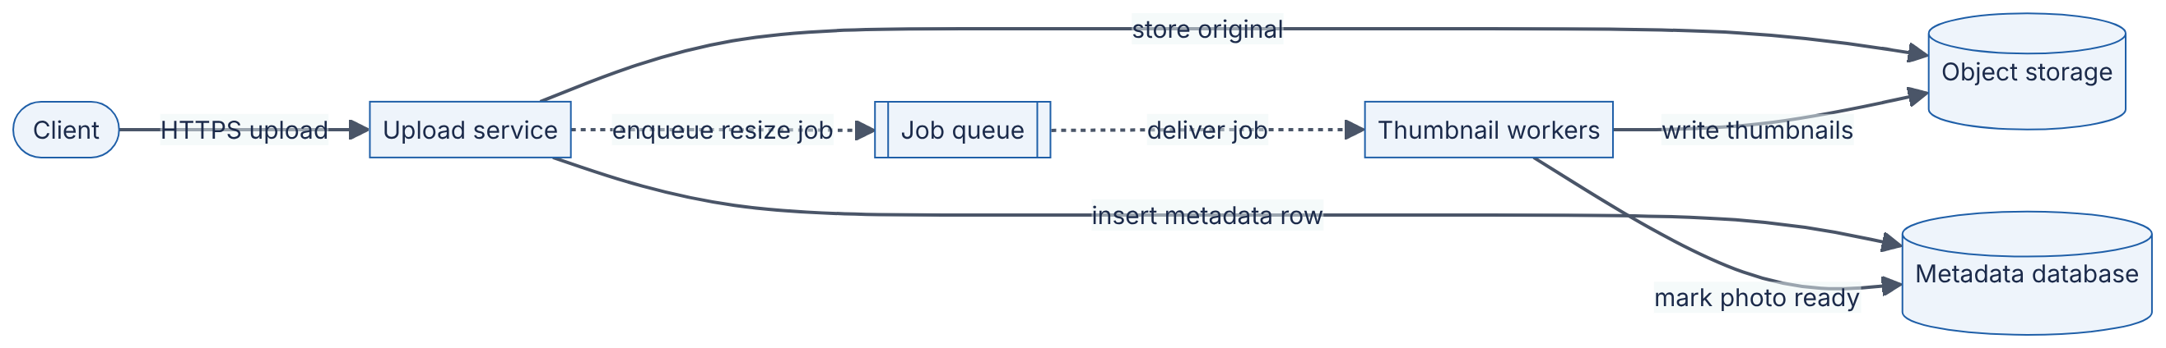
Reading the diagram.
- Components. The upload service accepts photos; object storage holds the image bytes; the metadata database holds rows describing each photo (owner, time, status, storage key); the job queue buffers work; thumbnail workers produce smaller versions of each photo.
- Protocols. HTTPS from the client; the object store is typically accessed over an HTTP API; the database over its wire protocol (SQL); the queue over the broker’s protocol.
- Direction and sync/async. Solid arrows are synchronous: the client waits while the original is stored and the metadata row inserted. Dotted arrows are asynchronous: the resize job is enqueued and processed later, so the client gets a response without waiting for thumbnails.
- Storage boundaries. Two stores with different jobs: large immutable blobs in object storage, small mutable rows in the database.
- Failure points. If the queue is unavailable, uploads can still succeed but thumbnails are delayed; if workers crash, jobs remain in the queue and are retried. A crash between storing the original and inserting the row leaves an orphaned object — a consistency gap the LLD must handle (for example, by a periodic cleanup job).
- Scaling options. Upload service and workers scale horizontally by adding instances; the queue absorbs bursts so workers can be sized for average rather than peak load.
Notice what the HLD does not say: how the upload service validates file types, which class generates storage keys, or what the table columns are. That is LLD.
Figure 1.3 — Low-level design of the upload component (class view).
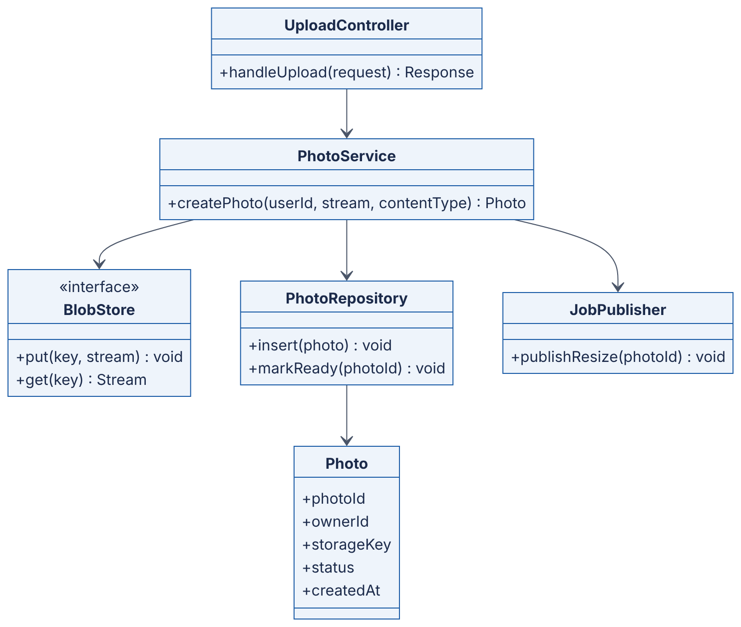
Reading the diagram.
- Components. UploadController handles HTTP concerns (parsing, authentication result, response codes). PhotoService holds the business rule “store bytes, record metadata, request thumbnails”. BlobStore is an interface, so the same code can target local disk in tests and object storage in production. PhotoRepository wraps database access. JobPublisher wraps the queue. Photo is the data record.
- Direction. Arrows show dependency: the controller depends on the service, which depends on three abstractions. Nothing depends on the controller.
- Sync/async and storage boundaries. All calls in this diagram are synchronous in-process calls; the asynchrony from Figure 1.2 is hidden behind JobPublisher.
- Failure points. createPhoto performs three external operations that can each fail; the LLD must define ordering (store bytes first, then the row, then the job) and compensation (a cleanup for orphaned objects). A status field (PENDING → READY) makes partial progress visible.
- Scaling options. Scaling is not decided here; this component is stateless, which is what allows the HLD to run many copies of it. Object-oriented principles behind this structure are covered in Ch 35 (Object-Oriented Design) and Ch 36 (SOLID Principles).

Alternatives and trade-offs
Table 1.4 — High-level design vs low-level design.
Aspect | High-level design | Low-level design
What it is | Components, data flows, deployment | Internals of one component
How it works | Boxes, arrows, contracts, capacity numbers | Classes, schemas, algorithms, state machines
Main concern | Quality attributes: scale, availability, latency, cost | Correctness, clarity, testability, extensibility
Typical diagrams | Flowchart/deployment, sequence across services | Class, sequence within a service, state, ER
Cost of a wrong decision | High — often needs data migration | Lower — usually a refactor within one team
Who reviews | Senior engineers across teams | The owning team
Interview format | “Design Instagram” (Ch 87–88, 91) | “Design a parking lot” (Ch 38)
Choose this zoom when | Deciding what to build and where it runs | Deciding how one part is written

Common misconceptions
COMMON MISTAKE
“HLD is for architects, LLD is for junior engineers.” Both require skill. A clumsy LLD (no idempotency, no error handling, a schema that cannot be indexed) can sink a sound HLD. Senior engineers move fluidly between levels — and recognizing when an LLD detail is actually an HLD concern (for example, a schema choice that blocks partitioning, see §14.7) is a hallmark of seniority.
COMMON MISTAKE
“Once the HLD is approved, it is fixed.” LLD routinely uncovers HLD flaws. Treat the HLD as a hypothesis that implementation tests.

1.6 Functional requirements

1.6.1 What functional requirements are and how to write them
DEFINITION
Definition — Functional requirement (FR). A statement of a behavior the system must provide: an input, action or event, and the observable result. Functional requirements describe what the system does — for example, “a signed-in user can upload a JPEG or PNG photo up to 20 MB, and it appears in their followers’ feeds”.

First-principles explanation
A restaurant’s functional requirements are its menu and services: it serves pasta, takes reservations, offers takeaway. They say nothing about how fast the food arrives or how many guests fit — those are non-functional (§1.7). If you forget a functional requirement (“we also do delivery”), you build the wrong kitchen.

Why does this exist?
Every design decision is justified by some requirement. If you do not write the functional requirements down, two things happen: the team builds features nobody needs (and designs infrastructure for them), and it misses features that change the design fundamentally. “Users can delete their account and all their photos” sounds minor, but it forces you to be able to find and erase every copy of a user’s data — in replicas, caches, backups, CDN edges and analytics pipelines — which is an architectural property, not a button.

How it works internally
- Identify actors. Who interacts with the system? For PhotoShare: viewers, posters, moderators, advertisers, internal services.
- List use cases per actor, as verb phrases: upload photo, follow user, view feed, like photo, report photo.
- Make each one testable: specify inputs, limits and the observable outcome. “Upload photos” becomes “upload a JPEG/PNG/HEIC up to 20 MB; on success, return a photo ID within the latency target”.
- Prioritize — for example with MoSCoW: Must, Should, Could, Won’t (this time).
- Write the non-goals. An explicit “out of scope” list prevents the design from silently growing.
- Sketch the API. A rough interface for each must-have use case (detailed API design is §8.6) catches ambiguities early.
Table 1.5 — PhotoShare functional requirements (v1 scope).
ID | Requirement (testable form) | Priority
FR-1 | A user can sign up and sign in with email and password | Must
FR-2 | A signed-in user can upload a JPEG, PNG or HEIC photo up to 20 MB with an optional caption up to 2,200 characters | Must
FR-3 | A user can follow and unfollow another user | Must
FR-4 | A user can view a home feed of photos from followed users, newest first, 20 per page | Must
FR-5 | A user can like a photo and see the like count | Should
FR-6 | A user can delete a photo; it disappears from all feeds | Must
FR-7 | A user can delete their account and all associated data | Must (legal)
FR-8 | A user can comment on a photo | Could
— | Video, direct messages, stories, search, ads | Won’t (v1 non-goals)
An API sketch for the must-haves might read:
POST /v1/photos (multipart: image, caption) -> 201 {photoId}
DELETE /v1/photos/{photoId} -> 204
PUT /v1/users/{userId}/followers/me -> 204
DELETE /v1/users/{userId}/followers/me -> 204
GET /v1/feed?cursor={cursor}&limit=20 -> 200 {items, nextCursor}
What to notice:
- The feed uses a cursor rather than a page number, because new photos arrive constantly and page numbers would skip or repeat items (pagination is detailed in §8.6).
- Follow is modeled as an idempotent PUT: repeating it has no further effect, which makes client retries safe (see §22.15 (Idempotency)).

Failure scenarios
Table 1.6 — Functional-requirement failure scenarios.
What goes wrong | Why | Detection | Recovery | Prevention
A late “small” feature forces redesign | Requirement with architectural impact discovered late (e.g., account deletion, data export) | Feature estimate is months, not days | Retrofit data inventory and deletion pipeline | Ask about lifecycle, legal and admin use cases up front
Scope creep | No non-goals list | Design keeps growing; launch slips | Re-prioritize with MoSCoW | Write non-goals explicitly
Ambiguous requirement built two ways | “Feed” never defined (chronological? ranked?) | Teams’ implementations disagree | Agree a definition; rework one side | Testable phrasing with examples

Common misconceptions
COMMON MISTAKE
“Functional requirements are the product manager’s job, not the designer’s.” Product managers own which features matter; designers must interrogate each feature for architectural consequences. “Newest first” and “ranked by relevance” are one word apart in a requirements document and an entire ML system apart in architecture (see Ch 68 (Recommendation and Ranking Systems Architecture)).

1.7 Non-functional requirements (the “-ilities” catalog)

1.7.1 What non-functional requirements are
DEFINITION
Definition — Non-functional requirement (NFR). A requirement on how well the system performs its functions, or on constraints under which it operates, expressed as a measurable target — for example “p99 feed latency ≤ 300 ms at 2,000 RPS” or “monthly availability ≥ 99.9%”. NFRs are also called quality attributes or, informally, the “-ilities” (scalability, availability, durability, …).

First-principles explanation
Two restaurants can serve the identical menu. One seats 20 and serves each dish in 40 minutes; the other seats 400 and serves each dish in 12 minutes, never runs out of bread, and passes every health inspection. Same functional requirements, completely different buildings, staff and suppliers. The difference is non-functional — and it is the non-functional requirements that determine the architecture.

Why does this exist?
Functional requirements can usually be met by a single program on a single machine. It is the non-functional requirements — serve 17,000 requests per second, never lose a photo, survive a data-center outage, cost less than $0.01 per user per month — that force systems to be distributed, replicated, cached and partitioned. Bass, Clements and Kazman make this the central thesis of software architecture: architecture is driven primarily by quality attributes, not by functionality [Bass et al. 2021]. Kleppmann similarly frames reliability, scalability and maintainability as the three central concerns when building data-intensive applications [Kleppmann 2017].

How it works internally
An NFR is only useful if it is measurable. Vague words — “fast”, “scalable”, “highly available” — cannot be tested and therefore cannot guide decisions. A reliable technique is the quality attribute scenario [Bass et al. 2021], which has six parts:
- Source — who or what generates the stimulus (users, an attacker, a failing disk).
- Stimulus — the event (a feed request, a node crash, a login attempt).
- Environment — the conditions (normal load, peak load, during a deploy).
- Artifact — the part of the system affected (feed service, metadata database).
- Response — what the system does.
- Response measure — the number that decides pass or fail.
Example: “When an availability zone fails (source/stimulus) during peak traffic (environment), the PhotoShare feed service (artifact) continues serving requests from the remaining zones (response) with no more than 60 seconds of elevated errors and p99 latency ≤ 500 ms after failover (response measure).”
In production, measurable NFRs become service level indicators (SLIs) — the measured quantity, such as the fraction of successful requests — and service level objectives (SLOs) — the target value for an SLI over a window [Beyer et al. 2016]. A service level agreement (SLA) is a contract with consequences (often financial) if an SLO-like target is missed. These are developed fully in §39.6 (SLI, SLO, SLA) and §39.7 (Error budgets).
DEFINITION
Definition — Percentile latency (p50, p95, p99, p99.9). The latency value below which the given percentage of requests fall. If p99 latency is 300 ms, 99% of requests completed in 300 ms or less and 1% took longer. p50 is the median.
Percentiles matter more than averages because users experience the slow requests, and a single page that fans out to many backend calls is slowed by the slowest of them [Dean and Barroso 2013] (fan-out amplification is quantified in §4.8).

1.7.2 The catalog
The catalog is split into qualities observable while the system runs (Table 1.7) and qualities that matter as the system is built, changed and paid for (Table 1.8). Each row gives a measurable metric and a PhotoShare target.
Table 1.7 — Runtime quality attributes.
Attribute | What it means | Typical metric | PhotoShare example target | Deep dive
Latency (performance) | Time to complete one operation | p50/p99 in ms | Feed API p99 ≤ 300 ms | §4.8, Ch 23
Throughput | Work completed per unit time | RPS; MB/s | 2,000 feed RPS at peak | Ch 23
Scalability | Ability to handle more load by adding resources | Cost or nodes per 1,000 RPS as load grows | 10× users with ≤ 10× cost | Ch 18
Availability | Fraction of time the system serves correctly | % successful requests per 30 days | ≥ 99.9% monthly | §4.14, Ch 39
Reliability | Probability of correct operation over time | Error rate; MTBF | < 0.1% failed uploads | Ch 39
Durability | Probability stored data is not lost | Annual object-loss probability | No acknowledged photo lost | §4.16, Ch 15
Consistency | Guarantees about what reads see after writes | Model name; staleness bound in s | Own uploads visible to self immediately; to followers within 5 s | Ch 25
Fault tolerance / resilience | Continued service despite component failure | Failures tolerated; recovery time | Survive loss of one zone | Ch 27, Ch 39
Recoverability (disaster recovery) | Ability to restore after disaster | RTO (time to restore); RPO (data loss window) | RTO 4 h; RPO 15 min | §39.8
Security | Protection of confidentiality, integrity, availability | Vulnerability count; time to patch; auth coverage | All traffic TLS; private photos never served to non-followers | Ch 10, Ch 50
Privacy | Appropriate handling of personal data | Deletion completed within N days; data minimized | Account deletion propagates in ≤ 30 days | Ch 50
Usability / accessibility | Ease and inclusiveness of use | Task success rate; accessibility conformance level | Screen-reader alt text on all photos | —
Elasticity | Speed of adapting capacity to load | Time to add capacity | Scale out in ≤ 5 min | §42.12
Table 1.8 — Development-time and business quality attributes.
Attribute | What it means | Typical metric | PhotoShare example target | Deep dive
Maintainability | Ease of understanding and fixing | Time to fix a bug; onboarding time | New engineer ships in week 1 | Ch 35–36
Modifiability / extensibility | Ease of adding features | Number of modules touched per feature | Adding video touches ≤ 3 services | Ch 33
Testability | Ease of verifying behavior | Test coverage of critical paths; test run time | Full test suite ≤ 10 min | Ch 36
Deployability | Ease and safety of releasing | Deploy frequency; change-failure rate | Daily deploys; rollback ≤ 5 min | Ch 43
Observability | Ability to understand internal state from outputs | % of requests traced; time to diagnose | Every request has a trace ID | Ch 40
Operability | Ease of running in production | Pages per week; manual steps per release | ≤ 2 pages per on-call week | Ch 39
Interoperability | Ability to work with other systems | Supported standards and API versions | Public API with versioning | §8.15
Portability | Ability to run in other environments | Effort to move cloud or region | Containerized services | Ch 41–42
Compliance | Conformance to laws and standards | Audit findings | EU users’ data stored in the EU | Ch 50
Cost efficiency | Resources consumed per unit of value | $ per 1,000 requests; $ per user per month | ≤ $0.01 per MAU per month | Ch 51
Sustainability | Energy and carbon per unit of work | kWh or gCO₂e per request | Track and report | Ch 51
The international quality-model standard ISO/IEC 25010 organizes many of these attributes into a formal hierarchy of characteristics and sub-characteristics; it is a useful checklist when you suspect you have forgotten a category [ISO/IEC 25010].

Mathematical foundations
Availability is the NFR most often stated as a number, and the number hides a surprisingly strict budget.
FORMULA
Availability and downtime budget
$$A=\frac{\text{MTBF}}{\text{MTBF}+\text{MTTR}} D=\left(1−A\right)×T$$
Symbol | Meaning | Units
$A$ | Availability: fraction of time the service is up (dimensionless, 0–1) | —
$\text{MTBF}$ | Mean time between failures | hours
$\text{MTTR}$ | Mean time to repair (restore service) | hours
$D$ | Allowed downtime in the period | minutes (or hours)
$T$ | Length of the period | minutes (or hours)
Table 1.9 — Downtime budgets for common availability targets.
Availability | Downtime per 30-day month | Downtime per 365-day year
99% (“two nines”) | 7.2 h | 3.65 days
99.9% (“three nines”) | 43.2 min | 8.76 h
99.95% | 21.6 min | 4.38 h
99.99% (“four nines”) | 4.32 min | 52.6 min
99.999% (“five nines”) | 25.9 s | 5.26 min
WORKED EXAMPLE
Worked example — What does 99.9% allow, and can PhotoShare v0 meet it?
- Minutes in a 30-day month: $30×24×60=43,200$ min.
- Allowed downtime at 99.9%: $\left(1−0.999\right)×43,200=0.001×43,200=43.2$ min.
- PhotoShare v0 (Figure 1.1) is deployed by stopping the application, copying new code and restarting: assume 3 minutes per deploy, and 5 deploys per week ≈ 21.7 deploys per month, giving $21.7×3≈65$ min of planned downtime.
- Add one unplanned VM failure per quarter with an MTTR of 2 hours, averaging 40 min per month.
- Total expected downtime ≈ $65+40=105$ min per month, so $A≈1−105/43,200≈0.9976$, i.e. 99.76%.
Interpretation. v0 misses 99.9% by more than a factor of two, before any traffic growth.
Engineering implication. Meeting 99.9% requires removing deploy downtime (multiple instances behind a load balancer, rolling deploys — §43.4) and shortening MTTR (automatic failover). An availability target, not request volume, is what first forces PhotoShare off a single server.
When a request must pass through several components in sequence, all must be up, so availabilities multiply.
FORMULA
Availability of components in series (independent failures)
$$A_{\text{series}}=\prod_{i=1}^{n}{A_{i}}$$
Symbol | Meaning | Units
$A_{\text{series}}$ | Availability of the whole request path | —
$A_{i}$ | Availability of component $i$ | —
$n$ | Number of components the request depends on | count
WORKED EXAMPLE
Worked example — A three-tier request path.
A feed request passes through a load balancer ($A=0.9999$), the feed service ($A=0.9995$) and the database ($A=0.9995$).
- $A_{\text{series}}=0.9999×0.9995×0.9995$.
- $0.9995×0.9995=0.99900025$.
- $0.99900025×0.9999≈0.99890$.
Interpretation. About 99.89% — below 99.9%, even though every component individually exceeds it.
Engineering implication. Every synchronous dependency you add lowers availability. Designers counter this with redundancy (parallel components; $A_{\text{parallel}}=1−∏\left(1−A_{i}\right)$ under independence), caching, and making non-critical dependencies asynchronous or optional. The full arithmetic, including the danger of assuming independence, is in §4.14.

Code example
SLOs are increasingly written as configuration that monitoring systems evaluate automatically. The following is illustrative, not the syntax of any specific tool.
# illustrative SLO specification for the PhotoShare feed service
service: feed-api
slos:
- name: feed-availability
sli: "fraction of GET /v1/feed requests returning non-5xx"
objective: 0.999 # 99.9 %
window: 30d # rolling 30-day window
- name: feed-latency
sli: "fraction of GET /v1/feed requests completing in <= 300 ms"
objective: 0.99 # i.e. p99 <= 300 ms
window: 30d
What to notice:
- A latency SLO is expressed as “the fraction of requests faster than a threshold”, which is equivalent to a percentile target and easier to aggregate across servers.
- The window matters: 99.9% over 30 days allows a single 43-minute outage; 99.9% over every 5-minute window allows almost none.

Real-world industry applications
INDUSTRY EXAMPLE
Google SRE and error budgets. Google’s Site Reliability Engineering book argues that 100% is the wrong reliability target for almost everything: users cannot tell the difference beyond a point (their own networks and devices are less reliable), and each additional nine costs disproportionately more. Instead, teams agree an SLO, and the gap between the SLO and 100% becomes an error budget that can be “spent” on risky launches; when the budget is exhausted, releases slow down in favor of reliability work. Evidence: Primary — [Beyer et al. 2016]

1.7.3 NFRs pull against each other
Quality attributes conflict. Improving one usually costs another, and naming the conflict is the heart of design reasoning.
Table 1.10 — Common tensions between quality attributes.
Tension | Why they conflict | Typical resolution | Deep dive
Consistency vs availability (under network partition) | Replicas that cannot communicate must either refuse requests or risk divergent answers | Choose per operation: strong for payments, eventual for like counts | Ch 25
Latency vs consistency (even without partitions) | Coordinating replicas adds round trips | Read from nearby replica; accept bounded staleness | §25.9 (PACELC)
Durability vs write latency | Waiting for multiple disks or zones to confirm takes time | Synchronous replication to a quorum; async to remote region | Ch 27
Availability vs cost | Redundancy means paying for idle capacity | Match nines to business value | Ch 39, Ch 51
Security vs usability | Extra checks add friction | Risk-based authentication | Ch 10
Simplicity (operability) vs scalability | Each scaling technique adds components | Scale only the measured bottleneck | Ch 18
Performance vs modifiability | Optimized code is specialized and harder to change | Optimize hot paths only, after profiling | Ch 23

Failure scenarios
Table 1.11 — Non-functional-requirement failure scenarios.
What goes wrong | Why | Detection | Recovery | Prevention
System is “fast” in tests, slow for users | Averages measured instead of tail percentiles | p99 dashboards; user complaints | Find tail causes (GC, slow dependencies) | Specify and test p99, not mean
Gold-plated availability | 99.999% demanded without business case | Cost far above budget | Renegotiate SLO | Tie each nine to business impact
Data loss despite “replication” | Durability never specified; replicas asynchronous; backups untested | Restore fails during incident | Partial recovery from logs | State RPO; test restores regularly
Privacy breach via forgotten copy | Deletion requirement ignored caches, logs, backups | Audit or regulator finding | Purge pipelines | Data inventory; deletion as an NFR

Common misconceptions
COMMON MISTAKE
“The system must be highly available, scalable and fast.” This is not a requirement; it is a wish. Every system wants these. A requirement has a number, a percentile, a window and a load level: “99.9% of feed requests per 30 days return successfully; p99 ≤ 300 ms at 2,000 RPS”.
COMMON MISTAKE
“Availability and reliability are the same thing.” Availability is the fraction of time the system is up; reliability is the probability it operates correctly over a period. A system that is up but returns wrong feeds is available and unreliable. See §39.3.
COMMON MISTAKE
“Aim for 100%.” A 100% target is unachievable, makes every change frighteningly risky, and leaves no error budget for shipping features [Beyer et al. 2016].

1.8 Architectural decision-making and ADRs

1.8.1 Architectural decisions
DEFINITION
Definition — Architectural decision. A design choice that addresses an architecturally significant requirement — one that affects structure, quality attributes, interfaces or technology in a way that is costly to change later. Examples: choosing a relational database over a key-value store; storing files in object storage; making photo processing asynchronous.
DEFINITION
Definition — Architecture Decision Record (ADR). A short document that captures one architectural decision: its context, the decision itself, its status, and its consequences. ADRs are numbered, kept in sequence (often in the code repository), and never edited to reverse a decision — a new ADR supersedes the old one [Nygard 2011].

First-principles explanation
A court does not just announce “guilty” or “not guilty”; it publishes the reasoning, so later judges can tell whether a new case is similar enough for the ruling to apply. An ADR is a judgment with its reasoning attached. Two years from now, an engineer wondering “why on earth are thumbnails generated asynchronously?” can read the ADR, see that the context was “synchronous resizing pushed upload p99 to 4 seconds”, and decide whether that context still holds.

Why does this exist?
Without records, architectural knowledge lives in people’s heads and leaves when they do. Nygard described the resulting dilemma for a newcomer facing an unexplained decision: either blindly accept it (and keep something that may no longer make sense) or blindly change it (and possibly break a quality attribute the decision was protecting) [Nygard 2011]. ADRs make a third option possible: read the context, then decide.

How it works internally
A disciplined decision process looks like this:
- Identify the driver. Which requirement or problem forces a decision now? (For PhotoShare: “the local disk is 80% full and v1 must reach 99.9% availability.”)
- Assess reversibility. Is this a cheap-to-reverse (“two-way door”) or expensive-to-reverse (“one-way door”) decision? Spend effort proportionally (developed in §2.8).
- Enumerate options — at least two plus “do nothing”.
- Choose criteria from the NFRs (§1.7) and weight them.
- Evaluate options against criteria — qualitatively, with a decision matrix, or with a prototype or benchmark when the numbers are uncertain.
- Decide and record the decision as an ADR with status Proposed, circulate it, and move it to Accepted after review.
- Revisit when the context changes, writing a new ADR that supersedes the old one.

Architecture diagram
Figure 1.4 — ADR lifecycle.
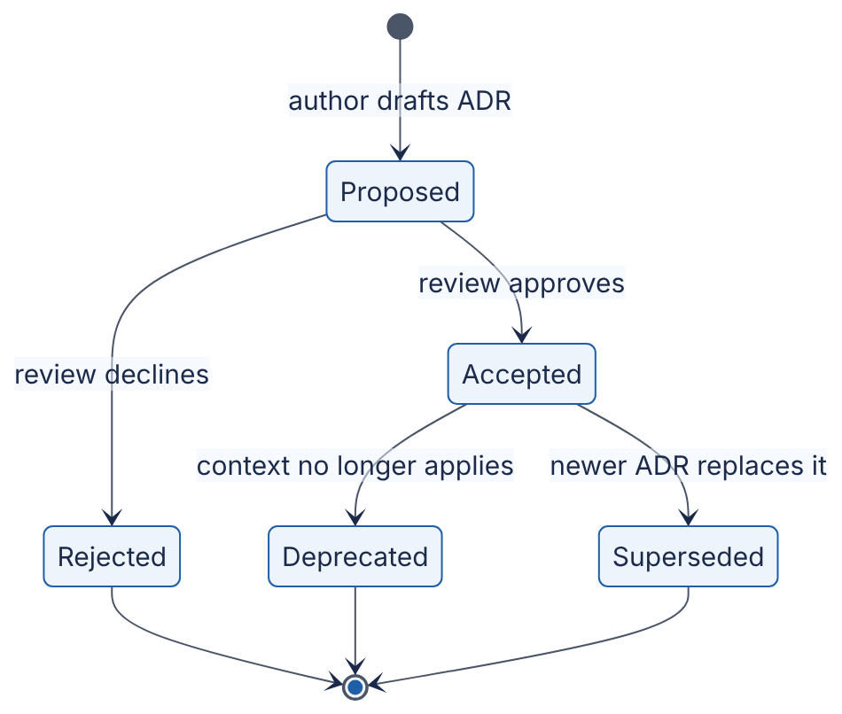
Reading the diagram.
- Components (states). Each box is the status field of an ADR. Nygard’s original format lists proposed, accepted, deprecated and superseded; Rejected is a common extension that preserves the record of options the team declined.
- Transitions. An ADR starts as Proposed and becomes Accepted or Rejected through review. An accepted ADR is never edited to say the opposite; it becomes Deprecated (no longer relevant) or Superseded (with a link to the replacing ADR).
- Direction and sync/async. This is a state machine, not a data flow; all transitions are human decisions, made asynchronously over days.
- Storage boundaries. ADRs typically live as Markdown files in the same repository as the code they govern, so they are versioned and reviewed like code.
- Failure points. The common failure is an ADR stuck in Proposed forever, or an accepted ADR silently contradicted by code. Design reviews (§1.10) check for both.
- Scaling options. At organization scale, teams keep per-repository ADR logs plus a shared log for cross-cutting decisions.

Mathematical foundations
When several criteria matter, a weighted decision matrix makes the trade-off explicit and arguable.
FORMULA
Weighted decision score
$$S_{j}=\sum_{i=1}^{m}{w_{i}} s_{ij}, \sum_{i=1}^{m}{w_{i}}=1$$
Symbol | Meaning | Units
$S_{j}$ | Total score of option $j$ | points (same scale as $s_{ij}$)
$w_{i}$ | Weight of criterion $i$ (importance; sums to 1) | —
$s_{ij}$ | Score of option $j$ on criterion $i$ (here 1 = poor, 5 = excellent) | points
$m$ | Number of criteria | count
WORKED EXAMPLE
Worked example — Where should PhotoShare store photo files?
Options: (A) keep files on each application server’s local disk; (B) a shared network file server (NFS); (C) managed object storage.
Table 1.12 — Decision matrix for photo storage.
Criterion | Weight | A: Local disk | B: NFS server | C: Object storage
Durability | 0.30 | 1 | 3 | 5
Scalability | 0.25 | 1 | 2 | 5
Operability | 0.20 | 3 | 2 | 5
Cost | 0.15 | 5 | 3 | 3
Latency | 0.10 | 5 | 4 | 3
- $S_{A}=0.30\left(1\right)+0.25\left(1\right)+0.20\left(3\right)+0.15\left(5\right)+0.10\left(5\right)=0.30+0.25+0.60+0.75+0.50=2.40$.
- $S_{B}=0.30\left(3\right)+0.25\left(2\right)+0.20\left(2\right)+0.15\left(3\right)+0.10\left(4\right)=0.90+0.50+0.40+0.45+0.40=2.65$.
- $S_{C}=0.30\left(5\right)+0.25\left(5\right)+0.20\left(5\right)+0.15\left(3\right)+0.10\left(3\right)=1.50+1.25+1.00+0.45+0.30=4.50$.
Interpretation. Object storage wins clearly. A sensitivity check matters more than the totals. Suppose a cost-conscious reviewer doubles cost’s weight to 0.30 and halves durability’s to 0.15:
- $S_{A}=0.15\left(1\right)+0.25\left(1\right)+0.20\left(3\right)+0.30\left(5\right)+0.10\left(5\right)=0.15+0.25+0.60+1.50+0.50=3.00$.
- $S_{B}=0.15\left(3\right)+0.25\left(2\right)+0.20\left(2\right)+0.30\left(3\right)+0.10\left(4\right)=0.45+0.50+0.40+0.90+0.40=2.65$.
- $S_{C}=0.15\left(5\right)+0.25\left(5\right)+0.20\left(5\right)+0.30\left(3\right)+0.10\left(3\right)=0.75+1.25+1.00+0.90+0.30=4.20$.
C still wins by more than a point, so the ranking is robust to this disagreement.
Engineering implication. The matrix does not make the decision; it exposes which weights would have to change for the decision to flip, so that reviewers argue about priorities rather than conclusions. Scores of 1–5 are judgments; where a number can be measured (latency, cost per TB), measure it.

Code example
Here is the ADR that records the decision. ADRs are plain Markdown; the block below uses the text tag so its content is shown verbatim.
# ADR-0003: Store photo binaries in managed object storage
Status: Accepted (2026-03-14). Supersedes ADR-0001 "Store photos on local disk".
Deciders: PhotoShare backend team. Reviewed in design review DR-12.
## Context
- v0 stores photo files on the single VM's local disk (ADR-0001).
- The disk is 80% full; uploads add ~50 GB/day at 100,000 DAU (§1.9 estimate).
- v1 must meet 99.9% monthly availability, which requires at least two
stateless application servers behind a load balancer. Files on one
server's local disk are invisible to the other servers.
- There is no off-machine copy of photos; a disk failure loses all photos.
## Decision
Store every original and thumbnail in managed object storage under the key
photos/{photoId}/{variant}. Application servers keep no photo files locally.
Clients download images through the CDN, never directly from app servers.
## Options considered
A. Local disk per server - rejected: blocks horizontal scaling; no durability.
B. Shared NFS server - rejected: new single point of failure; we would
operate replication and backups ourselves.
C. Managed object storage - chosen (decision matrix score 4.50 vs 2.65, 2.40).
## Consequences
+ Application servers become stateless and can be added or replaced freely.
+ Durability and capacity are the provider's responsibility.
- Upload path gains a network hop (~tens of ms to the object store).
- Storage cost becomes a per-GB monthly bill that grows with users; add a
lifecycle policy to move old originals to a colder tier (see Ch 15).
- One-time migration of existing files (~2 TB); plan a dual-read period.
- Vendor-specific API; wrap it behind the BlobStore interface (Figure 1.3).
What to notice:
- Context is factual and dated; it includes the numbers that made the decision necessary. When those numbers change, the ADR tells you the decision may need revisiting.
- Consequences list negatives, not only benefits. An ADR with no downsides is advocacy, not a record.
- Supersession is explicit in both directions: ADR-0001 should be updated only to change its status to “Superseded by ADR-0003”.
- Nygard’s original format is Title, Status, Context, Decision, Consequences [Nygard 2011]; “Options considered” and “Deciders” are widely used extensions.

Real-world industry applications
INDUSTRY EXAMPLE
Lightweight ADRs in open-source and public-sector projects. After Nygard’s 2011 post, the format spread widely; many public repositories contain an ADR numbered 0001 titled “Record architecture decisions”, whose decision is simply to adopt ADRs for the project. The appeal is low cost: a page of Markdown reviewed in the same pull-request workflow as code. Evidence: Secondary — [Nygard 2011] and the many public repositories that adopt its format; the specific spread is an observation, not a measured statistic.

Advantages and disadvantages
Advantages: cheap to write; versioned with the code; preserves the why; speeds onboarding; prevents re-litigating settled questions; forces explicit consequences. Disadvantages: only as good as team discipline; can become bureaucratic if required for trivial choices; a large ADR log needs an index to remain navigable.

Alternatives and trade-offs
ADRs complement rather than replace design documents (§1.10): a design doc explores a whole problem and may produce several decisions; each significant decision is then distilled into an ADR. Wikis are easier to browse but drift from the code. Commit messages capture what changed but rarely the alternatives rejected.

Failure scenarios
Table 1.13 — Decision-making failure scenarios.
What goes wrong | Why | Detection | Recovery | Prevention
Decision re-litigated every quarter | Rationale not recorded | Same debate in multiple meetings | Write the ADR retroactively | ADR for every one-way-door decision
Analysis paralysis | Treating a reversible choice as irreversible | Weeks of debate on a library choice | Time-box; pick and move on | Classify reversibility first (§2.8)
Decision by loudest voice | Criteria never made explicit | Dissenters disengage; later regret | Re-open with an explicit matrix | Agree criteria and weights before scoring
Stale ADR misleads | Context changed, ADR not superseded | Code contradicts accepted ADR | Write a superseding ADR | Review ADR log in design reviews

Common misconceptions
COMMON MISTAKE
“The decision matrix decides.” It structures judgment; it does not replace it. Weights encode values, and a team can make any option win by adjusting them. Its value is making those values visible.

1.9 Why system design matters (cost of wrong decisions)

1.9.1 Decisions differ in their cost of reversal
KEY CONCEPT
The asymmetry of design decisions. Most code-level decisions are cheap to reverse: rename a function, swap a library, redeploy. A few decisions are very expensive to reverse because data has been written in their shape: where files live, the primary key format, the partitioning key, the consistency model clients rely on, the public API contract. The job of system design is to spot the expensive few early and decide them deliberately, while keeping everything else cheap to change.

First-principles explanation
Moving furniture is easy; moving a load-bearing wall after the house is built is not. Data is software’s load-bearing wall: once billions of rows or petabytes of files exist in a particular shape, changing that shape means a migration that runs for days or months while the system stays live.

Why does this exist?
Bad design shows up as cost in four currencies: money (over-provisioned or emergency hardware), time (migrations that consume a team for a quarter), user trust (outages, data loss) and opportunity (features not built because engineers are fighting fires). Boehm and Basili summarized decades of industry data with the widely quoted observation that fixing a problem after delivery is often far more expensive than fixing it during requirements and design [Boehm and Basili 2001]; the exact multiplier varies greatly between studies and projects, but the direction is consistent.
The opposite error — over-engineering — has the same currencies. Building a 50-service architecture for 1,000 users spends money and time on problems that do not yet exist, and makes the system harder to change when you learn what users actually want.

How it works internally — PhotoShare grows up
We now evolve PhotoShare from Figure 1.1 through three more stages. Each stage is triggered by a specific requirement that the previous design cannot meet. All estimates come from the script in §1.3.2 with the same assumptions (50 photo views and 0.2 uploads per user per day; 2.5 MB stored per upload; 200 KB served per view; peak factor 3), plus one more: each user loads the feed about 5 times per day, so feed API requests are one-tenth of photo views.
Stage 1 — 100,000 DAU: separate state from compute. Two requirements break v0. The 99.9% availability target cannot be met with deploy downtime (§1.7.2 worked example), and uploads now add $100,000×0.2×2.5\text{ MB}=50$ GB per day to a single local disk. ADR-0003 (§1.8) moves files to object storage; a managed database with a standby replica replaces the local one; two stateless application servers sit behind a load balancer; images are served through a CDN.
Figure 1.5 — PhotoShare v1: stateless application tier and managed storage.
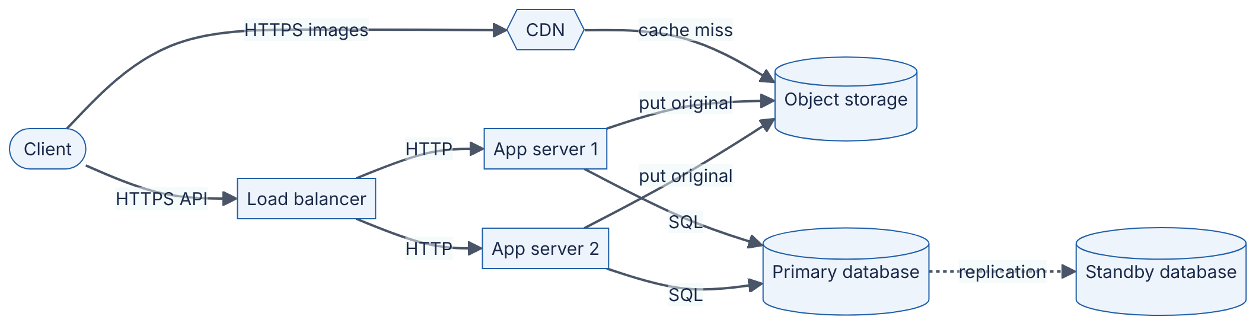
Reading the diagram.
- Components. A load balancer spreads API requests across two identical app servers (see Ch 19 (Load Balancing)). A primary database holds metadata, with a standby ready to take over. Object storage holds image bytes; a CDN (an external network of edge caches, drawn as a hexagon) serves images close to users (see Ch 21).
- Protocols. HTTPS from clients; plain HTTP inside the private network (or HTTPS, depending on the security model, §10.10); SQL to the database; the object store’s HTTP API.
- Direction and sync/async. API calls and image fetches are synchronous. Replication from primary to standby is drawn dotted: it is commonly asynchronous, so the standby may lag slightly (replication modes are covered in §14.4).
- Storage boundaries. App servers are now stateless: they hold no data that cannot be lost. All state lives in the database and object storage. This is what allows any app server to serve any request.
- Failure points. Losing one app server halves capacity but keeps the service up. The primary database is still critical: failover to the standby takes time and, with asynchronous replication, may lose the last few seconds of writes.
- Scaling options. Add app servers horizontally; scale the database vertically for now.
Stage 2 — 1,000,000 DAU: protect the database. Feed API traffic is now $1,000,000×5/86,400≈58$ RPS average and about 174 RPS at peak — modest — but each feed request runs a join across follows and photos, and the database CPU is the bottleneck. Synchronous thumbnail generation pushes upload p99 above 3 seconds. Two additions fix this: a cache for feeds, sessions and hot metadata (Ch 20), plus read replicas for queries that tolerate slight staleness (§14.3); and an asynchronous job queue so uploads return as soon as the original is stored (Figure 1.2; Ch 30).
Figure 1.6 — PhotoShare v2: cache, read replicas and asynchronous processing.
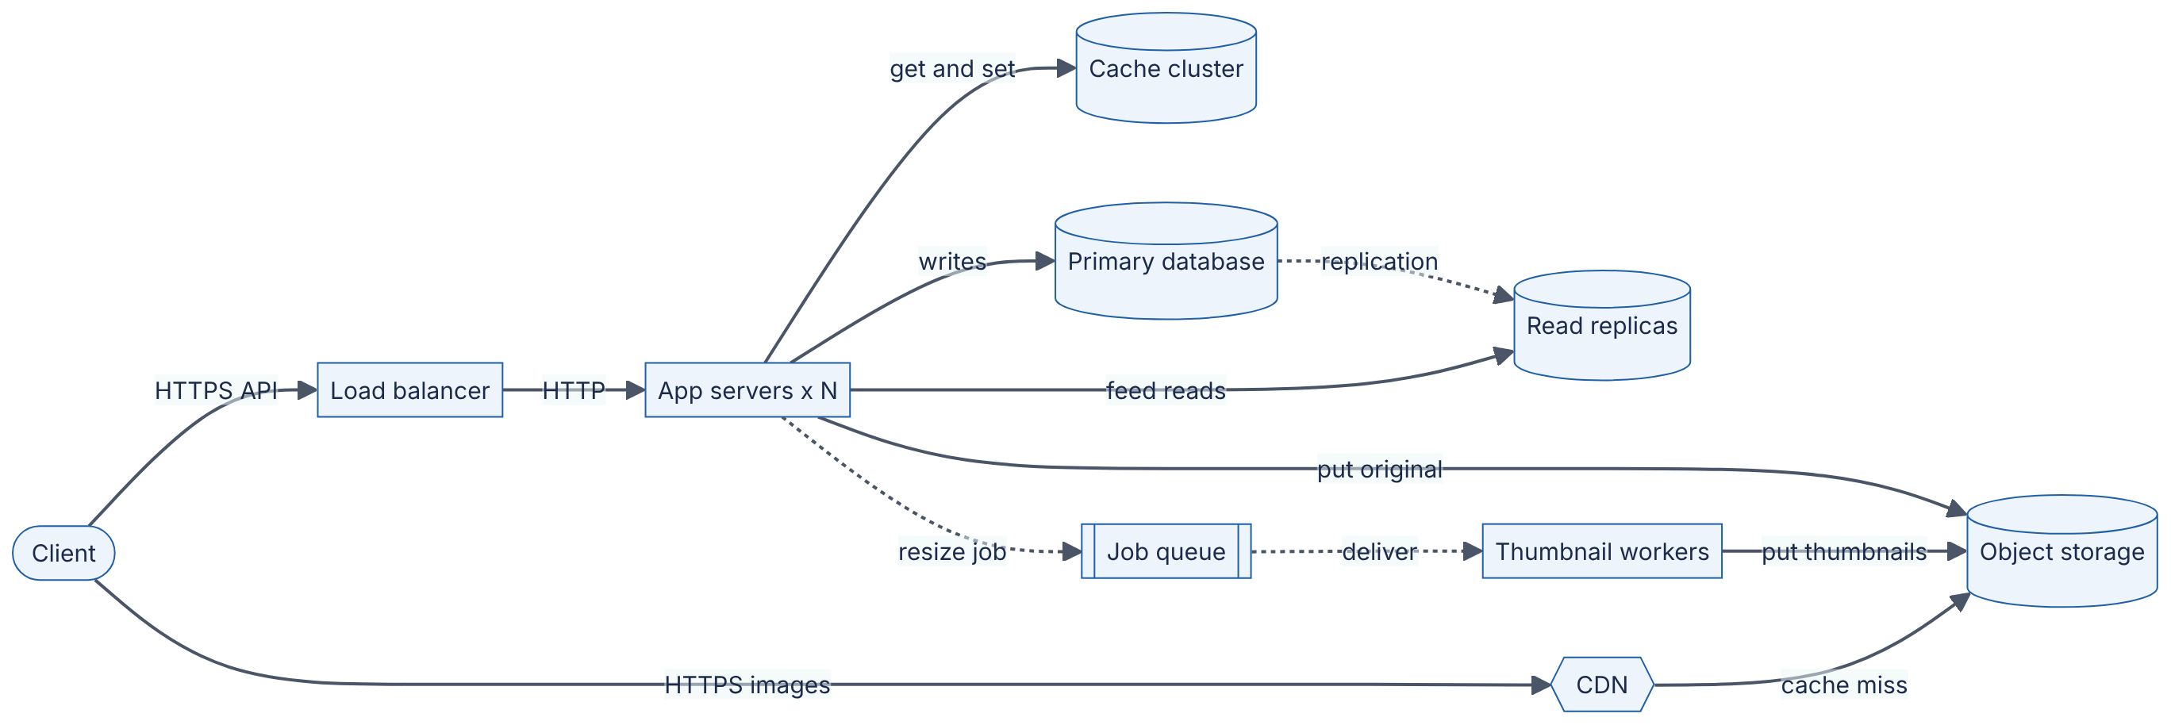
Reading the diagram.
- Components. New: a cache cluster (in-memory key-value store), read replicas of the database, a job queue and thumbnail workers.
- Protocols. The cache uses its own lightweight protocol over TCP; the queue uses the broker’s protocol.
- Direction and sync/async. Feed reads check the cache first (cache-aside, §20.7) and fall back to a replica on a miss. Uploads are synchronous only until the original is stored and the row written; resizing happens asynchronously (dotted arrows).
- Storage boundaries. Data now exists in up to four places — primary, replicas, cache, object storage — so consistency becomes a design question: a user who just uploaded may not see the photo if their next read hits a lagging replica. The consistency target in Table 1.7 (“own uploads visible to self immediately”) is met by routing a user’s reads of their own profile to the primary for a short time after a write (read-your-writes, §25.6).
- Failure points. A cache outage sends all reads to the replicas at once and can overload them (a cache avalanche, §20.13). A poisoned job that always crashes a worker must be moved aside to a dead-letter queue (§30.11).
- Scaling options. App servers and workers scale horizontally; replicas scale reads; the primary still takes every write.
Stage 3 — 10,000,000 DAU: scale every tier and survive a zone failure. The estimator now gives about 5,800 average and 17,400 peak photo views per second, about 1,700 peak feed API RPS, 5 TB of new photo data per day (1.8 PB per year before replication) and about 9.3 Gbit/s of average image egress (28 Gbit/s at peak). The availability target rises to “survive loss of one availability zone”. The design splits into a few services along clear data-ownership lines, partitions the metadata database by user ID (Ch 14), precomputes feeds asynchronously when a photo is posted (fan-out on write, examined in §53.3), and runs in at least two zones.
Figure 1.7 — PhotoShare v3: services, partitioned data and multi-zone deployment.
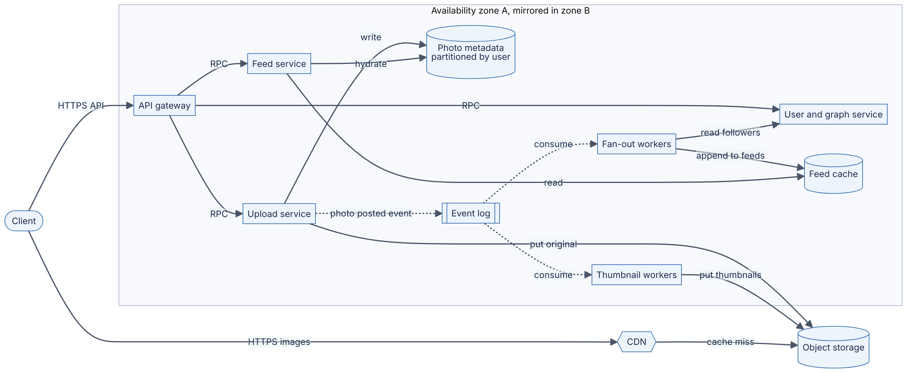
Reading the diagram.
- Components. An API gateway authenticates and routes requests (§34.6). The upload, feed and user and graph services each own their data. An event log (Ch 31) records “photo posted” events; fan-out workers insert the new photo ID into each follower’s precomputed feed in the feed cache; thumbnail workers consume the same events. Photo metadata is partitioned by user ID across many database nodes.
- Protocols. HTTPS at the edge; internal RPC (for example gRPC, §8.8) between gateway and services; the event log’s protocol for producers and consumers.
- Direction and sync/async. The read path (gateway → feed service → feed cache → metadata) is synchronous and short. The write path returns once the original and metadata are stored; everything else — thumbnails, fan-out — happens asynchronously from the event log, so a user with 100,000 followers does not make the upload slow.
- Storage boundaries. Object storage and the CDN are regional or global managed services outside the zone boundary; metadata, the event log and the feed cache are replicated across zones.
- Failure points. Loss of a zone: traffic shifts to the mirror zone, which must have spare capacity (≥ 50% headroom with two zones). Fan-out lag: followers see new photos seconds late — acceptable under the “within 5 s” consistency NFR, and visible as event-log consumer lag in monitoring (Ch 40). Celebrity accounts with tens of millions of followers make fan-out on write too expensive; a hybrid with fan-out on read for those accounts is the standard fix (§53.3).
- Scaling options. Every service is stateless and scales horizontally; metadata scales by adding partitions; the event log by adding partitions and consumers; the CDN absorbs image egress.
Table 1.14 — PhotoShare stages, triggers and costs.
Stage | DAU | Trigger (broken requirement) | Key changes | New cost or complexity
v0 (Fig. 1.1) | 1,000 | — | One VM | SPOF; no backups
v1 (Fig. 1.5) | 100,000 | 99.9% availability; disk filling | LB, stateless app servers, managed DB plus standby, object storage, CDN | Network hops; managed-service bills; failover semantics
v2 (Fig. 1.6) | 1,000,000 | DB CPU saturated; upload p99 > 3 s | Cache, read replicas, job queue, workers | Stale reads; cache invalidation; queue operations
v3 (Fig. 1.7) | 10,000,000 | Zone-failure tolerance; write volume; 28 Gbit/s egress | Services, partitioned metadata, event log, precomputed feeds, multi-zone | Distributed-systems failure modes; more teams and on-call

Mathematical foundations
WORKED EXAMPLE
Worked example — The cost of one wrong early decision.
Suppose PhotoShare had not written ADR-0003 and kept files on application-server disks until 1,000,000 DAU, by which time roughly 100 days at 0.5 TB/day had accumulated about 50 TB.
- Data to move: $50\text{ TB}=50×{10}^{12}$ bytes $=4×{10}^{14}$ bits.
- Available copy bandwidth, without starving production traffic: assume 1 Gbit/s $={10}^{9}$ bit/s.
- Copy time: $4×{10}^{14}/{10}^{9}=4×{10}^{5}$ s $≈111$ h $≈4.6$ days of continuous copying.
- Meanwhile 0.5 TB/day of new uploads keeps arriving, so the migration also needs dual-writes, verification checksums, a cut-over plan and a rollback plan — realistically several engineer-weeks, plus risk of data loss.
Interpretation. Making the decision at v1 with 2 TB took a few hours of copying; deferring it made it 25× larger and turned it into a project.
Engineering implication. Decisions about where data lives should be made early and on purpose, even when the system is small. Decisions about how much compute you run can safely wait.

Real-world industry applications
INDUSTRY EXAMPLE
Knight Capital (2012). On 1 August 2012, Knight Capital deployed new trading code to its order-routing servers using a manual process; one of eight servers did not receive the new code, and a repurposed configuration flag activated long-unused legacy logic on that server. In about 45 minutes the firm executed millions of unintended trades and lost more than $460 million. The U.S. Securities and Exchange Commission’s subsequent order cites, among other failures, the lack of adequate technical controls and written procedures for deployment. The lesson for designers: deployability and operability (Table 1.8) are architectural qualities, not afterthoughts — dead code, reused flags and manual deploys are design decisions with consequences. Evidence: Primary — [SEC 2013]
INDUSTRY EXAMPLE
A counter that outgrew its integer. In December 2014 YouTube reported that the view count of the music video “Gangnam Style” had exceeded the maximum value of a signed 32-bit integer (2,147,483,647), and that the counter had been upgraded to a 64-bit integer. Choosing the width of an identifier or counter is a tiny decision on day one and a data migration years later. Evidence: Secondary — widely reported at the time; primary source to be confirmed (see §1.19).

Failure scenarios
Table 1.15 — Costly design failure patterns.
What goes wrong | Why | Detection | Recovery | Prevention
Stateful app servers block scaling | Files or sessions stored locally | New servers serve 404s or log users out | Move state to shared stores; migration | Stateless services by default (§18.5)
Identifier overflow | 32-bit IDs or counters | Inserts fail at about 2.1 billion | Emergency schema migration | 64-bit or globally unique IDs (§17.10)
Premature microservices | Splitting before boundaries are understood | Every feature touches many services | Merge into a modular monolith | Start with a modular monolith (§33.5)
Unplanned celebrity load | Design assumed uniform users | Hot partitions; fan-out lag | Special-case heavy users | Ask about skew in requirements (§14.10)

Common misconceptions
COMMON MISTAKE
“We can always fix the architecture later.” You can always fix code later. Fixing data shape, storage location and public contracts later costs migrations that grow with the data. Decide those deliberately; defer the rest.

1.10 How system design is practiced in industry

1.10.1 Design documents
DEFINITION
Definition — Design document (design doc). A written proposal, produced before significant implementation, that states a problem, its goals and non-goals, a proposed design, the alternatives considered, and cross-cutting concerns (security, privacy, operations, cost), so that others can review it while changes are still cheap.

First-principles explanation
Before a building is constructed, its drawings are circulated to the structural engineer, the fire inspector and the client. Each reads for different risks, and each objection costs an eraser rather than a demolition crew. A design doc is the software equivalent: the cheapest place to find a design flaw is in a document.

How it works internally
Practice varies, but a widely cited public description of Google’s design-doc culture describes informal documents, written in a collaborative editor, typically containing [Ubl 2020]:
- Context and scope — the landscape the system lives in and what is being built.
- Goals and non-goals — including explicit things the system will not do.
- The actual design — often with a system-context diagram, APIs and data storage, emphasizing trade-offs rather than implementation detail.
- Alternatives considered — and why they were rejected.
- Cross-cutting concerns — security, privacy, observability and similar.
The same source describes larger design docs of roughly 10–20 pages and shorter “mini design docs” for smaller changes. Software Engineering at Google likewise treats design docs as a standard documentation type [Winters et al. 2020]. Amazon is publicly known for narrative documents instead of slide decks, including the “PR/FAQ” (a mock press release and FAQ written before building a product) described by two former Amazon executives [Bryar and Carr 2021].

1.10.2 Design reviews and production readiness
A design review is a meeting or asynchronous comment thread in which experienced engineers outside the authoring team challenge a design doc. Reviewers typically probe: Are the requirements and numbers right? What are the single points of failure? What happens under 10× load? How is it deployed and rolled back? How is it monitored? What does it cost? Is there a simpler design?
Close to launch, many organizations run a production readiness review (PRR): a checklist-based assessment that a service is operable — monitoring, alerting, capacity, runbooks, on-call — before it receives production traffic. Google’s SRE book describes PRRs as part of how SRE teams engage with services [Beyer et al. 2016]. After incidents, blameless postmortems (§39.12) feed lessons back into future designs.
Figure 1.8 — The life of a design in a typical engineering organization.
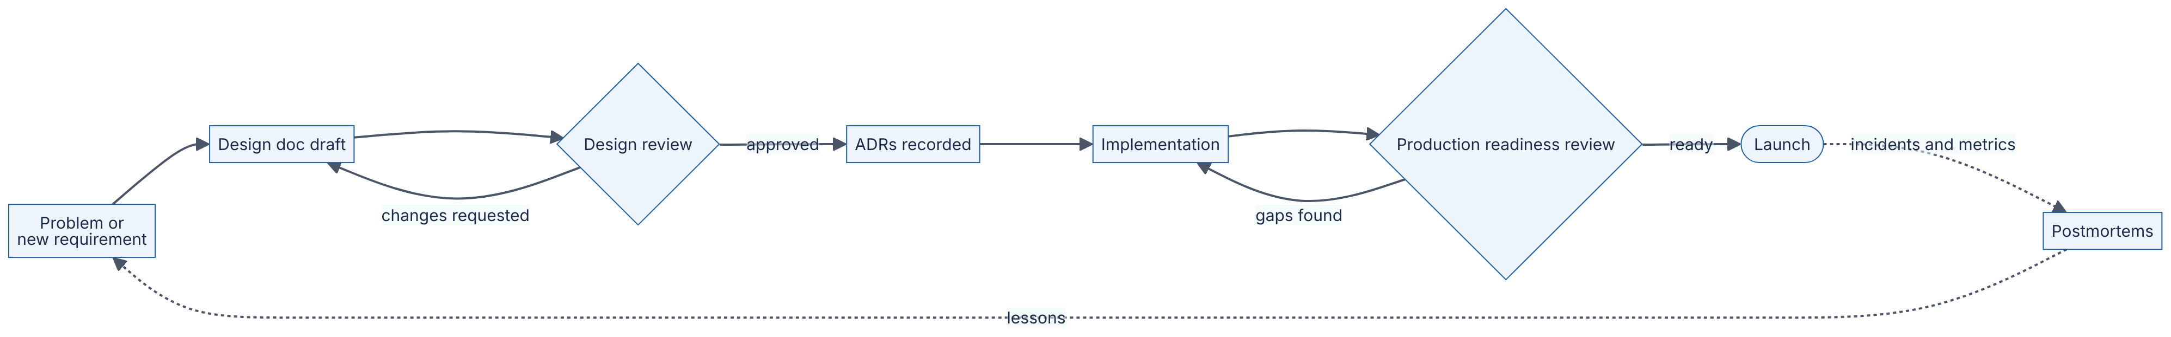
Reading the diagram.
- Components. Activities (rectangles), gates where a decision is made (diamonds) and the launch milestone (stadium).
- Direction. Work flows left to right from problem to launch, with two loops back: review feedback to the doc, and readiness gaps to implementation.
- Sync/async. Solid arrows are the planned path. Dotted arrows are the slower, asynchronous feedback from production — incidents and metrics — that eventually create new problems to design for.
- Storage boundaries. The durable artifacts are the design doc, the ADRs and the postmortems; together they form the organization’s architectural memory.
- Failure points. Skipping the review gate (designs built unreviewed), a review that becomes a rubber stamp, or postmortem lessons that never feed back into designs.
- Scaling options. Large organizations scale review capacity with tiered reviews: lightweight team review for reversible changes, cross-org architecture review for one-way-door decisions.

1.10.3 RFC processes
The term RFC (“Request for Comments”) comes from the Internet’s standards process; RFC 1, “Host Software”, was written by Steve Crocker in 1969 [Crocker 1969], and the IETF’s current standards process is itself defined in an RFC [Bradner 1996]. Many open-source projects run public proposal processes in the same spirit: Python Enhancement Proposals (PEPs) [Python PEP 1], Rust RFCs [Rust RFCs] and Kubernetes Enhancement Proposals (KEPs) [Kubernetes KEPs]. Inside companies, “RFC” usually means a design doc circulated widely for comment before a decision, often across teams.
Table 1.16 — Design artifacts compared.
Aspect | Design doc | ADR | RFC (company or open source) | PRR
What it is | Proposal for a whole design | Record of one decision | Proposal circulated for broad comment | Operability checklist
When | Before implementation | At decision time | Before cross-team or public change | Before launch
Length | 1–20 pages | ~1 page | 2–20 pages | Checklist
Audience | Team plus reviewers | Future maintainers | Whole organization or community | Operators and SRE
Output | Approved design | Durable rationale | Consensus decision | Launch go/no-go
Choose when | Non-trivial new system or change | Any one-way-door decision | Change affects many teams or users | New service or major change

Real-world industry applications
INDUSTRY EXAMPLE
Open-source RFCs as public design reviews. In the Rust and Python projects, any significant language change is proposed as a document in a public repository, discussed in the open, and accepted or rejected by a designated team, leaving a permanent record of the rationale and alternatives. They are among the best freely available corpora of real design reasoning — and good reading practice (see §3.5). Evidence: Primary — [Python PEP 1]; [Rust RFCs]

Failure scenarios
Table 1.17 — Design-process failure scenarios.
What goes wrong | Why | Detection | Recovery | Prevention
Review as rubber stamp | Reviewers lack time or context | Incidents in “reviewed” systems | Postmortem identifies missed risk | Named reviewers with explicit checklists
Design by committee | Every reviewer’s preference absorbed | Bloated design; slipped dates | Author re-asserts goals and non-goals | Clear decision owner
Doc written after the fact | Process seen as paperwork | Doc describes code, lists no alternatives | Treat as documentation, not review | Review before implementation starts

1.11 How system design interviews work

1.11.1 Format
DEFINITION
Definition — System design interview. A 45–60-minute interview in which a candidate designs a system from an open-ended prompt (for example, “design a photo-sharing service”) in conversation with an interviewer, who evaluates the candidate’s process, technical judgment and communication rather than a single correct answer.

First-principles explanation
The interview is a compressed design review in which you are the author and the interviewer is a friendly but probing reviewer. There is no single correct answer because real design has none; what is being assessed is whether you would be a good person to have in a real design review.

How it works internally
Formats differ between companies and levels (Ch 90 separates verified public information from general advice), but most follow a shape like Figure 1.9. Popular preparation guides describe a similar sequence — understand the problem and scope, propose a high-level design, dive deep, wrap up [Xu 2020].
Figure 1.9 — A typical 45-minute system design interview.
Reading the diagram.
- Components. Six phases, each with a suggested time budget for a 45-minute slot.
- Direction. Left to right. The dotted arrow shows that deep dives often send you back to revise the high-level design — that is expected, not a failure.
- What each phase produces. A short list of FRs and numeric NFRs; a few key numbers (peak RPS, storage per year); a handful of API calls and core tables; a diagram like Figure 1.6 or 1.7; a deep analysis of one or two components (feed generation, partitioning, consistency); a summary of bottlenecks, failure modes and what you would do next.
- Failure points. Spending 20 minutes on requirements, or jumping to the diagram with no requirements at all; going silent; designing for scale nobody asked for.
- Scaling to longer formats. In a 60-minute slot, the extra time usually goes to deep dives.

What interviewers evaluate
Table 1.18 — Interview signals: weak vs strong.
Signal | Weak | Strong
Requirements | Starts drawing immediately | Asks targeted questions; states FRs, numeric NFRs and non-goals
Estimation | Skips, or computes to six digits | Order-of-magnitude numbers that drive decisions
Design | Lists technologies by name | Explains what each component is for and why it is needed
Trade-offs | “X is the best” | “X gives A at the cost of B; given our NFRs, that’s acceptable”
Depth | Shallow everywhere | Deep on the hardest part of this problem
Failure thinking | Assumes nothing breaks | Names SPOFs, failure modes and recovery
Communication | Monologue or silence | Thinks aloud, checks in, adapts to hints
Expectations rise with level: a junior candidate is expected to produce a working design with guidance; a senior candidate to drive the conversation and identify the hard parts unprompted; a staff-level candidate to reason about evolution, organizational and cost concerns, and multiple viable designs (rubrics by level are in Ch 88).
INTERVIEW TIP
Interview tip — the first two minutes. For “design PhotoShare”, a strong opening sounds like: “Let me confirm scope: upload, follow, and a home feed of followed users’ photos — chronological, not ranked? I’ll leave out video, search and messaging. For scale, shall I assume around 10 million daily users, read-heavy — maybe 50 views per upload? And for quality targets: feed p99 under a few hundred milliseconds, uploads must never be lost, and a few seconds of delay before followers see a new photo is fine?” In thirty seconds you have stated FRs, non-goals, scale, read/write ratio, latency, durability and consistency — and given the interviewer a chance to redirect.
Variants include low-level/object-oriented design interviews (Ch 38), ML system design interviews (Ch 92), and product-flavored versus infrastructure-flavored prompts. Full preparation is in Book III (Ch 87–92).

1.12 Common beginner mistakes
Most beginner mistakes are versions of one error: designing without stating requirements and numbers. Table 1.19 lists the twelve most common.
Table 1.19 — Common beginner mistakes and their fixes.
# | Mistake | Symptom | Fix | See
1 | Jumping to a solution | Diagram before requirements | Spend the first minutes on FRs and NFRs | §1.6–1.7
2 | Vague NFRs | “Fast and scalable” | Numbers, percentiles, windows | §1.7
3 | No estimation | Arbitrary component counts | Back-of-the-envelope RPS, storage, bandwidth | §1.3.2, Ch 89
4 | Over-engineering | Microservices, Kafka and sharding for 1,000 users | Design for ~10× current load; evolve | §1.9
5 | Buzzword architecture | Technologies named, purpose unexplained | Justify every box by a requirement | §1.3
6 | Ignoring failure | No answer to “what if this node dies?” | Name SPOFs; add redundancy where the NFR demands it | Ch 39
7 | Averages instead of tails | p99 never mentioned | Specify and reason in percentiles | §1.7.1, §4.8
8 | Stateful app servers | Sessions or files on local disk | Push state into shared stores | §18.5
9 | One database for everything, forever | DB is every bottleneck | Cache, replicas, partitioning — when measured | Ch 14, Ch 20
10 | Silent trade-offs | Only advantages stated | Always name the cost of each choice | §1.7.3
11 | Forgetting the data lifecycle | No deletion, retention or backup plan | Treat deletion, backup and retention as requirements | §1.6, §39.9
12 | Forgetting operations | No monitoring, deploy or rollback story | Include observability and deployability | Ch 40, Ch 43
COMMON MISTAKE
The two-sided trap. Mistakes 4 and 9 are opposites, and beginners often swing from one to the other. The cure for both is the same: let measured or estimated load and stated requirements decide when each component is added. Figure 1.1 was right for v0; Figure 1.7 was right for v3; neither is right for the other.
RECOMMENDATION
A five-question self-check before any design discussion. (1) What must it do? (2) How well — in numbers? (3) How big — in RPS, bytes and growth? (4) What fails, and what happens then? (5) What did I give up, and why is that acceptable?

1.13 Summary and revision notes
SUMMARY
- System design is deciding components, responsibilities, interfaces, data flow, storage and deployment so a system meets functional and non-functional requirements under stated load and failure assumptions. A design is only good relative to its requirements.
- Software architecture is the set of significant, hard-to-change structures of a system; system design is its large-scale, runtime-focused part. Describe architecture with multiple views (4+1, C4).
- HLD fixes components, boundaries and contracts; LLD fixes the internals of one component. Design moves between the two levels.
- Functional requirements say what the system does; write them testably, prioritize them, and list non-goals. Some “small” FRs (account deletion) have large architectural consequences.
- Non-functional requirements say how well; they drive the architecture. Make them measurable (number, percentile, window, load) using quality attribute scenarios, SLIs and SLOs.
- 99.9% availability allows 43.2 minutes of downtime per 30 days; components in series multiply availabilities, so each synchronous dependency lowers the total.
- Quality attributes conflict (consistency vs availability, durability vs latency, availability vs cost). Name the tension and choose per operation.
- Record one-way-door decisions as ADRs (title, status, context, decision, consequences); supersede, never rewrite. Use weighted matrices to make priorities explicit.
- Decisions about where data lives and in what shape are expensive to reverse; decisions about compute quantity are cheap. Avoid both under- and over-engineering.
- Industry practice: design docs → design review → ADRs → implementation → production readiness review → launch → postmortems; RFC processes broaden review.
- Interviews compress a design review into 45–60 minutes: requirements, estimation, API and data, high-level design, deep dives, trade-offs.

1.14 Knowledge checkpoint
- In one sentence each, define system design and software architecture.
- Why is “a single server” a good design for PhotoShare v0 but a bad one for v3?
- Give two things that belong in an HLD and two that belong in an LLD.
- Rewrite “uploads should be fast” as a measurable NFR.
- What are the six parts of a quality attribute scenario?
- How much downtime does 99.95% availability allow in a 30-day month?
- Three components with availabilities 0.999, 0.999 and 0.9999 are in series. What is the path’s availability?
- Distinguish availability from reliability with an example.
- Distinguish an SLI, an SLO and an SLA.
- What are the five sections of Nygard’s ADR format?
- Why is an accepted ADR superseded rather than edited?
- A product has 2 million DAU, each making 30 API requests per day, with peak factor 3. Estimate average and peak RPS.
- Which PhotoShare requirement first forced the move off a single server — load or availability? Why?
- Name the five typical sections of a design doc as described in public accounts of Google’s practice.
- Name four of the twelve beginner mistakes in Table 1.19 and the fix for each.
Answers
- System design: choosing components, interfaces, data flow, storage and deployment so a system meets its functional and non-functional requirements under stated load and failure. Software architecture: the set of structures needed to reason about a system — its elements, their relations and the properties of both [Bass et al. 2021].
- At 1,000 DAU the peak load is about 1.7 RPS and simplicity dominates. At 10 million DAU the load (about 17,400 photo views per second at peak, 5 TB/day of new data), the zone-failure requirement and the 99.9% availability target all exceed what one machine — itself a single point of failure — can deliver.
- HLD: the list of services and data stores; the protocol and sync/async nature of each interaction (also deployment topology, data ownership). LLD: class structure and interfaces; table schemas and indexes (also algorithms, error handling, state machines).
- For example: “For photos up to 20 MB under normal load at up to 70 uploads per second, 99% of uploads return a photo ID within 2 s, measured server-side over a 30-day window.”
- Source, stimulus, environment, artifact, response, response measure.
- $\left(1−0.9995\right)×43,200=21.6$ minutes.
- $0.999×0.999×0.9999=0.998001×0.9999≈0.99790$, about 99.79%.
- Availability is the fraction of time the system is up and serving; reliability is the probability it operates correctly over a period. A feed service that responds quickly but sometimes shows other users’ private photos is available but unreliable (and insecure).
- SLI: the measured quantity (fraction of successful requests). SLO: the target for that SLI over a window (≥ 99.9% per 30 days). SLA: a contract with consequences if a stated target is missed.
- Title, Status, Context, Decision, Consequences.
- So that the historical reasoning remains intact: future readers can see what was decided, under what context, and what replaced it. Editing would erase the record of why the earlier choice was once right.
- Requests/day $=2×{10}^{6}×30=6×{10}^{7}$; average $=6×{10}^{7}/86,400≈694$ RPS; peak $≈3×694≈2,083$ RPS.
- Availability. At 100,000 DAU the load was still small, but deploy downtime plus occasional VM failures gave roughly 99.76%, below the 99.9% target; only multiple stateless servers behind a load balancer remove deploy downtime and the single point of failure.
- Context and scope; goals and non-goals; the actual design; alternatives considered; cross-cutting concerns [Ubl 2020].
- Any four, e.g. jumping to a solution → clarify FRs and NFRs first; vague NFRs → add numbers, percentiles and windows; over-engineering → design for about 10× current load and evolve; ignoring failure → name SPOFs and the recovery path.

1.15 Interview questions

Basic
Q1. What is the difference between functional and non-functional requirements? Give an example of each for a URL shortener.
Answer. Functional requirements describe behavior — what the system does: “given a long URL, return a short code; visiting the short URL redirects to the long one”. Non-functional requirements describe quality — how well, under what constraints, with numbers: “redirects complete with p99 ≤ 50 ms server-side at 10,000 RPS; the service is available 99.95% per month; a created mapping is never lost”. The NFRs drive the design: the latency and read volume suggest caching (Ch 20), and the durability requirement suggests a replicated store (Ch 27). The full design is in §52.1.
Q2. What is a single point of failure, and how would you find them in a design?
Answer. A component whose failure alone makes the whole system (or a critical function) unavailable. Trace each critical request path end to end and, for every component on it, ask “if this one instance disappears now, what happens?”. Typical SPOFs are a lone database primary, a single load balancer, one availability zone, a shared configuration service, and a person who is the only one able to deploy. Removing a SPOF usually means redundancy plus automatic failover, but each removal costs money and complexity, so remove the ones the availability NFR requires.

Intermediate
Q3. Your product manager asks for “five nines”. How do you respond?
Answer. First translate: 99.999% allows about 26 seconds of downtime per 30-day month — less than a typical database failover and less than most deploy rollbacks. Then ask what the business impact of downtime actually is and which user journeys need the target (checkout, perhaps; profile editing, probably not). Explain the cost: multi-zone or multi-region active–active deployment, automated failover, rigorous change management, and every synchronous dependency must itself exceed five nines because availabilities multiply in series. Propose per-journey SLOs (for example 99.95% for checkout, 99.9% elsewhere) with an error budget, and revisit with data [Beyer et al. 2016].
Q4. When would you introduce a cache, and what new problems does it bring?
Answer. When measurements or estimates show a read-heavy workload where a backing store is the bottleneck or too slow for the latency NFR, and where data can tolerate some staleness or be invalidated reliably — as at PhotoShare v2 (Figure 1.6). New problems: stale reads and invalidation (§20.10); cold-start and stampedes when popular keys expire together (§20.11); a cache outage overwhelming the database (§20.13); memory cost; and a new component to operate. State the expected hit ratio and what happens on a miss and on cache failure.

Advanced
Q5. Walk through how you would evolve a single-server photo-sharing app to 10 million DAU. What triggers each change?
Answer. Estimate first: at 10 million DAU with 50 views and 0.2 uploads per user per day, about 5,800 average and 17,400 peak photo views per second, about 1,700 peak feed API RPS, 5 TB/day of new data and about 28 Gbit/s peak egress. Then evolve by trigger, not by fashion. (1) Availability target and disk growth → stateless app servers behind a load balancer, managed database with standby, object storage and CDN; data location is decided early because it is expensive to change later. (2) Database CPU and upload latency → cache with cache-aside, read replicas with read-your-writes routing, async thumbnail jobs. (3) Zone-failure tolerance and write volume → services split by data ownership, metadata partitioned by user ID, an event log driving fan-out-on-write feed precomputation with a fan-out-on-read path for celebrity accounts, and multi-zone deployment with capacity headroom. At each stage, name the new failure modes (stale reads, cache avalanche, consumer lag, hot partitions) and how you would observe them.
Q6. Two senior engineers disagree about whether to adopt a new distributed database. How would you drive the decision?
Answer. Classify reversibility first: a primary datastore holding production data is a one-way door, so it deserves a design doc and review. Agree the decision drivers (specific NFRs with numbers), criteria and weights before scoring options, including “do nothing” and an incremental option (for example partitioning the existing database). Replace opinion with evidence where possible: a time-boxed prototype under representative load, failure-injection tests, and an estimate of migration and operational cost (team skills, on-call burden). Score with a weighted matrix, run a sensitivity check to see which weight changes would flip the result, and record the outcome as an ADR with explicit negative consequences and the conditions under which it should be revisited. The goal is a decision both engineers can commit to even if one disagrees.

1.16 Practical exercises
- Run and extend the estimator. Run the §1.3.2 script. Add fields for feed API requests (5 per user per day) and replication factor (3), and print API RPS and replicated storage per year for 1 million and 10 million DAU.
- Write NFRs. Pick an app you use daily. Write five measurable NFRs, one of them as a full six-part quality attribute scenario.
- Availability arithmetic. A request path has a CDN (99.99%), API gateway (99.95%), service (99.9%) and database (99.95%). Compute the path availability and the monthly downtime it implies. Which component would you make redundant first, and why?
- Write an ADR. Write ADR-0004 for PhotoShare: “Generate thumbnails asynchronously”. Include context with numbers, at least two options considered, and at least two negative consequences.
- Read a real design record. Choose one accepted Python PEP or Rust RFC. Identify its context, decision, alternatives and consequences, and compare its structure with Nygard’s ADR format.

1.17 Design challenges
- PhotoShare goes private. Add the requirement “accounts can be private; only approved followers can see their photos”. Which components in Figure 1.7 change? How do you stop the CDN from serving private photos to anyone with the URL? (Hint: signed URLs with short TTLs; see Ch 21.)
- PhotoShare in two regions. EU regulators require EU users’ photos and metadata to stay in the EU. Sketch the changes to Figure 1.7, list the new failure modes, and state which NFR tensions from Table 1.10 become sharper. (See Ch 44.)
- Cost ceiling. The business caps infrastructure cost at $0.01 per monthly active user per month. Using the v3 numbers, identify the two largest cost drivers (consider storage growth and egress) and propose design changes — storage tiers, image formats, CDN cache hit ratio — with estimated savings. (See Ch 51.)

1.18 References
- Barroso, L. A., Hölzle, U., Ranganathan, P. The Datacenter as a Computer: Designing Warehouse-Scale Machines, 3rd ed. Morgan & Claypool, 2018.
- Bass, L., Clements, P., Kazman, R. Software Architecture in Practice, 4th ed. Addison-Wesley, 2021.
- Beyer, B., Jones, C., Petoff, J., Murphy, N. R. (eds.). Site Reliability Engineering: How Google Runs Production Systems. O’Reilly Media, 2016. https://sre.google/sre-book/table-of-contents/
- Boehm, B., Basili, V. R. “Software Defect Reduction Top 10 List.” IEEE Computer, 34(1), 2001.
- Bradner, S. The Internet Standards Process — Revision 3. RFC 2026, IETF, 1996. https://www.rfc-editor.org/rfc/rfc2026
- Bryar, C., Carr, B. Working Backwards: Insights, Stories, and Secrets from Inside Amazon. St. Martin’s Press, 2021.
- Conway, M. E. “How Do Committees Invent?” Datamation, 14(4), 1968.
- Crocker, S. Host Software. RFC 1, 1969. https://www.rfc-editor.org/rfc/rfc1
- Dean, J., Barroso, L. A. “The Tail at Scale.” Communications of the ACM, 56(2), 2013.
- Fowler, M. “Who Needs an Architect?” IEEE Software, 20(5), 2003.
- Instagram Engineering. “What Powers Instagram: Hundreds of Instances, Dozens of Technologies.” Instagram Engineering blog, 2011. https://instagram-engineering.com/what-powers-instagram-hundreds-of-instances-dozens-of-technologies-adf2e22da2ad
- ISO/IEC 25010. Systems and software engineering — Systems and software Quality Requirements and Evaluation (SQuaRE) — Product quality model. ISO/IEC, 2011; revised 2023.
- ISO/IEC/IEEE 42010. Software, systems and enterprise — Architecture description. ISO/IEC/IEEE, 2011; revised 2022.
- Kleppmann, M. Designing Data-Intensive Applications. O’Reilly Media, 2017.
- Kruchten, P. “Architectural Blueprints — The ‘4+1’ View Model of Software Architecture.” IEEE Software, 12(6), 1995.
- Kubernetes Authors. Kubernetes Enhancement Proposals (KEPs). GitHub. https://github.com/kubernetes/enhancements
- Nygard, M. “Documenting Architecture Decisions.” Cognitect blog, 15 November 2011. https://cognitect.com/blog/2011/11/15/documenting-architecture-decisions
- Warsaw, B., Hylton, J., Goodger, D., Coghlan, A. PEP 1 — PEP Purpose and Guidelines. Python Software Foundation. https://peps.python.org/pep-0001/
- The Rust Project. Rust RFCs. GitHub. https://github.com/rust-lang/rfcs
- U.S. Securities and Exchange Commission. In the Matter of Knight Capital Americas LLC (administrative proceeding order). SEC, 2013.
- Ubl, M. “Design Docs at Google.” Industrial Empathy, 2020. https://www.industrialempathy.com/posts/design-docs-at-google/
- Winters, T., Manshreck, T., Wright, H. Software Engineering at Google: Lessons Learned from Programming Over Time. O’Reilly Media, 2020.
- Xu, A. System Design Interview – An Insider’s Guide. Independently published, 2020.

1.19 Open verification items
- [Nygard 2011] and [Ubl 2020]: URLs could not be fetched from the authoring environment (network-restricted); existence and dates confirmed only via search results. Re-check URLs and the Ubl page-length claim (“roughly 10–20 pages”; “mini design docs”).
- [SEC 2013]: confirm release number and URL of the Knight Capital order, and the figures “one of eight servers”, “about 45 minutes” and “more than $460 million”.
- YouTube “Gangnam Style” 32-bit counter (December 2014): locate a primary source (YouTube/Google post) or keep as Secondary.
- [Boehm and Basili 2001]: confirm wording of the after-delivery cost-of-fix item; the commonly quoted “100×” multiplier is deliberately not stated.
- [ISO/IEC 25010] and [ISO/IEC/IEEE 42010]: confirm exact current titles of the 2023 and 2022 revisions.

Chapter 2 — How to Think Like a System Designer
Level: 1–2 · Track: Shared · Estimated reading time: 3 h
Chapter 1 told you what system design is. This chapter is about how experienced designers think while they do it. It does not cover specific technologies (databases, caches, message brokers). Those come in Parts II–VI. What you get here is a set of thinking tools that apply to every design problem in this book, whether it is a URL shortener, a payment system or a large-language-model serving platform.
To keep the tools concrete, the whole chapter follows one running problem from a vague request to a documented architecture:
WORKED EXAMPLE
Running problem — QuickBite. A start-up asks you to “build the backend for our food-delivery app.” Customers browse nearby restaurants, put dishes in a cart, pay, and watch a courier bring the food. Restaurants receive orders on a tablet and mark them ready. Couriers receive delivery jobs on a phone and share their location while driving. QuickBite runs in one country today and wants to grow.
QuickBite is a hypothetical company invented for teaching. Every number attached to it in this chapter is an assumption we make and state openly. None of them is a measurement of any real food-delivery company.

2.1 Learning objectives
After this chapter you should be able to:
- Decompose a product description into components with clear responsibilities, using cohesion, coupling and data ownership as criteria.
- Draw a system-context diagram that separates what you are building from the people and external systems it depends on.
- Elicit, quantify and negotiate functional and non-functional requirements, turning vague wishes (“fast”, “real-time”, “never down”) into testable numbers.
- Identify the bottleneck of a request path using the resource model (CPU, memory, disk, network, locks and other software resources), the utilization law and Little’s Law.
- State assumptions explicitly, rank them by how much the design depends on them, and plan how to check them.
- Evaluate trade-offs with a weighted decision matrix, and judge how much process a decision needs by asking whether it is reversible (a “two-way door”) or not (a “one-way door”).
- Design for failure by listing failure modes, limiting blast radius and computing the availability of a dependency chain.
- Reason about scale in orders of magnitude, and predict which parts of a design break at 10×, 100× and 1000× the load.
- Perform a complete back-of-the-envelope capacity estimate with explicit arithmetic.
- Document an architecture with the C4 model, a design document and Architecture Decision Records (ADRs).

2.2 Prerequisites
- Functional vs non-functional requirements — §1.6 and §1.7. This chapter turns them into numbers and negotiates them.
- High-level vs low-level design — §1.5. Decomposition here stays at the high level.
- Powers of ten and units (KB vs KiB) — §4.3 and §4.5. Every estimate in §2.10 and §2.11 depends on them. This chapter uses SI prefixes throughout (1 KB = 10³ bytes, 1 GB = 10⁹ bytes).
- A rough idea of what a server, a database and a network request are. No deeper knowledge is assumed. Every other term is defined when first used.
Helpful but optional: Little’s Law (§4.11) and availability arithmetic (§4.14). This chapter introduces both informally and points forward to the full treatment.

2.3 Decomposition into components

2.3.1 The thinking loop and where decomposition fits
Before the first tool, look at the whole process. Experienced designers do not move in a straight line from requirements to boxes and arrows. They work in a loop. They make a rough pass through every concern, find the riskiest part, and go round again at higher resolution. The sections of this chapter are the tools used at each step of that loop. They are presented one at a time for teaching, but in practice you switch between them constantly.
Figure 2.1 — The system designer’s thinking loop.
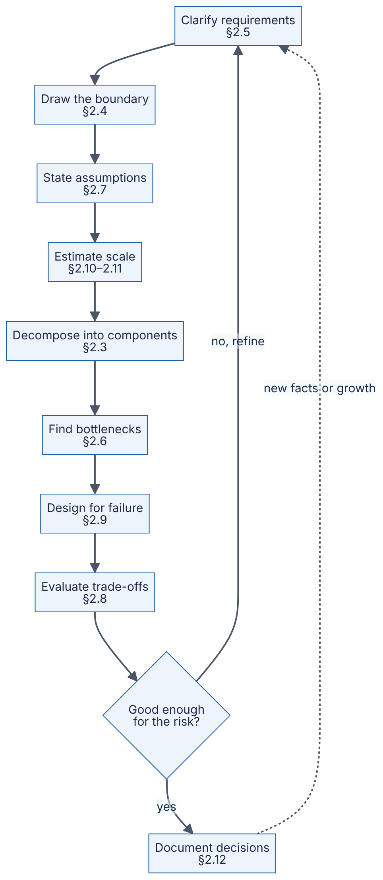
Reading the diagram. Each rectangle is a thinking activity, labeled with the section that teaches it. It is not a software component. Solid arrows show the usual order within one pass. The diamond is the decision every designer makes at the end of a pass: is the design good enough for the risk involved? A prototype for ten users clears that bar after one rough pass. A payment system may need many passes. The “no, refine” edge returns to requirements because a weak design is very often caused by a misunderstood requirement. The dotted arrow from documentation back to requirements is asynchronous: weeks or months later, production data or business growth disproves an assumption and starts the loop again. Nothing in this loop “fails” in the software sense. The failure to watch for is getting stuck, for example by polishing component diagrams (§2.3) before estimating scale (§2.11). The way to avoid that is to time-box each pass.

2.3.2 What decomposition is
DEFINITION
Definition — Decomposition. Dividing a system into smaller parts (components) so that each part has one clear responsibility, a well-defined interface, and as few dependencies on other parts as possible. Each part can then be understood, built, scaled and changed mostly on its own.

First-principles explanation
Think of a restaurant kitchen. Nobody “does the cooking.” There is a grill station, a fry station, a pastry station and a pass where plates are checked before they leave. Each station has its own tools and ingredients and gets work through a narrow interface: the ticket. When the fryer breaks, the grill keeps working. When dessert orders double, you add a pastry cook without touching the grill.
Software decomposition works the same way. You split a big, fuzzy problem (“the food-delivery backend”) into parts. Each part answers one question well (“what is on the menu?”, “where is the courier?”). The parts interact through narrow, explicit interfaces, usually an API or a message.

Why does this exist?
A system nobody can hold in their head cannot be reasoned about. Decomposition gives you four concrete benefits:
- Comprehension. One component fits in one engineer’s head.
- Independent scaling. In QuickBite, courier location updates arrive thousands of times per second, but restaurants edit menus a few times per day. Separating them lets each be scaled on its own terms.
- Failure isolation. A bug in the recommendation feature should not stop customers from paying.
- Team autonomy. Different teams can own different components. Conway’s observation that organizations produce designs that copy their own communication structures [Conway 1968] means team boundaries and component boundaries end up shaping each other whether you plan it or not.
David Parnas made the classic argument for how to choose the parts. Divide a system so that each module hides a design decision that is likely to change, rather than by the steps of a processing flowchart [Parnas 1972]. That principle, information hiding, is still the best single test of a good boundary.

How it works internally
A practical decomposition procedure:
- List the nouns and verbs. From the product description: customer, restaurant, menu, dish, cart, order, payment, courier, delivery, location, notification. Verbs: browse, search, add to cart, place order, pay, accept, prepare, assign, pick up, track, deliver, rate.
- Group by data ownership. Ask “who is the single source of truth for this data?” Menus belong with restaurants. Orders and their states belong together. Courier locations are a separate, high-volume stream.
- Group by rate of change and load profile. Things that change at very different speeds, or see very different traffic, usually belong apart. Menus are read-heavy and rarely written. Location is write-heavy and short-lived.
- Group by consistency need. Money movements need strong guarantees: no double charges. The display of a courier’s position can tolerate being a few seconds stale.
- Name each component with one sentence of responsibility. If the sentence needs “and”, consider splitting it.
- Draw the interactions. Mark each one as synchronous (the caller waits) or asynchronous (the caller hands off a message and moves on).
- Check against scenarios. Walk the top three user journeys through the diagram. Every step must have exactly one owner.
Applying this to QuickBite gives the components in Table 2.1.
Table 2.1 — QuickBite components and their single responsibilities.
Component | Responsibility (one sentence) | Owns data | Load profile | Consistency need
API gateway | Authenticates clients and routes requests | None (stateless) | All traffic | n/a
Catalog service | Serves restaurants, menus and prices | Restaurants, menus | Read-heavy | Minutes of staleness OK
Search service | Finds restaurants by location, cuisine, text | Search index (derived) | Read-heavy | Derived, can lag
Order service | Owns the life cycle of an order | Orders, order items | Moderate writes | Strong
Payment service | Charges and refunds via a payment provider | Payment records | Low volume | Strong, idempotent
Dispatch service | Assigns couriers to ready orders | Assignments | Bursty | Strong per assignment
Location service | Ingests and serves courier positions | Recent positions | Write-heavy | Seconds of staleness OK
Notification service | Sends push, SMS and email | Delivery log | Bursty, async | At-least-once

Architecture diagram
Figure 2.2 — QuickBite first-pass decomposition.
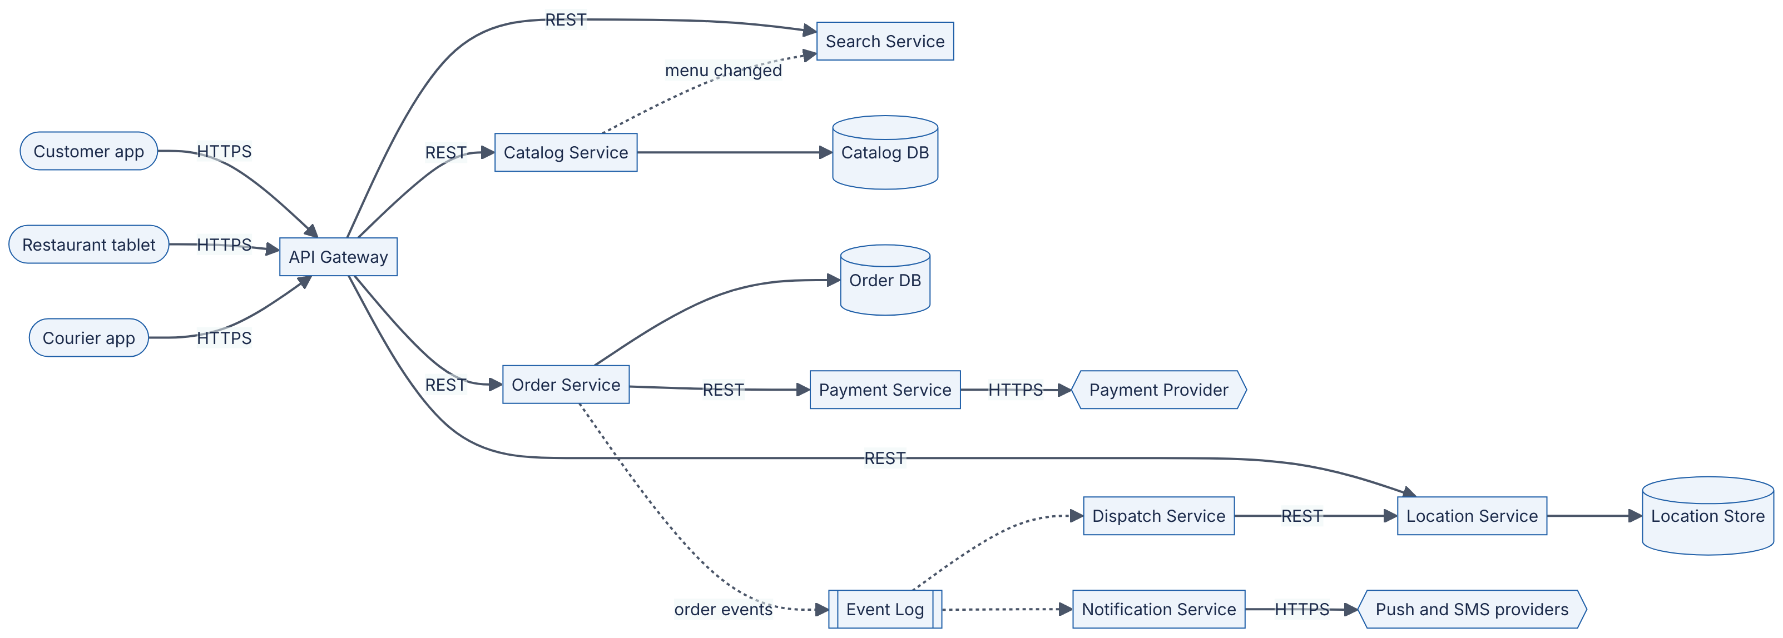
Reading the diagram. Three client types (stadiums) reach the system only through the API gateway over HTTPS. The gateway is stateless, so it scales horizontally behind a load balancer (Chapter 19). Solid arrows are synchronous request/response calls. Placing an order calls the order service, which calls the payment service, which calls the external payment provider (hexagon). That chain is the critical path, and every link in it can fail (§2.9). Dotted arrows are asynchronous. Once an order is committed, the order service publishes an event to the event log (subroutine shape; see Chapter 30). The dispatch and notification services consume it at their own pace, so a slow SMS provider cannot slow down checkout. Each cylinder is a storage boundary owned by exactly one service. No service reads another service’s database, which keeps data ownership clear (§34.11). The catalog service pushes menu changes asynchronously to the search service, whose index is a derived copy that may lag by seconds. The location store is the heaviest write path, as §2.11 will show, so it scales independently, for example with an in-memory store partitioned by city. Likely failure points: the payment provider (external, outside your control), the order database (single source of truth) and the event log (if it stops, dispatch stops). Each needs a mitigation in §2.9.
NOTE
Components are logical, not deployment units. Figure 2.2 shows logical components. On day one, QuickBite might deploy all of them as one process: a modular monolith (§33.5). Decomposition decides where the boundaries are. Deployment decides how many processes there are. §2.8 makes that second decision with a decision matrix.

Real-world industry applications
INDUSTRY EXAMPLE
Amazon’s move to services. In a 2006 interview, Amazon’s CTO Werner Vogels described how Amazon’s early monolithic application was restructured into services. Each service owned its data and could only be reached through a published interface. Direct database access between teams was ruled out. He linked this to team ownership (“you build it, you run it”). The design choice was data ownership behind interfaces, the same rule used in Figure 2.2. The trade-off he acknowledged was added operational and coordination complexity in exchange for team independence and scalability. Evidence: Primary — [Gray 2006]

Advantages and disadvantages
Good decomposition makes reasoning, scaling, failure isolation and team ownership easier. It also has costs. Every boundary that crosses a network turns a function call (~nanoseconds) into a remote call (~0.1–0.5 ms or more within a datacenter, see §4.17), and that call can fail independently. Data split across components loses cross-component transactions (Chapter 28). Too many components multiply operational load: more deployments, dashboards and on-call rotations.

Alternatives and trade-offs
Table 2.2 — Ways to choose component boundaries.
Approach | Splits by | Works well when | Main risk
By technical layer | UI / logic / data | Small systems, one team | Every feature change touches every layer
By business capability | Orders, catalog, payments | Most product systems | Needs domain understanding up front
By volatility (Parnas) | Decisions likely to change | Long-lived systems | Requires predicting change
By load profile | Read-heavy vs write-heavy | Very uneven traffic | Can fragment one domain concept
By domain-driven bounded context | Consistent language and model | Large organizations | Heavy analysis cost (§34.4–34.5)
In practice you combine them. QuickBite splits by business capability first, then splits location out of dispatch because of its very different load profile.

Failure scenarios
Table 2.3 — Decomposition failure scenarios.
What goes wrong | Why | Detection | Recovery | Prevention
Distributed monolith | Services share a database or must deploy together | Every release touches many services; cross-service schema locks | Merge tightly coupled services | Enforce data ownership; review coupling
Chatty interfaces | Boundary cuts through a hot loop | One user request causes dozens of internal calls; high p99 | Batch calls or move the boundary | Walk scenarios through the diagram before building
Orphan responsibility | No component owns a step, e.g. refunds | Bugs bounced between teams | Assign an owner explicitly | Step 7 of the procedure: one owner per step
Premature split | Boundaries drawn before the domain is understood | Frequent cross-boundary changes | Re-merge into a modular monolith | Start coarse; split when evidence appears

Common misconceptions
COMMON MISTAKE
“More components means a better design.” The number of boxes is not a quality measure. A good decomposition has few, cohesive components with narrow interfaces. A useful test: if two components change together in most pull requests, they are probably one component.
COMMON MISTAKE
“Decompose by technology.” “The Redis service” or “the Kafka service” are not responsibilities. Components are named after what they do for the business (“location service”). The technology they use is an internal detail that may change.

2.4 System boundaries and context diagrams

2.4.1 Boundaries and the context diagram
DEFINITION
Definition — System boundary. The line that separates what you are designing and are responsible for from everything outside it: users, other teams’ systems and third-party services. You control what is inside. You can only depend on what is outside.
DEFINITION
Definition — Context diagram. A diagram that shows the whole system as a single box, surrounded by the people (actors) and external systems that interact with it, with each interaction labeled. Context diagrams come from structured analysis [DeMarco 1979] and are Level 1 of the C4 model [Brown C4].

First-principles explanation
Before renovating a house, a builder walks the property line. Fences, the street, the neighbor’s tree and the water main are not part of the job, but every one of them constrains it. A context diagram is that walk around the property line. It answers three questions before any internal design starts: who uses this?, what does it depend on? and what is not our job?

Why does this exist?
Many expensive design failures are scope failures, not technical ones. A team builds a payment system and finds out late that tax calculation was expected. Or it assumes an external maps API can take 10,000 requests per second when the contract allows 100. Drawing the boundary early brings these surprises to the surface while they are still cheap to fix. It also gives non-engineers, such as product managers, legal and finance, a diagram they can actually check.

How it works internally
- Draw your system as one box. Resist the urge to draw its insides.
- Around it, place every actor (human role) and every external system.
- Label each interaction with what flows (not how): “places orders”, “sends card charge”.
- For every external system, note three facts: its availability promise (its SLA, see §39.6), its rate limits and its latency. These numbers are inherited constraints you do not control.
- Write down what is explicitly out of scope.

Architecture diagram
Figure 2.3 — QuickBite system-context diagram.
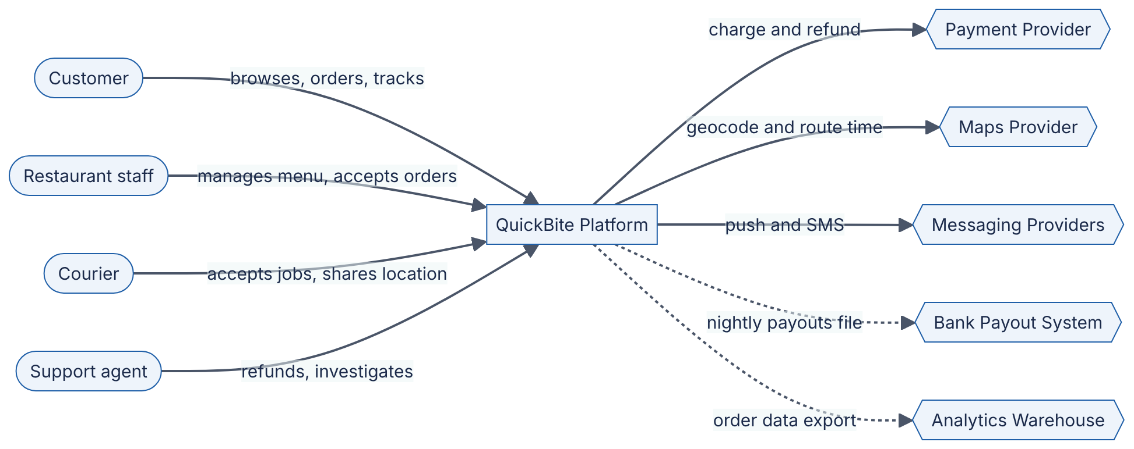
Reading the diagram. The single rectangle is the whole QuickBite platform, deliberately shown with no internal detail. Four human actors (stadiums) interact with it. Note the support agent, an actor often forgotten in first drafts, who needs refund and investigation tools. Five external systems (hexagons) sit outside the boundary. Solid arrows are synchronous, user-facing interactions. A customer waits while a card charge happens, so the payment provider’s latency and availability become part of QuickBite’s own checkout latency and availability. Dotted arrows are asynchronous batch flows. Payouts to restaurants and data exports run nightly and can be retried without users noticing. Each hexagon is a failure point outside your control. The maps provider is especially dangerous because both search (delivery-time estimates) and dispatch depend on it. Hexagons also bring rate limits and per-call costs, so scaling QuickBite may be limited by contracts rather than by servers.
WORKED EXAMPLE
Worked example — Inherited constraints from the boundary. Suppose the maps provider’s contract allows 500 requests per second and charges $0.005 per route-time request. (These figures are assumptions for QuickBite, not any real provider’s price list.)
- If every restaurant listing in search results needs a live route-time estimate, and search peaks at 2,000 requests per second showing 20 restaurants each, QuickBite would need 2,000 × 20 = 40,000 route requests per second.
- That is 40,000 / 500 = 80 times the contract limit.
- Cost at that rate for one peak hour: 40,000 × 3,600 × $0.005 = $720,000.
Interpretation. Calling the maps provider per listing is impossible, regardless of how good the internal architecture is. Engineering implication: estimate delivery times internally, for example from precomputed travel-time grids per city zone, and call the provider only once per placed order. The boundary diagram exposed this constraint before any code was written.

Real-world industry applications
INDUSTRY EXAMPLE
C4 system-context diagrams. Simon Brown’s C4 model makes the system-context diagram its first and most abstract level. It recommends showing the software system as one box with its users and the other software systems it depends on, and states that the diagram should be understandable by non-technical stakeholders. Evidence: Primary — [Brown C4]

Failure scenarios and misconceptions
Table 2.4 — Boundary failure scenarios.
What goes wrong | Why | Detection | Recovery | Prevention
Hidden dependency outage | An external system was never listed | Incident traced to an unlisted vendor | Add fallback; add it to the diagram | Inventory every outbound call
Rate-limit wall | Vendor limits not read | HTTP 429 errors at peak | Cache, batch, negotiate a higher tier | Step 4: record limits per external system
Scope creep | Boundary never agreed | Late “but we assumed you’d do X” | Re-plan | Explicit out-of-scope list signed off
COMMON MISTAKE
“External systems are always available.” A third-party SaaS API typically promises somewhere between 99.9% and 99.99% availability, as of 2026. At 99.9% that is up to about 43 minutes of downtime per 30-day month. Your design must decide what QuickBite does during those minutes (§2.9).

2.5 Understanding and negotiating requirements

2.5.1 Eliciting and negotiating requirements
DEFINITION
Definition — Requirement. A statement of what the system must do (a functional requirement, e.g. “a customer can cancel an order before the restaurant accepts it”) or how well it must do it (a non-functional requirement, e.g. “99% of order placements complete within 800 ms”). A requirement is testable if you could write an automated check or a measurement that proves it is met.

First-principles explanation
A customer asks a tailor for “a nice suit.” A bad tailor starts cutting. A good tailor asks: for what occasion? Which climate? What budget? Ready by when? The good tailor is not being difficult. “Nice” can mean a hundred different suits, and only one of them is what the customer actually wants. Requirements gathering is the tailor’s questions. Negotiation is the conversation that follows: “a hand-stitched suit by Friday for that budget is not possible, but a made-to-measure one is.”

Why does this exist?
Vague requirements cause two opposite failures. Under-engineering builds a system that falls over on launch day because nobody asked how many users would arrive. Over-engineering spends six months building multi-region active–active replication for a product with 200 users, because someone said “it must never go down.” Both come from the same root cause: a requirement nobody turned into a number.
Requirements also conflict. “Show the courier’s exact position in real time” pushes against “keep infrastructure costs under budget” and “protect courier privacy.” Someone has to decide how those conflicts are resolved, and the designer’s job is to make that decision visible and deliberate.

How it works internally
A reliable elicitation and negotiation procedure:
- Identify users and their top journeys. For QuickBite: browse and order, track delivery, restaurant accepts and prepares, courier delivers.
- Write functional requirements as user-observable behaviors, and rank them with MoSCoW priorities: Must, Should, Could, Won’t (this time).
- For each journey, ask the “-ility” questions (§1.7): How many users? How fast? How available? How consistent? How durable? How secure? What does it cost?
- Quantify every non-functional requirement as a metric, a threshold and a measurement window. “Fast” becomes “p99 < 800 ms measured over 5-minute windows”. The notation p99 means the 99th percentile: 99% of requests are faster than this value (§4.8).
- Differentiate by journey. Availability and latency targets rarely need to be uniform. Checkout deserves a stricter target than the restaurant’s sales-history report.
- Surface conflicts and negotiate. For each expensive requirement, show its cost and offer a cheaper alternative that still meets the underlying need.
- Record what was agreed, and what was explicitly rejected.
Table 2.5 — QuickBite requirements after negotiation.
ID | Requirement (as first stated) | Negotiated, testable version | Priority
F1 | “Customers can order food” | Customer can place an order of 1–30 items from one restaurant and pay by card or wallet | Must
F2 | “Real-time tracking” | Courier position shown on a map, refreshed every 5 s; position at most 10 s old at p95 | Must
F3 | “Restaurants get orders instantly” | New order appears on the restaurant tablet within 5 s at p99 | Must
F4 | “Smart recommendations” | Deferred to phase 2; phase 1 shows “popular near you” | Won’t (now)
N1 | “Never goes down” | Order placement available 99.95% per 30-day month; browsing 99.9% | Must
N2 | “Fast” | Place-order p99 < 800 ms excluding payment-provider time; browse p99 < 300 ms | Must
N3 | “Never lose an order” | Once the customer sees “order confirmed”, the order survives the loss of any single node or zone (RPO = 0 for orders) | Must
N4 | “Never double-charge” | Each order is charged at most once, even if the client retries (idempotency, §22.15) | Must
N5 | “Menus always correct” | Menu or price changes visible to customers within 60 s; price is re-checked at order time | Should
Notice what negotiation did to N1. “Never goes down” is impossible: no system reaches 100%. It was also unnecessary for most features. The negotiated version gives each journey its own target and makes the target measurable. RPO in N3 is the recovery point objective, the amount of recent data you may lose in a disaster (§39.8).

Mathematical foundations
The most useful number in a negotiation is the downtime a target actually allows.
FORMULA
Allowed downtime for an availability target
$$T_{down}=\left(1−A\right)×T_{period}$$
Symbol | Meaning | Units
$T_{down}$ | Maximum downtime allowed in the period | minutes
$A$ | Availability target, as a fraction | dimensionless (e.g. 0.9995)
$T_{period}$ | Length of the measurement period | minutes
WORKED EXAMPLE
Worked example — What “three and a half nines” buys QuickBite. A 30-day month has 30 × 24 × 60 = 43,200 minutes.
- Browsing at 99.9%: $T_{down}$ = (1 − 0.999) × 43,200 = 0.001 × 43,200 = 43.2 minutes per month.
- Order placement at 99.95%: (1 − 0.9995) × 43,200 = 0.0005 × 43,200 = 21.6 minutes per month.
- A naive “five nines” (99.999%): 0.00001 × 43,200 = 0.43 minutes, about 26 seconds per month.
Interpretation. Twenty-six seconds a month is less than the time a person takes to notice an alert, open a laptop and log in. Five nines requires fully automated detection and failover across independent zones or regions, which multiplies cost and complexity. Engineering implication: for a regional food-delivery start-up, 99.95% on checkout is ambitious but reachable with redundancy inside one region (§39.4). Five nines would be over-engineering, and the payment provider’s own availability probably caps the achievable number anyway (§2.9).

Real-world industry applications
INDUSTRY EXAMPLE
Service level objectives at Google. Google’s Site Reliability Engineering book argues that 100% is the wrong reliability target for almost everything. Users cannot tell the difference between very high availability and 100%, because their own devices and networks are less reliable than that. Each extra nine costs a lot. Google’s practice is to agree an explicit service level objective (SLO) with product owners and treat the remaining unreliability as an error budget to be spent on releasing features. This is requirement negotiation turned into an ongoing process (§39.6–39.7). Evidence: Primary — [Beyer et al. 2016]

Advantages, alternatives and trade-offs
Up-front negotiation costs meeting time, and stakeholders may not know the answers yet. When they do not, do not block. Make an assumption (§2.7), label it, and design so that it is cheap to change if wrong. In interviews, spend roughly the first five to ten minutes of a 45-minute session on requirements. In industry, requirements live in a design document (§2.12) and get re-negotiated as data arrives.

Failure scenarios
Table 2.6 — Requirements failure scenarios.
What goes wrong | Why | Detection | Recovery | Prevention
Launch-day overload | Peak load never quantified | Errors and latency spike at launch | Emergency scaling, load shedding (§22.9) | Ask “how many, at peak?”
Gold-plating | “Never down” accepted literally | Cost far exceeds the budget; delivery late | Simplify | Translate every adjective into a number
Silent conflict | Two stakeholders want contradictory things | Rework after review | Escalate with options and costs | Step 6: surface conflicts explicitly
Uniform targets | One SLO applied to all features | Expensive redundancy on unimportant paths | Tier the features | Step 5: differentiate by journey

Common misconceptions
COMMON MISTAKE
“Requirements are given to the designer.” In practice they are discovered and negotiated by the designer together with stakeholders. A designer who only takes orders will build exactly the wrong thing, very efficiently.
INTERVIEW TIP
Interview tip. Say your negotiated requirements out loud and write them on the board as numbers: “I’ll assume 2 million daily active users, checkout at 99.95%, tracking refreshed every 5 seconds — does that match what you have in mind?” Interviewers reward this because it shows you design to a target, not by habit.

2.6 Identifying bottlenecks

2.6.1 The resource model and the bottleneck
DEFINITION
Definition — Bottleneck. The resource whose capacity limits the throughput of the whole system for a given workload. Throughput cannot rise above the bottleneck’s capacity no matter how much the other resources are improved. Formally, it is the resource with the highest service demand per request (defined below).

First-principles explanation
Picture a highway that narrows from four lanes to one for a bridge. Widening the highway before or after the bridge to eight lanes changes nothing: cars still cross the bridge one lane at a time. The bridge is the bottleneck. Worse, traffic does not slow down evenly. It piles up in a queue in front of the bridge. That is why a system near its bottleneck shows rising latency long before it shows errors.
Two consequences follow, and they explain most performance work:
- Improving a non-bottleneck resource gives zero improvement in throughput. Faster CPUs do not help if the database disk is the limit.
- Fixing the bottleneck moves it. Once the bridge is widened, the next narrowest point becomes the new bottleneck. Performance work is a sequence of “find the bottleneck, relieve it, find the next one.”

Why does this exist?
Systems are made of finite resources. When a QuickBite lunch rush arrives, the first resource to run out decides whether customers see a spinner or an error. If you cannot name that resource, you will add capacity in the wrong place, and pay for servers that make no difference.

How it works internally: the resource model
Every request consumes a small amount of several resources. The classical hardware four plus one software category cover almost every case:
Table 2.7 — The resource model.
Resource | What a request consumes | Utilization signal | Saturation signal | Typical relief
CPU | Cycles for parsing, serialization, business logic, encryption | % busy per core | Run-queue length > core count | Optimize hot code, cache results, add cores or nodes
Memory | Working set, buffers, caches, per-connection state | % used | Swapping, OOM kills, GC pauses | Reduce footprint, add RAM, partition data
Disk | Reads and writes (IOPS), bytes per second, fsync latency | % time busy, IOPS used vs limit | Long I/O queue, rising await time | Cache, batch writes, faster media, partition
Network | Bytes in and out, packets, connections | Bandwidth used vs link capacity | Dropped packets, retransmits | Compress, CDN, bigger links, keep traffic local
Locks and other software resources | Exclusive access to a row, mutex, thread, connection-pool slot, file handle | Fraction of time held | Waiters queued; pool exhausted | Shorten hold time, finer-grained locks, bigger pools, partition the hot item
The last row is the one beginners miss. A software resource, such as a database row lock, a thread pool or a connection pool, is just as finite as a CPU. It can be the bottleneck while every hardware dashboard shows idle machines.
The standard diagnostic method is Brendan Gregg’s USE method: for every resource, check Utilization, Saturation and Errors [Gregg USE]. Figure 2.4 turns it into a procedure.
Figure 2.4 — Finding the bottleneck with the USE method.
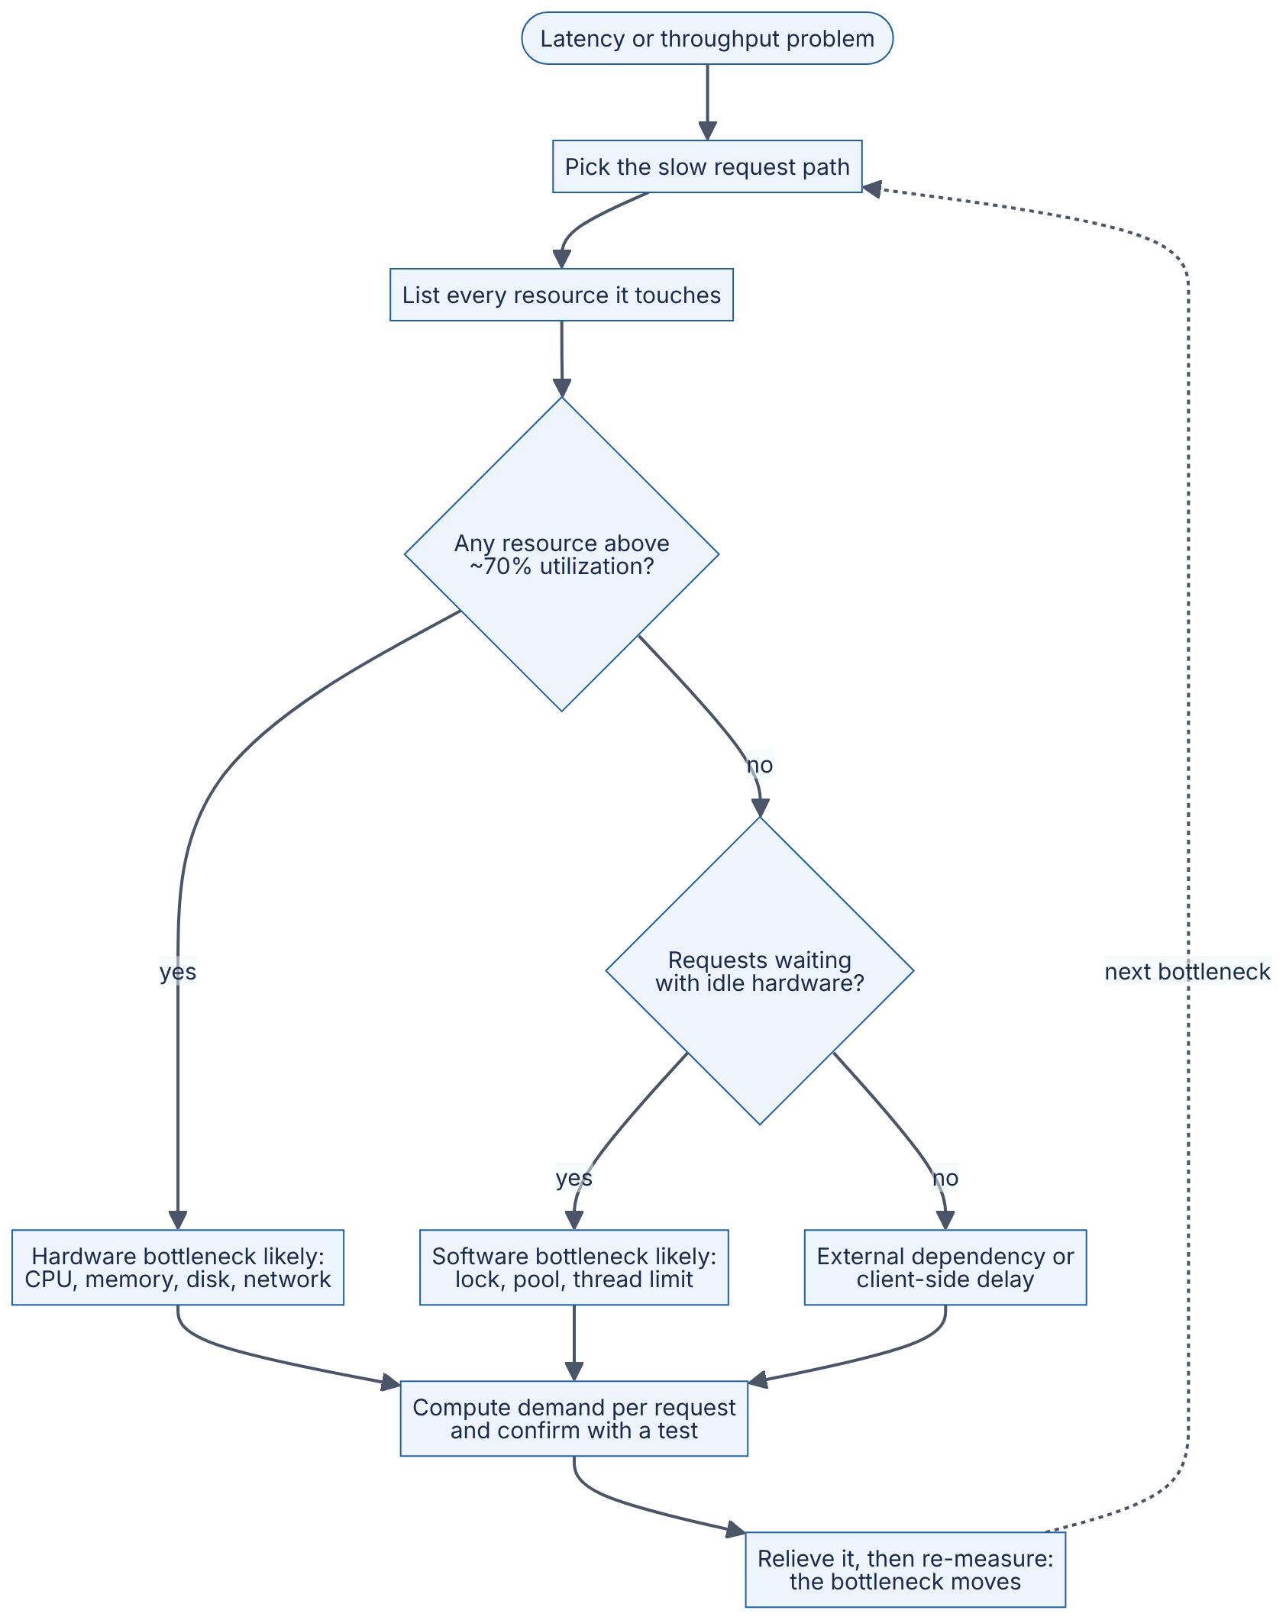
Reading the diagram. This is a reasoning procedure, not a running system. You start from a symptom (stadium) and pick one slow request path, because bottlenecks are workload-specific: browsing and ordering have different ones. The first decision checks hardware utilization. Around 70% is a common warning threshold, because queueing delay grows steeply as utilization approaches 100% (§4.10). The second decision is the key diagnostic insight: requests are waiting while the hardware is idle. This almost always means a software resource such as a lock or a pool is saturated. If neither applies, the time is being spent outside your servers, for example in a third-party API or on a slow mobile network. Every branch leads to the same discipline: compute the demand per request and confirm the hypothesis with a measurement or load test (Chapter 23). The dotted edge back to the start is the loop that never ends: relieving one bottleneck exposes the next.

Mathematical foundations
Two laws from operational analysis of computer systems [Denning and Buzen 1978] are enough to find most bottlenecks with arithmetic alone.
FORMULA
Service demand, the utilization law and the bottleneck bound
$$D_{i}=V_{i}×S_{i} U_{i}=X×D_{i} X_{max}=\frac{c_{i}}{D_{max}}$$
Symbol | Meaning | Units
$D_{i}$ | Service demand: total busy time one request places on resource $i$ | seconds per request
$V_{i}$ | Visits: how many times one request uses resource $i$ | visits per request
$S_{i}$ | Service time per visit to resource $i$ | seconds per visit
$U_{i}$ | Utilization of resource $i$, per unit of capacity | fraction (0–1)
$X$ | System throughput | requests per second
$c_{i}$ | Number of parallel units of resource $i$ (e.g. cores) | units
$X_{max}$ | Maximum throughput, set by the resource with the largest demand per unit | requests per second
The utilization law for a resource with $c_{i}$ parallel units is $U_{i}=X×D_{i}/c_{i}$. The bottleneck is the resource with the largest $D_{i}/c_{i}$.
FORMULA
Little’s Law (concurrency)
$$L=λ×W$$
Symbol | Meaning | Units
$L$ | Average number of requests in the system (or holding a resource) at once | requests
$λ$ | Average arrival rate | requests per second
$W$ | Average time each request spends in the system (or holds the resource) | seconds
Little’s Law holds for any stable system, regardless of the arrival pattern [Little 1961]. Full treatment in §4.11.
WORKED EXAMPLE
Worked example — Finding QuickBite’s checkout bottleneck.
Situation. At dinner peak QuickBite receives 60 order placements per second (this number is derived in §2.11). Customers complain that checkout sometimes spins for 5 seconds and then fails, yet CPU dashboards show the database at only 25% utilization. The order transaction, as first written, does this:
- Begin a database transaction.
- Insert the order and its items.
- Update the restaurant’s row in restaurant_load to increment open_orders (used to stop accepting orders when a kitchen is overwhelmed). This takes a row lock until commit.
- Call the payment service, which calls the payment provider. Average 300 ms.
- Commit.
Measured per-order demands (assumed values for the exercise):
Table 2.8 — Per-order resource demand in the checkout path.
Resource | Demand per order $D_{i}$ | Parallel units $c_{i}$ | $D_{i}/c_{i}$ | Max orders/s = $1/\left(D_{i}/c_{i}\right)$ | Utilization at 60/s
API tier CPU | 8 ms | 32 cores | 0.25 ms | 4,000 | 60 × 0.25 ms = 1.5%
Database CPU | 5 ms | 8 cores | 0.625 ms | 1,600 | 3.8%
Database WAL disk (fsync) | 2 ms | 1 device | 2 ms | 500 | 12%
Network (25 KB per order, 10 Gbps link) | 0.02 ms | 1 link | 0.02 ms | 50,000 | 0.1%
DB connection pool (20 connections) | 320 ms held | 20 | 16 ms | 62.5 | 96%
Row lock on one popular restaurant | 320 ms held | 1 | 320 ms | 3.1 | see below
Step 1 — Hardware. Every hardware resource is far below 70% utilization. The largest is the WAL disk at 12%, so hardware is not the bottleneck. Following Figure 2.4, “requests waiting with idle hardware” points to a software resource.
Step 2 — Connection pool, by Little’s Law. Each order holds a database connection from step 1 to step 5: about 300 ms of payment time plus about 20 ms of database work, so $W$ = 0.32 s. Then $L$ = λ × W = 60 × 0.32 = 19.2 connections busy on average, out of a pool of 20. Utilization is 19.2 / 20 = 96%. Any burst above 62.5 orders/s (20 / 0.32) makes requests queue for a connection, and queueing at 96% utilization is severe (§4.10).
Step 3 — The row lock. A celebrity chef’s restaurant runs a promotion and receives 8 orders per second. Each order holds that restaurant’s row lock for 0.32 s, so the row can serve at most 1 / 0.32 = 3.1 orders per second. Arrivals (8/s) exceed capacity (3.1/s), so the queue grows without bound until requests time out at 5 s. That matches the complaint exactly. This is the bottleneck for that workload: a single hot row.
Step 4 — Relieve it. Move the slow external call out of the database transaction. First authorize the payment, keyed by an idempotency key so retries cannot double-charge (§22.15). Then run a short transaction (insert order, update counter, commit) of about 15 ms. Then capture the payment, or publish an event to do so asynchronously.
Step 5 — Re-compute. Hold time $W$ drops from 0.32 s to 0.015 s.
- Pool: $L$ = 60 × 0.015 = 0.9 connections busy, which is 4.5% of the pool.
- Hot row: maximum 1 / 0.015 ≈ 66 orders/s per restaurant, comfortably above 8.
- The bottleneck has moved. It is now the WAL disk at 500 orders/s, about 8× headroom over today’s peak. That is the next thing to watch as QuickBite grows (group commit and partitioning address it, §13.5 and Chapter 14).
Interpretation. Adding database servers or CPUs would have cost money and fixed nothing: the limit was a lock held during a network call. Engineering implication: never hold a lock or a pooled connection across a call to a slow or external system. In general, hold time multiplied by arrival rate (Little’s Law) tells you how many units of any software resource you need.

Code example
A short, runnable script that turns the table above into a bottleneck report. Use it to check your own estimates.
# Bottleneck finder using the utilization law (U = X * D / c).
resources = {
# name: (demand per request in seconds, parallel units)
"api_cpu": (0.008, 32),
"db_cpu": (0.005, 8),
"wal_disk": (0.002, 1),
"network": (0.00002, 1),
"db_pool": (0.320, 20),
"hot_row": (0.320, 1),
}
arrival_rate = 60.0 # requests per second
for name, (demand, units) in sorted(
resources.items(), key=lambda kv: kv[1][0] / kv[1][1], reverse=True):
max_x = units / demand
util = arrival_rate * demand / units
flag = "SATURATED" if util >= 1 else ("HOT" if util >= 0.7 else "ok")
print(f"{name:9s} max={max_x:9.1f}/s util@{arrival_rate:.0f}/s={util:7.1%} {flag}")
What to notice:
- Resources are sorted by $D_{i}/c_{i}$, so the first line printed is the bottleneck.
- hot_row shows a utilization above 100% (1920%) at 60/s, because the script applies the whole arrival rate to one row. That is the worst case where every order goes to a single restaurant. In the worked example only 8/s hit the hot row, which still exceeds its 3.1/s capacity. Edit the script to model per-key arrival rates.
- Changing 0.320 to 0.015 for the pool and the row reproduces Step 5 and shows the bottleneck moving to wal_disk.

Real-world industry applications
INDUSTRY EXAMPLE
The USE method at Netflix and beyond. Brendan Gregg developed the USE method while working on performance analysis and has published it, together with per-operating-system checklists, as a way to find resource bottlenecks quickly without guessing. It explicitly includes software resources such as mutex locks, thread pools and file descriptors alongside CPUs, memory, disks and network interfaces. Evidence: Primary — [Gregg USE], [Gregg 2020]

Alternatives and trade-offs
The USE method is resource-centric. Its complement is the RED method (Rate, Errors, Duration per service), which is request-centric and better for spotting which service is slow in a microservice graph. The two work well together (§23.3). Profiling (§23.4) finds which code consumes a resource. Load testing (§23.5) confirms a bottleneck hypothesis empirically. The arithmetic above tells you where to point those tools.

Failure scenarios
Table 2.9 — Bottleneck-analysis failure scenarios.
What goes wrong | Why | Detection | Recovery | Prevention
Scaling the wrong tier | Added servers to a non-bottleneck | Throughput unchanged after scaling | Re-run USE analysis | Compute demand per resource first
Hot key or hot row | Skewed popularity, e.g. a viral restaurant | One key’s latency far above the others | Shorten hold time, shard the counter | Model per-key rates, not just totals
Pool exhaustion | Long hold times, often across remote calls | “Timeout acquiring connection” errors with idle DB | Move remote calls out of transactions | Little’s Law sizing
Retry amplification | Clients retry into a saturated resource | Load rises as success rate falls | Retry budgets, backoff with jitter (§22.12) | Cap retries; shed load

Common misconceptions
COMMON MISTAKE
“Low CPU means the system has spare capacity.” CPU is one resource of five. QuickBite’s checkout failed with every machine mostly idle, because the bottleneck was a lock. Always check software resources when latency is high and utilization is low.
COMMON MISTAKE
“Averages are enough.” A system can be fine on average and saturated on one hot key, one shard or one minute of the day. Bottleneck analysis must use peak rates and per-partition rates (§14.10).

2.7 Making and stating assumptions

2.7.1 The assumption register
DEFINITION
Definition — Design assumption. A belief about the workload, the environment or the business that the design depends on but that has not yet been verified, for example “80% of requests are reads” or “the payment provider responds within 1 s at p99”. An assumption is stated when it is written down with its value, its source, your confidence in it and how it will be checked.

First-principles explanation
A weather forecaster does not refuse to forecast because tomorrow is unknown. She says “70% chance of rain,” which is an explicit, checkable statement of uncertainty. System designers face the same situation: you never have all the facts before you must design. The professional response is not to wait. It is to assume out loud, so that everyone can see which parts of the design rest on which beliefs.

Why does this exist?
Every design rests on assumptions anyway. The only choice is whether they are visible. Hidden assumptions are dangerous because nobody checks them, and when one turns out wrong, nobody knows which parts of the design must change. Stated assumptions turn surprises into planned decision points.

How it works internally
- Write each assumption as a number with a source. “2 M daily active users (marketing forecast for year 1).”
- Rate confidence: high (measured), medium (comparable data exists), low (guess).
- Do a sensitivity check. Ask: if this is wrong by 10×, does the design change? Assumptions where the answer is “yes” are load-bearing.
- Attach a check and a tripwire to every load-bearing assumption: how you will verify it, and the observed value that will trigger a redesign.
- Prefer designs that are robust to the assumptions you are least sure of.
Table 2.10 — QuickBite assumption register (excerpt).
ID | Assumption | Value | Source | Confidence | Load-bearing? | Check and tripwire
A1 | Daily active users | 2 M | Business forecast | Low | Yes: sizes every tier | Weekly DAU dashboard; redesign review at 5 M
A2 | Orders per DAU per day | 0.25 | Industry intuition | Low | Yes: order DB and payments | Measure in beta
A3 | Busiest hour share of daily orders | 20% | Assumed dinner peak | Medium | Yes: peak sizing | Hourly order histogram
A4 | Courier location update interval | 4 s | Product decision | High | Yes: location write load | Config value, reviewed with product
A5 | Payment provider p99 latency | 1 s | Vendor documentation | Medium | Moderate: timeouts, pools | Client-side latency histogram
A6 | Average menu size | 100 items × 1 KB | Sample of 50 menus | Medium | No: menus fit in memory even at 10× | Catalog size metric
The sensitivity column is the payoff. A6 is not load-bearing: all menus total about 5 GB (§2.11), and 50 GB would still fit in a small cache cluster, so being 10× wrong changes nothing structural. A4 is load-bearing: halving the interval to 2 s doubles the heaviest write path in the system.
WORKED EXAMPLE
Worked example — Sensitivity of the location tier to assumption A4. Peak active couriers are assumed to be 20,000.
- Update interval 4 s: 20,000 / 4 = 5,000 writes/s.
- Product asks for 1 s “for smoother maps”: 20,000 / 1 = 20,000 writes/s, 4× the load.
- At an assumed 200 bytes per update including protocol overhead, ingress rises from 5,000 × 200 = 1 MB/s to 20,000 × 200 = 4 MB/s. That is modest for the network, but 4× the write operations for the store.
Interpretation. Network bandwidth is not the issue. The write rate to the location store is. Engineering implication: keep the 4 s interval on the server and have the client app interpolate the marker’s movement between updates. Customers see smooth motion at a quarter of the cost. The assumption register made this negotiation possible because the cost of the request was visible immediately.
INDUSTRY EXAMPLE
Assumptions in published design-review practice. Google’s internal design-doc culture, as described by a Google engineer, asks authors to state context, goals and non-goals, and to discuss alternatives and trade-offs, so that reviewers can challenge the premises behind a design and not only its mechanics. Evidence: Secondary — [Ubl 2020]

Failure scenarios and misconceptions
Table 2.11 — Assumption failure scenarios.
What goes wrong | Why | Detection | Recovery | Prevention
Stale assumption | The world changed, e.g. a new market launched | Metrics drift past the tripwire | Run the redesign review | Tripwires on load-bearing assumptions
Assumption mistaken for fact | Repeated until nobody remembers it was a guess | Nobody can name its source | Re-label and re-check | “Source” and “confidence” columns
Average-case assumption | Peak and skew ignored | Outages at peaks or on hot keys | Add peak and skew factors | Always state a peak factor
COMMON MISTAKE
“Stating assumptions shows you don’t know the answer.” The opposite is true. In interviews and design reviews, explicit assumptions signal seniority. They show you know which unknowns matter and have a plan for each one.

2.8 Evaluating trade-offs

2.8.1 Weighted decision matrices
DEFINITION
Definition — Trade-off. A situation where improving one desired property of a system makes another worse. Examples: lower latency at higher cost, stronger consistency at lower availability during network partitions, faster delivery at higher operational risk. Every design decision is a trade-off. If you cannot name what an option makes worse, you have not understood it yet.

First-principles explanation
Buying a car means trading price against comfort, fuel economy against power, cargo space against parking ease. No car wins on everything. A sensible buyer decides which properties matter most to them, scores the candidates, and also notices how hard the choice is to undo: leasing for a year is easy to reverse, buying a car and selling it a month later loses money. System design decisions have exactly the same two dimensions, weighted fit and reversibility.

Why does this exist?
Without a method, design decisions are made by whoever argues loudest or by habit (“we always use X”). A structured method makes the criteria and their importance explicit. It lets people disagree about weights (a business question) separately from scores (an engineering question), and it leaves a record for the ADR (§2.12).

How it works internally: the weighted decision matrix
- List the options, including “do nothing” or “the simplest thing” where it makes sense.
- List the criteria that come from the requirements (§2.5), not from personal taste.
- Assign weights that sum to 1 (or 100%), agreed with stakeholders.
- Score each option against each criterion on a fixed scale, e.g. 1–5, with a one-line justification per score.
- Compute weighted totals.
- Run a sensitivity check: does the winner change if a weight moves by ±10 percentage points? If it does, the decision is close and the deciding factor should be discussed explicitly.
- Check reversibility before committing (below).
This is a lightweight form of the concept-selection matrices used in engineering design, such as Pugh’s method [Pugh 1991].
FORMULA
Weighted decision score
$$S_{j}=\sum_{i=1}^{n}{w_{i}}×s_{ij}, \sum_{i=1}^{n}{w_{i}}=1$$
Symbol | Meaning | Units
$S_{j}$ | Total weighted score of option $j$ | score points (same scale as $s_{ij}$)
$w_{i}$ | Weight of criterion $i$ | fraction (0–1)
$s_{ij}$ | Score of option $j$ on criterion $i$ | score points, e.g. 1–5
$n$ | Number of criteria | count
WORKED EXAMPLE
Worked example — Modular monolith or microservices for QuickBite v1? The team is eight engineers and must launch in four months. Criteria and weights come from Table 2.5 and from business constraints.
Table 2.12 — Weighted decision matrix for QuickBite’s deployment architecture.
Criterion | Weight | Modular monolith | Microservices (8 services)
Time to launch with 8 engineers | 0.30 | 5 | 2
Operational simplicity | 0.20 | 5 | 2
Independent scaling of hot paths | 0.20 | 3 | 5
Failure isolation | 0.15 | 3 | 4
Team autonomy as headcount grows | 0.15 | 3 | 5
Weighted total | 1.00 | 3.90 | 3.35
Arithmetic for the monolith: 0.30×5 + 0.20×5 + 0.20×3 + 0.15×3 + 0.15×3 = 1.50 + 1.00 + 0.60 + 0.45 + 0.45 = 3.90. For microservices: 0.30×2 + 0.20×2 + 0.20×5 + 0.15×4 + 0.15×5 = 0.60 + 0.40 + 1.00 + 0.60 + 0.75 = 3.35.
Sensitivity. Move 10 points of weight from time-to-launch to independent scaling (0.20 and 0.30). Monolith: 0.20×5 + 0.20×5 + 0.30×3 + 0.45 + 0.45 = 1.00 + 1.00 + 0.90 + 0.90 = 3.80. Microservices: 0.20×2 + 0.20×2 + 0.30×5 + 0.60 + 0.75 = 0.40 + 0.40 + 1.50 + 1.35 = 3.65. The monolith still wins, so the result is robust to a reasonable disagreement about weights.
A hybrid surfaces. The one criterion where the monolith loses badly is independent scaling, and §2.11 shows that the location path dominates write load. Deploying the location service separately and everything else as a modular monolith captures most of the scaling benefit at a fraction of the operational cost.
Interpretation. The matrix did not “decide”. It made the reasoning inspectable and revealed a better third option. Engineering implication: record the matrix and the sensitivity result in the ADR, and name the trigger for revisiting it, for example “more than 30 engineers or more than 3 teams blocked on shared releases.”

2.8.2 Reversibility: one-way and two-way doors
The matrix measures fit. It says nothing about the cost of being wrong. In his 2015 letter to shareholders, Jeff Bezos distinguished Type 1 decisions, which are consequential and irreversible or nearly so (“one-way doors”) and deserve slow, careful deliberation, from Type 2 decisions, which are reversible (“two-way doors”) and should be made quickly by individuals or small groups with good judgment. He warned that large organizations tend to apply the heavyweight Type 1 process to Type 2 decisions, and that this causes slowness and too little experimentation [Bezos 2016].
In architecture, reversibility is mostly about data and contracts. Code behind a stable interface is cheap to change. Data formats that have accumulated years of records, and public APIs that thousands of clients depend on, are not.
Figure 2.5 — Choosing the decision process by reversibility.
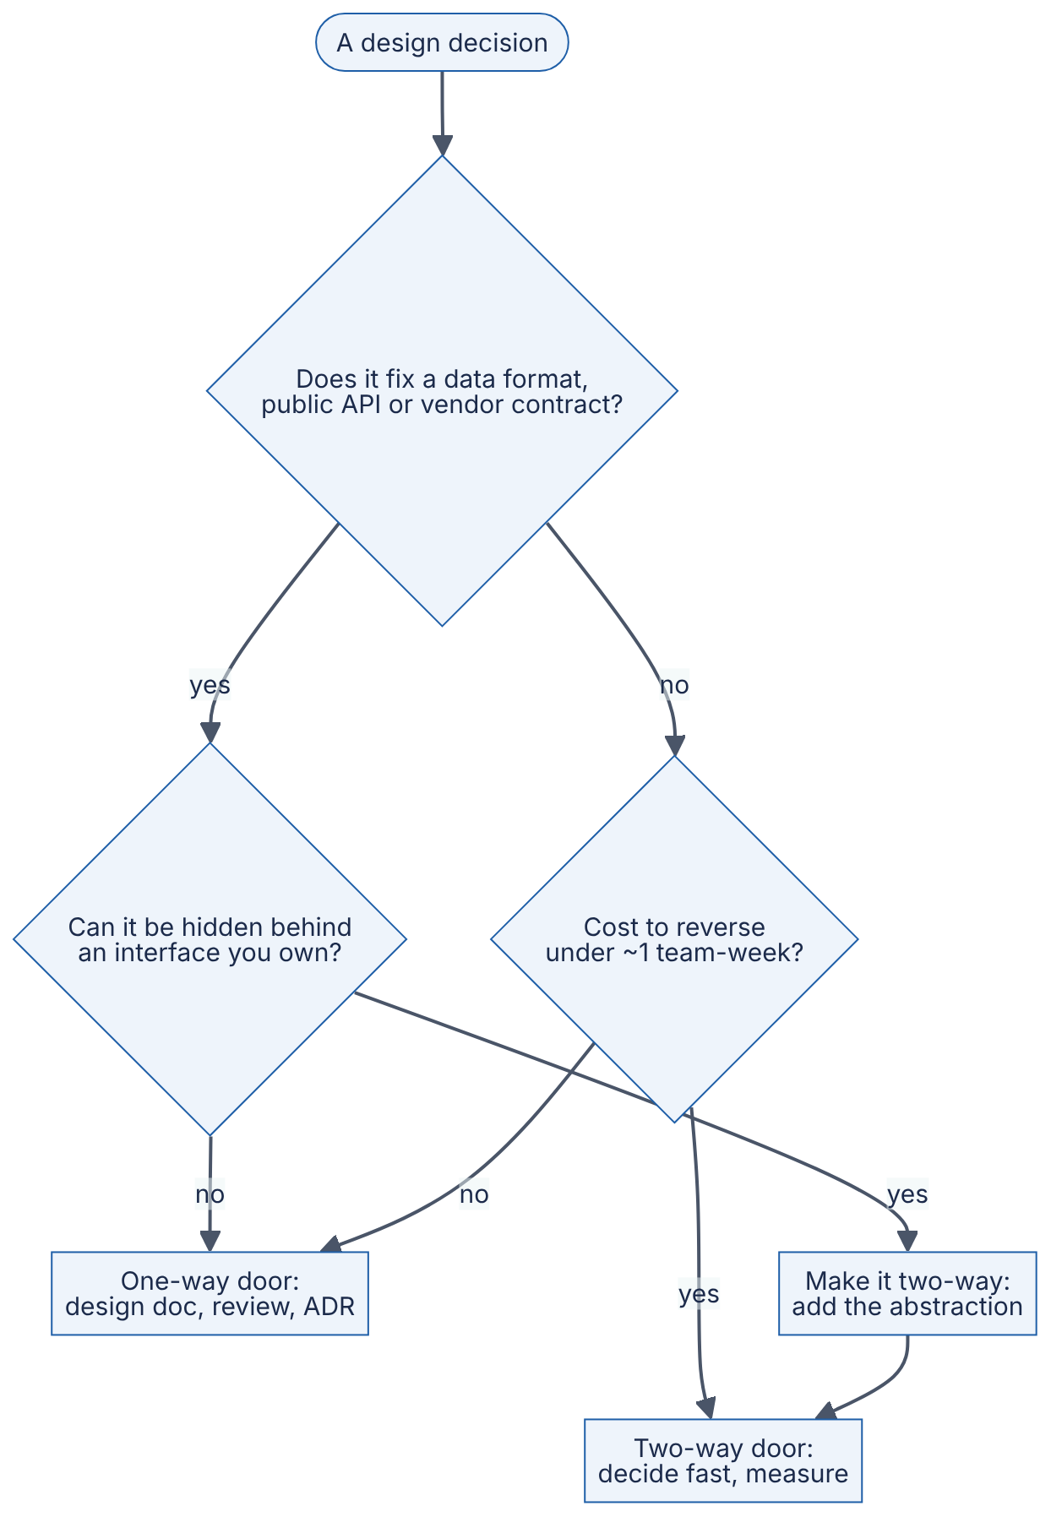
Reading the diagram. A decision (stadium) passes through up to three questions (diamonds). The first asks whether the decision fixes something that is costly to change later: stored data formats, public APIs, multi-year vendor contracts. If it does, the second asks whether an interface you own can hide it. A repository layer in front of the database, or an internal payment service in front of the payment provider, turns a one-way door into a two-way one (box T2). That is often the best move available. Decisions that fix nothing durable, and are cheap to reverse, are two-way doors: decide quickly and let measurement correct you. Everything else is a one-way door and earns the full process: a design document, a review and an ADR (§2.12). The “~1 team-week” threshold is a heuristic. Calibrate it to your organization. There is no software data flow here. The failure mode this procedure prevents is organizational: spending weeks debating a two-way door, or rushing a one-way door.
Table 2.13 — QuickBite decisions classified by reversibility.
Decision | Door | Why
Web framework for the catalog service | Two-way | Internal; can be rewritten behind the same API
Cache eviction policy | Two-way | A configuration change
Primary key and ID format for orders | One-way | Embedded in receipts, URLs, partner systems, years of data
Public order-status API shape for restaurant POS partners | One-way | External clients depend on it; versioning needed (§8.15)
Payment provider | One-way unless abstracted | Stored payment tokens are provider-specific
Monolith vs separate location service | Mostly two-way | Modular boundaries make extraction later feasible
INDUSTRY EXAMPLE
Amazon’s Type 1 / Type 2 decisions. The two-door model comes from Amazon’s 2015 shareholder letter. Bezos presented it as a way for a growing company to keep moving fast: reserve heavyweight deliberation for irreversible choices and push reversible ones down to small groups. Evidence: Primary — [Bezos 2016]

Alternatives, failure scenarios and misconceptions
Alternatives to a weighted matrix include simple pros/cons lists (fine for two-way doors), Pugh matrices (score relative to a baseline option, [Pugh 1991]) and formal methods such as the Architecture Tradeoff Analysis Method (ATAM) for large systems, which ties quality-attribute scenarios to architectural decisions [Bass et al. 2021].
Table 2.14 — Trade-off evaluation failure scenarios.
What goes wrong | Why | Detection | Recovery | Prevention
Matrix theater | Scores reverse-engineered to justify a choice already made | Justifications are vague | Re-score independently | Have two people score blind
Missing option | The best option was never listed | A reviewer proposes it late | Add and re-score | Always include “simplest thing” and a hybrid
Analysis paralysis on a two-way door | One process for every decision | Weeks of debate on reversible items | Time-box; pick and measure | Classify reversibility first
Rushed one-way door | Treated like a quick choice | Expensive migration later | Migration project | Figure 2.5 before deciding
COMMON MISTAKE
“There is a best architecture.” There is only a best architecture for a set of weighted requirements and constraints. Change the team size, the deadline or the load, and the winner changes. This is why the requirements and assumptions behind a decision must be recorded alongside it.

2.9 Designing for failure

2.9.1 Failure as a normal event
DEFINITION
Definition — Designing for failure. Treating component failure as a normal, expected event rather than an exception. For every component and dependency, the design states what happens when it is slow, returns errors or disappears, and makes sure the blast radius (the set of users and features affected) is as small as possible.

First-principles explanation
Aircraft are not designed on the assumption that engines never fail. They are designed to fly on one engine. Buildings have fire doors that confine a fire to one section. Designing for failure applies the same idea to software: accept that every part will fail at some point, and decide in advance how the rest of the system keeps working.

Why does this exist?
At scale, failure is a matter of arithmetic, not bad luck. With 1,000 servers that each fail on average once every three years, the fleet sees roughly one failure a day (1,000 / (3 × 365) ≈ 0.9). Networks drop packets, disks wear out, deploys ship bugs and third parties have outages. James Hamilton’s widely cited guidance for internet-scale services starts from this premise: expect failures, and design every component so that failures are handled automatically and without drama [Hamilton 2007]. The “fallacies of distributed computing,” such as “the network is reliable,” catalog the assumptions that make systems brittle (§24.5).

How it works internally
A failure-mode walk-through, sometimes called a lightweight failure mode and effects analysis (FMEA):
- For each component and each arrow in the decomposition diagram, ask: what if it is down? Slow? Returning wrong data?
- Decide the desired behavior: fail fast, retry, degrade gracefully or queue for later.
- Apply standard mechanisms: timeouts on every remote call, retries with backoff and jitter only for idempotent operations, circuit breakers to stop calling a failing dependency, bulkheads to isolate resource pools (all in Chapter 22), redundancy across zones (§39.4) and asynchrony to take non-essential work off the critical path.
- Remove things from the critical path, the chain of synchronous calls a user must wait for. Each item removed from it raises availability (formula below).
Figure 2.6 — QuickBite checkout designed for failure.
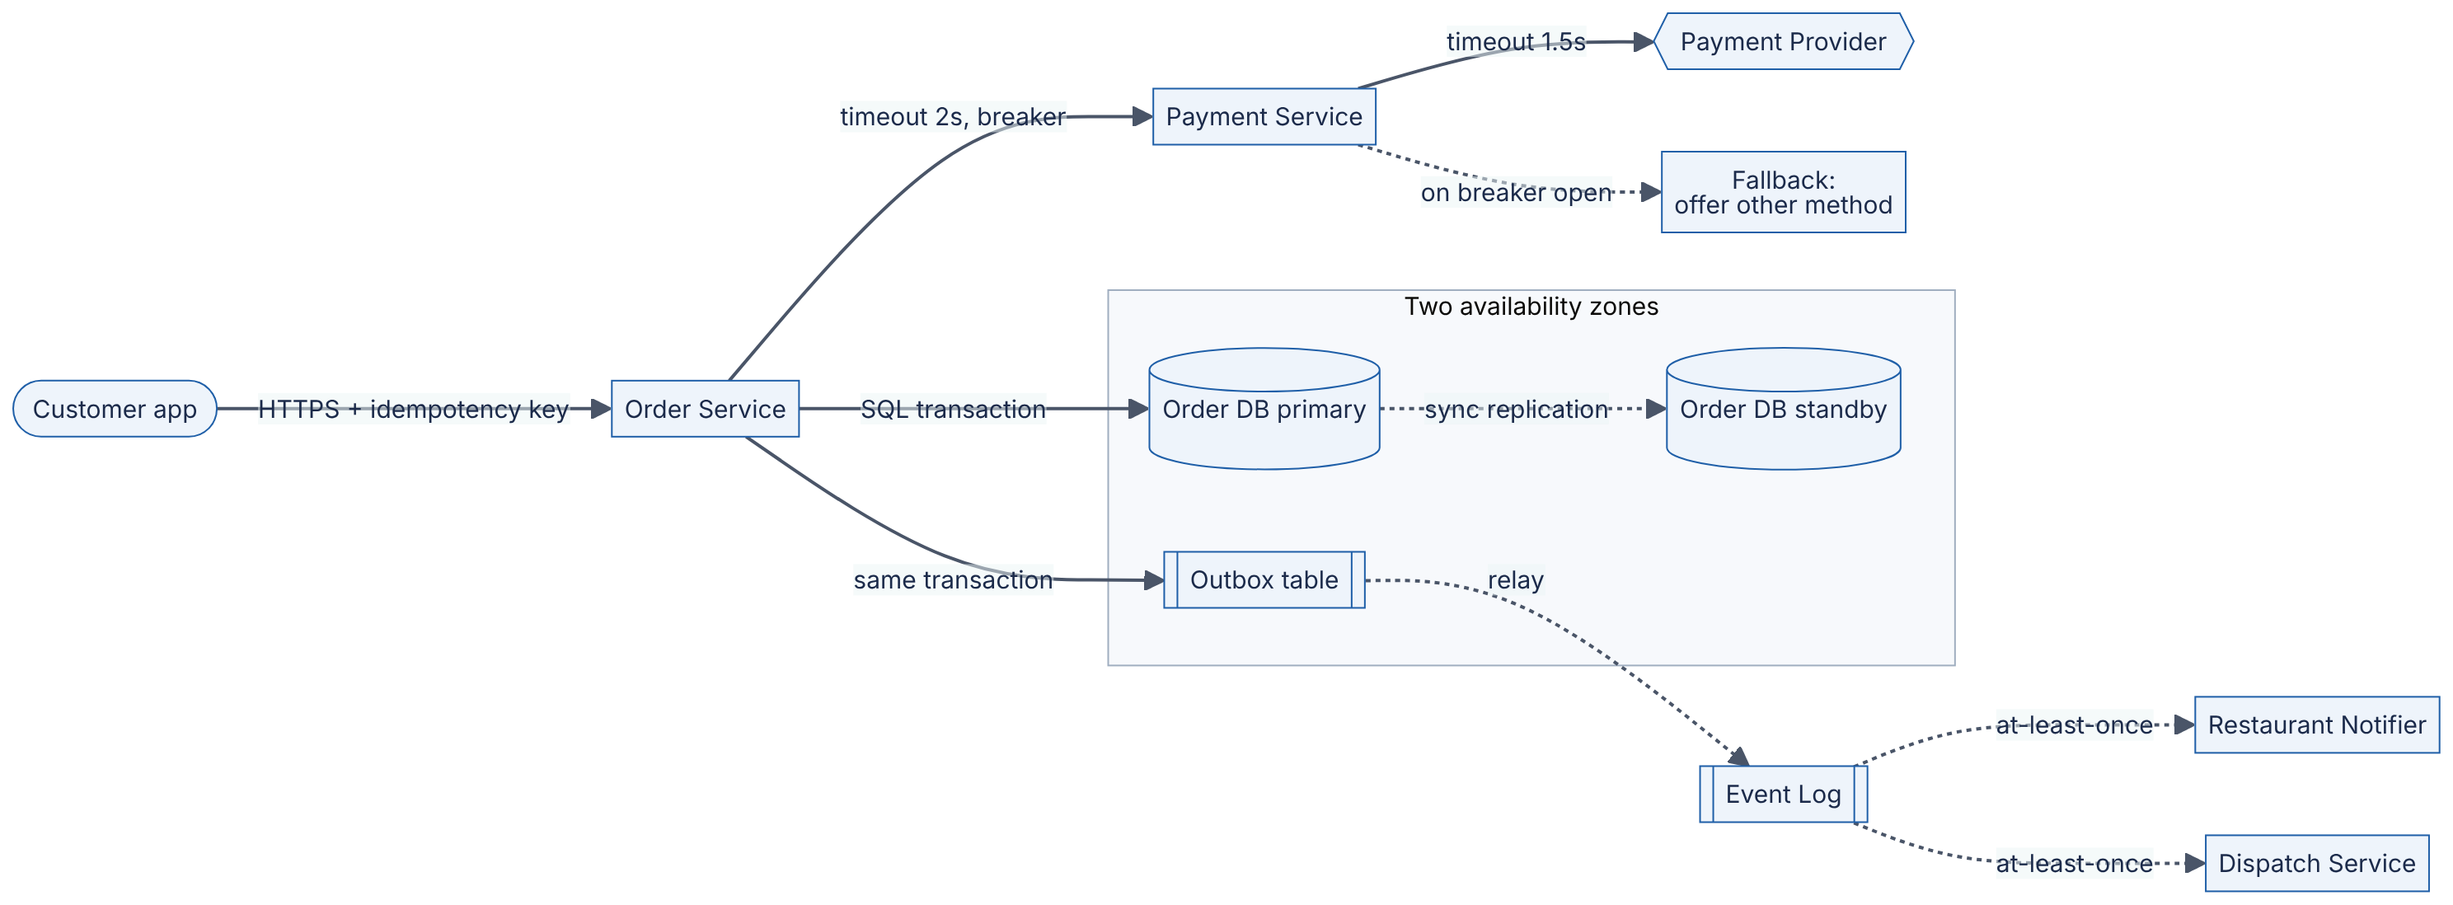
Reading the diagram. The customer’s request carries an idempotency key, so a retry after a network error cannot create a second order or a second charge (requirement N4). The synchronous critical path is customer → order service → payment service → payment provider. Each hop has an explicit timeout, and the payment call sits behind a circuit breaker. If the provider is failing, the breaker opens and the customer is offered another payment method within milliseconds, instead of waiting for timeouts (dotted fallback). The order database runs inside a subgraph spanning two availability zones: a primary with a synchronously replicated standby, which meets N3 (RPO = 0). Instead of calling the restaurant notifier and dispatch directly, the order service writes an event to an outbox table in the same transaction as the order (§32.5). A relay then publishes it to the event log. Restaurant notification and dispatch are therefore off the critical path: if either is down, orders still succeed, and the events are delivered when they recover (at-least-once, so consumers must be idempotent, §32.10). Remaining single points of failure to watch: the payment provider (mitigated by the fallback, or by a second provider later) and the event-log relay (mitigated by running two relays).
FORMULA
Availability of components in series
$$A_{series}=\prod_{i=1}^{n}{A_{i}}$$
Symbol | Meaning | Units
$A_{series}$ | Availability of a request path that needs all $n$ components | fraction (0–1)
$A_{i}$ | Availability of component $i$ | fraction (0–1)
$n$ | Number of components on the synchronous path | count
This assumes independent failures. Parallel (redundant) components and correlated failures are treated in §4.14.
WORKED EXAMPLE
Worked example — Taking the restaurant notifier off the critical path. Assumed monthly availabilities: order service 99.95%, order DB 99.95%, payment provider 99.9%, restaurant notifier 99.9%.
- Notifier called synchronously during checkout: 0.9995 × 0.9995 × 0.999 × 0.999 = 0.9990 × 0.9980 ≈ 0.9970, i.e. 99.70%. That allows 0.003 × 43,200 ≈ 130 minutes of checkout failure per month.
- Notifier asynchronous via the outbox: 0.9995 × 0.9995 × 0.999 ≈ 0.9990 × 0.999 ≈ 0.9980, i.e. 99.80%, about 86 minutes per month.
- Requirement N1 is 99.95%, or 21.6 minutes. Even the improved path misses it, because the payment provider alone allows 43 minutes.
Interpretation. A series chain can never be more available than its weakest link, and every extra synchronous dependency lowers the total. Engineering implication: either renegotiate N1 to exclude provider outages (a common SLO definition), or add a second payment provider in parallel. With two independent providers at 99.9% each, the pair is unavailable only when both fail: 1 − (0.001 × 0.001) = 99.9999%. This is a one-way-door-sized decision for a start-up (contracts, token migration), so it goes through Figure 2.5.
INDUSTRY EXAMPLE
Netflix’s Chaos Monkey. Netflix publicly described the “Simian Army,” starting with Chaos Monkey, a tool that randomly terminates production instances during business hours. Because engineers know instances will disappear, they must build services that tolerate it, and weaknesses are found while engineers are at work rather than at 3 a.m. This is designing for failure enforced by continuous practice (§39.11). Evidence: Primary — [Izrailevsky and Tseitlin 2011]
Table 2.15 — Failure scenarios for QuickBite checkout.
What goes wrong | Why | Detection | Recovery | Prevention
Payment provider outage | External dependency | Error rate on provider calls; breaker opens | Fallback method; queue payment capture | Second provider; breaker
Duplicate order on retry | Client retried after a timeout | Two orders with the same cart and customer | Refund the duplicate | Idempotency key (N4)
Order DB primary lost | Hardware or zone failure | Health checks, replication monitor | Automatic failover to standby | Synchronous standby in another zone
Event relay stalls | Bug or crash | Outbox backlog age metric | Restart; events retained in outbox | Two relays; alert on backlog age
Retry storm | Many clients retry at once | Load spikes as success falls | Shed load, open breakers | Exponential backoff with jitter, retry budgets
COMMON MISTAKE
“Redundancy alone makes a system reliable.” Two replicas that share a power supply, a configuration push or a software bug fail together. Redundancy only helps against independent failures, so look for correlated ones: same zone, same deploy, same dependency.

2.10 Reasoning about scale

2.10.1 Orders of magnitude
DEFINITION
Definition — Order of magnitude. A factor of ten. Two quantities differ by k orders of magnitude when their ratio is about ${10}^{k}$. Reasoning in orders of magnitude means estimating only the power of ten of a quantity (is it 10, 1,000 or 1,000,000 requests per second?) because that, not the exact value, decides the architecture.

First-principles explanation
Cooking dinner for 4 people, for 40 and for 4,000 are not the same task done more times. For 4 you use your home kitchen. For 40 you need a rented hall, borrowed pans and helpers. For 4,000 you need an industrial kitchen, refrigerated trucks, food-safety inspections and shift managers. Each 10× step changes the kind of solution, not just its size. Software behaves the same way, and this is why experienced designers first ask “what order of magnitude?”

Why does this exist?
Most design choices are insensitive to a factor of 2 but sensitive to a factor of 10. A single PostgreSQL primary comfortably handles QuickBite’s 60 orders per second. At 600 it needs careful tuning and read replicas. At 6,000 it likely needs partitioning (Chapter 14). Knowing the order of magnitude tells you which of these architectures you are in, and how far you are from the next one.

How it works internally
- Estimate the key rates and sizes to within a factor of about 3 (§2.11).
- Compare them with reference capacities (Table 2.17 and §4.17) to find which tier is closest to a limit.
- For each 10× step of growth, ask which components hit a qualitatively new problem.
Table 2.16 — What changes for QuickBite at each order of magnitude.
Scale | Orders/day | Peak orders/s | What breaks or changes | Typical response
1× (one city) | 5,000 | ~0.6 | Nothing; one server and one DB suffice | Modular monolith, managed DB with standby
10× (region) | 50,000 | ~6 | Browse reads dominate; menu queries load the DB | Cache menus, CDN for images (Chapters 20–21)
100× (country) | 500,000 | ~60 | Location writes (~5,000/s); hot restaurants; payment pool sizing | Separate location store; short transactions; async events
1000× (multi-country) | 5,000,000 | ~600 | Single order-DB write limits; data residency laws; multi-region latency | Partition orders by city or region; regional cells (§33.12, Chapter 44)
WORKED EXAMPLE
Worked example — Where does QuickBite’s single order database run out? From §2.6 the WAL disk caps the order DB at about 500 orders/s, assuming 2 ms of fsync demand per order.
- At 100× (today’s design point) peak is 60 orders/s: utilization = 60 / 500 = 12%.
- At 1000× peak is 600 orders/s: 600 / 500 = 120%, so the database saturates.
- Group commit, which flushes many transactions in one fsync, might cut per-order disk demand 4× (an assumed factor), giving 2,000 orders/s capacity and 30% utilization at 1000×. That buys roughly one more order of magnitude.
Interpretation. The current design has about 8× headroom on its most constrained resource. Engineering implication: no partitioning work is needed now (that would be over-engineering), but partitioning by city should be designed before order volume reaches about 5× today’s level, giving time to build it.
INDUSTRY EXAMPLE
“Design for 10× growth, plan to rewrite before 100×.” Jeff Dean of Google has given talks on building large distributed systems in which he advises designing for about ten times the current scale while expecting a significant redesign before about a hundred times. The point is that one architecture rarely spans more than one or two orders of magnitude gracefully. Evidence: Secondary — talk slides; see Open verification items. [Dean 2009]
COMMON MISTAKE
“Design for Google scale from day one.” Designing QuickBite v1 for 1000× its launch load would cost months of extra work, and the assumptions it relied on would likely be wrong by the time that scale arrived. Design for the next order of magnitude, keep the one after that possible, and use tripwires (§2.7) to know when to start.

2.11 Back-of-the-envelope capacity estimation

2.11.1 The estimation method
DEFINITION
Definition — Back-of-the-envelope estimation. A quick calculation, done with round numbers and stated assumptions, that gives the order of magnitude of a system’s load and resource needs (requests per second, storage, bandwidth, memory, number of nodes). The aim is to be within a factor of about 2–3 of the truth with a few minutes of arithmetic. This section introduces the method. Chapter 89 is the full handbook.

First-principles explanation
Enrico Fermi famously estimated quantities such as the number of piano tuners in Chicago by multiplying a chain of reasonable guesses: population, households with pianos, tunings per year, tunings a tuner can do. The individual errors partly cancel out, and the answer lands near the right power of ten. Capacity estimation is the same technique applied to users, requests and bytes.

Why does this exist?
Estimation tells you which architecture you are in (§2.10) before you spend money. It also exposes surprises early. In QuickBite’s case, the largest write load turns out to be courier GPS updates, not orders, a fact that reshapes the decomposition.

How it works internally
- Write down the assumptions (they come from the register in §2.7).
- Convert daily volumes to an average rate, then to a peak rate.
- Multiply by per-request sizes to get bandwidth, and by retention and copies to get storage.
- Divide peak load by per-node capacity at a target utilization to get node counts, then add spare capacity for failures.
- Round sensibly, compare against reference capacities, and name the dominant cost or bottleneck.
FORMULA
Average and peak request rate
$$R_{avg}=\frac{U×a}{86,400} R_{peak}=\frac{U×a×h}{3,600}×b$$
Symbol | Meaning | Units
$R_{avg}$ | Average request rate over a day | requests/s
$R_{peak}$ | Design peak request rate | requests/s
$U$ | Daily active users | users
$a$ | Actions of this type per user per day | requests/user/day
$h$ | Share of daily volume in the busiest hour | fraction
$b$ | Burst factor above the busiest-hour average | dimensionless
86,400 / 3,600 | Seconds per day / per hour | s
FORMULA
Storage and node count
$$S=n_{day}×s×T×k N=\left\lceil \frac{R_{peak}}{c×u}\right\rceil +N_{spare}$$
Symbol | Meaning | Units
$S$ | Total storage needed | bytes
$n_{day}$ | Records created per day | records/day
$s$ | Size per record, including indexes and overhead | bytes
$T$ | Retention period | days
$k$ | Number of stored copies (replication) | dimensionless
$N$ | Nodes needed | nodes
$c$ | Throughput one node sustains | requests/s
$u$ | Target utilization, leaving headroom for queueing (§4.10) | fraction
$N_{spare}$ | Extra nodes so a failure or deploy does not overload the rest | nodes
Table 2.17 — Rough reference capacities for estimation (order of magnitude only, as of 2026).
Resource | Rough capacity | Note
Round trip within one datacenter | ~0.1–0.5 ms | See §4.17 and Appendix F for dated values
Round trip across a continent | ~50–100 ms | Bounded by the speed of light in fiber
Stateless API node, simple JSON requests | ~10³ RPS | Varies by 10× with language and work per request
Relational DB primary, simple indexed writes | ~10³–10⁴ writes/s | Depends on fsync, schema, hardware
In-memory key-value store node | ~10⁵ ops/s | Small values, pipelining helps
1 Gbps network link | 125 MB/s | 1 Gbps ÷ 8 bits per byte
These numbers are deliberately rough. Measure your own system before relying on any of them.
WORKED EXAMPLE
Worked example — Full capacity estimate for QuickBite (the 100× design point). SI units throughout (1 KB = 10³ bytes).
Assumptions (from Table 2.10, plus new ones marked “new”). U = 2,000,000 DAU. Orders a = 0.25 per DAU per day. Browse reads 30 per DAU per day (new). Busiest-hour share h = 0.20 for both. Burst factor b = 2 (new; covers promotions). 20,000 couriers active at peak, updating every 4 s. Order record 2 KB including items and status history (new). Average browse response 20 KB with images served separately by a CDN (new).
Step 1 — Orders. - Daily: 2,000,000 × 0.25 = 500,000 orders/day. - Average: 500,000 / 86,400 ≈ 5.8 orders/s. - Busiest hour: 500,000 × 0.20 = 100,000 orders in one hour; 100,000 / 3,600 ≈ 27.8 orders/s. - Design peak: 27.8 × 2 ≈ 55.6, rounded up to 60 orders/s. This is the figure used in §2.6.
Step 2 — Browse reads. - Daily: 2,000,000 × 30 = 60,000,000 reads/day. Average: 60,000,000 / 86,400 ≈ 694 RPS. - Busiest hour: 60,000,000 × 0.20 / 3,600 ≈ 3,333 RPS. Design peak: × 2 ≈ 7,000 RPS (rounded up). - Read-to-order ratio at peak: 7,000 / 60 ≈ 117:1. Browsing is read-heavy and highly cacheable.
Step 3 — Courier locations and tracking. - Writes at peak: 20,000 / 4 s = 5,000 writes/s. That is about 83× the order write rate, so this is the dominant write path. - Orders in the delivery leg at once, by Little’s Law (§2.6): arrivals 27.8 orders/s × 900 s average delivery leg (15 min, new assumption) ≈ 25,000 orders. - Tracking reads: if half of those customers have the app open and it refreshes every 5 s, 25,000 × 0.5 / 5 = 2,500 reads/s.
Step 4 — Storage. - Orders: 500,000 × 2 KB = 1 GB/day. Over 5 years: 1 GB × 365 × 5 ≈ 1.8 TB. Add 50% for indexes: ≈ 2.7 TB. Two copies (primary + standby): ≈ 5.5 TB. One database server can hold this. - Locations: assume 6,000 couriers active on average across the day, giving 6,000 / 4 = 1,500 writes/s. Per day: 1,500 × 86,400 = 129.6 million points. At 100 bytes each: ≈ 13 GB/day. Keep 30 days hot: 13 × 30 ≈ 390 GB, then downsample to an archive. - Menus: 50,000 restaurants × 100 items × 1 KB = 5 GB, small enough to cache entirely in memory (§20.3).
Step 5 — Bandwidth. - Browse egress at peak: 7,000 × 20 KB = 140 MB/s = 140 × 8 = 1.12 Gbps, which needs more than one 1 Gbps link or a load balancer tier with 10 Gbps links. - Location ingress: 5,000 × 200 bytes = 1 MB/s = 8 Mbps, negligible.
Step 6 — API nodes for browsing. With c = 1,000 RPS per node, u = 0.6 and N_spare = 2 (one zone or one deploy batch down): 7,000 / (1,000 × 0.6) = 11.7, rounded up to 12, plus 2 = 14 nodes.
Step 7 — Interpretation.
Table 2.18 — QuickBite estimate summary (100× design point).
Quantity | Value | Dominant consequence
Peak orders | 60/s | One relational primary is enough (§2.6: ~500/s limit)
Peak browse reads | 7,000 RPS | Cache menus; ~14 API nodes
Peak location writes | 5,000/s | Separate, in-memory, partitioned location store
Tracking reads | 2,500/s | Serve from the location store, not the order DB
Order storage (5 years, 2 copies) | ~5.5 TB | Single DB cluster fine; plan partitioning at ~5×
Location storage (30 days hot) | ~390 GB | Time-partitioned; expire old data with a TTL
Peak egress (API, excluding images) | ~1.1 Gbps | CDN for images; 10 Gbps load balancer links
Engineering implication. The estimate confirms the decomposition in Figure 2.2. It also justifies the one deviation from the monolith in §2.8: location must scale independently because it carries about 83× the write rate of orders. Nothing here needs partitioning yet, and that is as important to know as what does.
COMMON MISTAKE
“Estimation needs precise numbers.” Round aggressively: 86,400 ≈ 10⁵ seconds per day is fine for a first pass. What matters is stating assumptions, keeping units consistent and reaching the right power of ten. Spending ten minutes on the third significant digit while never computing peak load is the classic mistake.

2.12 Architecture documentation

2.12.1 Structure and rationale
DEFINITION
Definition — Architecture documentation. The written and diagrammed record of a system’s structure and of the decisions that shaped it. It is written so that people who were not in the room (new team members, reviewers, your future self) can understand what the system is and why it is that way.

First-principles explanation
A map of a city at one scale cannot answer every question. You need a country map to see where the city is, a city map to see districts, and a street map to find a door. Architecture documentation works the same way: diagrams at several zoom levels for structure, and a logbook of decisions for reasons. Without the logbook, the next team sees a strange design choice and “fixes” it, reintroducing the problem it solved.

Why does this exist?
Knowledge in heads leaves when people do. Design decisions also tend to be revisited endlessly when their reasons are not written down. Three lightweight artifacts cover most needs:
Table 2.19 — Three architecture documentation artifacts.
Artifact | Answers | Written when | Lifetime
C4 diagrams | What are the parts and how do they connect, at each zoom level? | Before building; updated as the system changes | Living
Design document | What problem, what design, what alternatives, what risks? | Before a significant piece of work | Snapshot, then archived
Architecture Decision Record (ADR) | What did we decide, in what context, with what consequences? | At each significant decision | Immutable; superseded, never edited

2.12.2 The C4 model
The C4 model, created by Simon Brown, describes a software system at four zoom levels [Brown C4]:
- Context. The system as one box, with its users and external systems (Figure 2.3).
- Containers. The separately deployable or runnable units (applications, databases, queues) and the technologies and protocols between them. In C4, “container” means a runtime unit, not specifically a Docker container.
- Components. The major building blocks inside one container.
- Code. Classes and functions. This level is usually generated from code or skipped.
This book draws C4 views with standard flowchart diagrams rather than an experimental C4 diagram syntax (see the style guide).
Figure 2.7 — QuickBite C4 container view, after the §2.8 decision.
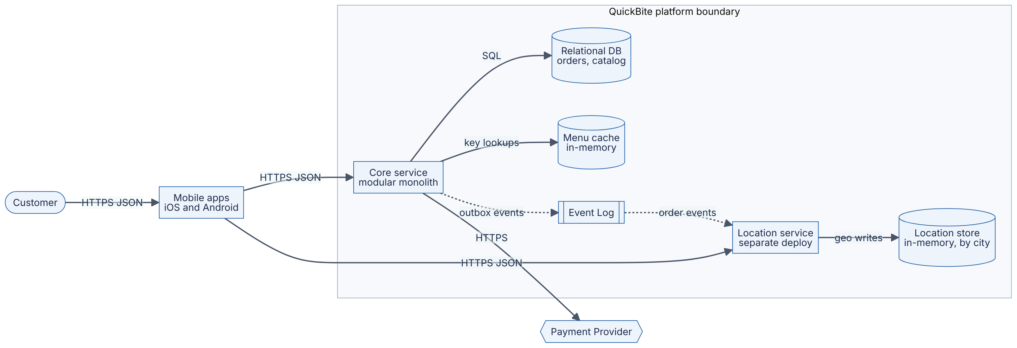
Reading the diagram. This is C4 level 2 for QuickBite after the trade-off decision in §2.8. The mobile apps are containers too, because they are separately deployed runtime units. The subgraph is the platform’s deployment boundary, matching the single box in Figure 2.3. The core service is the modular monolith: catalog, orders, payments, dispatch and notifications run in one process with internal module boundaries from Table 2.1. It talks SQL to the relational database (storage boundary for orders and catalog) and does key lookups against an in-memory menu cache, which keeps 7,000 browse RPS off the database (§2.11). The location service is deployed separately because of its 5,000 writes/s. It stores positions in an in-memory store partitioned by city and learns which courier is on which order from asynchronous order events (dotted). Synchronous paths (solid) are user-facing. Asynchronous paths (dotted) tolerate delay. Failure points match §2.9: the payment provider (external), the relational DB (standby in a second zone) and the event log. Scaling options: add core-service nodes horizontally, add location-store partitions per city, and later extract further modules into services if the tripwires from §2.7 fire.

2.12.3 Design documents
A design document (also called an RFC or a tech spec) is written before significant work, so that reviewers can find problems while changes are still cheap. Google engineers describe a widely copied structure: context and scope, goals and non-goals, the design itself, alternatives considered, and cross-cutting concerns such as security, privacy and observability [Ubl 2020]. A minimal skeleton:
Title, author(s), reviewers, status, date
1. Context and scope - what exists today, what problem we solve
2. Goals and non-goals - testable requirements (Table 2.5 style)
3. Assumptions - register with confidence and tripwires (Table 2.10)
4. Estimates - capacity numbers (Table 2.18)
5. Design - C4 context and container diagrams; APIs; data model
6. Alternatives considered - decision matrix, reversibility (Table 2.12, Figure 2.5)
7. Failure modes - FMEA table (Table 2.15)
8. Cross-cutting concerns - security, privacy, observability, cost
9. Rollout and migration - phases, flags, rollback plan
10. Open questions
What to notice:
- Sections 2–7 map directly onto the thinking tools of this chapter. A design document is the written output of the thinking loop in Figure 2.1.
- “Non-goals” and “Alternatives considered” are the sections reviewers value most, because they show what was rejected and why.

2.12.4 Architecture Decision Records
An Architecture Decision Record (ADR) is a short text file recording one significant decision. Michael Nygard’s original format has five parts: title, status, context, decision and consequences [Nygard 2011]. ADRs are numbered, stored in the code repository next to the code they affect, and never edited after acceptance. A changed decision gets a new ADR that supersedes the old one, so the history of reasoning is preserved.
ADR-007: Deploy the location service separately from the core monolith
Status: Accepted (2026-10-30). Supersedes: none.
Context: Peak location writes are estimated at 5,000/s, about 83x peak order
writes (design doc section 4). The core service is a modular monolith chosen
by weighted matrix (score 3.90 vs 3.35 for microservices; robust to +/-10 pt
weight changes). Location is the only module whose load profile differs by
more than 10x from the rest.
Decision: Run the location module as its own deployable service with its own
in-memory, city-partitioned store. All other modules remain in the monolith.
Consequences: (+) location scales independently; a location outage cannot
block checkout. (-) one more deployment pipeline and on-call surface; courier
assignment data reaches it asynchronously, with seconds of lag.
Revisit if: engineering headcount exceeds 30, or another module's peak load
exceeds 1,000 writes/s.
What to notice:
- The context carries the numbers and assumptions. Without them, a future reader cannot tell whether the decision is still valid.
- Consequences list the downsides honestly. An ADR with only positives is a sales pitch, not a record.
- “Revisit if” turns the assumption tripwires of §2.7 into an explicit trigger.
Figure 2.8 — ADR life cycle.
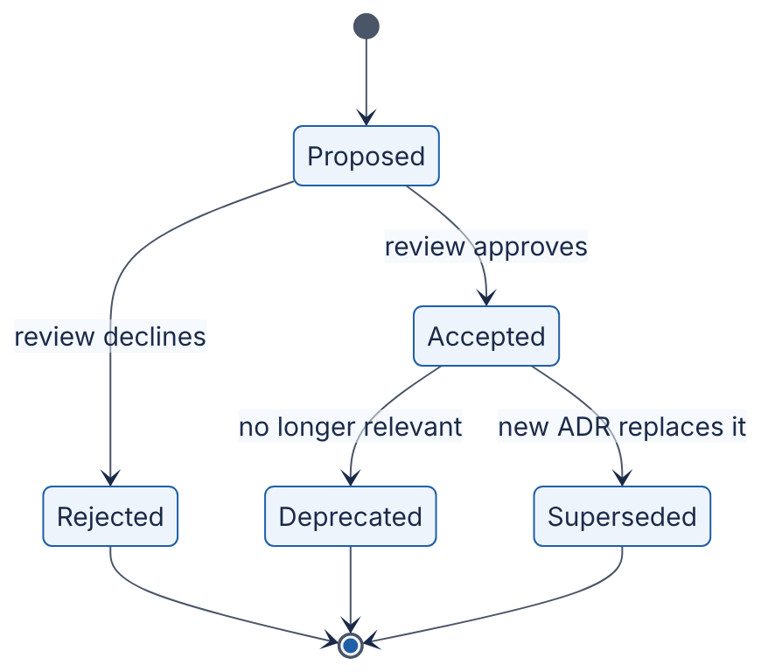
Reading the diagram. Each state is the status field of an ADR, not a running software component. An ADR starts as Proposed, often in a pull request, so that review happens with the usual code-review tooling. Review moves it to Accepted or Rejected. Rejected ADRs are kept, because knowing an option was considered and declined saves future debate. An accepted ADR is never rewritten. When circumstances change it becomes Superseded, with a link to the new ADR, or Deprecated if the thing it governed no longer exists. All transitions are human, asynchronous actions. The failure mode is decay: ADRs that are never updated to Superseded make the record misleading, so check ADR status during design reviews.
INDUSTRY EXAMPLE
ADRs and C4 in practice. Nygard’s 2011 post proposed ADRs as a lightweight alternative to large architecture documents that nobody reads, and the format has since spread widely, with open-source templates and tooling. Simon Brown’s C4 model is likewise published openly with notation guidance and is used to standardize diagrams across teams. Evidence: Primary — [Nygard 2011], [Brown C4]
Table 2.20 — Documentation failure scenarios.
What goes wrong | Why | Detection | Recovery | Prevention
Diagram drift | Diagrams not updated with the code | New joiners find components missing | Redraw from the running system | Diagrams in the repo; review with code changes
Lost rationale | Decisions made in chat or meetings | “Why is it like this?” has no answer | Write retroactive ADRs | ADR required for one-way doors
Unreadable tome | 80-page document nobody reads | No review comments | Split into C4 views plus ADRs | Keep docs short; link out to details
COMMON MISTAKE
“Documentation slows us down.” Writing an ADR takes about half an hour. Re-arguing an undocumented decision, or reversing it by accident, costs days. Document one-way doors always and two-way doors only when they are surprising.

2.13 Summary and revision notes
SUMMARY
- Design is a loop, not a line (Figure 2.1): requirements → boundary → assumptions → estimates → decomposition → bottlenecks → failure → trade-offs → documentation, repeated at higher resolution until the design is good enough for the risk.
- Decompose by business capability, data ownership, load profile and likely change (information hiding). One sentence of responsibility per component. One owner per data store.
- Draw the boundary first. External systems bring availability, latency, rate limits and costs you do not control. QuickBite’s maps contract ruled out per-listing route calls before any code existed.
- Turn adjectives into numbers. “Never down” became 99.95% for checkout (21.6 min/month). “Real-time” became a 5 s refresh with at most 10 s staleness.
- The bottleneck is the resource with the largest demand per unit of capacity. Check CPU, memory, disk, network and software resources (locks, pools). Utilization law: $U=X×D/c$. Little’s Law: $L=λW$. QuickBite’s checkout was limited by a row lock held across a payment call, not by hardware.
- State assumptions with source, confidence, sensitivity and a tripwire. A load-bearing assumption is one where a 10× error changes the design.
- Evaluate trade-offs with a weighted matrix plus a sensitivity check. Then classify reversibility: one-way doors get deliberation and an ADR, two-way doors get speed.
- Design for failure. Timeouts, idempotent retries, circuit breakers, redundancy across zones, and moving work off the critical path. A series path’s availability is the product of its parts.
- Think in orders of magnitude. Each 10× brings qualitatively new problems. Design for the next 10×, keep the following one possible.
- Estimate on the back of an envelope. Average → peak → bandwidth → storage → nodes. QuickBite’s heaviest write path is courier location (5,000/s), about 83× its order writes.
- Document structure with C4 (context, containers, components, code), plans with design docs, and decisions with immutable, superseding ADRs.

2.14 Knowledge checkpoint
- Name four criteria for choosing component boundaries.
- What does a context diagram deliberately leave out, and why?
- Convert “the site must be fast” into a testable requirement.
- How many minutes of downtime per 30-day month does 99.95% allow?
- Which five resource categories make up the resource model?
- A database is at 20% CPU but requests time out waiting. What class of bottleneck is most likely?
- Each request holds a pooled connection for 250 ms and 100 requests/s arrive. How many connections are busy on average?
- What makes an assumption “load-bearing”?
- Why run a sensitivity check on a weighted decision matrix?
- Give one example each of a one-way door and a two-way door in system design.
- Three components in series each have 99.9% availability. What is the path’s availability?
- 1 million DAU each perform 50 reads per day, 15% of them in the busiest hour. What is the busiest-hour read rate?
- What are the four levels of the C4 model?
- Why is an accepted ADR never edited?
Answers
- Business capability, data ownership, load profile or rate of change, consistency need, and likely future change (information hiding). Any four.
- The system’s internal structure. It focuses attention on actors, external dependencies and scope, and stays readable for non-technical stakeholders.
- For example: “p99 latency of the search endpoint below 300 ms, measured over 5-minute windows at up to 7,000 RPS.”
- (1 − 0.9995) × 43,200 = 21.6 minutes.
- CPU, memory, disk, network, and locks or other software resources (pools, threads, file handles).
- A software resource: a lock, a connection pool or a thread pool. Requests are waiting while hardware is idle.
- L = λW = 100 × 0.25 = 25 connections.
- If it were wrong by about 10×, the design would have to change.
- To learn whether the winner depends on a contested weight. If small weight changes flip the result, the decision is close and the deciding factor must be discussed explicitly.
- One-way: the order ID format, a public partner API, the stored data model. Two-way: a cache eviction policy, an internal framework behind a stable API.
- 0.999³ ≈ 0.997, i.e. 99.7%.
- 1,000,000 × 50 × 0.15 / 3,600 ≈ 2,083 RPS (before any burst factor).
- Context, Containers, Components, Code.
- To preserve the history of reasoning. A changed decision gets a new ADR that supersedes the old one, so readers can see what was believed when.

2.15 Interview questions

Basic
Q1. You are asked to “design a food-delivery app.” What do you do in the first five minutes?
Answer. Clarify before designing. Name the users (customers, restaurants, couriers, support) and the top journeys. Agree the functional scope and say explicitly what is out of scope. Then quantify: daily active users, orders per day, peak factor, latency targets per journey, availability for checkout, and consistency needs (“no double charges”). State the assumptions you are making and confirm them with the interviewer. Finish with a quick estimate (orders/s, reads/s, location writes/s) so that the architecture you draw is sized to a target.
Q2. What is a bottleneck, and why does adding servers sometimes not help?
Answer. It is the resource with the largest demand per unit of capacity. It caps throughput for the whole path. Adding capacity anywhere else changes nothing, as with widening a highway before a one-lane bridge. Servers add CPU and memory, but if the limit is a database disk, a hot row lock or a connection pool, throughput stays the same. Find it with the USE method and the utilization law before scaling anything.

Intermediate
Q3. Checkout latency is high at peak but every server’s CPU is below 30%. Walk through your diagnosis.
Answer. Low utilization with high latency points to waiting on a software resource or an external dependency. Look at per-hop latencies in traces. Check pool wait times, lock waits in the database and the latency of external calls. Apply Little’s Law to pools: busy connections = arrival rate × hold time. A common cause is holding a transaction (and therefore a row lock and a connection) across a remote payment call. That gives long hold times, pool exhaustion and hot-row queues. The fix is to shorten the critical section: do the external call outside the transaction, use an idempotency key, and keep transactions to milliseconds. Re-measure afterwards, because the bottleneck moves.
Q4. How do you decide between a modular monolith and microservices for a new product?
Answer. Derive criteria from requirements and constraints: time to market, team size, operational maturity, independent scaling needs, failure isolation. Weight and score them, and run a sensitivity check. For a small team with a deadline, a modular monolith usually wins. Then look for components whose load profile differs by an order of magnitude or more (QuickBite’s location service) and extract only those. Note reversibility: well-kept module boundaries make later extraction a two-way door. Record the decision and its revisit triggers in an ADR.

Advanced
Q5. Your checkout SLO is 99.95%, but the payment provider guarantees only 99.9%. What are your options?
Answer. In series, the path cannot beat its weakest link, so 99.95% is unreachable as stated. Options: (1) redefine the SLO to exclude declared third-party outages, which is common but must be agreed with the business; (2) add a second provider in parallel, giving roughly 1 − 0.001² for independent failures, at the cost of contracts, token handling and reconciliation, a one-way door; (3) accept the order and defer payment capture (authorize later, queue retries) for trusted customers, trading fraud risk for availability; (4) graceful degradation, such as offering alternative payment methods when the breaker opens. Present the costs and reversibility of each and let the business choose.
Q6. QuickBite expands from one country to ten. What changes, and what would you do first?
Answer. That is roughly 10×, so expect qualitative change. Order writes reach ~600/s and saturate the single primary’s WAL disk (§2.10). Data residency laws may require in-country storage. Cross-continent round trips of ~100 ms hurt latency. Payment providers differ by country. First, re-run the estimate and assumption register. Then partition by geography into regional cells, each with its own order database and location store, which addresses scale, residency, blast radius and latency together. Keep a thin global layer for identity and routing only. Treat the partition key (region or city) as a one-way door with a full design doc. Migrate incrementally, one country per cell, with rollback plans.

2.16 Practical exercises
- Context diagram. Draw a system-context diagram for a ride-hailing app. List every external system with an assumed SLA, rate limit and latency, and write three out-of-scope statements.
- Requirements negotiation. Rewrite these as testable requirements and propose a cheaper acceptable alternative for each: “instant search”, “zero data loss”, “global availability”.
- Bottleneck arithmetic. Edit the script in §2.6 so that 10% of orders go to the single most popular restaurant. At what total order rate does the hot row saturate with a 320 ms hold time? With 15 ms?
- Estimation. Repeat the §2.11 estimate for 20 M DAU and a 2 s location update interval. Which tier changes order of magnitude first?
- ADR. Write an ADR for QuickBite’s choice of an idempotency-key scheme for payments, including consequences and revisit triggers.

2.17 Design challenges
- Grocery delivery variant. QuickBite adds grocery delivery: orders of 40–100 items, with stock levels that change constantly and substitutions. Rework Table 2.1, the assumption register and the bottleneck analysis. Where does inventory consistency create new locks or hot rows, and how do you keep them short?
- Holiday surge. On one public holiday per year, orders spike to 8× the normal dinner peak for three hours. Compare three strategies: over-provision permanently, autoscale, or queue orders with a “your order is being placed” experience. Use a weighted decision matrix and classify each strategy’s reversibility. Estimate the cost difference, stating your price assumptions.

2.18 References
- Bass, L., Clements, P., Kazman, R. Software Architecture in Practice, 4th ed. Addison-Wesley, 2021.
- Beyer, B., Jones, C., Petoff, J., Murphy, N. R. (eds.). Site Reliability Engineering: How Google Runs Production Systems. O’Reilly Media, 2016. https://sre.google/sre-book/table-of-contents/
- Bezos, J. 2015 Letter to Shareholders. Amazon.com, Inc., 2016 (published with the 2015 annual report).
- Brown, S. The C4 model for visualising software architecture. c4model.com, accessed 2026. https://c4model.com
- Conway, M. E. How Do Committees Invent? Datamation 14(4), 1968.
- Dean, J. Designs, Lessons and Advice from Building Large Distributed Systems. Keynote, LADIS Workshop, 2009.
- DeMarco, T. Structured Analysis and System Specification. Yourdon Press, 1979.
- Denning, P. J., Buzen, J. P. The Operational Analysis of Queueing Network Models. ACM Computing Surveys 10(3), 1978.
- Gray, J. A Conversation with Werner Vogels: Learning from the Amazon Technology Platform. ACM Queue 4(4), 2006.
- Gregg, B. The USE Method. brendangregg.com. https://www.brendangregg.com/usemethod.html
- Gregg, B. Systems Performance: Enterprise and the Cloud, 2nd ed. Addison-Wesley, 2020.
- Hamilton, J. On Designing and Deploying Internet-Scale Services. Proceedings of the 21st Large Installation System Administration Conference (LISA ’07), USENIX, 2007.
- Izrailevsky, Y., Tseitlin, A. The Netflix Simian Army. Netflix Technology Blog, 2011.
- Little, J. D. C. A Proof for the Queuing Formula: L = λW. Operations Research 9(3), 1961.
- Nygard, M. Documenting Architecture Decisions. Cognitect blog, 2011. https://cognitect.com/blog/2011/11/15/documenting-architecture-decisions
- Parnas, D. L. On the Criteria To Be Used in Decomposing Systems into Modules. Communications of the ACM 15(12), 1972.
- Pugh, S. Total Design: Integrated Methods for Successful Product Engineering. Addison-Wesley, 1991.
- Ubl, M. Design Docs at Google. Industrial Empathy (blog), 2020. https://www.industrialempathy.com/posts/design-docs-at-google/

2.19 Open verification items
- [Bezos 2016] The exact wording and canonical URL (Amazon IR site or SEC exhibit) of the Type 1 / Type 2, “one-way / two-way door” passage. The chapter paraphrases it. sec.gov could not be reached from the authoring session.
- [Dean 2009] Confirm that the “design for ~10× growth, plan to rewrite before ~100×” advice appears in the LADIS 2009 keynote slides and not only in other Dean talks (e.g. Stanford, 2007). Hence the label is Secondary.
- [Ubl 2020] Confirm the publication year and URL. Only secondary summaries were checked.
- [Gray 2006] Confirm that “you build it, you run it” and the no-direct-database-access rule appear in this interview.
- [DeMarco 1979] The first edition is dated 1978 or 1979 depending on the source.
- [Izrailevsky and Tseitlin 2011] Confirm authors and date of the Netflix blog post.
- Table 2.17 capacities and the “99.9–99.99% third-party SLA” range are rough, as of 2026. Reconcile them with Appendix F and §4.17.
- The style guide asks for longer runnable programs in code/ch02/. The §2.6 script is short and was not copied there.

Chapter 3 — The System Design Learning Method
Level: 1 · Track: Shared · Estimated reading time: 3.5 h
System design is a large field. This book covers it in 93 chapters, and the field keeps changing while you read. No one masters it by reading straight through once. Engineers who become strong designers usually have two things: a deep stock of well-understood building blocks, and a reliable way to add new blocks. This chapter gives you that way. It is a method, so it applies to every later chapter, from B-trees (Chapter 11) to LLM inference (Chapter 73).

3.1 Learning objectives
After this chapter you should be able to:
- Apply the ten-step concept-mastery loop to any system-design concept and produce the artifact each step requires.
- Explain, with evidence, why retrieval practice and spaced practice beat rereading and highlighting, and schedule reviews to match.
- Read a systems paper using Keshav’s three-pass method and judge an engineering blog post’s claims by the strength of its evidence.
- Draw a reference architecture from memory, score it against a checklist, and repair the gaps.
- Scope a simplified implementation that keeps the core mechanism and leaves out production concerns.
- Follow a 12-month beginner path through this book, or build a gap-driven plan if you are already experienced.
- Track your progress with a self-assessment rubric, flashcards and a design journal.

3.2 Prerequisites
- What system design is — §1.3–§1.5. You need to know what counts as a “concept” or “building block” before you can learn concepts methodically.
- Trade-off reasoning — §2.8. Step 6 of the loop asks you to analyze trade-offs. Chapter 2 gives you the vocabulary.
- Basic Python — enough to read a 60-line program with a class, a list and a dictionary. Sections 3.3 and 3.4 contain short runnable programs.
- Hashing (informal) — you should know that a hash function maps any input to a fixed-size number. Chapter 17 (§17.3) covers hashing in depth; you do not need it yet.

3.3 The ten-step concept-mastery loop

3.3.1 Why a loop rather than a reading list
DEFINITION
Definition — Concept-mastery loop. A fixed sequence of ten learning activities applied to one system-design concept. Each activity produces a concrete artifact (a definition, a diagram, a program, a design). The concept counts as mastered only when you can rebuild every artifact without notes.

First-principles explanation
Think about learning to cook one dish well. Reading the recipe tells you what the dish is. Knowing why each ingredient is there tells you what goes wrong if you leave one out. Watching a chef shows you technique. But you only really know the dish after you have cooked it yourself, burned it once, fixed it, and then cooked it for someone else without the recipe in front of you. The loop applies the same idea to a concept such as caching or consistent hashing.

Why does this exist?
Most engineers learn system design by exposure: they read blog posts, watch videos and skim chapters. Exposure feels productive because the material seems familiar on the second reading. Familiarity is not the same as the ability to use a concept. Learning researchers call this mismatch an illusion of competence. Rereading and highlighting are among the least effective study techniques measured [Dunlosky et al. 2013]. A design interview or a design review asks you to produce: choose a mechanism, draw it, estimate it and defend it. The loop makes production the main activity.

How it works internally
Table 3.1 — The ten steps, the question each answers, and the artifact each produces.
# | Step | Question it answers | Artifact | Typical time (L1–L2)
1 | Understand the concept | What is it, in one precise sentence? | Definition in your own words | 15 min
2 | Identify the problem it solves | What breaks without it? | A “before” scenario with numbers | 20 min
3 | Understand the mechanism | How does it work, step by step? | Numbered mechanism description | 45 min
4 | Draw the architecture | Where does it sit and what talks to it? | Diagram drawn from memory | 20 min
5 | Study an actual implementation | How did a real system build it? | Notes on one paper, docs page or codebase | 60–120 min
6 | Analyze trade-offs | What does it cost, and versus what? | Comparison table against alternatives | 30 min
7 | Explore failure scenarios | How does it break? | Failure table (what, why, detect, recover, prevent) | 30 min
8 | Implement a simplified version | Can I build the core? | Runnable program of 50–300 lines with a measurement | 2–4 h
9 | Solve a design problem | Can I use it in context? | A small design that uses the concept | 45–60 min
10 | Explain it independently | Can I teach it without notes? | 2–5 minute spoken or written explanation | 15 min
A full pass takes about 6–10 hours for one substantial concept. Plan for that. A concept such as “HTTP status codes” does not need all ten steps. A concept such as consistent hashing, Raft or the KV cache does.
The steps are ordered so that each one gives the next one something to work with. You cannot weigh trade-offs (6) until you know the mechanism (3). You should not implement (8) before you know the failure modes (7), because the failures tell you what your simulation must be able to show. Step 10 then checks all the earlier steps. Wherever your explanation falters, you return to that step. That return is why it is a loop and not a line.
Figure 3.1 — The ten-step concept-mastery loop.
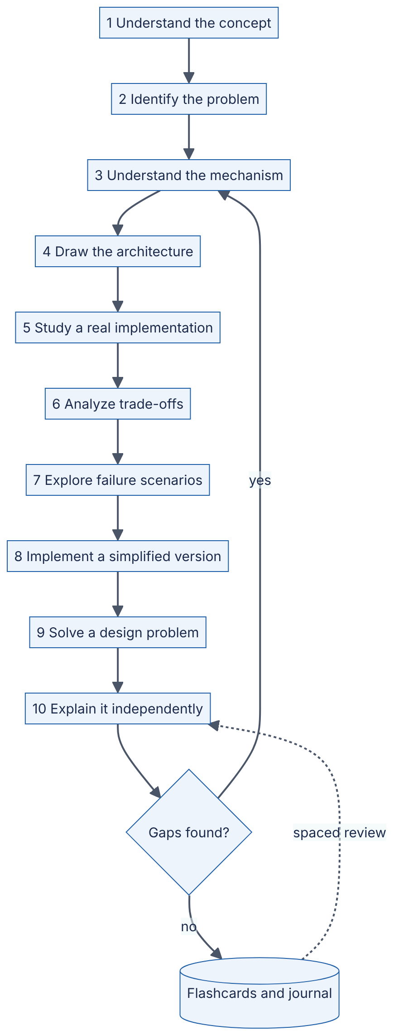
Reading the diagram. The ten rectangles are learning activities, done in order. The solid arrows mean “finish this before starting the next”. The decision node after step 10 is your self-test. If you cannot explain some part without notes, you go back to step 3 (mechanism), because most gaps turn out to be gaps in the mechanism. If you can, the concept goes into long-term storage: the cylinder represents your flashcard deck and design journal (§3.10). The dotted arrow is asynchronous. Days or weeks later, a scheduled review asks you to repeat step 10 from memory. The weak point in this process is skipping steps 7 and 8, which feel optional but are where most understanding is built. To scale the method across a whole book, run several concepts’ loops interleaved, not one after another (§3.4.5).

Common misconceptions
COMMON MISTAKE
Misconception — “I understood it when I read it, so I know it.” Understanding while reading is recognition: the text is in front of you and gives you the cues. Using a concept in a design is recall: you have to bring it up with no cues. Only steps 4, 8, 9 and 10 test recall. If you skip them, you will not know what you are unable to do.

3.3.2 The loop demonstrated: consistent hashing
The rest of §3.3 runs one concept through all ten steps. It shows the artifacts at the depth we expect from you. We use consistent hashing because it is compact enough for one section and still has a real mechanism, real failure modes and real implementations. Chapter 14 (§14.8) and Chapter 20 (§20.14) treat it in full. Treat what follows as a sample of how to study, not the canonical treatment.

Step 1 — Understand the concept
DEFINITION
Definition — Consistent hashing. A way of assigning keys to nodes so that, when a node is added or removed, only about $K/N$ of the $K$ keys change owner, where $N$ is the number of nodes. Both keys and nodes are hashed onto the same circular number space (the ring). Each key belongs to the first node found by moving clockwise from the key’s position [Karger et al. 1997].
Self-check artifact: one sentence in your own words, with no jargon you cannot define. For example: “It spreads keys over servers so that adding a server moves only that server’s fair share of keys.”

Step 2 — Identify the problem it solves
Suppose you run four cache nodes and route each key with node = hash(key) mod 4. Traffic grows, so you add a fifth node and the rule becomes hash(key) mod 5. For most keys, hash mod 4 and hash mod 5 point to different nodes. Those keys now live on the wrong node, so nearly every request misses the cache and falls through to the database at the very moment you were trying to add capacity.
FORMULA
Fraction of keys remapped when growing from $N$ to $N+1$ nodes
$$f_{\text{mod}}=1−\frac{1}{N+1}=\frac{N}{N+1} f_{\text{ring}}≈\frac{1}{N+1}$$
Symbol | Meaning | Units
$N$ | Number of nodes before the change | nodes
$f_{\text{mod}}$ | Expected fraction of keys whose owner changes under hash mod N (uniform hashing) | dimensionless (0–1)
$f_{\text{ring}}$ | Expected fraction of keys whose owner changes under consistent hashing | dimensionless (0–1)
The $f_{\text{mod}}$ result comes from a simple observation. A key stays on the same node only if h mod N equals h mod (N+1). For uniformly distributed hashes, that happens for about $1/\left(N+1\right)$ of keys. Under consistent hashing, the new node takes over only the keys that fall in its arcs of the ring. On average that is its fair share, $1/\left(N+1\right)$.
WORKED EXAMPLE
Worked example — Adding a fifth cache node.
- Setup: $N=4$, $K=100,000,000$ cached keys, cache hit ratio 95 %, and 50,000 reads per second (RPS) reach the cache tier.
- Naive scheme: $f_{\text{mod}}=4/5=0.80$. About $0.80×{10}^{8}=8×{10}^{7}$ keys are now on the wrong node.
- Ring scheme: $f_{\text{ring}}=1/5=0.20$. About $2×{10}^{7}$ keys move. They move only to the new node, which starts out empty.
- Database impact right after the change, before the cache refills. Under mod-N, about 80 % of reads miss, plus the normal 5 % on the rest. The database sees about $0.80×50,000+0.05×0.20×50,000=40,000+500=40,500$ RPS instead of the usual $0.05×50,000=2,500$ RPS. That is a 16× surge. Under the ring, about 20 % of reads miss, plus the normal 5 % on the remaining traffic. The database sees about $0.20×50,000+0.05×0.80×50,000=10,000+2,000=12,000$ RPS, a 4.8× surge.
Interpretation. Both schemes cause a miss spike. Consistent hashing makes it about 3.4× smaller ($40,500/12,000$) and limits it to one node’s share of keys. Engineering implication. If your database can absorb about 12,000 RPS, consistent hashing lets you add cache nodes without an outage. With mod-N you would need to warm the new layout ahead of time or add nodes only during low traffic. Chapter 20 (§20.11, cache stampede) covers the remaining spike.
Self-check artifact: a “before” scenario with numbers, like the one above.

Step 3 — Understand the mechanism
- Pick a hash function that maps strings to integers in $[0,2^{m})$. Treat that range as a circle in which $2^{m}−1$ is next to $0$.
- For each node, compute $V$ positions by hashing distinct labels such as "cache-2#vn17". Each position is a virtual node (vnode). Store all $N×V$ positions in a sorted array, each mapped to its physical node.
- To look up a key, hash it and binary-search the sorted array for the first position greater than the key’s hash. If there is none, wrap around to index 0. The node that owns that position owns the key. A lookup costs $O\left(log\left(NV\right)\right)$.
- To add a node, insert its $V$ positions. Each one takes over the arc between its predecessor and itself. Every other key keeps its owner.
- To remove a node, delete its positions. Each of its arcs goes to the next position clockwise. Because the vnodes are scattered around the ring, the removed node’s load is spread over many survivors instead of all landing on one neighbor.
- For replication, walk clockwise and collect the first $R$ distinct physical nodes. Dynamo calls this list the preference list [DeCandia et al. 2007].
Why do virtual nodes matter? With $V=1$, each node owns one arc, and arc lengths from $N$ random points vary widely. One node can easily own two or three times its fair share. With $V$ vnodes, each node’s load is the sum of $V$ arcs, and sums of many random lengths stay close to the average. The relative spread shrinks roughly in proportion to $1/\sqrt{V}$. Step 8 measures this.

Step 4 — Draw the architecture
Close the book and draw where consistent hashing sits in a distributed cache. Then compare your drawing with Figure 3.2.
Figure 3.2 — Consistent hashing in a client-routed distributed cache.
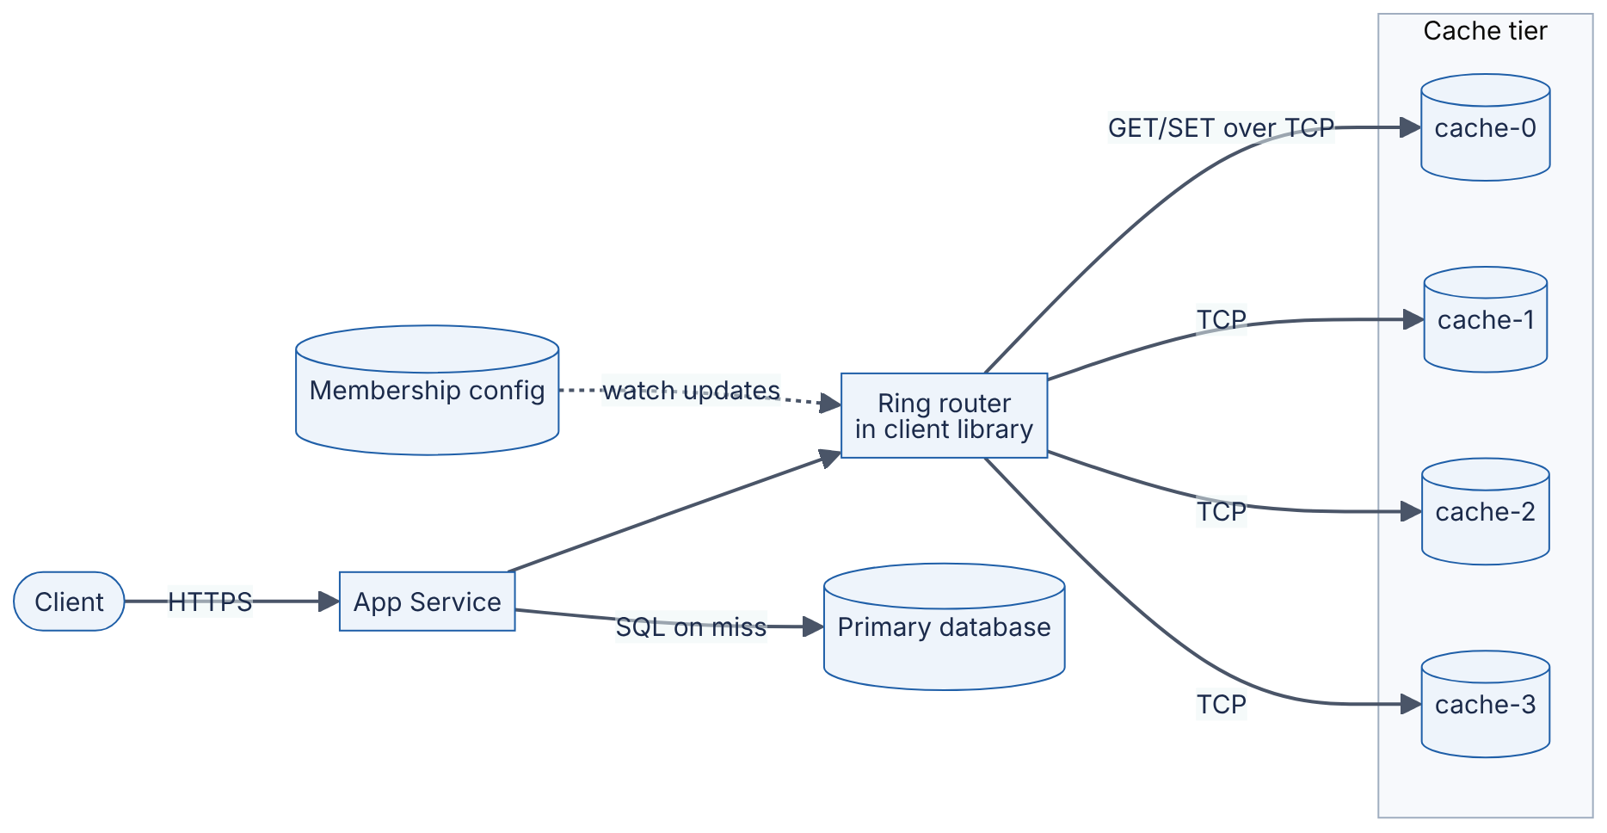
Reading the diagram. A client calls the app service over HTTPS. Inside the app service, a client library holds the ring: the sorted vnode positions and their owners. It is in-process, so a lookup is a binary search in memory, typically microseconds. The ring router sends each GET/SET to exactly one cache node over a TCP connection, such as the Memcached or Redis protocol. All of these are synchronous calls. On a miss, the app service reads the primary database over SQL and fills the cache (cache-aside, §20.7). The dotted arrow from the membership config is asynchronous. A coordination service or config file tells every app instance when nodes join or leave (§26.8–§26.9). There are two storage boundaries: the in-memory cache tier, which is disposable, and the database, which is durable. Failure points: a cache node that dies sends its keys to clockwise successors and causes a miss spike, and app instances that see different membership send the same key to different nodes. To scale, add cache nodes (each takes about $1/\left(N+1\right)$ of the keys) or raise $V$ to even out the load.
Self-check artifact: your own drawing, annotated with which calls are synchronous and where state lives. If your drawing left out the membership channel, you have found your first gap. Section 3.6 explains how to score drawings like this.

Step 5 — Study an actual implementation
Now read how real systems built it. Pick one primary source and read it with the three-pass method (§3.5). For consistent hashing, three sources are worth knowing:
INDUSTRY EXAMPLE
Akamai and the original paper. Karger and colleagues introduced consistent hashing to spread web-cache load without hot spots, in a setting where different clients may see different sets of caches. Their paper defines the properties a good scheme needs. Two of them are balance, meaning keys spread evenly, and monotonicity, meaning that adding a cache moves keys only onto the new cache, never between old caches. The paper also uses multiple copies of each cache point on the circle to improve balance, which is the idea behind virtual nodes. Evidence: Primary — [Karger et al. 1997]
INDUSTRY EXAMPLE
Amazon Dynamo. Dynamo partitions its key space with consistent hashing and assigns each physical node several virtual nodes. This lets a more powerful machine take more vnodes, and it spreads a failed node’s load over many survivors. Each key is replicated on the first $R$ distinct physical nodes clockwise, its preference list (the paper calls this count $N$). The paper compares three strategies for placing tokens. It reports that dividing the ring into equal-sized partitions, decoupled from node placement, gave the best load balance and the smallest membership metadata. Evidence: Primary — [DeCandia et al. 2007]
INDUSTRY EXAMPLE
Apache Cassandra. Cassandra’s original design hashes keys onto a ring with an order-preserving hash function and assigns each node one position. The paper acknowledges the load imbalance this causes. It handles the imbalance by analyzing load on the ring and moving lightly loaded nodes so they take load from heavily loaded ones. Evidence: Primary — [Lakshman and Malik 2010]
When you read an implementation, write down where it departs from the textbook mechanism and why. Departures are usually the most instructive part. Dynamo moved from random tokens to fixed equal-sized partitions because random tokens made bootstrapping and archiving slow. That is an operational reason, not an algorithmic one, and only a real implementation would show it to you.

Step 6 — Analyze trade-offs
Table 3.2 — Key-to-node assignment schemes compared.
Dimension | hash mod N | Ring + virtual nodes | Rendezvous (HRW) hashing | Jump consistent hash
What it is | Modulo of key hash | Keys and vnodes on a circle | Each key picks the node with the highest score hash(key, node) | Arithmetic function from key to bucket number
Keys moved on add | ~$N/\left(N+1\right)$ | ~$1/\left(N+1\right)$ | ~$1/\left(N+1\right)$ | ~$1/\left(N+1\right)$
Lookup cost | $O\left(1\right)$ | $O\left(logNV\right)$ | $O\left(N\right)$ (scores every node) | $O\left(logN\right)$, no table
Memory | None | $O\left(NV\right)$ positions | $O\left(N\right)$ node list | None
Load balance | Excellent | Good; improves with $V$ | Excellent | Excellent
Arbitrary node removal | Remaps almost everything | Yes | Yes | No; buckets must be numbered $0..N−1$ and removed from the end
Weighted nodes | Awkward | Natural (more vnodes) | Possible with weighted scores | No
Choose when | $N$ never changes | General-purpose caches and stores | Small $N$, simple code | Storage shards that only grow
Sources: [Karger et al. 1997], [Thaler and Ravishankar 1998], [Lamping and Veach 2014]. Two further variants are worth knowing by name. Maglev hashing builds a fixed-size lookup table for $O\left(1\right)$ lookups in load balancers and accepts a little extra disruption in exchange [Eisenbud et al. 2016]. Consistent hashing with bounded loads caps every node at $\left(1+ε\right)$ times the average load and sends overflow keys clockwise [Mirrokni et al. 2018].
Self-check artifact: a table like Table 3.2 written from memory, plus one sentence saying which scheme you would pick for a 6-node Redis cache and why.

Step 7 — Explore failure scenarios
Table 3.3 — Failure scenarios for consistent hashing.
What goes wrong | Why | Detection | Recovery | Prevention
One node overloaded | Too few vnodes, so arcs are uneven | Per-node RPS and memory skew | Add vnodes to the others; rebalance | $V≥100$; bounded-load variant
Hot key | One key gets a large share of traffic; hashing cannot split one key | Top-K key metrics (§17.6) | Replicate the hot key; add a local cache tier | Key splitting, request coalescing (§20.15)
Successor overload after node death | With $V=1$, the clockwise neighbor inherits all of the dead node’s keys | Neighbor CPU and miss-ratio spike | Bring up a replacement node | Virtual nodes spread the load over many successors
Split views of membership | Clients update membership at different times | Same key read from two nodes; inconsistent reads | Converge config; flush the affected range | Single source of truth with watches; versioned ring
Miss storm on resize | New node starts cold | Database RPS spike | Rate-limit fills; serve stale data | Pre-warm; add nodes off-peak; stampede protection (§20.11)
Poor hash function | Clustering of positions | Skewed arc lengths at build time | Change the hash, which remaps everything | Use a well-mixed hash (e.g., MurmurHash, xxHash, MD5 truncated)
The split-view row is the one beginners miss. The algorithm assumes every client has the same ring. Keeping that true is a distributed-systems problem in its own right, and you will meet it again in Chapter 26.

Step 8 — Implement a simplified version
Keep the mechanism and leave out everything else: no networking, no replication, no persistence. The goal is a program that lets you see the two properties you studied, minimal movement and load balance.
"""Simplified consistent-hashing ring with virtual nodes (teaching version)."""
import bisect
import hashlib
from collections import Counter
def h(key: str) -> int:
"""Map a string to a 64-bit integer position on the ring."""
digest = hashlib.md5(key.encode("utf-8")).digest()
return int.from_bytes(digest[:8], "big")
class HashRing:
def __init__(self, nodes=(), vnodes: int = 100):
self.vnodes = vnodes
self._positions = [] # sorted ring positions
self._owner = {} # position -> physical node name
for node in nodes:
self.add_node(node)
def add_node(self, node: str) -> None:
for i in range(self.vnodes):
pos = h(f"{node}#vn{i}")
bisect.insort(self._positions, pos)
self._owner[pos] = node
def remove_node(self, node: str) -> None:
for i in range(self.vnodes):
pos = h(f"{node}#vn{i}")
self._positions.remove(pos)
del self._owner[pos]
def get_node(self, key: str) -> str:
"""Return the first node clockwise from the key's position."""
if not self._positions:
raise LookupError("ring is empty")
idx = bisect.bisect_right(self._positions, h(key))
if idx == len(self._positions): # wrap around past the top
idx = 0
return self._owner[self._positions[idx]]
def mod_n_node(key: str, nodes: list) -> str:
"""The naive scheme: hash(key) mod N."""
return nodes[h(key) % len(nodes)]
if __name__ == "__main__":
keys = [f"user:{i}" for i in range(100_000)]
before = [f"cache-{i}" for i in range(4)]
after = before + ["cache-4"]
moved = sum(mod_n_node(k, before) != mod_n_node(k, after) for k in keys)
print(f"mod-N : {moved / len(keys):.1%} of keys moved (4 -> 5 nodes)")
for v in (1, 100):
ring = HashRing(before, vnodes=v)
old = {k: ring.get_node(k) for k in keys}
ring.add_node("cache-4")
moved = sum(old[k] != ring.get_node(k) for k in keys)
load = Counter(ring.get_node(k) for k in keys)
spread = max(load.values()) / (len(keys) / len(after))
print(f"ring vnodes={v:<3}: {moved / len(keys):.1%} moved, "
f"busiest node at {spread:.2f}x the mean load")
Running it with Python 3.8 or later prints:
mod-N : 79.9% of keys moved (4 -> 5 nodes)
ring vnodes=1 : 24.4% moved, busiest node at 2.60x the mean load
ring vnodes=100: 21.4% moved, busiest node at 1.08x the mean load
What to notice:
- h() uses MD5 only as a mixing function, which is fine here because nothing depends on it being cryptographically secure. Python’s built-in hash() is randomized per process for strings, so two app instances would build different rings. That is exactly the split-view failure from Table 3.3, reproduced by accident.
- bisect_right plus the wrap-around check is the clockwise walk. Those two lines are the whole algorithm.
- The measurement agrees with the formula. Mod-N moved 79.9 % against a predicted 80 %. The ring moved about 20 % (21.4 % with 100 vnodes).
- With one vnode per node, the busiest node carries 2.6× its fair share. With 100 vnodes it carries 1.08×. You have now seen why virtual nodes exist, which is worth more than reading it.
- bisect.insort costs $O\left(NV\right)$ per insert. That is fine at this scale. A production ring would rebuild a sorted array once per membership change.

Step 9 — Solve a design problem
Use the concept inside a small design. Problem: a session store for 20 million concurrently active users. Each session is about 2 KB. Reads run at 200,000 RPS and writes at 20,000 RPS. A cache node may fail without logging out more than about 10 % of users.
A sketch of the solution. Data volume is $2×{10}^{7}×2 \text{KB}=40 \text{GB}$ (SI units). With replication factor 2 that is 80 GB. Ten nodes with 16 GB of usable memory each hold it with headroom. Assign keys with a ring of 10 nodes × 150 vnodes. Write each session to the first two distinct physical nodes clockwise. If one node dies, its share (~10 %) has a replica on many different successors thanks to the vnodes, so no user is logged out and no single successor doubles its load. Figure 3.3 shows the read path during that failure.
Figure 3.3 — Session read when the primary owner has failed.
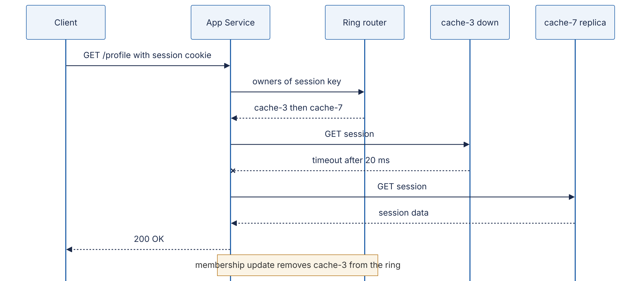
Reading the diagram. The participants are the client, the app service, the in-process ring router, the failed owner (cache-3) and the second replica on the preference list (cache-7). All arrows are synchronous request/response calls. The client uses HTTPS, and the app talks to the cache nodes over TCP. The crossed arrow is the failure: the call to cache-3 times out after a short, explicit deadline (§22.11). The app then tries the next node on the preference list. The cost to the user is one timeout of added latency, here 20 ms. The note shows the asynchronous repair: once failure detection (§27.10) removes cache-3, the router stops trying it and the extra latency goes away. The storage boundary is the cache tier, and each session lives on two nodes. To scale, add nodes. Each one takes about $1/\left(N+1\right)$ of the sessions.

Step 10 — Explain it independently
Close everything. Set a timer for three minutes and explain consistent hashing aloud, or in writing, to an imagined colleague who knows what a hash function is but nothing else. A good explanation covers five beats:
- The problem: mod-N remaps about $N/\left(N+1\right)$ of keys when $N$ changes.
- The trick: put nodes and keys on the same ring and walk clockwise.
- The consequence: only about $1/\left(N+1\right)$ of keys move, and only to or from the changed node.
- The refinement: virtual nodes fix uneven arcs and spread failure load.
- The limits: it does nothing for hot keys, and every client must share the same membership view.
Record yourself if you can. Then mark each beat as “fluent”, “hesitant” or “missing”. Each beat you marked “hesitant” or “missing” sends you back to the matching step: beats 1–2 to steps 2–3, beat 4 to step 8, beat 5 to step 7. Then turn the shaky beats into flashcards (§3.10.2).
RECOMMENDATION
Recommendation — Keep the artifacts. Store all ten artifacts for each concept in one folder or journal entry (§3.10.3). Months later, rebuilding a concept from your own artifacts is far quicker than the first loop was. That folder becomes your personal edition of this book.

3.4 Active recall, spaced repetition, the Feynman technique, interleaving and deliberate practice
The loop tells you what to do with a concept. This section explains how to practice so that what you learn lasts. The techniques come from cognitive psychology. They were tested mostly on facts, vocabulary, science texts and mathematics, not on architecture, so applying them to system design is a reasonable extrapolation rather than a measured result.

3.4.1 What the evidence says, in one table
Dunlosky and colleagues reviewed ten widely used study techniques. They rated each one’s utility by how well it generalized across learners, materials and test conditions [Dunlosky et al. 2013].
Table 3.4 — Study techniques by rated utility, and their system-design form.
Technique | Rated utility | System-design form
Practice testing (retrieval practice) | High | Flashcards; drawing from memory; mock design sessions
Distributed practice (spacing) | High | Scheduled reviews days and weeks apart (§3.4.3)
Elaborative interrogation | Moderate | Asking “why does Dynamo use vnodes rather than one token?”
Self-explanation | Moderate | Step 10 of the loop; the Feynman technique (§3.4.4)
Interleaved practice | Moderate | Mixing caching, queuing and replication problems in one session
Summarization | Low | Writing chapter summaries (useful only with good training)
Highlighting / underlining | Low | Marking up PDFs
Keyword mnemonic | Low | Acronyms for lists of terms
Imagery for text | Low | Picturing a text’s content
Rereading | Low | Reading a chapter a second time
The ratings of the top five are the ones that matter. The two techniques that feel most like studying, highlighting and rereading, rated low. The two that feel most like being tested, practice testing and spacing, rated high.
KEY CONCEPT
Key insight — Learning versus performance. How well you do during practice is a poor guide to how much you are learning. Conditions that make practice feel harder, such as spacing, interleaving and testing yourself before you feel ready, often produce better long-term retention. Bjork called these desirable difficulties [Bjork 1994]; see [Soderstrom and Bjork 2015] for a review. If a study session felt smooth and easy, be suspicious of it.

3.4.2 Active recall (retrieval practice)
DEFINITION
Definition — Active recall. Deliberately retrieving information from memory without looking at the source, for example by answering a question, drawing a diagram or explaining aloud. Its measured benefit for later retention is called the testing effect.
In a well-known experiment, students read short prose passages under one of three schedules. They either studied four times (SSSS), studied three times and then took one free-recall test (SSST), or studied once and took three tests (STTT). On a test five minutes later, more studying gave better recall. On a test one week later, the order reversed. The repeated-testing group recalled about 61 % of the idea units, against about 40 % for the repeated-study group, even though the testing group had seen the text only once [Roediger and Karpicke 2006]. A later study found that retrieval practice also beat building concept maps, an “active” elaborative technique, on a test of meaningful learning [Karpicke and Blunt 2011].
Applied to system design. Every reading session should end with retrieval: close the book, and write or draw what you just learned. The checkpoints at the end of each chapter in this book exist for this reason. Answer them before you open the <details> block.

3.4.3 Spaced repetition
DEFINITION
Definition — Spaced repetition. Reviewing material at increasing intervals, so that each review happens around the time you would otherwise begin to forget it. The underlying finding, that spacing study sessions apart beats massing them together, is the spacing effect.
The spacing effect is one of the oldest results in experimental psychology. It goes back to Ebbinghaus’s experiments on himself in the 1880s [Ebbinghaus 1885/1913]. A meta-analysis of hundreds of comparisons confirmed that spaced practice beats massed practice for verbal recall [Cepeda et al. 2006]. A follow-up study asked how far apart reviews should be. The best gap between study sessions depended on how long you need to remember the material. Expressed as a fraction of that retention interval, the best gap was about 20–40 % for a one-week retention interval and fell to about 5–10 % for a one-year interval [Cepeda et al. 2008].
The practical form of spaced repetition is the Leitner system: flashcards move through numbered boxes. A correct answer promotes a card to the next box, which is reviewed less often. A wrong answer sends it back to box 0. Software such as Anki automates the same idea with adaptive intervals.
Figure 3.4 — A five-box Leitner schedule for flashcards.
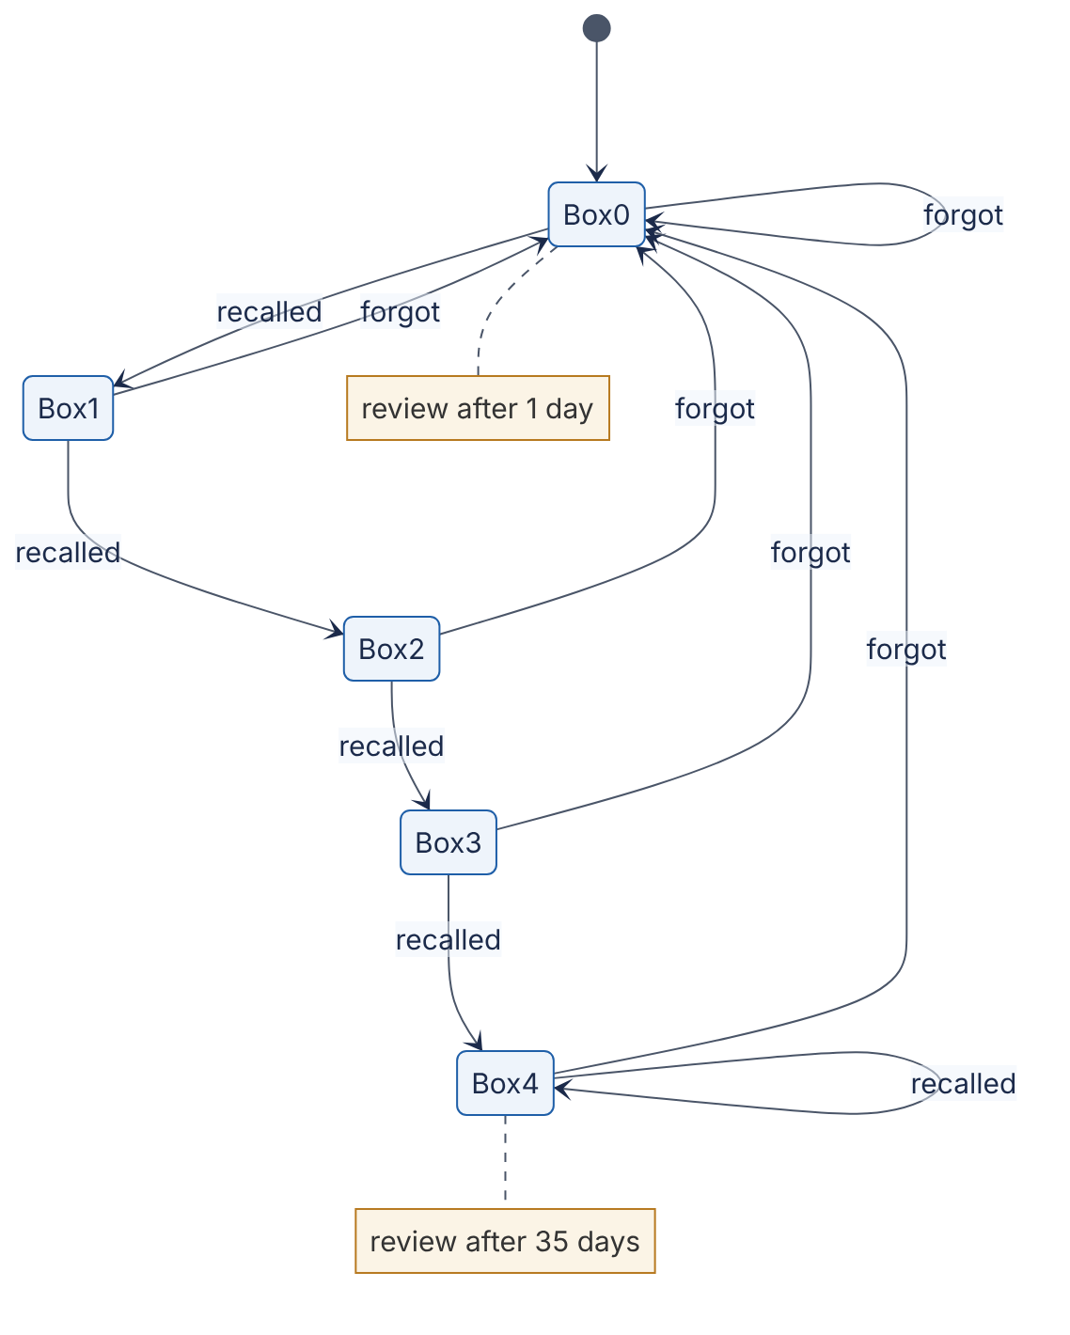
Reading the diagram. Each state is a box with its own review interval: 1, 3, 7, 16 and 35 days for boxes 0 to 4. The intervals are a reasonable starting point, not an empirically optimal set. Each transition is one review. “Recalled” moves a card one box up, and the top box keeps it there. “Forgot” sends it back to box 0. Data flows one card at a time. All of the state is the box number and due date per card, so a spreadsheet is enough storage. The failure point is a backlog: if you skip a week, the reviews that were due pile up. The fix is to cap new cards per day, not to skip reviews. The schedule scales because mastered cards cost one review every five weeks or so.
The scheduler itself is small enough to build in a few minutes, which makes it a good first “simplified implementation” (§3.7):
"""Minimal Leitner-box scheduler for system-design flashcards."""
from dataclasses import dataclass, field
from datetime import date, timedelta
INTERVALS = [1, 3, 7, 16, 35] # days until next review, per box (box 0..4)
@dataclass
class Card:
prompt: str
box: int = 0
due: date = field(default_factory=date.today)
def review(self, recalled: bool, today: date) -> None:
# Success promotes one box; failure sends the card back to box 0.
self.box = min(self.box + 1, len(INTERVALS) - 1) if recalled else 0
self.due = today + timedelta(days=INTERVALS[self.box])
def due_cards(cards, today):
return [c for c in cards if c.due <= today]
if __name__ == "__main__":
start = date(2026, 1, 5)
card = Card("Why do virtual nodes reduce load imbalance?", due=start)
today = start
for ok in [True, True, False, True, True, True]:
card.review(ok, today)
print(f"{today} recalled={ok!s:<5} -> box {card.box}, next {card.due}")
today = card.due
Output:
2026-01-05 recalled=True -> box 1, next 2026-01-08
2026-01-08 recalled=True -> box 2, next 2026-01-15
2026-01-15 recalled=False -> box 0, next 2026-01-16
2026-01-16 recalled=True -> box 1, next 2026-01-19
2026-01-19 recalled=True -> box 2, next 2026-01-26
2026-01-26 recalled=True -> box 3, next 2026-02-11
What to notice:
- field(default_factory=date.today) matters. A plain date.today() default would be evaluated once, when the class is defined, and every card would share that date. This is the kind of bug you only find by building the thing.
- One failure on 15 January wipes out two promotions. That is harsh by design: a card you forgot needs to be relearned, not just reviewed.
- After six reviews spread over five weeks, the card is due in 16 days. Spaced repetition costs little per item, and the cost keeps falling.
WORKED EXAMPLE
Worked example — Daily review load. You add 5 new cards per study day, 5 days a week, for a year: about $5×5×52=1,300$ cards. In the steady state, assume 70 % of cards sit in boxes 3–4 (reviewed about every 16–35 days, call it every 25 days), 20 % in box 2 (every 7 days) and 10 % in boxes 0–1 (every 2 days on average). Daily reviews ≈ $1,300×\left(0.70/25+0.20/7+0.10/2\right)=1,300×\left(0.028+0.029+0.050\right)≈139$ cards. At about 8 seconds per card that is roughly 19 minutes a day. Interpretation. A year of system-design vocabulary stays fresh for under 20 minutes a day, if most cards are mastered. Implication. Keep cards atomic so they move up the boxes quickly. Cards that bounce between boxes 0 and 1 dominate the load, so rewrite or split them.

3.4.4 The Feynman technique (self-explanation)
The “Feynman technique” is a popular name for a four-step routine. You pick a concept, explain it in plain language as if to a newcomer, find the places where your explanation breaks down or falls back on jargon, and go back to the source to fix those places. Richard Feynman did not publish this method under that name. The label was attached later. The research behind it is the work on self-explanation: learners who explain material to themselves while studying understand it better than those who only read it [Chi et al. 1994]. Dunlosky and colleagues rated self-explanation and elaborative interrogation as having moderate utility [Dunlosky et al. 2013].
In system design, the routine is step 10 of the loop, plus one rule: every “it just handles that” is a gap. If your explanation of Kafka says “the broker handles durability”, you have not explained durability. You have named it. Push until you reach a mechanism, such as “the leader waits for in-sync replicas to append the record before acknowledging when acks=all” (§31.6, §31.9).

3.4.5 Interleaving
DEFINITION
Definition — Interleaving. Mixing different kinds of problems or concepts within one practice session (A B C A C B), instead of finishing all practice on one kind before moving to the next (AAA BBB CCC, called blocking).
In one study, students who practiced mixed (shuffled) mathematics problems did worse during practice but much better on a delayed test than students who practiced in blocks [Rohrer and Taylor 2007]. Interleaving also helped people learn to tell categories apart, such as painters’ styles, even though most participants believed blocking had worked better for them [Kornell and Bjork 2008].
A design problem never tells you which chapter it comes from. Interleaving trains the skill that matters most in a real design: noticing which tool a situation calls for. In practice, once you have studied caching, queues and replication, practice with mixed questions such as “this read path is slow; is it a cache problem, a fan-out problem, or a replication-lag problem?” instead of ten caching questions in a row.

3.4.6 Deliberate practice
DEFINITION
Definition — Deliberate practice. Effortful practice designed to improve performance. It targets specific weaknesses, has clear goals, gives immediate feedback and is usually guided by a teacher or coach [Ericsson et al. 1993].
Ericsson and colleagues argued that differences in expert performance largely reflect accumulated deliberate practice. Later work found the picture more mixed. A meta-analysis found that deliberate practice explained about 12 % of the variance in performance across domains, and less in education and professions than in games, music and sports [Macnamara et al. 2014]. The honest conclusion is this: practice that targets weaknesses and comes with feedback helps, but hours alone do not guarantee expertise.
For a system designer, the scarce ingredient is feedback. You can get it from mock interviews with a scoring rubric (Chapter 88), from design reviews by senior engineers (§3.9.2), from comparing your design with published ones (Chapters 52–56), and from running your own simplified implementation to see whether it behaves as you predicted.
COMMON MISTAKE
Misconception — “I’m a visual learner, so I should only watch videos.” Matching instruction to self-reported “learning styles” has not been shown to improve outcomes in properly designed experiments [Pashler et al. 2008]. Diagrams do help with system design, but because the subject is spatial and structural, not because of your learning style. Everyone should draw.

3.5 Reading papers and engineering blogs
Step 5 of the loop sends you to primary sources. In system design, those are mostly conference papers (SOSP, OSDI, NSDI, USENIX ATC, VLDB, SIGMOD), official documentation and company engineering blogs. Each needs a different way of reading.

3.5.1 Keshav’s three-pass method
Keshav’s two-page note is the standard advice for reading systems papers. Read a paper in up to three passes, and decide after each pass whether the next one is worth the time [Keshav 2007].
- First pass (about 5–10 minutes). Read the title, abstract and introduction. Read the section headings and nothing under them. Glance at any mathematics, then read the conclusions and scan the references. Afterwards, you should be able to answer the five Cs: Category (what type of paper is it?), Context (which other work does it build on?), Correctness (do the assumptions look valid?), Contributions (what is new?) and Clarity (is it well written?).
- Second pass (up to about an hour). Read carefully but skip proofs. Study the figures, graphs and axes. Mark the references you have not read. Afterwards, you should be able to summarize the paper’s main thrust, with evidence, to someone else.
- Third pass (about 4–5 hours for a beginner, about an hour for an experienced reader). Virtually re-implement the paper. Make the same assumptions, recreate the work, and compare your version with the authors’. This pass exposes hidden assumptions and missing citations.
Figure 3.5 — The three-pass reading decision flow.
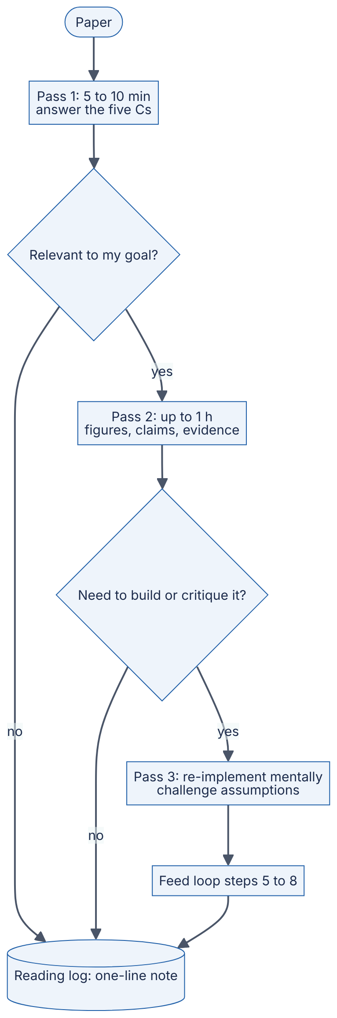
Reading the diagram. A paper enters at the top. Each rectangle is a pass with a time budget, and each diamond is a decision to stop or go deeper. Every path ends at the reading log, the cylinder. Even a paper you rejected after five minutes gets a one-line note, so you will not reread it by accident. Only the third pass feeds steps 5–8 of the loop. The usual failure is starting at the third pass: reading page one in detail and giving up on page four. To scale this across many papers, do many first passes and only a few third passes. For most engineers, about one paper in five deserves the third.
When you apply the method to a systems paper, add two questions to the five Cs. What was the workload? Dynamo’s design follows from Amazon’s shopping-cart writes, which had to be “always writeable”. What did they choose not to provide? GFS gave up a POSIX-compatible interface and offered relaxed consistency [Ghemawat et al. 2003]. A paper’s non-goals tell you as much as its goals.
Table 3.5 — A starter reading list mapped to this book.
Paper | Read with | Why this one first
Lamport, Time, Clocks, and the Ordering of Events [Lamport 1978] | §24.10 | Short; defines “happened-before”
The Google File System [Ghemawat et al. 2003] | §15.5 | Clear workload-driven trade-offs
MapReduce [Dean and Ghemawat 2004] | §29.4 | Simple model; good first third-pass paper
Dynamo [DeCandia et al. 2007] | §14.8, §27.7 | Assembles many chapter concepts in one design
The Chubby Lock Service [Burrows 2006] | §26.14 | Engineering lessons, not just algorithms
ZooKeeper [Hunt et al. 2010] | §26.8 | Coordination as a service
Kafka [Kreps et al. 2011] | §31.3 | The log as a central abstraction
Raft [Ongaro and Ousterhout 2014] | §26.7 | Written explicitly to be understandable
The Tail at Scale [Dean and Barroso 2013] | §23.6–§23.7 | Magazine-length; shapes how you think about latency
Spanner [Corbett et al. 2012] | §28.8 | Advanced; read after Chapters 25–26

3.5.2 Reading engineering blogs critically
Company engineering blogs are where the field’s current practice gets written down. They are also written to recruit engineers and to promote the company, and they rarely go through peer review. Read them as evidence of what one team did under its own constraints, not as recommendations for you.
Table 3.6 — Critical-reading checklist for engineering posts.
Ask | Why | Red flag
What was the workload and scale? | Solutions depend on the workload | No numbers at all, or only “massive scale”
What was the baseline? | A speed-up needs something to compare against | “10× faster” with no stated “than what”
What did they try that failed? | Shows what the real constraint was | Only a success story
What did it cost? | Every choice costs something | No downsides mentioned
When was it written? | Systems and versions change | No date; describes a deprecated version
Can it be checked? | Separates evidence from narrative | No benchmark method; no code; no follow-up
Who benefits from you believing it? | Vendor posts sell products | “Our product solved it” with no alternatives considered
This book uses the same discipline in its evidence labels (§9 of the style guide): Primary, Secondary or Illustrative. Label your own notes the same way. A claim you read in a conference talk summary is Secondary, even if it sounds authoritative.

3.6 Drawing architecture from memory

3.6.1 Why drawing from memory works
Drawing a system from memory is retrieval practice (§3.4.2) on structured material. It also builds what Chase and Simon called chunks. In their studies, chess masters reconstructed real game positions from a brief glance far better than novices. On random piece placements, the masters’ advantage largely disappeared [Chase and Simon 1973]. Their expertise was stored as meaningful patterns, not as better raw memory. Reference architectures are the chunks of system design: “CDN → load balancer → stateless service → cache → primary/replica database”, or “producer → partitioned log → consumer group”. Once each of these is a single chunk, your working memory is free to reason about what is different in the problem in front of you.

3.6.2 The protocol
- Choose a target: a figure from a chapter you finished at least two days ago.
- Draw blind for 10 minutes on paper or a whiteboard. Use the book’s shapes (§6 of the style guide): stadiums for clients, rectangles for services, cylinders for stores, subroutine shapes for queues.
- Annotate edges: protocol, synchronous or asynchronous, direction.
- Compare with the source and score your drawing with Table 3.7.
- Write the diff: every missing component and every wrong edge becomes a flashcard.
- Redraw after the next spacing interval (3 days, then 7, then 16).
Table 3.7 — Scoring rubric for a drawing from memory (0–2 points each, 12 maximum).
Criterion | 0 | 1 | 2
Components | Major pieces missing | All major pieces present | Also includes supporting pieces (config, discovery, monitoring)
Data flow | Arrows missing or wrong | Correct direction | Read and write paths distinguished
Sync vs async | Not marked | Partly marked | Every edge correct
Protocols | None | Some | Every edge labeled
Storage boundaries | Unclear where state lives | Stores shown | Durability of each store stated
Failure points | None marked | One marked | Each single point of failure plus its mitigation
A score of 10–12 on a figure means you can use that architecture fluently. Below 7 means you should go back to loop step 3 for the components you missed.
INTERVIEW TIP
Interview tip. Interviewers do not score how pretty your diagram is. They notice whether you mark the read and write paths separately and whether you can point at the single points of failure without being asked. Those are the two highest-value rows of Table 3.7, and both can be trained.

3.7 Building simplified implementations

3.7.1 Why build at all
Feynman’s blackboard at the time of his death carried the line “What I cannot create, I do not understand.” Building a small version of a mechanism forces you to make every decision the prose glossed over: what happens on wrap-around, what a timeout returns, which component owns a piece of state. The consistent-hashing ring in §3.3 and the Leitner scheduler in §3.4.3 each surfaced a bug that reading would not have, a process-randomized hash() and a shared default date.

3.7.2 Scoping rules
- Keep the mechanism; fake the environment. Simulate the network with function calls and the clock with a counter. Simulate disks with dictionaries.
- One file, under 300 lines. If it grows past that, you are building a product, not a learning model.
- Build in a measurement. Every simplified implementation should print a number that tests a claim from the chapter: keys moved, hit ratio, p99 latency, messages lost.
- Inject one failure. Kill a node, drop a message or skew a clock, then check whether the behavior matches Step 7’s failure table.
- Compare with a real system afterwards. Read the corresponding part of a real codebase or its documentation and list three things it does that yours does not. That list is your map to production concerns.
Table 3.8 — Simplified implementations that pay off, by chapter.
Build | Chapter | The measurement that proves it works
LRU cache with TTL | §20.8–§20.9, §38.10 | Hit ratio against cache size on a Zipf-like key stream
Token-bucket rate limiter | §22.4 | Accepted rate converges to the refill rate
Consistent-hash ring | §14.8 | Keys moved ≈ $1/\left(N+1\right)$; max/mean load against vnode count
Bloom filter | §17.4 | Measured false-positive rate matches the formula
Append-only log with offsets | §31.3, §31.8 | Consumer restarts from its committed offset
Leader election with leases | §26.5, §26.11 | At most one leader per lease epoch under clock skew
Raft log replication (simulated network) | §26.7 | No committed entry lost when a minority of nodes crash
Retry with exponential backoff and jitter | §22.12 | Load on a recovering server, with and without jitter
Chapter 93 turns several of these into full projects with deployment, testing and monitoring. The simplified versions here are the step before that.
WARNING / TRADE-OFF
Warning — The toy-to-production gap. A 100-line Raft simulation that passes your tests is not a correct Raft. Consensus implementations fail in rare interleavings of events that small tests seldom reach, which is why Jepsen-style testing exists (§25.11). Treat your build as a model of the mechanism, never as evidence that the real problem is easy.

3.8 Beginner methodology: a 12-month path
This path is for readers starting at Level 1: you can program, but you have not designed distributed systems. It assumes 8–10 hours a week. That is enough for about four full concept loops a month plus lighter reading. The target is Level 2 by month 6 and Level 3 on core Book I material by month 12. Levels 4 and 5 (senior/staff, principal) depend on production experience that no reading plan can replace. Part IX and §3.9 are where you go next.
Figure 3.6 — The 12-month beginner path (months shown as M01–M12).
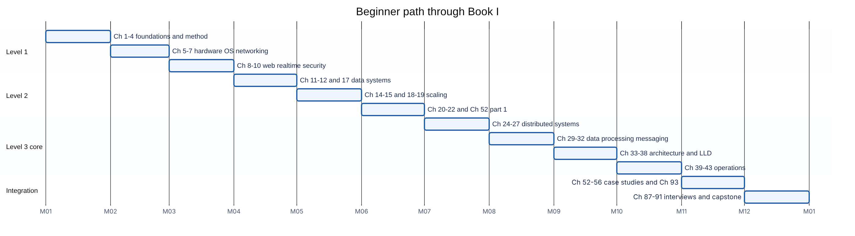
Reading the diagram. Each bar is one month of study, and bars run one after another. The after dependencies mean that each block assumes you have finished the one before it. The calendar dates are placeholders, so read the axis as month numbers. The three sections match the proficiency levels you should reach by the end of each phase. The fourth section, Integration, combines everything rather than adding new material. The common failure is slipping in months 7–8. Distributed systems is the steepest part of the path, so plan for those two months to take three. There are two ways to scale the plan. At 15+ hours a week, the whole path fits in about eight months. An ML-track reader can swap month 9 for Chapters 57–60 and month 10 for Chapters 66 and 72–75.
Table 3.9 — Month-by-month plan with loop targets and milestones.
Month | Chapters | Full-loop concepts (examples) | Milestone artifact
1 | 1–4 | Latency vs throughput; Little’s Law; availability arithmetic | Flashcard deck started; first design journal entry
2 | 5–7 | Memory hierarchy; event loops; TCP handshake; DNS | Request lifecycle drawn from memory (§8.5 preview)
3 | 8–10 | REST design; OAuth 2.0 flow; TLS; threat model | API spec for a URL shortener (§52.1)
4 | 11–12, 17 | B+ tree index; isolation levels; Bloom filter | Bloom filter build (Table 3.8)
5 | 14–15, 18–19 | Replication lag; consistent hashing; L4 vs L7 balancing | Hash ring build (§3.3)
6 | 20–22; 52.1–52.3 | Cache-aside; cache stampede; token bucket | L2 checkpoint: rate limiter design (§52.3), timed at 45 min
7 | 24–27 | Lamport clocks; linearizability; Raft; quorums | Raft election simulation
8 | 29–32 | Partitioned log; consumer groups; outbox; saga | Log with offsets build
9 | 33–38 | Modular monolith; bounded contexts; LLD of an LRU cache | LLD exercise from §38.10
10 | 39–43 | SLOs and error budgets; tracing; canary releases | One postmortem study (§3.9.3)
11 | 52–56; 93.1–93.2 | Five case studies through all 16 template sections | One beginner project from Ch 93 deployed
12 | 87–89, 91 | Estimation drills; interview pacing | L3 checkpoint: three mock interviews scored with the Ch 88 rubric
Chapters 13, 16, 23 and 28 and all of Part IX are deferred to year two. They are L3–L5 material that builds on everything above. Read their introductions when a case study points to them, but do not run full loops on them yet.
RECOMMENDATION
Recommendation — The weekly rhythm. Use two weekday sessions of 2 hours for loop steps 1–7 on one concept, and one weekend session of 3 hours for steps 8–9. Do 15–20 minutes of flashcards on five days. Close the week with a 30-minute review: one drawing from memory of a concept from last month and one journal entry. This rhythm builds in spacing, interleaving and retrieval without any extra planning.

3.9 Advanced methodology for experienced engineers
If you already build production systems, you do not need a path from Chapter 1. You need to know where your gaps are. Experience tends to be deep in the systems you have run and thin everywhere else. A payments engineer may know idempotency keys (§22.15) and sagas very well and know little about CDNs or GPU serving.

3.9.1 Gap analysis
Rate yourself from 0 to 4 on each of the book’s 19 parts, where 0 means “cannot define the main terms” and 4 means “could teach it and have operated it in production”. Set a target for each part from your role or the job you want. Then rank the parts by weighted gap.
FORMULA
Gap priority
$$P_{i}=\left(T_{i}−C_{i}\right)×W_{i}$$
Symbol | Meaning | Units
$P_{i}$ | Priority score for part $i$ | points (0–12)
$T_{i}$ | Target proficiency for part $i$ | 0–4 scale
$C_{i}$ | Current self-rated proficiency (use 0 if $C_{i}>T_{i}$ would make $P_{i}$ negative) | 0–4 scale
$W_{i}$ | Relevance weight: 1 = nice to have, 2 = useful, 3 = essential for role | dimensionless (1–3)
WORKED EXAMPLE
Worked example — A backend engineer moving to an infrastructure role.
Table 3.10 — Gap-analysis scores for one engineer.
Part | $T$ | $C$ | $W$ | $P=\left(T−C\right)×W$
V Distributed systems | 4 | 2 | 3 | $2×3=6$
VIII Operations | 4 | 3 | 3 | $1×3=3$
IV Scalability and performance | 3 | 2 | 2 | $1×2=2$
XIII Training infrastructure | 2 | 0 | 1 | $2×1=2$
Interpretation. Part V comes first with a score of 6, three times any other part. Parts IV and XIII tie at 2. Their gaps differ, but weighting by relevance brings them level. Implication. Spend the next quarter on Chapters 24–28 with full loops, and keep the others to first-pass reading. Re-rate yourself each quarter, because a self-rating is only a guess until a design review or a mock interview tests it.

3.9.2 Design reviews as a learning instrument
Design reviews (§1.10) are deliberate practice with expert feedback already built in. Use them on purpose. As an author, write a design document for a real change and ask reviewers to challenge specific sections, such as failure modes or capacity numbers. As a reviewer, read others’ designs with Table 3.7 and Table 3.3 in mind, and write at least one question about failure handling and one about cost. As an observer, sit in on reviews outside your team. Hearing how senior engineers question a design teaches you what to ask before you can answer it yourself. After each review, write down in your journal one thing you would have missed.

3.9.3 Postmortem study
Production incidents are the most honest record of how systems fail. Many organizations publish blameless postmortems. The SRE book describes postmortem culture as a way to learn from failure without assigning blame [Beyer et al. 2016]. Curated collections, such as Dan Luu’s public list of postmortems, make it easy to find many of them [Luu, post-mortems]. Research that analyzes failures across many systems shows patterns that single reports cannot. One study of failures in distributed data-intensive systems found that most catastrophic failures came from incorrect handling of non-fatal errors that the software had already signaled [Yuan et al. 2014]. A study of hundreds of public cloud outage reports cataloged their root causes and how far their impact spread [Gunawi et al. 2016].
Figure 3.7 — The postmortem study loop.
Reading the diagram. The hexagon is an external source, a published report. Each rectangle is an analysis step, done in order. The two most valuable steps are drawing the architecture yourself, since reports rarely include a complete diagram, and separating the trigger (what started it) from the contributing factors (why it spread and why recovery was slow). Mapping each factor to a chapter turns an anecdote into a lesson you can review. The rule you generalize goes into durable storage, your journal and flashcards. The dotted arrow is a spaced review in which you redraw the architecture from memory. The failure point in this process is stopping at the trigger. “Someone typed the wrong command” is never the whole story.
INDUSTRY EXAMPLE
Amazon S3, US-EAST-1, February 2017. While debugging a billing-system issue, an engineer ran an established playbook command meant to remove a small number of servers. An input was entered incorrectly, and a much larger set of servers was removed, including servers supporting two S3 subsystems: the index subsystem and the placement subsystem. Both needed a full restart, which took longer than expected because those subsystems had not been fully restarted in years while S3 had grown substantially. In response, AWS changed the tool to remove capacity more slowly and to refuse to take any subsystem below its minimum required capacity. It also prioritized splitting the index subsystem into smaller cells. Lessons mapped to chapters: guard rails on operational tools (§43.3), blast-radius reduction with cells (§33.12, Chapter 44), and recovery time as a design property (§39.8). Evidence: Primary — [AWS 2017]

3.9.4 Reading production incident reports critically
Published reports are edited for a public audience and tend to leave out organizational causes and near misses. Read them with Table 3.6 in mind. Separate what the report states from what you infer. Look for the detection gap, the time from trigger to first alert, which is often more instructive than the bug. Ask what the incident shows about the design, not the operator: why could one command remove so much capacity? One report a week gives you about 50 failure case studies a year, and that breadth is a large part of what distinguishes a Level 4 engineer.

3.10 Tracking progress

3.10.1 Self-assessment rubric
Rate yourself each quarter on the seven dimensions below, and ask a peer or mentor to rate you as well. A large gap between their rating and yours is itself useful information.
Table 3.11 — Self-assessment rubric mapped to the five proficiency levels.
Dimension | L1 Beginner | L2 Intermediate | L3 Advanced | L4 Senior/Staff | L5 Principal
Concept knowledge | Defines core terms | Explains building blocks | Explains internals | Knows edge cases and variants | Shapes how the field uses the concepts
Mechanism depth | Describes what it does | Describes how, step by step | Implements a simplified version | Debugs production behavior | Designs new mechanisms
Trade-off reasoning | Names one pro and one con | Compares two options | Compares options with numbers | Weighs cost, organization and time | Sets direction for many teams
Estimation | Needs a template | Estimates RPS and storage | Estimates the bottleneck resource | Builds a capacity model | Owns fleet-level planning
Failure reasoning | Rarely considers failure | Lists failure modes | Designs detection and recovery | Limits the blast radius | Sets reliability strategy
Communication | Describes components | Draws a clear diagram | Leads a 45-minute design discussion | Runs design reviews | Writes standards others adopt
Implementation | Follows tutorials | Builds small services | Builds simplified distributed mechanisms | Ships and operates such systems | Builds platforms others build on
Appendix E gives the full definitions of the levels. Your overall level is roughly the level reached by your weakest three dimensions, not your strongest, because a design is only as strong as its weakest reasoning.

3.10.2 Flashcard templates
Make each card atomic (one fact or one relationship) and prefer why and when cards over what cards. Six card types cover most of system design:
[DEFINITION] Q: Define linearizability in one sentence.
[MECHANISM] Q: In a hash ring, which node owns key k? (answer in two steps)
[NUMBER] Q: Rough round-trip time within one datacenter? (cite Appendix F, with year)
[TRADE-OFF] Q: When would you choose jump hash over a ring with vnodes?
[FAILURE] Q: A cache node dies under mod-N hashing. What happens to the database, and why?
[DIAGRAM] Q: Draw cache-aside read and write paths. (check against Fig. 20.x)
Each card should also record its source section (for example src: §3.3 step 6), so a failed card leads you straight to the material it came from.

3.10.3 Design journal template
Date: Concept / problem: Loop steps completed: 1-10
1. One-sentence definition (from memory):
2. Problem it solves, with a number:
3. Mechanism in 5 steps or fewer:
4. Drawing score (Table 3.7): __ / 12 Missing:
5. Source studied + evidence label:
6. Best alternative and when I would pick it:
7. Scariest failure mode and its mitigation:
8. Build: repo/file + the measurement it printed:
9. Design problem used in + what I would change next time:
10. Explanation beats fluent / hesitant / missing:
Cards created: Next review date:

3.10.4 The concept tracker
Table 3.12 — Concept tracker (example rows).
Concept | Section | Steps done | Drawing score | Last review | Next review | Confidence (1–5)
Consistent hashing | §14.8 | 1–10 | 11/12 | 2027-05-03 | 2027-05-19 | 4
Raft leader election | §26.7 | 1–7 | 8/12 | 2027-07-10 | 2027-07-13 | 2
Cache stampede | §20.11 | 1–4, 6–7 | 9/12 | 2027-06-02 | 2027-06-09 | 3
Look at the tracker every week. Three numbers tell you whether the method is working: flashcard retention, meaning the fraction recalled on review, where around 85–90 % is a healthy target; average drawing score, which should rise over a quarter; and loops completed per month, about four on the beginner path. If retention falls below about 80 %, you are adding cards faster than you are learning them. Slow down. If drawing scores stall, put more time into loop step 3.

3.11 Summary and revision notes
SUMMARY
- Mastery means you can produce the concept without notes: define it, draw it, build it, use it and explain it. Recognizing it when you read it does not count.
- The ten-step loop turns each concept into ten artifacts. Step 10 (explain independently) checks the other nine, and any gap sends you back to step 3.
- Consistent hashing shows the loop’s value. The formula predicts that ~80 % of keys move under mod-N and ~20 % under a ring when going from 4 to 5 nodes. A 60-line build confirmed it and showed that virtual nodes cut the busiest node’s load from 2.6× to 1.08× the mean.
- Retrieval practice and spacing have the strongest evidence. Rereading and highlighting have the weakest [Dunlosky et al. 2013]. Self-explanation and interleaving have moderate support. Deliberate practice helps, but it explains only part of the differences in expertise.
- Read papers in three passes [Keshav 2007]. Read blogs as evidence of one team’s choices under their own constraints, and label every claim Primary, Secondary or Illustrative.
- Drawing from memory builds chunks. Score your drawings out of 12 on components, flows, sync/async, protocols, storage and failure points.
- Simplified implementations keep the mechanism, fake the environment, print a measurement and inject a failure.
- Beginners: follow the 12-month path to reach L2 by month 6 and L3 on core Book I material by month 12. Experienced engineers: rank gaps with $P=\left(T−C\right)×W$, use design reviews as deliberate practice and study one incident report a week.
- Track flashcard retention (~85–90 %), drawing scores and loops per month. Judge your level by your weakest dimensions.

3.12 Knowledge checkpoint
- What artifact does each of loop steps 2, 4, 8 and 10 produce?
- Why does the loop return to step 3, not step 1, when step 10 reveals a gap?
- Using the formula, what fraction of keys move when a mod-N cluster grows from 9 to 10 nodes? And under consistent hashing?
- Why does Python’s built-in hash() make a poor ring hash for a multi-process service?
- Name two techniques Dunlosky et al. rated high utility and two they rated low.
- In Roediger and Karpicke’s experiment, which condition did best at five minutes and which at one week?
- According to Cepeda et al. (2008), does the best review gap, as a fraction of the retention interval, grow or shrink as the retention interval gets longer?
- What is the difference between interleaved and blocked practice, and why does interleaving suit system design?
- List Keshav’s five Cs.
- Which pass of the three-pass method feeds loop steps 5–8, and roughly how long does it take a beginner?
- Give three questions from the blog-reading checklist.
- What did Chase and Simon’s random-position condition show about expertise?
- State four scoping rules for a simplified implementation.
- Compute the gap priority for a part with target 3, current 1 and weight 2.
- In a postmortem study, why separate the trigger from the contributing factors?
- Your flashcard retention has fallen to 72 %. What should you change?
Answers
- Step 2: a “before” scenario with numbers. Step 4: a diagram drawn from memory. Step 8: a runnable program that prints a measurement. Step 10: a 2–5 minute explanation given without notes.
- Most gaps in an explanation are gaps in the mechanism. The definition (step 1) is rarely what is missing.
- Mod-N: $N/\left(N+1\right)=9/10=90\%$. Consistent hashing: about $1/\left(N+1\right)=10\%$.
- Python randomizes hash() for strings in each process, so different processes would build different rings. That is a split-view failure.
- High: practice testing and distributed practice. Low: any two of rereading, highlighting, summarization, keyword mnemonic and imagery for text.
- At five minutes, repeated study (SSSS) did best. At one week, repeated testing (STTT) did best, about 61 % against 40 %.
- It shrinks: from about 20–40 % for a one-week interval to about 5–10 % for a one-year interval.
- Interleaving mixes problem types within a session, while blocking finishes one type before starting the next. Real design problems do not say which tool they need, and interleaving trains you to choose.
- Category, Context, Correctness, Contributions, Clarity.
- The third pass, which takes about 4–5 hours for a beginner.
- Any three of: What was the workload and scale? What was the baseline? What failed? What did it cost? When was it written? Can it be checked? Who benefits?
- On random positions, the masters’ advantage largely disappeared. Their expertise was stored as meaningful patterns (chunks), not as better general memory.
- Keep the mechanism and fake the environment; one file under 300 lines; build in a measurement; inject one failure; compare with a real system afterwards.
- $P=\left(3−1\right)×2=4$.
- The trigger explains how the incident started. The contributing factors explain why it spread and why recovery was slow, and those are what design can change.
- Add fewer new cards, and rewrite or split the cards that keep falling back to box 0. Cards that are too big or vague cause most of the failures.

3.13 Interview questions
Interviewers sometimes ask how you learn, especially for senior roles. The concept used to demonstrate the loop, consistent hashing, also comes up often in interviews.

Basic
Q1. How do you get up to speed on a technology you have never used? Answer. Describe a method, not a list of resources: find the problem it solves and what came before it; first-pass the official architecture docs or paper; draw the architecture from memory and check it; build a toy that measures something you care about; read its known failure modes or incident reports; and write a one-page summary for your team, which exposes what you do not yet understand.
Q2. Why does hash(key) mod N cause problems when you add a cache node? Answer. With uniform hashing, about $N/\left(N+1\right)$ of keys change owner, so most of the cache misses at once and the load falls on the database. Consistent hashing moves only about $1/\left(N+1\right)$ of keys, all of them to the new node.

Intermediate
Q3. What do virtual nodes fix in consistent hashing, and what do they cost? Answer. With one position per node, arc lengths vary widely, so one node can carry two or three times its share. A dead node’s whole load also lands on a single successor. With $V$ vnodes per node, load evens out, the spread shrinking roughly as $1/\sqrt{V}$, and failure load is spread over many nodes. The costs are $O\left(NV\right)$ memory for the ring, larger membership metadata and more key ranges to manage during rebalancing.
Q4. Tell me about a postmortem you learned from. Answer. Choose a public report, such as the 2017 S3 disruption. Describe the trigger (a mistyped input to a capacity-removal command), the contributing factors (no minimum-capacity safeguard, and subsystems that had not been fully restarted in years at their current scale), and the design changes (slower removal, capacity floors, cell partitioning). Then say what you changed in your own work because of it.

Advanced
Q5. Your organization’s design reviews keep missing failure modes that later cause incidents. How would you change the process? Answer. Require a failure table in the design template (what goes wrong, why, detection, recovery, prevention); give one reviewer the explicit failure-hunting role; link each design to postmortems of similar architectures; and track whether later incidents were or were not anticipated in the design. That is deliberate practice at team scale, with feedback from real outcomes.
Q6. A ring-based cache shows one node at 3× average CPU even with 200 vnodes per node. Diagnose it. Answer. With 200 vnodes, the ring itself should keep the busiest node within roughly 10 % of the mean, so look elsewhere. The likely causes are a hot key, which hashing cannot split; clients with inconsistent membership sending one range to the wrong node; or a heterogeneous node, such as a smaller instance or a noisy neighbor. Check top-K key metrics and compare ring versions across clients. Fixes include replicating hot keys, adding a local cache tier, bounded-load hashing and versioned membership.

3.14 Practical exercises
- Run the loop. Take the cache-aside pattern (§20.7) through all ten steps. Turn in the ten artifacts, and use the journal template (§3.10.3) for at least one of them.
- Extend the ring. Add get_nodes(key, r) to the §3.3 HashRing so that it returns $r$ distinct physical nodes. Measure the fraction of keys whose replica set changes when you remove a node.
- Measure the vnode curve. For $V∈\{1,10,50,100,500\}$, plot max/mean load across 10 nodes. Check whether the excess over 1.0 shrinks roughly as $1/\sqrt{V}$.
- Three passes. Read the Dynamo paper with Keshav’s method. Turn in the five Cs after pass 1, a one-paragraph summary after pass 2, and, after pass 3, a list of three assumptions that would not hold for a bank ledger.
- Critique a post. Choose a recent engineering blog post about a migration. Score it against Table 3.6 and rewrite its main claim with an evidence label.

3.15 Design challenges
- Design your own learning system. Treat your next six months of study as a system. State requirements (hours per week, target level), components (deck, journal, tracker, build repository), data flows (reading → artifacts → cards → reviews) and failure modes (backlog, burnout, illusion of competence). Add detection and recovery for each failure mode.
- A team incident library. Design a lightweight internal system in which engineers log public and internal postmortems, tag them with this book’s chapters and receive spaced “redraw this architecture” prompts. Estimate storage and request rates for an organization of 2,000 engineers.
- Gap-driven onboarding. Design a 90-day onboarding plan for an experienced engineer joining an ML-infrastructure team from a web-backend background. Use the gap formula, Table 3.11 and specific chapters from Book II.

3.16 References
- Beyer, B., Jones, C., Petoff, J., Murphy, N. R. (eds.). Site Reliability Engineering: How Google Runs Production Systems (Ch. 15, “Postmortem Culture: Learning from Failure”). O’Reilly, 2016. https://sre.google/sre-book/postmortem-culture/
- Bjork, R. A. Memory and metamemory considerations in the training of human beings. In J. Metcalfe and A. P. Shimamura (eds.), Metacognition: Knowing about Knowing, MIT Press, 1994.
- Burrows, M. The Chubby Lock Service for Loosely-Coupled Distributed Systems. OSDI, 2006.
- Cepeda, N. J., Pashler, H., Vul, E., Wixted, J. T., Rohrer, D. Distributed Practice in Verbal Recall Tasks: A Review and Quantitative Synthesis. Psychological Bulletin 132(3), 2006.
- Cepeda, N. J., Vul, E., Rohrer, D., Wixted, J. T., Pashler, H. Spacing Effects in Learning: A Temporal Ridgeline of Optimal Retention. Psychological Science 19(11), 2008. https://pubmed.ncbi.nlm.nih.gov/19076480/
- Chase, W. G., Simon, H. A. Perception in Chess. Cognitive Psychology 4(1), 1973.
- Chi, M. T. H., de Leeuw, N., Chiu, M.-H., LaVancher, C. Eliciting Self-Explanations Improves Understanding. Cognitive Science 18(3), 1994.
- Corbett, J. C., et al. Spanner: Google’s Globally-Distributed Database. OSDI, 2012.
- Dean, J., Barroso, L. A. The Tail at Scale. Communications of the ACM 56(2), 2013.
- Dean, J., Ghemawat, S. MapReduce: Simplified Data Processing on Large Clusters. OSDI, 2004.
- DeCandia, G., et al. Dynamo: Amazon’s Highly Available Key-value Store. SOSP, 2007.
- Dunlosky, J., Rawson, K. A., Marsh, E. J., Nathan, M. J., Willingham, D. T. Improving Students’ Learning With Effective Learning Techniques: Promising Directions From Cognitive and Educational Psychology. Psychological Science in the Public Interest 14(1), 2013.
- Ebbinghaus, H. Memory: A Contribution to Experimental Psychology (trans. H. A. Ruger and C. E. Bussenius). Teachers College, Columbia University, 1913 (German original 1885).
- Eisenbud, D. E., et al. Maglev: A Fast and Reliable Software Network Load Balancer. NSDI, 2016.
- Ericsson, K. A., Krampe, R. T., Tesch-Römer, C. The Role of Deliberate Practice in the Acquisition of Expert Performance. Psychological Review 100(3), 1993.
- Ghemawat, S., Gobioff, H., Leung, S.-T. The Google File System. SOSP, 2003.
- Gunawi, H. S., et al. Why Does the Cloud Stop Computing? Lessons from Hundreds of Service Outages. ACM SoCC, 2016.
- Hunt, P., Konar, M., Junqueira, F. P., Reed, B. ZooKeeper: Wait-free Coordination for Internet-scale Systems. USENIX ATC, 2010.
- Karger, D., Lehman, E., Leighton, T., Panigrahy, R., Levine, M., Lewin, D. Consistent Hashing and Random Trees: Distributed Caching Protocols for Relieving Hot Spots on the World Wide Web. ACM STOC, 1997.
- Karpicke, J. D., Blunt, J. R. Retrieval Practice Produces More Learning than Elaborative Studying with Concept Mapping. Science 331(6018), 2011.
- Keshav, S. How to Read a Paper. ACM SIGCOMM Computer Communication Review 37(3), 2007.
- Kornell, N., Bjork, R. A. Learning Concepts and Categories: Is Spacing the “Enemy of Induction”? Psychological Science 19(6), 2008.
- Kreps, J., Narkhede, N., Rao, J. Kafka: a Distributed Messaging System for Log Processing. NetDB Workshop, 2011.
- Lakshman, A., Malik, P. Cassandra: A Decentralized Structured Storage System. ACM SIGOPS Operating Systems Review 44(2), 2010.
- Lamping, J., Veach, E. A Fast, Minimal Memory, Consistent Hash Algorithm. arXiv:1406.2294, 2014. https://arxiv.org/abs/1406.2294
- Lamport, L. Time, Clocks, and the Ordering of Events in a Distributed System. Communications of the ACM 21(7), 1978.
- Luu, D. A collection of postmortems (GitHub repository). https://github.com/danluu/post-mortems
- Macnamara, B. N., Hambrick, D. Z., Oswald, F. L. Deliberate Practice and Performance in Music, Games, Sports, Education, and Professions: A Meta-Analysis. Psychological Science 25(8), 2014.
- Mirrokni, V., Thorup, M., Zadimoghaddam, M. Consistent Hashing with Bounded Loads. ACM-SIAM SODA, 2018. https://arxiv.org/abs/1608.01350
- Ongaro, D., Ousterhout, J. In Search of an Understandable Consensus Algorithm. USENIX ATC, 2014.
- Pashler, H., McDaniel, M., Rohrer, D., Bjork, R. Learning Styles: Concepts and Evidence. Psychological Science in the Public Interest 9(3), 2008.
- Roediger, H. L., Karpicke, J. D. Test-Enhanced Learning: Taking Memory Tests Improves Long-Term Retention. Psychological Science 17(3), 2006.
- Rohrer, D., Taylor, K. The Shuffling of Mathematics Problems Improves Learning. Instructional Science 35, 2007.
- Soderstrom, N. C., Bjork, R. A. Learning Versus Performance: An Integrative Review. Perspectives on Psychological Science 10(2), 2015.
- Thaler, D. G., Ravishankar, C. V. Using Name-Based Mappings to Increase Hit Rates. IEEE/ACM Transactions on Networking 6(1), 1998.
- Yuan, D., et al. Simple Testing Can Prevent Most Critical Failures: An Analysis of Production Failures in Distributed Data-Intensive Systems. OSDI, 2014.
- Amazon Web Services [AWS 2017]. Summary of the Amazon S3 Service Disruption in the Northern Virginia (US-EAST-1) Region. 2017. https://aws.amazon.com/message/41926/

3.17 Open verification items
- [AWS 2017] URL and wording of the S3 post-event summary could not be fetched from this environment (network restriction); the summary in §3.9.3 is from the author’s knowledge of the report and should be checked against the primary text.
- Roediger and Karpicke (2006) Experiment 2 one-week figures (~61 % STTT vs ~40 % SSSS) were confirmed only through secondary summaries; verify against the paper’s Figure/Results.
- Macnamara et al. (2014): headline 12 % of variance confirmed; the domain ordering (lower in education and professions than in games, music, sports) is from memory and should be checked.
- Attribution of “What I cannot create, I do not understand” to Feynman’s blackboard (Caltech Archives, 1988): widely documented; add an archival citation if one is required.
- Leitner intervals (1, 3, 7, 16, 35 days) are a teaching choice, not an empirically derived schedule; the text says so.
- The “~1/√V” load-spread scaling is stated as an approximation; a formal bound should be cited or derived in §14.8.

Chapter 4 — Quantitative Foundations for System Design
Level: 1–3 · Track: Shared · Estimated reading time: 6 h
System design is often presented as a drawing exercise: boxes, arrows, a cache here, a queue there. The drawing is the easy part. What separates a design that works from one that merely looks plausible is arithmetic. How many machines? How much memory? What happens to latency when traffic doubles? How many nines does the whole system get when every component has three? How likely is it that all three replicas of a file die before you notice the first one is gone?
This chapter gives you the mathematical toolkit to answer those questions, assuming only high-school algebra. Each formula comes with an analogy, its units, a fully worked example and its engineering implication. Short Python programs check formulas against simulation — a habit worth keeping: never trust a formula you have not seen agree with reality at least once.
The tools are grouped into four clusters:
- Number sense (§4.3–§4.5): exponents, logarithms and units, the arithmetic of “how big” and “how fast”.
- Uncertainty (§4.6–§4.9): probability, statistics, percentiles and the small amount of linear algebra you need before the ML chapters.
- Performance laws (§4.10–§4.13): queueing theory, Little’s Law, Amdahl’s and Gustafson’s laws and the Universal Scalability Law.
- Dependability (§4.14–§4.16): availability, reliability and durability arithmetic.
The chapter closes with the latency numbers that anchor estimation (§4.17) and with the six quantitative relationships that recur throughout the rest of the book (§4.18).

4.1 Learning objectives
After this chapter you should be able to:
- Convert fluently between powers of two and powers of ten, and between bits, bytes, SI prefixes and binary prefixes, stating which convention you use.
- Use logarithms to explain why binary search and B-trees need so few steps, and compute the height of a B-tree for a given fan-out and data size.
- Calculate the probability that at least one of $N$ components fails, the expected number of failures, and the binomial probability of exactly $k$ failures.
- Compute mean, median, variance, standard deviation and percentiles from a sample, and explain why the mean is misleading for heavy-tailed latency distributions.
- Quantify tail-latency amplification under fan-out using $P\left(\text{all fast}\right)=p^{N}$.
- Compute a dot product, a cosine similarity and the floating-point cost of a matrix multiplication.
- Apply the M/M/1 formulas to predict how latency grows with utilization, and explain why a shared queue beats separate queues.
- Size thread pools and database connection pools with Little’s Law.
- Predict the limits of parallel speedup with Amdahl’s Law, Gustafson’s Law and the Universal Scalability Law.
- Compute the availability of components in series, in parallel and in $k$-of-$n$ configurations, and convert availability targets to downtime budgets.
- Relate MTBF, MTTR, failure rate and availability, and estimate the annual probability of data loss for a replicated store.
- Use dated latency reference numbers to sanity-check designs, and reason quantitatively about six recurring trade-offs.

4.2 Prerequisites
- High-school algebra: fractions, exponents, solving a linear equation — every formula in the chapter is built from these.
- The vocabulary of latency, throughput and availability from §1.7 (Non-functional requirements) — this chapter makes those words measurable.
- Orders-of-magnitude reasoning from §2.10 (Reasoning about scale) — helpful but not required; this chapter supplies the underlying mathematics.
- A Python 3 interpreter (3.10 or later) if you want to run the code examples. All examples use only the standard library.

4.3 Exponents, powers of two and powers of ten

4.3.1 What an exponent is
DEFINITION
Definition — Exponent. In $b^{n}$, the base $b$ is multiplied by itself $n$ times; $n$ is the exponent (or power). By convention $b^{0}=1$ and $b^{−n}=1/b^{n}$.

First-principles explanation
Imagine folding a sheet of paper in half repeatedly. After one fold it is 2 layers thick, after two folds 4 layers, after three folds 8. Each fold doubles the count, so after $n$ folds there are $2^{n}$ layers. After 10 folds you have 1,024 layers; after 20 folds, about a million. Exponential growth is the arithmetic of repeated multiplication, and computers are full of it, because every extra bit in an address or identifier doubles the number of values it can represent.
Three rules do almost all the work in estimation:
FORMULA
Laws of exponents
$$b^{m}×b^{n}=b^{m+n} \frac{b^{m}}{b^{n}}=b^{m−n} {\left(b^{m}\right)}^{n}=b^{mn}$$
Symbol | Meaning | Units
$b$ | Base (2 for binary quantities, 10 for decimal) | dimensionless
$m,n$ | Exponents | dimensionless
WORKED EXAMPLE
Worked example — Multiplying large numbers by adding exponents. A service handles $2×{10}^{4}$ requests per second (RPS). How many requests is that per day?
- Seconds per day: $86,400≈8.64×{10}^{4}$.
- Multiply the mantissas: $2×8.64=17.28$.
- Add the exponents: ${10}^{4}×{10}^{4}={10}^{8}$.
- Result: $17.28×{10}^{8}=1.728×{10}^{9}$ requests per day.
Interpretation. About 1.7 billion requests per day. Engineering implication. If each request writes a 1 KB log line, that is $1.7×{10}^{9}×{10}^{3}=1.7×{10}^{12}$ bytes, roughly 1.7 TB of logs per day — a number that immediately tells you logs need their own retention and sampling plan.

4.3.2 Powers of two
Memory addresses, identifiers, hash spaces and page sizes are all powers of two because hardware is built from binary switches. The key coincidence that makes mental arithmetic possible is
$$2^{10}=1,024≈{10}^{3}.$$
Every additional factor of $2^{10}$ is therefore “about another factor of a thousand”.
Table 4.1 — Powers of two that every engineer should recognize.
Power | Exact value | Approximately | Binary prefix | Typical meaning
$2^{10}$ | 1,024 | one thousand (${10}^{3}$) | kibi (Ki) | 1 KiB of memory
$2^{16}$ | 65,536 | 65 thousand | — | Number of TCP/UDP port numbers; max of a 16-bit unsigned integer + 1
$2^{20}$ | 1,048,576 | one million (${10}^{6}$) | mebi (Mi) | 1 MiB
$2^{30}$ | 1,073,741,824 | one billion (${10}^{9}$) | gibi (Gi) | 1 GiB
$2^{32}$ | 4,294,967,296 | 4.3 billion | — | IPv4 address space; 32-bit ID space
$2^{40}$ | 1,099,511,627,776 | one trillion (${10}^{12}$) | tebi (Ti) | 1 TiB
$2^{50}$ | 1,125,899,906,842,624 | one quadrillion (${10}^{15}$) | pebi (Pi) | 1 PiB
$2^{60}$ | 1,152,921,504,606,846,976 | one quintillion (${10}^{18}$) | exbi (Ei) | 1 EiB
$2^{64}$ | 18,446,744,073,709,551,616 | $1.8×{10}^{19}$ | — | 64-bit ID or hash space
Notice that the approximation drifts: $2^{10}$ is 2.4% larger than ${10}^{3}$, but $2^{40}$ is 10% larger than ${10}^{12}$ and $2^{60}$ is 15% larger than ${10}^{18}$. For estimation this is fine; for billing or capacity contracts it is not (see §4.5.2).
WORKED EXAMPLE
Worked example — How long until a 32-bit ID runs out? A table uses a 32-bit unsigned integer as its auto-increment primary key and receives 10,000 inserts per second.
- ID space: $2^{32}=4,294,967,296$ values.
- Seconds to exhaust: $4,294,967,296/10,000=429,497$ s.
- Convert to days: $429,497/86,400≈4.97$ days.
Interpretation. Under five days. Even at 100 inserts per second the space lasts only about 497 days. Engineering implication. Use 64-bit identifiers for any table that grows without bound; at 10,000 inserts per second a 64-bit space lasts $1.8×{10}^{19}/{10}^{4}≈1.8×{10}^{15}$ s, roughly 58 million years. Unique ID generation is covered in §17.10.

4.3.3 Powers of ten and scientific notation
Scientific notation writes a number as a mantissa between 1 and 10 times a power of ten: 86,400 becomes $8.64×{10}^{4}$. In estimation you usually round the mantissa to one significant figure and keep only the exponent honest. Being off by a factor of 2 rarely changes a design decision; being off by a factor of 1,000 always does. The order of magnitude of a number is its power of ten, and most back-of-the-envelope reasoning (§2.11, Chapter 89) is order-of-magnitude reasoning.

4.4 Logarithms

4.4.1 What a logarithm is
DEFINITION
Definition — Logarithm. The logarithm base $b$ of $x$, written $\log_{b}x$, is the exponent to which $b$ must be raised to give $x$: if $b^{y}=x$ then $y=\log_{b}x$.

First-principles explanation
A logarithm answers the question “how many times do I have to multiply (or divide) to get there?”. Go back to the folded paper: if you want 1,024 layers, how many folds? $\log_{2}1024=10$. Turn it around: if you have a phone book of 1,024 pages and open it in the middle, then in the middle of the correct half, and so on, how many openings until you reach one page? Also 10. A logarithm counts halvings. That is the reason logarithms appear wherever a data structure repeatedly cuts the search space: binary search, balanced trees, B-trees, skip lists, consistent-hash rings with binary-searched tokens.

Why does this exist?
Data sets grow multiplicatively (thousands, millions, billions), and the cost of searching them should not. Logarithms convert the multiplicative growth of $n$ into the additive growth of the step count: multiplying $n$ by 1,000 adds only about 10 steps to a binary search.

4.4.2 Rules and change of base
FORMULA
Logarithm rules and change of base
$$\log_{b}\left(xy\right)=\log_{b}x+\log_{b}y \log_{b}\left(x^{k}\right)=k\log_{b}x \log_{b}x=\frac{lnx}{lnb}=\frac{\log_{10}x}{\log_{10}b}$$
Symbol | Meaning | Units
$b$ | Base of the logarithm ($b>0$, $b≠1$) | dimensionless
$x,y$ | Positive numbers | dimensionless
$k$ | Any real exponent | dimensionless
$ln$ | Natural logarithm, base $e≈2.71828$ | —
The change-of-base rule means you only need one logarithm on your calculator. Two handy constants: $\log_{2}10≈3.32$ and $\log_{10}2≈0.301$.
WORKED EXAMPLE
Worked example — Binary search over one billion keys. How many comparisons does binary search need to find a key among $n={10}^{9}$ sorted keys?
- We need $\log_{2}\left({10}^{9}\right)$.
- Change of base: $\log_{2}\left({10}^{9}\right)=9×\log_{2}10=9×3.32=29.9$.
- Round up: 30 comparisons.
Interpretation. Thirty comparisons to search a billion items; a linear scan needs on average 500 million. Engineering implication. Each comparison in RAM costs on the order of 100 ns if it misses the CPU cache (§4.17), so 30 comparisons take roughly 3 µs. A sorted array or balanced tree in memory is fast enough for almost any lookup workload; the problem only becomes hard when each step requires a disk read, which is exactly the problem B-trees solve.

4.4.3 B-tree fan-out: why databases need only three or four disk reads
A binary tree halves the search space at each node, so a billion keys need about 30 levels. If each level is a random disk read, 30 reads is far too slow. A B-tree (detailed in §11.8 and §13.6) instead stores hundreds of keys per node, sized to fill one disk page, so each node splits the search space into hundreds of ranges [Bayer and McCreight 1972]. The number of children per node is the fan-out $f$.
FORMULA
Height of a B-tree
$$h=\left\lceil \log_{f}n\right\rceil =\left\lceil \frac{logn}{logf}\right\rceil$$
Symbol | Meaning | Units
$h$ | Number of levels from root to leaf (page reads per lookup if nothing is cached) | levels
$n$ | Number of keys indexed | keys
$f$ | Fan-out: child pointers per internal node | children/node
$⌈⋅⌉$ | Ceiling: round up to the next integer | —
The derivation is the same counting argument as the paper folds: one root reaches $f$ children, which reach $f^{2}$ grandchildren, so $h$ levels reach $f^{h}$ leaves. We need $f^{h}≥n$, so $h≥\log_{f}n$.
WORKED EXAMPLE
Worked example — Fan-out of a 16 KiB page. A database uses 16 KiB pages (16,384 bytes). Each index entry in an internal node is an 8-byte key plus an 8-byte child pointer = 16 bytes. Assume 20% of each page goes to headers and free space. How tall is the index on ${10}^{9}$ keys?
- Usable bytes per page: $16,384×0.8=13,107$ bytes.
- Fan-out: $f=13,107/16≈819$ children per node.
- Height: $\log_{819}\left({10}^{9}\right)=\frac{\log_{10}{10}^{9}}{\log_{10}819}=\frac{9}{2.913}=3.09$.
- Round up: $h=4$ levels.
- Compare: with $f=1,000$ the height would be exactly $9/3=3$; a binary tree needs 30.
Interpretation. Four page reads locate any one of a billion keys. Engineering implication. The top two levels contain only $1+819=820$ pages, about 13 MiB, which fits easily in the buffer pool (§13.4). In practice a point lookup therefore costs one or two real I/Os, around 0.1–0.2 ms on an NVMe SSD (§4.17). Larger keys shrink fan-out: a 100-byte string key gives $f≈13,107/108≈121$ and $h=⌈9/2.083⌉=5$. Short keys are an index-design decision with measurable latency consequences.
Figure 4.1 — B-tree fan-out turns a billion keys into four levels.
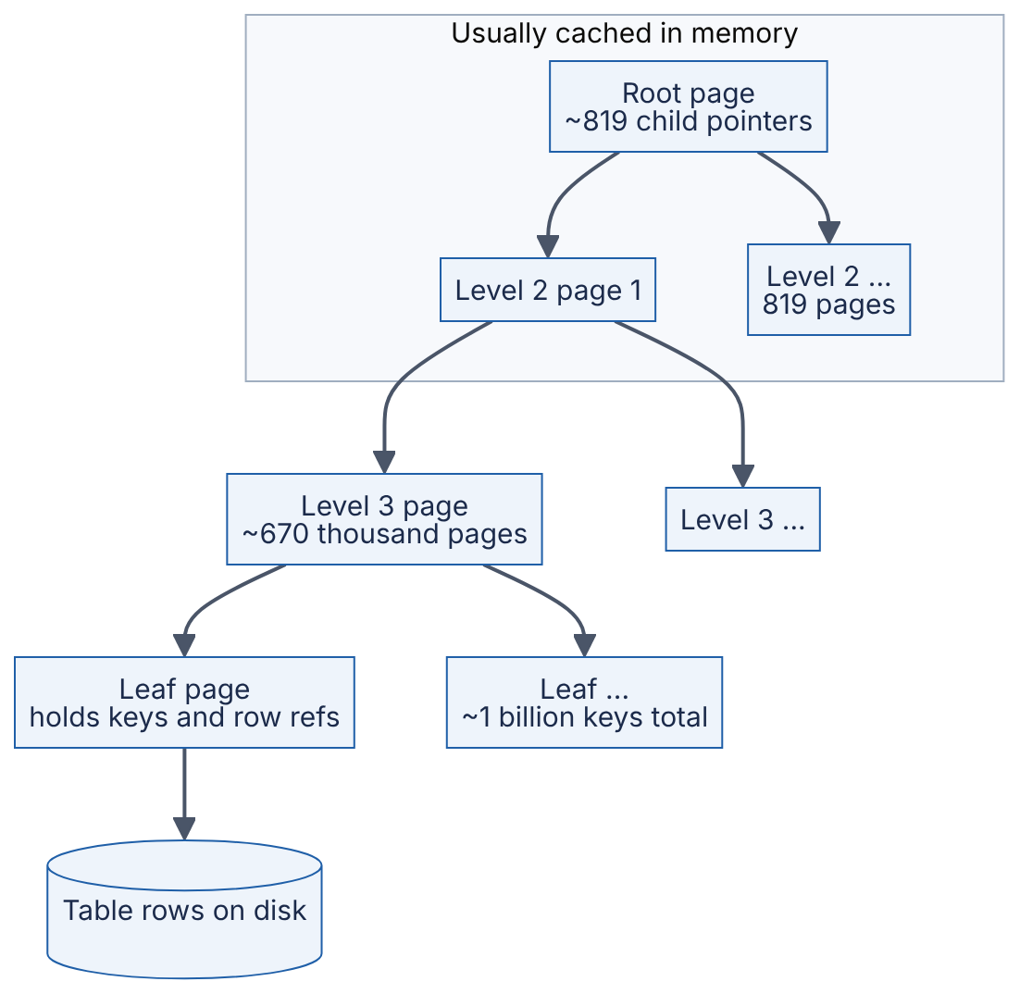
Reading the diagram. Each rectangle is one fixed-size page. A lookup flows top-down synchronously: read the root, binary-search its keys in memory, follow one child pointer, repeat. The number of pages per level multiplies by the fan-out (1 → 819 → about 670,000 → leaves), so the count of levels grows only logarithmically. The Cached subgraph marks the storage boundary that matters: pages above it are in RAM and cost nanoseconds to microseconds, pages below it may require a disk read. The failure point is a cold cache after a restart, when every level costs an I/O. Scaling the data by another factor of 819 adds only one level.
COMMON MISTAKE
Mistake — “Logarithmic means constant, so the base doesn’t matter.” Thirty dependent SSD reads at ~100 µs is 3 ms; four is 0.4 ms. The fan-out changes the constant by an order of magnitude.

4.5 Units: bits, bytes, rates and prefixes

4.5.1 Bits versus bytes
DEFINITION
Definition — Bit and byte. A bit (symbol b) is a single binary digit, 0 or 1. A byte (symbol B) is 8 bits. Storage and memory are conventionally measured in bytes; network link speeds are conventionally measured in bits per second (bps).
The lowercase/uppercase distinction is load-bearing: 1 Gbps (gigabit per second) is one-eighth of 1 GB/s (gigabyte per second). Mixing them up produces an error of exactly 8×, which is large enough to invalidate a design and small enough to escape notice.
FORMULA
Converting link speed to byte throughput
$$R_{\text{B/s}}=\frac{R_{\text{bps}}}{8} t_{\text{transfer}}=\frac{8×S}{R_{\text{bps}}}$$
Symbol | Meaning | Units
$R_{\text{bps}}$ | Link rate | bits/second
$R_{\text{B/s}}$ | The same rate expressed in bytes | bytes/second
$S$ | Amount of data to transfer | bytes
$t_{\text{transfer}}$ | Ideal transfer time, ignoring protocol overhead and congestion | seconds
WORKED EXAMPLE
Worked example — Copying 1 TB across a 1 Gbps link.
- Convert data to bits: $1 \text{TB}={10}^{12}$ bytes $=8×{10}^{12}$ bits.
- Divide by the rate: $8×{10}^{12}/{10}^{9}=8,000$ s.
- Convert to hours: $8,000/3,600≈2.2$ h.
- At 10 Gbps: $800$ s $≈13$ min.
Interpretation. Even a “fast” link takes hours to move a terabyte; real transfers are slower because TCP/IP headers, TLS and congestion reduce goodput, commonly by 5–10% or more. Engineering implication. Rebuilding a failed 20 TB storage node over a single 10 Gbps link takes at least $8×2×{10}^{13}/{10}^{10}=16,000$ s, about 4.4 hours. That repair window feeds directly into the durability calculations of §4.16, and it is why distributed stores spread re-replication across many source nodes in parallel.

4.5.2 SI versus binary prefixes
Two systems of prefixes coexist. The SI (decimal) prefixes k, M, G, T, P, E mean ${10}^{3},{10}^{6},{10}^{9},…$ exactly. The binary prefixes Ki, Mi, Gi, Ti, Pi, Ei, standardized by the IEC (now in IEC 80000-13) [IEC 80000-13], mean $2^{10},2^{20},2^{30},…$ exactly. Operating systems, memory vendors and disk vendors have historically used “GB” for both, which causes the classic “missing” capacity on a new drive.
Table 4.2 — SI versus binary prefixes.
SI name | SI value | Binary name | Binary value | Binary/SI ratio
kilobyte (KB or kB) | ${10}^{3}$ | kibibyte (KiB) | $2^{10}$ | 1.024
megabyte (MB) | ${10}^{6}$ | mebibyte (MiB) | $2^{20}$ | 1.049
gigabyte (GB) | ${10}^{9}$ | gibibyte (GiB) | $2^{30}$ | 1.074
terabyte (TB) | ${10}^{12}$ | tebibyte (TiB) | $2^{40}$ | 1.100
petabyte (PB) | ${10}^{15}$ | pebibyte (PiB) | $2^{50}$ | 1.126
exabyte (EB) | ${10}^{18}$ | exbibyte (EiB) | $2^{60}$ | 1.153
Book convention. Following terminology.md, this book uses KB/MB/GB/TB = ${10}^{3}$/${10}^{6}$/${10}^{9}$/${10}^{12}$ bytes for estimation and KiB/MiB/GiB when power-of-two precision matters (page sizes, memory allocation). Network rates are always decimal: 1 Gbps $={10}^{9}$ bits/s.
WORKED EXAMPLE
Worked example — The “missing” 7% on a new drive. A drive sold as 1 TB is shown by an operating system as “931 GB”.
- The vendor means SI: ${10}^{12}$ bytes.
- The operating system divides by $2^{30}$ but labels the result “GB”: ${10}^{12}/1,073,741,824=931.3$.
- So the drive holds 931.3 GiB, and nothing is missing.
Interpretation. A 6.9% labeling discrepancy at the tera scale, growing to 12.6% at peta and 15.3% at exa. Engineering implication. In a capacity plan for 5 PB of data, confusing PB with PiB means under-provisioning by $5×0.126=0.63$ PB. State your units in every capacity document.

4.5.3 Rates and time conversions
Most capacity estimates start from a daily or monthly volume and must become a per-second rate, because servers are sized per second.
Table 4.3 — Time conversions used in estimation.
Period | Seconds (exact) | Handy approximation
1 minute | 60 | —
1 hour | 3,600 | $3.6×{10}^{3}$
1 day | 86,400 | $≈{10}^{5}$ (overestimates seconds by 16%)
1 week | 604,800 | $≈6×{10}^{5}$
1 month (30 days) | 2,592,000 | $≈2.6×{10}^{6}$
1 year (365 days) | 31,536,000 | $≈π×{10}^{7}$
FORMULA
Average and peak rate from a daily volume
$$\overset{‾}{λ}=\frac{V_{\text{day}}}{86,400} λ_{\text{peak}}=k×\overset{‾}{λ}$$
Symbol | Meaning | Units
$V_{\text{day}}$ | Events (requests, writes, messages) per day | events/day
$\overset{‾}{λ}$ | Average rate | events/second
$k$ | Peak-to-average ratio, measured or assumed (often 2–10 for consumer traffic) | dimensionless
$λ_{\text{peak}}$ | Rate the system must be sized for | events/second
WORKED EXAMPLE
Worked example — 100 million requests per day.
- Average: ${10}^{8}/86,400=1,157$ RPS.
- Shortcut check: ${10}^{8}/{10}^{5}=1,000$ RPS (16% low, acceptable for a first pass).
- Assume a peak-to-average ratio $k=3$: $λ_{\text{peak}}≈3,500$ RPS.
Interpretation. “100 million a day” sounds enormous but is a few thousand requests per second at peak. Engineering implication. A few application servers can carry this request rate; the harder questions are usually storage growth and tail latency, not raw request rate. The peak factor $k$ is an assumption that must be stated and, once the system is live, measured.

4.6 Probability essentials

4.6.1 Probability, complement and independence
DEFINITION
Definition — Probability. A number between 0 and 1 that measures how likely an event is: 0 means impossible, 1 means certain. If an experiment is repeated many times, the probability of event $A$, written $P\left(A\right)$, is the long-run fraction of repetitions in which $A$ happens.

First-principles explanation
Think of a fleet as a bag of marbles: if 1 in 1,000 is red, a blind draw is red with probability 0.001. Probability in system design is about the fleet: a disk with a 2% annual failure probability is rare on its own and a daily event among 100,000 disks.
Two rules carry most of the weight. The complement rule: $P\left(\text{not }A\right)=1−P\left(A\right)$; computing “nothing goes wrong” is often far easier than enumerating what can. Independence: $A$ and $B$ are independent if knowing one happened tells you nothing about the other; then, and only then, $P\left(A\text{ and }B\right)=P\left(A\right)×P\left(B\right)$. Disks in different datacenters fail nearly independently; disks sharing a power supply do not.
FORMULA
Probability that at least one of $N$ independent components fails
$$P\left(\text{at least one fails}\right)=1−{\left(1−p\right)}^{N}$$
Symbol | Meaning | Units
$p$ | Probability that a single component fails during the period of interest | dimensionless (0–1)
$N$ | Number of independent components | count
${\left(1−p\right)}^{N}$ | Probability that none fails (complement, multiplied $N$ times by independence) | dimensionless
Derivation. One component survives with probability $1−p$. By independence, all $N$ survive with probability $\left(1−p\right)×\left(1−p\right)×⋯={\left(1−p\right)}^{N}$. “At least one fails” is the complement of “all survive”. A useful approximation for small $p$: ${\left(1−p\right)}^{N}≈e^{−Np}$, so $P\left(\text{at least one}\right)≈1−e^{−Np}$, and when $Np≪1$ this is simply $≈Np$.
WORKED EXAMPLE
Worked example — At least one of 1,000 servers fails today. Each server independently fails on a given day with probability $p=0.001$ (one failure per thousand server-days). The fleet has $N=1,000$ servers.
- Probability one server survives the day: $1−0.001=0.999$.
- Probability all survive: ${0.999}^{1000}$. Using the approximation: $e^{−1000×0.001}=e^{−1}=0.368$. (Exact: 0.3677.)
- Probability at least one fails: $1−0.368=0.632$.
Interpretation. A component that almost never fails individually produces a failure on 63% of days at fleet scale. At $N=10,000$ the probability is $1−e^{−10}>0.9999$: a failure every day. Engineering implication. At scale, failure is not an exception to handle but a steady background rate to design for. This is the quantitative core of “design for failure” (§2.9): automation must detect and replace failed nodes without human intervention, because humans cannot be paged every day for routine events.

4.6.2 Union and intersection
FORMULA
Union (inclusion–exclusion) and intersection
$$P\left(A∪B\right)=P\left(A\right)+P\left(B\right)−P\left(A∩B\right) P\left(A∩B\right)=P\left(A\right)×P\left(B∣A\right)$$
Symbol | Meaning | Units
$P\left(A∪B\right)$ | Probability that $A$ or $B$ (or both) happens | dimensionless
$P\left(A∩B\right)$ | Probability that both happen | dimensionless
$P\left(B∣A\right)$ | Conditional probability of $B$ given that $A$ happened; equals $P\left(B\right)$ when independent | dimensionless
The subtraction in the union rule avoids counting “both” twice. The conditional form of the intersection rule is how correlation enters: if two replicas share a rack, $P\left(B∣A\right)$ — the probability that the second fails given that the first did — can be many times larger than $P\left(B\right)$.
WORKED EXAMPLE
Worked example — Two dependencies, independent versus correlated. A request needs both a cache and a database. On a given day, the cache has an outage with probability 0.01 and the database with probability 0.02.
- If independent: $P\left(\text{both}\right)=0.01×0.02=0.0002$.
- $P\left(\text{either}\right)=0.01+0.02−0.0002=0.0298$.
- Now suppose they share a network switch, so that given a cache outage the database is also out with probability 0.5: $P\left(\text{both}\right)=0.01×0.5=0.005$ — 25 times the independent value.
Interpretation. The probability of “something breaks” barely changes, but the probability of “both break together” rises 25×. Engineering implication. Redundancy arithmetic (§4.14, §4.16) assumes independence. Every shared dependency — a rack, a power feed, a software version, a configuration push — breaks that assumption, which is why real systems spread replicas across failure domains.

4.6.3 Expected value
DEFINITION
Definition — Expected value. The probability-weighted average outcome of a random quantity $X$: EX=i​xi PX=xi. It is the long-run average over many repetitions.
FORMULA
Expected value and linearity of expectation
EX=i​xi PX=xi EX1+X2+⋯+XN=EX1+⋯+EXN
Symbol | Meaning | Units
$X$ | A random quantity (failures, latency, cost) | units of the quantity
$x_{i}$ | A possible value of $X$ | units of the quantity
$P\left(X=x_{i}\right)$ | Probability of that value | dimensionless
Linearity is powerful because it holds even when the components are not independent. The expected number of failed servers is $N×p$ whatever the correlation.
WORKED EXAMPLE
Worked example — Expected cost of a retry policy. A call fails with probability 0.05 and is retried once on failure. What is the expected number of calls per request?
- Outcomes: 1 call with probability 0.95; 2 calls with probability 0.05.
- $E\left[\text{calls}\right]=1×0.95+2×0.05=0.95+0.10=1.05$.
Interpretation. Retries add 5% load in normal operation. But if a dependency is degraded so that 50% of calls fail, the same policy gives $1×0.5+2×0.5=1.5$ calls per request — a 50% load increase on the struggling dependency. Engineering implication. Retries amplify load precisely when the system is weakest. Retry budgets (§22.12) cap this expected amplification.

4.6.4 The binomial distribution
When there are $N$ independent trials, each “failing” with probability $p$, the number of failures $K$ follows a binomial distribution.
FORMULA
Binomial probability of exactly $k$ failures
$$P\left(K=k\right)=\left({N \atop k}\right)p^{k}{\left(1−p\right)}^{N−k}, \left({N \atop k}\right)=\frac{N!}{k! \left(N−k\right)!}, E\left[K\right]=Np$$
Symbol | Meaning | Units
$N$ | Number of independent components (trials) | count
$k$ | Number of failures we ask about | count
$p$ | Per-component failure probability in the period | dimensionless
$\left({N \atop k}\right)$ | Number of ways to choose which $k$ components fail (“$N$ choose $k$”) | count
$E\left[K\right]$ | Expected number of failures | count
Derivation. One specific set of $k$ failures and $N−k$ survivals has probability $p^{k}{\left(1−p\right)}^{N−k}$ by independence. There are $\left({N \atop k}\right)$ such sets, and they are mutually exclusive, so we add them.
WORKED EXAMPLE
Worked example — How many spare servers are enough? Continuing the fleet of $N=1,000$ servers with daily failure probability $p=0.001$:
- Expected failures per day: $E\left[K\right]=1000×0.001=1$.
- $P\left(K=0\right)={0.999}^{1000}=0.3677$.
- $P\left(K=1\right)=1000×0.001×{0.999}^{999}=0.3681$.
- $P\left(K=2\right)=\left({1000 \atop 2}\right)×{0.001}^{2}×{0.999}^{998}=499,500×{10}^{−6}×0.3685=0.1840$.
- $P\left(K≥3\right)=1−0.3677−0.3681−0.1840=0.0802$.
Interpretation. On about 8% of days — roughly 29 days per year — three or more servers fail. Engineering implication. Provisioning spare capacity for “the average day” (one failure) leaves you short on one day in twelve. Capacity headroom should be chosen against a percentile of the failure distribution, not its mean.

4.7 Statistics: describing measurements
Probability reasons forward from a model to predictions. Statistics reasons backward from measurements (latency samples, failure logs) to a description of what is happening.

4.7.1 Mean and median
DEFINITION
Definition — Mean and median. The mean (arithmetic average) of $n$ values is their sum divided by $n$. The median is the middle value after sorting (the average of the two middle values when $n$ is even); half of the values are at or below it.

First-principles explanation
If nine people in a café each earn 50,000 a year and a billionaire walks in, the mean income in the room jumps to over 100 million while the median does not move. The mean is sensitive to every value, including extreme ones; the median is sensitive only to rank. Latency data behave like the café: most requests are quick, a few are extremely slow, and the slow ones drag the mean.
FORMULA
Mean, variance and standard deviation
$$\overset{‾}{x}=\frac{1}{n}\sum_{i=1}^{n}{x_{i}} σ^{2}=\frac{1}{n}\sum_{i=1}^{n}{{\left(x_{i}−\overset{‾}{x}\right)}^{2}} σ=\sqrt{σ^{2}}$$
Symbol | Meaning | Units
$x_{i}$ | The $i$-th measurement | e.g. ms
$n$ | Number of measurements | count
$\overset{‾}{x}$ | Mean | same as $x$ (ms)
$σ^{2}$ | Variance: average squared distance from the mean | ms²
$σ$ | Standard deviation: typical distance from the mean | ms
This is the population variance (divide by $n$). When estimating the variance of a larger population from a sample, statisticians divide by $n−1$ instead (the sample variance); for the large samples typical of latency monitoring the difference is negligible.
WORKED EXAMPLE
Worked example — Ten latency measurements with one outlier. Measured latencies in ms: 12, 15, 11, 14, 13, 16, 12, 18, 14, 250.
- Sum: $12+15+11+14+13+16+12+18+14+250=375$. Mean: $375/10=37.5$ ms.
- Sorted: 11, 12, 12, 13, 14, 14, 15, 16, 18, 250. Median: average of 5th and 6th values $=\left(14+14\right)/2=14$ ms.
- Squared deviations from 37.5: ${\left(12−37.5\right)}^{2}=650.25$; similarly 506.25, 702.25, 552.25, 600.25, 462.25, 650.25, 380.25, 552.25, and ${\left(250−37.5\right)}^{2}=45,156.25$. Sum $=50,212.5$.
- Variance: $50,212.5/10=5,021.25$ ms². Standard deviation: $\sqrt{5021.25}=70.9$ ms.
- Without the outlier: mean 13.9 ms, median 14 ms, standard deviation 2.1 ms.
Interpretation. One slow request in ten makes the mean 2.7 times the median and inflates the standard deviation 34-fold. The mean (37.5 ms) describes no actual request: nine were under 20 ms and one was 250 ms. Engineering implication. Report latency as percentiles (§4.8), not as mean ± standard deviation. Mean and standard deviation summarize a distribution well only when it is roughly symmetric and thin-tailed, which latency almost never is.

4.7.2 Distributions: normal, exponential, log-normal and Pareto
A probability distribution describes how likely each value is. Four shapes cover most of what you will meet.
The normal (Gaussian) distribution is the symmetric bell curve. It arises when many small independent effects add up. About 68% of values lie within $1σ$ of the mean, 95% within $2σ$ and 99.7% within $3σ$. Extreme values are vanishingly rare: a $6σ$ event has probability around ${10}^{−9}$.
The exponential distribution describes the time between independent random events occurring at a constant average rate $λ$, such as request arrivals from many independent users, or failures of a component that does not age. Its mean is $1/λ$ and $P\left(T>t\right)=e^{−λt}$. It is memoryless: having waited 5 seconds tells you nothing about how much longer you will wait. It underpins queueing theory (§4.10) and reliability theory (§4.15).
The log-normal distribution describes a quantity whose logarithm is normal — the result of many small multiplicative effects. Request latency often looks roughly log-normal: a long right tail, with the mean above the median. If $lnX$ has mean $μ$ and standard deviation $s$, then the median of $X$ is $e^{μ}$ and the mean is $e^{μ+s^{2}/2}$.
The Pareto (power-law) distribution has $P\left(X>x\right)={\left(x_{m}/x\right)}^{α}$ for $x≥x_{m}$. Its tail decays polynomially, not exponentially, so extreme values are far more common than a normal model predicts. File sizes, object popularity, and per-user activity are frequently described as heavy-tailed (Harchol-Balter 2013 discusses heavy-tailed job sizes in depth). With $α≈1.16$ you get the “80/20 rule”: the top 20% of items account for 80% of the total. For $α≤1$ the mean is infinite; for $α≤2$ the variance is infinite, so sample averages never settle down.
FORMULA
Tail formulas for three skewed distributions
$$\text{Exponential: }P\left(T>t\right)=e^{−λt}, E\left[T\right]=\frac{1}{λ} \text{Log-normal: median}=e^{μ}, \text{mean}=e^{μ+s^{2}/2} \text{Pareto: }P\left(X>x\right)={\left(\frac{x_{m}}{x}\right)}^{α}$$
Symbol | Meaning | Units
$λ$ | Event rate of the exponential distribution | events/second
$t$ | Elapsed time | seconds
$μ,s$ | Mean and standard deviation of $lnX$ for a log-normal $X$ | ln of the unit of $X$
$x_{m}$ | Pareto minimum (scale) value | unit of $X$ (e.g. bytes)
$α$ | Pareto tail index: smaller means heavier tail | dimensionless
Table 4.4 — Four distributions and where they appear in systems.
Distribution | Shape | Tail | Typical system quantity | Mean vs median
Normal | Symmetric bell | Very thin ($e^{−x^{2}}$) | Aggregates of many small effects; measurement noise | Equal
Exponential | Decaying from zero | Thin ($e^{−x}$) | Inter-arrival times; failures of non-aging parts | Mean ≈ 1.44 × median
Log-normal | Right-skewed | Moderately heavy | Request latency, service times | Mean > median
Pareto | Right-skewed, power law | Heavy (polynomial) | File sizes, key popularity, user activity | Mean ≫ median (may be infinite)
WORKED EXAMPLE
Worked example — Mean versus median for a log-normal latency. Suppose $ln\left(\text{latency in ms}\right)$ has mean $μ=ln20=2.996$ and standard deviation $s=1.0$.
- Median: $e^{μ}=20$ ms.
- Mean: $e^{μ+s^{2}/2}=e^{2.996+0.5}=20×e^{0.5}=20×1.649=33.0$ ms.
- The 99th percentile of a normal variable is $μ+2.326 s$, so p99 $=e^{2.996+2.326}=20×e^{2.326}=20×10.24=205$ ms.
Interpretation. The p99 is about 10 times the median, and the mean sits 65% above the median. Engineering implication. If you set a timeout at the mean (33 ms) you will time out nearly one request in three: $ln33−ln20=0.50$, which is $0.5 s$ above $μ$, and a normal variable exceeds $μ+0.5 s$ with probability 0.31. The Python example in §4.8.2 samples this exact distribution and confirms these values empirically.

4.7.3 Why averages lie
Averages mislead in four recurring ways: skew (the mean is pulled toward the tail, as above); time aggregation (a day-long average of 50 ms can hide a 10-minute window at 2 s); averaging percentiles (a fleet p99 is not the mean of per-host p99s — merge histograms instead, §4.8.3); and averaging over users (if 1% of users send 50% of requests, per-request and per-user averages can tell opposite stories).
COMMON MISTAKE
Mistake — “Average latency is 40 ms, so we meet our 100 ms SLO.” An SLO is about the fraction of requests that are fast enough. A mean of 40 ms is compatible with 10% of requests taking over a second. SLOs are written in percentiles (§39.6) for exactly this reason.

4.8 Percentiles and tail latency

4.8.1 Definition
DEFINITION
Definition — Percentile. The $q$-th percentile of a set of measurements is the value at or below which $q$% of the measurements fall. Latency percentiles are written p50 (the median), p95, p99 and p99.9 (also written p999): the 50th, 95th, 99th and 99.9th percentiles.

First-principles explanation
Line up 1,000 runners by finishing time: the p50 is the 500th runner’s time, the p99 the 990th’s, the p99.9 the 999th’s. Percentiles describe what a fraction of requests experiences — if your p99 is 2 s, one request in a hundred is painfully slow, and a page making 50 requests will often hit one (§4.8.4).
The region above roughly p99 is called the tail, and tail latency is the study of why those requests are slow and how to make them faster. Causes include garbage-collection pauses, queueing behind a large request, background compaction, cache misses, retransmitted packets and noisy neighbors [Dean and Barroso 2013].

4.8.2 Computing percentiles from samples
The simplest definition is the nearest-rank method.
FORMULA
Nearest-rank percentile
$$r=\left\lceil \frac{q}{100}×n\right\rceil , \text{p}q=x_{\left(r\right)}$$
Symbol | Meaning | Units
$q$ | Desired percentile, $0<q≤100$ | percent
$n$ | Number of samples | count
$r$ | 1-based rank in the sorted list | position
$x_{\left(r\right)}$ | The $r$-th smallest sample | e.g. ms
Other definitions interpolate between neighboring samples (NumPy’s default does); they differ noticeably only when $n$ is small. With 10 samples, a “p99” is just the maximum, which is why a p99 needs at least several hundred samples and a p99.9 several thousand to mean anything.
WORKED EXAMPLE
Worked example — Percentiles of the ten measurements from §4.7.1. Sorted: 11, 12, 12, 13, 14, 14, 15, 16, 18, 250.
- p50: $r=⌈0.50×10⌉=5$ → 14 ms.
- p90: $r=⌈0.90×10⌉=9$ → 18 ms.
- p95: $r=⌈0.95×10⌉=⌈9.5⌉=10$ → 250 ms.
Interpretation. p90 and p95 differ by a factor of 14 because with ten samples they land on different single observations. Engineering implication. Always report the sample count alongside a high percentile, and alert on percentiles computed over windows large enough to contain hundreds of tail samples.
The following program samples the log-normal distribution of §4.7.2, computes percentiles, and then checks the fan-out formula of §4.8.4 by simulation.
import math
import random
import statistics
def percentile_nearest_rank(samples, p):
"""Return the p-th percentile (0 < p <= 100) using the nearest-rank method."""
if not samples:
raise ValueError("no samples")
ordered = sorted(samples)
rank = math.ceil(p / 100 * len(ordered)) # 1-based rank
return ordered[max(rank, 1) - 1]
random.seed(42)
# Log-normal latencies: median ~20 ms, heavy right tail (sigma = 1.0)
latencies_ms = [random.lognormvariate(math.log(20), 1.0) for _ in range(100_000)]
print(f"mean = {statistics.fmean(latencies_ms):7.1f} ms")
for p in (50, 90, 99, 99.9):
print(f"p{p:<5} = {percentile_nearest_rank(latencies_ms, p):7.1f} ms")
# Fan-out: a request waits for the slowest of N parallel calls
p99 = percentile_nearest_rank(latencies_ms, 99)
for n in (1, 10, 100):
trials = 20_000
slow = sum(
max(random.choice(latencies_ms) for _ in range(n)) > p99
for _ in range(trials)
)
print(f"N={n:>3}: simulated P(slow) = {slow/trials:.3f}, "
f"formula 1 - 0.99^N = {1 - 0.99**n:.3f}")
Output (Python 3.13):
mean = 32.9 ms
p50 = 20.0 ms
p90 = 72.2 ms
p99 = 201.3 ms
p99.9 = 428.4 ms
N= 1: simulated P(slow) = 0.010, formula 1 - 0.99^N = 0.010
N= 10: simulated P(slow) = 0.093, formula 1 - 0.99^N = 0.096
N=100: simulated P(slow) = 0.637, formula 1 - 0.99^N = 0.634
What to notice:
- The simulated mean (32.9 ms), median (20.0 ms) and p99 (201 ms) match the closed-form values of §4.7.2 (33.0, 20 and 205 ms) within sampling error.
- max(...) models a request that must wait for all of its parallel sub-requests; the simulated probability of exceeding the single-server p99 matches $1−{0.99}^{N}$.
- Sorting 100,000 samples is fine offline, but production systems cannot keep every sample; they use histograms.

4.8.3 Histograms
A histogram counts how many samples fall into each of a fixed set of buckets. It uses constant memory regardless of request volume, and two histograms with identical buckets can be merged by adding counts, which makes fleet-wide percentiles possible. Percentiles are read from the cumulative counts, with an error no larger than the bucket width. Libraries such as HdrHistogram use buckets whose width grows with the value (logarithmic or log-linear buckets) so that relative error stays bounded across many orders of magnitude [Tene, HdrHistogram].
WORKED EXAMPLE
Worked example — p99 and p99.9 from a histogram. 10,000 requests are counted into buckets (ms): [0,10): 6,000; [10,20): 2,500; [20,50): 1,000; [50,100): 350; [100,200): 120; [200,500): 25; [500,1000): 5.
- Cumulative counts: 6,000; 8,500; 9,500; 9,850; 9,970; 9,995; 10,000.
- p99 is rank $0.99×10,000=9,900$. The cumulative count first reaches 9,900 in the [100,200) bucket (9,850 → 9,970).
- Interpolate linearly inside the bucket: $\left(9,900−9,850\right)/120=0.417$ of the way through, so p99 $≈100+0.417×100=142$ ms.
- p99.9 is rank 9,990, inside [200,500) (9,970 → 9,995): $\left(9,990−9,970\right)/25=0.8$, so p99.9 $≈200+0.8×300=440$ ms.
Interpretation. The true p99 is somewhere in [100, 200) ms; interpolation assumes samples are spread evenly inside the bucket. Engineering implication. Bucket boundaries should be densest where your SLO thresholds lie. If the SLO is “p99 < 150 ms”, a bucket edge exactly at 150 ms lets you count SLO violations exactly rather than estimate them.

4.8.4 Fan-out amplification
Modern requests are rarely served by one machine. A search query may be scattered to hundreds of index partitions (§16.7); a page render may call dozens of microservices. If a request must wait for all of its $N$ sub-requests, then it is slow whenever any of them is slow.
Figure 4.2 — Fan-out: the slowest leaf determines the response time.
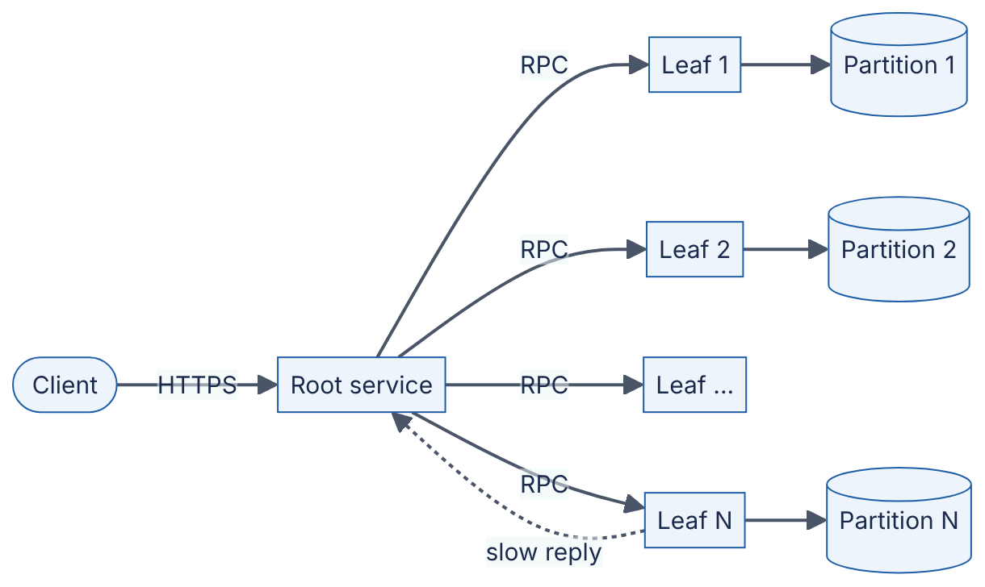
Reading the diagram. The client sends one HTTPS request to a root service, which issues $N$ parallel RPCs to leaf services, each owning one data partition (the cylinders mark storage boundaries). All arrows are synchronous request/response except the dotted arrow, which highlights the one leaf whose reply arrives late. The root cannot answer until every leaf replies (or a deadline fires), so the response time is the maximum of $N$ leaf latencies. Every leaf is a failure point for the whole request. Scaling out by adding partitions increases $N$ and therefore makes the tail worse unless tail-tolerant techniques are used.
FORMULA
Probability that a fan-out request is fast
$$P\left(\text{all }N\text{ fast}\right)=p^{N} P\left(\text{at least one slow}\right)=1−p^{N} p_{\text{required}}=P_{\text{target}}^{1/N}$$
Symbol | Meaning | Units
$p$ | Probability that one leaf responds within the threshold (e.g. 0.99 at the leaf’s p99) | dimensionless
$N$ | Number of parallel sub-requests the root must wait for | count
$P_{\text{target}}$ | Desired probability that the whole request is fast | dimensionless
$p_{\text{required}}$ | Per-leaf probability needed to meet $P_{\text{target}}$ | dimensionless
This is the complement rule of §4.6.1 again, assuming leaf latencies are independent.
WORKED EXAMPLE
Worked example — 100-way fan-out. Each leaf answers within 10 ms with probability 0.99 (its p99 is 10 ms). The root fans out to $N=100$ leaves.
- $P\left(\text{all fast}\right)={0.99}^{100}=0.366$.
- $P\left(\text{at least one slow}\right)=1−0.366=0.634$.
- For 99% of root requests to be fast we need $p={0.99}^{1/100}=0.99990$: every leaf must meet the 10 ms threshold at its p99.99.
- With $N=10$: ${0.99}^{10}=0.904$, so 9.6% of requests are slow.
Interpretation. A leaf p99 becomes the root’s p37 or so: 63% of user requests see at least one slow leaf. This is the example Dean and Barroso use to open The Tail at Scale: with a one-in-a-hundred chance of a slow leaf, 63% of 100-way fan-out requests are slow [Dean and Barroso 2013]. Engineering implication. In fan-out architectures you must engineer the leaf p99.9 or p99.99, not the leaf p99, or use tail-tolerant techniques that break the $p^{N}$ law.

Real-world industry applications
INDUSTRY EXAMPLE
Google — tail-tolerant techniques. Dean and Barroso describe how large fan-out services at Google tolerate latency variability instead of trying to eliminate it. Hedged requests send a second copy of a request to another replica if the first has not answered within, for example, the 95th-percentile expected latency, and use whichever reply arrives first; tied requests enqueue the request on two servers and let the first to start cancel the other. They report a benchmark reading 1,000 keys from 100 BigTable servers in which hedging after 10 ms cut the p99.9 latency from 1,800 ms to 74 ms while sending only about 2% more requests. Trade-off: hedging spends a little extra load to cut the tail, and must be disabled or rate-limited under overload so it does not amplify it. Chapter 23 (§23.6–§23.7) covers implementation. Evidence: Primary — [Dean and Barroso 2013]
Two further traps are covered in Chapter 23: computing a fleet p99 by averaging per-host p99s (merge histograms instead, §4.8.3), and coordinated omission, where a load generator that waits for slow replies stops sending during slow periods and so under-samples the tail (§23.5).
COMMON MISTAKE
Mistake — “Our p99 is fine, so only 1% of users suffer.” If a user session issues 100 requests, the probability that the session contains at least one request slower than p99 is $1−{0.99}^{100}=63\%$. Percentiles are per request; user experience is per session.

4.9 Basic linear algebra
This section is a preparation for the ML chapters (Part XI onward), where embeddings, similarity search and matrix multiplication dominate cost. You need only three ideas: vectors, the dot product and matrix multiplication.

4.9.1 Vectors
DEFINITION
Definition — Vector. An ordered list of $d$ numbers, $a=\left(a_{1},a_{2},…,a_{d}\right)$, where $d$ is the dimension. Geometrically, a vector is an arrow from the origin to a point in $d$-dimensional space; its length (or norm) is $∥a∥=\sqrt{a_{1}^{2}+⋯+a_{d}^{2}}$.

First-principles explanation
A map location is a 2-dimensional vector (latitude, longitude); a song might be a 3-dimensional vector (tempo, loudness, acousticness). An ML embedding is the same idea with hundreds or thousands of learned dimensions, arranged so that similar items point in similar directions. “Find similar items” becomes “find nearby arrows” (Chapter 74).

4.9.2 Dot product and cosine similarity
FORMULA
Dot product and cosine similarity
$$a⋅b=\sum_{i=1}^{d}{a_{i}}b_{i} cosθ=\frac{a⋅b}{∥a∥ ∥b∥}$$
Symbol | Meaning | Units
$a,b$ | Two vectors of the same dimension | (embedding units; dimensionless)
$d$ | Dimension | count
$a_{i},b_{i}$ | $i$-th components | dimensionless
$∥a∥$ | Length of $a$ | dimensionless
$θ$ | Angle between the vectors | radians or degrees
$cosθ$ | Cosine similarity: 1 = same direction, 0 = unrelated (perpendicular), −1 = opposite | dimensionless
The dot product multiplies matching components and adds the results. Dividing by both lengths removes the effect of magnitude, so cosine similarity measures direction only. If vectors are normalized to length 1 in advance (common for embeddings), cosine similarity is the dot product, which is cheaper to compute.
WORKED EXAMPLE
Worked example — Which document is closest to the query? Query $q=\left(1,2,2\right)$; document $a=\left(2,1,2\right)$; document $b=\left(2,4,4\right)$.
- $q⋅a=1×2+2×1+2×2=2+2+4=8$.
- $∥q∥=\sqrt{1+4+4}=3$; $∥a∥=\sqrt{4+1+4}=3$.
- $cosθ_{qa}=8/\left(3×3\right)=0.889$ (an angle of about 27°).
- $q⋅b=2+8+8=18$; $∥b∥=\sqrt{4+16+16}=6$; $cosθ_{qb}=18/\left(3×6\right)=1.0$.
Interpretation. $b$ is exactly twice $q$, so it points the same way: cosine 1.0. The raw dot product (18 vs 8) also prefers $b$ but would be fooled by long vectors in general. Engineering implication. Choose the similarity metric the embedding model was trained with; normalize vectors once at ingestion so that serving-time similarity is a plain dot product.

4.9.3 Matrices and the cost of matrix multiplication
DEFINITION
Definition — Matrix. A rectangular grid of numbers with $m$ rows and $n$ columns (an $m×n$ matrix). A set of $n$ embeddings of dimension $d$ is naturally stored as an $n×d$ matrix, one embedding per row.
Multiplying an $m×k$ matrix $A$ by a $k×n$ matrix $B$ produces an $m×n$ matrix $C$ in which each entry $C_{ij}$ is the dot product of row $i$ of $A$ with column $j$ of $B$. Each of the $m×n$ entries is a dot product of length $k$.
FORMULA
Cost of matrix multiplication
$$\text{FLOPs}=2 m n k \text{arithmetic intensity}=\frac{\text{FLOPs}}{\text{bytes moved}}$$
Symbol | Meaning | Units
$m,k$ | Rows and columns of $A$ | count
$k,n$ | Rows and columns of $B$ (inner dimension $k$ must match) | count
FLOPs | Floating-point operations: one multiply and one add per term | operations
bytes moved | Data read from and written to memory | bytes
arithmetic intensity | FLOPs per byte; low values mean memory-bandwidth-bound, high values compute-bound | FLOP/byte
WORKED EXAMPLE
Worked example — Brute-force similarity search and the value of batching.
Part A: one query against one million embeddings. $n={10}^{6}$ embeddings of dimension $d=768$ stored as 4-byte floats.
- Storage: ${10}^{6}×768×4=3.07×{10}^{9}$ bytes ≈ 3.1 GB.
- Compute: one dot product per embedding, ${10}^{6}×768=7.68×{10}^{8}$ multiply-adds = $1.54×{10}^{9}$ FLOPs.
- Intensity: $1.54×{10}^{9}/3.07×{10}^{9}=0.5$ FLOP/byte — every float is loaded once and used once.
- If memory delivers 20 GB/s to this computation (an illustrative figure), scanning takes $3.07/20=0.15$ s per query, regardless of how fast the arithmetic is.
Part B: a neural-network layer. Multiply a batch of $m$ inputs ($m×4096$) by a $4096×4096$ weight matrix stored in 2-byte (16-bit) floats.
- Weights: $4096×4096×2=33.5$ MB.
- With $m=1$: FLOPs $=2×1×4096×4096=3.36×{10}^{7}$, intensity ≈ $3.36×{10}^{7}/3.36×{10}^{7}=1$ FLOP/byte.
- With $m=32$: FLOPs $=2×32×4096×4096=1.07×{10}^{9}$; the weights are read once for the whole batch, so intensity ≈ 32 FLOP/byte.
Interpretation. Brute-force search and single-request inference are memory-bound: the processor waits for data. Batching reuses each loaded weight for many inputs and raises arithmetic intensity proportionally. Engineering implication. At a million vectors and many queries per second, brute force is too slow, which motivates approximate nearest neighbor (ANN) indexes (Chapter 74). For model serving, batching is the main lever for throughput — at a latency cost quantified in §4.18.6.
import math
def dot(a, b):
return sum(x * y for x, y in zip(a, b, strict=True))
def norm(a):
return math.sqrt(dot(a, a))
def cosine_similarity(a, b):
return dot(a, b) / (norm(a) * norm(b))
def matmul(A, B):
"""Naive matrix multiply: (m x k) times (k x n) -> (m x n)."""
m, k, n = len(A), len(B), len(B[0])
assert all(len(row) == k for row in A), "inner dimensions must match"
return [[sum(A[i][t] * B[t][j] for t in range(k)) for j in range(n)]
for i in range(m)]
query = [1, 2, 2]
docs = {"doc_a": [2, 1, 2], "doc_b": [2, 4, 4], "doc_c": [-2, 1, 0]}
for name, vec in docs.items():
print(f"{name}: dot = {dot(query, vec):3d}, cosine = {cosine_similarity(query, vec):.3f}")
# Score all documents at once: (1 x 3) query times (3 x 3) matrix of doc columns
D = [list(col) for col in zip(*docs.values())] # 3 x 3, one document per column
print("scores via matmul:", matmul([query], D)[0])
Output:
doc_a: dot = 8, cosine = 0.889
doc_b: dot = 18, cosine = 1.000
doc_c: dot = 0, cosine = 0.000
scores via matmul: [8, 18, 0]
What to notice:
- zip(..., strict=True) (Python 3.10+) raises an error if dimensions differ, a cheap guard against mixing embeddings from different models.
- doc_c is perpendicular to the query (dot product 0): unrelated, not opposite.
- Scoring many documents is one matrix multiplication. The triple loop in matmul performs exactly $m×n×k$ multiply-adds; production libraries (BLAS, GPU kernels) do the same arithmetic but reorganize it to reuse data in caches.

4.10 Queueing theory

4.10.1 Vocabulary
DEFINITION
Definition — Queueing system. A model in which jobs (requests, messages, packets) arrive at a service center, wait in a queue if all servers are busy, receive service, and depart. The arrival rate $λ$ is the average number of jobs arriving per second; the service rate $μ$ is the average number of jobs one server can complete per second when it is never idle, so the average service time is $S=1/μ$.

First-principles explanation
Picture a supermarket checkout. Customers arrive at random and take a random time to serve. When the cashier is idle half the time, a queue rarely forms; when the cashier is busy 95% of the time, a long queue is routine, although the cashier is not technically overloaded. Waiting is caused by variability, and its effect grows without bound as utilization approaches 100%. With perfectly regular arrivals and service, a cashier at 99% would never have a queue. Every CPU core, disk, thread, connection and network link in a design is a checkout.

Why does this exist?
Capacity plans that ignore queueing assume a server at 90% utilization performs like one at 50%. It does not. Queueing theory, begun by Erlang for telephone exchanges and developed for computer systems from the 1960s onward [Kleinrock 1975; Harchol-Balter 2013], quantifies how much worse it is.
Kendall notation names queue models as A/S/c: arrival process / service-time distribution / number of servers. “M” stands for Markovian (memoryless): Poisson arrivals, meaning exponentially distributed gaps between arrivals (§4.7.2), or exponentially distributed service times. M/M/1 is the simplest model: random arrivals, random service, one server, first-come-first-served, unlimited queue.

4.10.2 The M/M/1 queue
Figure 4.3 — The M/M/1 queue.
Reading the diagram. Jobs flow left to right. Arrivals come from many independent clients at average rate $λ$ (requests/s); the queue (subroutine shape) is a buffer, typically in memory, with no limit in this model; the single server processes one job at a time at average rate $μ$. In steady state, departures equal arrivals ($λ$), so throughput is set by demand, not by the server, as long as $λ<μ$. The failure point is the queue itself: if $λ≥μ$ it grows without bound until memory or timeouts intervene. Scaling options are a faster server (raise $μ$), more servers (M/M/c, §4.10.4) or less demand (caching, load shedding).
FORMULA
M/M/1 results
$$ρ=\frac{λ}{μ} W=\frac{1}{μ−λ}=\frac{S}{1−ρ} W_{q}=\frac{ρ}{μ−λ} L=\frac{ρ}{1−ρ} L_{q}=\frac{ρ^{2}}{1−ρ}$$
Symbol | Meaning | Units
$λ$ | Average arrival rate | jobs/second
$μ$ | Average service rate of the server | jobs/second
$S=1/μ$ | Average service time | seconds
$ρ$ | Utilization: fraction of time the server is busy (must be $<1$) | dimensionless
$W$ | Average time in system (waiting + service), i.e. response time | seconds
$W_{q}$ | Average time waiting in the queue before service starts | seconds
$L$ | Average number of jobs in the system | jobs
$L_{q}$ | Average number of jobs waiting in the queue | jobs
Derivation sketch. Because arrivals are memoryless, the number of jobs in the system behaves like a random walk that steps up at rate $λ$ and down at rate $μ$. Balancing the flow between neighboring states gives $P\left(n\text{ jobs}\right)=\left(1−ρ\right)ρ^{n}$, a geometric distribution. Its mean is $L=ρ/\left(1−ρ\right)$. Little’s Law (§4.11) then gives $W=L/λ=1/\left(μ−λ\right)$. A further useful fact: in M/M/1 the response time itself is exponentially distributed with rate $μ−λ$, so its $q$-th percentile is $W×ln\frac{1}{1−q}$; the p99 is $W×ln100=4.6 W$ [Harchol-Balter 2013].
WORKED EXAMPLE
Worked example — One server at increasing load. A service handles requests in 10 ms on average ($μ=100$/s).
- At $λ=50$/s: $ρ=0.5$; $W=1/\left(100−50\right)=0.020$ s = 20 ms; $L=0.5/0.5=1$ request.
- At $λ=80$/s: $ρ=0.8$; $W=1/20=50$ ms; $L=0.8/0.2=4$.
- At $λ=90$/s: $ρ=0.9$; $W=1/10=100$ ms; $L=9$; $L_{q}=0.81/0.1=8.1$; p99 $=4.605×100≈461$ ms.
- At $λ=99$/s: $ρ=0.99$; $W=1/1=1,000$ ms.
Interpretation. Going from 50% to 90% utilization (1.8× the traffic) multiplies mean latency by 5, and the last 9% of traffic (90 → 99/s) multiplies it by another 10. Engineering implication. Plan latency-sensitive services to run at moderate utilization at peak — often 50–70% for interactive work — and reserve high utilization for batch work whose latency nobody waits for.
Table 4.5 — M/M/1 response time as a multiple of service time.
Utilization $ρ$ | $W/S=1/\left(1−ρ\right)$ | $W$ when $S$ = 10 ms | Jobs in system $L$ | p99 when $S$ = 10 ms
0.50 | 2 | 20 ms | 1 | 92 ms
0.70 | 3.3 | 33 ms | 2.3 | 154 ms
0.80 | 5 | 50 ms | 4 | 230 ms
0.90 | 10 | 100 ms | 9 | 461 ms
0.95 | 20 | 200 ms | 19 | 921 ms
0.99 | 100 | 1,000 ms | 99 | 4,605 ms

4.10.3 Why latency explodes near 100% utilization
The factor $1/\left(1−ρ\right)$ is the whole story. The distance to saturation, $1−ρ$, is in the denominator, so each halving of the remaining headroom doubles the latency: 0.8 → 0.9 doubles $W$, 0.9 → 0.95 doubles it again, and so on. The curve is the familiar “hockey stick”. Two practical consequences follow:
- Small traffic increases near saturation cause large latency increases. A service at 90% that sees a 5% traffic spike moves to 94.5%, and its mean latency nearly doubles.
- Overload is not graceful. At $ρ≥1$ there is no steady state: the queue grows for as long as the overload lasts, and every request that joins it waits for all earlier ones. Bounded queues, timeouts and load shedding (§22.9) exist to convert unbounded latency into fast, explicit rejection.
The M/M/1 model assumes exponential service times. Real service times can be more or less variable; the general Pollaczek–Khinchine formula for the M/G/1 queue shows that mean queueing delay is proportional to $\left(1+C_{S}^{2}\right)/2$, where $C_{S}$ is the coefficient of variation (standard deviation divided by mean) of the service time [Harchol-Balter 2013]. Exponential service has $C_{S}=1$; perfectly constant service ($C_{S}=0$) halves the queueing delay; heavy-tailed service ($C_{S}≫1$) multiplies it. The $1/\left(1−ρ\right)$ explosion is present in all of them.
The following simulation checks the M/M/1 formula. It uses the recurrence “a job starts when it arrives or when the previous job finishes, whichever is later”.
import random
def simulate_mm1(lam, mu, n_customers=200_000, seed=1):
"""Simulate a FIFO single-server queue with Poisson arrivals and
exponential service times. Returns mean time in system (seconds)."""
rng = random.Random(seed)
arrival = 0.0 # arrival time of current customer
server_free_at = 0.0 # time at which the server finishes its current job
total_time = 0.0
for _ in range(n_customers):
arrival += rng.expovariate(lam) # next arrival
start = max(arrival, server_free_at) # wait if server busy
server_free_at = start + rng.expovariate(mu)
total_time += server_free_at - arrival # queueing + service
return total_time / n_customers
mu = 100.0 # server completes 100 requests/s on average (10 ms each)
print(" rho formula W (ms) simulated W (ms)")
for lam in (50, 80, 90, 95, 99):
formula = 1 / (mu - lam)
sim = simulate_mm1(lam, mu)
print(f"{lam/mu:4.2f} {formula*1000:12.1f} {sim*1000:14.1f}")
Output:
rho formula W (ms) simulated W (ms)
0.50 20.0 20.0
0.80 50.0 49.7
0.90 100.0 98.6
0.95 200.0 220.4
0.99 1000.0 1059.1
What to notice:
- At moderate utilization 200,000 simulated requests match the formula to within about 1%.
- Near saturation the simulation is noisy (±6–10% here) even with 200,000 requests: the queue drifts through long busy periods, so averages converge slowly. Load tests near saturation need long runs for the same reason.
- max(arrival, server_free_at) is the entire queueing mechanism: waiting happens only when a job arrives before the previous one finishes.

4.10.4 Multiple servers: M/M/c intuition
With $c$ identical servers sharing one queue (M/M/c), a job waits only if all $c$ servers are busy. The probability of waiting is given by the Erlang C formula; utilization is $ρ=λ/\left(cμ\right)$.
FORMULA
M/M/c (Erlang C)
$$a=\frac{λ}{μ}, ρ=\frac{a}{c}, P_{\text{wait}}=\frac{\frac{a^{c}}{c! \left(1−ρ\right)}}{\sum_{k=0}^{c−1}{\frac{a^{k}}{k!}}+\frac{a^{c}}{c! \left(1−ρ\right)}}, W=\frac{P_{\text{wait}}}{cμ−λ}+\frac{1}{μ}$$
Symbol | Meaning | Units
$c$ | Number of servers sharing one queue | count
$μ$ | Service rate of each server | jobs/second
$a$ | Offered load: average number of busy servers | servers (Erlangs)
$ρ$ | Per-server utilization ($<1$) | dimensionless
$P_{\text{wait}}$ | Probability an arriving job finds all servers busy | dimensionless
$W$ | Mean response time | seconds
Figure 4.4 — One shared queue versus separate queues.
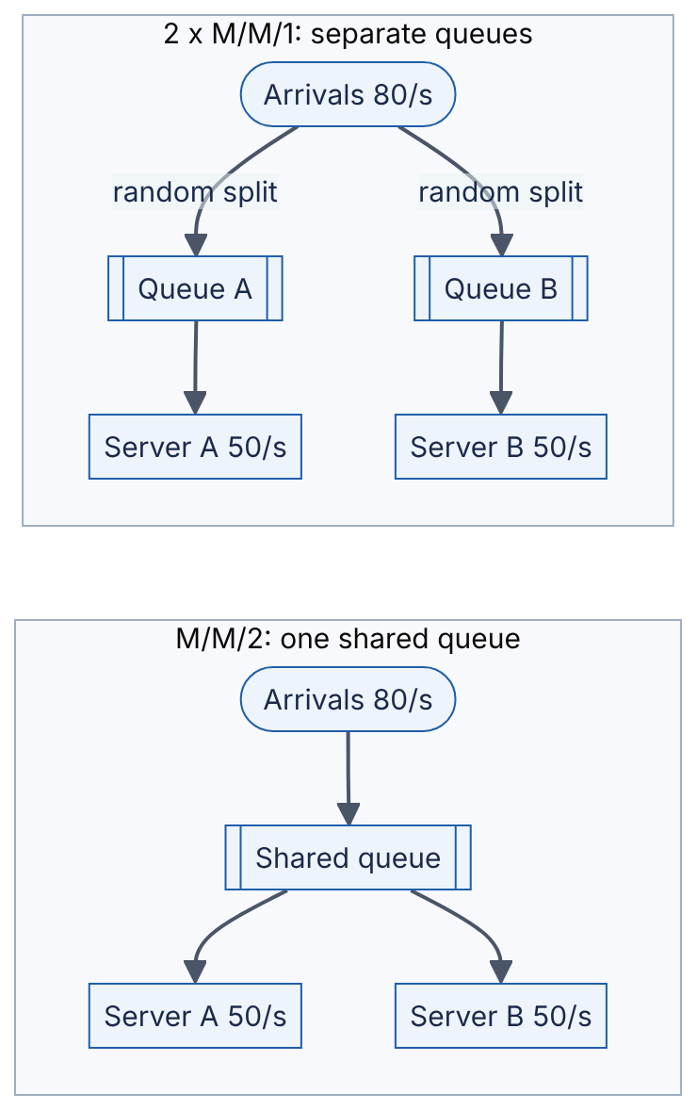
Reading the diagram. Both subgraphs have the same hardware (two servers at 50 jobs/s) and the same demand (80 jobs/s, $ρ=0.8$). On the left, any idle server takes the next job from a shared queue. On the right, each job is assigned to a server’s private queue at arrival, so one queue can hold waiting jobs while the other server sits idle. All paths are synchronous hand-offs. The failure point on the right is imbalance; the scaling lesson is that pooling beats partitioning for latency.
WORKED EXAMPLE
Worked example — Pooling. $λ=80$/s; compare three designs with 100 jobs/s of total capacity.
- One fast server (M/M/1, $μ=100$): $W=1/\left(100−80\right)=50$ ms.
- Two slow servers, separate queues (each M/M/1 with $λ=40$, $μ=50$): $W=1/\left(50−40\right)=100$ ms.
- Two slow servers, shared queue (M/M/2, $μ=50$): $a=80/50=1.6$, $ρ=0.8$. Numerator: $a^{2}/\left(2! \left(1−0.8\right)\right)=2.56/0.4=6.4$. Denominator: $1+1.6+6.4=9$. $P_{\text{wait}}=6.4/9=0.711$. $W=0.711/\left(100−80\right)+1/50=0.0356+0.020=55.6$ ms.
Interpretation. The shared queue (55.6 ms) is nearly as good as one server twice as fast (50 ms) and almost twice as good as separate queues (100 ms) on identical hardware. Engineering implication. Prefer a shared work queue (one listen socket feeding a pool of workers, one broker topic with competing consumers) over static assignment. Load-balancing algorithms such as least-connections and power-of-two-choices (§19.4) approximate a shared queue across machines.
import math
def erlang_c(c, lam, mu):
"""Probability that an arriving request must wait (M/M/c, Erlang C)."""
a = lam / mu # offered load in "servers' worth" of work
rho = a / c # per-server utilization
if rho >= 1:
return 1.0
top = a**c / (math.factorial(c) * (1 - rho))
bottom = sum(a**k / math.factorial(k) for k in range(c)) + top
return top / bottom
def mmc_response_time(c, lam, mu):
"""Mean time in system W for an M/M/c queue (seconds)."""
wait = erlang_c(c, lam, mu) / (c * mu - lam)
return wait + 1 / mu
lam = 80.0
print(f"One fast server (M/M/1, mu=100): W = {mmc_response_time(1, lam, 100)*1000:.1f} ms")
print(f"Two slow servers, shared queue (M/M/2, mu=50 each): "
f"W = {mmc_response_time(2, lam, 50)*1000:.1f} ms")
print(f"Two slow servers, separate queues (2 x M/M/1, mu=50, lam=40 each): "
f"W = {mmc_response_time(1, lam/2, 50)*1000:.1f} ms")
Output:
One fast server (M/M/1, mu=100): W = 50.0 ms
Two slow servers, shared queue (M/M/2, mu=50 each): W = 55.6 ms
Two slow servers, separate queues (2 x M/M/1, mu=50, lam=40 each): W = 100.0 ms
What to notice: with $c=1$ the Erlang C function reduces to $P_{\text{wait}}=ρ$ and $W=1/\left(μ−λ\right)$, so the same code covers M/M/1. The rho >= 1 guard reflects that no steady state exists at or above saturation.
COMMON MISTAKE
Mistake — “We are at 85% CPU, so we have 15% headroom.” Headroom in throughput is 15%, but latency at 85% is already $1/\left(1−0.85\right)=6.7$ times the service time in an M/M/1 model, and every further point of load costs more latency than the last. Express headroom as the latency you will have at the forecast peak, not as spare percentage.

4.11 Little’s Law

4.11.1 Statement and intuition
DEFINITION
Definition — Little’s Law. For any stable system observed over a long period, the average number of items in the system equals the average arrival rate multiplied by the average time each item spends in the system: $L=λW$ [Little 1961].

First-principles explanation
A café serves 20 customers per hour, and each customer stays for 30 minutes on average. How many customers are inside at a typical moment? Every hour 20 people come in, each contributing half an hour of “presence”, so the café accumulates $20×0.5=10$ customer-hours of presence per hour: on average 10 people are inside. That is all Little’s Law says. Remarkably, it does not depend on the arrival pattern, the service-time distribution, the number of servers or the scheduling order. It needs only that the system is stable (what goes in eventually comes out) and that the three quantities are long-run averages measured over the same boundary.
FORMULA
Little’s Law
$$L=λ×W$$
Symbol | Meaning | Units
$L$ | Average number of items in the system (concurrency, occupancy, in-flight requests) | items
$λ$ | Average arrival rate (equals throughput in a stable system) | items/second
$W$ | Average time an item spends inside the system boundary | seconds
Derivation intuition. Plot the number of items inside the system, $N\left(t\right)$, over a long interval of length $T$. The area under that curve can be computed two ways. Summed vertically, it is (average height) × (width) $=L×T$. Summed horizontally, each item contributes a horizontal strip as long as its stay, so the area is (number of items) × (average stay) $=λT×W$. Equating the two gives $LT=λTW$, i.e. $L=λW$. Little’s 1961 paper made this argument rigorous.
Because the law holds for any boundary, you can draw the boundary around a thread pool, a connection pool, a broker topic, a whole datacenter or a single CPU, and solve for whichever of the three quantities you do not know.
Figure 4.5 — Choosing the boundary for Little’s Law.
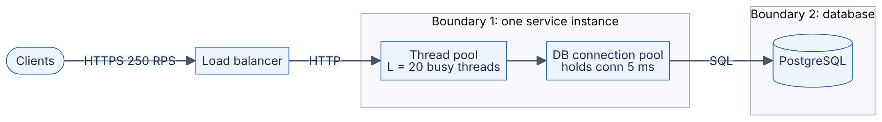
Reading the diagram. Clients send HTTPS requests to a load balancer, which forwards plain HTTP to a service instance. Inside the instance (boundary 1) each request occupies a worker thread for its whole duration, and briefly borrows a database connection to issue SQL to PostgreSQL (boundary 2, the storage boundary). All calls are synchronous. Little’s Law applies separately to each boundary: threads in use = request rate × request duration; connections in use = query rate × connection hold time. The failure point is any pool whose occupancy $L$ approaches its size, because requests then queue for a thread or connection. Scaling options are more instances (spreading $λ$), shorter hold times (reducing $W$) or larger pools (raising the limit on $L$).

4.11.2 Capacity planning examples
WORKED EXAMPLE
Worked example 1 — Sizing a thread pool. A service receives 2,000 RPS at peak, spread across 8 instances. Each request holds a worker thread for 80 ms on average (mostly waiting on downstream calls).
- Per-instance arrival rate: $λ=2,000/8=250$ RPS.
- Average busy threads: $L=λW=250×0.080=20$ threads.
- A pool of exactly 20 would run at 100% utilization and queue without bound (§4.10). Treat the pool as an M/M/c system with $c$ threads, $μ=1/0.08=12.5$/s per thread and $a=20$.
- Using the Erlang C code of §4.10.4: with $c=25$ ($ρ=0.80$), 20.9% of requests wait for a thread and mean latency is 83.4 ms; with $c=30$ ($ρ=0.67$), 2.5% wait and latency is 80.2 ms; with $c=35$, 0.16% wait.
Interpretation. Little’s Law gives the average concurrency (20); queueing theory tells you how much headroom above it buys acceptable waiting. Engineering implication. Size the pool around 30 threads per instance, and re-derive it whenever $W$ changes: if a downstream dependency slows from 80 ms to 400 ms, required concurrency jumps to $250×0.4=100$ threads, and a 30-thread pool saturates. That is why per-dependency timeouts and bulkheads (§22.11, §22.14) are capacity mechanisms, not just error handling.
WORKED EXAMPLE
Worked example 2 — Sizing a database connection pool. 30 application instances together issue 1,200 queries per second. Each query holds a connection for 5 ms (network round trip plus execution).
- Connections in use, fleet-wide: $L=1,200×0.005=6$ connections on average.
- Per instance: $λ=1,200/30=40$ queries/s, so $L=40×0.005=0.2$ connections.
- A common default of 10 connections per instance opens $30×10=300$ connections to serve an average demand of 6.
- Incident case: a missing index makes queries take 500 ms. Now $L=1,200×0.5=600$ connections are needed — more than the 300 that exist, so requests queue for connections, threads block, and the outage spreads upstream.
Interpretation. The pool is 50× oversized in normal operation and still too small during the incident. Engineering implication. Oversized pools are not free: in PostgreSQL each connection is a separate server process with its own memory, so hundreds of mostly idle connections waste database resources and let a slow-query incident push far more concurrent work onto an already struggling database. A small pool (here perhaps 2–3 per instance) or a central pooler such as PgBouncer (§14.13), combined with query timeouts, caps concurrency at the database where it matters.
WORKED EXAMPLE
Worked example 3 — Inferring latency from a backlog. A message broker topic holds a backlog of 5,000 messages, and consumers process 1,000 messages per second while producers add messages at the same rate.
- Rearranging Little’s Law: $W=L/λ=5,000/1,000=5$ s.
Interpretation. Each message spends about 5 s waiting in the topic before processing. Engineering implication. Consumer lag measured in messages (the metric most brokers expose) converts to lag in seconds — the metric users care about — by dividing by throughput. Alert on the latter.
COMMON MISTAKE
Mistake — Mixing boundaries. Little’s Law requires that $L$, $λ$ and $W$ are measured on the same boundary. Using end-to-end request latency (which includes time spent in the database) with the occupancy of the application thread pool is correct only if threads are held for the entire request. If an asynchronous framework releases the thread while waiting for I/O, the thread-holding time $W$ is much smaller than request latency.

4.12 Amdahl’s Law and Gustafson’s Law

4.12.1 Amdahl’s Law
DEFINITION
Definition — Speedup. The ratio of the time a job takes on one processor (or node) to the time it takes on $N$: $S\left(N\right)=T\left(1\right)/T\left(N\right)$. Perfect, linear speedup is $S\left(N\right)=N$.

First-principles explanation
Eight friends cook a dinner. Chopping vegetables parallelizes beautifully: eight people chop eight times faster. But the oven takes 40 minutes no matter how many cooks there are. However many friends you add, dinner cannot take less than 40 minutes. Gene Amdahl made this argument in 1967 about parallel computers [Amdahl 1967]: the part of a job that cannot be parallelized sets a hard ceiling on speedup.
FORMULA
Amdahl’s Law (fixed problem size)
$$S\left(N\right)=\frac{1}{\left(1−p\right)+\frac{p}{N}} \lim_{N→∞}S\left(N\right)=\frac{1}{1−p}$$
Symbol | Meaning | Units
$p$ | Fraction of the single-processor run time that can be parallelized | dimensionless (0–1)
$1−p$ | Serial fraction | dimensionless
$N$ | Number of processors, cores or nodes | count
$S\left(N\right)$ | Speedup relative to one processor | dimensionless (×)
Derivation. Normalize the one-processor time to 1. The serial part still takes $1−p$; the parallel part takes $p/N$ on $N$ processors. Speedup is the old time (1) divided by the new time.
WORKED EXAMPLE
Worked example — A 95% parallel job. A batch job spends 5% of its time in a single-threaded setup phase and 95% in work that splits perfectly across cores.
- On 8 cores: $S=1/\left(0.05+0.95/8\right)=1/\left(0.05+0.11875\right)=1/0.16875=5.93$.
- On 64 cores: $S=1/\left(0.05+0.01484\right)=1/0.06484=15.4$.
- Ceiling: $1/0.05=20$, however many cores.
- Efficiency on 64 cores: $15.4/64=24\%$.
Interpretation. Moving from 8 to 64 cores (8× the hardware) improves speed only 2.6×. Engineering implication. Before buying more parallelism, measure and shrink the serial fraction: a single-threaded coordinator, a global lock, a sequential merge step. Cutting the serial fraction from 5% to 1% raises the ceiling from 20 to 100.

4.12.2 Gustafson’s Law
Amdahl assumes a fixed problem. In practice, when engineers get more machines they usually tackle bigger problems — more data, higher resolution, larger models — in the same wall-clock time. John Gustafson observed in 1988 that under this assumption the serial part stays roughly constant while the parallel part grows with $N$ [Gustafson 1988].
FORMULA
Gustafson’s Law (scaled problem size)
$$S_{\text{scaled}}\left(N\right)=\left(1−p\right)+p N=N−\left(1−p\right)\left(N−1\right)$$
Symbol | Meaning | Units
$p$ | Fraction of the parallel run’s time spent in parallel work | dimensionless
$1−p$ | Fraction of the parallel run’s time that is serial | dimensionless
$N$ | Number of processors | count
$S_{\text{scaled}}$ | How much more work is completed in the same time than one processor could do | dimensionless (×)
WORKED EXAMPLE
Worked example — The same 5% serial fraction, scaled. On 64 processors a job spends 5% of its wall-clock time in serial work.
- $S_{\text{scaled}}=0.05+0.95×64=0.05+60.8=60.85$.
Interpretation. 64 processors complete about 61 times as much work as one would in the same time, versus Amdahl’s 15.4 for a fixed problem. The laws do not contradict each other; they answer different questions (“how much faster?” vs “how much bigger?”). Engineering implication. Horizontal scaling of data-parallel systems (MapReduce, Spark, distributed training) mostly lives in Gustafson’s world: more nodes handle more data. Latency-sensitive single requests live in Amdahl’s world: more nodes do not make one request much faster.

4.13 The Universal Scalability Law

4.13.1 Beyond Amdahl: coordination costs
Amdahl’s Law predicts that adding nodes never hurts: throughput keeps rising toward a ceiling. Real systems often get slower past some size. Neil Gunther’s Universal Scalability Law (USL) explains why by adding a second penalty: coherency (or crosstalk), the cost of nodes keeping each other consistent [Gunther 2007].

First-principles explanation
Return to the kitchen. Contention is the queue for the single oven (Amdahl’s serial part). Coherency is the time cooks spend talking to each other — “did you already salt this?”. If every cook must check with every other cook, the number of conversations grows like $N\left(N−1\right)$, roughly $N^{2}$. With few cooks this is negligible; with many it dominates, and adding a cook makes dinner later.
FORMULA
Universal Scalability Law
$$C\left(N\right)=\frac{N}{1+α\left(N−1\right)+βN\left(N−1\right)} N^{*}=\sqrt{\frac{1−α}{β}}$$
Symbol | Meaning | Units
$N$ | Number of nodes, cores, threads or concurrent users | count
$C\left(N\right)$ | Relative capacity: throughput at $N$ divided by throughput at 1 | dimensionless (×)
$α$ | Contention coefficient: serialization on shared resources (queues, locks) | dimensionless (0–1)
$β$ | Coherency coefficient: pairwise coordination cost (cache coherence, consensus, data exchange) | dimensionless (≥ 0)
$N^{*}$ | Concurrency at which throughput peaks | count
Gunther’s later work writes the coefficients as $σ$ (contention) and $κ$ (coherency); the formula is the same. With $β=0$ the USL reduces exactly to Amdahl’s Law with serial fraction $α$. $N^{*}$ comes from setting the derivative of $C\left(N\right)$ to zero.
WORKED EXAMPLE
Worked example — Where adding nodes stops helping. A clustered service is measured and fitted with $α=0.05$ and $β=0.001$.
- $C\left(8\right)=8/\left(1+0.05×7+0.001×8×7\right)=8/\left(1+0.35+0.056\right)=8/1.406=5.69$.
- $C\left(32\right)=32/\left(1+1.55+0.992\right)=32/3.542=9.03$.
- $C\left(64\right)=64/\left(1+3.15+4.032\right)=64/8.182=7.82$.
- Peak: $N^{*}=\sqrt{\left(1−0.05\right)/0.001}=\sqrt{950}=30.8$ nodes.
Interpretation. Throughput peaks around 31 nodes at about 9× a single node; doubling to 64 nodes loses 13% of throughput. Amdahl with the same $α$ predicts 15.4× at 64 nodes. Engineering implication. If load tests show throughput flattening and then falling as you add nodes or threads, look for coherency costs: all-to-all communication, cache-line ping-pong, distributed locks, broadcast invalidation. The cure is architectural (partitioning so that nodes rarely coordinate), not more hardware.
import math
def amdahl(p, n):
"""Speedup with n processors when fraction p of the work is parallel."""
return 1 / ((1 - p) + p / n)
def gustafson(p, n):
"""Scaled speedup when the parallel part grows with n."""
return (1 - p) + p * n
def usl(n, alpha, beta):
"""Relative capacity C(n) under the Universal Scalability Law."""
return n / (1 + alpha * (n - 1) + beta * n * (n - 1))
p, alpha, beta = 0.95, 0.05, 0.001
print(" N Amdahl Gustafson USL")
for n in (1, 2, 4, 8, 16, 32, 64, 128):
print(f"{n:4d} {amdahl(p, n):6.2f} {gustafson(p, n):9.2f} {usl(n, alpha, beta):5.2f}")
n_star = math.sqrt((1 - alpha) / beta)
print(f"USL peak at N* = {n_star:.1f}; Amdahl ceiling = {1/(1-p):.0f}")
Table 4.6 — Output: three scaling models with a 5% serial fraction.
N | Amdahl | Gustafson | USL ($α$=0.05, $β$=0.001)
1 | 1.00 | 1.00 | 1.00
2 | 1.90 | 1.95 | 1.90
4 | 3.48 | 3.85 | 3.44
8 | 5.93 | 7.65 | 5.69
16 | 9.14 | 15.25 | 8.04
32 | 12.55 | 30.45 | 9.03
64 | 15.42 | 60.85 | 7.82
128 | 17.41 | 121.65 | 5.42
The program also prints USL peak at N* = 30.8; Amdahl ceiling = 20. What to notice: the three columns agree for small $N$, which is why a few measurements at low concurrency cannot distinguish the models. Measure out to the concurrency you intend to run. In practice the USL coefficients are fitted by regression to throughput measured at several values of $N$ [Gunther 2007]; Chapter 23 (§23.10) shows the workflow.
COMMON MISTAKE
Mistake — Extrapolating linear scaling from a small test. “Two nodes gave 1.9×, so 100 nodes will give 95×.” Every model in Table 4.6 is nearly linear at $N=2$. Contention and coherency only show up at scale, so linear extrapolation is the most common way capacity plans fail.

4.14 Availability arithmetic

4.14.1 Nines and downtime budgets
DEFINITION
Definition — Availability. The fraction of time (or of requests) for which a system serves correctly: $A=\text{uptime}/\left(\text{uptime}+\text{downtime}\right)$, or, request-based, $A=\text{successful requests}/\text{valid requests}$. It is commonly quoted in “nines”: 99.9% is “three nines”.
Table 4.7 — Nines and the downtime they allow (365-day year, 30-day month, 7-day week).
Availability | Nines | Downtime per year | Downtime per month | Downtime per week
90% | 1 | 36.5 days | 72 h | 16.8 h
99% | 2 | 3.65 days (87.6 h) | 7.2 h | 1.68 h
99.9% | 3 | 8.76 h | 43.2 min | 10.1 min
99.95% | 3.5 | 4.38 h | 21.6 min | 5.04 min
99.99% | 4 | 52.6 min | 4.32 min | 60.5 s
99.999% | 5 | 5.26 min | 25.9 s | 6.05 s
99.9999% | 6 | 31.5 s | 2.59 s | 0.60 s
FORMULA
Downtime budget
$$D=\left(1−A\right)×T$$
Symbol | Meaning | Units
$A$ | Availability target | dimensionless
$T$ | Length of the period | minutes (or any time unit)
$D$ | Allowed downtime in the period (the error budget, in time) | same unit as $T$
WORKED EXAMPLE
Worked example — What four nines allows. Target $A=99.99\%$ over a 30-day month.
- $T=30×24×60=43,200$ min.
- $D=0.0001×43,200=4.32$ min.
Interpretation. Four minutes and 19 seconds per month, total. Engineering implication. A human cannot be paged, wake up, log in and diagnose in four minutes. Four nines therefore implies automated detection and failover; five nines (26 s/month) implies the failover itself must be nearly invisible. Each additional nine changes the architecture, not just the effort.
INDUSTRY EXAMPLE
Google SRE — error budgets. Google’s SRE practice turns an availability SLO into an error budget equal to $1−\text{SLO}$: a 99.9% SLO allows 0.1% of requests (or time) to fail. While budget remains, teams may ship risky changes; when it is exhausted, releases slow until reliability recovers. The SRE book also argues that 100% is the wrong target, because users cannot distinguish the last nines from failures in their own devices and networks, while each extra nine costs disproportionately more. Error budgets are covered in §39.7. Evidence: Primary — [Beyer et al. 2016]

4.14.2 Series and parallel composition
Figure 4.6 — Series, parallel and k-of-n availability.
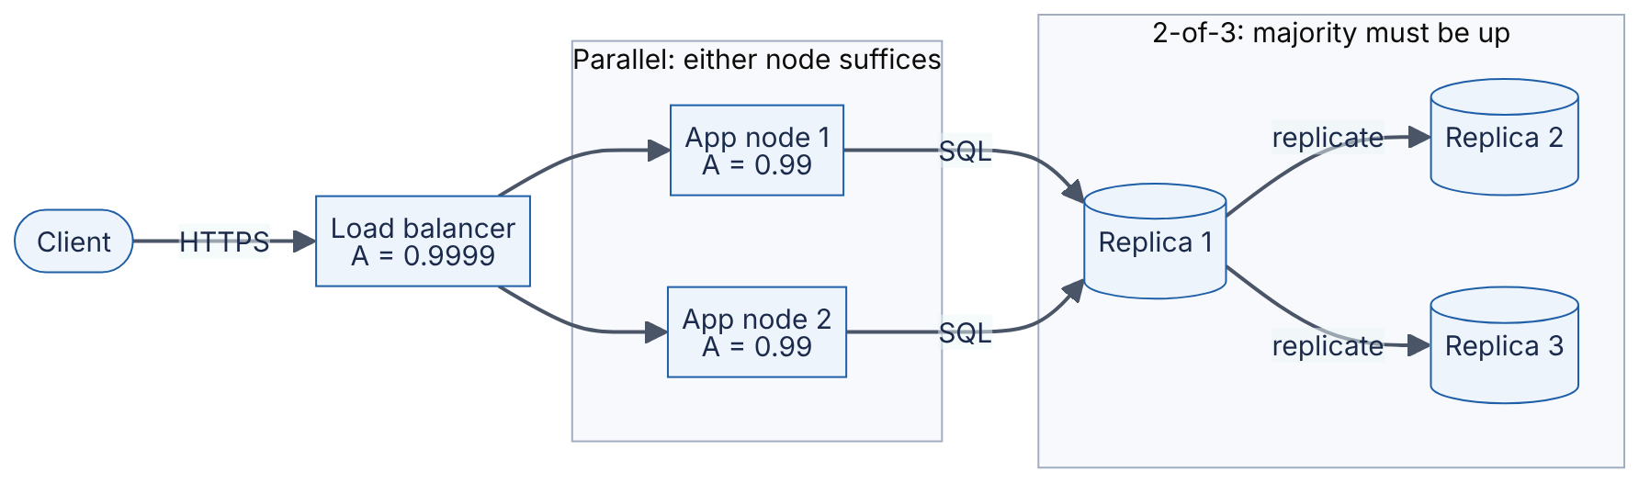
Reading the diagram. A request flows synchronously left to right: HTTPS from the client to a single load balancer, then to either application node, then over SQL to the current leader replica (Replica 1), which replicates each write to the other two and needs a majority (2 of 3) of replicas up to serve, as consensus-based stores do (§26.4); if the leader fails, a surviving replica is elected in its place. The three stages are in series: the request fails if any stage fails. Within the middle stage the two nodes are in parallel: the stage fails only if both fail. The cylinders are the storage boundary. The single load balancer is the obvious single point of failure; the scaling and availability option is to make it redundant too (§19.8).
FORMULA
Series, parallel and k-of-n availability (independent failures)
$$A_{\text{series}}=\prod_{i=1}^{n}{A_{i}} A_{\text{parallel}}=1−\prod_{i=1}^{n}{\left(1−A_{i}\right)} A_{k\text{-of-}n}=\sum_{j=k}^{n}{\left({n \atop j}\right)}A^{j}{\left(1−A\right)}^{n−j}$$
Symbol | Meaning | Units
$A_{i}$ | Availability of component $i$ | dimensionless
$∏$ | Product over all components | —
$n$ | Number of components | count
$k$ | Minimum number of identical components that must be up | count
$A$ | Availability of each identical component (k-of-n case) | dimensionless
Derivation. Series: the system is up only if every component is up; with independence, multiply. Parallel: the system is down only if every component is down; the probability all are down is $∏\left(1−A_{i}\right)$, and availability is its complement. k-of-n: the number of up components is binomial (§4.6.4); add the probabilities of $k,k+1,…,n$ components up.
WORKED EXAMPLE
Worked example — Composing the system of Figure 4.6.
- Series of three single components first, for intuition: LB 99.99%, one app node 99.95%, one database 99.9%: $0.9999×0.9995×0.999=0.99840$, i.e. 99.84%, about 14.0 h of downtime per year — worse than the weakest component.
- Parallel app tier: two nodes at 99%: $1−{\left(0.01\right)}^{2}=1−0.0001=0.9999$.
- 2-of-3 database: $A=0.99$: $\left({3 \atop 2}\right){\left(0.99\right)}^{2}\left(0.01\right)+{\left(0.99\right)}^{3}=3×0.9801×0.01+0.970299=0.029403+0.970299=0.999702$.
- Whole system in series: $0.9999×0.9999×0.999702=0.999502$, about 4.4 h of downtime per year.
Interpretation. Series composition always lowers availability; redundancy raises it dramatically — two 99% nodes give 99.99%. Engineering implication. A request path through 10 services, each 99.9% available, is at most ${0.999}^{10}=99.0\%$ available. Long synchronous call chains are an availability liability, which is one argument for asynchronous decoupling (Part VI) and for keeping critical paths short.
from math import comb, prod
def series(*avail):
"""All components must be up (assumes independent failures)."""
return prod(avail)
def parallel(*avail):
"""At least one component must be up (independent failures)."""
return 1 - prod(1 - a for a in avail)
def k_of_n(k, n, a):
"""At least k of n identical, independent components must be up."""
return sum(comb(n, i) * a**i * (1 - a)**(n - i) for i in range(k, n + 1))
def downtime_per_year(a, hours_per_year=365 * 24):
return (1 - a) * hours_per_year
web_tier = parallel(0.99, 0.99) # two app nodes behind a load balancer
db_quorum = k_of_n(2, 3, 0.99) # 2-of-3 replicated database
system = series(0.9999, web_tier, db_quorum) # LB -> web tier -> DB
for name, a in [("web tier", web_tier), ("db 2-of-3", db_quorum), ("system", system)]:
print(f"{name:10s} A = {a:.6f} downtime = {downtime_per_year(a):6.2f} h/year")
Output:
web tier A = 0.999900 downtime = 0.88 h/year
db 2-of-3 A = 0.999702 downtime = 2.61 h/year
system A = 0.999502 downtime = 4.36 h/year
What to notice: series, parallel and k_of_n compose — the result of one can be fed into another to model any tree of components. Every function assumes independent failures, so the outputs are upper bounds on what a real system with shared dependencies achieves.
WARNING / TRADE-OFF
Warning — Redundancy arithmetic is only as good as its independence assumption. Two app nodes deployed by the same bad configuration push fail together; three replicas on one power feed fail together. Also, parallel redundancy requires failover to work: if detecting a failure and rerouting takes 30 s, each failure still costs 30 s of errors. Model failover time explicitly, and place replicas in separate failure domains (racks, zones, regions; §39.4).

4.15 Reliability: MTBF, MTTR and failure rates

4.15.1 Definitions
DEFINITION
Definition — Reliability, MTBF, MTTR and failure rate. Reliability $R\left(t\right)$ is the probability that a component operates without failure for a period of length $t$. The mean time between failures (MTBF) is the average operating time from the end of one repair to the next failure (for non-repairable parts the same quantity is called MTTF, mean time to failure). The mean time to repair (MTTR) is the average time from failure to restored service, including detection, diagnosis and repair. The failure rate $λ$ is the average number of failures per unit of operating time.

First-principles explanation
Availability asks “what fraction of the time is it working?”. Reliability asks “how likely is it to keep working for the next hour (or day, or job)?”. A car that breaks down every week but is fixed in five minutes by the roadside is highly available and poorly reliable; a car that never breaks down for a year but then spends a month in the garage is the opposite. Both properties matter, for different users (§4.18.2).
FORMULA
Reliability and availability from MTBF and MTTR
$$λ=\frac{1}{\text{MTBF}} R\left(t\right)=e^{−λt} A=\frac{\text{MTBF}}{\text{MTBF}+\text{MTTR}} \text{AFR}=1−e^{−8760/\text{MTTF}}$$
Symbol | Meaning | Units
MTBF | Mean operating time between failures | hours
MTTR | Mean time to repair (detect + diagnose + fix + restore) | hours
MTTF | Mean time to failure of a non-repairable part | hours
$λ$ | Constant failure rate | failures/hour
$t$ | Mission time: the period we need it to survive | hours
$R\left(t\right)$ | Probability of no failure during $t$ | dimensionless
$A$ | Steady-state availability | dimensionless
AFR | Annualized failure rate: probability a part fails within a year (8,760 h) | dimensionless (often %)
Derivation. $R\left(t\right)=e^{−λt}$ follows from assuming a constant failure rate: failures are random events with no memory of age, so the time to failure is exponentially distributed (§4.7.2) with mean $1/λ=\text{MTBF}$. Availability is the long-run fraction of each up–down cycle spent up: MTBF out of MTBF + MTTR. The constant-rate assumption is a simplification: real hardware follows a “bathtub curve” with higher failure rates in early life (infant mortality) and at wear-out, and is roughly constant in between.
Figure 4.7 — The up–down cycle of a repairable component.
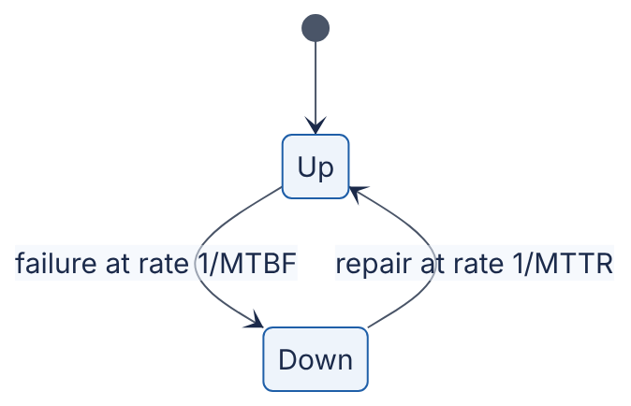
Reading the diagram. The component alternates between two states. It stays Up for an exponentially distributed time with mean MTBF, then moves to Down, where it stays for a repair time with mean MTTR. There is no data flow or protocol; the arrows are state transitions. Availability is the fraction of time spent in Up. The two levers are visible: make failures rarer (longer MTBF) or make repair faster (shorter MTTR). In distributed systems the second is usually cheaper — automatic failover turns an MTTR of hours into seconds.
WORKED EXAMPLE
Worked example — Two ways to get a nine. A server has MTBF = 1,000 h and MTTR = 1 h.
- $A=1000/\left(1000+1\right)=0.99900$ (three nines).
- Option 1, double MTBF to 2,000 h (better hardware): $A=2000/2001=0.99950$.
- Option 2, cut MTTR to 6 min = 0.1 h (automated failover): $A=1000/1000.1=0.99990$ (four nines).
- Reliability over a 100-hour batch job: $R\left(100\right)=e^{−100/1000}=e^{−0.1}=0.905$. Over one MTBF: $R\left(1000\right)=e^{−1}=0.368$.
Interpretation. A 10× reduction in MTTR buys a full nine; a 2× increase in MTBF buys half of one. Note that only 37% of components survive to their MTBF: “mean time” is not “typical time”. Engineering implication. Invest in detection and automated recovery (health checks, failover, restarts) before investing in more expensive hardware. For long jobs, reliability matters more than availability: a 100-hour job on this server fails about 10% of the time, so it needs checkpointing.
WORKED EXAMPLE
Worked example — Disk failures in a fleet. A disk datasheet quotes MTTF = 1,000,000 h. The fleet has 10,000 disks.
- $\text{AFR}=1−e^{−8760/1,000,000}=1−e^{−0.00876}=0.0087=0.87\%$.
- Expected failures per year: $10,000×0.0087=87$, about 1.7 per week.
Interpretation. A “million-hour” disk still fails nearly twice a week in a 10,000-disk fleet. Engineering implication. Field studies have found real-world replacement rates substantially above datasheet AFRs — Schroeder and Gibson report annual replacement rates typically exceeding 1% and commonly 2–4% across the large populations they studied [Schroeder and Gibson 2007]. Plan with measured fleet data, and use a pessimistic AFR (for example 2–4%) when you have none.

4.16 Durability and replication

4.16.1 Durability as a probability
DEFINITION
Definition — Durability. The probability that data, once acknowledged as written, is not lost over a given period (usually a year). It is quoted in nines like availability: “eleven nines of durability” means an annual loss probability of ${10}^{−11}$ per object.
Durability and availability are different: a storage system can be unavailable for an hour (you cannot read your data) without losing anything, and it can be available while silently having lost an object. Data is lost when every copy is destroyed before the system notices and repairs the first loss. Durability is therefore a race between failure and repair.
Figure 4.8 — The replica-loss race for three-way replication.
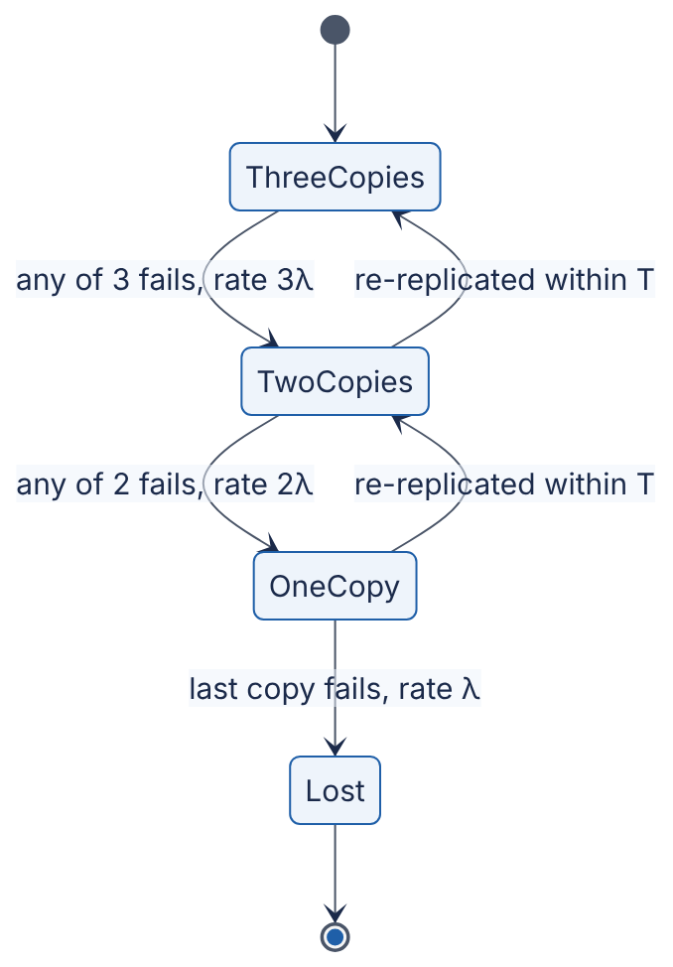
Reading the diagram. States count the surviving copies of one piece of data. Each copy fails independently at rate $λ$, so the rate of leaving a state is (copies) × $λ$. A failed copy is re-created from a survivor in an average repair time $T$, which is dominated by detection time and by copy bandwidth (§4.5.1). Lost is absorbing: there is no way back. Data is lost only if two more failures occur while the group is still degraded. The failure point is a long repair window; the scaling lever is parallel re-replication, which shrinks $T$.
FORMULA
Approximate annual probability of losing an $n$-way replicated item
$$P_{\text{loss/yr}}≈n! λ^{n} T^{ n−1}×H \text{valid when }λT≪1$$
Symbol | Meaning | Units
$n$ | Number of replicas | count
$λ$ | Per-replica failure rate (AFR / 8,760 for small AFR) | failures/hour
$T$ | Mean time to detect and re-replicate a lost copy | hours
$H$ | Hours per year (8,760) | hours/year
$P_{\text{loss/yr}}$ | Annual probability that all $n$ replicas are lost | dimensionless
Derivation (three replicas). First failures in the group occur at rate $3λ$. Given a first failure, one of the two survivors fails before repair with probability about $2λT$, and then the last survivor fails before its repair completes with probability about $λT$. Multiply: loss rate $≈3λ×2λT×λT=6λ^{3}T^{2}$ per hour, and multiply by 8,760 for a year. The same chain for $n$ replicas gives $n! λ^{n}T^{n−1}$. This is the standard approximation from a Markov model with one repair at a time and independent failures.
WORKED EXAMPLE
Worked example — How many replicas, and how fast must repair be? Disks have AFR = 2%, so $λ=0.02/8760=2.28×{10}^{−6}$ per hour. Repair takes $T=24$ h, so $λT=5.48×{10}^{−5}$.
- One replica: $P≈\text{AFR}=2×{10}^{−2}$.
- Two replicas: $2λ^{2}T×8760=2×0.02×λT=0.04×5.48×{10}^{−5}=2.2×{10}^{−6}$.
- Three replicas: $6λ^{3}T^{2}×8760=3×0.02×2{\left(λT\right)}^{2}=0.06×2×3.00×{10}^{−9}=3.6×{10}^{−10}$.
- Fleet view: with ${10}^{6}$ independent three-replica groups, expected losses are ${10}^{6}×3.6×{10}^{−10}=3.6×{10}^{−4}$ groups per year.
- Slower repair, $T=168$ h (one week): $λT=3.84×{10}^{−4}$; three-replica loss $=0.06×2×{\left(3.84×{10}^{−4}\right)}^{2}=1.8×{10}^{−8}$, which is $7^{2}=49$ times worse.
Interpretation. Each extra replica multiplies durability by roughly $1/\left(λT\right)$, here about four orders of magnitude, and for three replicas loss probability grows with the square of the repair time. Engineering implication. Fast, parallel re-replication is as important as the replica count. These numbers are, however, optimistic upper bounds on durability: they assume independence. In practice correlated failures — a rack losing power, a bad firmware batch, a datacenter-wide event, a software bug that deletes all copies — dominate data loss, which is why durable stores spread replicas across failure domains, keep backups outside the replication system, and checksum data to catch silent corruption (§13.12, §39.9).
Table 4.8 — Annual loss probability per item (AFR 2%, independent failures).
Replicas | $T$ = 1 h | $T$ = 24 h | $T$ = 168 h
1 | $2×{10}^{−2}$ | $2×{10}^{−2}$ | $2×{10}^{−2}$
2 | $9.1×{10}^{−8}$ | $2.2×{10}^{−6}$ | $1.5×{10}^{−5}$
3 | $6.3×{10}^{−13}$ | $3.6×{10}^{−10}$ | $1.8×{10}^{−8}$
INDUSTRY EXAMPLE
Correlated failures in real storage fleets. Ford et al. analyzed a year of availability data from Google’s distributed storage and found that failures are often correlated — many nodes failing together in bursts, for example after power or network events — and that models assuming independence can overestimate durability by orders of magnitude; their models incorporate correlated failures and placement across failure domains [Ford et al. 2010]. Cidon et al. showed that with random replica placement across a large cluster, almost any simultaneous failure of three nodes destroys some chunk, and proposed limiting the number of distinct replica sets (“copysets”) to reduce the frequency of loss events [Cidon et al. 2013]. Amazon S3 documentation states that S3 is designed for 99.999999999% (eleven nines) annual durability of objects, achieved by storing data redundantly across multiple devices and facilities [AWS S3 documentation]. Replication and erasure coding are compared in §15.6. Evidence: Primary — [Ford et al. 2010; Cidon et al. 2013; AWS S3 documentation]

4.17 Latency numbers every engineer should know

4.17.1 The table and its history
A table of hardware and network latencies popularized by Jeff Dean around 2009–2010, building on a similar table by Peter Norvig, is the standard estimation reference [Dean 2009; Norvig]. Its value lies in the ratios between rows, which change far more slowly than the absolute numbers. Since then SSDs have replaced disks for latency-sensitive data and datacenter networks have moved to 25–100 Gbps and beyond, while memory latency has barely moved. Treat every number as an order-of-magnitude anchor and measure your own hardware.
Table 4.9 — Latency reference numbers (approximate; era-dependent).
Operation | Classic value (as circulated c. 2010) | Approximate order of magnitude, as of 2025 | Notes
L1 cache reference | 0.5 ns | ~1 ns | A few CPU cycles
Branch mispredict | 5 ns | ~5 ns | Pipeline flush
L2 cache reference | 7 ns | ~3–5 ns
Mutex lock/unlock (uncontended) | 25 ns | ~10–25 ns | Contended locks cost far more
Main memory reference | 100 ns | ~80–120 ns | Has changed little in 15 years
Compress 1 KB with a fast compressor (Zippy/Snappy) | 3 µs | ~1–3 µs
Send 1 KB over a network link | 10 µs (1 Gbps) | ~1 µs (10 Gbps) | Serialization time only
Read 4 KB randomly from SSD | 150 µs (SATA era) | ~50–100 µs (NVMe)
Read 1 MB sequentially from memory | 250 µs | ~50–100 µs | One thread; depends on bandwidth per core
Round trip within one datacenter | 500 µs | ~50–500 µs | Kernel bypass can be much lower
Read 1 MB sequentially from SSD | 1 ms | ~0.15–0.3 ms (NVMe)
Disk (HDD) seek | 10 ms | ~4–10 ms | Mechanical; unchanged
Read 1 MB sequentially from HDD | 20 ms | ~5 ms | ~200 MB/s sequential
Packet round trip California ↔ Netherlands | 150 ms | ~140–150 ms | Bounded by the speed of light in fiber
The modern column is this book’s order-of-magnitude estimate for commodity server hardware as of 2025, not a benchmark result; ranges reflect variation across hardware generations. Colin Scott’s interactive version of the table extrapolates the values year by year [Scott].

Physics sets the floor
Light in optical fiber travels at about two-thirds of its vacuum speed, roughly 200,000 km/s, or 5 µs per km. The great-circle distance from California to the Netherlands is about 8,800 km, so the round trip cannot take less than $2×8,800/200,000=0.088$ s = 88 ms, even with perfect routing. No engineering removes that floor; only moving data closer (caching, CDNs, replicas in more regions; Chapters 21 and 44) does.
WORKED EXAMPLE
Worked example — Reading 1 GB from four places, using the classic column.
- From memory: $1,000×250$ µs $=0.25$ s.
- From SSD (sequential): $1,000×1$ ms $=1$ s.
- From HDD (sequential): $1,000×20$ ms $=20$ s.
- Over a 1 Gbps network: $8×{10}^{9}/{10}^{9}=8$ s.
- From HDD with a seek per 4 KB block (random): $250,000$ blocks $×$ 10 ms $=2,500$ s ≈ 42 min.
Interpretation. Memory, SSD, network and disk span two orders of magnitude for sequential access, and random disk access is another two orders slower than sequential. Engineering implication. Design data layouts for sequential access (log-structured storage, §13.7; columnar files, §13.13), keep hot working sets in memory (Chapter 20), and count cross-region round trips on every user-facing path: five sequential 150 ms round trips is already 750 ms.

4.18 Quantitative relationships that recur in system design
The formulas of this chapter are not independent facts. They describe six trade-offs you will meet in almost every later chapter.
Figure 4.9 — Six recurring quantitative relationships.
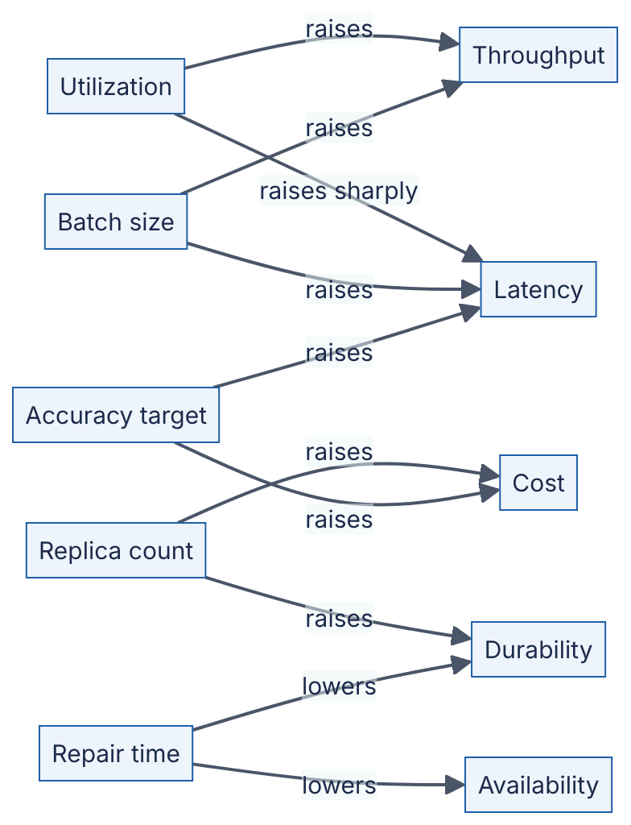
Reading the diagram. This is a conceptual map, not a data flow: there are no protocols or storage boundaries. Left-hand nodes are design levers, right-hand nodes are outcomes, and each arrow gives the direction of the effect. Most levers improve one outcome while worsening another — that is what makes them trade-offs. The subsections below quantify each arrow.

4.18.1 Latency ↔ throughput
In a closed system, where a fixed number of clients each wait for a reply before sending the next request, Little’s Law gives throughput $X=N/R$: concurrency divided by latency. In an open system, where requests arrive regardless of how fast earlier ones finish, raising throughput toward capacity raises latency by $1/\left(1−ρ\right)$ (§4.10).
WORKED EXAMPLE
Worked example — One connection versus many. A client sends requests one at a time over one connection. Each request spends 1.9 ms on the network round trip and 0.1 ms of server processing, so the server can complete at most 10,000 requests/s, and an unloaded request takes $R=2$ ms.
- One connection: $X=N/R=1/0.002=500$ requests/s, no matter how powerful the server is. The server is 5% utilized.
- Sixteen concurrent connections: ignoring queueing, $X=16/0.002=8,000$ requests/s. But the server would then be 80% utilized, and by the M/M/1 approximation its 0.1 ms becomes $0.1/\left(1−0.8\right)=0.5$ ms. Solving $X=16/R$ and $R=1.9+0.1/\left(1−X/10,000\right)$ ms together gives $X≈7,100$ requests/s and $R≈2.25$ ms.
- Sixty-four connections: the naive $64/0.002=32,000$ requests/s exceeds capacity, so $X$ approaches 10,000 requests/s and Little’s Law forces $R=N/X=64/10,000=6.4$ ms. The extra 4.4 ms is pure queueing.
Interpretation. Throughput is limited by concurrency × (1 / latency) and by capacity; latency rises as throughput approaches capacity. Engineering implication. If throughput is low while servers are idle, the bottleneck is client concurrency or round trips (fix with pooling, pipelining, batching); if latency is high while servers are busy, the bottleneck is capacity.

4.18.2 Availability ↔ reliability
WORKED EXAMPLE
Worked example — More available, less reliable. System X fails once a day (MTBF = 24 h) but recovers in 1 s. System Y fails once a year (MTBF = 8,760 h) but takes a day to recover.
- $A_{X}=86,400/86,401=0.999988$ (almost five nines).
- $A_{Y}=8,760/8,784=0.99727$ (under three nines).
- Probability of completing a 6-hour job without interruption: $R_{X}\left(6\right)=e^{−6/24}=0.78$; $R_{Y}\left(6\right)=e^{−6/8760}=0.9993$.
Interpretation. X is far more available; Y is far more reliable. Engineering implication. Interactive services with retries care about availability; long-running jobs, transactions and stateful sessions care about reliability. Choose the metric that matches what the user experiences, and design accordingly (checkpointing for jobs, fast failover for services).

4.18.3 Replication ↔ durability (and cost and write latency)
From §4.16, each extra replica improves durability by about $1/\left(λT\right)$ but costs a full copy of storage and, for synchronous replication, adds the slowest acknowledgment to every write.
WORKED EXAMPLE
Worked example — Paying for nines. With AFR 2% and $T=24$ h (Table 4.8):
- Two replicas: $2.2×{10}^{−6}$ annual loss probability, 2× storage.
- Three replicas: $3.6×{10}^{−10}$, 3× storage: 50% more storage for about 6,000× better durability.
- Synchronous write to 3 replicas waiting for all: if each replica acknowledges within 5 ms with probability 0.99, all three do with probability ${0.99}^{3}=0.970$ — the fan-out law of §4.8.4 applied to writes. Waiting for 2 of 3 (a quorum) instead: $3×{0.99}^{2}×0.01+{0.99}^{3}=0.9997$.
Interpretation. Durability is cheap in storage relative to what it buys, but synchronous replication taxes the write tail. Engineering implication. Quorum writes (§27.8) capture most of the durability while hiding the slowest replica; erasure coding (§15.6) reaches comparable durability with less storage at the cost of more expensive repair.

4.18.4 Accuracy ↔ latency
Many computations can trade correctness for speed: sampling, approximate algorithms, smaller models, fewer candidates. The statistical baseline is the standard error of a mean estimated from $n$ samples, $σ/\sqrt{n}$.
FORMULA
Standard error of a sample mean
$$\text{SE}=\frac{σ}{\sqrt{n}}$$
Symbol | Meaning | Units
$σ$ | Standard deviation of the quantity being measured | units of the quantity
$n$ | Number of independent samples | count
SE | Typical error of the estimated mean | units of the quantity
WORKED EXAMPLE
Worked example — The square-root tax. Latency has $σ=50$ ms. A monitoring job estimates mean latency from samples.
- $n=100$: SE $=50/\sqrt{100}=5$ ms.
- $n=10,000$: SE $=50/100=0.5$ ms.
Interpretation. Ten times the accuracy costs a hundred times the samples, and so a hundred times the processing time. Engineering implication. The same diminishing returns appear elsewhere: an ANN index searched more exhaustively gains recall slowly while latency grows roughly in proportion to the work done (Chapter 74); a ranking stage that scores 5,000 candidates at, say, 20 µs each spends 100 ms versus 10 ms for 500 (an illustrative cost). Decide the accuracy the product needs, then buy exactly that much.

4.18.5 GPU utilization ↔ throughput
For ML workloads, throughput is governed by how much of the accelerator’s peak arithmetic is actually used. The model FLOPs utilization (MFU) is the achieved model FLOP/s divided by peak FLOP/s. A dense transformer forward pass costs roughly $2P$ FLOPs per token for a model with $P$ parameters [Kaplan et al. 2020].
FORMULA
Compute-bound token throughput
$$X_{\text{tokens}}=\frac{\text{MFU}×F_{\text{peak}}}{2P}$$
Symbol | Meaning | Units
$F_{\text{peak}}$ | Peak accelerator throughput at the precision used | FLOP/s
MFU | Model FLOPs utilization | dimensionless (0–1)
$P$ | Model parameters | count
$2P$ | Forward-pass FLOPs per token (approximation) | FLOP/token
$X_{\text{tokens}}$ | Tokens processed per second per accelerator | tokens/s
WORKED EXAMPLE
Worked example — Utilization is money. A hypothetical accelerator has $F_{\text{peak}}={10}^{15}$ FLOP/s (1,000 TFLOP/s, the order of magnitude of data-center GPUs at 16-bit precision as of 2024–2025). The model has $P=7×{10}^{9}$ parameters, so $2P=1.4×{10}^{10}$ FLOP/token.
- At MFU = 40%: $X=0.4×{10}^{15}/1.4×{10}^{10}=28,571$ tokens/s.
- At MFU = 20%: $X=14,286$ tokens/s.
Interpretation. Halving utilization halves throughput and doubles the cost per token on the same hardware. Engineering implication. Training clusters push MFU as high as possible because they are batch work. Online inference cannot run accelerators at 100% busy for the queueing reasons of §4.10 — latency explodes — so serving systems balance utilization against latency SLOs (Chapters 64, 66 and 73).

4.18.6 Batch size ↔ latency
Batching amortizes a fixed per-batch cost (kernel launch, loading weights from memory, a network round trip, a disk flush) across many items. A simple model: a batch of $B$ items takes $T\left(B\right)=t_{0}+B t_{1}$.
FORMULA
Batching model
$$T\left(B\right)=t_{0}+B t_{1} X\left(B\right)=\frac{B}{t_{0}+B t_{1}} W_{\text{fill}}≈\frac{B−1}{2λ}$$
Symbol | Meaning | Units
$B$ | Batch size | items
$t_{0}$ | Fixed cost per batch | seconds
$t_{1}$ | Marginal cost per item | seconds/item
$T\left(B\right)$ | Time to process one batch | seconds
$X\left(B\right)$ | Throughput | items/second
$λ$ | Arrival rate of items | items/second
$W_{\text{fill}}$ | Average time an item waits for its batch to fill | seconds
WORKED EXAMPLE
Worked example — Choosing a batch size. An inference server has $t_{0}=8$ ms and $t_{1}=0.5$ ms per request; requests arrive at $λ=1,000$/s.
- $B=1$: $T=8.5$ ms; $X=1/0.0085=118$/s — far below demand.
- $B=8$: $T=12$ ms; $X=8/0.012=667$/s — still below demand.
- $B=32$: $T=24$ ms; $X=32/0.024=1,333$/s — meets demand; average fill wait $≈31/2000=15.5$ ms, so latency ≈ 15.5 + 24 ≈ 40 ms.
- $B=64$: $T=40$ ms; $X=1,600$/s; fill wait $≈63/2000=31.5$ ms; latency ≈ 72 ms.
Interpretation. Throughput rises toward the ceiling $1/t_{1}=2,000$/s with diminishing returns, while latency rises roughly linearly with $B$. Engineering implication. Choose the smallest batch that meets throughput with headroom, and cap the fill wait with a timeout (dynamic batching) so that low-traffic periods do not wait for full batches. In memory-bound LLM decoding the effect is even stronger: if each decoding step must stream all $7×{10}^{9}×2$ bytes = 14 GB of weights from memory at a hypothetical 3 TB/s, a step takes about 4.7 ms whether it serves 1 or 32 sequences, so batch 32 yields about $32/0.0047≈6,800$ tokens/s instead of about 210 (ignoring attention-cache traffic; Chapter 73).
Table 4.10 — The six relationships at a glance.
Relationship | Governing formula | One-line rule
Latency ↔ throughput | $X=N/R$; $W=S/\left(1−ρ\right)$ | More concurrency raises throughput until queueing raises latency
Availability ↔ reliability | $A=\text{MTBF}/\left(\text{MTBF}+\text{MTTR}\right)$; $R\left(t\right)=e^{−t/\text{MTBF}}$ | Fast repair buys availability; only rare failure buys reliability
Replication ↔ durability | $P_{\text{loss}}≈n!λ^{n}T^{n−1}H$ | Each replica adds ~$1/\left(λT\right)$; repair speed matters as much
Accuracy ↔ latency | $\text{SE}=σ/\sqrt{n}$ | 10× accuracy often costs 100× work
GPU utilization ↔ throughput | $X=\text{MFU}⋅F_{\text{peak}}/\left(2P\right)$ | Throughput and cost per token scale with utilization
Batch size ↔ latency | $X=B/\left(t_{0}+Bt_{1}\right)$ | Batching buys throughput with latency

4.19 Summary and revision notes
SUMMARY
- Powers and logs. $2^{10}≈{10}^{3}$; carry exponents exactly and mantissas roughly. Logarithms count halvings: binary search over ${10}^{9}$ keys takes 30 steps; a B-tree with fan-out ~800 needs 4 levels, and the top levels are cached.
- Units. Network rates are bits/s, storage is bytes: divide by 8. KB/MB/GB are decimal, KiB/MiB/GiB binary; the gap is 7% at tera and 13% at peta. One day ≈ 86,400 s ≈ ${10}^{5}$ s.
- Probability. $P\left(\text{at least one of }N\text{ fails}\right)=1−{\left(1−p\right)}^{N}≈1−e^{−Np}$. Expected values add even without independence. The binomial distribution gives the chance of exactly $k$ failures — size spares against its tail, not its mean.
- Statistics. Latency is right-skewed (log-normal or heavier); the mean is pulled up by the tail and describes no real request. Report percentiles with sample counts; never average percentiles — merge histograms.
- Tail at scale. Fan-out to $N$ leaves: $P\left(\text{all fast}\right)=p^{N}$. With $N=100$ and leaf p99, 63% of requests are slow; leaves must be engineered at p99.99 or use hedged/tied requests.
- Linear algebra. Cosine similarity compares directions; a matrix multiply costs $2mnk$ FLOPs; brute-force vector search and batch-1 inference are memory-bound; batching raises arithmetic intensity.
- Queueing. M/M/1: $W=1/\left(μ−λ\right)=S/\left(1−ρ\right)$. Latency doubles each time the remaining headroom halves. Shared queues (M/M/c) beat separate queues on identical hardware.
- Little’s Law. $L=λW$ on any stable boundary: size thread pools and connection pools from rate × hold time, then add queueing headroom; convert backlog to delay with $W=L/λ$.
- Scaling laws. Amdahl: ceiling $1/\left(1−p\right)$ for fixed problems. Gustafson: near-linear for growing problems. USL adds coherency $β$, producing a throughput peak at $N^{*}=\sqrt{\left(1−α\right)/β}$ and retrograde scaling beyond it.
- Availability. Series multiplies availabilities (always worse than the weakest); parallel multiplies unavailabilities; k-of-n is binomial. Four nines = 4.3 min/month and demands automated recovery. All of it assumes independence.
- Reliability. $A=\text{MTBF}/\left(\text{MTBF}+\text{MTTR}\right)$; $R\left(t\right)=e^{−t/\text{MTBF}}$. Cutting MTTR is usually the cheapest nine. Only 37% of parts survive to their MTBF.
- Durability. Annual loss $≈n!λ^{n}T^{n−1}×8760$: each replica buys ~$1/\left(λT\right)$, and repair time enters squared for three replicas. Correlated failures dominate real loss.
- Latency numbers. Memory ~100 ns, NVMe random read ~tens of µs, datacenter round trip ~0.1–0.5 ms, cross-continent round trip ~100+ ms (physics floor ~5 µs/km of fiber). Use ratios; date your numbers.
- Trade-offs. Throughput costs latency near saturation; fast repair buys availability, not reliability; replicas buy durability with storage and write tail; accuracy costs work at a square-root rate; utilization sets cost per token; batching buys throughput with latency.

4.20 Knowledge checkpoint
- Roughly how many bytes is $2^{40}$ bytes, and what is its binary-prefix name?
- How many levels does a B-tree with fan-out 500 need to index ${10}^{9}$ keys?
- A 25 Gbps link must copy 50 TB. What is the minimum transfer time?
- Each of 500 independent servers fails on a given day with probability 0.002. What is the probability that at least one fails today, and the expected number of failures?
- Why is the median often a better summary of latency than the mean?
- Using the nearest-rank method, what is the p90 of 1, 2, 3, 4, 5, 6, 7, 8, 9, 100?
- A root service fans out to 20 leaves, each fast with probability 0.995. What fraction of root requests are fast?
- Compute the cosine similarity of $\left(3,4\right)$ and $\left(4,3\right)$.
- An M/M/1 server has a service time of 5 ms. What is the mean response time at 60% and at 95% utilization?
- A service processes 400 RPS and each request holds a thread for 150 ms. What is the average number of busy threads?
- A job is 90% parallelizable. What is its maximum speedup under Amdahl’s Law, and its speedup on 10 cores?
- In the USL, what physical effect does $β$ model, and what happens to throughput when $β>0$ and $N$ grows large?
- A request path calls five services in series, each 99.95% available. What is the path availability, and how much downtime per 30-day month does it allow?
- A component has MTBF = 500 h and MTTR = 30 min. What is its availability?
- Why does halving the re-replication time improve the durability of a three-replica system by about 4×?
- Why is a round trip between California and the Netherlands never faster than about 88 ms?
Answers
- $2^{40}=1,099,511,627,776≈1.1×{10}^{12}$ bytes; one tebibyte (TiB).
- $\log_{500}{10}^{9}=9/\log_{10}500=9/2.699=3.33$, so 4 levels.
- $50×{10}^{12}×8/\left(25×{10}^{9}\right)=16,000$ s ≈ 4.4 h (before protocol overhead).
- $1−{0.998}^{500}≈1−e^{−1}=0.632$; expected failures $500×0.002=1$.
- Latency is right-skewed; a few very slow requests pull the mean up so that it describes no actual request, while the median reflects the typical request and is robust to outliers.
- Rank $⌈0.9×10⌉=9$; the 9th value is 9.
- ${0.995}^{20}=0.905$, so about 90.5% fast and 9.5% slow.
- Dot $=12+12=24$; both lengths are 5; cosine $=24/25=0.96$.
- $W=S/\left(1−ρ\right)$: $5/0.4=12.5$ ms at 60%; $5/0.05=100$ ms at 95%.
- $L=400×0.15=60$ threads (size the pool above this for queueing headroom).
- Ceiling $1/0.1=10$; on 10 cores $1/\left(0.1+0.09\right)=5.26$.
- Coherency: pairwise coordination such as cache coherence, consensus or data exchange, growing like $N^{2}$. Throughput peaks at $N^{*}$ and then declines (retrograde scaling).
- ${0.9995}^{5}=0.99750$; downtime $0.0025×43,200=108$ min per month.
- $500/500.5=0.999$ (three nines).
- For three replicas annual loss probability is proportional to $T^{2}$, so halving $T$ divides it by $2^{2}=4$.
- The great-circle distance is about 8,800 km; light in fiber travels about 200,000 km/s; $2×8,800/200,000=88$ ms. Real routes are longer, so measured RTTs are higher.

4.21 Interview questions

Basic
Q1. Your service averages 50 ms latency. Is that enough to say it meets a “p99 under 200 ms” SLO? Answer. No. The mean says nothing about the tail: a right-skewed distribution can have a 50 ms mean with several percent of requests above 200 ms. You need the p99 itself, computed from a histogram over a window with enough samples (hundreds of requests in the tail), and you should check it at fine time resolution so that bad minutes are not averaged away.
Q2. Estimate the average and peak RPS for 500 million requests per day. Answer. $5×{10}^{8}/86,400≈5,800$ RPS on average (or ~5,000 using ${10}^{5}$ s/day). With an assumed peak-to-average ratio of 2–3, plan for roughly 12,000–17,000 RPS, and say the ratio is an assumption to be replaced by measurement.
Q3. Two independent replicas each have 99% availability. What is the availability of the pair, and what assumptions are you making? Answer. $1−{0.01}^{2}=99.99\%$. Assumptions: failures are independent (no shared rack, power, network, deployment or software bug), failover is instantaneous and automatic, and either replica alone can carry the full load. Each assumption, if false, lowers the real number.

Intermediate
Q4. A database server is at 70% CPU and the team wants to consolidate to fewer servers to reach 90%. What would you tell them? Answer. In an M/M/1 approximation, response time scales as $1/\left(1−ρ\right)$: going from 0.7 to 0.9 triples queueing-inclusive latency ($3.3×$ to $10×$ the service time), and the tail grows proportionally (M/M/1 p99 ≈ 4.6× mean). For a latency-sensitive OLTP database that is usually unacceptable; for batch analytics it may be fine. I would model the latency at the forecast peak after consolidation, and keep enough headroom to absorb a replica failure as well.
Q5. How would you size the connection pool for 40 application instances that together run 3,000 queries/s with a mean connection hold time of 4 ms? Answer. Little’s Law: $L=3,000×0.004=12$ connections busy on average across the fleet, 0.3 per instance. A small per-instance pool (2–4) or a shared pooler with on the order of 20–40 server connections gives queueing headroom. The important parts are a query timeout and a cap at the database, because if hold time rises to 200 ms during an incident, demand becomes 600 connections and an uncapped fleet would overload the database.
Q6. A search service fans out to 50 partitions. Leaf p99 is 20 ms. What will the root p99 roughly look like, and what would you do? Answer. $P\left(\text{all under 20 ms}\right)={0.99}^{50}=0.605$, so 40% of root requests exceed 20 ms; the root p99 will be set by roughly the leaf p99.98 (${0.99}^{1/50}≈0.9998$), which may be many times 20 ms. Remedies: reduce leaf variability (GC tuning, isolation from background work), hedged or tied requests, per-leaf deadlines with partial results, and fewer, larger partitions if that is feasible.

Advanced
Q7. Load tests show throughput rising to 16 nodes, flat at 32, and falling at 64. Explain using a model, and say what you would investigate. Answer. This is retrograde scaling, which Amdahl’s Law cannot produce but the USL can: a non-zero coherency term $βN\left(N−1\right)$ grows quadratically and eventually dominates. Fitting $α$ and $β$ to the measurements gives $N^{*}=\sqrt{\left(1−α\right)/β}$ near 32. I would look for all-to-all interactions: distributed locks, cache invalidation broadcasts, gossip or membership traffic, cross-partition transactions, hot shared rows. The remedy is to partition so that most work needs no coordination, not to add nodes.
Q8. Design the replication policy for a storage system targeting ${10}^{−9}$ annual loss probability per object with disks at AFR 3%. Answer. $λ=0.03/8760=3.4×{10}^{−6}$/h. Two replicas with $T=1$ h give $2×0.03×λT≈2×{10}^{−7}$ — not enough. Three replicas with $T=24$ h give $3×0.03×2{\left(λT\right)}^{2}=0.09×2×{\left(8.2×{10}^{−5}\right)}^{2}≈1.2×{10}^{−9}$ — borderline, so I would cut repair time (parallel re-replication across many nodes, fast detection) to a few hours, which gives roughly ${10}^{−11}$–${10}^{−10}$. Then I would state the caveat: the independent-failure model is optimistic, so I would place replicas in distinct failure domains, consider erasure coding across zones for cost, add end-to-end checksums and scrubbing for silent corruption, and keep backups against logical deletion.
Q9. An LLM serving team reports 25% MFU and asks whether to raise batch size. How do you reason about it? Answer. Throughput scales with MFU, so raising utilization lowers cost per token. In the decode phase, each step is memory-bandwidth-bound (all weights are streamed per step), so larger batches amortize that fixed cost and raise throughput nearly linearly until compute or KV-cache memory becomes the limit. But per-request latency rises: batch formation time grows with $B/λ$, and step time grows once compute-bound. I would plot throughput and p99 time per output token against batch size, pick the largest batch that keeps p99 within the SLO, use dynamic batching with a maximum wait, and keep utilization below the knee of the queueing curve for bursty traffic.

4.22 Practical exercises
- Percentiles versus means. Modify the §4.8.2 program to use $σ=0.5$ and $σ=1.5$ for the log-normal. Record mean, p50, p99 and p99.9 for each, and explain how the ratio p99/p50 changes. Check against $e^{2.326σ}$.
- Coordinated omission. Write a load generator that sends a request, waits for the reply, then sends the next (closed loop), against a simulated server that pauses for 1 s every 10 s. Compare the p99 it records with that of an open-loop generator that sends at a fixed rate and measures latency from the intended send time.
- M/M/1 versus M/D/1. Change simulate_mm1 so that service times are constant (always $1/μ$). Verify that mean waiting time in the queue halves, as the Pollaczek–Khinchine formula predicts.
- Pool sizing. Using erlang_c, find the smallest thread pool for $λ=500$ RPS and mean hold time 40 ms such that fewer than 1% of requests wait for a thread. Then repeat for a hold time of 200 ms.
- Availability of your own system. List every synchronous dependency on the critical path of a service you know, estimate each one’s availability, and compute the series availability with the calculator. Which single change raises it most?
- USL fitting. Measure throughput of a local service (or a multithreaded program) at 1, 2, 4, 8, 16 and 32 threads. Fit $α$ and $β$ by minimizing squared error over a grid, and predict $N^{*}$.

4.23 Design challenges
- Fan-out search tier. You must build a search tier over 2 billion documents with a root p99 of 150 ms. Each leaf can hold 20 million documents and has a p50 of 15 ms and a p99 of 60 ms. Determine the number of leaves, the probability that a root request waits on at least one leaf slower than 60 ms, and a design (replication, hedging, deadlines, partial results) that meets the SLO. Show the arithmetic for every step.
- Four-nines checkout. A checkout path calls an API gateway, an order service, a payment service and a database. The payment provider offers 99.95%. Can the path meet 99.99%? If not, what architectural changes (asynchronous capture, retries with idempotency keys, a second provider in parallel) change the arithmetic, and what new failure modes do they introduce?
- Durable object store on a budget. Design the redundancy scheme for 10 PB of user data with a target of ${10}^{−11}$ annual loss probability per object, using drives with an assumed 2–4% AFR and a 10 Gbps network per node. Compute repair times, compare three-way replication with an erasure code of your choice (see §15.6 for the arithmetic), and identify which correlated failures your model ignores.

4.24 References
- Amdahl, G. M. “Validity of the Single Processor Approach to Achieving Large Scale Computing Capabilities.” AFIPS Spring Joint Computer Conference Proceedings, vol. 30, pp. 483–485, 1967.
- Amazon Web Services. Amazon S3 User Guide — Data protection in Amazon S3. AWS documentation, accessed 2026.
- Bayer, R., McCreight, E. “Organization and Maintenance of Large Ordered Indices.” Acta Informatica 1(3):173–189, 1972.
- Beyer, B., Jones, C., Petoff, J., Murphy, N. R. (eds.). Site Reliability Engineering: How Google Runs Production Systems. O’Reilly Media, 2016. https://sre.google/sre-book/table-of-contents/
- Cidon, A., Rumble, S., Stutsman, R., Katti, S., Ousterhout, J., Rosenblum, M. “Copysets: Reducing the Frequency of Data Loss in Cloud Storage.” USENIX Annual Technical Conference (ATC), 2013.
- Dean, J. “Designs, Lessons and Advice from Building Large Distributed Systems.” Keynote, LADIS Workshop, 2009.
- Dean, J., Barroso, L. A. “The Tail at Scale.” Communications of the ACM 56(2):74–80, 2013.
- Ford, D., Labelle, F., Popovici, F. I., Stokely, M., Truong, V.-A., Barroso, L., Grimes, C., Quinlan, S. “Availability in Globally Distributed Storage Systems.” USENIX Symposium on Operating Systems Design and Implementation (OSDI), 2010.
- Gunther, N. J. Guerrilla Capacity Planning: A Tactical Approach to Planning for Highly Scalable Applications and Services. Springer, 2007.
- Gustafson, J. L. “Reevaluating Amdahl’s Law.” Communications of the ACM 31(5):532–533, 1988.
- Harchol-Balter, M. Performance Modeling and Design of Computer Systems: Queueing Theory in Action. Cambridge University Press, 2013.
- International Electrotechnical Commission. IEC 80000-13: Quantities and units — Part 13: Information science and technology. IEC, 2008.
- Kaplan, J., McCandlish, S., Henighan, T., Brown, T. B., Chess, B., Child, R., Gray, S., Radford, A., Wu, J., Amodei, D. “Scaling Laws for Neural Language Models.” arXiv:2001.08361, 2020. https://arxiv.org/abs/2001.08361
- Kleinrock, L. Queueing Systems, Volume 1: Theory. Wiley, 1975.
- Little, J. D. C. “A Proof for the Queuing Formula: L = λW.” Operations Research 9(3):383–387, 1961.
- Norvig, P. “Teach Yourself Programming in Ten Years.” Essay with table of approximate timings. https://norvig.com/21-days.html
- Schroeder, B., Gibson, G. A. “Disk Failures in the Real World: What Does an MTTF of 1,000,000 Hours Mean to You?” USENIX Conference on File and Storage Technologies (FAST), 2007.
- Scott, C. “Latency Numbers Every Programmer Should Know” (interactive, extrapolated by year). https://colin-scott.github.io/personal_website/research/interactive_latency.html
- Tene, G. HdrHistogram: A High Dynamic Range Histogram. http://hdrhistogram.org/

4.25 Open verification items
- Dean and Barroso (2013) hedged-request benchmark figures (p99.9 from 1,800 ms to 74 ms with ~2% extra requests, 1,000 keys over 100 BigTable servers): confirm exact numbers and wording against the CACM article.
- Schroeder and Gibson (2007) field replacement rates (“typically exceeding 1%, 2–4% common”): confirm against the paper’s abstract.
- Table 4.9 “classic” column: the circulated versions differ (e.g., 1 KB vs 2 KB network send; 20 ms vs 30 ms for 1 MB sequential disk read; SSD rows were added later than Dean’s 2009 talk). Verify each value against Dean’s LADIS 2009 slides and Norvig’s essay, and attribute row by row.
- Table 4.9 “as of 2025” column is the author’s order-of-magnitude estimate; validate against current vendor specifications or measurements before publication.
- AWS S3 durability statement: confirm current wording and add the documentation URL.
- Gunther’s notation ($σ$, $κ$ in later work vs $α$, $β$ in Guerrilla Capacity Planning): confirm which notation the 2007 book uses.
- IEC 80000-13: confirm the current edition year.
- Copy runnable programs to code/ch04/ per style guide §8 (not done by this author; out of scope for this file).

Part II — Computer Science Foundations

Chapter 5 — Computer Architecture
Level: 1 · Track: Shared · Estimated reading time: 3 h
Every distributed system, however large, is built out of single machines. When a database is “slow”, a queue “backs up” or a service “needs more threads”, the real cause almost always comes down to one of a small number of physical facts: it takes about 100 ns to fetch a value from main memory, a spinning disk can perform only about 100 random reads per second, a network card can only move so many bytes per second, and a CPU core can do useful work only when its data is close at hand. This chapter teaches those facts from the ground up. You need no prior knowledge of hardware. By the end you will be able to explain why system designers favor sequential I/O, batching, caching and data locality, and you will be able to back those preferences with numbers.
Throughout the chapter we use decimal units for estimation (KB, MB, GB = 10³, 10⁶, 10⁹ bytes) and binary units where hardware is built in powers of two (KiB, MiB, GiB = 2¹⁰, 2²⁰, 2³⁰ bytes), for example cache sizes and page sizes. Hardware numbers are labeled “as of , approximate”. They change every product generation, so learn the orders of magnitude and the ratios, which are far more stable than any single figure.

5.1 Learning objectives
After this chapter you should be able to:
- Describe what a CPU core does on every clock cycle, and explain pipelining, branch prediction, superscalar and out-of-order execution, and simultaneous multithreading (hyperthreading) in plain language.
- Calculate CPU execution time from instruction count, cycles per instruction and clock rate, and estimate the cost of branch mispredictions.
- Explain how L1, L2 and L3 caches, cache lines and associativity work, and calculate average memory access time for a multi-level cache.
- Explain cache coherence using the MESI protocol, recognize false sharing in code, and fix it.
- Draw the memory hierarchy from registers to archival storage with dated latency, capacity and cost figures.
- Calculate hard disk access time from seek time, rotational latency and transfer time, and explain why random I/O on a disk is hundreds of times slower than sequential I/O.
- Explain how flash SSDs store data (pages, blocks, erase-before-write), what write amplification is, and why NVMe outperforms SATA.
- Compare programmed I/O, interrupts, DMA, polling and kernel bypass.
- Diagnose whether a workload is CPU-bound or I/O-bound and size a thread pool accordingly.
- Estimate how long it takes to scan 1 GB from RAM, SSD, HDD or the network, and explain the difference between latency and bandwidth.
- Explain NUMA and its effect on multi-socket servers.
- Explain what SIMD and hardware accelerators do and when they matter.
- Map hardware facts to system design decisions: sequential I/O, batching, caching, data locality and queue depth.

5.2 Prerequisites
- Powers of two and powers of ten — §4.3 (cache sizes, addresses and capacities are powers of two).
- Units: bits, bytes, rates and prefixes — §4.5 (we convert between ns, µs, ms and between MB/s and Gbit/s constantly).
- Little’s Law — §4.11 (we use it to relate queue depth, latency and throughput for memory and SSDs).
- Latency numbers every engineer should know — §4.17 (this chapter explains the hardware behind those numbers).
- Basic programming in any language; the code examples use C and Python, and every line that matters is explained.

5.3 The CPU: cores, registers, clock and the instruction pipeline

5.3.1 What a CPU does
DEFINITION
Definition — Central processing unit (CPU). The hardware that executes a program’s instructions: simple operations such as “add these two numbers”, “load a value from memory address X”, or “if this value is zero, jump to instruction Y”. A modern CPU package contains several independent cores, each of which can execute its own stream of instructions.

First-principles explanation
Imagine a restaurant kitchen. The chef is a CPU core. The recipe is the program: a numbered list of small steps. The chef’s two hands and the cutting board are the registers, a tiny number of slots holding the values being worked on right now. The counter beside the stove is the cache, the walk-in fridge at the back of the kitchen is main memory (RAM), and the supplier’s warehouse across town is the disk. The chef works at astonishing speed with whatever is in hand, but any trip to the fridge or the warehouse stops the cooking. Most of the techniques in this chapter are tricks for keeping the chef’s hands full.
The analogy also explains cores: a kitchen with eight chefs, each following their own recipe, can prepare eight dishes at once — provided they do not keep reaching for the same pan.

Why does this exist?
Early computers ran one instruction at a time and memory was about as fast as the processor. Since the 1980s processor speed has grown much faster than memory speed — the so-called memory wall [Hennessy & Patterson 2017, ch. 2]. Every feature in a modern core (caches, pipelines, prediction, out-of-order execution) exists to keep a very fast execution engine busy despite slow memory and unpredictable control flow.

How it works internally
At its simplest a core repeats the fetch–decode–execute cycle:
- Fetch. Read the next instruction from memory at the address held in the program counter (PC) register.
- Decode. Work out what the instruction means: which operation, which registers, which memory address.
- Execute. Perform the operation in an execution unit — the arithmetic logic unit (ALU) for integer maths, the floating-point unit for decimals, the load/store unit for memory.
- Memory access. If the instruction reads or writes memory, do so (via the caches, §5.4).
- Write back. Store the result in the destination register and advance the program counter (or jump, if the instruction was a branch).
Figure 5.1 — Inside a single-socket server.
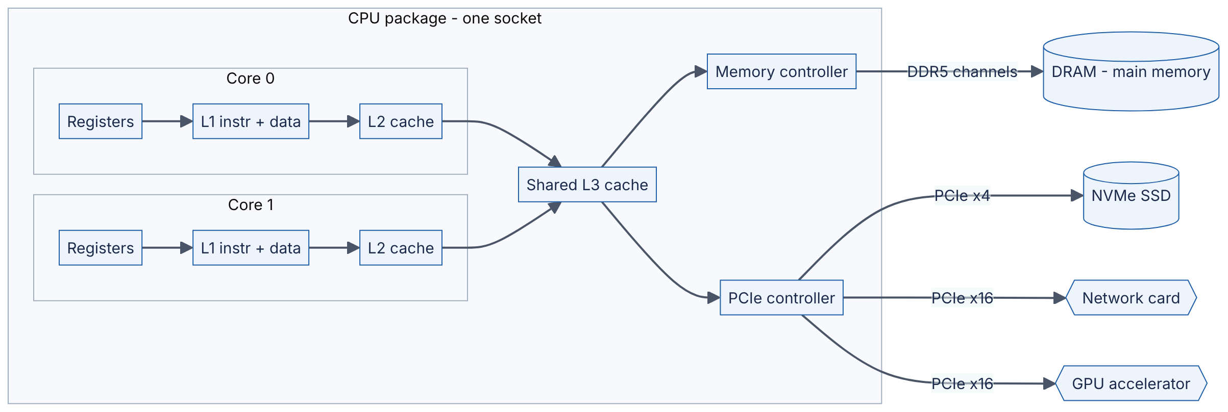
Reading the diagram. The package (the chip you hold in your hand) contains several cores; we show two, but server parts in 2025 carry anywhere from 8 to well over 100. Each core has private registers, a private L1 cache split into an instruction half and a data half, and usually a private L2 cache. All cores share an L3 cache, which connects to the memory controller and the PCIe controller. The memory controller drives several DDR5 channels to the DRAM modules (main memory). The PCIe controller connects storage (NVMe SSDs), the network card and accelerators such as GPUs over PCIe lanes (x4 = four lanes, x16 = sixteen). Arrows point outward from the core because the core initiates requests; data flows back along the same path. All of these paths are synchronous from the core’s point of view (an instruction waits for its load), except device I/O, which is asynchronous via DMA and interrupts (§5.7). Every arrow is a potential bottleneck: the further right you go, the higher the latency and the lower the bandwidth per byte of capacity. The storage boundary that matters most is the one between DRAM (volatile, lost on power failure) and the SSD (persistent). The machine scales up by adding cores, memory channels, sockets (§5.10) and PCIe devices; beyond that you scale out across machines, which is the subject of most of this book.

5.3.2 Registers, the clock and the “iron law” of performance
DEFINITION
Definition — Register. A tiny, extremely fast storage slot inside a core, typically 64 bits wide for general-purpose registers. x86-64 exposes 16 general-purpose integer registers to programs; ARMv8-A (AArch64) exposes 31. Reading a register costs essentially nothing beyond the instruction that uses it.
DEFINITION
Definition — Clock rate. The frequency at which a core’s internal circuitry steps from one state to the next, measured in hertz (cycles per second). A 4 GHz core has a cycle time of 1 / (4 × 10⁹) s = 0.25 ns.
The clock is like a metronome in the kitchen: on every tick each part of the core can advance its work by one step. For decades chip makers raised clock rates every year. Around 2005 this stopped: higher frequencies needed more voltage, and power (and therefore heat) grows faster than linearly with voltage and frequency. Clock rates have hovered around 2–6 GHz since (as of 2025, approximate), so the industry turned to doing more work per cycle and putting more cores on each chip [Hennessy & Patterson 2017, ch. 1]. This “end of free speed-ups” is why concurrency and horizontal scaling dominate modern system design.
How long a program takes is governed by three numbers multiplied together.
FORMULA
CPU execution time (the “iron law”)
$$T_{CPU}=N_{instr}×CPI×t_{cycle}=\frac{N_{instr}×CPI}{f}$$
Symbol | Meaning | Units
$T_{CPU}$ | CPU time to run the program | seconds
$N_{instr}$ | Number of instructions executed | instructions
$CPI$ | Average clock cycles per instruction (its inverse is IPC, instructions per cycle) | cycles/instruction
$t_{cycle}$ | Duration of one clock cycle | seconds/cycle
$f$ | Clock frequency, $1/t_{cycle}$ | cycles/second (Hz)
WORKED EXAMPLE
Worked example — Running a program and paying for mispredicted branches.
A program executes $N_{instr}=4×{10}^{9}$ instructions on a 4 GHz core ($t_{cycle}=0.25$ ns) at an average CPI of 0.5 (the core completes two instructions per cycle on average).
- $T_{CPU}=4×{10}^{9}×0.5×0.25×{10}^{−9} \text{s}=0.5$ s.
Now suppose 20% of instructions are branches, 5% of those branches are mispredicted (§5.3.4), and each misprediction costs 15 cycles.
- Extra CPI from mispredictions $=0.20×0.05×15=0.15$ cycles per instruction.
- New CPI $=0.5+0.15=0.65$.
- New $T_{CPU}=4×{10}^{9}×0.65×0.25×{10}^{−9}=0.65$ s.
Cross-check: $4×{10}^{9}×0.2×0.05=4×{10}^{7}$ mispredictions $×$ 15 cycles $=6×{10}^{8}$ cycles $=6×{10}^{8}×0.25$ ns $=0.15$ s extra. ✓
Interpretation. One branch in a hundred instructions going the “wrong way” costs 30% of the run time. Engineering implication. Raw clock speed is only one of three factors; CPI — which depends on caches, branches and dependencies — usually varies far more between two versions of the same code than clock rate varies between two CPUs.

5.3.3 The instruction pipeline
DEFINITION
Definition — Instruction pipeline. A technique in which the core splits instruction execution into stages and works on different stages of several consecutive instructions at the same time, like an assembly line.

First-principles explanation
A laundry has a washer, a dryer and a folding table. Doing one load start-to-finish before starting the next wastes the washer while the dryer runs. Instead you start load 2 in the washer the moment load 1 moves to the dryer. Each load still takes as long as before (its latency is unchanged), but a load finishes far more often (its throughput rises). A CPU pipeline is the same idea applied to instructions. This distinction between latency and throughput recurs at every level of system design (§5.12).

How it works internally
The classic teaching pipeline has five stages: instruction fetch (IF), instruction decode (ID), execute (EX), memory access (MEM) and write back (WB) [Hennessy & Patterson 2017, appendix C]. Real cores have between roughly 10 and 20 stages (as of 2025, approximate), but the principle is identical.
Table 5.1 — Five instructions flowing through a five-stage pipeline.
Cycle → | 1 | 2 | 3 | 4 | 5 | 6 | 7 | 8 | 9
Instruction 1 | IF | ID | EX | MEM | WB
Instruction 2 |  | IF | ID | EX | MEM | WB
Instruction 3 |  |  | IF | ID | EX | MEM | WB
Instruction 4 |  |  |  | IF | ID | EX | MEM | WB
Instruction 5 |  |  |  |  | IF | ID | EX | MEM | WB
Without pipelining, five instructions would take 5 × 5 = 25 cycles. With it they take 9 cycles, and once the pipeline is full one instruction completes every cycle. Each individual instruction still takes 5 cycles.
Figure 5.2 — A pipelined core with a branch predictor.
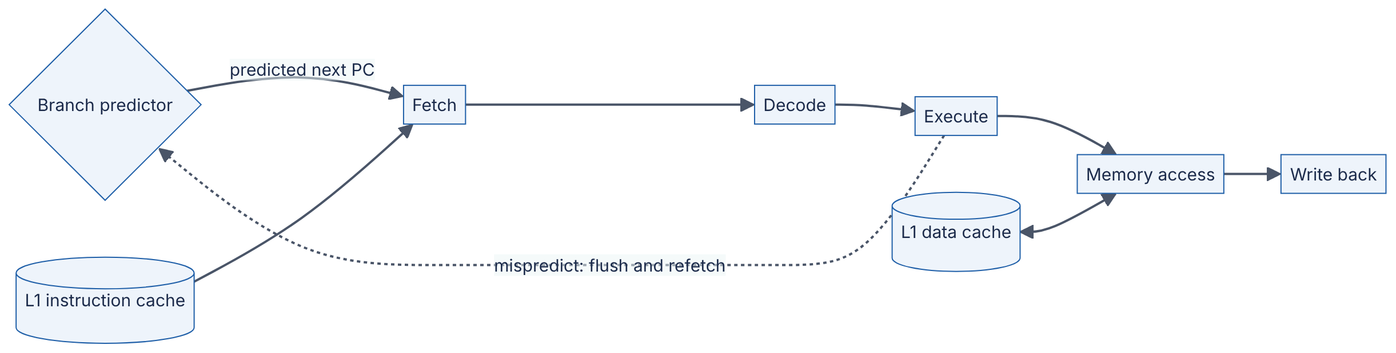
Reading the diagram. Instructions move left to right through five stages; each arrow is a hand-off on a clock edge, so the whole chain is synchronous. The fetch stage reads instructions from the L1 instruction cache; the memory stage reads and writes the L1 data cache (bidirectional arrow). The branch predictor tells fetch which instruction comes next before the core actually knows. The dotted arrow is the failure path: when the execute stage discovers that a branch went the other way, the work in all earlier stages is wrong and is thrown away (flushed), and fetching restarts from the correct address. Pipelines fail to deliver one instruction per cycle when an instruction needs a result not yet produced (a data hazard), when two instructions need the same unit (a structural hazard), or when the next instruction is unknown (a control hazard). Designers scale this structure by making it wider (§5.3.5) rather than much deeper, because deeper pipelines make each misprediction more expensive.

5.3.4 Branch prediction
DEFINITION
Definition — Branch prediction. Hardware that guesses the outcome of a conditional jump (a branch, e.g. an if or a loop condition) before it is computed, so that the pipeline can keep fetching instructions. A wrong guess is a misprediction and forces a pipeline flush.
A long pipeline needs to know which instruction to fetch next on every cycle, but a branch’s outcome is only known several stages later. Waiting would leave the pipeline empty for 10–20 cycles at every if, and typical code has a branch every five to ten instructions. So the core guesses. Modern predictors record the recent history of each branch and of the branches before it, and are right well over 95% of the time on typical code (approximate; it depends heavily on the program) [Hennessy & Patterson 2017, ch. 3]. A misprediction costs roughly 15–20 cycles on recent high-performance x86 cores (as of 2025, approximate).
The practical lesson: predictable code runs faster. Loops over sorted data, or code whose if almost always goes the same way, mispredict rarely. A filter over random data where each element passes with 50% probability mispredicts about half the time. Compilers can sometimes replace such branches with branch-free “conditional move” instructions, and data-processing engines often sort or partition data first precisely to make branches predictable.

5.3.5 Superscalar and out-of-order execution (intuition)
DEFINITION
Definition — Superscalar execution. A core that can issue and complete more than one instruction per cycle by having several execution units working in parallel.
DEFINITION
Definition — Out-of-order (OoO) execution. A technique in which the core executes instructions as soon as their inputs are ready rather than strictly in program order, while still making the results appear in program order (it retires them in order).
Back to the kitchen. A good chef reading a recipe does not stand idle while the water boils; they skip ahead to chopping onions, which does not depend on the water, and come back when the pot is ready. That is out-of-order execution. And a chef with two hands and several burners can sear, stir and plate in the same moment; that is superscalar execution.
Internally, the core decodes a window of upcoming instructions — several hundred on recent high-end cores (as of 2025, approximate) — into a buffer called the reorder buffer. Each instruction waits in a scheduler until its inputs are ready, then dispatches to any free execution unit. Results are held until every earlier instruction has completed and are then retired in order, which preserves the illusion of sequential execution for the programmer. The key algorithmic idea dates to Tomasulo’s work at IBM in 1967 [Tomasulo 1967].
Why does this matter to a system designer? Because the main thing OoO hides is memory latency. If a loop issues ten independent loads, an OoO core can have all ten outstanding at once and pay roughly one memory latency instead of ten. If each load depends on the previous one — walking a linked list, chasing pointers through a tree — nothing can overlap and the core pays the full latency every time. This is why arrays usually beat linked lists by a wide margin in practice, even when asymptotic complexity is identical, and why B-trees with wide nodes (§11.8) beat binary trees on real hardware.

5.3.6 Multiple cores and simultaneous multithreading (hyperthreading)
DEFINITION
Definition — Multi-core processor. A single chip containing several complete cores, each with its own pipeline and private caches, sharing the last-level cache and memory.
DEFINITION
Definition — Simultaneous multithreading (SMT). A technique in which one physical core runs two (occasionally more) instruction streams at once, interleaving them through the same execution units. Intel markets its implementation as Hyper-Threading Technology. Each stream appears to the operating system as a separate logical CPU (or hardware thread).
Even with out-of-order execution, a single thread often leaves execution units idle — for example while waiting for a cache miss. SMT gives the core a second recipe to work from: when thread A stalls, the core issues instructions from thread B. The core duplicates only the per-thread state (registers, program counter) and shares nearly everything else, so the extra silicon is small. The benefit depends heavily on the workload. Intel’s original description reported gains of up to about 30% on some server benchmarks [Marr et al. 2002]; workloads that already saturate the execution units or the caches may gain nothing or even slow down, because two threads now compete for the same L1 and L2.
Three consequences for system design:
- A “vCPU” in the cloud is usually a hardware thread, not a core. On most x86 instance types at the major cloud providers, two vCPUs share one physical core (as of 2025; check your provider’s documentation per instance family). Do not assume 16 vCPUs give 16 cores’ worth of throughput.
- Benchmarks must state whether SMT is on. Doubling thread count from 8 to 16 on an 8-core, 16-thread machine will not double CPU-bound throughput.
- Security. Because SMT siblings share caches and execution units, they can leak information to each other through timing side channels. Some operators disable SMT for multi-tenant isolation, and some recent client CPUs ship without it (as of 2024).

Failure scenarios
Table 5.2 — CPU-level failure scenarios.
What goes wrong | Why | Detection | Recovery | Prevention
Service throughput flat after doubling vCPUs | vCPUs were SMT siblings; the workload saturates execution units | Per-core utilization near 100%; IPC drops as threads are added | Size by physical cores; scale out | Benchmark with physical-core counts in mind
Hot loop far slower on production data than in tests | Test data was sorted or uniform; production data makes branches unpredictable | perf stat shows high branch-miss rate | Sort/partition input; use branch-free code | Benchmark on realistic data distributions
Throttled CPU under sustained load | Thermal or power limits lower the clock rate | Clock frequency drops in telemetry | Improve cooling; spread load | Capacity-plan at sustained, not turbo, frequency

Common misconceptions
COMMON MISTAKE
“A higher GHz number means a faster CPU.” Clock rate is only one factor in the iron law. A 3 GHz core with an IPC of 4 completes more work than a 4 GHz core with an IPC of 2. Compare CPUs on benchmarks of your own workload.
COMMON MISTAKE
“The CPU runs my code one line at a time, in order.” It overlaps dozens to hundreds of instructions and executes them out of order; only the visible results are in order. That is why independent operations can be nearly free while dependent chains are slow.

5.4 CPU caches

5.4.1 Why caches exist
DEFINITION
Definition — CPU cache. A small, fast memory built from SRAM (static RAM) on the processor chip that holds copies of recently used main-memory data, so that most loads and stores do not have to wait for DRAM.

First-principles explanation
Picture a researcher in a library. The book on the desk is instantly available. The shelf behind the chair holds a few dozen books and takes a few seconds to reach. The library stacks on the same floor take a minute. The off-site depository takes a day. The researcher keeps the books they are using right now on the desk and the ones they will probably need soon on the shelf. When they fetch a book from the stacks, they bring back its neighbors too, because research tends to move along the shelf.
A CPU cache is that desk and shelf. It works because programs exhibit locality of reference:
- Temporal locality — data used recently is likely to be used again soon (a loop counter, a hot configuration object).
- Spatial locality — data near recently used data is likely to be used soon (the next element of an array, the next field of a struct).

Why does this exist?
A DRAM access costs about 80–120 ns (as of 2025, approximate), which at 4 GHz is 320–480 cycles. A core that could issue several instructions per cycle would spend almost all of its time waiting. Making all of main memory as fast as a register is physically impossible: fast memory (SRAM) needs about six transistors per bit, sits on the expensive processor die, and the longer the wires to it, the slower it gets. So designers build a hierarchy: tiny and very fast near the core, larger and slower further away.

5.4.2 Cache levels
Table 5.3 — Typical CPU cache levels (as of 2024–2025, approximate; sizes and latencies vary by product).
Level | Typical size | Shared by | Latency (cycles) | Latency at ~4 GHz | Analogy
Registers | Tens of 64-bit values visible per thread | One hardware thread | 0–1 | < 0.3 ns | Hands
L1 data | 32–64 KiB | One core | ~4–6 | ~1–1.5 ns | Desk
L2 | 0.5–3 MiB | One core (usually) | ~12–18 | ~3–5 ns | Shelf behind you
L3 (last-level cache) | 8 MiB to several hundred MiB | All cores on the chip or chiplet | ~40–80 | ~10–20 ns | Stacks on your floor
DRAM | GBs to TBs | Whole socket (or machine) | ~300–500 | ~80–120 ns | Off-site depository
Sources for the ranges: vendor optimization manuals and independent measurements summarized in [Hennessy & Patterson 2017, ch. 2] and [Drepper 2007]; check lscpu on your own machine. The machine on which this chapter’s examples were tested reports 48 KiB L1d and 2 MiB L2 per core.
Figure 5.3 — What happens on a load instruction.
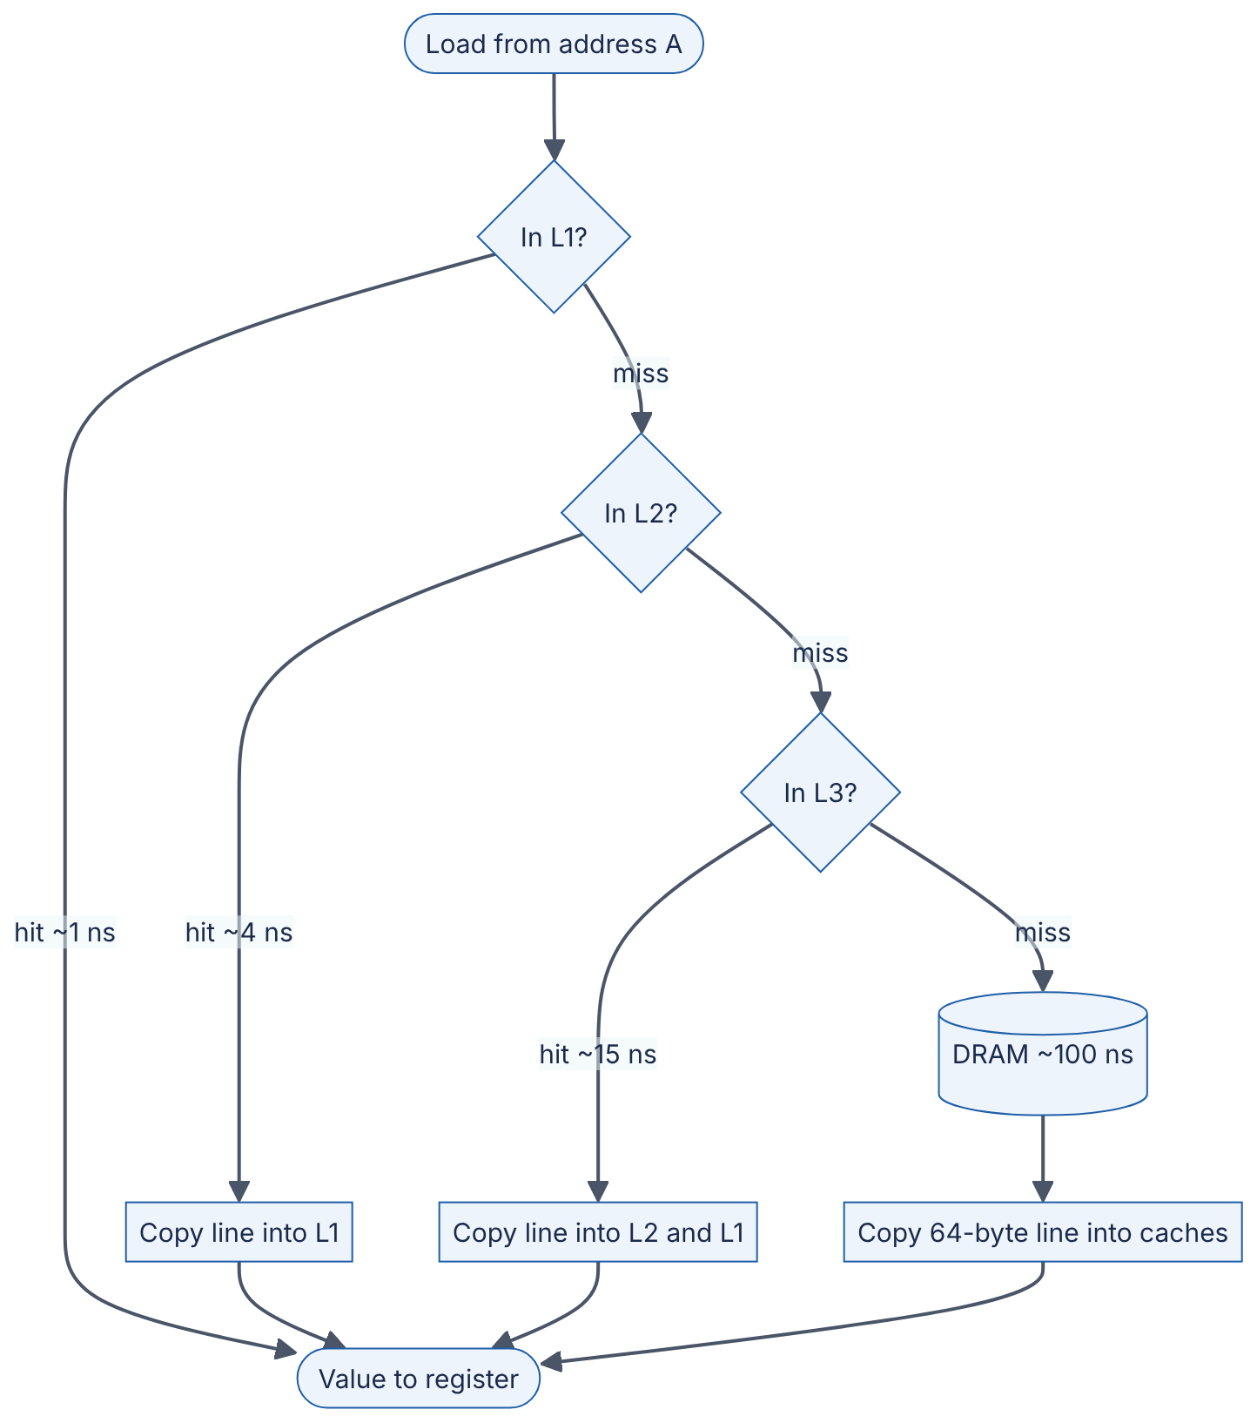
Reading the diagram. A load instruction checks each level in turn. A hit returns the data at that level’s latency; a miss passes the request to the next level. When the data finally arrives it is copied into the faster levels so the next access hits (this is temporal locality at work), possibly evicting some other line to make room. Each step is synchronous for the instruction that needs the value, but an out-of-order core keeps running independent instructions while it waits, and several misses can be outstanding at once (§5.9.2). The storage boundary is between L3 (on chip, SRAM) and DRAM (off chip). The main failure mode is a miss storm: a working set larger than the caches turns most loads into 100 ns trips. The way to scale is not a bigger cache — you cannot buy one — but a smaller, denser working set and access patterns the hardware can predict.

5.4.3 Cache lines and locality
DEFINITION
Definition — Cache line. The fixed-size unit in which data moves between memory and caches. On x86-64 and most ARM server cores a line is 64 bytes; some designs (for example Apple’s M-series cores) use 128 bytes (as of 2024). A load of a single byte brings its whole line into the cache.
Because a whole line arrives at once, reading the first element of an array also brings in the next seven 8-byte elements “for free”. Hardware prefetchers go further: when they detect that you are walking through memory in a regular pattern, they start fetching the next lines before you ask. Sequential access is therefore the best case in the entire memory system, and random access the worst.

Code example — row-major vs column-major traversal
/* traverse.c — build: gcc -O2 -std=c11 traverse.c -o traverse */
#define _POSIX_C_SOURCE 199309L
#include <stdio.h>
#include <stdlib.h>
#include <time.h>
#define N 8192 /* 8192 x 8192 ints = 256 MiB */
static double now(void) {
struct timespec t;
clock_gettime(CLOCK_MONOTONIC, &t);
return t.tv_sec + t.tv_nsec / 1e9;
}
int main(void) {
int *m = malloc((size_t)N * N * sizeof *m);
if (!m) return 1;
for (size_t i = 0; i < (size_t)N * N; i++) m[i] = 1;
long long sum = 0;
double t0 = now();
for (size_t r = 0; r < N; r++) /* row-major: consecutive addresses */
for (size_t c = 0; c < N; c++)
sum += m[r * N + c];
double t1 = now();
for (size_t c = 0; c < N; c++) /* column-major: jumps of N*4 bytes */
for (size_t r = 0; r < N; r++)
sum += m[r * N + c];
double t2 = now();
printf("row-major: %.3f s\n", t1 - t0);
printf("column-major: %.3f s\n", t2 - t1);
printf("checksum: %lld\n", sum); /* stops the compiler deleting loops */
free(m);
return 0;
}
What to notice:
- Both loops add exactly the same 67,108,864 integers; only the order differs.
- The row-major loop touches consecutive 4-byte integers, so each 64-byte line serves 16 additions and the prefetcher streams lines ahead of time.
- The column-major loop jumps 8192 × 4 = 32,768 bytes between consecutive accesses, so every access lands on a different line and, because the matrix is 256 MiB, most of those lines have been evicted before the loop comes back for their neighbors.
- On the test machine (a cloud x86-64 VM, 2026) the row-major loop took 0.038 s and the column-major loop 0.667 s — about 17× slower for identical arithmetic. Your ratio will differ, but the direction will not.
- sum is printed so that the optimizing compiler cannot prove the loops are useless and delete them — a classic benchmarking pitfall (§23.5).

5.4.4 Associativity: where a line may live
A cache must find a line quickly, so it cannot search every slot. Instead the memory address decides which set (group of slots) a line may occupy.
DEFINITION
Definition — Set-associative cache. A cache divided into $S$ sets of $W$ slots (ways). A line at a given address may be stored in any of the $W$ ways of exactly one set. $W=1$ is a direct-mapped cache; a cache with a single set holding every line is fully associative.
The analogy is a coat check with numbered racks. Your ticket number decides the rack (the set); within the rack your coat can go on any free hook (any way). If many guests’ tickets map to the same rack, that rack overflows even though others are empty — a conflict miss.
FORMULA
Address decomposition in a set-associative cache
$$S=\frac{C}{B×W}, \text{offset bits}=\log_{2}B, \text{index bits}=\log_{2}S$$
$$\text{set index}=\left\lfloor \frac{A}{B}\right\rfloor mod S, \text{tag}=\left\lfloor \frac{A}{B×S}\right\rfloor$$
Symbol | Meaning | Units
$C$ | Cache capacity | bytes
$B$ | Line (block) size | bytes
$W$ | Associativity (ways per set) | lines
$S$ | Number of sets | sets
$A$ | Memory address | byte address
tag | High-order address bits stored with the line to identify it | —
WORKED EXAMPLE
Worked example — Where does address 0x12345 go in a 32 KiB, 8-way cache with 64-byte lines?
- Sets: $S=32 768/\left(64×8\right)=32 768/512=64$ sets.
- Offset bits $=\log_{2}64=6$; index bits $=\log_{2}64=6$.
- Address $A=\text{0x12345}=74 565$.
- Offset within the line $=74 565 mod 64=74 565−1165×64=74 565−74 560=5$.
- Line number $=⌊74 565/64⌋=1165$; set index $=1165 mod 64=1165−18×64=13$.
- Tag $=⌊1165/64⌋=18$ (0x12).
Check in binary: 0x12345 = 0001 0010 0011 0100 0101; the low 6 bits 000101 = 5 ✓, the next 6 bits 001101 = 13 ✓, the remaining bits 10010 = 18 ✓.
Interpretation. Addresses that differ by a multiple of $B×S=64×64=4096$ bytes land in the same set. Engineering implication. A loop that strides through memory in steps of exactly 4 KiB (for example, reading one field from each of many page-aligned 4 KiB records) can use only one set — 8 lines, 512 bytes — of a 32 KiB cache. Power-of-two strides are a known performance trap; padding a row or record by one cache line often removes it [Drepper 2007, §6.2].

5.4.5 Average memory access time
FORMULA
Average memory access time (AMAT), applied recursively to each level
$$AMAT=t_{L1}+m_{L1}×\left(t_{L2}+m_{L2}×\left(t_{L3}+m_{L3}×t_{mem}\right)\right)$$
Symbol | Meaning | Units
$t_{L1},t_{L2},t_{L3}$ | Hit time at each cache level | ns
$t_{mem}$ | DRAM access time | ns
$m_{L1}$ | Fraction of all accesses that miss L1 | dimensionless (0–1)
$m_{L2},m_{L3}$ | Local miss rate: fraction of accesses reaching that level that miss it | dimensionless (0–1)
The same formula, with two levels, is the effective access time of any cache in front of a slower store: $EAT=h×t_{hit}+\left(1−h\right)×t_{miss}$, where $h$ is the hit ratio. You will use it again for application caches (§20.3).
WORKED EXAMPLE
Worked example — Good locality versus poor locality.
Assume $t_{L1}=1$ ns, $t_{L2}=4$ ns, $t_{L3}=15$ ns, $t_{mem}=90$ ns.
Good locality (array scans, small hot data): $m_{L1}=0.05$, $m_{L2}=0.20$, $m_{L3}=0.30$.
- L3 term: $15+0.30×90=15+27=42$ ns.
- L2 term: $4+0.20×42=4+8.4=12.4$ ns.
- AMAT $=1+0.05×12.4=1+0.62=1.62$ ns.
Poor locality (random lookups in a large hash table): $m_{L1}=0.30$, $m_{L2}=0.60$, $m_{L3}=0.70$.
- L3 term: $15+0.70×90=15+63=78$ ns.
- L2 term: $4+0.60×78=4+46.8=50.8$ ns.
- AMAT $=1+0.30×50.8=1+15.24=16.24$ ns.
Interpretation. The same hardware delivers memory ten times slower on average for the second workload. Engineering implication. Data layout (compact structs, arrays instead of pointer-linked nodes, hot fields grouped together) can change performance by an order of magnitude without changing the algorithm. The application-level twin of this example: raising a cache hit ratio from 90% to 99% in front of a 100 µs SSD read, with a 1 µs hit, cuts effective access time from $0.9×1+0.1×100=10.9$ µs to $0.99×1+0.01×100=1.99$ µs, about 5.5× faster.

5.4.6 Cache coherence and the MESI protocol
DEFINITION
Definition — Cache coherence. The guarantee that all cores observe a single, consistent sequence of values for each memory location, even though each core keeps private copies in its own caches.
Suppose cores 0 and 1 both cache the variable x. Core 0 writes x = 5. If core 1 keeps reading its stale copy, the program breaks. Coherence protocols prevent this by tracking, for every cached line, which cores hold it and whether it has been changed. The textbook protocol is MESI, named after the four states a line can be in within one core’s cache [Papamarcos & Patel 1984; Sorin, Hill & Wood 2011]:
- Modified (M) — this core has the only copy and has changed it; memory is stale. The core must write the line back before anyone else may use it.
- Exclusive (E) — this core has the only copy, and it matches memory. The core may write to it without telling anyone.
- Shared (S) — several cores may hold read-only copies that match memory.
- Invalid (I) — this cache does not hold a valid copy.
The analogy is a shared document with a single “edit pen”. Anyone may hold a read-only photocopy (Shared). To write, you must collect every photocopy and shred it (invalidate them), then you hold the pen (Modified). Real processors use extensions — Intel describes MESIF, AMD MOESI — that add states to reduce memory traffic, but the core idea is the same.
Figure 5.4 — MESI state transitions for one cache line in one core’s cache.
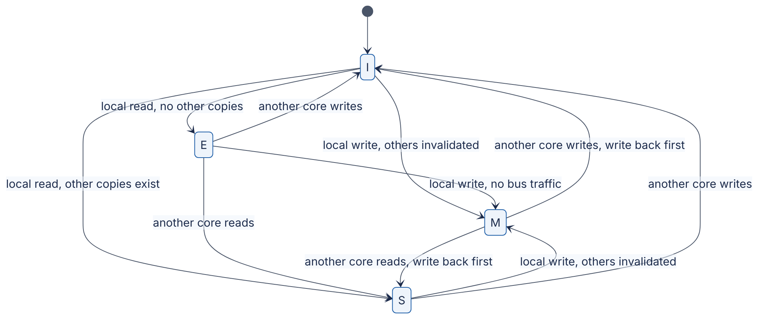
Reading the diagram. Each box is the state of one 64-byte line in one core’s cache; every core runs this machine independently for every line. “Local” events come from this core’s own instructions; “another core” events arrive as coherence messages over the on-chip interconnect (a ring or mesh linking cores, caches and memory controllers) or, between sockets, over the socket-to-socket link. Transitions caused by our own reads and writes are synchronous with the instruction; invalidations and write-backs triggered by other cores arrive asynchronously. Note the two expensive arcs: moving from Shared to Modified requires invalidating every other copy and waiting for acknowledgments, and a remote read of a Modified line forces a write-back. When two cores repeatedly write the same line, it ping-pongs between their caches, each transfer costing tens of nanoseconds on one chip and more across sockets. Coherence traffic is the reason “just add cores” stops scaling for shared, frequently written data.

5.4.7 False sharing
DEFINITION
Definition — False sharing. A performance problem in which threads on different cores write to different variables that happen to sit in the same cache line, so the coherence protocol bounces the line between cores as if they were sharing data.
Coherence works at the granularity of a whole line, not a variable. Two counters 8 bytes apart, each updated by its own thread, look to the hardware exactly like one heavily contended variable. The program is logically correct and has no locks, yet it scales negatively.

Code example — demonstrating and fixing false sharing in C
/* false_sharing.c — build: gcc -O2 -std=c11 -pthread false_sharing.c -o fs */
#define _POSIX_C_SOURCE 199309L
#include <pthread.h>
#include <stdalign.h>
#include <stdatomic.h>
#include <stdint.h>
#include <stdio.h>
#include <time.h>
#define ITERATIONS 50000000ULL /* 5 x 10^7 increments per thread */
#define CACHE_LINE 64 /* x86-64 line size; check yours */
/* Variant A: two counters 8 bytes apart -> same cache line. */
struct packed {
_Atomic uint64_t a;
_Atomic uint64_t b;
};
/* Variant B: each counter starts its own 64-byte cache line. */
struct padded {
alignas(CACHE_LINE) _Atomic uint64_t a;
alignas(CACHE_LINE) _Atomic uint64_t b;
};
static struct packed P;
static struct padded Q;
static void *worker(void *arg) {
_Atomic uint64_t *counter = arg;
for (uint64_t i = 0; i < ITERATIONS; i++)
atomic_fetch_add_explicit(counter, 1, memory_order_relaxed);
return NULL;
}
static double run(_Atomic uint64_t *x, _Atomic uint64_t *y) {
struct timespec t0, t1;
pthread_t ta, tb;
clock_gettime(CLOCK_MONOTONIC, &t0);
pthread_create(&ta, NULL, worker, (void *)x);
pthread_create(&tb, NULL, worker, (void *)y);
pthread_join(ta, NULL);
pthread_join(tb, NULL);
clock_gettime(CLOCK_MONOTONIC, &t1);
return (double)(t1.tv_sec - t0.tv_sec) + (t1.tv_nsec - t0.tv_nsec) / 1e9;
}
int main(void) {
printf("gap between counters: packed=%td B, padded=%td B\n",
(char *)&P.b - (char *)&P.a, (char *)&Q.b - (char *)&Q.a);
printf("packed (false sharing): %.2f s\n", run(&P.a, &P.b));
printf("padded (separate lines): %.2f s\n", run(&Q.a, &Q.b));
return 0;
}
What to notice:
- Each thread touches only its own counter; there is no logical sharing and no lock.
- In struct packed the counters are 8 bytes apart, so they share a 64-byte line. In struct padded, alignas(64) forces each counter onto its own line (the struct grows from 16 to 128 bytes).
- atomic_fetch_add_explicit compiles to a locked read-modify-write instruction, which requires the core to hold the line in the Modified state — every increment by one thread therefore steals the line from the other.
- On the 4-vCPU test VM (2026), three runs gave 1.57–1.69 s for the packed layout versus 0.31–0.34 s for the padded layout: about 5× slower purely because of memory layout. With plain (non-atomic) increments, the effect is smaller and noisier because store buffers and compiler optimizations hide part of it — another reason to measure rather than assume.
- The fix costs memory (112 wasted bytes here). Pad only data that is genuinely written by different threads at high frequency: per-thread counters, queue head and tail indices, per-core statistics.

Real-world industry applications
INDUSTRY EXAMPLE
LMAX Disruptor (low-latency financial exchange). LMAX built an inter-thread messaging library for its trading platform and found that the head and tail sequence counters of a queue, written by different threads, suffered false sharing. The Disruptor pads its sequence counters to occupy their own cache lines and avoids locks on the hot path; the authors attribute a large part of its throughput advantage over conventional bounded queues to this “mechanical sympathy” with the cache hierarchy. Trade-off: padded structures waste memory and the design assumes a known line size. Evidence: Primary — [Thompson et al. 2011]
INDUSTRY EXAMPLE
Netflix (JVM service on larger cloud instances). When Netflix moved a stateless Java service to an instance type with three times the vCPUs, throughput rose only about 25% instead of the expected ~3×. Using hardware performance counters, engineers traced the problem to cache-line contention inside the JVM’s type-checking code — first false sharing, then, after a workaround, true sharing of a frequently written cache field. Fixing it brought throughput close to the expected scaling. Trade-off: diagnosing it required low-level counters that are not exposed on every cloud instance type. Evidence: Primary — [Filanovsky & Sane 2022]
Runtimes offer help: Java’s internal @Contended annotation, C++17’s std::hardware_destructive_interference_size, and explicit padding fields in Go and Rust.

Advantages and disadvantages of caches
Caches make the common case (good locality) almost as fast as registers, with no effort from the programmer. Their disadvantages are that performance becomes data-dependent and hard to predict, that coherence traffic limits how well shared, written data scales across cores, and that shared caches create interference between unrelated workloads — one tenant’s large scan can evict another tenant’s hot data (the noisy neighbor problem, Ch 47).

Failure scenarios
Table 5.4 — Cache-related failure scenarios.
What goes wrong | Why | Detection | Recovery | Prevention
Throughput falls as threads are added | False sharing or a hot shared counter | perf c2c on Linux; high cross-core cache-to-cache transfers | Pad or shard per-thread state | Per-thread or per-core data; aggregate occasionally
Latency spikes when a batch job runs on the same host | Batch job’s scan evicts the service’s working set from shared L3 | LLC miss rate rises in sync with the batch job | Move the job; pin to other cores | Cache partitioning (e.g., Intel RDT) or separate hosts
Mysterious slowdown at certain array sizes | Power-of-two stride causes conflict misses in one set | Performance cliff at sizes like 4096 or 8192 | Pad rows/records | Avoid power-of-two strides in hot loops
Pointer-heavy structure slow despite good big-O | Each hop is a dependent cache miss | Low IPC, high cache-miss counts | Switch to arrays / B-tree-like wide nodes | Design data structures for locality

Common misconceptions
COMMON MISTAKE
“Lock-free code always scales.” Lock-free code still writes to shared cache lines. If many cores update the same atomic counter, the line ping-pongs between them and throughput can be lower than with one thread. Scalable designs avoid shared writes altogether (per-core counters, sharded state).
COMMON MISTAKE
“Caches only matter to C programmers.” Every language runs on the same hardware. Java object headers, Python object pointers and Go slices all have cache footprints; the gap between “array of values” and “array of pointers to objects” is often several-fold in any language.

5.5 RAM and the memory hierarchy

5.5.1 Main memory (DRAM)
DEFINITION
Definition — DRAM (dynamic random-access memory). The technology used for main memory. Each bit is stored as charge in a tiny capacitor that leaks and must be refreshed every few tens of milliseconds. DRAM is volatile: its contents are lost when power is removed.
DRAM uses one transistor and one capacitor per bit, versus about six transistors for the SRAM in caches, so it is far denser and cheaper — but slower. Memory chips sit on modules (DIMMs) that plug into channels, each an independent 64-bit data path to the CPU’s memory controller (DDR5 splits each module’s path into two 32-bit subchannels, still 64 bits in total). Inside a chip, bits are arranged in banks of rows and columns; reading a row that is already “open” is faster than opening a new one, which is one more reason sequential access is cheaper than random access [Drepper 2007, §2]. Servers use ECC (error-correcting code) memory, which stores extra check bits to correct single-bit errors.

5.5.2 The memory hierarchy
DEFINITION
Definition — Memory hierarchy. The layered arrangement of storage technologies in a computer, from small, fast and expensive per byte (registers, caches) to large, slow and cheap per byte (disks, tape), in which each level acts as a cache for the level below it.
Figure 5.5 — The memory and storage hierarchy (as of 2024–2025, approximate).
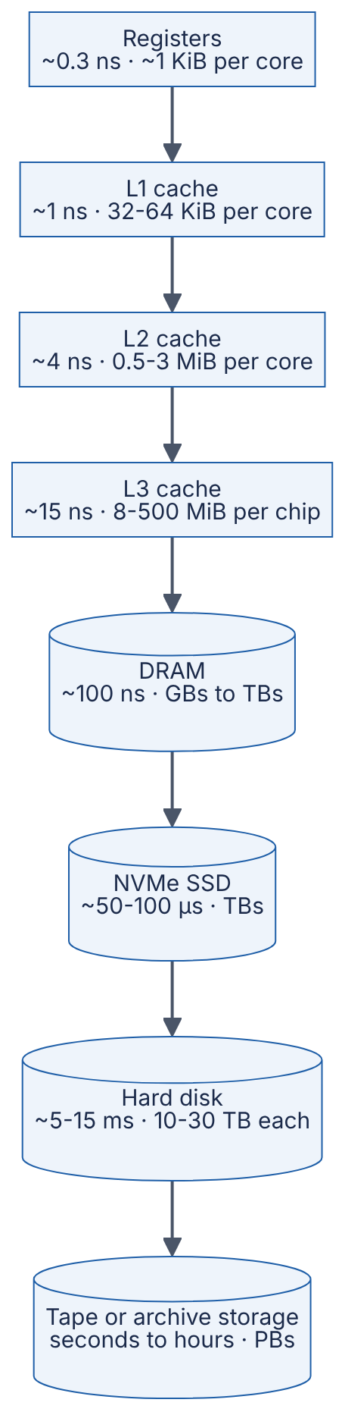
Reading the diagram. Read it top to bottom as “faster, smaller, costlier per byte” turning into “slower, larger, cheaper per byte”. Each arrow means “misses at this level are served by the next level”. The levels above DRAM are managed by hardware automatically; the boundary between DRAM and SSD is managed by software — the operating system’s page cache (§6.6) or your database’s buffer pool (§13.4). The most important storage boundary is volatility: everything from DRAM upward vanishes on power loss, so durability requires reaching the SSD, disk or a remote replica (§6.14). Each step down costs roughly 3–1000× in latency. Systems “scale” this pyramid by keeping the working set as high up as possible: more RAM to cache hot data, SSDs instead of disks for random access, and disks or object storage only for cold, sequentially read data.
Table 5.5 — Memory hierarchy numbers (as of 2024–2025, approximate; prices are volatile).
Level | Typical capacity | Random-access latency | Sequential bandwidth | Approx. cost per GB | Persistent?
L1 / L2 / L3 cache | KiB to hundreds of MiB | ~1 / ~4 / ~15 ns | Hundreds of GB/s per core (L1) | Not sold separately | No
DRAM (DDR5) | 16 GB – several TB per server | ~80–120 ns | ~38 GB/s per DDR5-4800 channel; ~300–600 GB/s per socket | ~$2–5 | No
NVMe SSD (TLC flash) | 1–30+ TB | ~50–100 µs read | ~3–7 GB/s (PCIe 4.0 x4); ~10–14 GB/s (PCIe 5.0 x4) | ~$0.05–0.15 | Yes
SATA SSD | 0.25–8 TB | ~80–150 µs read | ~0.55 GB/s | ~$0.05–0.10 | Yes
HDD (7200 RPM) | 4–30+ TB | ~5–15 ms | ~0.15–0.28 GB/s | ~$0.015–0.03 | Yes
LTO-9 tape | 18 TB native per cartridge | Seconds to minutes (mount, wind) | ~0.4 GB/s native | < $0.01 | Yes
Sources: interface limits from the DDR5, PCIe and SATA specifications (bandwidth arithmetic in §5.9); device ranges from vendor datasheets of the period; LTO-9 figures from the LTO Program; general structure from [Hennessy & Patterson 2017, ch. 2] and [Bryant & O’Hallaron 2015, ch. 6]. Prices are retail/street approximations for 2024 and changed sharply in 2025–2026 for DRAM and flash; treat them as ratios, not quotes.
The ratios are the lesson: DRAM costs roughly 30–100× more per GB than flash, and flash roughly 3–5× more than disk, while latency falls by about 1,000× from DRAM to flash and 100× again from flash to disk. Choosing where data lives is an economic decision as much as a technical one.

5.6 Storage devices

5.6.1 Hard disk drives (HDDs)
DEFINITION
Definition — Hard disk drive (HDD). A storage device that records data magnetically on spinning platters, read and written by heads mounted on a moving arm (the actuator). Data is organized in concentric tracks divided into sectors of 512 or 4096 bytes.

First-principles explanation
Think of a record player. To play a particular song, you lift the arm and move it to the right groove (the seek), then wait for the start of the song to come round under the needle (rotational latency), then listen to the song (transfer). Moving the arm and waiting for the platter take milliseconds — millions of CPU cycles — whereas reading the data once the head is in place is fast. An HDD rewards you for reading long runs of adjacent data and punishes you for jumping around.
FORMULA
HDD access time
$$T_{access}=T_{seek}+T_{rot}+T_{transfer}, T_{rot}=\frac{1}{2}×\frac{60}{RPM}, T_{transfer}=\frac{S}{R}$$
$$IOPS_{random}≈\frac{1}{T_{access}}$$
Symbol | Meaning | Units
$T_{seek}$ | Average time to move the head to the target track | ms
$T_{rot}$ | Average rotational latency: half a revolution | ms
$RPM$ | Spindle speed | revolutions per minute
$S$ | Size of the request | bytes
$R$ | Sustained media transfer rate | bytes/second
$IOPS_{random}$ | Random I/O operations per second for one outstanding request | operations/second
WORKED EXAMPLE
Worked example — Random versus sequential reads on a 7200 RPM disk.
Assume $T_{seek}=8.5$ ms (a typical desktop-class average), $R=200$ MB/s (as of 2024, approximate; outer tracks are faster than inner tracks).
- One revolution: $60/7200=0.008 33$ s $=8.33$ ms, so $T_{rot}=8.33/2=4.17$ ms.
- Transfer of a 4 KiB block: $4096/\left(200×{10}^{6}\right)=2.05×{10}^{−5}$ s $=0.02$ ms.
- Random 4 KiB read: $T_{access}=8.5+4.17+0.02=12.69$ ms.
- Random IOPS $≈1/0.012 69≈79$ operations/s, so random throughput $=79×4096≈0.32$ MB/s.
- Sequential throughput $≈200$ MB/s, which is $200/0.32≈620×$ the random throughput.
- Reading 100 MB contiguously after one positioning: $12.67+\left({10}^{8}/2×{10}^{8}\right)×1000=12.67+500=512.67$ ms, an effective ${10}^{8}/0.512 67≈195$ MB/s — 97.5% of the maximum.
Interpretation. For small random reads, 99.8% of the time is mechanical positioning ($12.67/12.69$). Engineering implication. On disks, design for large sequential transfers: append-only logs, LSM trees (§13.8), large blocks in distributed file systems (§15.5) and batch scans. Even a 15,000 RPM enterprise disk ($T_{rot}=2$ ms, seek ≈ 3.5 ms) reaches only about $1/0.0055≈180$ random IOPS.
HDDs remain the cheapest online storage per byte (Table 5.5), so they still hold most of the world’s bulk data in object stores and backup systems — where access is overwhelmingly sequential [Ruemmler & Wilkes 1994].

5.6.2 Solid-state drives (SSDs) and flash memory
DEFINITION
Definition — Solid-state drive (SSD). A storage device with no moving parts that stores data in NAND flash memory cells, managed by an on-board controller running a flash translation layer (FTL).
Flash is fast to read and has no seek time, but it has three peculiar rules that shape everything about SSD behavior [Agrawal et al. 2008]:
- Read and write in pages. The smallest unit you can read or program (write) is a page, typically 4–16 KiB (as of 2024, approximate).
- Erase in blocks. A page cannot be overwritten in place. It must first be erased, and erasure works only on a whole erase block of hundreds of pages (several MiB in modern chips).
- Cells wear out. Each block survives a limited number of program/erase (P/E) cycles — on the order of 1,000–3,000 for TLC (three bits per cell) flash and fewer for QLC (four bits per cell) (as of 2024, approximate; vendors rarely publish exact figures).
The analogy is a notebook written in pen. You cannot rub out one line; to reuse a page you must tear out a whole chapter, and the binding can only take so many tear-outs. So when you “update” a line, you write the new version on a fresh page and cross out the old one. Periodically you copy the still-valid lines from a messy chapter to a fresh one and tear the old chapter out. That is exactly what an SSD controller does.
Figure 5.6 — How an SSD handles an overwrite and garbage collection.
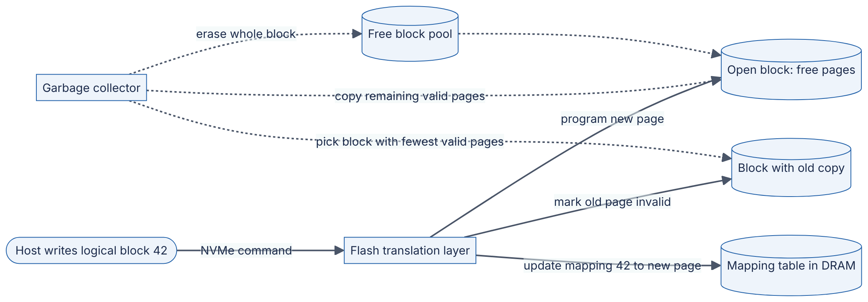
Reading the diagram. The host addresses data by logical block address (LBA); the FTL translates LBAs to physical flash pages using a mapping table held in the SSD’s own DRAM (backed up to flash). An overwrite from the host (solid arrows, synchronous with the write command) becomes “program a fresh page, then repoint the mapping”, and the old page is merely marked invalid. In the background (dotted arrows, asynchronous), the garbage collector chooses a block with few valid pages, copies the survivors elsewhere and erases the block, returning it to the free pool. The failure point is garbage collection under sustained random writes: when free blocks run out, the host’s writes wait behind GC, producing latency spikes. Drives mitigate this with over-provisioning (spare capacity invisible to the host) and the host helps with TRIM/deallocate commands that tell the drive which pages no longer hold useful data. The mapping table is also why SSDs need power-loss protection capacitors in enterprise models.

5.6.3 Write amplification and endurance
FORMULA
Write amplification factor and drive lifetime
$$WAF=\frac{\text{bytes written to flash}}{\text{bytes written by the host}}, \text{Lifetime (days)}≈\frac{C×PE}{W_{host}×WAF}$$
Symbol | Meaning | Units
$WAF$ | Write amplification factor (≥ 1 for a drive without compression) | dimensionless
$C$ | Raw flash capacity | bytes
$PE$ | Rated program/erase cycles per block | cycles
$W_{host}$ | Host write volume per day | bytes/day
WORKED EXAMPLE
Worked example — How long will this SSD last?
A 1 TB TLC SSD, assumed rating $PE=3000$ cycles, so total flash write budget $={10}^{12}×3000=3×{10}^{15}$ bytes $=3$ PB. A database writes $W_{host}=500$ GB/day (0.5 drive writes per day).
- With sequential, log-structured writes, $WAF≈2.5$: flash writes $=500×2.5=1250$ GB/day $=1.25$ TB/day. Lifetime $=3000\text{ TB}/1.25\text{ TB/day}=2400$ days $≈6.6$ years.
- With small random in-place updates on a nearly full drive, $WAF≈5$: flash writes $=2.5$ TB/day. Lifetime $=3000/2.5=1200$ days $≈3.3$ years.
Interpretation. The same host workload wears the drive out twice as fast purely because of the write pattern. Engineering implication. Write amplification compounds: an LSM tree’s own compaction (§13.11) multiplies with the SSD’s internal WAF. Prefer large, sequential, aligned writes; leave free space (or over-provisioning) on write-heavy drives; and monitor the drive’s wear indicators (SMART / NVMe health log).

5.6.4 SATA versus NVMe
SSDs first plugged into the same SATA interface designed for hard disks. SATA III signals at 6 Gbit/s, and after its 8b/10b line encoding (10 bits on the wire per data byte) delivers at most 600 MB/s; real drives reach about 550 MB/s. Its command protocol, AHCI, offers one command queue of 32 entries — ample for a disk that can do 100 operations per second, but a straitjacket for flash that can do hundreds of thousands.
NVMe (Non-Volatile Memory Express) is a protocol designed for flash that attaches drives directly to PCIe lanes. It supports up to about 65,535 I/O queues, each up to 65,536 commands deep [NVM Express Base Specification], so every CPU core can have its own submission and completion queue pair with no locking between cores. A PCIe 4.0 x4 link carries roughly 7.9 GB/s of payload after encoding (16 GT/s × 4 lanes × 128/130 ÷ 8 ≈ 7.9 GB/s), and fast drives deliver about 7 GB/s sequential and around a million random 4 KiB reads per second at high queue depth (as of 2024, approximate).

5.6.5 IOPS, throughput and queue depth
DEFINITION
Definition — IOPS. Input/output operations per second: the number of independent read or write requests a device completes per second, quoted for a stated request size (usually 4 KiB) and queue depth (number of requests outstanding at once).
FORMULA
Little’s Law applied to a storage device
$$IOPS=\frac{QD}{L}, \text{Throughput}=IOPS×S$$
Symbol | Meaning | Units
$QD$ | Average number of requests outstanding (queue depth) | requests
$L$ | Average latency per request | seconds
$S$ | Request size | bytes
WORKED EXAMPLE
Worked example — Why a single-threaded reader cannot exploit an NVMe SSD.
An NVMe SSD has a random-read latency of $L=80$ µs.
- One request at a time ($QD=1$): $IOPS=1/\left(80×{10}^{−6}\right)=12 500$; throughput $=12 500×4096=51.2$ MB/s.
- To reach the drive’s rated ${10}^{6}$ IOPS: $QD=IOPS×L={10}^{6}×80×{10}^{−6}=80$ requests outstanding.
Interpretation. A program that issues one blocking read, waits, then issues the next will use about 1% of a fast SSD. Engineering implication. To use modern storage you need concurrency in the I/O path: many threads, asynchronous I/O (io_uring, §6.13), or batched requests. The same law governs memory (§5.9.2) and network connections (§7.15).

5.6.6 Persistent memory and newer tiers
Persistent memory (PMem) is byte-addressable like DRAM — the CPU reads it with ordinary load instructions — but keeps its contents without power. The best-known product, Intel Optane persistent memory, offered larger capacities than DRAM at read latencies of a few hundred nanoseconds (approximate); Intel announced in 2022 that it was winding the business down. The ideas survive in capacitor-backed DRAM inside storage controllers and in CXL (Compute Express Link), which attaches extra memory over the PCIe physical layer at somewhat higher latency than local DRAM. Programming persistent memory requires explicit cache-line flushes and fences, because data still in a volatile CPU cache is not durable.
Table 5.6 — Storage device comparison (as of 2024–2025, approximate).
 | HDD | SATA SSD | NVMe SSD | Persistent memory / CXL memory
What it is | Spinning magnetic platters | Flash behind a disk-era interface | Flash on PCIe with a flash-native protocol | Byte-addressable memory on the memory bus or CXL
How it works | Mechanical seek + rotation | FTL, 1 queue × 32 commands | FTL, up to ~64K queues | CPU loads/stores
Advantages | Cheapest per TB; good sequential speed | Drop-in replacement for disks | Very high IOPS and bandwidth | Nanosecond-scale access, large capacity
Disadvantages | ~100 random IOPS; mechanical failure | Interface caps at ~550 MB/s | Wear-out; GC latency spikes | Niche, costly; Optane discontinued
Performance | ~80–200 IOPS; ~0.2 GB/s | ~50–100K IOPS; 0.55 GB/s | ~0.5–1.5M IOPS; 3–14 GB/s | ~100s ns latency
Cost per GB | ~$0.02 | ~$0.05–0.10 | ~$0.05–0.15 | Above DRAM-adjacent tiers
Choose when | Cold, bulk, sequential data | Legacy servers, budget | Databases, logs, anything random-access | Very large in-memory datasets; specialized logging

Real-world industry applications
INDUSTRY EXAMPLE
Apache Kafka (append-only log on ordinary disks). Kafka’s designers observed that sequential disk throughput is hundreds of times higher than random-access throughput and that the operating system’s page cache already keeps recently written data in RAM. Kafka therefore stores each partition as an append-only file, reads and writes it sequentially, and relies on the page cache rather than an in-process cache, which lets brokers sustain high throughput even on hard disks. Trade-off: the design favors sequential consumers; random lookups by key are not what it is for. Evidence: Primary — [Apache Kafka Documentation, Design]

Failure scenarios
Table 5.7 — Storage failure scenarios.
What goes wrong | Why | Detection | Recovery | Prevention
p99 write latency spikes on a busy SSD | Garbage collection when free blocks are exhausted | Latency spikes correlate with sustained writes | Throttle writes; free space | Over-provision; TRIM; sequential writes
SSD wears out early | High write amplification from small random writes | SMART “percentage used” climbs fast | Replace drive; rebuild replica | Log-structured writes; endurance-rated drives
Database slow after moving from SSD to cheaper HDD tier | Random-access workload on ~100 IOPS devices | Queue depth high, low throughput, high await | Move back; add cache | Match the device to the access pattern
Data lost after power failure despite successful write | Data was still in volatile cache (OS, drive) | Corruption on restart | Restore from replica/backup | fsync and drives with power-loss protection (§6.14)
COMMON MISTAKE
“SSDs make access patterns irrelevant.” Sequential I/O on an SSD is still faster than random I/O, writes are amplified by small random updates, and a single blocking thread cannot exploit the device’s parallelism. SSDs shrink the penalty for randomness from ~600× to a few times; they do not remove it.

5.7 I/O operations
DEFINITION
Definition — I/O (input/output). Any transfer of data between the CPU/memory and a device outside it: storage, network cards, GPUs, keyboards. A device controller on each device does the physical work; the CPU communicates with it through device registers and shared memory.
The central question of I/O design is: what does the CPU do while a slow device works? Back in the kitchen, ordering from the supplier can be handled four ways. You can stand at the phone repeating “is it ready yet?” (polling). You can do something else and let the supplier ring a bell when the delivery arrives (interrupts). You can have the supplier’s driver carry the goods straight into the fridge without you lifting a box (DMA). Or, for the busiest restaurants, you can bypass the front office entirely and deal with the driver directly (kernel bypass).

5.7.1 Programmed I/O
In programmed I/O (PIO) the CPU itself moves every word between the device and memory, reading and writing device registers in a loop. It is simple and still used for tiny, infrequent transfers (configuring a device), but for bulk data it wastes the most expensive resource in the machine — CPU cycles — on copying.

5.7.2 Interrupts
An interrupt is a hardware signal from a device that makes the CPU suspend its current work, run a short interrupt handler in the kernel, and then resume. The CPU starts an operation, goes off to run other threads, and is notified on completion. Modern PCIe devices raise message-signaled interrupts (MSI-X), which can be steered to a specific core. Interrupts are efficient when events are rare, but each one costs on the order of a microsecond or more of CPU time (handler entry, cache pollution, possible context switch; approximate). At millions of events per second — a single 10 Gbit/s link can deliver up to about 14.9 million minimum-size Ethernet frames per second (10¹⁰ bit/s ÷ (84 bytes × 8) on the wire, counting preamble and inter-frame gap) — one interrupt per packet would overwhelm the CPU.

5.7.3 Direct memory access (DMA)
DEFINITION
Definition — Direct memory access (DMA). A mechanism that lets a device controller read from or write to main memory directly, without the CPU copying each word; the CPU only sets up the transfer and is told when it finishes.
Figure 5.7 — Reading a block from an NVMe SSD with DMA and an interrupt.
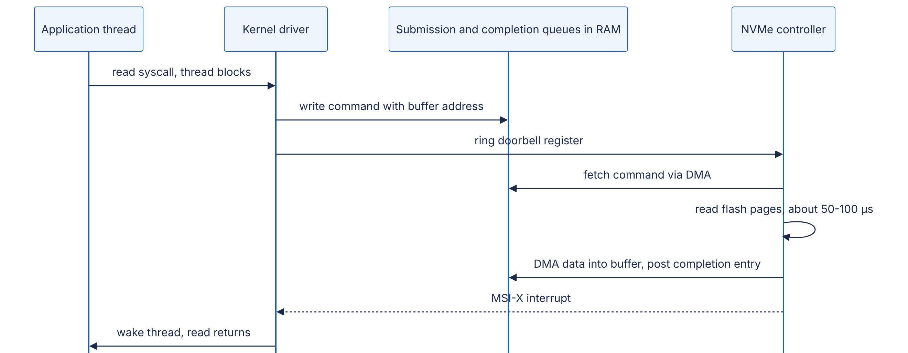
Reading the diagram. Four participants: the application thread, the kernel’s NVMe driver, the command queues living in ordinary RAM, and the SSD’s controller. The application’s read system call is synchronous for the thread — it blocks — but the CPU core is free to run other threads in the meantime. The kernel writes a command describing the request and the destination buffer into a submission queue in memory, then writes to a doorbell register on the device over PCIe. From then on the device does the work: it fetches the command, reads flash, and DMAs the data straight into the buffer — no CPU copying. Finally it posts a completion entry and raises an interrupt (dashed arrow: asynchronous notification). The storage boundary is crossed only by the device. Failure points: the device may time out (the driver resets it and fails the I/O), and a buggy device with unrestricted DMA could overwrite arbitrary memory, which is why servers use an IOMMU to restrict which addresses each device may access. Scaling comes from many queue pairs (one per core) and many outstanding commands (§5.6.5).

5.7.4 Polling and interrupt coalescing
When events are very frequent, polling — a core repeatedly checking a completion queue — is cheaper than taking an interrupt per event, at the cost of burning a core even when idle. Practical systems mix the two. Network cards coalesce interrupts (one interrupt per batch of packets or per few microseconds), and Linux’s NAPI network subsystem switches from interrupts to polling under load, then back again when traffic subsides. This is the batching principle of §5.12 appearing inside the kernel. How programs see all this — blocking calls versus non-blocking interfaces such as epoll and io_uring — is covered in §6.13; underneath, the device always works in parallel with the CPU, and software’s job is to keep enough requests in flight.

5.7.5 Kernel bypass (introduction)
For each I/O, the conventional path crosses the user/kernel boundary, runs generic driver code, and often copies data between kernel and user buffers. At 10–100 Gbit/s or a million IOPS, those per-operation costs (each a few hundred nanoseconds to microseconds) become the bottleneck. Kernel bypass lets an application drive the device directly from user space:
- DPDK (Data Plane Development Kit) — user-space network drivers that poll NIC queues; used in software routers, load balancers and packet processors [DPDK Documentation].
- SPDK (Storage Performance Development Kit) — the same approach for NVMe storage [SPDK Documentation].
- RDMA (remote direct memory access) — network cards that read and write a remote machine’s memory without involving the remote CPU, used in HPC and some databases and ML clusters (Ch 49, Ch 65).
- io_uring (Linux 5.1, 2019) — not a full bypass, but shared submission/completion rings between application and kernel that remove most per-operation system calls and can poll [Axboe 2019].
Bypass trades generality, security isolation and operational simplicity for raw speed: you dedicate cores to polling, give up the kernel’s TCP stack or file system, and take on more of the driver’s responsibilities. Most services never need it; network appliances, exchanges and storage engines sometimes do.
Table 5.8 — I/O mechanisms compared.
Mechanism | CPU cost per transfer | Latency | Best for | Drawback
Programmed I/O | Very high (CPU copies every word) | Low for tiny transfers | Device configuration | Wastes CPU on bulk data
Interrupt-driven + DMA | Low per byte; ~µs per interrupt | Adds interrupt + wake-up time | General-purpose I/O | Interrupt storms at high event rates
Polling | A dedicated core, even when idle | Lowest | Very high event rates | Burns CPU and power
Coalescing / hybrid (NAPI) | Low | Slightly higher for single events | Network stacks under variable load | Tuning trade-off between latency and CPU
Kernel bypass (DPDK/SPDK/RDMA) | Lowest per operation | Lowest | Packet processing, storage engines, HPC | Complexity; loses kernel features

5.8 CPU-bound versus I/O-bound workloads
DEFINITION
Definition — CPU-bound and I/O-bound. A workload is CPU-bound when its speed is limited by how fast the processor can execute instructions; giving it a faster CPU or more cores speeds it up. It is I/O-bound when it spends most of its time waiting for storage or the network; a faster CPU barely helps, but more concurrency or faster devices do. A related category, memory-bound, is limited by memory latency or bandwidth (§5.9) — the CPU looks “busy” but is mostly stalled.
A cook who spends all day chopping is CPU-bound: hire more cooks. A cook who spends all day waiting for deliveries is I/O-bound: hiring more cooks only adds more people waiting — what helps is ordering many deliveries at once, or keeping stock closer to hand (caching).

5.8.1 How to tell
Figure 5.8 — Diagnosing what limits a workload.
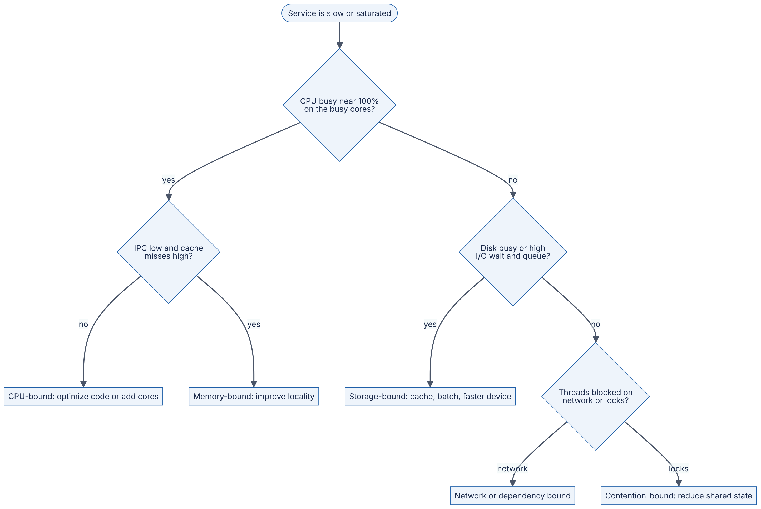
Reading the diagram. Start at the top with a symptom and walk the decisions using measurements, not guesses. CPU utilization per core (not the machine average, which hides one saturated core) separates “computing” from “waiting”. Among busy CPUs, instructions per cycle and cache-miss counters (from perf stat on Linux) separate genuine computation from stalls on memory. Among idle CPUs, disk utilization and queue length (iostat -x) reveal storage limits, and thread dumps or off-CPU profiles reveal whether threads wait on network calls to dependencies or on locks. Each leaf names a different remedy; applying the wrong one (more threads for a CPU-bound service, a faster CPU for an I/O-bound one) wastes money. This is the resource model of §2.6 applied to one machine; the systematic version is Brendan Gregg’s USE method (§23.3) [Gregg 2020].
Table 5.9 — Signals that distinguish CPU-bound from I/O-bound workloads.
Signal | CPU-bound | I/O-bound
Per-core CPU utilization | Near 100% in user time | Low or moderate
time output for a command | user + sys ≈ real (× cores used) | real ≫ user + sys
Effect of a faster CPU | Proportional speed-up | Little effect
Effect of more threads | Helps up to the core count, then hurts | Helps until the device or dependency saturates
Typical examples | Compression, encryption, image resizing, JSON parsing at scale, model inference on CPU | Database queries over the network, file servers, API gateways, web crawlers
A caution about the Linux %iowait metric: it reports idle time during which some I/O was outstanding. It is a hint, not a measure of I/O capacity; a fully busy CPU can hide I/O waits, and on multi-core machines the number is easy to misread [Gregg 2020].

5.8.2 Why it matters for thread pools
FORMULA
Thread pool sizing heuristic [Goetz et al. 2006, §8.2]
$$N_{threads}=N_{cores}×U_{target}×\left(1+\frac{W}{C}\right)$$
Symbol | Meaning | Units
$N_{threads}$ | Threads in the pool | threads
$N_{cores}$ | Cores available to the pool | cores
$U_{target}$ | Target CPU utilization (0–1) | dimensionless
$W$ | Average time a task spends waiting (I/O, remote calls) | seconds
$C$ | Average CPU time per task | seconds
WORKED EXAMPLE
Worked example — Sizing pools for two services on an 8-core machine.
- Image-thumbnail service (CPU-bound): $W≈0$, so $N=8×1×\left(1+0\right)=8$ threads. Goetz et al. suggest $N_{cores}+1$ to cover the occasional page fault. Using 64 threads would add context switches and cache thrashing, not throughput.
- Order API (I/O-bound): each request uses $C=5$ ms of CPU and waits $W=50$ ms on the database. At $U_{target}=1$: $N=8×\left(1+50/5\right)=8×11=88$ threads. At $U_{target}=0.8$, leaving headroom: $8×0.8×11=70.4≈70$ threads.
- Maximum throughput of the order API is set by CPU: $8\text{ cores}/5\text{ ms}=1600$ requests/s at 100% CPU. Little’s Law check: $1600\text{ req/s}×55\text{ ms}=88$ requests in flight ✓.
Interpretation. The I/O-bound service needs about 11× more threads than cores, because each thread spends 10/11 of its life waiting. Engineering implication. The formula assumes the dependency can absorb the load: 88 concurrent requests need about 88 database connections (§14.13). If the database saturates first, more threads only lengthen its queue. Event loops and async runtimes (§6.15) achieve the same concurrency with far fewer threads.
COMMON MISTAKE
“Python threads speed up CPU-bound work.” In CPython the global interpreter lock (GIL) lets only one thread execute Python bytecode at a time, so threads help I/O-bound Python code but not pure-Python CPU-bound code; use processes or native extensions (such as numpy) that release the lock. Free-threaded CPython builds exist experimentally since Python 3.13 (as of 2025), which may change this advice over time.

5.9 Memory latency and bandwidth

5.9.1 Two different numbers
DEFINITION
Definition — Latency and bandwidth (hardware). Latency is the time from issuing one request to receiving its first byte (for example, ~100 ns for a DRAM load). Bandwidth is the maximum rate at which data can be moved once transfers are flowing (for example, ~38 GB/s for one DDR5-4800 channel). Achieved bandwidth is throughput.
A motorway is the usual picture: latency is how long one car takes to drive from A to B; bandwidth is how many cars per hour the road can carry. Adding lanes raises bandwidth but does not make any single car arrive sooner. For hardware, latency improves slowly (DRAM latency has changed little in two decades), while bandwidth improves steadily with more channels and faster signaling [Hennessy & Patterson 2017, ch. 2]. Designs that need bandwidth can buy it; designs that need low latency must avoid the trip altogether — by caching, prefetching or co-locating data.
FORMULA
Peak DRAM bandwidth
$$BW_{peak}=R_{transfer}×W_{bus}×N_{channels}$$
Symbol | Meaning | Units
$R_{transfer}$ | Data transfers per second per channel (the “4800” in DDR5-4800) | transfers/second (MT/s)
$W_{bus}$ | Width of a channel’s data path: 8 bytes (64 bits) | bytes/transfer
$N_{channels}$ | Populated memory channels | channels
WORKED EXAMPLE
Worked example — How much bandwidth does a server socket have?
- One DDR5-4800 channel: $4800×{10}^{6}×8=38.4×{10}^{9}$ B/s $=38.4$ GB/s.
- A socket with 8 channels: $8×38.4=307.2$ GB/s. With 12 channels (as on some 2023–2024 server CPUs): $12×38.4=460.8$ GB/s.
Interpretation. These are theoretical peaks; sustained throughput on streaming benchmarks is typically 70–90% of peak (approximate). Engineering implication. Leaving channels unpopulated to save money (four DIMMs in an eight-channel server) halves memory bandwidth — a common, invisible misconfiguration for analytics and ML workloads.

5.9.2 Why one core cannot use all the bandwidth: Little’s Law in memory
Bandwidth is only achieved if enough requests are in flight to cover the latency — the same law as for SSDs (§5.6.5).
WORKED EXAMPLE
Worked example — Memory-level parallelism.
Each core can track a limited number of outstanding L1 misses — on the order of 10–20 on recent x86 cores (as of 2024, approximate; hardware prefetchers into L2 add more). Assume 12 outstanding 64-byte misses and 100 ns latency.
- Bytes in flight $=12×64=768$ B.
- Throughput $=768\text{ B}/100\text{ ns}=7.68$ B/ns $=7.68$ GB/s.
- To saturate an 8-channel socket at 307.2 GB/s with a loaded latency of ~110 ns: bytes in flight $=307.2×{10}^{9}×110×{10}^{−9}=33 792$ B $=528$ cache lines.
Interpretation. One thread doing demand loads tops out well below the socket’s bandwidth; it takes many cores — or very effective prefetching — to keep 500+ lines in flight. Engineering implication. Memory-bound jobs (scans, aggregations, embedding lookups) scale with cores until the memory channels saturate, then stop, however many more cores you add. Pointer chasing is worst of all: with one outstanding miss, throughput is $64\text{ B}/100\text{ ns}=0.64$ GB/s.

5.9.3 Worked examples: scanning 1 GB
The single most useful exercise in this chapter is estimating how long it takes to read 1 GB (${10}^{9}$ bytes) from each place it might live.
WORKED EXAMPLE
Worked example — Time to read 1 GB (as of 2024–2025, approximate rates).
Sequential reads: $T={10}^{9}\text{ B}/\text{throughput}$.
- DRAM, one thread streaming at ~10 GB/s: ${10}^{9}/{10}^{10}=0.1$ s $=100$ ms. Whole socket at ~200 GB/s achieved: 5 ms.
- NVMe SSD (PCIe 4.0) at ~7 GB/s: ${10}^{9}/\left(7×{10}^{9}\right)≈0.143$ s $=143$ ms.
- SATA SSD at ~550 MB/s: ${10}^{9}/\left(5.5×{10}^{8}\right)≈1.82$ s.
- HDD at ~200 MB/s: ${10}^{9}/\left(2×{10}^{8}\right)=5$ s.
- Network at 1 / 10 / 100 Gbit/s ($=0.125$ / $1.25$ / $12.5$ GB/s): 8 s / 0.8 s / 0.08 s, before protocol overhead of a few percent.
Random reads: the same gigabyte read as many small, dependent requests.
- DRAM, random 64-byte lines, one at a time: ${10}^{9}/64=15 625 000$ lines $×$ 100 ns $=1.5625$ s — about 16× slower than streaming the same memory.
- NVMe, random 4 KiB reads at QD 1: ${10}^{9}/4096≈244 141$ reads $×$ 80 µs $≈19.5$ s. At QD 80 (~${10}^{6}$ IOPS): $244 141/{10}^{6}≈0.24$ s.
- HDD, random 4 KiB reads: $244 141×12.69$ ms $≈3098$ s $≈51.6$ minutes.
Interpretation. Between the best case (5 ms) and the worst (52 minutes) lies a factor of about 600,000 — for the same gigabyte. Engineering implication. The access pattern matters as much as the device: random HDD access is 620× slower than sequential HDD access, and random DRAM access is slower than sequential NVMe access. This is why databases build indexes that turn scans into a few targeted reads, why analytics systems store columns contiguously, and why caches exist at every level.
Table 5.10 — Time to read 1 GB, summary (as of 2024–2025, approximate).
Source and pattern | Rate or latency assumed | Time
DRAM, all cores streaming | ~200 GB/s | ~5 ms
DRAM, one thread streaming | ~10 GB/s | ~0.1 s
NVMe SSD, sequential | ~7 GB/s | ~0.14 s
10 Gbit/s network | 1.25 GB/s | ~0.8 s
DRAM, dependent random 64 B reads | 100 ns each | ~1.6 s
SATA SSD, sequential | 0.55 GB/s | ~1.8 s
HDD, sequential | 0.2 GB/s | ~5 s
NVMe SSD, random 4 KiB, QD 1 | 80 µs each | ~20 s
HDD, random 4 KiB | 12.7 ms each | ~52 min

5.9.4 Latency numbers, then and now
Jeff Dean’s list of “numbers everyone should know”, presented in 2009 and building on a similar table by Peter Norvig, is the best-known summary of these facts [Dean 2009; Norvig 2001]. §4.17 discusses it in full; Table 5.11 shows how the hardware-specific entries compare with this chapter’s figures.
Table 5.11 — Classic latency numbers versus approximate 2024–2025 values.
Operation | Dean 2009 | Approx. 2024–2025 (this chapter) | What changed
L1 cache reference | 0.5 ns | ~1 ns | About the same in cycles; clocks stalled near 3–5 GHz
Branch mispredict | 5 ns | ~4–5 ns (15–20 cycles) | Little change
L2 cache reference | 7 ns | ~3–5 ns | Somewhat faster
Main memory reference | 100 ns | ~80–120 ns | Essentially unchanged
Read 1 MB sequentially from memory | 250 µs | ~50–100 µs per thread | Bandwidth grew ~3–5×
Disk seek | 10 ms | ~4–10 ms | Mechanics barely changed
Read 1 MB sequentially from disk | 20 ms | ~5 ms | Higher areal density
Random read from SSD | Not in 2009 list (150 µs in later versions) | ~50–100 µs | SSDs became mainstream
Read 1 MB sequentially from NVMe SSD | Not in 2009 list (1 ms for SSD in later versions) | ~0.15–0.3 ms | New tier
Versions of Dean’s list differ slightly in individual entries; the durable lesson is the shape: memory latency stuck, bandwidth up, disks still mechanical, flash filling the gap between them.

5.10 NUMA
DEFINITION
Definition — NUMA (non-uniform memory access). A memory architecture in which each processor socket (or each chiplet group within a socket) has its own directly attached memory. A core can access all memory in the machine, but accessing its local memory is faster than accessing remote memory attached to another socket.
Picture two kitchens joined by a corridor, each with its own fridge. A chef can fetch from either fridge, but the far one takes noticeably longer and the corridor can get crowded. NUMA exists because a single shared memory controller cannot scale to dozens of cores and hundreds of GB/s; attaching memory to each socket multiplies total bandwidth, at the price of uneven latency [Lameter 2013].
Figure 5.9 — A two-socket NUMA server.
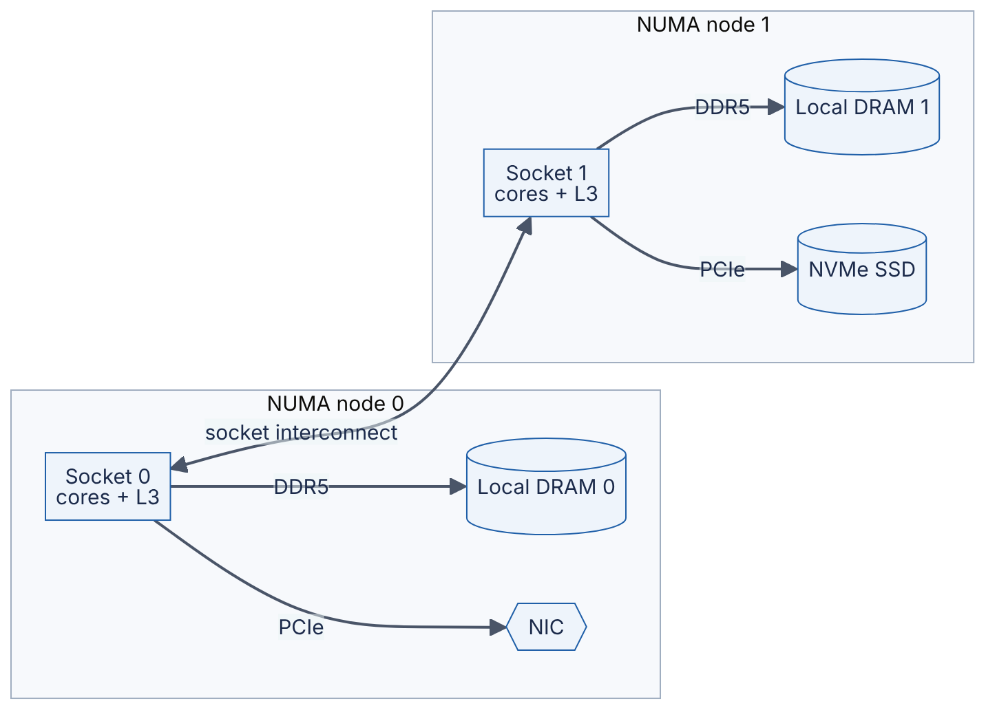
Reading the diagram. Each socket, with its cores, its L3 cache, its memory channels and its PCIe devices, forms a NUMA node. A core on socket 0 reaches DRAM 0 directly; to reach DRAM 1 its request travels over the socket-to-socket interconnect (Intel UPI, AMD Infinity Fabric), adding latency — remote accesses commonly cost about 1.5–2× local ones (as of 2024, approximate; Linux reports relative distances via numactl --hardware, typically 10 for local and around 20 or more for remote). Devices are local to one node as well: packets arriving on a NIC attached to socket 0 are cheapest to process on socket 0’s cores. The interconnect is shared and carries coherence traffic too, so it is both a latency penalty and a bandwidth bottleneck. Failure points are performance failures — a process whose threads run on node 1 while its memory sits on node 0. Scaling within the machine means keeping threads, their memory and their devices on the same node.
WORKED EXAMPLE
Worked example — The cost of ignoring NUMA.
Assume local DRAM latency 80 ns and remote 140 ns.
- Two sockets, memory placed without regard to which node will use it: about half of accesses are remote. Average $=0.5×80+0.5×140=40+70=110$ ns, 37.5% worse than all-local.
- Four sockets, memory interleaved evenly: 75% remote. Average $=0.25×80+0.75×140=20+105=125$ ns, 56% worse.
Interpretation. For memory-bound work, NUMA-unaware placement directly inflates latency and congests the interconnect. Engineering implication. On large servers, pin latency-sensitive processes to one node (numactl --cpunodebind=0 --membind=0), run one process per node rather than one huge process, or prefer smaller single-socket instances. Cloud VMs that span sockets expose NUMA topology too.
INDUSTRY EXAMPLE
MySQL “swap insanity” on two-socket servers. Jeremy Cole described MySQL servers with a buffer pool sized for the whole machine’s RAM that nevertheless swapped to disk. Linux’s default policy allocated memory from the local node of the allocating thread, so one NUMA node filled up while the other had free memory, and the kernel swapped instead of using the remote node. His recommended remedy was to start MySQL with memory interleaved across nodes (numactl --interleave=all), accepting uniformly higher latency in exchange for predictable behavior; later MySQL versions added an option to interleave the buffer pool. Evidence: Primary — [Cole 2010]
COMMON MISTAKE
“All RAM in a server is equally fast.” On multi-socket and many-chiplet servers it is not. Check lscpu and numactl --hardware before benchmarking, and keep the benchmark’s threads and memory on the same node or document that you did not.

5.11 SIMD and accelerators

5.11.1 SIMD
DEFINITION
Definition — SIMD (single instruction, multiple data). CPU instructions that apply the same operation to several data elements packed into one wide vector register at once — for example, adding eight pairs of 32-bit floats in a single instruction.
Instead of a cook slicing one carrot at a time, SIMD is a mandoline that slices eight at once with a single stroke. It pays off when the same operation runs over large arrays of uniform data: image and audio processing, compression, checksums, string search, database column scans and machine-learning arithmetic.
Table 5.12 — Common SIMD instruction sets (as of 2025).
Instruction set | Platform | Register width | 32-bit floats per instruction
SSE family | x86 | 128 bits | 4
AVX / AVX2 | x86 | 256 bits | 8
AVX-512 | x86 (many server parts) | 512 bits | 16
NEON (Advanced SIMD) | ARM | 128 bits | 4
SVE / SVE2 | ARM (some server parts) | 128–2048 bits, implementation-defined | 4–64
You rarely write SIMD instructions by hand. Compilers auto-vectorize simple loops, and libraries such as numpy, BLAS and database engines ship vectorized kernels. Your job is to give them data they can vectorize: contiguous arrays of one type, not lists of objects. The database research system MonetDB/X100 showed that processing data in cache-sized vectors of column values, rather than one row at a time, cut interpretation overhead and enabled SIMD, which shaped modern vectorized analytics engines [Boncz et al. 2005].
"""simd.py — interpreted loop vs vectorized (SIMD-backed) numpy."""
import time
import numpy as np
n = 10_000_000
a = np.random.rand(n).astype(np.float32)
b = np.random.rand(n).astype(np.float32)
t0 = time.perf_counter()
out = [0.0] * n
for i in range(n): # one element at a time, interpreted
out[i] = a[i] * b[i] + 1.0
t1 = time.perf_counter()
c = a * b + 1.0 # whole-array ops in compiled, SIMD loops
t2 = time.perf_counter()
print(f"python loop: {t1 - t0:.2f} s")
print(f"numpy: {t2 - t1:.4f} s ({(t1 - t0) / (t2 - t1):.0f}x faster)")
What to notice:
- Both versions compute the same 10 million results.
- The speed-up (about 20× on the test VM in 2026; often larger) comes from two sources: removing the interpreter’s per-element overhead, and SIMD in numpy’s compiled loops. Do not attribute it all to SIMD.
- a * b + 1.0 makes two passes over memory and allocates a temporary array; at this size the vectorized version is limited by memory bandwidth (§5.9), not arithmetic.

5.11.2 Accelerators
When one kind of computation dominates a workload, it can pay to build or buy hardware specialized for it:
- GPUs — thousands of simple arithmetic lanes and very high-bandwidth memory (HBM), designed for massively parallel, regular computation. They dominate ML training and inference. Chapter 64 covers their architecture, the roofline model [Williams et al. 2009] and the compute-bound versus memory-bound distinction in depth.
- TPUs and other ML ASICs — chips built around large matrix-multiply units [Jouppi et al. 2017].
- Fixed-function units inside the CPU — AES and SHA instructions make TLS encryption cheap; compression and cryptography offload engines exist on some server CPUs and NICs.
- SmartNICs / DPUs and FPGAs — network cards with programmable processors that offload packet processing, storage virtualization or encryption from the host CPU.
The design question is always whether the workload is large and regular enough to justify specialized hardware, and whether data can reach it fast enough — an accelerator starved by PCIe or by CPU-side data preparation delivers a fraction of its rated speed.

5.12 Throughput versus latency at the hardware level

5.12.1 The pattern underneath everything
Every component in this chapter shows the same trade-off. A pipeline raises instruction throughput without shortening any instruction. Out-of-order cores and memory-level parallelism raise memory throughput by keeping many misses in flight. NVMe queues raise IOPS by keeping dozens of requests outstanding. Interrupt coalescing raises packet throughput by delaying notifications. In each case Little’s Law ($L=λW$, §4.11) holds: to get throughput $λ$ from a resource with latency $W$, you need $L=λW$ operations in flight. Latency is mostly fixed by physics; throughput is bought with parallelism and batching.
FORMULA
Throughput with batching (fixed plus per-item cost)
$$X\left(B\right)=\frac{B}{F+B×v}, T_{batch}\left(B\right)=F+B×v, X_{max}=\frac{1}{v}$$
Symbol | Meaning | Units
$B$ | Items per batch | items
$F$ | Fixed cost per operation (system call, device round trip, interrupt, network RTT) | seconds
$v$ | Variable cost per item | seconds/item
$X\left(B\right)$ | Throughput at batch size $B$ | items/second
$T_{batch}\left(B\right)$ | Time to complete one batch | seconds
WORKED EXAMPLE
Worked example — Batching small writes.
Writing 100-byte records to a log, each write call has fixed cost $F=50$ µs and per-record cost $v=0.1$ µs.
- $B=1$: $X=1/50.1\text{ µs}≈19 960$ records/s; each write completes in 50.1 µs.
- $B=100$: $T=50+100×0.1=60$ µs; $X=100/60\text{ µs}≈1.67$ million records/s.
- $B=1000$: $T=50+100=150$ µs; $X=1000/150\text{ µs}≈6.67$ million records/s.
- Ceiling: $X_{max}=1/0.1\text{ µs}=10$ million records/s.
Interpretation. Batching 100 records multiplies throughput by about 84× while raising per-batch latency only from 50 µs to 60 µs; going to 1000 gains another 4× in throughput but per-batch latency rises 2.5×, plus the time spent waiting for the batch to fill. Engineering implication. Batch until the fixed cost is amortized (a few times $F/v$ items), then stop; bound the wait with a timer. Kafka producers (linger.ms, §31.6), group commit in databases (§13.5) and dynamic batching in model serving (Ch 66) all implement this curve.

5.12.2 How hardware facts drive system design decisions
Figure 5.10 — From hardware facts to design decisions.
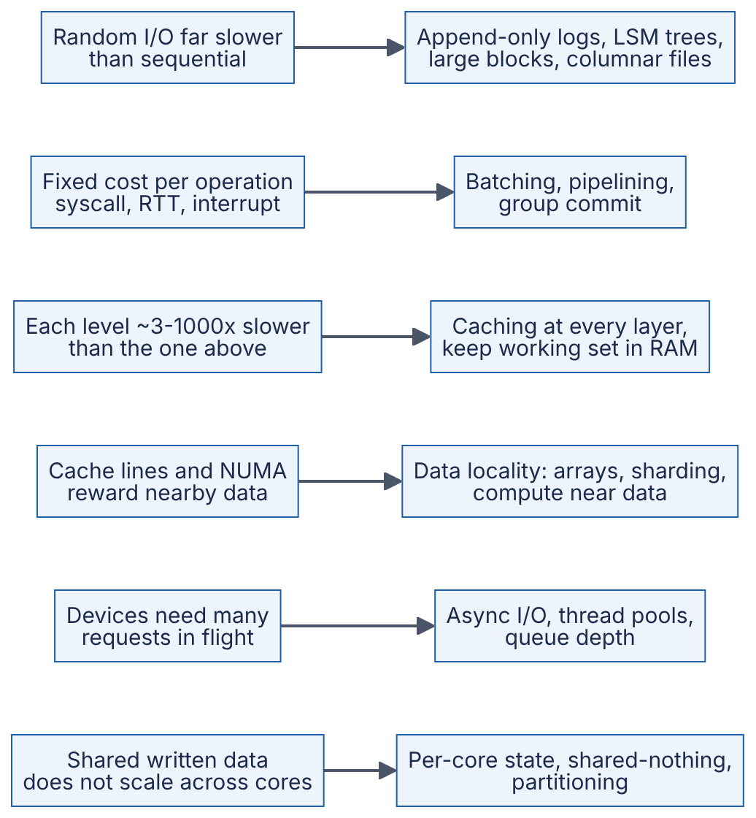
Reading the diagram. Each row pairs a physical fact (left) with the design principle it forces (right); arrows mean “therefore”. None of these is a fashion — each follows from numbers you calculated in this chapter. The same principles reappear at datacenter scale: a cross-region network round trip is to a datacenter what a DRAM miss is to a core, so caching, batching, locality and parallelism return in Part IV (scalability, caching, CDNs) and Part V (distributed systems). When a design violates one of these pairs — chatty per-item network calls, random writes to disks, a global counter updated by every core — it usually fails at scale for precisely the reason on the left.
Table 5.13 — Hardware facts and the design decisions they drive.
Hardware fact (§) | Design decision | Examples in this book
Sequential ≫ random on HDD (~620×) and still better on SSD (§5.6) | Write sequentially; read in large chunks | Write-ahead logs (§13.5), LSM trees (§13.8), Kafka (§31.13)
Fixed cost per operation (§5.7, §5.12) | Batch and pipeline | Kafka batching (§31.6), HTTP/2 multiplexing (§7.9), dynamic batching (Ch 66)
Memory hierarchy steps of 3–1000× (§5.5) | Cache hot data close to its consumer | Buffer pools (§13.4), Redis (§20.6), CDNs (Ch 21)
Cache lines, prefetching, NUMA (§5.4, §5.10) | Keep related data together and near the compute | Columnar storage (§13.13), data locality in Spark (§29.7)
Devices need queue depth (§5.6.5) | Concurrency in the I/O path | io_uring and event loops (§6.13), connection pools (§7.16)
Coherence makes shared writes expensive (§5.4.6) | Avoid shared mutable state; partition it | Shard-per-core designs, partitioned databases (Ch 14)
DRAM is volatile (§5.5) | Durability needs persistent media or replicas | fsync (§6.14), replication (Ch 27)
INDUSTRY EXAMPLE
ScyllaDB and the Seastar framework (shard-per-core). ScyllaDB, a Cassandra-compatible database, is built on the Seastar framework, which runs one thread per core, partitions data so that each core owns its shard, and passes messages between cores instead of sharing locked data structures. The design avoids cache-line contention and lock overhead and keeps each core’s data in its own caches and local NUMA memory. Trade-off: everything must be asynchronous, and skewed keys can overload a single core. Evidence: Primary — [Seastar Documentation]
RECOMMENDATION
Mechanical sympathy in practice. (1) Estimate before you build: write down the latency and bandwidth of each hop. (2) Prefer arrays and contiguous layouts for hot data. (3) Turn many small operations into fewer large ones. (4) Keep enough requests in flight to use your devices. (5) Do not share frequently written data across cores or machines. (6) Measure with hardware counters (perf) before and after; intuition about hardware is often wrong.
INTERVIEW TIP
Interview tip. When an interviewer asks “why is X fast?” (Kafka, Redis, a columnar database), the answer almost always maps onto one row of Table 5.13. Say the hardware fact and its number first, then the design choice.

5.13 Summary and revision notes
SUMMARY
- A CPU core repeatedly fetches, decodes and executes instructions. Execution time = instructions × CPI × cycle time; clock rates stalled near 3–5 GHz around 2005, so performance now comes from more work per cycle and more cores.
- Pipelining, superscalar issue and out-of-order execution raise throughput by overlapping instructions; branch prediction keeps the pipeline fed. Mispredictions (~15–20 cycles) and dependent memory accesses are what slow cores down.
- SMT (hyperthreading) shares one core between two hardware threads; a cloud vCPU is usually one such thread, not a full core.
- Caches (L1 ~1 ns, L2 ~4 ns, L3 ~15 ns, DRAM ~100 ns; as of 2024–2025, approximate) exploit temporal and spatial locality. Data moves in 64-byte cache lines; sequential access is the best case and pointer chasing the worst.
- AMAT = hit time + miss rate × miss penalty, applied level by level; layout alone can change it 10×.
- MESI keeps caches coherent per line; writes to one line from several cores cause ping-pong. False sharing is unrelated variables in one line; fix it with padding or per-thread data.
- The memory hierarchy spans ~1 ns to ~10 ms and about 1000× in cost per GB; DRAM and above are volatile.
- HDD access = seek + rotational latency + transfer; ~80–200 random IOPS versus ~200 MB/s sequential (~620× gap for 4 KiB reads).
- Flash writes pages, erases blocks and wears out; the FTL remaps writes, garbage-collects and causes write amplification. NVMe’s many deep queues unlock flash parallelism that SATA’s single 32-entry queue cannot.
- IOPS = queue depth / latency: fast devices need many requests in flight.
- I/O evolves from programmed I/O to interrupts + DMA to polling and kernel bypass as event rates rise.
- CPU-bound work needs ~one thread per core; I/O-bound work needs about N_cores × (1 + W/C) threads, limited by downstream capacity.
- Latency barely improves; bandwidth does. Peak DRAM bandwidth = transfer rate × 8 bytes × channels; achieving it needs hundreds of misses in flight.
- NUMA makes remote memory ~1.5–2× slower; keep threads, memory and devices on one node.
- SIMD and accelerators speed up regular, data-parallel work if data is contiguous and can be fed fast enough.
- Hardware facts drive design: sequential I/O, batching, caching, data locality, concurrency in the I/O path, and no shared mutable hot spots.

5.14 Knowledge checkpoint
- Using the iron law, what happens to execution time if CPI rises from 0.5 to 0.75 at a fixed clock rate and instruction count?
- Why does a deeper pipeline make branch mispredictions more expensive?
- Why can an out-of-order core hide the latency of ten independent loads but not ten loads in a linked list?
- What is the difference between temporal and spatial locality? Give one example of each.
- In a 32 KiB, 8-way cache with 64-byte lines, how many sets are there, and why are addresses 4 KiB apart a problem?
- Compute AMAT for $t_{L1}=1$ ns, $m_{L1}=0.1$, and a flat 50 ns penalty for every L1 miss.
- Name the four MESI states and say which one allows a write without any coherence traffic.
- Two threads increment separate counters and get slower when you add the second thread. What is the likely cause and the fix?
- A 5400 RPM disk has an average seek of 10 ms. What is its average rotational latency and approximate random-read IOPS for small blocks?
- Why can a flash SSD not overwrite a page in place, and what does the FTL do instead?
- A device has 100 µs latency. What queue depth is needed for 400,000 IOPS?
- What is DMA and what problem does it solve?
- A service’s time output shows real = 10 s, user + sys = 0.5 s. Is it CPU-bound or I/O-bound? What would you change first?
- What is the peak bandwidth of six DDR5-5600 channels?
- On a two-socket server, local latency is 90 ns and remote 150 ns. What is the average latency if 30% of accesses are remote?
Answers
- Time rises by 50% (0.75 / 0.5 = 1.5), because time is proportional to CPI.
- The branch outcome is known later in a deeper pipeline, so more stages hold wrongly fetched instructions that must be flushed; more cycles are lost per misprediction.
- Independent loads can all be issued and outstanding at once, overlapping their latency. In a linked list each address is known only after the previous load returns, so the latencies add up serially.
- Temporal: reusing the same data soon (a loop counter, a hot config value). Spatial: using nearby data soon (the next array element, adjacent struct fields).
- $32 768/\left(64×8\right)=64$ sets. Addresses $64×64=4096$ bytes apart map to the same set, so a 4 KiB stride can use only 8 lines (one set) and suffers conflict misses.
- $1+0.1×50=6$ ns.
- Modified, Exclusive, Shared, Invalid. Writes to an Exclusive line (moving it to Modified) need no bus/interconnect traffic; a line already in Modified also needs none.
- False sharing: both counters are in one cache line, which ping-pongs between cores. Pad each counter to its own 64-byte line or keep per-thread counters and combine them at the end.
- One revolution $=60/5400=11.1$ ms; average rotational latency $=5.56$ ms. Access ≈ $10+5.56≈15.6$ ms, so ≈ $1/0.0156≈64$ IOPS.
- Flash must be erased before being reprogrammed, and erase works only on whole blocks of many pages. The FTL writes the new data to a free page, updates its logical-to-physical map, marks the old page invalid and later garbage-collects blocks.
- $QD=400 000×100×{10}^{−6}=40$ outstanding requests.
- Direct memory access lets a device copy data to or from RAM itself; the CPU only sets up the transfer and handles the completion, so CPU cycles are not spent copying bytes.
- I/O-bound (or waiting on something): the CPU was busy only 5% of the time. Find what it waits on — disk, network or locks — and add concurrency, caching or batching rather than a faster CPU.
- $5600×{10}^{6}×8×6=268.8×{10}^{9}$ B/s $=268.8$ GB/s.
- $0.7×90+0.3×150=63+45=108$ ns.

5.15 Interview questions

Basic
Q1. Why is reading data sequentially faster than reading it randomly, on both disks and memory? Answer. On an HDD a random read pays a seek (~4–10 ms) and half a rotation (~4 ms at 7200 RPM) for every request, while a sequential read pays them once and then streams at ~200 MB/s — about 620× faster for 4 KiB requests. In memory, data arrives in 64-byte cache lines and hardware prefetchers detect sequential patterns and fetch ahead, so sequential reads hit in cache while random reads each pay ~100 ns of DRAM latency. SSDs narrow the gap but still favor large sequential I/O.
Q2. What is a cache line and why should a programmer care? Answer. The 64-byte (on most x86 and ARM servers) unit in which data moves between memory and caches. It means neighbors of anything you read are nearly free (so arrays and compact structs are fast), and that coherence works per line, so threads writing different variables in the same line interfere (false sharing).

Intermediate
Q3. You moved a service from an 8-vCPU to a 32-vCPU instance and throughput rose only 30%. What could explain this, and how would you investigate? Answer. Candidates: (1) the service is limited by something other than CPU — a database, a lock, a single-threaded component (check per-thread CPU, thread dumps); (2) contention on shared cache lines (atomic counters, false sharing, a JVM internal structure) — check with perf c2c or cache-miss counters; (3) NUMA effects if the larger instance spans sockets; (4) vCPUs are hyperthreads, so 32 vCPUs are 16 cores. Measure per-core utilization and IPC before and after, then test hypotheses one by one. Netflix’s published 2022 case was exactly this pattern, caused by cache-line sharing in the JVM.
Q4. How would you size a thread pool for a service that calls a database? Answer. Measure CPU time per request $C$ and wait time $W$. Start with $N=N_{cores}×U×\left(1+W/C\right)$; e.g., 8 cores, $C=5$ ms, $W=50$ ms gives ~88 threads at full utilization. Then cap it by the downstream: the database connection pool and the database’s own capacity. Validate with a load test, watching p99 latency and CPU; if latency rises without throughput gain, the pool is too large. For very high concurrency, consider async I/O instead.

Advanced
Q5. Explain why Kafka can sustain high throughput even on hard disks. Answer. Each partition is an append-only log, so writes are sequential (no seeks). Reads by consumers are also mostly sequential and usually served from the OS page cache because recently written data is still in RAM. Producers and brokers batch many messages per request, amortizing per-request fixed costs (Table 5.13). Data is sent from page cache to socket without copying through user space (zero-copy, §31.13). Each design choice maps to a hardware fact: sequential ≫ random, fixed per-operation costs, and DRAM ≫ disk.
Q6. Design the counters for a metrics library that must record 50 million increments per second across 64 cores. Answer. A single shared atomic counter would ping-pong one cache line between 64 cores and cap at a few tens of millions of updates per second or less, with heavy cross-core traffic. Instead, give each core (or thread) its own counter, each padded to its own cache line (or grouped per core in a per-core region), and increment it with plain or relaxed atomic operations. A reader sums all slots when scraping — reads are rare, so their cost is irrelevant. This trades a little memory (64 lines × 64 B = 4 KiB per counter) and slightly stale reads for near-linear scaling. Keep each core’s slots on its own NUMA node. This is the same “partition, don’t share” principle used by shard-per-core databases.

5.16 Practical exercises
- Cache-line stride benchmark (Python + numpy). Run the program below. Plot nanoseconds per element against stride. Explain why the cost per element rises until the stride reaches about 64–128 bytes and then levels off, and why total time stays roughly constant for strides up to 64 bytes.
"""stride.py — how access stride affects time per element touched.
Run: python3 stride.py (needs numpy)
"""
import time
import numpy as np
N_BYTES = 256 * 1024 * 1024 # 256 MiB buffer, far larger than any L3
data = np.ones(N_BYTES // 8, dtype=np.int64) # 8-byte elements
def ns_per_element(stride_elems: int, repeats: int = 3) -> float:
view = data[::stride_elems] # strided view, no copy
best = float("inf")
for _ in range(repeats):
t0 = time.perf_counter()
view.sum() # touches every element of the view
best = min(best, time.perf_counter() - t0)
return best / view.size * 1e9
print(f"{'stride (B)':>10} {'elements':>12} {'ns/element':>11}")
for stride in [1, 2, 4, 8, 16, 32, 64, 128, 512]:
n = data[::stride].size
print(f"{stride * 8:>10} {n:>12,} {ns_per_element(stride):>11.2f}")
What to notice: up to a 64-byte stride every cache line is still fetched, so total time is dominated by moving 256 MiB from DRAM and the time per element grows as fewer elements share each line; beyond 64 bytes each element costs one line fetch (plus adjacent-line prefetch effects up to ~128 bytes). On the test VM the cost rose from ~0.7 ns/element at an 8-byte stride to ~7 ns/element at 256 bytes and above.
- False sharing. Compile and run false_sharing.c from §5.4.7. Then change CACHE_LINE to 32 and 128 and explain the results. Finally, run the packed version with both threads pinned to the same core (taskset -c 0 ./fs) and explain why the penalty disappears.
- Disk and SSD. Using fio, measure random 4 KiB read IOPS at queue depths 1, 4, 16 and 64 on a scratch file on your SSD. Check that IOPS ≈ QD / latency until the device saturates.
- CPU-bound or I/O-bound? Run a compression job (gzip on a large file) and a script that downloads 100 URLs sequentially, each under time. Compare real versus user + sys and watch vmstat 1 during each.
- Topology tour. On a Linux machine, record the output of lscpu, lscpu -C (cache sizes and line size) and numactl --hardware. Draw your own version of Figure 5.1 with real numbers.

5.17 Design challenges
- Log-structured key-value store on HDDs. You must store 20 TB of 1 KB values on HDDs with 50,000 writes/s and 5,000 random reads/s. Estimate how many disks a random-write design would need versus an append-only log with an in-memory index, and what the memory cost of the index would be.
- Analytics scan budget. Analysts want to scan a 2 TB table in under 10 seconds. Using Table 5.10, decide whether this is feasible from NVMe on one machine, from RAM on one machine, or only across a cluster, and how many nodes and what storage format (row or column) you would choose.
- Low-latency order gateway. A trading gateway must handle 2 million messages/s with p99 under 20 µs on one server. Choose between interrupts, polling and kernel bypass for the NIC; decide thread-to-core and NUMA placement; and explain how you would avoid false sharing between the receive and send threads.

5.18 References
- Agrawal, N., Prabhakaran, V., Wobber, T., Davis, J. D., Manasse, M., Panigrahy, R. Design Tradeoffs for SSD Performance. USENIX Annual Technical Conference, 2008.
- Apache Software Foundation. Apache Kafka Documentation — Design. https://kafka.apache.org/documentation/#design
- Axboe, J. Efficient IO with io_uring. 2019. https://kernel.dk/io_uring.pdf
- Boncz, P., Zukowski, M., Nes, N. MonetDB/X100: Hyper-Pipelining Query Execution. CIDR, 2005.
- Bryant, R. E., O’Hallaron, D. R. Computer Systems: A Programmer’s Perspective, 3rd ed. Pearson, 2015.
- Cole, J. The MySQL “swap insanity” problem and the effects of the NUMA architecture. Blog post, 2010.
- Dean, J. Designs, Lessons and Advice from Building Large Distributed Systems. Keynote, LADIS Workshop, 2009.
- DPDK Project. Data Plane Development Kit Documentation. https://doc.dpdk.org/
- Drepper, U. What Every Programmer Should Know About Memory. Red Hat, 2007. https://www.akkadia.org/drepper/cpumemory.pdf
- Filanovsky, V., Sane, H. Seeing through hardware counters: a journey to threefold performance increase. Netflix Technology Blog, 2022.
- Goetz, B., Peierls, T., Bloch, J., Bowbeer, J., Holmes, D., Lea, D. Java Concurrency in Practice. Addison-Wesley, 2006.
- Gregg, B. Systems Performance: Enterprise and the Cloud, 2nd ed. Addison-Wesley, 2020.
- Hennessy, J. L., Patterson, D. A. Computer Architecture: A Quantitative Approach, 6th ed. Morgan Kaufmann, 2017.
- Jouppi, N. P., et al. In-Datacenter Performance Analysis of a Tensor Processing Unit. ISCA, 2017.
- Lameter, C. NUMA (Non-Uniform Memory Access): An Overview. ACM Queue 11(7), 2013.
- LTO Program. LTO technology specifications (LTO-9). https://www.lto.org/
- Marr, D. T., Binns, F., Hill, D. L., Hinton, G., Koufaty, D. A., Miller, J. A., Upton, M. Hyper-Threading Technology Architecture and Microarchitecture. Intel Technology Journal 6(1), 2002.
- Norvig, P. Teach Yourself Programming in Ten Years. 2001. https://norvig.com/21-days.html
- NVM Express, Inc. NVM Express Base Specification. https://nvmexpress.org/specifications/
- Papamarcos, M. S., Patel, J. H. A Low-Overhead Coherence Solution for Multiprocessors with Private Cache Memories. ISCA, 1984.
- Ruemmler, C., Wilkes, J. An Introduction to Disk Drive Modeling. IEEE Computer 27(3), 1994.
- Seastar Project. Seastar Documentation. https://seastar.io/
- Sorin, D. J., Hill, M. D., Wood, D. A. A Primer on Memory Consistency and Cache Coherence. Morgan & Claypool, 2011.
- SPDK Project. Storage Performance Development Kit Documentation. https://spdk.io/
- Thompson, M., Farley, D., Barker, M., Gee, P., Stewart, A. Disruptor: High performance alternative to bounded queues for exchanging data between concurrent threads. LMAX, 2011. https://lmax-exchange.github.io/disruptor/
- Tomasulo, R. M. An Efficient Algorithm for Exploiting Multiple Arithmetic Units. IBM Journal of Research and Development 11(1), 1967.
- Williams, S., Waterman, A., Patterson, D. Roofline: An Insightful Visual Performance Model for Multicore Architectures. Communications of the ACM 52(4), 2009.

5.19 Open verification items
- Cost per GB in Table 5.5 and Table 5.6 reflects approximate 2024 street prices; DRAM and NAND prices moved sharply in 2025–2026. Re-check before publication.
- Exact URLs for [Dean 2009] (LADIS keynote slides), [Cole 2010] and [Filanovsky & Sane 2022] are omitted pending verification; confirm the specific entries of Dean’s list (versions differ, e.g. 20 ms vs 30 ms for 1 MB from disk).
- Confirm the “up to ~30%” Hyper-Threading gain against [Marr et al. 2002] and the MySQL release that added buffer-pool NUMA interleaving.
- Cite a primary source (Intel investor communication, 2022) for the Optane wind-down.
- Microarchitectural ranges (branch-mispredict penalty 15–20 cycles; 10–20 outstanding L1 misses per core; reorder buffer “several hundred” entries) should be checked against current Intel/AMD/Arm optimization manuals.
- TLC endurance of 1,000–3,000 P/E cycles is a commonly quoted range, not a vendor specification.
- Status of free-threaded CPython (experimental from 3.13) may have changed.

Chapter 6 — Operating Systems
Level: 1–2 · Track: Shared · Estimated reading time: 3 h
Every service you will design in this book, whether a URL shortener, a Kafka broker or an LLM inference server, is in the end a set of processes running on an operating system. The operating system decides which of them runs, how much memory each one sees, how its bytes reach the network card and the disk, and what happens when two of them touch the same data at once. When a service is “slow for no reason”, the reason is often here: a context-switch storm, a page-fault spike, a thread pool sized for 200 that is serving 20,000 connections, or an fsync that took 400 ms. This chapter gives you the vocabulary and the mental models to see those problems, estimate them with numbers, and choose designs that avoid them.

6.1 Learning objectives
After this chapter you should be able to:
- Explain what a process and a thread are, draw the process state diagram, and list what the kernel stores in a process control block.
- Describe the steps of a context switch and estimate both its direct cost and its indirect cache cost.
- Compare FCFS, round robin, priority, MLFQ and Linux’s CFS/EEVDF schedulers, and calculate turnaround and response times for a small workload.
- Trace a memory access through the TLB, page table and page-fault handler, and calculate effective access time and TLB reach.
- Explain what a system call is, why it costs more than a function call, and how batching and vDSO reduce that cost.
- Distinguish concurrency from parallelism and identify a race condition and its critical section in code.
- Choose between a mutex, semaphore, condition variable, atomic/CAS operation, read-write lock and lock-free structure, and explain the ABA problem.
- State the four Coffman conditions, apply prevention, avoidance and detection to deadlock, and explain priority inversion using the Mars Pathfinder incident.
- Compare blocking, non-blocking, multiplexed (select/poll/epoll/kqueue) and completion-based (io_uring) I/O, and explain the C10K problem.
- Write a crash-safe file update using fsync correctly and name the common durability pitfalls.
- Compare thread-per-request, event loop, actor, goroutine and async/await concurrency models and size a server’s memory for a target number of concurrent connections.

6.2 Prerequisites
- CPU cores, registers and caches — §5.3–§5.4 (context-switch cost is mostly a cache story).
- RAM and the memory hierarchy — §5.5 and §5.9 (virtual memory sits on top of it).
- Storage devices and I/O with DMA and interrupts — §5.6–§5.7 (I/O models and fsync depend on them).
- Little’s Law — §4.11 (used to size thread pools and connection counts).
- Amdahl’s Law — §4.12 (limits on parallel speed-up).
- Powers of two and binary prefixes — §4.3 and §4.5 (page sizes and address spaces are powers of two). In this chapter, KiB/MiB/GiB (powers of two) are used for page sizes, stacks and address spaces; KB/MB/GB (powers of ten) for rough capacity estimates.

6.3 Processes and threads

6.3.1 What an operating system is for
DEFINITION
Definition — Operating system (OS). The software layer that manages a computer’s hardware (CPU, memory, storage, network) and provides running programs with safe, shared, abstract access to it. The privileged core of the OS that runs with full hardware access is the kernel.

First-principles explanation
Think of a busy shared kitchen. Many cooks (programs) want the same stoves (CPU cores), counter space (memory) and fridge (disk). The kitchen manager (the kernel) gives each cook a private-looking workstation, rotates stove time fairly, and is the only person allowed to touch the gas valves (the hardware).
The OS provides three big illusions, which is how Operating Systems: Three Easy Pieces organizes the subject [Arpaci-Dusseau 2018]:
- Virtualization — each program believes it has its own CPU and its own large, private memory.
- Concurrency — many things appear to happen at once, safely.
- Persistence — data survives power loss, through file systems.

Why does this exist?
Running several programs at once (multiprogramming) keeps the CPU busy while one program waits for I/O, but creates three problems: programs could overwrite each other’s memory, one could hog the CPU forever, and each would have to drive the hardware itself. The kernel solves all three by being the single trusted intermediary. The CPU enforces this with privilege levels: user code runs in user mode and cannot execute privileged instructions or touch kernel memory; the kernel runs in kernel mode (on x86-64, ring 0 versus ring 3).

6.3.2 The process and its address space
DEFINITION
Definition — Process. A running instance of a program: its code, its private virtual address space, one or more threads of execution, and the OS resources it holds (open files, sockets, signal handlers, credentials).
DEFINITION
Definition — Address space. The range of memory addresses a process can use. On Linux x86-64 with 4-level page tables, user space spans 2⁴⁷ bytes = 128 TiB of virtual addresses; the kernel occupies the upper half and is not accessible from user mode.
A program is a recipe on disk; a process is a cook following it, with their own bench and progress marker. Every process sees the same layout of its private memory (Figure 6.1).
Figure 6.1 — Layout of a process’s virtual address space on Linux x86-64.
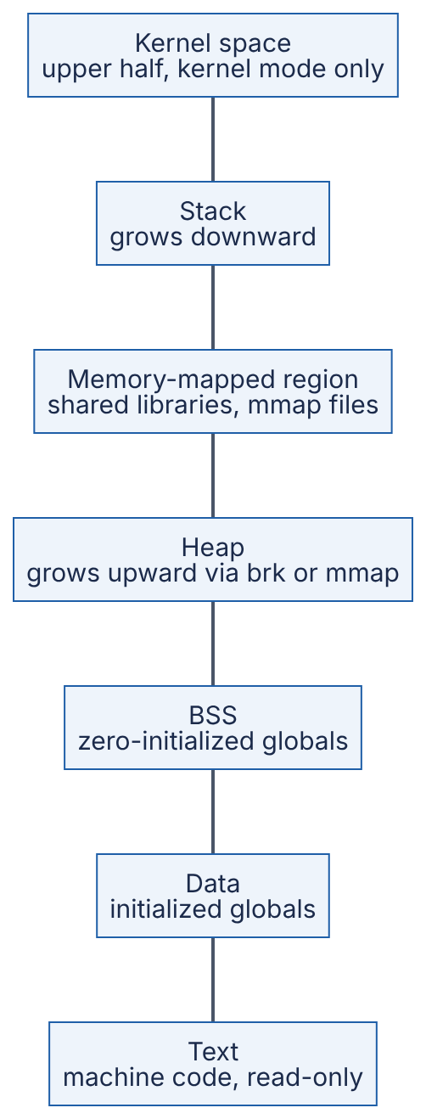
Reading the diagram. High addresses are at the top. Text holds the program’s instructions, mapped read-only so a stray write crashes rather than corrupts. Data and BSS hold global variables. The heap (malloc/new) grows upward; the stack (call frames, locals; one per thread) grows downward. The memory-mapped region holds shared libraries and mmaped files (§6.6.6). The gap between heap and stack is unbacked: no physical memory is used until a page is touched. The kernel region is mapped into every process but protected by the CPU’s privilege check. Failure points: a stack overflowing into its guard page (a crash) and a heap growing until memory runs out (§6.6.4). There are no network edges or storage boundaries: this is one process’s view of memory.

6.3.3 The process control block
DEFINITION
Definition — Process control block (PCB). The kernel data structure that records everything needed to stop a process and later resume it exactly where it left off. In Linux it is struct task_struct.
The PCB is the cook’s clipboard. It typically contains [Silberschatz et al. 2018]:
- Identity: process ID (PID), parent PID, user and group IDs.
- State: new, ready, running, blocked, terminated (§6.3.4).
- CPU context: saved program counter, stack pointer and general-purpose registers (on Linux these are saved on the task’s kernel stack and in thread_struct).
- Scheduling information: priority, nice value, accumulated CPU time, which run queue it is on.
- Memory-management information: a pointer to the page tables and the list of mapped regions (Linux mm_struct).
- I/O and file information: the table of open file descriptors, current directory.
- Signal information: pending signals and installed handlers.
- Accounting: CPU time used, start time, resource limits.
On Linux, each thread is also a task_struct; threads of one process point at the same mm_struct and file table. A task_struct is several kilobytes, and each task also has a 16 KiB kernel stack on x86-64 (as of Linux 6.x), so 10,000 threads cost roughly 200 MB of kernel memory before their user-space stacks are counted.

6.3.4 Process states
DEFINITION
Definition — Process state. The scheduling status of a process (or thread): whether it is running on a CPU, ready and waiting for a CPU, or blocked waiting for an event.
Figure 6.2 — Process state diagram.
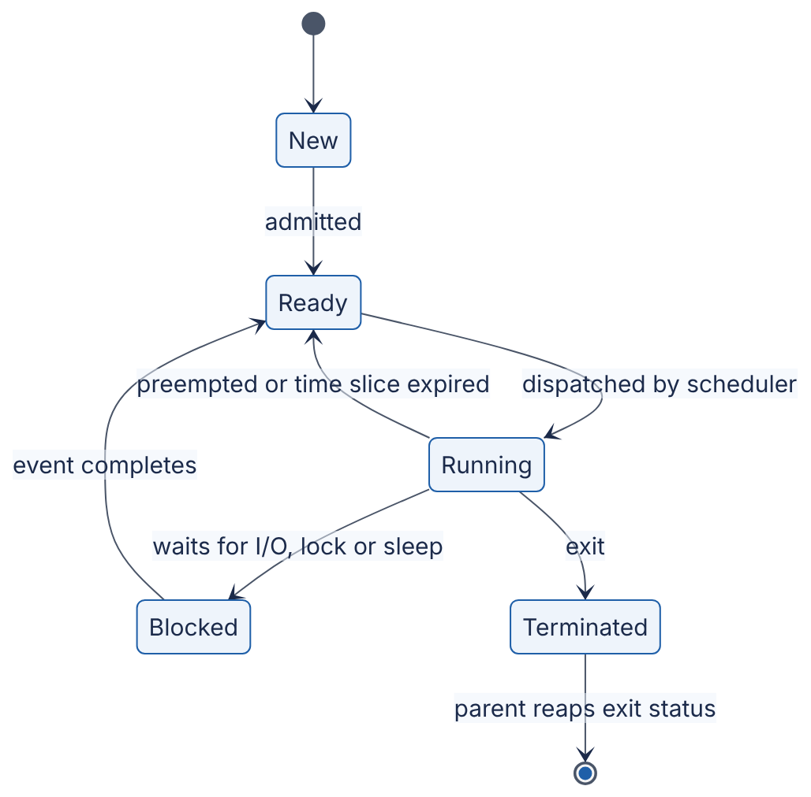
Reading the diagram. A process is New while the kernel builds its PCB and address space, then Ready: runnable but waiting for a CPU. The scheduler (§6.5) dispatches one ready task per core to Running. A running process leaves the CPU in three ways: it is preempted (slice expired or a higher-priority task woke) and returns to Ready; it waits for something not yet available (disk, network packet, lock, timer) and becomes Blocked; or it exits. When the awaited event occurs, usually signaled by a hardware interrupt (§5.7), the process returns to Ready, not straight to Running. A Terminated process whose parent has not collected its exit status is a zombie. Every transition is made by the kernel.
Linux reports these states in ps and top with single letters: R (running or ready, Linux does not distinguish them), S (interruptible sleep, the normal blocked state), D (uninterruptible sleep, usually waiting on disk or network file system I/O, cannot be killed until the I/O completes), T (stopped by a signal or debugger) and Z (zombie). On Linux, tasks in D count toward the load average along with R tasks, which is why a server with a hung NFS mount can show a load average of 200 while its CPUs are idle [Gregg 2020].

6.3.5 Threads
DEFINITION
Definition — Thread. An independent sequence of execution within a process, with its own program counter, registers and stack, sharing the process’s address space, heap, globals and open files with the process’s other threads.
If a process is a cook with a private workstation, threads are several cooks sharing one workstation: they pass ingredients instantly (shared memory) but can reach for the same knife at once (a race condition, §6.9).

How it works internally
- A process starts with one thread (the main thread).
- Creating a thread (pthread_create, new Thread(), threading.Thread) asks the kernel, on Linux via the clone() system call, to create a new schedulable task that shares the address space and file table instead of copying them.
- The runtime allocates a new user-space stack for the thread (by default 8 MiB of virtual address space for glibc threads on Linux, taken from ulimit -s; 1 MiB for Java platform threads on 64-bit Linux, as of JDK 21) plus a guard page below it to catch overflow.
- The kernel scheduler sees each thread as an independent task. Two threads of one process can run truly simultaneously on two cores.
Linux uses a 1:1 threading model: every user thread is one kernel task. Go goroutines, Erlang processes and Java virtual threads multiplex many lightweight user-space threads onto a few kernel threads (an M:N model, §6.15). New processes are created with fork(), a near-copy of the caller made cheap by copy-on-write (§6.6.5), usually followed by exec() to load a new program.
Table 6.1 — Processes versus threads.
Aspect | Process | Thread
Address space | Private | Shared with sibling threads
Creation cost (Linux, order of magnitude) | Tens to hundreds of µs (fork+exec more) | ~10 µs or less
Communication | IPC: pipes, sockets, shared memory (§6.12) | Direct reads/writes to shared memory
Isolation | Strong: a crash or wild pointer affects only itself | Weak: one bad thread can crash all
Context-switch cost | Higher: may change page tables | Lower: same page tables
Memory overhead | Full set of page tables and mappings | Stack + kernel task (~16 KiB kernel stack)
Typical use | Isolation between services, browser tabs, worker pools (e.g. PostgreSQL backends) | Parallelism inside one service (e.g. Java/Go servers)
Choose when | Faults must be contained, or code is not thread-safe | Tasks share large data and need low-latency communication
The creation-cost figures are orders of magnitude, not benchmarks; measure on your own hardware.

Real-world industry applications
INDUSTRY EXAMPLE
PostgreSQL versus MySQL. PostgreSQL forks one backend process per client connection, containing faults at the cost of per-connection memory, which is why large deployments put a pooler such as PgBouncer in front (§14.13). MySQL uses one thread per connection inside a single process: cheaper connections, shared fate. Evidence: Primary — [PostgreSQL Docs: Architectural Fundamentals]; [MySQL Docs: Connection Interfaces]

Failure scenarios
What goes wrong | Why | Detection | Recovery | Prevention
Zombie processes accumulate until no PIDs are left | Parent never calls wait(); in containers, the app runs as PID 1 and does not reap orphans | ps shows many Z entries; fork fails with EAGAIN | Restart the parent | Reap children; run a minimal init (e.g. tini) as PID 1 in containers
Load average 200 but CPU idle | Many tasks in D state on hung storage or NFS | ps -eo stat shows D; /proc/<pid>/stack | Fix storage; reboot if stuck | Timeouts on network file systems; monitor I/O latency

Common misconceptions
COMMON MISTAKE
“Threads are free.” Each costs a kernel task, kernel stack, user stack and scheduling work. Ten thousand threads is feasible; a million kernel threads on one machine is not (§6.15.6).

6.4 Context switching and its cost
DEFINITION
Definition — Context switch. The kernel operation that stops one thread running on a CPU core, saves its CPU state into its PCB, and loads the saved state of another thread so that it resumes where it left off.

First-principles explanation
Switching between two books, noting your page is quick; reloading the plot into your head is what costs. Likewise, saving and loading registers is quick; the expensive part is that the new thread finds the CPU’s caches full of the old thread’s data. Switching exists because a core runs one thread at a time: pausing a thread that waits for a 10 ms disk read lets the core do useful work meanwhile.

How it works internally
A switch is triggered in one of two ways. A voluntary switch happens when the running thread blocks (reads from an empty socket, waits for a lock, sleeps). An involuntary switch happens when the kernel preempts the thread, usually because a periodic timer interrupt found its time slice used up or a higher-priority thread became ready.
Figure 6.3 — A context switch between two threads triggered by a timer interrupt.
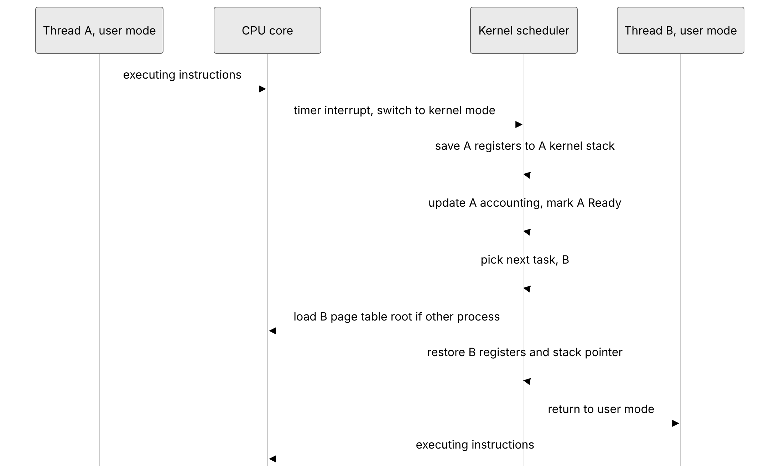
Reading the diagram. The dotted arrow is asynchronous: the timer interrupt arrives regardless of what A is doing and forces the CPU into kernel mode, saving A’s instruction pointer and stack pointer. Solid arrows are synchronous steps on the same core. The kernel saves A’s remaining registers, returns A to the Ready queue and asks the scheduling policy (§6.5) for the next task. If B belongs to a different process, the kernel loads B’s page-table root (on x86-64, the CR3 register); process-context identifiers (PCIDs) let TLB entries of different processes coexist, avoiding a full TLB flush. B’s registers are restored and the CPU returns to user mode. No storage or network is involved; the failure point is performance: too-frequent switches leave the core in the kernel and refilling caches.

Mathematical foundations
There are two costs.
- Direct cost — the kernel instructions above: entering the kernel, saving and restoring registers, running the scheduler, switching page tables. On modern x86-64 Linux this is roughly 1–5 µs per switch (as of the 2020s; it varies with CPU, kernel version and security mitigations such as those for Spectre and Meltdown).
- Indirect cost — after the switch the incoming thread’s data and instructions are no longer in the L1/L2 caches (§5.4) and its address translations are no longer in the TLB (§6.6.3), so it runs slowly until they are reloaded. This can exceed the direct cost by one or two orders of magnitude for threads with large working sets [Li et al. 2007].
FORMULA
Context-switch overhead fraction
$$f=\frac{C}{Q+C}$$
Symbol | Meaning | Units
$f$ | Fraction of CPU time lost to switching | dimensionless (0–1)
$C$ | Effective cost of one switch, direct + indirect | µs
$Q$ | Average time a thread runs between switches | µs
FORMULA
Cache refill estimate (indirect cost)
$$C_{\text{refill}}≈\frac{W}{L}×\frac{t_{\text{miss}}}{M}$$
Symbol | Meaning | Units
$C_{\text{refill}}$ | Time spent reloading the working set after a switch | ns
$W$ | Working set that was evicted | bytes
$L$ | Cache line size (64 on x86-64 and most ARM servers) | bytes/line
$t_{\text{miss}}$ | Latency of one miss to the next memory level | ns
$M$ | Memory-level parallelism: misses overlapped in flight | dimensionless (≥ 1)
WORKED EXAMPLE
Worked example — When does switching hurt?
Case 1: CPU-bound batch job. A thread runs a full 4 ms slice ($Q=4000$ µs) and the direct switch cost is $C=3$ µs. $f=3/\left(4000+3\right)=0.00075$, i.e. 0.075 % of CPU time. Negligible.
Case 2: the same switch, but the thread’s 1 MiB working set was evicted to DRAM. $W=1,048,576$ bytes, $L=64$ bytes, so $W/L=16,384$ lines. Take $t_{\text{miss}}=90$ ns to DRAM and $M=8$ overlapping misses: $C_{\text{refill}}=16,384×90/8=184,320$ ns ≈ 184 µs, about 60× the direct cost.
Case 3: a chatty server. Threads handle tiny requests and block on the network every 20 µs ($Q=20$ µs). With a modest 10 µs effective switch cost (direct plus a small refill), $f=10/\left(20+10\right)=0.33$: a third of the CPU goes to switching.
Interpretation. Context switches are cheap when threads run for milliseconds and expensive when they run for microseconds. Engineering implication: for high-rate, short-request workloads, prefer designs that do many small units of work per switch: event loops (§6.13), batching (§23.8), fewer threads than cores-times-a-small-factor for CPU-bound pools, and pinning hot threads to cores.

How to observe it
- vmstat 1 — the cs column is context switches per second for the whole machine. Tens of thousands per second per core is normal for a busy server; hundreds of thousands per core deserves investigation.
- pidstat -w 1 or /proc/<pid>/status — per-task voluntary switches (blocking: lock contention, small I/Os) versus involuntary ones (preemption: CPU contention). If thread migrations between NUMA sockets are frequent, pin threads (§5.10).
- perf sched and perf stat -e context-switches,cpu-migrations for detailed analysis [Gregg 2020].
COMMON MISTAKE
“A context switch costs a few microseconds, so it never matters.” The few microseconds is only the direct cost. The cache and TLB refill afterwards can cost far more, and it appears in your profile as “slow application code”, not as kernel time.

6.5 CPU scheduling
DEFINITION
Definition — CPU scheduler. The part of the kernel that decides which ready thread runs next on each core and for how long. The rule it follows is the scheduling policy; the mechanism that performs the switch is the dispatcher (§6.4).

First-principles explanation
A doctor with a waiting room is a scheduler. Strict arrival order leaves a 2-minute renewal stuck behind a 60-minute consultation; quickest-first minimizes average waiting but may leave the long case waiting all day; 10 minutes each in rotation means nobody waits long to be seen, but long cases finish later. Every CPU scheduling policy is one of these trade-offs. It optimizes some mix of:
- Turnaround time — arrival to completion; matters for batch work.
- Response time — arrival to first run; matters for interactive work and request handlers.
- Throughput, fairness (each thread, user or container gets its share) and utilization.
These conflict: shortest-job-first minimizes turnaround but is unfair to long jobs; rapid rotation minimizes response time but adds switching overhead.

6.5.1 First-come, first-served (FCFS)
Run jobs to completion in arrival order. Simple, but suffers the convoy effect: short jobs queue behind a long one. Shortest job first (SJF) and its preemptive form STCF are optimal for average turnaround but need job lengths in advance, which a general-purpose OS does not have [Arpaci-Dusseau 2018].

6.5.2 Round robin (RR)
Run each ready thread for a fixed time slice (quantum), then move it to the back of the queue. RR gives good response time and cannot starve anyone, but too short a slice wastes time switching (§6.4) and too long a slice degenerates into FCFS. General-purpose systems use roughly 1–10 ms.
FORMULA
Average turnaround and response time
$${\overset{‾}{T}}_{\text{turn}}=\frac{1}{n}\sum_{i=1}^{n}{\left(T_{\text{completion}}^{ i}−T_{\text{arrival}}^{ i}\right)} {\overset{‾}{T}}_{\text{resp}}=\frac{1}{n}\sum_{i=1}^{n}{\left(T_{\text{first run}}^{ i}−T_{\text{arrival}}^{ i}\right)}$$
Symbol | Meaning | Units
$n$ | Number of jobs | jobs
$T_{\text{arrival}}^{ i}$ | Time job $i$ became ready | ms
$T_{\text{first run}}^{ i}$ | Time job $i$ first got a CPU | ms
$T_{\text{completion}}^{ i}$ | Time job $i$ finished | ms
WORKED EXAMPLE
Worked example — FCFS vs SJF vs RR on one core. Three jobs arrive at $t=0$: A needs 100 ms of CPU, B needs 10 ms, C needs 10 ms. Ignore switching cost.
FCFS (order A, B, C). Completions: A = 100, B = 110, C = 120. Average turnaround = (100 + 110 + 120)/3 = 110 ms. First runs: A = 0, B = 100, C = 110; average response = 70 ms.
SJF (order B, C, A). Completions: B = 10, C = 20, A = 120. Average turnaround = (10 + 20 + 120)/3 = 50 ms. Average response = (0 + 10 + 20)/3 = 10 ms.
RR, 10 ms slice. A runs 0–10, B 10–20 (done), C 20–30 (done), then A alone 30–120. Average turnaround = (120 + 20 + 30)/3 ≈ 56.7 ms. Average response = (0 + 10 + 20)/3 = 10 ms.
Interpretation. RR matches SJF’s response time and comes close to its turnaround without knowing job lengths. FCFS is more than twice as bad on turnaround because two short jobs waited behind a long one. Engineering implication: the same convoy effect appears in application queues: one slow request type in a shared FIFO worker pool inflates latency for every fast request. Separate queues or pools per request class (bulkheads, §22.14) apply this lesson at the service level.

6.5.3 Priority scheduling
Each thread has a priority; the highest-priority ready thread runs. This lets important work (an audio driver, a heartbeat thread) preempt bulk work, but low-priority threads can starve: wait forever because higher-priority work keeps arriving. The classic remedy is aging: gradually raise the priority of threads that have waited a long time. Priorities also create priority inversion with locks (§6.11.5).

6.5.4 Multi-level feedback queue (MLFQ)
MLFQ, first described for the CTSS time-sharing system in 1962 by Corbató and colleagues, learns a thread’s behavior instead of requiring it to be declared. It keeps several RR queues at different priority levels and applies five rules, as formulated in OSTEP [Arpaci-Dusseau 2018]:
- If priority(A) > priority(B), A runs.
- If priority(A) = priority(B), A and B run round robin.
- A new job starts at the highest priority.
- Once a job uses up its time allotment at a level, however many times it gave up the CPU, its priority drops one level.
- After some period S, move every job back to the top queue (a priority boost).
Figure 6.4 — Multi-level feedback queue decisions.
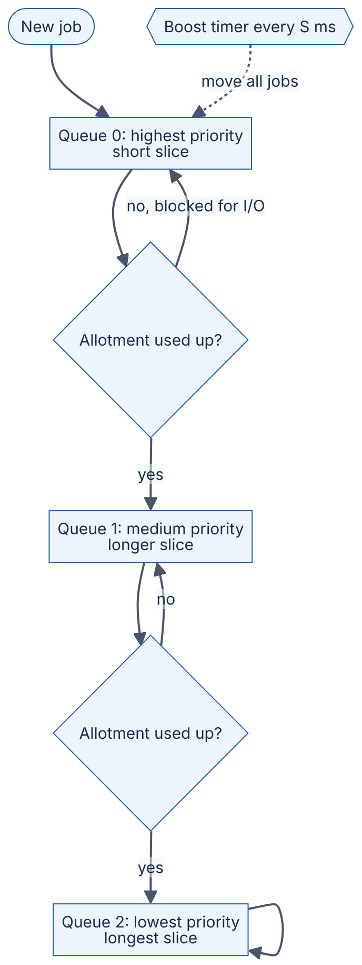
Reading the diagram. Rectangles are run queues; the highest non-empty queue is served (rule 1), round robin within it (rule 2). New jobs enter Queue 0 (rule 3). Interactive jobs block for I/O before exhausting their allotment and stay high, so they respond fast; CPU-bound jobs sink to lower queues with longer slices (rule 4). The dotted arrow is the asynchronous priority boost (rule 5), which prevents starvation of the bottom queue. Counting total allotment used stops a program gaming the scheduler by yielding just before its slice expires. Variants of MLFQ underlie the schedulers of BSD derivatives, Solaris and Windows [Arpaci-Dusseau 2018].

6.5.5 Linux: CFS and EEVDF
Linux’s normal scheduling class (SCHED_NORMAL, also called SCHED_OTHER) aims at proportional-share fairness: each runnable thread should get a share of CPU proportional to its weight, which is derived from its nice value (−20 = highest weight, +19 = lowest).
CFS (Completely Fair Scheduler) was the default from Linux 2.6.23 (2007) until Linux 6.6 (2023). It tracks for each thread a virtual runtime (vruntime): actual CPU time scaled inversely by weight. It keeps runnable threads in a red-black tree ordered by vruntime and always runs the thread that has had the least weighted CPU, so picking the next thread costs $O\left(logn\right)$ [Linux Docs: CFS].
EEVDF (Earliest Eligible Virtual Deadline First) replaced CFS’s selection logic in Linux 6.6 (October 2023), based on an algorithm by Stoica and Abdel-Wahab [Stoica & Abdel-Wahab 1995]. Each thread has a lag: CPU time owed minus time received. Threads with non-negative lag are eligible; among them EEVDF runs the one with the earliest virtual deadline (roughly eligible time plus requested slice divided by weight). Fairness is kept, and latency-sensitive threads that request shorter slices get a principled advantage instead of hand-tuned heuristics [Linux Docs: EEVDF; Corbet 2023]. The default base slice is about 0.75 ms (as of Linux 6.6–6.x, scaled up on many-CPU machines).
Linux also has real-time classes (SCHED_FIFO, SCHED_RR, priorities 1–99) that always preempt normal threads, SCHED_DEADLINE for tasks with explicit runtime and period guarantees, and, from Linux 6.12 (2024), sched_ext, which lets a scheduling policy be loaded as a BPF program [Linux man-pages: sched(7)].
FORMULA
Proportional CPU share
si=wij∈R​wj
Symbol | Meaning | Units
$s_{i}$ | Fraction of one core’s time thread $i$ receives when all threads in $R$ compete | dimensionless (0–1)
$w_{i}$ | Weight of thread $i$, from its nice value (nice 0 = 1024; each nice step changes weight by about 1.25×) | dimensionless
$R$ | Set of runnable threads competing on that core | —
WORKED EXAMPLE
Worked example — Nice values. Two CPU-bound threads share one core. Thread X has nice 0 (weight 1024); thread Y has nice 5 (weight 335, from the kernel’s weight table). $s_{X}=1024/\left(1024+335\right)=1024/1359≈0.753$; $s_{Y}≈0.247$. Interpretation. Five nice levels give roughly a 3:1 split, consistent with the rule of thumb that each nice step shifts about 10 % of CPU between two competing threads. Engineering implication: to keep a log-compaction or backup job from hurting request latency on the same machine, running it at nice 10–19 is a cheap first step; cgroup CPU weights do the same for whole containers.
Table 6.2 — CPU scheduling policies compared.
Policy | How it works | Advantages | Disadvantages | Choose when
FCFS | Run in arrival order to completion | Simple, no switching | Convoy effect; poor response time | Batch queues of similar-sized jobs
SJF / STCF | Shortest (remaining) job first | Optimal average turnaround | Needs job lengths; starves long jobs | Job sizes known (some batch systems)
Round robin | Fixed slice, rotate | Good response time; no starvation | Switching overhead; poor turnaround for equal jobs | Time-sharing with similar priorities
Priority | Highest priority runs | Important work goes first | Starvation; priority inversion | Real-time and control systems
MLFQ | Priority queues; demote CPU hogs; periodic boost | Learns behavior; good interactivity | Many tuning knobs | General-purpose desktops and servers
CFS / EEVDF (Linux) | Weighted fair share by virtual runtime; EEVDF adds lag and virtual deadlines | Fair, scalable, tunable by nice and cgroups | Fairness is not latency; complex | Default on Linux servers (as of 2026)

Real-world industry applications
INDUSTRY EXAMPLE
CPU limits in containers cause throttling. Kubernetes CPU limits use CFS bandwidth control: a cgroup gets a CPU-time quota per period (default 100 ms, cpu.max in cgroup v2). A service limited to 1 CPU with 4 busy threads uses its quota in 25 ms and is throttled for the remaining 75 ms, delaying in-flight requests even on an idle node. nr_throttled in cpu.stat reveals it. Mitigations: raise or remove limits for latency-critical services, or size thread pools to the limit rather than the host’s cores (§42.13). Evidence: Primary — [Linux Docs: CFS Bandwidth Control]

Common misconceptions
COMMON MISTAKE
“Nice -20 makes my latency-sensitive service fast.” Nice changes the share of CPU under contention; on a machine that is not CPU-saturated it has almost no effect. For latency, keep runnable threads below core count and avoid CPU throttling.

6.6 Virtual memory, paging and the page cache

6.6.1 The idea of virtual memory
DEFINITION
Definition — Virtual memory. A mechanism in which every address a program uses is a virtual address that the hardware’s memory-management unit (MMU) translates, using tables maintained by the kernel, into a physical address in RAM, or into a fault if no valid mapping exists.

First-principles explanation
A hotel guest is told “you are in room 12”; the front desk’s private sheet for that guest says room 12 is physically room 407. Two guests can both have “room 12”, luggage can be moved without telling the guest, and a guest asking for a room not on their sheet is stopped at the desk. Virtual memory gives each process exactly this, and so delivers isolation (separate tables), convenience (the same layout for everyone, Figure 6.1) and flexibility (memory allocated lazily, shared, mapped to files or moved to disk).

6.6.2 Paging and page tables
Memory is divided into fixed-size blocks: pages in virtual memory and frames in physical memory, typically 4 KiB on x86-64 and most ARM servers. A virtual address is split into a virtual page number and an offset within the page. The kernel keeps a page table per process that maps virtual page numbers to physical frame numbers, plus permission bits: present, writable, user-accessible, no-execute, and accessed/dirty flags that the hardware sets so the kernel knows which pages were used or modified.
A flat table for 128 TiB of virtual space would need 2³⁵ entries, far too large. So the table is a multi-level tree: on x86-64 with 4-level paging, the 48-bit address is split into four 9-bit indices (one per level) and a 12-bit offset (9 + 9 + 9 + 9 + 12 = 48). Only the branches actually used are allocated. Newer CPUs support 5-level paging (57-bit addresses) for very large-memory machines.

6.6.3 The TLB
Walking a four-level tree means up to four extra memory reads for every load or store, which would make every memory access several times slower. The translation lookaside buffer (TLB) is a small cache inside the CPU core that holds recent virtual-to-physical translations. Typical server cores have tens of entries in the first-level TLB and roughly 1,000–3,000 entries in a second-level TLB (as of 2020s x86-64 and ARM designs; consult your CPU’s documentation).
Figure 6.5 — Translating a virtual address: TLB, page walk and page fault.
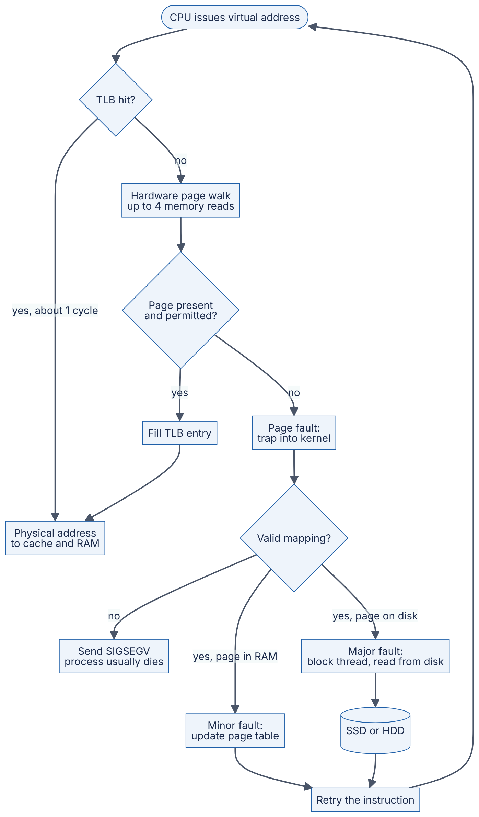
Reading the diagram. Every load, store and instruction fetch starts at the top. A TLB hit makes translation essentially free. On a miss, the MMU hardware walks the page table; if the entry is present and permitted, the TLB is filled. Otherwise the CPU raises a page fault, a synchronous trap into the kernel. An invalid address (null pointer, write to read-only code) gets SIGSEGV. A valid page already in RAM (a shared library page, a fresh zero page on first touch) is a cheap minor fault: the kernel just fills in the entry. A page that must come from storage (a file page or a swapped-out page) is a major fault: the thread blocks while the disk is read, the storage boundary in this figure. Then the instruction is retried. The failure point that matters is the major-fault path, which turns a 100 ns access into a 100 µs (SSD) to 10 ms (HDD) wait.
FORMULA
TLB reach
$$R_{\text{TLB}}=E×P$$
Symbol | Meaning | Units
$R_{\text{TLB}}$ | Amount of memory addressable without a TLB miss | bytes
$E$ | Number of TLB entries | entries
$P$ | Page size per entry | bytes
FORMULA
Effective memory access time with page faults
$$\text{EAT}=\left(1−p\right)×t_{\text{mem}}+p×t_{\text{fault}}$$
Symbol | Meaning | Units
EAT | Average time per memory access | ns
$p$ | Probability that an access causes a major page fault | dimensionless (0–1)
$t_{\text{mem}}$ | Time for an access with no fault | ns
$t_{\text{fault}}$ | Time to service a major fault, including the disk read | ns
WORKED EXAMPLE
Worked example — Why huge pages and why swapping hurts.
TLB reach. A core with $E=1,536$ second-level entries and 4 KiB pages has $R=1,536×4=6,144$ KiB = 6 MiB. A database with a 64 GiB in-memory buffer pool touching memory randomly will miss in the TLB on most accesses. With 2 MiB huge pages, the same entries cover $1,536×2$ MiB = 3 GiB, 512× more. This is why databases and JVMs often use explicit huge pages.
Page faults. Let $t_{\text{mem}}=100$ ns and a major fault from an NVMe SSD take $t_{\text{fault}}=100$ µs = 100,000 ns. If one access in 10,000 faults ($p={10}^{−4}$): EAT $=0.9999×100+0.0001×100,000=99.99+10≈$ 110 ns, a 10 % slowdown. To keep the slowdown under 10 % with a 10 ms HDD ($t_{\text{fault}}={10}^{7}$ ns), we need $p×{10}^{7}<10$, i.e. $p<{10}^{−6}$: fewer than one fault per million accesses.
Interpretation. Even rare major faults dominate the average. Engineering implication: a latency-sensitive service must keep its working set in RAM. When the working set exceeds RAM and the system swaps heavily (thrashing), throughput collapses by orders of magnitude rather than degrading gracefully.

6.6.4 Demand paging and overcommit
Linux allocates physical memory lazily: malloc(1 GiB) reserves only virtual addresses, and frames are assigned on first touch. It also overcommits by default, promising more virtual memory than exists. When the bet fails, the OOM killer kills a process, typically the largest, with SIGKILL; a container exceeding its cgroup limit (memory.max) is killed the same way (§42.3). Watch resident set size (RSS, physical pages in use), not virtual size.

6.6.5 Copy-on-write
When fork() creates a child, the kernel shares all the parent’s pages with the child and marks them read-only in both. The first write by either side triggers a fault, and only then is that one page copied. This makes fork fast and allows a process to take a consistent snapshot of its memory cheaply.
INDUSTRY EXAMPLE
Redis background snapshots. Redis calls fork() to snapshot; the child writes its frozen copy-on-write view to disk while the parent keeps serving writes. Overhead is proportional to pages modified meanwhile, up to twice the dataset for write-heavy instances. Redis recommends disabling Transparent Huge Pages, because then one small write copies a 2 MiB page instead of 4 KiB, causing latency spikes. Evidence: Primary — [Redis Docs: Persistence]; [Redis Docs: Latency diagnosis]

6.6.6 The page cache and mmap
DEFINITION
Definition — Page cache. The kernel’s in-RAM cache of file contents, organized in pages. Reads are served from it when possible; writes normally modify pages in it (marking them dirty) and return immediately, with the kernel writing them back to storage later.
Linux uses almost all otherwise-free RAM as page cache, so free reports little “free” memory on a healthy server; watch “available” instead. By default dirty pages are written back by kernel threads after they have been dirty for about 30 s, checked every 5 s (vm.dirty_expire_centisecs = 3000, vm.dirty_writeback_centisecs = 500, as of Linux 6.x) or sooner under memory pressure. The consequence for durability is in §6.14.
mmap maps a file directly into a process’s address space: reading the memory reads the file through the page cache, with no read() system call and no copy into a user buffer. It is elegant for read-mostly data (shared libraries are loaded this way), but it hides I/O inside ordinary memory accesses: any pointer dereference may block on a major fault, I/O errors arrive as a SIGBUS signal instead of an error code, and the kernel, not the application, decides what to evict. Crotty, Leis and Pavlo argue that for these reasons database systems should usually manage their own buffer pool instead of relying on mmap [Crotty et al. 2022] (see §13.4).
INDUSTRY EXAMPLE
Apache Kafka relies on the page cache. Kafka brokers append to log files and let the OS page cache hold recent data instead of caching messages in the JVM, avoiding double caching, surviving process restarts and keeping heaps small. Consumers of recent data are served from the page cache via sendfile, without copying through user space (§31.13). Evidence: Primary — [Apache Kafka Docs: Design, Persistence]

6.6.7 Swapping
Swapping moves rarely used anonymous pages (heap and stack, with no file behind them) to disk so their frames can be reused; clean file-backed pages are simply dropped and re-read later. Modest swap moves idle memory out of the way; swapping a working set is thrashing. Many latency-sensitive deployments disable swap or set vm.swappiness low.

Failure scenarios
What goes wrong | Why | Detection | Recovery | Prevention
Process killed with exit code 137, no error log | OOM killer or cgroup limit sent SIGKILL | dmesg “Out of memory: Killed process”; container OOMKilled status | Restart with more memory | Set memory limits above peak RSS; bound caches and queues
Latency rises 100× under load | Working set exceeds RAM; major faults or swap thrashing | vmstat si/so columns; major-fault counters (sar -B) | Add RAM or shed load | Capacity plan working set; avoid swap for latency tiers
“Free memory is 1 %” alert fires constantly | Page cache is counted as used | Compare with “available” | None needed | Alert on available memory and major faults instead

6.7 System calls and the kernel/user boundary
DEFINITION
Definition — System call (syscall). A controlled entry from user mode into the kernel to request a privileged service, such as reading a file, sending on a socket, allocating memory or creating a process. Linux x86-64 has a few hundred system calls, each identified by a number [Linux man-pages: syscalls(2)].

First-principles explanation
A bank customer cannot walk into the vault; they hand a slip through one narrow window where every request is checked. A system call is that window, and library functions such as printf or Python’s open() are wrappers that fill in the slip.

How it works internally
Figure 6.6 — A read() system call that must wait for the disk.
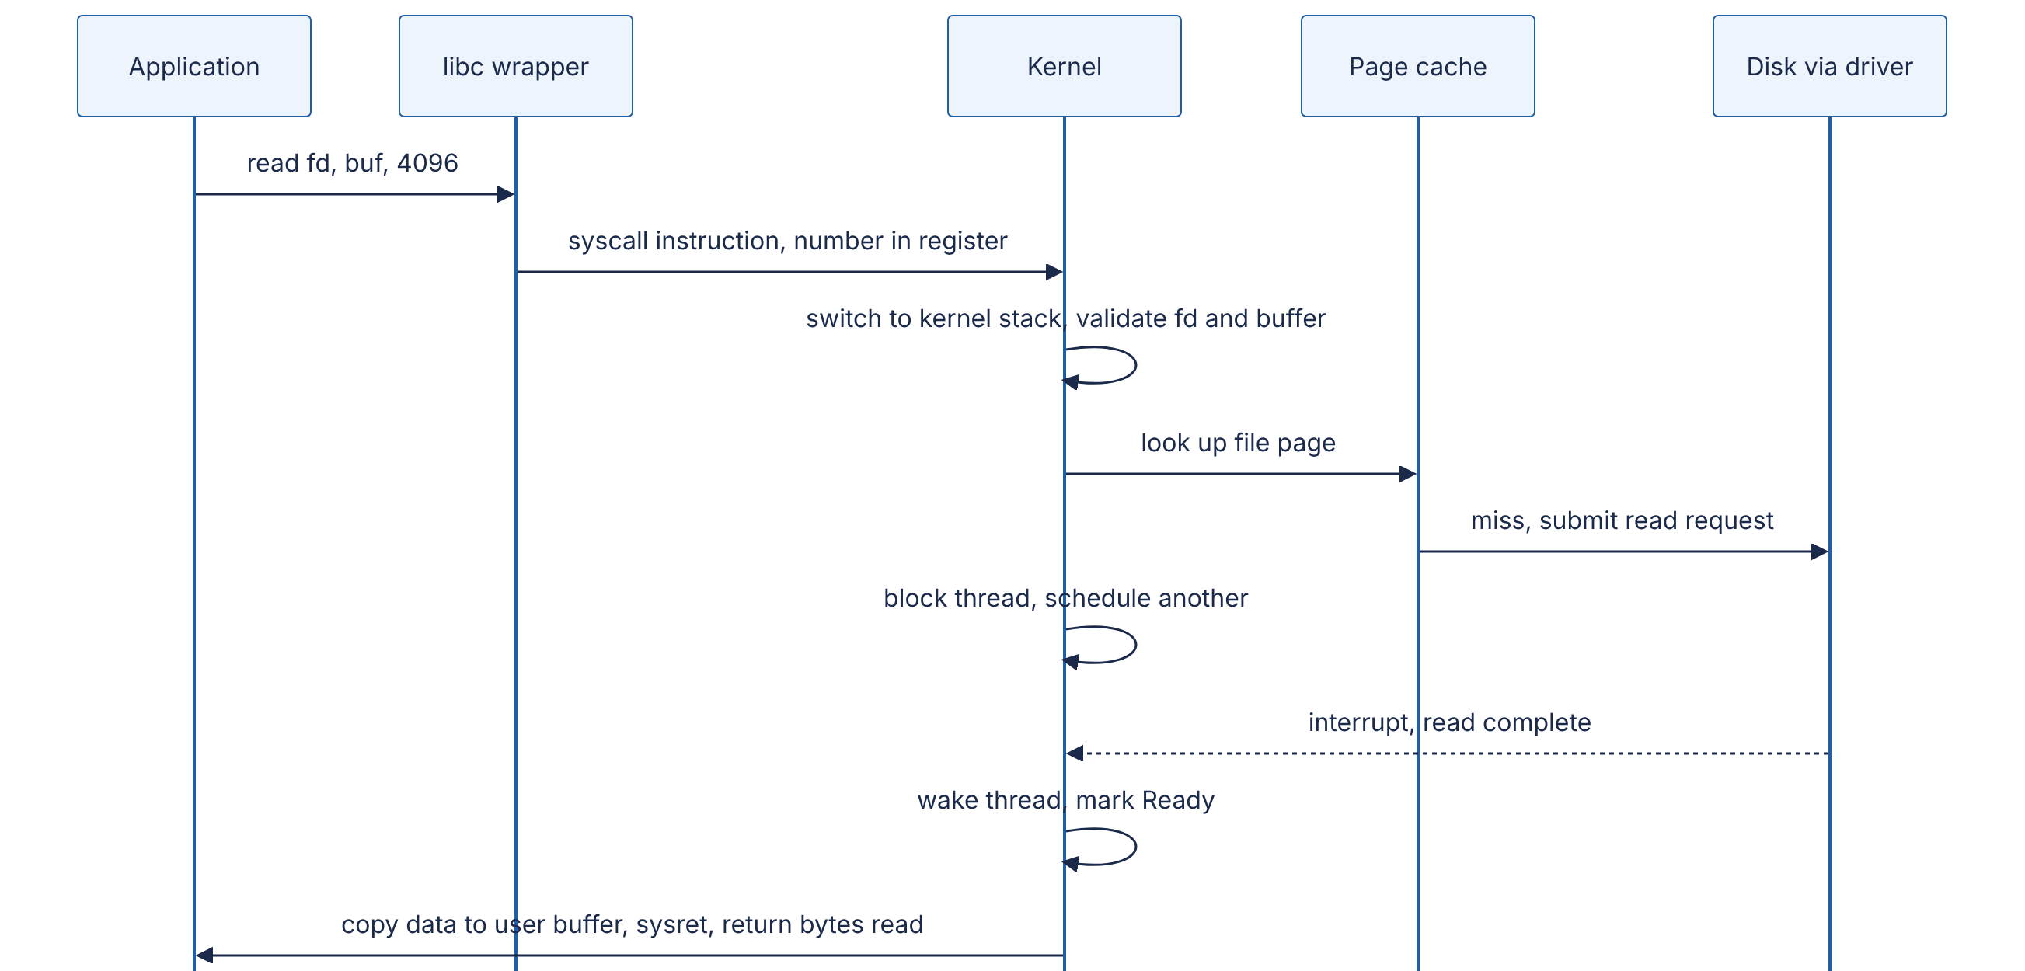
Reading the diagram. The library wrapper puts the system-call number and arguments in registers and executes the syscall instruction, entering the kernel at a fixed entry point, the only way in. The kernel validates everything, since user code can pass any value: is the descriptor open, does the buffer lie in the caller’s memory? On a page-cache hit (§6.6.6) it copies the data and returns within about a microsecond. On a miss it submits a request across the storage boundary and the thread blocks (a voluntary context switch). The dotted arrow is the device’s asynchronous completion interrupt; the thread becomes Ready, runs again, and the kernel copies the data out and returns. Failure points: bad arguments return EBADF or EFAULT, device errors EIO, and a signal can interrupt a slow call with EINTR, which callers must retry.

What it costs
A trivial system call costs on the order of 100 ns to a few hundred ns on modern x86-64 Linux, against about 1–5 ns for a function call (as of the 2020s). The cost rose in 2018 when kernel page-table isolation (KPTI), the Meltdown mitigation, began switching page tables on every kernel entry on affected CPUs. A rough Python measurement on this chapter’s test VM found os.getppid() at about 190 ns per call against about 50 ns for a built-in function call.
Three techniques reduce syscall cost:
- Batching — do more per call: readv/writev for scatter/gather I/O, sendmmsg for many UDP datagrams, larger buffers.
- vDSO (virtual dynamic shared object) — the kernel maps a small read-only library into every process so that some calls, notably clock_gettime and gettimeofday, run entirely in user mode by reading kernel-maintained data.
- Shared-memory rings — io_uring (§6.13.5) lets the application queue many I/O requests in memory shared with the kernel, submitting them with one system call or, in polled mode, none.
To observe system calls, strace -c -p <pid> counts and times them (with heavy overhead); perf trace and eBPF tools such as syscount are cheaper [Gregg 2020].
COMMON MISTAKE
“Calling write() means my data is on disk.” write() returns when the data is in the page cache. It is durable only after a successful fsync() (§6.14.3).

6.8 Concurrency versus parallelism
DEFINITION
Definition — Concurrency and parallelism. Concurrency is the structuring of a program as multiple tasks whose lifetimes overlap, so that progress on one does not wait for the others to finish. Parallelism is the simultaneous execution of multiple computations on multiple hardware units (cores, CPUs, GPUs).
One cook juggling three dishes, stirring one while another simmers, is concurrent but not parallel. Three cooks each making one dish are parallel. Rob Pike’s summary: concurrency is about dealing with many things at once; parallelism is about doing many things at once [Pike 2012].
I/O-bound work (a web server waiting on databases) needs concurrency: thousands of requests in flight, mostly waiting, which one core can serve with an event loop (§6.13). CPU-bound work (image encoding) needs parallelism, with speed-up limited by the serial fraction (Amdahl’s Law, §4.12). Concurrency alone gives no CPU speed-up.
CPython’s global interpreter lock (GIL) is the standard illustration: Python threads are concurrent, and overlap well while waiting on I/O, but only one executes Python bytecode at a time, so CPU-bound Python code gains nothing from threads. Use processes (multiprocessing), native extensions that release the GIL, or the optional free-threaded build of CPython (experimental in 3.13, officially supported but not the default in 3.14, as of 2026) for CPU parallelism.

6.9 Race conditions and critical sections
DEFINITION
Definition — Race condition. A bug in which the result of a program depends on the relative timing or interleaving of concurrent operations on shared state. A data race is the specific case where two threads access the same memory location concurrently, at least one access is a write, and nothing orders them.
DEFINITION
Definition — Critical section. A region of code that accesses shared state and must not be executed by more than one thread at a time. Guaranteeing this is mutual exclusion.

First-principles explanation
Two people deposit $50 at the same moment into a shared account holding $100, at different cash machines. Each machine reads $100, adds $50 and writes $150; the correct balance is $200. Neither machine erred alone: the bug is the interleaving of read, modify and write, the lost update.
Figure 6.7 — Two threads lose an update to a shared counter.
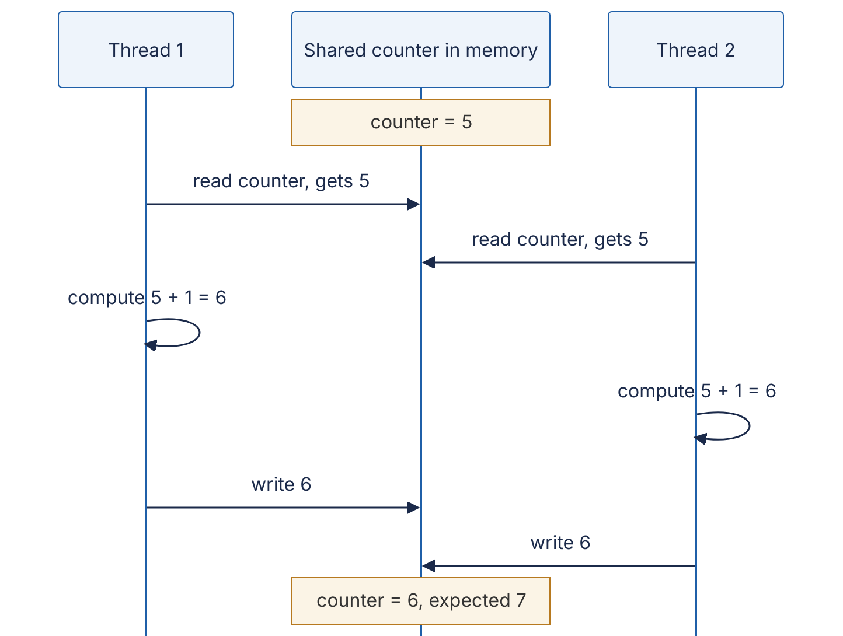
Reading the diagram. Each arrow is a synchronous step, but the two threads’ steps interleave in an order chosen by the scheduler and hardware. Both read before either writes, so one increment is lost. The critical section is read, compute, write; making it indivisible, with a lock or one atomic instruction, removes the bug. The same failure occurs across machines when two service instances read-modify-write a database row (§11.13, §26.13).

Code example
The Python program below makes the race visible. counter += 1 in CPython is not atomic, but the GIL makes the bad interleaving rare, so time.sleep(0) deliberately yields the CPU between the read and the write, exactly where a preemption could occur.
"""Lost updates: a read-modify-write race, then the fix with a mutex."""
import threading
import time
N_THREADS = 4
N_INCREMENTS = 10_000
counter = 0
lock = threading.Lock()
def unsafe_increment() -> None:
global counter
for _ in range(N_INCREMENTS):
current = counter # 1. read
time.sleep(0) # widen the window: yield the CPU (see note)
counter = current + 1 # 2. modify + 3. write
def safe_increment() -> None:
global counter
for _ in range(N_INCREMENTS):
with lock: # critical section starts
current = counter
time.sleep(0)
counter = current + 1
# critical section ends (lock released)
def run(worker) -> int:
global counter
counter = 0
threads = [threading.Thread(target=worker) for _ in range(N_THREADS)]
for t in threads:
t.start()
for t in threads:
t.join()
return counter
if __name__ == "__main__":
expected = N_THREADS * N_INCREMENTS
print(f"expected = {expected}")
print(f"without a lock = {run(unsafe_increment)}")
print(f"with a lock = {run(safe_increment)}")
A run on CPython 3.13 printed expected = 40000, without a lock = 10000 and with a lock = 40000; the unsafe count varies between runs.
What to notice:
- The unsafe version loses about three quarters of the increments: writes overwrite each other.
- with lock: makes read-compute-write a critical section: correct, but threads now take turns.
- Removing time.sleep(0) makes the race rarer, not absent. Tests that pass “most of the time” are the hallmark of races.
The Go version needs no artificial delay, because goroutines run in parallel on multiple cores:
// Three counters incremented by many goroutines: racy, mutex, atomic.
package main
import (
"fmt"
"sync"
"sync/atomic"
)
const goroutines = 8
const increments = 100_000
func main() {
var wg sync.WaitGroup
// 1. Racy: counter++ is a read-modify-write, not one indivisible step.
racy := 0
for g := 0; g < goroutines; g++ {
wg.Add(1)
go func() {
defer wg.Done()
for i := 0; i < increments; i++ {
racy++
}
}()
}
wg.Wait()
// 2. Mutex: only one goroutine at a time inside the critical section.
var mu sync.Mutex
locked := 0
for g := 0; g < goroutines; g++ {
wg.Add(1)
go func() {
defer wg.Done()
for i := 0; i < increments; i++ {
mu.Lock()
locked++
mu.Unlock()
}
}()
}
wg.Wait()
// 3. Atomic: the hardware performs the increment indivisibly.
var atomicCount atomic.Int64
for g := 0; g < goroutines; g++ {
wg.Add(1)
go func() {
defer wg.Done()
for i := 0; i < increments; i++ {
atomicCount.Add(1)
}
}()
}
wg.Wait()
fmt.Println("expected:", goroutines*increments)
fmt.Println("racy: ", racy)
fmt.Println("mutex: ", locked)
fmt.Println("atomic: ", atomicCount.Load())
}
On a 4-core VM with Go 1.24, go run . printed racy: 493557 against expected: 800000; the mutex and atomic counters were exact.
What to notice:
- go run -race . runs Go’s race detector, which reports WARNING: DATA RACE with both stack traces; use -race in CI [Go Docs: Data Race Detector].
- atomic.Int64 (Go 1.19+) is one locked hardware instruction, usually faster than a mutex for a single counter; for two or more variables, use a mutex.
- In Go, Java and C/C++, racy programs have weak or undefined semantics: compilers and CPUs may reorder or cache values [Go Docs: Memory Model].
COMMON MISTAKE
“It is only a counter; a small error is fine.” The same pattern guards bank balances, inventory counts, rate-limit tokens and “is this seat booked?” flags. Treat every read-modify-write of shared state as a critical section, or replace it with a single atomic operation.

6.10 Synchronization primitives
Each primitive below answers a specific coordination problem. Table 6.3 at the end of the section compares them.

6.10.1 Mutexes and spinlocks
DEFINITION
Definition — Mutex (mutual-exclusion lock). An object with two operations, lock and unlock, guaranteeing that at most one thread holds it at a time. A thread that calls lock while another holds it waits.
A mutex is the key to a single-occupancy bathroom. A spinlock waits by looping, burning CPU but reacting within nanoseconds; it suits tiny kernel critical sections. A blocking mutex puts the waiter to sleep (§6.4) and wakes it on unlock. Linux builds mutexes on futexes: an uncontended lock is one atomic instruction in user space; only under contention does the thread call futex() to sleep in the kernel [Franke et al. 2002]. Most mutexes spin briefly, then sleep. Uncontended locks cost tens of nanoseconds; contended ones cost microseconds of context switching.

6.10.2 Semaphores
DEFINITION
Definition — Semaphore. An integer counter with two atomic operations introduced by Dijkstra: wait (P, or acquire) decrements it and blocks if the result would be negative; signal (V, or release) increments it and wakes a waiter [Dijkstra 1965].
A semaphore initialized to N is a car park with N spaces: the natural tool for limiting concurrency, such as at most 20 database connections or 4 concurrent inferences on one GPU. Unlike a mutex, any thread may signal it, so it has no owner and cannot support priority inheritance (§6.11.5).

6.10.3 Condition variables
DEFINITION
Definition — Condition variable. A queue of threads waiting for some condition on shared state to become true, always used together with a mutex. wait atomically releases the mutex and sleeps; notify (signal) wakes one waiter and notify_all (broadcast) wakes all.
A mutex answers “only one at a time”; a condition variable answers “wait until something is true”, such as “the queue is not empty”. The bounded buffer below is the canonical example: producers wait while the buffer is full, consumers while it is empty.
"""A bounded buffer (producer/consumer) built from one mutex and two condition variables."""
import threading
from collections import deque
class BoundedBuffer:
def __init__(self, capacity: int) -> None:
self.capacity = capacity
self.items = deque()
self.lock = threading.Lock()
self.not_full = threading.Condition(self.lock) # producers wait here
self.not_empty = threading.Condition(self.lock) # consumers wait here
def put(self, item) -> None:
with self.lock:
while len(self.items) == self.capacity: # while, not if
self.not_full.wait() # releases lock while asleep
self.items.append(item)
self.not_empty.notify() # wake one consumer
def get(self):
with self.lock:
while not self.items:
self.not_empty.wait()
item = self.items.popleft()
self.not_full.notify() # wake one producer
return item
if __name__ == "__main__":
buf = BoundedBuffer(capacity=8)
N_PRODUCERS, PER_PRODUCER = 3, 10_000
results = []
def producer(pid: int) -> None:
for i in range(PER_PRODUCER):
buf.put((pid, i))
def consumer() -> None:
for _ in range(N_PRODUCERS * PER_PRODUCER):
results.append(buf.get())
threads = [threading.Thread(target=producer, args=(p,)) for p in range(N_PRODUCERS)]
threads.append(threading.Thread(target=consumer))
for t in threads:
t.start()
for t in threads:
t.join()
print("consumed:", len(results), "unique:", len(set(results)))
Output: consumed: 30000 unique: 30000.
What to notice:
- The condition is re-checked in a while loop: under Mesa semantics, used by almost every real system, a woken thread only becomes runnable, and another thread may take the item first; spurious wake-ups are also allowed [Lampson & Redell 1980].
- wait() releases the lock while sleeping and reacquires it before returning.
- The bounded capacity is backpressure (§22.10): producers slow to the consumer’s pace instead of exhausting memory. Python’s queue.Queue works this way.

6.10.4 Atomics and compare-and-swap
DEFINITION
Definition — Compare-and-swap (CAS). An atomic CPU instruction that, in one indivisible step, compares a memory location with an expected value and, only if they are equal, replaces it with a new value, reporting whether it succeeded. On x86-64 it is LOCK CMPXCHG; ARMv8.1 and later provide CAS, and earlier ARM uses load-linked/store-conditional pairs.
Atomic instructions (atomic add, exchange, CAS) make a single read-modify-write indivisible in hardware, with no lock and no sleeping. CAS is the building block for everything else: to apply any update, read the current value, compute the new one, and CAS it in; if another thread changed the value meanwhile, the CAS fails and you retry.
import java.util.concurrent.atomic.AtomicLong;
/** A lock-free "max seen so far" tracker built from a compare-and-swap retry loop. */
public class CasCounter {
private final AtomicLong max = new AtomicLong(Long.MIN_VALUE);
private final AtomicLong retries = new AtomicLong();
void offer(long candidate) {
while (true) {
long current = max.get(); // 1. read
if (candidate <= current) return; // nothing to do
if (max.compareAndSet(current, candidate)) { // 2. swap only if unchanged
return;
}
retries.incrementAndGet(); // 3. someone beat us: retry
}
}
public static void main(String[] args) throws InterruptedException {
CasCounter tracker = new CasCounter();
Thread[] workers = new Thread[4];
for (int t = 0; t < workers.length; t++) {
final int id = t;
workers[t] = new Thread(() -> {
for (long i = 0; i < 1_000_000; i++) {
tracker.offer(i * workers.length + id);
}
});
workers[t].start();
}
for (Thread w : workers) w.join();
System.out.println("max = " + tracker.max.get()); // 3999999
System.out.println("retries = " + tracker.retries.get());
}
}
On JDK 21 with 4 threads this printed max = 3999999 and several hundred thousand retries.
What to notice:
- No thread blocks; a failed CAS means another thread made progress. This is lock-free progress.
- Each retry bounced a cache line between cores (§5.4); under heavy contention a CAS loop can be slower than a mutex.
- Atomics also impose memory ordering: writes before an atomic store become visible to threads that observe it. Plain variables have no such guarantee.

6.10.5 Read-write locks
A read-write lock allows many concurrent readers or one writer. It helps when reads dominate and critical sections are long, such as a routing table. Caveats: every reader updates the lock’s shared counter, so for very short reads on many cores it can be slower than a mutex; and readers can starve writers unless the lock is writer-preferring. For read-mostly data, copy-on-write snapshots (readers load an atomic pointer to an immutable version; writers swap in a new one) and Linux’s read-copy-update (RCU) avoid reader locking entirely.

6.10.6 Lock-free data structures and the ABA problem
A lock-free data structure guarantees that some thread always makes progress, even if others are paused mid-operation; a wait-free one guarantees that every thread finishes in a bounded number of steps [Herlihy & Shavit 2012]. The classic example is the Treiber stack [Treiber 1986]: push reads the current top, sets the new node’s next to it, and CASes the top from old to new.
The ABA problem breaks naive CAS designs. CAS checks only that the value looks the same, not that it is unchanged:
- Thread 1 reads top = A (with A.next = B) and is preempted before its CAS(top, A → B).
- Thread 2 pops A, pops B, frees B, then pushes A back (or a new node reusing A’s memory). Top is A again, but A.next is now something else.
- Thread 1 resumes; CAS(top, A → B) succeeds, because top equals A, and installs the freed node B as the top. The stack is corrupted.
Remedies: pair the pointer with a version counter and CAS both together (a tagged pointer); use hazard pointers [Michael 2004] or epoch-based reclamation so memory is not reused while any thread may hold a reference; or rely on garbage collection, which prevents node reuse while referenced. In practice, use tested concurrent collections (java.util.concurrent, Go channels, Rust’s crossbeam) rather than writing your own.
Table 6.3 — Synchronization primitives compared.
Primitive | Problem it solves | Waiting behavior | Typical cost (uncontended) | Pitfalls | Choose when
Spinlock | Mutual exclusion for tiny sections | Busy-waits | ~10–20 ns | Wastes CPU; terrible if holder is preempted | Kernel code, sections of a few instructions
Mutex | Mutual exclusion | Spin briefly, then sleep | ~20–50 ns | Deadlock, contention, priority inversion | Default for protecting shared state
Semaphore | Limit concurrency to N | Sleeps | Similar to mutex | No ownership; easy to miscount | Connection or resource pools
Condition variable | Wait until a predicate holds | Sleeps, releases mutex | Similar to mutex | Must loop on predicate; lost wake-ups | Queues, producer/consumer
Atomic / CAS | Single-variable read-modify-write | Never sleeps; may retry | ~5–20 ns; more when contended | Only one variable; ABA; ordering subtleties | Counters, flags, pointers
Read-write lock | Many readers, rare writers | Sleeps | Higher than mutex | Writer starvation; reader-counter contention | Long read-mostly sections
Lock-free structure | Progress without locks | Never sleeps | Varies | ABA; memory reclamation; very hard to verify | Proven library implementations only
Costs are orders of magnitude on current x86-64 servers (as of the 2020s) and grow sharply under contention, when cache lines move between cores.

6.11 Deadlock, livelock, starvation and priority inversion

6.11.1 Deadlock and the Coffman conditions
DEFINITION
Definition — Deadlock. A state in which each thread in a set is waiting for a resource held by another thread in the same set, so none can ever proceed.
Four cars at a four-way junction, each waiting for the car on its right, will never move. Deadlock requires all four of these conditions at once [Coffman et al. 1971; Tanenbaum & Bos 2014]:
- Mutual exclusion — a resource can be held by only one thread at a time.
- Hold and wait — a thread holds at least one resource while waiting for another.
- No preemption — a resource cannot be forcibly taken away; it is released only voluntarily.
- Circular wait — there is a cycle of threads, each waiting for a resource held by the next.
Figure 6.8 — Resource-allocation graph with a deadlock cycle.
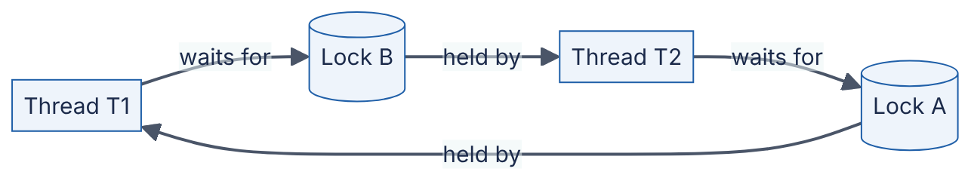
Reading the diagram. Rectangles are threads, cylinders are locks. Thread → lock means “waits for”; lock → thread means “is held by”. Following the arrows from T1 returns to T1: a cycle. With single-instance resources such as locks, a cycle is necessary and sufficient for deadlock, which is how deadlock detectors, including those in databases (§11.15), work. Every edge is a synchronous blocking wait; breaking any one edge removes the deadlock.
The code below produces exactly this cycle. Because a real deadlock would hang forever, it uses acquire(timeout=...) to detect the situation:
"""Two threads take two locks in opposite order -> deadlock (detected via timeout)."""
import threading
import time
lock_a = threading.Lock()
lock_b = threading.Lock()
def worker(name: str, first: threading.Lock, second: threading.Lock) -> None:
with first:
time.sleep(0.1) # make the bad interleaving very likely
if second.acquire(timeout=1.0): # a real program would block forever
second.release()
print(f"{name}: finished")
else:
print(f"{name}: gave up after 1 s -- probable deadlock")
t1 = threading.Thread(target=worker, args=("T1", lock_a, lock_b))
t2 = threading.Thread(target=worker, args=("T2", lock_b, lock_a)) # opposite order!
t1.start(); t2.start(); t1.join(); t2.join()
# Fix: impose a global lock order (always A before B) and the cycle cannot form.
t1 = threading.Thread(target=worker, args=("T1", lock_a, lock_b))
t2 = threading.Thread(target=worker, args=("T2", lock_a, lock_b))
t1.start(); t2.start(); t1.join(); t2.join()
Typical output: T1: gave up after 1 s -- probable deadlock, T2: finished, T1: finished, T2: finished.
What to notice:
- In the first run each thread holds one lock and wants the other. When T1 gives up and releases A, T2 can finish: the timeout broke hold and wait, which is how databases resolve deadlocks by aborting a victim transaction.
- In the second run both threads take A before B. No cycle can form, so no timeout is needed.

6.11.2 Handling deadlock: prevention, avoidance, detection
Prevention makes one Coffman condition impossible by design:
- Circular wait: define a global lock ordering (by address, by ID, by level) and always acquire locks in that order. This is the most practical technique.
- Hold and wait: acquire all needed locks at once, or use tryLock and release everything on failure.
- No preemption: use timeouts so a waiting thread gives up what it holds.
- Mutual exclusion: avoid locks entirely: immutable data, lock-free structures, or one owner thread per piece of state (actors, §6.15.3).
Avoidance refuses requests that could lead to deadlock. Dijkstra’s banker’s algorithm grants a resource only if some order still exists in which every thread can obtain its declared maximum and finish (a safe state) [Dijkstra 1965]; needing maximum demands in advance makes it rare in practice.
Detection and recovery lets deadlocks happen, finds cycles in the wait-for graph and aborts a victim, as databases do. For applications, a thread dump (jstack, Go’s SIGQUIT dump) shows each thread’s held and awaited locks.

6.11.3 Livelock
In a livelock, threads keep reacting to each other without progress, like two people in a corridor stepping aside the same way again and again; threads that tryLock, fail, release and retry in lock-step do the same. The fix is randomized backoff, as with retry jitter (§22.12).

6.11.4 Starvation
In starvation, a thread waits indefinitely because others are always preferred: low priority under strict priority scheduling, writers under a reader-preferring lock, a thread that always loses an unfair lock. Remedies are fairness policies: FIFO locks (Java’s new ReentrantLock(true)), aging, priority boosts. Fair locks cost throughput, since each handoff to a sleeping thread is a context switch, so most locks default to unfair.

6.11.5 Priority inversion
DEFINITION
Definition — Priority inversion. A situation in which a high-priority thread is blocked waiting for a lock held by a low-priority thread, while a medium-priority thread, which needs no lock, preempts the low-priority one, so the high-priority thread effectively runs at the lowest priority.

6.11.6 Case study: Mars Pathfinder, 1997
Figure 6.9 — Priority inversion on Mars Pathfinder.
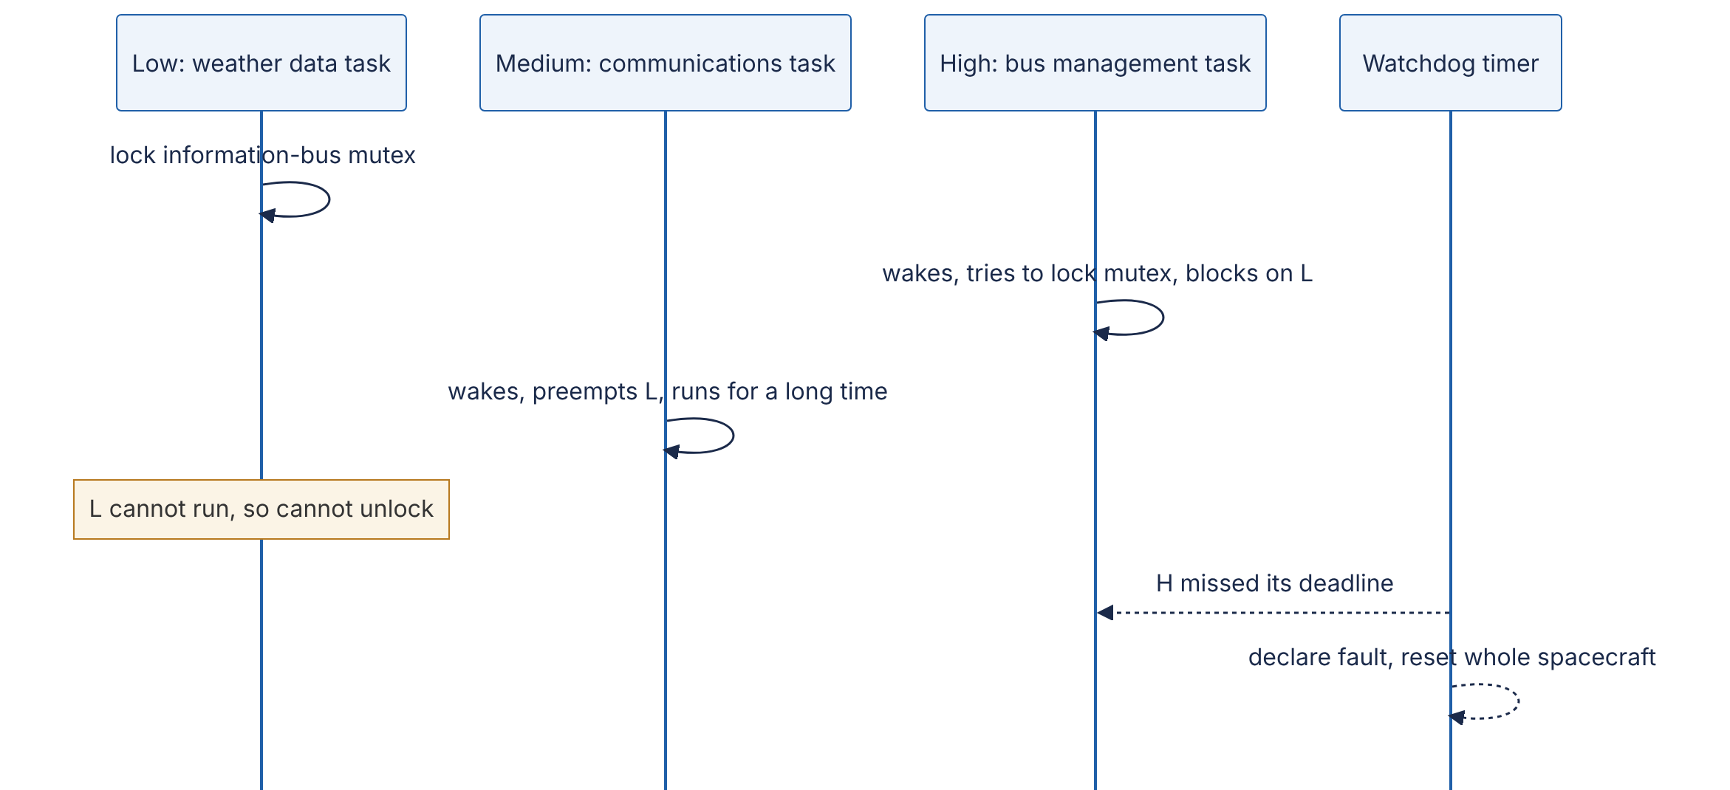
Reading the diagram. Three tasks share one CPU under strict priorities, and one mutex guards a shared memory area, the information bus. The low-priority weather task takes the mutex; the high-priority bus task blocks on it, normally briefly. The medium-priority communications task, which needs no mutex, preempts the low task, so the mutex is never released and the high task waits as long as the medium task runs. The dotted arrows are asynchronous: a watchdog saw that the high-priority work had not completed in time and reset the computer. Failure point: the mutex. Fix: priority inheritance.
INDUSTRY EXAMPLE
Mars Pathfinder, July 1997. Days after landing on 4 July 1997, the Pathfinder lander began suffering total system resets, losing data each time. JPL engineers reproduced the problem on an identical ground system and traced it to priority inversion on a mutex in the VxWorks real-time operating system. The mutex had been created with priority inheritance disabled. Priority inheritance temporarily raises a lock holder to the priority of the highest thread waiting for it, so the low task would have run at high priority, released the lock quickly, and not been preempted by the medium task [Sha et al. 1990]. Because the team had left debugging facilities enabled in the flight software, they could change the mutex’s initialization parameter remotely; after the patch was uploaded the resets stopped. The lessons: real-time systems need priority-inheritance (or priority-ceiling) locks, and the ability to diagnose and patch in production is a design requirement, not a luxury. Evidence: Primary — account by Glenn Reeves, JPL software team lead [Reeves 1997], as summarized by Mike Jones [Jones 1997]
Priority inversion also appears in servers, when a background job holds a lock, pool slot or database row lock that user-facing requests need.
Table 6.4 — Liveness failures compared.
Failure | What it looks like | Threads are | Root cause | Detection | Fix
Deadlock | Requests hang forever; CPU idle | Blocked | Cycle of waits (all four Coffman conditions) | Thread dump shows lock cycle | Lock ordering, timeouts, victim abort
Livelock | CPU busy, no progress | Running | Symmetric retry reactions | High CPU with zero throughput | Randomized backoff
Starvation | Some requests never finish; others are fine | Ready or blocked | Unfair scheduling or locking | Per-class latency; wait-time histograms | Fair locks, aging, quotas
Priority inversion | High-priority work delayed by low-priority work | High blocked; medium running | Lock held by low-priority thread | Latency spikes correlated with background jobs | Priority inheritance or ceiling; avoid sharing locks across priorities

6.12 Inter-process communication
Processes have private address spaces (§6.3.2), so they cooperate through kernel-provided channels, trading speed, structure and reach.
- Pipes — a one-way byte stream through a kernel buffer (64 KiB by default on Linux), as in grep error log | wc -l; named pipes (FIFOs) let unrelated processes connect. A writer to a full pipe blocks: built-in backpressure.
- Unix domain sockets — the socket API on one machine, addressed by a file path; bidirectional, and able to pass file descriptors. Docker’s API and local database connections use them; they skip the TCP/IP stack.
- TCP/UDP sockets — slower locally, but the same code works across machines (§7.7).
- Shared memory — processes map the same physical pages (shm_open + mmap). Fastest, with no system calls after setup, but the processes must synchronize themselves. PostgreSQL’s shared buffer pool uses it.
- Message queues — POSIX mq_open keeps discrete, prioritized messages in the kernel, locally; distributed brokers (Chapter 30) generalize the idea.
- Signals — asynchronous notifications carrying only a number: SIGTERM (please exit), SIGKILL (exit now, uncatchable), SIGINT (Ctrl-C), SIGHUP (often “reload”), SIGCHLD (child exited). Handlers interrupt the program anywhere, so they may call only async-signal-safe functions; set a flag and act in the main loop [Linux man-pages: signal(7)]. Kubernetes sends SIGTERM, waits a grace period (30 s by default), then SIGKILL, so services must handle SIGTERM to drain gracefully (§43.4).
Table 6.5 — IPC mechanisms compared.
Mechanism | Direction | Data model | Speed (local) | Scope | Synchronization | Choose when
Pipe / FIFO | One-way | Byte stream | Fast | Same machine (pipe: related processes) | Built in (blocking) | Streaming between parent and child, shell pipelines
Unix domain socket | Two-way | Stream or datagram | Fast | Same machine | Built in | Local client–server, sidecars, passing file descriptors
TCP socket | Two-way | Stream | Moderate | Network | Built in | Anything that may later run on another machine
Shared memory | Any | Raw bytes | Fastest | Same machine | Do it yourself | Very high throughput, low latency, large shared data
POSIX message queue | One-way | Discrete messages | Fast | Same machine | Built in | Small prioritized messages between local processes
Signal | One-way | A number | Fast | Same machine | Asynchronous | Lifecycle control: stop, reload, child exit

6.13 I/O models: from blocking to io_uring
A network server spends most of its life waiting. The I/O model decides what a thread does while it waits, and so how many connections one machine can hold.

6.13.1 Blocking and non-blocking I/O
With blocking I/O, read() on a socket with no data puts the thread to sleep until data arrives: simple code, but one thread per waiting connection. With non-blocking I/O (O_NONBLOCK), read() returns EAGAIN immediately when there is no data, so one thread can juggle many sockets, but it needs a way to sleep until any of them is ready rather than spinning.

6.13.2 I/O multiplexing: select, poll, epoll, kqueue
I/O multiplexing lets one thread ask the kernel: “here are my sockets; sleep until at least one can be read or written without blocking, and tell me which.” These are readiness notifications.
- select (4.2BSD) passes descriptor bitmaps on every call, is limited to descriptors below FD_SETSIZE (1,024 on Linux/glibc), and scans all of them: $O\left(n\right)$ work per wake-up.
- poll uses an array, removing the limit, but still scans all $n$.
- epoll (Linux 2.6) registers interest once (epoll_ctl); the kernel maintains a ready list, and epoll_wait returns only ready descriptors, so cost scales with ready, not watched, descriptors [Linux man-pages: epoll(7)].
- kqueue (FreeBSD 4.1, 2000; also macOS) scales the same way and also covers files, signals, timers and processes [Lemon 2001].
Level-triggered notification keeps reporting a socket while data remains; edge-triggered reports only new arrivals, so the program must read until EAGAIN. Readiness has a blind spot: regular files are always “ready” yet reads can block on disk, which is why Node.js’s libuv runs file operations on a thread pool (4 threads by default) [Node.js Docs: Don’t Block the Event Loop].

6.13.3 The C10K problem
In 1999 Dan Kegel’s web page The C10K problem asked how one server could handle ten thousand simultaneous clients, when the hardware clearly could but the software could not [Kegel 1999]. Thread-per-connection hit memory and scheduling limits, and select/poll spent their time rescanning idle sockets. Kegel surveyed the strategies (thread per client, readiness notification, asynchronous completion); the eventual answer was event-driven servers on epoll/kqueue, the architecture of nginx, HAProxy, Node.js and Redis. Today a tuned server holds millions of mostly idle connections (see §9.9).

6.13.4 The event loop
DEFINITION
Definition — Event loop. A single thread that repeatedly waits for events (ready sockets, expired timers, completed tasks) using an I/O multiplexing call, and dispatches each event to a short, non-blocking handler.
Figure 6.10 — An event loop on epoll.
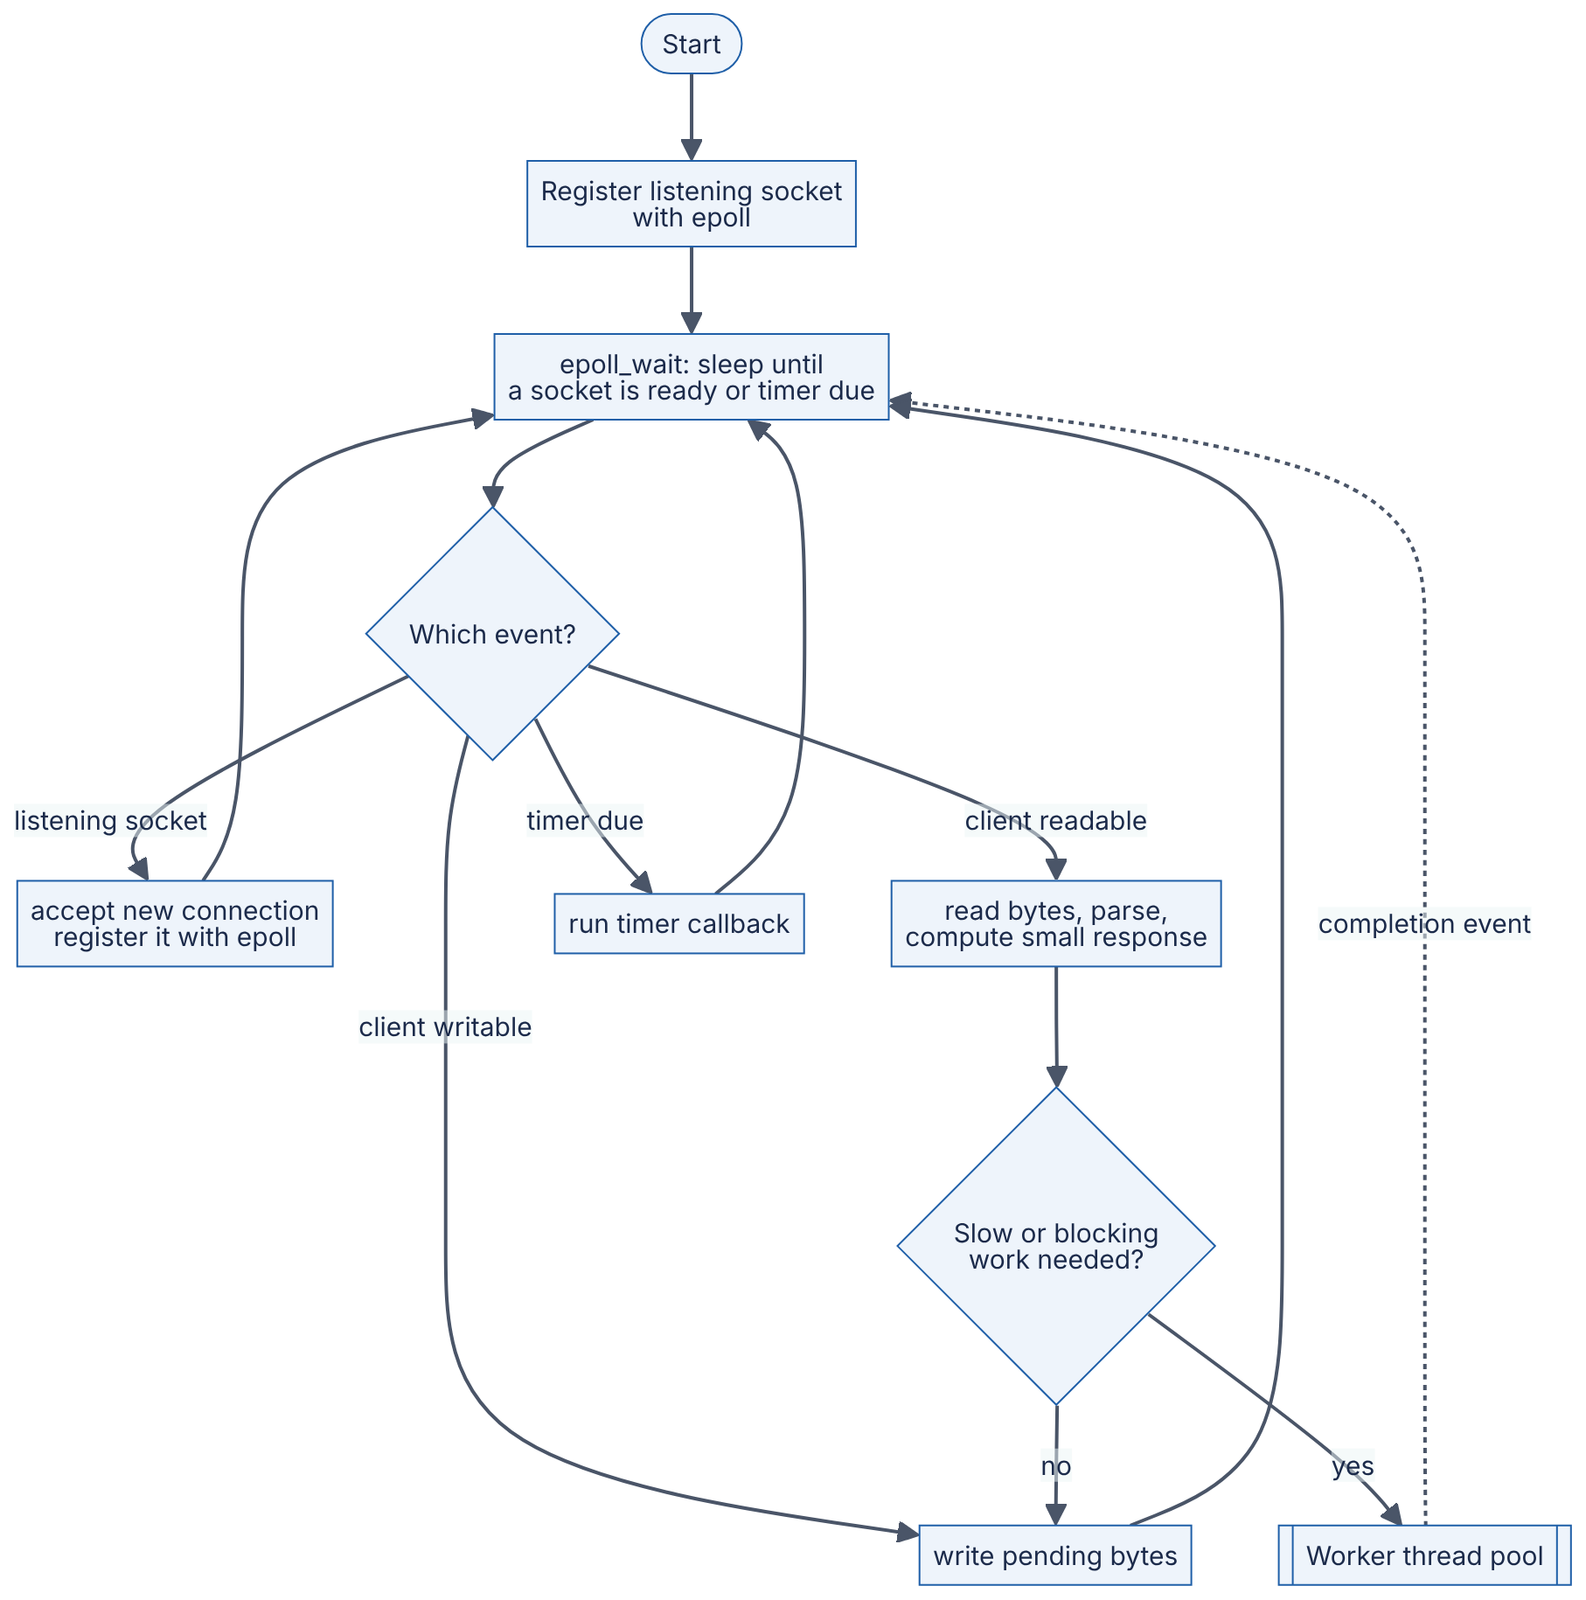
Reading the diagram. One thread sleeps in epoll_wait, the only place it may block, and dispatches each ready event: accept a connection, read and parse a request, flush output, run a timer. Handlers must be short. Blocking or CPU-heavy work (disk reads, password hashing, a synchronous database driver) goes to a worker pool, whose completion returns asynchronously as a new event (dotted arrow). The failure point is a slow handler: while one callback runs for 200 ms, every connection on the loop waits 200 ms. To use more cores, run one loop per core (nginx workers, SO_REUSEPORT, Node.js cluster).
The Python program below is a complete event-loop echo server. On Linux, selectors.DefaultSelector uses epoll; on macOS, kqueue.
"""A single-threaded echo server: one event loop, many connections.
On Linux, selectors.DefaultSelector is backed by epoll; on macOS/BSD by kqueue.
"""
import selectors
import socket
sel = selectors.DefaultSelector()
def accept(server: socket.socket) -> None:
conn, _addr = server.accept() # ready, so this will not block
conn.setblocking(False)
sel.register(conn, selectors.EVENT_READ, handle)
def handle(conn: socket.socket) -> None:
data = conn.recv(4096) # ready, so this will not block
if data:
conn.sendall(data) # simplification: assumes the send buffer has room
else: # empty read = peer closed
sel.unregister(conn)
conn.close()
def serve(host: str = "127.0.0.1", port: int = 9000) -> None:
server = socket.socket(socket.AF_INET, socket.SOCK_STREAM)
server.setsockopt(socket.SOL_SOCKET, socket.SO_REUSEADDR, 1)
server.bind((host, port))
server.listen(1024)
server.setblocking(False)
sel.register(server, selectors.EVENT_READ, accept)
print(f"selector = {type(sel).__name__}; listening on {host}:{port}")
while True: # THE event loop
for key, _mask in sel.select(): # block until >= 1 socket is ready
callback = key.data
callback(key.fileobj) # run the handler; it must not block
if __name__ == "__main__":
serve()
Connect with nc 127.0.0.1 9000 from several terminals; in testing it printed selector = EpollSelector and served 200 concurrent clients correctly.
What to notice:
- There is exactly one blocking call, sel.select(). Everything else runs only when the kernel has said it will not block.
- sendall on a non-blocking socket can still fail if the client is slow to read; a production server keeps a per-connection output buffer and registers for EVENT_WRITE. Frameworks handle this for you.

6.13.5 Completion-based I/O and io_uring
Readiness APIs need one system call to learn a socket is ready and another to read it. Completion-based APIs instead let the application submit an operation and later be told it is complete (Windows I/O completion ports; Linux’s older AIO worked well only for O_DIRECT files).
io_uring, added in Linux 5.1 (2019) by Jens Axboe, provides two ring buffers in memory shared between application and kernel: a submission queue (SQ) and a completion queue (CQ) [Axboe 2019].
Figure 6.11 — io_uring submission and completion rings.
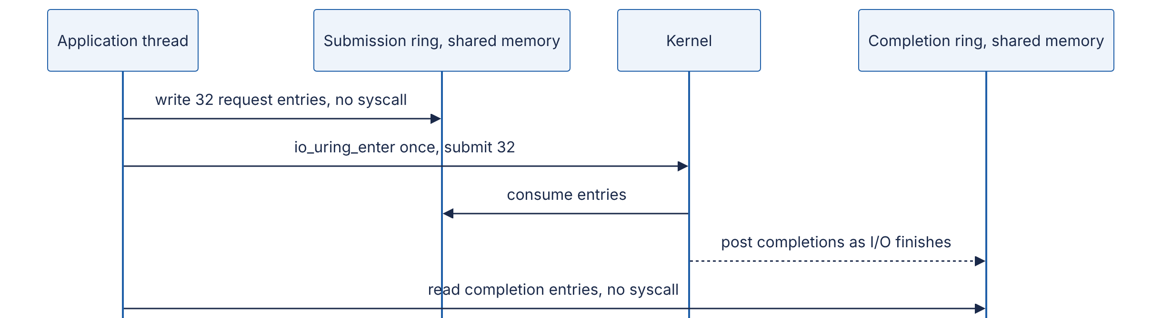
Reading the diagram. The application writes request entries (opcode, descriptor, buffer, user tag) into the shared submission ring with plain memory writes, then submits any number with one io_uring_enter call. The kernel performs them, files and sockets alike, and posts results asynchronously to the completion ring (dotted arrow), possibly out of order; the tag matches results to requests. Reaping completions needs no system call, and in SQPOLL mode a kernel thread polls the submission ring so submission needs none either. Costs: a more complex programming model and a large new kernel attack surface. Google reported in 2023 that most kernel exploits submitted to its bug-bounty program involved io_uring and that it had restricted io_uring on ChromeOS, Android apps and its production servers [Google Security Blog 2023]; some container runtimes block it by default.
Table 6.6 — I/O models compared.
Model | How it works | Advantages | Disadvantages | Scales to | Choose when
Blocking, thread per connection | Each thread blocks in read/write | Simplest code; natural stack traces | Memory and switching per connection | Thousands of connections | Moderate concurrency; blocking libraries
Non-blocking + busy polling | Loop calling read until not EAGAIN | Lowest latency on a dedicated core | Burns a full core | Few connections | Kernel-bypass and trading systems
select / poll | Readiness for a set passed each call | Portable | $O\left(n\right)$ per call; select limited to 1,024 | Hundreds | Small tools, portability
epoll / kqueue | Register once; wait for ready list | $O\left(\text{ready}\right)$; mature | Readiness only; files still block | Millions of sockets | Network servers on Linux/BSD
io_uring | Shared submission/completion rings | Batching; async files and sockets; few syscalls | Newer; security restrictions; complex | Very high IOPS | Storage engines, proxies on modern Linux

6.14 File systems, journaling and fsync

6.14.1 What a file system does
A file system turns an array of numbered disk blocks into named, hierarchical files. Each file has an inode holding metadata (size, owner, permissions, timestamps) and the locations of its data blocks; a directory maps names to inode numbers. Creating /data/log.txt touches several structures: a new inode, the free-block bitmap, data blocks and the parent directory.

6.14.2 Crash consistency and journaling
A crash midway through those updates can leave a directory entry pointing at an uninitialized inode; older file systems needed a full-disk fsck, taking hours on large disks. A journaling file system uses a write-ahead log (§13.5): record the intended changes in a journal, commit, then apply them in place; after a crash, replay committed entries in seconds. ext4 offers three modes: data=journal (data and metadata both journaled: safest, slowest), data=ordered (the default: only metadata journaled, but data blocks are written before the metadata that points at them) and data=writeback (metadata only, no ordering: a crash can expose stale data). XFS journals metadata. Copy-on-write file systems such as ZFS and Btrfs never overwrite in place: they write new blocks and atomically switch a root pointer.
Journaling protects the file system’s own structures. It does not make your application’s data durable at any particular moment.

6.14.3 fsync and durability
Figure 6.12 — The write path from application to stable storage.
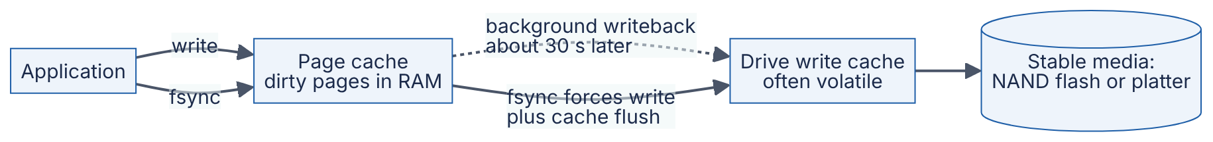
Reading the diagram. write() copies data into the page cache and returns; nothing is on disk yet. The dotted arrow is asynchronous background writeback (§6.6.6), roughly 30 s later by default. fsync(fd) is the synchronous path: it writes the file’s dirty pages and metadata, waits for the device, and issues a cache flush so the drive’s volatile write cache reaches stable media, the storage boundary that matters. Enterprise SSDs with power-loss protection capacitors can treat their cache as stable. Failure points: a crash loses dirty pages, a drive that ignores flushes loses its cache, and a writeback I/O error can lose data silently.
Durability pitfalls, each of which has caused real data loss:
- write() is not durable. Without fsync (or fdatasync, which skips non-essential metadata), a crash loses acknowledged writes.
- The directory needs fsync too. Creating or renaming a file changes the directory, which must also be synced [Linux man-pages: fsync(2); Pillai et al. 2014].
- “Write temp, then rename” needs fsync before the rename, or a crash can leave the new name pointing at an empty file.
- fsync errors are not retryable. On Linux a failed writeback may mark pages clean, so a second fsync can succeed although the data was lost. After the 2018 “fsyncgate” investigation, PostgreSQL crashes and recovers from its write-ahead log on any fsync failure [PostgreSQL Wiki: Fsync Errors; Rebello et al. 2020].
- macOS fsync does not flush the drive cache; use fcntl(fd, F_FULLFSYNC) [Apple: fsync(2) man page].
- O_DIRECT is not O_SYNC: bypassing the page cache does not make writes durable.
- Torn writes: a crash mid-write can leave half-old, half-new sectors; databases detect this with checksums (§13.12).
The program below replaces a file atomically and durably on POSIX systems:
"""Atomically and durably replace a file on a POSIX system (Linux, macOS)."""
import os
def durable_replace(path: str, data: bytes) -> None:
directory = os.path.dirname(os.path.abspath(path))
tmp_path = path + ".tmp"
fd = os.open(tmp_path, os.O_WRONLY | os.O_CREAT | os.O_TRUNC, 0o644)
try:
view = memoryview(data)
while view: # write() may write fewer bytes than asked
written = os.write(fd, view)
view = view[written:]
os.fsync(fd) # 1. file contents reach stable storage
finally:
os.close(fd)
os.replace(tmp_path, path) # 2. atomic rename over the old file
dir_fd = os.open(directory, os.O_RDONLY)
try:
os.fsync(dir_fd) # 3. the rename itself (a directory entry) is durable
finally:
os.close(dir_fd)
if __name__ == "__main__":
durable_replace("config.json", b'{"version": 2}\n')
with open("config.json", "rb") as f:
print(f.read())
What to notice:
- Readers see the complete old or complete new file, never a mixture: os.replace is an atomic rename within one file system.
- Skipping step 1 risks an empty file under the new name; skipping step 3 risks the old file reappearing after a crash.
- If os.fsync raises, the function propagates the exception rather than retrying (pitfall 4). On macOS, add fcntl.fcntl(fd, fcntl.F_FULLFSYNC) for power-loss durability.
FORMULA
Group-commit throughput
$$X=\frac{B}{t_{\text{fsync}}}$$
Symbol | Meaning | Units
$X$ | Maximum durable commits per second on one log | commits/s
$B$ | Commits made durable by one fsync (batch size) | commits
$t_{\text{fsync}}$ | Latency of one fsync | s
WORKED EXAMPLE
Worked example — Why databases batch fsyncs. An SSD without power-loss protection takes $t_{\text{fsync}}=2$ ms (0.002 s) per fsync. One commit per fsync: $X=1/0.002=$ 500 commits/s, no matter how fast the CPU is. Group commit waits briefly to collect concurrent commits into one fsync. With $B=50$: $X=50/0.002=$ 25,000 commits/s, at the price of up to a couple of milliseconds of extra latency per commit. Interpretation. Durable write throughput is set by fsync latency, not bandwidth. Engineering implication: databases batch commits into one log flush, and drives with power-loss protection raise the ceiling further. When a vendor quotes “100,000 writes per second”, ask how many fsyncs that included.
Table 6.7 — Durability options for a write.
Option | What is guaranteed at return | Relative cost | Choose when
write() only | Data in page cache; lost on power failure or kernel crash | Lowest | Caches, temporary data, data you can regenerate
write() + fdatasync() | Data and size metadata on stable storage | High (one device flush) | Write-ahead logs and append-only files
write() + fsync() | Data and all metadata on stable storage | High | General durable files
+ fsync() on directory | The file’s name and existence are durable | Additional flush | Newly created or renamed files
O_DSYNC / O_SYNC on open | Every write behaves as if followed by fdatasync / fsync | Highest per write | Small, critical, infrequent writes
Replication instead of local fsync | Data in RAM on several machines | Network round trip | Distributed logs that accept correlated-failure risk (§27.3)

6.15 Concurrency models in practice
The five models below answer one question differently: what represents a waiting request, and what does it cost?

6.15.1 Thread per request
Each request gets an OS thread (usually from a pool) running blocking code start to finish: classic Tomcat servlets, Apache httpd’s worker model, threaded Python WSGI servers. Strengths: sequential code, readable stack traces, parallelism across cores. Weaknesses: each waiting request costs a whole thread, capping concurrency by memory and switching overhead, and a slow dependency can tie up every pool thread.

6.15.2 Event loop (Node.js, nginx, Redis)
One thread runs an event loop (§6.13.4); a waiting request costs a small state object and a callback. Node.js runs JavaScript on one libuv loop; nginx runs one loop per worker process; Redis executes commands on one main thread, making each command trivially atomic. Strengths: tiny per-connection cost, no locks for loop-owned state. Weaknesses: one core per loop, and any blocking callback stalls every connection [Node.js Docs: Don’t Block the Event Loop].

6.15.3 Actors (Erlang/OTP, Akka)
An actor is an isolated unit of state with a mailbox; actors share no memory, communicate only by asynchronous messages and process one message at a time, so their state has no data races [Hewitt et al. 1973]. Erlang processes, scheduled by the BEAM virtual machine with one scheduler thread per core, take a few hundred machine words each at creation [Erlang Docs: Efficiency Guide]. Erlang/OTP adds supervision trees that restart crashed actors (“let it crash”) [Armstrong 2003]; Akka brings the model to the JVM. Weaknesses: unbounded mailboxes, extra plumbing for request/response, and hard reasoning about ordering across actors.
INDUSTRY EXAMPLE
WhatsApp on Erlang. WhatsApp built its messaging servers on Erlang/FreeBSD and reported in a 2012 engineering blog post more than two million simultaneous TCP connections on a single server, attributing it to lightweight Erlang processes and kernel tuning. Evidence: Primary — [WhatsApp Blog 2012]

6.15.4 Goroutines (Go)
Go multiplexes goroutines onto GOMAXPROCS OS threads (by default the number of usable CPUs). A goroutine starts with a 2 KiB stack that grows on demand. On network I/O the runtime parks the goroutine and registers the socket with its netpoller (built on epoll/kqueue), so blocking-style code gets event-loop efficiency; since Go 1.14 long-running goroutines can also be preempted. Weaknesses: shared memory still allows races and deadlocks (§6.9), and leaked goroutines accumulate silently. Java’s virtual threads (JDK 21, 2023) apply the same idea to the JVM [OpenJDK JEP 444].

6.15.5 async/await (Python asyncio, JavaScript, C#, Rust)
async/await is syntax for event-loop code that reads sequentially. An async function is a coroutine; each await is a point where it may suspend and return control to the loop. Scheduling is cooperative: coroutines yield only at await.
"""10,000 concurrent 'requests', one thread, about one second."""
import asyncio
import time
async def handle_request(i: int) -> int:
await asyncio.sleep(1.0) # stands in for a 1 s network call; yields to the loop
return i
async def main() -> None:
start = time.perf_counter()
results = await asyncio.gather(*(handle_request(i) for i in range(10_000)))
elapsed = time.perf_counter() - start
print(f"{len(results)} requests finished in {elapsed:.2f} s on one thread")
asyncio.run(main())
Output in testing: 10000 requests finished in 1.09 s on one thread.
What to notice:
- 10,000 one-second waits overlap on one thread: this is concurrency without parallelism (§6.8).
- Replace await asyncio.sleep(1.0) with time.sleep(1.0) and the program takes about 10,000 seconds: one blocking call inside a coroutine blocks the whole loop.
- async is “contagious”: a function that awaits must itself be async, so libraries split into synchronous and asynchronous versions (the “function color” problem).

6.15.6 Comparison and capacity
Table 6.8 — Concurrency models compared.
Aspect | Thread per request | Event loop | Actors | Goroutines / virtual threads | async/await
Unit of concurrency | OS thread | Callback + state | Actor with mailbox | Runtime-managed thread | Coroutine
Memory per waiting request (order of magnitude) | 64 KiB–1 MiB touched stack + kernel task | ~1 KiB or less | ~1–3 KB | ~2–8 KiB | ~1–2 KiB
Scheduling | Preemptive, kernel | Cooperative, one thread | Runtime, per message | Runtime, mostly preemptive | Cooperative at await
Uses multiple cores | Yes | No (run one loop per core) | Yes | Yes | Only with multiple loops or executors
Shared-state safety | Locks needed | Safe within the loop | Safe by isolation | Locks or channels needed | Safe within one loop
Main failure mode | Thread exhaustion; context switching | Blocking the loop | Mailbox overflow | Goroutine leaks; races | Accidental blocking call
Code style | Sequential, blocking | Callbacks or promises | Message handlers | Sequential, blocking | Sequential with await
Examples | Tomcat, Apache httpd, Django with threads | nginx, Node.js, Redis | Erlang/OTP, Akka | Go servers, Java 21 virtual threads | FastAPI, aiohttp, Rust Tokio
Choose when | Moderate concurrency, blocking libraries | Many connections, light per-request CPU | Fault isolation, many stateful entities | High concurrency with simple code | High I/O concurrency in Python/JS/Rust
Memory figures are orders of magnitude for planning (as of 2026 runtimes), not measurements; measure your own service’s resident memory per connection.
FORMULA
Memory for concurrent connections
$$M_{\text{total}}=N×\left(m_{\text{unit}}+m_{\text{conn}}\right)$$
Symbol | Meaning | Units
$M_{\text{total}}$ | Memory needed for concurrency overhead | bytes
$N$ | Concurrent connections (or in-flight requests) | connections
$m_{\text{unit}}$ | Resident memory per concurrency unit (thread stack + kernel task, or coroutine) | bytes
$m_{\text{conn}}$ | Per-connection buffers (socket buffers, TLS state, request object) | bytes
WORKED EXAMPLE
Worked example — 10,000 and 100,000 connections. A chat gateway must hold $N=10,000$ mostly idle WebSocket connections. Assume $m_{\text{conn}}=20$ KB of socket buffers and TLS state per connection in every model.
Thread per connection (Java platform threads). Each thread reserves 1 MiB of virtual stack, but only touched pages are resident; assume 64 KiB touched + 16 KiB kernel stack + ~8 KiB other kernel state ≈ 88 KB. $M=10,000×\left(88+20\right)$ KB = 1.08 GB. Workable, though with 10,000 schedulable threads. Goroutines. Assume 8 KiB per goroutine (≈ 8 KB). $M=10,000×\left(8+20\right)$ KB = 280 MB.
Now scale to $N=100,000$: threads need 10.8 GB plus 100,000 kernel tasks (beyond typical pids.max and thread limits, and every wake-up is a context switch); goroutines need 2.8 GB; an event loop with ~1 KB per connection needs about 2.1 GB, dominated by socket buffers.
Interpretation. Thread-per-connection works at thousands of connections and becomes the bottleneck at hundreds of thousands, where per-connection buffers also start to dominate. Engineering implication: for connection-heavy services (gateways, push, chat; §9.9) choose event loops, goroutines or virtual threads; for CPU-heavy work, core count matters more than the model.
FORMULA
Thread-pool sizing
$$N_{\text{threads}}=λ×W \text{and, for mixed CPU/I/O work,} N_{\text{threads}}≈N_{\text{cpu}}×U×\left(1+\frac{T_{\text{wait}}}{T_{\text{cpu}}}\right)$$
Symbol | Meaning | Units
$N_{\text{threads}}$ | Threads needed to sustain the load | threads
$λ$ | Request arrival rate | requests/s
$W$ | Time a request occupies a thread | s
$N_{\text{cpu}}$ | Available cores | cores
$U$ | Target CPU utilization | dimensionless (0–1)
$T_{\text{wait}}$, $T_{\text{cpu}}$ | Per-request time spent waiting and computing | ms
WORKED EXAMPLE
Worked example — Sizing a blocking service. A service receives $λ=2,000$ requests/s; each request spends 10 ms on CPU and 90 ms waiting for a database ($W=0.1$ s). Little’s Law (§4.11): $N_{\text{threads}}=2,000×0.1=$ 200 threads in use on average. CPU check: $2,000×0.010$ s = 20 core-seconds per second, so at least 20 cores. With $N_{\text{cpu}}=32$, $U=0.7$: $N_{\text{threads}}≈32×0.7×\left(1+90/10\right)=224$, consistent with 200 [Goetz et al. 2006]. Interpretation. 200–250 threads is reasonable here. If the database slows to 900 ms, the same load needs $2,000×0.91≈1,820$ threads: a fixed pool of 250 saturates and requests queue. Engineering implication: bound the pool and the queue, set timeouts on downstream calls (§22.11), and shed load rather than letting a slow dependency consume every thread.
COMMON MISTAKE
“Async is faster.” async/await and event loops do not make individual operations faster; they make waiting cheaper, so more requests can wait at once. For CPU-bound work they are no better than threads, and a single misplaced blocking call makes them much worse.

6.16 Summary and revision notes
SUMMARY
- A process is a running program with a private address space; a thread is an execution context sharing its process’s memory. The PCB (task_struct) stores everything needed to resume. States: New → Ready ⇄ Running → Blocked → Ready → … → Terminated.
- A context switch costs ~1–5 µs directly, but cache and TLB refill can cost 10–100× more. Overhead fraction $f=C/\left(Q+C\right)$: it matters when threads run only microseconds between switches.
- Scheduling trades turnaround, response time and fairness. RR fixes FCFS’s convoy effect; MLFQ learns interactivity; Linux uses weighted fair sharing (CFS from 2.6.23, EEVDF from 6.6). CPU quotas in containers can throttle a service even when the host is idle.
- Virtual memory translates addresses through page tables cached in the TLB. TLB reach = entries × page size; huge pages extend it. Major page faults cost 100 µs–10 ms, so even rare faults dominate average access time. The page cache holds file data; mmap maps it into memory; copy-on-write makes fork cheap.
- A system call costs ~100 ns or more versus ~1 ns for a function call; batch, use vDSO, or use shared rings (io_uring).
- Concurrency is about structure and overlapping waits; parallelism is simultaneous execution. Neither implies the other.
- A race condition is a timing-dependent bug; protect every read-modify-write of shared state as a critical section, and run race detectors in CI.
- Mutex for exclusion; semaphore to limit concurrency; condition variable (in a while loop) to wait for a predicate; atomics/CAS for single-word updates; read-write locks for long read-mostly sections; lock-free structures only from proven libraries, minding ABA.
- Deadlock needs all four Coffman conditions; break circular wait with lock ordering. Livelock → randomized backoff; starvation → fairness; priority inversion → priority inheritance (Mars Pathfinder, 1997).
- IPC: pipes, sockets, shared memory (fastest), message queues, signals (handle SIGTERM).
- I/O: blocking needs a thread per connection; epoll/kqueue readiness notification solved C10K; io_uring adds batched completion-based I/O. An event loop must never block.
- write() is not durable. Use fsync on the file and its directory, treat fsync errors as fatal, and batch commits (group commit $X=B/t_{\text{fsync}}$).
- Thread-per-request is simple but costs ~100 KB per connection; event loops, goroutines, virtual threads and async/await make waiting cheap. Size pools with Little’s Law and bound them.

6.17 Knowledge checkpoint
- What is the difference between a program, a process and a thread?
- Name five pieces of information stored in a PCB.
- Why does a process go from Blocked to Ready rather than directly to Running?
- Distinguish the direct and indirect costs of a context switch.
- Three jobs of 100, 10 and 10 ms arrive together. What is the average turnaround time under FCFS (in that order) and under SJF?
- How does a CPU limit in a container cause latency spikes on an idle host?
- Calculate the TLB reach of 2,048 entries with 4 KiB pages and with 2 MiB pages.
- What is the difference between a minor and a major page fault?
- Why must a condition-variable wait be inside a while loop?
- Describe the ABA problem in one or two sentences and give one remedy.
- List the four Coffman conditions and the most practical way to break one.
- Why does epoll not help with reading regular files?
- List the three steps to durably replace a file and the consequence of skipping each.
- A service handles 1,000 requests/s, each holding a thread for 250 ms. How many threads are busy on average?
Answers
- A program is an executable file; a process is a running instance with its own address space and resources; a thread is one execution context (registers, stack) inside a process, sharing its memory.
- Any five of: PID and parent PID, state, saved registers and program counter, scheduling priority and accounting, page-table pointer and memory map, open file table, signal handlers, credentials, resource limits.
- The event that unblocked it does not mean a CPU is free; it must be chosen by the scheduler like any other ready task.
- Direct: kernel work to save and restore state and choose the next task (~1–5 µs). Indirect: slower execution afterwards because caches and TLB hold the previous thread’s state.
- FCFS: completions 100, 110, 120 → average 110 ms. SJF: 10, 20, 120 → average 50 ms.
- CFS bandwidth control gives the cgroup a quota per period (default 100 ms). Several threads exhaust it early and the cgroup is throttled for the rest of the period, delaying requests regardless of host load.
- 2,048 × 4 KiB = 8 MiB; 2,048 × 2 MiB = 4 GiB.
- A minor fault needs no I/O (page already in RAM, or a fresh zero page); a major fault reads from storage and blocks the thread for 100 µs–10 ms.
- Under Mesa semantics another thread may change the state before the woken waiter reacquires the lock, and spurious wake-ups are allowed.
- A CAS succeeds because a location again holds value A, although it changed to B and back in between, so the CAS acts on stale assumptions. Remedies: version-tagged pointers, hazard pointers, epoch-based reclamation.
- Mutual exclusion, hold and wait, no preemption, circular wait. Break circular wait with a global lock order.
- Regular files are always reported ready, yet reads can block on disk. Use a thread pool or io_uring.
- fsync the temporary file (else the new name may point at empty data), rename atomically (else readers may see a partial file), fsync the directory (else the old file may reappear after a crash).
- Little’s Law: 1,000 × 0.25 = 250 threads.

6.18 Interview questions

Basic
Q1. What is the difference between a process and a thread, and when would you choose processes? Answer. A process has its own address space; threads share their process’s memory and file descriptors but have their own stacks and registers. Threads communicate cheaply and switch faster; processes isolate faults. Choose processes for isolation (untrusted code, non-thread-safe libraries, PostgreSQL backends) or to bypass a GIL; threads for low-latency sharing of large in-memory state.
Q2. What is a race condition? Give an example and two fixes. Answer. A bug whose outcome depends on the interleaving of concurrent operations; e.g. two threads both read 5 and both write 6. Fixes: a mutex around the read-modify-write, or one atomic operation (atomic add, CAS loop); across services, transactions or conditional writes. Tests rarely reveal races, so use race detectors.
Q3. What is a deadlock and how do you prevent it in application code? Answer. A cycle of threads each waiting for a resource held by the next, requiring all four Coffman conditions. Acquire locks in one global order, never hold locks across I/O or unknown callbacks, use tryLock with timeouts, and prefer single-owner state or message passing. Detect with thread dumps.

Intermediate
Q4. Your service’s p99 latency doubled after you increased the worker pool from 64 to 2,000 threads on a 16-core machine. Why might that be? Answer. If the work is CPU-bound, 2,000 runnable threads on 16 cores each wait behind ~125 others; involuntary switches multiply and evict caches, so throughput falls while queueing grows, and lock contention rises. Check vmstat (cs, run queue), voluntary versus involuntary switches and lock profiles. Size the pool with Little’s Law and the CPU/wait ratio, with a bounded queue and load shedding. If the work is I/O-bound, async or virtual threads are cheaper than a huge pool.
Q5. Explain how an event loop serves 10,000 connections on one thread, and what breaks it. Answer. Non-blocking sockets are registered with epoll/kqueue; the loop sleeps in one wait call and runs short handlers for the ready sockets, so a waiting connection costs a small state object, not a thread. It breaks when a handler blocks or burns CPU (synchronous DB driver, large JSON parse, file I/O), stalling every connection. Mitigations: worker pools, one loop per core, event-loop-lag monitoring.
Q6. A database acknowledges writes after write() but before fsync(). What can go wrong, and how do real databases make commits durable but fast? Answer. A crash loses data still in the page cache, so acknowledged commits vanish. Durable systems append to a write-ahead log and fdatasync before acknowledging, using group commit to amortize flushes ($X=B/t_{\text{fsync}}$); they fsync directories after creating files, treat fsync errors as fatal, and use drives with power-loss protection. Alternatively, replicate to other machines before acknowledging, trading flush latency for a network round trip and correlated-failure risk.

Advanced
Q7. Explain priority inversion with a real example and how to prevent it, including outside real-time systems. Answer. A high-priority task blocks on a lock held by a low-priority task, which a medium-priority task preempts, so the high task waits indefinitely. Mars Pathfinder (1997) reset repeatedly because a VxWorks mutex shared by a low-priority weather task and a high-priority bus task lacked priority inheritance; JPL enabled it remotely. Prevention: priority inheritance or ceiling locks, no locks shared across priority levels, short critical sections. In servers, isolate pools and resources so background jobs cannot hold what user traffic needs.
Q8. Compare epoll and io_uring. When would you adopt io_uring? Answer. epoll is readiness-based: it says a socket can be read, then a separate call reads it, and file reads can still block. io_uring is completion-based, with shared submission and completion rings, giving batching, asynchronous file I/O and, with SQPOLL, near-zero system calls. Adopt it for high-IOPS storage engines or proxies where syscall overhead is a measured bottleneck, accepting complexity, kernel-version dependence and security restrictions. For typical web services, epoll via a mature runtime is enough.
Q9. Design the concurrency model for a WebSocket gateway holding 1 million mostly idle connections across a fleet. Justify it with numbers. Answer. Thread-per-connection at ~100 KB each needs ~100 GB and a million kernel tasks: impractical. An event loop or goroutines at ~1–8 KB plus ~20 KB of socket and TLS buffers needs ~25–30 GB in total; spread it over, say, 10 nodes × 100,000 connections so one node loss affects 10 %. Run one loop per core (or Go with GOMAXPROCS = cores), raise file-descriptor limits, size socket buffers deliberately, push heavy work to other services via queues, and drain connections gradually on SIGTERM to avoid reconnect storms (§9.9).

6.19 Practical exercises
- Watch process states. Run sleep 100 &, a CPU loop (yes > /dev/null &) and cat reading from a terminal. Use ps -o pid,stat,wchan:20,cmd to identify R and S states. Kill the parent of a child that has exited without being reaped and observe the zombie.
- Measure a context switch. Run the following ping-pong program, once normally and once pinned to one core with taskset -c 0. Explain the difference. On one test VM for this chapter, it gave about 24 µs per round trip unpinned and about 4 µs pinned, because cross-core wake-ups add inter-processor interrupts and idle-state exits.
"""Two processes bounce one byte over a pair of pipes (POSIX only: uses fork).
Each round trip forces at least two blocking reads and wake-ups, so the
time per round trip upper-bounds the cost of two context switches plus
four system calls and Python interpreter overhead.
"""
import os
import time
ROUNDS = 100_000
parent_to_child_r, parent_to_child_w = os.pipe()
child_to_parent_r, child_to_parent_w = os.pipe()
pid = os.fork()
if pid == 0: # child process
for _ in range(ROUNDS):
os.read(parent_to_child_r, 1) # block until parent writes
os.write(child_to_parent_w, b"x") # wake the parent
os._exit(0)
start = time.perf_counter()
for _ in range(ROUNDS):
os.write(parent_to_child_w, b"x") # wake the child
os.read(child_to_parent_r, 1) # block until child answers
elapsed = time.perf_counter() - start
os.waitpid(pid, 0)
print(f"{elapsed / ROUNDS * 1e6:.1f} us per round trip")
- Find the race. Run the Go program in §6.9 with go run -race .. Then write a version that uses a channel owned by one goroutine instead of a mutex, and confirm the race detector is silent.
- Break the event loop. Add time.sleep(2) inside handle() in the echo server of §6.13.4, connect three clients, and measure how long the third waits. Fix it by moving the slow work to a concurrent.futures.ThreadPoolExecutor.
- Count system calls. Run strace -c python3 -c "open('/etc/hostname').read()" and then the same for a program that copies a 100 MB file using 1-byte reads versus 64 KiB reads. Relate the time difference to §6.7.
- Durability check. Write a program that appends 10,000 small records with and without fsync after each, and with one fsync per 100 records. Compute the commits per second and compare with the group-commit formula in §6.14.3.

6.20 Design challenges
- Log-ingestion agent. Design a host agent that tails 500 log files, batches lines, and ships them to a remote collector at 50 MB/s, surviving agent restarts without losing or duplicating more than one batch. Decide: threads versus event loop versus io_uring; how offsets are made durable (fsync strategy and cost); how backpressure works when the collector is slow; how the agent behaves when the disk fills. Justify each choice with numbers from this chapter.
- Multi-tenant job runner. Design a single-machine runner for untrusted user jobs that guarantees each tenant a fair CPU share and a memory cap, and kills runaway jobs without affecting others. Discuss processes versus threads, cgroup CPU weights versus quotas (and throttling), OOM behavior, signals for graceful termination, and how to prevent a tenant from starving others through a shared lock or file system. Relate to §47.
- In-memory rate limiter. Design a per-API-key rate limiter inside a service handling 200,000 requests/s on 32 cores. Compare a global mutex-protected map, a sharded map with per-shard locks, per-core counters merged periodically, and atomic CAS on token buckets. Estimate contention, explain where false sharing appears (§5.4), and state which you would ship and why (see §22.4).

6.21 References
- Arpaci-Dusseau, R. H., and Arpaci-Dusseau, A. C. Operating Systems: Three Easy Pieces. Arpaci-Dusseau Books, 2018 (v1.00; free online). https://ostep.org
- Silberschatz, A., Galvin, P. B., and Gagne, G. Operating System Concepts, 10th ed. Wiley, 2018.
- Tanenbaum, A. S., and Bos, H. Modern Operating Systems, 4th ed. Pearson, 2014.
- Kegel, D. The C10K problem. Web page, first published 1999. http://www.kegel.com/c10k.html
- Axboe, J. Efficient IO with io_uring. 2019. https://kernel.dk/io_uring.pdf
- Linux man-pages project. syscalls(2), sched(7), signal(7), epoll(7), fsync(2), mmap(2), futex(2), io_uring(7), pipe(7). https://man7.org/linux/man-pages/
- Linux kernel documentation. CFS Scheduler; EEVDF Scheduler; CFS Bandwidth Control. https://docs.kernel.org/scheduler/
- Stoica, I., and Abdel-Wahab, H. Earliest Eligible Virtual Deadline First: A Flexible and Accurate Mechanism for Proportional Share Resource Allocation. Technical Report TR-95-22, Old Dominion University, 1995.
- Corbet, J. “An EEVDF CPU scheduler for Linux.” LWN.net, 2023. https://lwn.net/Articles/925371/
- Gregg, B. Systems Performance: Enterprise and the Cloud, 2nd ed. Addison-Wesley, 2020.
- Li, C., Ding, C., and Shen, K. “Quantifying the Cost of Context Switch.” Workshop on Experimental Computer Science (ExpCS), 2007.
- Franke, H., Russell, R., and Kirkwood, M. “Fuss, Futexes and Furwocks: Fast Userlevel Locking in Linux.” Ottawa Linux Symposium, 2002.
- Dijkstra, E. W. Cooperating Sequential Processes (EWD 123). Technological University, Eindhoven, 1965.
- Lampson, B. W., and Redell, D. D. “Experience with Processes and Monitors in Mesa.” Communications of the ACM 23(2), 1980.
- Herlihy, M., and Shavit, N. The Art of Multiprocessor Programming, revised 1st ed. Morgan Kaufmann, 2012.
- Treiber, R. K. Systems Programming: Coping with Parallelism. IBM Research Report RJ 5118, 1986.
- Michael, M. M. “Hazard Pointers: Safe Memory Reclamation for Lock-Free Objects.” IEEE Transactions on Parallel and Distributed Systems 15(6), 2004.
- Coffman, E. G., Elphick, M. J., and Shoshani, A. “System Deadlocks.” ACM Computing Surveys 3(2), 1971.
- Sha, L., Rajkumar, R., and Lehoczky, J. P. “Priority Inheritance Protocols: An Approach to Real-Time Synchronization.” IEEE Transactions on Computers 39(9), 1990.
- Reeves, G. E. “What really happened on Mars?” Email account, December 1997; reproduced at https://www.cs.cornell.edu/courses/cs614/1999sp/papers/pathfinder.html
- Jones, M. B. “What really happened on Mars Rover Pathfinder.” The RISKS Digest 19(49), 1997.
- Lemon, J. “Kqueue: A Generic and Scalable Event Notification Facility.” USENIX Annual Technical Conference, FREENIX Track, 2001.
- Pillai, T. S., et al. “All File Systems Are Not Created Equal: On the Complexity of Crafting Crash-Consistent Applications.” OSDI, 2014.
- Rebello, A., et al. “Can Applications Recover from fsync Failures?” USENIX Annual Technical Conference, 2020.
- PostgreSQL Wiki. Fsync Errors. https://wiki.postgresql.org/wiki/Fsync_Errors
- Crotty, A., Leis, V., and Pavlo, A. “Are You Sure You Want to Use MMAP in Your Database Management System?” CIDR, 2022.
- Apache Kafka. Documentation: Design — Persistence. https://kafka.apache.org/documentation/#persistence
- Redis. Redis persistence and Diagnosing latency issues. https://redis.io/docs/
- PostgreSQL. Documentation: Architectural Fundamentals. https://www.postgresql.org/docs/current/tutorial-arch.html
- MySQL. MySQL 8.0 Reference Manual: Connection Interfaces. https://dev.mysql.com/doc/
- Pike, R. “Concurrency is not Parallelism.” Talk, Heroku Waza conference, 2012.
- The Go Authors. Data Race Detector and The Go Memory Model. https://go.dev/doc/articles/race_detector, https://go.dev/ref/mem
- Node.js. Don’t Block the Event Loop (or the Worker Pool). https://nodejs.org/en/learn/asynchronous-work/dont-block-the-event-loop
- Google Security Blog. “Learnings from kCTF VRP’s 42 Linux kernel exploits submissions.” 2023. https://security.googleblog.com/
- Apple. fsync(2) macOS manual page.
- Hewitt, C., Bishop, P., and Steiger, R. “A Universal Modular ACTOR Formalism for Artificial Intelligence.” IJCAI, 1973.
- Armstrong, J. Making Reliable Distributed Systems in the Presence of Software Errors. PhD thesis, Royal Institute of Technology (KTH), Stockholm, 2003.
- Erlang/OTP. Efficiency Guide: Processes. https://www.erlang.org/doc/
- WhatsApp. “1 million is so 2011.” WhatsApp Blog, January 2012.
- OpenJDK. JEP 444: Virtual Threads. 2023. https://openjdk.org/jeps/444
- Goetz, B., et al. Java Concurrency in Practice. Addison-Wesley, 2006.

6.22 Open verification items
- Exact LWN article URL and date for [Corbet 2023] (lwn.net was unreachable from the authoring environment). EEVDF merge in 6.6 and the 0.75 ms × (1 + log2 ncpus) base slice were confirmed against the v6.6 scheduler pull request and commit e4ec3318; whether later 6.x releases changed the default is not verified.
- Magnitude of indirect context-switch cost reported by [Li et al. 2007]; direct-cost range 1–5 µs on current hardware.
- Mars Pathfinder details (task names, watchdog mechanism, remote patch via on-board interpreter) against Reeves’s original text; Cornell mirror URL.
- Google Security Blog 2023 io_uring statistics and the exact scope of the restriction; full article URL.
- WhatsApp 2012 “2 million connections” blog post URL and wording.
- Erlang process initial size (“a few hundred words”) for the current OTP release; Python 3.14 free-threading status.
- Whether Dijkstra’s banker’s algorithm should be cited to EWD 123 or EWD 108.
- MySQL “Connection Interfaces” page title for thread-per-connection.
- TLB entry counts (1,000–3,000 second-level entries) for current server CPUs.

Chapter 7 — Networking Fundamentals
Level: 1–2 · Track: Shared · Estimated reading time: 5 h
Every system in this book is a set of computers that talk to each other. A database replica talks to its primary, a browser talks to a load balancer, and a model server streams tokens to a phone. Whenever two computers talk, the network sets hard limits on how fast they can do it, how often it fails, and what it costs. Those limits come from physics (the speed of light), from economics (the cost of bandwidth), and from decades-old protocol decisions that you cannot change. You can design around them only if you understand them.
This chapter builds the network up from nothing. We start with the layered model that lets thousands of independently built protocols cooperate, then follow a single request down through addressing, routing, name resolution, transport, security and application protocols. We finish by tracing everything that happens when you type a URL into a browser. Throughout, the goal is quantitative intuition: by the end you should be able to estimate, with arithmetic, how long a request will take and why.

7.1 Learning objectives
After this chapter you should be able to:
- Explain the OSI and TCP/IP layer models and describe how encapsulation wraps application data in transport, network and link headers.
- Read and compute IPv4 and IPv6 CIDR blocks: network address, broadcast address, usable host count and whether an address falls in a subnet.
- Describe how packets are routed inside a network and between autonomous systems with BGP, and explain how anycast steers users to a nearby server.
- Draw the DNS resolution sequence (stub, recursive resolver, root, TLD, authoritative), name the common record types, and reason about TTLs and the limits of DNS-based load balancing.
- Explain TCP’s three-way handshake, four-way close, TIME_WAIT, sequence numbers, retransmission, flow control and congestion control (slow start, AIMD, CUBIC, BBR), and identify head-of-line blocking.
- Decide when UDP is the right transport and what you must rebuild on top of it.
- Compare HTTP/1.1, HTTP/2 and HTTP/3 (over QUIC) and justify a choice for a given workload.
- Sequence the TLS 1.3 handshake, explain certificate validation, and state the security caveats of 0-RTT.
- Distinguish forward proxies from reverse proxies, and explain NAT, firewalls and cloud security groups.
- Decompose latency into propagation, transmission, queuing and processing delay; compute the bandwidth-delay product; and apply the Mathis formula to estimate TCP throughput under loss.
- Quantify the cost of connection setup and size a connection pool.
- Describe leaf–spine (Clos) datacenter fabrics and why east–west traffic dominates modern datacenters.

7.2 Prerequisites
- Units: bits vs bytes, SI prefixes, rates — §4.5 (every calculation here converts between bits per second and bytes).
- Percentiles and tail latency — §4.8 (network latency is heavy-tailed; averages mislead).
- Little’s Law — §4.11 (used to size connection pools in §7.16).
- Latency numbers every engineer should know — §4.17 (this chapter derives several of them).
- Processes, sockets as file descriptors, and I/O models (blocking, epoll) — §6.7 and §6.13 (a TCP connection is a kernel object your process reads and writes).
No prior networking knowledge is assumed.

7.3 OSI and TCP/IP models

7.3.1 The postal analogy
Imagine you want to send a letter to a friend in another country. You write the letter (the content). You put it in an envelope and write your friend’s name on it. The post office puts your envelope into a mail sack addressed to a sorting center in the destination city. The mail sack goes into a truck, then a plane, then another truck. At each sorting center, a worker reads only the sack label, not your letter, and decides where it goes next. At the far end, the sack is opened, the envelope is delivered to the right house, and your friend opens it and reads the letter.
Three ideas in this story are the foundation of all computer networking:
- Layering. Each participant does one job and trusts the others to do theirs. The letter writer does not care whether the mail flies or sails. The truck driver does not read letters.
- Encapsulation. Each layer wraps the thing it was given in its own envelope with its own address, and the matching layer at the far end unwraps it.
- Hop-by-hop forwarding. Intermediate sorting centers look only at the outer address and forward toward the destination. They do not need the whole route in advance.
Computer networks work the same way. Your application writes bytes. The operating system wraps them in a segment with port numbers (which program on the machine), then in a packet with IP addresses (which machine on the planet), then in a frame with hardware addresses (which device on this particular wire). Routers along the way read the packet header and forward it, and the receiving machine unwraps each layer in reverse.
DEFINITION
Definition — Protocol. A set of rules two parties agree on for exchanging messages: message formats, the meaning of each field, and the actions each side takes on sending, receiving or timing out. A protocol stack is a set of protocols layered so that each uses the service provided by the layer below and offers a service to the layer above.
DEFINITION
Definition — Encapsulation. The process by which each layer of the stack prepends its own header (and sometimes appends a trailer) to the data unit handed down by the layer above, treating that data unit as an opaque payload. Decapsulation is the reverse at the receiver.

Why does this exist?
In the 1970s, every computer vendor had its own networking scheme, and machines from different vendors could not talk. Layering solved two problems. First, it made interoperability possible: if two vendors implement the same protocol at a layer, their machines can communicate regardless of what is above or below. Second, it made independent evolution possible: Wi-Fi replaced Ethernet cables at the bottom and HTTP/3 replaced HTTP/1.1 at the top, while IP in the middle stayed the same. This “narrow waist” design, with many link technologies below and many applications above one common Internet Protocol, is the main reason the Internet scaled from a few dozen hosts in 1970 to billions of devices.

7.3.2 The two models
There are two reference models you will hear about. The OSI model (Open Systems Interconnection), standardized by ISO in the early 1980s, has seven layers. It is a teaching vocabulary; the OSI protocol suite itself lost to TCP/IP in the market. The TCP/IP model (also called the Internet model) has four or five layers and describes the protocols the Internet actually runs. Engineers mix the vocabularies freely: “an L4 load balancer” uses the OSI number for the transport layer, and “an L7 proxy” uses the OSI number for the application layer.
Table 7.1 — OSI and TCP/IP layers compared.
OSI layer | TCP/IP layer | Job | Example protocols | Data unit (PDU) | Address used
7 Application | Application | Meaning of messages for a specific application | HTTP, DNS, SMTP, gRPC | Message | URL, hostname
6 Presentation | (folded into application) | Encoding, compression, encryption | TLS*, JSON, Protobuf | — | —
5 Session | (folded into application) | Dialogue management, resumption | TLS sessions*, RPC sessions | — | —
4 Transport | Transport | Process-to-process delivery; reliability; flow and congestion control | TCP, UDP, QUIC** | Segment (TCP), datagram (UDP) | Port number
3 Network | Internet | Host-to-host delivery across many networks | IPv4, IPv6, ICMP | Packet | IP address
2 Data link | Link | Delivery across one physical network segment | Ethernet, Wi-Fi (802.11) | Frame | MAC address
1 Physical | Link (or separate physical layer) | Bits as voltages, light or radio | Copper, fiber, radio | Bit/symbol | —
*TLS does not fit cleanly: it runs on top of TCP but below HTTP, so people place it at 5, 6 or “4.5”. **QUIC runs on top of UDP yet provides transport services (reliability, streams, congestion control), so it is a transport protocol implemented in user space.
Do not memorize the OSI layers 5 and 6 as separate things that exist in real stacks; they do not. What matters in practice is the five-layer view: physical, link, network, transport, application. This is the organizing structure of the standard textbook treatment [Kurose and Ross 2021], which is the recommended companion for this chapter.

7.3.3 How encapsulation works internally
Follow one HTTP request from a browser to a web server.
- Application. The browser produces the bytes GET /index.html HTTP/1.1\r\nHost: example.com\r\n\r\n (about 40 bytes) and calls write() on a socket.
- Transport. The kernel’s TCP implementation copies the bytes into the socket’s send buffer, splits them into segments no larger than the maximum segment size (MSS), and prepends a 20-byte TCP header (up to 60 bytes with options) containing source port (say 52,814), destination port 443, a sequence number, an acknowledgment number, flags and a window size.
- Network. IP prepends a 20-byte IPv4 header (or a 40-byte IPv6 header) containing source and destination IP addresses, a time-to-live (TTL, renamed “hop limit” in IPv6) counter, and the protocol number of the payload (6 for TCP, 17 for UDP).
- Link. The network interface driver looks up the MAC address of the next hop (the local router) using ARP (IPv4) or Neighbor Discovery (IPv6), and prepends a 14-byte Ethernet header (destination MAC, source MAC, EtherType) and appends a 4-byte frame check sequence (a CRC for error detection).
- Physical. The network card serializes the frame onto the wire as electrical or optical symbols.
- Each router receives the frame, checks the CRC, strips the Ethernet header, reads the IP destination, decrements the TTL, looks up the next hop, and wraps the packet in a new link-layer frame for the next link. The IP packet travels end to end; link-layer frames live for one hop only.
- The server decapsulates in reverse: the NIC checks the frame, IP checks the destination address, TCP uses the (source IP, source port, destination IP, destination port) 4-tuple to find the right socket, and the application reads the original bytes.
Figure 7.1 — Encapsulation down the sender’s stack and decapsulation up the receiver’s.
Reading the diagram. The left group is the sending host; data flows down its stack, gaining one header per layer. The middle group is a single router: it operates only up to the network layer, stripping the incoming Ethernet frame, reading and modifying the IP header (decrementing TTL), and building a fresh frame for the outgoing link. The right group is the receiving host, where data flows up and each layer removes its own header. All arrows are synchronous hand-offs within the same packet’s journey; nothing here is queued asynchronously except inside each device’s transmit buffer, which is a failure point (buffers overflow and drop packets, see §7.15). Storage boundaries are absent: the network stores nothing durably. To scale, you add links and routers; the layered design means hosts need not change.

Mathematical foundations: header overhead
FORMULA
Protocol efficiency (goodput fraction)
$$η=\frac{P}{P+H}$$
Symbol | Meaning | Units
$η$ | Fraction of transmitted bytes that are application payload | dimensionless (0–1)
$P$ | Application payload bytes per frame | bytes
$H$ | Total per-frame overhead from all layers (headers, trailers, and on Ethernet the preamble and inter-frame gap) | bytes
WORKED EXAMPLE
Worked example — How much of a gigabit link carries your data?
A standard Ethernet maximum transmission unit (MTU) is 1,500 bytes: the largest IP packet a frame can carry. Inside that, IPv4 uses 20 bytes and TCP 20 bytes, plus 12 bytes for the commonly enabled TCP timestamp option.
- TCP payload per packet: $1500−20−20−12=1448$ bytes.
- On-the-wire cost per frame: 1,500 (packet) + 14 (Ethernet header) + 4 (FCS) + 8 (preamble) + 12 (inter-frame gap) = 1,538 bytes.
- Efficiency: $η=1448/1538≈0.941$.
- Maximum TCP goodput on 1 Gbps Ethernet: $0.941×1000≈941$ Mbps.
Interpretation: about 6% of a full-size frame is overhead. Now consider a tiny 40-byte request carried in one packet: the wire cost is $40+20+32+38=130$ bytes, so efficiency is $40/130≈31\%$.
Engineering implication: small messages are dominated by header cost (and, more importantly, by per-packet processing cost in CPUs and switches). This is one reason systems batch small writes (§23.8) and why the 941 Mbps “real” ceiling of gigabit Ethernet is a well-known measurement in iperf tests.

Common misconceptions
COMMON MISTAKE
“Layer 7 means HTTP and Layer 4 means TCP, so a Layer 4 device cannot see anything about HTTP.” Roughly right, but the numbers are labels for what a device inspects, not for physical boxes. A “Layer 4 load balancer” makes decisions using IP addresses and ports; a “Layer 7 load balancer” parses HTTP and can route on path or header. Both receive the full packet (§19.3).

7.4 IP addressing, IPv4/IPv6, subnets and CIDR

7.4.1 What an IP address is
DEFINITION
Definition — IP address. A numeric identifier assigned to a network interface that the Internet Protocol uses to deliver packets. An IPv4 address is 32 bits, written as four decimal octets (203.0.113.25) [RFC 791]. An IPv6 address is 128 bits, written as eight groups of four hexadecimal digits separated by colons (2001:db8:0:1::25) [RFC 8200].

First-principles explanation
A postal address is hierarchical: country, city, street, house number. A sorting center in another country only needs to read the country to forward the letter; only the local post office reads the house number. IP addresses are hierarchical in the same way, but the split point is flexible. The leading bits form the network prefix (which network), and the trailing bits identify the host within that network. Routers far away only need the prefix.

Why does this exist?
Routers must decide where to send every packet in nanoseconds. If they had to store a route for every one of billions of devices, their tables would not fit in fast memory. Grouping addresses into prefixes lets a router store one entry for millions of hosts. The original 1981 scheme fixed the split at 8, 16 or 24 bits (“classes A, B, C”), which wasted addresses: an organization needing 300 addresses had to take a class B with 65,536. Classless Inter-Domain Routing (CIDR), introduced in 1993 and specified today in RFC 4632, allows the split at any bit.

7.4.2 CIDR notation and subnet arithmetic
DEFINITION
Definition — CIDR block. An address range written as address/prefix-length, for example 192.168.10.64/26. The prefix length $n$ says that the first $n$ bits identify the network; the remaining $32−n$ bits (IPv4) or $128−n$ bits (IPv6) identify hosts. The subnet mask is the same information as a dotted number with $n$ one-bits followed by zeros (/26 = 255.255.255.192).
FORMULA
Addresses in a CIDR block
$$N_{\text{addr}}=2^{ W−n} N_{\text{hosts,IPv4}}=2^{ 32−n}−2$$
Symbol | Meaning | Units
$N_{\text{addr}}$ | Total addresses in the block | addresses
$W$ | Address width: 32 for IPv4, 128 for IPv6 | bits
$n$ | Prefix length | bits
$N_{\text{hosts,IPv4}}$ | Assignable IPv4 hosts on a traditional subnet: subtract the network address (all host bits 0) and the broadcast address (all host bits 1) | addresses
The “−2” applies to ordinary IPv4 LAN subnets. Point-to-point /31 links (RFC 3021) and single-host /32 routes are exceptions, and cloud providers reserve more: AWS reserves five addresses in every VPC subnet (network, VPC router, DNS, one reserved for future use, broadcast), as of 2025 [AWS Docs: VPC subnets].
WORKED EXAMPLE
Worked example 1 — Which subnet is 192.168.10.77/26 in?
- A /26 leaves $32−26=6$ host bits, so each subnet holds $2^{6}=64$ addresses.
- The mask is 26 one-bits: 11111111.11111111.11111111.11000000 = 255.255.255.192.
- Only the last octet is split. Subnets start at multiples of 64 in that octet: .0, .64, .128, .192.
- 77 lies between 64 and 127, so the network address is 192.168.10.64.
- Broadcast address: last address of the block = 64 + 64 − 1 = 192.168.10.127.
- Usable hosts: 192.168.10.65 – 192.168.10.126, which is $64−2=62$ hosts.
Bitwise check: 77 = 01001101; AND with mask 11000000 gives 01000000 = 64. Correct.
WORKED EXAMPLE
Worked example 2 — Carving a cloud VPC into subnets.
You are given the VPC range 10.0.0.0/16 and want equal subnets across three availability zones, each with public and private tiers (six subnets), leaving room to grow.
- The VPC has $2^{32−16}=65,536$ addresses.
- Choose /20 subnets: $2^{20−16}=16$ subnets of $2^{12}=4,096$ addresses each. Six are used now; ten remain for growth.
- With /20, the third octet advances in steps of $4096/256=16$: 10.0.0.0/20, 10.0.16.0/20, 10.0.32.0/20, … , 10.0.240.0/20.
- Usable per subnet on AWS: $4096−5=4,091$.
- Membership test: is 10.0.37.200 in 10.0.32.0/20? The block covers third-octet values 32–47 (32 + 16 − 1). 37 is in that range, so yes; its range is 10.0.32.0–10.0.47.255.
Interpretation: a /20 per subnet sounds generous, but container platforms that give every pod its own VPC address (for example, the AWS VPC CNI for Kubernetes) can consume thousands of addresses per subnet. Running out of IPs in a subnet is a common production incident; size for pods, not for nodes (Ch 42).
WORKED EXAMPLE
Worked example 3 — Do two networks overlap?
Team A uses 10.0.0.0/16 (10.0.0.0–10.0.255.255). Team B uses 10.0.128.0/17 (10.0.128.0–10.0.255.255). B’s range lies entirely inside A’s, so the two VPCs overlap and cannot be peered or connected with simple routing: a packet to 10.0.200.1 would be ambiguous. Engineering implication: allocate non-overlapping RFC 1918 ranges centrally (an IP address management plan) before teams create networks; renumbering later is painful.
Table 7.2 — CIDR quick reference (IPv4).
Prefix | Mask | Addresses | Typical use
/8 | 255.0.0.0 | 16,777,216 | Large private network (10.0.0.0/8)
/16 | 255.255.0.0 | 65,536 | A cloud VPC
/20 | 255.255.240.0 | 4,096 | A large subnet per availability zone
/24 | 255.255.255.0 | 256 | Classic LAN; smallest prefix widely accepted in global BGP
/26 | 255.255.255.192 | 64 | Small subnet
/30 | 255.255.255.252 | 4 | Legacy point-to-point link (2 usable)
/31 | 255.255.255.254 | 2 | Point-to-point link (RFC 3021, both usable)
/32 | 255.255.255.255 | 1 | A single host route

7.4.3 Private and special-purpose ranges
Some ranges are reserved and never routed on the public Internet. The most important are the private ranges of RFC 1918, which any organization may reuse internally; they reach the Internet only through NAT (§7.13).
Table 7.3 — Special-purpose address ranges.
Range | Size | Purpose
10.0.0.0/8 | 16,777,216 | Private (RFC 1918)
172.16.0.0/12 | 1,048,576 | Private (RFC 1918): 172.16.0.0–172.31.255.255
192.168.0.0/16 | 65,536 | Private (RFC 1918), common in homes
100.64.0.0/10 | 4,194,304 | Shared address space for carrier-grade NAT (RFC 6598)
127.0.0.0/8 | 16,777,216 | Loopback (127.0.0.1 = this machine)
169.254.0.0/16 | 65,536 | Link-local; cloud instance metadata services commonly live at 169.254.169.254
192.0.2.0/24, 198.51.100.0/24, 203.0.113.0/24 | 256 each | Documentation examples (RFC 5737); used in this book
::1/128 | 1 | IPv6 loopback
fe80::/10 | — | IPv6 link-local
fc00::/7 | — | IPv6 unique local addresses (RFC 4193), the IPv6 analog of private space
2000::/3 | — | IPv6 global unicast
2001:db8::/32 | — | IPv6 documentation (RFC 3849)

7.4.4 IPv4 exhaustion and IPv6
IPv4 offers $2^{32}≈4.29$ billion addresses, fewer than the number of connected devices. The regional Internet registries ran out of freely allocatable IPv4 space during the 2010s, and IPv4 addresses are now bought and sold. Two responses coexist: NAT (§7.13), which lets many devices share one public address, and IPv6, which offers $2^{128}≈3.4×{10}^{38}$ addresses.
IPv6 makes several other changes [RFC 8200]:
- Fixed 40-byte header with optional extension headers, simpler for hardware to parse.
- No fragmentation by routers. Only the sender fragments; routers send an ICMPv6 “Packet Too Big” message instead, so path MTU discovery is mandatory.
- No header checksum (the link and transport layers already check).
- Standard /64 subnets. A single LAN gets $2^{64}$ addresses, enough for hosts to self-assign addresses (SLAAC). A typical site receives a /48, which holds $2^{64−48}=65,536$ /64 subnets.
- Notation shortcuts. Leading zeros in a group may be dropped, and one run of all-zero groups may be replaced by ::. So 2001:0db8:0000:0000:0000:0000:0000:0025 is 2001:db8::25.
Clients with both IPv4 and IPv6 use Happy Eyeballs (RFC 8305): they start connecting over IPv6 and, if that has not succeeded within a short delay (around 250 ms is recommended), race an IPv4 attempt, using whichever connects first. This prevents broken IPv6 paths from adding seconds of delay.
COMMON MISTAKE
“Private addresses are a security feature.” RFC 1918 ranges are not routed on the Internet, which incidentally makes hosts unreachable from outside without NAT rules. But reachability is not access control: a compromised host inside the network reaches them freely. Use firewalls and authentication (§7.14, §10.10), not address choice, for security.

7.5 Routing basics, BGP and anycast

7.5.1 Forwarding and longest-prefix match
DEFINITION
Definition — Routing and forwarding. Forwarding is the per-packet act of choosing an outgoing interface for a packet based on its destination address and the forwarding table. Routing is the control-plane process of building those tables by exchanging reachability information with other routers.
Each router holds a table of prefixes and next hops. When a packet arrives, the router selects the most specific (longest) prefix that contains the destination. This rule is called longest-prefix match.
WORKED EXAMPLE
Worked example — Longest-prefix match.
A router has these entries:
Prefix | Next hop
0.0.0.0/0 (default route) | ISP uplink
10.0.0.0/8 | Core router A
10.1.0.0/16 | Core router B
10.1.2.0/24 | Access switch C
- Destination 10.1.2.3 matches /0, /8, /16 and /24. Longest is /24, so it goes to C.
- 10.1.9.9 matches /0, /8, /16: goes to B.
- 10.200.0.1 matches /0 and /8: goes to A.
- 8.8.8.8 matches only /0: goes to the ISP uplink.
Engineering implication: longest-prefix match lets operators override broad routes with specific ones. It also lets an attacker or a misconfiguration hijack traffic by announcing a more specific prefix than the legitimate owner, as the industry example below shows.
When several equally good next hops exist, routers use equal-cost multi-path (ECMP) routing: they hash each packet’s flow identifiers (the 5-tuple of protocol, source and destination address and port) to pick one path. All packets of one flow take the same path, which avoids reordering, while different flows spread across paths. ECMP is the foundation of datacenter fabrics (§7.17) and of horizontally scaled load balancers (§19.8).

7.5.2 Interior and exterior routing
The Internet is a network of networks. Each independently operated network, such as an ISP, a cloud provider or a large enterprise, is an autonomous system (AS) identified by an AS number (ASN). Routing happens at two levels:
- Interior gateway protocols (OSPF, IS-IS) run inside an AS. They compute shortest paths using link costs, converge in seconds or less, and assume everyone is cooperative.
- The Border Gateway Protocol (BGP), version 4 (RFC 4271), runs between ASes. It is the protocol that holds the Internet together.
DEFINITION
Definition — BGP. A path-vector routing protocol in which neighboring routers (peers) exchange, over a TCP session on port 179, announcements of the form “prefix P is reachable via AS path [X, Y, Z]”. Each AS chooses among the paths it hears according to its own policy, then re-announces its chosen path (with its own ASN prepended) to the peers its policy allows.

How BGP works internally
- Two routers in different ASes open a TCP connection on port 179 and exchange OPEN messages.
- Each sends UPDATE messages announcing prefixes it can reach, with attributes including the AS path (the list of ASes traversed), the next hop, and preference hints.
- Each router stores all received paths, then chooses one best path per prefix. The decision is policy-first: a network prefers routes learned from paying customers over routes from peers, and peers over upstream providers it pays. Only after policy does it prefer the shortest AS path, and then a series of tie-breakers.
- The router installs the best path in its forwarding table and announces it onward, prepending its own ASN. Loops are prevented because a router rejects any path that already contains its own ASN.
- When a route disappears, a WITHDRAW propagates. Convergence across the Internet can take seconds to minutes.
Two consequences matter for system designers. First, BGP picks paths by business policy, not latency: traffic between two cities may detour through a third. Second, BGP trusts announcements by default. The Resource Public Key Infrastructure (RPKI) lets prefix owners publish cryptographically signed statements of which ASN may originate their prefixes, and route-origin validation is increasingly deployed, but it is not universal.

7.5.3 Anycast
DEFINITION
Definition — Anycast. An addressing scheme in which the same IP prefix is announced via BGP from many locations at once. Each client’s packets are routed to whichever announcing location is “closest” according to BGP path selection.
Analogy: a national emergency phone number connects you to your nearest dispatch center, not to a single central office. You dial the same number everywhere.
Anycast is how the DNS root servers, public resolvers such as 8.8.8.8 and 1.1.1.1, and most CDNs (§21.3) put one address in front of hundreds of sites. Its strengths are automatic proximity, natural absorption of distributed denial-of-service (DDoS) traffic across many sites (§10.11), and failover by withdrawal: if a site fails, it stops announcing the prefix, and BGP reroutes clients to the next-nearest site.
Its weaknesses follow from BGP. “Closest” means best by BGP policy, which usually but not always correlates with lowest latency. And because routing can change mid-connection, a long-lived TCP connection can suddenly have its packets delivered to a different site that has no state for it. For this reason anycast was first popular for short UDP exchanges such as DNS; operators that use it for TCP rely on route stability in practice and design for the occasional reset.
Figure 7.2 — BGP routing between autonomous systems, with an anycast prefix announced from two sites.
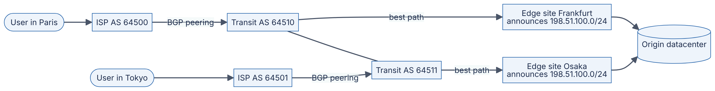
Reading the diagram. Two users (stadiums) reach their ISPs, which are separate autonomous systems connected to transit providers by BGP sessions. Two edge sites announce the same prefix, 198.51.100.0/24. The Paris user’s ISP hears the shortest policy-preferred path via Frankfurt, and the Tokyo user’s ISP hears a path via Osaka, so the same destination address is served from different continents. Traffic flows synchronously left to right for requests (responses return along a path that may differ, because Internet routing is asymmetric). The origin datacenter is the storage boundary; the edges may cache (§21.4). Failure points: if Frankfurt withdraws its announcement, Paris traffic reconverges toward Osaka (or another site) within seconds to minutes, and in-flight TCP connections break. Scaling: add more announcing sites.

Real-world industry applications
INDUSTRY EXAMPLE
Facebook, 4 October 2021. During routine maintenance, a command intended to assess backbone capacity unintentionally disconnected Facebook’s backbone, and a bug in an audit tool failed to stop it. Facebook’s DNS servers are designed to withdraw their BGP anycast announcements when they cannot reach the datacenters, as a health safeguard. With the backbone gone, every DNS site withdrew at once, so facebook.com and related names could not be resolved anywhere. The outage lasted roughly six hours, and recovery was slowed because internal tools depended on the same network. Lesson: a health-driven withdrawal that is correct for one site can become a global outage when all sites share a failure; build in “never withdraw the last route” guards and out-of-band access. Evidence: Primary — [Janardhan 2021]
INDUSTRY EXAMPLE
YouTube prefix hijack, February 2008. Pakistan Telecom, intending to block YouTube domestically, announced a more-specific /24 covering YouTube’s address space. Its upstream provider propagated the announcement globally, and by longest-prefix match much of the Internet sent YouTube traffic to Pakistan for about two hours. The incident is a standard case study for BGP’s trust model and motivates prefix filtering and RPKI. Evidence: Secondary — [RIPE NCC 2008]

Failure scenarios
Table 7.4 — Routing failure scenarios.
What goes wrong | Why | Detection | Recovery | Prevention
Route leak or hijack | A network announces prefixes it does not own, or re-announces routes against policy | External BGP monitors; sudden traffic shifts; latency jumps | Contact upstreams; announce more-specific prefixes | RPKI origin validation, prefix filters, max-prefix limits
Self-inflicted withdrawal | Health checks or automation withdraw all announcements simultaneously | Global reachability probes fail | Out-of-band access to re-announce | Guard rails preventing withdrawal of the last route; staged changes
Slow convergence | BGP path exploration after a failure | Elevated loss for seconds to minutes | Wait; fail over at a higher layer (DNS, client retry) | Multiple upstreams; BFD for fast failure detection
Anycast connection resets | Route change moves an in-flight TCP flow to another site | Spikes in TCP resets during route changes | Client retries | Short-lived connections; stable announcements

7.6 DNS: the Internet’s directory

7.6.1 What DNS is and why it exists
DEFINITION
Definition — Domain Name System (DNS). A hierarchical, distributed database that maps human-readable domain names (such as www.example.com) to data, most often IP addresses, and the protocol used to query it [RFC 1034; RFC 1035].

First-principles explanation
People remember names; routers need numbers. In the early ARPANET, every host downloaded a single file, HOSTS.TXT, listing every name and address. As the network grew, that file became too large, changed too often, and depended on one central maintainer. DNS replaced it with a delegated hierarchy, much like a library catalog split across buildings: the front desk (the root) does not know where every book is, but it knows which building holds each subject (the top-level domains such as .com), and each building knows which room holds each shelf (the authoritative servers for example.com). Responsibility for each zone is delegated to whoever owns it, so no one party maintains everything.

The cast of characters
- Stub resolver. A small library in your operating system. It does not do the work itself; it asks a recursive resolver and waits.
- Recursive resolver (also called a caching or full-service resolver). Run by your ISP, your company, or a public service such as 8.8.8.8 or 1.1.1.1. It chases the answer through the hierarchy on your behalf and caches the results.
- Root name servers. Thirteen named server identities (a.root-servers.net through m.root-servers.net), each replicated via anycast (§7.5.3) to many physical instances worldwide. They know where each top-level domain’s servers are.
- TLD name servers. Authoritative for a top-level domain such as .com or .uk. They know the name servers for each second-level domain.
- Authoritative name servers. Hold the actual records for a zone such as example.com. Managed DNS providers and cloud DNS services operate these for most companies.

7.6.2 Recursive versus iterative resolution
There are two query styles. In a recursive query, the client asks “give me the final answer”, and the server must either return it or an error. Your stub resolver sends recursive queries to the recursive resolver. In an iterative query, the server returns the best information it has, often a referral (“I don’t know, but ask these servers”), and the asker continues. Recursive resolvers send iterative queries to root, TLD and authoritative servers.
Figure 7.3 — DNS resolution of www.example.com with an empty cache.
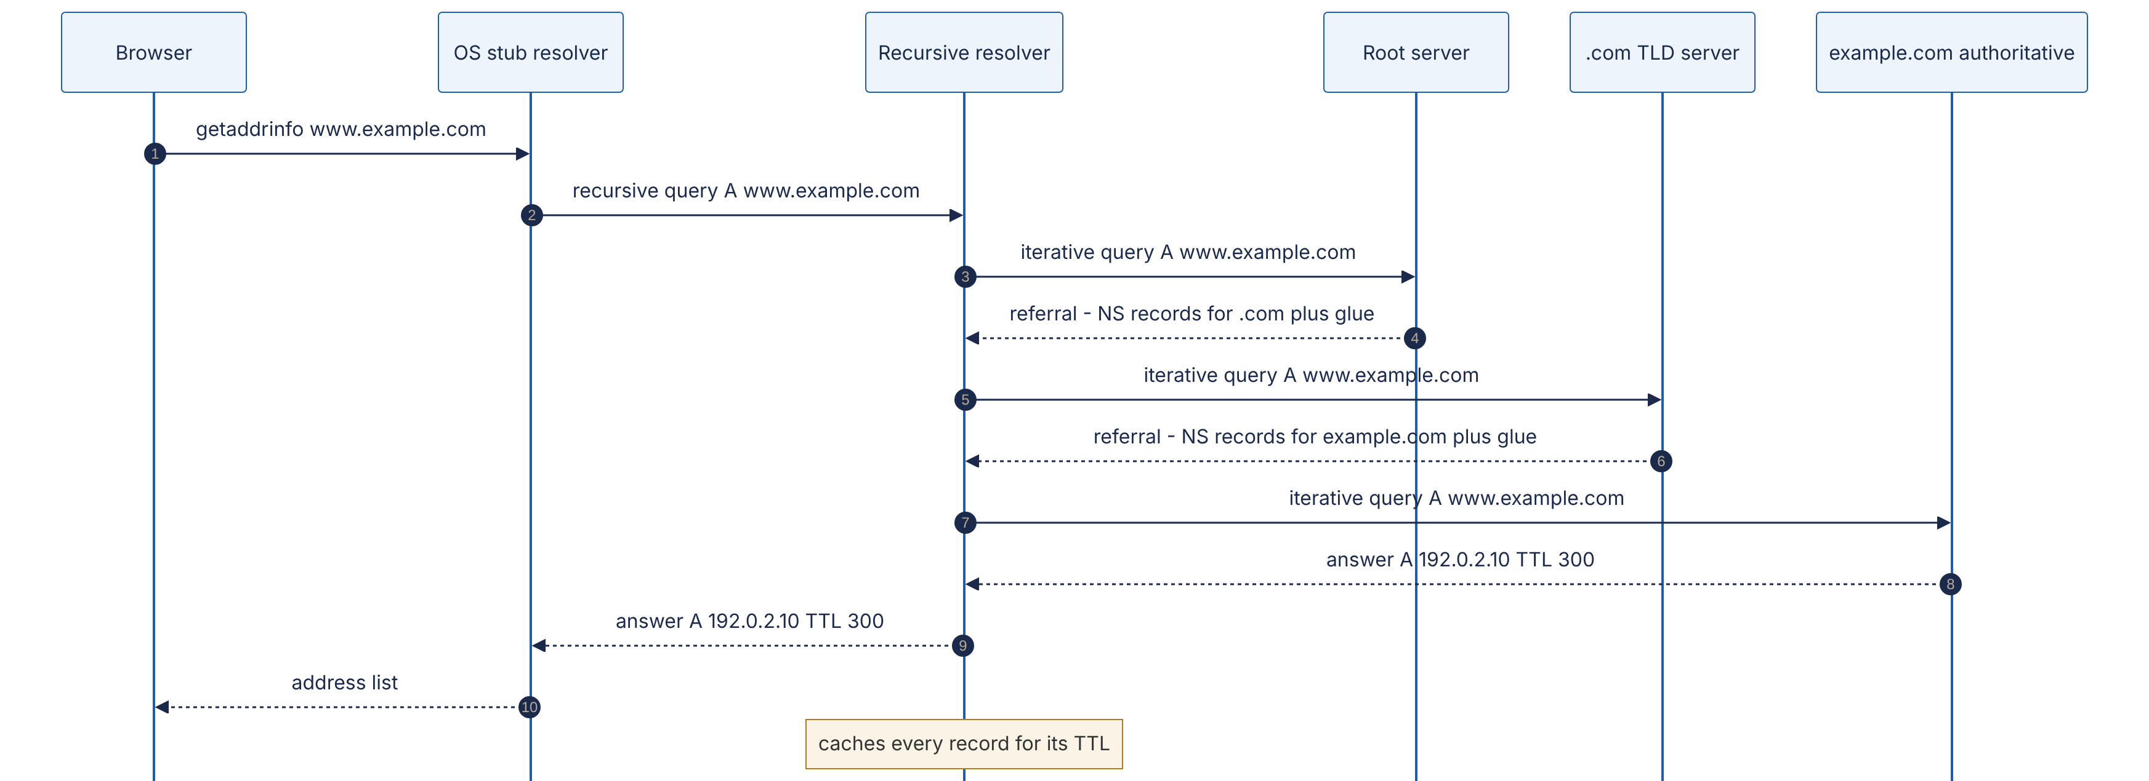
Reading the diagram. Six participants appear from left to right: the application, the operating system’s stub resolver, the recursive resolver, and three levels of authoritative servers. Steps 1–2 are the recursive part: the stub asks once and waits. Steps 3–8 are iterative: the resolver walks down the hierarchy, receiving referrals (dashed return arrows) from the root and the TLD, each containing the name-server (NS) records for the next level and glue records giving those servers’ IP addresses. Step 8 is the final answer, here an A record with a 300-second TTL. All exchanges are synchronous request/response, normally over UDP port 53. The resolver’s cache is the storage boundary: once populated, steps 3–8 are skipped for every client of that resolver until the TTL expires, and the root and TLD referrals are cached for much longer (typically days). Failure points: any server not responding forces a timeout and retry against another listed server (each zone must have at least two). Scaling comes from caching and from anycast replication of the root and TLD servers. (The address 192.0.2.10 is a documentation address used for illustration.)

Mathematical foundations: what a cold lookup costs
WORKED EXAMPLE
Worked example — Cold versus warm DNS lookup.
Assume the client is 5 ms from its recursive resolver, and the resolver is 20 ms from the root instance, 30 ms from the TLD server and 40 ms from the authoritative server (all round-trip times).
- Cold cache: $5+20+30+40=95$ ms before the browser can even open a connection.
- Root and TLD referrals cached (typical, since they have long TTLs) but the name itself expired: $5+40=45$ ms.
- Fully warm at the resolver: 5 ms.
- Cached in the operating system or browser: effectively 0 ms.
Interpretation: almost all real lookups hit case 3 or 4, which is why DNS feels free. The cold path matters for rarely visited domains, for very low TTLs, and for every new third-party domain a page references. Engineering implication: minimize the number of distinct hostnames on a critical path, and use <link rel="dns-prefetch"> or preconnect hints for domains you know you will need.

7.6.3 Record types
Table 7.5 — Common DNS record types.
Type | Maps a name to | Example | Typical use
A | An IPv4 address | www.example.com. 300 IN A 192.0.2.10 | Host address
AAAA | An IPv6 address | www.example.com. 300 IN AAAA 2001:db8::10 | Host address over IPv6
CNAME | Another name (an alias) | shop.example.com. 3600 IN CNAME shops.saas-provider.example. | Point your name at a provider’s hostname
MX | A mail server name, with priority | example.com. 3600 IN MX 10 mail1.example.com. | Email delivery (lower number = preferred)
NS | The authoritative name servers of a zone | example.com. 86400 IN NS ns1.dnsprovider.example. | Delegation
TXT | Arbitrary text | example.com. 300 IN TXT "v=spf1 include:_spf.mailer.example -all" | Domain ownership proofs, SPF, DKIM, DMARC
SRV | Host and port for a service, with priority and weight | _sip._tcp.example.com. 300 IN SRV 10 60 5060 sip1.example.com. | Service discovery (RFC 2782); used by SIP, XMPP, some service meshes
SOA | Zone metadata: primary server, serial, timers, negative-caching TTL | — | Zone administration
PTR | A name, for reverse lookup of an address | 10.2.0.192.in-addr.arpa. PTR www.example.com. | Logs, mail server checks
CAA | Which certificate authorities may issue for the domain | example.com. CAA 0 issue "letsencrypt.org" | Restricting certificate issuance (§7.10)
HTTPS / SVCB | Connection parameters: ALPN protocols, ports, address hints | example.com. HTTPS 1 . alpn="h3,h2" | Advertising HTTP/3 before the first connection (RFC 9460)
Three rules trip people up. First, a CNAME cannot coexist with other records at the same name, so you cannot put a CNAME at the zone apex (example.com itself, which must hold SOA and NS records). DNS providers offer non-standard “ALIAS” or “CNAME flattening” features to work around this. Second, every record in a response carries its own TTL. Third, MX and SRV records point to names, never directly to addresses.

7.6.4 TTL and caching
DEFINITION
Definition — DNS time to live (TTL). A per-record value, in seconds, that tells any cache how long it may reuse the record before asking again. Negative caching stores “this name does not exist” (NXDOMAIN) answers for a duration derived from the zone’s SOA record [RFC 2308].
Caches exist at several levels: the browser, the operating system, the recursive resolver, and sometimes in application runtimes. (Some runtimes have historically cached DNS answers far longer than the TTL, or forever, by default; the Java Virtual Machine’s behavior depends on configuration and security manager settings, so check your runtime.)
TTL is a trade-off between agility (how quickly a change takes effect) and load and latency (how often resolvers must re-query). Short TTLs (30–60 s) let you fail over quickly but raise query volume and the fraction of slow cold lookups. Long TTLs (hours to a day) are efficient but make changes slow.
WORKED EXAMPLE
Worked example — How long does a DNS failover really take?
Your record has TTL 300 s, and your health checker takes 30 s (three failed probes, 10 s apart) to declare the primary site dead and update DNS.
- Detection: 30 s.
- Worst-case cache staleness: a resolver that refreshed one second before the update keeps serving the old answer for up to 300 s.
- Worst-case total for well-behaved resolvers: $30+300=330$ s, about 5.5 minutes. The average client re-queries halfway through the TTL, so the mean is about $30+150=180$ s.
- Clients holding open connections are not affected by DNS at all: they keep sending to the dead address until their connections fail and they reconnect.
- Misbehaving caches that enforce a minimum TTL or ignore it extend the tail indefinitely.
Engineering implication: DNS failover is a minutes-scale mechanism. If you need seconds, put a stable address in front (an anycast virtual IP or a load balancer, §19.8) and fail over behind it.
Before a planned migration, lower the TTL well in advance. If the old TTL is 86,400 s (one day), you must lower it at least one day before the cut-over, because resolvers that cached the record just before you changed it will not re-query for a day.

7.6.5 DNS-based load balancing and its limits
Because a DNS answer can differ per query, DNS is the coarsest and cheapest load balancer:
- Round-robin DNS. Return several A records, rotating their order. Clients typically try the first.
- Weighted answers. Return each address in proportion to configured weights.
- Geo-DNS / latency-based DNS. Answer based on the resolver’s (or, with the EDNS Client Subnet extension, the client’s) location, pointing users to a nearby region (Ch 44, §19.9).
- Health-checked DNS. Remove addresses whose health checks fail.
The limits are fundamental, not implementation details:
- Caching defeats fine control. A large resolver (an ISP serving millions of users) caches one answer and hands it to all its clients for the TTL, so “1/N of queries” is not “1/N of users”.
- Resolver location is not client location. Geo-DNS sees the recursive resolver’s address. A user in Singapore using a resolver in the US may be sent to the US region, unless EDNS Client Subnet is supported.
- Failover speed is bounded by TTL and by stale clients, as computed above.
- No load awareness. DNS does not see connection counts or server latency; it picks before the connection exists.
- Clients behave inconsistently. Some try only the first address; some try all; some pin forever.
DNS is therefore used to pick a region or site, and real load balancers distribute connections within the site (Chapter 19).

Transport details
DNS normally uses UDP port 53 because a query and a response each fit in one datagram, avoiding a handshake. Classic DNS limited UDP responses to 512 bytes; the EDNS(0) extension (RFC 6891) lets clients advertise larger buffers, and current operational guidance favors about 1,232 bytes to avoid IP fragmentation. If a response is too large, the server sets the truncation (TC) bit and the client retries over TCP. Zone transfers between servers use TCP. Encrypted variants exist: DNS over TLS (port 853, RFC 7858) and DNS over HTTPS (RFC 8484), which hide queries from on-path observers.

Failure scenarios
Table 7.6 — DNS failure scenarios.
What goes wrong | Why | Detection | Recovery | Prevention
Authoritative provider outage | DDoS or provider failure; all NS records at one provider | Resolution failures from external probes | Wait, or change NS at the registrar (slow: TLD TTLs are long) | Two independent DNS providers serving the same zone
Stale records after migration | TTL was long when you changed the record | Traffic still reaching old addresses | Keep old endpoint alive until TTL × 2 has passed | Lower TTL in advance of planned changes
Resolver overload / latency | Too many lookups per request; no local caching | High p99 on connection setup; resolver timeouts | Add local caching resolver | Cache in-process with TTL respect; reuse connections
Negative-cache trap | Name queried before it was created; NXDOMAIN cached | “Works for me, not for them” | Wait out SOA negative TTL | Create records before announcing names
Split-horizon mismatch | Internal and external views of a zone differ | Errors only inside or only outside the network | Fix the view | Test both views in deployment checks
COMMON MISTAKE
“Changing a DNS record takes 24–48 hours to propagate.” DNS does not propagate; caches expire. A change is visible to a given resolver as soon as its cached copy’s TTL runs out. The folklore “48 hours” comes from long TTLs, especially on NS records at the TLD.

7.7 TCP: reliable byte streams over an unreliable network

7.7.1 What TCP provides
IP is a best-effort service: packets may be lost, duplicated, delayed or delivered out of order, and IP will not tell you. Most applications want the opposite: a reliable, ordered pipe of bytes. The Transmission Control Protocol builds that pipe on top of IP [RFC 9293].
DEFINITION
Definition — TCP. A connection-oriented transport protocol that provides a reliable, ordered, full-duplex byte stream between two endpoints identified by (IP address, port) pairs. It achieves reliability with sequence numbers, acknowledgments and retransmission; it protects a slow receiver with flow control; and it protects the network with congestion control.

First-principles explanation
Imagine mailing a 300-page manuscript one page per envelope through an unreliable postal service. To make sure your editor gets every page in order, you would number each page, ask the editor to send back postcards saying “I have everything up to page 57”, and resend any page not acknowledged within a reasonable time. You would also avoid sending all 300 pages at once if the editor’s desk is small (flow control) or if the post office is visibly overwhelmed (congestion control). That is TCP. The one twist is that TCP numbers bytes, not pages: the stream has no message boundaries, so an application that writes “hello” and then “world” may receive “hellowor” and “ld”. Application protocols must add their own framing (a length prefix or a delimiter).

7.7.2 The segment
Every TCP segment carries a header of 20 bytes plus up to 40 bytes of options. The fields you will reason about most are:
- Source and destination ports (16 bits each). Together with the IP addresses they form the connection’s 4-tuple.
- Sequence number (32 bits). The stream offset of the first payload byte in this segment, relative to a random initial sequence number (ISN).
- Acknowledgment number (32 bits). The next byte the sender of this segment expects to receive: “I have everything before this”.
- Flags. SYN (synchronize, opens a connection), ACK (acknowledgment field valid), FIN (no more data from me), RST (abort), PSH, URG, plus ECE/CWR for explicit congestion notification.
- Window (16 bits). How many more bytes the sender of this segment is willing to receive (flow control, §7.7.6).
- Options. MSS, window scale, selective acknowledgments (SACK) and timestamps, mostly negotiated in the handshake.

7.7.3 The three-way handshake
Before data flows, both sides must agree that the connection exists and learn each other’s initial sequence numbers. Each ISN is chosen randomly so that stray segments from an old connection, or an off-path attacker, are unlikely to fall into the valid window.
Figure 7.4 — TCP three-way handshake followed by the first request.
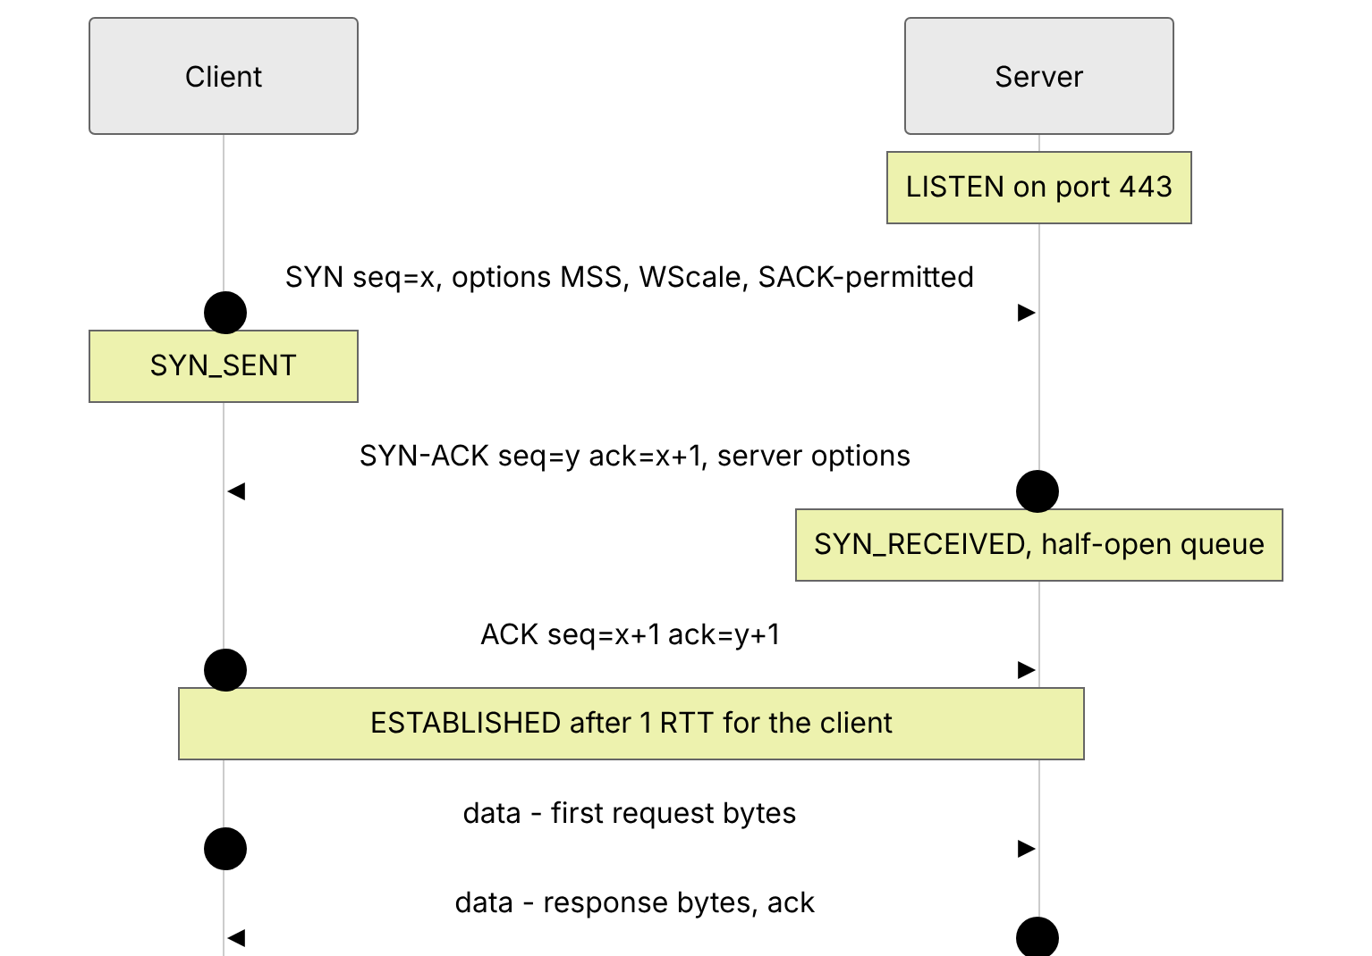
Reading the diagram. Two participants: the client, which actively opens, and the server, which is listening. Step 1 is the SYN, carrying the client’s random ISN $x$ and its option offers. Step 2, the SYN-ACK, acknowledges $x+1$ (a SYN consumes one sequence number) and carries the server’s own ISN $y$. Step 3 completes the handshake. The client may send data immediately after step 3, so the handshake costs the client one round-trip time (RTT) before its request can leave; the server sees the request 1.5 RTTs after the client began. All exchanges are synchronous. The server’s half-open queue (connections between steps 2 and 3) is a failure point: a SYN flood attack fills it with spoofed SYNs, which servers counter with SYN cookies, encoding the connection state in the ISN instead of storing it. Scaling: the server’s accept queue (listen backlog) must be sized for connection bursts.
TCP Fast Open (RFC 7413) lets a returning client put data in the SYN using a cookie from a previous connection, saving one RTT, but middlebox interference and replay concerns have limited its deployment. QUIC (§7.9.4) achieves the same goal more robustly.

7.7.4 The four-way close and TIME_WAIT
TCP is full-duplex, so each direction closes independently. Each side sends a FIN when it has no more data, and the other acknowledges it.
Figure 7.5 — TCP four-way close and the TIME_WAIT state.
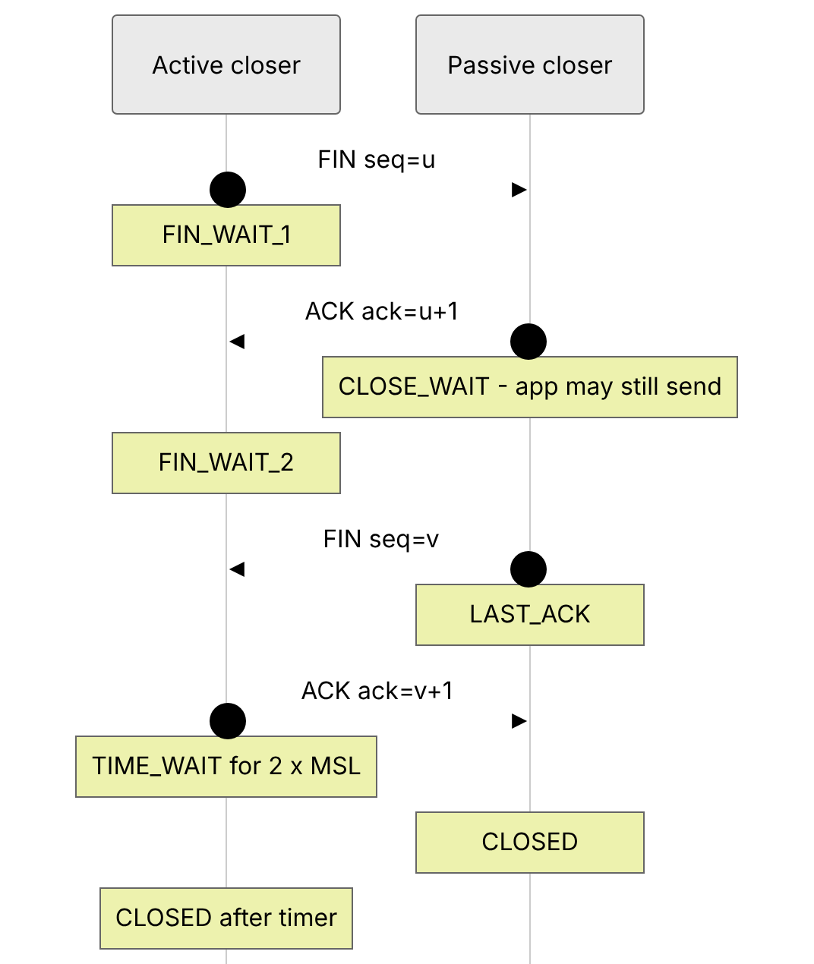
Reading the diagram. The active closer is whichever side calls close() first; the other is the passive closer. Steps 1–2 close the active side’s direction; the passive side enters CLOSE_WAIT and may keep sending until its application also closes (a pile-up of CLOSE_WAIT sockets is the classic symptom of an application that forgets to close connections). Steps 3–4 close the other direction. Steps 2 and 3 are often combined into one segment, making the close effectively three segments. The active closer then waits in TIME_WAIT for twice the maximum segment lifetime (MSL). All steps are synchronous; RST is the abrupt alternative that skips all of this and discards unsent data.
TIME_WAIT exists for two reasons. First, if the final ACK (step 4) is lost, the passive side will retransmit its FIN, and the active side must still be around to re-acknowledge it. Second, it ensures that delayed segments from this connection have died out before a new connection with the same 4-tuple can be created and misinterpret them. RFC 793 set MSL to two minutes; Linux hard-codes TIME_WAIT at 60 seconds.
WORKED EXAMPLE
Worked example — Ephemeral port exhaustion from TIME_WAIT.
A service opens a new TCP connection for every request to one backend (one destination IP and port) and closes it afterward, so the service is the active closer.
- Each connection needs a unique source port. Linux’s default ephemeral port range is 32,768–60,999: $60,999−32,768+1=28,232$ ports.
- Each closed connection holds its port in TIME_WAIT for 60 s.
- Sustainable new-connection rate to that single destination: $28,232/60≈470$ connections per second.
- At 1,000 requests per second with one connection per request, ports run out after about $28,232/1,000≈28$ s, and connect() starts failing with EADDRNOTAVAIL.
Interpretation: TIME_WAIT is not a bug, but opening a connection per request is. Fixes, in order of preference: reuse connections with keep-alive and pooling (§7.16); add destination IPs or ports (each distinct 4-tuple has its own port space); widen the ephemeral range; enable net.ipv4.tcp_tw_reuse for outgoing connections. Never use the long-removed tcp_tw_recycle, which broke clients behind NAT.

7.7.5 Sequence numbers, acknowledgments and retransmission
TCP uses cumulative acknowledgments: ACK number $N$ means “I have all bytes before $N$”. The sender keeps every unacknowledged byte in its send buffer and retransmits on one of two signals:
- Retransmission timeout (RTO). If no ACK arrives within a timeout computed from measured RTTs, the sender retransmits the oldest unacknowledged segment, doubles the timeout (exponential backoff), and treats the event as severe congestion.
- Fast retransmit. If the receiver gets a segment out of order, it immediately re-sends its last ACK. Three duplicate ACKs strongly suggest a single lost segment with later ones still arriving, so the sender retransmits at once without waiting for the timer [RFC 5681].
Selective acknowledgments (SACK) let the receiver report exactly which blocks beyond the gap it holds, so the sender retransmits only what is missing.
FORMULA
Retransmission timeout (RFC 6298)
On each new RTT sample $R$ (after the first):
$$\text{RTTVAR}←\left(1−β\right) \text{RTTVAR}+β \left|\text{SRTT}−R\right|$$
$$\text{SRTT}←\left(1−α\right) \text{SRTT}+α R$$
$$\text{RTO}=\text{SRTT}+max\left(G, 4 \text{RTTVAR}\right)$$
Symbol | Meaning | Units
$R$ | Latest measured round-trip time | ms
SRTT | Smoothed (exponentially averaged) RTT | ms
RTTVAR | Smoothed RTT variation | ms
$α,β$ | Smoothing gains, $1/8$ and $1/4$ | dimensionless
$G$ | Clock granularity | ms
RTO | Retransmission timeout; RFC 6298 says round up to at least 1 s | ms
WORKED EXAMPLE
Worked example — Computing an RTO.
Current state: SRTT = 100 ms, RTTVAR = 10 ms. A new sample arrives: $R=140$ ms. Assume $G$ is negligible.
- RTTVAR $=0.75×10+0.25×\left|100−140\right|=7.5+10=17.5$ ms (computed with the old SRTT, as the RFC requires).
- SRTT $=0.875×100+0.125×140=87.5+17.5=105$ ms.
- RTO $=105+4×17.5=175$ ms.
- RFC 6298 rounds this up to its 1 s minimum; Linux uses a 200 ms minimum, so Linux would wait 200 ms.
Interpretation: inside a datacenter, where RTTs are around 0.1–0.5 ms, a single timeout-driven retransmission costs 200 ms, hundreds of times the normal latency. This is why one lost packet can dominate p99 latency for small RPCs (§23.6), and why datacenter operators tune minimum RTOs down and work hard to avoid drops.

7.7.6 Flow control and the receive window
Flow control prevents a fast sender from overflowing a slow receiver. Each ACK advertises the receive window (rwnd): the free space in the receiver’s socket buffer. The sender never has more than rwnd unacknowledged bytes outstanding. If the application stops reading, the buffer fills, the advertised window drops to zero, and the sender pauses, probing periodically until the window reopens. Flow control is how TCP provides backpressure end to end (§22.10).
The header’s window field is 16 bits, so it can express at most 65,535 bytes. That is far too small for fast long-distance links (see the bandwidth-delay product in §7.15), so the window scale option (RFC 7323), negotiated in the SYN, multiplies the window by $2^{s}$ for $s≤14$, allowing windows up to about 1 GiB ($65,535×2^{14}=1,073,725,440$ bytes).

7.7.7 Congestion control
Flow control protects the receiver. Congestion control protects the network. In October 1986, the early Internet suffered congestion collapse: throughput between Lawrence Berkeley Laboratory and UC Berkeley fell from 32 kbps to 40 bps [Jacobson 1988] because senders retransmitted aggressively into already-full queues, so most bandwidth carried duplicate packets that were then dropped. Van Jacobson’s 1988 algorithms, refined into today’s RFC 5681, made each sender infer congestion and back off.
DEFINITION
Definition — Congestion window (cwnd). A sender-side limit, in bytes or segments, on unacknowledged data in flight, based on the sender’s estimate of what the network path can absorb. The sender may have at most $min\left(\text{cwnd},\text{rwnd}\right)$ bytes outstanding.

How classic congestion control works
- Slow start. A new connection starts with a small initial window (10 segments, about 14.6 KB, per RFC 6928) and increases cwnd by one segment for every segment acknowledged. That doubles cwnd every RTT: “slow” only in comparison with sending everything at once.
- When cwnd reaches the slow-start threshold (ssthresh), the sender switches to congestion avoidance: it adds about one segment per RTT (additive increase).
- On a loss detected by three duplicate ACKs, the sender halves cwnd (multiplicative decrease), sets ssthresh to the new value, retransmits, and continues in congestion avoidance via fast recovery.
- On a retransmission timeout, the sender assumes something severe happened, sets ssthresh to half the flight size, resets cwnd to one segment, and re-enters slow start.
Steps 2 and 3 together are AIMD (additive increase, multiplicative decrease). It produces the familiar sawtooth of cwnd over time, and it has a beautiful property: multiple AIMD flows sharing a bottleneck converge toward an equal share.
Figure 7.6 — Loss-based TCP congestion control states (Reno-style).
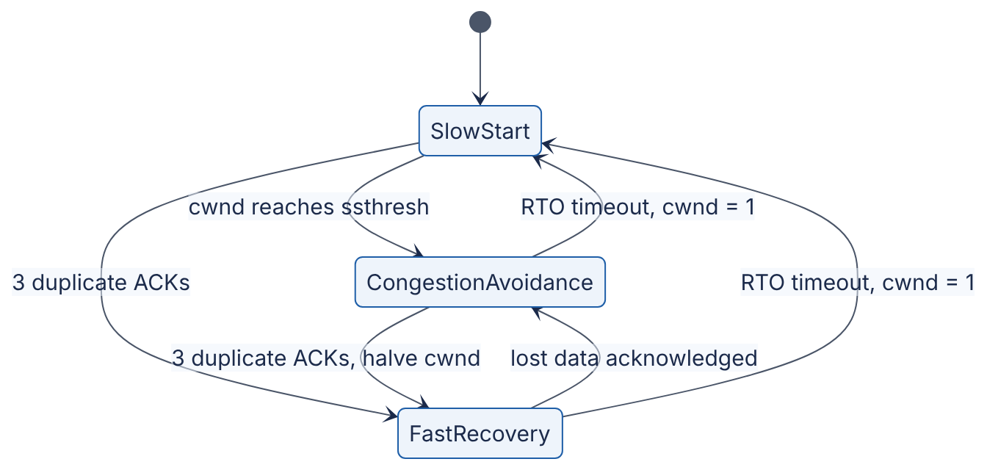
Reading the diagram. Each box is a sender state. A connection begins in slow start, where cwnd doubles each RTT. Reaching ssthresh moves it to congestion avoidance (linear growth). Three duplicate ACKs, a mild loss signal, move it to fast recovery with cwnd halved; once the lost data is acknowledged, it returns to congestion avoidance. A timeout, the severe signal, sends it all the way back to slow start with cwnd of one segment. All transitions are driven by asynchronous events (ACK arrivals and timers) on the sender. Failure point: repeated timeouts on a lossy path keep the connection in slow start with exponentially growing RTOs, which users experience as a “hung” transfer.
WORKED EXAMPLE
Worked example — How many RTTs does slow start need for 1 MB?
Assume MSS = 1,460 bytes, initial cwnd = 10 segments, no loss, a large receive window, and ignore delayed ACKs.
- Segments needed: $1,000,000/1,460≈685$.
- Segments sent per round (RTT): 10, 20, 40, 80, 160, 320, 640.
- Cumulative: 10, 30, 70, 150, 310, 630, 1,270.
- After 6 rounds, 630 < 685; the 7th round finishes the transfer. So 7 RTTs of data transfer.
- At an 80 ms RTT that is $7×80=560$ ms, plus 1 RTT of TCP handshake and 1 RTT of TLS 1.3 handshake (§7.10): $9×80=720$ ms in total, regardless of whether the link is 100 Mbps or 10 Gbps.
Interpretation: for small and medium transfers on long paths, latency, not bandwidth, determines download time. A 10× faster link barely helps; reducing RTT (a CDN edge close to the user, §21.3) or reusing a connection whose cwnd is already large (§7.16) helps enormously.

CUBIC
On fast long-distance paths, Reno’s “add one segment per RTT” is painfully slow to regain a large window after a loss: after a loss halves a 10,000-segment window, regaining the missing 5,000 segments at one segment per 100 ms RTT takes $5,000×0.1=500$ s. CUBIC [Ha et al. 2008; RFC 9438] replaces linear growth with a cubic function of time since the last loss, independent of RTT. It has been Linux’s default since 2006 and is the default in most operating systems today.
FORMULA
CUBIC window growth
$$W\left(t\right)=C {\left(t−K\right)}^{3}+W_{max}, K=\sqrt[3]{\frac{W_{max} \left(1−β\right)}{C}}$$
Symbol | Meaning | Units
$W\left(t\right)$ | Congestion window $t$ seconds after the last loss | segments
$W_{max}$ | Window just before the last loss | segments
$β$ | Multiplicative decrease factor; window becomes $βW_{max}$ after loss (0.7) | dimensionless
$C$ | Scaling constant (0.4) | segments/s³
$K$ | Time to climb back to $W_{max}$ | s
WORKED EXAMPLE
Worked example — CUBIC recovery time.
Suppose $W_{max}=100$ segments when a loss occurs.
- After the loss: $W\left(0\right)=0.7×100=70$ segments. Check with the formula: $K^{3}=100×0.3/0.4=75$, so $K=\sqrt[3]{75}≈4.22$ s, and $W\left(0\right)=0.4×{\left(−4.22\right)}^{3}+100=0.4×\left(−75\right)+100=70$. Consistent.
- Growth is fast at first, flattens as $t→K$ (the curve is cautious near the window where loss last occurred), and reaches 100 segments at $t≈4.22$ s.
- Beyond $K$ the window accelerates again, probing for newly available bandwidth.
Interpretation: recovery time depends on $W_{max}$ and constants, not on RTT, so long-RTT flows are not penalized as much as under Reno. The plateau around $W_{max}$ keeps CUBIC near the last known-good operating point.

BBR
Loss-based algorithms (Reno, CUBIC) treat packet loss as the congestion signal. That has two problems. On paths with large buffers, they keep filling the queue until it overflows, adding hundreds of milliseconds of queuing delay (bufferbloat, §7.15). On paths with random loss unrelated to congestion (wireless, long-haul links), they back off when they should not.
BBR (Bottleneck Bandwidth and Round-trip propagation time) [Cardwell et al. 2016] instead builds an explicit model of the path. It continuously estimates the bottleneck bandwidth (the maximum recent delivery rate) and the minimum RTT (the propagation delay with empty queues). It then paces packets at the estimated bandwidth and keeps roughly one bandwidth-delay product in flight, periodically probing slightly above that rate to discover more bandwidth and periodically draining the queue to re-measure minimum RTT.
Table 7.7 — Congestion control algorithms compared.
Aspect | Reno (AIMD) | CUBIC | BBR (v1)
Congestion signal | Packet loss | Packet loss | Measured bandwidth and RTT model
Growth function | +1 MSS per RTT | Cubic in time since last loss | Pacing at estimated bottleneck rate, with probing
Response to loss | Halve cwnd | Multiply by 0.7 | Largely ignores isolated loss
Queue occupancy | Fills buffers until loss | Fills buffers until loss | Aims for little standing queue
Strength | Simple, fair among equals | Good on high-BDP paths; default almost everywhere | Low latency; high throughput with random loss
Weakness | Slow on high-BDP paths | Bufferbloat; collapses with random loss | Fairness issues versus loss-based flows; retransmissions with shallow buffers
Where used | Teaching baseline | Linux, Windows, macOS defaults | Google services, available in Linux since 4.9
INDUSTRY EXAMPLE
BBR at Google. Google reported deploying BBR on its B4 inter-datacenter backbone, where it delivered 2–25× higher throughput than CUBIC, and on YouTube and google.com traffic, where it reduced median RTT (by reducing queuing) while improving throughput. Later work (BBRv2/v3) addresses fairness and loss-sensitivity issues found in BBRv1. Evidence: Primary — [Cardwell et al. 2016]

7.7.8 Nagle’s algorithm and delayed ACKs
In 1984, John Nagle observed that interactive programs sending one keystroke per write produced 41-byte packets (40 bytes of headers, 1 byte of data), wasting bandwidth. Nagle’s algorithm (RFC 896) says: if there is unacknowledged data in flight, buffer small writes until either the ACK arrives or a full segment accumulates.
Separately, receivers use delayed ACKs: they wait briefly (up to 500 ms by RFC 1122; Linux uses about 40 ms or more) hoping to piggyback the ACK on response data or to acknowledge two segments at once.
Each idea is reasonable; together they cause a notorious stall. A client writes a request header (small write 1), then the body (small write 2), then waits for a response. Write 1 is sent. Nagle holds write 2 until write 1 is acknowledged. The server cannot respond before it has the whole request, so it has nothing to piggyback on and delays its ACK. The pair sit idle for the delayed-ACK timer, adding tens of milliseconds to every request. The fixes are to assemble the full message and write it once, or to set the TCP_NODELAY socket option, which disables Nagle. Almost every RPC framework and database driver sets TCP_NODELAY by default.

7.7.9 Head-of-line blocking
Head-of-line (HOL) blocking occurs when an item at the front of a queue holds up everything behind it. TCP guarantees in-order delivery of one byte stream, so if segment 5 is lost and segments 6–20 arrive, the receiving kernel holds 6–20 in its buffer and the application can read nothing until segment 5’s retransmission arrives, at least one RTT later. If the application multiplexed several independent requests over that connection (HTTP/2, §7.9.3), all of them stall because of one packet that belonged to only one of them. This is the central motivation for QUIC (§7.9.4), which provides independent streams with no cross-stream HOL blocking.

7.7.10 Code example: a TCP echo server and client
# echo_server.py — a minimal, runnable TCP echo server (Python 3.8+).
import socket
HOST, PORT = "127.0.0.1", 9000
with socket.socket(socket.AF_INET, socket.SOCK_STREAM) as srv:
srv.setsockopt(socket.SOL_SOCKET, socket.SO_REUSEADDR, 1) # rebind despite TIME_WAIT
srv.bind((HOST, PORT))
srv.listen(128) # backlog of completed handshakes
print(f"listening on {HOST}:{PORT}")
while True:
conn, addr = srv.accept() # handshake already done by the kernel
with conn:
conn.setsockopt(socket.IPPROTO_TCP, socket.TCP_NODELAY, 1)
while True:
data = conn.recv(4096) # may return fewer bytes than were sent
if not data: # empty read: peer sent FIN
break
conn.sendall(data) # loops until every byte is queued
# echo_client.py — measures connect time and one request/response round trip.
import socket, time
t0 = time.perf_counter()
s = socket.create_connection(("127.0.0.1", 9000)) # SYN, SYN-ACK, ACK
t1 = time.perf_counter()
s.sendall(b"hello")
reply = s.recv(4096)
t2 = time.perf_counter()
s.close() # client is active closer: TIME_WAIT here
print(reply, f"connect={1e3*(t1-t0):.3f} ms rtt={1e3*(t2-t1):.3f} ms")
What to notice:
- accept() returns only after the kernel has completed the three-way handshake; your application never sees SYNs.
- recv(4096) returns up to 4,096 bytes. TCP is a byte stream, so a real protocol must loop until a complete message has arrived, using a length prefix or delimiter.
- recv returning b"" is how the application learns that the peer sent FIN.
- SO_REUSEADDR lets a restarted server bind its port while old connections linger in TIME_WAIT.
- The server handles one client at a time; production servers use threads, an event loop (§6.13) or asyncio.
- Over loopback, both timings will be tens of microseconds; the same client against a server 80 ms away would show about 80 ms for each.

Failure scenarios
Table 7.8 — TCP failure scenarios.
What goes wrong | Why | Detection | Recovery | Prevention
Ephemeral port exhaustion | Connection per request; TIME_WAIT holds ports | EADDRNOTAVAIL; many TIME_WAIT sockets in ss -s | Reuse connections; tcp_tw_reuse | Pooling and keep-alive (§7.16)
CLOSE_WAIT leak | Application never closes sockets after peer FIN | Growing CLOSE_WAIT count; file-descriptor exhaustion | Restart process; fix code | Close in finally/context managers; timeouts
Half-open connection | Peer crashed or a NAT/firewall dropped state; no FIN sent | Writes hang or eventually reset; reads block forever | Application-level timeouts; reconnect | TCP keep-alive or application heartbeats; read deadlines
Retransmission-driven tail latency | Packet loss; minimum RTO of 200 ms+ | p99 spikes; nstat retransmission counters | — | Avoid drops; hedged requests (§23.7)
Nagle/delayed-ACK stall | Multiple small writes per request | Latency floor of about 40 ms on small requests | Set TCP_NODELAY | Write whole messages; framework defaults
SYN flood | Spoofed SYNs fill the half-open queue | Many SYN_RECV sockets | SYN cookies | SYN cookies on by default; DDoS protection
COMMON MISTAKE
“TCP guarantees my message was processed.” An ACK means the peer’s kernel received the bytes into a buffer, not that the application read them, let alone acted on them or wrote them durably. If the server crashes after ACKing, the data is gone. End-to-end confirmation must come from the application (§24.14, the end-to-end argument).
COMMON MISTAKE
“A TCP connection notices immediately when the other side dies.” If the peer vanishes without sending FIN or RST (power loss, cable cut, a firewall silently dropping state), an idle connection looks healthy indefinitely. TCP keep-alive probes default to starting after two hours of idleness on Linux. Always set application-level timeouts.

7.8 UDP and when to use it
DEFINITION
Definition — UDP. The User Datagram Protocol [RFC 768] is a connectionless transport protocol that adds only port numbers, a length and a checksum to IP. Its 8-byte header provides process-to-process delivery of individual datagrams with no handshake, no acknowledgments, no retransmission, no ordering, and no flow or congestion control.
If TCP is registered mail with numbered pages and receipts, UDP is a postcard: cheap, immediate, and with no guarantee it arrives or that two postcards arrive in order. UDP does preserve message boundaries: one sendto() produces one datagram, and the receiver gets exactly that datagram or nothing.

Why does this exist?
Some applications are hurt more by TCP’s guarantees than helped:
- Request/response with tiny messages. A DNS query fits in one packet. A TCP handshake would triple the latency; if the reply is lost, the client simply asks again.
- Real-time media and games. A voice packet that arrives 300 ms late is useless; it is better to skip it than to stall the stream waiting for a retransmission (TCP’s head-of-line blocking).
- Custom transports. QUIC (§7.9.4) implements its own reliability, streams and congestion control on top of UDP, because UDP passes through existing firewalls and NATs and can be implemented in user space without kernel changes.
- Multicast and broadcast, such as DHCP address assignment and market-data feeds, which TCP’s one-to-one connections cannot express.
- High-volume, loss-tolerant telemetry, such as StatsD metrics, where an occasional lost sample does not matter.
Table 7.9 — TCP versus UDP.
Aspect | TCP | UDP
What it is | Reliable, ordered byte stream | Unreliable datagrams
Connection setup | 3-way handshake (1 RTT) | None
Header | 20–60 bytes | 8 bytes
Reliability and ordering | Yes, via sequence numbers and retransmission | No
Message boundaries | No (byte stream) | Yes (one datagram = one message)
Flow and congestion control | Yes | No; application’s responsibility
Head-of-line blocking | Yes, within the stream | No
State on server | Per connection | None required
Typical uses | HTTP/1.1, HTTP/2, databases, RPC | DNS, VoIP, games, QUIC/HTTP/3, DHCP, telemetry
Choose when | You need every byte, in order, and can tolerate setup cost | Timeliness beats completeness, or you are building your own transport

What you must rebuild on UDP
Choosing UDP moves responsibilities into your application: detecting loss (sequence numbers), deciding whether to retransmit, reordering, splitting messages to fit the path MTU (a UDP datagram larger than the MTU gets fragmented by IP, and losing any fragment loses the whole datagram), and above all congestion control. A UDP application that sends at a fixed high rate regardless of loss harms every other flow on the path; RFC 8085 gives guidelines for responsible UDP use.
WARNING / TRADE-OFF
UDP amplification attacks. Because UDP has no handshake, an attacker can forge the source address of a small request so that a server sends a much larger response to the victim. Open DNS resolvers, NTP and memcached servers exposed over UDP have been abused for very large DDoS attacks. Never expose UDP services that send responses much larger than requests to the Internet without rate limiting and source validation (§10.11).

7.9 HTTP/1.1, HTTP/2, HTTP/3 and QUIC

7.9.1 HTTP semantics
The Hypertext Transfer Protocol is a request/response application protocol. A client sends a request with a method (GET, POST, PUT, DELETE, …), a target (path), header fields (metadata such as Host, Content-Type, Cache-Control) and an optional body. The server answers with a status code (200 OK, 301 redirect, 404 not found, 503 unavailable, …), headers and an optional body. RFC 9110 defines these semantics separately from how they are encoded on the wire, and three wire versions coexist: HTTP/1.1 [RFC 9112], HTTP/2 [RFC 9113] and HTTP/3 [RFC 9114]. Your application code sees the same methods, headers and status codes whichever version carries them. API design on top of HTTP is covered in §8.6. For a performance-oriented treatment of everything in this section, see [Grigorik 2013].

7.9.2 HTTP/1.1: text, keep-alive and pipelining
HTTP/1.1 messages are human-readable text:
GET /index.html HTTP/1.1
Host: www.example.com
User-Agent: curl/8.5.0
Accept: */*
The response begins HTTP/1.1 200 OK, followed by headers, a blank line and the body. The body’s end is marked by Content-Length or by chunked transfer encoding.
HTTP/1.0 opened a new TCP connection per request. HTTP/1.1 made persistent connections (keep-alive) the default: after a response, the connection stays open for the next request, saving a TCP (and TLS) handshake and keeping the warmed-up congestion window.
The remaining problem is that one connection carries one request at a time. HTTP/1.1 defined pipelining, sending several requests without waiting, but responses must return in request order, so one slow response blocks all those behind it (application-level head-of-line blocking). Buggy intermediaries and that HOL problem meant browsers never enabled pipelining by default. Browsers instead open multiple parallel connections, typically six per host, and sites used to “shard” assets across hostnames to get more. Each extra connection costs handshakes, server memory and separate slow starts, and connections compete with each other for bandwidth.

7.9.3 HTTP/2: binary framing and multiplexing
HTTP/2 (originally RFC 7540 in 2015, now RFC 9113) keeps HTTP semantics but changes the wire format.

How it works internally
- Binary framing. Each message is split into frames with a 9-byte header giving length, type (HEADERS, DATA, SETTINGS, WINDOW_UPDATE, RST_STREAM, GOAWAY, PING, …), flags and a stream identifier.
- Streams and multiplexing. Each request/response pair is a stream with its own ID (odd numbers for client-initiated streams). Frames from many streams interleave on one TCP connection, so a slow response no longer blocks others at the HTTP layer. One connection per origin replaces six.
- Header compression with HPACK [RFC 7541]. Requests repeat nearly identical headers (cookies, user agent). HPACK keeps a static table of 61 common header fields and a dynamic table of recently sent ones on both ends, so repeated headers are sent as small integer indexes; new values may be Huffman-coded. HPACK avoids the compression side-channel attacks (CRIME) that made general-purpose compression of headers unsafe.
- Per-stream and connection flow control with WINDOW_UPDATE frames, so one large download cannot starve other streams of buffer space.
- Stream cancellation with RST_STREAM, without closing the connection.
Two features have faded. The original priority tree was complex and inconsistently implemented, and RFC 9113 deprecates it in favor of the simpler scheme in RFC 9218. Server push, which let servers send resources before they were requested, proved hard to use well; major browsers have removed support.

The TCP head-of-line problem remains
HTTP/2 removed head-of-line blocking at the HTTP layer, but all streams still share one TCP byte stream. A single lost packet stalls every stream until it is retransmitted (§7.7.9). On a clean network HTTP/2’s single connection beats six HTTP/1.1 connections; at loss rates of a few percent, typical of poor mobile networks, it can do worse, because six independent connections each suffer only their own losses.

7.9.4 QUIC and HTTP/3
QUIC [RFC 9000] is a general-purpose transport protocol, developed first at Google and standardized by the IETF in 2021, that runs over UDP. HTTP/3 [RFC 9114] is HTTP mapped onto QUIC.

Why does this exist?
Three problems could not be fixed inside TCP. First, TCP’s head-of-line blocking is inherent in its single ordered stream. Second, a secure connection costs two sequential handshakes (TCP, then TLS). Third, TCP lives in operating-system kernels and is inspected and sometimes rewritten by middleboxes (firewalls, NATs, load balancers), so new TCP features take a decade to deploy, a problem called ossification. Building on UDP, implementing the transport in user space, and encrypting nearly all transport headers solves all three.

How it works internally
- Integrated handshake. QUIC carries the TLS 1.3 handshake inside its own packets [RFC 9001]. Transport and cryptographic setup happen together in 1 RTT; a resumed connection can send application data in its first flight (0-RTT, with the caveats in §7.10.4).
- Independent streams. Reliability and ordering are per stream. A lost packet delays only the streams whose data it carried.
- Connection IDs. A QUIC connection is identified by connection IDs chosen by the endpoints, not by the IP/port 4-tuple. When a phone moves from Wi-Fi to cellular and its IP address changes, the connection migrates without a new handshake.
- Encrypted headers. Packet numbers and most transport metadata are encrypted, so middleboxes cannot depend on (and ossify) them.
- Better loss recovery. Packet numbers are never reused (a retransmission gets a new number), which removes TCP’s ambiguity about whether an ACK refers to the original or the retransmission [RFC 9002].
- QPACK [RFC 9204] replaces HPACK, because HPACK assumes in-order delivery of headers, which independent streams no longer guarantee.
Clients learn that a server supports HTTP/3 from an Alt-Svc response header on an earlier HTTP/2 connection, or from a DNS HTTPS record (§7.6.3), and fall back to HTTP/2 over TCP when UDP is blocked, as it is on some enterprise networks.
Figure 7.7 — Protocol stacks for the three HTTP versions.
Reading the diagram. Each column is one protocol stack, top (application) to bottom (network). In HTTP/1.1 and HTTP/2, the security layer (TLS) sits between HTTP and TCP, and reliability lives in the kernel’s TCP. HTTP/2 changes only the top box: binary framing and multiplexed streams over a single TCP connection. In HTTP/3, QUIC absorbs the jobs of both TCP and TLS and runs over UDP, so the stream abstraction moves into the transport and loss on one stream no longer blocks others. Arrows represent encapsulation (synchronous hand-off of each message down the stack). Failure point specific to HTTP/3: networks that block or throttle UDP, handled by falling back to HTTP/2. Scaling consideration: QUIC runs in user space and encrypts every packet individually, so it has historically cost more server CPU per byte than kernel TCP with TLS; implementations close the gap with UDP segmentation offload and batching.
Table 7.10 — HTTP/1.1, HTTP/2 and HTTP/3 compared.
Aspect | HTTP/1.1 | HTTP/2 | HTTP/3
Specification | RFC 9112 | RFC 9113 | RFC 9114 (over QUIC, RFC 9000)
Encoding | Text | Binary frames | Binary frames
Transport | TCP | TCP | QUIC over UDP
Concurrency per connection | One request at a time | Many multiplexed streams | Many independent streams
Head-of-line blocking | HTTP layer and TCP | TCP layer only | None across streams
Header compression | None | HPACK | QPACK
Encryption | Optional (TLS) | Effectively required by browsers | Always (TLS 1.3 built in)
New-connection setup with TLS 1.3 | 2 RTT (TCP + TLS) | 2 RTT | 1 RTT; 0 RTT on resumption
Connection migration | No | No | Yes, via connection IDs
Debuggability | Plain text with telnet or curl | Needs tools | Needs tools and decrypting keys
Choose when | Simple clients, internal tooling, legacy | Default for APIs and gRPC; most traffic | Mobile and lossy networks, latency-sensitive web traffic
RECOMMENDATION
Choosing an HTTP version. Terminate HTTP/2 (and HTTP/3 where your load balancer or CDN supports it) at the edge for browsers and mobile clients. Inside a datacenter, HTTP/2 over long-lived connections (for example, gRPC, §8.8) is the common default: loss is rare, so TCP HOL blocking matters little, while kernel TCP is cheap and mature. Do not hand-roll HTTP/3 between internal services without a measured reason.
COMMON MISTAKE
“HTTP/2 is always faster than HTTP/1.1.” HTTP/2 wins in most browser workloads because it removes connection limits and compresses headers. But one connection means one congestion window and one point of HOL blocking: under heavy loss, or when a single connection’s cwnd is the bottleneck for bulk transfer, several HTTP/1.1 connections can outperform it. Measure on your traffic.

7.10 TLS 1.3 and HTTPS

7.10.1 What TLS provides
DEFINITION
Definition — Transport Layer Security (TLS). A protocol that gives two communicating applications confidentiality (eavesdroppers cannot read the data), integrity (tampering is detected) and authentication (at least the server proves its identity, usually with an X.509 certificate). HTTPS is HTTP carried over TLS, on TCP port 443 by default. TLS 1.3 is specified in RFC 8446 (2018).
Analogy: before discussing secrets with a stranger on the phone, you check their government-issued ID (the certificate, vouched for by a trusted issuer), then the two of you agree on a code that only you two know, without ever saying it aloud on the line (a key exchange), and from then on you speak only in that code and seal every sentence so changes would be noticed (authenticated encryption).
The cryptography itself (Diffie–Hellman, signatures, AEAD ciphers) is covered in §10.4. Here we focus on the round trips and their operational consequences.

7.10.2 The TLS 1.3 handshake
TLS 1.2 needed two round trips before application data could flow. TLS 1.3 needs one, because the client guesses the key-exchange group the server will accept and sends its key share in the very first message.
Figure 7.8 — TLS 1.3 full handshake (after the TCP handshake).
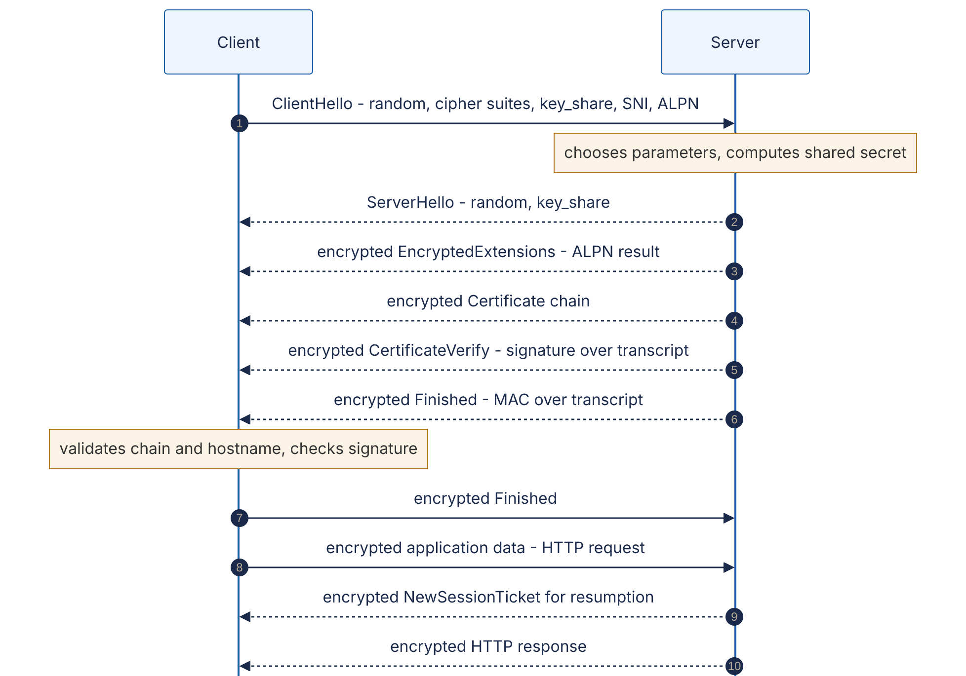
Reading the diagram. Step 1, the ClientHello, carries a random nonce, the cipher suites the client supports, its ephemeral Diffie–Hellman key share, the Server Name Indication (SNI) naming the host it wants (so one IP address can serve many sites), and the ALPN list of application protocols it speaks (h2, http/1.1). Steps 2–6 are the server’s single flight. From the ServerHello onward, both sides can derive handshake keys, so everything after it, including the certificate, is encrypted (in TLS 1.2 the certificate traveled in clear text). CertificateVerify proves the server holds the private key for the certificate; Finished proves nobody tampered with the handshake. In step 7 the client sends its Finished and, in step 8, its first request, all after one RTT. Steps 9–10 arrive later: a session ticket for faster resumption, and the response. Everything is synchronous request/response over the already-established TCP connection. Failure points: certificate validation (expired, wrong name, untrusted issuer) aborts the handshake; mismatched protocol versions or cipher suites fail at step 2. Scaling consideration: the server’s signature in step 5 is the main CPU cost of a handshake, which is a reason to reuse connections (§7.16) and resume sessions.

7.10.3 Certificates and the chain of trust
A certificate binds a public key to one or more names (in the Subject Alternative Name field), with a validity period, signed by a certificate authority (CA). Browsers and operating systems ship a root store of trusted root CAs. Servers send their own (leaf) certificate plus intermediate certificates; the client builds a chain from leaf to a trusted root and checks:
- each signature in the chain verifies with the issuer’s public key;
- the current time is within every certificate’s validity period;
- the requested hostname matches a name in the leaf;
- the certificate has not been revoked (via OCSP or CRLs, imperfectly in practice); and
- publicly trusted certificates appear in Certificate Transparency logs, as major browsers require.
Operationally, the most common TLS outage is mundane: an expired certificate. Publicly trusted certificates have a maximum lifetime of 398 days as of 2025, and the CA/Browser Forum has adopted a schedule to shorten it further over the coming years; ACME-based automation (as popularized by Let’s Encrypt) is the only sane response. Monitor expiry dates of every certificate, including internal ones.
Mutual TLS (mTLS), in which the client also presents a certificate, is the standard way to authenticate services to each other inside a zero-trust network (§10.10). PKI design — issuance, revocation and private CAs — is covered in §10.5.
Table 7.11 — TLS 1.2 versus TLS 1.3.
Aspect | TLS 1.2 (RFC 5246) | TLS 1.3 (RFC 8446)
Full handshake | 2 RTT | 1 RTT
Resumption | 1 RTT | 1 RTT, or 0-RTT with early data
Key exchange | RSA key transport or (EC)DHE | (EC)DHE only, so forward secrecy is mandatory
Cipher suites | Many, including weak legacy options | Five AEAD suites
Certificate visibility | Sent in clear text | Encrypted
Removed features | — | RSA key transport, static DH, CBC-mode ciphers, compression, renegotiation
Forward secrecy means that stealing a server’s long-term private key later does not let an attacker decrypt previously recorded sessions, because each session’s keys came from ephemeral Diffie–Hellman values that were discarded.

7.10.4 0-RTT and its caveats
With a session ticket from a previous connection, a TLS 1.3 client can send early data in its first flight, encrypted under a key derived from the resumption pre-shared key. Combined with QUIC, a returning client can deliver a request with zero round trips of setup. Two caveats make 0-RTT dangerous if used carelessly [RFC 8446 §8]:
- Replay. An attacker who records the first flight can resend it, and the server may process the early data twice. TLS cannot fully prevent this across a distributed server fleet.
- Weaker forward secrecy for early data, which is protected only by the resumption key, not by fresh ephemeral key exchange.
The rule: accept 0-RTT only for idempotent, safe requests (GET without side effects). Servers and CDNs that support it typically restrict it to such methods, and HTTP defines the Early-Data header and the 425 (Too Early) status code (RFC 8470) so origins can reject replay-unsafe early requests. Never let a payment or any non-idempotent POST ride in 0-RTT (see idempotency keys, §22.15).
COMMON MISTAKE
“TLS is too slow to use internally.” With TLS 1.3, a handshake costs one RTT (sub-millisecond inside a datacenter) and some CPU, and modern CPUs encrypt with AES-GCM at several GB/s per core using hardware instructions. With connection reuse, the steady-state cost is small. The exceptions are extreme-throughput paths, where kernel TLS and NIC offload exist for exactly this reason.

7.11 WebSockets (introduction)
HTTP is client-initiated: the server cannot speak until asked. Chat, live dashboards, collaborative editors and multiplayer games need the server to push data whenever it has some. WebSocket [RFC 6455] provides a persistent, full-duplex, message-oriented channel between browser and server, created by upgrading an HTTP/1.1 connection.
Figure 7.9 — WebSocket opening handshake and framing.
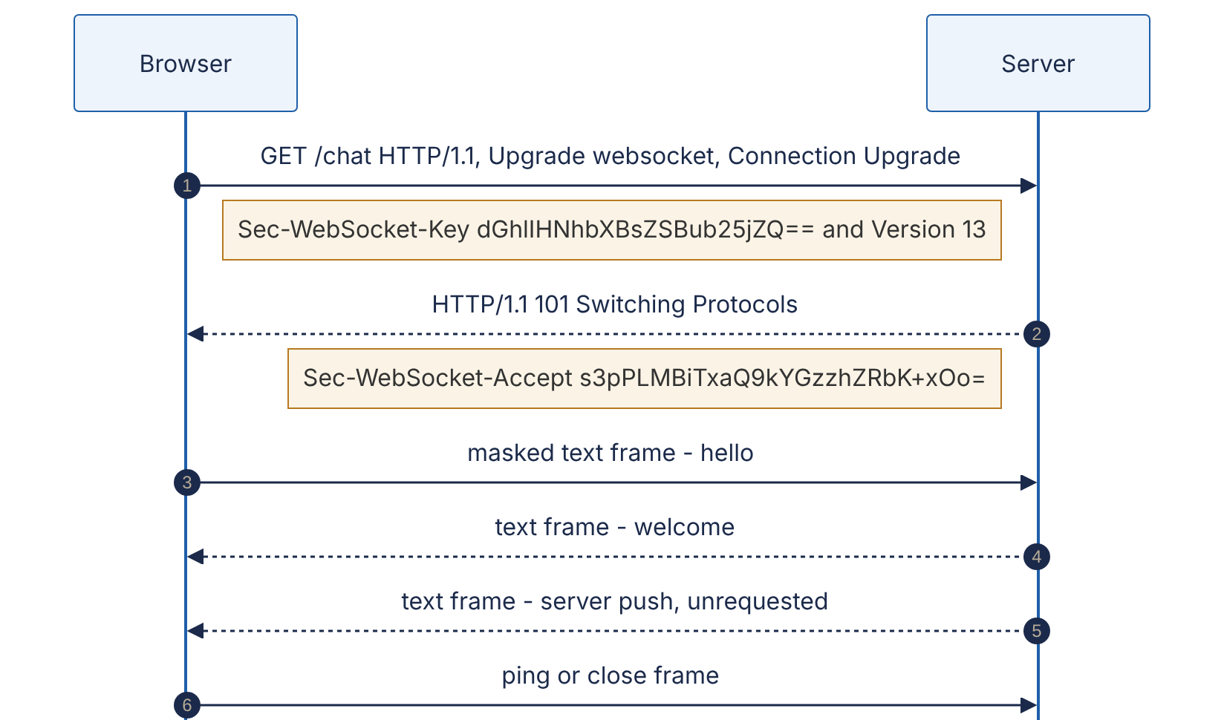
Reading the diagram. Steps 1–2 are an ordinary HTTP/1.1 exchange over an existing TCP (usually TLS) connection. The client sends a random base64 key; the server proves it understood the WebSocket protocol by returning Sec-WebSocket-Accept, the base64-encoded SHA-1 hash of the key concatenated with the fixed GUID 258EAFA5-E914-47DA-95CA-C5AB0DC85B11 (the values shown are the example from RFC 6455). After the 101 response the same TCP connection carries WebSocket frames in both directions, at any time (steps 3–6): either side may send without being asked, so the arrows are asynchronous in the application sense. Frames from client to server are masked with a random 4-byte key to stop malicious pages from crafting bytes that confuse caching proxies. Control frames (ping, pong, close) keep the connection alive and close it cleanly. Failure points: intermediaries with idle timeouts (load balancers commonly default to around 60 s) silently kill quiet connections, so applications send periodic pings; and every connection pins state to one server, which complicates deploys and load balancing.
The full design space (long polling, Server-Sent Events, WebSockets at scale, sticky routing, presence) is Chapter 9. WebSockets can also run over HTTP/2 (RFC 8441) and HTTP/3 (RFC 9220) using an extended CONNECT method.

7.12 Forward proxies and reverse proxies
DEFINITION
Definition — Proxy. An intermediary that terminates a client’s connection and opens its own connection onward, relaying requests and responses. A forward proxy acts on behalf of clients and is chosen by them (or their network administrator). A reverse proxy acts on behalf of servers and is chosen by the site operator; clients usually do not know it exists.
Analogy: a forward proxy is your personal assistant who places all your calls, so callees see the assistant’s number. A reverse proxy is a company switchboard: callers dial one number and the receptionist routes them to the right employee, who never has to expose a direct line.
Figure 7.10 — Forward proxy versus reverse proxy.
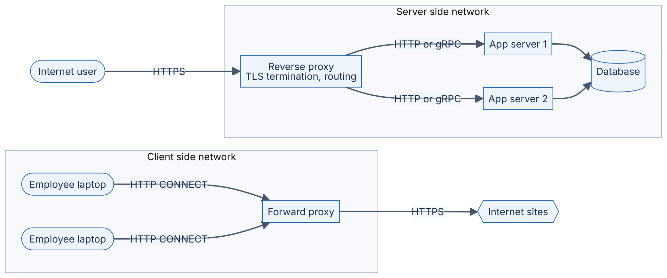
Reading the diagram. On the left, client machines inside an organization send all outbound traffic through a forward proxy, using the HTTP CONNECT method to tunnel TLS connections; destination sites see the proxy’s address. On the right, Internet users connect to a reverse proxy, which terminates TLS, inspects HTTP and forwards each request to one of several application servers over internal HTTP or gRPC; users see only the proxy. Both paths are synchronous request/response. The database behind the app servers is the storage boundary. Failure points: each proxy is a single point of failure unless replicated behind anycast, ECMP or DNS (§19.8). Scaling: reverse proxies scale horizontally and absorb connection-handling work (TLS, slow clients) so app servers do not have to.
Table 7.12 — Forward and reverse proxies compared.
Aspect | Forward proxy | Reverse proxy
Acts for | Clients | Servers
Configured by | Client or client’s network | Service operator
Hides | Client identity from servers | Server topology from clients
Typical functions | Egress filtering, caching, auditing, access control, anonymity | TLS termination, load balancing, routing by path or host, caching, compression, rate limiting, WAF, request buffering
Examples | Squid, corporate secure web gateways, egress proxies in VPCs | NGINX, HAProxy, Envoy, cloud load balancers, CDNs, API gateways
System-design relevance | Controlled egress from private networks | Nearly every web architecture’s front door
A reverse proxy that distributes load is a load balancer (Chapter 19); one that adds authentication, quotas and API management is an API gateway (§34.6); one deployed beside every service instance is a sidecar in a service mesh. Proxies that terminate TCP also shield back-ends from slow clients: the proxy buffers a slowly uploaded request and hands the application a complete one, so the application’s limited workers are not tied up for seconds.
WARNING / TRADE-OFF
The client IP problem. Behind a reverse proxy, the application sees the proxy’s IP as the source. Proxies pass the original address in the X-Forwarded-For or standard Forwarded header (RFC 7239), or at L4 via the PROXY protocol. Trust these headers only when they were set by your own proxy; otherwise clients can forge them to evade rate limits or IP allow-lists.

7.13 NAT
DEFINITION
Definition — Network Address Translation (NAT). A function, usually in a router or gateway, that rewrites the source and/or destination IP addresses (and usually ports) of packets as they pass, keeping a translation table so that replies can be rewritten back. The most common form, source NAT with port translation (NAPT, often just “NAT”), lets many hosts with private addresses share one public address [RFC 3022].
Analogy: an office building with one street address and a mailroom. Outgoing letters carry the building’s return address with an internal “room code” written on them; when replies come back with that code, the mailroom forwards them to the right room. A letter that arrives with no room code the mailroom has issued has nowhere to go.
Figure 7.11 — Source NAT for an outbound connection.
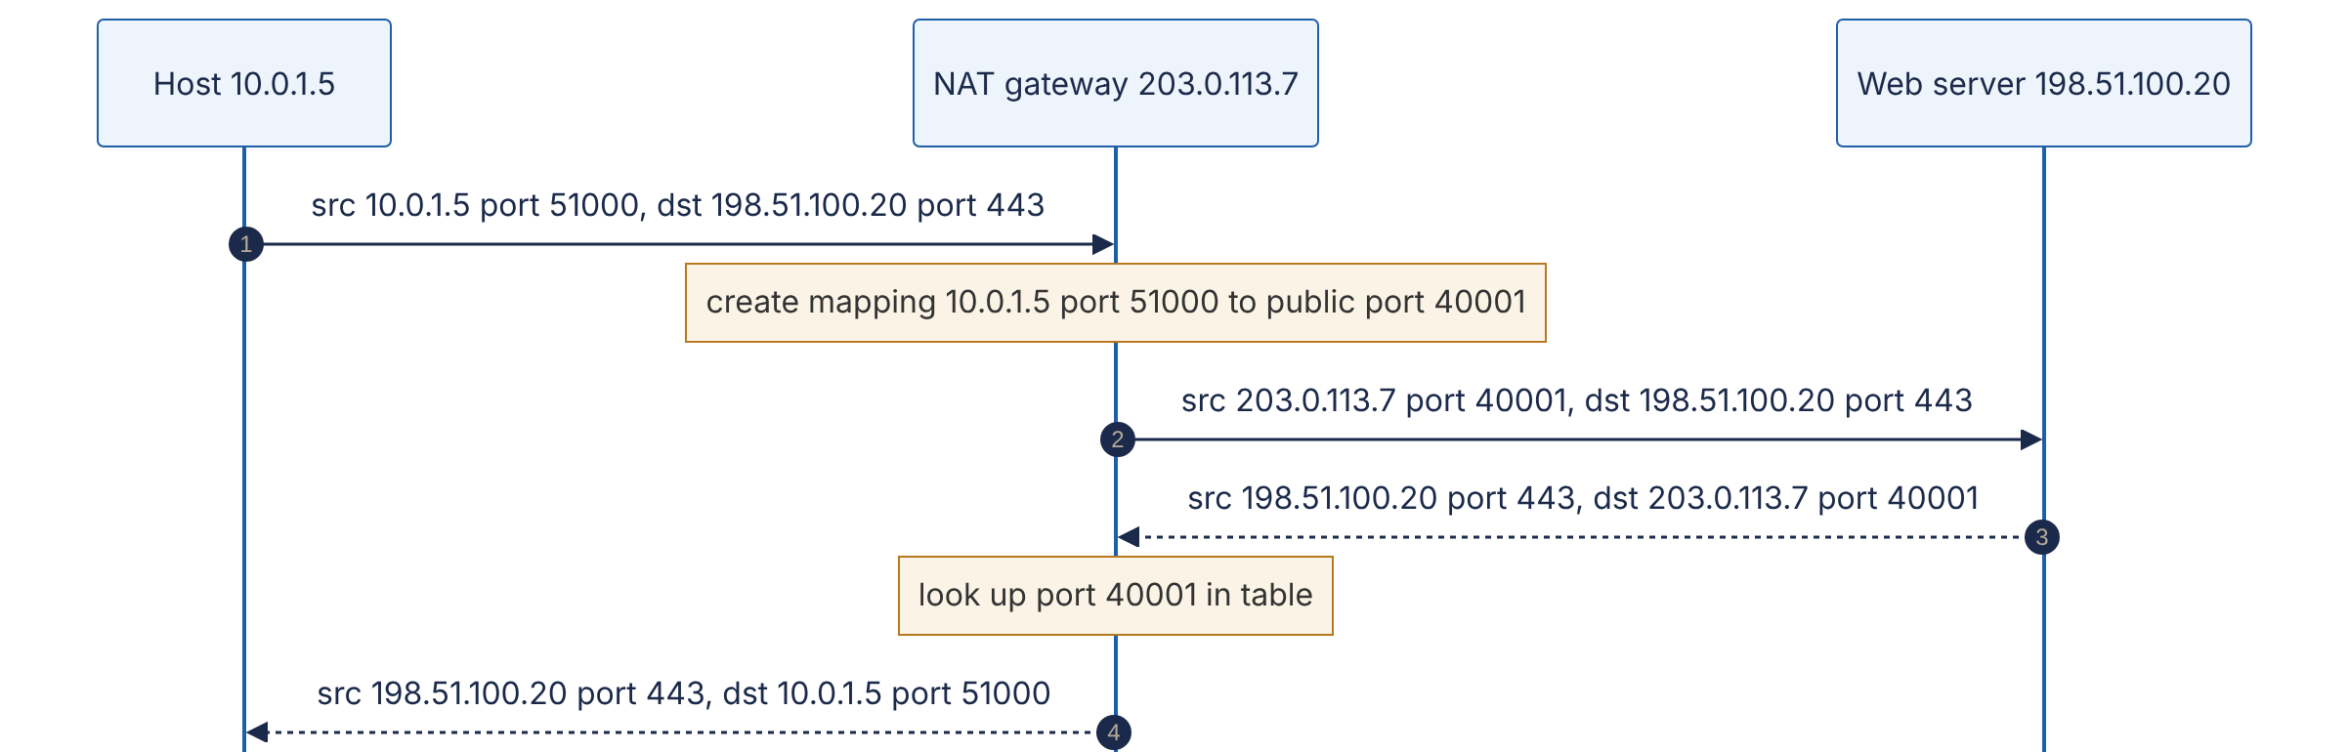
Reading the diagram. A private host (left) opens a connection to a public server (right) through a NAT gateway (middle). In step 1 the packet carries the host’s private address. The NAT rewrites the source to its own public address and a free public port, recording the mapping (steps 2–3). The server replies to the public address (step 4), and the NAT reverses the translation using the table (steps 5–6). All traffic is synchronous and flows through the same NAT in both directions: the NAT is stateful, which makes it a failure point (if it restarts or the mapping times out, existing connections die) and a scaling limit (ports per destination).

Consequences for system design
- Inbound connections are impossible by default, because no mapping exists until the inside host sends first. Peer-to-peer systems (WebRTC, §9.7) use STUN to discover their public mapping and fall back to TURN relays when NAT behavior prevents direct connections.
- Mappings time out. Idle UDP mappings may expire in tens of seconds and TCP mappings in minutes to hours, depending on the device. Long-lived idle connections need keep-alives shorter than the NAT timeout, or they become half-open (§7.7).
- Port exhaustion. A single public IP has about 64,000 usable ports per destination (IP, port, protocol). AWS documents a NAT gateway limit of 55,000 simultaneous connections per assigned IP address to each unique destination, raisable by assigning more IPs (as of 2025) [AWS Docs: NAT gateways]. A fleet of services calling one external API through one NAT IP can exhaust this; connection pooling and more NAT IPs fix it.
- Carrier-grade NAT (CGNAT): mobile and some fixed ISPs place many subscribers behind shared addresses from 100.64.0.0/10. Thousands of users can share one public IP, so IP-based rate limiting and blocking punish innocent users.
- Cost. Managed cloud NAT gateways usually charge per gigabyte processed; routing bulk traffic to cloud storage through them instead of private endpoints is a common surprise on the bill.

7.14 Firewalls and security groups
DEFINITION
Definition — Firewall. A device or software function that permits or denies traffic according to rules. A stateless (packet-filter) firewall evaluates each packet independently against rules on addresses, ports and protocol. A stateful firewall tracks connections, so a reply to an allowed outbound connection is automatically permitted. Application-layer firewalls, including web application firewalls (WAFs), parse protocols such as HTTP to block malicious requests.
Cloud providers expose two common forms. A security group (AWS, similar constructs elsewhere) is a stateful, allow-only rule set attached to a network interface or instance. A network ACL is a stateless, ordered allow-and-deny rule list attached to a subnet. Because NACLs are stateless, you must explicitly allow return traffic, typically to the client’s ephemeral port range, which is a frequent source of “connection hangs” misconfigurations.
Table 7.13 — Firewall mechanisms compared.
Aspect | Stateless ACL | Stateful firewall / security group | Web application firewall
Inspects | Packet headers | Headers plus connection state | HTTP requests (L7)
Return traffic | Must be explicitly allowed | Allowed automatically | N/A (proxy)
Rule style | Ordered allow/deny | Usually allow-only | Signatures, rate rules, custom logic
Cost of state | None | Connection table (can be exhausted) | Full proxying
Typical placement | Subnet boundary | Each instance or interface | In front of web apps, often at the CDN
Choose when | Coarse subnet guardrails | Default micro-segmentation between tiers | Blocking injection, bots, abusive patterns

Practical rules
- Default deny. Allow only the ports and sources each tier needs: the load balancer may reach the app tier on port 8080; only the app tier may reach the database on 5432.
- Reference groups, not addresses. Security groups can name other groups as sources (“allow from sg-app”), which keeps rules correct as instances scale in and out.
- Firewalls are one layer of defense in depth. Combine them with authentication and encryption (mTLS, §10.10); a network position is not an identity.
- Watch the state table. Stateful devices track every connection; a flood of connections (legitimate or attack) can exhaust their tables and drop everything. Linux’s conntrack table is a common culprit on busy proxies.
- Silent drops cause timeouts, rejections cause fast failure. A firewall that drops packets makes clients wait for a timeout; one that sends RST or ICMP unreachable fails fast. Choose deliberately.

7.15 Latency, bandwidth, the bandwidth-delay product and packet loss

7.15.1 The four components of latency
Think of a highway. Bandwidth is the number of lanes: how many cars per second can pass a point. Latency is how long one car takes to travel from entrance to exit. Adding lanes does not make the drive shorter. A packet’s one-way delay through each hop is the sum of four parts.
DEFINITION
Definition — Components of network delay. Propagation delay: time for a signal to travel the physical distance. Transmission (serialization) delay: time to push all of a packet’s bits onto the link. Queuing delay: time spent waiting in buffers behind other packets. Processing delay: time for a device to examine headers, look up routes and copy the packet.
FORMULA
One-hop delay
$$d_{\text{hop}}=\underset{\text{propagation}}{\underset{⏟}{\frac{D}{v}}}+\underset{\text{transmission}}{\underset{⏟}{\frac{L}{R}}}+d_{\text{queue}}+d_{\text{proc}}$$
Symbol | Meaning | Units
$D$ | Physical length of the link | m (or km)
$v$ | Signal speed in the medium: about $2×{10}^{8}$ m/s in optical fiber (roughly two-thirds of $c$) | m/s
$L$ | Packet size | bits
$R$ | Link rate (bandwidth) | bits/s
$d_{\text{queue}}$ | Queuing delay: bytes waiting ahead ÷ link rate | s
$d_{\text{proc}}$ | Processing delay: microseconds in software, sub-microsecond in switch hardware | s
Table 7.14 — Delay components at a glance.
Component | Depends on | Typical magnitude | How to reduce it
Propagation | Distance, medium | ~5 µs per km of fiber; tens of ms across oceans | Move closer: CDNs, edge, regional replicas
Transmission | Packet size, link rate | 12 µs for 1,500 B at 1 Gbps; 1.2 µs at 10 Gbps | Faster links, smaller packets
Queuing | Load, buffer size | 0 to hundreds of ms | Lower utilization, AQM, BBR
Processing | Device and software path | ~µs (hardware) to tens of µs (software) | Kernel bypass, offloads, fewer hops
WORKED EXAMPLE
Worked example 1 — The speed-of-light floor from New York to London.
The great-circle distance between New York and London is about 5,570 km.
- One-way propagation in fiber: $5,570\text{ km}/200,000\text{ km/s}=0.02785$ s = 27.85 ms.
- Round-trip time: $2×27.85=55.7$ ms.
- Even in a vacuum at $c≈299,792$ km/s, the RTT would be $2×5,570/299,792≈37.2$ ms.
- Real cables do not follow the great circle, and routers, transmission and queuing add more, so measured RTTs are noticeably higher than 55.7 ms (often in the 70 ms range).
Interpretation: no engineering can make a New York–London round trip faster than about 56 ms over fiber. A user in London calling a single-region service in New York pays at least that on every round trip, and a page needing five sequential round trips pays at least 280 ms. Engineering implication: for global users, reduce round trips (connection reuse, TLS 1.3, QUIC) and move content and computation closer (CDNs, Ch 21; multi-region, Ch 44).
WORKED EXAMPLE
Worked example 2 — Transmission versus propagation.
Send one 1,500-byte packet ($L=12,000$ bits).
- On a 10 Mbps link: $12,000/{10}^{7}=1.2$ ms.
- On a 1 Gbps link: $12,000/{10}^{9}=12$ µs.
- On a 100 Gbps link: $12,000/{10}^{11}=120$ ns.
Compare with propagation across a 100 m datacenter cable: $100/\left(2×{10}^{8}\right)=0.5$ µs. Interpretation: on slow access links, serialization dominates; on fast datacenter links, serialization becomes negligible and per-hop processing and software stacks dominate.
WORKED EXAMPLE
Worked example 3 — Bufferbloat.
A home router has a 10 MB buffer in front of a 1 Gbps uplink. When a large upload fills that buffer, a newly arriving packet waits behind $10×{10}^{6}×8=8×{10}^{7}$ bits, so its queuing delay is $8×{10}^{7}/{10}^{9}=0.08$ s = 80 ms. On a 20 Mbps uplink the same buffer would add $8×{10}^{7}/\left(2×{10}^{7}\right)=4$ s. Loss-based congestion control (CUBIC) keeps such buffers full, so a video call alongside a big upload suffers seconds of lag. Fixes: active queue management (CoDel, FQ-CoDel) on the bottleneck, and delay-aware congestion control such as BBR.

7.15.2 Throughput and the bandwidth-delay product
A reliable sender can only have a window’s worth of unacknowledged data in flight; it then waits for ACKs, which take one RTT. So:
FORMULA
Window-limited throughput and the bandwidth-delay product (BDP)
$$\text{Throughput}≤\frac{W}{\text{RTT}} \text{BDP}=R×\text{RTT}$$
Symbol | Meaning | Units
$W$ | Effective window, $min\left(\text{cwnd},\text{rwnd}\right)$ | bytes
RTT | Round-trip time | s
$R$ | Bottleneck link rate | bits/s (divide by 8 for bytes/s)
BDP | Data that must be in flight to keep the link full | bits or bytes
WORKED EXAMPLE
Worked example — BDP for a 10 Gbps, 80 ms path.
- BDP $=10×{10}^{9}\text{ bits/s}×0.080\text{ s}=8×{10}^{8}$ bits.
- In bytes: $8×{10}^{8}/8={10}^{8}$ bytes = 100 MB.
- Without window scaling, $W$ is at most 65,535 bytes, giving throughput $≤65,535×8/0.08≈6.55$ Mbps, about 0.07% of the link.
- To fill the link, the receiver must advertise (and the sender buffer) about 100 MB per connection: window scaling must be on and kernel buffer limits (net.ipv4.tcp_rmem and tcp_wmem maximums on Linux) must be at least that large.
Interpretation: on “long fat networks”, a single TCP connection is limited by buffers and window, not by the link. Engineering implication: bulk cross-region transfers (backups, replication, dataset copies) need tuned buffers, parallel streams, or both.

7.15.3 Packet loss and the Mathis formula
Loss hurts TCP twice: each lost packet must be retransmitted, and each loss signal halves (Reno) or cuts (CUBIC) the congestion window. For loss-based congestion avoidance with random loss probability $p$, Mathis, Semke, Mahdavi and Ott derived a simple upper bound on steady-state throughput [Mathis et al. 1997].
FORMULA
Mathis throughput formula
$$\text{Throughput}≤\frac{\text{MSS}}{\text{RTT}}×\frac{C}{\sqrt{p}}$$
Symbol | Meaning | Units
MSS | Maximum segment size | bits (or bytes, for bytes/s)
RTT | Round-trip time | s
$p$ | Packet loss probability | dimensionless
$C$ | Constant, $\sqrt{3/2}≈1.22$ for periodic loss with every packet ACKed | dimensionless
WORKED EXAMPLE
Worked example — Loss caps a long-distance connection.
MSS = 1,460 bytes = 11,680 bits; RTT = 80 ms.
- $\text{MSS}/\text{RTT}=11,680/0.08=146,000$ bits/s.
- With $p={10}^{−4}$ (0.01% loss): $C/\sqrt{p}=1.22/0.01=122$, so throughput $≤146,000×122≈17.8$ Mbps.
- With $p={10}^{−6}$: $C/\sqrt{p}=1,220$, so throughput $≤178$ Mbps.
- To reach 10 Gbps: $\sqrt{p}=1.22×146,000/{10}^{10}≈1.79×{10}^{−5}$, so $p≈3.2×{10}^{−10}$, about one loss in three billion packets.
Interpretation: throughput falls with $1/\text{RTT}$ and $1/\sqrt{p}$, independent of link speed. A tiny 0.01% loss caps a single transcontinental CUBIC- or Reno-style flow at under 20 Mbps on a 10 Gbps link. Engineering implications: (a) find and fix lossy links, which are often a dirty optic or a bad cable; (b) reduce RTT; (c) for bulk transfers, use parallel connections or a model-based algorithm such as BBR that does not treat random loss as congestion. The formula is an approximation for loss-based algorithms in congestion avoidance; it does not describe BBR, short flows still in slow start, or timeout-dominated regimes.

7.16 Connection pooling and keep-alive

7.16.1 The cost of a new connection
Before the first byte of a response can arrive over a new HTTPS connection, the client pays for DNS, the TCP handshake, the TLS handshake, and the request itself.
Table 7.15 — Round trips before the first response byte (DNS cached).
Stack | Setup RTTs | Request RTT | Total | At RTT 80 ms | At RTT 0.5 ms (same datacenter)
HTTP over TCP, no TLS | 1 | 1 | 2 | 160 ms | 1.0 ms
HTTPS, TCP + TLS 1.2 | 1 + 2 | 1 | 4 | 320 ms | 2.0 ms
HTTPS, TCP + TLS 1.3 | 1 + 1 | 1 | 3 | 240 ms | 1.5 ms
HTTP/3, QUIC first connection | 1 | 1 | 2 | 160 ms | 1.0 ms
HTTP/3, QUIC 0-RTT resumption | 0 | 1 | 1 | 80 ms | 0.5 ms
Any stack, reused connection | 0 | 1 | 1 | 80 ms | 0.5 ms
Round trips are only part of the cost. Each new connection also burns CPU (the TLS asymmetric cryptography is the expensive part), allocates kernel and proxy memory, starts in slow start with a small congestion window (§7.7.7), and leaves a TIME_WAIT entry when closed (§7.7.4).
WORKED EXAMPLE
Worked example — Reusing connections to a cross-region dependency.
Service A in Virginia calls service B in Oregon (RTT about 70 ms) 200 times per second. Each call takes 10 ms of server time.
- New TCP + TLS 1.3 connection per call: latency ≈ $3×70+10=220$ ms per call.
- Reused connection: $1×70+10=80$ ms per call, a 2.75× reduction.
- Handshake work avoided: 200 TLS handshakes per second, each involving a signature on B and verification on A.
- Ports: with per-call connections and A as active closer, $200×60=12,000$ sockets sit in TIME_WAIT at any time, about 43% of the 28,232 default ephemeral ports.
Interpretation: connection reuse is not a micro-optimization; it changes latency by a factor of nearly three and removes a scaling cliff.

7.16.2 Sizing a pool with Little’s Law
A connection pool keeps a set of open connections that callers borrow and return. For protocols that carry one request at a time per connection (HTTP/1.1, most database protocols), the number of connections in use equals the number of requests in flight, which Little’s Law gives directly (§4.11).
FORMULA
Connections needed for a one-request-per-connection protocol
$$N=λ×W$$
Symbol | Meaning | Units
$N$ | Average connections busy | connections
$λ$ | Request rate | requests/s
$W$ | Time a request holds a connection (network RTT plus server time) | s
WORKED EXAMPLE
Worked example — Database pool sizing.
An application server issues 2,000 queries per second; each holds a connection for 5 ms on average (0.5 ms RTT plus 4.5 ms of query execution).
- $N=2,000×0.005=10$ busy connections on average.
- Add headroom for bursts and tail latency: if p99 hold time is 25 ms, bursts can need $2,000×0.025=50$. A pool of 20–50 is reasonable.
- With 40 application servers each holding a pool of 50, the database must accept 2,000 connections. Many databases degrade with thousands of connections (PostgreSQL uses a process per connection), which is why connection proxies such as PgBouncer sit in between (Chapter 14).
Interpretation: size pools from rate × hold time, not by guessing; and remember pools multiply across instances.

7.16.3 Keep-alive pitfalls
- Idle-timeout races. If the server (or a load balancer) closes idle connections after 60 s and the client’s pool keeps them for 90 s, the client will occasionally send a request on a connection the server has just closed, getting a reset. Set client idle timeouts shorter than every server-side timeout along the path, and retry idempotent requests on this specific failure.
- Stale connections after failover. Long-lived connections keep talking to an old backend after DNS changes, so set a maximum connection lifetime.
- Load imbalance with multiplexed protocols. An HTTP/2 or gRPC client may send all its traffic over one long-lived connection to one backend; an L4 load balancer balances connections, not requests, so new backends receive nothing. Use L7 (request-level) load balancing or client-side balancing, and cap connection age so connections periodically redistribute (§19.10).
- TCP keep-alive is not HTTP keep-alive. HTTP keep-alive means “reuse this connection for more requests”. TCP keep-alive sends empty probes on an idle connection to detect dead peers and refresh NAT and firewall state.

7.17 Datacenter networking

7.17.1 From trees to leaf–spine
Traditional enterprise networks were trees: servers connect to access switches, which connect to aggregation switches, which connect to a pair of large core routers. Trees suit north–south traffic (between users outside and servers inside). Modern applications are different: a single user request fans out to dozens of internal services, caches and databases, and batch jobs shuffle terabytes between servers. Most bytes now flow east–west, server to server inside the datacenter. In a tree, east–west traffic converges on the few links near the top, which become the bottleneck, and the expensive core routers become both a cost and a failure concentration.
DEFINITION
Definition — Leaf–spine (folded Clos) network. A two-tier topology in which every leaf (top-of-rack) switch connects to every spine switch, and servers attach only to leaves. Any two servers on different leaves are exactly two switch hops apart (leaf → spine → leaf), and traffic is spread across all spines with ECMP. It is a form of the multistage Clos network, first described by Charles Clos in 1953 for telephone switching. Larger fabrics add a third tier.
Figure 7.12 — A leaf–spine fabric with ECMP.
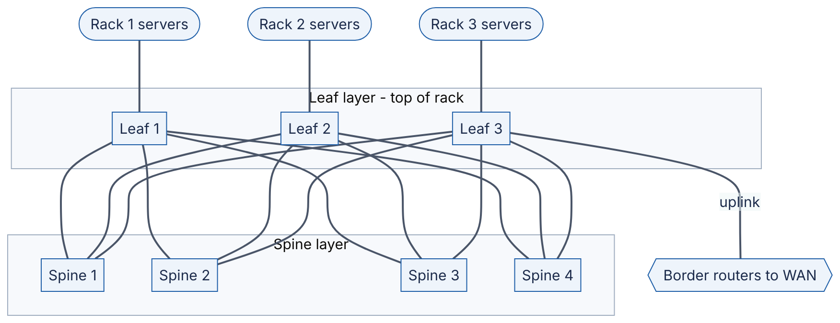
Reading the diagram. Servers in each rack connect to their leaf switch. Every leaf has one uplink to every spine (a full bipartite mesh), so a flow from rack 1 to rack 3 has four equal-cost two-hop paths, and leaves pick among them by hashing each flow’s 5-tuple (ECMP). Spines never connect to each other or to servers. One leaf (or a dedicated pair) connects to border routers for north–south traffic. Links are undirected because traffic flows both ways; all forwarding is synchronous hardware switching. Failure points: losing a spine removes one quarter of cross-rack capacity rather than isolating anything; losing a leaf isolates its rack, which is why critical services spread replicas across racks. Scaling: add spines for more bandwidth, add leaves (up to the spine port count) for more racks.
FORMULA
Oversubscription ratio at a leaf
$$\text{Oversubscription}=\frac{\text{total server-facing bandwidth}}{\text{total uplink bandwidth}}$$
Symbol | Meaning | Units
Server-facing bandwidth | Sum of the leaf’s downlink port speeds | Gbps
Uplink bandwidth | Sum of the leaf’s spine-facing port speeds | Gbps
WORKED EXAMPLE
Worked example — Sizing a leaf–spine fabric.
Each leaf has 48 × 25 Gbps server ports and 6 × 100 Gbps uplinks; each spine has 64 × 100 Gbps ports.
- Downlink: $48×25=1,200$ Gbps. Uplink: $6×100=600$ Gbps.
- Oversubscription: $1,200/600=2:1$. If every server sends cross-rack at full rate, each gets at most 12.5 Gbps.
- Each leaf uses one port on each of 6 spines, so there are 6 spines. Each spine has 64 ports, so at most 64 leaves.
- Maximum servers: $64×48=3,072$.
- Total leaf-to-spine capacity: $64\text{ leaves}×600\text{ Gbps}=38.4$ Tbps. The bisection bandwidth (capacity between any half of the leaves and the other half) is $32×600=19.2$ Tbps.
Interpretation: oversubscription is a cost lever. 1:1 (“non-blocking”) fabrics cost more uplinks and spines; 3:1 is acceptable for workloads that are mostly rack-local. Larger fabrics add a third tier of switches to go beyond the port count of one spine.
INDUSTRY EXAMPLE
Google Jupiter. Google’s SIGCOMM 2015 paper describes a decade of five datacenter network generations, culminating in Jupiter. Instead of buying ever-larger proprietary routers, Google built multistage Clos topologies from many small switches using commodity merchant silicon, managed them with centralized, software-defined control rather than traditional distributed routing protocols, and scaled capacity about 100× over ten years to more than 1 Pbps of bisection bandwidth. The paper’s argument (that bandwidth demand from east–west traffic grows faster than any single box can, so the network must scale out like the servers) is now standard practice across large datacenter operators. Evidence: Primary — [Singh et al. 2015]

7.17.2 Datacenter-specific problems
- Incast. When a client fans a request out to 100 servers that all reply at the same instant, the replies converge on one leaf port, overflow its shallow buffer, and drop packets. The dropped flows wait for a 200 ms minimum RTO in a network whose RTT is about 100 µs, producing extreme tail latency (§23.6). Mitigations: limit fan-out concurrency, jittered responses, smaller minimum RTOs, and ECN-based congestion control such as DCTCP.
- ECMP hash collisions. Two elephant flows hashed onto the same spine link share it while other links sit idle. Flowlet switching, packet spraying and adaptive routing reduce this.
- Gray failures. A link that drops 1% of packets is worse than a dead one, because routing still uses it while TCP throughput collapses (recall the Mathis formula). Operators monitor per-link error counters and drain suspect links automatically.

7.18 What happens when you type a URL
Everything in this chapter appears in the life of one request. Suppose you type https://www.example.com/ into a browser on a laptop connected by Wi-Fi at home, with a cold DNS cache, and the site is served by a CDN edge 20 ms away (RTT) with HTTP/2.
Figure 7.13 — Loading https://www.example.com/ end to end.
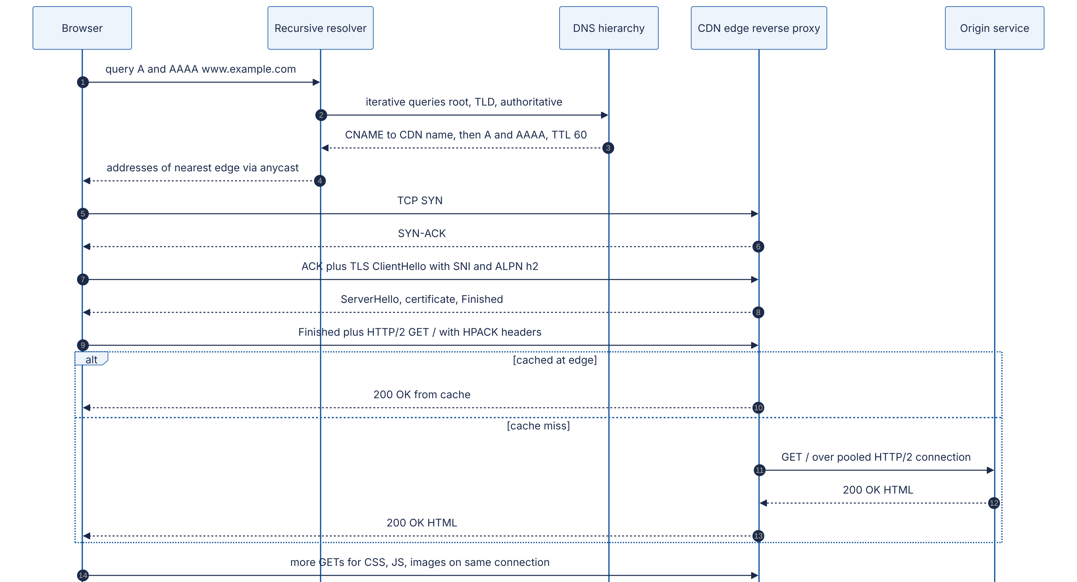
Reading the diagram. Steps 1–4: the browser (via the operating system stub) asks a recursive resolver, which walks the DNS hierarchy (§7.6); the authoritative server returns a CNAME pointing into the CDN, whose own authoritative servers answer with an anycast address (§7.5.3). Steps 5–7: the TCP handshake (§7.7.3), with the TLS ClientHello piggybacked on the final ACK. Step 8: the server’s TLS 1.3 flight (§7.10.2), including the certificate the browser validates. Step 9: the client’s Finished and the first HTTP/2 request, with ALPN having selected h2 (§7.9.3). Steps 10–13: the edge serves from cache or fetches from the origin over a pre-warmed, pooled connection (§7.16), so the user does not pay the origin’s handshakes. Step 14: subresources reuse the same multiplexed connection. All steps are synchronous; the edge cache and origin are the storage boundaries. Failure points include DNS (every step depends on it), certificate validity, and the origin path on cache misses.

7.18.1 Steps the diagram leaves out
Figure 7.13 shows the protocol messages. Several steps happen around them:
- Before any network traffic, the browser parses the URL into scheme (https, so port 443), host and path, applies its HSTS list (which may force HTTPS), and checks its HTTP cache and any existing connection to the origin. A reused connection skips steps 1–9 of the figure entirely.
- Choosing an address (§7.4). With both AAAA and A answers, Happy Eyeballs tries IPv6 first and races IPv4 if needed.
- The first hop (§7.3). The destination is off-subnet, so the laptop frames the packet for its default gateway, learning the gateway’s MAC address with ARP or Neighbor Discovery.
- NAT (§7.13). For IPv4, the home router rewrites the private source address (for example 192.168.1.23) to its public address and records the mapping; the ISP may add carrier-grade NAT.
- Routing (§7.5). ISP routers forward by longest-prefix match, and BGP delivers the anycast destination to a nearby edge site.
- Edge admission (§7.14, Chapter 19). DDoS filtering and an L4 load balancer (ECMP plus consistent hashing) pick the server running the reverse proxy.
- Behind the edge (§8.5, Chapter 21). On a cache miss, the origin’s reverse proxy routes the request to an application server, which may call caches and databases across a leaf–spine fabric (§7.17).
- After the response. The browser discovers CSS, JavaScript and images and fetches them as concurrent streams on the same connection, ramping up under slow start (§7.7.7). An Alt-Svc header may advertise HTTP/3 for later connections.
WORKED EXAMPLE
Worked example — Time to first byte budget.
Assume: 5 ms RTT to the resolver; resolver needs root, TLD and authoritative lookups costing 15, 20 and 30 ms, plus 25 ms for the CDN’s authoritative servers; 20 ms RTT to the edge; 2 ms edge processing on a cache hit.
- DNS: $5+15+20+30+25=95$ ms (cold); 5 ms warm.
- TCP handshake: 20 ms.
- TLS 1.3 handshake: 20 ms.
- Request and first response byte: $20+2=22$ ms.
- Total cold: $95+20+20+22=157$ ms. Warm DNS: $5+62=67$ ms. Reused connection: 22 ms.
- On a cache miss with the origin 70 ms from the edge over a pooled connection, add $70 + $ origin processing (say 30 ms) = 100 ms.
Interpretation: on a cold visit, connection setup (DNS, TCP, TLS) is most of the time to first byte, and the server’s own work is a small slice. This is why the biggest wins for global latency are fewer round trips and shorter round trips, not faster servers.

7.19 Summary and revision notes
SUMMARY
- Layering and encapsulation. Each layer adds its own header: application message → TCP segment or UDP datagram (ports) → IP packet (addresses) → link frame (MAC). Routers rewrite link frames at every hop; IP packets travel end to end.
- Addressing. IPv4 is 32 bits, IPv6 is 128. CIDR /n leaves $2^{32−n}$ IPv4 addresses (minus 2 on ordinary subnets; minus 5 on AWS). Private ranges: 10/8, 172.16/12, 192.168/16. Plan non-overlapping ranges before networks need to connect.
- Routing. Forwarding uses longest-prefix match. BGP connects autonomous systems by policy, not latency, and trusts announcements by default. Anycast announces one prefix from many sites to steer users to a nearby one.
- DNS. Stub → recursive resolver (recursive query) → root → TLD → authoritative (iterative queries). Caches expire by TTL; nothing “propagates”. DNS load balancing picks sites, not servers, and fails over in minutes.
- TCP. 1-RTT handshake; four-way close; the active closer holds TIME_WAIT (60 s on Linux), which can exhaust ephemeral ports. Reliability via sequence numbers, cumulative ACKs, fast retransmit and RTO (200 ms minimum on Linux). Flow control uses the receive window; congestion control uses cwnd: slow start doubles per RTT, AIMD halves on loss, CUBIC grows by a cubic of time, BBR paces at measured bandwidth. One lost segment blocks the whole stream (head-of-line blocking). Set TCP_NODELAY for RPC.
- UDP. 8-byte header, no setup, no reliability. Use it when timeliness beats completeness or to build your own transport; you then own congestion control.
- HTTP. 1.1: one request at a time per connection, about six connections per host. 2: binary frames, multiplexed streams, HPACK, but TCP HOL blocking. 3: QUIC over UDP with independent streams, built-in TLS 1.3, 1-RTT (0-RTT on resumption) setup and connection migration.
- TLS 1.3. 1-RTT handshake, encrypted certificates, mandatory forward secrecy. 0-RTT early data is replayable: use only for idempotent requests. Expired certificates are the most common TLS outage; automate renewal.
- Middle of the network. Forward proxies act for clients; reverse proxies act for servers (TLS termination, routing, load balancing). NAT shares public IPs, blocks unsolicited inbound traffic, and has finite ports per destination. Security groups are stateful; network ACLs are stateless.
- Numbers. Fiber propagation is about 5 µs/km; NY–London RTT is at least 56 ms. BDP $=R×\text{RTT}$: 10 Gbps × 80 ms = 100 MB in flight. Mathis: throughput $≤\left(\text{MSS}/\text{RTT}\right)×1.22/\sqrt{p}$, so 0.01% loss caps an 80 ms flow near 18 Mbps.
- Connections. A new HTTPS connection with TLS 1.3 costs 3 RTTs to first byte, versus 1 on a reused connection. Pool connections; size pools with $N=λW$; set client idle timeouts shorter than server timeouts.
- Datacenters. East–west traffic dominates; leaf–spine Clos fabrics with ECMP give every rack equal-cost two-hop paths and scale out with commodity switches (Google Jupiter: over 1 Pbps of bisection bandwidth).

7.20 Knowledge checkpoint
- Which headers does a router remove and rebuild at each hop, and which header fields does it modify?
- What are the network address, broadcast address and usable host range of 172.20.14.200/22?
- A router has routes for 10.0.0.0/8, 10.4.0.0/14 and 10.4.4.0/24. Which is used for 10.5.1.1?
- Why can anycast break long-lived TCP connections, and why is it nevertheless ideal for DNS?
- Distinguish recursive and iterative DNS queries, and say which participants send each kind.
- Why can’t you place a CNAME at the zone apex?
- You need to move a service to new IP addresses; the A record’s TTL is 86,400 s. What must you do and when?
- What does an acknowledgment number of 5,001 mean?
- Why does the active closer of a TCP connection enter TIME_WAIT, and for how long on Linux?
- Explain the difference between flow control and congestion control, naming the window each uses.
- Starting from an initial window of 10 segments, how many RTTs of slow start are needed to send 300 segments with no loss?
- Explain how Nagle’s algorithm and delayed ACKs together add latency, and give the standard fix.
- HTTP/2 multiplexes streams over one connection. Why does it still suffer head-of-line blocking, and how does HTTP/3 avoid it?
- Why must 0-RTT early data be limited to idempotent requests?
- Compute the BDP of a 1 Gbps link with a 40 ms RTT, in megabytes.
- Using the Mathis formula, what is the maximum throughput with MSS 1,460 bytes, RTT 20 ms and 1% loss?
- Why are network ACLs a frequent cause of “connection hangs” while security groups are not?
- What is the oversubscription ratio of a leaf with 32 × 100 Gbps server ports and 8 × 400 Gbps uplinks?
Answers
- The router strips the incoming link-layer (Ethernet) header and trailer and builds a new frame with new source and destination MACs for the next link. In the IP header it decrements TTL (hop limit) and, for IPv4, recomputes the header checksum. NAT devices also rewrite addresses and ports.
- A /22 has $2^{10}=1,024$ addresses; the third octet advances in steps of 4. 14 lies in 12–15, so network 172.20.12.0, broadcast 172.20.15.255, usable 172.20.12.1–172.20.15.254 (1,022 hosts).
- 10.4.0.0/14 covers 10.4.0.0–10.7.255.255, which includes 10.5.1.1; the /24 does not. Longest match is the /14.
- A BGP route change can deliver a flow’s later packets to a different site that has no state for the connection, which resets it. DNS queries are typically single UDP request/response exchanges with no connection state, so a route change between queries is harmless.
- A recursive query asks the server for a final answer; the stub resolver sends it to the recursive resolver. An iterative query accepts referrals; the recursive resolver sends these to root, TLD and authoritative servers.
- A CNAME may not coexist with any other record at the same name, and the apex must hold SOA and NS records.
- Lower the TTL (for example to 60 s) at least 86,400 s before the change, so all caches have refreshed with the short TTL; make the change; keep the old addresses serving until at least the short TTL (plus margin for misbehaving caches) has passed; then raise the TTL again.
- The receiver has received every byte up to and including byte 5,000 (relative to the ISN) and expects byte 5,001 next.
- To retransmit the final ACK if the peer resends its FIN, and to let delayed segments of the old connection expire before the same 4-tuple can be reused. Linux uses 60 s (2 × MSL).
- Flow control protects the receiver’s buffer using the advertised receive window (rwnd). Congestion control protects the network using the sender’s congestion window (cwnd). The sender is limited by $min\left(\text{cwnd},\text{rwnd}\right)$.
- Cumulative segments: 10, 30, 70, 150, 310. 300 segments complete in the 5th RTT.
- With unacknowledged data in flight, Nagle holds a second small write; the receiver delays its ACK because it has no response ready until the full request arrives; both wait for the delayed-ACK timer. Fix: write whole messages at once and set TCP_NODELAY.
- All streams share one ordered TCP byte stream, so a lost segment blocks delivery of later bytes for every stream. QUIC orders data per stream, so loss stalls only the affected stream.
- An attacker can capture and replay the first flight, causing the server to process the early request again; idempotent requests are safe to repeat.
- ${10}^{9}×0.04=4×{10}^{7}$ bits $=5×{10}^{6}$ bytes = 5 MB.
- $\text{MSS}/\text{RTT}=11,680/0.02=584,000$ bits/s; $1.22/\sqrt{0.01}=12.2$; throughput ≤ about 7.1 Mbps.
- NACLs are stateless, so return traffic to the client’s ephemeral ports must be explicitly allowed; if it is not, SYN-ACKs or responses are silently dropped and clients wait for timeouts. Security groups are stateful and allow return traffic automatically.
- Downlink $32×100=3,200$ Gbps; uplink $8×400=3,200$ Gbps; ratio 1:1 (non-blocking).

7.21 Interview questions

Basic
Q1. What is the difference between TCP and UDP, and when would you choose UDP?
Answer. TCP provides a connection-oriented, reliable, ordered byte stream with flow and congestion control, at the cost of a 1-RTT handshake, head-of-line blocking and per-connection state. UDP provides unreliable, unordered datagrams with an 8-byte header and no setup. Choose UDP when timeliness matters more than completeness (voice, video, games), when exchanges are a single small request and response (DNS), or when you need a custom transport (QUIC). Mention the cost: the application must handle loss, ordering, message sizing to the MTU and, critically, congestion control.
Q2. Walk me through what happens during a DNS lookup.
Answer. The application calls the OS stub resolver, which checks local caches and then sends a recursive query to a recursive resolver. If the resolver’s cache is cold, it queries a root server, which refers it to the TLD servers; the TLD server refers it to the domain’s authoritative servers; the authoritative server returns the record with a TTL. The resolver caches every record for its TTL and returns the answer. Mention UDP port 53 with TCP fallback, TTL trade-offs, and that DNS changes do not “propagate”; caches expire.
Q3. What happens during a TCP three-way handshake, and why three messages?
Answer. The client sends SYN with its random ISN; the server replies SYN-ACK with its own ISN and acknowledges the client’s; the client ACKs the server’s ISN. Three messages are the minimum for each side to announce its ISN and confirm the other’s has been received, in both directions. It costs the client one RTT before sending data. Strong answers mention option negotiation (MSS, window scaling, SACK), SYN floods and SYN cookies.

Intermediate
Q4. Your service’s p99 latency to a dependency in another region is far higher than its p50. What network causes would you investigate?
Answer. First, connection setup: if connections are not reused, some requests pay DNS plus TCP plus TLS handshakes (3+ RTTs instead of 1); check pool hit rates and idle-timeout races that produce resets and retries. Second, packet loss: a single retransmission timeout costs at least 200 ms on Linux, and loss also shrinks cwnd; check retransmission counters (nstat, ss -ti). Third, slow start after idle: large responses on cold or idle connections need several RTTs to ramp. Fourth, queuing (bufferbloat) on congested links, Nagle/delayed-ACK stalls on small writes, DNS resolution timeouts, and NAT port exhaustion. Measure with connection-phase timings (e.g., curl -w) and distributed traces before changing anything.
Q5. Compare HTTP/1.1, HTTP/2 and HTTP/3 for a mobile application.
Answer. HTTP/1.1 serializes requests per connection, so clients open several connections, each paying handshakes and slow start. HTTP/2 multiplexes streams on one connection with HPACK header compression, a big improvement, but a lost TCP segment stalls all streams, which hurts on lossy mobile links. HTTP/3 over QUIC gives per-stream reliability (no cross-stream HOL blocking), a 1-RTT combined transport and TLS handshake with 0-RTT resumption, and connection migration when the device switches networks. Costs: UDP may be blocked (keep HTTP/2 fallback), and QUIC uses more server CPU. For a mobile app, enable HTTP/3 at the CDN or edge with HTTP/2 fallback, and use 0-RTT only for idempotent requests.
Q6. How would you use DNS for global traffic distribution, and what are its limitations?
Answer. Use latency-based or geo-DNS with health checks to return the nearest healthy region’s address, typically pointing at a regional load balancer or anycast address. Limitations: resolvers cache answers for the TTL, so control is coarse and failover takes the detection time plus up to one TTL (and longer for misbehaving caches); geo decisions see the resolver, not the client, unless EDNS Client Subnet is used; DNS has no knowledge of load; clients with open connections ignore DNS changes. So use DNS for region selection with moderate TTLs (30–300 s), anycast or load balancers for fast failover within and across sites, and client retries across regions for resilience.

Advanced
Q7. A nightly replication job copies data between regions 80 ms apart over a 10 Gbps link but achieves only about 200 Mbps. Diagnose and fix.
Answer. Compute the BDP: $10\text{ Gbps}×80\text{ ms}=100$ MB must be in flight. Check whether the window is the limit: 200 Mbps × 0.08 s = 2 MB, so the effective window is about 2 MB, possibly because of tcp_rmem/tcp_wmem maximums or application socket buffer settings. Check loss: by Mathis, 200 Mbps at 80 ms RTT corresponds to $p≈{\left(1.22×146,000/2×{10}^{8}\right)}^{2}≈8×{10}^{−7}$, so even tiny loss could explain it with CUBIC. Fixes: raise buffer limits and ensure window scaling; use several parallel streams (each has its own cwnd); consider BBR for the bulk sender, since it does not treat random loss as congestion; fix lossy links; compress data. Verify with ss -ti (cwnd, rtt, retransmits) and iperf3.
Q8. Design the network path for a global API with low latency, high availability and DDoS resilience.
Answer. Publish the API hostname with DNS from two independent providers, pointing at an anycast address announced from many edge sites, so users reach a nearby edge and attacks spread across sites. At each edge, L4 load balancers using ECMP and consistent hashing feed L7 reverse proxies that terminate TLS 1.3 and HTTP/2/HTTP/3, apply WAF rules and rate limits, and cache what they can. Edges forward to the nearest healthy regional origin over pre-warmed, pooled, long-lived connections (mTLS), avoiding per-request handshakes on long paths. Regions are active–active behind health-checked routing, with DNS TTLs of about 60 s as a slower backstop. Inside regions, leaf–spine fabrics and security groups segment tiers. Discuss trade-offs: anycast and TCP stability, 0-RTT replay restrictions, certificate automation, and cost of egress.
Q9. Explain BBR to someone who knows CUBIC, including when you would and would not deploy it.
Answer. CUBIC infers congestion from loss: it grows cwnd as a cubic function of time since the last loss and multiplies cwnd by 0.7 on loss, so it fills buffers until they overflow and reacts badly to random loss. BBR builds a model: it measures the bottleneck bandwidth (maximum delivery rate) and the minimum RTT, paces at the bandwidth estimate, and keeps about one BDP in flight, cycling its pacing gain to probe for more bandwidth and periodically draining queues to re-measure min RTT. Benefits: much higher throughput on lossy long paths (Google reported 2–25× on its B4 backbone) and lower queuing delay. Concerns: BBRv1 can be unfair to loss-based flows sharing a bottleneck and can cause high retransmission rates with shallow buffers; later versions address this. Deploy it on senders serving users over the WAN or doing bulk transfers on lossy paths; be cautious in shared, shallow-buffer datacenter fabrics, and A/B test.

7.22 Practical exercises
- Trace DNS by hand. Run dig +trace www.wikipedia.org and identify the root, TLD and authoritative steps. Then run dig www.wikipedia.org twice against your resolver and compare the TTL values in the two answers; explain the difference. Query dig example.com MX, dig example.com TXT, and dig _xmpp-server._tcp.jabber.org SRV, and read each record using Table 7.5.
- Time a request phase by phase. Run:
- curl -o /dev/null -s -w 'dns=%{time_namelookup} tcp=%{time_connect} tls=%{time_appconnect} ttfb=%{time_starttransfer} total=%{time_total}\n' https://www.example.com/
- All values are cumulative seconds from the start. Compute the TCP handshake (tcp − dns), TLS handshake (tls − tcp) and server time (ttfb − tls). Repeat with --http1.1, --http2 and (if your curl supports it) --http3, and against a nearby and a distant site. Estimate RTT from the TCP phase and check it against ping.
- Watch a handshake. Start the echo server from §7.7.10, then in another terminal run sudo tcpdump -i lo -nn 'tcp port 9000' and run the client. Identify the SYN, SYN-ACK, ACK, data segments, FIN/ACK exchanges and their sequence and acknowledgment numbers. Run ss -tan state time-wait afterward and find the TIME_WAIT socket on the client side. Repeat the capture in Wireshark and use “Follow TCP Stream”.
- Exhaust and fix. Write a client that opens and closes a new connection to the echo server in a tight loop, and count TIME_WAIT sockets with ss -s. Then rewrite it to reuse one connection, and compare throughput.
- Feel the Mathis formula. On a Linux test machine, add delay and loss to loopback with sudo tc qdisc add dev lo root netem delay 40ms loss 0.1% (giving roughly an 80 ms RTT), measure throughput with iperf3, then remove it with sudo tc qdisc del dev lo root. Compare your result with the formula, and repeat with -C bbr if the BBR module is available.
- Subnet calculator. Verify the worked examples in §7.4 with Python’s standard library:
- import ipaddress
n = ipaddress.ip_network("192.168.10.77/26", strict=False)
print(n, n.netmask, n.broadcast_address, n.num_addresses - 2) # 192.168.10.64/26 255.255.255.192 192.168.10.127 62
print(ipaddress.ip_address("10.0.37.200") in ipaddress.ip_network("10.0.32.0/20")) # True
print(list(ipaddress.ip_network("10.0.0.0/16").subnets(new_prefix=20))[:3])
print(ipaddress.ip_network("10.0.0.0/16").overlaps(ipaddress.ip_network("10.0.128.0/17"))) # True
- Inspect a certificate. Run openssl s_client -connect www.example.com:443 -servername www.example.com -tls1_3 </dev/null and identify the chain, the negotiated protocol and cipher, and the leaf’s validity period.

7.23 Design challenges
- Global login service. Users on five continents must log in with p95 under 300 ms. The credential database must live in one region. Design the network path (DNS, anycast or regional endpoints, TLS termination location, connection reuse between edge and origin) and compute the round-trip budget for a user in Sydney with the database in Virginia (great-circle distance about 15,700 km). Which steps can 0-RTT safely accelerate, and which cannot?
- Egress at scale. 3,000 containers in private subnets call a single third-party payments API through cloud NAT. Calls take 300 ms, peak load is 20,000 requests per second, and each call currently opens a new TLS connection. Estimate concurrent connections with Little’s Law, identify the NAT and TIME_WAIT limits you will hit, and redesign (pooling, egress proxies, multiple NAT IPs, keep-alive settings).
- Datacenter fabric for an analytics cluster. 2,000 servers with 25 Gbps NICs run shuffle-heavy batch jobs. Choose leaf and spine port counts and an oversubscription ratio, compute the bisection bandwidth, and explain how you would detect and mitigate incast and ECMP hot spots.

7.24 References
- Postel, J. RFC 791: Internet Protocol. IETF, 1981. https://www.rfc-editor.org/rfc/rfc791
- Deering, S., Hinden, R. RFC 8200: Internet Protocol, Version 6 (IPv6) Specification. IETF, 2017. https://www.rfc-editor.org/rfc/rfc8200
- Mockapetris, P. RFC 1034: Domain Names — Concepts and Facilities. IETF, 1987. https://www.rfc-editor.org/rfc/rfc1034
- Mockapetris, P. RFC 1035: Domain Names — Implementation and Specification. IETF, 1987. https://www.rfc-editor.org/rfc/rfc1035
- Eddy, W. (Ed.). RFC 9293: Transmission Control Protocol (TCP). IETF, 2022. https://www.rfc-editor.org/rfc/rfc9293
- Postel, J. RFC 768: User Datagram Protocol. IETF, 1980. https://www.rfc-editor.org/rfc/rfc768
- Fielding, R., Nottingham, M., Reschke, J. (Eds.). RFC 9110: HTTP Semantics. IETF, 2022. https://www.rfc-editor.org/rfc/rfc9110
- Fielding, R., Nottingham, M., Reschke, J. (Eds.). RFC 9112: HTTP/1.1. IETF, 2022. https://www.rfc-editor.org/rfc/rfc9112
- Thomson, M., Benfield, C. (Eds.). RFC 9113: HTTP/2. IETF, 2022. https://www.rfc-editor.org/rfc/rfc9113
- Bishop, M. (Ed.). RFC 9114: HTTP/3. IETF, 2022. https://www.rfc-editor.org/rfc/rfc9114
- Iyengar, J., Thomson, M. (Eds.). RFC 9000: QUIC: A UDP-Based Multiplexed and Secure Transport. IETF, 2021. https://www.rfc-editor.org/rfc/rfc9000
- Rescorla, E. RFC 8446: The Transport Layer Security (TLS) Protocol Version 1.3. IETF, 2018. https://www.rfc-editor.org/rfc/rfc8446
- Fette, I., Melnikov, A. RFC 6455: The WebSocket Protocol. IETF, 2011. https://www.rfc-editor.org/rfc/rfc6455
- Allman, M., Paxson, V., Blanton, E. RFC 5681: TCP Congestion Control. IETF, 2009. https://www.rfc-editor.org/rfc/rfc5681
- Other IETF RFCs cited by number in this chapter, each available at https://www.rfc-editor.org/rfc/rfcNNNN: 896 (Nagle’s algorithm), 1122 (host requirements), 1918 (private addresses), 2308 (negative caching), 2782 (SRV), 3021 (/31 links), 3022 (NAT), 3849 and 5737 (documentation prefixes), 4193 (IPv6 ULA), 4271 (BGP-4), 4632 (CIDR), 5246 (TLS 1.2), 6298 (RTO), 6598 (CGNAT space), 6891 (EDNS(0)), 6928 (initial window), 7239 (Forwarded), 7323 (window scaling), 7413 (TCP Fast Open), 7541 (HPACK), 7858 (DNS over TLS), 8085 (UDP guidelines), 8305 (Happy Eyeballs v2), 8441 and 9220 (WebSockets over HTTP/2 and HTTP/3), 8470 (early data in HTTP), 8484 (DNS over HTTPS), 9001 (QUIC-TLS), 9002 (QUIC loss recovery), 9204 (QPACK), 9218 (HTTP priorities), 9438 (CUBIC), 9460 (SVCB/HTTPS records).
- Kurose, J. F., Ross, K. W. Computer Networking: A Top-Down Approach, 8th ed. Pearson, 2021.
- Grigorik, I. High Performance Browser Networking. O’Reilly Media, 2013. https://hpbn.co
- Mathis, M., Semke, J., Mahdavi, J., Ott, T. The Macroscopic Behavior of the TCP Congestion Avoidance Algorithm. ACM SIGCOMM Computer Communication Review 27(3), 1997.
- Cardwell, N., Cheng, Y., Gunn, C. S., Hassas Yeganeh, S., Jacobson, V. BBR: Congestion-Based Congestion Control. ACM Queue 14(5), 2016. https://queue.acm.org/detail.cfm?id=3022184
- Singh, A., Ong, J., Agarwal, A., et al. Jupiter Rising: A Decade of Clos Topologies and Centralized Control in Google’s Datacenter Network. ACM SIGCOMM, 2015. https://research.google/pubs/pub43837/
- Jacobson, V. Congestion Avoidance and Control. ACM SIGCOMM, 1988.
- Ha, S., Rhee, I., Xu, L. CUBIC: A New TCP-Friendly High-Speed TCP Variant. ACM SIGOPS Operating Systems Review 42(5), 2008.
- Clos, C. A Study of Non-Blocking Switching Networks. Bell System Technical Journal 32(2), 1953.
- Janardhan, S. More details about the October 4 outage. Engineering at Meta, 2021. https://engineering.fb.com/2021/10/05/networking-traffic/outage-details/
- RIPE NCC. YouTube Hijacking: A RIPE NCC RIS case study. RIPE NCC, 2008.
- Amazon Web Services. NAT gateways (Amazon VPC User Guide). AWS Documentation, accessed 2025. https://docs.aws.amazon.com/vpc/latest/userguide/nat-gateway-working-with.html
- Amazon Web Services. Subnet CIDR blocks (Amazon VPC User Guide). AWS Documentation, accessed 2025.

7.25 Open verification items
- [RIPE NCC 2008]: confirm the exact title and URL of the YouTube hijacking case study and the “about two hours” duration.
- [AWS Docs: VPC subnets]: confirm the URL and that five addresses per subnet are still reserved (stated “as of 2025”).
- The current CA/Browser Forum schedule for reducing maximum public certificate lifetime below 398 days (deliberately not quantified in §7.10.3).
- “Measured NY–London RTTs are often in the 70 ms range” (§7.15.1) is an order-of-magnitude statement; replace with a dated measurement if one is wanted.
- Jacobson’s 1986 collapse figure (32 kbps to 40 bps) and Google’s BBR results (2–25× on B4) should be checked against the primary texts.
- Linux defaults quoted (TIME_WAIT 60 s, minimum RTO 200 ms, delayed-ACK minimum about 40 ms, ephemeral range 32,768–60,999, keep-alive after two hours) are version- and distribution-dependent.
- Runnable code is inline only; per style guide §8 it should also be copied to code/ch07/ (not done, since this task was limited to the chapter file).

Chapter 8 — Web Application Fundamentals
Level: 1–2 · Track: A (Traditional) · Estimated reading time: 5 h

8.1 Learning objectives
After this chapter you should be able to:
- Explain the client–server model and why stateless application servers are the basis of horizontal scaling.
- Compare server-side rendering, single-page applications, static generation and native mobile clients, and say which constraints each puts on the backend.
- Trace one HTTPS request from a browser through DNS, the load balancer, the web server, the application and the database and back, and estimate its latency hop by hop.
- Design a resource-oriented REST API: choose URIs, methods, status codes, a pagination scheme (offset or cursor, with the SQL behind each), filtering, sorting and an RFC 9457 error format.
- Explain how GraphQL executes a query, why it suffers from the N+1 problem and how DataLoader fixes it.
- Define a gRPC service in Protocol Buffers, choose among its four streaming modes and propagate deadlines.
- Encode a Protocol Buffers message by hand, explain varints, and state the schema-evolution rules for Protobuf, Avro, Thrift and JSON.
- Configure cookies safely (Secure, HttpOnly, SameSite) and choose between server-side sessions and signed cookies.
- Distinguish authentication from authorization; compare RBAC, ABAC and ReBAC, and describe Google’s Zanzibar.
- Build and validate a JWT, explain HS256 versus RS256, and describe the revocation problem and its mitigations.
- Draw the OAuth 2.0 authorization code flow with PKCE, and say what OpenID Connect adds.
- Version and deprecate an API without breaking clients, and describe it in OpenAPI.

8.2 Prerequisites
- DNS resolution and TTLs — §7.6 (the first hop of every web request is a DNS lookup).
- TCP handshake and connection reuse — §7.7, §7.16 (connection setup dominates the latency of short requests).
- HTTP/1.1, HTTP/2 and HTTP/3 — §7.9 (REST and gRPC are built on HTTP semantics and HTTP/2 framing).
- TLS 1.3 — §7.10 (cookies marked Secure, bearer tokens and OAuth all assume an encrypted channel).
- Reverse proxies — §7.12 (load balancers and web servers in front of the application are reverse proxies).
- Basic SQL SELECT … WHERE … ORDER BY … LIMIT — §11.6 (needed for the pagination queries; you can read this chapter first and come back).
- Hashes, MACs and digital signatures at the level of “a MAC proves a shared-key holder made this; a signature proves a private-key holder made this” — §10.4 (needed for signed cookies, JWTs and OAuth).

8.3 Client–server architecture

8.3.1 The client–server model
DEFINITION
Definition — Client–server architecture. A way of dividing a system into two roles: a client, which initiates requests on behalf of a user or another program, and a server, which waits for requests, performs work on shared resources (data, computation) and returns responses. The two communicate over a network using an agreed protocol.

First-principles explanation
Think of a restaurant. You, the diner, are the client. You do not walk into the kitchen; you tell a waiter what you want, in a format the kitchen understands (the menu is the protocol). The kitchen is the server: it holds the shared, expensive resources (stoves, ingredients, the chef’s skill), serves many diners at once, and sends back a plate (the response). Three properties of this arrangement carry directly into software:
- The client initiates. The kitchen never comes to your table unasked. In classic HTTP the server cannot send anything until the client asks; Chapter 9 covers the techniques that work around this.
- The server is shared and centralized. One kitchen serves hundreds of tables, so the restaurant can keep its ingredients (data) consistent in one place.
- The menu decouples the two. You can change tables, or the kitchen can hire a new chef, without either side noticing, as long as the menu stays the same. In software, that contract is the API (application programming interface).

Why does this exist?
Before networks, a program and its data lived on one computer. Once many people needed the same data — a bank’s balances, an airline’s seat map — something had to own the single authoritative copy and arbitrate concurrent changes. Putting that copy on a server, and letting many thin clients talk to it, solves three problems at once: shared state (one source of truth), security (clients never touch the database directly, so they cannot bypass business rules) and independent evolution (you can ship a new server without reinstalling every client, and vice versa, provided the contract holds).

How it works internally
A modern web system usually has three tiers:
- Presentation tier — the client: a browser running HTML/JavaScript, or a native mobile app.
- Application tier — one or more services that implement business logic. They are normally stateless: they keep nothing about a user between requests in their own memory.
- Data tier — databases, caches and object stores that hold durable state.
Each request flows inwards (client → application → data) and the response flows back out. Because the application tier is stateless, any copy of it can handle any request, which is what makes the tier easy to scale horizontally behind a load balancer (see §18.5 and Chapter 19).

Architecture diagram
Figure 8.1 — Three-tier client–server architecture.
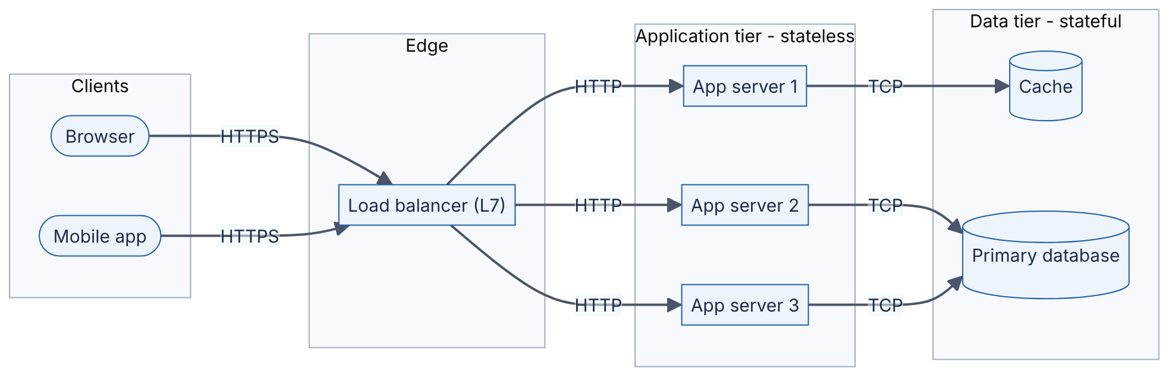
Reading the diagram. Two kinds of client (stadium shapes) send HTTPS requests to a layer-7 load balancer, which terminates TLS and forwards plain HTTP (or re-encrypted HTTPS) inside the private network to one of three identical application servers. All arrows are synchronous request/response calls. The application servers are stateless, so the only storage boundary is the data-tier subgraph: the cache and the primary database. Failure points: the load balancer (mitigated by running a redundant pair, §19.8), any single app server (the load balancer’s health checks remove it, §19.5) and the database (the hardest to make redundant; Chapter 14). Scaling: add app servers freely; the data tier scales with caching (Chapter 20), replicas and partitioning (Chapter 14).

8.3.2 Statelessness
DEFINITION
Definition — Stateless service. A service that keeps no client-specific data in its own memory between requests. Every request carries, or lets the service look up from a shared store, everything needed to process it.
A waiter who memorizes your order is stateful: if he goes home sick, your order is lost and only he can serve your table. A waiter who writes every order on a ticket and pins it to a shared board is stateless: any waiter can pick up any table. Stateless servers can be added, removed, restarted and replaced without losing anything, which is why every scaling, deployment and fault-tolerance technique later in this book assumes them.
State does not disappear; it moves. Login status moves into a cookie or token the client sends on every request (§8.10, §8.13), or into a shared session store (§8.10.2). Shopping carts move into a database. The price is an extra lookup per request (typically ~0.5–1 ms to an in-datacenter cache), which is almost always worth paying.

Failure scenarios
Table 8.1 — Client–server failure scenarios.
What goes wrong | Why | Detection | Recovery | Prevention
Users logged out after a deploy | Sessions stored in app-server memory | Spike in 401s and login traffic after each rollout | Users log in again | Move sessions to a shared store or signed cookie
One server overloaded, others idle | Sticky sessions pin heavy users to one server | Uneven per-server CPU and p99 | Drain and rebalance | Make servers stateless; avoid affinity (§19.6)
Old mobile clients break | Server changed the API contract | Error rate segmented by app version | Hotfix server to accept old format | Compatibility rules and versioning (§8.15)
Database saturated | Every tier’s requests ultimately land on one primary | DB CPU, connection count, lock waits | Shed load, add read replicas | Caching, connection pooling, partitioning

Common misconceptions
COMMON MISTAKE
“Stateless means the system has no state.” It means the compute tier holds no per-client state between requests. The state lives in databases, caches and the client. Designing a stateless tier is really deciding where state should live.
COMMON MISTAKE
“Client–server is the opposite of peer-to-peer, so it is obsolete.” Almost every web, mobile and inter-service interaction today is client–server; even “peer” microservices act as client in one call and server in the next. Peer-to-peer appears in specific niches (WebRTC media, §9.7; BitTorrent-style distribution).

8.4 Frontend and backend; SPA, SSR and mobile clients

8.4.1 Frontend and backend
The frontend is the code that runs on the user’s device and draws the interface: HTML, CSS and JavaScript in a browser, or Swift/Kotlin in a mobile app. The backend is the code that runs on servers you control: APIs, business logic, databases, background jobs. The split matters for design because the two sides have opposite trust and update properties:
- Trust. Anything on the client can be read and modified by the user. Validation in the frontend is a usability feature; validation and authorization in the backend are security features. Never trust a price, a user ID or a role sent by a client.
- Update speed. You can redeploy the backend in minutes. A web frontend updates on the next page load. A mobile app updates only when users install the new version, so versions that are months or years old stay in use and your API must keep serving them (§8.15).

8.4.2 Rendering strategies
Where the HTML is produced determines how many round trips the user waits for, how much work the server does and how search engines see the page.
DEFINITION
Definition — Server-side rendering (SSR). The server produces complete HTML for each request; the browser displays it immediately and then loads JavaScript to make it interactive (hydration).
DEFINITION
Definition — Single-page application (SPA) / client-side rendering (CSR). The server sends a nearly empty HTML shell plus a JavaScript bundle; the JavaScript calls JSON APIs and builds the page in the browser. Navigation afterwards happens without full page loads.
DEFINITION
Definition — Static site generation (SSG). HTML is produced at build time and served as static files, usually from a CDN (Chapter 21). Pages that change per user cannot be fully static.
In restaurant terms: SSR is a plated dish (ready to eat, but the kitchen does all the work for every order); SPA is a meal kit (one trip to fetch the kit, then the diner assembles everything, quick to re-assemble but slow to the first bite); SSG is the pre-made sandwich in the display fridge (instant, but everyone gets the same sandwich).
Table 8.2 — Rendering strategies compared.
Aspect | SSR | SPA (CSR) | SSG | Native mobile
Where HTML/UI is built | Server, per request | Browser | Build server, once | Device (compiled app)
Round trips before content | 1 (HTML) | ≥ 2–3 (shell, JS bundle, API) | 1, from a CDN edge | API calls only; UI is installed
Server CPU per page view | High | Low (JSON APIs only) | ~0 | Low (JSON/Protobuf APIs only)
SEO (crawler sees content) | Good | Weaker; depends on crawler running JS | Good | N/A
Personalized content | Yes | Yes | No (or via client-side calls) | Yes
Backend shape | Server renders templates and calls services | Pure API (REST/GraphQL) | Build pipeline + CDN | Pure API, must tolerate old versions
Typical use | Content and e-commerce pages | Dashboards, editors, apps behind login | Docs, marketing, blogs | Consumer apps
Modern frameworks blend these (SSR for the first page, SPA navigation afterwards; static pages with per-request “islands”). For a system designer the key consequence is the backend shape: an SPA or mobile app needs a well-designed JSON/Protobuf API, and SSR needs a rendering tier that itself is a client of your APIs.

8.4.3 Mobile clients and the backend for frontend
Mobile clients add three constraints:
- Old versions never die quickly. Expect several app versions live at once; any field you remove from a response may crash an old build.
- Networks are slow and flaky. Cellular round-trip times of 50–150 ms are common (as of 2026; varies widely by network). Chatty APIs that need ten sequential calls to draw one screen add up to a second or more of waiting. Mobile clients therefore favor fewer, coarser calls, compact encodings and offline caches.
- Different screens need different data. A phone’s feed card shows 3 fields; the desktop card shows 12.
One common answer is the backend for frontend (BFF) pattern: a thin server per client type that aggregates downstream services into exactly the payload that client needs (covered in §34.6). GraphQL (§8.7) is another answer to the same problem.
Figure 8.2 — Backend-for-frontend aggregation.
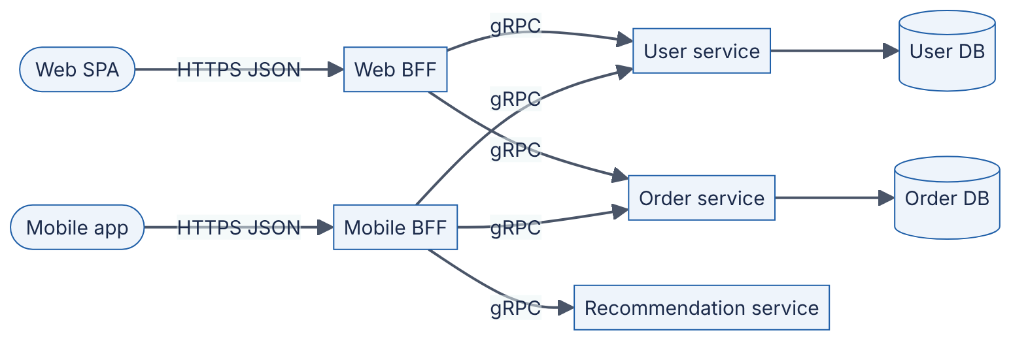
Reading the diagram. Each client type talks only to its own BFF over HTTPS with JSON. The BFFs call internal services over gRPC (binary, HTTP/2; §8.8) and merge results, so a phone makes one round trip over the slow cellular link instead of three. All calls are synchronous. Each service owns its own database (storage boundaries at the cylinders). Failure points: a slow recommendation service delays the mobile screen unless the BFF uses a deadline and degrades gracefully (§8.8.4). Scaling: BFFs are stateless and scale horizontally; the cost is one more service per client type to own and deploy.

8.5 The request–response lifecycle end to end

8.5.1 What happens when you press Enter
DEFINITION
Definition — Request–response lifecycle. The complete sequence of network and processing steps between a client issuing a request and receiving the full response, including name resolution, connection establishment, routing through intermediaries, application processing, data access and the return path.

First-principles explanation
Before your restaurant order is cooked, someone must find the restaurant’s address (DNS), drive there (TCP connection), show ID at the door (TLS handshake), be seated by a host who picks a free waiter (load balancer), have the waiter take the order to the kitchen (web server to application), and wait while the kitchen fetches ingredients from the pantry (database). Only the last two steps are “real work”. The others are setup, and for short requests setup often dominates.

How it works internally
Take GET https://shop.example.com/api/v1/orders/42 from a browser. (§7.18 follows a similar journey at the packet level; here the focus is the server side.)
- URL parsing and cache check. The browser splits the URL into scheme (https), host (shop.example.com), path and query. If a fresh copy is in the HTTP cache (Cache-Control: max-age), it stops here (§20.5).
- DNS resolution (§7.6). The browser asks the OS stub resolver, which asks a recursive resolver, which (on a cache miss) walks root → .com → example.com authoritative servers. The answer is an IP address, often of a CDN edge or a regional load balancer, cached for its TTL.
- TCP handshake (§7.7). SYN, SYN-ACK, ACK: one round trip (RTT) before data can flow. With HTTP/3 this is replaced by QUIC, which combines transport and TLS setup (§7.9).
- TLS 1.3 handshake (§7.10). One more RTT to agree keys and verify the server certificate (zero RTT on resumption, with replay caveats).
- HTTP request sent. Method, path, headers (Host, Cookie or Authorization, Accept), and possibly a body. Over HTTP/2 this is a set of compressed frames on a stream within the connection.
- Load balancer (Chapter 19). A layer-7 load balancer terminates TLS, reads the HTTP request, applies routing rules (path /api/ → API pool), picks a healthy backend and forwards the request, often over a pooled keep-alive connection. It adds headers such as X-Forwarded-For so the backend knows the client IP.
- Web server / reverse proxy. Something like Nginx or Envoy (or the application server’s own HTTP layer) parses the request, enforces limits (body size, timeouts), may serve static files, and passes the request to the application process via HTTP, a socket or an in-process call (for Python, via the ASGI or WSGI interface).
- Application framework. Middleware runs in order: request ID and tracing, authentication (cookie or token → user identity, §8.10–§8.13), rate limiting (Chapter 22), then the router maps GET /api/v1/orders/{id} to a handler function.
- Business logic and authorization. The handler checks that this user may read order 42 (§8.12), then fetches data.
- Data access. The handler borrows a connection from a pool (§7.16), sends SQL to the database (or reads the cache first), and waits. The database parses, plans, reads pages from its buffer pool or disk and returns rows (Chapter 11).
- Response built. The handler serializes the result (JSON, §8.9), sets status (200 OK), headers (Content-Type, Cache-Control, ETag) and returns it through the middleware stack, web server and load balancer.
- Browser processes the response. It decompresses, parses, updates its cache and cookie jar, and renders or hands the JSON to JavaScript. The TCP/TLS connection stays open (keep-alive) for later requests.

Architecture diagram
Figure 8.3 — End-to-end lifecycle of one HTTPS API request.
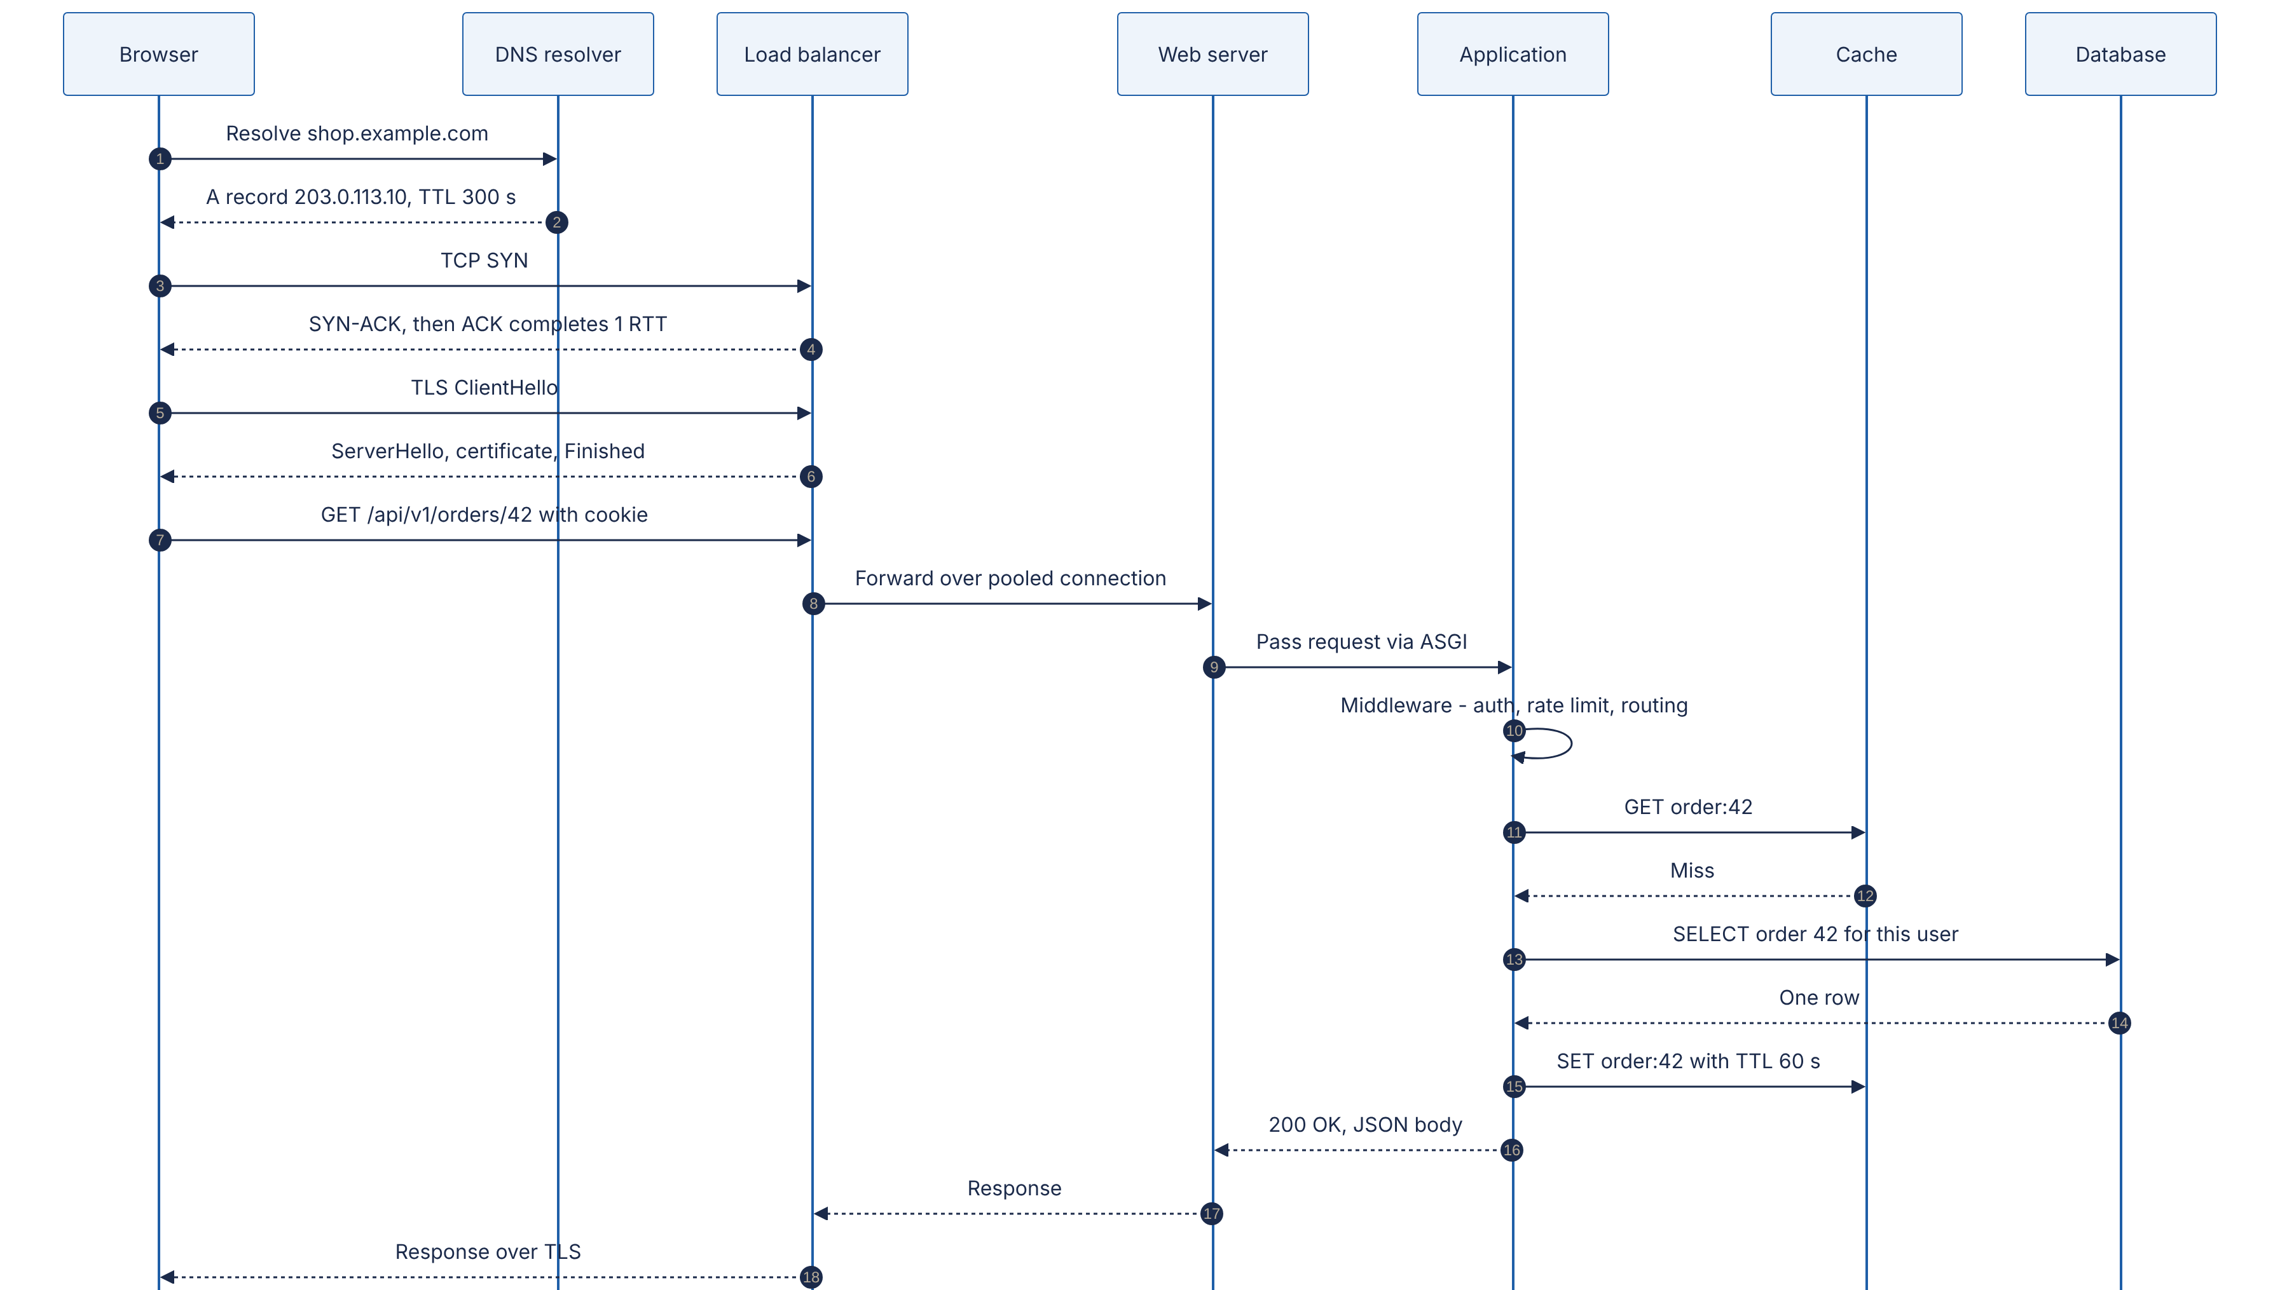
Reading the diagram. Time flows downward. Messages 1–2 are DNS over UDP (or DNS over HTTPS); 3–4 are the TCP handshake; 5–6 are the TLS 1.3 handshake. Message 7 is the actual HTTP request, carried over the encrypted connection. The load balancer forwards it (8) over a connection it already holds open to the web server, which hands it to the application process (9). The application runs middleware (10), tries the cache (11–12), falls through to the database (13–14) and populates the cache on the way out (15) in the cache-aside pattern (§20.7). Everything is synchronous: the browser waits for the whole chain. Storage boundaries are the cache and the database. Failure points: DNS (stale or failing resolvers), the load balancer, a slow database query that holds a pooled connection, and timeouts that are not aligned along the chain. Scaling options: CDN and HTTP caching remove steps 3–15 entirely for cacheable responses; connection reuse removes steps 3–6 for repeat requests; app servers scale horizontally; the database scales with replicas and partitions.

Mathematical foundations
FORMULA
End-to-end latency of a request on a new connection
$$T_{\text{total}}=T_{\text{DNS}}+T_{\text{TCP}}+T_{\text{TLS}}+T_{\text{req}}+T_{\text{server}}+T_{\text{transfer}}$$
with $T_{\text{TCP}}≈1×RTT$, $T_{\text{TLS 1.3}}≈1×RTT$, $T_{\text{req}}≈1×RTT$ and $T_{\text{transfer}}≈\frac{S}{B}$ for a response that fits in the congestion window.
Symbol | Meaning | Units
$T_{\text{DNS}}$ | DNS lookup time (≈ 0 if cached) | ms
$RTT$ | Client-to-load-balancer round-trip time | ms
$T_{\text{server}}$ | Time from the load balancer receiving the request to sending the response (app + DB) | ms
$S$ | Response size | bytes
$B$ | Bottleneck bandwidth | bytes/ms
WORKED EXAMPLE
Worked example — Cold versus warm request. A user is 40 ms RTT from the region. Uncached DNS takes 30 ms. The server spends 2 ms in the load balancer and web server, 8 ms in application code and one 3 ms database query: $T_{\text{server}}=13$ ms. The 4 KB response transfers in well under 1 ms on a broadband link, so ignore it.
- Cold (new DNS, new connection): $30+40+40+40+13=163$ ms.
- Warm (DNS cached, connection reused): $0+0+0+40+13=53$ ms.
- Share of the cold request spent on actual server work: $13/163≈8\%$.
Interpretation. For short API calls, the network setup costs about ten times as much as the work. Engineering implication: before optimizing a 3 ms query, make sure clients reuse connections (HTTP keep-alive, HTTP/2 multiplexing), keep DNS TTLs reasonable, terminate TLS close to users (CDN edges, §21.3) and avoid designs that need several sequential round trips per screen.
Table 8.3 — Typical latency budget per hop (order-of-magnitude, as of 2026).
Hop | Typical cost | Dominated by
DNS lookup (cached in OS/browser) | ~0 ms | —
DNS lookup (recursive resolver cache miss) | 10–100 ms | RTTs to authoritative servers
TCP + TLS 1.3 setup | 2 × RTT (e.g. 20–200 ms on the public internet) | Distance to the TLS terminator
Load balancer and reverse proxy | ~0.1–1 ms | Parsing, TLS termination CPU
Application code (simple handler) | 1–20 ms | Serialization, framework overhead, language runtime
Cache read in the same datacenter | ~0.2–1 ms | Network RTT inside the datacenter
Indexed database point read | ~0.5–5 ms | Network RTT + buffer-pool hit or disk read
Unindexed scan of a large table | 100 ms–seconds | Rows read from disk (Chapter 11)
These figures are illustrative ranges for estimation; measure your own system (Chapter 23). See §4.17 and Appendix F for dated reference numbers.

Failure scenarios
Table 8.4 — Lifecycle failure scenarios.
What goes wrong | Why | Detection | Recovery | Prevention
Users hit old servers after a migration | DNS answers cached for the old TTL | Traffic still arriving at old IPs | Keep old endpoints serving until TTL expires | Lower TTL days before a planned change
502/504 from the load balancer | Backend crashed or slower than the LB timeout | LB 5xx metrics by backend | Remove unhealthy backends | Health checks; timeouts that shrink inward along the chain
Requests pile up, then everything times out | DB connection pool exhausted by slow queries | Pool wait time, active connections | Kill slow queries, shed load | Query timeouts, indexes, pool sizing (§14.13)
Client retries make an outage worse | Timeouts plus immediate retries multiply load | Request rate rises while success rate falls | Shed load, open circuit breakers | Exponential backoff with jitter, retry budgets (§22.12)
COMMON MISTAKE
“Latency is mostly the database.” For a typical small API call, connection setup and round trips often cost more than the query. Count round trips first, then optimize server time.

8.6 REST API design

8.6.1 What REST is: Fielding’s constraints
DEFINITION
Definition — REST (Representational State Transfer). An architectural style for distributed hypermedia systems, defined by Roy Fielding in his 2000 doctoral dissertation as a set of constraints on how components interact [Fielding 2000]. In everyday usage, a “REST API” is an HTTP API that models its domain as resources identified by URIs and manipulated with the standard HTTP methods.

First-principles explanation
A library does not give each patron a custom set of instructions. It has a uniform system: every book has a call number (a resource identifier), and there are a few standard actions — look up, borrow, return — that work the same for every book. You can walk into any library and use it. REST applies the same idea to networked software: instead of inventing a new verb per operation (getOrder, cancelOrderV2, listAllOrdersForUser), you name things (/orders/42) and use a small, fixed set of verbs that every client, proxy and cache already understands.

Why does this exist?
Fielding was describing why the web had scaled to millions of independently developed servers and clients. Its uniform interface lets intermediaries — caches, proxies, CDNs, load balancers — understand and optimize traffic without knowing anything about the application. A CDN can cache any GET response marked cacheable; a proxy can retry any idempotent request. Custom RPC protocols of the 1990s could not offer that.
Table 8.5 — Fielding’s REST constraints.
Constraint | Meaning | What it buys you
Client–server | Separate the user interface from data storage | Independent evolution of client and server
Stateless | Each request contains all information needed to understand it; no session state on the server | Visibility, reliability, horizontal scalability
Cache | Responses label themselves cacheable or not | Fewer interactions; lower latency
Uniform interface | Resource identification, manipulation through representations, self-descriptive messages, hypermedia as the engine of application state (HATEOAS) | Generic intermediaries and clients
Layered system | A client cannot tell whether it talks to the origin or an intermediary | Load balancers, caches, gateways can be inserted transparently
Code on demand (optional) | Servers may send executable code (e.g. JavaScript) | Extensible clients
NOTE
Note — “RESTful” in practice. Most public “REST” APIs implement the first five constraints partially and skip HATEOAS. Fielding has written that an API which is not hypertext-driven is not REST in his sense. This book uses “REST API” in the common, looser sense — resource-oriented HTTP + JSON — and flags HATEOAS separately (§8.6.8).

8.6.2 Resources and URIs
A resource is any named thing the API exposes: a user, an order, a collection of orders, the current exchange rate. A representation is a serialized snapshot of it (JSON, usually). Design rules that hold up in practice:
- Nouns, not verbs, in paths. POST /orders, not POST /createOrder. The method is the verb.
- Plural collections, item by identifier. /orders (collection) and /orders/42 (item).
- Nest only for true containment, at most one level. /orders/42/items is clear; /users/7/orders/42/items/3/discounts couples clients to your data model. Prefer /order-items/3 once items have their own identity.
- Opaque, stable identifiers. Prefer IDs that do not leak row counts or allow enumeration (UUIDs or Snowflake-style IDs, §17.10).
- Actions that do not fit CRUD become sub-resources or state changes: POST /orders/42/cancellation or PATCH /orders/42 {"status":"cancelled"}, rather than POST /cancelOrder?id=42.
- Consistent casing (snake_case or camelCase in JSON, kebab-case in paths) across the whole API.

8.6.3 HTTP methods: safety and idempotency
Two properties of methods matter enormously for distributed systems, because networks lose responses and clients retry.
DEFINITION
Definition — Safe method. A method whose semantics are read-only: the client does not request, and does not expect, any state change on the server [RFC 9110 §9.2.1]. Logging or metrics side effects are allowed.
DEFINITION
Definition — Idempotent method. A method for which the intended effect on the server of sending the same request $N>0$ times is the same as sending it once [RFC 9110 §9.2.2]. The response may differ (a second DELETE may return 404); the state does not.
Analogy: pressing a lift’s call button is idempotent (pressing five times summons one lift); dropping a coin in a vending machine is not (five coins, five charges). If a client sends POST /payments and the connection drops before the response arrives, it cannot know whether the payment happened. Retrying a non-idempotent request risks a double charge. Retrying an idempotent one is always safe.
Table 8.6 — HTTP method properties [RFC 9110].
Method | Typical use | Safe | Idempotent | Request body | Cacheable
GET | Read a resource or collection | Yes | Yes | No (no defined semantics) | Yes
HEAD | GET without the body (check existence, size) | Yes | Yes | No | Yes
OPTIONS | Discover allowed methods; CORS preflight | Yes | Yes | Optional | No
POST | Create in a collection; any non-idempotent action | No | No | Yes | Only with explicit freshness; rare
PUT | Create or fully replace at a known URI | No | Yes | Yes | No
PATCH | Partial update [RFC 5789] | No | Not guaranteed | Yes | No
DELETE | Remove a resource | No | Yes | Rarely | No
What to notice:
- PUT /users/7/avatar with the full new representation is idempotent: sending it twice leaves the same avatar. PATCH {"op":"increment","path":"/balance"} is not.
- To make POST safe to retry, clients send an idempotency key header (for example a UUID per logical operation); the server stores the key with the result and returns the stored result for duplicates. Chapter 22 (§22.15) covers the full design.

8.6.4 Status codes
Status codes are part of the uniform interface: a load balancer, a retry library or a monitoring system can act on 503 without understanding your JSON.
Table 8.7 — Status codes every API designer uses [RFC 9110 unless noted].
Code | Meaning | Use it when | Client should
200 OK | Success with body | Successful GET, PUT, PATCH | Use the body
201 Created | New resource created | POST created something; include Location header | Follow Location
202 Accepted | Queued for asynchronous processing | Long jobs; return a status URL | Poll the status resource
204 No Content | Success, no body | DELETE, or update returning nothing | Nothing
301 / 308 | Moved permanently | Resource has a new URI (308 preserves the method) | Update bookmarks
304 Not Modified | Cached copy still valid | Conditional GET with If-None-Match matched the ETag | Use cached copy
400 Bad Request | Malformed request | Unparseable JSON, invalid parameter syntax | Fix the request; do not retry as is
401 Unauthorized | Not authenticated | Missing, expired or invalid credentials; send WWW-Authenticate | Authenticate, then retry
403 Forbidden | Authenticated but not allowed | Lacks permission or scope | Do not retry
404 Not Found | No such resource (or hidden from you) | Unknown ID; also to avoid revealing existence | Do not retry
409 Conflict | Conflicts with current state | Duplicate unique key; version conflict | Re-read, resolve, retry
412 Precondition Failed | If-Match ETag did not match | Optimistic concurrency failure | Re-read and retry
422 Unprocessable Content | Well-formed but semantically invalid | Validation errors (end date before start date) | Fix input
429 Too Many Requests [RFC 6585] | Rate limited | Client exceeded quota; send Retry-After | Back off
500 Internal Server Error | Unexpected server bug | Unhandled exception | Retry only if idempotent, with backoff
502 / 504 | Bad gateway / gateway timeout | An upstream failed or timed out | Retry idempotent requests with backoff
503 Service Unavailable | Temporarily overloaded or in maintenance | Load shedding; send Retry-After | Back off and retry
COMMON MISTAKE
Returning 200 OK with {"error": "..."} in the body. Every intermediary and monitoring tool then counts failures as successes, retries never happen, and error-rate SLOs (§39.6) silently read 100%. Use the status code for the class of outcome and the body for detail.

8.6.5 Pagination: offset versus cursor
A collection such as /orders may hold millions of items. Returning all of them would take seconds, megabytes and a lot of database work, so APIs return pages.

Offset pagination
The client asks for ?limit=20&offset=40 (or ?page=3&per_page=20). The SQL is straightforward:
-- Page 3 of 20 items, newest first (PostgreSQL)
SELECT id, title, created_at
FROM articles
ORDER BY created_at DESC, id DESC
LIMIT 20 OFFSET 40;
It is simple and supports “jump to page 37”. It has two serious problems:
- Cost grows with depth. The database cannot jump to row 40; it must produce and discard the first 40 rows in sorted order, then return 20. Deep pages read $\text{offset}+\text{limit}$ rows.
- Results shift under concurrent writes. If a new article is inserted while the user reads page 1, every item moves down one place: the last item of page 1 appears again at the top of page 2. Deletions cause items to be skipped silently.

Cursor (keyset) pagination
Instead of “skip N rows”, the client says “give me rows after this one”. The server returns an opaque cursor encoding the sort key of the last row it sent; the next query uses it in a WHERE clause that an index can seek to directly.
-- Supporting index: the sort order, with id as a unique tie-breaker
CREATE INDEX idx_articles_created_id ON articles (created_at DESC, id DESC);
-- First page
SELECT id, title, created_at
FROM articles
ORDER BY created_at DESC, id DESC
LIMIT 21; -- one extra row tells us whether a next page exists
-- Next page: $1, $2 = created_at and id of the last row of the previous page
SELECT id, title, created_at
FROM articles
WHERE (created_at, id) < ($1, $2) -- row-value comparison: seek, don't skip
ORDER BY created_at DESC, id DESC
LIMIT 21;
What to notice:
- The id tie-breaker makes the sort order total. Without it, two rows with the same created_at could be skipped or duplicated at a page boundary.
- The row-value comparison (created_at, id) < ($1, $2) means “earlier timestamp, or same timestamp with smaller id”. PostgreSQL, MySQL 8 and SQLite support it; on databases that do not, expand it to created_at < $1 OR (created_at = $1 AND id < $2).
- Fetching limit + 1 rows answers “is there a next page?” without a separate COUNT(*), which is itself expensive on large tables.
FORMULA
Rows touched per page
$$R_{\text{offset}}=o+ℓ R_{\text{keyset}}≈ℓ+\log_{b}n$$
Symbol | Meaning | Units
$o$ | Offset (rows skipped) | rows
$ℓ$ | Page size (limit) | rows
$n$ | Rows in the table or index | rows
$b$ | B-tree fan-out (entries per index page, typically hundreds) | entries
WORKED EXAMPLE
Worked example — Page 50,000 of an activity feed. Table of $n={10}^{7}$ rows, page size $ℓ=20$, user (or a scraper) requests page 50,000, so $o=49,999×20=999,980$.
- Offset: $R=999,980+20=1,000,000$ index entries walked, 999,980 of them discarded.
- Keyset: one B-tree descent of $\log_{200}{10}^{7}≈3$ levels, then 21 entries: about 24 entries.
- Ratio: ${10}^{6}/24≈40,000×$ more work for the offset query.
Interpretation. Offset pagination is fine for shallow pages (an admin table with a few thousand rows) but degrades linearly with depth and is an easy denial-of-service vector. Engineering implication: use cursors for feeds, timelines, logs, sync and any public API; cap offset if you must offer it.
Table 8.8 — Offset versus cursor pagination.
Aspect | Offset / page number | Cursor (keyset)
Request | ?limit=20&offset=40 | ?limit=20&cursor=eyJ…
Cost of deep pages | Grows linearly with offset | Constant (index seek)
Stable under inserts/deletes | No: duplicates and skips | Yes, relative to the last seen key
Jump to arbitrary page | Yes | No (only next/previous)
Total count | Often shown (costly COUNT(*)) | Usually omitted
Sort flexibility | Any ORDER BY | Needs an index matching the sort key plus a unique tie-breaker
Choose when | Small, mostly static datasets; UI needs page numbers | Large or fast-changing collections; infinite scroll; API sync

Code example
The following FastAPI service implements cursor pagination with an opaque, base64url-encoded cursor, optional filtering, and RFC 9457 error responses (§8.6.7). It runs as written with pip install fastapi uvicorn and uvicorn articles_api:app.
# articles_api.py — run with: pip install fastapi uvicorn && uvicorn articles_api:app
import base64
import json
import sqlite3
from fastapi import FastAPI, Query, Request
from fastapi.responses import JSONResponse
app = FastAPI(title="Articles API", version="1.0.0")
# In-memory database so the example is self-contained.
db = sqlite3.connect(":memory:", check_same_thread=False)
db.row_factory = sqlite3.Row
db.executescript("""
CREATE TABLE articles (
id INTEGER PRIMARY KEY,
title TEXT NOT NULL,
status TEXT NOT NULL,
created_at TEXT NOT NULL -- ISO-8601 UTC timestamp
);
CREATE INDEX idx_articles_created_id ON articles (created_at DESC, id DESC);
""")
db.executemany(
"INSERT INTO articles (id, title, status, created_at) VALUES (?, ?, ?, ?)",
[(i, f"Article {i}", "draft" if i % 3 == 0 else "published",
f"2026-01-{i % 28 + 1:02d}T10:00:00Z") for i in range(1, 101)],
)
class Problem(Exception):
"""An error that is rendered as RFC 9457 problem details."""
def __init__(self, status: int, title: str, detail: str,
type_: str = "about:blank"):
self.status, self.title, self.detail, self.type_ = status, title, detail, type_
@app.exception_handler(Problem)
async def problem_handler(request: Request, exc: Problem) -> JSONResponse:
return JSONResponse(
status_code=exc.status,
media_type="application/problem+json",
content={"type": exc.type_, "title": exc.title, "status": exc.status,
"detail": exc.detail, "instance": request.url.path},
)
def encode_cursor(created_at: str, row_id: int) -> str:
raw = json.dumps([created_at, row_id]).encode()
return base64.urlsafe_b64encode(raw).decode().rstrip("=")
def decode_cursor(cursor: str) -> tuple[str, int]:
try:
padded = cursor + "=" * (-len(cursor) % 4)
created_at, row_id = json.loads(base64.urlsafe_b64decode(padded))
return str(created_at), int(row_id)
except Exception:
raise Problem(400, "Invalid cursor",
"The cursor parameter is malformed or expired.",
"https://api.example.com/problems/invalid-cursor")
@app.get("/v1/articles")
def list_articles(
limit: int = Query(20, ge=1, le=100),
cursor: str | None = None,
status: str | None = Query(None, pattern="^(draft|published)$"),
):
where, params = [], []
if status is not None:
where.append("status = ?")
params.append(status)
if cursor is not None:
created_at, last_id = decode_cursor(cursor)
where.append("(created_at, id) < (?, ?)") # keyset predicate
params += [created_at, last_id]
sql = "SELECT id, title, status, created_at FROM articles"
if where:
sql += " WHERE " + " AND ".join(where)
sql += " ORDER BY created_at DESC, id DESC LIMIT ?"
params.append(limit + 1) # fetch one extra row
rows = db.execute(sql, params).fetchall()
has_more = len(rows) > limit
rows = rows[:limit]
next_cursor = (encode_cursor(rows[-1]["created_at"], rows[-1]["id"])
if has_more else None)
return {"data": [dict(r) for r in rows], "next_cursor": next_cursor}
@app.get("/v1/articles/{article_id}")
def get_article(article_id: int):
row = db.execute("SELECT id, title, status, created_at FROM articles WHERE id = ?",
(article_id,)).fetchone()
if row is None:
raise Problem(404, "Not Found", f"No article with id {article_id} exists.")
return dict(row)
What to notice:
- The cursor is opaque. Clients must treat it as a token, not parse it. That leaves you free to change its contents (add a sort field, sign or encrypt it, add an expiry) without a breaking change. In production, sign the cursor with an HMAC (as in §8.10.2) so clients cannot forge one that seeks to arbitrary positions.
- limit is bounded (le=100). An unbounded page size is a denial-of-service hole. FastAPI rejects limit=500 with 422 automatically.
- SQL parameters are bound with ?, never formatted into the string, which prevents SQL injection (§10.7).
- Filters and cursors compose: the status predicate and the keyset predicate are both in the WHERE clause. A production version would also bind the cursor to the filter that produced it, so a cursor from status=draft cannot be replayed against status=published.
Exercising it with curl:
curl -s 'http://localhost:8000/v1/articles?limit=2'
# {"data":[{"id":83,"title":"Article 83","status":"published","created_at":"2026-01-28T10:00:00Z"},
# {"id":55,...}],"next_cursor":"WyIyMDI2LTAxLTI4VDEwOjAwOjAwWiIsIDU1XQ"}
curl -s 'http://localhost:8000/v1/articles?limit=2&cursor=WyIyMDI2LTAxLTI4VDEwOjAwOjAwWiIsIDU1XQ'
curl -si 'http://localhost:8000/v1/articles/999'
# HTTP/1.1 404 Not Found
# content-type: application/problem+json
# {"type":"about:blank","title":"Not Found","status":404,
# "detail":"No article with id 999 exists.","instance":"/v1/articles/999"}

8.6.6 Filtering and sorting
Common conventions, any of which is fine if applied consistently:
- Filtering by field: GET /orders?status=shipped&customer_id=c_17. For ranges: created_after=2026-01-01T00:00:00Z or created_at[gte]=….
- Sorting: ?sort=-created_at,id (minus for descending).
- Sparse fieldsets: ?fields=id,title to reduce payload size, a partial answer to the over-fetching that motivates GraphQL.
- Search is a different operation from filtering. Free-text search belongs on a search endpoint backed by a search engine (Chapter 16), not on LIKE '%term%' against the primary database.
Every filter and sort combination you allow is a query shape your database must serve efficiently. Allow-list the fields, and make sure each permitted combination has a supporting index; otherwise one creative client can trigger a full table scan per request. With cursor pagination, the cursor must encode the values of every sort column plus the tie-breaker.

8.6.7 Error format: RFC 9457 problem details
Ad-hoc error bodies ({"err": 1}, {"message": "..."}, {"errors": [...]}) force every client to write custom parsing per API. RFC 9457 (which obsoletes RFC 7807) defines a standard JSON shape served with media type application/problem+json [RFC 9457]:
{
"type": "https://api.example.com/problems/insufficient-funds",
"title": "Insufficient funds",
"status": 403,
"detail": "Your balance is 30.00 EUR; the transfer requires 50.00 EUR.",
"instance": "/v1/transfers/7f9c2e",
"balance_cents": 3000,
"required_cents": 5000
}
What to notice:
- type is a URI that identifies the kind of problem; clients branch on it. It should ideally resolve to human-readable documentation. When omitted it defaults to about:blank, in which case title should be the HTTP status phrase.
- title is a short, stable summary of the type; detail explains this occurrence; instance identifies this occurrence (a request path or an error ID you can grep logs for).
- Extension members (balance_cents) carry machine-readable specifics. Never put stack traces, SQL or internal hostnames in error bodies.

8.6.8 HATEOAS, briefly
HATEOAS (Hypermedia as the Engine of Application State) means responses include links telling the client what it can do next, so the client follows links instead of constructing URLs:
{
"id": "ord_42",
"status": "placed",
"_links": {
"self": { "href": "/v1/orders/ord_42" },
"cancel": { "href": "/v1/orders/ord_42/cancellation", "method": "POST" },
"items": { "href": "/v1/orders/ord_42/items" }
}
}
The cancel link disappears once the order ships, so the server, not the client, encodes the workflow rules. Full HATEOAS is rare in public JSON APIs because most clients are written against documentation and hard-code URL templates anyway. A lightweight and widely used piece of it is pagination links in the HTTP Link header (Link: <…?cursor=abc>; rel="next").

Real-world industry applications
INDUSTRY EXAMPLE
Stripe and GitHub list endpoints. Stripe’s list endpoints use cursor-style pagination: the client passes the ID of the last object it saw in starting_after (or ending_before) together with limit, and the response carries has_more [Stripe API Docs: Pagination]. GitHub’s REST API returns pagination URLs in the HTTP Link header with rel="next", rel="last" and similar relations, and some endpoints use cursor-based before/after parameters [GitHub Docs: Using pagination in the REST API]. Both choices follow from the same problem: collections that are large and constantly changing, accessed by automated clients that page to the end. Evidence: Primary — [Stripe API Docs: Pagination]; [GitHub Docs: Using pagination in the REST API]

Failure scenarios
Table 8.9 — REST API failure scenarios.
What goes wrong | Why | Detection | Recovery | Prevention
Duplicate orders or charges | Client retried a timed-out POST | Duplicate rows with the same payload seconds apart | Refund / merge duplicates | Idempotency keys on all non-idempotent writes (§22.15)
Database CPU pinned by one client | Deep offset pages or unindexed sort | Slow-query log; per-client cost metrics | Rate-limit the client | Cursor pagination; allow-listed, indexed sorts
Lost update | Two clients PUT the same resource concurrently | Users report reverted changes | Restore from audit log | ETag + If-Match, return 412 on mismatch
Clients crash on new error | Error body shape changed | Client error reports by version | Roll back | One stable error format (RFC 9457) from day one

Common misconceptions
COMMON MISTAKE
“PUT is for updates, POST is for creates.” The real distinction is idempotency and who chooses the URI. PUT /articles/my-slug creates or replaces at a client-chosen URI, idempotently. POST /articles lets the server choose the URI and is not idempotent. Partial updates are PATCH.
COMMON MISTAKE
“401 means the user lacks permission.” 401 Unauthorized (misleadingly named) means not authenticated. Lacking permission while authenticated is 403 Forbidden. Many APIs return 404 instead of 403 for resources the caller should not even know exist.

8.7 GraphQL

8.7.1 Schema, operations and resolvers
DEFINITION
Definition — GraphQL. A query language for APIs and a runtime for executing those queries against a strongly typed schema. The client sends a document describing exactly the fields it wants; the server returns JSON of the same shape [GraphQL Spec].

First-principles explanation
A REST API is a set menu: /users/7 returns whatever the kitchen decided a “user” contains. If you need the user, their last five posts and each post’s comment count, you either order three dishes (three round trips — under-fetching) or receive a platter of fields you never eat (over-fetching). GraphQL is ordering à la carte from one waiter: you write down precisely what you want, nested as deep as you like, and get exactly that back in one trip.

Why does this exist?
Facebook built GraphQL in 2012 for its native mobile apps, where many REST round trips over cellular networks made news-feed screens slow and every new screen needed a new endpoint; it was open-sourced in 2015 and is now governed by the GraphQL Foundation [Byron 2015]. The specification’s most recent edition at the time of writing is September 2025 [GraphQL Spec].

How it works internally
- Schema. The server publishes types in the Schema Definition Language (SDL). Three root types are entry points: Query (reads), Mutation (writes) and Subscription (event streams).
- Parse and validate. The server parses the query document into an abstract syntax tree and validates every field and argument against the schema before running anything. Typos fail fast with a precise error.
- Execute. The executor walks the query tree. For every field it calls a resolver: a function (parent, args, context) → value. The resolver for Query.posts returns a list of post objects; then, for each post, the resolver for Post.author runs with that post as parent.
- Respond. The result is JSON shaped like the query, plus an errors array if some fields failed. Over HTTP, GraphQL servers usually expose one endpoint (POST /graphql) and often return 200 OK even when errors is non-empty, which matters for monitoring.
"""A blog: users write posts; posts have comments."""
type Query {
user(id: ID!): User
posts(first: Int = 10, after: String): PostConnection!
}
type Mutation {
createPost(input: CreatePostInput!): CreatePostPayload!
}
type User {
id: ID!
name: String!
posts(first: Int = 10): [Post!]!
}
type Post {
id: ID!
title: String!
body: String!
author: User!
comments(first: Int = 10): [Comment!]!
publishedAt: String
}
type Comment {
id: ID!
text: String!
author: User!
}
# Relay-style cursor pagination
type PostConnection {
edges: [PostEdge!]!
pageInfo: PageInfo!
}
type PostEdge {
cursor: String!
node: Post!
}
type PageInfo {
hasNextPage: Boolean!
endCursor: String
}
input CreatePostInput {
title: String!
body: String!
}
type CreatePostPayload {
post: Post
errors: [String!]!
}
A client query and the matching curl call:
curl -s https://api.example.com/graphql \
-H 'Content-Type: application/json' \
-H 'Authorization: Bearer eyJhbGciOi...' \
-d '{"query":"query RecentPosts { posts(first: 5) { edges { node { title author { name } } } pageInfo { hasNextPage endCursor } } }"}'
What to notice:
- ! means non-null; [Post!]! is a non-null list of non-null posts. Nullability is part of the contract: making a nullable field non-null later is safe for clients, the reverse is not.
- Pagination uses the cursor model of §8.6.5 (first, after, endCursor), in the “connection” shape popularized by Facebook’s Relay client.
- Mutations return a payload type with a domain errors list, so business-rule failures are typed data rather than transport errors.

8.7.2 The N+1 problem and DataLoader
The resolver model is elegant but naive. For the query above, posts runs one SQL query that returns 5 posts; then Post.author runs once per post, each issuing SELECT … FROM users WHERE id = ?. That is $1+N$ queries — the N+1 problem. Nesting multiplies it.
WORKED EXAMPLE
Worked example — Query count for a nested feed. A screen asks for 50 posts, the first 10 comments on each, and each comment’s author. Each database round trip costs 1 ms.
- Naive resolvers: $1$ (posts) $+50$ (comments per post) $+50×10=500$ (comment authors) $=551$ queries, about 551 ms if executed one after another.
- With batching per tree level: 1 query for posts, 1 for all comments WHERE post_id IN (…50 ids…), 1 for all authors WHERE id IN (…): 3 queries, about 3 ms.
Interpretation. The difference is two orders of magnitude, and it grows with page size. Engineering implication: a GraphQL server without batching is a load generator pointed at your database.
DataLoader is the standard fix, published by Facebook as a small JavaScript library and re-implemented in every major language [DataLoader]. Resolvers do not query directly; they call loader.load(id), which returns a promise. DataLoader collects every load issued during one tick of the event loop, then calls a batch function once with all the keys, and resolves each promise from the result. It also memoizes keys for the duration of the request, so the same author requested 30 times is fetched once.
Figure 8.4 — N+1 resolution versus DataLoader batching.
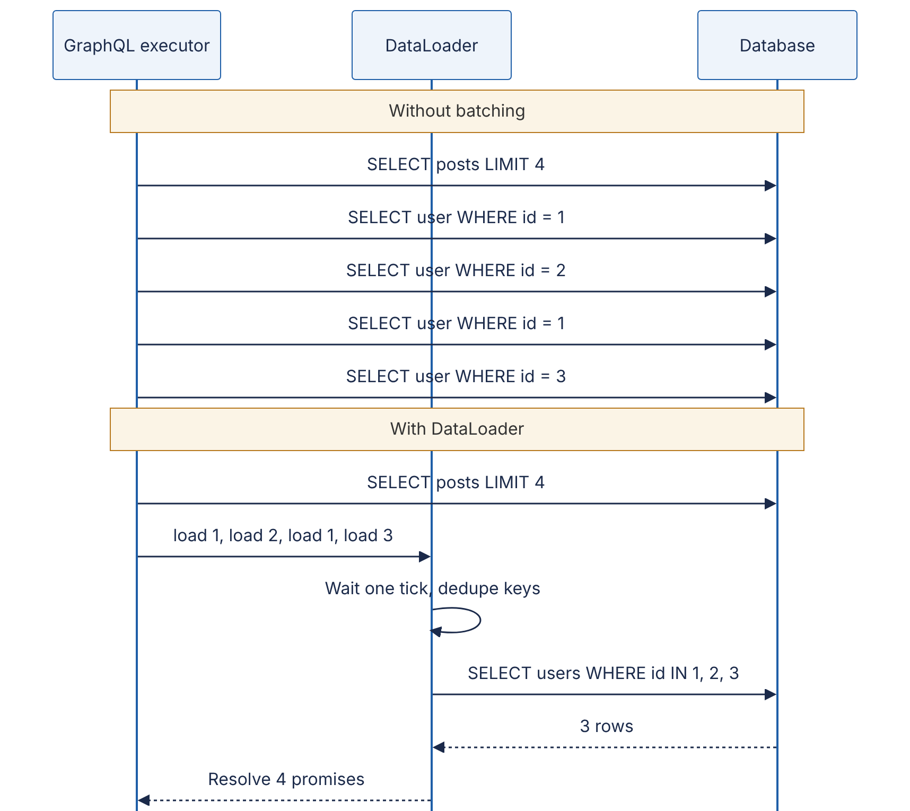
Reading the diagram. In the first half, the executor issues one database query per post for the author field: five synchronous round trips, one of them a duplicate. In the second half, the four author resolvers each call load on a per-request DataLoader; it waits until the current tick ends, deduplicates the keys to {1, 2, 3}, makes one IN query, and fans the rows back out to the four waiting resolvers. The storage boundary is the database. Failure point: if the batch query fails, every waiting resolver must receive the error. Scaling: batching turns $O\left(N\right)$ round trips into $O\left(\text{depth}\right)$.
A minimal DataLoader in Python’s asyncio shows the mechanism:
import asyncio
class DataLoader:
"""Coalesce every load(key) issued in the same event-loop tick into one batch call."""
def __init__(self, batch_fn):
self.batch_fn = batch_fn # async fn: list[key] -> list[value], same order
self.cache = {} # key -> Future (per-request memoization)
self.queue = [] # keys waiting for the next dispatch
def load(self, key):
if key in self.cache:
return self.cache[key]
fut = asyncio.get_running_loop().create_future()
self.cache[key] = fut
self.queue.append(key)
if len(self.queue) == 1: # first key in this tick: schedule a dispatch
asyncio.get_running_loop().call_soon(
lambda: asyncio.ensure_future(self._dispatch()))
return fut
async def _dispatch(self):
keys, self.queue = self.queue, []
try:
values = await self.batch_fn(keys)
for k, v in zip(keys, values):
self.cache[k].set_result(v)
except Exception as exc: # fail every waiter, not just one
for k in keys:
self.cache[k].set_exception(exc)
queries = []
AUTHORS = {1: "Ada", 2: "Linus", 3: "Grace"}
async def fetch_authors(ids):
queries.append(f"SELECT id, name FROM authors WHERE id IN {tuple(ids)}")
return [AUTHORS.get(i) for i in ids]
async def main():
loader = DataLoader(fetch_authors) # create one loader PER REQUEST
posts = [{"id": 10, "author_id": 1}, {"id": 11, "author_id": 2},
{"id": 12, "author_id": 1}, {"id": 13, "author_id": 3}]
names = await asyncio.gather(*(loader.load(p["author_id"]) for p in posts))
print(names) # ['Ada', 'Linus', 'Ada', 'Grace']
print(queries) # ['SELECT id, name FROM authors WHERE id IN (1, 2, 3)']
asyncio.run(main())
What to notice:
- call_soon defers the dispatch until every resolver running in the current tick has called load; that is the whole trick.
- The batch function must return values in the same order as the keys, with None (or an error) for missing keys.
- The loader is created per request. A process-wide loader would leak one user’s cached data to another user and would never notice updates.

8.7.3 Caching and security challenges
REST gets HTTP caching almost for free: GET /posts/7 has a URL, so browsers and CDNs can cache it by URL with Cache-Control and ETag. GraphQL makes this harder:
- One URL, usually POST. CDNs and browsers do not cache POST responses by default, and the cache key would have to include the query body.
- Every query is unique. Two clients requesting slightly different fields produce different responses, so shared-cache hit ratios are low.
- Mixed freshness. One response may combine a user’s name (cacheable for hours) and their unread count (seconds); the whole response gets the most restrictive policy.
Mitigations: persisted queries (clients send a hash of a pre-registered query via GET /graphql?id=<sha256>, which is cacheable by URL and also blocks arbitrary queries); normalized client caches (Apollo Client and Relay store objects by type and ID and reuse them across queries); and server-side caching in resolvers or DataLoader batch functions using the techniques of Chapter 20.
The same flexibility creates a security problem: one small request can ask for an enormous result (friends { friends { friends { … } } }). Production servers enforce depth limits, query cost analysis (estimate cost from the schema and arguments before executing; reject or rate-limit by cost, not by request count), pagination maximums on every list field, and timeouts. GitHub’s public GraphQL API, for example, rate-limits by a computed per-query cost rather than by request count [GitHub Docs: GraphQL rate limits].
COMMON MISTAKE
“GraphQL is faster than REST.” GraphQL removes client round trips and over-fetching; it does not make the server faster. Without batching and cost limits it is frequently slower and harder to protect. It moves complexity from the client to the server.

8.8 gRPC and RPC

8.8.1 Remote procedure calls
DEFINITION
Definition — Remote procedure call (RPC). A mechanism that lets a program call a function in another process, usually on another machine, with syntax that resembles a local function call. Generated stubs serialize the arguments, send them over the network, and deserialize the result [Birrell and Nelson 1984].
Instead of resources and verbs, RPC exposes operations: GetOrder(order_id), ReserveInventory(sku, qty). That maps naturally to how programmers think inside one codebase, which is why internal service-to-service APIs often use RPC. The danger is the illusion of locality: a remote call can be a million times slower than a local one, can fail halfway, and can succeed on the server while the response is lost (see the fallacies of distributed computing, §24.5). Good RPC frameworks make these differences explicit through deadlines, status codes and retries.

8.8.2 gRPC: Protocol Buffers over HTTP/2
DEFINITION
Definition — gRPC. An open-source RPC framework, originally developed at Google and released in 2015, that uses Protocol Buffers as its interface definition language and message format and HTTP/2 as its transport [gRPC Docs].
You describe the service once in a .proto file; the protoc compiler generates client stubs and server interfaces in a dozen or so languages.
syntax = "proto3";
package shop.v1;
import "google/protobuf/timestamp.proto";
// The service contract: four methods, one per gRPC streaming mode.
service OrderService {
// Unary: one request, one response.
rpc GetOrder(GetOrderRequest) returns (Order);
// Server streaming: one request, a stream of responses.
rpc WatchOrderStatus(GetOrderRequest) returns (stream OrderStatusEvent);
// Client streaming: a stream of requests, one response.
rpc UploadLineItems(stream LineItem) returns (UploadSummary);
// Bidirectional streaming: both sides stream independently.
rpc Chat(stream ChatMessage) returns (stream ChatMessage);
}
message GetOrderRequest {
string order_id = 1;
}
enum OrderStatus {
ORDER_STATUS_UNSPECIFIED = 0; // proto3 enums must start at zero
ORDER_STATUS_PLACED = 1;
ORDER_STATUS_SHIPPED = 2;
ORDER_STATUS_DELIVERED = 3;
}
message Order {
string order_id = 1;
string customer_id = 2;
repeated LineItem items = 3;
OrderStatus status = 4;
google.protobuf.Timestamp created_at = 5;
reserved 6; // field 6 was deleted; never reuse the number
reserved "coupon_code";
}
message LineItem {
string sku = 1;
int32 quantity = 2;
int64 unit_price_cents = 3; // money as integer cents, never float
}
message OrderStatusEvent {
string order_id = 1;
OrderStatus status = 2;
}
message UploadSummary {
int32 items_received = 1;
}
message ChatMessage {
string text = 1;
}
What to notice:
- The numbers (= 1, = 2) are field numbers, not default values. They, not the names, are written on the wire (§8.9.2), so they must never change or be reused; reserved enforces that for deleted fields.
- The version lives in the package name (shop.v1), so a breaking redesign becomes shop.v2 alongside it (§8.15).
- stream on the request, the response or both selects the streaming mode.

How it works internally
Each call maps onto HTTP/2 (§7.9):
- The client opens (or reuses) one long-lived HTTP/2 connection, called a channel, to the server.
- Each RPC becomes an HTTP/2 stream: a POST to the path /shop.v1.OrderService/GetOrder with content-type: application/grpc and, if the client set one, a grpc-timeout header carrying the deadline.
- Each message is length-prefixed: 1 byte compression flag + 4-byte big-endian length + the Protobuf bytes, carried in HTTP/2 DATA frames.
- The server replies with headers, zero or more length-prefixed messages, and trailers containing grpc-status (0 = OK, 4 = DEADLINE_EXCEEDED, 14 = UNAVAILABLE, and so on) and an optional grpc-message.
Because HTTP/2 multiplexes many streams over one TCP connection, hundreds of concurrent RPCs share a connection without head-of-line blocking at the HTTP layer (TCP-level head-of-line blocking remains; §7.7).
Figure 8.5 — gRPC call mapped onto an HTTP/2 connection.
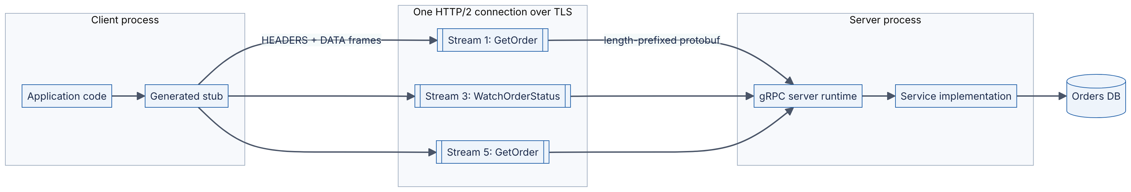
Reading the diagram. Application code calls a generated stub as if it were local. The stub serializes the request to Protobuf and sends it as HEADERS and DATA frames on a new stream of a single shared HTTP/2 connection; three concurrent calls occupy streams 1, 3 and 5 (client-initiated HTTP/2 streams use odd numbers). The server runtime reassembles each stream, deserializes the message, invokes the implementation and streams the response back with a trailing grpc-status. Unary calls are synchronous request/response; stream 3 stays open while the server pushes events. Storage boundary: the database behind the implementation. Failure points: a single connection pins all of a client’s traffic to one server, which defeats layer-4 load balancers; use layer-7 (HTTP/2-aware) proxies or client-side load balancing (§19.10). Scaling: add servers behind an L7 balancer that balances per stream, not per connection.

8.8.3 Streaming modes
Table 8.10 — The four gRPC call types.
Mode | Shape | Example use
Unary | 1 request → 1 response | Fetch an order; most calls
Server streaming | 1 request → stream of responses | Order status updates; large result sets in chunks; log tailing
Client streaming | Stream of requests → 1 response | Uploading telemetry or a file in chunks, then a summary
Bidirectional streaming | Two independent streams | Chat, collaborative editing, interactive speech recognition
Streams are flow-controlled by HTTP/2, so a slow receiver applies backpressure to a fast sender (§22.10) instead of buffering without bound.

8.8.4 Deadlines and their propagation
DEFINITION
Definition — Deadline. An absolute point in time by which a client needs an RPC to complete. gRPC transmits it as a remaining timeout; when it passes, the client stops waiting with DEADLINE_EXCEEDED and the server can see that the call was canceled [gRPC Docs: Deadlines].
Without deadlines, a slow dependency makes callers wait indefinitely, holding threads, memory and connections until the whole call graph is exhausted (Chapter 22). gRPC’s default is no deadline, so you must set one on every call. A deadline, unlike a per-hop timeout, should be propagated: if the front end has 300 ms left and has already spent 40 ms, it passes the remaining ~260 ms downstream, minus a margin for its own post-processing, so no service keeps working on an answer nobody is waiting for.
Figure 8.6 — Deadline propagation through a call chain.
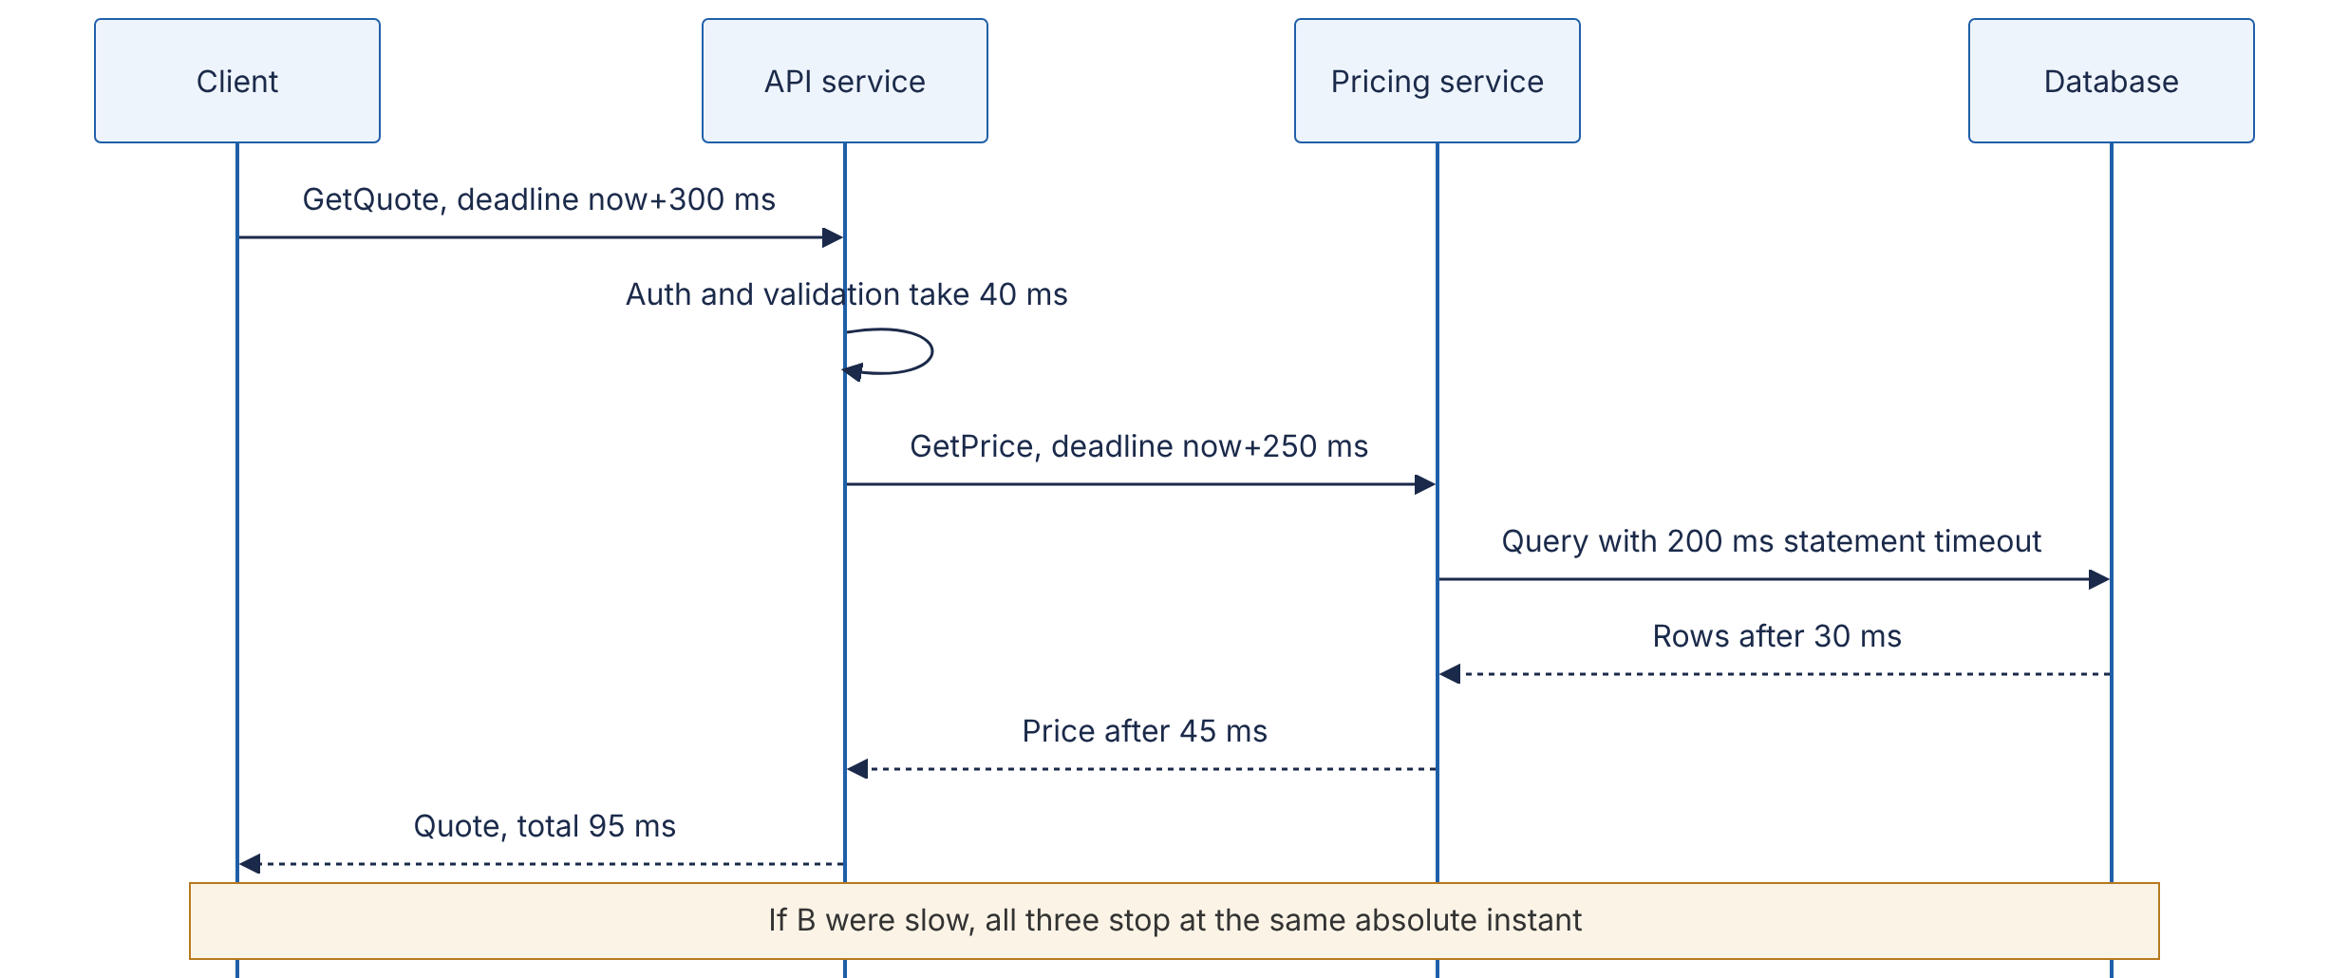
Reading the diagram. The client sets an absolute deadline of 300 ms. The API service spends 40 ms, then calls the pricing service with the remaining budget minus a 10 ms reserve for building its own response. The pricing service in turn bounds its database query below its own remaining time. All calls are synchronous. Failure point: if any hop sets a longer timeout than its caller’s remaining budget, that hop does work whose result will be discarded. Scaling: deadlines plus cancellation free resources quickly under overload, which keeps a slow dependency from cascading.

Code example
# pip install grpcio grpcio-tools
# python -m grpc_tools.protoc -I. --python_out=. --grpc_python_out=. orders.proto
import grpc
import orders_pb2
import orders_pb2_grpc
with grpc.insecure_channel("localhost:50051") as channel: # use TLS credentials in production
stub = orders_pb2_grpc.OrderServiceStub(channel)
# Unary call with a 200 ms deadline.
try:
order = stub.GetOrder(orders_pb2.GetOrderRequest(order_id="o-42"), timeout=0.2)
print(order.order_id, orders_pb2.OrderStatus.Name(order.status))
except grpc.RpcError as err:
if err.code() == grpc.StatusCode.DEADLINE_EXCEEDED:
print("gave up after 200 ms; serve a fallback")
else:
raise
# Server streaming: iterate over responses as they arrive.
for event in stub.WatchOrderStatus(orders_pb2.GetOrderRequest(order_id="o-42"),
timeout=30):
print(orders_pb2.OrderStatus.Name(event.status))
What to notice:
- timeout=0.2 is converted by the library into the grpc-timeout header; the server can read the remaining time with context.time_remaining() and pass it on.
- Errors are typed status codes, not free-text. Retry UNAVAILABLE with backoff; do not retry INVALID_ARGUMENT; retry DEADLINE_EXCEEDED only if the operation is idempotent and budget remains.
- Browsers cannot speak raw gRPC because they do not expose HTTP/2 trailers and framing to JavaScript; gRPC-Web with a translating proxy, or a REST/JSON gateway, is used for browser clients.

Industry application
INDUSTRY EXAMPLE
Google Stubby → gRPC. gRPC’s documentation describes it as the open-source successor to Stubby, the general-purpose RPC infrastructure Google used internally to connect its services, and it is now a Cloud Native Computing Foundation project [gRPC Docs]. The design goals that carried over — a compact binary IDL-based format, generated stubs in many languages, deadlines and cancellation as first-class concepts — come from operating very large internal call graphs where a slow or hung call would otherwise cascade. Evidence: Primary — [gRPC Docs]

8.8.5 Choosing REST, GraphQL or gRPC
Table 8.11 — REST versus GraphQL versus gRPC.
Row | REST | GraphQL | gRPC
What it is | Resource-oriented HTTP API style | Typed query language + runtime over one endpoint | RPC framework: Protobuf IDL over HTTP/2
How it works | URIs + standard methods + status codes; usually JSON | Client sends a query; resolvers assemble the response tree | Generated stubs; length-prefixed binary messages on HTTP/2 streams
Advantages | Universal tooling; HTTP caching and CDNs; easy to debug with curl | Exactly the data a screen needs in one round trip; strong typing; introspection | Compact and fast; streaming; deadlines; strict contracts and codegen
Disadvantages | Over/under-fetching; many round trips for complex screens; loose contracts unless documented | Hard to cache; N+1 risk; query-cost security; errors hidden in 200s | Not native in browsers; binary is harder to inspect; needs L7-aware load balancing
Performance | Good; JSON parsing cost; benefits from HTTP caching | Fewer client round trips; server work per request is higher and variable | Smallest payloads and lowest serialization cost of the three
Operational complexity | Low | Medium–high (cost limits, batching, schema governance) | Medium (proto management, L7 proxies, gRPC-Web for browsers)
Cost | Low; bandwidth higher than binary | Server CPU for resolution; engineering time | Low bandwidth and CPU; tooling investment
Use cases | Public APIs, CRUD services, webhooks, cacheable content | Product frontends aggregating many entities; mobile apps with diverse screens | Internal service-to-service calls; low-latency or streaming backends; polyglot microservices
Choose when | Third parties consume your API or responses are cacheable | Many client types need different shapes of a rich graph of data | You control both ends and need efficiency, streaming or strict typing
A common production pattern uses all three: gRPC between internal services, GraphQL or a BFF for first-party frontends, and REST for public and partner APIs.

8.9 Serialization: JSON, Protocol Buffers, Avro and Thrift

8.9.1 Why encoding matters
DEFINITION
Definition — Serialization (encoding). Translating an in-memory data structure into a sequence of bytes for storage or transmission; deserialization (decoding) is the reverse [Kleppmann 2017, ch. 4].
Objects in memory are full of pointers that mean nothing to another process. To send an order across the network you must flatten it into bytes that the receiver, possibly written in another language and deployed at a different time, can rebuild. Three questions decide the format: How big and how fast? (bandwidth and CPU at millions of messages per second), Is it self-describing or schema-driven?, and How does it survive change? — the last is the most important in practice, because in any system with rolling deployments, old and new code run side by side and read each other’s data.

8.9.2 The formats
JSON is text, human-readable, universally supported and self-describing: field names travel with every message. Its costs are size (names repeated in every record), parsing CPU, and a weak type system: no distinction between integers and floats, no binary type (bytes must be base64-encoded, +33%), and numbers above $2^{53}$ lose precision in JavaScript, which is why many APIs send 64-bit IDs as strings.
Protocol Buffers (Protobuf) is Google’s schema-driven binary format [Protocol Buffers Docs]. Each field is written as a tag followed by a value. The tag is a varint holding (field_number << 3) | wire_type, where the wire type tells the reader how to find the end of the value even if it does not recognize the field: 0 = VARINT, 1 = I64 (8 fixed bytes), 2 = LEN (length-delimited: strings, bytes, embedded messages, packed repeated fields), 5 = I32 (4 fixed bytes); 3 and 4 are deprecated group markers.
DEFINITION
Definition — Varint. A variable-length encoding of an unsigned integer in base 128: each byte carries 7 bits of the number, least-significant group first, and the most significant bit (MSB) of each byte is a continuation flag — 1 means “another byte follows” [Protocol Buffers Docs: Encoding].
Small numbers, which dominate real data (counts, enum values, field tags), take one byte instead of four or eight. Negative numbers in an int32/int64 field always take 10 bytes, so signed fields that are often negative use sint32/sint64, which first apply ZigZag encoding, mapping $0,−1,1,−2,…$ to $0,1,2,3,…$.
FORMULA
Varint length
$$\text{bytes}\left(n\right)=max​\left(1,\left\lceil \frac{⌊\log_{2}n⌋+1}{7}\right\rceil \right)$$
Symbol | Meaning | Units
$n$ | Non-negative integer being encoded | —
$⌊\log_{2}n⌋+1$ | Number of significant bits in $n$ (for $n≥1$) | bits
7 | Payload bits per varint byte | bits/byte
WORKED EXAMPLE
Worked example — Encoding a record by hand. The record (the example used in [Kleppmann 2017, ch. 4]) is user_name = "Martin" (field 1, string), favorite_number = 1337 (field 2, int64), interests = ["daydreaming", "hacking"] (field 3, repeated string).
- Field 1: tag $\left(1≪3\right)∣2=10$ = 0a; length 6 = 06; then the 6 UTF-8 bytes 4d 61 72 74 69 6e. Subtotal 8 bytes.
- Field 2: tag $\left(2≪3\right)∣0=16$ = 10. Value 1337 = binary 101 0011 1001 (11 bits → 2 bytes). Low 7 bits 0111001 = 0x39, set the continuation bit → b9; remaining bits 1010 = 0a. Subtotal 3 bytes: 10 b9 0a.
- Field 3, twice: tag $\left(3≪3\right)∣2=26$ = 1a, length 0b, 11 bytes of “daydreaming” (13 bytes); then 1a 07 + 7 bytes of “hacking” (9 bytes).
- Total: $8+3+13+9=33$ bytes. The same record as compact JSON, {"userName":"Martin","favoriteNumber":1337,"interests":["daydreaming","hacking"]}, is 81 bytes.
Interpretation. Protobuf is 2.5× smaller here because field names are replaced by one-byte tags and the number by two bytes instead of four ASCII digits. Engineering implication: field numbers 1–15 fit in a one-byte tag; reserve them for the most frequent fields.
def encode_varint(n: int) -> bytes:
"""Protocol Buffers base-128 varint for a non-negative integer."""
out = bytearray()
while True:
byte = n & 0x7F # take the low 7 bits
n >>= 7
if n:
out.append(byte | 0x80) # more bytes follow: set the MSB
else:
out.append(byte) # last byte: MSB clear
return bytes(out)
def encode_tag(field_number: int, wire_type: int) -> bytes:
return encode_varint((field_number << 3) | wire_type)
def encode_string(field_number: int, s: str) -> bytes:
data = s.encode("utf-8")
return encode_tag(field_number, 2) + encode_varint(len(data)) + data
msg = (encode_string(1, "Martin")
+ encode_tag(2, 0) + encode_varint(1337)
+ encode_string(3, "daydreaming")
+ encode_string(3, "hacking"))
print(msg.hex(" "), len(msg), "bytes")
# 0a 06 4d 61 72 74 69 6e 10 b9 0a 1a 0b 64 61 79 64 72 65 61 6d 69 6e 67 1a 07 68 61 63 6b 69 6e 67 33 bytes
What to notice: this output is byte-for-byte identical to what the official Protobuf library produces for the equivalent .proto message; and because every field carries its own tag and wire type, a reader that does not know field 3 can still skip exactly the right number of bytes.
Apache Avro takes the opposite approach: the binary data contains no field tags or names at all, just values concatenated in schema order (integers as ZigZag varints, strings as length + bytes). The same record encodes to 32 bytes [Kleppmann 2017, ch. 4]. The reader therefore needs the exact writer’s schema to parse the bytes; it then resolves that schema against its own reader’s schema by field name, filling defaults for fields the writer lacked and ignoring fields the reader does not know [Apache Avro Spec]. The writer’s schema travels in the file header (Avro object container files), or a short schema ID is prefixed to each message and looked up in a schema registry, the usual arrangement with Kafka (Chapter 31). Because Avro has no hand-assigned tags, schemas can be generated from database tables, which suits data pipelines (Chapter 61).
Apache Thrift, created at Facebook [Slee et al. 2007], is an IDL plus RPC framework like gRPC. Fields carry numeric tags as in Protobuf; it offers several encodings, including BinaryProtocol (fixed-width numbers; 59 bytes for the example record) and CompactProtocol (varints and packed field headers; 34 bytes) [Kleppmann 2017, ch. 4].
Table 8.12 — Serialization formats compared (sizes for the 3-field example record).
Format | Schema | Field identity on wire | Example size | Human-readable | Typical use
JSON | Optional (JSON Schema) | Names, every record | 81 B | Yes | Public APIs, browsers, config
Thrift Binary | Required (IDL) | Numeric tags | 59 B | No | Thrift RPC
Thrift Compact | Required (IDL) | Numeric tags, packed | 34 B | No | Thrift RPC, storage
Protobuf | Required (.proto) | Numeric tags | 33 B | No | gRPC, internal APIs, storage
Avro | Required, writer’s schema needed to read | None (schema order) | 32 B | No | Kafka with schema registry, data lakes

8.9.3 Schema evolution and compatibility
DEFINITION
Definition — Backward and forward compatibility. Backward compatibility: newer code can read data written by older code. Forward compatibility: older code can read data written by newer code [Kleppmann 2017, ch. 4].
During a rolling deployment both hold at once: new servers read messages from old servers (backward) and old servers, not yet upgraded, read messages from new ones (forward). Mobile apps and long-lived data on disk or in Kafka stretch the window from minutes to years.
Figure 8.7 — Mixed versions during a rolling deployment.
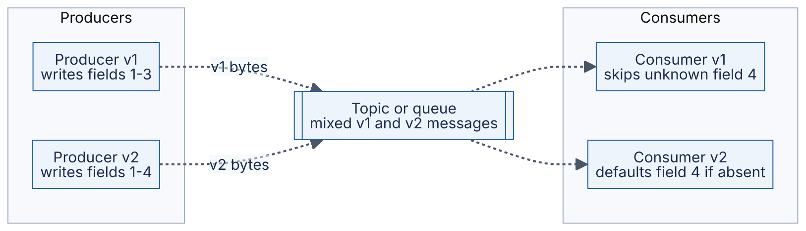
Reading the diagram. Two producer versions write to the same queue during a deployment, so the queue (the storage boundary) holds both message versions; arrows are dotted because the path is asynchronous. The old consumer must ignore field 4, which it has never heard of (forward compatibility); the new consumer must cope with messages lacking field 4 (backward compatibility). Failure point: if either assumption breaks, a deployment that looked fine in testing fails only when versions mix. Scaling: the same rules let independent teams deploy producers and consumers on separate schedules.
Table 8.13 — Schema-evolution rules by format.
Change | Protobuf (proto3) | Avro | Thrift | JSON API
Add a field | Safe: old readers skip unknown tags; new readers see the default | Safe only if the new field has a default | Safe if optional | Safe if clients ignore unknown fields
Remove a field | Safe; mark its number and name reserved | Safe only if the field had a default | Safe for optional; never reuse the tag | Breaking for clients that read it
Rename a field | Wire-safe (names not encoded); breaks the JSON mapping and code | Use aliases in the reader’s schema | Wire-safe | Breaking
Change a field number / tag | Breaking | n/a | Breaking | n/a
Change type | Only between compatible types (e.g. int32↔int64, with truncation risk) | Only defined promotions (int→long→float→double) | Limited | Usually breaking
Add a required field | Not possible in proto3 (no required) | Breaking unless defaulted | Breaking | Breaking for requests
RECOMMENDATION
Practical rules. Only add optional fields with sensible defaults. Never reuse a deleted field number or name. Never change a field’s meaning while keeping its name. Treat required as permanent. Run an automated compatibility check (schema-registry compatibility modes, buf breaking for Protobuf, OpenAPI diff tools) in CI, so incompatible changes fail the build instead of production.
COMMON MISTAKE
“Binary formats are always better.” For a public API consumed by browsers and third parties, JSON’s readability, tooling and zero-setup debugging usually outweigh a 2–3× size difference, especially after HTTP compression (gzip/Brotli) shrinks repeated field names. Binary formats win for high-volume internal traffic and stored data.

8.10 Cookies and sessions

8.10.1 Cookies
DEFINITION
Definition — HTTP cookie. A small name–value pair that a server asks the browser to store, via the Set-Cookie response header, and that the browser automatically returns in the Cookie request header on later requests to matching URLs [RFC 6265].
HTTP is stateless: each request arrives without memory of the previous one. A cookie is the coat-check ticket: the server hands you a numbered ticket once, you show it every time you come back, and the cloakroom (the server) knows which coat is yours. Cookies power sessions, preferences and tracking. Because browsers attach them automatically, including to requests triggered by other websites, their attributes are security-critical.
Set-Cookie: __Host-sid=8f2c1e9a7b; Path=/; Secure; HttpOnly; SameSite=Lax; Max-Age=3600
Table 8.14 — Cookie attributes.
Attribute | Effect | Why it matters
Expires / Max-Age | When the browser deletes the cookie; absent → deleted when the browser session ends | Bounds the lifetime of a stolen cookie
Domain | Send to this domain and its subdomains; absent → exact host only | Setting Domain=example.com exposes the cookie to every subdomain
Path | Send only for URLs under this path | Organization, not a security boundary
Secure | Send only over HTTPS | Prevents leakage over plaintext networks
HttpOnly | Not readable by JavaScript (document.cookie) | Limits theft via cross-site scripting (XSS)
SameSite=Strict | Never sent on cross-site requests | Strongest CSRF protection; breaks inbound links that need login
SameSite=Lax | Sent on top-level cross-site navigations using safe methods (GET), not on cross-site POST, iframes or fetches | Good default for session cookies
SameSite=None | Sent on all requests; must be combined with Secure | Needed only for genuine cross-site use (embedded widgets, some SSO)
__Host- name prefix | Browser enforces Secure, Path=/ and no Domain | Stops subdomains from overwriting the cookie
Cross-site request forgery (CSRF) is the attack that SameSite targets: a malicious page makes your browser submit POST https://bank.example/transfer, and the browser helpfully attaches your bank session cookie. SameSite=Lax or Strict stops the cookie being sent; anti-CSRF tokens (a per-session random value the server embeds in forms and checks on submission) are the traditional complement. SameSite was specified after RFC 6265 and is defined in its revision draft (“RFC 6265bis”). As of 2026, Chromium-based browsers treat cookies without a SameSite attribute as Lax, but not every browser does, so always set it explicitly.
RFC 6265 requires browsers to support at least 4,096 bytes per cookie and 50 cookies per domain [RFC 6265 §6.1]. Every cookie is sent on every matching request, so 4 KB of cookies on a page with 80 asset requests to the same domain uploads 320 KB of headers. Serve static assets from a separate cookie-less domain or CDN.

8.10.2 Sessions
DEFINITION
Definition — Session. Server-recognized state that links a series of requests to one authenticated user (or anonymous visitor) over time, typically identified by a cookie.
There are two ways to store it.
Server-side session store. The cookie holds only a long random session ID (at least 128 bits of entropy). Session data — user ID, roles, CSRF token, cart — lives in a shared store such as Redis, keyed by that ID. Every request costs one lookup; logging out or revoking a session is a single DELETE.
Figure 8.8 — Server-side session lookup.
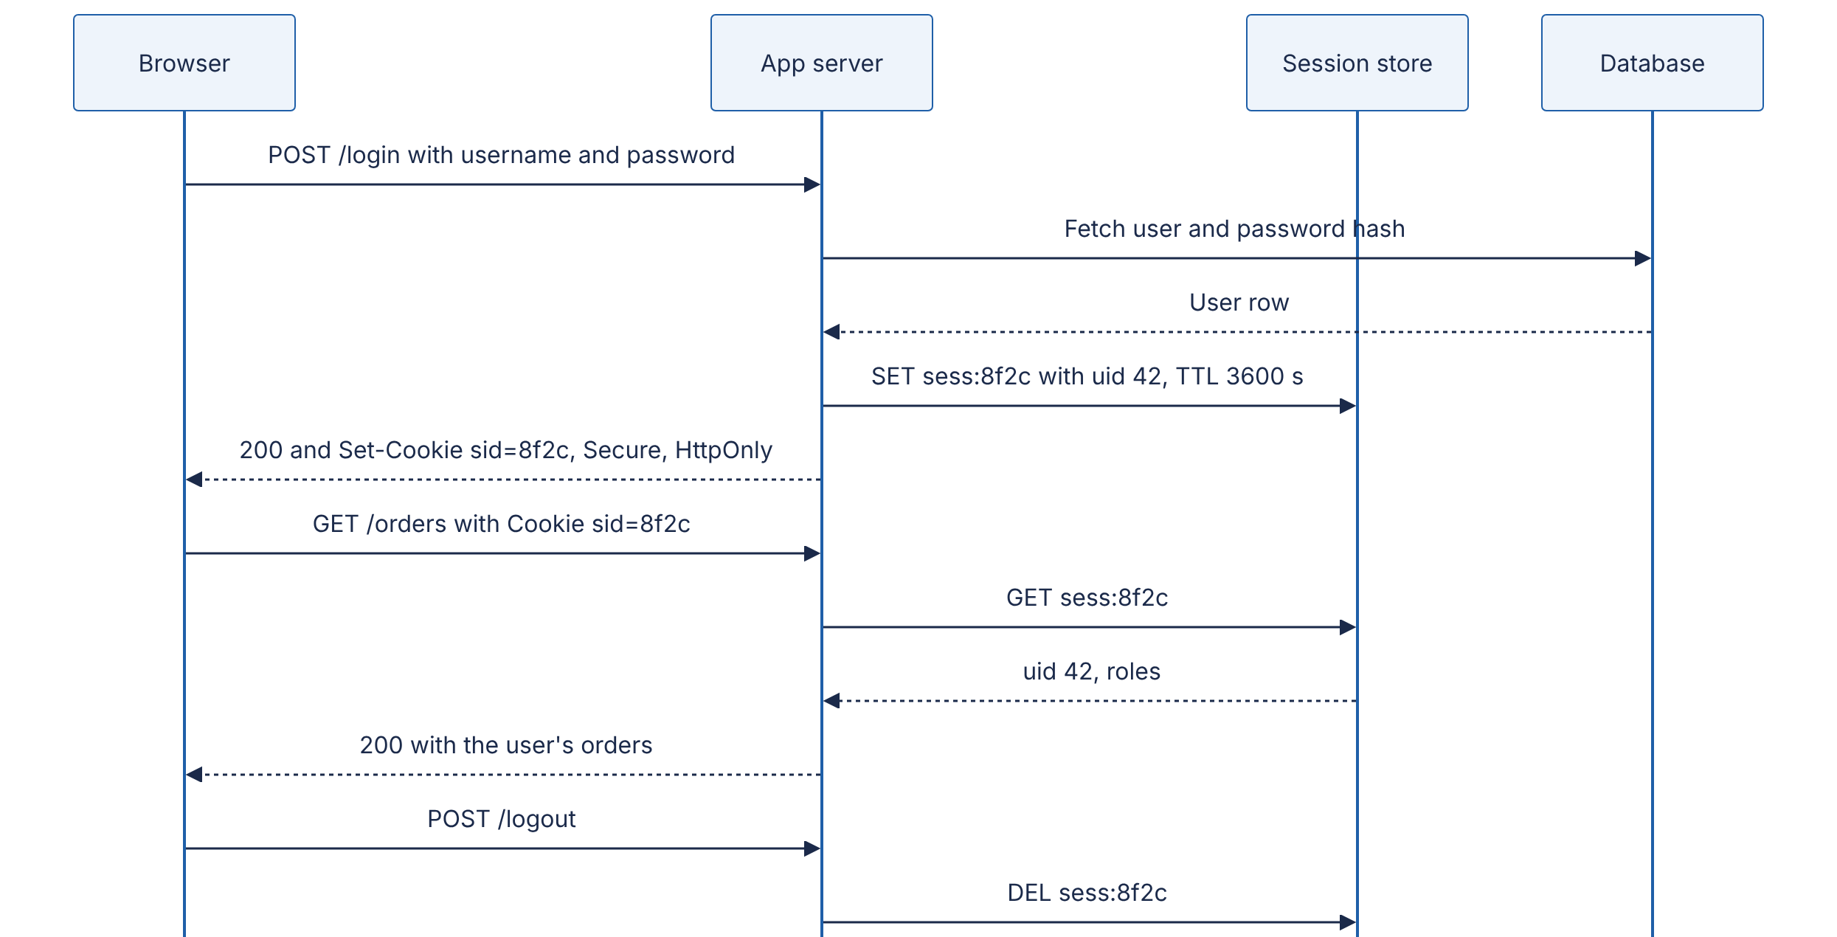
Reading the diagram. Login verifies the password against the database, creates a session record in the store with a TTL, and sends only the opaque ID to the browser. Every later request costs one synchronous session-store read (about 0.5 ms in the same datacenter). Logout deletes the record, so a copied cookie stops working immediately. Storage boundaries: the user database and the session store. Failure point: the session store is on the critical path of every authenticated request, so it must be replicated (Chapter 20); if it fails, everyone is logged out. Scaling: 10 million active sessions × ~500 bytes ≈ 5 GB, which fits in a single replicated Redis primary; partition by session ID beyond that.
Signed cookie (client-side session). The session data itself is in the cookie, with a MAC (message authentication code) computed with a server-side secret key. The server needs no store: it recomputes the MAC and rejects any cookie whose contents were altered. The data is not encrypted — the user can read it — only protected against tampering.
import base64, hashlib, hmac, json, time
SECRET_KEY = b"load-me-from-a-secrets-manager-32+bytes" # never hard-code in production
def _b64(data: bytes) -> str:
return base64.urlsafe_b64encode(data).rstrip(b"=").decode()
def _unb64(text: str) -> bytes:
return base64.urlsafe_b64decode(text + "=" * (-len(text) % 4))
def sign_session(data: dict, ttl_s: int = 3600) -> str:
body = _b64(json.dumps({**data, "exp": int(time.time()) + ttl_s}).encode())
mac = hmac.new(SECRET_KEY, body.encode(), hashlib.sha256).digest()
return f"{body}.{_b64(mac)}"
def verify_session(cookie: str) -> dict | None:
try:
body, mac = cookie.split(".")
except ValueError:
return None
expected = hmac.new(SECRET_KEY, body.encode(), hashlib.sha256).digest()
if not hmac.compare_digest(expected, _unb64(mac)): # constant-time compare
return None
data = json.loads(_unb64(body))
return data if data["exp"] >= time.time() else None
What to notice: hmac.compare_digest compares in constant time, so an attacker cannot learn the correct MAC byte by byte from response timing; the expiry is inside the signed body, so it cannot be extended by the client; and there is no way to revoke one cookie before exp except rotating SECRET_KEY, which logs out everyone. Web frameworks implement exactly this; Flask’s default session is a signed cookie, configured as follows:
from flask import Flask
import os
app = Flask(__name__)
app.config.update(
SECRET_KEY=os.environ["SECRET_KEY"],
SESSION_COOKIE_SECURE=True, # only sent over HTTPS
SESSION_COOKIE_HTTPONLY=True, # invisible to JavaScript
SESSION_COOKIE_SAMESITE="Lax", # not sent on cross-site POSTs
PERMANENT_SESSION_LIFETIME=3600, # seconds
)
# After login, Flask emits for example:
# Set-Cookie: session=eyJ1aWQiOiJhZGEifQ.auQy5w.2G2C9...; Expires=...; Secure; HttpOnly; Path=/; SameSite=Lax
Table 8.15 — Server-side sessions versus signed cookies.
Aspect | Server-side session store | Signed cookie
Cookie contents | Random ID only | Data + MAC (readable, tamper-evident)
Per-request cost | One store lookup (~0.5–1 ms) | One HMAC computation (microseconds)
Revocation / logout everywhere | Immediate (DEL) | Not possible before expiry without key rotation or a deny-list
Size limit | Unlimited server-side | ~4 KB, sent on every request
Infrastructure | Replicated store on the critical path | None beyond key management
Choose when | You need instant revocation, large session state, or admin “log out this device” | Small, short-lived state; minimal infrastructure
COMMON MISTAKE
Keeping the same session ID across login. If an attacker can plant a known session ID in a victim’s browser before login and the server keeps it afterwards, the attacker shares the authenticated session (session fixation). Always issue a fresh session ID (or clear the signed session) at login and at privilege changes.

8.11 Authentication
DEFINITION
Definition — Authentication (AuthN). Verifying who a client is. Authorization (AuthZ) is deciding what that verified identity may do (§8.12). AuthN failures return 401; AuthZ failures return 403.
At a hotel, the front desk checks your passport (authentication) and gives you a key card; the card then opens only your room and the gym (authorization). Keep the two separate in code too: authentication middleware turns credentials into an identity once per request; authorization checks run in every handler that touches a resource.
Authentication factors fall into three classes: something you know (password, PIN), something you have (phone, hardware security key), something you are (fingerprint, face). Multi-factor authentication (MFA) requires factors from at least two classes, so a phished or leaked password alone is not enough.
Passwords. Never store passwords, or fast hashes of them. Store the output of a deliberately slow, salted password-hashing function (Argon2id, scrypt, bcrypt or PBKDF2), tuned so one guess costs tens to hundreds of milliseconds; §10.6 covers parameters and the arithmetic of offline cracking. Compare in constant time, rate-limit login attempts per account and per IP, and check new passwords against lists of breached passwords, as NIST’s guidance recommends [NIST SP 800-63B-4].
import hashlib, hmac, os
def hash_password(password: str) -> str:
salt = os.urandom(16) # unique per user
dk = hashlib.scrypt(password.encode(), salt=salt, n=2**17, r=8, p=1,
maxmem=256 * 1024 * 1024) # ~128 MiB of memory per guess
return f"scrypt$131072$8$1${salt.hex()}${dk.hex()}"
def verify_password(password: str, stored: str) -> bool:
_, n, r, p, salt_hex, dk_hex = stored.split("$")
dk = hashlib.scrypt(password.encode(), salt=bytes.fromhex(salt_hex),
n=int(n), r=int(r), p=int(p), maxmem=256 * 1024 * 1024)
return hmac.compare_digest(dk, bytes.fromhex(dk_hex))
What to notice: the parameters ($N=2^{17}$, $r=8$, $p=1$, the OWASP minimum for scrypt listed in Table 10.8) are stored with the hash so they can be raised later; on a typical server core this takes a few hundred milliseconds per call, which is negligible for one login and crippling for an attacker trying billions of guesses.
Second factors, from weakest to strongest:
- SMS or email one-time codes. Better than nothing; vulnerable to SIM-swap, interception and phishing.
- TOTP (time-based one-time passwords, RFC 6238): an authenticator app and the server share a secret and each compute a 6-digit code from the current 30-second time window. Not phishing-resistant: a fake site can relay the code within its window.
- WebAuthn / passkeys (W3C WebAuthn with FIDO2): the device holds a private key per site and signs a server challenge; the browser binds the signature to the real site’s origin, so a look-alike domain cannot obtain a usable response. This is phishing-resistant and can replace passwords entirely.

8.11.1 Sessions versus tokens
After login, the client needs something to present on each request. There are two families:
- Session (reference) credentials: an opaque random ID that means nothing by itself; the server looks it up (§8.10.2).
- Self-contained (value) tokens: a signed token, typically a JWT (§8.13), carrying the identity and claims; any server with the key can verify it without a lookup.
Table 8.16 — Session IDs versus self-contained tokens.
Aspect | Opaque session ID | Self-contained token (JWT)
Validation | Lookup in a shared store | Signature check, local, no network call
Revocation | Immediate | Hard: valid until exp (§8.13.4)
Size on each request | ~32–64 bytes | Hundreds of bytes to over 1 KB
Works across services and organizations | Only those that can reach the store | Any party with the verification key
Typical transport | Cookie header (browsers) | Authorization: Bearer header (APIs, mobile, service-to-service)
Choose when | First-party web apps, especially with server rendering | Distributed APIs, third-party access (OAuth), short-lived service credentials
A common hybrid: the browser holds an opaque session cookie with the BFF or web tier; behind it, services exchange short-lived JWT access tokens.

8.12 Authorization: RBAC, ABAC and ReBAC

8.12.1 Three models
DEFINITION
Definition — Access-control model. A rule system that answers “may subject S perform action A on resource R (in context C)?” The three models in common use differ in what the rules are written in terms of: roles (RBAC), attributes (ABAC) or relationships (ReBAC).
Role-based access control (RBAC). Permissions attach to roles (viewer, editor, admin); users are assigned roles. It is what most company org charts look like: anyone with the “nurse” badge can open the medicine cabinet. RBAC is simple to audit (“who has admin?”) but coarse: “editor” usually means editor of everything. Scoping roles per tenant or per project (editor@project-7) helps until the number of role assignments explodes.
Attribute-based access control (ABAC). A policy is a predicate over attributes of the subject, the resource, the action and the environment: “a user may read a document if their department equals the document’s department, their clearance ≥ its classification, and it is business hours”. ABAC is expressive and handles context (time, location, device posture), but policies become hard to reason about and audit, and every check needs all the attributes at hand. Policy engines such as Open Policy Agent evaluate such rules outside application code.
ROLE_PERMISSIONS = {
"viewer": {"doc:read"},
"editor": {"doc:read", "doc:write"},
"admin": {"doc:read", "doc:write", "doc:delete", "user:manage"},
}
def rbac_allows(user_roles: set[str], permission: str) -> bool:
return any(permission in ROLE_PERMISSIONS.get(r, set()) for r in user_roles)
def abac_allows(sub: dict, action: str, res: dict, ctx: dict) -> bool:
if action == "read":
return (sub["department"] == res["department"]
and sub["clearance"] >= res["classification"]
and 8 <= ctx["hour_utc"] < 20) # business hours only
if action == "write":
return sub["id"] == res["owner_id"]
return False
Relationship-based access control (ReBAC). Permissions follow from a graph of relationships: Alice can view this document because she is a member of a group that is a viewer of the folder that contains it. This is how sharing works in collaboration products (“anyone in Engineering can comment”), and neither roles nor flat attributes express it naturally.

8.12.2 Google Zanzibar
INDUSTRY EXAMPLE
Zanzibar: Google’s consistent, global authorization system. Google built one authorization service to serve the access-control checks of many products (the paper lists Calendar, Cloud, Drive, Maps, Photos and YouTube among its clients). It stores permissions as relation tuples of the form object#relation@user, where the user may itself be a set of users such as group:eng#member. A per-namespace configuration of userset rewrite rules derives relations from others — for example, every editor is also a viewer, and a document’s viewers include the viewers of its parent folder. A check is a graph search over tuples and rewrites. The paper reports trillions of stored ACL tuples (more than two trillion), millions of authorization checks per second, 95th-percentile latency under 10 ms and availability above 99.999% over three years of production. Data is stored in Spanner; aggressive caching, request deduplication and a specialized index (Leopard) for deeply nested groups keep latency low. To avoid the “new enemy” problem — checking an old ACL against new content, for example after removing a user and then adding sensitive content — clients store an opaque consistency token, the zookie, with content updates, and later checks are evaluated at a snapshot at least as fresh as that zookie [Pang et al. 2019]. Open-source systems inspired by the paper, such as OpenFGA and SpiceDB, exist as of 2026. Evidence: Primary — [Pang et al. 2019]
A toy check function shows the core idea of tuples plus rewrite rules:
# Relation tuples: (object, relation, subject). A subject is a user or a userset "obj#rel".
TUPLES = {
("doc:readme", "owner", "user:alice"),
("doc:readme", "parent", "folder:eng"), # doc lives in a folder
("folder:eng", "viewer", "group:eng#member"), # eng members can view the folder
("group:eng", "member", "user:bob"),
("group:eng", "member", "group:sre#member"), # nested group
("group:sre", "member", "user:carol"),
}
# Rewrite rules: an editor is an owner or editor; a viewer is an editor,
# or a viewer of the parent folder.
REWRITES = {"editor": ["owner"], "viewer": ["editor", ("parent", "viewer")]}
def check(obj: str, relation: str, user: str, depth: int = 0) -> bool:
if depth > 25: # guard against cycles
return False
for (o, r, s) in TUPLES:
if o == obj and r == relation:
if s == user: # direct tuple
return True
if "#" in s and check(*s.split("#"), user, depth + 1): # userset
return True
for rule in REWRITES.get(relation, []):
if isinstance(rule, str): # same object, implied relation
if check(obj, rule, user, depth + 1):
return True
else: # follow a pointer, e.g. parent
via, target_rel = rule
if any(o == obj and r == via and check(s, target_rel, user, depth + 1)
for (o, r, s) in TUPLES):
return True
return False
print(check("doc:readme", "viewer", "user:alice")) # True: owner -> editor -> viewer
print(check("doc:readme", "viewer", "user:carol")) # True: sre in eng; eng views folder
print(check("doc:readme", "editor", "user:bob")) # False: bob can only view
What to notice: the answer for Carol required walking five edges across three objects, which is why a real system needs indexing, caching and a depth limit; and sharing a folder with a group is one tuple write, not millions of per-document ACL updates.
Figure 8.9 — Relationship graph for a Zanzibar-style check.
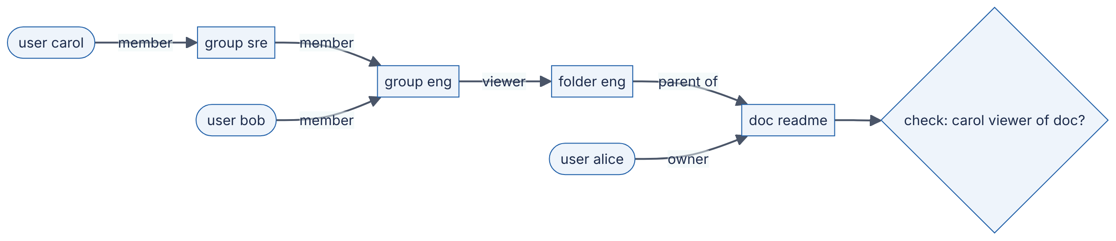
Reading the diagram. Users (stadium shapes) are linked by member edges to groups, groups to a folder by a viewer edge, and the folder to the document by a parent edge. Answering “is Carol a viewer of the document?” is a search from the document back to Carol: viewer of doc ⇐ viewer of parent folder ⇐ member of group eng ⇐ member of group sre ⇐ Carol. All edges are stored tuples in one logical database (the storage boundary). Failure points: very deep or wide group nesting makes checks slow, and stale caches can grant access that was just revoked (hence zookies). Scaling: partition tuples by object, cache sub-results, and precompute group membership closure for hot nested groups.
Table 8.17 — RBAC, ABAC and ReBAC compared.
Aspect | RBAC | ABAC | ReBAC
Rules written in terms of | Roles | Attributes of subject, resource, environment | Relationships between objects and subjects
Example | “Editors can publish” | “Same department and business hours” | “Viewers of the parent folder can view”
Strength | Simple, auditable | Context-aware, fine-grained | Natural sharing and hierarchy; per-object
Weakness | Coarse; role explosion | Hard to audit; needs attributes at check time | Needs a graph store; check latency
Choose when | Internal tools, admin consoles, B2B tenants | Regulatory or contextual rules | Collaboration and sharing products
Real systems combine them: ReBAC for per-object sharing, RBAC for administrative roles, ABAC conditions (IP range, MFA freshness) on top.
COMMON MISTAKE
Checking authorization only in the frontend, or only on the list page. Hiding a button does not stop a direct API call, and checking permission when listing orders does not protect GET /orders/43. Every handler that touches a resource must check it; broken object-level authorization — returning object 43 because the caller asked for it — is one of the most common API vulnerabilities (§10.7).

8.13 JSON Web Tokens (JWT)

8.13.1 Structure
DEFINITION
Definition — JSON Web Token (JWT). A compact, URL-safe string representing a set of claims (statements about a subject) as a JSON object, digitally signed (JWS) or encrypted (JWE) so its integrity can be verified [RFC 7519]. This section covers the signed form, which is by far the most common.
A signed JWT is like a festival wristband: the organizer prints your ticket type and the dates on it and seals it with a tamper-evident clasp. Any steward can check it at any gate without phoning the box office. The flip side: if you are banned mid-festival, every steward will still honor the wristband until it expires.
A JWT has three base64url-encoded parts separated by dots: header.payload.signature.
{"alg": "RS256", "typ": "JWT", "kid": "2026-10-key-1"}
{
"iss": "https://auth.example.com",
"sub": "user-123",
"aud": "https://api.example.com",
"iat": 1793340000,
"nbf": 1793340000,
"exp": 1793340900,
"jti": "7d1e4c1a-3b9e-4f0a-9b8e-2f6c0f1e5a77",
"scope": "articles:read articles:write"
}
The registered claims are iss (issuer), sub (subject, the user or client), aud (audience: which API the token is for), exp (expiry, seconds since the Unix epoch), nbf (not before), iat (issued at) and jti (unique token ID) [RFC 7519 §4.1]. The signature is computed over base64url(header) + "." + base64url(payload).
WARNING / TRADE-OFF
A JWT is signed, not encrypted. Anyone holding the token can base64-decode and read every claim. Never put secrets or sensitive personal data in a JWT payload.

8.13.2 Signing: HS256 versus RS256
Table 8.18 — HS256 versus RS256.
Aspect | HS256 (HMAC with SHA-256) | RS256 (RSA PKCS#1 v1.5 signature with SHA-256)
Key type | One shared secret | Private key signs; public key verifies
Who can create tokens | Anyone who can verify them | Only the private-key holder
Signature size | 32 bytes (43 base64url chars) | 256 bytes with a 2048-bit key (342 chars)
Speed | Very fast | Signing slower; verification fast
Key distribution | Secret must reach every verifier | Public keys published at a JWKS endpoint; rotated by kid
Choose when | One service issues and verifies its own tokens | An identity provider issues tokens many services verify
Elliptic-curve signatures (ES256, EdDSA) offer the asymmetric property of RS256 with much smaller keys and signatures; check that your libraries and partners support them.

8.13.3 Validation
Validation must check, in order: the token is well-formed; the alg is one you expect (taken from configuration, never from the token’s header); the signature verifies with the right key (selected by kid from a trusted JWKS); exp is in the future and nbf is in the past, with a small clock-skew leeway; iss is your trusted issuer; aud contains this API; and only then do you read scopes and claims.
Figure 8.10 — JWT validation pipeline.
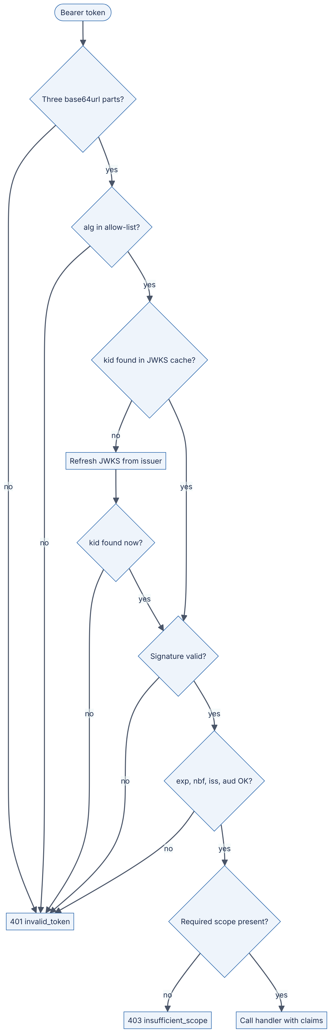
Reading the diagram. A bearer token enters at the top and passes a series of local checks; only the JWKS refresh involves a network call (to the issuer’s key endpoint), and it happens only when an unknown kid appears — typically just after the issuer rotates keys. Failures before the scope check produce 401 with WWW-Authenticate: Bearer error="invalid_token"; a valid token lacking the scope produces 403 insufficient_scope [RFC 6750 §3.1]. Failure points: an attacker sending random kid values can force repeated JWKS fetches, so rate-limit refreshes. Scaling: validation is CPU-only and stateless, which is the whole appeal.
import time, uuid
import jwt # pip install "pyjwt[crypto]"
from cryptography.hazmat.primitives import serialization
from cryptography.hazmat.primitives.asymmetric import rsa
ISSUER, AUDIENCE = "https://auth.example.com", "https://api.example.com"
# Authorization server: holds the private key.
private_key = rsa.generate_private_key(public_exponent=65537, key_size=2048)
public_pem = private_key.public_key().public_bytes(
serialization.Encoding.PEM, serialization.PublicFormat.SubjectPublicKeyInfo)
def issue_access_token(user_id: str, scopes: list[str], ttl_s: int = 900) -> str:
now = int(time.time())
claims = {"iss": ISSUER, "aud": AUDIENCE, "sub": user_id, "iat": now, "nbf": now,
"exp": now + ttl_s, "jti": str(uuid.uuid4()), "scope": " ".join(scopes)}
return jwt.encode(claims, private_key, algorithm="RS256",
headers={"kid": "2026-10-key-1"})
# Resource server: holds only the public key.
def validate_access_token(token: str) -> dict:
return jwt.decode(
token, public_pem,
algorithms=["RS256"], # pin the algorithm; never trust the header
audience=AUDIENCE, issuer=ISSUER,
leeway=30, # tolerate 30 s of clock skew
options={"require": ["exp", "iat", "sub", "aud", "iss"]},
)
token = issue_access_token("user-123", ["articles:read", "articles:write"])
print(len(token), validate_access_token(token)["scope"]) # ~700 articles:read articles:write
What to notice:
- algorithms=["RS256"] defends against two classic attacks: tokens with "alg": "none" (no signature at all), and algorithm confusion, where an attacker signs an HS256 token using the server’s public RSA key as the HMAC secret and a careless library verifies it [RFC 8725].
- The token is about 700 characters; at 10,000 requests per second that is about 7 MB/s of header bytes, which HTTP/2 header compression reduces on reused connections.
- In a FastAPI service, the same validation sits in a dependency that returns 401 or 403 with RFC 6750 WWW-Authenticate errors:
from fastapi import Depends, FastAPI, HTTPException
from fastapi.security import HTTPAuthorizationCredentials, HTTPBearer
app = FastAPI()
bearer = HTTPBearer(auto_error=False)
def current_claims(creds: HTTPAuthorizationCredentials | None = Depends(bearer)) -> dict:
if creds is None:
raise HTTPException(401, "Missing bearer token",
headers={"WWW-Authenticate": 'Bearer realm="api"'})
try:
return validate_access_token(creds.credentials)
except jwt.InvalidTokenError:
raise HTTPException(401, "Invalid or expired token",
headers={"WWW-Authenticate": 'Bearer error="invalid_token"'})
def require_scope(scope: str):
def checker(claims: dict = Depends(current_claims)) -> dict:
if scope not in claims.get("scope", "").split():
raise HTTPException(403, f"Requires scope {scope}", headers={
"WWW-Authenticate": f'Bearer error="insufficient_scope", scope="{scope}"'})
return claims
return checker
@app.delete("/v1/articles/{article_id}", status_code=204)
def delete_article(article_id: int, claims: dict = Depends(require_scope("articles:delete"))):
... # delete, recording claims["sub"] in the audit log

8.13.4 The revocation problem
Because verification is local, a server cannot know that a token was revoked — after logout, a password change, or a stolen laptop — until it expires. Mitigations, usually combined:
- Short access-token lifetimes (5–15 minutes) plus refresh tokens (§8.14.4), which are checked against a server-side store on each refresh.
- Deny-list by jti (or by sub + “tokens issued before time T”) in a fast replicated store, checked on each request. This reintroduces a lookup, but the list holds only revoked, not-yet-expired tokens.
- Token introspection (RFC 7662): the resource server asks the authorization server whether a token is active, which trades the local-verification advantage for immediacy; often used only for high-risk operations.
WORKED EXAMPLE
Worked example — Revocation window and deny-list size. Access tokens live $T=15$ min. Users revoke sessions at $r=100$ per minute.
- Worst-case exposure after revocation without a deny-list: up to 15 min; if revocation times are uniformly distributed relative to issuance, on average 7.5 min.
- Deny-list size: entries need be kept only until the token would have expired anyway, so $N=r×T=100×15=1,500$ entries — about 1,500 × ~50 bytes ≈ 75 KB.
Interpretation. A deny-list is tiny and can be replicated into every service’s memory and refreshed every few seconds. Engineering implication: “JWTs cannot be revoked” is false; the cost is a small, bounded amount of shared state.
COMMON MISTAKE
Storing JWTs in localStorage because “cookies are old-fashioned”. Any XSS bug can read localStorage and exfiltrate the token. For browser apps, an HttpOnly, Secure, SameSite session cookie to your own backend (which holds the tokens server-side, the BFF pattern) is usually safer.

8.14 OAuth 2.0 and OpenID Connect

8.14.1 The delegation problem
DEFINITION
Definition — OAuth 2.0. An authorization framework that lets a third-party application obtain limited access to an HTTP service on behalf of a resource owner, by obtaining an access token from an authorization server instead of using the owner’s credentials [RFC 6749].
Many cars come with a valet key: it starts the engine but cannot open the boot or the glovebox. You hand the valet a limited key instead of your full key ring. Before OAuth, a photo-printing site that wanted your photos from another service asked for your password — your full key ring — and could then do anything, forever, until you changed it. OAuth gives the printing site a valet key: a token scoped to “read photos”, time-limited, revocable, and issued without the site ever seeing your password.

8.14.2 Roles and grants
OAuth defines four roles [RFC 6749 §1.1]:
- Resource owner — the user who owns the data.
- Client — the application requesting access (the photo printer). A confidential client (a server-side app) can keep a client secret; a public client (SPA, mobile app) cannot, because its code is in users’ hands.
- Authorization server (AS) — authenticates the owner, asks for consent and issues tokens.
- Resource server (RS) — the API that accepts access tokens.
Tokens are presented as bearer tokens — “whoever bears this token may use it” — in the Authorization: Bearer <token> header, so they must only travel over TLS [RFC 6750].
Table 8.19 — OAuth 2.0 grant types and their status.
Grant | Who uses it | Status (as of 2026)
Authorization code + PKCE | Web apps, SPAs, mobile and desktop apps acting for a user | Recommended for all user-facing clients
Client credentials | A service acting for itself (machine-to-machine) | Recommended
Refresh token | Any client renewing an access token | Recommended, with rotation for public clients
Device authorization (RFC 8628) | TVs and CLIs without a convenient browser | Recommended for those devices
Implicit | Old SPAs (token returned in the URL fragment) | Deprecated; omitted from OAuth 2.1
Resource owner password credentials | Client collects the user’s password | Deprecated; omitted from OAuth 2.1

8.14.3 Authorization code flow with PKCE
DEFINITION
Definition — PKCE (Proof Key for Code Exchange, “pixy”). An extension in which the client creates a random secret, the code verifier, sends only its SHA-256 hash, the code challenge, with the authorization request, and must present the verifier when redeeming the authorization code. An attacker who intercepts the code cannot redeem it without the verifier [RFC 7636].
Figure 8.11 — OAuth 2.0 authorization code flow with PKCE.
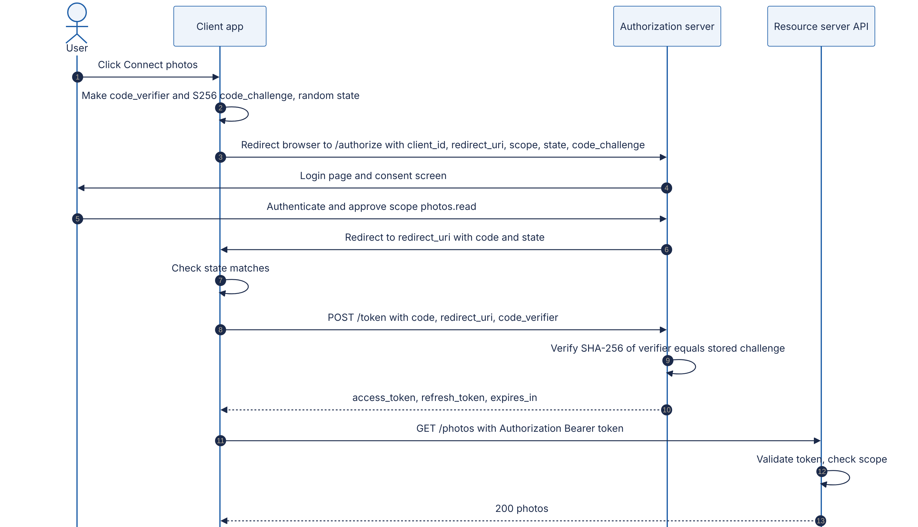
Reading the diagram. Steps 3–6 happen through the user’s browser via redirects (the front channel), where URLs can leak through history, logs and malicious apps registered for the same redirect scheme on mobile devices. The authorization server only ever sees the hash of the verifier there. Step 8 is a direct HTTPS call from client to authorization server (the back channel), where the client proves possession of the verifier; an attacker who stole the code in step 6 lacks it. The state value checked in step 7 stops an attacker from injecting their own authorization response into the user’s session (CSRF against the redirect endpoint). Steps 11–13 are ordinary API calls with a bearer token, validated as in §8.13.3 or by introspection. All calls are synchronous. Storage boundaries: the authorization server stores codes (single use, short-lived, typically under a minute), challenges, grants and refresh tokens. Failure points: the authorization server is on the login path for every user and must be highly available; resource servers that validate JWTs locally keep working during a brief AS outage until tokens expire. Scaling: token validation scales with the number of resource servers; the token endpoint scales like any stateless service backed by a replicated store.
import base64, hashlib, secrets
def make_pkce_pair() -> tuple[str, str]:
# 32 random bytes -> 43-character base64url verifier (RFC 7636 allows 43-128 chars)
verifier = base64.urlsafe_b64encode(secrets.token_bytes(32)).rstrip(b"=").decode()
return verifier, challenge_for(verifier)
def challenge_for(verifier: str) -> str:
digest = hashlib.sha256(verifier.encode("ascii")).digest()
return base64.urlsafe_b64encode(digest).rstrip(b"=").decode()
# Test vector from RFC 7636 Appendix B:
assert challenge_for("dBjftJeZ4CVP-mB92K27uhbUJU1p1r_wW1gFWFOEjXk") == \
"E9Melhoa2OwvFrEMTJguCHaoeK1t8URWbuGJSstw-cM"
The token exchange (step 8) on the wire:
curl -s https://auth.example.com/oauth/token \
-d grant_type=authorization_code \
-d code=SplxlOBeZQQYbYS6WxSbIA \
-d redirect_uri=https://app.example.com/callback \
-d client_id=photo-printer \
-d code_verifier=dBjftJeZ4CVP-mB92K27uhbUJU1p1r_wW1gFWFOEjXk
# {"access_token":"eyJhbGciOi...","token_type":"Bearer","expires_in":900,
# "refresh_token":"8xLOxBtZp8...","scope":"photos.read"}
What to notice: PKCE was designed for public clients, which have no secret; current guidance recommends it for confidential clients too [RFC 9700]. Redirect URIs must be registered in advance and matched exactly, since a loose match lets an attacker redirect codes to their own site.

8.14.4 Client credentials and refresh tokens
Client credentials grant. No user is involved: a backend service authenticates as itself (client ID plus secret, a signed JWT assertion, or mutual TLS) and receives a token scoped to the APIs it may call. This is the standard pattern for machine-to-machine calls between organizations or between internal services when not using mTLS identities (§10.10).
curl -s -u billing-service:$CLIENT_SECRET https://auth.example.com/oauth/token \
-d grant_type=client_credentials -d scope=invoices.write
Refresh tokens let a client obtain new short-lived access tokens without user interaction. Because the refresh token is long-lived and is checked by the authorization server on each use, it is where revocation actually happens: revoke the refresh token and the client loses access within one access-token lifetime. For public clients, refresh-token rotation issues a new refresh token on every use and invalidates the old one; if an old one is ever presented again, the server assumes theft and revokes the whole token family [RFC 9700].

8.14.5 OAuth 2.1
OAuth 2.1 is an IETF Internet-Draft that consolidates RFC 6749, RFC 6750, PKCE and the security best current practice into one document: PKCE required for the authorization code grant, implicit and password grants removed, exact redirect-URI matching, and no bearer tokens in query strings. As of October 2026 it is still a draft (revision -16, September 2026), not an RFC [OAuth 2.1 draft]; in practice, following RFC 9700 gets you the same behavior today.

8.14.6 OpenID Connect
OAuth answers “may this app access these photos?” It deliberately says nothing about who the user is; an access token is meant for the resource server and may be opaque to the client. Applications nonetheless abused OAuth for “Sign in with …”, which caused vulnerabilities. OpenID Connect (OIDC) is a thin identity layer on top of OAuth 2.0 that standardizes login [OpenID Connect Core 1.0]:
- The client requests scope=openid (plus profile, email as needed).
- The token response additionally contains an ID token: a JWT for the client (its aud is the client ID) asserting who logged in — iss, sub (stable user identifier at that issuer), aud, exp, iat, auth_time, and the nonce the client sent, which prevents replay of an ID token into a different login.
- A UserInfo endpoint returns profile claims for the access token.
- Discovery (/.well-known/openid-configuration) publishes the issuer’s endpoints and its JWKS URL, so clients configure themselves from one URL.
COMMON MISTAKE
Sending the ID token to your API as an access token, or accepting any provider’s access token as proof of login. The ID token’s audience is the client; the access token’s audience is the API. Validate each only for its intended audience. Identify users by the pair (iss, sub), never by email address alone, which can change or be reassigned.

8.15 API versioning and compatibility

8.15.1 What breaks clients
An API is a promise to every client that ever integrated with it. You cannot redeploy those clients; you can only stop breaking them. Applying the rules of §8.9.3 to HTTP APIs:
Table 8.20 — Breaking and non-breaking API changes.
Non-breaking (additive) | Breaking
Add a new endpoint | Remove or rename an endpoint or field
Add an optional request parameter | Add a required request parameter
Add a field to a response | Change a field’s type, format or meaning
Add a new enum value if clients were told to tolerate unknown values | Add an enum value clients switch on exhaustively
Relax a validation rule | Tighten validation; change defaults; change error codes
Add a new error type within an existing status | Change pagination or authentication scheme
Clients share responsibility: a tolerant reader ignores unknown fields and unknown enum values instead of failing. Document that obligation explicitly.

8.15.2 Versioning strategies
Table 8.21 — API versioning strategies.
Strategy | Example | Advantages | Disadvantages
URI path | GET /v2/orders/42 | Obvious; easy to route, cache and test in a browser | A version is a whole parallel API; encourages big-bang versions
Custom header | Api-Version: 2 | Clean URIs | Invisible in logs and links; caches must Vary on the header
Media type | Accept: application/vnd.example.v2+json | Most aligned with HTTP content negotiation | Awkward tooling; rarely understood by clients
Date-based, pinned per client | Stripe-Version: 2024-06-20 | Small, frequent changes; each client upgrades on its own schedule | Server must maintain transformations for every live version
Two practices that work regardless of the mechanism: use major versions only for breaking changes (additive changes need no new version), and keep the number of live major versions small (one or two).
INDUSTRY EXAMPLE
Stripe’s date-based versions. Stripe pins each account to the API version current when it first made a request, and lets requests override it with a Stripe-Version header. Internally the latest code produces the latest response shape, and a chain of small “version change” modules transforms responses backwards, one step per version, to whatever version the client is pinned to. This lets Stripe ship breaking improvements frequently without forcing integrations to change [Leach 2017]. GitHub’s REST API similarly uses date-named versions selected by the X-GitHub-Api-Version header [GitHub Docs: API versions]. Evidence: Primary — [Leach 2017]; [GitHub Docs: API versions]

8.15.3 Deprecation
Deprecation is a process, not an event:
- Announce in the changelog and documentation, with a date.
- Signal in-band. Send the Deprecation response header [RFC 9745] on deprecated endpoints, a Link with rel="deprecation" pointing to migration docs, and the Sunset header [RFC 8594] with the date the endpoint will stop working.
- Measure. Log usage of deprecated endpoints per client ID; contact the remaining heavy users directly.
- Brown-outs. Before the sunset date, fail a small, increasing fraction of calls for short scheduled windows, so forgotten integrations surface while there is time to fix them.
- Remove, returning 410 Gone with a problem-details body that links to the migration guide.
Figure 8.12 — Lifecycle of an API version.
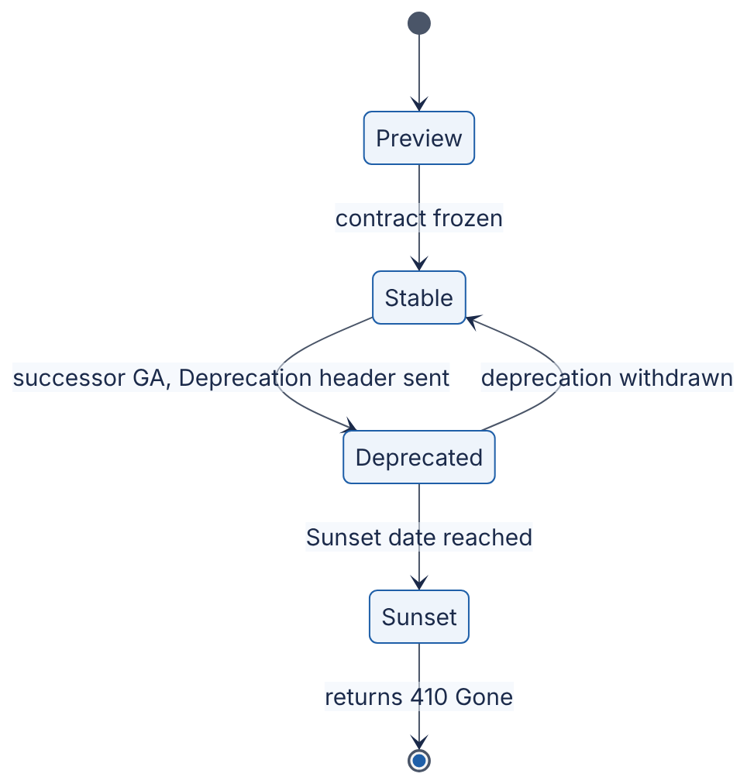
Reading the diagram. A version starts as a preview (no compatibility promise), becomes stable when its contract is frozen, and is deprecated once a successor is generally available; from then on responses carry Deprecation and Sunset headers. At the sunset date it is removed and answers 410 Gone. The transitions are driven by policy and calendar, not by traffic. Failure point: removing a version that still carries significant traffic; usage metrics per client must gate the final transition.

8.16 API documentation: OpenAPI
DEFINITION
Definition — OpenAPI Specification (OAS). A vendor-neutral, machine-readable format (YAML or JSON) for describing HTTP APIs: paths, operations, parameters, request and response bodies (as JSON Schema), status codes and security schemes [OpenAPI Specification]. It grew out of Swagger and is maintained by the OpenAPI Initiative; version 3.1 aligned its schemas with JSON Schema, and version 3.2.0 was released in September 2025.
An OpenAPI document is the API’s contract in a form that tools can use: generating interactive documentation, client SDKs and server stubs, mock servers, request validation at gateways, and contract tests and breaking-change detection in CI (diffing the spec against the previous release flags the changes in Table 8.20 automatically).
openapi: 3.1.0
info:
title: Articles API
version: 1.0.0
paths:
/v1/articles:
get:
summary: List articles, newest first
parameters:
- name: limit
in: query
schema: { type: integer, minimum: 1, maximum: 100, default: 20 }
- name: cursor
in: query
description: Opaque cursor from a previous response's next_cursor.
schema: { type: string }
security:
- bearerAuth: []
responses:
"200":
description: A page of articles.
content:
application/json:
schema:
type: object
required: [data, next_cursor]
properties:
data:
type: array
items: { $ref: "#/components/schemas/Article" }
next_cursor: { type: [string, "null"] }
"400":
description: Invalid cursor.
content:
application/problem+json:
schema: { $ref: "#/components/schemas/Problem" }
components:
securitySchemes:
bearerAuth: { type: http, scheme: bearer, bearerFormat: JWT }
schemas:
Article:
type: object
required: [id, title, status, created_at]
properties:
id: { type: integer }
title: { type: string }
status: { type: string, enum: [draft, published] }
created_at: { type: string, format: date-time }
Problem:
type: object
properties:
type: { type: string, format: uri }
title: { type: string }
status: { type: integer }
detail: { type: string }
instance: { type: string }
What to notice: next_cursor is typed [string, "null"], OpenAPI 3.1’s JSON Schema way of saying “nullable”; errors are documented with the application/problem+json media type of §8.6.7; and the bearer scheme declares that operations need a JWT.
There are two workflows. In design-first, teams write and review the OpenAPI document before code, then generate stubs; this suits public APIs where the contract matters most. In code-first, the framework derives the document from code: FastAPI, for example, serves the document generated from the articles_api.py example of §8.6.5 at /openapi.json and interactive documentation at /docs, with no extra work. Either way, keep the spec in version control and treat changes to it as API changes that require review. GraphQL APIs are self-describing through introspection, and gRPC APIs through their .proto files, which play the same role.

8.17 Summary and revision notes
SUMMARY
- Client–server: clients initiate, servers own shared state. Keep the application tier stateless; state lives in databases, caches, cookies or tokens.
- Rendering: SSR (server builds HTML), SPA (browser builds UI from JSON APIs), SSG (built once, served from a CDN), native mobile (old versions live for years). SPAs and mobile apps need a well-designed API; BFFs tailor it per client.
- Lifecycle: DNS → TCP → TLS → load balancer → web server → app middleware → handler → cache/DB → response. On a cold connection, setup round trips often cost more than server work; reuse connections.
- REST: resources named by URIs, standard methods, status codes. Know which methods are safe (GET, HEAD, OPTIONS) and idempotent (those plus PUT, DELETE). Make POST retryable with idempotency keys.
- Pagination: offset costs $O\left(\text{offset}+\text{limit}\right)$ and shifts under writes; cursor/keyset pagination with WHERE (sort_key, id) < (…) and a matching index is constant-cost and stable.
- Errors: use status codes for the class of outcome and RFC 9457 application/problem+json for detail.
- GraphQL: typed schema, client-chosen fields, one round trip. Fix N+1 with per-request DataLoader batching; HTTP caching is hard (use persisted queries); enforce depth and cost limits.
- gRPC: Protobuf IDL, generated stubs, HTTP/2 streams; unary, server-, client- and bidirectional streaming. Always set and propagate deadlines; use L7 load balancing.
- Serialization: JSON is readable and universal; Protobuf and Thrift use numeric tags and varints; Avro has no tags and resolves writer’s against reader’s schema. Evolve by adding optional fields with defaults; never reuse field numbers.
- Cookies: Secure, HttpOnly, SameSite=Lax (or Strict), __Host- prefix. Sessions are server-side (instant revocation, one lookup) or signed cookies (no store, no early revocation).
- AuthN vs AuthZ: who you are (401) vs what you may do (403). Hash passwords with slow salted functions (§10.6); prefer phishing-resistant MFA (WebAuthn/passkeys).
- Authorization models: RBAC (roles), ABAC (attribute predicates), ReBAC (relationship graph; Zanzibar’s tuples, rewrites and zookies).
- JWT: header.payload.signature, signed not encrypted. Pin the algorithm; validate exp, iss, aud. HS256 = shared secret; RS256/ES256 = private signs, public verifies. Revocation needs short TTLs, refresh tokens and/or deny-lists.
- OAuth 2.0: delegated, scoped access via tokens. Use authorization code + PKCE for user-facing apps, client credentials for machines, rotating refresh tokens. OAuth 2.1 is still a draft (as of 2026). OIDC adds the ID token and standard login.
- Versioning: additive changes need no new version; breaking changes do. URI, header, media-type or date-based pinning; deprecate with Deprecation/Sunset headers, usage metrics and brown-outs.
- OpenAPI is the machine-readable contract: docs, SDKs, validation and breaking-change detection in CI.

8.18 Knowledge checkpoint
- Why does making the application tier stateless make horizontal scaling easy, and where does the state go?
- Name two backend consequences of supporting a native mobile client that an SSR website does not impose.
- A user 50 ms RTT away makes a first request needing an uncached DNS lookup (20 ms), TCP and TLS 1.3 setup, and 15 ms of server time. Estimate the latency, and the latency of the next request.
- Which HTTP methods are safe? Which are idempotent? Why does the distinction matter to a retry library?
- When should an API return 401, 403, 404, 409, 422 and 429?
- Write the keyset-pagination WHERE clause for sorting by created_at DESC, id DESC, and explain why id is included.
- Page size 50, page 10,001 with offset pagination: how many rows does the database walk? Roughly how many with keyset pagination?
- What are the five standard members of an RFC 9457 problem-details object?
- A GraphQL query fetches 20 posts and each post’s author. How many database queries run with naive resolvers and with DataLoader?
- Why must a DataLoader instance be created per request?
- What are the four gRPC call types? Give one use for each.
- What happens to a gRPC call with no deadline when the server hangs?
- Encode the integer 300 as a Protobuf varint in hex.
- In Protobuf, why must you never reuse a deleted field number? What does Avro need instead of field numbers?
- What does each of Secure, HttpOnly and SameSite=Lax protect against?
- Give one advantage and one disadvantage of a signed-cookie session versus a server-side session store.
- In a JWT, why must the server not use the alg value from the token header to choose the verification algorithm?
- Why does PKCE stop an attacker who intercepts the authorization code?
- What does OpenID Connect add to OAuth 2.0?
- Classify as breaking or non-breaking: adding an optional query parameter; renaming a response field; adding a required request field.
Answers
- Any instance can serve any request, so instances can be added, removed or replaced behind a load balancer without losing anything. State moves to databases, caches, a session store, or the client (cookies, tokens).
- Old app versions remain in use for months or years, so the API must stay backward compatible; slow cellular links make round trips expensive, favoring coarse-grained or aggregated endpoints (BFF, GraphQL) and compact payloads.
- Cold: $20+50+50+50+15=185$ ms. Next request on the same connection with cached DNS: $50+15=65$ ms.
- Safe: GET, HEAD, OPTIONS (and TRACE). Idempotent: the safe methods plus PUT and DELETE. A retry library can automatically retry idempotent requests after a timeout; retrying POST may duplicate effects unless an idempotency key is used.
- 401: not authenticated. 403: authenticated but not permitted. 404: no such resource (or hidden). 409: conflicts with current state, such as a duplicate key. 422: well-formed but semantically invalid input. 429: rate limit exceeded, with Retry-After.
- WHERE (created_at, id) < (:last_created_at, :last_id) ORDER BY created_at DESC, id DESC LIMIT :n. id makes the order total, so rows sharing a timestamp are neither skipped nor repeated across pages.
- Offset $=10,000×50=500,000$, so about 500,050 rows. Keyset: an index descent (~3–4 levels) plus 50–51 rows.
- type, title, status, detail, instance.
- Naive: $1+20=21$. DataLoader: 2 (one for posts, one batched IN query for distinct authors).
- Its cache would otherwise serve one user’s data (possibly unauthorized) to another user and return stale data across requests.
- Unary (fetch an order); server streaming (status updates, tailing logs); client streaming (uploading telemetry in chunks); bidirectional (chat, live transcription).
- The client waits indefinitely, holding a thread or connection and memory; under load such calls accumulate and can exhaust the caller, cascading up the call chain.
- 300 = 1 0010 1100. Low 7 bits 010 1100 = 0x2C, plus continuation bit → ac; remaining bits 10 → 02. Result: ac 02.
- Old data or old clients would interpret the new field’s bytes as the old field, causing silent corruption. Avro needs the writer’s schema (from a file header or schema registry) and resolves fields by name, using defaults.
- Secure: leakage over unencrypted HTTP. HttpOnly: theft of the cookie by JavaScript injected through XSS. SameSite=Lax: the cookie being sent on cross-site POSTs and subresource requests, that is, CSRF.
- Advantage: no store lookup and no shared infrastructure. Disadvantage: cannot be revoked individually before expiry; limited to ~4 KB sent on every request; contents readable by the user.
- An attacker controls the header. They could set alg: none, or HS256 and sign with the server’s public RSA key as the HMAC secret (algorithm confusion). The server must use its configured algorithm allow-list.
- The code is useless without the code verifier, which never travels through the browser; only its SHA-256 hash does, and the hash cannot be inverted.
- A standard identity layer: the openid scope, the ID token (a JWT about the authenticated user with audience = client), the UserInfo endpoint, standard claims, nonce-based replay protection and discovery metadata.
- Non-breaking; breaking; breaking.

8.19 Interview questions

Basic
Q1. Walk me through what happens when a user types a URL and presses Enter. Answer. The browser parses the URL and checks its HTTP cache. It resolves the host name through DNS (OS cache, then recursive resolver, then authoritative servers), opens a TCP connection (one RTT) and performs a TLS 1.3 handshake (one RTT), or a combined QUIC handshake on HTTP/3. It sends the HTTP request with headers and cookies. A load balancer terminates TLS, routes on host and path, and forwards to a healthy backend over a pooled connection. The web server passes it to the application, where middleware authenticates, rate-limits and routes to a handler; the handler authorizes, reads cache and database, serializes a response and returns it back through the chain. The browser parses and renders, fetching subresources, often over the same connection. Strong answers attach rough numbers to each hop and note which steps connection reuse and CDNs remove.
Q2. What is the difference between PUT, PATCH and POST? Answer. POST asks the target collection or resource to process the body, commonly creating a resource whose URI the server chooses; it is not idempotent. PUT creates or completely replaces the resource at the URI the client names; it is idempotent. PATCH applies a partial modification; it is not guaranteed idempotent (an “increment” patch is not). Retries are therefore safe for PUT but need idempotency keys for POST.
Q3. Cookies or tokens for authentication? Answer. For a first-party browser application, an opaque session ID in a Secure; HttpOnly; SameSite cookie is simple and secure and allows instant logout. For APIs consumed by mobile apps, other services or third parties, short-lived bearer tokens (often JWTs) obtained through OAuth fit better, because any service can verify them without a shared store. Many systems combine them: the browser holds a session cookie with a BFF, which holds tokens and calls services with them.

Intermediate
Q4. Design pagination for an activity feed API with 500 million rows and constant inserts. Answer. Use cursor (keyset) pagination ordered by (created_at DESC, id DESC), backed by a composite index (per user, if the feed is per user: (user_id, created_at DESC, id DESC)). The response returns data and an opaque next_cursor encoding the last row’s sort key, base64url-encoded and HMAC-signed, optionally with an expiry and a hash of the filter parameters. Query with a row-value comparison and LIMIT n+1 to detect more pages. Cap limit at, say, 100. Omit total counts or serve approximate ones. Explain why offset fails: cost grows linearly with depth (deep pages walk millions of rows) and inserts cause duplicates. Mention that cursors survive deletes of the boundary row because the comparison is on values, not on row existence.
Q5. Your GraphQL API’s database load tripled after a new mobile screen launched. Diagnose and fix. Answer. Likely N+1 resolution on nested lists, possibly compounded by a query requesting large page sizes or deep nesting. Confirm with per-request query counts and resolver tracing. Fix with per-request DataLoaders for every relation field (batch by parent IDs, dedupe), enforce maximum first values, add query-cost analysis with per-client budgets, and use persisted queries so the expensive query can be reviewed and cached. Consider caching hot entities in the batch functions.
Q6. How do you revoke access for a user whose laptop was stolen, if your APIs use JWT access tokens? Answer. Revoke their refresh tokens at the authorization server (so no new access tokens are minted) and end their server-side sessions. For outstanding access tokens, either accept exposure until expiry (keep TTLs at 5–15 minutes) or push a deny-list entry — by jti, or “all tokens for sub issued before T” — to a replicated store or in-memory cache in every resource server, checked during validation. Entries can expire with the tokens, so the list stays small. High-risk operations can additionally require introspection or step-up authentication.

Advanced
Q7. Design authorization for a document-collaboration product with folders, nested groups and link sharing, serving 100,000 checks per second at p99 under 20 ms. Answer. Use ReBAC in the Zanzibar style. Store tuples object#relation@subject (subjects can be usersets like group:eng#member) in a partitioned, replicated store, partitioned by object ID. Define namespace rewrite rules: owner ⊂ editor ⊂ commenter ⊂ viewer, and viewer inherited from parent folder; link sharing is a tuple with a special subject such as anyone-with-link. A check service evaluates the rewrite graph with memoization of sub-results, request deduplication, depth limits and a precomputed membership index for large nested groups. For freshness, return a consistency token with each ACL or content write and evaluate later checks at a snapshot at least that recent, avoiding the new-enemy problem; otherwise allow slightly stale cached results for latency. Provide list/filter APIs (“which of these 50 docs can Alice see?”) as batched checks. Discuss failure modes: the authorization service on every read path must be multi-region and degrade by failing closed; audit logs of tuple changes; and the cost of deep nesting.
Q8. Your company runs 300 microservices with a mix of REST/JSON and gRPC. Propose an inter-service API strategy, including versioning and schema evolution. Answer. Default to gRPC with Protobuf for internal synchronous calls: compact, typed, streaming, deadline propagation. Keep all .proto files in a central schema repository with linting and breaking-change detection in CI; version by package (orders.v1), additive changes only within a version. Expose public and partner APIs as REST/JSON with OpenAPI, generated or transcoded from the same definitions where possible, with RFC 9457 errors and date-based or major-version URIs. Mandate deadlines on every call, propagation of deadline and trace context, and status-code-based retry policies with budgets. Use L7 or client-side load balancing for HTTP/2. For asynchronous events, use Avro or Protobuf with a schema registry enforcing backward/forward compatibility. Measure the usage of every deprecated field and method before removal.
Q9. Walk through the security of a SPA that signs users in with an external identity provider and calls your API. Answer. The SPA is a public client, so use the authorization code flow with PKCE (S256), a random state, and an OIDC nonce; register exact redirect URIs. Preferably run a BFF: the browser holds only an HttpOnly; Secure; SameSite=Lax (or Strict), __Host- session cookie with the BFF, which performs the code exchange as a confidential client and stores access and refresh tokens server-side, so XSS cannot steal tokens. Validate the ID token (signature via JWKS, iss, aud = client ID, exp, nonce) and identify users by (iss, sub). The API validates access tokens with pinned algorithms, aud = API, scopes, and short TTLs; refresh tokens rotate with reuse detection. Add CSRF protection for state-changing BFF endpoints, a strict Content Security Policy, and an authorization check on every object access.

8.20 Practical exercises
- Build a small REST API (2–4 h). Extend articles_api.py (§8.6.5) into a FastAPI or Flask service backed by SQLite or PostgreSQL with POST /v1/articles (201 + Location), GET with cursor pagination and filtering by status and author_id, PATCH with If-Match ETags (412 on mismatch), and DELETE (204). Protect writes with the JWT dependency of §8.13.3 and scopes articles:write and articles:delete. Return RFC 9457 errors throughout. Write tests that page through 1,000 rows while inserting new ones, and assert that no row is returned twice.
- Measure offset versus keyset. Load 5 million rows into PostgreSQL. Time OFFSET queries at offsets 0, 10⁴, 10⁵ and 10⁶, and the equivalent keyset queries, and read EXPLAIN (ANALYZE, BUFFERS) for each. Plot latency against page depth.
- Encode by hand. Write a decoder for the varint encoder of §8.9.2 that turns the 33-byte message back into fields, skipping unknown field numbers using the wire type. Add sint64 ZigZag support and verify against the official protobuf library.
- Fix an N+1. Implement the blog schema of §8.7.1 with Strawberry or Ariadne (Python) over SQLite, log every SQL statement, and count queries for a request of 50 posts with comments and authors. Add DataLoaders and compare.
- OAuth end to end. Run an open-source identity provider (for example Keycloak) locally, register a public client, and implement the authorization code + PKCE flow from a small Python web app, including state, nonce and ID-token validation. Then demonstrate that replaying a stolen code without the verifier fails.

8.21 Design challenges
- Public API for a payments startup. Design the external API for creating charges, refunds and listing transactions: resource model, idempotency keys, pagination, error types, webhooks, authentication for merchants (API keys vs OAuth for platforms), versioning and deprecation policy. Justify every status code.
- One backend, three frontends. A retailer has an SSR website, an iOS/Android app with five live versions, and partner integrations. Choose between REST, GraphQL, BFFs and gRPC for each layer, draw the architecture, and explain how a schema change to “product price” rolls out without breaking any client.
- Authorization at scale. A B2B SaaS product needs per-tenant roles, per-project sharing and conditional rules (“contractors only from the corporate network”). Combine RBAC, ReBAC and ABAC; specify the data model, the check API, caching and consistency, and how you would audit “who can see project X?”.

8.22 References
- Fielding, R. T. Architectural Styles and the Design of Network-based Software Architectures. Doctoral dissertation, University of California, Irvine, 2000. https://ics.uci.edu/~fielding/pubs/dissertation/top.htm
- Fielding, R., Nottingham, M., Reschke, J. (Eds.). HTTP Semantics. RFC 9110, IETF, 2022. https://www.rfc-editor.org/rfc/rfc9110
- Dusseault, L., Snell, J. PATCH Method for HTTP. RFC 5789, IETF, 2010. https://www.rfc-editor.org/rfc/rfc5789
- Nottingham, M., Fielding, R. Additional HTTP Status Codes. RFC 6585, IETF, 2012. https://www.rfc-editor.org/rfc/rfc6585
- Nottingham, M., Wilde, E., Dalal, S. Problem Details for HTTP APIs. RFC 9457, IETF, 2023. https://www.rfc-editor.org/rfc/rfc9457
- Barth, A. HTTP State Management Mechanism. RFC 6265, IETF, 2011. https://www.rfc-editor.org/rfc/rfc6265
- Hardt, D. (Ed.). The OAuth 2.0 Authorization Framework. RFC 6749, IETF, 2012. https://www.rfc-editor.org/rfc/rfc6749
- Jones, M., Hardt, D. The OAuth 2.0 Authorization Framework: Bearer Token Usage. RFC 6750, IETF, 2012. https://www.rfc-editor.org/rfc/rfc6750
- Jones, M., Bradley, J., Sakimura, N. JSON Web Token (JWT). RFC 7519, IETF, 2015. https://www.rfc-editor.org/rfc/rfc7519
- Sakimura, N., Bradley, J., Agarwal, N. Proof Key for Code Exchange by OAuth Public Clients. RFC 7636, IETF, 2015. https://www.rfc-editor.org/rfc/rfc7636
- Richer, J. (Ed.). OAuth 2.0 Token Introspection. RFC 7662, IETF, 2015. https://www.rfc-editor.org/rfc/rfc7662
- Sheffer, Y., Hardt, D., Jones, M. JSON Web Token Best Current Practices. RFC 8725, IETF, 2020. https://www.rfc-editor.org/rfc/rfc8725
- Lodderstedt, T., Bradley, J., Labunets, A., Fett, D. Best Current Practice for OAuth 2.0 Security. RFC 9700, IETF, 2025. https://www.rfc-editor.org/rfc/rfc9700
- Hardt, D., Parecki, A., Lodderstedt, T. The OAuth 2.1 Authorization Framework. Internet-Draft draft-ietf-oauth-v2-1-16, IETF, 2026 (work in progress). https://datatracker.ietf.org/doc/draft-ietf-oauth-v2-1/
- Denniss, W., Bradley, J., Jones, M., Tschofenig, H. OAuth 2.0 Device Authorization Grant. RFC 8628, IETF, 2019. https://www.rfc-editor.org/rfc/rfc8628
- Sakimura, N., Bradley, J., Jones, M., de Medeiros, B., Mortimore, C. OpenID Connect Core 1.0. OpenID Foundation, 2014. https://openid.net/specs/openid-connect-core-1_0.html
- M’Raihi, D., Machani, S., Pei, M., Rydell, J. TOTP: Time-Based One-Time Password Algorithm. RFC 6238, IETF, 2011. https://www.rfc-editor.org/rfc/rfc6238
- NIST. SP 800-63B-4: Digital Identity Guidelines — Authentication and Authenticator Management. National Institute of Standards and Technology, 2025. https://pages.nist.gov/800-63-4/sp800-63b.html
- Wilde, E. The Sunset HTTP Header Field. RFC 8594, IETF, 2019. https://www.rfc-editor.org/rfc/rfc8594
- Dalal, S., Wilde, E. The Deprecation HTTP Response Header Field. RFC 9745, IETF, 2025. https://www.rfc-editor.org/rfc/rfc9745
- GraphQL Foundation. GraphQL Specification, September 2025 Edition. 2025. https://spec.graphql.org/September2025/
- Byron, L. GraphQL: A data query language. Facebook Engineering Blog, 2015.
- GraphQL Foundation. DataLoader (source repository and documentation). 2015. https://github.com/graphql/dataloader
- gRPC Authors. gRPC Documentation (Introduction, Core concepts, Deadlines). Accessed 2026. https://grpc.io/docs/
- Google. Protocol Buffers Documentation: Encoding. Accessed 2026. https://protobuf.dev/programming-guides/encoding/
- Apache Software Foundation. Apache Avro Specification. Accessed 2026. https://avro.apache.org/docs/
- Slee, M., Agarwal, A., Kwiatkowski, M. Thrift: Scalable Cross-Language Services Implementation. Facebook white paper, 2007.
- Kleppmann, M. Designing Data-Intensive Applications, Chapter 4: Encoding and Evolution. O’Reilly Media, 2017.
- Birrell, A. D., Nelson, B. J. Implementing Remote Procedure Calls. ACM Transactions on Computer Systems 2(1), 1984.
- Pang, R., Cáceres, R., Burrows, M., Chen, Z., Dave, P., Germer, N., Golynski, A., Graney, K., Kang, N., Kissner, L., Korn, J. L., Parmar, A., Richards, C. D., Wang, M. Zanzibar: Google’s Consistent, Global Authorization System. USENIX Annual Technical Conference (ATC), 2019. https://www.usenix.org/conference/atc19/presentation/pang
- OpenAPI Initiative. OpenAPI Specification (v3.1.0, 2021; v3.2.0, 2025). https://spec.openapis.org/oas/
- Leach, B. APIs as infrastructure: future-proofing Stripe with versioning. Stripe Blog, 2017. https://stripe.com/blog/api-versioning
- Stripe. API Reference: Pagination. Accessed 2026. https://docs.stripe.com/api/pagination
- GitHub. Using pagination in the REST API. GitHub Docs, accessed 2026. https://docs.github.com/en/rest/using-the-rest-api/using-pagination-in-the-rest-api
- GitHub. API Versions. GitHub Docs, accessed 2026. https://docs.github.com/en/rest/about-the-rest-api/api-versions
- GitHub. Rate limits and query limits for the GraphQL API. GitHub Docs, accessed 2026. https://docs.github.com/en/graphql/overview/rate-limits-and-query-limits-for-the-graphql-api

8.23 Open verification items
- Zanzibar throughput: the chapter says “millions of authorization checks per second”; confirm the exact figure in the paper’s abstract (secondary sources quote “more than 10 million client queries per second”).
- SameSite default: confirm current (2026) behavior of Chromium, Firefox and Safari for cookies without a SameSite attribute, and the publication status of RFC 6265bis.
- OAuth 2.1: re-check the draft revision (or RFC number, if published) at the time of book publication; -16 was current in September 2026.
- NIST SP 800-63B-4: reference aligned with Chapter 10 (§10.6); confirm final wording at publication time.
- Exact URLs and titles of [Byron 2015], the GitHub GraphQL rate-limit page, and the Stripe pagination page.
- Table 8.3 latency ranges are illustrative estimation figures; cross-check against Appendix F when it is written.
- The “few hundred milliseconds per scrypt hash” figure was measured once (≈0.4 s at N = 2¹⁷, r = 8, p = 1) on a single cloud vCPU in 2026; Chapter 10 (§10.6.2) owns the authoritative parameter guidance.

Chapter 9 — Real-Time Communication
Level: 2 · Track: A (Traditional) · Estimated reading time: 3 h
The web was built as a conversation in which only one side may speak first. A browser asks; a server answers; the exchange ends. That model, described in §8.5 (The request–response lifecycle), works well for loading a page or submitting a form. It works badly when the server is the first to know something: a new chat message has arrived, a stock price has moved, a driver is two minutes away, a colleague has started typing. This chapter is about the family of techniques that let a server tell a client about something now, without waiting to be asked.
Picture a restaurant kitchen and a diner. Short polling is the diner walking to the kitchen every five minutes to ask “is my food ready?”. Long polling is the diner asking once and the chef saying “wait here, I’ll tell you as soon as it is”. Server-Sent Events is a waiter assigned to the diner’s table who walks over every time a course is ready. WebSockets is a telephone line between table and kitchen that either side can talk into at any moment. WebRTC lets two diners talk to each other directly across the room instead of passing notes through the kitchen. Mobile push is the restaurant sending a text message to a diner who has gone home: the phone company decides when it arrives, and it might not arrive at all. Every technique in this chapter is a trade between how quickly the news arrives, how much it costs to keep the line open, and how much infrastructure must understand the line.

9.1 Learning objectives
After this chapter you should be able to:
- Explain the mechanism, wire format and failure modes of short polling, long polling, Server-Sent Events (SSE), WebSockets, WebRTC and mobile push.
- Calculate the request rate, wasted requests and added latency of a polling design from the number of clients and the polling interval.
- Walk through the RFC 6455 WebSocket opening handshake, compute Sec-WebSocket-Accept, and decode a WebSocket frame byte by byte, including masking.
- Describe how ICE, STUN and TURN establish a peer-to-peer WebRTC session, and choose between mesh, SFU and MCU topologies with bandwidth arithmetic.
- Design a mobile push pipeline using APNs and FCM that tolerates dropped notifications, stale device tokens and collapsed messages.
- Size a connection gateway fleet for 10 million concurrent connections, including memory, server count, heartbeat load and reconnect-storm behavior.
- Design a pub/sub backplane, a presence system and a graceful-drain deployment procedure for long-lived connections.
- Choose the right real-time technique for a given product requirement and defend the choice with a comparison of cost, latency and operational complexity.

9.2 Prerequisites
- TCP connections, the three-way handshake and head-of-line blocking — §7.7 (needed because every technique here rides on long-lived TCP or UDP flows).
- HTTP/1.1, HTTP/2, HTTP/3 and QUIC — §7.9 (SSE and WebSockets interact with HTTP versions in non-obvious ways).
- TLS 1.3 — §7.10 (handshake cost dominates reconnect storms).
- WebSockets introduction — §7.11 (this chapter is the deep dive).
- Proxies, reverse proxies and NAT — §7.12, §7.13 (they break long-lived connections and motivate STUN/TURN).
- I/O models and event loops (epoll, kqueue, async/await) — §6.13, §6.15 (how one server holds hundreds of thousands of idle connections).
- Little’s Law — §4.11 (concurrent connections = arrival rate × connection lifetime).
- Load balancing and session affinity — §19.3, §19.6 (sticky routing for connections).
- Retries with exponential backoff and jitter — §22.12 (reconnect storms).

9.3 Short polling

9.3.1 What short polling is
DEFINITION
Definition — Short polling. A technique in which the client sends an ordinary HTTP request at a fixed interval T to ask whether new data exists; the server answers immediately, either with the new data or with an empty response, and the connection’s request ends.

First-principles explanation
A child in the back seat asking “are we there yet?” every minute is short polling. The parent answers right away, almost always with “no”. The child learns of arrival at most one minute late, and the parent spends most of the trip answering a question whose answer has not changed. Nothing about the car or the road had to change to support this protocol, which is precisely why it is popular.

Why does this exist?
Short polling needs nothing beyond what every HTTP client, proxy, CDN, firewall and load balancer already supports. It was the first way web pages showed “live” data, and it remains the right answer when updates are infrequent, a few seconds of staleness is acceptable and clients are few — a build-status page polled every 30 seconds by a few hundred engineers, for example.

How it works internally
- The client starts a timer with period T (for example, 5 seconds).
- When the timer fires, the client sends GET /updates?since=<cursor>. The cursor is an opaque value (a sequence number or timestamp) identifying the last item the client has seen.
- The server looks up anything newer than the cursor and responds immediately: 200 OK with items and a new cursor, or 204 No Content (or 200 with an empty list, or 304 Not Modified with an ETag) when nothing changed.
- The client applies the items, stores the new cursor and waits for the next tick.
- With HTTP keep-alive (§7.16), the TCP and TLS connection is reused across polls, so each poll costs one request/response round trip rather than a full handshake.

Architecture diagram
Figure 9.1 — Short polling.
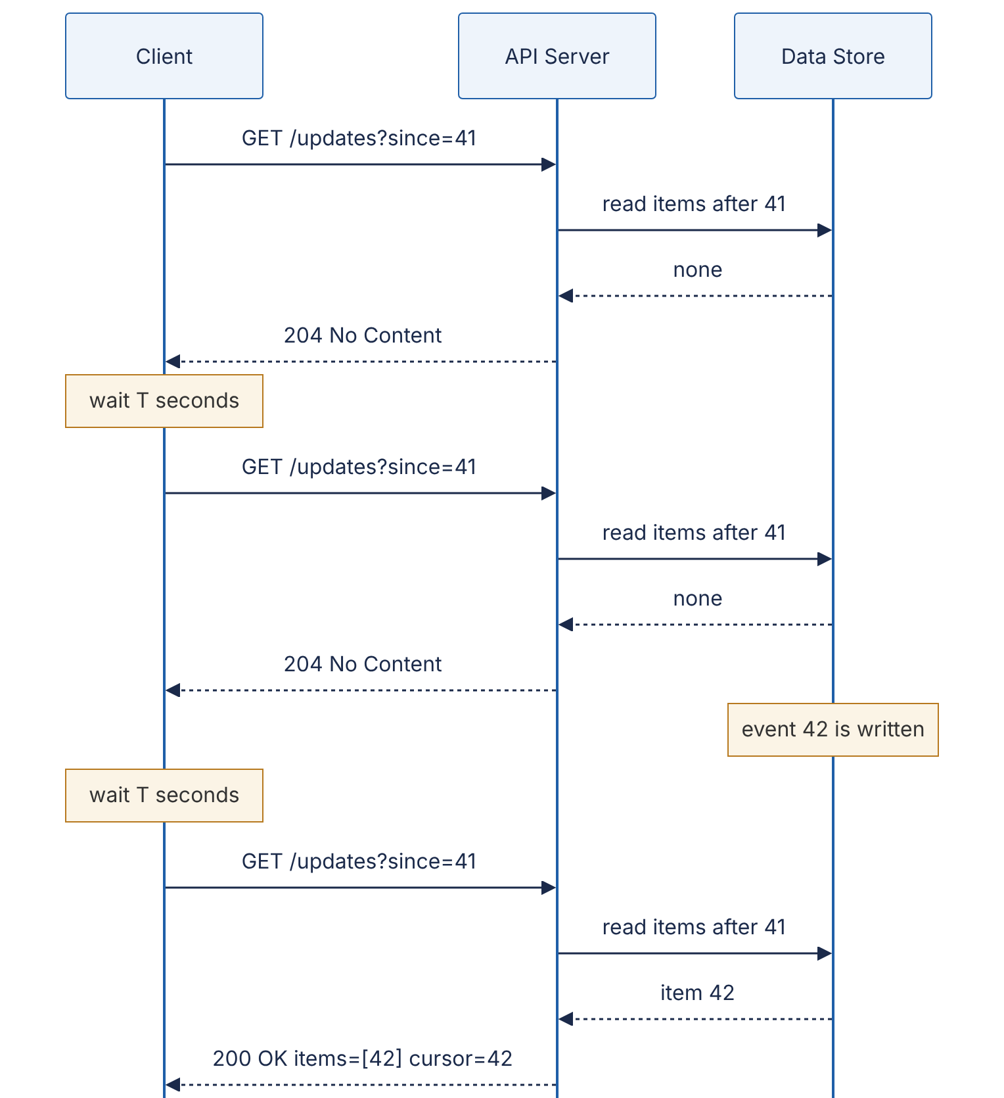
Reading the diagram. The client, a stateless API server and the data store exchange only synchronous HTTP over a reused keep-alive connection (solid = request, dashed = response); the server never initiates. Event 42 is written between polls, so the client learns of it up to T seconds late — inherent, not a bug. The data store receives one read per poll whether or not anything changed, which is the failure point at scale. Scaling is easy: stateless servers behind a load balancer, with a cache in front of the “anything new?” query.

Mathematical foundations
FORMULA
Short-polling request rate
$$R=\frac{N}{T}$$
Symbol | Meaning | Units
$R$ | Request rate arriving at the servers | requests/second
$N$ | Number of concurrently active (polling) clients | clients
$T$ | Polling interval | seconds
FORMULA
Fraction of wasted (empty) polls and added latency
If updates for a client arrive as a Poisson process with rate $λ$, the probability that a given interval contains no update is
$$P_{\text{empty}}=e^{−λT}≈1−λT \left(\text{when }λT≪1\right)$$
and the average delay between an event occurring and the client seeing it is
$$D_{\text{avg}}=\frac{T}{2}+t_{\text{rtt}}$$
Symbol | Meaning | Units
$P_{\text{empty}}$ | Fraction of polls that return nothing | dimensionless (0–1)
$λ$ | Average update rate per client | events/second
$T$ | Polling interval | seconds
$D_{\text{avg}}$ | Average notification delay | seconds
$t_{\text{rtt}}$ | Network round-trip time for one poll | seconds
WORKED EXAMPLE
Worked example — A notification badge polled every 5 seconds.
A web app has $N=1,000,000$ users online at peak. Each tab polls /notifications every $T=5$ s. A typical user receives one notification every 10 minutes, so $λ=1/600≈0.00167$ events/s.
- Request rate: $R=1,000,000/5=200,000$ requests/s.
- Empty fraction: $λT=5/600=0.00833$; $P_{\text{empty}}=e^{−0.00833}≈0.9917$. So 99.2 % of requests — about 198,300 per second — return nothing.
- Useful requests: $200,000×0.0083≈1,700$ per second actually carry a notification.
- Header overhead: assume about 800 bytes of request headers (cookies, user-agent, auth token) and 200 bytes of response headers on HTTP/1.1 — about 1 KB per poll (SI units, 1 KB = 1,000 bytes). $200,000×1\text{ KB}=200$ MB/s ≈ 1.6 Gbit/s of traffic that mostly says “nothing new”. HTTP/2 header compression (HPACK) shrinks repeated headers considerably, but the request count and server work remain.
- Average delay: $D_{\text{avg}}≈2.5$ s plus one round trip.
Interpretation. You are paying for 200,000 requests per second of capacity — load balancers, TLS termination, application threads and a database or cache lookup each — to deliver about 1,700 useful updates per second. Halving the interval to 2.5 s to improve freshness doubles the bill.
Engineering implication. Short polling’s cost scales with $N/T$, not with the rate of real events. When $λT$ is small (rare events, short interval), switch to a push technique; when events are frequent relative to the interval (for example, a dashboard that changes every second and is polled every 10 s), polling’s waste is low and its simplicity wins.
Table 9.1 — Short-polling cost for 1 million clients as the interval shrinks (λ = 1 event per 10 minutes per client).
Interval $T$ | Requests/s | Empty polls | Avg. delay | Header traffic (≈1 KB/poll)
60 s | 16,667 | 90.5 % | 30 s | 16.7 MB/s
30 s | 33,333 | 95.1 % | 15 s | 33.3 MB/s
10 s | 100,000 | 98.3 % | 5 s | 100 MB/s
5 s | 200,000 | 99.2 % | 2.5 s | 200 MB/s
1 s | 1,000,000 | 99.8 % | 0.5 s | 1 GB/s
The table shows the central tension: every halving of delay doubles the cost, while the useful work stays constant at about 1,667 notifications per second.

Real-world industry applications
INDUSTRY EXAMPLE
Status dashboards and job progress pages. A CI system’s build page or a cloud console’s “creating instance…” spinner typically polls a status endpoint every few seconds. The number of watchers is small, staleness of a few seconds is invisible to users, and the endpoint can be served from a cache, so the waste is cheap and the operational simplicity (no long-lived connections, works through every proxy) dominates. Evidence: Illustrative — a common pattern used for teaching; not a claim about any specific product.

Advantages and disadvantages
- Advantages: works everywhere (every proxy, CDN, firewall, HTTP version); servers stay stateless; trivially cacheable (ETag, Cache-Control: max-age); easy to rate-limit and to reason about; failures are self-healing because the next poll simply retries.
- Disadvantages: latency is bounded below by $T/2$ on average; cost grows with clients and polling frequency rather than with real events; mobile radios are woken on every poll, draining battery; synchronized clients (for example, all tabs opened at 09:00) create load spikes unless the timer is jittered.

Alternatives and trade-offs
Long polling (§9.4) removes empty responses and the $T/2$ delay; SSE (§9.5) and WebSockets (§9.6) remove per-update request overhead. Adaptive polling — lengthening $T$ while nothing changes, or honoring a server-supplied Retry-After hint — is a cheap middle ground.

Failure scenarios
Table 9.2 — Short-polling failure scenarios.
What goes wrong | Why | Detection | Recovery | Prevention
Synchronized poll spikes | Clients start timers at the same moment (deploy, page load at shift start) | Request-rate graph shows sawtooth at multiples of $T$ | Shed load with 429 + Retry-After | Add ±20 % random jitter to every timer
Database overload | Every empty poll hits the database | DB CPU tracks request rate, not write rate | Cache “latest cursor per user” in memory | Serve “anything new?” from a cache or version counter
Missed updates | Client uses wall-clock timestamps as cursor; clock skew or same-millisecond writes | Users report gaps | Re-fetch from an earlier cursor | Use monotonically increasing sequence numbers

Common misconceptions
COMMON MISTAKE
“Polling every second is fine; requests are cheap.” A request that returns nothing still costs a TLS record, a load-balancer decision, an application thread slot, an authentication check and usually a cache or database lookup. Multiplied by $N/T$, “cheap” becomes the dominant load on the system. Always compute $R=N/T$ before choosing an interval.

9.4 Long polling

9.4.1 What long polling is
DEFINITION
Definition — Long polling. A technique in which the client sends an HTTP request that the server deliberately does not answer until either new data is available or a server-side timeout Thold expires; on receiving any response, the client immediately sends the next request.

First-principles explanation
Now the child asks once and the parent says “I’ll tell you when we arrive — and if nothing happens in half an hour I’ll say so anyway”. The news arrives the instant it happens, but the parent must remember that a question is pending — that memory is the new cost.

Why does this exist?
Mid-2000s webmail and chat needed sub-second updates, but browsers could only make JavaScript-initiated HTTP requests. Nothing in HTTP forbids a server from answering slowly, so holding the request open approximates push using only standard HTTP. Alex Russell named this family of techniques Comet in 2006 [Russell 2006]; the CometD project’s Bayeux protocol standardized a message format, and RFC 6202 documented the pitfalls [Loreto et al. 2011]. Long polling survives as the universal fallback transport in libraries such as Socket.IO.

How it works internally
- The client sends GET /poll?cursor=41.
- The server checks for items after cursor 41. If any exist, it responds immediately (this is exactly short polling’s fast path).
- If none exist, the server parks the request in an in-memory waiter list keyed by user or topic. On an event-loop server (§6.13) a parked request costs only memory, not a thread.
- When an event for that user arrives from a broker, the server wakes the waiter and responds with the new items and cursor.
- If no event arrives within Thold (commonly 20–55 seconds), the server responds 204 No Content or an empty list with the same cursor.
- On any response the client immediately re-polls with the latest cursor (after a backoff delay if the response was an error).
Timeouts. Thold must be shorter than every idle timeout on the path. The AWS Application Load Balancer’s default idle timeout is 60 s and NGINX’s proxy_read_timeout defaults to 60 s (as of 2024); corporate proxies may be shorter, so 25–30 s is a common safe choice. If an intermediary cuts the request first, the client sees an error instead of a clean empty response — and if it retries without backoff, an error storm.
Ordering and loss. Between response k and request k+1 there is a one-round-trip gap with no outstanding request. The cursor closes it: the server keeps a per-user buffer of recent events with monotonically increasing sequence numbers, and each request asks for “everything after c”. Clients apply items in sequence order and discard duplicates (an event racing a timeout may be sent twice). Never run two concurrent long polls per client: responses can arrive out of order. A parked request also occupies one of the browser’s roughly six HTTP/1.1 connections per origin [Loreto et al. 2011].

Architecture diagram
Figure 9.2 — Long polling with cursors and a hold timeout.
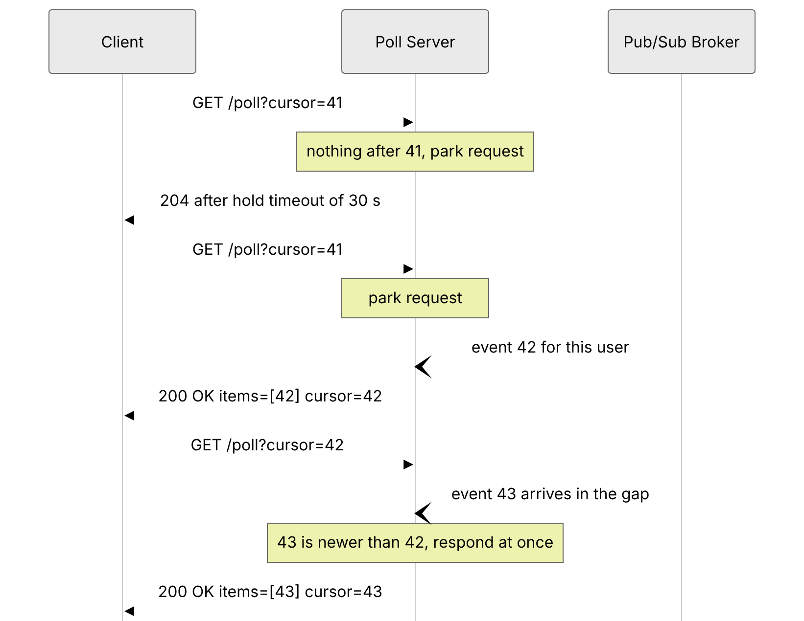
Reading the diagram. The poll server receives events asynchronously (open arrowheads) from a pub/sub broker. The first request parks and ends empty after the 30 s hold timeout; the second is answered the moment event 42 arrives — one network hop instead of $T/2$. Event 43 arrives while the client is re-polling; the cursor and the server-side buffer ensure nothing is lost. If the client reconnects to a different server, that server must answer “after 42”, so the buffer must be shared or routing sticky (§9.9.4). Failure points: intermediaries that time out first, and in-memory buffers lost on restart. Capacity is planned in concurrent held connections.

Mathematical foundations
FORMULA
Long-polling request rate
With Poisson events at rate $λ$ per client and hold timeout $T_{h}$, each request lasts $min\left(T_{h},X\right)$ where $X$ is the time to the next event. Its mean is
$$E\left[\text{duration}\right]=\frac{1−e^{−λT_{h}}}{λ}, R=\frac{N}{E\left[\text{duration}\right]}, C_{\text{open}}≈N$$
Symbol | Meaning | Units
$λ$ | Average update rate per client | events/second
$T_{h}$ | Server hold timeout | seconds
$E\left[\text{duration}\right]$ | Mean lifetime of one long-poll request | seconds
$N$ | Number of connected clients | clients
$R$ | Request rate at the servers | requests/second
$C_{\text{open}}$ | Concurrently open requests (Little’s Law: $R×E\left[\text{duration}\right]$) | requests
WORKED EXAMPLE
Worked example — The same 1 million users, now with long polling.
Use the numbers from §9.3: $N=1,000,000$, $λ=1/600$ events/s, and a hold timeout $T_{h}=30$ s.
- $λT_{h}=30/600=0.05$; $e^{−0.05}=0.9512$.
- $E\left[\text{duration}\right]=\left(1−0.9512\right)/\left(1/600\right)=0.0488×600≈29.3$ s.
- $R=1,000,000/29.3≈34,000$ requests/s, versus 200,000 requests/s for 5-second short polling — about 5.9× fewer requests.
- Average notification delay: about one network round trip (tens of milliseconds) instead of 2.5 s.
- Concurrent open requests: $34,000×29.3≈1,000,000$ — every client holds one open request at all times.
Interpretation. Long polling improves both cost and latency, but it shifts the bottleneck from request throughput to concurrent held connections. 95 % of responses are still empty timeouts ($e^{−0.05}$), each carrying full HTTP headers.
Engineering implication. Long polling needs an asynchronous server that can park a million requests and an event-routing layer that wakes the right one — the same infrastructure as a WebSocket gateway (§9.9). Once you have built that, SSE or WebSockets usually deliver more for the same effort.

Real-world industry applications
INDUSTRY EXAMPLE
Universal fallback transports. Real-time libraries such as Socket.IO and SockJS offer long polling as a transport for networks where WebSockets are blocked by proxies or firewalls. Socket.IO’s documentation notes that when HTTP long-polling is enabled with several server nodes, the load balancer must use sticky sessions, because successive polls of one session must reach the node that holds its state. Evidence: Primary — Socket.IO documentation, “Using multiple nodes” [Socket.IO Docs].

Advantages and disadvantages
- Advantages: near-instant delivery over plain HTTP; works through almost every proxy; client logic is simple; degrades to polling when events are frequent.
- Disadvantages: every message still carries full HTTP headers and costs a new request; a round-trip gap after each response (mitigated by cursors); holds a connection per client, so servers must be asynchronous; intermediary timeouts must be understood; occupies one of the browser’s HTTP/1.1 connections per origin; strictly server-to-client (client-to-server messages need separate requests).

Alternatives and trade-offs
SSE (§9.5) gives the same reach for server-to-client data with one request for many messages and built-in resumption; WebSockets (§9.6) remove per-message HTTP overhead for bidirectional traffic. Long polling wins where streaming responses are broken — some antivirus products and corporate proxies buffer responses until they complete, which ruins SSE but leaves long polling intact.

Failure scenarios
Table 9.3 — Long-polling failure scenarios.
What goes wrong | Why | Detection | Recovery | Prevention
Requests cut off at 60 s with 504 | Hold timeout exceeds a proxy or LB idle timeout | Spike in 504/502 at exactly the intermediary’s timeout | Lower hold timeout | Keep hold timeout below the smallest idle timeout on the path
Lost events | Server buffers in memory and restarts; client lands on another node | Sequence gaps detected by client | Client resyncs with a full fetch | Shared event store or sticky routing plus resync-on-gap
Retry storm | Clients re-poll instantly after errors | Request rate jumps far above $N/T_{h}$ | Shed with 503 + Retry-After | Exponential backoff with jitter on errors (§22.12)

Common misconceptions
COMMON MISTAKE
“Long polling is just polling with a longer interval.” No — the interval is not a client timer at all. The server decides when to answer, so delivery latency is one hop, not $T/2$. What it shares with polling is the per-message HTTP cost and the reconnect after every response.

9.5 Server-Sent Events

9.5.1 What SSE is
DEFINITION
Definition — Server-Sent Events (SSE). A W3C/WHATWG-standardized mechanism in which a client opens one long-lived HTTP request and the server streams a sequence of UTF-8 text events down the response body using the text/event-stream format; browsers expose it through the EventSource API, which parses events and reconnects automatically, resuming from the last received event ID [WHATWG HTML §9.2].

First-principles explanation
Long polling is like ordering a newspaper one issue at a time: each issue arrives, and then you must place the next order. SSE is a newspaper subscription: you sign up once and issues keep arriving at your door. If you move house (the connection drops), you tell the newspaper “the last issue I received was number 1,042”, and they send you everything from 1,043 onward.

Why does this exist?
Long polling wastes a full request per message. Many features need only server-to-client data: feeds, notifications, live scores, progress bars, and the token-by-token output of large language models (Chapter 73). SSE standardizes “keep the response open and keep writing”, adds a tiny text framing, and builds reconnection and resumption into the browser.

How it works internally
- The client creates new EventSource("/events") (optionally { withCredentials: true } for cross-origin cookies). The browser sends GET /events with Accept: text/event-stream.
- The server responds 200 OK with Content-Type: text/event-stream and Cache-Control: no-cache, then does not end the response. It writes events as they occur.
- Each event is a block of field: value lines terminated by a blank line. The fields are:
  - data: — the payload; several data: lines are joined with newline characters.
  - event: — an event type; the browser dispatches it to listeners registered with addEventListener("<type>", …); without it the event fires onmessage.
  - id: — sets the stream’s last event ID.
  - retry: — an integer in milliseconds; sets the reconnection delay.
  - A line beginning with : is a comment, ignored by the parser — servers send one every 15–30 seconds as a heartbeat to stop intermediaries from closing an idle connection.
- If the connection drops because of a network error, the browser waits the reconnection time (initially an implementation-defined value of a few seconds, or whatever retry: set) and re-sends the request with a Last-Event-ID header containing the last id: it received. The server replays events after that ID from a buffer and then continues live.
- The server can stop reconnection permanently by responding 204 No Content. A response with a status other than 200, or a wrong Content-Type, makes the browser fail the connection rather than retry — so a load balancer returning 503 during an outage silently turns off auto-reconnect, and your application code must notice (readyState === EventSource.CLOSED) and recreate the EventSource with backoff.
A stream on the wire looks like this:
HTTP/1.1 200 OK
Content-Type: text/event-stream
Cache-Control: no-cache
retry: 5000
: heartbeat
id: 1042
event: price
data: {"symbol":"ACME","price":101.25}
id: 1043
event: price
data: {"symbol":"ACME","price":101.40}
Interaction with HTTP versions. Over HTTP/1.1 each EventSource holds a whole TCP connection, and browsers allow only about six HTTP/1.1 connections per origin across all tabs, so a seventh tab can stall. Over HTTP/2 (§7.9) each stream is multiplexed on one shared connection, limited by the server’s SETTINGS_MAX_CONCURRENT_STREAMS (commonly 100 or more), and a new stream needs no TCP or TLS handshake; the price is TCP head-of-line blocking across all streams, which HTTP/3 removes. Finally, reverse proxies that buffer responses (NGINX does by default) hold events back: disable buffering on stream routes (proxy_buffering off; or the header X-Accel-Buffering: no) and keep compression middleware off them.

Architecture diagram
Figure 9.3 — SSE streaming, disconnection and resumption with Last-Event-ID.
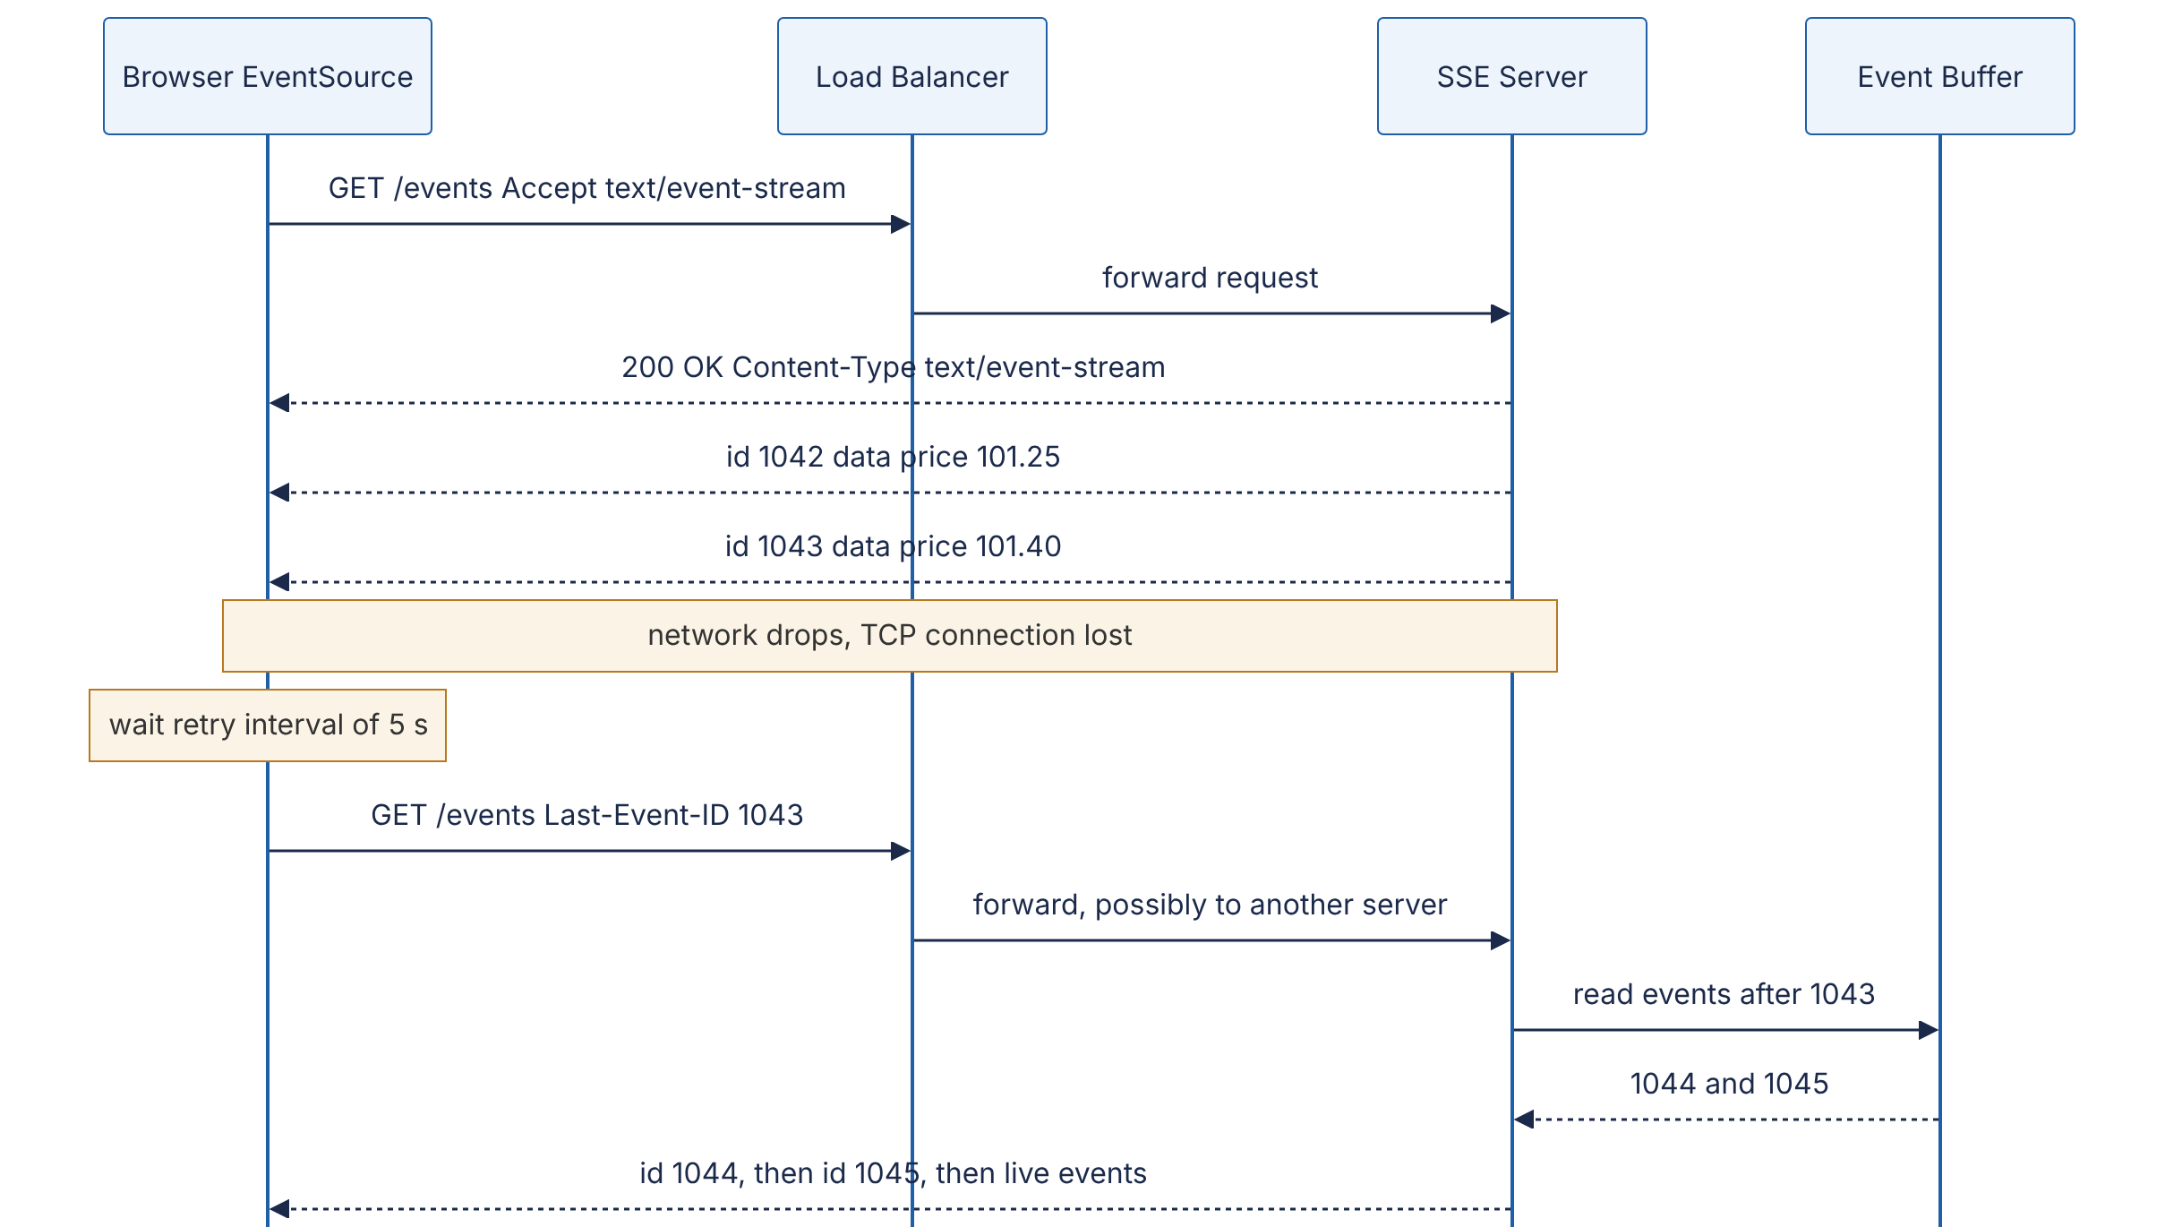
Reading the diagram. Every dashed arrow from the server is a chunk of the same streamed response. After a network failure the browser reconnects by itself with Last-Event-ID; the load balancer may pick a different server, which is why the event buffer (Redis Streams, Kafka, a replicated ring) lives outside the SSE server. Data flows only server-to-client; client actions use ordinary HTTP requests. Failure points: buffering proxies, idle timeouts on silent streams (fixed by heartbeat comments), and a buffer that no longer reaches back to the client’s ID (force a full resync). SSE servers scale like the gateways in §9.9.

Code example
The following SSE endpoint uses only the Python standard library and has been run and tested with curl -N. It keeps a bounded history so that reconnecting clients resume from Last-Event-ID.
"""Minimal Server-Sent Events endpoint using only the standard library.
Run: python3 sse_server.py
Test: curl -N http://127.0.0.1:8080/events
curl -N -H "Last-Event-ID: 3" http://127.0.0.1:8080/events
"""
import asyncio
import json
import time
HISTORY: list[tuple[int, str]] = [] # (event id, JSON payload) ring buffer
HISTORY_LIMIT = 1000
new_event = asyncio.Condition()
async def producer() -> None:
"""Pretend to be a business event source: one price tick per second."""
event_id = 0
while True:
await asyncio.sleep(1)
event_id += 1
payload = json.dumps({"symbol": "ACME", "price": 100 + event_id, "ts": time.time()})
async with new_event:
HISTORY.append((event_id, payload))
del HISTORY[:-HISTORY_LIMIT] # keep the buffer bounded
new_event.notify_all()
def format_event(event_id: int, data: str) -> bytes:
return f"id: {event_id}\nevent: price\ndata: {data}\n\n".encode()
async def handle(reader: asyncio.StreamReader, writer: asyncio.StreamWriter) -> None:
# 1. Read the request line and headers (no body for GET).
request_line = await reader.readline()
headers = {}
while (line := await reader.readline()) not in (b"\r\n", b"\n", b""):
name, _, value = line.decode().partition(":")
headers[name.strip().lower()] = value.strip()
if not request_line.startswith(b"GET /events"):
writer.write(b"HTTP/1.1 404 Not Found\r\nContent-Length: 0\r\n\r\n")
await writer.drain(); writer.close(); return
# 2. Resume point: the browser sends Last-Event-ID automatically on reconnect.
try:
last_seen = int(headers.get("last-event-id", "0"))
except ValueError:
last_seen = 0
writer.write(b"HTTP/1.1 200 OK\r\n"
b"Content-Type: text/event-stream\r\n"
b"Cache-Control: no-cache\r\n"
b"Connection: keep-alive\r\n\r\n"
b"retry: 5000\n\n") # ask client to wait 5 s before reconnecting
try:
while True:
# 3. Send everything newer than last_seen (replay, then live).
pending = [(i, d) for i, d in HISTORY if i > last_seen]
for event_id, data in pending:
writer.write(format_event(event_id, data))
last_seen = event_id
if not pending:
writer.write(b": keep-alive\n\n") # comment line; defeats idle timeouts
await writer.drain() # backpressure: wait if socket buffer full
async with new_event:
try:
await asyncio.wait_for(new_event.wait(), timeout=15)
except asyncio.TimeoutError:
pass
except (ConnectionResetError, BrokenPipeError):
pass
finally:
writer.close()
async def main() -> None:
asyncio.create_task(producer())
server = await asyncio.start_server(handle, "127.0.0.1", 8080)
async with server:
await server.serve_forever()
if __name__ == "__main__":
asyncio.run(main())
On the browser side, consuming this stream takes four lines:
const es = new EventSource("/events");
es.addEventListener("price", (e) => render(JSON.parse(e.data)));
es.onerror = () => { if (es.readyState === EventSource.CLOSED) scheduleRecreate(); };
// the browser reconnects by itself after network errors and sends Last-Event-ID
What to notice:
- The response never ends; the server writes id:/event:/data: blocks separated by blank lines. Curl started with -H "Last-Event-ID: 2" received events 3, 4, 5… — the replay-then-live behavior the browser gets for free.
- await writer.drain() is the backpressure point: if a client reads slowly, the coroutine pauses instead of letting the process buffer unbounded data (§9.6.7).
- The : keep-alive comment is invisible to EventSource but keeps proxies and load balancers from closing an idle connection.
- The in-memory HISTORY would be lost on restart and is not shared between servers; production systems put it in Redis Streams, Kafka or a database so any server can replay.

Real-world industry applications
INDUSTRY EXAMPLE
Streaming responses from large-language-model APIs. Several widely used LLM HTTP APIs stream generated tokens to clients as text/event-stream responses, because generation is strictly one-directional (server to client), each response is short-lived (seconds to minutes), and SSE passes through standard HTTP infrastructure, authentication and rate limiting unchanged. Chapter 73 discusses time to first token (TTFT) and inter-token latency (ITL), which is what this streaming exposes to users. Evidence: Illustrative — a widely observed pattern; consult each provider’s API documentation for specifics.

Advantages and disadvantages
- Advantages: plain HTTP (works with existing auth, cookies, CORS, load balancers, HTTP/2 and HTTP/3); automatic reconnection and resumption built into browsers; tiny per-event framing (tens of bytes); simple to implement on any server that can flush a response; easy to debug with curl -N.
- Disadvantages: server-to-client only; UTF-8 text only (binary must be base64-encoded, +33 %); the standard EventSource cannot set custom request headers (use cookies, a short-lived token in the URL, or a fetch-based stream reader instead); HTTP/1.1 connection-per-origin limits; buffering proxies and compression can delay events; non-200 responses stop automatic reconnection.

Failure scenarios
Table 9.4 — SSE failure scenarios.
What goes wrong | Why | Detection | Recovery | Prevention
Events arrive in bursts minutes late | Reverse proxy or compression buffers the response | Server log timestamps vs. client receipt times diverge | Disable buffering on the route | proxy_buffering off / X-Accel-Buffering: no; no gzip on streams
Streams die every 60 s | Idle timeout on LB or proxy | Reconnect rate ≈ connections / 60 s | Send heartbeats | Comment line every 15–30 s, below every idle timeout
Clients never reconnect after outage | LB returned 502/503; EventSource fails permanently on non-200 | Connected-client gauge drops and stays low | Application recreates EventSource with jittered backoff | Handle readyState === CLOSED in onerror
Seventh tab hangs | HTTP/1.1 six-connection limit per origin | Requests pending in browser dev tools | Close tabs | Serve SSE over HTTP/2; share one stream across tabs (BroadcastChannel, SharedWorker)

Common misconceptions
COMMON MISTAKE
“SSE is obsolete because WebSockets exist.” SSE is the better tool for one-directional streams: it rides on ordinary HTTP (so HTTP/2 multiplexing, standard authentication and observability all apply), it resumes automatically, and it needs no special proxy configuration. Choose WebSockets when the client also sends frequent low-latency messages, or when you need binary frames.

9.6 WebSockets in depth

9.6.1 What a WebSocket is
DEFINITION
Definition — WebSocket. A protocol, standardized in RFC 6455 [Fette & Melnikov 2011], that starts as an HTTP/1.1 request, upgrades the underlying TCP connection, and thereafter carries a full-duplex sequence of framed messages in both directions with 2–14 bytes of framing overhead per frame. URLs use the schemes ws:// (plain TCP, default port 80) and wss:// (over TLS, default port 443).

First-principles explanation
HTTP is a postal system: every letter needs a full envelope, and the recipient can only reply, never write first. A WebSocket is a telephone call that begins with a short postal exchange — “may we switch to the telephone?”, “yes” — after which either party speaks whenever it likes for a few bytes of overhead. Because the call starts as a letter, it passes through the same post offices (ports 80/443, HTTP proxies).

Why does this exist?
Before RFC 6455 (2011), bidirectional browser communication meant gluing a long poll (downstream) to separate POSTs (upstream), each carrying hundreds of bytes of headers. Games, collaborative editors, trading screens and chat needed many small messages per second both ways. RFC 6455 reuses HTTP’s ports for the initial connection, keeps framing minimal, keeps the browser’s origin-based security model, and avoids giving web pages a raw TCP socket that could attack other protocols.

9.6.2 The opening handshake

How it works internally
- The client opens a TCP connection (and, for wss://, a TLS session) to the server.
- It sends an HTTP/1.1 GET with these headers:
  - Upgrade: websocket and Connection: Upgrade — ask to switch protocols.
  - Sec-WebSocket-Key: — 16 random bytes, base64-encoded, fresh for each connection.
  - Sec-WebSocket-Version: 13 — the only version in RFC 6455.
  - Origin: — set by browsers; the server must check it (see the security note below).
  - Optionally Sec-WebSocket-Protocol: (application subprotocols, for example graphql-transport-ws or mqtt) and Sec-WebSocket-Extensions: (for example permessage-deflate, RFC 7692).
- The server validates the request and responds HTTP/1.1 101 Switching Protocols with Upgrade: websocket, Connection: Upgrade and Sec-WebSocket-Accept, computed as base64(SHA-1(key + 258EAFA5-E914-47DA-95CA-C5AB0DC85B11)). That fixed GUID appears in RFC 6455; the computation proves that the server actually understood a WebSocket handshake (and was not, say, an unsuspecting HTTP server or cache replaying a response). It is not an authentication mechanism.
- From the next byte onward, both sides speak the WebSocket framing protocol on the same TCP connection. HTTP is gone.
GET /chat HTTP/1.1
Host: server.example.com
Upgrade: websocket
Connection: Upgrade
Sec-WebSocket-Key: dGhlIHNhbXBsZSBub25jZQ==
Origin: https://example.com
Sec-WebSocket-Version: 13
HTTP/1.1 101 Switching Protocols
Upgrade: websocket
Connection: Upgrade
Sec-WebSocket-Accept: s3pPLMBiTxaQ9kYGzzhZRbK+xOo=
WARNING / TRADE-OFF
Cross-Site WebSocket Hijacking. Browsers attach cookies to the WebSocket handshake but WebSockets are not subject to CORS. If your server authenticates the handshake by cookie and does not check Origin against an allow-list, any website the user visits can open an authenticated WebSocket to your service. Check Origin, or authenticate with a short-lived token sent in the first message or in the URL rather than relying on cookies alone.
HTTP/2 and HTTP/3. RFC 6455’s Upgrade mechanism exists only in HTTP/1.1. RFC 8441 defines an “extended CONNECT” method that carries a WebSocket over a single HTTP/2 stream, and RFC 9220 does the same for HTTP/3; support across browsers, proxies and servers is uneven (as of 2024), so most deployments still run WebSockets over a dedicated HTTP/1.1-upgraded TCP connection.
Figure 9.4 — WebSocket opening handshake, message exchange, heartbeat and closing handshake.
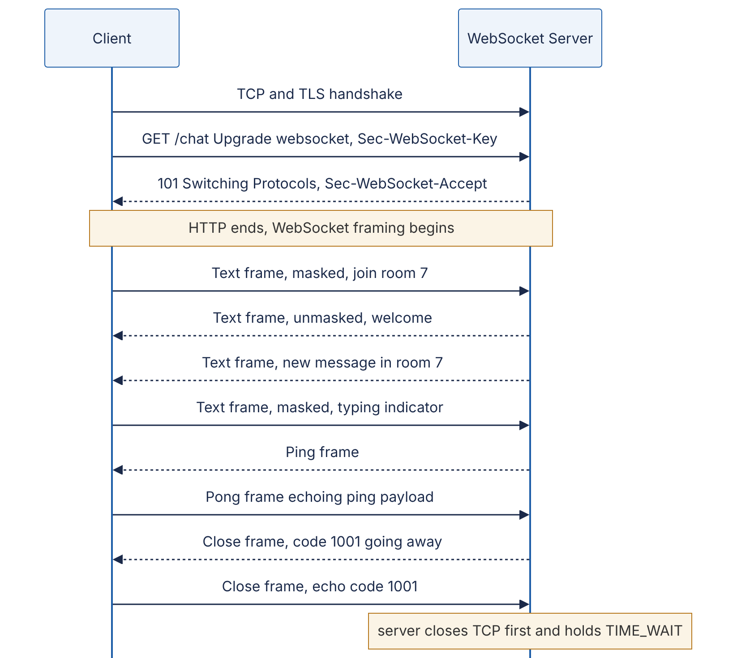
Reading the diagram. One TCP connection carries the whole session. Only the upgrade request and the 101 response are HTTP; afterward frames flow independently in both directions — the server pushes a chat message unasked, the client sends a typing indicator without waiting. Client frames are masked, server frames are not (§9.6.4). Ping/Pong is a protocol-level liveness check. In the closing handshake each side sends one Close frame and the server closes TCP first, so TIME_WAIT (§7.7) accumulates on the server. Failure points: proxies that do not understand Upgrade, idle timeouts, and abrupt TCP loss with no Close frame (reported locally as 1006). The server is stateful for the connection’s lifetime, which drives §9.9.

Code example
import base64
import hashlib
GUID = "258EAFA5-E914-47DA-95CA-C5AB0DC85B11" # fixed by RFC 6455
def accept_key(sec_websocket_key: str) -> str:
"""Compute Sec-WebSocket-Accept from the client's Sec-WebSocket-Key."""
digest = hashlib.sha1((sec_websocket_key + GUID).encode("ascii")).digest()
return base64.b64encode(digest).decode("ascii")
print(accept_key("dGhlIHNhbXBsZSBub25jZQ==")) # s3pPLMBiTxaQ9kYGzzhZRbK+xOo=
What to notice: the output matches the example in RFC 6455 exactly. SHA-1’s known collision weaknesses do not matter here because the value is a protocol-confirmation nonce, not a security signature.

9.6.3 Frames

How it works internally
After the handshake, every message is sent as one or more frames. The header is at least 2 bytes:
Table 9.5 — WebSocket frame header fields (RFC 6455 §5.2).
Field | Size | Meaning
FIN | 1 bit | 1 = this is the final fragment of a message
RSV1–3 | 3 bits | Reserved for extensions (RSV1 marks a compressed message under permessage-deflate)
Opcode | 4 bits | Frame type (Table 9.6)
MASK | 1 bit | 1 = payload is masked; must be 1 for client→server, 0 for server→client
Payload length | 7 bits | 0–125 = actual length; 126 = next 2 bytes hold length; 127 = next 8 bytes hold length
Extended length | 0, 2 or 8 bytes | Present when length field is 126 or 127
Masking key | 0 or 4 bytes | Present when MASK = 1
Payload | variable | Application data (after unmasking)
Table 9.6 — WebSocket opcodes.
Opcode | Type | Notes
0x0 | Continuation | Subsequent fragment of a fragmented message
0x1 | Text | Payload must be valid UTF-8
0x2 | Binary | Arbitrary bytes (Protocol Buffers, MessagePack, media)
0x8 | Close | Optional 2-byte status code + UTF-8 reason
0x9 | Ping | Receiver must answer with a Pong carrying the same payload
0xA | Pong | Reply to Ping, or unsolicited one-way heartbeat
Control frames (Close, Ping, Pong) carry at most 125 bytes of payload, must not be fragmented, and may be injected between the fragments of a large data message — so a 100 MB upload does not delay a heartbeat. Fragmentation lets a sender stream a message of unknown length: the first frame has opcode Text or Binary with FIN = 0, middle frames use opcode Continuation, and the last frame sets FIN = 1. Note that WebSocket gives you messages, not a byte stream: the receiver’s API delivers whole messages, which is one of its key conveniences over raw TCP.

Mathematical foundations
FORMULA
WebSocket framing overhead per frame
$$H=2+L_{\text{ext}}+4m, L_{\text{ext}}=\left\{\begin{matrix}0 & n≤125 \\ 2 & 126≤n≤65,535 \\ 8 & n≥65,536\end{matrix}\right.$$
Symbol | Meaning | Units
$H$ | Header bytes per frame | bytes
$n$ | Payload length | bytes
$L_{\text{ext}}$ | Extended-length bytes | bytes
$m$ | 1 if masked (client→server), 0 otherwise | dimensionless
WORKED EXAMPLE
Worked example — Sending a 60-byte chat message.
- Server→client: $n=60≤125$, unmasked → $H=2$ bytes. Total 62 bytes, 3 % overhead.
- Client→server: masked → $H=2+4=6$ bytes. Total 66 bytes.
- The same message as an HTTP/1.1 long-poll response would carry roughly 200–800 bytes of headers — 3× to 13× the payload.
- TLS 1.3 with AES-GCM adds about 22 bytes per record (5-byte record header, 1-byte inner content type, 16-byte authentication tag), and TCP/IP adds 40+ bytes per packet, so for tiny messages the transport, not WebSocket, dominates.
Engineering implication. For high-frequency small messages (cursor positions, game state, typing indicators) WebSocket framing is close to free, which is why chat and multiplayer systems prefer it. To save more, batch several small updates into one frame every 50–100 ms.

Code example
The following encoder/decoder is runnable with the standard library and reproduces the byte layout from Table 9.5.
import os
import struct
def encode_frame(payload: bytes, opcode: int = 0x1, mask: bool = True) -> bytes:
"""Build a single, unfragmented frame (FIN=1)."""
first = 0x80 | opcode # FIN bit + opcode
n = len(payload)
mask_bit = 0x80 if mask else 0x00
if n <= 125:
header = struct.pack("!BB", first, mask_bit | n)
elif n <= 0xFFFF:
header = struct.pack("!BBH", first, mask_bit | 126, n)
else:
header = struct.pack("!BBQ", first, mask_bit | 127, n)
if not mask:
return header + payload
key = os.urandom(4) # fresh masking key per frame
masked = bytes(b ^ key[i % 4] for i, b in enumerate(payload))
return header + key + masked
def decode_frame(frame: bytes):
"""Parse one complete frame; return (fin, opcode, payload)."""
b0, b1 = frame[0], frame[1]
fin, opcode = bool(b0 & 0x80), b0 & 0x0F
masked, n = bool(b1 & 0x80), b1 & 0x7F
pos = 2
if n == 126:
(n,) = struct.unpack("!H", frame[pos:pos + 2]); pos += 2
elif n == 127:
(n,) = struct.unpack("!Q", frame[pos:pos + 8]); pos += 8
key = b""
if masked:
key = frame[pos:pos + 4]; pos += 4
data = frame[pos:pos + n]
if masked:
data = bytes(b ^ key[i % 4] for i, b in enumerate(data))
return fin, opcode, data
print(encode_frame(b"Hello", mask=False).hex(" ")) # 81 05 48 65 6c 6c 6f
f = encode_frame(b"Hello") # 11 bytes: 2 header + 4 key + 5
print(len(f), decode_frame(f)) # 11 (True, 1, b'Hello')
What to notice:
- 0x81 = FIN (0x80) + Text opcode (0x1); 0x05 = unmasked, length 5. This is the unmasked “Hello” example given in RFC 6455 §5.7.
- A masked frame is 4 bytes longer, and the masked payload bytes look random on the wire even though the plaintext is “Hello”.
- A 70,000-byte binary frame uses the 8-byte extended length: 2 + 8 + 4 = 14 header bytes (the maximum).
- Production libraries also validate UTF-8 in text frames, enforce maximum message sizes, reassemble fragments and reject unmasked client frames — never hand-roll this in production.

9.6.4 Masking: why the client scrambles its own data
Every client-to-server frame is XORed with a fresh, unpredictable 4-byte masking key chosen by the browser. Masking is not encryption — the key travels in the frame header in clear. It exists to protect intermediaries. Researchers showed that if a malicious script could choose the exact bytes a browser puts on the wire, it could craft WebSocket payloads that a confused transparent proxy would parse as a separate HTTP request, poisoning that proxy’s cache for other users [Huang et al. 2011]. Because the script cannot predict the masking key, it cannot control the bytes that appear on the wire. RFC 6455 §10.3 explains this rationale. Server-to-client frames are not masked because the threat is script-controlled upstream bytes. Servers must close the connection (code 1002) if a client sends an unmasked frame.

9.6.5 Heartbeats (ping/pong) and the closing handshake
A TCP connection can die silently: a phone moves into a tunnel, a NAT device forgets its mapping after a few minutes of idleness, a load balancer reaps an idle flow. Neither endpoint is told. Heartbeats solve two problems at once: they detect dead peers (no pong within a deadline ⇒ close and clean up), and they prevent idle-timeout disconnections by keeping traffic flowing.
- The server sends a Ping every H seconds (commonly 20–30 s) and closes the connection if no Pong arrives within a timeout. Browsers answer Pings automatically.
- The browser WebSocket API does not let JavaScript send Pings, so client-side liveness detection needs an application-level heartbeat (for example, a {"type":"ping"} text message every 25 s and a “reconnect if nothing received for 60 s” rule).
- H must be smaller than the smallest idle timeout on the path (NAT, mobile carrier, load balancer).
Closing. Either side sends a Close frame with a status code; the other replies with a Close frame; then the TCP connection closes, ideally server first. The codes matter operationally because clients decide whether and how fast to reconnect based on them.
Table 9.7 — WebSocket close codes you will meet in practice.
Code | Name | Meaning and typical client reaction
1000 | Normal closure | Purpose fulfilled; do not reconnect automatically
1001 | Going away | Server shutting down or browser navigating away; reconnect with jitter
1002 | Protocol error | Malformed frame; reconnect, report bug
1003 | Unsupported data | For example binary sent to a text-only endpoint
1005 | No status received | Reserved: reported locally when Close had no code; never sent
1006 | Abnormal closure | Reserved: reported locally when TCP dropped without a Close frame; reconnect with backoff
1007 | Invalid payload data | For example invalid UTF-8 in a text frame
1008 | Policy violation | Generic rejection (auth failure, slow consumer); reconnect only after fixing cause
1009 | Message too big | Exceeded server’s maximum message size
1011 | Internal error | Server-side failure; reconnect with backoff
1012 | Service restart | IANA-registered (not in RFC 6455 text); reconnect with jitter
1013 | Try again later | IANA-registered; overload — reconnect with longer backoff
4000–4999 | Private use | Application-defined, for example 4001 “token expired”
Figure 9.5 — Lifecycle of a WebSocket connection as seen by a gateway.
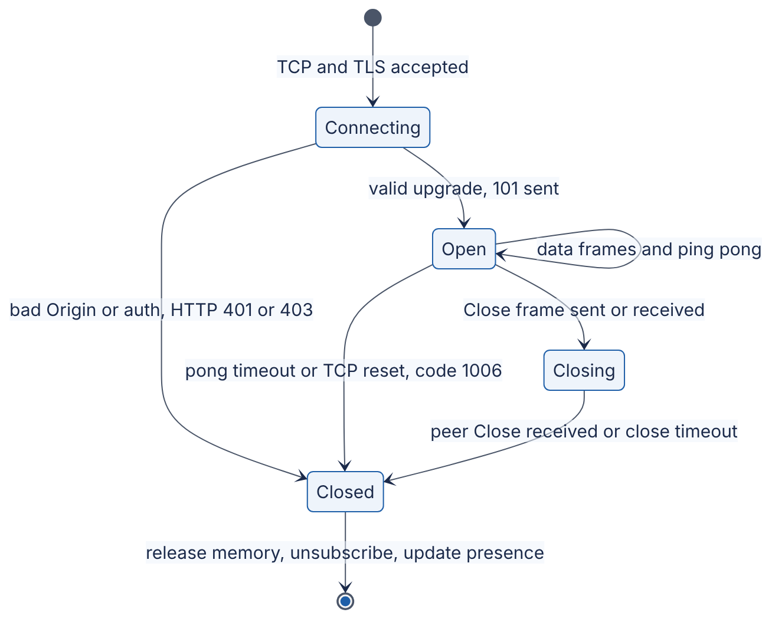
Reading the diagram. Authentication and Origin checks belong in Connecting, before 101 — rejecting there is cheapest. Open loops on data and heartbeat frames. The orderly exit passes through Closing; heartbeat failure or TCP reset jumps straight to Closed. The exit action from Closed — unsubscribe from the backplane, update presence (§9.9) — is where leaks and “ghost online” bugs live. A close timeout of a few seconds stops an unresponsive peer from holding resources.

9.6.6 Proxies and load balancers
Long-lived, upgraded connections stress infrastructure built for short HTTP exchanges:
- Hop-by-hop headers. Proxies strip Upgrade and Connection unless configured otherwise; NGINX needs proxy_http_version 1.1;, proxy_set_header Upgrade $http_upgrade; and proxy_set_header Connection "upgrade";. Managed L7 load balancers generally support WebSockets natively.
- Idle timeouts. The 60 s defaults from §9.4 apply; keep heartbeats more frequent than the smallest timeout.
- Use wss://. Old transparent proxies and carrier middleboxes mangle unrecognized traffic on port 80 but cannot see inside TLS [Grigorik 2013].
- L4 vs L7. An L4 load balancer passes TCP through and scales to millions of flows; an L7 proxy terminates TLS and HTTP (path routing, central certificates) but holds two sockets per connection, and its upstream connections from one IP to one gateway IP:port are limited by the ephemeral port range (Linux default 32768–60999, about 28,000 ports) — add upstream IPs or ports beyond that.
- Balancing happens only at connect time. A newly added gateway gets no load until clients reconnect, so least-connections beats round robin (§19.4); deploys need draining (§9.9.7).

9.6.7 Backpressure
Backpressure is a slow receiver pushing back on a fast sender (§22.10). TCP provides it at the transport layer: when a receiver stops reading, the sender’s kernel buffer fills and await send() stops completing. The danger is the layer above: a gateway fanning a room message out to 10,000 connections must queue data for the one client on a congested mobile link. Unbounded, a few hundred slow clients can exhaust memory and kill every healthy connection on the gateway. Browsers have the mirror problem: WebSocket.send() never blocks; it just grows bufferedAmount. Policies for a full per-connection queue:
- Disconnect the slow consumer (close 1008 or an application code) and let it reconnect and resync from durable storage — simplest and safest; protects the gateway.
- Drop or coalesce — for “latest value wins” data (prices, cursor positions, presence), keep only the newest value per key.
- Degrade — switch the client to a lower update rate or a summary feed.
The chat server in Exercise 9.2 (§9.14) implements policy 1 with a bounded asyncio.Queue per connection.

Real-world industry applications
INDUSTRY EXAMPLE
Slack’s real-time messaging. Slack’s engineering blog describes clients holding WebSocket connections to stateful Gateway Servers (user information and channel subscriptions in memory), which subscribe to Channel Servers that own channels via consistent hashing; separate Presence Servers track who is online. A message goes to the owning Channel Server, which pushes it to every subscribed Gateway Server, which writes it to local sockets. A separate post describes migrating millions of concurrent WebSockets at the edge from HAProxy to Envoy, motivated largely by operational problems such as configuration reloads. Evidence: Primary — [Slack Engineering 2023]; [Slack Engineering 2021].

Advantages and disadvantages
- Advantages: full duplex with minimal per-message overhead (2–14 bytes); binary and text messages; message boundaries preserved; universal browser support; passes through ports 80/443.
- Disadvantages: stateful connections complicate load balancing, autoscaling and deploys; you must build heartbeats, reconnection, resumption, ordering and backpressure yourself (none are in the protocol); bypasses HTTP-level caching, compression defaults and much of the HTTP observability tooling; security is easy to get wrong (Origin checks, message-size limits, authentication refresh on long sessions).

Failure scenarios
Table 9.8 — WebSocket failure scenarios.
What goes wrong | Why | Detection | Recovery | Prevention
Handshake fails with 400/426 behind proxy | Proxy strips Upgrade/Connection | 101 rate ≈ 0 for one route | Fix proxy config | Configure WebSocket routes explicitly; integration test through the real proxy
“Ghost” connections | TCP peer vanished; no FIN received | Connection gauge grows, traffic per connection falls | Close on pong timeout | Server pings every 20–30 s with timeout
Gateway OOM | Unbounded per-connection send queues to slow clients | Memory rises with fan-out volume | Kill slow consumers | Bounded queues + slow-consumer policy
Reconnect storm after deploy | All connections on a node closed at once; clients retry immediately | Spike of handshakes and TLS CPU | Shed with 1013 | Gradual drain + jittered backoff (§9.9.6–9.9.7)

Common misconceptions
COMMON MISTAKE
“TCP keepalive makes WebSocket heartbeats unnecessary.” Linux TCP keepalive defaults to the first probe after 2 hours of idleness — far longer than NAT and load-balancer idle timeouts — and it is not visible to the application. Use WebSocket Ping/Pong (server side) and an application heartbeat (browser side).

9.7 WebRTC basics

9.7.1 What WebRTC is
DEFINITION
Definition — WebRTC. A set of IETF protocols (overview in RFC 8825 [Alvestrand 2021]) and a W3C browser API [W3C WebRTC] for real-time audio, video and arbitrary data directly between peers. Media travels over SRTP, data over SCTP data channels, both secured by DTLS, typically over UDP; peers discover a working network path using ICE with the help of STUN and TURN servers.

First-principles explanation
Everything so far routes through your servers. For a video call that is wasteful: two people in one city would send video to a data center and back. WebRTC lets browsers talk directly — but most devices sit behind NAT (§7.13), which drops unsolicited inbound packets. Think of two employees in different buildings whose receptionists only admit callers they have already phoned. They need a mutual friend to pass numbers (signaling), a way to learn the number the outside world sees (STUN), a trick of both calling at once so each receptionist expects the call (ICE connectivity checks, or hole punching), and as a last resort a switchboard that relays the call (TURN).

Why does this exist?
Conversation needs mouth-to-ear latency below roughly 150–200 ms and tolerates a little loss better than delay. TCP-based techniques retransmit lost packets and suffer head-of-line blocking — the wrong trade for live media. WebRTC gives browsers encrypted, congestion-controlled UDP media and data channels with NAT traversal built in.

How it works internally
- Signaling (not specified by WebRTC). Peers exchange session descriptions — SDP offer and answer listing codecs, encryption fingerprints and media streams — through any channel you choose, commonly a WebSocket to your signaling server. The browser API that produces offers and answers is defined by JSEP [RFC 8829].
- Candidate gathering. Each peer’s ICE agent collects candidates (address:port pairs): host candidates (local interface addresses), server-reflexive candidates (the public address:port a STUN server reports seeing the request come from [RFC 8489]) and relayed candidates (an address allocated on a TURN relay server [RFC 8656]). Candidates are trickled to the other peer through signaling as they are found.
- Connectivity checks. ICE [RFC 8445] pairs local and remote candidates, sends STUN binding requests on each pair simultaneously from both sides (punching holes through both NATs), and nominates the best pair that works, preferring direct paths over relayed ones.
- Security. A DTLS handshake on the chosen path authenticates peers using the certificate fingerprints exchanged in SDP and derives keys for SRTP (media). Data channels run SCTP over DTLS. Encryption is mandatory.
- Media flow and adaptation. Media flows peer to peer (or via TURN); congestion control and the codec adapt bitrate continuously; RTCP feedback reports loss and jitter.
When NATs allocate a new external port per destination (often called symmetric NAT) or firewalls block UDP, direct paths fail and traffic relays through TURN (over UDP, TCP or TLS on 443). TURN carries every media byte, so it is the most expensive component of a WebRTC deployment.
Figure 9.6 — WebRTC session establishment: signaling, STUN, ICE and TURN fallback.
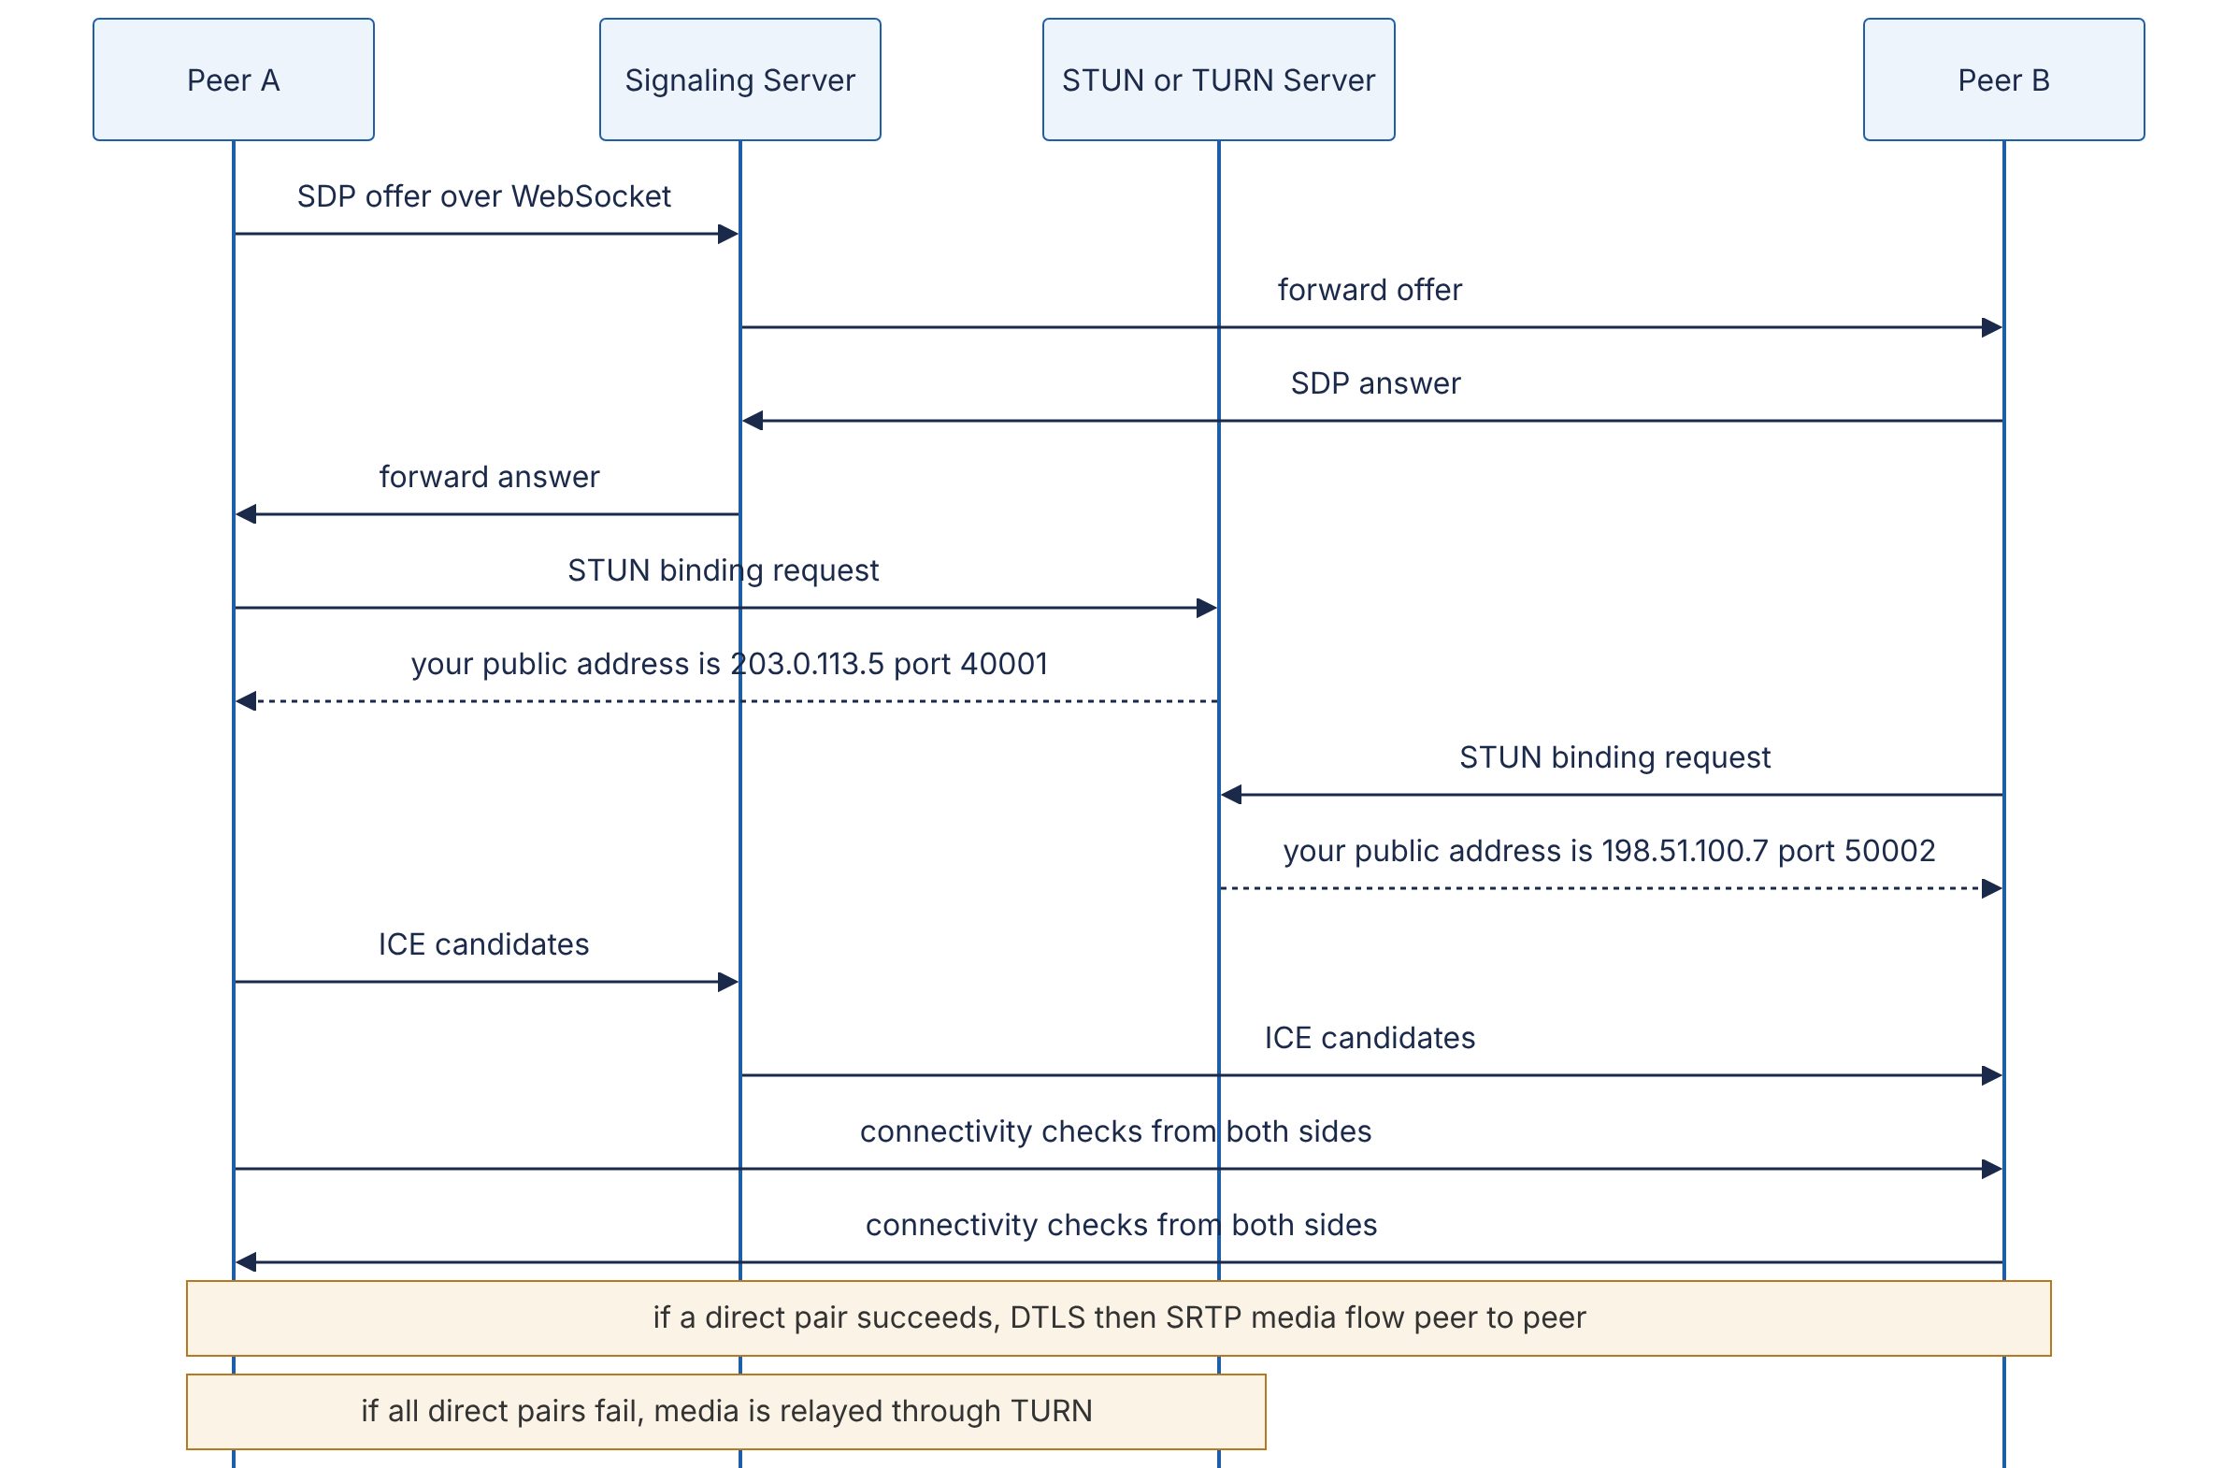
Reading the diagram. The signaling server is your service (often a WebSocket gateway) and relays only offers, answers and candidates over TCP — never media. The STUN server answers “what address do you appear to come from?” with one small UDP exchange. The peers then run simultaneous connectivity checks; if any direct pair works, encrypted media flows peer to peer over UDP and your infrastructure carries nothing. Otherwise TURN relays every media packet — the fallback path and the main cost driver, best deployed in several regions close to users.

9.7.2 Group calls: mesh, SFU and MCU
Peer-to-peer works for two people. For N participants there are three topologies:
- Mesh — every participant sends its stream to every other participant directly.
- SFU (Selective Forwarding Unit) — every participant sends one stream (often several resolutions at once, called simulcast) to a server, which forwards packets to each receiver without decoding them, choosing a resolution per receiver.
- MCU (Multipoint Control Unit) — the server decodes all streams, mixes them into one composite (a grid video, a mixed audio track), re-encodes and sends one stream to each participant.
Figure 9.7 — Mesh, SFU and MCU topologies for a four-person call.
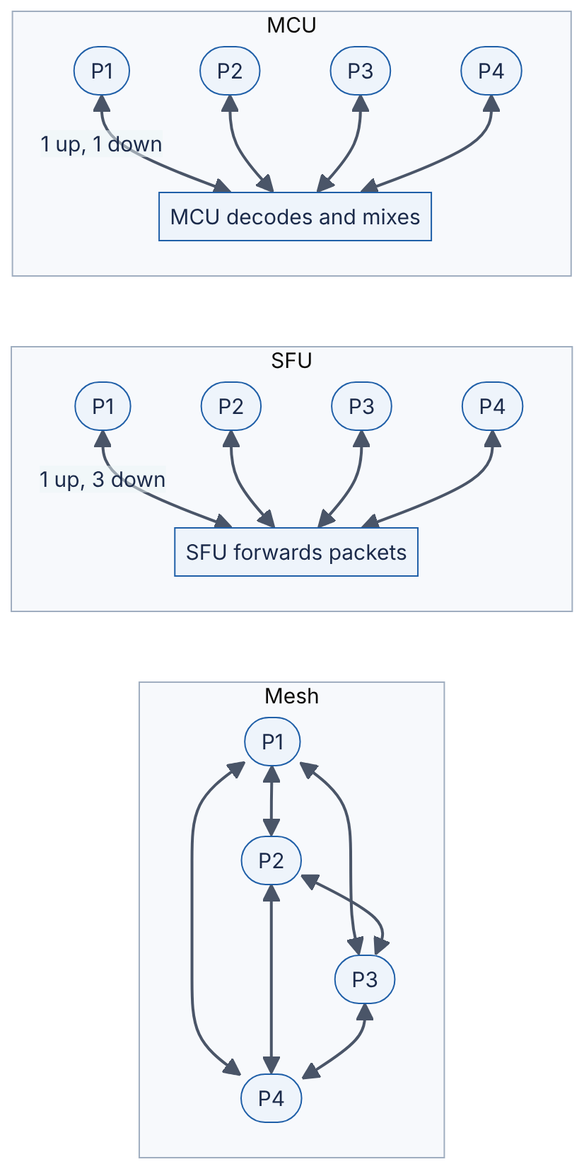
Reading the diagram. In the mesh, each participant uploads three copies of its video, so home upstream bandwidth is the bottleneck. With an SFU, each participant uploads once and downloads three streams; the server only copies packets (cheap CPU, high bandwidth). With an MCU, each participant uploads and downloads one stream, but the server decodes, mixes and re-encodes everything (expensive CPU, added latency, no end-to-end encryption). All arrows are asynchronous UDP media; signaling (not shown) runs through your WebSocket service.
FORMULA
Per-participant bandwidth by topology
Topology | Upload per participant | Download per participant | Server work
Mesh | $\left(N−1\right) b$ | $\left(N−1\right) b$ | none
SFU | $b$ (or $≈1.5b$–$2b$ with simulcast) | $\left(N−1\right) b$ (less if receivers get lower layers) | forward $N\left(N−1\right)$ streams
MCU | $b$ | $b$ | decode $N$, mix, encode up to $N$

Symbol | Meaning | Units
$N$ | Participants in the call | participants
$b$ | Bitrate of one participant’s stream | Mbit/s
WORKED EXAMPLE
Worked example — Six-person video call at 1.5 Mbit/s per stream.
- Mesh upload per participant: $\left(6−1\right)×1.5=7.5$ Mbit/s. Many residential connections upload less than this, so the call degrades — mesh is practical for about 2–4 participants.
- SFU upload: 1.5 Mbit/s (say 2.5 Mbit/s with three simulcast layers). Download: $5×1.5=7.5$ Mbit/s at full quality; with the SFU sending low layers for thumbnails and full quality only for the active speaker, perhaps $1.5+4×0.3=2.7$ Mbit/s.
- SFU server egress for this one call: $6×7.5=45$ Mbit/s at full quality. A server with 10 Gbit/s of egress at 70 % target utilization carries about $7,000/45≈155$ such calls — bandwidth, not CPU, is the SFU’s limit.
- MCU: each participant sends and receives 1.5 Mbit/s, but the server must decode six and encode up to six video streams per call — CPU-bound, typically far fewer calls per server than an SFU.
Engineering implication. Most modern group-video services use SFUs (often cascaded across regions) because they scale better per dollar and preserve per-receiver adaptation; MCUs survive for interop with legacy room systems and very weak clients.
Table 9.9 — Group-call topologies compared.
Aspect | Mesh | SFU | MCU
How it works | Every peer sends to every peer | Server forwards packets selectively | Server decodes, mixes, re-encodes
Advantages | No media servers; lowest latency for 2–3 people | Scales to large calls; per-receiver quality; cheap CPU | Minimal client bandwidth and CPU
Disadvantages | Upload grows with $N$ | Download grows with $N$; server bandwidth heavy | Very high server CPU; extra latency; breaks end-to-end encryption
Choose when | 1:1 or ≤ 4 people | Default for group calls and webinars | Legacy endpoints, recording composites, very weak clients

Failure scenarios and misconceptions
Table 9.10 — WebRTC failure scenarios.
What goes wrong | Why | Detection | Recovery | Prevention
Call never connects for some users | Symmetric NAT or UDP-blocking firewall; no TURN configured | ICE state failed; failures cluster by network | Retry with TURN over TCP/TLS 443 | Always deploy TURN with TCP/TLS fallback
TURN bill explodes | Many sessions relay media | Relay bandwidth per session metric | — | Regional TURN, short-lived credentials, monitor relay ratio
Media freezes on network change | Wi-Fi → cellular changes the address | ICE disconnected | ICE restart via signaling | Handle iceconnectionstatechange; trigger ICE restart
Open TURN relay abused | Static TURN credentials leaked | Unknown traffic on relays | Rotate credentials | Time-limited, HMAC-derived TURN credentials per session
COMMON MISTAKE
“WebRTC means I don’t need servers.” You always need a signaling service, STUN, and — for reliable connectivity — TURN; group calls need SFUs. WebRTC removes servers from the media path only in the best case.

9.8 Mobile push: APNs and FCM

9.8.1 What mobile push is
DEFINITION
Definition — Mobile push notification. A message sent by an application’s server to a platform-operated push service — Apple Push Notification service (APNs) for Apple platforms, Firebase Cloud Messaging (FCM) for Android (and optionally iOS and web) — which delivers it, on a best-effort basis, over a single persistent connection that the operating system maintains to that service on behalf of all apps.
Browsers have an analogous, standardized mechanism, Web Push [Thomson et al. 2016], in which a service worker receives messages relayed by the browser vendor’s push service; the design principles below apply to it as well.

First-principles explanation
If every app kept its own background WebSocket, heartbeats would wake the cellular radio constantly and drain the battery in hours. So mobile operating systems suspend background apps and keep one connection to the platform push service, multiplexing every app’s notifications over it — one mailroom for the whole apartment building. You hand your letter to the mailroom; it decides when to deliver, may combine or discard letters, and never sends a receipt.

How it works internally
- Registration. On launch, the app asks the OS for a push token (APNs device token, FCM registration token). The token identifies this app on this device to the push service.
- Token upload. The app sends the token, with the user ID and a timestamp, to your backend, which stores it (a user typically has several tokens: phone, tablet, reinstalls).
- Send. When an event occurs, your notification service (§52.4 designs one) looks up the user’s tokens and calls the provider:
  - APNs: an HTTP/2 POST /3/device/<token> to api.push.apple.com (or api.sandbox.push.apple.com for development), authenticated by a JWT signed with your .p8 key (token-based) or by a TLS client certificate. Headers include apns-topic (the app bundle ID), apns-push-type (alert, background, voip, …), apns-priority (10 = send immediately, 5 = send at a power-efficient time), apns-expiration and apns-collapse-id [Apple: Sending notification requests to APNs].
  - FCM: an HTTPS POST https://fcm.googleapis.com/v1/projects/<project>/messages:send (the HTTP v1 API) with an OAuth 2.0 access token from a service account. The JSON body names the token (or a topic) and carries notification and/or data payloads plus platform options such as android.collapse_key, android.ttl and android.priority [FCM Docs].
- Store and forward. If the device is offline, the provider stores the message for a limited time and delivers it when the device reconnects — with strict limits (below).
- Feedback. The provider’s response tells you whether the token is still valid. APNs returns HTTP 410 (Unregistered) for a token that is no longer active [Apple: Handling notification responses from APNs]; FCM returns UNREGISTERED (HTTP 404) or INVALID_ARGUMENT (HTTP 400). Delete or deactivate such tokens.
Figure 9.8 — Mobile push architecture.
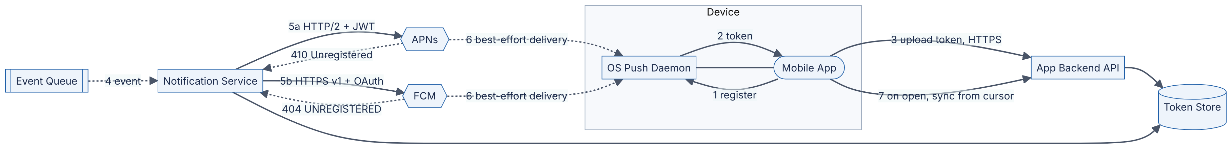
Reading the diagram. The OS push daemon owns the device’s single connection to the provider. Steps 1–3 obtain and upload the token over HTTPS into your token store. Events arrive asynchronously (dotted) at the notification service, which calls APNs or FCM synchronously. Provider-to-device delivery is asynchronous and best-effort — the dotted arrows mark where your guarantees end. Error responses (410/404) let the service prune dead tokens. Step 7 is the most important arrow: on open, the app syncs authoritative state with a cursor. Failure points: throttling, expired tokens, offline devices, OS suppression (Focus, battery saver). The notification service is a stateless worker pool scaled by send rate.

9.8.2 Delivery is not guaranteed — design for it
Push is a hint, never the source of truth:
- Limited storage while offline. APNs stores only the most recent notification per app for an offline device; sending a new one discards the stored one [Apple: Sending notification requests to APNs]. FCM stores up to 100 non-collapsible messages per device; past that it discards all of them and tells the app (on Android via a “deleted messages” callback) that it must sync with your server [FCM Docs: collapsible messages].
- Expiry. Messages older than their TTL (apns-expiration; FCM ttl, default and maximum 4 weeks) are dropped.
- OS policy. Low-priority and background (“silent”) pushes may be delayed, batched or throttled by the OS to save power; Apple’s guidance is to treat background notifications as low priority and to avoid sending more than a few per hour (as of 2024). Users can disable notifications entirely.
- No delivery receipt. A 200 from APNs or FCM means “accepted”, not “displayed”.
The robust pattern is tickle, then fetch: the push says “something changed” (optionally with display text), and the app, when opened or woken, fetches the authoritative state from your API since its last cursor — the same cursor idea as §9.4.

Collapse keys
When notifications about the same thing pile up — “3 new messages”, “4 new messages” — only the latest matters. A collapse key tells the provider that a newer message replaces an older pending one. APNs uses the apns-collapse-id header (at most 64 bytes), and notifications sharing an ID are shown as one. FCM uses collapse_key and keeps at most four distinct collapse keys per device, with no guarantee which four survive [FCM Docs: collapsible messages]. Use collapse keys for state (“order status: shipped”), not for messages that each carry unique content.

Token lifecycle
Tokens change when users reinstall, restore a backup to a new device, clear app data, or when the platform rotates them. Rules of thumb (as of 2024–2025):
- Fetch the token on every app start and upload it if changed, with a last_seen timestamp.
- Delete tokens on 410/404 UNREGISTERED responses immediately.
- Expire tokens not refreshed for a period you choose; Google recommends treating tokens older than about one month as stale, and FCM itself treats Android tokens inactive for 270 days as expired [FCM Docs: token management].
- Keep one row per (user, device, app) so that a user’s ten old reinstall tokens do not each receive a copy.
- Never put sensitive content in the payload when the lock screen could show it; payloads are limited to 4 KB (4,096 bytes) for regular notifications on both APNs and FCM.

Mathematical foundations
WORKED EXAMPLE
Worked example — Breaking-news push to 50 million devices.
Assume 50 million registered tokens, of which 8 % are stale (uninstalled apps), and you want delivery started within 5 minutes.
- Required send rate: $50,000,000/300\text{ s}≈167,000$ requests/s to APNs and FCM combined.
- With HTTP/2 multiplexing, assume one worker connection sustains about 1,000 sends/s (an Illustrative figure; measure your own): $167,000/1,000=167$ concurrent provider connections across the worker fleet.
- Wasted sends to stale tokens: $0.08×50\text{ M}=4$ million requests, each returning 410/404 — prune them so that the next campaign is 8 % cheaper.
- Return traffic: if 10 % of recipients open the app in the first minute and each open triggers a sync, your API sees $5,000,000/60≈83,000$ extra requests/s. Stagger large sends, or put enough content in the payload that opening needs no immediate fetch.
Engineering implication. The bottleneck of a mass push is often your own API absorbing the return traffic, not the push provider.
Table 9.11 — APNs and FCM compared (as of 2024–2025).
Aspect | APNs | FCM
Platforms | iOS, iPadOS, macOS, watchOS, tvOS, Safari web push | Android; also iOS (via APNs) and web
Server API | HTTP/2, POST /3/device/<token> | HTTPS HTTP v1 messages:send
Authentication | JWT from .p8 key, or TLS client certificate | OAuth 2.0 service-account access token
Max payload | 4 KB (VoIP: 5 KB) | 4 KB
Offline storage | Latest notification per app only | Up to 100 non-collapsible; 4 collapse keys
Collapse mechanism | apns-collapse-id (≤ 64 bytes) | collapse_key
Invalid-token signal | HTTP 410 Unregistered | UNREGISTERED (404)
Fan-out helpers | None (one request per token) | Topics and device groups
COMMON MISTAKE
“A 200 OK from APNs means the user saw the notification.” It means APNs accepted the request. The device may be offline beyond the expiration, the notification may be replaced by a newer one, or the user may have disabled alerts. Track engagement through the app itself (for example, an “opened from notification” event), not through provider responses.

9.9 Connection management at scale
Sections 9.4–9.6 each ended with the same observation: once a server holds long-lived connections, it becomes stateful, and the problems shift from “how many requests per second?” to “how many connections, where are they, and what happens when they all move at once?”. This section assembles the pieces into a production architecture.

9.9.1 Connection gateways
DEFINITION
Definition — Connection gateway. A dedicated, thin service tier whose only job is to terminate long-lived client connections (WebSocket, SSE, long polling), authenticate them, track which user and topics each connection belongs to, and move messages between those connections and back-end services through a messaging layer. It contains no business logic.

Why does this exist?
Put chat logic, feed ranking and the WebSocket server in one service, and every deploy of chat logic disconnects every user, every memory leak kills millions of connections, and CPU-based autoscaling adds instances that receive no connections until clients reconnect. Separating a gateway tier (stateful, memory-bound, simple, rarely deployed) from business services (stateless, CPU-bound, deployed many times a day) is the central design move of large real-time systems — an airport terminal that airlines can reschedule around without rebuilding it.
Figure 9.9 — Architecture of a connection gateway fleet.
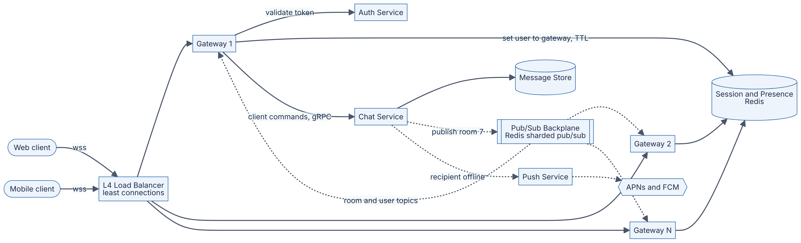
Reading the diagram. Clients connect over wss through an L4 load balancer (least connections) and stay on the gateway they reach. On connect, the gateway validates the token and records “user → gateway” with a TTL in a Redis registry. Gateways subscribe to backplane topics for rooms with local members. A client message goes synchronously (gRPC) to the chat service, which persists it in the message store — the durable boundary — and then publishes it asynchronously (dotted); the backplane delivers only to subscribed gateways, which write to local sockets. Offline recipients go to the push service (§9.8). Failure points: a gateway crash drops its connections (clients reconnect and resync from the store); a backplane outage pauses live fan-out but loses no data; a registry outage breaks presence and targeted delivery. Gateways scale by connections, the chat service by request rate, the backplane by fan-out.

9.9.2 Memory per connection and capacity estimation
An idle connection consumes almost no CPU — on an event-loop server (§6.13), it is a file descriptor registered with epoll — so gateways are usually memory-bound and blast-radius-bound rather than CPU-bound. The C10K problem of the late 1990s [Kegel 1999] asked how to hold 10,000 connections on one server; modern kernels and runtimes routinely hold hundreds of thousands to millions.
Table 9.12 — Per-connection memory budget for a TLS WebSocket gateway (Illustrative assumptions; measure your own stack).
Component | Typical range | Assumed
Kernel socket structures, idle (buffers grow only while data is in flight) | 2–10 KB | 4 KB
TLS session state and record buffers (depends heavily on library and buffer-release settings) | 5–40 KB | 16 KB
Runtime task (goroutine stack, Erlang process, async task) | 2–8 KB | 4 KB
Application read/write buffers | 4–16 KB | 8 KB
Session state: user, auth claims, subscriptions, outbound queue | 1–20 KB | 8 KB
Total | 14–94 KB | 40 KB
Note the caveat in the first row: Linux autotunes socket buffers up to tcp_rmem/tcp_wmem maximums of several megabytes per socket. A burst of traffic to many slow clients can multiply kernel memory far above the idle figure; cap buffer maximums with sysctl and bound application queues (§9.6.7).
FORMULA
Gateway fleet sizing
$$n_{\text{conn,max}}=min\left(\frac{f⋅M}{m}, c_{\text{blast}}\right) S=Z⋅\left\lceil \frac{C}{\left(Z−1\right) n_{\text{conn,max}}}\right\rceil$$
Symbol | Meaning | Units
$M$ | RAM per gateway server | bytes
$f$ | Fraction of RAM budgeted for connections | dimensionless
$m$ | Memory per connection | bytes/connection
$c_{\text{blast}}$ | Maximum connections you accept losing in one server failure | connections
$n_{\text{conn,max}}$ | Design ceiling of connections per server | connections
$C$ | Peak concurrent connections | connections
$Z$ | Availability zones; the fleet must survive loss of one | zones
$S$ | Total gateway servers | servers
WORKED EXAMPLE
Worked example — 10 million concurrent connections.
Requirements: $C=10,000,000$ concurrent WebSocket connections at peak; three availability zones ($Z=3$); survive the loss of one zone; per-connection memory $m=40$ KB from Table 9.12 (SI units: 1 KB = 1,000 bytes); servers with $M=64$ GB RAM, of which $f=50 \%$ is budgeted for connections (the rest for the OS, runtime heap, garbage-collection headroom and traffic bursts).
- Memory limit per server: $0.5×64\text{ GB}/40\text{ KB}=32×{10}^{9}/40×{10}^{3}=800,000$ connections.
- Blast-radius limit: losing one server should disconnect at most about 5 % of users and produce a reconnect wave the rest of the fleet can absorb. Choose $c_{\text{blast}}=500,000$. So $n_{\text{conn,max}}=min\left(800,000,500,000\right)=500,000$.
- Zone-failure sizing: after losing one zone, the remaining two must hold all 10 M: servers per zone $=⌈10,000,000/\left(2×500,000\right)⌉=10$. Total $S=3×10=30$.
- Deploy and surge headroom: during a rolling deploy one server per zone is draining, and traffic may exceed forecast by 10–20 %. Add two servers per zone: 36 servers (12 per zone).
- Normal load per server: $10,000,000/36≈278,000$ connections → $278,000×40\text{ KB}≈11.1$ GB of connection memory.
- After losing a zone: $10,000,000/24≈417,000$ connections per server → 16.7 GB — inside the 32 GB budget.
- Total connection memory: $10,000,000×40\text{ KB}=400$ GB across the fleet.
- File descriptors: each process needs more than 500,000 open files; set the nofile limit to about 1,000,000.
- Heartbeats: with a 25 s ping interval, $10,000,000/25=400,000$ pings/s fleet-wide, about 11,000 per server — trivial CPU, but visible in packet-rate and NAT-table metrics.
- Message CPU: if each connection receives on average one message every 10 s, a server at 278,000 connections sends about 27,800 frames/s plus 11,000 pongs/s to process — well within one multi-core server (Illustrative; benchmark with your payload size and TLS library).
Interpretation. Memory alone would allow about 13 servers ($10\text{ M}/800\text{ k}$); fault tolerance and blast radius nearly triple that. That is typical: connection fleets are sized by failure behavior, not by steady-state efficiency.
Engineering implication. Measure $m$ on your real stack with a load generator holding idle TLS connections (resident memory ÷ connections), re-measure under message load, and state the blast-radius limit explicitly in the design document.

Real-world industry applications
INDUSTRY EXAMPLE
WhatsApp’s per-server connection counts. In January 2012 WhatsApp’s blog reported pushing a single server past 2 million concurrent TCP connections, following an earlier 1 million milestone; a contemporaneous Erlang Factory talk by Rick Reed described the Erlang/FreeBSD stack and the kernel and VM tuning involved. These figures show what a tuned stack can hold; production fleets generally run below such peaks to keep headroom for failures and deploys. Evidence: Primary — [WhatsApp 2012]; [Reed 2012].
INDUSTRY EXAMPLE
Discord’s Elixir gateway. Discord’s engineering blog describes scaling its Elixir/Erlang real-time system to nearly 5 million concurrent users, including fan-out problems in very large communities and bursts of reconnecting sessions overwhelming a few coordinating processes, plus libraries the team built in response (for example, Manifold to distribute message sending across nodes). Evidence: Primary — [Discord 2017].

9.9.3 Routing messages: registries and the pub/sub backplane
A message for room 7 is created by a chat service instance; its recipients’ connections are scattered across 36 gateways. Two routing designs exist, and large systems use both:
- Topic-based pub/sub backplane. Each gateway subscribes to room:7 when its first local member of room 7 connects and unsubscribes when the last leaves; publishers send to room:7 without knowing which gateways care. Redis Pub/Sub is the usual starting point: simple and sub-millisecond, but fire-and-forget (at-most-once) — a gateway whose subscription blips misses messages. In Redis Cluster, classic PUBLISH is broadcast to every node; sharded pub/sub (SPUBLISH/SSUBSCRIBE, Redis 7.0+) keeps a channel on the shard owning its hash slot [Redis Docs: Pub/Sub]. Kafka or NATS fit when you need replay or more throughput.
- Connection registry with direct routing. A registry maps user → (gateway, connection ID). For one-to-one messages the sender looks up the user’s gateway(s) and calls them directly (gRPC). This avoids creating millions of per-user topics but needs a registry that is kept accurate as connections churn.
Because the live path is lossy, correctness comes from the durable path: every message gets a per-conversation sequence number in the message store; clients track the last sequence they have seen; on reconnect, or when they notice a gap, they fetch the missing range over HTTPS. Live delivery is an optimization of latency; the store guarantees completeness. This is the same at-least-once-plus-deduplication pattern as §30.8.
FORMULA
Fan-out load
$$D=μ×\overset{‾}{r}$$
Symbol | Meaning | Units
$D$ | Message deliveries written to sockets | deliveries/second
$μ$ | Messages published | messages/second
$\overset{‾}{r}$ | Average number of online recipients per message | recipients/message
WORKED EXAMPLE
Worked example — Fan-out for a team chat product.
At peak, users send $μ=50,000$ messages/s; the average channel has 40 members, 25 % online, so $\overset{‾}{r}=10$ and $D=500,000$ deliveries/s — about 13,900 socket writes/s per gateway across 36 gateways. But one announcement channel with 200,000 online members turns a single message into 200,000 deliveries. Large channels need posting rate limits and delivery once per gateway (each gateway then fans out locally), so the backplane carries 36 copies rather than 200,000.

9.9.4 Sticky routing and session resumption
A WebSocket is sticky by construction for its lifetime. The question is what happens on reconnect:
- Stateless reconnect (preferred). Any gateway can accept any user; everything needed to resume — subscriptions, last-seen sequence numbers — is rebuilt from the client’s handshake and the shared registry. Load balancing is then simple least-connections.
- Sticky reconnect. The load balancer returns a user to the same gateway (consistent hashing on user ID or an affinity cookie, §19.6) so a per-connection buffer can be resumed without a store query — cheaper in the common case, but it breaks whenever the fleet resizes and concentrates hot users.
Long-polling and SSE fallbacks require stickiness, or shared state, because consecutive HTTP requests of one logical session must find the same buffer (§9.4).

9.9.5 Presence with heartbeats
Presence — the green dot — answers “is this user online right now?”. The naïve design writes online on connect and offline on disconnect; it fails because disconnections are often silent (§9.6.5) and gateways crash without cleaning up. Robust presence uses leases:
- On connect and on each heartbeat (every $h$ = 30 s), the gateway writes presence:user42 = gateway-7 with a TTL of about $3h$ = 90 s.
- If heartbeats stop, the key expires and the user becomes offline within at most 90 s — no explicit cleanup needed after a crash.
- A user with several devices is online if any device’s lease is alive.
- Status changes (online → offline, active → idle) are published to interested watchers through the backplane.
To cut write load, gateways refresh batched leases (one pipeline per second per gateway) or refresh a per-gateway liveness key and record users per gateway, so a dead gateway expires all its users at once.
WORKED EXAMPLE
Worked example — Presence load for 10 million online users.
- Lease refresh writes with $h=30$ s: $10,000,000/30≈333,000$ writes/s — a sharded Redis cluster is required (several shards at an assumed 100,000+ simple operations/s each), or the per-gateway lease design above, which needs only 36 writes/s plus membership changes.
- Status-change fan-out: if each user changes status every 10 minutes on average and 50 online contacts watch each user, $10,000,000×\left(1/600\right)×50≈833,000$ presence deliveries/s — more than the chat messages themselves.
Engineering implication. Presence is often the most expensive real-time feature. Common mitigations: deliver presence only for users currently visible on the watcher’s screen (subscribe on view), coalesce rapid flaps (offline-then-online within a few seconds), and do not show live presence for very large groups.

9.9.6 Reconnect storms and jittered backoff
When a gateway dies, a load balancer fails over or a region recovers, hundreds of thousands of clients lose their connections at once. If all reconnect immediately, surviving gateways face a spike of TLS handshakes, the auth service a spike of token checks, and the message store a spike of resync queries; they time out, clients retry, and the storm sustains itself — the thundering herd. The fix is exponential backoff with jitter (§22.12, [Brooker 2015]).
FORMULA
Reconnect arrival rate with uniform jitter
$$λ_{\text{reconnect}}≈\frac{n_{\text{lost}}}{W}$$
Symbol | Meaning | Units
$λ_{\text{reconnect}}$ | Peak reconnect (handshake) rate | connections/second
$n_{\text{lost}}$ | Connections dropped by the failure | connections
$W$ | Width of the random delay window for the first reconnect attempt | seconds
WORKED EXAMPLE
Worked example — One gateway of 36 fails.
- $n_{\text{lost}}=278,000$ connections (from §9.9.2).
- No jitter, everyone retries within about 1 s: $λ≈278,000$ handshakes/s, about 7,900 per surviving gateway, plus 278,000 auth checks/s and 278,000 resync queries/s — likely to overload auth and the store.
- Uniform jitter over $W=30$ s: $λ≈9,300$/s fleet-wide, about 265 per gateway — comfortably absorbed.
- A simulation of 500,000 clients confirms the arithmetic: all in one second without jitter; a peak of about 16,900 per one-second bucket with a 30 s uniform window (expected $500,000/30≈16,700$).
Engineering implication. Jitter turns a spike into a plateau. Add server-side protection too: a token-bucket admission limit on new handshakes per gateway, close code 1013 (“try again later”) with a server-suggested delay, and resumable sessions so a reconnect costs a delta fetch rather than a full resync.
import random
def full_jitter_delay(attempt: int, base: float = 1.0, cap: float = 60.0) -> float:
"""'Full jitter': uniform in [0, min(cap, base * 2**attempt)] seconds."""
return random.uniform(0, min(cap, base * (2 ** attempt)))
# illustrative client loop
# attempt = 0
# while not connected:
# await asyncio.sleep(full_jitter_delay(attempt)); attempt += 1
# connected = await try_connect() # reset attempt = 0 after a stable minute
What to notice: clients that failed together spread out immediately and back off further if the outage persists; cap bounds the wait; reset the attempt counter only after a connection has stayed healthy for a while, or a server that accepts and immediately drops connections causes a tight retry loop.

9.9.7 Graceful drain on deploy
Deploying a gateway restarts the process that owns its connections. Doing it abruptly is a self-inflicted reconnect storm. A graceful drain:
- Stop new connections. Fail the gateway’s readiness check or deregister it from the load balancer; existing connections stay open.
- Close gradually. Over a drain window $D$ (for example, 5 minutes), close connections at a steady rate $n/D$ — 278,000 / 300 s ≈ 930 per second — using close code 1012 (service restart) or 1001 (going away), or send an application “please reconnect” message with a randomized delay hint.
- Clients reconnect with jitter and land on other gateways, because the load balancer no longer routes to this one.
- Clean up and exit. Unsubscribe from the backplane, release presence leases, flush metrics, exit.
- Orchestrator settings. Kubernetes gives a pod 30 seconds by default (terminationGracePeriodSeconds) between SIGTERM and SIGKILL; gateways need this raised to cover $D$, plus a preStop hook that starts the drain (§42.7).
Rolling 36 servers in batches of three (one per zone) with a 5-minute drain takes $12×5=60$ minutes — another reason to keep business logic out of the gateway and deploy it rarely.

Failure scenarios
Table 9.13 — Connection-fleet failure scenarios.
What goes wrong | Why | Detection | Recovery | Prevention
Reconnect storm takes down auth | Mass disconnect, synchronized retries | Handshake rate and auth latency spike together | Admission control, 1013 with delay | Jittered backoff; cached token validation at gateway
New gateways sit idle after scale-out | Connections only rebalance on reconnect | Connection-count skew across gateways | Shed a few % of connections from hot gateways | Least-connections LB; periodic gentle rebalancing
Messages lost during backplane blip | Redis Pub/Sub is at-most-once | Clients detect sequence gaps | Client fetches missing range | Sequence numbers + durable store as source of truth
Users shown online for hours | Presence written on connect, never expired | Online count exceeds connection count | Expire stale entries | Lease with TTL refreshed by heartbeat

9.10 Choosing a real-time technique
No technique is best; each answers a different question. Work through the requirements in this order: Is the app even running? Which direction does data flow? How fresh must it be? Is it media? What does the network allow?
Figure 9.10 — Decision flowchart for choosing a real-time technique.
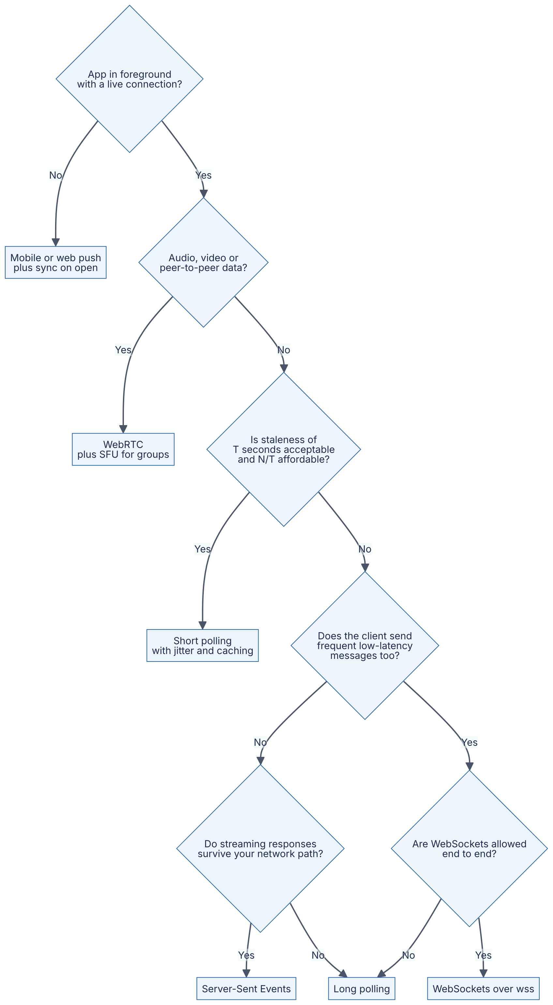
Reading the diagram. Diamonds are requirement questions; rectangles are recommended techniques. Only platform push can reach a suspended mobile app, so that split comes first; media goes to WebRTC regardless. For ordinary data, the cheapest technique that meets the freshness requirement wins; long polling is the fallback for hostile networks. Real systems combine branches: a chat app uses WebSockets in the foreground, push in the background, HTTPS for history and WebRTC for calls.
Table 9.14 — Real-time techniques compared.
Aspect | Short polling | Long polling | SSE | WebSockets | WebRTC | Mobile push
What it is | Periodic HTTP requests | Held HTTP request | Streamed HTTP response | Upgraded full-duplex TCP | P2P UDP media/data | OS-level provider delivery
Direction | Client pulls | Server → client | Server → client | Both | Both, peer to peer | Server → device
Latency | ≈ T/2 | ≈ 1 RTT | ≈ ½ RTT | ≈ ½ RTT | Lowest; UDP | Seconds to never
Overhead per message | Full HTTP request | Full HTTP request | ~10–50 bytes | 2–14 bytes | RTP/SRTP headers | Provider API call
Server state | None | Parked request | Open stream | Open connection | Signaling + TURN/SFU | Token store
Infrastructure friendliness | Excellent | Good (timeouts) | Good (buffering) | Needs Upgrade + timeouts | NAT traversal, TURN | Provider-dependent
Resumption | Cursor | Cursor | Built in (Last-Event-ID) | Build your own | ICE restart | Collapse + sync
Operational complexity | Low | Medium | Medium | High | Very high | Medium
Cost driver | $N/T$ requests | Concurrent connections | Concurrent connections | Concurrent connections + fan-out | TURN/SFU bandwidth | Send volume + return traffic
Use cases | Dashboards, job status | Fallback transport | Feeds, notifications, LLM token streams | Chat, collaboration, games, trading | Calls, screen share, P2P files | Background alerts
Choose when | Rare updates, few clients | Streaming blocked | One-way, HTTP-native | Two-way, high frequency | Real-time media | App not running
RECOMMENDATION
Default choices for common products. Notifications badge on a website: SSE (or short polling at 30–60 s if traffic is small). Chat and collaborative editing: WebSockets in the foreground, mobile push in the background, HTTPS sync for history. Live sports scores or stock tickers for millions of viewers: SSE or WebSockets fed from a CDN or edge fan-out tier, with “latest value wins” coalescing. Video meetings: WebRTC with an SFU, WebSockets for signaling. Ride-hailing driver location to a rider: WebSockets or SSE while the app is open, push for “driver arrived” when it is not.
INTERVIEW TIP
In an interview, state the requirement that drives the choice (“updates are server-to-client only and must survive reconnects, so SSE with Last-Event-ID”), then immediately address the scale consequence: how many concurrent connections, how many gateways, how messages reach the right gateway, and what happens on reconnect. Interviewers care far more about the connection-management design (§9.9) than about the name of the protocol.

9.11 Summary and revision notes
SUMMARY
- HTTP is client-initiated; every technique in this chapter is a way for the server to speak first, trading freshness against connection cost and infrastructure complexity.
- Short polling: $R=N/T$; average delay $T/2$; with rare events nearly every request is wasted ($P_{\text{empty}}=e^{−λT}$). Fine for few clients or slow-changing data; jitter the timers.
- Long polling: the server holds the request until data or a hold timeout (keep it below every intermediary’s idle timeout, e.g. 25–30 s); cursors prevent loss in the gap between polls; cost moves from requests to concurrent connections. Comet (2006) and RFC 6202 document it.
- SSE: one streamed text/event-stream response; fields data, event, id, retry, comments for heartbeats; browsers reconnect and send Last-Event-ID; server-to-client only; text only; prefer HTTP/2 to escape the ~6 connections-per-origin limit; disable proxy buffering.
- WebSockets (RFC 6455): HTTP/1.1 Upgrade handshake with Sec-WebSocket-Accept = base64(SHA-1(key + GUID)); frames with 2–14 byte headers; opcodes text, binary, continuation, close, ping, pong; client frames masked to protect intermediaries; heartbeats below idle timeouts; close codes guide reconnection; check Origin; bound send queues and disconnect slow consumers.
- WebRTC: signaling (yours) + ICE with STUN (discover public address) and TURN (relay fallback) + DTLS-SRTP media; mesh for ≤ 4, SFU for most group calls, MCU for weak or legacy clients.
- Mobile push: one OS-managed connection to APNs/FCM; best effort; APNs keeps only the latest notification per app when offline, FCM up to 100 messages and 4 collapse keys; 4 KB payloads; prune tokens on 410/404; push is a tickle — sync from your API with a cursor.
- At scale: thin, rarely deployed connection gateways; size by memory and blast radius and zone failure (10 M connections × 40 KB ≈ 400 GB; 36 servers of 64 GB in the worked example); route through a pub/sub backplane or connection registry; make the durable store with sequence numbers the source of truth; presence as TTL leases refreshed by heartbeats; jittered reconnects ($λ≈n/W$); drain gradually on deploy.

9.12 Knowledge checkpoint
- A site has 400,000 tabs open, each polling every 4 s. What request rate reaches the servers?
- Why does long polling need a cursor, and what goes wrong without one?
- Why should a long-poll hold timeout be 25–30 s rather than 120 s?
- Name the four SSE fields and the purpose of a line that starts with a colon.
- What header does a browser send when an EventSource reconnects, and what must the server do with it?
- Why does SSE over HTTP/1.1 cause problems for users with many tabs, and how does HTTP/2 change this?
- Compute Sec-WebSocket-Accept conceptually: what inputs and which functions?
- What are the header sizes of an unmasked 100-byte frame and a masked 1,000-byte frame?
- Why are client-to-server WebSocket frames masked and server-to-client frames not?
- What is the difference between close codes 1000, 1001, 1006 and 1008?
- Why can’t browser JavaScript rely on WebSocket Ping frames for its own liveness detection?
- What role do STUN and TURN each play in ICE, and which one carries media?
- In a 5-person SFU call at 2 Mbit/s per stream, what is each participant’s upload and full-quality download?
- What does APNs do with notifications sent while a device is offline? What does FCM do?
- Using the formula in §9.9.2, how many gateways are needed for 3 M connections with a 300 k per-server ceiling across 3 zones that must survive one zone failure?
- Why are presence systems built on TTL leases rather than explicit “offline” writes?
Answers
- $R=400,000/4=100,000$ requests/s.
- After each response there is a gap of about one round trip with no outstanding request; events in that gap would be lost unless the next request asks for “everything after cursor c” from a server-side buffer. The cursor also lets the client discard duplicates.
- Proxies and load balancers commonly close idle requests at 60 s (for example, ALB and NGINX defaults); a hold longer than the smallest idle timeout produces errors instead of clean empty responses.
- data, event, id, retry. A line starting with : is a comment, ignored by the client and used as a heartbeat to keep intermediaries from timing out the stream.
- Last-Event-ID, containing the last id: received; the server replays events after it from a buffer (or signals a full resync if the buffer no longer reaches back that far).
- Each SSE stream occupies one of roughly six HTTP/1.1 connections per origin shared across all tabs, so further tabs’ requests stall. Over HTTP/2 streams are multiplexed on one connection, limited only by the negotiated maximum concurrent streams (commonly 100+).
- Concatenate the client’s Sec-WebSocket-Key with the fixed GUID 258EAFA5-E914-47DA-95CA-C5AB0DC85B11, take SHA-1, base64-encode the 20-byte digest.
- Unmasked 100 bytes: 2-byte header. Masked 1,000 bytes: 2 + 2 (extended length) + 4 (key) = 8 bytes.
- Masking with an unpredictable key prevents a malicious script from choosing the exact bytes on the wire and thereby confusing intermediaries (cache poisoning). The attacker controls only browser (upstream) data, so only client frames are masked.
- 1000 normal closure (done; do not auto-reconnect); 1001 going away (server shutdown or navigation; reconnect with jitter); 1006 abnormal closure, never sent, reported locally when TCP died without a Close frame; 1008 policy violation (for example auth failure or slow consumer).
- The browser WebSocket API exposes no method to send Pings or observe Pongs; browsers answer server Pings automatically. Client-side liveness requires an application-level heartbeat message.
- STUN tells a peer the public address and port its NAT presents (server-reflexive candidate); TURN allocates a relay address and forwards traffic when no direct path works. Only TURN carries media.
- Upload 2 Mbit/s (more with simulcast); download $\left(5−1\right)×2=8$ Mbit/s.
- APNs stores only the most recent notification per app and discards older ones. FCM stores up to 100 non-collapsible messages (beyond that it drops them all and signals the app to sync) and at most four collapse keys; both drop messages past their expiry/TTL.
- Per zone $⌈3,000,000/\left(2×300,000\right)⌉=5$; total $3×5=15$ servers, plus deploy/surge headroom (for example 18).
- Disconnections are often silent and gateways can crash; a lease that must be refreshed by heartbeats expires automatically, so presence converges to correct without relying on cleanup code that may never run.

9.13 Interview questions

Basic
Q1. What is the difference between short polling, long polling and WebSockets?
Answer. Short polling sends a request every T seconds and gets an immediate (often empty) answer: simple, stateless, average delay $T/2$, cost $N/T$ requests/s. Long polling sends a request that the server holds until data arrives or a timeout fires, then the client re-requests: near-instant delivery over plain HTTP, but a full HTTP exchange per message and one held connection per client. WebSockets upgrade one HTTP/1.1 connection into a persistent full-duplex channel with 2–14 bytes of framing per message: lowest overhead and bidirectional, but stateful, requiring heartbeats, reconnection logic and proxy/load-balancer configuration.
Q2. When would you choose Server-Sent Events over WebSockets?
Answer. When data flows only from server to client (notifications, feeds, live scores, LLM token streams) and you want to stay on plain HTTP. SSE gets HTTP/2 multiplexing, standard authentication, cookies and observability for free; browsers reconnect automatically and resume with Last-Event-ID. Choose WebSockets when the client also sends frequent low-latency messages or when you need binary frames.

Intermediate
Q3. Users report that WebSocket connections drop every 60 seconds in production but not locally. Diagnose.
Answer. Exactly-periodic drops point to an idle timeout on an intermediary — commonly a load balancer or reverse proxy with a 60 s default — closing connections that carried no traffic. Confirm by correlating close times with connection-open times and checking close codes (1006 on the client indicates TCP loss without a Close frame). Fix by sending server Pings (or application heartbeats) every 20–30 s, below the smallest idle timeout, and optionally raising the timeout on WebSocket routes. Also verify that the proxy forwards Upgrade/Connection correctly and that heartbeats are not suppressed by client backgrounding on mobile.
Q4. Design delivery of a chat message to recipients connected to different gateway servers.
Answer. The sender’s gateway forwards the message to a chat service, which assigns a per-conversation sequence number and persists it (source of truth). The service then publishes to the conversation’s topic on a pub/sub backplane (for example, Redis sharded pub/sub); every gateway with at least one local member is subscribed and writes the message to its local sockets. Recipients without a live connection get an APNs/FCM push with a collapse key. Because the backplane is at-most-once, clients track the last sequence number seen and fetch missing ranges over HTTPS on reconnect or gap detection; deduplicate by sequence number. Discuss large-room fan-out (deliver once per gateway, rate limits) and backpressure (bounded per-connection queues).

Advanced
Q5. Size a gateway fleet for 10 million concurrent connections and explain how you would deploy it without disrupting users.
Answer. Measure memory per idle TLS WebSocket (assume 40 KB) → 400 GB total. On 64 GB servers with 50 % budgeted, memory allows 800 k per server, but cap at a blast-radius limit such as 500 k. To survive losing one of three zones, each zone needs $⌈10\text{M}/\left(2×500\text{k}\right)⌉=10$ servers → 30, plus deploy/surge headroom → 36 (≈ 278 k each, ≈ 11 GB). Raise file-descriptor limits to ~1 M. Heartbeats at 25 s → 400 k pings/s fleet-wide. For deploys: keep the gateway thin so it rarely changes; drain one server per zone at a time — remove from the load balancer, close connections gradually over ~5 minutes with code 1012, clients reconnect with full-jitter backoff, then exit; raise terminationGracePeriodSeconds accordingly. Protect dependencies with admission control on handshakes and cached token validation.
Q6. A gateway crash causes a cascading outage of your auth service. What happened and how do you prevent it?
Answer. A reconnect storm: hundreds of thousands of clients reconnected within a second, each requiring a TLS handshake and a token validation; the auth service saturated, handshakes timed out, clients retried immediately, and the load became self-sustaining — possibly spreading to other gateways and the message store via resync queries. Prevention: client-side exponential backoff with full jitter (spreading $n$ reconnects over a window $W$ gives $λ≈n/W$); server-side admission control (token bucket on new handshakes, close 1013 with a retry hint); validate signed tokens locally at the gateway instead of calling auth on every connect; resumable sessions so a reconnect costs a small delta fetch; smaller per-gateway connection counts to limit blast radius; load-test failure of a gateway at peak.

9.14 Practical exercises
Exercise 9.1 — SSE endpoint with resumption. Run the standard-library SSE server from §9.5. (a) Connect with curl -N http://127.0.0.1:8080/events, disconnect after five events, and reconnect with -H "Last-Event-ID: 5"; confirm no events are lost or duplicated. (b) Write a small HTML page using EventSource and watch the browser reconnect automatically when you restart the server. (c) Replace the in-memory HISTORY with a Redis Stream (XADD/XRANGE) so two server processes behind a proxy can both resume a client. (d) Put NGINX in front with default settings and observe buffering; then fix it with proxy_buffering off.
Exercise 9.2 — WebSocket chat server with heartbeats and backpressure. The following server uses the websockets library (pip install "websockets>=13"; tested with version 17.3 on Python 3.13). It supports rooms, server Pings every 20 s, a maximum message size, and a bounded outbox per client that disconnects slow consumers with close code 1008.
"""Room-based WebSocket chat server with heartbeats and slow-consumer protection."""
import asyncio
import json
from websockets.asyncio.server import serve, ServerConnection
from websockets.exceptions import ConnectionClosed
OUTBOX_LIMIT = 100 # max queued messages per client
rooms: dict[str, set["Client"]] = {}
class Client:
def __init__(self, ws: ServerConnection, room: str, name: str):
self.ws, self.room, self.name = ws, room, name
self.outbox: asyncio.Queue[str] = asyncio.Queue(maxsize=OUTBOX_LIMIT)
def offer(self, message: str) -> None:
"""Non-blocking enqueue; a full outbox means a slow consumer."""
try:
self.outbox.put_nowait(message)
except asyncio.QueueFull:
# Policy: disconnect slow consumers rather than buffer without limit.
asyncio.ensure_future(self.ws.close(code=1008, reason="slow consumer"))
async def writer(self) -> None:
while True:
message = await self.outbox.get()
await self.ws.send(message) # awaits if the TCP send buffer is full
def publish(room: str, sender: str, text: str) -> None:
message = json.dumps({"room": room, "from": sender, "text": text})
for client in list(rooms.get(room, ())):
client.offer(message)
async def handler(ws: ServerConnection) -> None:
# First message must be a join: {"room": "...", "name": "..."}
try:
hello = json.loads(await asyncio.wait_for(ws.recv(), timeout=10))
room, name = str(hello["room"]), str(hello["name"])
except (asyncio.TimeoutError, ValueError, KeyError, TypeError):
await ws.close(code=1008, reason="expected join message")
return
client = Client(ws, room, name)
rooms.setdefault(room, set()).add(client)
writer_task = asyncio.create_task(client.writer())
publish(room, "system", f"{name} joined")
try:
async for raw in ws: # reader loop
if isinstance(raw, str) and len(raw) <= 4096:
publish(room, name, raw)
except ConnectionClosed:
pass
finally:
writer_task.cancel()
rooms[room].discard(client)
if not rooms[room]:
del rooms[room]
publish(room, "system", f"{name} left")
async def main() -> None:
# Ping every 20 s; close if no Pong within 20 s (detects dead TCP peers).
async with serve(handler, "127.0.0.1", 8765,
ping_interval=20, ping_timeout=20,
max_size=64 * 1024) as server:
await server.serve_forever()
if __name__ == "__main__":
asyncio.run(main())
What to notice:
- Each connection has two tasks: the handler’s reader loop and a writer draining a bounded queue. Fan-out (publish) never awaits, so one slow socket cannot stall delivery to the rest of the room.
- When a client’s outbox fills, the server closes it with 1008; in testing, a client that stopped reading while another flooded the room was disconnected with 1008 slow consumer while the server stayed healthy.
- The finally block is the cleanup path from Figure 9.5: unsubscribe and announce departure regardless of how the connection ended.
- max_size bounds memory per inbound message (oversized messages are closed with 1009).
Tasks: (a) write a client with websockets.asyncio.client.connect that joins a room and prints messages; (b) add per-room sequence numbers and a {"type":"resume","after":N} message backed by a bounded history; (c) run two server processes and connect them with Redis Pub/Sub so rooms span processes; (d) add a client reconnect loop using full_jitter_delay from §9.9.6 and kill the server to watch the reconnect spread.
Exercise 9.3 — Measure memory per connection. Using Exercise 9.2’s server, open 10,000 idle connections from a load generator (raise ulimit -n first), record the server’s resident memory before and after, and compute KB per connection. Repeat with wss:// (TLS) and compare against Table 9.12.
Exercise 9.4 — Capacity spreadsheet. Implement the formulas from §9.3, §9.4 and §9.9 in a script that takes $N$, $T$, $λ$, $m$, $M$, $f$, $Z$ and $c_{\text{blast}}$ and prints request rates, gateway counts, memory, heartbeat rate and reconnect-storm peak for a given jitter window.

9.15 Design challenges
- Live sports scores for 20 million viewers. Scores change a few times per minute; viewers must see updates within 2 seconds. Compare short polling through a CDN (cacheable responses, $T$ = 2 s) with SSE through an edge fan-out tier. Estimate request rate, connection count and egress for each, and decide.
- Collaborative document editor. Up to 50 concurrent editors per document, 10 keystroke operations per second per editor, cursors and presence shown live. Design the gateway routing (all editors of a document on one node, or a backplane?), ordering (per-document sequence numbers), backpressure for cursor updates (coalesce), and what happens when the node holding a document fails.
- Ride-hailing driver tracking. 1 million active drivers send GPS every 4 s; riders watch their assigned driver while the app is open and receive “driver arrived” when it is not. Choose techniques for each direction, size the ingest and fan-out, and design behavior when the rider’s phone loses connectivity for 30 s.

9.16 References
- Fette, I., Melnikov, A. The WebSocket Protocol (RFC 6455). IETF, 2011. https://www.rfc-editor.org/rfc/rfc6455
- WHATWG. HTML Living Standard — §9.2 Server-sent events. WHATWG, living standard. https://html.spec.whatwg.org/multipage/server-sent-events.html
- Loreto, S., Saint-Andre, P., Salsano, S., Wilkins, G. Known Issues and Best Practices for the Use of Long Polling and Streaming in Bidirectional HTTP (RFC 6202). IETF, 2011. https://www.rfc-editor.org/rfc/rfc6202
- Russell, A. Comet: Low Latency Data for the Browser. Infrequently Noted (blog), 2006. https://infrequently.org/2006/03/comet-low-latency-data-for-the-browser/
- Alvestrand, H. Overview: Real-Time Protocols for Browser-Based Applications (RFC 8825). IETF, 2021. https://www.rfc-editor.org/rfc/rfc8825
- W3C. WebRTC: Real-Time Communication in Browsers. W3C Recommendation. https://www.w3.org/TR/webrtc/
- Uberti, J., Jennings, C., Rescorla, E. JavaScript Session Establishment Protocol (JSEP) (RFC 8829). IETF, 2021. https://www.rfc-editor.org/rfc/rfc8829
- Keränen, A., Holmberg, C., Rosenberg, J. Interactive Connectivity Establishment (ICE) (RFC 8445). IETF, 2018. https://www.rfc-editor.org/rfc/rfc8445
- Petit-Huguenin, M., Salgueiro, G., Rosenberg, J., Wing, D., Mahy, R., Matthews, P. Session Traversal Utilities for NAT (STUN) (RFC 8489). IETF, 2020. https://www.rfc-editor.org/rfc/rfc8489
- Reddy, T., Johnston, A., Matthews, P., Rosenberg, J. Traversal Using Relays around NAT (TURN) (RFC 8656). IETF, 2020. https://www.rfc-editor.org/rfc/rfc8656
- McManus, P. Bootstrapping WebSockets with HTTP/2 (RFC 8441). IETF, 2018. https://www.rfc-editor.org/rfc/rfc8441
- Hamilton, R. Bootstrapping WebSockets with HTTP/3 (RFC 9220). IETF, 2022. https://www.rfc-editor.org/rfc/rfc9220
- Yoshino, T. Compression Extensions for WebSocket (RFC 7692). IETF, 2015. https://www.rfc-editor.org/rfc/rfc7692
- Huang, L.-S., Chen, E. Y., Barth, A., Rescorla, E., Jackson, C. Talking to Yourself for Fun and Profit. Web 2.0 Security and Privacy Workshop (W2SP), 2011.
- Grigorik, I. High Performance Browser Networking. O’Reilly Media, 2013. https://hpbn.co/
- Apple. Sending notification requests to APNs. Apple Developer Documentation. https://developer.apple.com/documentation/usernotifications/sending-notification-requests-to-apns
- Apple. Handling notification responses from APNs. Apple Developer Documentation. https://developer.apple.com/documentation/usernotifications/handling-notification-responses-from-apns
- Google. Non-collapsible and collapsible messages. Firebase Cloud Messaging documentation. https://firebase.google.com/docs/cloud-messaging/customize-messages/collapsible-message-types
- Google. Best practices for FCM registration token management. Firebase Cloud Messaging documentation. https://firebase.google.com/docs/cloud-messaging/manage-tokens
- Google. Firebase Cloud Messaging HTTP v1 API. Firebase documentation. https://firebase.google.com/docs/cloud-messaging
- Slack Engineering. Real-time Messaging. Slack Engineering blog, 2023. https://slack.engineering/real-time-messaging/
- Slack Engineering. Migrating Millions of Concurrent Websockets to Envoy. Slack Engineering blog, 2021. https://slack.engineering/migrating-millions-of-concurrent-websockets-to-envoy/
- Discord. How Discord Scaled Elixir to 5,000,000 Concurrent Users. Discord blog, 2017. https://discord.com/blog/how-discord-scaled-elixir-to-5-000-000-concurrent-users
- WhatsApp. 1 million is so 2011. WhatsApp blog, 2012. https://blog.whatsapp.com/1-million-is-so-2011
- Reed, R. Scaling to Millions of Simultaneous Connections. Erlang Factory SF Bay Area, 2012. https://www.erlang-factory.com/upload/presentations/558/efsf2012-whatsapp-scaling.pdf
- Brooker, M. Exponential Backoff and Jitter. AWS Architecture Blog, 2015. https://aws.amazon.com/blogs/architecture/exponential-backoff-and-jitter/
- Redis. Redis Pub/Sub (including sharded Pub/Sub). Redis documentation. https://redis.io/docs/latest/develop/interact/pubsub/
- Socket.IO. Using multiple nodes. Socket.IO documentation. https://socket.io/docs/v4/using-multiple-nodes/
- Kegel, D. The C10K problem. 1999 (updated later). http://www.kegel.com/c10k.html
- Thomson, M., Damaggio, E., Raymor, B. Generic Event Delivery Using HTTP Push (RFC 8030). IETF, 2016. https://www.rfc-editor.org/rfc/rfc8030

9.17 Open verification items
- APNs: exact current wording that only the latest notification per app is stored for offline devices; apns-collapse-id 64-byte limit; VoIP payload 5 KB; guidance of “two or three” background pushes per hour (Apple docs not fetched directly in this session).
- FCM: default/maximum TTL of 4 weeks (28 days) and 4 KB payload limit (firebase.google.com was unreachable from the authoring environment; limits on 100 stored messages, four collapse keys and 270-day token expiry were confirmed via search snippets of the official pages only).
- SSE: confirm current WHATWG text that non-200 responses “fail the connection” (no auto-reconnect) and the default reconnection time wording.
- Default idle timeouts (AWS ALB 60 s, NGINX proxy_read_timeout 60 s) and Kubernetes terminationGracePeriodSeconds 30 s — stable for years but flagged “as of 2024”.
- Authors of RFC 8489 and RFC 8656 reference entries; exact URL of Russell 2006 post.
- Per-connection memory figures in Table 9.12 are Illustrative and should be replaced with measured values (Exercise 9.3).
- Runnable programs should also be copied to code/ch09/ per style guide §8 (not done; out of this author’s file scope).

Chapter 10 — Security Fundamentals for System Designers
Level: 2 · Track: Shared · Estimated reading time: 5 h
Every system you design will be attacked. Not “might be”: a service with a public IP address receives automated scanning traffic within minutes of going online, and any system that stores money, personal data or compute capacity is worth an attacker’s time. Security is therefore not a feature you add at the end. It is a property of the architecture, in the same way that availability and latency are, and the cheapest time to get it right is when the boxes and arrows are still on the whiteboard.
This chapter gives you the vocabulary and mental models a system designer needs: finding threats systematically, choosing cryptographic building blocks, storing passwords and secrets, encrypting data with managed keys, limiting the blast radius of a breach, surviving denial-of-service attacks and keeping records an intruder cannot quietly rewrite. The focus is defensive and architectural. Chapter 50 builds on it with identity architecture, supply-chain security and privacy engineering.

10.1 Learning objectives
After this chapter you should be able to:
- Draw a data-flow diagram for a system, mark its trust boundaries and enumerate threats with STRIDE.
- Choose the correct cryptographic primitive (hash, MAC, symmetric encryption, asymmetric encryption, signature, key exchange) for a stated security goal and explain what it does not guarantee.
- Explain how a browser decides to trust a TLS certificate, and design certificate issuance and rotation for internal services.
- Store passwords with Argon2id, scrypt or bcrypt, choose cost parameters, and compute an attacker’s expected brute-force cost.
- Map each OWASP Top 10 (2021) category to an architectural control.
- Design secrets management with a vault, short-lived credentials and automated rotation.
- Explain envelope encryption with a key management service (KMS) and draw its sequence diagram.
- Contrast perimeter security with zero trust, and explain mTLS, least privilege and network segmentation.
- Classify DDoS attacks as volumetric, protocol or application-layer and place mitigations at the right layer.
- Design a tamper-evident audit log.
- Apply a security checklist to any system design.

10.2 Prerequisites
- TCP, UDP and the OSI layers — §7.3, §7.7, §7.8 (DDoS attacks target specific layers).
- TLS 1.3 and HTTPS — §7.10 (this chapter explains the cryptography and certificates underneath it).
- Firewalls and security groups — §7.14 (the starting point for network segmentation).
- Authentication, authorization, sessions, JWT and OAuth 2.0 — §8.10–§8.14 (we assume you know what a session token is).
- Powers of two and logarithms — §4.3, §4.4 (key sizes and brute-force estimates are exponential).
- Probability essentials — §4.6 (collision and risk estimates).

10.3 Threat modeling

10.3.1 What “secure” means: security goals
DEFINITION
Definition — Security property. A statement about what must remain true about a system even when an adversary is actively trying to violate it. The classic triad is confidentiality (only authorized parties can read data), integrity (data and behavior cannot be changed without detection) and availability (authorized parties can use the system when they need it), often abbreviated CIA. System designers add authentication (knowing who is acting), authorization (deciding what that actor may do) and non-repudiation (an actor cannot credibly deny an action they took).

First-principles explanation
Think about a house. Confidentiality is curtains: people outside cannot see your belongings. Integrity is a tamper seal on the medicine cabinet: you may not stop someone opening it, but you will know if they did. Availability is being able to get into your own home: a burglar who glues your lock shut has harmed you without stealing anything. Authentication is the doorman recognizing your face; authorization is the rule that your face opens the front door but not the neighbor’s flat. Non-repudiation is the signed visitor’s book: a visitor cannot later claim they were never there.
“Is this system secure?” has no answer on its own. The only answerable question is “secure against whom, protecting what, with respect to which property?” A public weather website needs integrity and availability but almost no confidentiality. A password database needs all three, and confidentiality failures there are catastrophic. Threat modeling is the discipline of asking these questions systematically instead of by intuition.

10.3.2 Assets, adversaries and trust boundaries
DEFINITION
Definition — Threat model. A structured description of a system, the assets in it that are worth protecting, the adversaries who might attack it and their capabilities, the threats (ways a security property could be violated), and the mitigations chosen for each threat [Shostack 2014].
DEFINITION
Definition — Trust boundary. A line in a system where the level of trust changes: data or requests crossing it come from a party that the receiving side does not fully control or trust. Examples: the internet-to-load-balancer edge, the browser-to-server connection, a service calling a third-party API, a tenant’s code running on shared infrastructure.
Assets are the things an attacker wants or the things you cannot afford to lose: user credentials, payment data, personal data, signing keys, the ability to send email from your domain, compute capacity (attackers mine cryptocurrency on stolen cloud accounts), and your reputation. Rank them: a leaked public product catalog is embarrassing; leaked password hashes or private keys are a crisis.
Adversaries range from automated opportunists (bots scanning the whole internet for default passwords and known vulnerabilities), through targeted external attackers who study your system and phish your employees, malicious or compromised insiders who already hold legitimate credentials, and supply-chain attackers who compromise a library or vendor you depend on, up to well-resourced state actors. Every internet-facing design must handle the first three. The insider is the one beginners forget, and the reason zero trust (§10.10) and audit logging (§10.12) exist.
Trust boundaries are where attacks happen. Inside a single process, data you created yourself can be trusted; the moment data crosses a boundary, it must be authenticated (who sent it?), authorized (are they allowed?) and validated (is it well-formed?). Almost every vulnerability class in §10.7 is a failure to do one of these three things at a boundary.

10.3.3 Data-flow diagrams

How it works internally
A data-flow diagram (DFD) is the standard picture for threat modeling. It uses only four element types, plus boundaries:
- External entity — something outside your control that sends or receives data (a user, a partner API).
- Process — code that transforms data (a web server, a worker).
- Data store — where data rests (a database, a bucket, a cache, a log).
- Data flow — an arrow showing data moving between the above, labeled with what moves and over which protocol.
- Trust boundary — a dashed box or line where trust changes.
The rules are deliberately simple so that every engineer on a team can draw one in ten minutes. The value is not the drawing; it is that each arrow crossing a boundary becomes a question: how is this authenticated, authorized, validated and protected in transit?
Shostack frames the whole exercise as four questions [Shostack 2014]: What are we working on? (draw the DFD) · What can go wrong? (apply STRIDE) · What are we going to do about it? (choose mitigations) · Did we do a good job? (review and test).

Architecture diagram
Figure 10.1 — Data-flow diagram of a photo-sharing web application with trust boundaries.
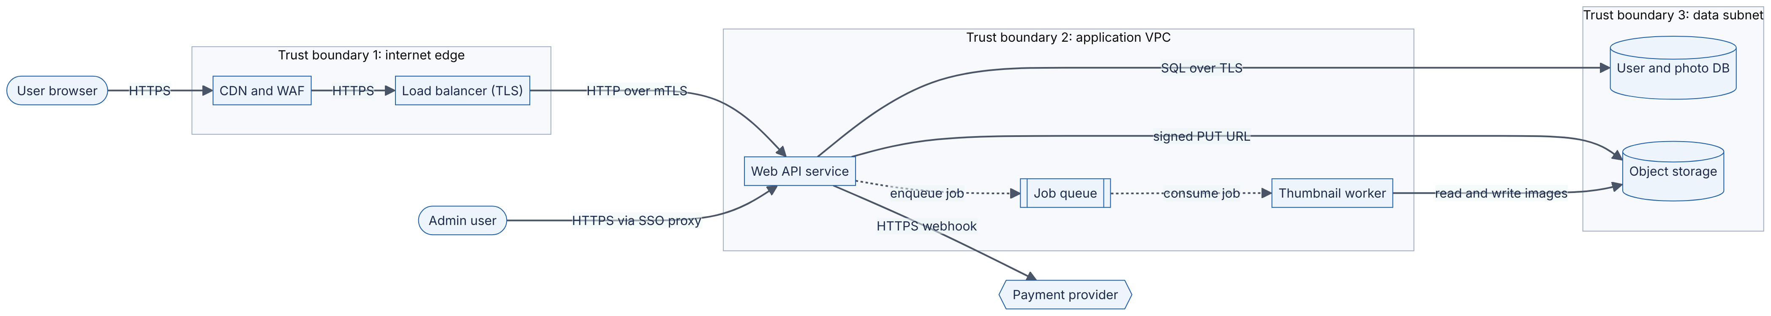
Reading the diagram. Two external entities (the user’s browser and an administrator) and one external system (a payment provider, hexagon) sit outside every boundary. Trust boundary 1 is the internet edge: the CDN with a web application firewall (WAF) and the TLS-terminating load balancer are the first components that see untrusted traffic, so they carry rate limiting and coarse filtering. Trust boundary 2 is the application network: the web API is the only process that authenticates users and authorizes actions; it talks to the load balancer over mutual TLS. Solid arrows are synchronous request/response flows; the dotted arrows to and from the job queue are asynchronous — the thumbnail worker processes uploads later, so a failure there delays thumbnails but does not break uploads. Trust boundary 3 contains the storage: the database and object store accept connections only from the application subnet. Notice where the risky crossings are: every arrow from U, ADM and PAY crosses at least one boundary, and the worker parses user-uploaded image files, which is a classic place for parser vulnerabilities. Scaling options (more web replicas, more workers) do not change the boundaries, but each new data store or third-party integration adds a new arrow that must be modeled.

10.3.4 STRIDE
DEFINITION
Definition — STRIDE. A mnemonic for six threat categories, developed at Microsoft in 1999 by Loren Kohnfelder and Praerit Garg and popularized by Shostack [Shostack 2014]: Spoofing, Tampering, Repudiation, Information disclosure, Denial of service and Elevation of privilege. Each category is the violation of one security property.
Table 10.1 — STRIDE categories, the property each violates, and typical mitigations.
Threat | Violates | Plain-language question | Typical mitigations
Spoofing | Authentication | Can someone pretend to be another user or service? | Strong authentication, MFA, mTLS, signed tokens
Tampering | Integrity | Can someone change data in transit or at rest? | TLS, MACs, signatures, AEAD encryption, DB permissions
Repudiation | Non-repudiation | Can someone deny doing something? | Audit logs, signatures, tamper-evident storage
Information disclosure | Confidentiality | Can someone read what they should not? | Encryption, access control, data minimization
Denial of service | Availability | Can someone stop legitimate use? | Rate limits, quotas, autoscaling, DDoS protection
Elevation of privilege | Authorization | Can someone gain rights they were not granted? | Least privilege, authorization checks on every request, sandboxing
You apply STRIDE per element of the DFD: for each process, data store and flow, walk through the six letters and ask whether the threat applies. Not every letter applies to every element type: an external entity can be spoofed but cannot be “tampered with” by you; a data flow can be tampered with, disclosed or flooded. This mechanical walk-through is what makes STRIDE useful — it stops you from fixating on the one threat you happened to think of first.

10.3.5 Worked example: STRIDE on the photo-sharing application
WORKED EXAMPLE
Worked example — STRIDE pass over Figure 10.1.
Step 1 — Assets. User credentials and session tokens; private photos; payment tokens returned by the provider; admin capabilities (delete any account); the database administrator credentials; the TLS private keys.
Step 2 — Walk each boundary-crossing element. The table below shows a representative (not exhaustive) result.
Step 3 — Rank. Score each threat for likelihood and impact on a 1–3 scale (see the risk-score formula below) and fix high scores first.
Step 4 — Record. The result is a short table in the design document, owned by the team, revisited whenever the DFD changes.
Table 10.2 — STRIDE threats for the photo-sharing application (excerpt).
# | Element | STRIDE | Threat | Mitigation | L × I
T1 | User → Web API | S | Credential stuffing with passwords leaked from other sites | Rate limit per account and IP; breached-password check; MFA; Argon2id storage | 3 × 3 = 9
T2 | Web API | E | User changes photo_id in URL and reads another user’s private photo (IDOR) | Object-level authorization check on every read, enforced in a shared data-access layer | 3 × 3 = 9
T3 | Web API → Object store | I | Bucket accidentally made public | Block public access at account level; serve via short-lived signed URLs | 2 × 3 = 6
T4 | Thumbnail worker | E | Malicious image exploits image-parsing library, attacker runs code in worker | Sandbox worker (no network, minimal IAM role), patch libraries, separate account | 2 × 3 = 6
T5 | Payment webhook | S | Attacker forges “payment succeeded” webhook | Verify provider’s HMAC signature and timestamp (§10.4.6) | 2 × 3 = 6
T6 | Admin → Web API | R | Admin deletes an account and later denies it | Append-only, tamper-evident audit log of admin actions (§10.12) | 1 × 2 = 2
T7 | Upload endpoint | D | Attacker uploads thousands of 1 GB files | Size limits, per-user quotas, rate limits | 2 × 2 = 4
T8 | Web API → DB | T | SQL injection modifies rows | Parameterized queries; DB user without DDL rights | 2 × 3 = 6
Look at what the exercise produced: eight concrete, testable requirements, most of which are architectural (where the authorization check lives, which account the worker runs in, how the bucket is exposed) rather than “write secure code”. That is the point of threat modeling for a system designer.

Mathematical foundations
FORMULA
Qualitative risk score
$$R=L×I$$
Symbol | Meaning | Units
$R$ | Risk score used to rank threats | dimensionless (1–9 on a 3-point scale)
$L$ | Likelihood that the threat is exploited within the planning horizon (1 = unlikely, 2 = plausible, 3 = expected) | ordinal score
$I$ | Impact if exploited (1 = minor, 2 = serious, 3 = severe: data breach, financial loss, regulatory) | ordinal score
WORKED EXAMPLE
Worked example — Ranking T1 against T6. Credential stuffing (T1) is expected for any consumer login page, because attackers replay billions of leaked username–password pairs automatically: $L=3$. Its impact is account takeover and private-photo exposure: $I=3$. So $R=3×3=9$. Admin repudiation (T6) requires a malicious administrator ($L=1$) and its impact is a dispute rather than a breach ($I=2$): $R=2$. Interpretation: fix T1 in the first release; T6 can follow. Engineering implication: the score is ordinal, not a probability — do not multiply it by dollar figures or average it across threats. Its only job is to order the work and make the reasoning visible to reviewers.

Advantages, disadvantages and alternatives
STRIDE is easy to teach, systematic and tied to properties, which makes it ideal for design reviews. Its weaknesses: it can produce long lists of low-value threats, it does not rank risk by itself, and it focuses on technical threats more than abuse of legitimate features (spam, fraud, harassment). Alternatives include attack trees (a root goal such as “read another user’s photo” decomposed into AND/OR subgoals — good for deep analysis of one critical asset), PASTA (a seven-stage risk-centric process), LINDDUN (privacy threats) and kill-chain analysis (focused on detection and response). Many teams use STRIDE for breadth and attack trees for the top two or three risks.

Failure scenarios
Table 10.3 — Threat-modeling failure scenarios.
What goes wrong | Why | Detection | Recovery | Prevention
Threat model is stale | Architecture changed, DFD did not | New data store or vendor absent from DFD in review | Re-run STRIDE on changed elements | Make DFD update a checklist item for design changes
Threat model is a document nobody reads | Produced for compliance, not engineering | Mitigations not traced to tickets/tests | Convert each mitigation to a tracked task | Keep it short; review it in design review
Insider threats ignored | “Everything inside the VPC is trusted” assumption | Red-team exercise with internal credentials | Add authorization and audit inside the network | Include insider row in adversary list

Common misconceptions
COMMON MISTAKE
“We use HTTPS, so we are secure.” TLS protects data in transit between two endpoints. It does nothing about a logged-in user requesting someone else’s data (T2), a forged webhook (T5) or SQL injection (T8). Most real breaches happen through authenticated, encrypted connections.

10.4 Cryptography essentials
Cryptography is the toolbox that turns security goals into mathematics. As a system designer you will almost never implement a cryptographic algorithm, but you will constantly choose one, and choosing the wrong primitive for a goal (encrypting when you needed to authenticate, hashing when you needed a secret key) is one of the most common design errors. This section explains each primitive by analogy, then by mechanism, then with the numbers that tell you how strong it is.
Table 10.4 — Which primitive achieves which goal.
Goal | Primitive | Needs a key? | Typical algorithm (as of 2026) | Analogy
Detect accidental or malicious change, given a trusted reference value | Cryptographic hash | No | SHA-256, SHA-3, BLAKE2/3 | Fingerprint
Prove a message came from someone holding a shared secret, unchanged | MAC | Shared secret | HMAC-SHA-256 | Wax seal pressed with a ring both parties own
Keep data secret and detect tampering, between parties sharing a key | Authenticated (AEAD) symmetric encryption | Shared secret | AES-256-GCM, ChaCha20-Poly1305 | Locked box with a tamper seal
Let anyone send you a secret without a pre-shared key | Asymmetric encryption / KEM | Public + private key | RSA-OAEP, ECIES, ML-KEM | Padlock you hand out open; only you hold its key
Agree on a shared secret over a public channel | Key exchange | Ephemeral key pairs | ECDHE (X25519, P-256) | Mixing paint colors (see §10.4.4)
Prove to anyone that a specific key holder approved a message | Digital signature | Private key signs, public key verifies | Ed25519, ECDSA P-256, RSA-PSS | Notarized handwritten signature
Produce unpredictable keys, nonces, tokens | CSPRNG | Seeded by OS | /dev/urandom, getrandom(), secrets | Fair dice nobody can watch

10.4.1 Hash functions
DEFINITION
Definition — Cryptographic hash function. A deterministic function $H$ that maps an input of any length to a fixed-length output (the digest), such that it is computationally infeasible to (1) find an input that hashes to a given digest (preimage resistance), (2) given one input, find a different input with the same digest (second-preimage resistance), and (3) find any two distinct inputs with the same digest (collision resistance).

First-principles explanation
A hash is a fingerprint. You cannot reconstruct a person from a fingerprint, two people practically never share one, and the tiniest change in the person (a cut on the finger) changes the print. SHA-256 takes a 4 GB disk image or the single letter “a” and produces 256 bits; flip one input bit and roughly half of the output bits flip (the avalanche effect).
Hashes give you integrity only if the reference digest itself is trustworthy. If an attacker can change a download and the digest published next to it, the hash proves nothing. That is why hashes are combined with keys (MACs) or signatures, and why a plain hash is never a password-storage scheme on its own (§10.6).

How it works internally
SHA-2 hashes pad the input, split it into 512-bit (SHA-256) blocks and mix each block into a running internal state with a compression function (the Merkle–Damgård construction); the final state is the digest. A side effect is the length-extension property: given $H\left(m\right)$ and the length of $m$, anyone can compute $H\left(m ∥ \text{padding} ∥ x\right)$ without knowing $m$. That is harmless for fingerprints but fatal if you build a MAC as $H\left(\text{key} ∥ \text{message}\right)$ — the reason HMAC exists (§10.4.6). SHA-3 uses a different “sponge” construction without this property.
MD5 and SHA-1 are broken for collision resistance: practical collisions were published for MD5 in 2004 and for SHA-1 in 2017 (the “SHAttered” attack). Do not use them for any security purpose.

Mathematical foundations
FORMULA
Birthday bound for hash collisions
$$P_{\text{collision}}≈\frac{k^{2}}{2^{ n+1}}$$
Symbol | Meaning | Units
$k$ | Number of distinct inputs hashed | count
$n$ | Digest length | bits
$P_{\text{collision}}$ | Probability that at least two of the $k$ digests are equal (valid while $P≪1$) | probability
Consequence: an $n$-bit hash offers about $n/2$ bits of collision resistance, because $P$ approaches $1/2$ when $k≈2^{n/2}$.
WORKED EXAMPLE
Worked example — Is a 64-bit truncated hash safe as a content ID? Suppose a storage service names objects by the first 64 bits of their SHA-256 digest and stores $k={10}^{10}$ objects (ten billion).
- $k^{2}={10}^{20}$.
- $2^{65}≈3.69×{10}^{19}$.
- $P≈{10}^{20}/3.69×{10}^{19}≈2.7$ — the approximation has broken down because $P$ is not small; in reality a collision is all but certain.
With the full 256-bit digest: $P≈{10}^{20}/2^{257}≈{10}^{20}/2.3×{10}^{77}≈4×{10}^{−58}$.
Interpretation: 64 bits feels large, but birthday collisions arrive at around $2^{32}≈4.3$ billion items. Engineering implication: if an adversary benefits from a collision (deduplication, content addressing, signatures), use at least 256-bit digests; truncate only for non-adversarial uses such as cache sharding.

10.4.2 Symmetric encryption and AES-GCM
DEFINITION
Definition — Symmetric encryption. Encryption in which the same secret key is used to encrypt and decrypt. A block cipher such as AES (Advanced Encryption Standard) encrypts fixed 128-bit blocks under a 128-, 192- or 256-bit key; a mode of operation turns the block cipher into a scheme for messages of any length.
DEFINITION
Definition — Authenticated encryption with associated data (AEAD). A symmetric scheme that provides confidentiality for the plaintext and integrity for both the ciphertext and optional unencrypted associated data (AAD), producing an authentication tag that decryption checks before releasing any plaintext. AES-GCM and ChaCha20-Poly1305 are AEAD schemes.

First-principles explanation
Symmetric encryption is a lockbox where sender and receiver hold copies of the same key. It is extremely fast: modern CPUs have AES instructions (AES-NI on x86, equivalent extensions on ARM) that encrypt at multiple gigabytes per second per core, which is why every bulk-data protocol — TLS records, disk encryption, database encryption — uses symmetric ciphers for the data itself. The hard part is not encrypting; it is getting the same key to both parties securely and keeping it secret, which the rest of this chapter addresses.
An unauthenticated mode such as AES-CBC or AES-CTR hides the content but does not detect changes. An attacker who flips bit 7 of a CTR ciphertext flips bit 7 of the plaintext — turning “pay $100” into “pay $900” without knowing the key. AEAD adds the tamper seal: any change to ciphertext, tag, nonce or associated data makes decryption fail.

How it works internally
AES-GCM (Galois/Counter Mode, NIST SP 800-38D):
- Take a key $K$ and a 96-bit nonce (number used once) $N$.
- Generate a keystream by encrypting the counter values $N∥2,N∥3,…$ with AES; XOR it with the plaintext to get ciphertext (counter mode).
- Compute a 128-bit tag over the AAD and ciphertext using GHASH, a polynomial hash keyed by a value derived from $K$, and mask it with the encryption of $N∥1$.
- Output (nonce, ciphertext, tag). Decryption recomputes the tag and rejects mismatches before returning plaintext.
The single most important rule: never reuse a nonce with the same key. A repeated nonce produces the same keystream, so XOR of two ciphertexts reveals the XOR of the two plaintexts, and it also leaks enough to forge tags. Use a 96-bit random nonce per message, or a counter that is guaranteed never to repeat, and rotate keys before the nonce collision probability becomes meaningful.
FORMULA
Random-nonce collision probability for AES-GCM
$$P_{\text{reuse}}≈\frac{q^{2}}{2^{97}}$$
Symbol | Meaning | Units
$q$ | Number of messages encrypted under one key with random 96-bit nonces | messages
$P_{\text{reuse}}$ | Probability that any two of them share a nonce (birthday bound with $n=96$) | probability
WORKED EXAMPLE
Worked example — How many messages per key? NIST SP 800-38D caps random-nonce GCM at $2^{32}$ invocations per key. Check the risk: $q=2^{32}$ gives $q^{2}=2^{64}$, so $P≈2^{64}/2^{97}=2^{−33}≈1.2×{10}^{−10}$. A service encrypting 50,000 messages per second reaches $2^{32}≈4.3×{10}^{9}$ messages in $4.3×{10}^{9}/5×{10}^{4}≈86,000$ s, about one day. Engineering implication: a high-throughput service must rotate data keys at least daily, or use per-object keys (envelope encryption, §10.9), or a nonce-misuse-resistant mode such as AES-GCM-SIV, or a scheme with larger nonces (XChaCha20-Poly1305 uses 192-bit nonces).
The associated data is a powerful design tool. If you encrypt a user’s tax ID in row 42 of the users table and put table=users;id=42 in the AAD, an attacker with database write access cannot copy that ciphertext into row 43 — decryption would fail because the context differs. The runnable example in §10.4.8 demonstrates exactly this.

10.4.3 Asymmetric cryptography: RSA and elliptic curves
DEFINITION
Definition — Asymmetric (public-key) cryptography. Cryptography using a mathematically linked key pair: a public key that can be shared with anyone and a private key kept secret by its owner. What one key does, only the other can undo or verify. Security rests on problems believed hard to invert: factoring large integers (RSA) or computing discrete logarithms on elliptic curves (ECC).

First-principles explanation
Picture a padlock factory. You manufacture thousands of open padlocks, all of which only your key opens, and leave them in a bowl on the street. Anyone can put a message in a box, snap one of your padlocks shut, and mail it to you; nobody, including the sender, can reopen it — only you. The open padlocks are your public key; your key is the private key. Asymmetric cryptography solves the problem symmetric encryption cannot: two parties who have never met can communicate securely, provided the sender knows the padlock really is yours (that is what certificates in §10.5 establish).
The price is speed and size. An RSA-2048 private-key operation costs on the order of a millisecond of CPU, thousands of times more than encrypting a short message with AES. So real systems use asymmetric cryptography only to establish or protect a symmetric key and to sign things, never for bulk data. This combination is called hybrid encryption.

How it works internally
- RSA: pick two large random primes $p$ and $q$; the public key is $\left(n=pq,e\right)$, the private key is $d$ with $ed≡1 (mod \left(p−1\right)\left(q−1\right))$. Encryption is $c=m^{e} mod n$, decryption $m=c^{d} mod n$. Breaking it requires factoring $n$. RSA must always be used with a padding scheme (OAEP for encryption, PSS for signatures); “textbook RSA” is insecure.
- Elliptic-curve cryptography (ECC): the private key is a random integer $a$; the public key is the point $A=a⋅G$ obtained by “adding” a fixed base point $G$ on a curve to itself $a$ times. Recovering $a$ from $A$ (the elliptic-curve discrete logarithm problem) is believed to be infeasible. ECC achieves the same security as RSA with much smaller keys and faster operations, which is why TLS 1.3 deployments overwhelmingly use X25519 and P-256.
Table 10.5 — Approximate equivalent security strengths (NIST SP 800-57 Part 1).
Security strength (bits) | Symmetric | RSA modulus | Elliptic curve key | Hash for collision resistance | Status
112 | 3-key 3DES (legacy) | 2048 | 224 | SHA-224 | Minimum acceptable today
128 | AES-128 | 3072 | 256 (P-256, X25519, Ed25519) | SHA-256 | Recommended default
192 | AES-192 | 7680 | 384 (P-384) | SHA-384 | High assurance
256 | AES-256 | 15360 | 512+ (P-521) | SHA-512 | Long-term / post-quantum margin for symmetric
“128-bit security” means the best known attack takes about $2^{128}$ operations. At ${10}^{18}$ operations per second (far beyond all computers on Earth combined) that is $3.4×{10}^{38}/{10}^{18}=3.4×{10}^{20}$ s, about ${10}^{13}$ years.
WARNING / TRADE-OFF
Quantum computers and “harvest now, decrypt later.” A large fault-tolerant quantum computer running Shor’s algorithm would break RSA and ECC; Grover’s algorithm only roughly halves symmetric strength, leaving AES-256 a large margin. No such machine exists as of 2026, but recorded traffic could be decrypted later. NIST published post-quantum standards in August 2024 — FIPS 203 (ML-KEM), FIPS 204 (ML-DSA) and FIPS 205 (SLH-DSA) — and TLS libraries have begun deploying hybrid X25519 + ML-KEM key exchange. Design for crypto agility (configurable algorithms) and prefer AES-256 for long-lived data.

10.4.4 Key exchange and forward secrecy

First-principles explanation
The classic analogy for Diffie–Hellman key exchange uses paint. Alice and Bob publicly agree on a common color, yellow. Alice secretly picks red, Bob secretly picks blue. Alice mixes yellow + red and sends the result (orange) across the open channel; Bob mixes yellow + blue and sends green. Alice adds her secret red to Bob’s green; Bob adds his secret blue to Alice’s orange. Both end up with the same yellow + red + blue brown. An eavesdropper saw yellow, orange and green but cannot “unmix” paint to recover red or blue.
In the elliptic-curve version (ECDH), Alice’s secret is $a$, her public value $aG$; Bob’s are $b$ and $bG$; both compute the shared point $abG$. The shared secret is then fed through a key-derivation function such as HKDF to produce symmetric session keys.
DEFINITION
Definition — Forward secrecy. A property of a key-exchange protocol whereby compromise of a party’s long-term private key does not reveal session keys from past sessions. It is achieved by using fresh ephemeral key pairs for every session (the “E” in ECDHE) and deleting them afterward.
Why it matters: before TLS 1.3, many servers used RSA key transport, where the client encrypted the session secret with the server’s long-term RSA public key. Anyone who recorded traffic and later stole that one private key could decrypt years of recorded sessions. TLS 1.3 removed RSA key transport entirely; every full handshake uses ephemeral (EC)DHE, and the server’s long-term key is used only to sign the handshake, proving its identity.
Figure 10.2 — Simplified TLS 1.3 handshake: ephemeral key exchange plus signature.
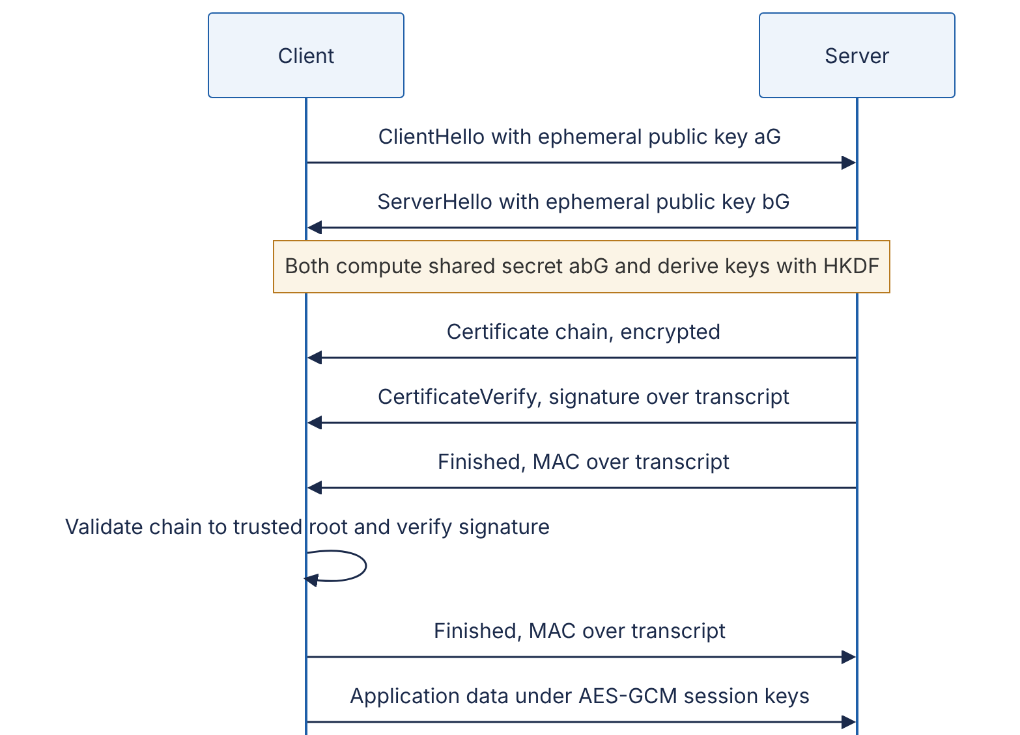
Reading the diagram. All messages flow synchronously over one TCP (or QUIC) connection, and the full handshake completes in one round trip before application data flows (round-trip costs and 0-RTT resumption are covered in §7.10). The ephemeral public values travel in the clear; the shared secret never crosses the network. From the ServerHello onward, everything is encrypted with keys derived from that secret, including the certificate (hiding which certificate the server uses from passive observers). The server proves it owns the certificate’s private key by signing the handshake transcript (CertificateVerify); the client validates the certificate chain (§10.5). The Finished messages are MACs over everything exchanged so far, so a man-in-the-middle who altered any earlier message is detected. Failure points: an expired or untrusted certificate (handshake aborts), a client and server with no common cipher suite, or clock skew on the client breaking validity checks.

10.4.5 Digital signatures
DEFINITION
Definition — Digital signature. A scheme with three algorithms: key generation, sign (using the private key, produces a signature over a message) and verify (using the public key, checks a signature against a message). A valid signature shows that the message was approved by the holder of the private key and has not changed since. Because verification needs only the public key, anyone can verify, which provides non-repudiation.
Signatures are the notary of cryptography. They secure software updates (the update client holds the vendor’s public key and refuses unsigned binaries), container images, JWTs signed with RS256 or ES256 (§8.13), certificates themselves, Git commits and the TLS handshake. In practice you sign a hash of the message: the signing algorithm hashes internally, so signing a 2 GB file costs one SHA-256 pass plus one fast private-key operation.
Prefer Ed25519 (fast, deterministic, small 64-byte signatures, few ways to misuse) or ECDSA P-256 where compliance requires NIST curves. ECDSA is fragile when the per-signature random value repeats or is biased: in 2010 researchers extracted Sony’s PlayStation 3 code-signing key because the same random value was reused for every signature. Ed25519 derives this value deterministically, eliminating the failure mode.

10.4.6 Message authentication codes and HMAC
DEFINITION
Definition — Message authentication code (MAC). A short tag computed from a message and a secret key, $t={\text{MAC}}_{K}\left(m\right)$, such that without $K$ it is infeasible to produce a valid tag for any new message. HMAC is the standard construction from a hash function: ${\text{HMAC}}_{K}\left(m\right)=H\left(\left(K⊕\text{opad}\right) ∥ H\left(\left(K⊕\text{ipad}\right) ∥ m\right)\right)$ [Krawczyk et al. 1997].
A MAC is a wax seal pressed with a ring that both parties own. The receiver, holding the same ring, can tell the letter is genuine and unopened. But because both own the ring, a third party cannot tell which of them sealed it — so MACs provide integrity and authenticity between the two key holders, but not non-repudiation. That is the essential difference from a signature, and the reason payment providers sign webhooks with an HMAC (they only need you to know it came from them) while software vendors sign releases with asymmetric signatures (millions of verifiers who must not be able to forge).
HMAC’s nested structure defeats the length-extension attack described in §10.4.1. It is also fast (two hash computations) and needs only a shared key, which makes it the standard tool for request signing: AWS Signature Version 4, Stripe and GitHub webhook signatures and many internal service-to-service schemes use HMAC-SHA-256.
Figure 10.3 — HMAC request signing with replay protection.
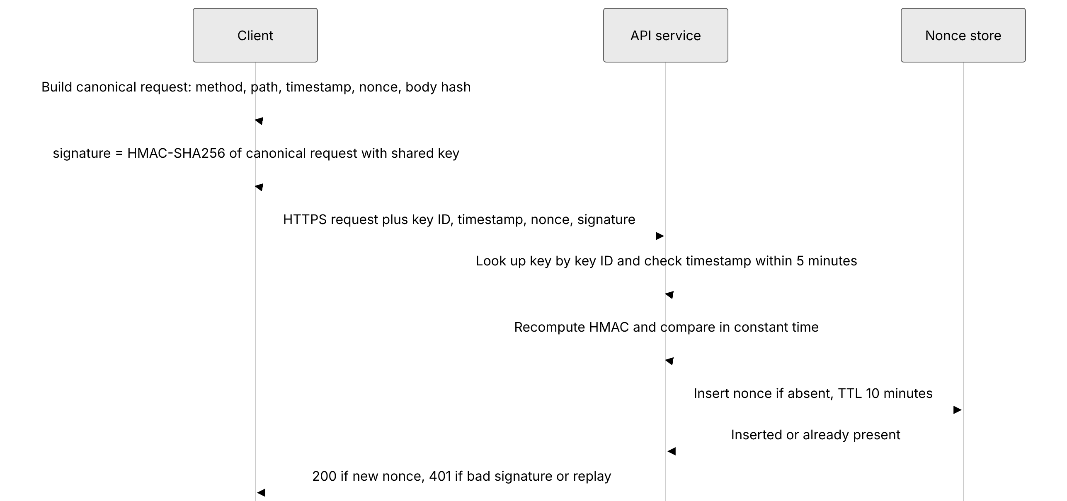
Reading the diagram. The client and API service share a secret key identified by a key ID (so keys can be rotated: during rotation the server accepts both the old and new key IDs). The client signs a canonical representation — a byte-exact serialization of every field the server will act on — because if a field is not covered (say, the HTTP method), an attacker can change it without invalidating the signature. The timestamp bounds how long a captured request remains useful; the nonce store (in production a shared cache such as Redis with a TTL slightly longer than twice the allowed skew) rejects exact replays inside that window. The signature comparison must be constant-time to avoid leaking, byte by byte, how much of a forged signature was correct. All calls are synchronous; the nonce store is the only shared state and a single point of failure — if it is unavailable, the service must choose between failing closed (reject requests) and failing open (accept possible replays), a decision that belongs in the design document.

Code example: HMAC request signing
"""HMAC-SHA256 request signing and verification with replay protection."""
import hashlib
import hmac
import secrets
import time
MAX_SKEW_SECONDS = 300 # accept requests at most 5 minutes old/new
def canonical_request(method: str, path: str, timestamp: str,
nonce: str, body: bytes) -> bytes:
body_hash = hashlib.sha256(body).hexdigest()
# Every field the server relies on must be covered by the signature.
return "\n".join([method.upper(), path, timestamp, nonce, body_hash]).encode()
def sign(key: bytes, method: str, path: str, body: bytes) -> dict:
ts = str(int(time.time()))
nonce = secrets.token_hex(16)
mac = hmac.new(key, canonical_request(method, path, ts, nonce, body),
hashlib.sha256).hexdigest()
return {"X-Key-Id": "client-42", "X-Timestamp": ts,
"X-Nonce": nonce, "X-Signature": mac}
class Verifier:
def __init__(self, keys: dict[str, bytes]):
self.keys = keys
self.seen_nonces: dict[str, int] = {} # production: shared store with TTL
def verify(self, method: str, path: str, body: bytes, headers: dict) -> bool:
key = self.keys.get(headers.get("X-Key-Id", ""))
if key is None:
return False
ts = int(headers["X-Timestamp"])
now = int(time.time())
if abs(now - ts) > MAX_SKEW_SECONDS:
return False # stale or future
expected = hmac.new(key, canonical_request(method, path, headers["X-Timestamp"],
headers["X-Nonce"], body),
hashlib.sha256).hexdigest()
if not hmac.compare_digest(expected, headers["X-Signature"]):
return False # forged or tampered
# Expire old nonces, then reject a nonce we have already seen (replay).
self.seen_nonces = {n: t for n, t in self.seen_nonces.items()
if now - t <= 2 * MAX_SKEW_SECONDS}
if headers["X-Nonce"] in self.seen_nonces:
return False
self.seen_nonces[headers["X-Nonce"]] = ts
return True
Tested with Python 3.13: a correctly signed request verifies; replaying it, altering one byte of the body, or signing with a different key all return False.
What to notice:
- hmac.compare_digest compares in constant time; == returns early at the first differing byte and can leak timing information.
- The body is covered via its SHA-256 hash, and the method and path are included, so neither can be swapped.
- The order of checks matters: the nonce is recorded only after the signature verifies, so an attacker cannot fill the nonce store with garbage that blocks legitimate nonces.
- The in-memory seen_nonces dictionary works for one process only; with several API replicas, use a shared store with an atomic “set if absent” operation (for example Redis SET key value NX EX 600).

10.4.7 Randomness
Every key, nonce, salt, session token and password-reset link depends on unpredictable random numbers. General-purpose generators (random in Python, Math.random() in JavaScript, rand() in C) are designed for simulations: they are fast and statistically uniform but predictable — observing a few hundred outputs of Python’s Mersenne Twister lets an attacker compute all future outputs. Security code must use a cryptographically secure pseudo-random number generator (CSPRNG) seeded from the operating system’s entropy pool: secrets or os.urandom in Python, crypto.getRandomValues in browsers, SecureRandom in Java, crypto/rand in Go.
FORMULA
Entropy of a uniformly random secret
$$H=L⋅\log_{2}N$$
Symbol | Meaning | Units
$H$ | Entropy: the number of bits an attacker must effectively guess | bits
$L$ | Length of the secret | symbols
$N$ | Number of equally likely choices per symbol | symbols
Valid only when every symbol is chosen independently and uniformly at random — true for machine-generated tokens, false for human-chosen passwords.
WORKED EXAMPLE
Worked example — How long should a session token be? secrets.token_urlsafe(32) draws 32 random bytes ($N=256$, $L=32$): $H=32×8=256$ bits. An attacker making ${10}^{6}$ guesses per second for a year ($3.15×{10}^{13}$ guesses) against ${10}^{8}$ live sessions succeeds with probability about $3.15×{10}^{13}×{10}^{8}/2^{256}≈3×{10}^{−56}$. Engineering implication: 128 bits of CSPRNG output is already ample; the realistic risk is tokens leaking through logs, URLs and referrer headers, not guessing.

10.4.8 Don’t roll your own crypto
“Don’t roll your own crypto” does not only mean “don’t invent a cipher”. It means: do not assemble primitives into your own protocol or storage format when a vetted, high-level construction exists. The canonical failures are all compositions of correct primitives: encrypting without authenticating (bit-flipping attacks), MAC-then-encrypt with distinguishable padding errors (padding-oracle attacks against CBC), SHA256(key || msg) as a MAC (length extension), reused GCM nonces, comparing MACs with == (timing attacks), and ECB mode, which encrypts identical blocks to identical ciphertext so that patterns in an image remain visible. Ferguson, Schneier and Kohno make the case that most cryptographic failures in practice are engineering failures in how primitives are combined and keys are handled, not breaks of the primitives themselves [Ferguson et al. 2010].
RECOMMENDATION
Practical rule set. (1) Use TLS 1.3 for data in transit — do not design a transport protocol. (2) Use a high-level library API (libsodium/NaCl secretbox, Google Tink, or the cryptography package’s AEAD classes) that chooses nonces, modes and tag checks for you. (3) Use a managed KMS for key storage and envelope encryption (§10.9). (4) Use a password-hashing function, not a hash (§10.6). (5) Use your platform’s JWT/OAuth libraries, pinned to an explicit algorithm allow-list. (6) Have a cryptographer review any design where you still feel you need to combine primitives.

Code example: AEAD, signatures and key agreement
"""AES-256-GCM with associated data, Ed25519 signatures and X25519 key agreement."""
import os
from cryptography.exceptions import InvalidSignature, InvalidTag
from cryptography.hazmat.primitives import hashes
from cryptography.hazmat.primitives.asymmetric.ed25519 import Ed25519PrivateKey
from cryptography.hazmat.primitives.asymmetric.x25519 import X25519PrivateKey
from cryptography.hazmat.primitives.ciphers.aead import AESGCM
from cryptography.hazmat.primitives.kdf.hkdf import HKDF
# --- 1. Authenticated symmetric encryption: AES-256-GCM ---
key = AESGCM.generate_key(bit_length=256)
aead = AESGCM(key)
nonce = os.urandom(12) # 96-bit nonce; NEVER reuse with same key
aad = b"user_id=42;table=payments" # authenticated but not encrypted
ct = aead.encrypt(nonce, b"card ending 4242", aad)
print("ciphertext+tag bytes:", len(ct)) # plaintext length + 16-byte tag
print("decrypted:", aead.decrypt(nonce, ct, aad))
try:
aead.decrypt(nonce, ct, b"user_id=43;table=payments") # wrong context
except InvalidTag:
print("AAD mismatch -> InvalidTag (ciphertext cannot be moved to another row)")
tampered = bytearray(ct); tampered[0] ^= 1
try:
aead.decrypt(nonce, bytes(tampered), aad)
except InvalidTag:
print("bit flip -> InvalidTag")
# --- 2. Digital signatures: Ed25519 ---
signing_key = Ed25519PrivateKey.generate()
verify_key = signing_key.public_key()
release = b"release v2.4.1 sha256=9f86d08..."
sig = signing_key.sign(release)
print("signature bytes:", len(sig))
verify_key.verify(sig, release) # raises if invalid
try:
verify_key.verify(sig, release + b"!")
except InvalidSignature:
print("modified message -> InvalidSignature")
# --- 3. Key agreement: X25519 + HKDF ---
alice, bob = X25519PrivateKey.generate(), X25519PrivateKey.generate()
shared_a = alice.exchange(bob.public_key()) # only public keys cross the network
shared_b = bob.exchange(alice.public_key())
assert shared_a == shared_b
session_key = HKDF(algorithm=hashes.SHA256(), length=32, salt=None,
info=b"example-protocol v1 session key").derive(shared_a)
print("both sides derived the same 256-bit session key:", session_key.hex()[:16], "...")
Tested with cryptography 50.0.1: decryption succeeds with the right AAD; a changed AAD or a single flipped ciphertext bit raises InvalidTag; a modified release string raises InvalidSignature; both X25519 parties derive the same key.
What to notice:
- The 16-byte plaintext became 32 bytes: GCM ciphertext is the same length as the plaintext plus a 16-byte tag. The 12-byte nonce must be stored alongside it (it is not secret).
- Decryption fails loudly on any tampering or context mismatch; there is no way to obtain partially decrypted garbage.
- The raw X25519 output is never used directly as a key; HKDF with a protocol-specific info string turns it into a uniformly random key bound to its purpose.
Table 10.6 — Hash vs MAC vs signature vs encryption.
 | Hash | MAC (HMAC) | Digital signature | AEAD encryption
Confidentiality | No | No | No | Yes
Integrity | Only against a trusted digest | Yes | Yes | Yes
Authenticity | No | Yes, among key holders | Yes, publicly verifiable | Yes, among key holders
Non-repudiation | No | No | Yes | No
Key | None | Shared secret | Private / public pair | Shared secret
Speed | GB/s | GB/s | ~10⁴–10⁵ signatures/s per core (Ed25519) | GB/s with AES-NI
Typical use | Checksums, content addressing, Merkle trees | Webhooks, API request signing, cookies | Software updates, certificates, JWT (RS/ES), audit anchors | Data at rest and in transit

Common misconceptions
COMMON MISTAKE
“Encoding, hashing and encryption are interchangeable.” Base64 is an encoding: reversible by anyone, provides no security. A hash is one-way and keyless: anyone can compute it, so it cannot keep a low-entropy value (a phone number, a password) secret — an attacker hashes every candidate. Encryption is reversible with the key. Kubernetes Secrets stored as base64 in etcd without encryption at rest are, from a security standpoint, plaintext.

10.5 PKI and certificates
DEFINITION
Definition — Public key infrastructure (PKI). The set of roles, policies and systems that bind public keys to identities. A certificate (X.509) is a document stating “this public key belongs to this name (for example api.example.com), valid from date A to date B”, signed by a certificate authority (CA). A client trusts a certificate if it can build a chain of valid signatures from it to a root CA certificate in its local trust store.

First-principles explanation
Asymmetric cryptography lets anyone lock a box with your padlock — but how does a stranger know the padlock in the bowl is yours and not one an impostor swapped in? A passport solves the same problem for people: a government you already trust vouches for the link between a photo and a name. A CA is that government for public keys. Your browser or operating system ships with roughly a hundred-odd root CA certificates (the exact number varies by vendor), and it trusts any certificate that chains back to one of them.

How it works internally
- The server operator generates a key pair and sends the CA a certificate signing request containing the public key and the domain name.
- The CA verifies control of the domain — for automated CAs, via the ACME protocol (RFC 8555): placing a token at a well-known HTTP path or in a DNS TXT record.
- The CA signs a certificate using an intermediate CA key. Root keys are kept offline in hardware security modules and only sign intermediates, so a root key is used a few times per decade.
- In the TLS handshake the server sends its leaf certificate plus intermediates. The client checks each signature up to a trusted root, the validity dates, the domain name, key-usage constraints and revocation status.
Figure 10.4 — Certificate chain of trust and Certificate Transparency.
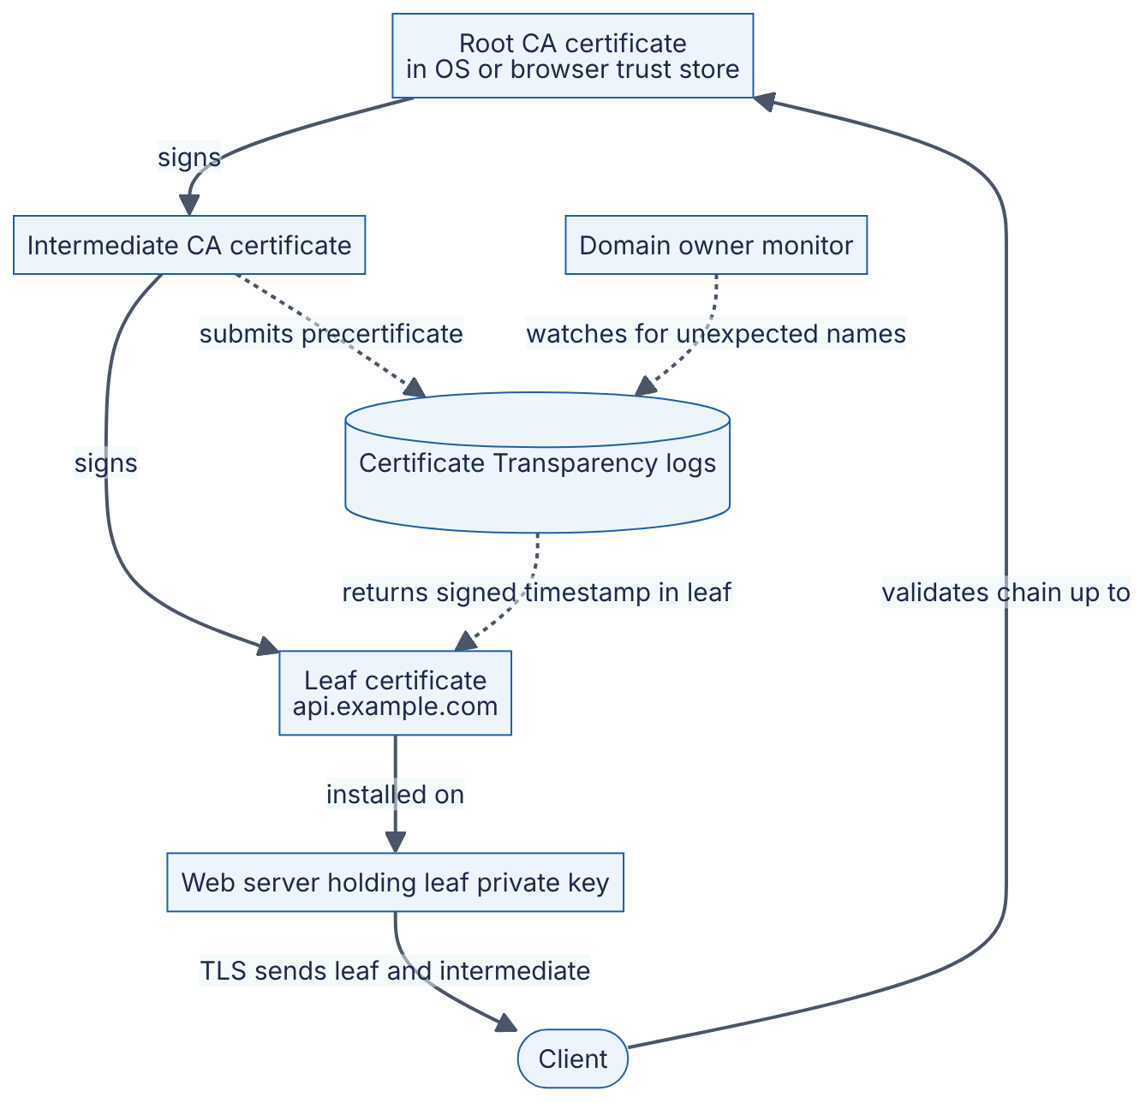
Reading the diagram. Solid arrows show the signing hierarchy and the synchronous TLS path: the root signs the intermediate, the intermediate signs the leaf, and the server presents leaf plus intermediate to the client, which already holds the root. Dotted arrows show the asynchronous transparency path: before issuance the CA submits a precertificate to public append-only logs and embeds the logs’ signed timestamps in the final certificate; browsers that enforce CT reject publicly trusted certificates without them. A domain owner’s monitor watches the logs and alerts on any certificate for its names it did not request. Failure points: an expired leaf or intermediate (the most common certificate outage), a server that forgets to send the intermediate (works in some clients, fails in others), and a compromised or misbehaving CA — the reason CT exists.
Revocation — withdrawing a certificate before expiry because its key leaked — works poorly in practice: revocation lists grow large, online status checks (OCSP) add latency and leak browsing history, and clients usually “soft-fail” when the responder is unreachable. The industry’s answer is shorter lifetimes. Let’s Encrypt has issued 90-day certificates since 2015 to force automation, and in 2025 the CA/Browser Forum voted to shrink the maximum lifetime of publicly trusted TLS certificates in stages, reaching 47 days by 2029 (as of 2026; check the current Baseline Requirements).
DEFINITION
Definition — Certificate Transparency (CT). A system of public, append-only, Merkle-tree-based logs into which CAs record every certificate they issue, so that mis-issued certificates become publicly detectable [RFC 6962].
INDUSTRY EXAMPLE
DigiNotar (2011). Attackers compromised the Dutch CA DigiNotar and issued hundreds of fraudulent certificates, including one for *.google.com that was used to intercept traffic of users in Iran. Browsers removed DigiNotar from their trust stores and the company went bankrupt within weeks. The incident directly motivated Certificate Transparency: had CT existed, Google’s monitors would have seen the rogue certificate within hours of issuance. Evidence: Secondary — [Fox-IT 2012]

Certificate rotation for internal services
For service-to-service mTLS (§10.10) you run a private CA (cloud private CA services, HashiCorp Vault’s PKI engine, or a service mesh’s built-in CA). The design rules: issue short-lived certificates (hours to days); rotate automatically well before expiry (renew at about two-thirds of lifetime); have services reload certificates without restarting; alert on any certificate with less than, say, 25% of its lifetime remaining; and treat the CA’s private key as the most sensitive key in the company (store it in an HSM or KMS).
Table 10.7 — Certificate failure scenarios.
What goes wrong | Why | Detection | Recovery | Prevention
Expired certificate outage | Manual renewal forgotten; long lifetime meant the process was never exercised | Synthetic TLS probes; expiry metrics | Emergency renewal and deploy | Automated issuance (ACME), short lifetimes, expiry alerts
Private key leak | Key in a repo, image or backup | Secret scanning; CT monitor shows unexpected certs | Revoke, reissue, rotate | Keys generated on host or in KMS/HSM, never copied
Rogue certificate for your domain | Compromised or careless CA | CT log monitoring | Request revocation; report to browser vendors | CAA DNS records restricting which CAs may issue

10.6 Password storage

10.6.1 Why passwords need special treatment

First-principles explanation
Suppose you run a coat check. You could keep each customer’s ticket number in a ledger, but if the ledger is stolen, the thief can claim every coat. Better: keep only a “fingerprint” of each ticket, so a stolen ledger is useless — unless the tickets are so predictable that the thief can fingerprint every possible ticket and match them. Human passwords are predictable tickets: “Summer2024!” and its millions of cousins appear in every attacker’s wordlist.
The design goal therefore is: assume the password database will one day be stolen (via SQL injection, a leaked backup or an insider), and make each password as expensive as possible to recover from what was stolen. Three techniques combine to achieve this.
- Hash, don’t encrypt. The server never needs the password back; it only needs to check a candidate. A one-way function means there is no decryption key to steal.
- Salt. A salt is a unique random value (at least 16 bytes) stored next to each hash and mixed into it. Without salts, identical passwords produce identical hashes, so one computation cracks every user with “123456”, and attackers can use precomputed rainbow tables. With salts, every guess must be computed separately per user.
- Slow, memory-hard hashing. SHA-256 is designed to be fast; a single high-end GPU computes on the order of ${10}^{10}$ SHA-256 hashes per second (order-of-magnitude figure as of 2024). A password-hashing function (bcrypt, scrypt, Argon2id) is deliberately slow and, for scrypt and Argon2, memory-hard: each guess needs tens of megabytes of RAM, which defeats the massive parallelism of GPUs and custom chips.
Optionally add a pepper: a secret key, stored outside the database (in a KMS or HSM), applied as an HMAC before or after hashing. A database-only leak then yields hashes that cannot be attacked at all without also stealing the pepper. NIST SP 800-63B recommends this additional keyed step.
INDUSTRY EXAMPLE
LinkedIn (2012). About 6.5 million LinkedIn password hashes were posted publicly in 2012; they were unsalted SHA-1 hashes, and a large fraction were cracked within days. In 2016 a much larger dataset from the same breach (reported at over 100 million accounts) surfaced. The lesson is both technical (fast, unsalted hashes) and architectural (credential reuse turns one site’s breach into credential stuffing against every other site — threat T1 in Table 10.2). Evidence: Secondary — widely reported in the technology press, 2012 and 2016.

10.6.2 Algorithms and cost parameters
Table 10.8 — Password-hashing functions compared (parameters per [OWASP Password Storage Cheat Sheet], as of 2026).
 | Argon2id | scrypt | bcrypt | PBKDF2-HMAC-SHA-256
What it is | Winner of the 2015 Password Hashing Competition, RFC 9106 | Memory-hard KDF, RFC 7914 | Blowfish-based adaptive hash (1999) | Iterated HMAC, NIST-approved
Cost knobs | memory $m$, iterations $t$, parallelism $p$ | $N$ (CPU/memory), $r$ (block size), $p$ | work factor (cost $c$ ⇒ $2^{c}$ rounds) | iteration count
Memory-hard | Yes | Yes | No (4 KiB) | No
OWASP minimum | $m$ = 19 MiB, $t$ = 2, $p$ = 1 | $N=2^{17}$, $r$ = 8, $p$ = 1 | cost ≥ 10 | ≥ 600,000 iterations
Gotchas | Library support varies | Memory = $128⋅N⋅r$ bytes (128 MiB at OWASP minimum) | Truncates input at 72 bytes | GPU-friendly; use only when FIPS-140 is required
Choose when | Default for new systems | Argon2id unavailable | Legacy systems, wide library support | Compliance mandates FIPS
RFC 9106 also gives two general-purpose Argon2id recommendations: $t=1$, $p=4$, $m=2$ GiB where memory allows, or $t=3$, $p=4$, $m=64$ MiB otherwise [RFC 9106]. The OWASP minimums are lower because login servers must handle many concurrent hashes.
Choosing cost parameters is a capacity-planning decision. Pick the most expensive setting that keeps a single hash at roughly 50–500 ms on your production hardware and that your login fleet can afford at peak. If peak login rate is 200 per second and one hash costs 100 ms of one core and 64 MiB, you need about $200×0.1=20$ cores and $20×64$ MiB ≈ 1.3 GiB of RAM dedicated to hashing — plus headroom, because an attacker can make login attempts to burn your CPU (rate-limit the endpoint). Store the algorithm and parameters with each hash so you can raise them later and rehash on next successful login.

Mathematical foundations
FORMULA
Expected offline brute-force time
$$T=\frac{S}{2⋅R⋅G}$$
Symbol | Meaning | Units
$T$ | Expected time to find one password (average: half the space) | seconds
$S$ | Size of the search space: $N^{L}$ for random passwords, or the size of the attacker’s ranked wordlist up to the target | candidates
$R$ | Guesses per second per attacking device for this hash function and cost | guesses/s/device
$G$ | Number of attacking devices (GPUs) | devices
Salting means $T$ is paid per user; without salts, one pass covers all users.
WORKED EXAMPLE
Worked example — Fast hash vs slow hash. A user picks a random 8-character password from the 95 printable ASCII characters.
- Search space: $S={95}^{8}≈6.63×{10}^{15}$ (entropy $8\log_{2}95≈52.6$ bits).
- Salted SHA-256, $R≈{10}^{10}$ /s, $G=10$ GPUs: $T=6.63×{10}^{15}/\left(2×{10}^{11}\right)≈3.3×{10}^{4}$ s ≈ 9 hours.
- Argon2id or bcrypt tuned to ~100 ms on a server core. An attacker’s GPU is far less advantaged on memory-hard functions; assume an optimistic $R≈{10}^{4}$ /s per device: $T=6.63×{10}^{15}/\left(2×{10}^{5}\right)≈3.3×{10}^{10}$ s ≈ 1,050 years per password.
- A 12-character random password ($S={95}^{12}≈5.4×{10}^{23}$) against the same slow hash: $≈2.7×{10}^{18}$ s, about $8.6×{10}^{10}$ years.
Interpretation: the slow hash multiplies the attacker’s cost by ${10}^{6}$; length multiplies it exponentially. But human passwords are not random: “Summer2024!” appears near the top of real wordlists, so $S$ for it is perhaps ${10}^{6}$, and even at ${10}^{4}$ guesses/s it falls in under a minute. Engineering implication: slow hashing protects the middle of the distribution; protecting the weakest passwords requires refusing them at registration (breached-password lists) and adding MFA.
NIST guidance. NIST SP 800-63B, revised as SP 800-63B-4 (final in 2025), reverses several folk rules: do not impose composition rules (“one uppercase, one symbol”), do not force periodic password changes without evidence of compromise, do check new passwords against lists of breached and commonly used passwords, allow at least 64 characters and all printable characters including spaces, and require a minimum length — 15 characters when the password is the only authentication factor, 8 when it is part of multi-factor authentication [NIST SP 800-63B-4].

Architecture diagram
Figure 10.5 — Registration and login with salted Argon2id and a pepper.
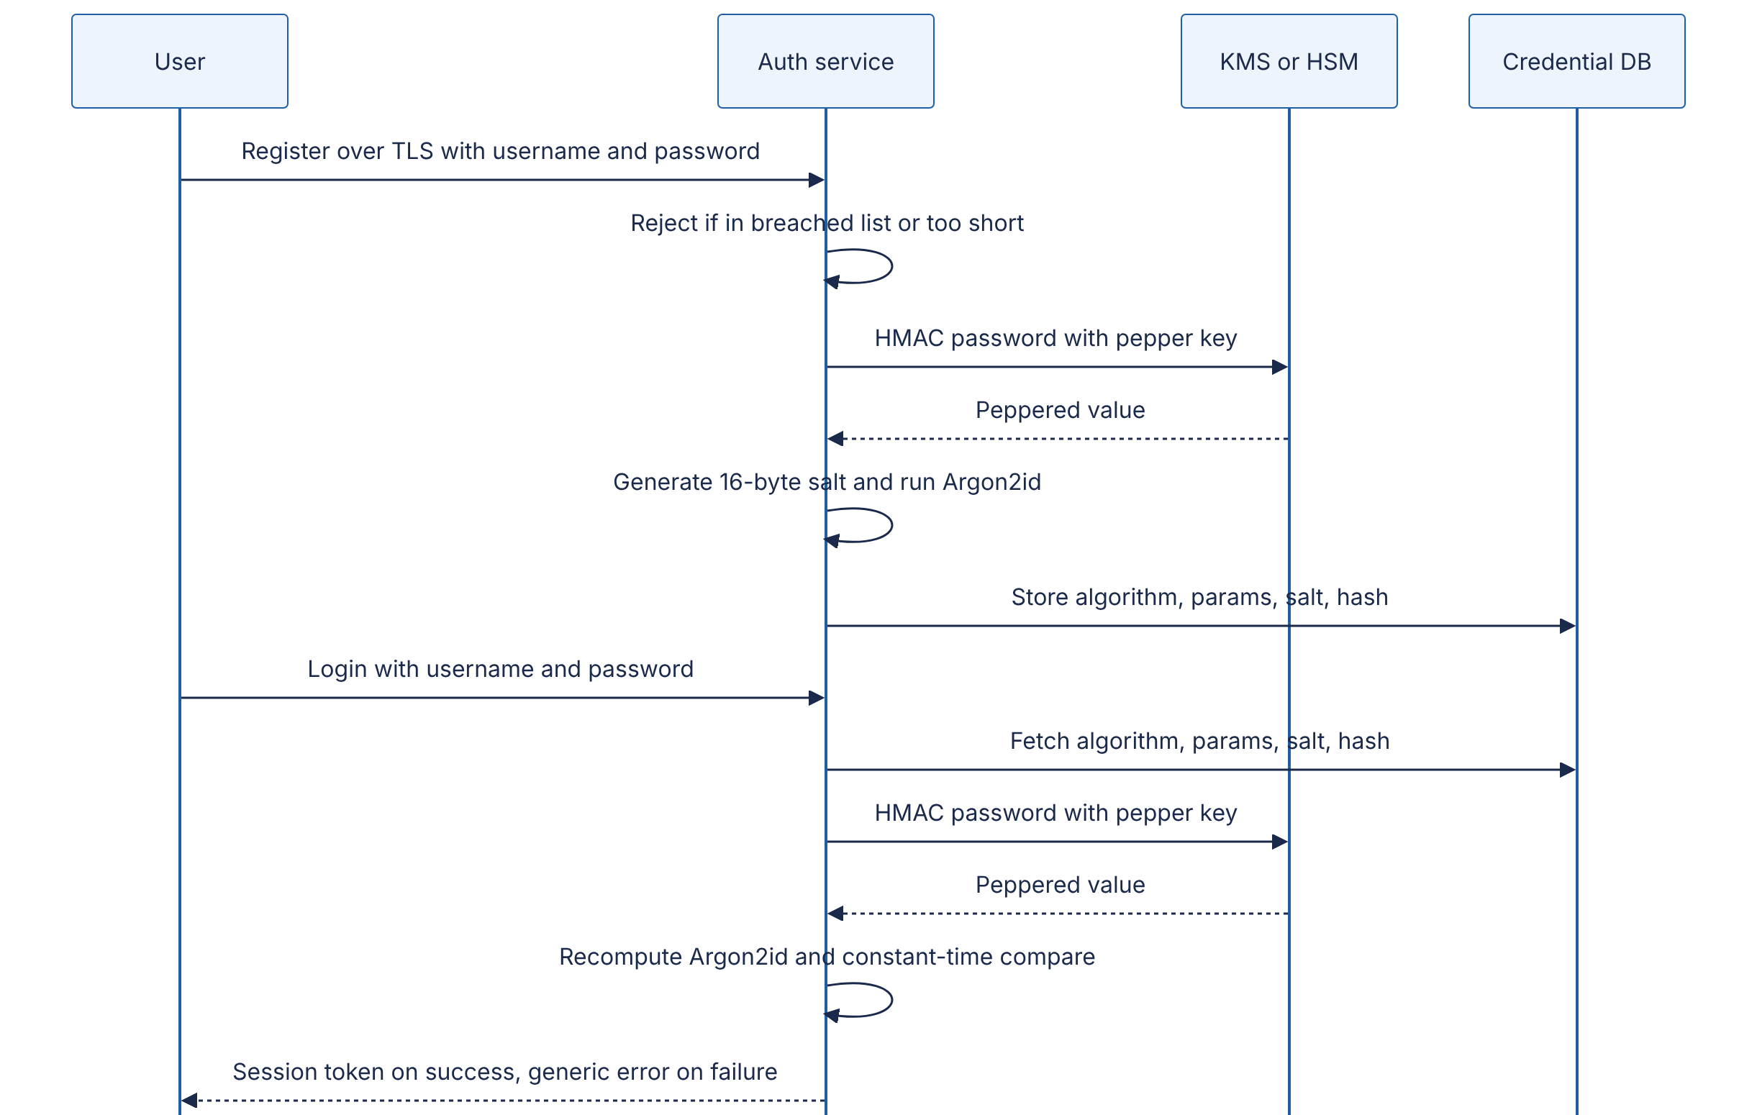
Reading the diagram. All calls are synchronous. The password exists in plaintext only in memory of the auth service, briefly. The pepper key never leaves the KMS or HSM; the service sends it data to MAC (some designs instead load the pepper into service memory at startup, trading isolation for one fewer network call per login). The credential database stores only the self-describing record — for example argon2id$m=19456,t=2,p=1$<salt>$<hash> — so a stolen database alone is not enough to start guessing. The failure response is deliberately generic (“invalid username or password”) and takes the same time for unknown users to avoid revealing which accounts exist. Scaling: the Argon2id step dominates CPU and memory, so login capacity scales with auth-service replicas; rate limiting per account and per IP sits in front of it.

Code example
"""Password hashing with scrypt (standard library) and Argon2id (cryptography >= 44)."""
import base64
import hashlib
import hmac
import os
import time
# ---------- scrypt (stdlib) ----------
SCRYPT_N, SCRYPT_R, SCRYPT_P = 2**17, 8, 1 # OWASP minimum: N=2^17, r=8, p=1
SCRYPT_MAXMEM = 256 * 1024 * 1024 # memory needed is ~128*N*r = 128 MiB
def b64(b: bytes) -> str:
return base64.b64encode(b).decode().rstrip("=")
def unb64(s: str) -> bytes:
return base64.b64decode(s + "=" * (-len(s) % 4))
def scrypt_hash(password: str) -> str:
salt = os.urandom(16) # unique per password
dk = hashlib.scrypt(password.encode("utf-8"), salt=salt,
n=SCRYPT_N, r=SCRYPT_R, p=SCRYPT_P,
maxmem=SCRYPT_MAXMEM, dklen=32)
# Store algorithm, parameters, salt and hash together so they can evolve.
return f"scrypt${SCRYPT_N}${SCRYPT_R}${SCRYPT_P}${b64(salt)}${b64(dk)}"
def scrypt_verify(password: str, stored: str) -> bool:
alg, n, r, p, salt_s, dk_s = stored.split("$")
if alg != "scrypt":
raise ValueError("unknown algorithm")
n, r, p = int(n), int(r), int(p)
candidate = hashlib.scrypt(password.encode("utf-8"), salt=unb64(salt_s),
n=n, r=r, p=p,
maxmem=max(SCRYPT_MAXMEM, 256 * n * r), dklen=32)
return hmac.compare_digest(candidate, unb64(dk_s)) # constant-time compare
def needs_rehash(stored: str) -> bool:
_, n, r, p, *_ = stored.split("$")
return (int(n), int(r), int(p)) != (SCRYPT_N, SCRYPT_R, SCRYPT_P)
# ---------- Argon2id (cryptography library) ----------
from cryptography.hazmat.primitives.kdf.argon2 import Argon2id
from cryptography.exceptions import InvalidKey
ARGON_T, ARGON_M_KIB, ARGON_P = 2, 19 * 1024, 1 # OWASP minimum: m=19 MiB, t=2, p=1
def argon2id_hash(password: str) -> str:
salt = os.urandom(16)
kdf = Argon2id(salt=salt, length=32, iterations=ARGON_T,
lanes=ARGON_P, memory_cost=ARGON_M_KIB)
tag = kdf.derive(password.encode("utf-8"))
return f"argon2id${ARGON_M_KIB}${ARGON_T}${ARGON_P}${b64(salt)}${b64(tag)}"
def argon2id_verify(password: str, stored: str) -> bool:
alg, m, t, p, salt_s, tag_s = stored.split("$")
if alg != "argon2id":
raise ValueError("unknown algorithm")
kdf = Argon2id(salt=unb64(salt_s), length=32, iterations=int(t),
lanes=int(p), memory_cost=int(m))
try:
kdf.verify(password.encode("utf-8"), unb64(tag_s)) # constant-time inside
return True
except InvalidKey:
return False
Tested with Python 3.13 and cryptography 50.0.1 on a cloud VM: one scrypt hash at OWASP-minimum settings took about 400 ms, one Argon2id hash about 33 ms; correct passwords verify, a one-letter change fails, and hashing the same password twice gives different strings.
What to notice:
- hashlib.scrypt refuses to use more than 32 MiB by default; maxmem must be raised for $N=2^{17}$, $r=8$ (128 MiB).
- The stored string is self-describing (algorithm, parameters, salt, hash), which is what makes needs_rehash and gradual parameter upgrades possible. Production code should prefer the standard PHC string format produced by maintained libraries such as argon2-cffi.
- ~33 ms for Argon2id at OWASP-minimum settings is a floor; raise $m$ or $t$ until the cost reaches your latency and capacity budget.
COMMON MISTAKE
“Encrypting passwords is safer than hashing them.” Encryption is reversible, so whoever obtains the key — an attacker with application-server access, a rogue administrator — recovers every password at once. Systems should never need to recover a user’s password; if a product requirement says “email users their password”, the requirement is wrong.

10.7 The OWASP Top 10 in architectural terms
DEFINITION
Definition — OWASP Top 10. A consensus ranking of the most critical web application security risk categories, published by the Open Worldwide Application Security Project from vulnerability data contributed by testing organizations plus a community survey. This section uses the 2021 edition [OWASP 2021]. A 2025 edition has since been published; it keeps broken access control at #1, folds SSRF into it, and adds categories for software supply-chain failures and mishandling of exceptional conditions, so the architectural controls below remain applicable.
The Top 10 is often taught as a list of coding bugs. For a system designer, each category is better read as a missing architectural control: something that should exist once, centrally, rather than being re-implemented correctly by every developer on every endpoint.
Table 10.9 — OWASP Top 10 (2021) mapped to architectural controls.
ID | Category | What goes wrong | Architectural control
A01 | Broken Access Control | Users act outside their permissions: IDOR, missing function-level checks, CORS misconfiguration | Deny by default; central policy engine or authorization middleware; object-level checks in the data-access layer; tenant ID derived from the token, never from the request body
A02 | Cryptographic Failures | Sensitive data unencrypted or protected with weak/misused crypto | TLS everywhere; KMS-managed keys; AEAD; data classification deciding what is encrypted (§10.9)
A03 | Injection | Untrusted data interpreted as code: SQL, NoSQL, OS command, LDAP; cross-site scripting is included here in 2021 | Parameterized queries/ORMs; no shell invocation with user input; context-aware output encoding; Content Security Policy
A04 | Insecure Design | Missing or ineffective security controls by design, not by implementation | Threat modeling (§10.3); abuse-case requirements; rate limits and business-logic limits designed in
A05 | Security Misconfiguration | Default credentials, verbose errors, open buckets, unnecessary features enabled | Infrastructure as code with policy checks; hardened base images; configuration drift detection
A06 | Vulnerable and Outdated Components | Known-vulnerable libraries, frameworks, OS packages | Software bill of materials (SBOM); dependency scanning in CI; patch SLAs; automated update PRs
A07 | Identification and Authentication Failures | Credential stuffing, weak session handling, missing MFA | Central identity provider; MFA; rate limiting; secure session tokens (§10.4.7)
A08 | Software and Data Integrity Failures | Unsigned updates, compromised CI/CD, insecure deserialization | Signed artifacts and provenance; protected build pipeline; no deserialization of untrusted native objects
A09 | Security Logging and Monitoring Failures | Breaches go undetected for months | Central, tamper-evident audit logs (§10.12); alerting on security events
A10 | Server-Side Request Forgery (SSRF) | Server fetches an attacker-chosen URL, reaching internal services | Egress allow-lists via a dedicated fetch proxy; block metadata and private ranges; IMDSv2-style token-protected metadata

10.7.1 Broken access control (A01)
Broken access control is #1 because authorization is the one control that cannot be bolted on by infrastructure: only the application knows that photo 9001 belongs to user 42. The classic form is the insecure direct object reference (IDOR): GET /api/photos/9001 returns the photo to anyone authenticated, because the handler checks that the user is logged in but not whether they own photo 9001.
Architectural patterns that make the correct behavior the default:
- Deny by default. A new endpoint without an explicit policy rejects all requests.
- Centralize decisions. Route every authorization question through one library or service (a policy engine such as Open Policy Agent, or a relationship-based system modeled on Google’s Zanzibar — §8.12), so the rules are written and reviewed once.
- Push checks to the data layer. Repository methods take the caller’s identity and add WHERE owner_id = :caller (or tenant filters) automatically; database row-level security can enforce the same rule underneath.
- Use unguessable identifiers as defense in depth, not as the control. Random UUIDs make enumeration harder but are not authorization; IDs leak through URLs, logs and shares.

10.7.2 Injection (A03)
Injection happens when data and code share a channel. A query built as "SELECT * FROM users WHERE name = '" + name + "'" lets an attacker supply ' OR '1'='1 and change the query’s structure. Parameterized queries separate the channels: the query text is sent to the database with placeholders, and values are sent separately, so a value can never become syntax.
import sqlite3
db = sqlite3.connect(":memory:")
db.execute("CREATE TABLE users (name TEXT, email TEXT)")
db.execute("INSERT INTO users VALUES ('alice', 'a@example.com')")
attacker_input = "x' OR '1'='1"
# Vulnerable (illustrative, never do this): f"... WHERE name = '{attacker_input}'"
rows = db.execute("SELECT email FROM users WHERE name = ?", (attacker_input,)).fetchall()
print(rows) # [] -- the input is treated purely as a value
What to notice: the ? placeholder is bound by the driver; no escaping function is needed or involved. The architectural layer of defense is to give the application’s database user only the rights it needs (no DROP, no access to other schemas), so a missed injection cannot become a full compromise.

10.7.3 Server-side request forgery (A10)
Many features make the server fetch a URL the user supplied: link previews, webhooks, “import from URL”, PDF rendering. If the server can reach internal addresses, the attacker can make it fetch http://169.254.169.254/ (the cloud instance-metadata endpoint that hands out the instance’s IAM credentials), http://localhost:8080/admin or internal databases’ HTTP interfaces.
INDUSTRY EXAMPLE
Capital One (2019). An attacker exploited a misconfigured web application firewall to make requests to the AWS instance-metadata service, obtained temporary credentials for the instance’s IAM role, and used that role’s overly broad permissions to copy data on roughly 100 million credit-card applicants from S3. Two architectural failures compounded: an SSRF path to metadata, and a role with far more S3 access than the WAF needed. Later that year AWS introduced IMDSv2, which requires a session token obtained via an HTTP PUT, defeating most simple SSRF requests. Evidence: Secondary — public court filings and widespread reporting; [AWS Docs: IMDSv2].
Defense in depth for SSRF: (1) route all user-driven outbound fetches through a dedicated egress proxy in its own network segment with no route to internal ranges; (2) validate URLs (scheme, port, resolved IP) and pin the validated IP for the connection, otherwise DNS rebinding — a hostname that resolves to a public IP at check time and a private IP at fetch time — bypasses the check; (3) disable redirects or re-validate each hop; (4) require IMDSv2 and give instance roles least privilege.
"""Defense-in-depth check for user-supplied URLs fetched by a server (SSRF)."""
import ipaddress
import socket
from urllib.parse import urlsplit
ALLOWED_SCHEMES = {"https"}
ALLOWED_PORTS = {443}
def resolve_and_check(url: str) -> list[str]:
parts = urlsplit(url)
if parts.scheme not in ALLOWED_SCHEMES:
raise ValueError(f"scheme {parts.scheme!r} not allowed")
port = parts.port or 443
if port not in ALLOWED_PORTS or not parts.hostname:
raise ValueError("port or host not allowed")
infos = socket.getaddrinfo(parts.hostname, port, proto=socket.IPPROTO_TCP)
addrs = sorted({info[4][0] for info in infos})
for a in addrs:
ip = ipaddress.ip_address(a)
if not ip.is_global: # rejects private, loopback, link-local (169.254.169.254), etc.
raise ValueError(f"{parts.hostname} resolves to non-public {ip}")
# Caller must connect to one of THESE addresses (pin them) to avoid DNS rebinding.
return addrs
Tested results: http://example.com/ is denied (scheme), https://127.0.0.1/admin, https://169.254.169.254/latest/meta-data/, https://10.0.0.5:443/ and https://[::1]/ are denied (non-public address), and https://localhost:8443/ is denied (port). What to notice: the check uses every resolved address, not just the first, and ip.is_global covers private, loopback, link-local and other reserved ranges for both IPv4 and IPv6. Application-level validation is the inner layer; the network-level egress proxy is the layer that still holds when a developer forgets to call this function.
COMMON MISTAKE
“A WAF fixes the OWASP Top 10.” A web application firewall blocks known attack patterns at the edge and buys time for patching. It cannot know who owns photo 9001 (A01), cannot fix insecure design (A04), and can itself be a component with an SSRF flaw, as the Capital One case shows. Treat the WAF as one layer, not the control.

10.8 Secrets management
DEFINITION
Definition — Secret. Any value that grants access and must be kept confidential: database passwords, API keys, OAuth client secrets, TLS and signing private keys, encryption keys, webhook HMAC keys. Secrets management is the practice of storing, distributing, rotating, auditing and revoking secrets so that they are available to the workloads that need them and to nobody else.

First-principles explanation
In an office, physical keys drift: copies are cut for contractors, left in drawers, never returned. Eventually nobody knows who can open the server room. Software secrets drift the same way and faster: a database password gets pasted into a configuration file, committed to Git, baked into a container image, printed in a debug log, copied into a CI variable and a teammate’s laptop. Each copy is a place it can leak from, and a secret that has existed unchanged for three years has had three years to leak.
The progression of maturity is:
- Hard-coded in source — anyone with repository access has production access, forever (Git history keeps it).
- Environment variables / config files injected at deploy time — out of source, but static, widely copied, visible in crash dumps.
- Central vault — a secrets manager (HashiCorp Vault, AWS Secrets Manager, Google Secret Manager, Azure Key Vault) stores secrets encrypted, releases them only to authenticated workloads, logs every read and supports rotation.
- Dynamic, short-lived credentials — the vault creates a unique credential per workload on demand with a lease (say one hour) and revokes it at expiry.
- Identity-based (“secretless”) — workloads authenticate with a platform-attested identity (cloud IAM role, Kubernetes service-account token, SPIFFE ID) and receive short-lived tokens; there is no long-lived secret to leak.
Figure 10.6 — A workload obtaining dynamic database credentials from a vault.
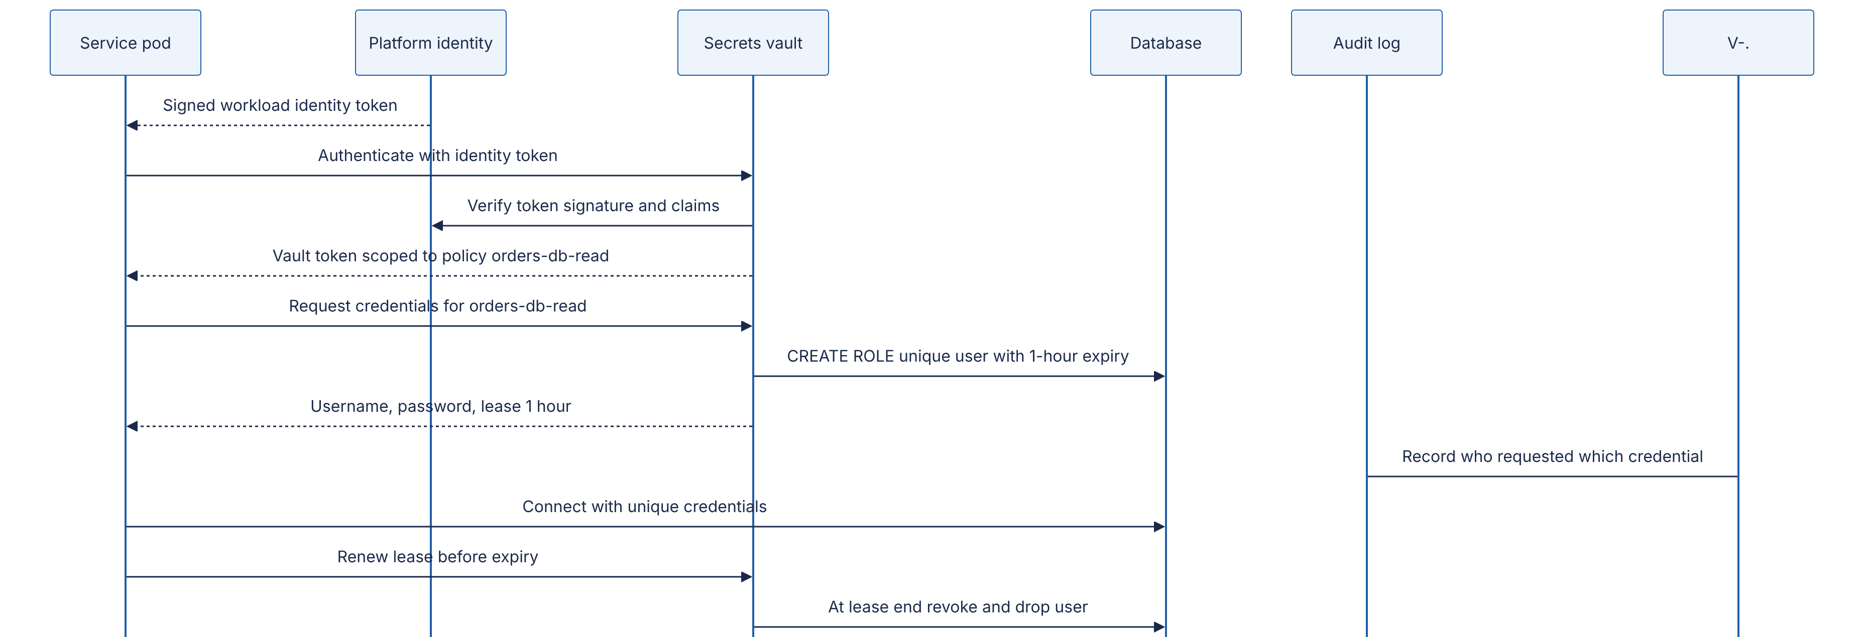
Reading the diagram. The pod starts with no secret at all: the platform (for example Kubernetes or a cloud provider) gives it a signed identity token describing which service it is. The vault verifies that token and maps the identity to a policy. Instead of returning a shared password, the vault connects to the database with its own administrative credential and creates a unique, time-limited database user. The workload receives credentials it alone holds; the vault records the issuance asynchronously in an audit log (dotted arrow). Leases are renewed while the pod lives; when the pod dies the lease expires and the vault drops the user. Failure points: the vault is now a critical dependency — if it is unavailable, new pods cannot get credentials, so vaults are run as replicated clusters (Vault uses Raft consensus, §26.7) and clients cache credentials for their lease. Scaling: one credential per pod means the database must tolerate many distinct users; for very large fleets, issue per-service rather than per-pod credentials.
FORMULA
Credential misuse window
$$W=\left\{\begin{matrix}T_{\text{detect}}+T_{\text{rotate}} & \text{long-lived credential} \\ min\left(T_{\text{TTL}}, T_{\text{detect}}+T_{\text{revoke}}\right) & \text{short-lived credential}\end{matrix}\right.$$
Symbol | Meaning | Units
$W$ | Time during which a leaked credential remains usable | hours
$T_{\text{detect}}$ | Time from leak to detection | hours
$T_{\text{rotate}},T_{\text{revoke}}$ | Time to rotate or revoke after detection | hours
$T_{\text{TTL}}$ | Lifetime of a short-lived credential | hours
WORKED EXAMPLE
Worked example — Static key vs one-hour credential. Industry breach studies commonly report detection times measured in months; assume $T_{\text{detect}}=200$ days $=4,800$ h and $T_{\text{rotate}}=24$ h. A static API key leaked to a public repository is usable for $W=4,824$ h. A one-hour dynamic credential leaked in the same way is usable for at most $W=min\left(1,4,824\right)=1$ h. Interpretation: short lifetimes shrink the window by more than three orders of magnitude without requiring detection to improve. Engineering implication: invest first in making credentials short-lived and automatically renewed; detection and response remain necessary for the vault and identity provider themselves.
Rotation must be designed, not improvised. A safe rotation for a static secret uses two valid versions: (1) create the new secret and register it with the receiving side, which now accepts both; (2) roll out the new secret to all callers; (3) verify no traffic uses the old one (metrics per key ID); (4) revoke the old one. This is why key IDs appear in the HMAC design of Figure 10.3. Complement rotation with secret scanning in repositories and CI, pre-commit hooks, and an incident runbook that answers “this key leaked — what do we do in the next 15 minutes?”
WARNING / TRADE-OFF
Kubernetes Secrets are not encrypted by default. They are base64-encoded objects in etcd; anyone with etcd access or broad RBAC get secrets permission can read them. Enable encryption at rest for etcd with a KMS provider, restrict RBAC, and prefer mounting secrets from an external vault (§42.11).

10.9 Encryption at rest and in transit, KMS and envelope encryption

10.9.1 In transit and at rest
Encryption in transit protects data moving over a network from eavesdropping and tampering. The rule is simple: TLS 1.2 or later (prefer 1.3) on every hop, including internal ones — between load balancer and service, service and database, service and cache. “The internal network is trusted” is exactly the perimeter assumption that zero trust (§10.10) rejects.
Encryption at rest protects stored data from someone who obtains the storage medium or a copy of it. It is applied at different layers, and the layer determines which attacker it stops.
Table 10.10 — Layers of encryption at rest and what each protects against.
Layer | Example | Protects against | Does not protect against | Cost
Full-disk / volume | Cloud volume encryption, LUKS | Stolen disks, discarded hardware | Anyone who can query the running system | Near-zero; usually default
Storage service | S3 SSE-KMS, managed DB storage encryption | Above, plus snapshots/backups copied without key permission | Application or DB credentials compromise | Low; KMS call costs
Database (TDE) | Transparent data encryption | Stolen DB files and backups | SQL injection, compromised DB user | Low
Application / field-level | App encrypts SSN column with a KMS-managed key before writing | DB admins, SQL injection reading raw columns, backup leaks | Compromise of the application with decrypt permission | Higher: no querying on ciphertext, key plumbing
Client-side / end-to-end | Messaging apps, client-encrypted backups | The service operator itself | Compromised client device | Highest: server cannot read or index data
The key insight: lower layers are cheap and defeat physical and backup threats; higher layers are expensive and defeat logical threats from people and processes with access to the running system. Most designs use volume or service encryption everywhere, and field-level encryption for a small set of highly sensitive fields (government IDs, health data, payment details).

10.9.2 Key management services and envelope encryption
DEFINITION
Definition — Key management service (KMS). A managed service, backed by hardware security modules (HSMs), that generates and stores key-encryption keys (KEKs) that never leave it in plaintext, performs cryptographic operations with them on request, enforces access policies on every use and logs every call. Examples: AWS KMS, Google Cloud KMS, Azure Key Vault, HashiCorp Vault’s Transit engine.
DEFINITION
Definition — Envelope encryption. Encrypting data with a data-encryption key (DEK) generated for that data, then encrypting (“wrapping”) the DEK with a KEK held in a KMS, and storing the wrapped DEK alongside the ciphertext [AWS Docs: KMS concepts].

First-principles explanation
A hotel does not give each guest the master key. Each room has its own key (the DEK); the room keys are kept in a safe at the front desk, and only the manager has the key to the safe (the KEK in the KMS). Losing one room key affects one room; changing the safe’s lock does not require changing every room’s lock.

Why does this exist?
Three problems with sending all data to the KMS directly: (1) size — KMS encrypt APIs accept only small payloads (AWS KMS Encrypt takes at most 4,096 bytes of plaintext); (2) latency and throughput — every encryption would cost a network round trip and count against request quotas; (3) blast radius — one key encrypting everything means one leak exposes everything. Envelope encryption sends only 32-byte keys to the KMS and encrypts the bulk data locally at memory speed.
Figure 10.7 — Envelope encryption: write and read paths.
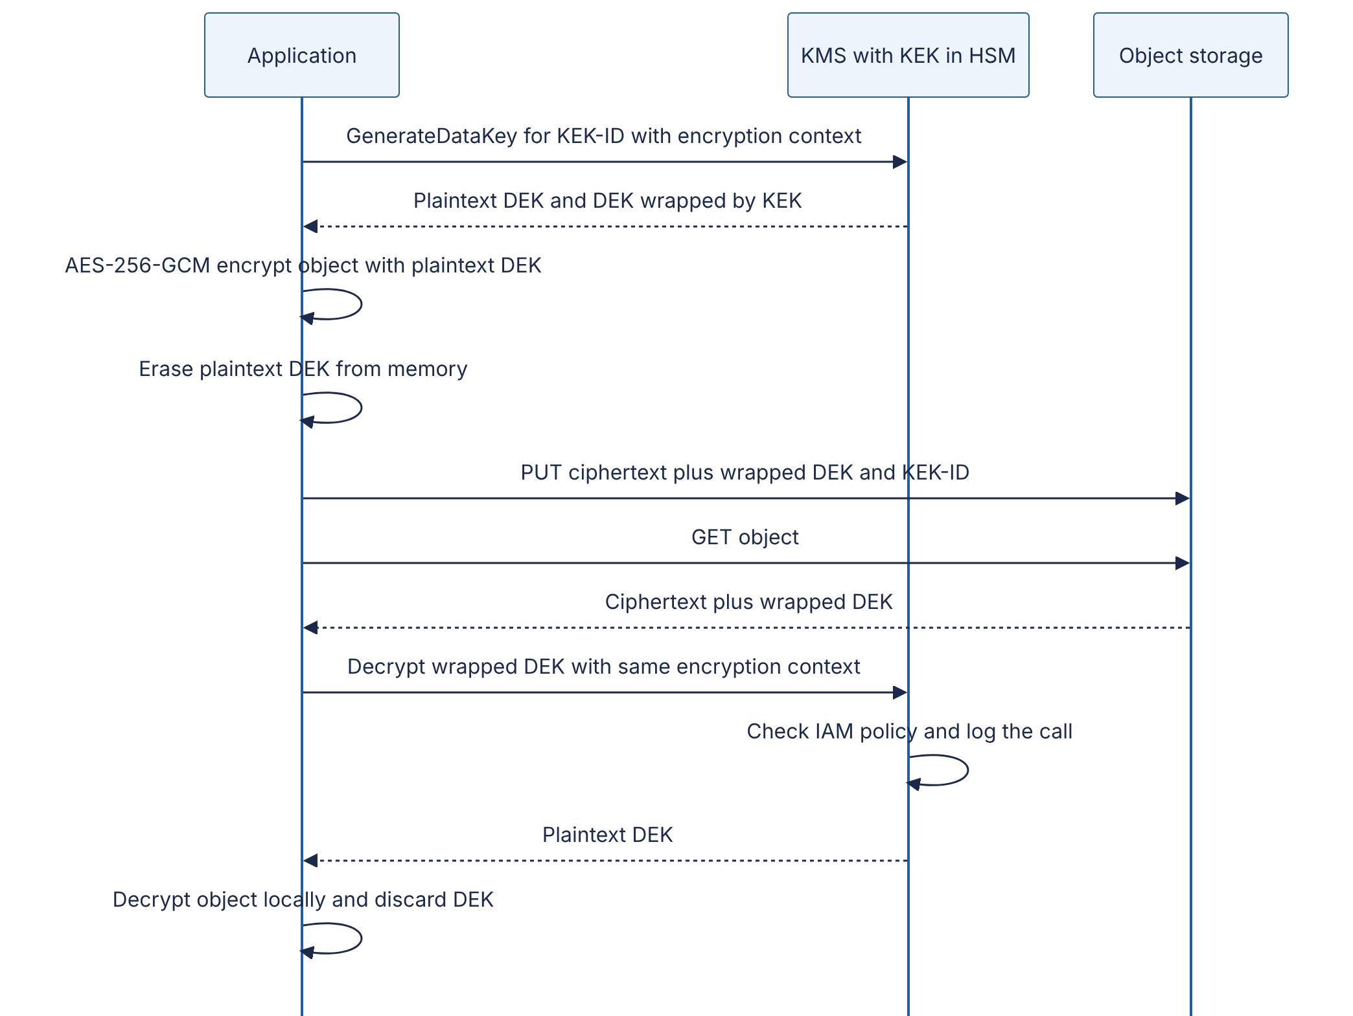
Reading the diagram. All calls are synchronous. On the write path the application asks the KMS for a fresh DEK; the KMS returns it twice — in plaintext for immediate use, and wrapped under the KEK for storage. The object is encrypted locally and stored with its wrapped DEK, so the storage system holds only ciphertext. On the read path the application sends the small wrapped DEK to the KMS; the KMS enforces the access policy at decrypt time and writes an audit record, which means “who read this data” becomes visible in KMS logs even if storage access logging is off. The encryption context (non-secret key–value pairs such as tenant and object name) is bound to the wrapped DEK as associated data; a wrapped DEK copied onto another tenant’s object fails to unwrap. Failure points: KMS unavailability blocks all reads and writes of new objects (mitigate with regional KMS keys, retries and, carefully, short-lived DEK caching); a deleted KEK makes all data under it unrecoverable (KMS services enforce deletion waiting periods for this reason). Scaling: KMS calls grow with the number of objects, not their size.

Code example: envelope encryption with a simulated KMS
"""Envelope encryption with a simulated KMS (the KEK never leaves the 'KMS')."""
import json
import os
from dataclasses import dataclass
from cryptography.hazmat.primitives.ciphers.aead import AESGCM
class FakeKMS:
"""Stands in for AWS KMS / Cloud KMS / Vault Transit. Holds KEKs internally."""
def __init__(self):
self._keks = {"kek-2026-10": AESGCM.generate_key(bit_length=256)}
self.current = "kek-2026-10"
def generate_data_key(self, context: dict) -> tuple[bytes, dict]:
dek = AESGCM.generate_key(bit_length=256) # fresh DEK per object
nonce = os.urandom(12)
aad = json.dumps(context, sort_keys=True).encode() # "encryption context"
wrapped = AESGCM(self._keks[self.current]).encrypt(nonce, dek, aad)
return dek, {"kek_id": self.current, "nonce": nonce.hex(), "wrapped": wrapped.hex()}
def decrypt_data_key(self, blob: dict, context: dict) -> bytes:
aad = json.dumps(context, sort_keys=True).encode()
return AESGCM(self._keks[blob["kek_id"]]).decrypt(
bytes.fromhex(blob["nonce"]), bytes.fromhex(blob["wrapped"]), aad)
def rotate(self) -> None:
new_id = f"kek-{len(self._keks) + 1}"
self._keks[new_id] = AESGCM.generate_key(bit_length=256)
self.current = new_id # old KEKs kept for decrypt
def rewrap(self, blob: dict, context: dict) -> dict:
"""Re-encrypt a DEK under the current KEK without touching the data."""
dek = self.decrypt_data_key(blob, context)
nonce = os.urandom(12)
aad = json.dumps(context, sort_keys=True).encode()
return {"kek_id": self.current, "nonce": nonce.hex(),
"wrapped": AESGCM(self._keks[self.current]).encrypt(nonce, dek, aad).hex()}
@dataclass
class EncryptedObject:
wrapped_dek: dict
nonce: bytes
ciphertext: bytes
def encrypt_object(kms: FakeKMS, plaintext: bytes, context: dict) -> EncryptedObject:
dek, wrapped = kms.generate_data_key(context) # 1 KMS call per object
nonce = os.urandom(12)
ct = AESGCM(dek).encrypt(nonce, plaintext, None) # bulk data encrypted locally
del dek # drop plaintext DEK ASAP
return EncryptedObject(wrapped, nonce, ct)
def decrypt_object(kms: FakeKMS, obj: EncryptedObject, context: dict) -> bytes:
dek = kms.decrypt_data_key(obj.wrapped_dek, context)
return AESGCM(dek).decrypt(obj.nonce, obj.ciphertext, None)
if __name__ == "__main__":
kms = FakeKMS()
ctx = {"tenant": "acme", "object": "invoices/2026-10.pdf"}
data = os.urandom(5_000_000) # 5 MB document
obj = encrypt_object(kms, data, ctx)
assert decrypt_object(kms, obj, ctx) == data
print("round trip OK; wrapped DEK is", len(bytes.fromhex(obj.wrapped_dek["wrapped"])), "bytes")
kms.rotate()
obj.wrapped_dek = kms.rewrap(obj.wrapped_dek, ctx) # rotate KEK: rewrap ~60 bytes,
assert decrypt_object(kms, obj, ctx) == data # not re-encrypt 5 MB
print("after KEK rotation, DEK now wrapped by", obj.wrapped_dek["kek_id"])
try:
decrypt_object(kms, obj, {"tenant": "evil", "object": "invoices/2026-10.pdf"})
except Exception as e:
print("wrong encryption context ->", type(e).__name__)
Output (tested):
round trip OK; wrapped DEK is 48 bytes
after KEK rotation, DEK now wrapped by kek-2
wrong encryption context -> InvalidTag
What to notice:
- Rotation is cheap. Rotating the KEK means rewrapping a 48-byte wrapped DEK per object, not re-encrypting 5 MB of data. Managed KMS services go further: automatic rotation keeps old key versions for decryption, so existing wrapped DEKs remain valid without any rewrap.
- Crypto-shredding. Deleting a tenant’s KEK (or an object’s DEK) renders the data permanently unreadable, including every backup copy — a practical way to honor deletion requests in systems with immutable backups.
- Context binding. The encryption context is authenticated, so a confused-deputy bug that passes the wrong tenant fails closed.
- del dek only removes the Python reference; Python cannot guarantee the bytes are wiped from memory. Production envelope encryption should use a maintained SDK (for example the AWS Encryption SDK or Google Tink), which also defines a standard on-disk message format.
FORMULA
KMS request rate under envelope encryption
$$Q_{\text{KMS}}=\frac{λ_{\text{obj}}}{B}$$
Symbol | Meaning | Units
$Q_{\text{KMS}}$ | KMS requests generated | requests/s
$λ_{\text{obj}}$ | Rate of objects (or records) encrypted or decrypted | objects/s
$B$ | Objects protected per KMS call (1 for a DEK per object; larger with DEK caching or per-batch keys) | objects/request
WORKED EXAMPLE
Worked example — Sizing KMS usage. An ingestion service writes $λ=20,000$ records per second. With one DEK per record ($B=1$), it would send 20,000 KMS requests per second — likely above a default per-account quota (AWS KMS cryptographic-operation quotas are in the thousands to tens of thousands of requests per second depending on region and key type, as of 2026) and costly at roughly $0.03 per 10,000 requests: $20,000×86,400/10,000×\$0.03≈\$5,184$ per day. If each of 40 ingestion nodes instead generates a DEK once per minute and uses it for a batch of records (storing the wrapped DEK once per batch), then $Q=40/60≈0.67$ requests per second, about $0.17 per day. Interpretation: DEK granularity is a trade-off between cost/throughput and blast radius: a per-minute DEK exposes at most one minute of one node’s records if leaked from memory. Engineering implication: choose per-object DEKs for large or individually deletable objects, and time- or count-bounded cached DEKs for high-rate small records — and keep under the GCM per-key message limit from §10.4.2.

10.10 Network security, zero trust and mTLS

10.10.1 From the castle to zero trust
The traditional perimeter model is a castle with a moat: a firewall at the edge, a VPN for remote workers, and implicit trust for anything inside. Its failure mode is total. Once an attacker is inside — through a phished laptop, a vulnerable VPN appliance or a compromised internal service — they can reach everything, a technique called lateral movement. Most large breaches are a small initial foothold followed by weeks of lateral movement.
DEFINITION
Definition — Zero trust. A security model in which network location confers no trust: every request is authenticated, authorized and encrypted based on the identity of the user, the device and the workload, plus contextual signals, regardless of where it originates. NIST SP 800-207 describes it as moving defenses “from static, network-based perimeters to focus on users, assets, and resources” [NIST SP 800-207].
INDUSTRY EXAMPLE
Google BeyondCorp. After the 2009 “Operation Aurora” intrusions, Google began moving its corporate applications off the privileged internal network. In BeyondCorp, as described by Ward and Beyer, employee devices sit on an unprivileged network even inside Google offices; every request to an internal application goes through an internet-facing access proxy; access decisions are made per request by an access control engine using the user’s identity and group membership, a device inventory with per-device certificates, and a computed trust tier for the device (patch level, management state). Remote and in-office access become identical, and the VPN is retired. Follow-up papers describe the multi-year migration and the access-proxy design. Evidence: Primary — [Ward & Beyer 2014]; [Osborn et al. 2016]
Figure 10.8 — Zero-trust access in the style of BeyondCorp.
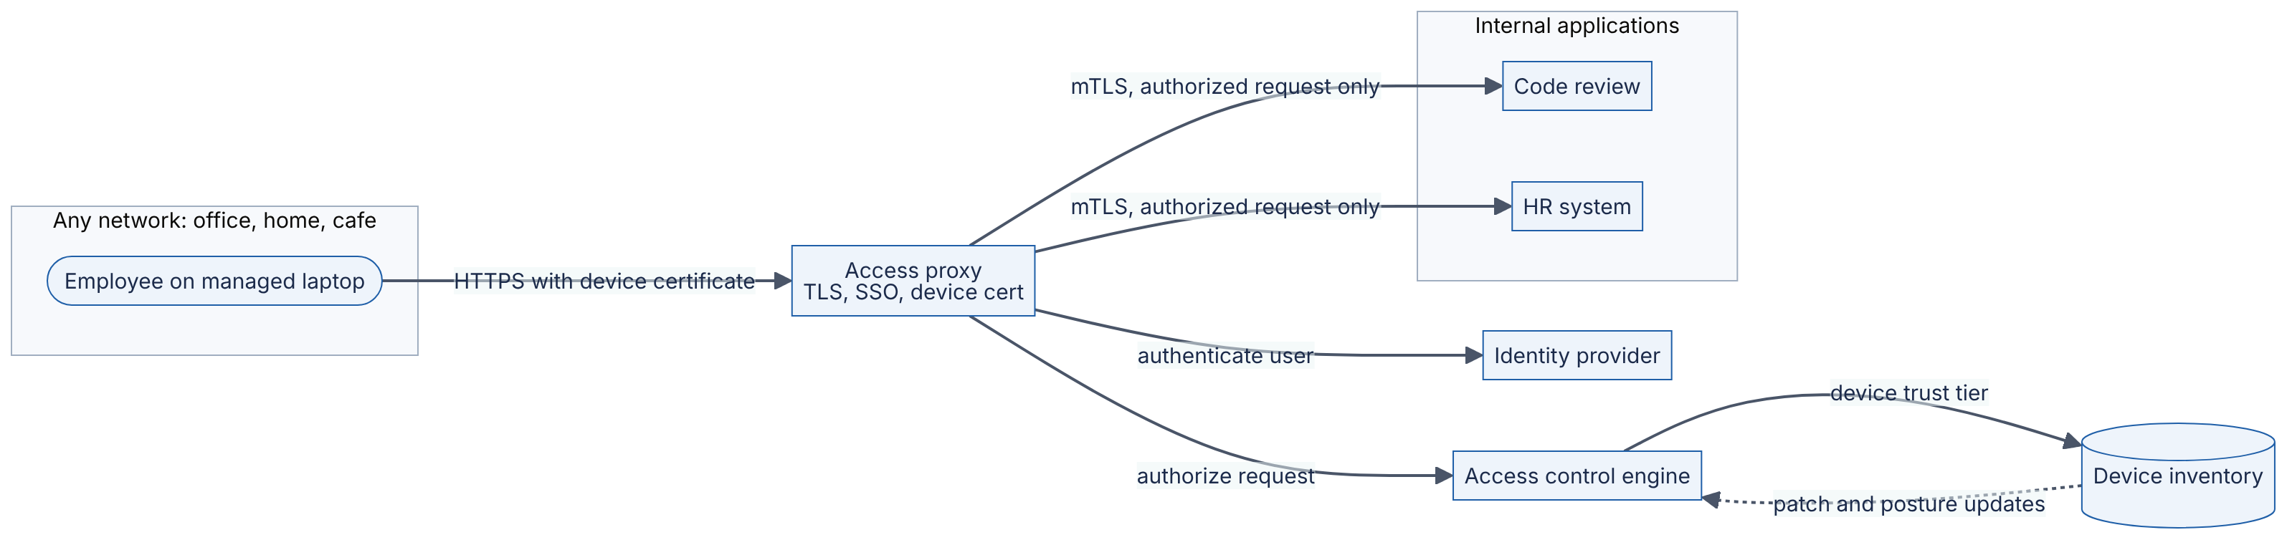
Reading the diagram. The employee’s location is irrelevant: the office network has no special privileges. Every request reaches the access proxy over HTTPS, presenting a device certificate (identifying the machine) and a single-sign-on session (identifying the person). The proxy asks the identity provider to authenticate the user and the access control engine to authorize this request to this application, using group membership and the device’s current trust tier from the inventory (fed asynchronously by device-management data). Only authorized requests are forwarded, over mTLS, to applications that accept connections from the proxy alone. Failure points: the proxy and access engine become critical, highly available infrastructure; an over-permissive policy reproduces the old flat network. Scaling: the proxy is a stateless, horizontally scaled L7 tier (§19.3).

10.10.2 Mutual TLS and workload identity
Ordinary TLS authenticates only the server. Mutual TLS (mTLS) has both sides present certificates and prove possession of the private key, so a service knows cryptographically which workload is calling it — not merely which IP address, which can be spoofed or reused. In practice mTLS between services is provided by a service mesh sidecar or proxy (§34.10) that obtains short-lived certificates automatically. The SPIFFE standard defines a portable workload identity such as spiffe://example.org/ns/payments/sa/api carried in an X.509 certificate (an SVID), so authorization policies can be written as “only orders may call payments POST /charge”, independent of IP addresses.

10.10.3 Least privilege and segmentation
Least privilege grants every user, service and credential the minimum permissions needed for its task, for the minimum time [Adkins et al. 2020]. In practice: one IAM role per service, not a shared “app” role; read-only database users for read-only services; no standing production admin access (engineers request time-boxed, approved, logged elevation — “just-in-time access”); and periodic review that removes unused permissions (cloud providers report “last used” data for this).
Segmentation limits blast radius at the network layer: separate VPCs or accounts for production and non-production; subnets for edge, application and data tiers with security groups allowing only the required flows (the boundaries in Figure 10.1); Kubernetes NetworkPolicies that default-deny pod-to-pod traffic; and dedicated egress paths. Microsegmentation pushes this down to per-workload policies. Zero trust does not abolish network controls — it stops relying on them. Defense in depth means an attacker must defeat identity, authorization, network policy and monitoring, not just one.
Table 10.11 — Perimeter model vs zero trust.
 | Perimeter (“castle and moat”) | Zero trust
What it is | Trust based on network location | Trust based on verified identity and context per request
How it works | Edge firewall, VPN, flat internal network | Identity-aware proxies, mTLS, per-request policy
Advantages | Simple; works with legacy apps | Limits lateral movement; uniform remote access
Disadvantages | One breach exposes everything | Requires strong identity, device inventory, mature tooling
Operational complexity | Low initially, high after incidents | High upfront; policy management is ongoing
Choose when | Never as the only control | Default target architecture for new systems

10.11 DDoS basics
DEFINITION
Definition — Distributed denial of service (DDoS). An attack that makes a service unavailable by overwhelming some finite resource — network bandwidth, packet-processing capacity, connection-state tables, or application CPU, memory and database capacity — with traffic from many sources at once, typically a botnet of compromised devices or abused open servers.

First-principles explanation
Imagine a restaurant. A volumetric attack is a crowd so large it blocks the street, so no customer reaches the door. A protocol attack is a crowd that walks in, occupies every table, and orders nothing. An application-layer attack is a crowd of well-dressed customers each ordering the single dish that takes the kitchen an hour to cook. Each needs a different defense, applied at a different place.
Table 10.12 — DDoS attack classes.
 | Volumetric | Protocol (state exhaustion) | Application layer (L7)
Target resource | Link bandwidth | Connection tables in firewalls, load balancers, servers | Application CPU, DB, cache, downstream APIs
Examples | UDP floods; reflection/amplification via DNS, NTP, memcached | SYN floods, fragmented-packet floods | HTTP floods on expensive endpoints; HTTP/2 Rapid Reset
Measured in | Bits per second (Gbps–Tbps) | Packets per second | Requests per second
Looks like | Obviously abnormal traffic | Half-open connections | Legitimate-looking requests
Primary defense | Upstream capacity: anycast scrubbing networks, CDN | SYN cookies, stateless edge proxies, scrubbing | WAF rules, rate limits, bot detection, caching, autoscaling, load shedding
Reflection and amplification are what make volumetric attacks cheap. The attacker sends small UDP requests to thousands of open servers with the victim’s IP address forged as the source; each server sends its (much larger) reply to the victim.
FORMULA
Amplified attack bandwidth
$$B_{\text{victim}}=B_{\text{attacker}}×A$$
Symbol | Meaning | Units
$B_{\text{victim}}$ | Traffic arriving at the victim | bits/s
$B_{\text{attacker}}$ | Spoofed request traffic the attacker sends | bits/s
$A$ | Bandwidth amplification factor of the abused protocol (response bytes / request bytes) | dimensionless
WORKED EXAMPLE
Worked example — DNS amplification. US-CERT lists DNS amplification factors of roughly 28–54 [US-CERT TA14-017A]. An attacker with 2 Gbps of spoofing capacity and $A=50$ produces $B=2×50=100$ Gbps at the victim. A single origin data center with a 10 Gbps uplink is saturated tenfold; nothing the origin does locally helps, because the link is full before packets reach any server. Engineering implication: volumetric defense must happen upstream, in networks whose capacity exceeds the attack — anycast CDNs and scrubbing services that advertise your IP prefixes from many locations and absorb the flood across their global capacity.
INDUSTRY EXAMPLE
GitHub memcached attack (2018) and HTTP/2 Rapid Reset (2023). On 28 February 2018 GitHub received a 1.35 Tbps memcached-reflection attack; memcached servers exposed on UDP can amplify requests by factors in the tens of thousands. GitHub routed traffic to its DDoS-mitigation provider and the attack was mitigated within about ten minutes. In 2023 the “HTTP/2 Rapid Reset” technique (CVE-2023-44487) — opening and immediately cancelling streams on a single connection — produced application-layer floods that Google reported peaking at about 398 million requests per second. Evidence: Primary — [GitHub 2018]; [Google Cloud 2023]
Figure 10.9 — DDoS mitigation in layers.
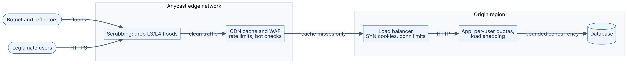
Reading the diagram. Traffic flows left to right through successively narrower and more expensive layers. The anycast edge, spread across many locations, absorbs volumetric and protocol floods (the scrubbing stage) because its aggregate capacity is far larger than any single origin’s. The CDN serves cacheable content without touching the origin and applies L7 controls: WAF rules, per-IP and per-session rate limits, and bot challenges. The origin should accept traffic only from the edge (allow-list the CDN’s ranges or use authenticated origin pulls), otherwise attackers bypass the edge by hitting the origin IP directly. Inside, the load balancer defends connection state, and the application enforces per-user quotas and sheds load (§22.9) so that the database — the scarcest resource — sees bounded concurrency. Scaling: autoscaling helps against L7 floods only up to your budget; an attacker’s marginal cost per request is usually lower than yours, so the main lever is making requests cheap (caching) or refusing them early.
RECOMMENDATION
Design rules. Put every public endpoint behind an anycast CDN or DDoS-protection service; hide origin IPs; cache aggressively; make expensive endpoints (search, report generation, login) authenticated and rate-limited; set timeouts and bounded queues everywhere (§22.11); know in advance who you call and what you toggle during an attack (a runbook, rehearsed).

10.12 Audit logging and tamper evidence
DEFINITION
Definition — Audit log. An append-only record of security-relevant events — who (actor), did what (action), to which resource, when, from where, and with what result — retained so that actions can be investigated and attributed. A log is tamper-evident if any modification, deletion or reordering of past entries can be detected.

First-principles explanation
An audit log is a bank’s bound, page-numbered ledger written in ink: you can add lines but cannot tear out a page or erase a line without it being obvious. Application debug logs are the opposite — a whiteboard. Attackers who gain privileged access routinely delete or edit logs to hide their tracks, and malicious insiders are precisely the people with access to logs. So audit logs must be designed so that the people being audited cannot rewrite them.
What to log. Authentication events (success, failure, MFA changes), authorization failures, privilege and role changes, access to sensitive data (reads, exports), administrative and configuration changes, key and secret usage (KMS logs this for you), and security-control changes (disabling logging is itself an event). Each entry: timestamp (UTC, synchronized clock), actor identity (user and workload), source (IP, device), action, resource, result, and a request or trace ID. What not to log: passwords, session tokens, full card numbers, secret values, or more personal data than necessary — the log becomes a sensitive data store itself.
How tamper evidence works. Each entry includes the hash of the previous entry, forming a hash chain: $h_{i}=H\left(h_{i−1} ∥ e_{i}\right)$. Changing any past entry changes its hash and breaks every link after it. A chain alone is not enough — whoever can write the log can recompute the whole chain — so the latest hash (the head) is periodically anchored somewhere the writer cannot alter: signed by a key in a KMS, written to a separate account’s write-once (WORM) storage, or published to an external transparency log. Schneier and Kelsey described keyed hash-chain audit logs in 1999; Crosby and Wallach later showed how Merkle-tree structures make such logs efficiently verifiable — the same idea behind Certificate Transparency (§10.5) [Schneier & Kelsey 1999; Crosby & Wallach 2009].
Figure 10.10 — Tamper-evident audit logging pipeline.
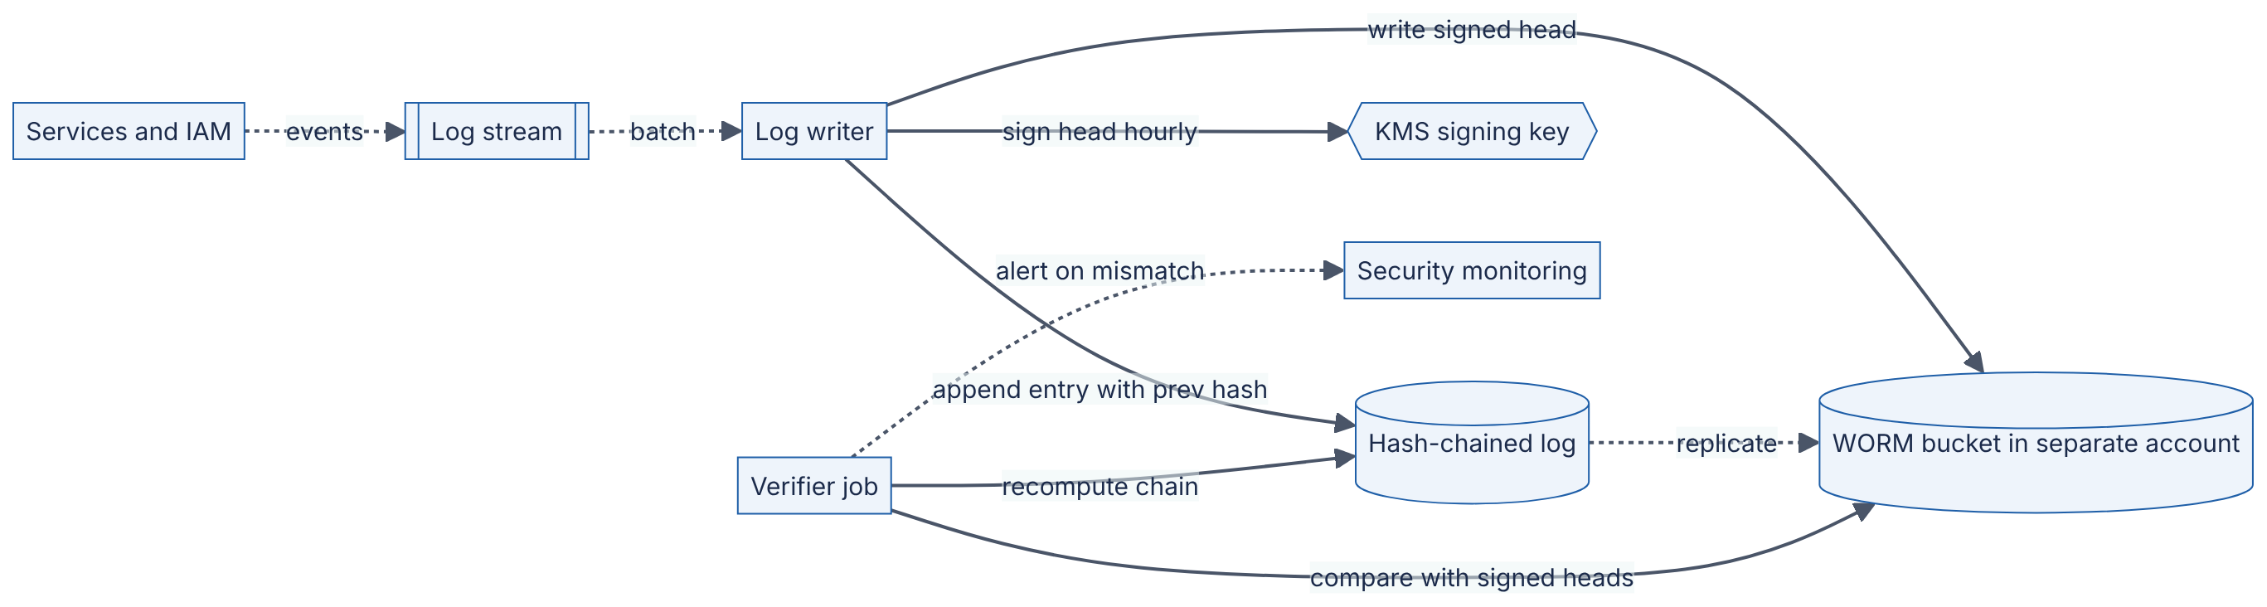
Reading the diagram. Services emit events asynchronously to a stream (dotted arrows), so logging never blocks user requests — at the cost that events can be delayed; the stream must be durable so events are not lost. A single writer appends each event with the previous entry’s hash. Every hour it asks the KMS to sign the current head (the signing key is usable only by the writer’s role and never leaves the KMS) and stores signed heads and log replicas in a WORM bucket in a separate account with object lock, so even production administrators cannot delete them before retention expires. An independent verifier recomputes the chain and compares it with the signed heads, alerting the security team on any mismatch. Failure points: the writer is a bottleneck and single point of ordering (partition the chain per service or per tenant to scale); clock skew complicates ordering (use the chain order, not timestamps, as the authority).
"""Tamper-evident audit log: each entry commits to the previous one (hash chain)."""
import hashlib
import hmac
import json
GENESIS = "0" * 64
def entry_hash(prev_hash: str, event: dict) -> str:
payload = json.dumps(event, sort_keys=True, separators=(",", ":")).encode()
return hashlib.sha256(prev_hash.encode() + payload).hexdigest()
class AuditLog:
def __init__(self):
self.entries: list[dict] = []
def append(self, event: dict) -> str:
prev = self.entries[-1]["hash"] if self.entries else GENESIS
h = entry_hash(prev, event)
self.entries.append({"event": event, "prev": prev, "hash": h})
return h # publish/anchor this "head" externally
def verify(self, anchored_head: str | None = None) -> int | None:
"""Return index of first bad entry, or None if the chain is intact."""
prev = GENESIS
for i, e in enumerate(self.entries):
if e["prev"] != prev or not hmac.compare_digest(e["hash"], entry_hash(prev, e["event"])):
return i
prev = e["hash"]
if anchored_head is not None and prev != anchored_head:
return len(self.entries) # tail truncated or rewritten
return None
Tested: an intact chain verifies; editing the resource field of entry 1 makes verify return index 1; deleting the last entry is caught only when the verifier is given the previously anchored head.
What to notice: canonical JSON (sort_keys, fixed separators) makes the hash reproducible; truncation is detectable only because the verifier holds an anchored head from outside the log; and in production the anchor is signed and stored where the writer cannot overwrite it.
INDUSTRY EXAMPLE
AWS CloudTrail log file integrity validation. CloudTrail delivers hourly digest files that contain the SHA-256 hashes of the log files delivered in that hour, are signed with an RSA key held by AWS, and include the signature of the previous digest — a signed hash chain. Customers verify with a CLI command and are advised to store logs in a separate account with S3 Object Lock. Evidence: Primary — [AWS Docs: CloudTrail log file integrity validation]

10.13 A security checklist for every design
Use this table in every design document and design review — and in interviews, where spending two minutes on it distinguishes senior candidates.
Table 10.13 — Security checklist for every design.
Area | Question to answer in the design | Default good answer | Section
Threat model | What are the assets, adversaries and trust boundaries? Top 3 threats? | DFD with boundaries; STRIDE table; owners for mitigations | §10.3
Authentication | How is every user and every service identified? | Central IdP, MFA for humans; mTLS or signed tokens for services | §10.10, §8.11
Authorization | Where is each access decision made? Default? | Deny by default; central policy; object-level checks in data layer | §10.7.1
Input handling | What untrusted input crosses boundaries, and how is it validated? | Schema validation; parameterized queries; output encoding; SSRF egress proxy | §10.7
Data in transit | Is every hop encrypted, including internal ones? | TLS 1.3 everywhere; mTLS between services | §10.4.4, §10.10
Data at rest | What is sensitive? At which layer is it encrypted? Who can decrypt? | Volume encryption everywhere; KMS envelope/field encryption for sensitive fields | §10.9
Keys and secrets | Where do secrets live? Lifetime? Rotation? | Vault or KMS; short-lived dynamic credentials; no secrets in code or images | §10.8
Passwords | If you store them, how? | Argon2id (or scrypt/bcrypt), unique salt, optional pepper, breached-list check | §10.6
Least privilege | What is the minimum each component can do? Blast radius if compromised? | Per-service roles; segmented networks; no standing admin access | §10.10.3
Availability under attack | What happens under a 100× traffic flood? | CDN/anycast, rate limits, quotas, load shedding, hidden origin | §10.11
Logging and detection | Can you reconstruct who did what? Can logs be altered? | Structured audit log; tamper-evident; separate account; alerts | §10.12
Supply chain | How do dependencies and builds stay trustworthy? | Pinned dependencies, scanning, signed artifacts, protected CI | §10.7, Ch 50
Incident response | Who is paged, what is revoked, how do you rotate everything? | Runbooks; tested key rotation; backups that attackers cannot delete | §39.12
Privacy and retention | Do you need this data? For how long? | Collect minimum; retention limits; crypto-shredding for deletion | §10.9, Ch 50

10.14 Summary and revision notes
SUMMARY
- Security is a property of the architecture. Ask “against whom, protecting what, for which property (CIA, authentication, authorization, non-repudiation)?”
- Threat modeling: draw a DFD, mark trust boundaries, walk STRIDE per element, rank with likelihood × impact, and turn mitigations into tracked requirements. Most mitigations are architectural.
- Pick primitives by goal: hash (fingerprint, no key), MAC (shared-key authenticity), AEAD such as AES-GCM (secrecy + integrity), asymmetric encryption/KEM (no pre-shared key), signatures (publicly verifiable, non-repudiation), ECDHE (key agreement with forward secrecy), CSPRNG (all randomness).
- Never reuse a GCM nonce with the same key; never use H(key‖msg) as a MAC; never compare MACs with ==; never use MD5/SHA-1 for security; use high-level libraries.
- PKI binds keys to names through CA signatures; Certificate Transparency makes mis-issuance detectable; short-lived, automatically rotated certificates beat revocation.
- Passwords: Argon2id (OWASP minimum m = 19 MiB, t = 2, p = 1), scrypt or bcrypt; unique salt; optional pepper in a KMS; store parameters; rehash on login; check breached lists; MFA. Expected cracking time $T=S/\left(2RG\right)$.
- OWASP Top 10 categories are missing central controls: deny-by-default authorization, parameterized queries, egress proxies against SSRF, signed artifacts, audit logging.
- Secrets: vault, short-lived dynamic credentials, workload identity, two-version rotation, secret scanning. Misuse window shrinks from months to the TTL.
- Encrypt in transit everywhere (TLS 1.3, mTLS). At rest, the layer decides which attacker you stop. Envelope encryption: DEK encrypts data locally, KMS-held KEK wraps the DEK; cheap rotation, auditable decrypts, crypto-shredding.
- Zero trust: no trust from network location; per-request authentication and authorization of user, device and workload (BeyondCorp, NIST SP 800-207), plus least privilege and segmentation for defense in depth.
- DDoS: volumetric (bandwidth, absorb upstream), protocol (state, SYN cookies/stateless edge), application (requests, rate limits, caching, shedding). Amplification $B_{\text{victim}}=B_{\text{attacker}}×A$.
- Audit logs: who/what/which/when/where/result, no secrets; hash-chained, anchored heads signed and stored in WORM storage outside the writer’s control.

10.15 Knowledge checkpoint
- Which STRIDE category does each of the following violate: (a) a forged webhook, (b) an admin denying a deletion, (c) reading another user’s invoice by changing an ID?
- Why is $\text{SHA-256}\left(\text{key} ∥ \text{message}\right)$ not a safe MAC, and what does HMAC change?
- What happens if AES-GCM encrypts two messages with the same key and nonce?
- What is the purpose of associated data (AAD) in an AEAD scheme? Give a database example.
- Why does TLS 1.3 use ephemeral Diffie–Hellman rather than RSA key transport?
- A MAC and a signature both detect tampering. Which one provides non-repudiation, and why?
- What problem does Certificate Transparency solve that the CA chain alone does not?
- Name three reasons salts are required in password storage.
- Compute the entropy of a 10-character password chosen uniformly from 62 alphanumeric characters.
- Give two architectural controls for SSRF beyond URL validation.
- Classify: SYN flood, DNS amplification, HTTP flood on /search.
- Why must the head of a hash-chained audit log be anchored outside the log?
Answers

  - Spoofing; (b) Repudiation; (c) Elevation of privilege (an authorization failure — an IDOR; it also causes information disclosure).
- SHA-256 is vulnerable to length extension: from the tag of key‖m, an attacker can compute a valid tag for key‖m‖padding‖x without the key. HMAC’s nested two-pass construction with inner and outer padded keys prevents this.
- The same keystream is used twice, so XORing the ciphertexts reveals the XOR of the plaintexts, and the authentication key can be recovered, enabling forgeries. Confidentiality and integrity both fail.
- AAD is authenticated but not encrypted; it binds ciphertext to its context. Putting table=users;id=42 in the AAD prevents an attacker with DB write access from moving that ciphertext to row 43.
- Forward secrecy: ephemeral keys are discarded after each session, so stealing the server’s long-term key later does not decrypt recorded traffic. The long-term key only signs.
- The signature. A MAC key is shared by both parties, so either could have produced the tag; only the private-key holder can produce a signature, and anyone can verify it.
- It detects a trusted CA issuing a certificate for your domain to someone else (compromise or error). The chain only shows some trusted CA signed it; CT logs make every issuance public so domain owners can notice.
- Identical passwords no longer have identical hashes; precomputed (rainbow) tables become useless; attackers must attack each user separately, multiplying cost by the number of users.
- $H=10×\log_{2}62≈10×5.954=59.5$ bits.
- A dedicated egress proxy in a network segment without routes to internal ranges; blocking or token-protecting the metadata service (IMDSv2); least-privilege instance roles; pinning resolved IPs and disabling redirects.
- SYN flood: protocol (state exhaustion). DNS amplification: volumetric. HTTP flood on /search: application layer.
- Anyone who can write the log can recompute the entire chain after editing it. A head signed by a separate key and stored in WORM storage the writer cannot modify fixes a point the rewritten chain will not match.

10.16 Interview questions

Basic
Q1. How should a web application store user passwords? Answer. Never in plaintext or reversibly encrypted. Hash each password with a slow, memory-hard password-hashing function — Argon2id by default (at least m = 19 MiB, t = 2, p = 1 per OWASP), otherwise scrypt or bcrypt — with a unique random salt of at least 16 bytes. Store algorithm and parameters with the hash so you can raise cost later and rehash on next login. Optionally apply a pepper (a secret key in a KMS/HSM) so a database-only leak is not attackable. Compare in constant time, rate-limit login, check new passwords against breached lists, and offer MFA. Size the login fleet for the hashing cost.
Q2. What is the difference between encryption, hashing and signing? Answer. Encryption provides confidentiality and is reversible with a key. Hashing is a keyless one-way fingerprint for integrity against a trusted reference. Signing uses a private key to produce a tag anyone can verify with the public key, providing integrity, authenticity and non-repudiation. A MAC is the shared-key analog of a signature without non-repudiation. AEAD encryption combines confidentiality with integrity.

Intermediate
Q3. Design encryption for a multi-tenant document store where each tenant’s data must be deletable on request, including from backups. Answer. Use envelope encryption with a per-tenant KEK in a KMS and a per-document DEK. Each document is encrypted locally with AES-256-GCM under its DEK; the wrapped DEK and KEK ID are stored with it, and the encryption context includes tenant ID and document ID. IAM policy on each KEK allows decrypt only by the service’s role, and KMS logs every decrypt for audit. To delete a tenant, schedule deletion of its KEK: all its DEKs, and therefore all copies of its documents including immutable backups, become unreadable (crypto-shredding). Discuss KMS quotas (DEK per document is fine for large documents; batch keys for tiny records), KMS availability as a dependency, regional keys for residency, and the waiting period that protects against accidental KEK deletion.
Q4. A partner sends you webhooks. How do you make sure they are genuine and not replayed? Answer. Share a high-entropy secret per partner (with a key ID for rotation). The partner computes HMAC-SHA-256 over a canonical string of timestamp, a unique event ID or nonce, and the raw body. You verify by recomputing over the raw bytes, comparing in constant time, rejecting timestamps outside a ±5-minute window and rejecting event IDs already seen (a shared store with TTL just longer than the window). Process idempotently by event ID (§22.15), since retries are legitimate. Support two active keys during rotation. Use TLS for confidentiality; HMAC provides authenticity.

Advanced
Q5. Your company runs 400 microservices on a flat internal network with shared database passwords in environment variables. Propose a two-year security roadmap. Answer. Start with visibility: inventory services and data flows, threat-model the most sensitive data stores, centralize tamper-evident audit logging. Phase 1 (0–6 months): move secrets into a vault and rotate all of them (assume compromise); add secret scanning; one IAM role and one database user per service. Phase 2 (6–12 months): issue short-lived SPIFFE-style workload certificates via a mesh or library; enable mTLS in permissive then strict mode; move databases to dynamic credentials. Phase 3 (12–24 months): default-deny network policies, per-service authorization policies, an identity-aware proxy for internal tools, just-in-time admin access. Measure progress (share of traffic on mTLS, secrets older than 30 days, wildcard permissions), roll out with dashboards and per-phase rollback switches. Trade-offs: mesh latency and operational load, database connection limits with per-workload users, and the need for owned, reviewed policies.
Q6. How would you design an audit logging system for a bank that regulators and internal investigators must be able to trust, even against a malicious administrator? Answer. Define the event schema (actor, workload, action, resource, result, source, trace ID) and emit from every service through a durable stream so logging does not block requests. A writer service builds per-partition hash chains; hourly it signs each chain head using a KMS key restricted to the writer role and writes signed heads plus log segments to WORM storage (object lock in compliance mode) in a separate account administered by a different team. An independent verifier recomputes chains and compares with signed heads; mismatches alert security operations. Separate duties: no single administrator controls the production account, the log account and the KMS key policy. Index a copy in a SIEM for search, treating the SIEM as derived and untrusted. Address clock sync, retention (years, per regulation), personal data minimization, and Merkle-tree structures if third parties need efficient inclusion proofs.

10.17 Practical exercises
- Password hashing benchmark. Run the code in §10.6.2. Increase Argon2id memory to 64 MiB and $t$ to 3 and measure latency. Compute how many cores you would need for 500 logins per second at peak with 50% headroom.
- HMAC request signing. Extend the code in §10.4.6 to support two active keys per client, and write a test proving that removing the HTTP method from the canonical string lets an attacker turn a signed GET into a DELETE.
- Envelope encryption. Extend the FakeKMS example in §10.9.2 with a per-tenant KEK and a delete_tenant operation. Show that encrypted objects for a deleted tenant can no longer be decrypted while other tenants are unaffected. Then replace FakeKMS with a real KMS client in a sandbox account if you have one.
- Brute-force calculator. Write a function that takes alphabet size, length, guesses per second and number of GPUs and prints expected time. Use it to compare a 4-word and a 6-word Diceware passphrase (7,776 words) against bcrypt and against unsalted SHA-256.
- Tamper-evident log. Modify the audit log in §10.12 so that every 100 entries the head is signed with an Ed25519 key (§10.4.8). Write a verifier that accepts only chains whose signed heads verify.
- Threat model. Draw a DFD for a URL shortener (§52.1) with trust boundaries and produce a STRIDE table with at least eight threats ranked by $L×I$.

10.18 Design challenges
- Secure file-sharing link service. Users share files by link; links can expire and be revoked; recipients may be anonymous. Design storage encryption, link-token generation (entropy and length), revocation, download rate limiting and audit logging. Identify where signed URLs, HMAC and envelope encryption each fit.
- Zero-trust migration for an admin console. A company’s internal admin console is reachable over VPN by 300 support agents and offers “view any customer” functionality. Redesign access with an identity-aware proxy, device posture, just-in-time elevation for sensitive actions and an audit trail that customers can be shown. State the failure mode if the identity provider is down.
- DDoS-resilient public API. A public API serves 20,000 RPS normally, with an expensive search endpoint costing 50 ms of database time per request. Design layered defenses for a 1 Tbps volumetric attack and for a 2 million RPS application-layer flood from residential IPs. Quantify how much the cache hit ratio and per-key rate limits reduce database load.

10.19 References
- Shostack, A. Threat Modeling: Designing for Security. Wiley, 2014.
- Kohnfelder, L., Garg, P. The Threats to Our Products. Microsoft internal paper, 1999.
- OWASP Foundation. OWASP Top 10:2021. 2021. https://owasp.org/Top10/
- OWASP Foundation. OWASP Top 10:2025. 2025–2026. https://owasp.org/Top10/2025/
- OWASP Cheat Sheet Series. Password Storage Cheat Sheet. https://cheatsheetseries.owasp.org/cheatsheets/Password_Storage_Cheat_Sheet.html
- NIST. SP 800-63B-4: Digital Identity Guidelines — Authentication and Authenticator Management. National Institute of Standards and Technology, 2025. https://pages.nist.gov/800-63-4/sp800-63b.html
- Biryukov, A., Dinu, D., Khovratovich, D., Josefsson, S. Argon2 Memory-Hard Function for Password Hashing and Proof-of-Work Applications. RFC 9106, IETF, 2021. https://www.rfc-editor.org/rfc/rfc9106
- Percival, C., Josefsson, S. The scrypt Password-Based Key Derivation Function. RFC 7914, IETF, 2016. https://www.rfc-editor.org/rfc/rfc7914
- Ward, R., Beyer, B. “BeyondCorp: A New Approach to Enterprise Security.” ;login: 39(6), USENIX, 2014.
- Osborn, B., McWilliams, J., Beyer, B., Saltonstall, M. “BeyondCorp: Design to Deployment at Google.” ;login: 41(1), USENIX, 2016.
- Rose, S., Borchert, O., Mitchell, S., Connelly, S. Zero Trust Architecture. NIST SP 800-207, 2020. https://doi.org/10.6028/NIST.SP.800-207
- Ferguson, N., Schneier, B., Kohno, T. Cryptography Engineering: Design Principles and Practical Applications. Wiley, 2010.
- Adkins, H., Beyer, B., Blankinship, P., Lewandowski, P., Oprea, A., Stubblefield, A. Building Secure and Reliable Systems. O’Reilly, 2020.
- Amazon Web Services. AWS Key Management Service Developer Guide — AWS KMS concepts (envelope encryption, data keys, encryption context). https://docs.aws.amazon.com/kms/latest/developerguide/concepts.html
- Amazon Web Services. Amazon EC2 User Guide — Use the Instance Metadata Service Version 2 (IMDSv2). https://docs.aws.amazon.com/AWSEC2/latest/UserGuide/configuring-instance-metadata-service.html
- Amazon Web Services. AWS CloudTrail User Guide — Validating CloudTrail log file integrity. https://docs.aws.amazon.com/awscloudtrail/latest/userguide/cloudtrail-log-file-validation-intro.html
- Krawczyk, H., Bellare, M., Canetti, R. HMAC: Keyed-Hashing for Message Authentication. RFC 2104, IETF, 1997. https://www.rfc-editor.org/rfc/rfc2104
- Rescorla, E. The Transport Layer Security (TLS) Protocol Version 1.3. RFC 8446, IETF, 2018. https://www.rfc-editor.org/rfc/rfc8446
- Laurie, B., Langley, A., Kasper, E. Certificate Transparency. RFC 6962, IETF, 2013. https://www.rfc-editor.org/rfc/rfc6962
- Barnes, R., Hoffman-Andrews, J., McCarney, D., Kasten, J. Automatic Certificate Management Environment (ACME). RFC 8555, IETF, 2019. https://www.rfc-editor.org/rfc/rfc8555
- Dworkin, M. Recommendation for Block Cipher Modes of Operation: Galois/Counter Mode (GCM) and GMAC. NIST SP 800-38D, 2007.
- Barker, E. Recommendation for Key Management: Part 1 — General. NIST SP 800-57 Part 1 Rev. 5, 2020.
- NIST. FIPS 203 (ML-KEM), FIPS 204 (ML-DSA), FIPS 205 (SLH-DSA). August 2024.
- US-CERT (CISA). Alert TA14-017A: UDP-Based Amplification Attacks. 2014 (updated).
- GitHub Engineering. “February 28th DDoS Incident Report.” GitHub Blog, 2018.
- Google Cloud. “How it works: The novel HTTP/2 ‘Rapid Reset’ DDoS attack.” Google Cloud Blog, 2023.
- Fox-IT. Black Tulip: Report of the Investigation into the DigiNotar Certificate Authority Breach. 2012.
- Schneier, B., Kelsey, J. “Secure Audit Logs to Support Computer Forensics.” ACM Transactions on Information and System Security 2(2), 1999.
- Crosby, S. A., Wallach, D. S. “Efficient Data Structures for Tamper-Evident Logging.” USENIX Security Symposium, 2009.

10.20 Open verification items
- OWASP Top 10:2025 final category names, numbering and release status (reported as unveiled November 2025, finalized early 2026); owasp.org was not reachable from the authoring environment.
- NIST SP 800-63B-4 exact final wording on 15-character single-factor minimum and on peppers/keyed hashing (confirmed only through secondary sources).
- CA/Browser Forum ballot SC-081 lifetime schedule (200 → 100 → 47 days, 2026–2029).
- GPU guessing rates (~10¹⁰ SHA-256/s per GPU; ~10⁴/s for tuned memory-hard hashes) are order-of-magnitude estimates.
- AWS KMS request quotas and pricing ($0.03 per 10,000 requests) as of 2026.
- LinkedIn 2012/2016 and Capital One 2019 figures (secondary reporting).
- Exact URLs for BeyondCorp ;login: papers and the AWS KMS envelope-encryption page anchor.

Appendix E — Learning Roadmap and Proficiency Levels
Deliverable 3. This appendix turns the 93 chapters into a schedule. It defines five proficiency levels, what you must know and be able to do at each, and week-by-week milestones for three tracks: the full 12-month program, a 16-week interview track, and a 24-week ML/AI infrastructure track for working engineers.

E.1 How to use this roadmap
- Find your starting level with the self-assessment in §E.3. Do not skip a level because a topic “sounds familiar” — the readiness criteria test whether you can explain and apply a concept, not whether you recognize its name.
- Pick a track (§E.4–E.6). Each week lists chapters, a hands-on task and a checkpoint. Budget the stated hours; if a week overruns, extend it rather than skipping the exercise — implementation is where understanding consolidates (Ch 3, §3.7).
- At the end of every month, run the month’s milestone review: answer the knowledge checkpoints of each chapter from memory, redraw the month’s key architecture diagrams without notes, and solve one design challenge aloud in 45 minutes.
- Record progress in a design journal (template in Ch 3, §3.10).

E.2 The five proficiency levels
Figure E.1 — Proficiency ladder.
WARNING / TRADE-OFF
Diagram failed to render. Source:
flowchart LR
L1["Level 1<br/>Absolute beginner"] --> L2["Level 2<br/>Intermediate engineer"]
L2 --> L3["Level 3<br/>Advanced engineer"]
L3 --> L4["Level 4<br/>Senior / Staff"]
L4 --> L5["Level 5<br/>Expert / Principal"]
Reading the diagram. The levels are cumulative: each assumes every competency of the previous one. The arrows are not time-boxed — a strong backend engineer may already sit at Level 3 for traditional systems but at Level 1 for ML infrastructure. Assess each track (A: traditional, B: ML/AI) separately.

Level 1 — Absolute beginner
Dimension | Definition
Required knowledge | Ch 1–8, 11, 35. What a client, server, API, database, process, thread, IP address, DNS lookup and HTTP request are; functional vs non-functional requirements; powers of ten and basic percentiles.
Expected competencies | Trace one HTTP request from browser to database and back, naming every hop. Write a CRUD REST API with a relational database. Model a simple domain in tables with primary/foreign keys. Do a back-of-the-envelope estimate of requests per second from daily active users.
Practical projects | P-01 REST API service; P-02 URL shortener (single node).
Architecture exercises | Draw a single-server web app; then add a load balancer and a second app server and explain what breaks (sessions).
Interview readiness | Not yet ready for system design rounds. Can answer “what happens when you type a URL?” thoroughly.
Explain independently | TCP vs UDP; what an index is and why it speeds reads but slows writes; what latency vs throughput mean; why HTTPS needs certificates.

Level 2 — Intermediate engineer
Dimension | Definition
Required knowledge | Ch 9–10, 12, 14, 17–22, 24, 30, 33, 36–37, 57. Replication, sharding, consistent hashing, caching patterns, CDNs, load-balancing algorithms, rate limiting, queues and pub/sub, monolith vs microservices, ML basics.
Expected competencies | Turn a vague prompt into numbered FRs/NFRs with targets. Estimate storage, bandwidth and RPS with peak factors. Choose SQL vs NoSQL with justification. Add a cache and explain invalidation and stampede protection. Design a rate limiter and pick an algorithm.
Practical projects | P-03 Redis cache; P-04 rate limiter; P-05 load-balancer simulation; P-06 message queue.
Architecture exercises | URL shortener, Pastebin, rate limiter and notification system (Ch 52) at 10⁷ DAU.
Interview readiness | Can complete an entry-level (new-grad / mid-level) system design round: correct high-level architecture, reasonable estimates, identifies the main bottleneck.
Explain independently | Cache-aside vs write-through; why sharding needs a good key; at-least-once delivery and why consumers must be idempotent; Little’s Law applied to a thread pool.

Level 3 — Advanced engineer
Dimension | Definition
Required knowledge | Ch 13, 15–16, 23, 25–27, 29, 31–32, 34, 38–43, 58–62, 66. Storage engines, consistency models, Raft, quorums, Kafka internals, outbox/saga/CQRS, observability, Kubernetes, CI/CD, ML lifecycle, feature stores, model serving.
Expected competencies | Design a complete distributed application with explicit consistency choices, failure handling and observability. Explain a database’s write path down to WAL and fsync. Design an ML system from problem formulation to online serving with a feature store.
Practical projects | P-07 distributed KV store; P-08 replicated DB simulation; P-09 notification service; P-10 real-time chat; P-11 distributed job scheduler.
Architecture exercises | All of Ch 52–53; ML case studies 81.5 (product recommendation) and 82.3 (spam detection).
Interview readiness | Passes a senior-level (L5/E5 equivalent) traditional round and a mid-level ML system design round: deep-dives on request, quantifies trade-offs, discusses failure modes unprompted.
Explain independently | Raft leader election and log matching; why R + W > N gives read-your-writes only under certain conditions; Kafka ISR and acks=all; point-in-time feature joins and training–serving skew.

Level 4 — Senior / Staff engineer
Dimension | Definition
Required knowledge | Ch 28, 44, 46–48, 50–51, 63–65, 67–80. Distributed transactions, multi-region design, cluster scheduling, multi-tenancy, security architecture, cost; GPU performance, distributed training, model optimization, recommendation architecture, MLOps, LLM inference, RAG, agents, AI platforms.
Expected competencies | Make and defend architecture decisions spanning teams: multi-region active–active, tenant isolation, SLOs and error budgets, cost models. Size a GPU fleet for training and for LLM serving from first principles. Design a RAG or agent platform with evaluation, guardrails and observability.
Practical projects | P-12 event-driven microservices; P-13 real-time analytics pipeline; P-14 recommendation engine; P-15 distributed ML inference; P-18 production RAG; P-19 scalable LLM inference.
Architecture exercises | All of Ch 54–56 and 81–86. Write a design document with ADRs for one case study and have it reviewed.
Interview readiness | Passes staff-level rounds: drives the conversation, scopes ambiguity, prioritizes the hardest sub-problem, connects technical choices to business, cost and organizational constraints.
Explain independently | Spanner commit-wait; why cells limit blast radius; ZeRO stage 3 memory math; continuous batching and PagedAttention; when RAG beats fine-tuning; how to evaluate an agent.

Level 5 — Expert / Principal architect
Dimension | Definition
Required knowledge | Ch 45, 49, 80 plus the primary papers cited across Parts V, IX, XIII and XVI. Theory (FLP, CAP proofs, BFT bounds, consistency hierarchies, scaling laws) and practice at 10⁴–10⁵ machine scale.
Expected competencies | Set multi-year technical direction; evaluate novel systems from papers; reason about organization-wide failure domains, reliability economics and sustainability; design platforms other teams build on.
Practical projects | P-16 distributed training platform; P-17 multi-tenant feature store; P-20 multi-agent orchestration platform.
Architecture exercises | Critique a published architecture (e.g., a Dynamo, Spanner or PagedAttention paper) and propose a design for a changed constraint. Lead a postmortem-driven redesign.
Interview readiness | Principal-level: articulates long-term trade-offs, migration strategy, organizational design (Conway’s law), and the economics of the platform.
Explain independently | Why consensus is impossible in a fully asynchronous system with one crash failure and how real systems sidestep it; goodput at 16k-GPU scale; the cost/latency frontier of an LLM product.

E.3 Self-assessment
Score yourself 0–2 on each statement (0 = cannot, 1 = with notes, 2 = from memory, aloud, in under five minutes). Start at the first level where your total is below 14 of 20.
Table E.1 — Placement self-assessment.
Level | Ten statements to score
1 | Explain DNS resolution · TCP handshake · HTTP request/response · process vs thread · what an index is · primary/foreign keys · REST verbs and status codes · latency vs throughput · p99 · RPS from DAU
2 | Cache-aside and invalidation · consistent hashing · token bucket · L4 vs L7 load balancing · replication lag · sharding keys · at-least-once delivery · CDN pull vs push · SQL vs NoSQL choice · precision vs recall
3 | Raft election · quorum math · Kafka partitions/ISR · outbox pattern · LSM vs B-tree · Kubernetes control plane · SLO/error budget · feature store PIT join · dynamic batching · canary analysis
4 | 2PC failure modes · multi-region active–active · tenant isolation options · cost model of a service · data/tensor/pipeline parallelism · KV-cache memory · RAG evaluation · agent guardrails · model routing · DRF scheduling
5 | FLP intuition · linearizability vs serializability · PBFT bound · TrueTime · ZeRO-3 communication · MFU at scale · scaling laws · disaggregated serving · failure rates at 10k GPUs · multi-year platform migration

E.4 Track 1 — Full 12-month program (beginner to Level 4)
Budget: 10–12 hours per week · 52 weeks · Levels 1 → 4. Each week: read (≈ 60%), implement or exercise (≈ 30%), recall and explain (≈ 10%).
Figure E.2 — Twelve-month program at a glance.
WARNING / TRADE-OFF
Diagram failed to render. Source:
gantt
title Twelve-month program
dateFormat YYYY-MM-DD
axisFormat M%m
section Level 1
Thinking, maths, CS foundations :a1, 2027-01-04, 8w
Web, data basics, OOD :a2, after a1, 5w
section Level 2
Data systems, scale, caching :b1, after a2, 7w
Distributed basics, messaging :b2, after b1, 5w
section Level 3
Distributed depth, Kafka, EDA :c1, after b2, 5w
Production infra, case studies I-II :c2, after c1, 6w
section Level 3-4 ML
ML foundations, data, GPUs, serving :d1, after c2, 8w
section Level 4
LLMs, RAG, agents, AI infra :e1, after d1, 5w
Expert topics, case studies, interviews :e2, after e1, 3w
Reading the diagram. Bars are sequential phases; the dates are an example start (any Monday works). Levels overlap at the boundaries because review weeks consolidate the previous level while starting the next. The ML phase begins only after production infrastructure because serving, MLOps and AI-infrastructure chapters assume Kubernetes, observability and deployment knowledge.
Table E.2 — Weekly milestones, 12-month program.
Wk | Chapters | Hands-on task | Checkpoint
1 | 1, 3 | Set up design journal and flashcard deck | Explain FR vs NFR with three examples each
2 | 2 | Write requirements + context diagram for a food-ordering app | Present it in 10 minutes
3 | 4 (§4.3–4.9) | Estimation drills: 20 powers-of-ten problems | Score ≥ 18/20
4 | 4 (§4.10–4.18) | Simulate an M/M/1 queue in Python; compare with formula | Explain why latency explodes near 100% utilization
5 | 5 | Cache-stride benchmark | Draw the memory hierarchy with latencies from memory
6 | 6 | Race condition + mutex fix; event-loop echo server | Explain epoll vs thread-per-connection
7 | 7 | dig, curl -w, Wireshark on a TLS handshake | Narrate “type a URL” end to end
8 | Review | Redo checkpoints Ch 1–7 | Month 2 milestone review
9 | 8 | P-01 REST API with pagination and JWT | Defend cursor vs offset pagination
10 | 11 | Schema design + EXPLAIN on indexed vs unindexed queries | Explain B+ tree lookups in I/Os
11 | 35, 36 | Refactor a small codebase with SOLID | Class diagram from memory
12 | 9, 10 | SSE + WebSocket demo; password hashing | Choose a real-time technique for 3 scenarios
13 | Review | P-02 URL shortener (single node) | Level 1 exit: self-assessment ≥ 14
14 | 12 | Model one domain in a document DB and a wide-column DB | SQL vs NoSQL decision for 5 prompts
15 | 13 | Toy LSM tree (memtable + SSTables + compaction) | Draw write path with WAL
16 | 14 | Consistent-hashing ring with virtual nodes | Keys moved when adding a node
17 | 15, 16 | Inverted index + BM25 in Python | Explain erasure coding overhead
18 | 17 | Bloom filter, HyperLogLog, Snowflake IDs | False-positive-rate calculation
19 | 18, 19 | P-05 load-balancer simulation | Power-of-two-choices intuition
20 | 20, 21 | P-03 Redis cache-aside with stampede protection | Five caching patterns from memory
21 | 22 | P-04 distributed rate limiter | Token bucket parameters for a given SLA
22 | 23 | Load test with wrk/k6; find the bottleneck | Explain coordinated omission
23 | 24 | Lamport and vector clocks implementation | Two partial-failure stories
24 | 30 | P-06 message queue with acks and DLQ | Delivery semantics table from memory
25 | 33, 37 | Implement 6 design patterns | Monolith vs microservices debate
26 | Review | Ch 52.1–52.4 case studies | Level 2 exit + Month 6 milestone
27 | 25 | Jepsen-style anomaly hunt on a toy store | Consistency hierarchy diagram
28 | 26 | Raft (election + log replication) — MIT 6.5840 style | Explain fencing tokens
29 | 27, 28 | P-07 distributed KV store with quorums | 2PC failure walkthrough
30 | 29, 31 | Kafka locally: partitions, consumer groups, lag | Partition count sizing
31 | 32, 34 | Outbox + saga demo | Choreography vs orchestration
32 | 38 | Four LLD problems (parking lot, elevator, LRU, vending) | 45-min LLD mock
33 | 39, 40 | SLOs, burn-rate alerts, OpenTelemetry tracing | Error-budget policy
34 | 41, 42 | Deploy P-01 to Kubernetes with HPA | Kubernetes control-plane walk-through
35 | 43 | CI/CD with canary; Terraform a VPC | Rollback plan
36 | 52, 53 | P-09 notification service; P-10 chat | Two 45-min mocks
37 | 54, 55 | YouTube, Uber, payment system cases | Two 45-min mocks
38 | Review | 56 + P-11 job scheduler | Level 3 exit (Track A)
39 | 57 | Train/evaluate a classifier; compute all metrics | Precision/recall trade-off for fraud
40 | 58, 59 | Small MLP in PyTorch; memory math | ML lifecycle diagram
41 | 60, 61 | Batch + streaming feature pipeline | Lambda vs Kappa
42 | 62, 63 | Feast feature store with PIT join | Training–serving skew causes
43 | 64 | Roofline analysis of a matmul | Compute- vs memory-bound
44 | 65 | DDP on 2 GPUs (or simulated); FLOPs estimate | 6ND estimate for a model
45 | 66, 67 | Serve a model with dynamic batching; quantize it | Batch size vs latency curve
46 | 68–71 | P-14 two-tower recommender; drift monitor | Multi-stage funnel sizing
47 | 72 | Implement attention + KV cache in NumPy | KV-cache size for a 70B model
48 | 73 | Run vLLM; measure TTFT/TPOT vs concurrency | Continuous batching explanation
49 | 74, 75 | P-18 production RAG with hybrid search + reranking | Retrieval metrics
50 | 76–78 | Agent with tool calling, guardrails and eval set | Prompt-injection defenses
51 | 79, 80, 81–86 (2 cases) | Model gateway with token-based rate limits | Two ML/AI mocks
52 | 87–92 | Full mock loop: 2 traditional + 2 ML/AI | Level 4 readiness review
Level 5 content (Ch 45, 49, 80 deep dives, primary-paper reading) is a continuing program after week 52: one paper and one design critique per week.

E.5 Track 2 — 16-week interview track (Level 2–3 engineer → senior interviews)
Budget: 12–15 hours/week. Assumes Level 2 fundamentals.
Table E.3 — Interview track.
Wk | Focus | Chapters | Practice
1 | Framework and estimation | 2, 4, 87, 88, 89 | 30 estimation drills
2 | Data systems refresh | 11, 12, 14 | Q-T-01 … Q-T-04
3 | Caching, CDN, LB | 19, 20, 21 | Q-T-05 … Q-T-08
4 | Traffic management | 22, 17 | Rate limiter + URL shortener mocks
5 | Distributed core | 24, 25, 26 | KV-store mock
6 | Replication and transactions | 27, 28 | Payment-system mock
7 | Messaging | 30, 31, 32 | Notification-system mock
8 | Microservices and reliability | 34, 39, 40 | Mid-point mock with a peer
9 | Social systems | 53 | News feed, chat, Twitter mocks
10 | Media and files | 54 | YouTube, Dropbox mocks
11 | Location and commerce | 55 | Uber, ticketing mocks
12 | Data platforms | 56, 16 | Search, logging mocks
13 | Senior depth | 44, 47 | Multi-region mock
14 | Company preparation | 90 | Company-specific mocks
15 | Practice library sweep | 91 | 10 timed questions
16 | Final review | Summaries of all above | 3 full mocks; rubric self-score ≥ “Hire”

E.6 Track 3 — 24-week ML/AI infrastructure track (software engineer → ML/AI systems)
Budget: 10–12 hours/week. Assumes Level 3 on Track A.
Table E.4 — ML/AI track.
Wk | Chapters | Deliverable
1–2 | 4.9, 57 | Metrics notebook; A/B test sample-size calculator
3 | 58 | PyTorch MLP; parameter/activation memory worksheet
4 | 59, 60 | Architecture diagram of an end-to-end ML system
5–6 | 61, 29 | Lakehouse table + streaming feature job
7 | 62, 63 | Feature store with PIT-correct training set
8–9 | 64 | GPU profiling exercise; roofline worksheet
10–11 | 65 | Multi-GPU training run; parallelism plan for a 70B model
12 | 66 | Model server with dynamic batching and autoscaling
13 | 67 | Quantization + ONNX/TensorRT comparison
14 | 68 | Two-tower retrieval + ranker
15 | 69, 70 | CI/CD/CT pipeline with drift-triggered retraining
16 | 71 | Fairness audit and model card
17 | 72 | Transformer from scratch (small)
18–19 | 73 | LLM serving benchmark; capacity plan
20 | 74, 75 | Production RAG with evaluation harness
21 | 76, 77 | LoRA fine-tune; tool-using agent
22 | 78, 79 | Eval pipeline; model gateway with routing and fallback
23 | 80, 81–85 | Two case studies written as design docs
24 | 86, 92 | Four ML/AI mock interviews

E.7 Monthly milestone review template
- Recall: answer every knowledge-checkpoint question for the month’s chapters without notes; mark misses for spaced repetition.
- Redraw: reproduce the month’s three most important architecture diagrams from memory; compare with the book.
- Quantify: solve three estimation problems from Ch 89 in under five minutes each.
- Design: solve one design challenge aloud in 45 minutes; self-score with the Ch 88 rubric.
- Build: demo the month’s project to someone else, including one injected failure.
- Reflect: write half a page in the design journal — what is still unclear, which open question to research next.

Appendix A — Glossary
Generated by build/build.py from the definition callouts in every chapter; the first (defining) occurrence of each term is used. Canonical usage rules are in docs/project/terminology.md.

A
Access-control model — A rule system that answers “may subject S perform action A on resource R (in context C)?” The three models in common use differ in what the rules are written in terms of: roles (RBAC), attributes (ABAC) or relationships (ReBAC). (§8.12.1)
Active recall — Deliberately retrieving information from memory without looking at the source, for example by answering a question, drawing a diagram or explaining aloud. Its measured benefit for later retention is called the testing effect. (§3.4.2)
Address space — The range of memory addresses a process can use. On Linux x86-64 with 4-level page tables, user space spans 2⁴⁷ bytes = 128 TiB of virtual addresses; the kernel occupies the upper half and is not accessible from user mode. (§6.3.2)
Anycast — An addressing scheme in which the same IP prefix is announced via BGP from many locations at once. Each client’s packets are routed to whichever announcing location is “closest” according to BGP path selection. (§7.5.3)
Architectural decision — A design choice that addresses an architecturally significant requirement — one that affects structure, quality attributes, interfaces or technology in a way that is costly to change later. Examples: choosing a relational database over a key-value store; storing files in object storage; making photo processing asynchronous. (§1.8.1)
Architecture Decision Record (ADR) — A short document that captures one architectural decision: its context, the decision itself, its status, and its consequences. ADRs are numbered, kept in sequence (often in the code repository), and never edited to reverse a decision — a new ADR supersedes the old one [Nygard 2011]. (§1.8.1)
Architecture documentation — The written and diagrammed record of a system’s structure and of the decisions that shaped it. It is written so that people who were not in the room (new team members, reviewers, your future self) can understand what the system is and why it is that way. (§2.12.1)
Asymmetric (public-key) cryptography — Cryptography using a mathematically linked key pair: a public key that can be shared with anyone and a private key kept secret by its owner. What one key does, only the other can undo or verify. Security rests on problems believed hard to invert: factoring large integers (RSA) or computing discrete logarithms on elliptic curves (ECC). (§10.4.3)
Audit log — An append-only record of security-relevant events — who (actor), did what (action), to which resource, when, from where, and with what result — retained so that actions can be investigated and attributed. A log is tamper-evident if any modification, deletion or reordering of past entries can be detected. (§10.12)
Authenticated encryption with associated data (AEAD) — A symmetric scheme that provides confidentiality for the plaintext and integrity for both the ciphertext and optional unencrypted associated data (AAD), producing an authentication tag that decryption checks before releasing any plaintext. AES-GCM and ChaCha20-Poly1305 are AEAD schemes. (§10.4.2)
Authentication (AuthN) — Verifying who a client is. Authorization (AuthZ) is deciding what that verified identity may do (§8.12). AuthN failures return 401; AuthZ failures return 403. (§8.11)
Availability — The fraction of time (or of requests) for which a system serves correctly: $A=\text{uptime}/\left(\text{uptime}+\text{downtime}\right)$, or, request-based, $A=\text{successful requests}/\text{valid requests}$. It is commonly quoted in “nines”: 99.9% is “three nines”. (§4.14.1)

B
Back-of-the-envelope estimation — A quick calculation, done with round numbers and stated assumptions, that gives the order of magnitude of a system’s load and resource needs (requests per second, storage, bandwidth, memory, number of nodes). The aim is to be within a factor of about 2–3 of the truth with a few minutes of arithmetic. This section introduces the method. Chapter 89 is the full handbook. (§2.11.1)
Backward and forward compatibility — Backward compatibility: newer code can read data written by older code. Forward compatibility: older code can read data written by newer code [Kleppmann 2017, ch. 4]. (§8.9.3)
BGP — A path-vector routing protocol in which neighboring routers (peers) exchange, over a TCP session on port 179, announcements of the form “prefix P is reachable via AS path [X, Y, Z]”. Each AS chooses among the paths it hears according to its own policy, then re-announces its chosen path (with its own ASN prepended) to the peers its policy allows. (§7.5.2)
Bit and byte — A bit (symbol b) is a single binary digit, 0 or 1. A byte (symbol B) is 8 bits. Storage and memory are conventionally measured in bytes; network link speeds are conventionally measured in bits per second (bps). (§4.5.1)
Bottleneck — The resource whose capacity limits the throughput of the whole system for a given workload. Throughput cannot rise above the bottleneck’s capacity no matter how much the other resources are improved. Formally, it is the resource with the highest service demand per request (defined below). (§2.6.1)
Branch prediction — Hardware that guesses the outcome of a conditional jump (a branch, e.g. an if or a loop condition) before it is computed, so that the pipeline can keep fetching instructions. A wrong guess is a misprediction and forces a pipeline flush. (§5.3.4)

C
Cache coherence — The guarantee that all cores observe a single, consistent sequence of values for each memory location, even though each core keeps private copies in its own caches. (§5.4.6)
Cache line — The fixed-size unit in which data moves between memory and caches. On x86-64 and most ARM server cores a line is 64 bytes; some designs (for example Apple’s M-series cores) use 128 bytes (as of 2024). A load of a single byte brings its whole line into the cache. (§5.4.3)
Central processing unit (CPU) — The hardware that executes a program’s instructions: simple operations such as “add these two numbers”, “load a value from memory address X”, or “if this value is zero, jump to instruction Y”. A modern CPU package contains several independent cores, each of which can execute its own stream of instructions. (§5.3.1)
Certificate Transparency (CT) — A system of public, append-only, Merkle-tree-based logs into which CAs record every certificate they issue, so that mis-issued certificates become publicly detectable [RFC 6962]. (§10.5)
CIDR block — An address range written as address/prefix-length, for example 192.168.10.64/26. The prefix length $n$ says that the first $n$ bits identify the network; the remaining $32−n$ bits (IPv4) or $128−n$ bits (IPv6) identify hosts. The subnet mask is the same information as a dotted number with $n$ one-bits followed by zeros (/26 = 255.255.255.192). (§7.4.2)
Client–server architecture — A way of dividing a system into two roles: a client, which initiates requests on behalf of a user or another program, and a server, which waits for requests, performs work on shared resources (data, computation) and returns responses. The two communicate over a network using an agreed protocol. (§8.3.1)
Clock rate — The frequency at which a core’s internal circuitry steps from one state to the next, measured in hertz (cycles per second). A 4 GHz core has a cycle time of 1 / (4 × 10⁹) s = 0.25 ns. (§5.3.2)
Compare-and-swap (CAS) — An atomic CPU instruction that, in one indivisible step, compares a memory location with an expected value and, only if they are equal, replaces it with a new value, reporting whether it succeeded. On x86-64 it is LOCK CMPXCHG; ARMv8.1 and later provide CAS, and earlier ARM uses load-linked/store-conditional pairs. (§6.10.4)
Component — A unit of a system with a clear responsibility and an interface — for example a web service, a database, a cache, a message queue, a load balancer or a third-party payment provider. (§1.3.1)
Components of network delay — Propagation delay: time for a signal to travel the physical distance. Transmission (serialization) delay: time to push all of a packet’s bits onto the link. Queuing delay: time spent waiting in buffers behind other packets. Processing delay: time for a device to examine headers, look up routes and copy the packet. (§7.15.1)
Concept-mastery loop — A fixed sequence of ten learning activities applied to one system-design concept. Each activity produces a concrete artifact (a definition, a diagram, a program, a design). The concept counts as mastered only when you can rebuild every artifact without notes. (§3.3.1)
Concurrency and parallelism — Concurrency is the structuring of a program as multiple tasks whose lifetimes overlap, so that progress on one does not wait for the others to finish. Parallelism is the simultaneous execution of multiple computations on multiple hardware units (cores, CPUs, GPUs). (§6.8)
Condition variable — A queue of threads waiting for some condition on shared state to become true, always used together with a mutex. wait atomically releases the mutex and sleeps; notify (signal) wakes one waiter and notify_all (broadcast) wakes all. (§6.10.3)
Congestion window (cwnd) — A sender-side limit, in bytes or segments, on unacknowledged data in flight, based on the sender’s estimate of what the network path can absorb. The sender may have at most $min\left(\text{cwnd},\text{rwnd}\right)$ bytes outstanding. (§7.7.7)
Connection gateway — A dedicated, thin service tier whose only job is to terminate long-lived client connections (WebSocket, SSE, long polling), authenticate them, track which user and topics each connection belongs to, and move messages between those connections and back-end services through a messaging layer. It contains no business logic. (§9.9.1)
Consistent hashing — A way of assigning keys to nodes so that, when a node is added or removed, only about $K/N$ of the $K$ keys change owner, where $N$ is the number of nodes. Both keys and nodes are hashed onto the same circular number space (the ring). Each key belongs to the first node found by moving clockwise from the key’s position [Karger et al. 1997]. (§3.3.2)
Context diagram — A diagram that shows the whole system as a single box, surrounded by the people (actors) and external systems that interact with it, with each interaction labeled. Context diagrams come from structured analysis [DeMarco 1979] and are Level 1 of the C4 model [Brown C4]. (§2.4.1)
Context switch — The kernel operation that stops one thread running on a CPU core, saves its CPU state into its PCB, and loads the saved state of another thread so that it resumes where it left off. (§6.4)
CPU-bound and I/O-bound — A workload is CPU-bound when its speed is limited by how fast the processor can execute instructions; giving it a faster CPU or more cores speeds it up. It is I/O-bound when it spends most of its time waiting for storage or the network; a faster CPU barely helps, but more concurrency or faster devices do. A related category, memory-bound, is limited by memory latency or bandwidth (§5.9) — the CPU looks “busy” but is mostly stalled. (§5.8)
CPU cache — A small, fast memory built from SRAM (static RAM) on the processor chip that holds copies of recently used main-memory data, so that most loads and stores do not have to wait for DRAM. (§5.4.1)
CPU scheduler — The part of the kernel that decides which ready thread runs next on each core and for how long. The rule it follows is the scheduling policy; the mechanism that performs the switch is the dispatcher (§6.4). (§6.5)
Critical section — A region of code that accesses shared state and must not be executed by more than one thread at a time. Guaranteeing this is mutual exclusion. (§6.9)
Cryptographic hash function — A deterministic function $H$ that maps an input of any length to a fixed-length output (the digest), such that it is computationally infeasible to (1) find an input that hashes to a given digest (preimage resistance), (2) given one input, find a different input with the same digest (second-preimage resistance), and (3) find any two distinct inputs with the same digest (collision resistance). (§10.4.1)

D
Deadline — An absolute point in time by which a client needs an RPC to complete. gRPC transmits it as a remaining timeout; when it passes, the client stops waiting with DEADLINE_EXCEEDED and the server can see that the call was canceled [gRPC Docs: Deadlines]. (§8.8.4)
Deadlock — A state in which each thread in a set is waiting for a resource held by another thread in the same set, so none can ever proceed. (§6.11.1)
Decomposition — Dividing a system into smaller parts (components) so that each part has one clear responsibility, a well-defined interface, and as few dependencies on other parts as possible. Each part can then be understood, built, scaled and changed mostly on its own. (§2.3.2)
Deliberate practice — Effortful practice designed to improve performance. It targets specific weaknesses, has clear goals, gives immediate feedback and is usually guided by a teacher or coach [Ericsson et al. 1993]. (§3.4.6)
Design assumption — A belief about the workload, the environment or the business that the design depends on but that has not yet been verified, for example “80% of requests are reads” or “the payment provider responds within 1 s at p99”. An assumption is stated when it is written down with its value, its source, your confidence in it and how it will be checked. (§2.7.1)
Design document (design doc) — A written proposal, produced before significant implementation, that states a problem, its goals and non-goals, a proposed design, the alternatives considered, and cross-cutting concerns (security, privacy, operations, cost), so that others can review it while changes are still cheap. (§1.10.1)
Designing for failure — Treating component failure as a normal, expected event rather than an exception. For every component and dependency, the design states what happens when it is slow, returns errors or disappears, and makes sure the blast radius (the set of users and features affected) is as small as possible. (§2.9.1)
Digital signature — A scheme with three algorithms: key generation, sign (using the private key, produces a signature over a message) and verify (using the public key, checks a signature against a message). A valid signature shows that the message was approved by the holder of the private key and has not changed since. Because verification needs only the public key, anyone can verify, which provides non-repudiation. (§10.4.5)
Direct memory access (DMA) — A mechanism that lets a device controller read from or write to main memory directly, without the CPU copying each word; the CPU only sets up the transfer and is told when it finishes. (§5.7.3)
Distributed denial of service (DDoS) — An attack that makes a service unavailable by overwhelming some finite resource — network bandwidth, packet-processing capacity, connection-state tables, or application CPU, memory and database capacity — with traffic from many sources at once, typically a botnet of compromised devices or abused open servers. (§10.11)
DNS time to live (TTL) — A per-record value, in seconds, that tells any cache how long it may reuse the record before asking again. Negative caching stores “this name does not exist” (NXDOMAIN) answers for a duration derived from the zone’s SOA record [RFC 2308]. (§7.6.4)
Domain Name System (DNS) — A hierarchical, distributed database that maps human-readable domain names (such as www.example.com) to data, most often IP addresses, and the protocol used to query it [RFC 1034; RFC 1035]. (§7.6.1)
DRAM (dynamic random-access memory) — The technology used for main memory. Each bit is stored as charge in a tiny capacitor that leaks and must be refreshed every few tens of milliseconds. DRAM is volatile: its contents are lost when power is removed. (§5.5.1)
Durability — The probability that data, once acknowledged as written, is not lost over a given period (usually a year). It is quoted in nines like availability: “eleven nines of durability” means an annual loss probability of ${10}^{−11}$ per object. (§4.16.1)

E
Encapsulation — The process by which each layer of the stack prepends its own header (and sometimes appends a trailer) to the data unit handed down by the layer above, treating that data unit as an opaque payload. Decapsulation is the reverse at the receiver. (§7.3.1)
Envelope encryption — Encrypting data with a data-encryption key (DEK) generated for that data, then encrypting (“wrapping”) the DEK with a KEK held in a KMS, and storing the wrapped DEK alongside the ciphertext [AWS Docs: KMS concepts]. (§10.9.2)
Event loop — A single thread that repeatedly waits for events (ready sockets, expired timers, completed tasks) using an I/O multiplexing call, and dispatches each event to a short, non-blocking handler. (§6.13.4)
Expected value — The probability-weighted average outcome of a random quantity $X$: EX=i​xi PX=xi. It is the long-run average over many repetitions. (§4.6.3)
Exponent — In $b^{n}$, the base $b$ is multiplied by itself $n$ times; $n$ is the exponent (or power). By convention $b^{0}=1$ and $b^{−n}=1/b^{n}$. (§4.3.1)

F
False sharing — A performance problem in which threads on different cores write to different variables that happen to sit in the same cache line, so the coherence protocol bounces the line between cores as if they were sharing data. (§5.4.7)
Firewall — A device or software function that permits or denies traffic according to rules. A stateless (packet-filter) firewall evaluates each packet independently against rules on addresses, ports and protocol. A stateful firewall tracks connections, so a reply to an allowed outbound connection is automatically permitted. Application-layer firewalls, including web application firewalls (WAFs), parse protocols such as HTTP to block malicious requests. (§7.14)
Forward secrecy — A property of a key-exchange protocol whereby compromise of a party’s long-term private key does not reveal session keys from past sessions. It is achieved by using fresh ephemeral key pairs for every session (the “E” in ECDHE) and deleting them afterward. (§10.4.4)
Functional requirement (FR) — A statement of a behavior the system must provide: an input, action or event, and the observable result. Functional requirements describe what the system does — for example, “a signed-in user can upload a JPEG or PNG photo up to 20 MB, and it appears in their followers’ feeds”. (§1.6.1)

G
GraphQL — A query language for APIs and a runtime for executing those queries against a strongly typed schema. The client sends a document describing exactly the fields it wants; the server returns JSON of the same shape [GraphQL Spec]. (§8.7.1)
gRPC — An open-source RPC framework, originally developed at Google and released in 2015, that uses Protocol Buffers as its interface definition language and message format and HTTP/2 as its transport [gRPC Docs]. (§8.8.2)

H
Hard disk drive (HDD) — A storage device that records data magnetically on spinning platters, read and written by heads mounted on a moving arm (the actuator). Data is organized in concentric tracks divided into sectors of 512 or 4096 bytes. (§5.6.1)
High-level design (HLD) — A description of a system as a set of major components (services, data stores, queues, caches, external dependencies), their responsibilities, the interfaces and protocols between them, data flows, and deployment topology — at a level of detail where each component is a box whose internals are not yet specified. (§1.5.1)
HTTP cookie — A small name–value pair that a server asks the browser to store, via the Set-Cookie response header, and that the browser automatically returns in the Cookie request header on later requests to matching URLs [RFC 6265]. (§8.10.1)

I
Idempotent method — A method for which the intended effect on the server of sending the same request $N>0$ times is the same as sending it once [RFC 9110 §9.2.2]. The response may differ (a second DELETE may return 404); the state does not. (§8.6.3)
Instruction pipeline — A technique in which the core splits instruction execution into stages and works on different stages of several consecutive instructions at the same time, like an assembly line. (§5.3.3)
Interleaving — Mixing different kinds of problems or concepts within one practice session (A B C A C B), instead of finishing all practice on one kind before moving to the next (AAA BBB CCC, called blocking). (§3.4.5)
I/O (input/output) — Any transfer of data between the CPU/memory and a device outside it: storage, network cards, GPUs, keyboards. A device controller on each device does the physical work; the CPU communicates with it through device registers and shared memory. (§5.7)
IOPS — Input/output operations per second: the number of independent read or write requests a device completes per second, quoted for a stated request size (usually 4 KiB) and queue depth (number of requests outstanding at once). (§5.6.5)
IP address — A numeric identifier assigned to a network interface that the Internet Protocol uses to deliver packets. An IPv4 address is 32 bits, written as four decimal octets (203.0.113.25) [RFC 791]. An IPv6 address is 128 bits, written as eight groups of four hexadecimal digits separated by colons (2001:db8:0:1::25) [RFC 8200]. (§7.4.1)

J
JSON Web Token (JWT) — A compact, URL-safe string representing a set of claims (statements about a subject) as a JSON object, digitally signed (JWS) or encrypted (JWE) so its integrity can be verified [RFC 7519]. This section covers the signed form, which is by far the most common. (§8.13.1)

K
Key management service (KMS) — A managed service, backed by hardware security modules (HSMs), that generates and stores key-encryption keys (KEKs) that never leave it in plaintext, performs cryptographic operations with them on request, enforces access policies on every use and logs every call. Examples: AWS KMS, Google Cloud KMS, Azure Key Vault, HashiCorp Vault’s Transit engine. (§10.9.2)

L
Latency and bandwidth (hardware) — Latency is the time from issuing one request to receiving its first byte (for example, ~100 ns for a DRAM load). Bandwidth is the maximum rate at which data can be moved once transfers are flowing (for example, ~38 GB/s for one DDR5-4800 channel). Achieved bandwidth is throughput. (§5.9.1)
Leaf–spine (folded Clos) network — A two-tier topology in which every leaf (top-of-rack) switch connects to every spine switch, and servers attach only to leaves. Any two servers on different leaves are exactly two switch hops apart (leaf → spine → leaf), and traffic is spread across all spines with ECMP. It is a form of the multistage Clos network, first described by Charles Clos in 1953 for telephone switching. Larger fabrics add a third tier. (§7.17.1)
Little’s Law — For any stable system observed over a long period, the average number of items in the system equals the average arrival rate multiplied by the average time each item spends in the system: $L=λW$ [Little 1961]. (§4.11.1)
Logarithm — The logarithm base $b$ of $x$, written $\log_{b}x$, is the exponent to which $b$ must be raised to give $x$: if $b^{y}=x$ then $y=\log_{b}x$. (§4.4.1)
Long polling — A technique in which the client sends an HTTP request that the server deliberately does not answer until either new data is available or a server-side timeout Thold expires; on receiving any response, the client immediately sends the next request. (§9.4.1)
Low-level design (LLD) — A description of the internals of one component: its modules, classes or functions, data structures, algorithms, database schemas, API request and response formats, error handling and state transitions — at a level of detail from which an engineer can write code. (§1.5.1)

M
Matrix — A rectangular grid of numbers with $m$ rows and $n$ columns (an $m×n$ matrix). A set of $n$ embeddings of dimension $d$ is naturally stored as an $n×d$ matrix, one embedding per row. (§4.9.3)
Mean and median — The mean (arithmetic average) of $n$ values is their sum divided by $n$. The median is the middle value after sorting (the average of the two middle values when $n$ is even); half of the values are at or below it. (§4.7.1)
Memory hierarchy — The layered arrangement of storage technologies in a computer, from small, fast and expensive per byte (registers, caches) to large, slow and cheap per byte (disks, tape), in which each level acts as a cache for the level below it. (§5.5.2)
Message authentication code (MAC) — A short tag computed from a message and a secret key, $t={\text{MAC}}_{K}\left(m\right)$, such that without $K$ it is infeasible to produce a valid tag for any new message. HMAC is the standard construction from a hash function: ${\text{HMAC}}_{K}\left(m\right)=H\left(\left(K⊕\text{opad}\right) ∥ H\left(\left(K⊕\text{ipad}\right) ∥ m\right)\right)$ [Krawczyk et al. 1997]. (§10.4.6)
Mobile push notification — A message sent by an application’s server to a platform-operated push service — Apple Push Notification service (APNs) for Apple platforms, Firebase Cloud Messaging (FCM) for Android (and optionally iOS and web) — which delivers it, on a best-effort basis, over a single persistent connection that the operating system maintains to that service on behalf of all apps. (§9.8.1)
Multi-core processor — A single chip containing several complete cores, each with its own pipeline and private caches, sharing the last-level cache and memory. (§5.3.6)
Mutex (mutual-exclusion lock) — An object with two operations, lock and unlock, guaranteeing that at most one thread holds it at a time. A thread that calls lock while another holds it waits. (§6.10.1)

N
Network Address Translation (NAT) — A function, usually in a router or gateway, that rewrites the source and/or destination IP addresses (and usually ports) of packets as they pass, keeping a translation table so that replies can be rewritten back. The most common form, source NAT with port translation (NAPT, often just “NAT”), lets many hosts with private addresses share one public address [RFC 3022]. (§7.13)
Non-functional requirement (NFR) — A requirement on how well the system performs its functions, or on constraints under which it operates, expressed as a measurable target — for example “p99 feed latency ≤ 300 ms at 2,000 RPS” or “monthly availability ≥ 99.9%”. NFRs are also called quality attributes or, informally, the “-ilities” (scalability, availability, durability, …). (§1.7.1)
NUMA (non-uniform memory access) — A memory architecture in which each processor socket (or each chiplet group within a socket) has its own directly attached memory. A core can access all memory in the machine, but accessing its local memory is faster than accessing remote memory attached to another socket. (§5.10)

O
OAuth 2.0 — An authorization framework that lets a third-party application obtain limited access to an HTTP service on behalf of a resource owner, by obtaining an access token from an authorization server instead of using the owner’s credentials [RFC 6749]. (§8.14.1)
OpenAPI Specification (OAS) — A vendor-neutral, machine-readable format (YAML or JSON) for describing HTTP APIs: paths, operations, parameters, request and response bodies (as JSON Schema), status codes and security schemes [OpenAPI Specification]. It grew out of Swagger and is maintained by the OpenAPI Initiative; version 3.1 aligned its schemas with JSON Schema, and version 3.2.0 was released in September 2025. (§8.16)
Operating system (OS) — The software layer that manages a computer’s hardware (CPU, memory, storage, network) and provides running programs with safe, shared, abstract access to it. The privileged core of the OS that runs with full hardware access is the kernel. (§6.3.1)
Order of magnitude — A factor of ten. Two quantities differ by k orders of magnitude when their ratio is about ${10}^{k}$. Reasoning in orders of magnitude means estimating only the power of ten of a quantity (is it 10, 1,000 or 1,000,000 requests per second?) because that, not the exact value, decides the architecture. (§2.10.1)
Out-of-order (OoO) execution — A technique in which the core executes instructions as soon as their inputs are ready rather than strictly in program order, while still making the results appear in program order (it retires them in order). (§5.3.5)
OWASP Top 10 — A consensus ranking of the most critical web application security risk categories, published by the Open Worldwide Application Security Project from vulnerability data contributed by testing organizations plus a community survey. This section uses the 2021 edition [OWASP 2021]. A 2025 edition has since been published; it keeps broken access control at #1, folds SSRF into it, and adds categories for software supply-chain failures and mishandling of exceptional conditions, so the architectural controls below remain applicable. (§10.7)

P
Page cache — The kernel’s in-RAM cache of file contents, organized in pages. Reads are served from it when possible; writes normally modify pages in it (marking them dirty) and return immediately, with the kernel writing them back to storage later. (§6.6.6)
Percentile — The $q$-th percentile of a set of measurements is the value at or below which $q$% of the measurements fall. Latency percentiles are written p50 (the median), p95, p99 and p99.9 (also written p999): the 50th, 95th, 99th and 99.9th percentiles. (§4.8.1)
Percentile latency (p50, p95, p99, p99.9) — The latency value below which the given percentage of requests fall. If p99 latency is 300 ms, 99% of requests completed in 300 ms or less and 1% took longer. p50 is the median. (§1.7.1)
PKCE (Proof Key for Code Exchange, “pixy”) — An extension in which the client creates a random secret, the code verifier, sends only its SHA-256 hash, the code challenge, with the authorization request, and must present the verifier when redeeming the authorization code. An attacker who intercepts the code cannot redeem it without the verifier [RFC 7636]. (§8.14.3)
Priority inversion — A situation in which a high-priority thread is blocked waiting for a lock held by a low-priority thread, while a medium-priority thread, which needs no lock, preempts the low-priority one, so the high-priority thread effectively runs at the lowest priority. (§6.11.5)
Probability — A number between 0 and 1 that measures how likely an event is: 0 means impossible, 1 means certain. If an experiment is repeated many times, the probability of event $A$, written $P\left(A\right)$, is the long-run fraction of repetitions in which $A$ happens. (§4.6.1)
Process — A running instance of a program: its code, its private virtual address space, one or more threads of execution, and the OS resources it holds (open files, sockets, signal handlers, credentials). (§6.3.2)
Process control block (PCB) — The kernel data structure that records everything needed to stop a process and later resume it exactly where it left off. In Linux it is struct task_struct. (§6.3.3)
Process state — The scheduling status of a process (or thread): whether it is running on a CPU, ready and waiting for a CPU, or blocked waiting for an event. (§6.3.4)
Protocol — A set of rules two parties agree on for exchanging messages: message formats, the meaning of each field, and the actions each side takes on sending, receiving or timing out. A protocol stack is a set of protocols layered so that each uses the service provided by the layer below and offers a service to the layer above. (§7.3.1)
Proxy — An intermediary that terminates a client’s connection and opens its own connection onward, relaying requests and responses. A forward proxy acts on behalf of clients and is chosen by them (or their network administrator). A reverse proxy acts on behalf of servers and is chosen by the site operator; clients usually do not know it exists. (§7.12)
Public key infrastructure (PKI) — The set of roles, policies and systems that bind public keys to identities. A certificate (X.509) is a document stating “this public key belongs to this name (for example api.example.com), valid from date A to date B”, signed by a certificate authority (CA). A client trusts a certificate if it can build a chain of valid signatures from it to a root CA certificate in its local trust store. (§10.5)

Q
Queueing system — A model in which jobs (requests, messages, packets) arrive at a service center, wait in a queue if all servers are busy, receive service, and depart. The arrival rate $λ$ is the average number of jobs arriving per second; the service rate $μ$ is the average number of jobs one server can complete per second when it is never idle, so the average service time is $S=1/μ$. (§4.10.1)

R
Race condition — A bug in which the result of a program depends on the relative timing or interleaving of concurrent operations on shared state. A data race is the specific case where two threads access the same memory location concurrently, at least one access is a write, and nothing orders them. (§6.9)
Register — A tiny, extremely fast storage slot inside a core, typically 64 bits wide for general-purpose registers. x86-64 exposes 16 general-purpose integer registers to programs; ARMv8-A (AArch64) exposes 31. Reading a register costs essentially nothing beyond the instruction that uses it. (§5.3.2)
Reliability, MTBF, MTTR and failure rate — Reliability $R\left(t\right)$ is the probability that a component operates without failure for a period of length $t$. The mean time between failures (MTBF) is the average operating time from the end of one repair to the next failure (for non-repairable parts the same quantity is called MTTF, mean time to failure). The mean time to repair (MTTR) is the average time from failure to restored service, including detection, diagnosis and repair. The failure rate $λ$ is the average number of failures per unit of operating time. (§4.15.1)
Remote procedure call (RPC) — A mechanism that lets a program call a function in another process, usually on another machine, with syntax that resembles a local function call. Generated stubs serialize the arguments, send them over the network, and deserialize the result [Birrell and Nelson 1984]. (§8.8.1)
Request–response lifecycle — The complete sequence of network and processing steps between a client issuing a request and receiving the full response, including name resolution, connection establishment, routing through intermediaries, application processing, data access and the return path. (§8.5.1)
Requirement — A statement of what the system must do (a functional requirement, e.g. “a customer can cancel an order before the restaurant accepts it”) or how well it must do it (a non-functional requirement, e.g. “99% of order placements complete within 800 ms”). A requirement is testable if you could write an automated check or a measurement that proves it is met. (§2.5.1)
REST (Representational State Transfer) — An architectural style for distributed hypermedia systems, defined by Roy Fielding in his 2000 doctoral dissertation as a set of constraints on how components interact [Fielding 2000]. In everyday usage, a “REST API” is an HTTP API that models its domain as resources identified by URIs and manipulated with the standard HTTP methods. (§8.6.1)
Routing and forwarding — Forwarding is the per-packet act of choosing an outgoing interface for a packet based on its destination address and the forwarding table. Routing is the control-plane process of building those tables by exchanging reachability information with other routers. (§7.5.1)

S
Safe method — A method whose semantics are read-only: the client does not request, and does not expect, any state change on the server [RFC 9110 §9.2.1]. Logging or metrics side effects are allowed. (§8.6.3)
Secret — Any value that grants access and must be kept confidential: database passwords, API keys, OAuth client secrets, TLS and signing private keys, encryption keys, webhook HMAC keys. Secrets management is the practice of storing, distributing, rotating, auditing and revoking secrets so that they are available to the workloads that need them and to nobody else. (§10.8)
Security property — A statement about what must remain true about a system even when an adversary is actively trying to violate it. The classic triad is confidentiality (only authorized parties can read data), integrity (data and behavior cannot be changed without detection) and availability (authorized parties can use the system when they need it), often abbreviated CIA. System designers add authentication (knowing who is acting), authorization (deciding what that actor may do) and non-repudiation (an actor cannot credibly deny an action they took). (§10.3.1)
Semaphore — An integer counter with two atomic operations introduced by Dijkstra: wait (P, or acquire) decrements it and blocks if the result would be negative; signal (V, or release) increments it and wakes a waiter [Dijkstra 1965]. (§6.10.2)
Serialization (encoding) — Translating an in-memory data structure into a sequence of bytes for storage or transmission; deserialization (decoding) is the reverse [Kleppmann 2017, ch. 4]. (§8.9.1)
Server-Sent Events (SSE) — A W3C/WHATWG-standardized mechanism in which a client opens one long-lived HTTP request and the server streams a sequence of UTF-8 text events down the response body using the text/event-stream format; browsers expose it through the EventSource API, which parses events and reconnects automatically, resuming from the last received event ID [WHATWG HTML §9.2]. (§9.5.1)
Server-side rendering (SSR) — The server produces complete HTML for each request; the browser displays it immediately and then loads JavaScript to make it interactive (hydration). (§8.4.2)
Session — Server-recognized state that links a series of requests to one authenticated user (or anonymous visitor) over time, typically identified by a cookie. (§8.10.2)
Set-associative cache — A cache divided into $S$ sets of $W$ slots (ways). A line at a given address may be stored in any of the $W$ ways of exactly one set. $W=1$ is a direct-mapped cache; a cache with a single set holding every line is fully associative. (§5.4.4)
Short polling — A technique in which the client sends an ordinary HTTP request at a fixed interval T to ask whether new data exists; the server answers immediately, either with the new data or with an empty response, and the connection’s request ends. (§9.3.1)
SIMD (single instruction, multiple data) — CPU instructions that apply the same operation to several data elements packed into one wide vector register at once — for example, adding eight pairs of 32-bit floats in a single instruction. (§5.11.1)
Simultaneous multithreading (SMT) — A technique in which one physical core runs two (occasionally more) instruction streams at once, interleaving them through the same execution units. Intel markets its implementation as Hyper-Threading Technology. Each stream appears to the operating system as a separate logical CPU (or hardware thread). (§5.3.6)
Single-page application (SPA) / client-side rendering (CSR) — The server sends a nearly empty HTML shell plus a JavaScript bundle; the JavaScript calls JSON APIs and builds the page in the browser. Navigation afterwards happens without full page loads. (§8.4.2)
Software architecture — “The set of structures needed to reason about the system, which comprise software elements, relations among them, and properties of both” [Bass et al. 2021]. The international standard for architecture description defines it as the fundamental concepts or properties of a system in its environment, embodied in its elements, relationships, and in the principles of its design and evolution [ISO/IEC/IEEE 42010]. (§1.4.1)
Solid-state drive (SSD) — A storage device with no moving parts that stores data in NAND flash memory cells, managed by an on-board controller running a flash translation layer (FTL). (§5.6.2)
Spaced repetition — Reviewing material at increasing intervals, so that each review happens around the time you would otherwise begin to forget it. The underlying finding, that spacing study sessions apart beats massing them together, is the spacing effect. (§3.4.3)
Speedup — The ratio of the time a job takes on one processor (or node) to the time it takes on $N$: $S\left(N\right)=T\left(1\right)/T\left(N\right)$. Perfect, linear speedup is $S\left(N\right)=N$. (§4.12.1)
Stateless service — A service that keeps no client-specific data in its own memory between requests. Every request carries, or lets the service look up from a shared store, everything needed to process it. (§8.3.2)
Static site generation (SSG) — HTML is produced at build time and served as static files, usually from a CDN (Chapter 21). Pages that change per user cannot be fully static. (§8.4.2)
STRIDE — A mnemonic for six threat categories, developed at Microsoft in 1999 by Loren Kohnfelder and Praerit Garg and popularized by Shostack [Shostack 2014]: Spoofing, Tampering, Repudiation, Information disclosure, Denial of service and Elevation of privilege. Each category is the violation of one security property. (§10.3.4)
Superscalar execution — A core that can issue and complete more than one instruction per cycle by having several execution units working in parallel. (§5.3.5)
Symmetric encryption — Encryption in which the same secret key is used to encrypt and decrypt. A block cipher such as AES (Advanced Encryption Standard) encrypts fixed 128-bit blocks under a 128-, 192- or 256-bit key; a mode of operation turns the block cipher into a scheme for messages of any length. (§10.4.2)
System — A set of interacting components (programs, machines, data stores, networks and people) that together deliver a capability no single component delivers alone. Components interact only through interfaces: agreed formats and protocols for exchanging requests, responses and data. (§1.3.1)
System boundary — The line that separates what you are designing and are responsible for from everything outside it: users, other teams’ systems and third-party services. You control what is inside. You can only depend on what is outside. (§2.4.1)
System call (syscall) — A controlled entry from user mode into the kernel to request a privileged service, such as reading a file, sending on a socket, allocating memory or creating a process. Linux x86-64 has a few hundred system calls, each identified by a number [Linux man-pages: syscalls(2)]. (§6.7)
System design — The process of deciding the components of a software system, their responsibilities, their interfaces, how data flows and is stored between them, and how they are deployed — so that the system meets its functional requirements and its non-functional requirements (performance, scalability, availability, durability, security, cost and others) under stated assumptions about load and failure. The output of the process is also called the system design: a set of decisions, diagrams and documents. (§1.3.2)
System design interview — A 45–60-minute interview in which a candidate designs a system from an open-ended prompt (for example, “design a photo-sharing service”) in conversation with an interviewer, who evaluates the candidate’s process, technical judgment and communication rather than a single correct answer. (§1.11.1)

T
TCP — A connection-oriented transport protocol that provides a reliable, ordered, full-duplex byte stream between two endpoints identified by (IP address, port) pairs. It achieves reliability with sequence numbers, acknowledgments and retransmission; it protects a slow receiver with flow control; and it protects the network with congestion control. (§7.7.1)
Thread — An independent sequence of execution within a process, with its own program counter, registers and stack, sharing the process’s address space, heap, globals and open files with the process’s other threads. (§6.3.5)
Threat model — A structured description of a system, the assets in it that are worth protecting, the adversaries who might attack it and their capabilities, the threats (ways a security property could be violated), and the mitigations chosen for each threat [Shostack 2014]. (§10.3.2)
Trade-off — A situation where improving one desired property of a system makes another worse. Examples: lower latency at higher cost, stronger consistency at lower availability during network partitions, faster delivery at higher operational risk. Every design decision is a trade-off. If you cannot name what an option makes worse, you have not understood it yet. (§2.8.1)
Transport Layer Security (TLS) — A protocol that gives two communicating applications confidentiality (eavesdroppers cannot read the data), integrity (tampering is detected) and authentication (at least the server proves its identity, usually with an X.509 certificate). HTTPS is HTTP carried over TLS, on TCP port 443 by default. TLS 1.3 is specified in RFC 8446 (2018). (§7.10.1)
Trust boundary — A line in a system where the level of trust changes: data or requests crossing it come from a party that the receiving side does not fully control or trust. Examples: the internet-to-load-balancer edge, the browser-to-server connection, a service calling a third-party API, a tenant’s code running on shared infrastructure. (§10.3.2)

U
UDP — The User Datagram Protocol [RFC 768] is a connectionless transport protocol that adds only port numbers, a length and a checksum to IP. Its 8-byte header provides process-to-process delivery of individual datagrams with no handshake, no acknowledgments, no retransmission, no ordering, and no flow or congestion control. (§7.8)

V
Varint — A variable-length encoding of an unsigned integer in base 128: each byte carries 7 bits of the number, least-significant group first, and the most significant bit (MSB) of each byte is a continuation flag — 1 means “another byte follows” [Protocol Buffers Docs: Encoding]. (§8.9.2)
Vector — An ordered list of $d$ numbers, $a=\left(a_{1},a_{2},…,a_{d}\right)$, where $d$ is the dimension. Geometrically, a vector is an arrow from the origin to a point in $d$-dimensional space; its length (or norm) is $∥a∥=\sqrt{a_{1}^{2}+⋯+a_{d}^{2}}$. (§4.9.1)
Virtual memory — A mechanism in which every address a program uses is a virtual address that the hardware’s memory-management unit (MMU) translates, using tables maintained by the kernel, into a physical address in RAM, or into a fault if no valid mapping exists. (§6.6.1)

W
WebRTC — A set of IETF protocols (overview in RFC 8825 [Alvestrand 2021]) and a W3C browser API [W3C WebRTC] for real-time audio, video and arbitrary data directly between peers. Media travels over SRTP, data over SCTP data channels, both secured by DTLS, typically over UDP; peers discover a working network path using ICE with the help of STUN and TURN servers. (§9.7.1)
WebSocket — A protocol, standardized in RFC 6455 [Fette & Melnikov 2011], that starts as an HTTP/1.1 request, upgrades the underlying TCP connection, and thereafter carries a full-duplex sequence of framed messages in both directions with 2–14 bytes of framing overhead per frame. URLs use the schemes ws:// (plain TCP, default port 80) and wss:// (over TLS, default port 443). (§9.6.1)

Z
Zero trust — A security model in which network location confers no trust: every request is authenticated, authorized and encrypted based on the identity of the user, the device and the workload, plus contextual signals, regardless of where it originates. NIST SP 800-207 describes it as moving defenses “from static, network-based perimeters to focus on users, assets, and resources” [NIST SP 800-207]. (§10.10.1)

