**ASSIGNMENT- 4 - Image Classification**

**Sampath Kumar Medam- 700760222**

**Github: <https://github.com/Sampath119/ICP4>**

**Google Drive Link: <https://drive.google.com/file/d/1tKoTV9T5d5SV1eLZWc-PEnkd2lhjGHDQ/view?usp=drive_link>**

import numpy as np

from keras.datasets import cifar10

from keras.models import Sequential

from keras.layers import Dense, Dropout, Flatten, Conv2D, MaxPooling2D

from keras.constraints import maxnorm

from keras.optimizers import SGD

from keras.utils import np_utils

# from keras import backend as K

# K.tensorflow_backend.set_image_dim_ordering('th')

# fix random seed for reproducibility

seed = 7

np.random.seed(seed)

# load data

(X_train, y_train), (X_test, y_test) = cifar10.load_data()

# convert from int to float and normalize inputs from 0-255 to 0.0-1.0

X_train = X_train.astype('float32') / 255.0

X_test = X_test.astype('float32') / 255.0

# one hot encode outputs

y_train = np_utils.to_categorical(y_train)

y_test = np_utils.to_categorical(y_test)

num_classes = y_test.shape[1]

# transpose the dimensions of the input data

X_train = np.transpose(X_train, (0, 3, 1, 2))

X_test = np.transpose(X_test, (0, 3, 1, 2))

# Create the model

model = Sequential()

model.add(Conv2D(32, (3, 3), input_shape=(3, 32, 32), padding='same', activation='relu', kernel_constraint=maxnorm(3)))

model.add(Dropout(0.2))

model.add(Conv2D(32, (3, 3), activation='relu', padding='same', kernel_constraint=maxnorm(3)))

model.add(MaxPooling2D(pool_size=(2, 2)))

model.add(Conv2D(64, (3, 3), padding='same', activation='relu', kernel_constraint=maxnorm(3)))

model.add(Dropout(0.2))

model.add(Conv2D(64, (3, 3), activation='relu', padding='same', kernel_constraint=maxnorm(3)))

model.add(MaxPooling2D(pool_size=(1, 1)))

model.add(Conv2D(128, (3, 3), padding='same', activation='relu', kernel_constraint=maxnorm(3)))

model.add(Dropout(0.2))

model.add(Conv2D(128, (3, 3), activation='relu', padding='same', kernel_constraint=maxnorm(3)))

model.add(MaxPooling2D(pool_size=(1, 1)))

model.add(Flatten())

model.add(Dropout(0.2))

model.add(Dense(1024, activation='relu', kernel_constraint=maxnorm(3)))

model.add(Dropout(0.2))

model.add(Dense(512, activation='relu', kernel_constraint=maxnorm(3)))

model.add(Dropout(0.2))

model.add(Dense(num_classes, activation='softmax'))

# Compile model

epochs = 25

lrate = 0.01

decay = lrate/epochs

sgd = SGD(lr=lrate, momentum=0.9, decay=decay, nesterov=False)

model.compile(loss='categorical_crossentropy', optimizer=sgd, metrics=['accuracy'])

print(model.summary())

# Fit the model

history=model.fit(X_train, y_train, validation_data=(X_test, y_test), epochs=epochs, batch_size=32)

# Final evaluation of the model

scores = model.evaluate(X_test, y_test, verbose=0)

print("Accuracy: %.2f%%" % (scores[1]*100))

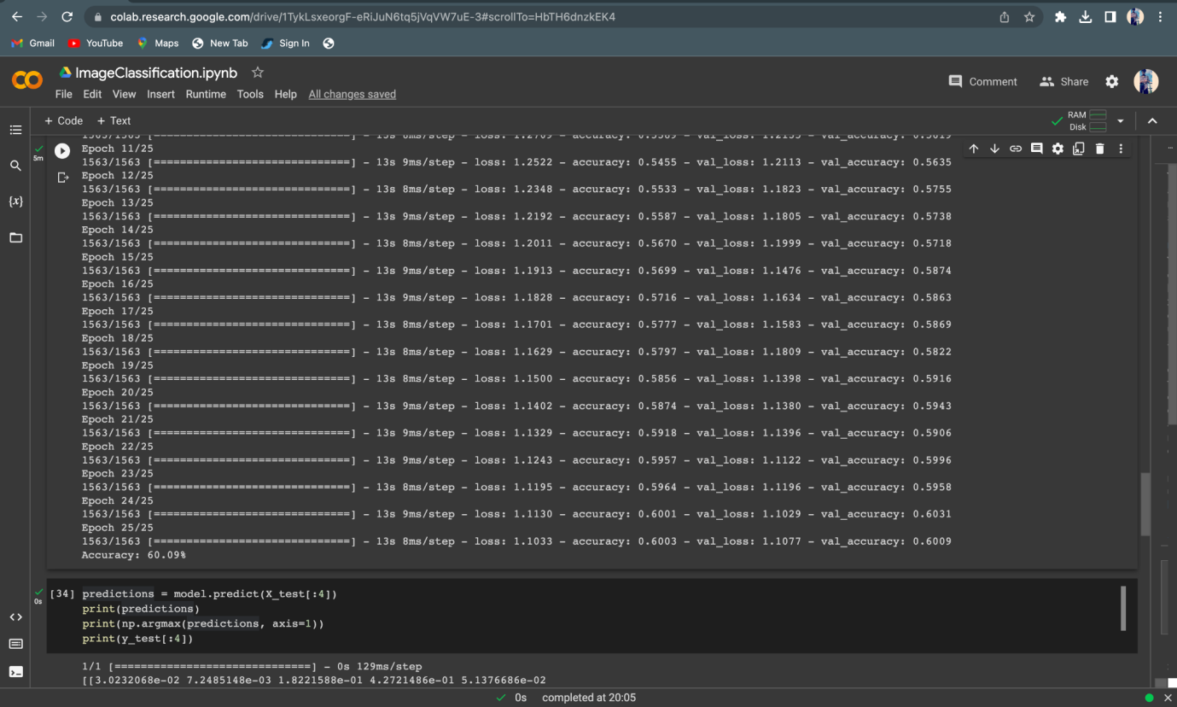

The Accuracy Score obtained by the model is slightly changed.Initially the accuracy score is around 59.87% and for after the modifications and adding the layers the accuracy is slightly changed.

2. Predict the first 4 images of the test data using the above model. Then, compare with the actual label for those 4 images to check whether or not the model has predicted correctly.

predictions = model.predict(X_test[:4])

print(predictions)

print(np.argmax(predictions, axis=1))

print(y_test[:4])

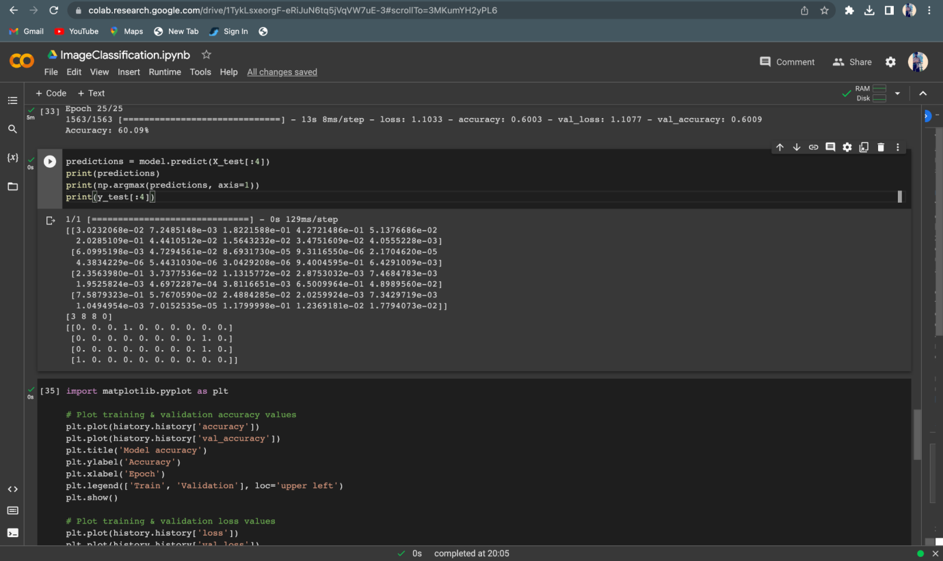

3. Visualize Loss and Accuracy using the history object

import matplotlib.pyplot as plt

# Plot training & validation accuracy values

plt.plot(history.history['accuracy'])

plt.plot(history.history['val_accuracy'])

plt.title('Model accuracy')

plt.ylabel('Accuracy')

plt.xlabel('Epoch')

plt.legend(['Train', 'Validation'], loc='upper left')

plt.show()

# Plot training & validation loss values

plt.plot(history.history['loss'])

plt.plot(history.history['val_loss'])

plt.title('Model loss')

plt.ylabel('Loss')

plt.xlabel('Epoch')

plt.legend(['Train', 'Validation'], loc='upper left')

plt.show()

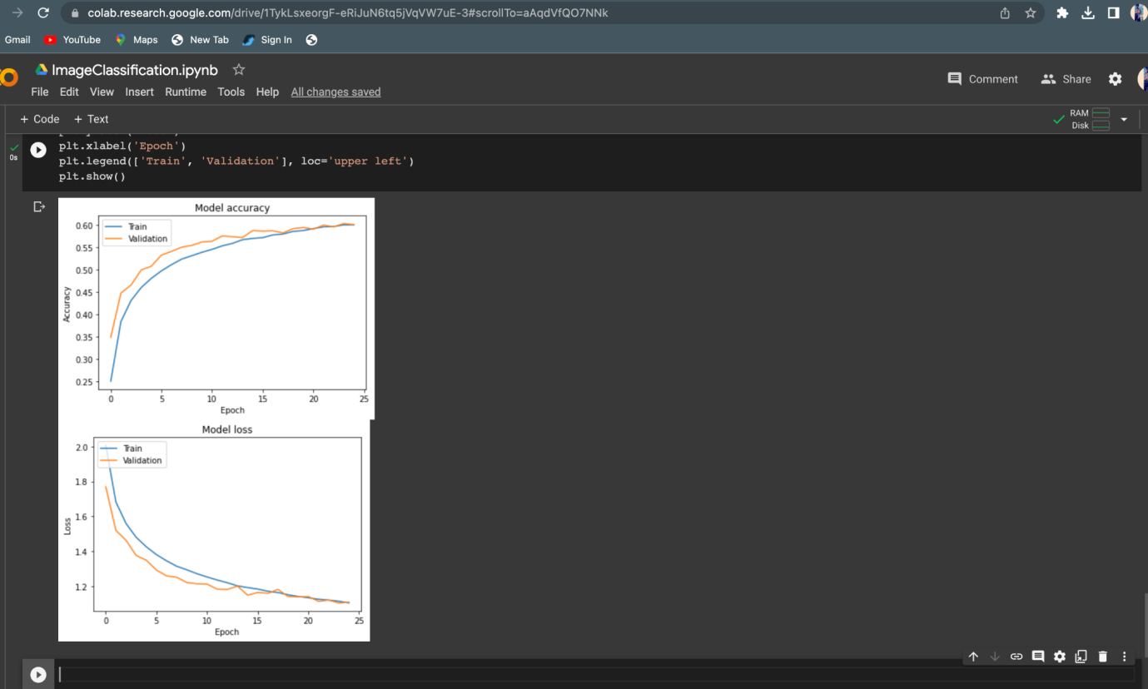

The CIFAR-10 dataset, which is a well-known dataset of images separated into 10 classes, is loaded using the code above. Training sets and testing sets are created from the data. The input pictures are normalized between 0 and 1 and translated from integers to floats. One-hot encoding is used for the output labels.

The dimensions of the input data are then transformed to fit the convolutional neural network's anticipated input shape (CNN).

The Keras Sequential API is then used to define the CNN model. It is made up of dense layers with ReLU activation, dropout layers to avoid overfitting, and several convolutional layers with ReLU activation. categorize the photos into the 10 classes. classify the images into the 10 classes. classify the image into the 10 classes. The model is built using categorical cross-entropy as the loss function, stochastic gradient descent (SGD) as the optimizer, and accuracy as the training-phase performance indicator.32 batches are used during the 25 epochs of model training. model is evaluated on the test set and the accuracy is printed.

The model is then applied to the first 4 photos in the test set to make predictions. To determine whether the model has predicted accurately, the predicted labels are compared to the actual labels. Lastly, the history object returned by the fit() method is used to illustrate the loss and accuracy.