**Data Analyst Intern**

**Task allocation on:**

**Problem Statement**:

Analyze and Provide Insights on Amazon Sales Report.

**Contents:**

|  |  |  |
| --- | --- | --- |
| s.no | subject | Pg.no |
| 1 | Business Insights and Recommendations | 1 |
| 1.1 | Sales Overview | 1 |
| 1.2 | Product Analysis | 3 |
| 1.3 | Fulfilment Analysis | 5 |
| 1.4 | Customer Segmentation | 9 |
| 1.5 | Geographical Analysis | 11 |

**Business Insights and Recommendations**

**1. Total Sales**

* **Graph:** Bar or Line Chart to visualize the total sales over time.
* **Goal:** Identify trends and make improvements where needed, like boosting sales in low-performing periods.

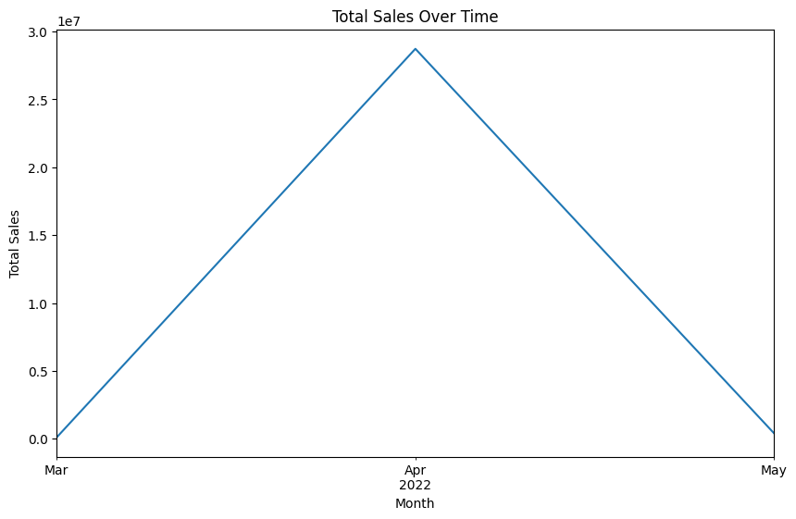

**Total Sales:** 29232013.08

**Total Quantity Sold:** 44778.00

**Insight from Graph:** If sales are declining in certain months, promotions or new product launches may be needed.

**Graph Analysis:**

The line graph depicts total sales over time, specifically for March, April, and May of 2022. The sales trend is clearly upward, peaking in April and then declining in May.

**Insights and Improvement Strategies:**

1. **April's Success:**
   * **Identify Key Factors:** Analyze marketing campaigns, promotions, product launches, or any other factors that contributed to the April sales spike.
   * **Replicate Success:** Implement similar strategies in future months to replicate this positive trend.
2. **May's Dip:**
   * **Understand the Cause:** Investigate reasons for the sales decline in May. Was it due to a lack of promotions, inventory issues, or changes in consumer behavior.
   * **Address the Root Cause:** Take corrective measures to address the identified issue(s) and prevent similar dips in the future.
3. **Overall Trend:**
   * **Sustain the Momentum:** The upward trend in March and April is encouraging. Develop strategies to maintain or even accelerate this growth.

**Additional improvements:**

* **Data Granularity:** If the data allows, analyze sales on a weekly or daily basis to identify more specific trends and opportunities.
* **Product-Level Analysis:** Break down sales by product category or individual products to understand which items are driving growth and which require attention.
* **Customer Segmentation:** Analyze sales data by customer demographics or purchase behavior to identify target segments and tailor marketing efforts accordingly.
* **Competitor Analysis:** Monitor competitor sales and marketing activities to stay ahead of the curve.
* **Continuous Monitoring and Optimization:** Regular analysis and adjustments are crucial to maintain sales growth and adapt to changing market conditions.

**2. product category sales**

* **Graph:** Bar chart for category-wise sales distribution.
* **Goal :** Focus efforts on the top-performing categories while evaluating the underperformating one.

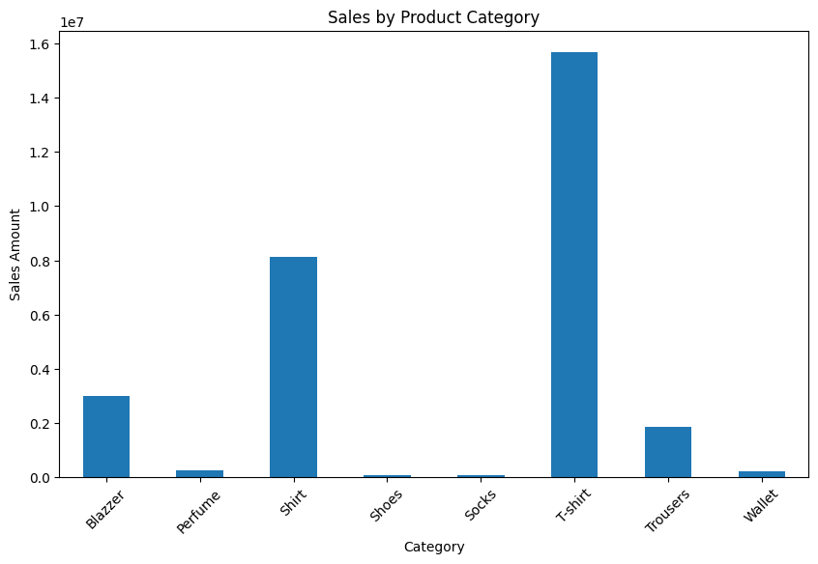

**Insight from Graph:** You can easily see which categories are driving sales and focus on improving or promoting underperforming categories.

**Graph Analysis:**

The bar chart illustrates the sales distribution across different product categories. It's clear that **T-shirts** and **Shirts** are the top-performing categories, while **Shoes**, **Socks**, and **Wallet** have significantly lower sales.

**Improvement Strategies:**

**1. Focus on Top-Performing Categories:**

* **T-shirts and Shirts:**
  + **Product Expansion:** Introduce new styles, designs, and sizes to cater to a wider audience.
  + **Bundle Deals:** Create attractive bundle deals with complementary products to increase sales.
  + **Targeted Marketing:** Utilize Amazon's advertising tools to target specific customer segments for these categories.
  + **Customer Reviews and Feedback:** Actively engage with customers, address their concerns, and encourage positive reviews.

**2. Address Underperforming Categories:**

* **Shoes, Socks, and Wallet:**
  + **Competitive Analysis:** Analyze competitor offerings, pricing, and marketing strategies to identify areas for improvement.
  + **Product Quality and Variety:** Ensure high-quality products and a wider range of options to attract customers.
  + **Clear Product Descriptions:** Write compelling product descriptions highlighting key features and benefits.
  + **Customer Reviews and Feedback:** Encourage customer reviews to build trust and credibility.
  + **Limited-Time Offers and Discounts:** Run targeted promotions to boost sales temporarily.

**3. Overall Strategies:**

* **Inventory Management:** Maintain optimal inventory levels to avoid stockouts and overstocking.
* **Pricing Strategy:** Conduct regular price analysis to remain competitive and maximize profitability.
* **Customer Service:** Provide excellent customer service to build brand loyalty and positive reviews.
* **Data Analysis:** Use Amazon's analytics tools to track sales performance, customer behavior, and identify areas for improvement.

**Additional Improvement:**

* **Seasonal Trends:** Consider seasonal trends and adjust inventory accordingly.
* **Customer Reviews:** Actively manage customer reviews and respond promptly to negative feedback.
* **Amazon's Marketing Tools:** Utilize Amazon's advertising and promotional tools to reach a wider audience.
* **Product Photography:** High-quality product images are crucial for attracting customers.

**3. Sales by Product Size**

* **Graph:** Bar Chart for quantity sold by product size.
* **Goal:** Ensure stock availability for the popular sizes and evaluate if adjustments to the available sizes are necessary.

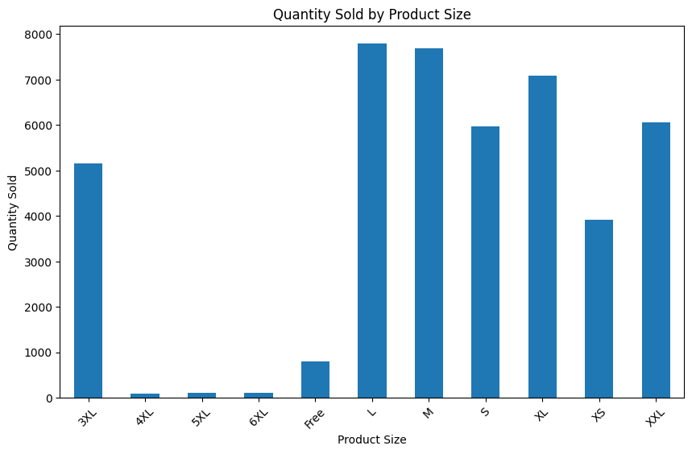**Insight from Graph**: Identify the best-selling sizes to stock more inventory or introduce similar sizes in high-demand segments.

**Graph Analysis:**

The bar chart illustrates the quantity sold for different product sizes. It's clear that L, M, S, and XL are the most popular sizes, while 4XL, 5XL, and 6XL have significantly lower sales.

**Improvement Strategies:**

**1. Focus on Popular Sizes:**

* **L, M, S, and XL:** 
  + **Inventory Management**: Ensure adequate stock levels for these sizes to avoid stockouts.
  + **Targeted Marketing:** Highlight these sizes in promotions and advertising campaigns.
  + **Customer Reviews and Feedback:** Encourage customer reviews for these sizes to build trust and credibility.

**2. Address Underperforming Sizes:**

* **4XL, 5XL, and 6XL:** 
  + **Evaluate Demand:** Consider whether the demand for these sizes justifies the inventory investment.
  + **Limited-Time Offers and Discounts:** Run targeted promotions to boost sales temporarily.
  + **Customer Feedback:** Gather feedback from customers on the availability of these sizes.

**3. Overall Strategies:**

* **Product Sizing Guide:** Provide a clear and accurate sizing guide to help customers select the right size.
* **Customer Reviews and Feedback:** Actively manage customer reviews and respond promptly to negative feedback related to sizing issues.
* **Data Analysis:** Use Amazon's analytics tools to track sales performance by size and identify trends.

**Additional Improvement:**

* **Seasonal Trends:** Consider seasonal variations in demand and adjust inventory accordingly.
* **Customer Returns:** Analyze return data to identify sizing issues and make necessary adjustments.
* **Competitor Analysis:** Monitor competitor offerings and sizing options.

**4. Sales by Fulfillment Method**

* **Graph:** Pie Chart to analyze sales distribution by fulfillment method.
* **Goal**: Understand which fulfillment method is more effective (Amazon vs. third-party) and optimize accordingly.

**Insight from Graph**: If a significant proportion of sales comes from third-party sellers, you may want to enhance your in-house fulfillment capacity to increase profitability.

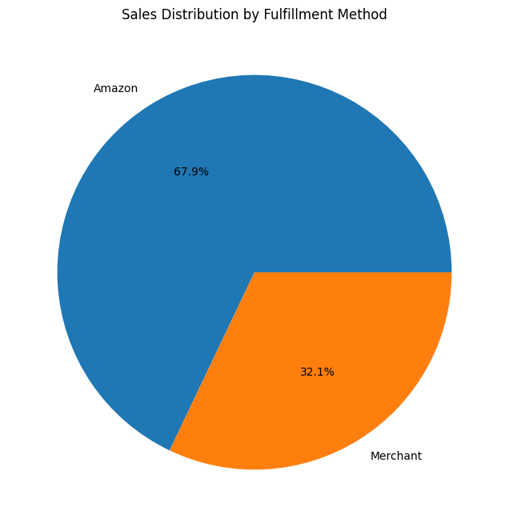

**Graph Analysis:**

The pie chart shows the distribution of sales based on fulfillment method. It's clear that Amazon Fulfillment accounts for a significantly larger portion of sales (67.9%) compared to Merchant Fulfillment (32.1%).

**Improvement Strategies:**

**1. Leverage Amazon Fulfillment (FBA):**

* **Advantages:** 
  + Faster shipping times
  + Prime eligibility
  + Enhanced customer service
  + Increased visibility in search results
* **Strategies:** 
  + **Utilize FBA for High-Demand Products:** Prioritize products with high sales potential and customer demand.
  + **Optimize Listing for FBA:** Ensure accurate product listings, competitive pricing, and high-quality images to maximize visibility.
  + **Monitor FBA Inventory Levels:** Maintain adequate stock levels to avoid stockouts and fulfill orders promptly.

**2. Improve Merchant Fulfillment (FBM):**

* **Challenges:** 
  + Longer shipping times
  + Limited customer service options
  + Lower visibility in search results
* **Strategies:** 
  + **Focus on High-Value and Niche Products:** Target products with unique selling points or high profit margins.
  + **Invest in Efficient Fulfillment Processes:** Streamline order processing, packaging, and shipping to minimize errors and delays.
  + **Offer Competitive Shipping Rates:** Provide attractive shipping options to encourage customer purchases.
  + **Provide Excellent Customer Service:** Respond promptly to customer inquiries and resolve issues efficiently.

**3. Overall Strategies:**

* **Data Analysis**: Use Amazon's analytics tools to track sales performance, customer behavior, and identify areas for improvement.
* **Customer Reviews and Feedback:** Actively manage customer reviews and respond promptly to negative feedback.
* **Competitive Analysis:** Monitor competitor fulfillment strategies and adjust your approach accordingly.
* **Continuous Optimization:** Regularly review and optimize your fulfillment processes to improve efficiency and customer satisfaction.

**5.Customer Purchase Frequency**

* **Graph:** Histogram of customer orders to understand how often customers are purchasing.
* 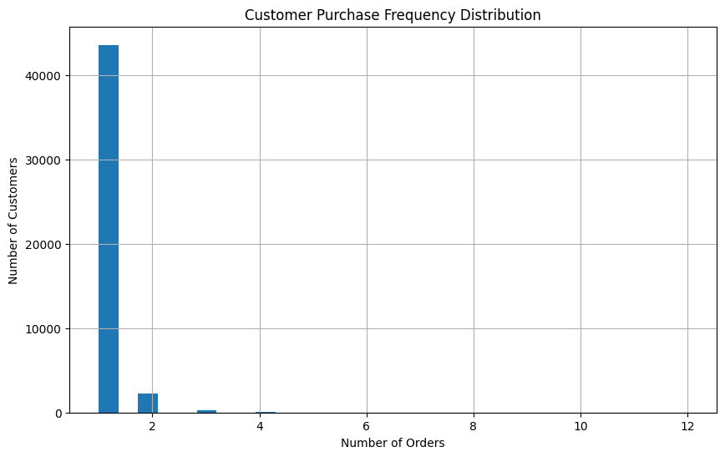**Goal:** Segment frequent and infrequent buyers, then develop targeted campaigns for both groups.

**Insight from Graph:** Use this data to identify frequent buyers for loyalty programs and target infrequent buyers with special offers.

**Graph Analysis:**

The histogram shows the distribution of customer orders. It's clear that a majority of customers make only 1-2 purchases, while a smaller number of customers make more frequent purchases.

**Strategies to Improve Customer Purchase Frequency:**

**1. Segment Customers:**

* **Frequent Buyers:** Identify customers who have made multiple purchases.
* **Infrequent Buyers:** Identify customers who have made only a few purchases or haven't purchased in a while.

**2. Targeted Campaigns for Frequent Buyers:**

* **Loyalty Programs:** Implement a loyalty program with rewards and incentives for repeat purchases.
* **Personalized Recommendations:** Use purchase history to recommend relevant products and offers.
* **Exclusive Discounts and Offers:** Provide special discounts and promotions to encourage repeat purchases.
* **Early Access to New Products:** Give frequent buyers early access to new products and limited-edition items.

**3. Targeted Campaigns for Infrequent Buyers:**

* **Win-Back Campaigns:** Send personalized emails or SMS messages to inactive customers with special offers or discounts.
* **Product Recommendations:** Recommend products based on their past purchase history or browsing behavior.
* **Limited-Time Offers:** Create a sense of urgency with time-limited offers and discounts.
* **Personalized Marketing:** Tailor marketing messages to their specific interests and needs.

**4. Overall Strategies:**

* **Excellent Customer Service:** Provide exceptional customer service to build trust and loyalty.
* **Easy Returns and Exchanges:** Offer hassle-free return and exchange policies to encourage repeat purchases.
* **Data Analysis:** Use Amazon's analytics tools to track customer behavior and identify opportunities for improvement.
* **Continuous Optimization:** Regularly review and optimize your marketing and customer engagement strategies.

**6. Geographical Sales Distribution**

* **Graph:** Bar Chart showing sales by state or geographical region.
* 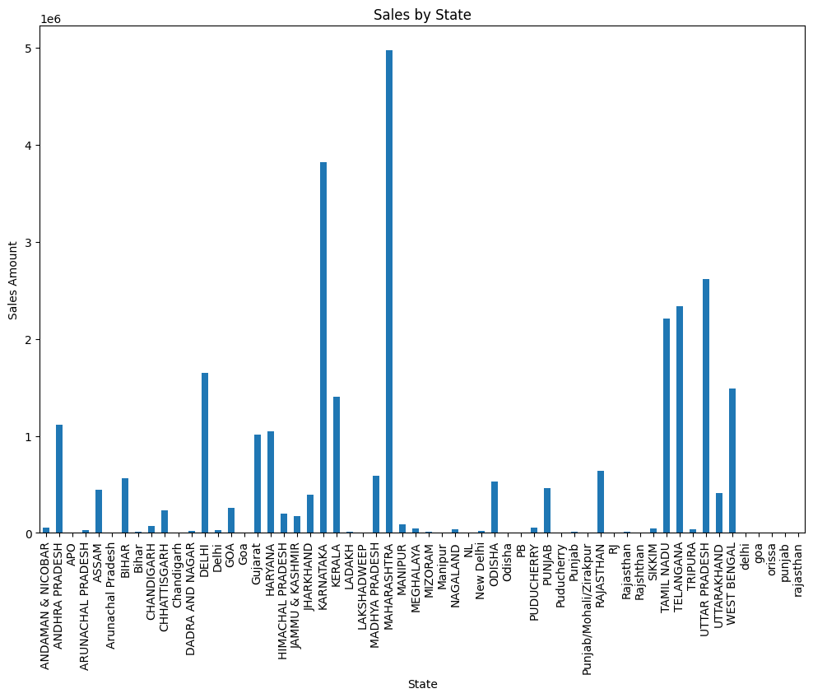**Goal:** Optimize marketing and distribution strategies based on regional performance.

**Insight from Graph:** Allocate resources to high-performing states or explore reasons for lower performance in certain areas.

**Graph Analysis:**

The bar chart illustrates the sales distribution across different states or regions. It's clear that states like **Maharashtra** and **Delhi** have significantly higher sales compared to others.

**Improvement Strategies:**

**1. Focus on High-Performing Regions:**

* **Maharashtra and Delhi:**
  + **Targeted Marketing:** Utilize Amazon's advertising tools to target specific customer segments in these regions.
  + **Local Partnerships:** Collaborate with local businesses and influencers to promote your products.
  + **Inventory Management:** Ensure adequate stock levels in these regions to meet demand.

**2. Address Underperforming Regions:**

* **Identify Reasons:** Analyze factors like population density, purchasing power, and competition in these regions.
* **Targeted Marketing:** Develop region-specific marketing campaigns to attract customers.
* **Localized Product Offerings:** Consider offering products that cater to the specific needs and preferences of customers in these regions.
* **Improved Logistics:** Optimize shipping and delivery times to reduce customer wait times.

**3. Overall Strategies:**

* **Data Analysis:** Use Amazon's analytics tools to track sales performance by region and identify trends.
* **Customer Reviews and Feedback:** Actively manage customer reviews and respond promptly to negative feedback.
* **Competitive Analysis:** Monitor competitor strategies in different regions and adjust your approach accordingly.
* **Continuous Optimization:** Regularly review and optimize your marketing and distribution strategies to improve performance.

**Additional Improvement:**

* **Regional Preferences:** Consider regional preferences for product features, packaging, and pricing.
* **Language and Culture:** Tailor your marketing messages and product descriptions to local language and culture.
* **Local Regulations:** Be aware of local regulations and compliance requirements.