FITNESS CENTER
BUSINESS REQUIREMENTS DOCUMENT
Oracle SQL + Power BI Business Analysis Project
Portfolio / Project Documentation
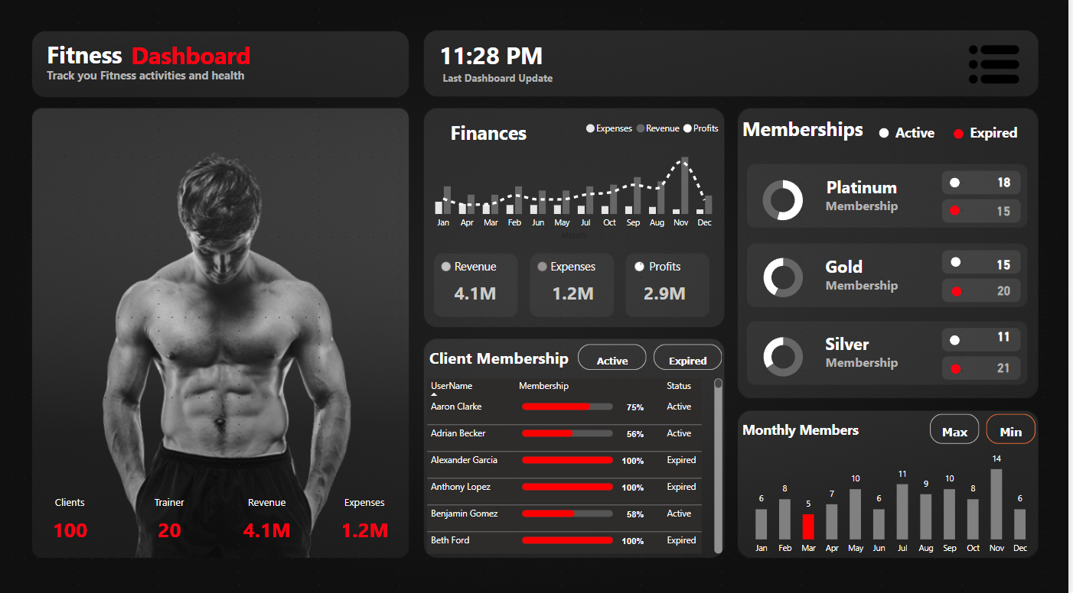
Prepared for portfolio presentation

1. Executive Summary
The Fitness Center Business Analysis project is designed to provide a centralized view of customer, membership, revenue, expense and profitability performance. Oracle SQL is used for structured business analysis across the USERS, PAYMENTS and EXPENSES tables, while Power BI is used to present the results through an interactive Fitness Dashboard.
The dashboard focuses on the business questions visible in the completed project: overall financial performance, monthly performance, membership status, customer membership details, and key customer/trainer characteristics.

2. Business Objective
- Create a single reporting view for fitness center management.
- Reduce the need to manually calculate customer, revenue, expense and profit metrics.
- Track monthly revenue, expenses and profit trends.
- Monitor active and expired memberships by membership tier.
- Identify customer-level membership status and payment behavior.
- Analyze revenue contribution by membership type and payment mode.
- Understand customer demographics, fitness goals, trainer allocation and average fitness measures.
- Support business decisions related to retention, renewals, revenue growth and expense management.

3. Data Source & Technology
Database | Oracle Database
SQL Tool | Oracle SQL Developer
BI Tool | Microsoft Power BI
Primary Tables | USERS, PAYMENTS, EXPENSES
Supporting Dataset | Users, Payments and Expenses data; ColorCodes is used as a supporting Power BI table.
Reporting Approach | Oracle SQL analysis + Power BI data model, DAX measures and interactive dashboard

4. Project Scope
- Overall business performance analysis.
- Monthly revenue, expense and profit analysis.
- Membership tier and membership status analysis.
- Payment and revenue analysis.
- Expense category analysis.
- Customer and fitness profile analysis.
- Trainer workload / customer distribution analysis.
- Customer-level payment analysis and top-customer ranking.
- Power BI dashboard visualization of key business KPIs and trends.

5. Business Requirements

5.1 Overall Business Performance
Management requires a quick overview of the fitness center's current business performance without manually calculating totals each time.
Requirement | Business Need | Power BI / SQL Output
BR-01 | Total number of customers/clients | Customer count KPI
BR-02 | Total number of trainers | Trainer count / trainer analysis
BR-03 | Total revenue generated | Revenue KPI
BR-04 | Total expenses incurred | Expenses KPI
BR-05 | Net profit | Profit KPI = Revenue - Expenses

5.2 Monthly Performance Tracking
Management needs to compare business performance over time and identify strong or weak months.
Requirement | Business Need | Power BI / SQL Output
BR-06 | Monthly revenue | Monthly revenue trend
BR-07 | Monthly expenses | Monthly expense trend
BR-08 | Monthly profit | Monthly profit calculation/trend
BR-09 | Revenue vs. expenses comparison | Combined monthly finance visual
BR-10 | Monthly member/customer activity | Monthly members visual

5.3 Membership Status Tracking
Requirement | Business Need | Power BI / SQL Output
BR-11 | Membership distribution by tier | Platinum, Gold and Silver membership view
BR-12 | Active memberships by tier | Active membership count
BR-13 | Expired memberships by tier | Expired membership count
BR-14 | Customer-level membership status | Client Membership status table/progress visual

5.4 Revenue & Payment Analysis
Requirement | Business Need | Power BI / SQL Output
BR-15 | Revenue by payment status | Payment status analysis
BR-16 | Revenue by payment mode | Cash, Card and Online comparison
BR-17 | Revenue by membership type | Membership-wise revenue analysis
BR-18 | Customer payment contribution | Total paid and average payment by customer
BR-19 | Top customers by total payment | Customer ranking using SQL window function

5.5 Expense Analysis
Requirement | Business Need | Power BI / SQL Output
BR-20 | Total expense transactions | Expense record count
BR-21 | Total expenses | Total expense KPI
BR-22 | Average, minimum and maximum expense | Expense summary metrics
BR-23 | Expenses by category | ExpenseType-wise expense analysis

5.6 Customer & Fitness Profile Analysis
Requirement | Business Need | Power BI / SQL Output
BR-24 | Customer distribution by gender | Gender-wise customer count
BR-25 | Customer distribution by fitness goal | Weight Loss, Muscle Gain and Maintenance analysis
BR-26 | Customer distribution by trainer | Trainer-wise customer count
BR-27 | Average age, height, starting weight and BMI | Fitness profile summary metrics

6. Power BI Dashboard Requirements
The completed dashboard should provide an executive-style view where a user can understand the most important business metrics quickly and then inspect membership and monthly details.
- Dashboard title: Fitness Dashboard.
- Finance section showing Revenue, Expenses and Profits.
- Membership section showing Active vs. Expired members by Platinum, Gold and Silver tiers.
- Client Membership section showing customer name, membership and status.
- Monthly Members section showing month-wise member activity with Max/Min selection.
- Executive KPI area showing Clients, Trainer count, Revenue and Expenses.
- Interactive Power BI visuals and measures for business analysis.

7. Oracle SQL Analysis Requirements
The SQL analysis file contains business-oriented queries rather than only basic SELECT statements. The analysis covers aggregation, grouping, joins, CTEs, date-based monthly analysis and a window function for customer ranking.
- Overall customer, payment, revenue and payment-value analysis.
- Membership distribution and active/expired membership analysis.
- Revenue analysis by payment status and payment mode.
- Expense summary and expense-category analysis.
- Profit calculation using Revenue - Expenses.
- Monthly revenue, expenses and profit using CTEs and a FULL OUTER JOIN.
- Customer distribution by gender and fitness goal.
- Trainer-wise customer distribution.
- Average age, height, starting weight and BMI.
- Customer-level payment analysis using a join between USERS and PAYMENTS.
- Revenue by membership type.
- Top-customer ranking using RANK() OVER (ORDER BY SUM(P.AMOUNT) DESC).

8. Key Business Findings from the SQL Analysis
Area | Finding
Customer base | 100 registered customers and 20 trainers are represented in the analysis.
Revenue | Recorded payment revenue is ₹40,90,000.
Expenses | Recorded expenses are ₹11,74,472.
Net profit | Calculated net profit is ₹29,15,528.
Membership mix | Gold has 35 customers, Platinum 33 and Silver 32.
Membership status | 44 customers are active and 56 are expired.
Revenue by membership | Gold generates the highest membership-wise revenue at ₹28,00,000.
Payment mode | Card generates the highest revenue among the payment modes analyzed.
Expense driver | Salaries are the largest expense category.
Monthly performance | November is identified in the SQL analysis as the strongest month by revenue/profit, while December has the lowest revenue.
Fitness profile | Average customer age is 40.84 years and average BMI is 28.84.
Fitness goals | Weight Loss is the most common goal, followed by Muscle Gain and Maintenance.

9. Business Questions Answered
- How many customers and trainers does the fitness center have?
- How much revenue, expense and profit has the business generated?
- Which membership tier has the most customers?
- How many memberships are active versus expired?
- Which membership type contributes the most revenue?
- Which payment mode generates the most revenue?
- Which expense category is the biggest cost driver?
- Which months perform best and worst financially?
- Which fitness goals are most common among customers?
- How are customers distributed among trainers?
- Who are the highest-paying customers?
- What are the average customer age, height, starting weight and BMI?

10. Data Model / Analytical Flow
The analytical flow is designed around the customer and transaction tables used in the project.
- USERS: customer, membership, trainer and fitness-profile information.
- PAYMENTS: payment date, amount, payment mode and payment status linked to customers through UserID.
- EXPENSES: expense date, expense category and amount.
- Power BI consumes the Oracle database tables and applies the project measures/visualizations for reporting.

11. Scope Clarification
The original reference Business Requirements document also mentions a calories calculator (BMI, BMR and TDEE) and a detailed individual client profile containing contact/address information. Those requirements are not represented as completed visuals in the supplied final dashboard screenshot or in the supplied SQL analysis file. Therefore, they are treated as future enhancements rather than completed requirements for this portfolio version.

12. Project Deliverables
- Oracle SQL analysis script containing business analysis queries and documented business insights.
- Power BI (.pbix) dashboard with executive finance, membership and monthly performance visuals.
- Source dataset containing Users, Payments and Expenses data.
- Business Requirements Document describing the business problem, requirements, analytical scope and findings.

13. Portfolio Project Summary
This project demonstrates an end-to-end business analytics workflow: understanding business requirements, working with relational data in Oracle, writing SQL queries for KPI and diagnostic analysis, connecting the database to Power BI, creating measures and interactive visuals, and converting analytical results into business insights.
Document prepared from the supplied Fitness Center Business Requirements, Oracle SQL analysis, dataset and dashboard screenshot.

