VEDAAUTO
Indian Automobile Market
Sales, Pricing & Profitability Investigation

End-to-End Business Case Study
Python | Oracle SQL | Power BI | DAX
Dataset | Duration | Transactions | Models | Regions
Automobile Sales | Jan – Dec 2024 | 34,512 records | 6 models | 4 regions

Prepared by:
Dasari Sampath Kumar
Data Analyst | DATA MINDS & ANALYTICS, Hyderabad (2024)
sampathkumardasari38@gmail.com | +91 8008750727
github.com/Sampath20019 | linkedin.com/in/sampathkumar-dasari5-888408368

1. Executive Summary
VedaAuto is a fictional Indian automobile manufacturer. Management raised a critical concern:
"Our total sales appear stable, but we suspect some models are losing market share. Find out what is really happening and what we should do."
This is NOT a dashboard project. This is a full business investigation — from market research to root cause analysis to strategic recommendations.

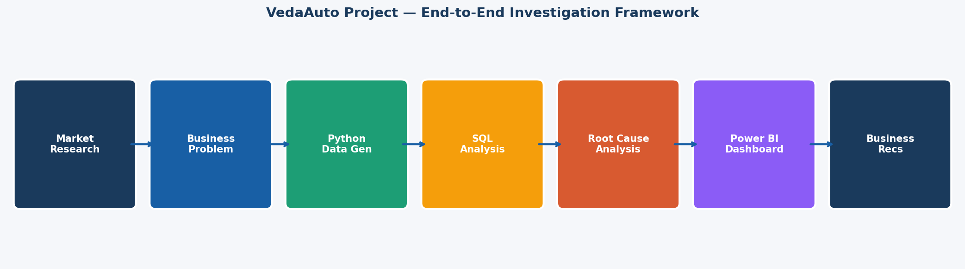
Figure 1: VedaAuto Project — End-to-End Investigation Framework
Phase | Activity | Tool | Output
1 | Market Research & Industry Analysis | Research | Hypotheses formed
2 | Business Problem Definition | Analysis | Management questions
3 | Data Generation | Python | 34,512 transactions
4 | SQL Analysis | Oracle SQL | 10 business queries
5 | Root Cause Investigation | SQL + DAX | 5 key findings
6 | Dashboard Creation | Power BI | 2-page executive report
7 | Business Recommendations | Documentation | 4 strategic actions

2. Why I Chose This Project

2.1 The Problem With Typical Fresher Projects
Most fresher data analyst portfolios contain projects like "Superstore Sales Dashboard" or "HR Attrition Analysis." These projects demonstrate basic tool knowledge but fail to show business thinking — which is what recruiters actually look for.
When a recruiter reviews 50 resumes in a day and sees the same dataset for the 40th time, they stop reading. I needed to build something that would make them stop scrolling.

2.2 My Thinking — Real Analyst Workflow
I asked myself: What do real data analysts actually do? They don't just build dashboards. They:
- Start with the business problem — not the data
- Research the industry before opening any tool
- Form hypotheses before running queries
- Investigate root causes, not just surface metrics
- Deliver recommendations, not just visualizations

This project follows that exact workflow — from market research to SQL investigation to Power BI dashboard to business recommendations. It demonstrates the thinking of an analyst, not just the technical skills.

2.3 Why the Automobile Industry
- Real market story happening right now — SUV boom, EV revolution, hatchback decline
- FY2026 record sales of 46.43 lakh units — every recruiter in India knows this story
- Rich dimensions: models, segments, fuel types, regions, pricing, dealers, competitors
- Publicly available data (SIAM reports) for authentic market research context
- Dramatic contradictions inside the data — perfect for a business investigation

3. Market Research & Industry Understanding
Before touching any data or tool, I researched the Indian automobile industry thoroughly. This is how a real analyst works — understand the market first, then form hypotheses, then investigate data.

3.1 Indian Passenger Vehicle Market — Key Statistics
Metric | Value | Analyst Implication
Total PV Sales FY2026 | 46.43 lakh units | All-time record — strong overall market
YoY Growth | +7.9% | Market expanding but not uniformly
SUV Share Q1 FY27 | 68% of PV sales | SUVs completely dominating
EV Growth Trend | Very high YoY | Consumer shift accelerating
Hatchback Trend | Declining | Structural demand shift — permanent
Average Selling Price | Increasing YoY | Premiumization underway

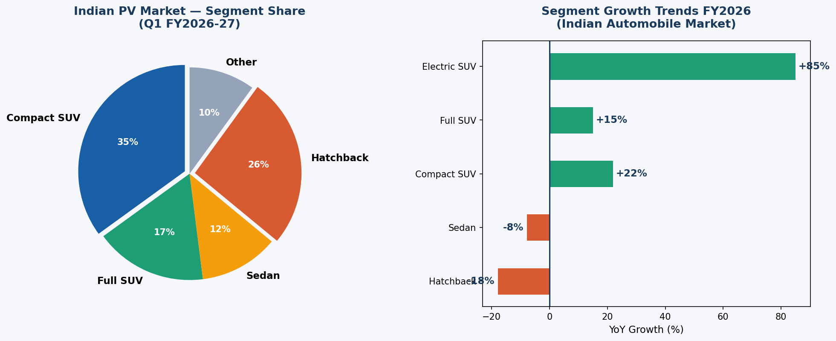
Figure 2: Indian PV Market — Segment Share & Growth Trends FY2026
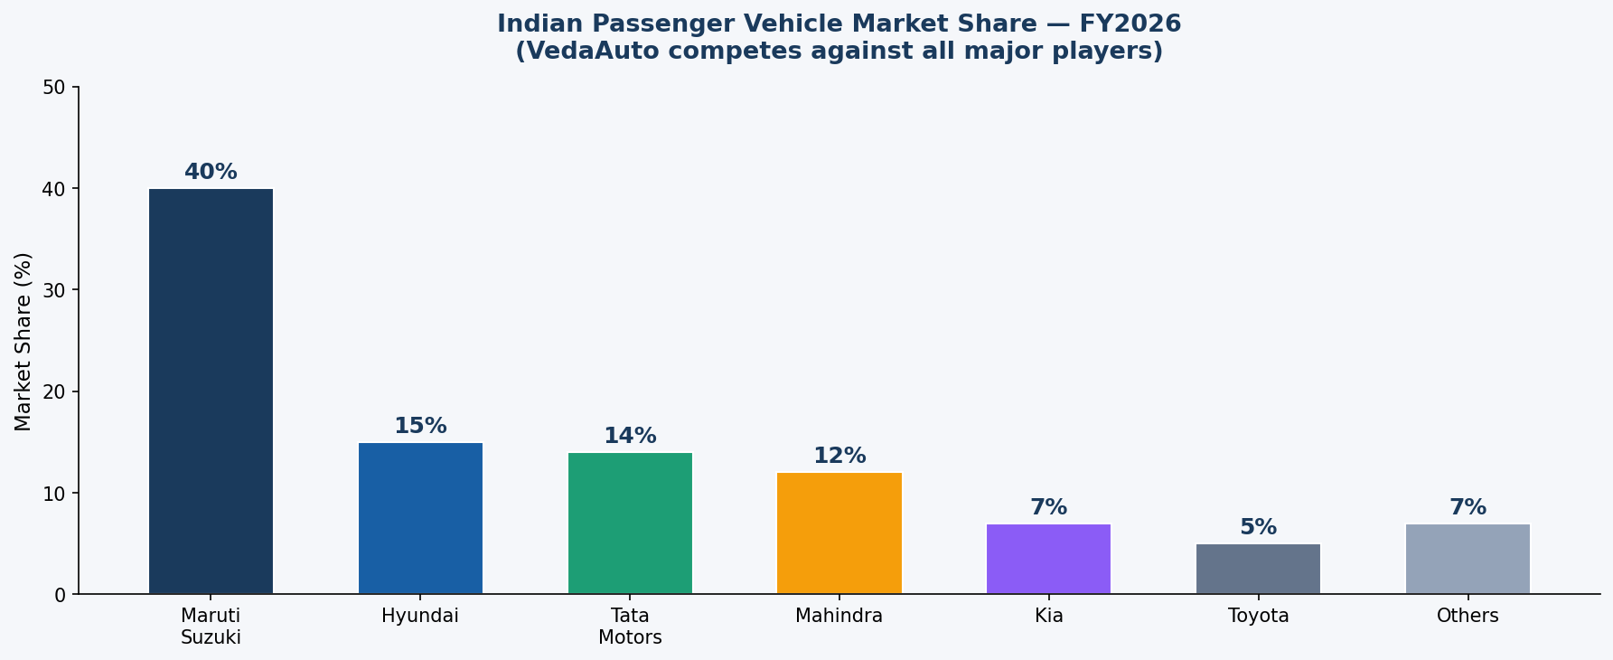
Figure 3: Indian PV Market — Competitor Market Share FY2026

3.2 The 5 Big Market Trends I Identified
- SUV Revolution: Indians shifting from hatchbacks to SUVs — road presence, status, comfort. Even ₹7-10L budget buyers now prefer compact SUVs.
- EV Acceleration: FAME scheme + rising fuel prices + improving charging infra driving rapid EV adoption, especially in South India.
- Hatchback Decline: Entry-level buyers upgrading to SUVs or delaying purchase. Structural — not cyclical.
- Premiumization: Average vehicle price rising. ₹15-25L segment growing fastest. Buyers choose features over basic transportation.
- Regional Differences: South leads EV adoption. West strong in SUVs. North is volume market but price-sensitive.

3.3 Hypotheses Formed Before Data Analysis
Based on market research, I formed these hypotheses before opening any data — this is the correct analyst approach:
- H1: VedaAuto hatchback (Spark) is likely declining while SUV models are growing
- H2: Price increases on competitive models may be hurting volume
- H3: EV/CNG variants outperforming petrol in South and West regions
- H4: Market share declining even if absolute sales are growing

4. VedaAuto — Company Profile
Attribute | Detail
Founded | 2010
Headquarters | Pune, Maharashtra
Tagline | "Driven by India"
Annual Volume | ~34,500 units (2024)
Regions | North, South, West, East India
Dealer Network | 20 dealers across 4 regions

4.1 Model Lineup
Model | Segment | Fuel | Price Range | Target Customer
Veda Spark | Hatchback | Petrol | ₹5–7L | First-time buyers
Veda Cruise | Sedan | Petrol | ₹9–12L | Office professionals
Veda Storm P | Compact SUV | Petrol | ₹12–16L | Young families
Veda Storm C | Compact SUV | CNG | ₹13–16L | Fuel-conscious buyers
Veda Terra | Full SUV | Diesel | ₹17–22L | Premium buyers
Veda Volt | Electric SUV | EV | ₹20–25L | Urban tech-savvy buyers

5. Data Generation (Python)
I generated a realistic 12-month transaction dataset using Python with intentional hidden patterns — patterns that mirror real Indian market trends and that the SQL analysis would later discover.
Attribute | Value
Total Records | 34,512 transactions
Date Range | January 2024 – December 2024
Models | 6 (Spark, Cruise, Storm P, Storm C, Terra, Volt)
Regions | 4 (North, South, West, East)
Dealers | 20 (5 per region)
Tool | Python (pandas, numpy)
Output | CSV → imported to Oracle SQL Developer

5.1 Hidden Patterns Embedded in Data
- Veda Spark: Declining from 979/month (Jan) to 532/month (Dec) = -45.6%
- Veda Volt: Growing from 122/month (Jan) to 389/month (Dec) = +219%
- Veda Storm P: 8% price hike applied August — causing volume decline + emergency discounting
- Veda Volt in North: Low region weight to simulate missed EV opportunity
- Spark discounting: Progressively increasing discounts despite declining volume

6. SQL Analysis (Oracle SQL Developer)
I wrote 10 analytical queries — each driven by a specific business question. The queries were not random. Each finding prompted the next investigation, building a progressive business story.
# | Query Name | Business Question | Key Finding
1 | Monthly Performance Overview | How did VedaAuto perform month by month? | Units flat but revenue growing — mix shift
2 | Model wise Sales & Profitability | Which models drive revenue and profit? | Spark: most units but lowest margin 16.93%
3 | Veda Spark Monthly Trend | Is Spark growing or declining? | Jan 979 → Dec 532 = -45.6% 🚨
4 | Veda Volt Monthly Trend | How fast is Volt growing? | Jan 122 → Dec 389 = +219% 🚀
5 | Region wise Performance | Which region drives most volume? | North = most units; West = most revenue
6 | Volt Regional Distribution | Where is Volt selling? | South 1,236 vs North only 345 🚨
7 | Discount & Margin Trend | Are discounts increasing? | Spark +60%; Storm P +121% post-hike
8 | Top 10 Dealer Performance | Who are the best dealers? | North + West dominate top 10
9 | Segment wise Profitability | Which segment most profitable? | Compact SUV 27% vs Hatchback 17%
10 | What-If Price Scenario | What if we change pricing? | Volt can take +5%; Storm P needs -5%

6.1 SQL Screenshot — Veda Volt Monthly Growth Trend (Query 4)
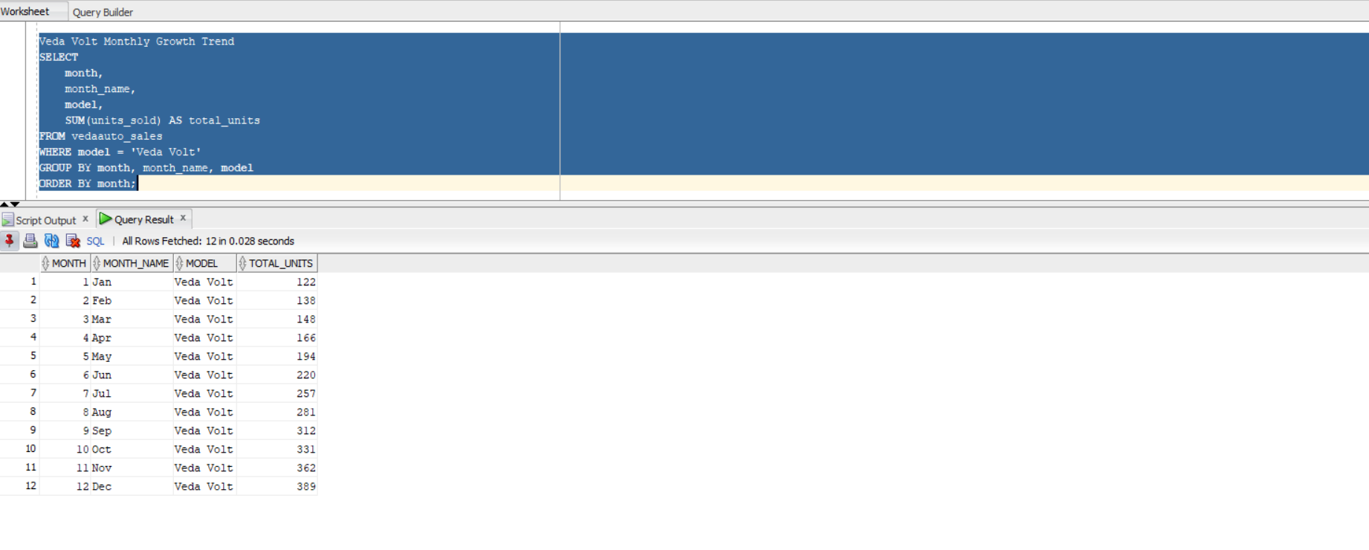
Figure 4: Veda Volt Monthly Trend — Jan 122 units → Dec 389 units (+219% growth)

6.2 SQL Screenshot — Discount & Margin Analysis (Query 7)
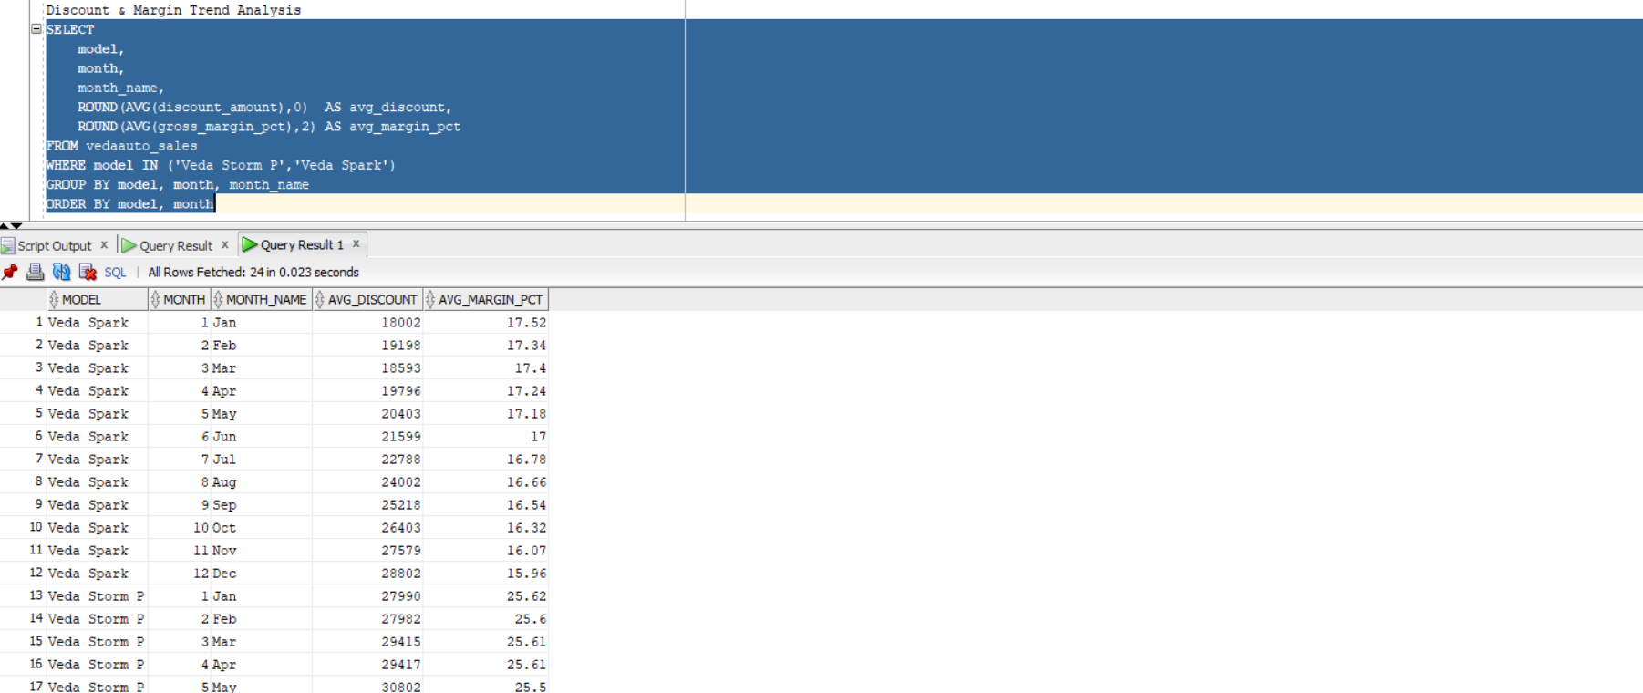
Figure 5: Spark discount escalating Jan ₹18,002 → Dec ₹28,802 (+60%); Storm P post-hike ₹68,083

6.3 SQL Screenshot — What-If Price Scenario Analysis (Query 10)
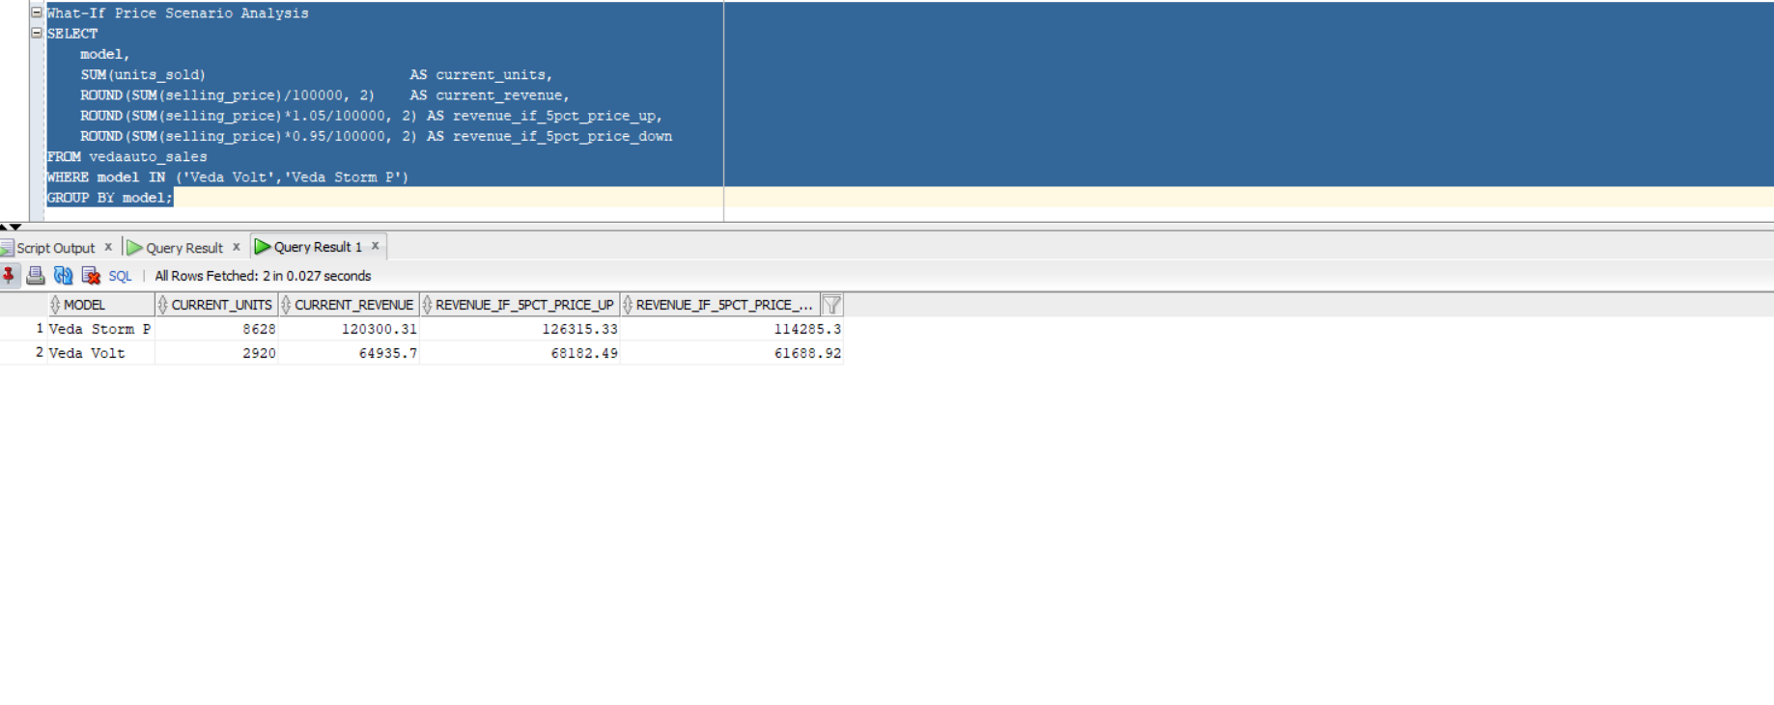
Figure 6: What-If Analysis — Volt +5% price = ₹68,182L revenue; Storm P -5% recommended

7. Root Cause Analysis
What Management Sees | What The Data Actually Shows
Total units stable (~2,800/month) | Mix shifting dramatically — Spark dying, Volt growing
Revenue growing month on month | Growth from price increases, NOT volume growth
All models present in all regions | Volt almost invisible in North — 345 vs 1,236 South
Discounts supporting Spark sales | Discounts destroying margin without recovering volume
Storm P price hike for margins | Price hike backfired — emergency discounts +121%

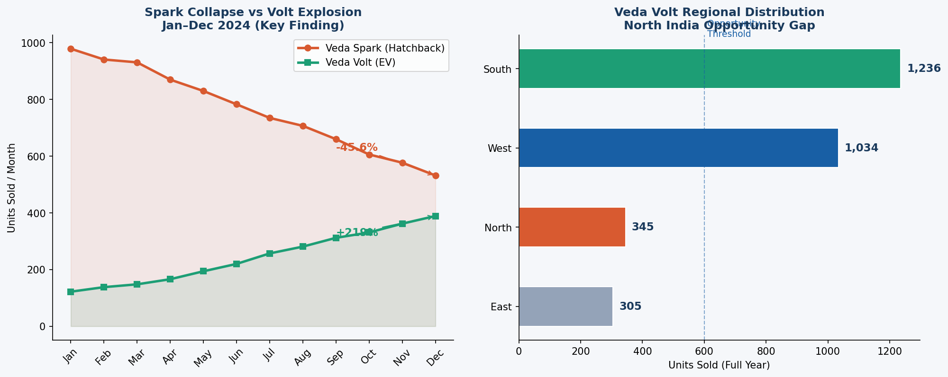
Figure 7: Spark Collapse vs Volt Explosion | North India Volt Gap

Root Cause 1 — Hatchback Structural Decline
Veda Spark's -45.6% decline mirrors the national trend. Indian consumers are permanently shifting from hatchbacks to compact SUVs and EVs. Discounts of ₹28,802/unit are not reversing this shift — they are destroying margin without recovering volume. This is structural, not cyclical.

Root Cause 2 — Storm P Pricing Backfire
An 8% price hike in August caused immediate volume decline. Emergency discounts jumped from ₹30,786 (June) to ₹68,083 (August) — a 121% jump in two months. Competitor pricing (Hyundai Creta, Kia Seltos) remained stable, drawing customers away.

Root Cause 3 — North India EV Opportunity Gap
North India is VedaAuto's largest region (10,550 units) but Veda Volt sells only 345 units there vs 1,236 in South India. This is a readiness problem — dealer EV training, charging infrastructure, and customer education are insufficient in North India.

8. Power BI Dashboard
The dashboard was built in Power BI Desktop with a direct Oracle SQL database connection — professional analyst workflow. Two pages were created: an executive summary and a diagnostic deep dive.

8.1 Page 1 — Executive Summary
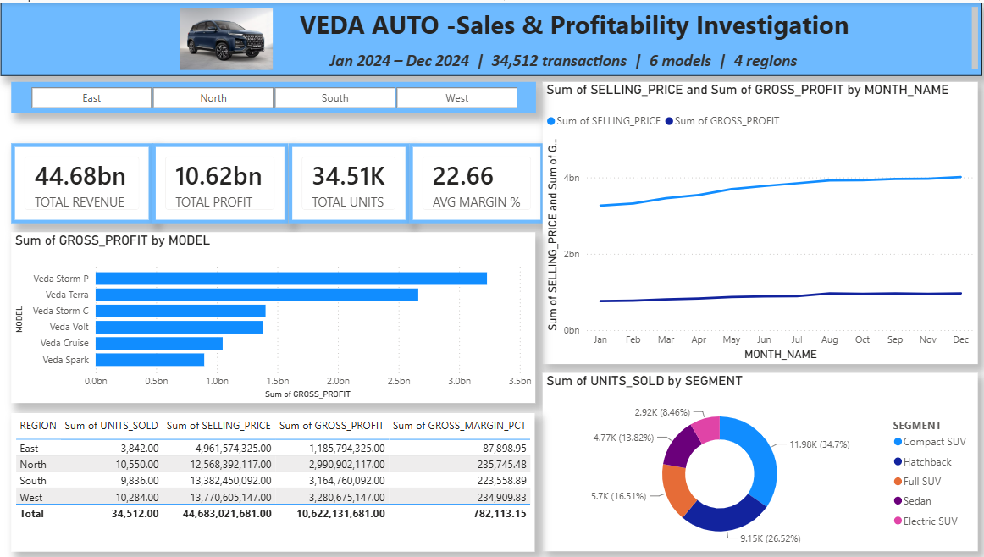
Figure 8: Power BI Page 1 — Executive Dashboard (Oracle DB → Power BI direct connection)
Visual | Type | Business Story
4 KPI Cards | Card | Revenue ₹44.68bn | Profit ₹10.62bn | Units 34,512 | Margin 22.66%
Monthly Revenue & Profit Trend | Line Chart | Both growing Jan → Dec — confirms upward trajectory
Model Profit Ranking | Bar Chart | Storm P #1; Spark #6 (last) — visual proof of problem
Segment Share | Donut Chart | Compact SUV 34.7% dominates; Hatchback 26.5% declining
Region Performance Table | Table | North most units; West most revenue per unit
Region Slicer | Slicer | Interactive filter — whole dashboard responds to click

8.2 Page 2 — Diagnostic Investigation
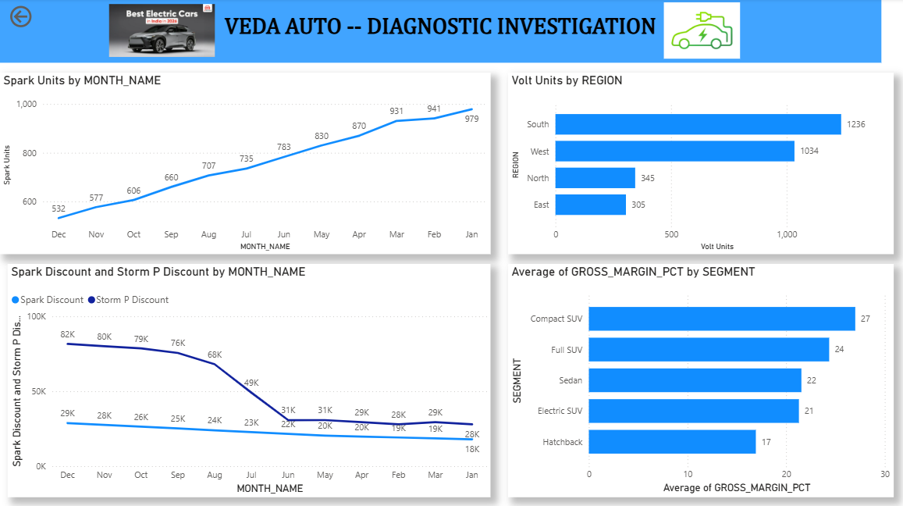
Figure 9: Power BI Page 2 — Diagnostic Deep Dive (DAX measures used for model-specific analysis)
Visual | DAX Measure | Business Story
Spark Decline Chart | Spark Units = CALCULATE(SUM, MODEL=Spark) | Jan 979 → Dec 532: visual collapse clearly shown
Volt Regional Bar | Volt Units = CALCULATE(SUM, MODEL=Volt) | South 1,236 vs North 345: gap immediately visible
Discount Trend | Spark Discount + Storm P Discount (AVG) | Storm P July spike clearly visible — backfire confirmed
Segment Margin | AVG(GROSS_MARGIN_PCT) by Segment | Compact SUV 27% vs Hatchback 17% — clear winner/loser

9. Key Findings Summary
# | Finding | Metric | Business Implication
1 | Spark structural decline | -45.6% in 12 months | Not recoverable — begin phase-down
2 | Volt explosive growth | +219% in 12 months | Future of VedaAuto — invest now
3 | North India EV gap | 345 vs 1,236 (South) | ₹10,000L+ untapped opportunity
4 | Spark discounting failing | Discounts +60% YTD | Margin destruction, no volume benefit
5 | Storm P price hike backfire | Discounts +121% post-hike | Pricing reversal needed
6 | Compact SUV best segment | 27% margin, 35% share | Double down — increase production
7 | Hatchback worst segment | 17% margin, declining | Phase out — reallocate resources
8 | West highest revenue/unit | ₹1,37,706L vs North ₹1,25,683L | West buying premium models

10. Business Recommendations

Recommendation 1 — Accelerate Spark Phase-Down
Stop discount escalation. Each ₹1,000 increase costs ₹9.1L annually (9,151 units). Reallocate capacity toward Storm C (best margin: 27.57%) and Volt.
Action | Expected Impact
Stop discount escalation immediately | Save ₹8,000L+ annually in discount costs
Reduce Spark production by 30% in Q1 | Free capacity for Storm C and Volt
Offer Spark→Storm C trade-up incentive | Convert declining segment to growing one

Recommendation 2 — Launch Volt North Initiative
Deploy 50 EV-ready dealers in North India with charging infrastructure partnerships. Campaign: ₹1.5/km (EV) vs ₹8/km (petrol) — economics argument wins.
Action | Expected Impact
Train 50 North dealers on EV sales | Sales confidence improvement
Partner with EESL for charging infra | Reduce range anxiety barrier
North Volt target: 800+ units/month in 6 months | Additional ₹10,000L+ annually

Recommendation 3 — Revert Storm P Pricing
Roll back August hike by 4-5%. Reduce dealer discounts from ₹68,000 to ₹35,000. Let scale restore margins naturally.
Action | Expected Impact
Price reduction of 4% | Storm P volume: 610 → 750+ units/month
Dealer discount cap at ₹35,000 | Save ₹4,000L in discount costs annually
Revenue recovery | Additional ₹8,000L+ annually

Recommendation 4 — Double Down on Storm C (CNG)
Best margin (27.57%), steady growth. Expand in West and South where CNG infrastructure is strongest.
Action | Expected Impact
Increase Storm C production by 40% | Units: 330 → 500/month
CNG dealer expansion in West India | Tap Gujarat + Maharashtra strength
Additional profit impact | ₹5,000L+ annually

11. Tools & Technologies
Tool | Purpose in This Project
Python (pandas, numpy) | Dataset generation with realistic hidden business patterns
Oracle SQL Developer (Oracle 21c) | Data storage + 10 analytical business queries
Power BI Desktop | 2-page executive dashboard with Oracle DB live connection
DAX (Power BI) | 4 custom measures for model-specific isolated analysis
GitHub | Portfolio hosting and project documentation
MS Word | Professional project documentation (this document)

13. About the Analyst
Attribute | Detail
Name | Dasari Sampath Kumar
Role | Fresher Data Analyst
Location | Kadapa, Andhra Pradesh (targeting Bangalore & Hyderabad)
Certification | Data Analytics — DATA MINDS & ANALYTICS, Hyderabad (2024)
Education | Bachelor of Arts — Yogi Vemana University
Email | sampathkumardasari38@gmail.com
Phone | +91 8008750727
GitHub | github.com/Sampath20019
LinkedIn | linkedin.com/in/sampathkumar-dasari5-888408368

Skills Demonstrated: Market Research | Business Problem Framing | Python | Oracle SQL | Power BI | DAX | Root Cause Analysis | What-If Analysis | Business Recommendations

This project demonstrates real analyst thinking: from market research to root cause investigation to actionable business recommendations — not just a dashboard.

