fxghdfg

*by* Ananth Kumar

**Submission date:** 17-Oct-2023 06:40PM (UTC-0700)

**Submission ID:** 2143294140

**File name:** research_paper_for_csp.pdf (562.18K)

**Word count:** 2802

**Character count:** 15789

3

**ABSTRACT**

Heart attacks and other cardiovascular disorders continue to be the world's top cause of death. Heart attack early detection and prediction are essential for prompt medical intervention and better patient outcomes. The goal of this project is to create a system that can predict heart attacks by analysing PQRS peaks and ECG (Electrocardiogram) data. A common and non-invasive diagnostic method for evaluating the electrical activity of the heart is [(quizlet.com)](https://quizlet.com/5003380/strength-and-conditioning-flash-cards/) electrocardiography. The PQRS complex, which reflects the atrial and ventricular depolarization and repolarization phases, is one area where the ECG data gathered from sensors can be particularly useful in understanding the electrical behaviour of the heart. [(doi.org)](http://doi.org/10.1007/978-94-007-0753-5_100123) The objective of this effort is to forecast the likelihood of a heart attack by examining the PQRS peaks in ECG signals. This project's main goal is to use advanced machine learning techniques and ECG data to forecast the possibility of a heart attack, with a focus on the PQRS peaks**.**

**INTRODUCTION**

Cardiovascular diseases, particularly myocardial infarction, commonly referred to as a heart attack, remain a leading cause of mortality and morbidity [(doi.org)](http://doi.org/10.1007/978-94-007-0753-5_100123) worldwide. In order to improve patient outcomes and lessen the strain on healthcare systems, early diagnosis and prediction of heart attacks are essential. The use of electrocardiogram (ECG) signals, notably the P, Q, R, and S waves, has drawn a lot of attention in this day of enhanced technology for the prediction of heart attacks. This study intends to investigate the possibility of employing these ECG waveforms as a foundation for heart attack prediction, providing a novel and non-invasive method to improve the precision and promptness of diagnosis and intervention.

A non-invasive and frequently used diagnostic technology called electrocardiography gives a glimpse into the electrical activity of the heart. It keeps track of the variations in electrical potential brought on by each heartbeat, enabling the detection of anomalies that might indicate the beginning of a heart attack. Being a representation of the electrical depolarization and repolarization of the atria and ventricles, the PQRS complex in the ECG waveform is especially important. These PQRS peaks can be analysed to provide information on the condition of the heart and assist in the prediction of cardiovascular events.

To avoid or lessen the harm that results from a heart attack, it is essential to be able to foresee when one will occur. The key to this endeavour is electrocardiography, which offers a non-invasive way to evaluate the electrical activity of the heart. The PQRS complex, which is part of the ECG waveform, is particularly significant because it depicts the electrical depolarization and repolarization of the heart's chambers and can provide important information about cardiac health.

The main goal of our study is to use [(www.cognizant.com)](https://www.cognizant.com/whitepapers/from-data-to-insights-how-it-operations-data-can-boost-quality-codex2311.pdf) advanced machine learning algorithms to analyse ECG data obtained from ECG sensors and forecast the possibility of a heart attack. We think that by concentrating on the study of the PQRS peaks included within ECG data, a deeper comprehension of the heart status and improved predicted accuracy would be provided.

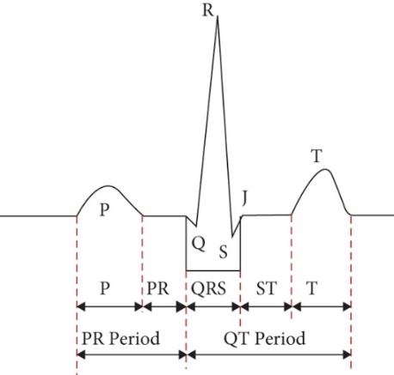

Fig-1 ECG PQRS peaks segmentation

**RELATED WORKS**

For many years, the MIT-BIH Arrhythmia Database has been an important resource in the fields of cardiology and biomedical engineering. It is made up of a wide range of electrocardiogram (ECG) recordings that provide a complete depiction of cardiac electrical activity. ECG signals, which capture electrical impulses from the heart, are critical in detecting and monitoring a variety of heart problems such as arrhythmias, heart attacks, and other cardiac illnesses. The importance of the MIT-BIH Arrhythmia Database in heart attack detection studies utilising ECG signal peaks cannot be emphasised. The study of ECG signals is critical in the early detection and diagnosis of cardiac problems. Detecting myocardial infarction, sometimes known as a heart attack, is a crucial medical problem, and correct ECG signal identification is essential and This is a critical phase in the procedure.

Over the last four decades, scientists have developed a number of automated methods for detecting distinct waveforms in ECG data. Pan-Tompkins created one of the most prominent derivative-based algorithms for identifying just the QRS-wave in 1985. Typically, three approaches are used to discover distinct waveforms in ECG: derivative-based wavelet-filters [2] and amplitude-based methods. Machine learning approaches have also been employed in this field of study. Neural Network (NN) [4], Random Forest [6], Support Vector Machine (SVM) [5], Ada Boost, Naive Bayes, K-Nearest Neighborhood (KNN), Hidden Markov Models (HMM), rule-based approaches, linear discriminants, and logistic regression are examples of these studies. With the successful rise of Deep Learning (DL) approaches in numerous domains of signal processing and data analysis, [1], [2] have recently been published. The first related DL approaches were used to categories heartbeats into five types. However, no research has been conducted on detecting and identifying the waves in heartbeats, which is critical in cardiology communities because every cardiologist refers to them in their diagnosis.

Then, early intervention can begin, possibly avoiding minimising the damage caused by myocardial infarctions. Furthermore, the research will help to advance wearable ECG sensor technology, enabling for continuous monitoring and personalised healthcare solutions. The use of ECG sensors to anticipate heart attack illness is an exciting new path for enhancing cardiac care. The creation of precise and dependable prediction models, as well as real-time monitoring capabilities, has the potential to save lives and minimise the burden of heart-related disorders on individuals and healthcare systems.

Follow Up Study in 2023 [1] researches developed a model using the convolutional neural networks (CNN) where they used MIT-BTH and PTB normal for their work which gave 9835% of accuracy and 98.4% with RNN. They mainly focused on the QRS complexes and they didn’t focused on the distance between the peaks and the beats per second as well.

Ongoing exploration on 2023 studies, they have proposed elephant adaptive sliding window for finding the co-relatin between the features and their probability density function they done this by implementing the unsupervised learning method and this about how they worked with their data the ECG signals are initially gathered from a real-time database that includes several classes, including mitochondrial (SDHB), succinate dehydrogenase [ubiquinone] iron-sulphur subunit, right bundle branch block (RBBB), left bundle branch block (LBBB), ventricular flutter (VFL), idiopathic ventricular rhythm (IVR), ventricular tachycardia (VT), bigeminy, trigeminy, premature ventricular contraction [(www.ncbi.nlm.nih.gov)](https://www.ncbi.nlm.nih.gov/pmc/articles/PMC4109044/) (P The obtained ECG signal is thereafter forwarded for segmentation.

In summary, The use of this information provides a once-in-a-lifetime chance to test, develop, and create algorithms for heart attack detection. It allows for the creation of automated systems that can help healthcare practitioners make prompt and accurate diagnoses, possibly saving lives and improving patient outcomes. The following research projects build on the rich legacy of the MIT-BIH Arrhythmia Database, which remains an invaluable resource for those working on heart attack detection and the broader field of cardiac health, ultimately contributing to advances in the diagnosis and treatment of heart-related conditions.

**PROPOSED MODEL**

In our research we mainly focusing on the ECG sensor data and implementing CNN for our data, The relevance of this technology rests in its potential to revolutionise heart attack diagnosis and prevention. Using ECG sensor data, healthcare practitioners can identify those who are at risk of having a heart attack before they happen.

The characteristics of ECG sensors vary depending on their intended usage. They can have one or more channels, recording various leads for different types of cardiac data. Sampling speeds range from 500 Hz to 1,000 Hz, with typical resolutions of 12 or 16 bits, allowing for high-resolution data capture. To decrease interference, noise filtering is used, and they link via wired or wireless ways such as Bluetooth or Wi-Fi. Portable ECG sensors priorities battery life, whereas wearables prioritize comfort and compactness. These sensors may store data locally or send it in real time, and they are compatible with certain data analysis tools or apps. Some additionally include clinical certifications, connectivity with healthcare systems, and user-friendly interfaces to ensure that they fit the requirements of medical, research, or personal health monitoring applications.

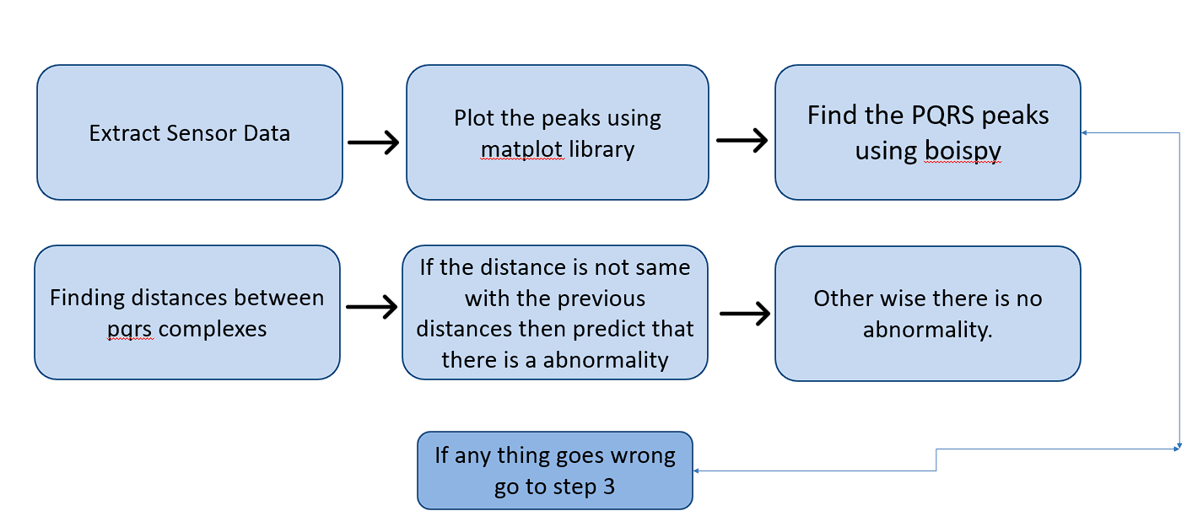

Fig -2 Architecture Diagram

**SOFTWARE AND HARDWARE**

In this project we used Arduino UNO board ECG module and connector pins for ECG leads The Arduino Uno is a widely acclaimed microcontroller development board known for its versatility and ease of use. It's a fundamental part of the open-source Arduino platform, perfect for both beginners and experienced makers. At its core, the Arduino Uno is powered by the ATmega328P microcontroller, equipped with 14 digital input/output pins and 6 analog input pins. [(arduino-info.wikispaces.com)](http://arduino-info.wikispaces.com/Cables) These pins enable the board to interface with various sensors, actuators, and devices, making it suitable for a wide range of projects. The board's USB interface simplifies programming and serial communication, allowing you to upload code via the Arduino IDE. With a clock speed of 16 MHz and support for multiple power sources, including USB, external DC power, and batteries, the Arduino Uno offers flexibility in project design. Whether used for home automation, robotics, IoT applications, or educational purposes, the Arduino Uno's user-friendly environment and extensive community support make it an excellent choice for [(techbriel.com)](https://techbriel.com/quarkus-vs-spring-boot-pros-and-cons/) turning creative ideas into functional prototypes.

An ECG (Electrocardiogram) module is a vital medical device used to record and display the electrical activity of the heart. It is an essential tool in diagnosing various cardiac conditions and monitoring the overall health of the heart. ECG modules typically consist of multiple electrodes that are attached to the patient's skin to capture the electrical signals produced by the heart. These signals are then amplified and processed to create a graphical representation of the heart's electrical activity, which is displayed as a waveform on a monitor or recorded for further analysis.

Interfacing an ECG module involves connecting it to a computer or another monitoring device for data acquisition and analysis. This process is crucial in clinical settings and healthcare applications. The interface may include analog-to-digital converters to digitize the analog ECG signals, signal processing units to filter and enhance the data, and software for real-time display and storage. In modern healthcare, ECG modules are often integrated with wireless technology, allowing for remote monitoring and real-time data transmission to medical professionals, enhancing patient care. The versatility of ECG modules and their seamless interfacing capabilities make them indispensable tools for diagnosing cardiac conditions and ensuring the well-being of patients.

Connecting an ECG (Electrocardiogram) module involves establishing the necessary electrical connections between the module and the components that interface with or process ECG signals. The module typically features electrodes, amplifiers, and sometimes analog-to-digital converters. The ECG module often contains built-in amplifiers to enhance the weak ECG signals, followed by analog-to-digital converters (ADCs) to digitize the analog signals for subsequent digital signal processing or data storage. The connection between the electrodes and the ECG module is usually via shielded cables to minimize interference and noise.

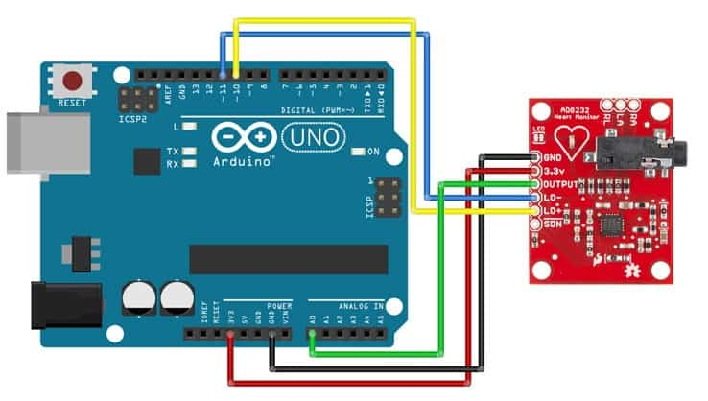

Fig-3 Interface of ECG Moule and Arduino UNO Board

The ECG module connection begins with the placement of electrodes on the patient's skin, typically in a standardized configuration such as the limb leads (bipolar leads) or the precordial leads (unipolar leads). These electrodes are essential for capturing the electrical signals generated by the heart. The module itself usually comprises input connectors for these electrodes, which are securely attached to the patient's body. Lead placements are specific locations on the body where electrodes or sensors are positioned to capture electrical signals for an electrocardiogram (ECG). ECG lead placements follow standardized configurations to record different aspects of cardiac electrical activity. Once the electrodes are in place, their leads are connected to the corresponding input terminals on the ECG module. These connections ensure that the electrical signals from the body are correctly conveyed to the module for further processing.

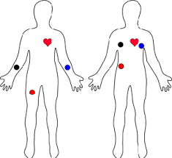

Fig-4 Placements of leads

DATA COLLECTION & PREPROCESSING

In this research paper, we delve into the application of ECG sensors for the precise extraction of ECG peak values, a fundamental aspect of cardiac signal analysis. Electrocardiogram (ECG) peak values, such as the R-peak, QRS complex, T-wave, and ST-segment, contain vital information about the heart's electrical activity and are pivotal for diagnosing various cardiac conditions, including arrhythmias and heart attacks. By harnessing the capabilities of ECG sensors, we aim to develop a robust methodology for the accurate identification and extraction of these peaks. This work contributes to the advancement of cardiac diagnostics, paving the way for improved [(doi.org)](http://doi.org/10.1117/1.JMI.3.3.034501) patient care through early detection and intervention, and has the potential to play a significant role in the development of automated, real-time monitoring systems for heart health.

For getting real time data we are using python with a module called “serial” which will captures and analyzes Electrocardiogram (ECG) data using an Arduino-based ECG sensor. It begins by establishing a serial connection with the Arduino [(doi.org)](http://doi.org/10.1007/978-1-4842-0241-8) and then allows the user to specify the recording time in minutes. The script continuously receives ECG data from the [(doi.org)](http://doi.org/10.1007/978-1-4842-0241-8) Arduino, visualizing it in real-time using Matplotlib. It collects the ECG data and saves it as a CSV file for further analysis. After data acquisition, our script employs the “find peaks” function from SciPy to detect R-peaks in the ECG signal, which represent the highest points of the QRS complex in the ECG waveform. These R-peaks are essential for calculating the beats per minute (BPM), a crucial measure of heart rate. The code also plots the ECG signal with detected R-peaks and generates a histogram showing the distribution of distances between the R-peaks, representing the heartbeat intervals.

Moreover, our script provides the option to save the ECG signal plot and the distribution plot as images for future reference or analysis. This code serves as a valuable tool for those interested in ECG data collection, peak detection, and heart rate analysis, making it particularly useful for researchers and healthcare professionals working on cardiovascular monitoring and diagnostics. Output will be displayed using the matplotlib module and it will plot the peaks according to Time(ms) vs Voltage(mV) it will be look like this and our code finds BPM of particular person by using formula “bpm = (ecg_values.size / np.mean(distances)) / (ecg_values.size / 15000)”.

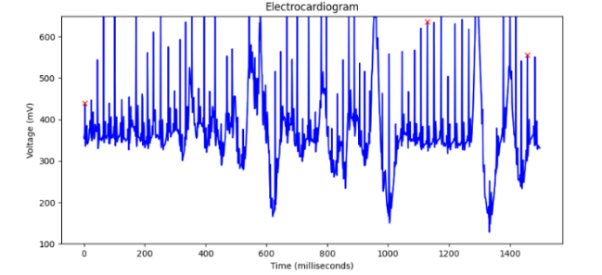

Fig-5 ECG data

In our research we took over 1500 samples for examining ECG behavior of a particular person. This substantial quantity of samples allows for a more comprehensive analysis of the ECG signal and the identification of various features, including the QRS complex, T-wave, and ST-segment. By gathering a larger dataset, you enhance the accuracy of your analysis, which can be particularly beneficial in applications such as arrhythmia detection, heart rate variability assessment, or any research involving detailed ECG waveform characterization. The script we have employed provides a practical and efficient means to collect and process this extensive dataset, ultimately contributing to a more in-depth understanding of cardiac electrical activity and potential clinical applications. For preprocessing data we implementing label encoding and MinMax Scaling it is also known as Min-Max normalization, is a data preprocessing technique used to transform features in a dataset to a specific range, usually between 0 and 1. This technique is particularly useful when the features in your dataset have varying scales and you want to bring them to a common scale. Min-Max Scaling works by rescaling the values of each feature linearly, mapping the minimum value to 0 and the maximum value to 1. It is given by the formula:

Xnew = X – Xmin / Xmax – Xmin

Min-Max Scaling helps to prevent features with large scales from dominating the learning process in machine learning algorithms, especially when using models like neural networks. Label Encoding is a valuable preprocessing technique to convert categorical data into numerical values, enabling machine learning models to work with such data. It simplifies the representation of categories with unique integer labels, but it's essential to be aware of potential issues, such as unintentional ordinal relationships, when applying this technique.

Adam is an optimization algorithm commonly used for training machine learning models, particularly deep learning models. [(doi.org)](http://doi.org/10.1117/1.JMI.3.3.034501) It combines the advantages of two other popular optimization techniques: AdaGrad and RMSProp. Adam optimizes the learning process by dynamically adjusting the learning rates for each parameter in the model. It also keeps a moving average of the gradients to adaptively update the learning rates. Adam utilizes two moving averages: the first moment (mean) and the second moment (uncentered variance) of the gradients. These moving averages help control the learning rates during training. The algorithm's adaptive learning rates make it suitable for various types of models and datasets. It is widely used for training deep neural networks [(doi.org)](http://doi.org/10.1117/1.JMI.3.3.034501) due to its effectiveness and robustness.

**TRAINING AND TESTING**

In this project we used TensorFlow and Keras to build a simple neural network for [(doi.org)](http://doi.org/10.1117/1.JMI.3.3.034501) binary classification. The goal of [(doi.org)](http://doi.org/10.2307/3061405) the model is to predict whether a person is at risk of a heart-related issue based on their heart rate data. Here's a breakdown of the code in a paragraph:

The data pre-processing and model construction for binary classification based on heart rate data are carried out. The heart rate data is first split into training and testing sets using scikit-learn's train_test_split function. The split data includes the training data (X_train), testing data (X_test), training labels (Y_train), and testing labels (Y_test). The split ratio is set at 80% for training and 20% for testing, ensuring reproducibility with a specified random seed.

A neural network model is created using Keras, consisting of an input layer with one unit, two hidden layers with 64 and 32 units and ReLU activation functions, and an output layer with [(ethesis.nitrkl.ac.in)](http://ethesis.nitrkl.ac.in/4244/1/Improved_Digital_Watermarking_Schemes_Using_DCT_and_Neural_Techniques_Improved_Digital_Watermarking_Schemes_Using_DCT_and_Neural_Techniques.pdf) a single unit and a sigmoid activation function, which is suitable for binary classification. The Early Stopping callback is also defined to monitor the validation loss and stop training if it doesn't improve for 10 epochs. The model is trained using the training data with a specified number of epochs and batch size. It is also validated using the testing data during training to monitor its performance. After training is complete, the code calculates the loss and accuracy of the model on the testing data and prints the results to the [(fabacademy.org)](http://fabacademy.org/archives/2015/eu/students/santos.fabricio/week13.html) console.

To ensure the neural network model receives properly scaled input data, a MinMaxScaler is employed from scikit-learn's preprocessing module. The scaler is initialized as scaler, and the training data is normalized using the fit_transform method. This transformation brings the data into a consistent range, often between 0 and 1, which aids in model convergence and performance. The testing data is similarly scaled using the same scaler to maintain consistency between the two [(www.beeo.emsd.gov.hk)](http://www.beeo.emsd.gov.hk/en/pee/BEC_2012.pdf) datasets.

Finally, a neural network model is constructed using Keras. It's a sequential model with an input layer, two hidden layers with ReLU activation functions, and an output layer with a sigmoid activation function. [(s3.amazonaws.com)](https://s3.amazonaws.com/heatonresearch-books/free/Encog3Java-User.pdf) The input layer [(doi.org)](http://doi.org/10.1007/978-3-319-28531-3_13) is designed to handle the heart rate data, the hidden layers introduce non-linearity and abstraction, and the output layer [(doi.org)](http://doi.org/10.1007/978-3-319-28531-3_13) produces a probability indicating the likelihood of a given heart rate belonging to the positive class (1) in the binary classification task.

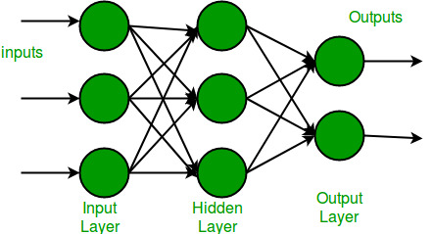

Fig-6 Neural Network Architecture [(s3.amazonaws.com)](https://s3.amazonaws.com/heatonresearch-books/free/Encog3Java-User.pdf)

**MODEL ARCHITECTURE**

We have trained over model with 1500 samples for better accuracy and over model starts with the compilation of the model using the Adam optimizer, which is a popular optimization algorithm. [(medium.com)](https://medium.com/@gyanp7880/the-power-of-functional-api-deep-learning-predicting-two-output-age-and-gender-simultaneously-371f1c5b181e) The loss function is set to 'binary_crossentropy,' indicating that this is a binary classification problem. Additionally, it tracks the 'accuracy' metric during training to monitor the model's performance. [(medium.com)](https://medium.com/@gyanp7880/the-power-of-functional-api-deep-learning-predicting-two-output-age-and-gender-simultaneously-371f1c5b181e) And we are fitting over model for training the neural network. Then we specified over tarin and test data along with the number of training epochs (200 in this case), the batch size (8 samples per batch), and the validation data [(bonndoc.ulb.uni-bonn.de)](https://bonndoc.ulb.uni-bonn.de/xmlui/bitstream/20.500.11811/8981/1/6111.pdf) for monitoring the model's performance on unseen data. It also employs a callback called early_stopping which can halt training if the model's performance stops improving on the validation data, [(bonndoc.ulb.uni-bonn.de)](https://bonndoc.ulb.uni-bonn.de/xmlui/bitstream/20.500.11811/8981/1/6111.pdf) thus preventing overfitting.

Then we find the loss and accuracy of over model using the normalized values so we got Test Loss: 0.38491857051849365 and Test Accuracy: 0.8409090638160706

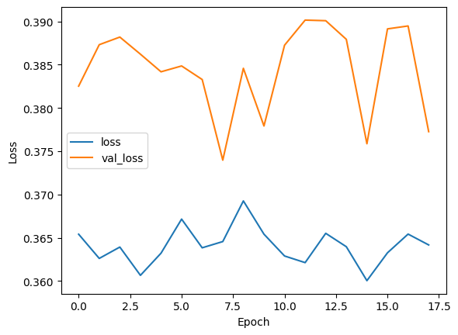

Fig-6 loss vs value loss

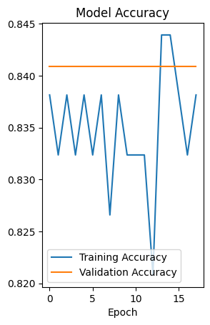

Fig-7 Training accuracy vs validation Accuracy

Then we tested over model with another person’s ECG data set of 1500 samples over model predicted it accurately by showing with label “1” which means the person is not having any arrythmia he is good.

12

%

PRIMARY SOURCES

1 Hedayat Abrishami, Matthew Campbell, Chia Han, Richard Czosek, Xuefu Zhou. "P-QRS-T localization in ECG using deep learning", 2018 IEEE EMBS International Conference on Biomedical & Health Informatics (BHI), 2018

Publication

3%

1

publications.eai.eu

Internet Source %

2

1

Submitted to University of Birmingham

Student Paper %

3

1%

4 Submitted to Liverpool John Moores University

Student Paper

1%

5 Submitted to University of Technology, Sydney

Student Paper

1

[www.ncbi.nlm.nih.gov](http://www.ncbi.nlm.nih.gov/)

Internet Source %

6

1

Submitted to University of North Texas

Student Paper %

7

8

9

10

11

12

13

14

15

16

Submitted to Coventry University

Student Paper

[www.blogarama.com](http://www.blogarama.com/)

Internet Source

Submitted to University of West London

Student Paper

Gokul M, Kiruthika Uma R, Arun Prasath T, Anisha M. "Electrogastrogram Analysis of Unclear Stomach Pain", 2023 Second International Conference on Electronics and Renewable Systems (ICEARS), 2023

Publication

Submitted to National College of Ireland

Student Paper

appsilon.com

Internet Source

[www.hindawi.com](http://www.hindawi.com/)

Internet Source

open.library.ubc.ca

Internet Source

Avishek Garain, Biswarup Ray, Pawan Kumar Singh, Ali Ahmadian, Norazak Senu, Ram Sarkar. "GRA_Net: A Deep Learning Model for Classiﬁcation of Age and Gender From Facial Images", IEEE Access, 2021

Publication

1%

1%

<1%

<1%

<1%

<1%

<1%

<1%

<1%

Exclude quotes Oﬀ Exclude bibliography On