SMART EV CHARGING PLATFORM
Website • UX/UI • IoT • Payments • Backend • Database • Developer Handoff
Architecture & Product Blueprint
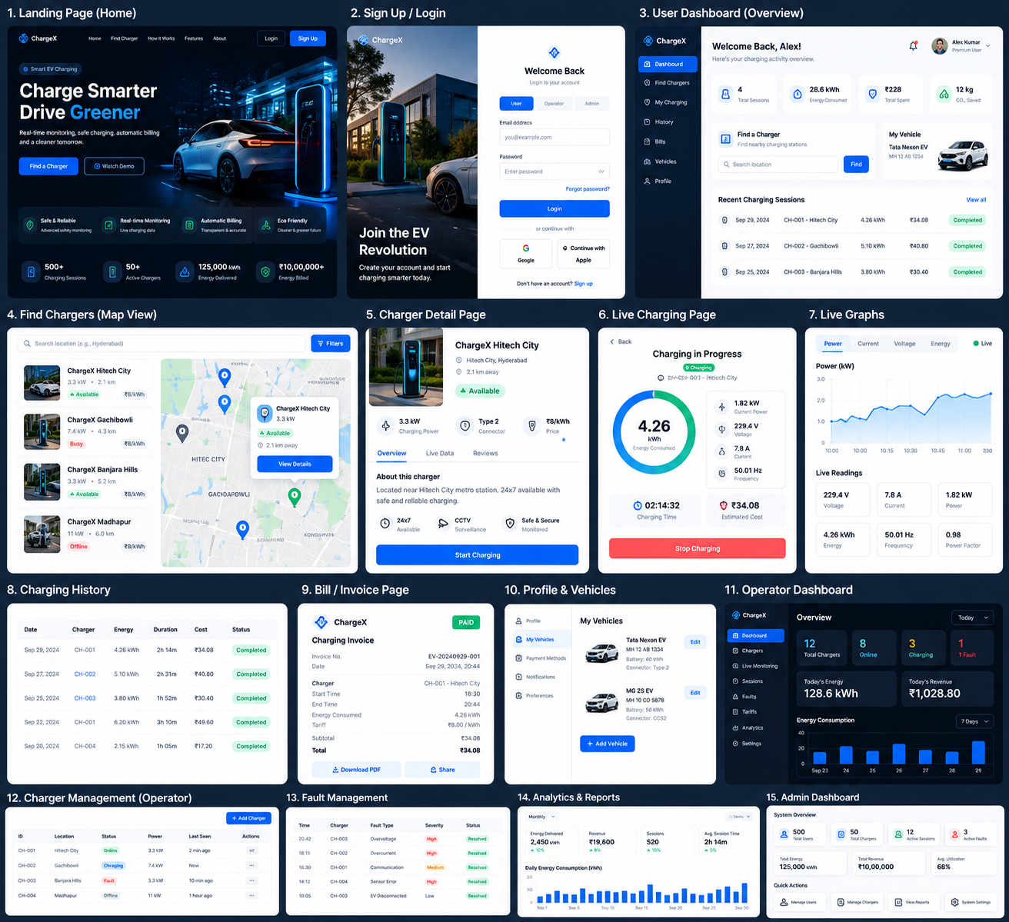
Prepared from the uploaded 9-page project proposal plus the agreed product/engineering extensions from the design discussion.

1. Executive Summary
The proposed website is the digital platform for an IoT-based smart EV charging system. The original project proposal describes a single-phase 230 V, 50 Hz EV charging system with real-time monitoring, regulated charging, PFC, automatic billing, EV connection detection, local display, data storage and IoT-based remote monitoring.
- The website should not be only a sensor dashboard; it should behave like a complete smart-charging platform.
- Users can discover chargers, start a session, monitor charging, view energy/cost, access history and bills, manage vehicles, wallet and RFID cards.
- QR/UPI is the payment path for scan-and-pay charging; RFID is the fast identification/authorization path for registered users.
- Operators/admins can monitor chargers, sessions, faults, tariffs, payments and analytics.
- Safety-critical charging decisions remain local to the charger/controller; the website must never be the only safety mechanism.
Source basis: uploaded project proposal, especially the objectives on page 5 and methodology on pages 6–7. The proposal explicitly includes real-time voltage/current/power monitoring, PFC, automatic billing, EV detection, local display, storage and IoT communication.

2. Requirements Derived from the Original Project
Requirement | What the proposal says | Website implication
Regulated charging | Stable and efficient EV charging. | Show charger state, readiness and charging status.
Real-time monitoring | Voltage, current and power during charging. | Live telemetry cards + graphs.
Power quality | PFC and reduced harmonic distortion. | Power-quality screen; display only measured metrics.
Automatic billing | Energy consumption × predefined tariff. | Live estimated cost + final bill + payment status.
EV detection | Connection status and charging start/end time. | Session lifecycle and history.
Local display | Voltage/current/power/energy/time/bill. | Web mirrors the important operational metrics.
Data storage | Charging history, user records, energy and billing. | PostgreSQL data model.
IoT communication | Remote monitoring via Wi-Fi/IoT. | MQTT telemetry + WebSocket live UI.
Fault safety | Relay cutoff and audible/visual alarms. | Fault center and notifications; local cutoff remains primary.

Important scope clarification
The proposal contains a specification inconsistency: the introduction describes a single-phase 230 V, 50 Hz system, while the methodology diagram visually shows 230 V / 415 V. The website should be implemented independently of this electrical ambiguity, but the final hardware specification must explicitly choose the supported electrical configuration.

3. Product Vision
Position the product as a Smart EV Charging Management Platform rather than a college-style monitoring dashboard.
Core user promise:
FIND → AUTHORIZE → CHARGE → MONITOR → CALCULATE → PAY → REMEMBER
The platform should support two primary charging experiences: Scan & Charge using QR/UPI and Tap & Go using RFID.

4. Website Sitemap & Page Count
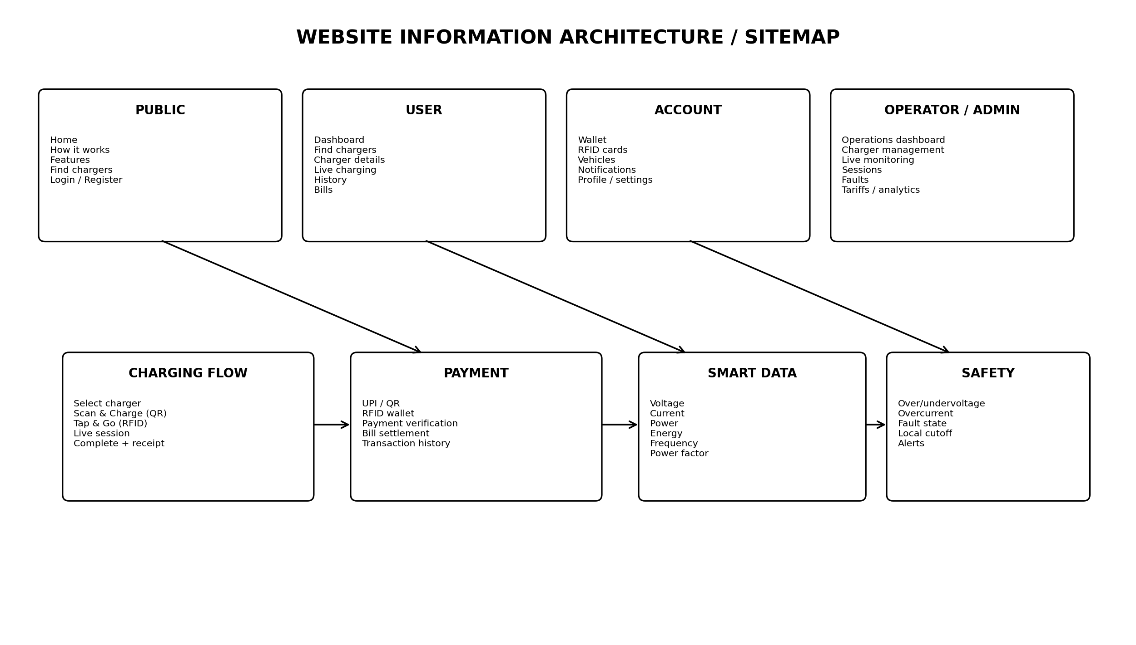
Area | Pages | Purpose
Public | 5 | Home, how it works, features, charger discovery, login/register.
User | 8 | Dashboard, charger details, live charging, history, bills, wallet, RFID, vehicles/profile.
Operator/Admin | 10+ | Operations, chargers, live monitoring, sessions, faults, tariffs, payments, analytics, users, settings.

Recommended initial implementation: 12 core public/user pages plus a separate operator/admin workspace. Some account screens can be implemented as nested tabs instead of separate top-level routes.

5. Screen-by-Screen Product Blueprint
Page | What it should contain | Primary action
Home | Premium hero, clear value proposition, smart charging visual, key benefits, how-it-works steps, safety, monitoring and primary CTA. | Find a Charger / Sign Up
Login / Register | Clean authentication with role-aware access. Keep the experience simple; avoid exposing admin/operator options unnecessarily. | Login / Create account
User Dashboard | Active session, wallet balance, recent sessions, energy consumed, total spend and quick Find Charger action. | Find Charger / Continue Charging
Find Chargers | Map/list split view, search, availability, distance, power and price filters. | View Details
Charger Details | Availability, charging power, connector, price, safety status, location and start action. | Start Charging
Start Charging | Choice between Scan & Charge (QR/UPI) and Tap & Go (RFID). | Pay/Authorize
Live Charging | Large energy/power visualization plus voltage, current, frequency, time, cost and stop action. | Stop Charging
Charging Complete | Final energy, duration, tariff, total bill, payment status and receipt. | View Bill
History | Search/filter sessions with date, charger, energy, duration, cost and payment method. | Open Session
Bill / Invoice | Detailed charging invoice with session ID, tariff, energy, amount, payment method and transaction reference. | Download/Share
Wallet | Balance, add money, transaction history and RFID-linked charging debits. | Add Money
RFID Cards | Registered cards, active/blocked state, last used, add/block card. | Manage Card
Vehicles | Vehicle model, registration, battery/connector details where actually available. | Edit Vehicle
Notifications | Charging completion, payment result, faults, charger offline and other actionable alerts. | Open Event
Profile / Settings | Account details, security, preferences, notification settings and account controls. | Save Changes
Operator Dashboard | Fleet-level charger counts, online/charging/fault states, energy, revenue and utilization. | Open Charger
Charger Management | List, add/edit, status, last seen, power rating and configuration. | Manage
Live Monitoring | Real-time telemetry, graphs, power quality and system health. | Inspect
Fault Management | Fault type, severity, charger, timestamp, current state and resolution. | Investigate
Analytics & Reports | Energy, revenue, sessions, average duration, utilization and power-quality trends. | Filter / Export
Tariffs | Configurable energy tariff and future peak/off-peak support if required. | Update
Payment Management | Payment status, references, refunds/settlement state and wallet transactions. | Inspect

6. Modern UI/UX Direction
Recommended visual language:
- Dark navy / deep blue foundation with electric-blue accents; use green only for positive states.
- Clean typography, generous spacing, rounded cards and restrained shadows.
- Use strong visual hierarchy: one primary metric per screen rather than making every metric equally large.
- Use subtle motion for live telemetry, charging progress, state changes and navigation—not decorative animation everywhere.
- Mobile-first responsive behavior: desktop dashboard with sidebar; mobile dashboard with compact bottom navigation.
- Use consistent status colors: online/available, charging, warning, fault and offline.
- Always design loading, empty, offline and error states, not just the happy path.
Reference UI/UX montage generated for the project. It is a visual direction/prototype, not final production artwork.

7. Technical Architecture Blueprint
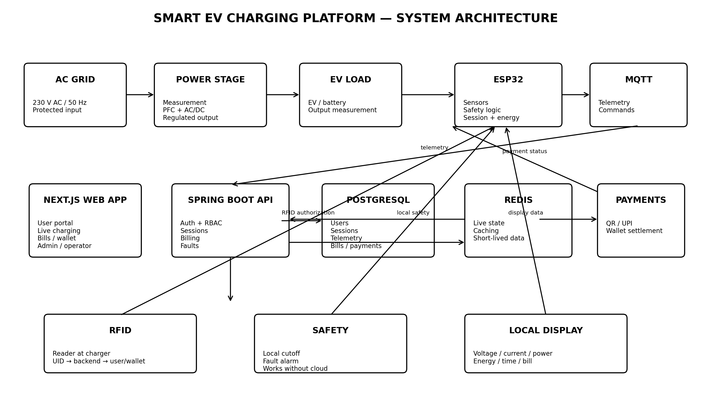
Recommended separation: Next.js handles presentation; Spring Boot owns business logic and authorization; PostgreSQL stores durable relational data; Redis supports live state/caching; MQTT transports device telemetry; WebSocket pushes validated live state to browsers; the payment provider handles QR/UPI transactions.

Critical safety principle
The charger/controller must be able to detect abnormal electrical conditions and stop charging locally even if the website, internet, backend or database is unavailable. The web application is a monitoring/management layer, not the sole safety controller.

8. Recommended Technology Stack
Layer | Technology | Why
Frontend | Next.js + TypeScript | Structured routing, maintainability, responsive product UI and strong developer fit.
UI | Tailwind CSS + shadcn/ui | Fast, consistent and professional component system.
Charts | Recharts | Live power/current/voltage/energy visualizations.
Backend | Spring Boot + Java | Strong fit for business APIs, security, validation and your existing Java skills.
API | REST | Users, chargers, sessions, billing, configuration and administration.
Realtime | WebSocket | Push live validated telemetry to the browser without refresh.
IoT | MQTT | Lightweight telemetry protocol suitable for ESP32 devices.
Database | PostgreSQL | Relational integrity for users, sessions, bills, payments and RFID.
Cache | Redis | Live state, caching and short-lived data.
Hardware | ESP32 | Wi-Fi plus sensor/control integration.
Auth | JWT + refresh tokens + RBAC | Secure user/operator/admin access.
Deployment | Docker + GitHub Actions | Repeatable builds and CI/CD.

9. Core Database Blueprint
Recommended durable entities:
Entity | Important fields / responsibility
users | id, name, email, phone, role, status
vehicles | id, user_id, model, registration, battery/connector data where available
chargers | id, name, location, power_rating, connector, status, last_seen
charging_sessions | id, user_id, charger_id, start/end, duration, status, energy_kwh
measurements | session_id, timestamp, voltage, current, power, energy, frequency, power_factor
tariffs | id, price_per_kwh, effective_from, status
bills | session_id, energy_kwh, tariff, amount, status
payments | user/session reference, method, gateway reference, amount, status
wallets | user_id, balance, status
wallet_transactions | wallet_id, credit/debit/refund, amount, reference, timestamp
rfid_cards | user_id, uid, status, last_used_at
faults | charger_id, session_id, type, severity, timestamp, status
notifications | user_id, type, message, read state, timestamp

Keep billing and payment as separate concepts: the bill answers 'what was consumed and owed'; the payment answers 'how and whether it was settled'.

10. QR/UPI and RFID Payment & Authorization
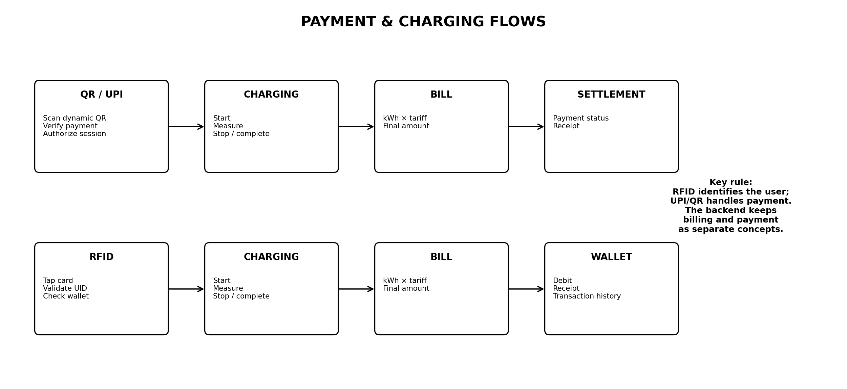

QR / UPI — Scan & Charge
- User selects a charger and chooses Scan & Charge.
- Backend creates a charging/payment context and presents a dynamic QR or supported UPI payment flow.
- Payment status is verified server-side; do not trust a browser-only success message.
- Once authorization is confirmed, the charger/session can start.
- During charging, the user sees live energy and estimated cost.
- At completion, the final bill is generated and the payment/settlement status is recorded.

RFID — Tap & Go
- User taps a registered RFID card on the charger.
- The RFID UID is sent to the backend/device authorization layer.
- The system checks that the card is active and associated with an eligible account/wallet.
- Charging is authorized and the session starts without requiring the website to be open.
- At completion, the final bill is calculated and the configured account/wallet settlement flow is applied.
- If the card is lost, the user/admin can block it; the card should identify the user rather than store the wallet balance itself.

11. IoT Telemetry & Real-Time Data Flow
Recommended flow:
Sensors → ESP32 → MQTT → Spring Boot → Redis/PostgreSQL → WebSocket → Next.js
Example telemetry payload:
{
"chargerId": "CH-001",
"timestamp": "2026-09-29T20:40:00+05:30",
"voltage": 229.4,
"current": 7.8,
"power": 1788,
"energyKwh": 4.26,
"frequency": 50.01,
"powerFactor": 0.98,
"status": "CHARGING"
}

12. Safety and Fault Architecture
- Local protection and cutoff must not depend on the website.
- Implement a charger state machine: AVAILABLE → CONNECTED → CHARGING → COMPLETED or FAULT.
- Potential monitored conditions include overvoltage, undervoltage, overcurrent, abnormal frequency, EV disconnect and sensor/communication faults.
- On a confirmed safety fault: stop/disable charging locally, activate the appropriate alarm/indicator, log the event and report it to the backend when communication is available.
- The website should display the fault and recovery state, but it should not be the only mechanism preventing hazardous charging.

13. Suggested Backend API Surface
Area | Example endpoints
Auth | POST /api/auth/login • POST /api/auth/refresh • POST /api/auth/register
Chargers | GET /api/chargers • GET /api/chargers/{id} • GET /api/chargers/{id}/status
Sessions | POST /api/charging-sessions • GET /api/charging-sessions/{id} • POST /api/charging-sessions/{id}/stop
Telemetry | POST /api/measurements • GET /api/charging-sessions/{id}/measurements
Billing | GET /api/bills • GET /api/bills/{sessionId}
Payments | POST /api/payments/create • POST /api/payments/webhook • GET /api/payments/{id}
Wallet | GET /api/wallet • POST /api/wallet/top-up • GET /api/wallet/transactions
RFID | GET /api/rfid-cards • POST /api/rfid-cards • PATCH /api/rfid-cards/{id}/status
Faults | GET /api/faults • GET /api/chargers/{id}/faults
Admin | CRUD endpoints for users, chargers, tariffs and reports

14. UX Rules for a Modern, User-Friendly Product
- Make the primary action obvious on every screen.
- During active charging, prioritize current power, energy, time and cost.
- Never hide a safety fault behind a generic error.
- Show the last-seen time when a charger is offline.
- Do not show metrics that the hardware does not actually measure; placeholders must be clearly marked as demo data.
- Keep QR payment to a short, verifiable flow.
- Make RFID nearly frictionless for returning users.
- Use confirmation for irreversible actions such as stopping a session or blocking an RFID card.
- Provide accessible contrast, readable typography and keyboard-friendly controls.
- Use consistent terminology: 'Scan & Charge' for QR and 'Tap & Go' for RFID.

15. Development Roadmap
Phase | Deliverable
Phase 1 — UX prototype | Landing, auth, dashboard, charger discovery, charger details, live charging, history, bills, wallet/RFID, admin dashboard using mock telemetry.
Phase 2 — Backend | Spring Boot auth, users, chargers, sessions, billing, tariffs, payments, RFID, faults.
Phase 3 — Database | PostgreSQL schema, migrations, indexes, audit data and reporting queries.
Phase 4 — Real-time | MQTT ingestion, Redis live state and WebSocket browser updates.
Phase 5 — Hardware | ESP32 sensor acquisition, RFID reader, display, charger control and local safety logic.
Phase 6 — Payment integration | UPI/QR gateway integration and server-side webhook verification; RFID wallet/account settlement.
Phase 7 — Integration | End-to-end testing from sensor → device → MQTT → backend → database → dashboard.
Phase 8 — Production hardening | Security, rate limits, observability, backups, offline sync, fault recovery and deployment.

MVP feature set
- Login/register and role-based access
- User dashboard
- Charger discovery and charger details
- QR/UPI and RFID charging authorization
- Live charging telemetry
- Energy and billing calculation
- Charging history and invoices
- Wallet/RFID management
- Operator charger monitoring
- Fault management
- Tariff management
- Basic analytics

16. Decisions Required Before Hardware Integration
Decision | Why it matters
Single-phase 230 V vs 415 V three-phase | Affects charger topology, sensors, protection and electrical documentation.
Maximum charging power | Determines current rating, power stage, contactor, cable and thermal requirements.
EV/battery voltage range | Determines output power electronics and measurement requirements.
Charging interface/standard | Determines EV connection detection and pilot/proximity implementation.
Exact PFC approach | Needed to demonstrate the power-quality objective credibly.
Metering accuracy | Needed for trustworthy energy and billing data.
Payment provider | Required for real UPI/QR integration and webhook/settlement behavior.
RFID hardware | Reader type and protocol must be selected and tested with ESP32.
Tariff model | Defines how bills and wallet deductions are calculated.
Cloud/deployment target | Determines networking, TLS, secrets, backups and monitoring setup.

17. Developer Acceptance Criteria
- A user can register/login and see only the screens allowed by their role.
- A user can discover a charger and see its current availability.
- A user can choose QR/UPI or RFID authorization.
- A successful QR payment is verified by the backend before charging authorization.
- A valid RFID card can authorize charging without the website being open.
- A charging session records start time, end time, energy and status.
- Live voltage/current/power/frequency values update without page refresh when real telemetry is connected.
- The final bill is calculated from measured energy and the configured tariff.
- Payment status is stored separately from the bill.
- An RFID card can be blocked and subsequently rejected.
- Faults are logged and visible to the operator.
- The local safety controller can stop charging even if the internet/backend is unavailable.
- The web UI handles loading, empty, offline and error states.
- The system is responsive on desktop and mobile.

18. Important Engineering Notes
The original proposal is a concept-level specification. It does not fully define charger power, EV/battery voltage, exact charging standard, PFC topology, payment provider, database, MQTT topics or detailed protection limits. Those items must be finalized before final hardware design.
Features such as charger maps, wallets, RFID management, notifications, analytics, operator dashboards and payment integrations are product-level extensions recommended in this blueprint. They should be clearly distinguished from measured hardware capabilities.
For real 230 V mains and EV power electronics, use appropriately rated isolation, protection, switching devices, enclosures, fusing/MCB/RCD or equivalent protection as required by the final design, and qualified electrical engineering/testing practices. Do not use the website as a substitute for hardware safety.

19. Source Reference
Primary source: the uploaded 9-page presentation titled “IOT-Based smart EV charging unit.” Key source sections used in this blueprint: Introduction (page 2), Literature Review (pages 3–4), Project Objectives (page 5), Methodology Block Diagram (page 6), Methodology Overview (page 7), Proposed Outcomes (page 8), and References (page 9).

