**What is SOX:**

* SOX provides the foundation for new corporate governance rules, regulations & standards issued by the SEC (Securities and Exchange Commission).
* It covers a range of topics from criminal penalties to Corporate Board responsibilities.
* Covers [issues](CK__Sarbanes_Oxley_Act_of_2002.pdf) such as independent auditing requirements, corporate governance, internal control assessment, and enhanced financial disclosure.
* CEO’s of publicly traded companies will be held accountable for the quality of the controls established which enable accurate Financial reporting (including IT processes, systems & roles).

**Sarbanes-Oxley Act** **(SOX) - An Overview**

* Publicly-owned corporations must comply with Sarbanes-Oxley Act (SOX) of July 2002.
* Companies that are private and are considering going public should prepare early for SOX compliance requirements

Companies wishing to demonstrate due diligence in their IT controls and management processes may want to understand their level of compliance with SOX section 404

**Importance of SOX:**

* Renewed investor confidence and Restore public trust in the public securities market
* Protect investors by improving accuracy & reliability of corporate disclosure made pursuant to the security laws
* Improve corporate governance and promote ethical business practices
* Enhance transparency of financial statements and disclosures
* Ensure that company executives are aware of material information emanating from a well-controlled environment
* Hold Management accountable for material information that is filed with U.S. Securities and Exchange Commission (SEC) and released to investors

**SOx Purpose:**

The purpose of SOx is to ensure the accuracy and timeliness of financial reporting. It sought to restore public opinion and investor faith by accomplishing greater:

* + - transparency in corporate finance
    - accountability for corporate officers
    - auditor independence
    - auditor oversight
    - ability to prosecute

**SOx Benefits:**

SOx is the most significant change to federal securities law since the Securities Exchange Act of 1934.

There have been several positive results:

* + - renewed investor confidence
    - better quality, accuracy and timeliness of financial data
    - operational efficiencies
    - greater reliance on information technology

**Who must comply with SOx?**

All publicly held companies (SEC registrants)

**GE Registrants:**

* + GE Company
  + GE Capital Corporation (GECC)
  + GE Capital Services (GECS)

**Similar foreign laws:**

* + - Canada’s Bill 198 (C-Sox) and MI52-109/11
    - Japan’s financial instruments & Exchange Law (J-Sox)
    - Australian Corporations Act 2001
    - French Financial Securities Law

**Sarbanes-Oxley 302 & 404 Terminology**

**302: “Financial Reporting “**

* Disclosure Controls Over Financial Reporting (What)
* Disclosure Committee Process CEO, CFO, Controller Sign-Off (How)
* Perform Quarterly Certification (When)
* Certify Completeness Of Disclosures and Adequacy Of Disclosure Controls (output)

**404: “Internal Controls”**

* Design and Operating Effectiveness of Internal Controls Over Financial Reporting
* 404 Leaders, Steering Committee & Tollgate Reviews
* Perform Annual Certification
* Certify The Design & Effectiveness Of Internal Controls Over Financial Reporting

**Control Objectives for IT Framework :**

Control Objective for Information and related Technology (COBIT) is a framework, issued by Information Systems Audit and Control Foundation (ISACF) in 1996. COBIT guidelines and best practices have become the de facto standard for auditors and SOX compliance. There are approximately 300 generic COBIT objectives, grouped under six COBIT Components.

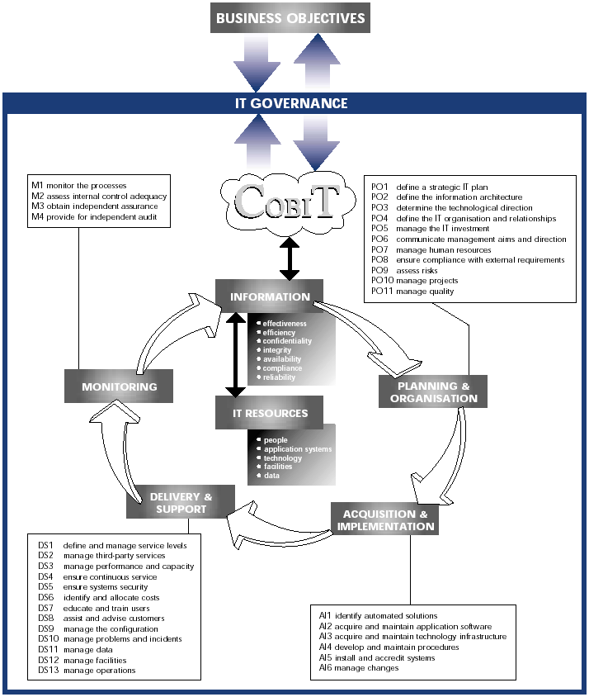

**What are Controls?**

* **Controls are the methods and measures used by a business to:**
  + Monitor assets
  + Prevent fraud
  + Minimize errors
  + Verify correctness and reliability of data
  + Promote operational efficiency
  + Ensure that established managerial policies are followed
* **Examples include:** 
  + Management Reviews, Exception Reports
  + Password complexity and/or expirations
  + Required approvals and/or authorizations

**Types of Controls**

* **Entity Level Controls**

Controls that permeate an organization and have a significant impact on how it achieves its financial reporting and disclosure objectives.

* **Finance Controls**

Controls focus on the integrity of data captured and/or reported through manual and key applications controls.

* **Application Controls**

Controls are controls in/or between applications to enforce data integrity, business rules or manual controls.

* **General Information Technology (GIT) Controls**

IT process controls that ensure sustainable application controls, financial accuracy and timeliness of reporting.

**Control Characteristics:**

**Frequency:**

* + - **Indicates the rate of control occurrence i.e. daily, weekly, monthly, quarterly, annual, adhoc or recurring**

**Category:**

* + - **Preventative: control prevents the risk from occurring**
    - **Detective: control detects the event after it occurs**

**Type:**

* + - **Manual: control is executed in full or part by an individual**
    - **Automated: control is triggered or fully executed by a program**

**Why are Controls Important?**

* Controls are designed to give assurance that transactions are properly authorized and recorded.
* Controls ensure accountability for assets, proper authorization to access assets and periodic reconciliations between recorded assets on the books and the existence of physical assets.
* Administrative or managerial controls deal with operational efficiency, adherence to managerial policies and management’s authorization of transactions.
* SOx 404 focuses on the documentation and testing of internal controls over financial reporting.

**Internal Controls over Financial Reporting**

Internal control is a process, effected by an entity’s board of directors, management and other personnel, designed to provide reasonable assurance regarding the reliability of financial reporting and the preparation of financial statements for external purposes in accordance with generally accepted accounting principles.

Purpose: To prevent material misstatements in financial reporting.

**Types of SOX Controls**

**General IT (GIT) Controls**

IT process controls that ensure sustainable application controls, financial accuracy and timeliness of reporting.

**Application Controls**

Controls in/or between applications to enforce data integrity, business rules or manual controls.

**Entity Level Controls**

Controls that permeate an organization and have a significant impact on how it achieves its financial reporting and disclosure objectives.

**Finance Controls**

Controls focus on the integrity of data captured and/or reported through manual and key applications controls.