MAVEN

[Maven](https://maven.apache.org/) is an open-source [build automation](https://www.browserstack.com/guide/build-automation) and project management tool widely used for Java applications.  As a build automation tool, it automates the source code compilation and dependency management, assembles binary codes into packages, and executes test scripts. Maven translates and packages your source code so that it becomes an executable application

MAVEN PROJECCT

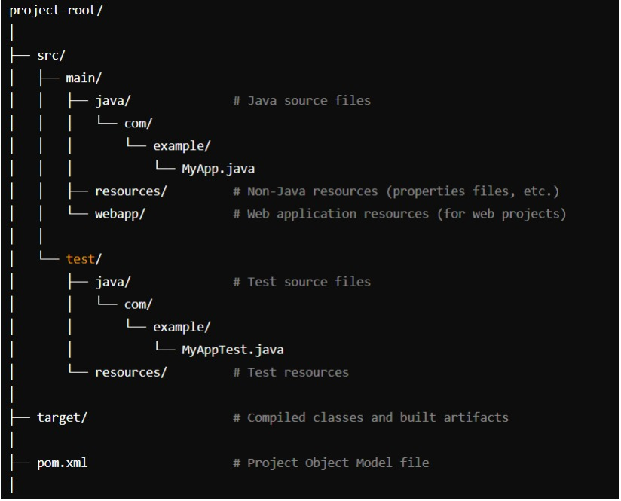

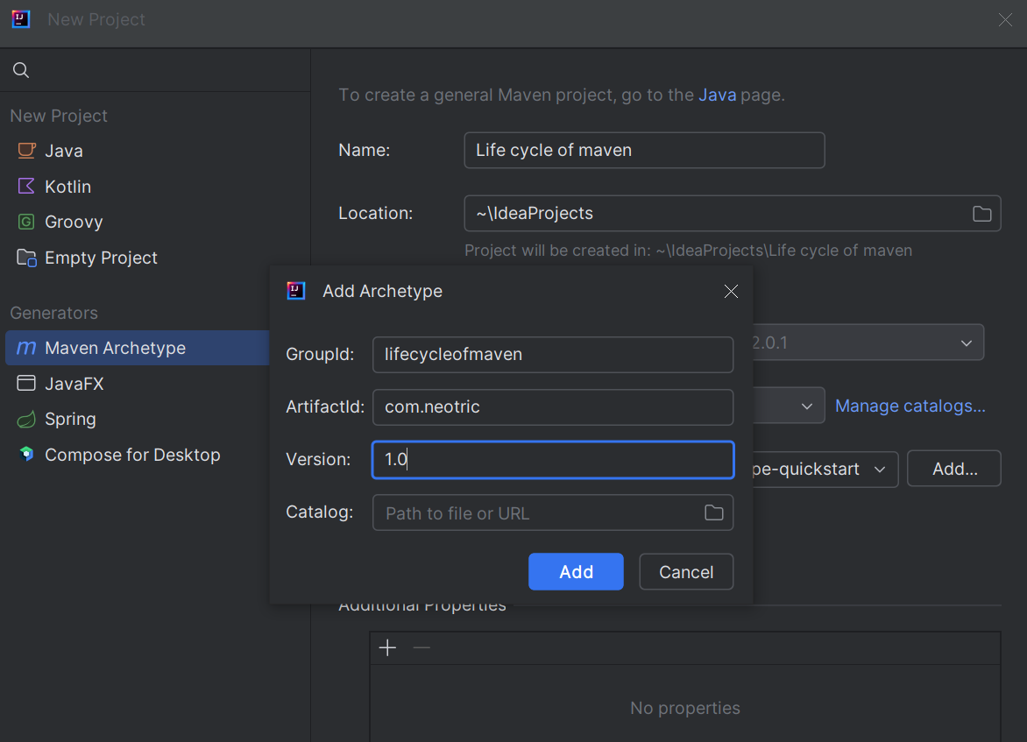

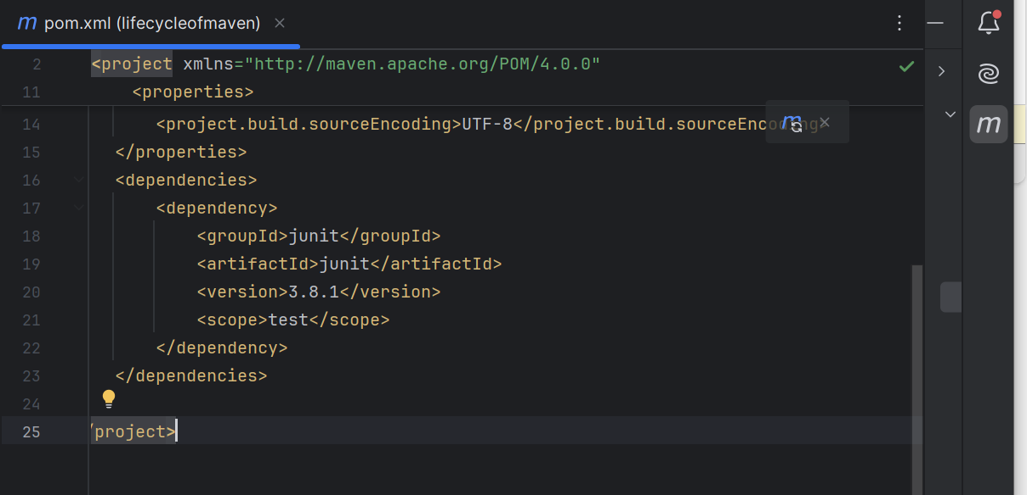

Step 2 -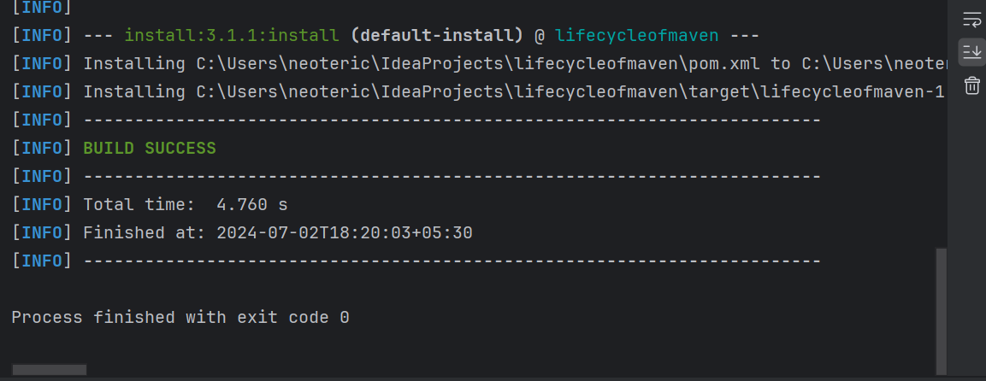

Step 6 -

Step 7-

Step 8-

