**e- Recruiting application**

Sampath

Github URL

**Initial Proposal:**

During the course I am working on an e-Recruiting application. It is a simple application used for finding a right person for a right job. e-Recruitment works on cloud computing. Data related to openings with organizations directly, openings with consultancies, candidates (job seekers) personal data, data related to finance generated through CV purchasing by the recruiters. All these data are stored in database, file server. File server is used to store CV’s.

After storing the data, we can use the data to advertise the job opening, find out an eligible candidate, interview him through vide calls and surveys can also be conducted regarding the application.

As already discussed, the data will majorly come from organizations, consultancies, job seekers. I will be using SharePoint portal as my front end application and SQL server as my DB.

The application is mostly used by HR people and candidate searching for job as this save most of their time. Not only from the time perspective but also the application is efficient and less expensive.

**Relational Database Design Process**

The main Objective of designing Data Base is helpful for logical designing and Application Model.

This Design Process determines the purpose of database for e-recruitment application,

* -database design with size, authentication
* -creating tables (Entities)
* -specifying table relationships like Primary Key, Foreign Key
* -Data Base Diagrams (ER-Diagrams)
* -Normal Forms
* -Functions
* -Triggers
* -Stored Procedures

Database design is the crucial part of designing application. In this week-2 assignment I am presenting few tables and sample data (in CSV format) for e-recruitment Application.

**Establishing Data Base Tables for e-Recruiting Application:**

* JobSeeker Table: Information of candidate who is searching for a job
* Fresher Table : if the candidate is fresher who just from University with out technical skills
* Experienced Table : candidate who worked for different organizations and lots of Skills
* Organization Table: Organizations who is looking for canditates
* Technology Table : different technologies in market

**List of Fields (Columns) in Data Base Tables:**

**JobSeeker**

{ Js_ID int,   
Js_FirstName Varchar (10),  
 Js_LastNAme Varchar(10),  
 Js_Email Varchar(10),   
Js_mobileNumber int,   
Js_DOB Date }

**Fresher**

{ JS_ID int,  
University varchar (20),  
YearPassing Date  
CourseTitle VarChar(20) }

**Experienced**

{ Js_ID int,  
ORG_ID int,  
Years_of_Exp int,  
JobRole varchar,  
Technology_ID int,   
Salary int,  
Location varchar(10) }

**Organization**

{ ORGID int,  
ORGName varchar,  
JObtitle varchar,  
ORG_emai varchar}

**Technology**

{ TechID int,  
TechName Varchar(10) }

**ERD Model PART 3**

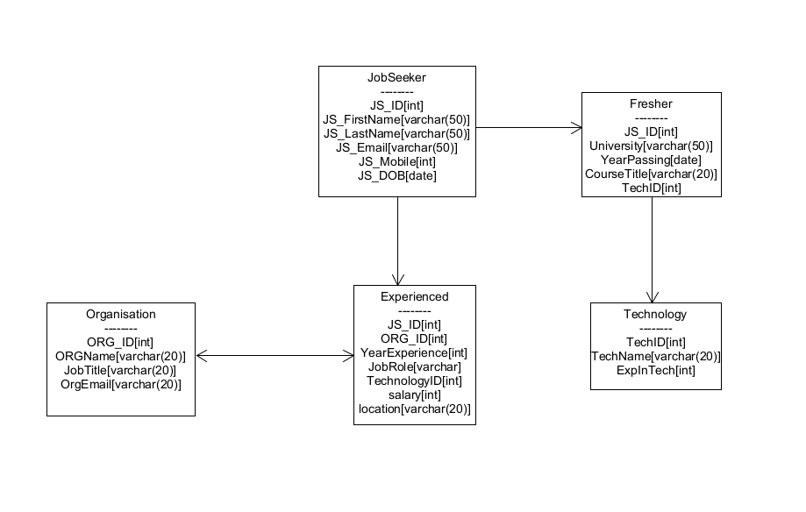

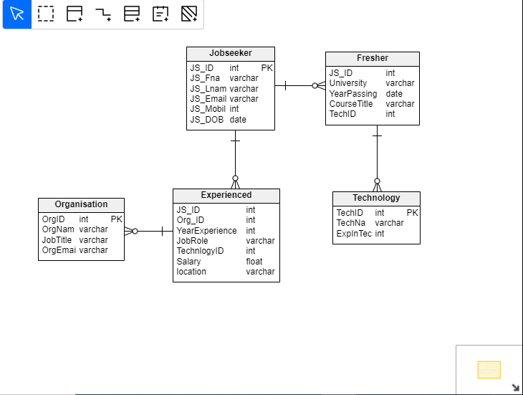

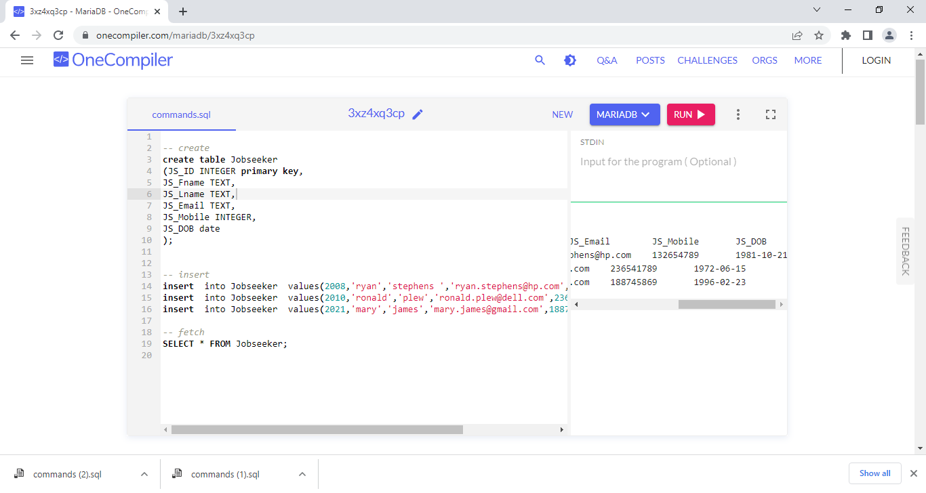

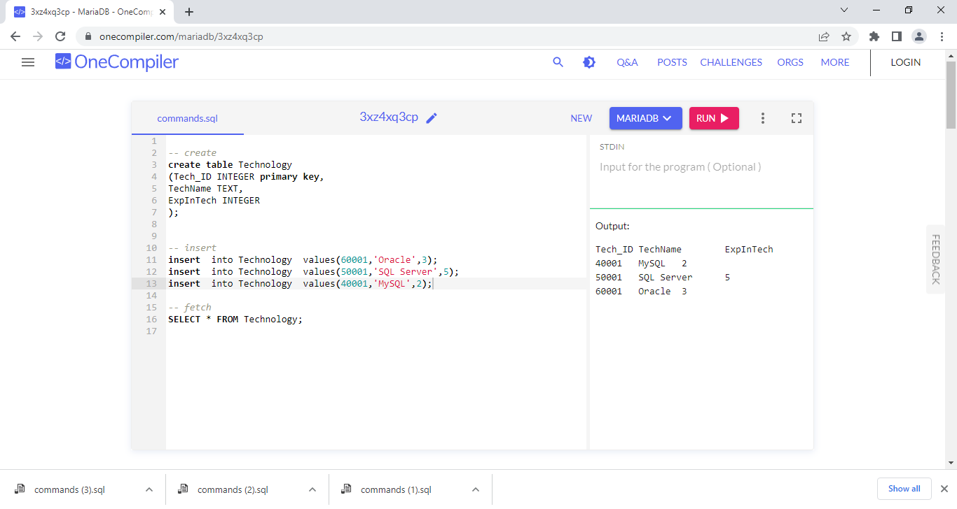

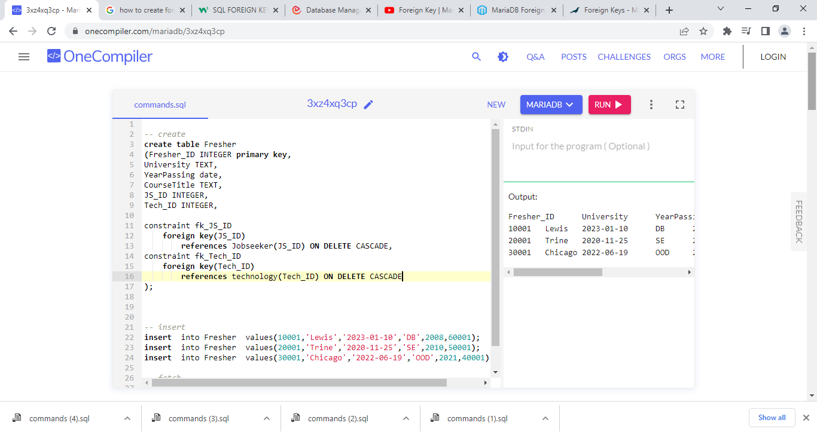

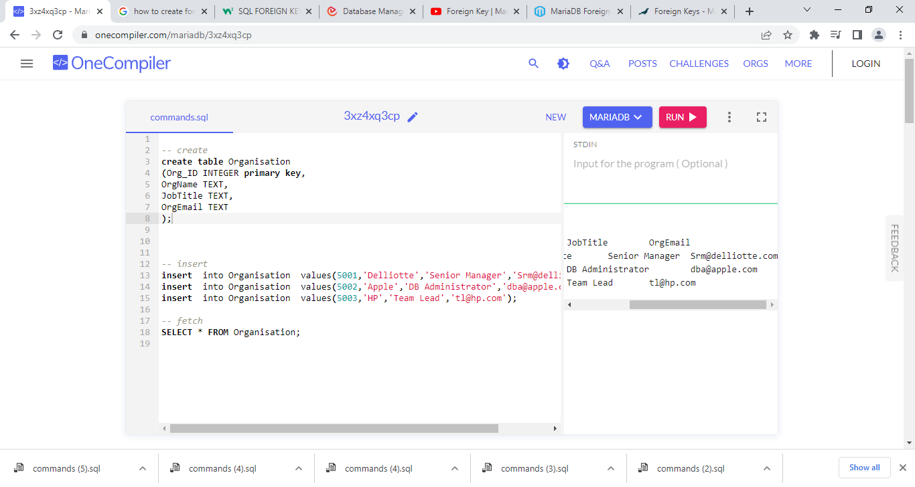

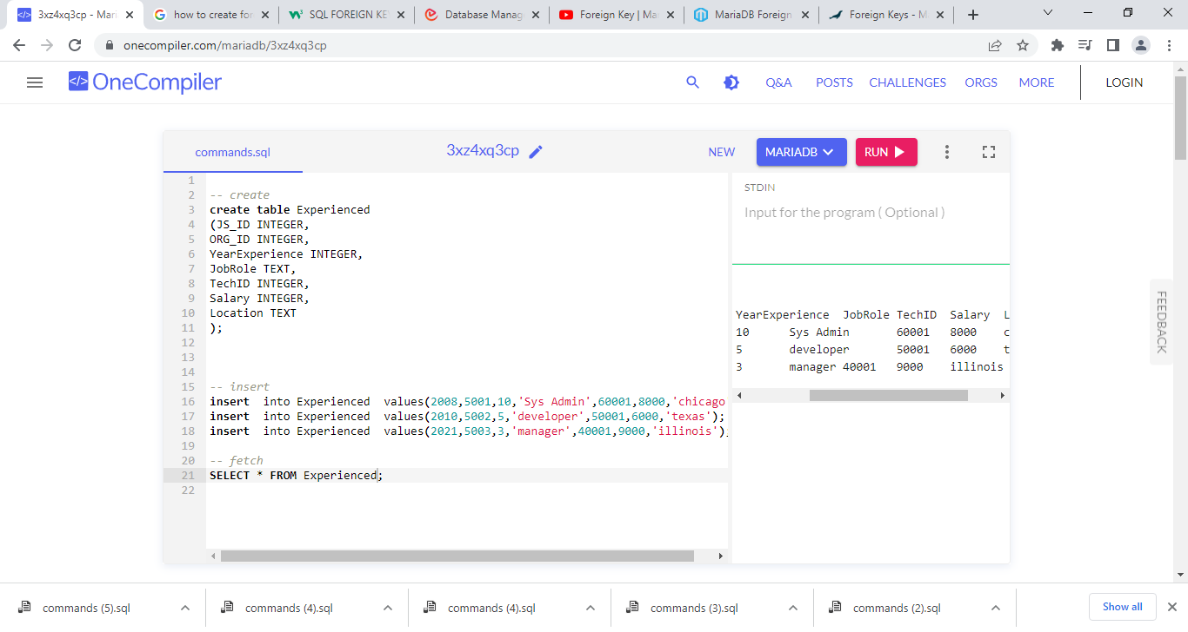

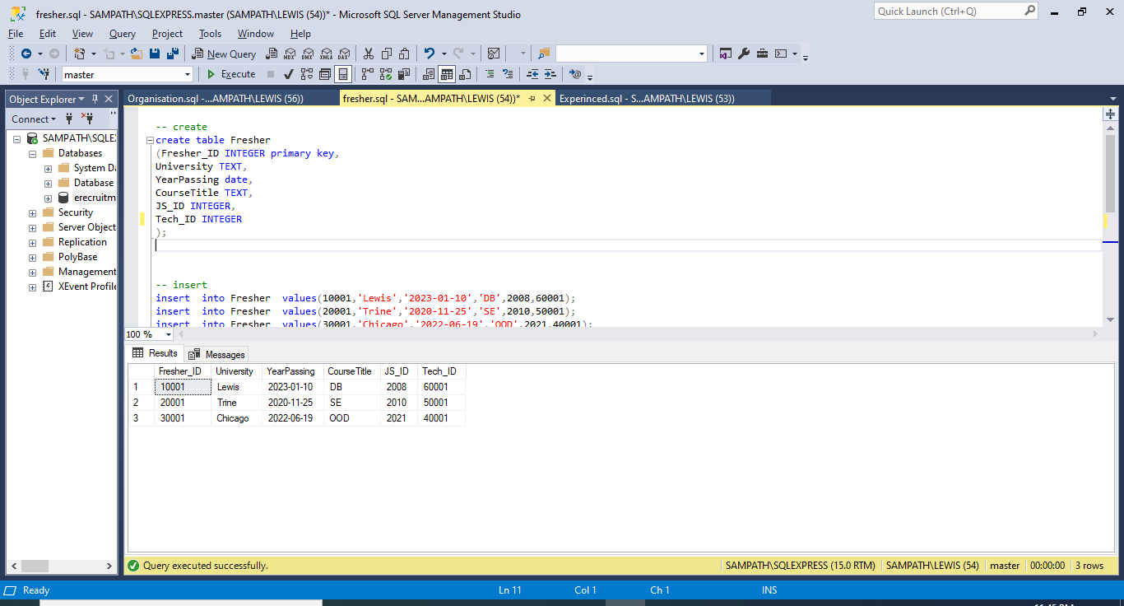

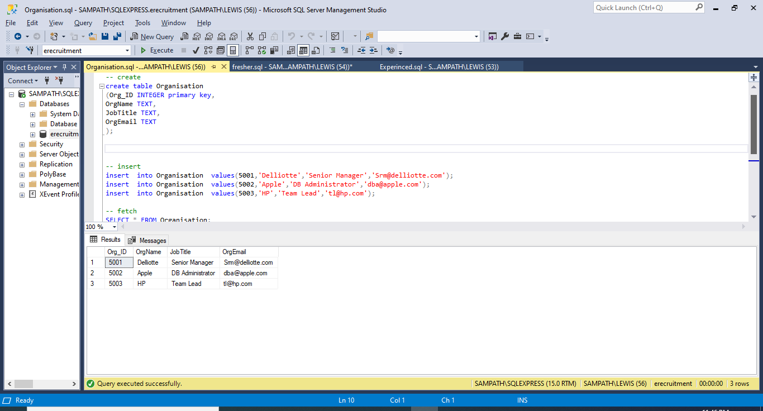

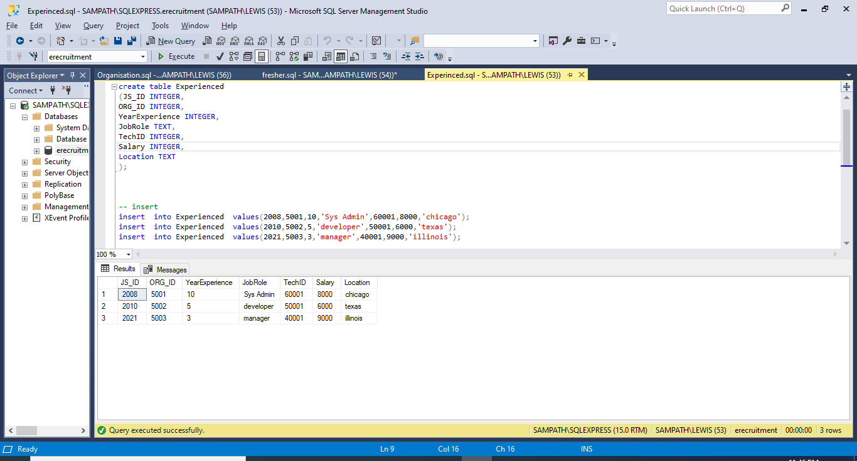

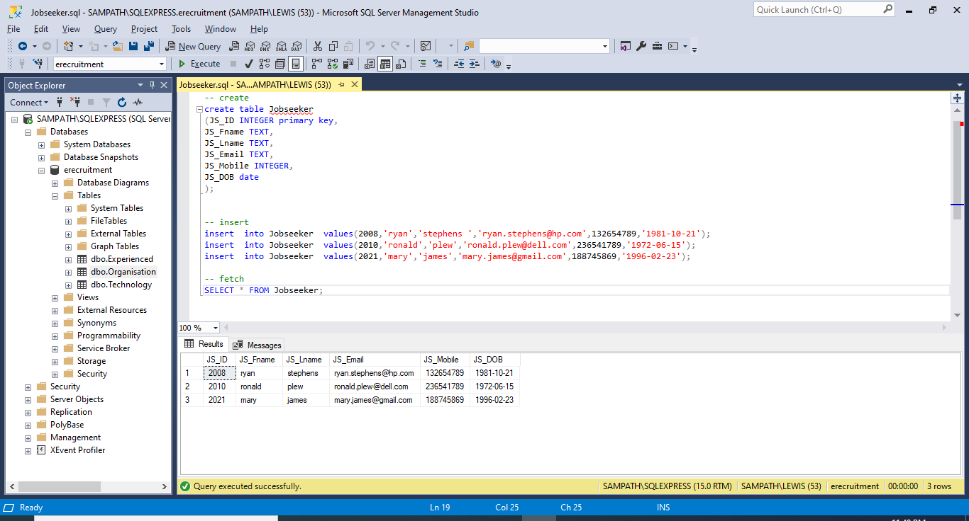

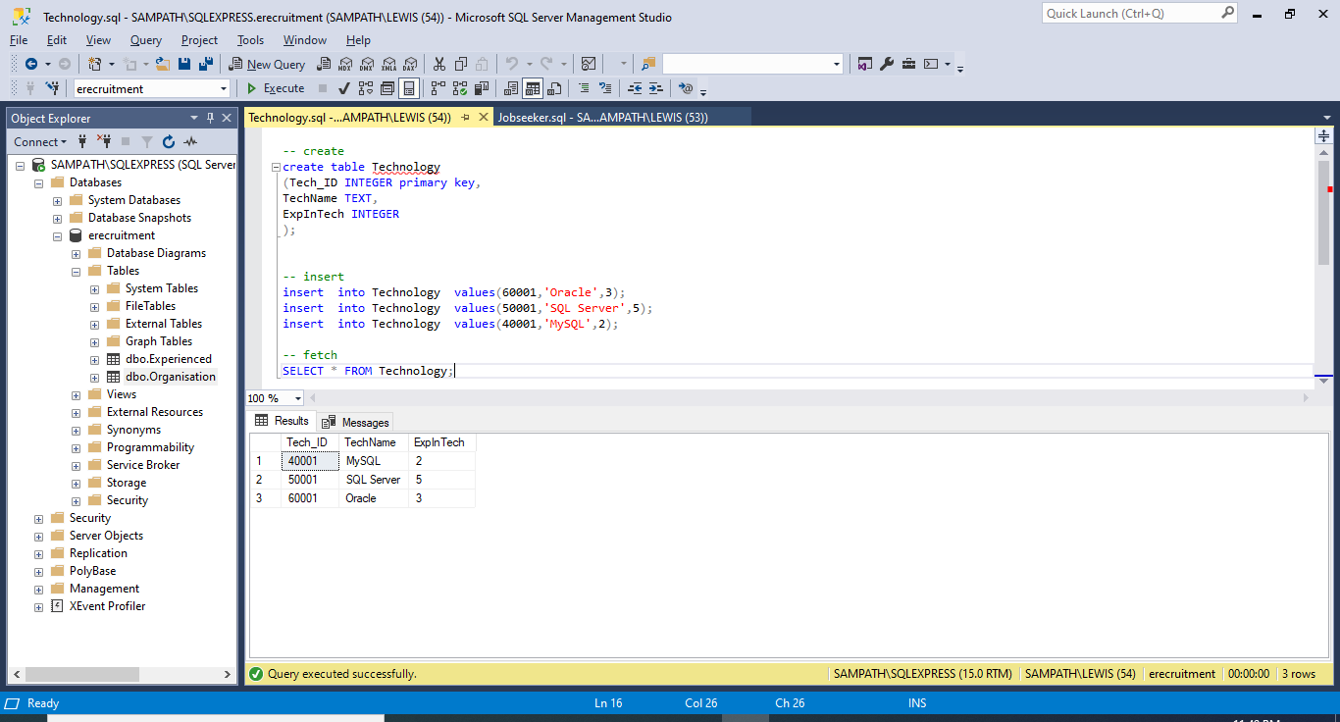

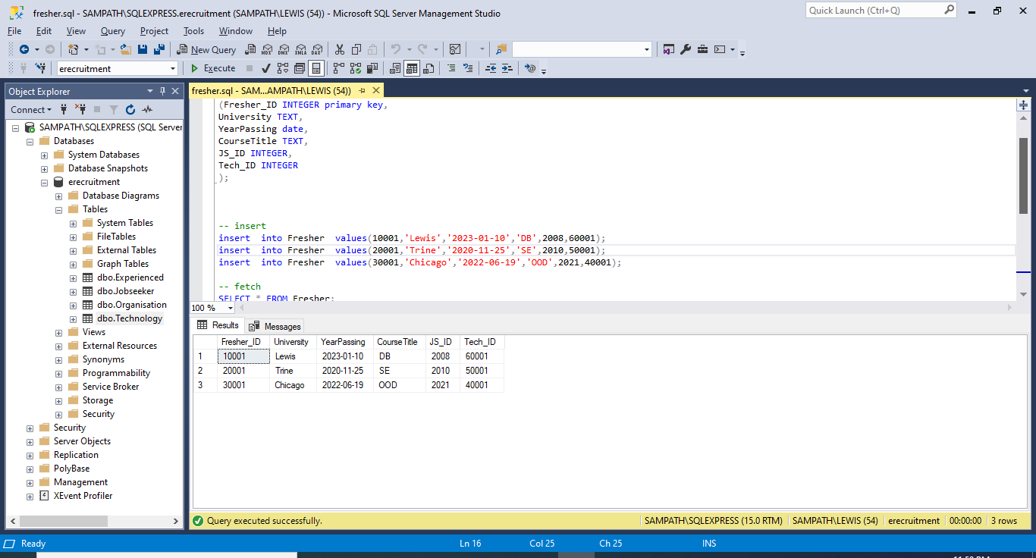

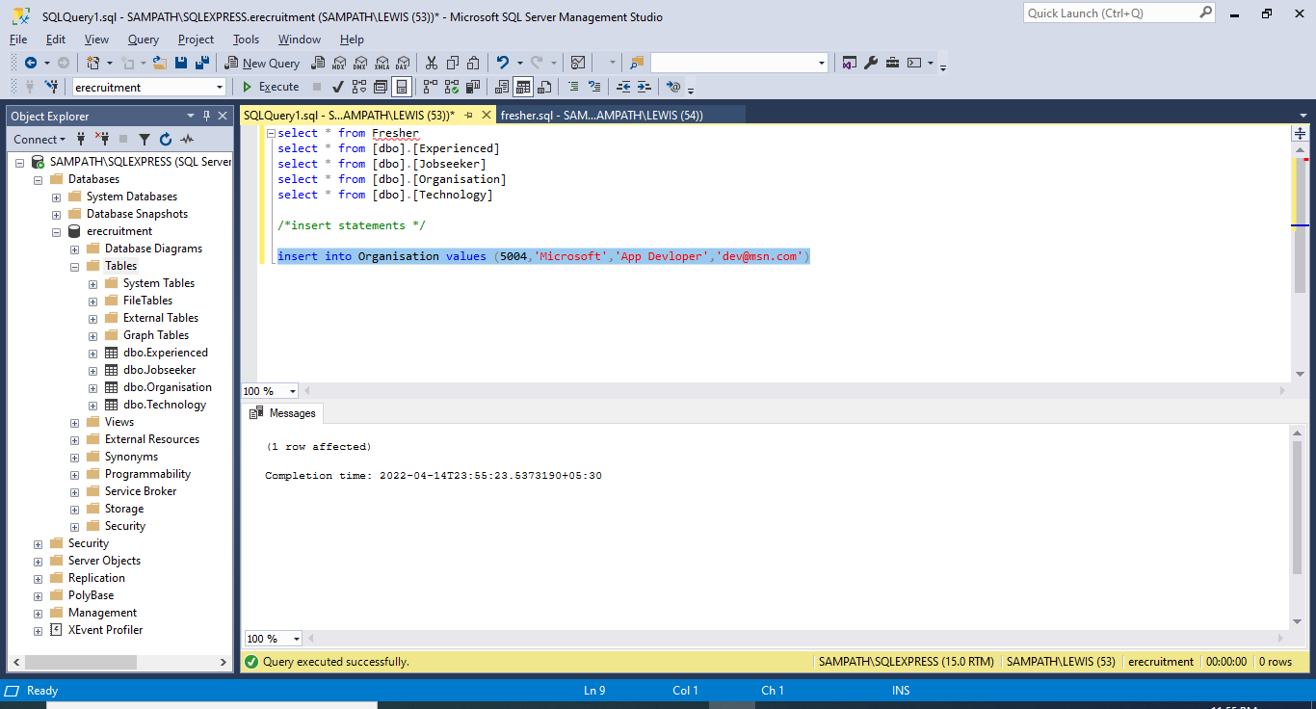

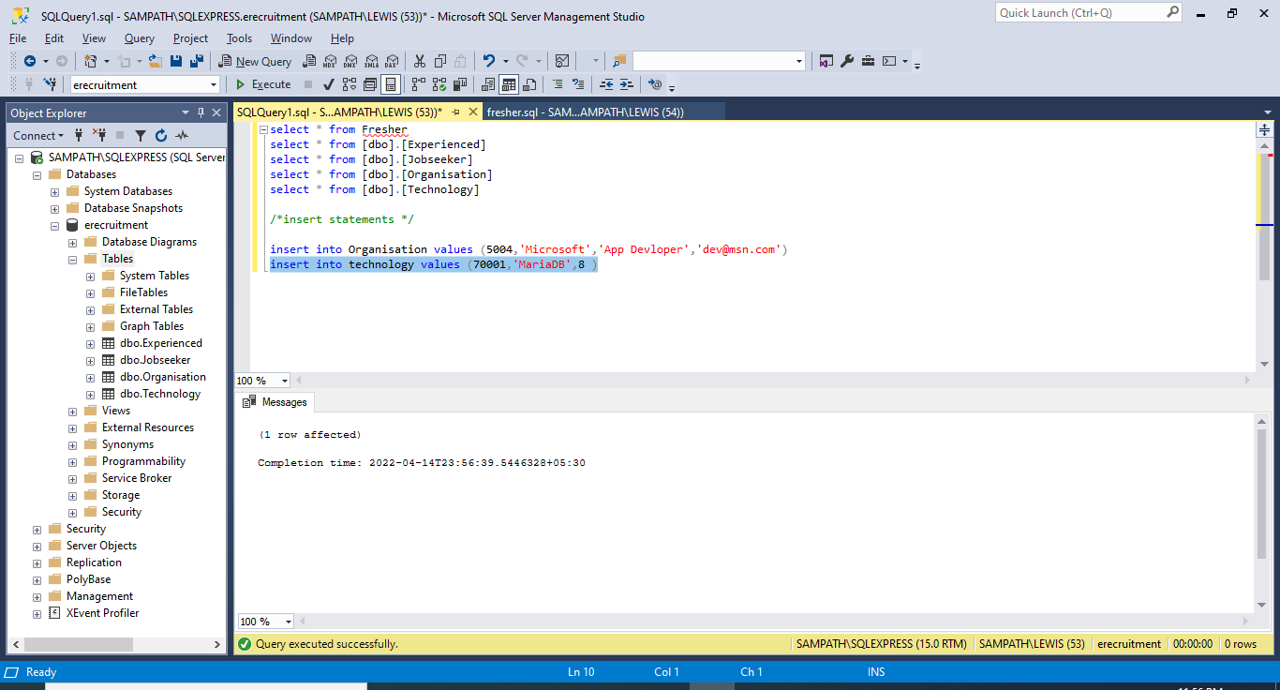

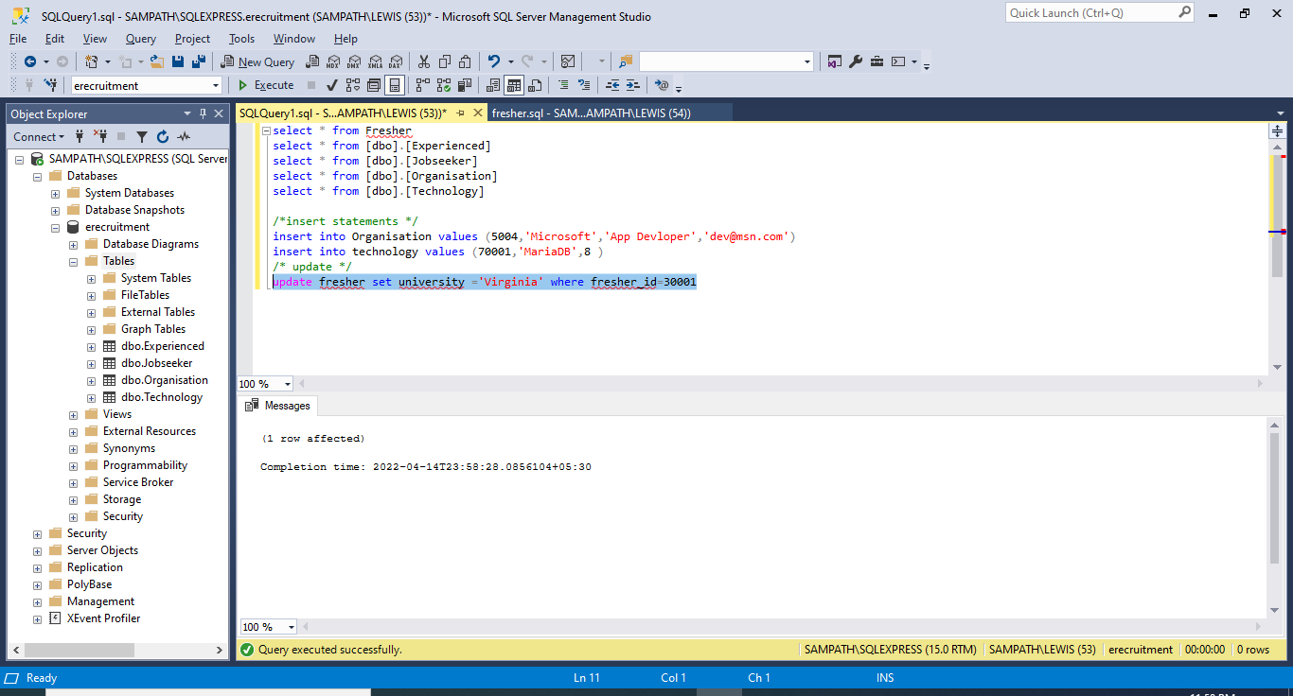

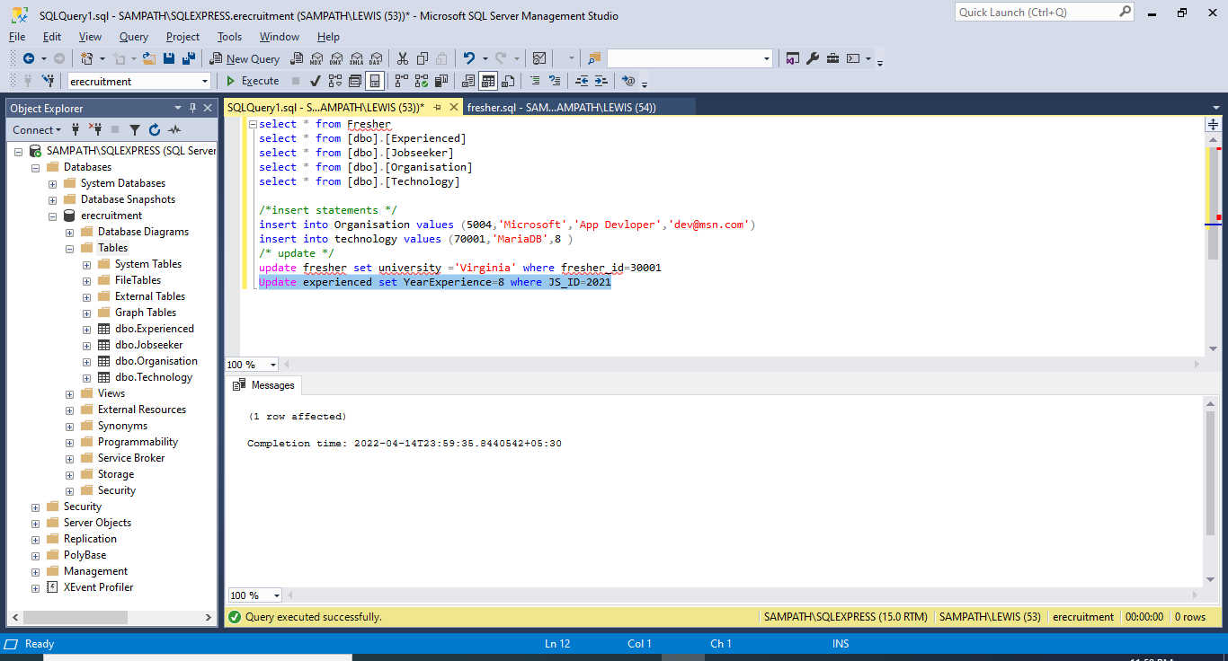

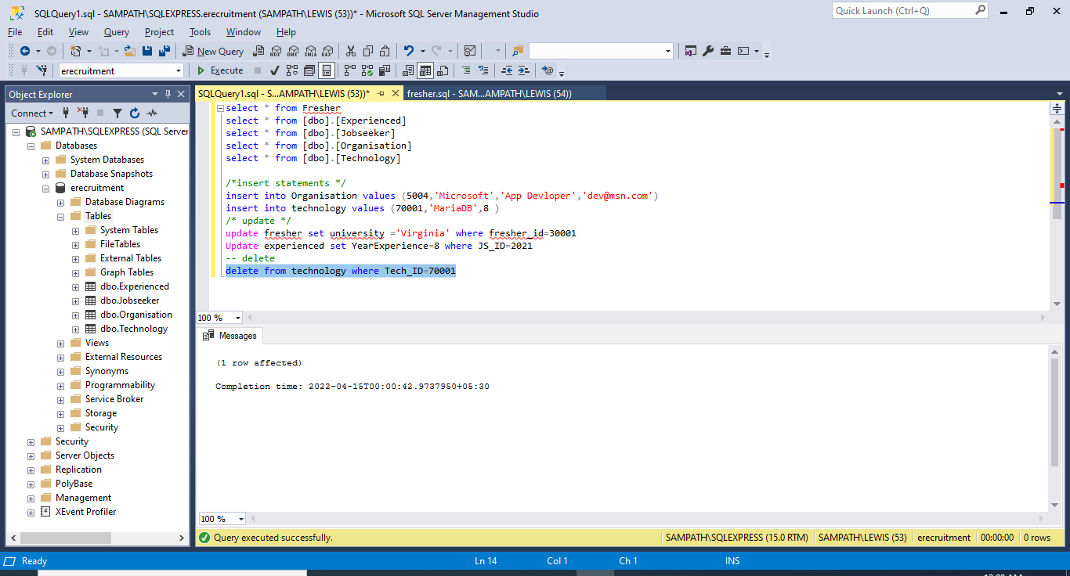

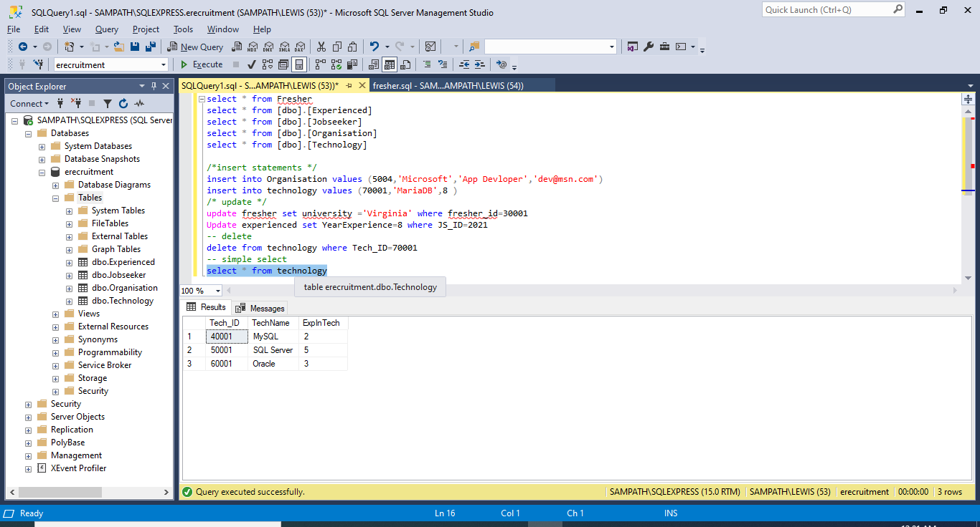

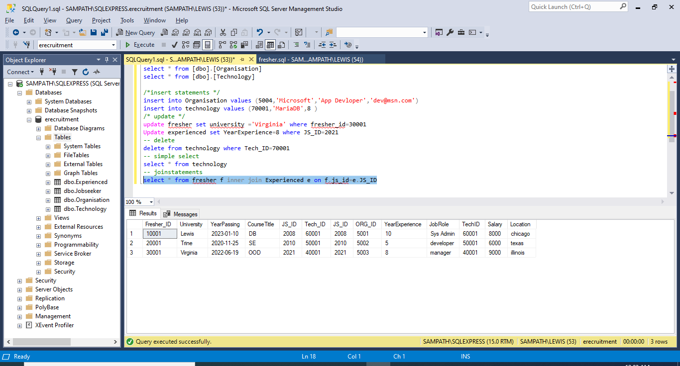

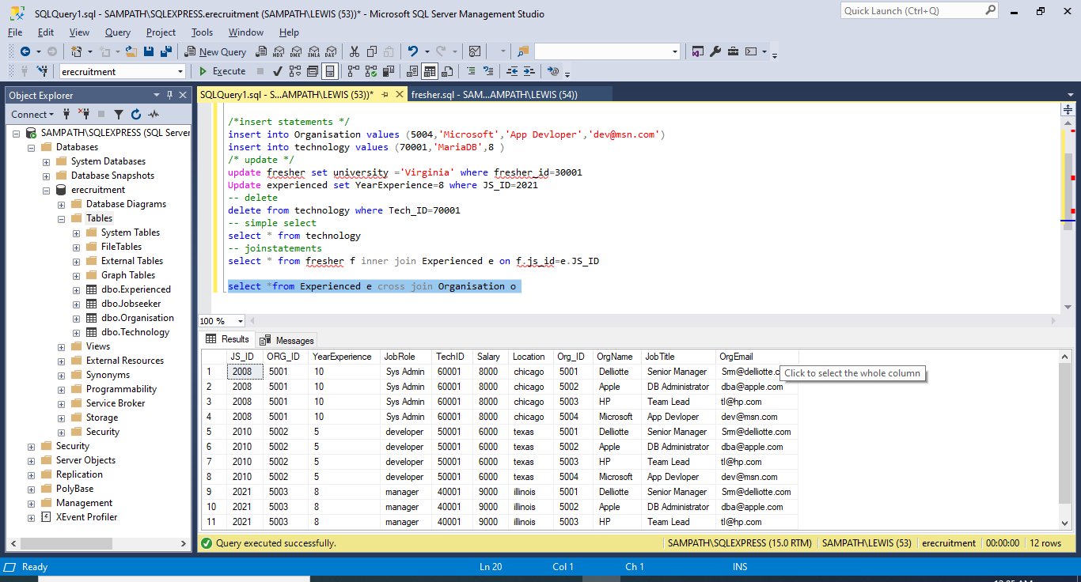

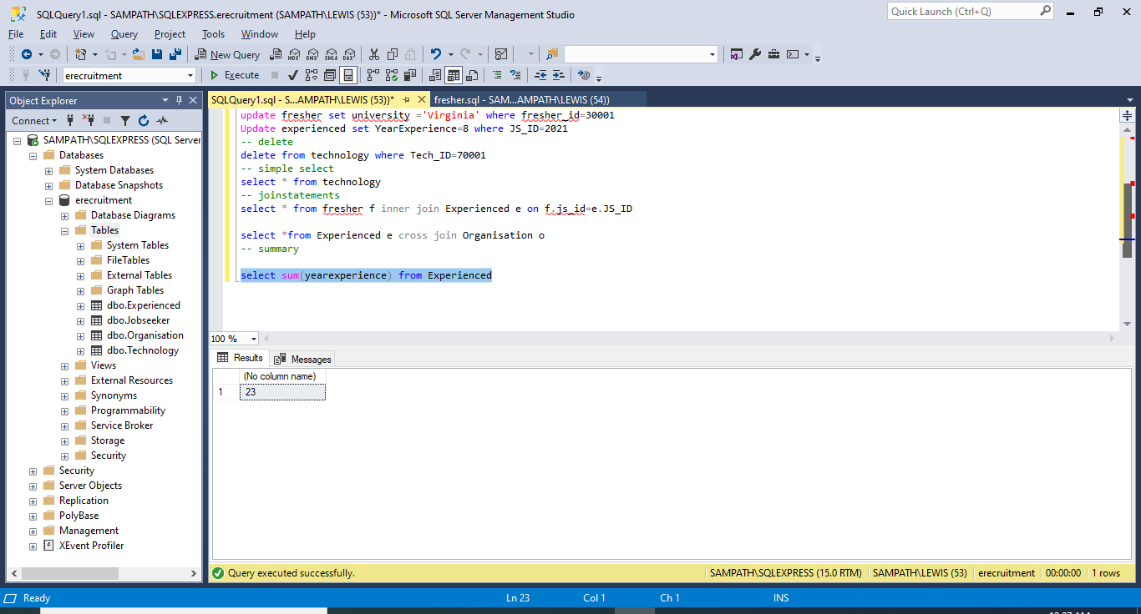

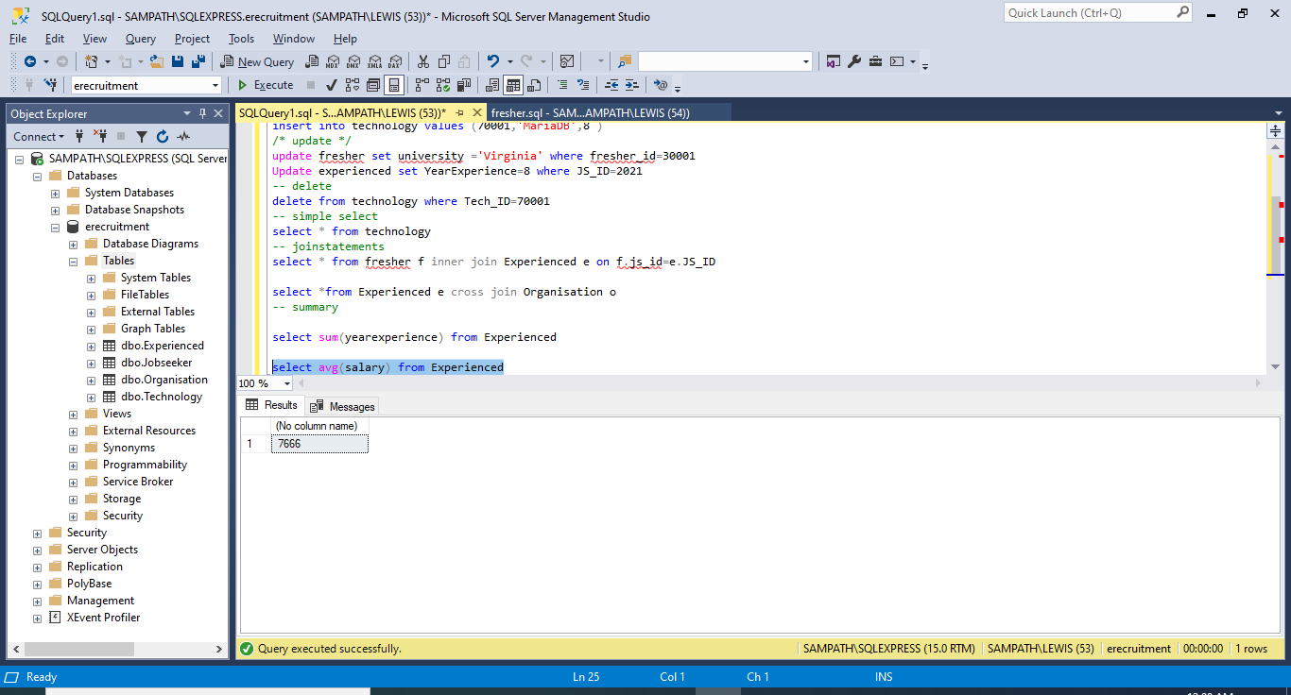

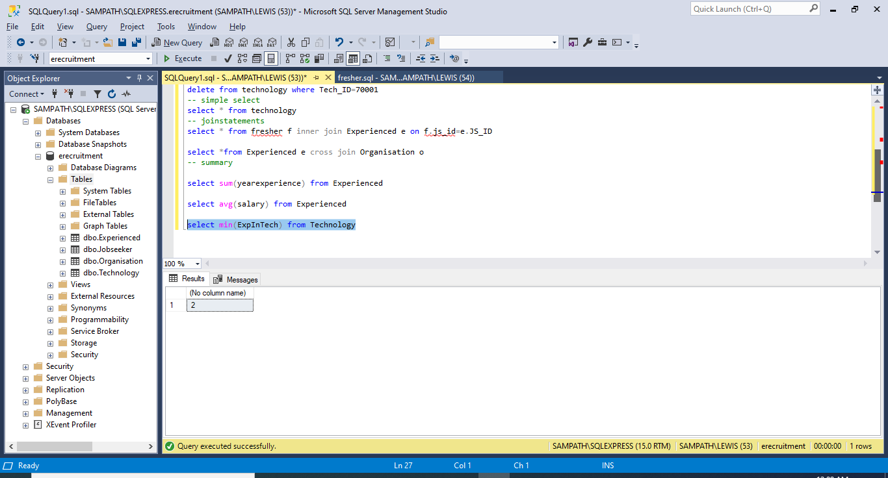

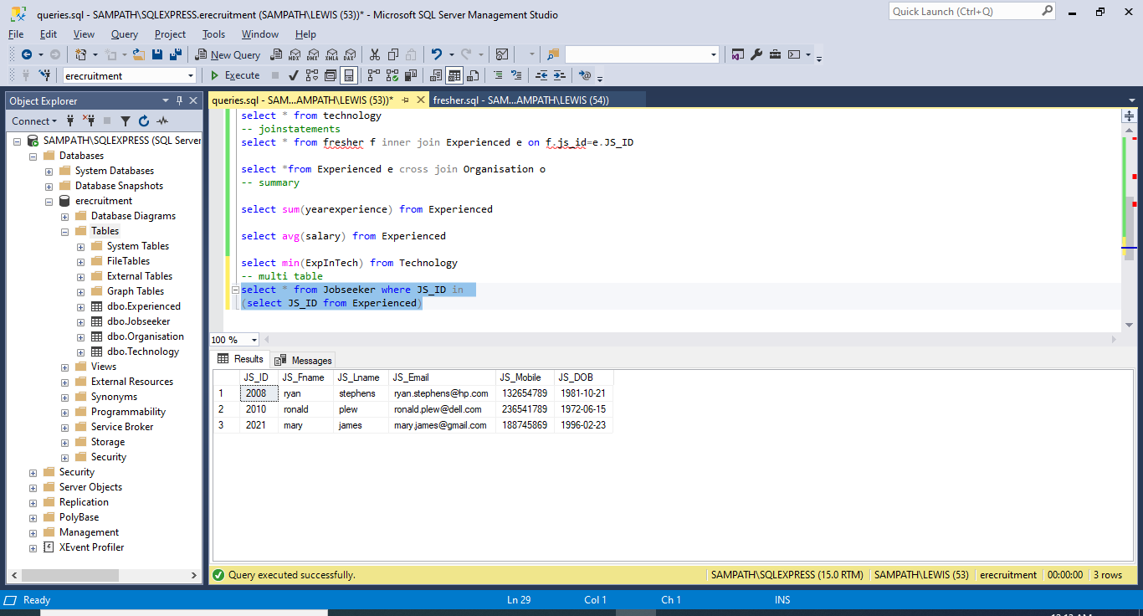

**Project:5**

**Indexes:**

Indexes speeds performance when searching and joining tables. Indexes are created on two table namely – Fresher, Organisation.

Index1:

In fresher table I am choosing ‘CourseTitle’ column because it is used frequently in search conditions. And from the project purpose ‘CourseTitle’ is important to select the fresher for Job purpose.

Index2:

From Organization table, I am picking ‘JobTitle’,’OrgEmail’. I choose these columns because they contain distinct values and from project purpose these two columns are important for a candidate to apply for job in an organization.

A built-in tool for SQL Server Management Studio called “Activity Monitor” tells us about slow running queries. Activity monitor tells us what the current and recent activities are in the SQL Server Instance.

I have logged into Maria Db and changed my data base to ‘eRecruiting’.



create index Fresher_CourseTitle_ix on Fresher(CourseTitle);



create index Organisation_Info_ix on organisation(JobTitle,OrgEmail);



As already discussed, we can check the performance improvement through Activity Monitor in SQL Server Management Studio.

**Views:**

View1:

create View FresherDetails as select University,YearPassing,CourseTitle from fresher;



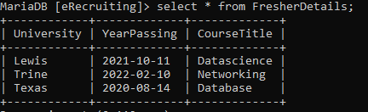

View2:

create view OpeningsAtApple as select * from Organisation where OrgName='Apple';



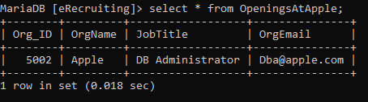

Each view is important and adds value to the database. View 1 improves security as it hides the details like JS_ID and Tech_ID as they are personal and confidential respective to a person.

View2 increases convenience as only data related to one organization can be viewed.

Mainly all these data are very informative and used by eRecruitment employees so that they can easily grab freshers mandatory details like university, courseTitle and YearOfPassing. And also Openings can be viewed organization wise.