RETAIL REVENUE INSIGHTS DASHBOARD
A decision-focused sales analytics project using Python and Streamlit

1. Abstract
This project converts retail transaction data into business-facing information. It summarizes revenue, profit, orders, customers and average order value, then explores trends, category and regional drivers, product profitability, customer concentration and discount risk. It ends with practical actions rather than relying on chart count or code length.

2. Problem Statement
Retail teams can have many transaction rows but still lack a clear view of which products and regions contribute to performance, where profit is weak, and which risks should be investigated. This dashboard provides a simple, filterable view to support those decisions.

3. Objectives
- Summarize core business KPIs.
- Identify monthly revenue and profit trends.
- Compare category and regional performance.
- Highlight low-profit products and discount risk.
- Examine customer revenue concentration.
- Recommend actions that can be validated by a business team.

4. Dataset and Source
The included sample_retail_sales.csv is synthetic demo data created to make the project runnable immediately. It must not be described as real company data. For a sourced submission, use a permitted dataset that is not the one used in the course masterclasses. Suggested source: UCI Online Retail, https://archive.ics.uci.edu/dataset/352/online+retail. That dataset needs preprocessing and a documented cost/profit assumption before profit analysis is valid.

5. Technology Stack
Python, Streamlit, Pandas, NumPy, Matplotlib, python-docx. The Streamlit app combines the user interface and analytics logic in one Python file (app.py).

6. Methodology
Data → Information → Insight → Decision → Action. Data is validated and dates/numeric columns are parsed. Sidebar filters select the analysis period, category and region. Aggregations calculate KPIs and group-level summaries. The dashboard displays trends and flags potential risks. The analyst then validates these signals with operational context.

7. Dashboard Preview
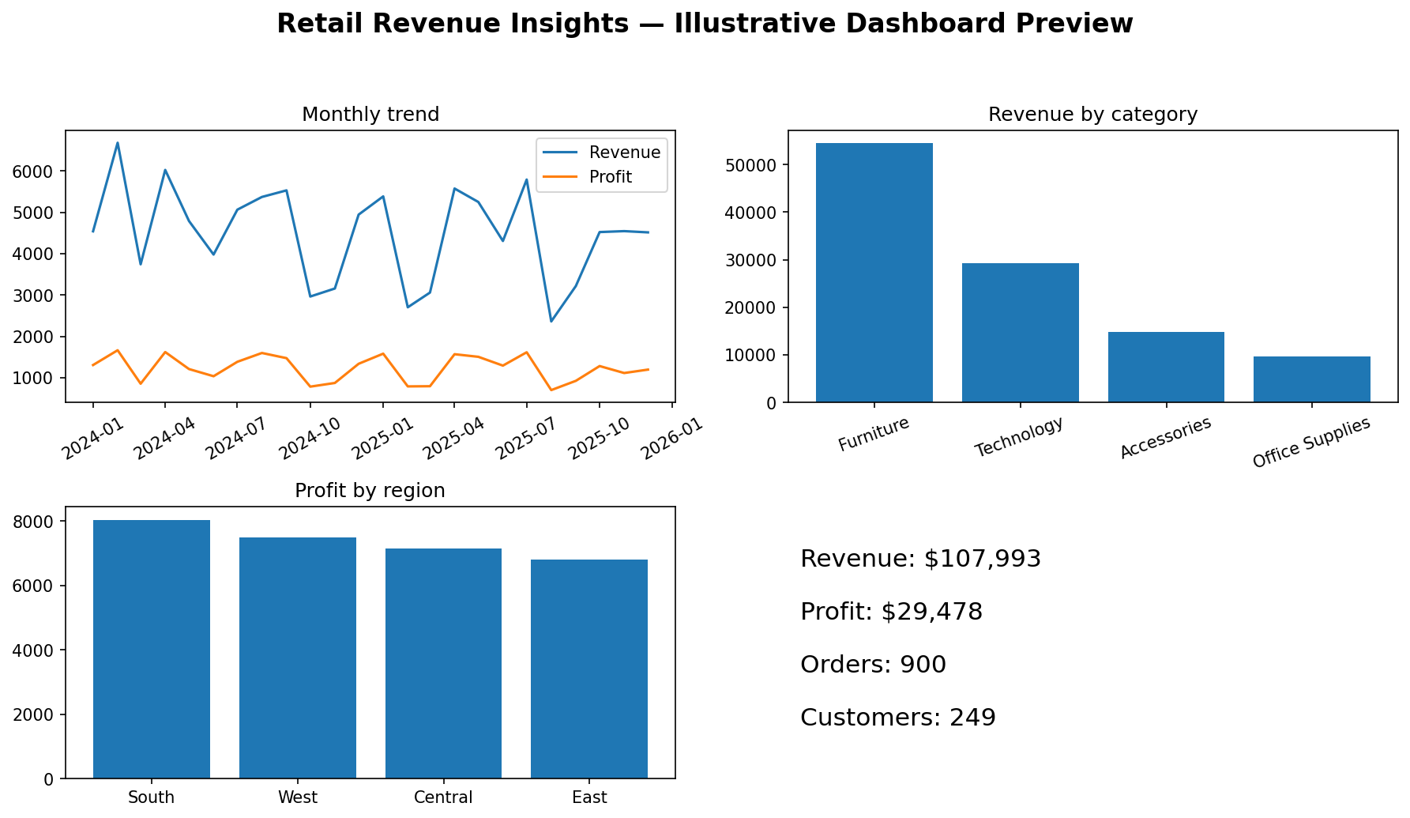
Figure 1. Illustrative preview generated from synthetic sample data. The live interactive dashboard is rendered by Streamlit when app.py is run.

8. KPIs and Business Questions
- Revenue: total sales value in the selected period.
- Profit and profit margin: contribution after the cost values in the dataset.
- Orders and customers: transaction/order count and distinct customer count.
- Average order value: revenue divided by distinct orders.
- Trend: monthly revenue and profit.
- Drivers: category revenue, regional profit and product-level profitability.
- Risk: high-discount orders, loss-making rows and top-customer revenue concentration.

9. Insights-to-Action Framework
Signal to inspect | Possible interpretation | Recommended action
Falling monthly revenue | Demand or order frequency may be weakening | Compare categories/regions and validate stock, campaign and seasonality data
Low-profit products | Cost, discount or price mismatch may exist | Review product costs, discounts, returns and pricing before promotion
High top-customer share | Revenue may depend on a small customer group | Track repeat purchase and build retention beyond top accounts
High discounts with weak profit | Discounting may be eroding contribution | Set discount guardrails and compare incremental sales with profit
Strong category/region | Potential growth opportunity | Test a targeted campaign, then compare incremental profit
These are investigation prompts, not causal claims. The dashboard does not prove why a pattern occurred.

10. How to Run
- Install Python 3.10+.
- Run pip install -r requirements.txt.
- Run streamlit run app.py from the project directory.
- Open the local URL shown in the terminal.
- Use the sidebar to filter or upload a compatible CSV.

11. Limitations
The demo dataset is synthetic. Profit depends on the supplied Profit/Cost values. The period-over-period growth metric is only available when a preceding comparison period exists. Results are descriptive, and any real business action should be tested against more context.

12. Conclusion
Retail Revenue Insights demonstrates a complete analytics workflow: clean and filter data, summarize KPIs, identify performance drivers and risks, and translate them into specific follow-up actions. The dashboard is extensible and supports a sourced dataset through CSV upload.

13. Submission Checklist
- app.py — combined dashboard UI and backend logic
- requirements.txt — dependencies
- README.md — project overview, run instructions and dataset source
- sample_retail_sales.csv — synthetic demo dataset for immediate execution
- project_report.docx — project report and illustrative screenshot
- GitHub public repository URL — create after uploading the files

