CHAPTER 1

INTRODUCTION

1.1 INTRODUCTION TO RAG
Large Language Models have changed the way users interact with software systems. Instead of sending requests through menu-driven or predetermined commands, users formulate their information needs through natural language. Modern LLMs have the ability to summarize, explain, manipulate, reason about, and generate text. But being useful does not mean that the learned parameters of such models comprise a complete and up-to-date knowledge base.
The Retrieval-Augmented Generation framework has been put forward as a way of addressing this problem. In lieu of generating answers based on the language model’s learned parameters, a RAG system retrieves external documents and uses them as additional context. Then, the generative part of the system is able to use both the query and the retrieved document as context. This framework works well when the source of information is extensive, dynamic, specialized, or granular.
A conventional RAG system can be described as a fixed pipeline. The query is embedded, a vector index returns a predetermined number of documents, the documents are concatenated into a context, and the same language model generates an answer. This design is attractive because it is simple and reproducible. Nevertheless, it assumes that all user queries benefit from the same retrieval behavior.
CARO is motivated by the observation that information needs are heterogeneous. A user may ask for a definition, a procedure, a comparison, a multi-hop relationship, or a follow-up question whose meaning depends on previous dialogue. A semantic vector search may be ideal for one query, whereas exact lexical matching may be more suitable for another. A conversational question may require memory before retrieval can even be interpreted correctly.
Therefore, the central design question is not simply how to retrieve documents, but when to retrieve, what retrieval method to use, whether previous context is necessary, whether the evidence is sufficient, and whether another retrieval step is justified. CARO treats these decisions as explicit orchestration stages.
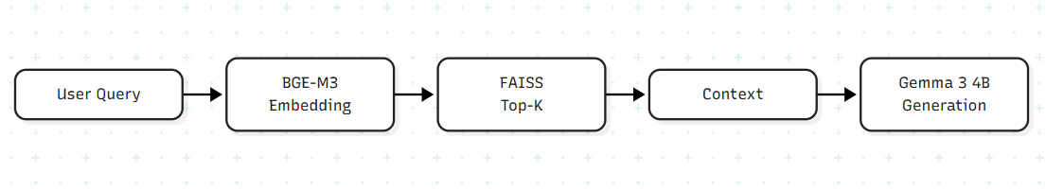
Figure 1. Conventional Fixed RAG Pipeline.

1.2 MOTIVATION
Developing CARO is primarily driven by balancing computational efficiency against retrieval quality within Retrieval-Augmented Generation (RAG). In particular, retrieval is costly from the computational point of view, as the number of retrieved documents increases the amount of processed text, and the presence of unnecessary context makes it difficult for the generator to distinguish relevant evidence. Retrieving too few documents can result in missing a piece of supporting information.
The second reason for a fixed Top-K approach is a balance. On the one hand, increasing K can improve the recall, but at the same time, it can also increase the latency and amount of context. On the other hand, choosing a smaller value of K can make the operation fast, but will result in poorer robustness on difficult queries. CARO solves the problem by making the decision to retrieve based on the query.
There is also an issue of explainability. The system should explain its choice of the strategy for retrieval. At present, the CARO router is deterministic and rule-based, which means that it is possible for a developer to understand the reasons for considering a query to be definitional, procedural, conversational or multi-hop. It is especially useful when developing a dissertation in the area of MCA.
Furthermore, the main driving force behind the creation of CARO is its modularity. It is not in any way meant to say that CARO is intended to replace other modules like BGE-M3, FAISS, BM25, or even the generator, but the point here is modularity itself.

1.3 RESEARCH PROBLEM
Purpose of this research is to create and test explainable adaptive orchestration layer for RAG that will be capable to
(1) identify the query needs,
(2) choose the proper retrieval mechanism,
(3) control the temporary context of the conversation,
(4) evaluate the adequacy of evidence provided and
(5) conduct comparative analysis of controllable type with the fixed RAG
baseline.

1.4 RESEARCH QUESTIONS
- How much is an individual restricted by the phenomenon of linguistic determinism in satisfying the information needs of various user groups?
- Can information retrieval be separated from memory-informed decision-making processes?
- How are the characteristics used in determining the type of information retrieval (dense, sparse, hybrid, or memory-based)?
- Is there enough empirical proof of the adequacy of evidence to kick start the information retrieval process?
- Is adaptive orchestration better than a static generator for Top-K RAG?

1.5 OBJECTIVES
- Design a layer for processing of datasets for performing RAG experiments.
- Define the baseline using BGE-M3, FAISS, and Gemma 3 4B.
- Design a deterministic Adaptive Query Router.
- Separate query dependency analysis from retrieval.
- Classify retrieval approaches into dense, sparse, hybrid, and memory-efficient.
- Suggest a filtering approach, an evidence sufficiency measure, and an iterative retrieval mechanism.
- Design an experiment setting for comparing the RAG baseline and CARO.
- Note limitations and avoid making unwarranted performance claims.

1.6 CONTRIBUTIONS
- In tackling these retrieval bottlenecks, CARO structures query processing into distinct stages. Module M3 handles preliminary intent analysis well before Module M4 touches the underlying index. Many prompts do not need reference documents at all; by checking intent early, we avoid hitting the vector index when an answer can be generated directly.
- For queries that do require evidence, CARO selects from four discrete operational states: DIRECT, RETRIEVE, MEMORY, and RETRIEVE_AND_MEMORY. Instead of relying on a black-box model to make this choice, simple threshold heuristics route queries to BM25, dense BGE-M3 embeddings, or hybrid rank fusion.
- Finally, we establish a closed-form evaluation protocol to monitor answerability, evidence coverage, latency, and token consumption under fixed test conditions. This benchmark setup ensures reproducible comparisons with static Top-K pipelines and preserves a clear distinction between verified modules (M1 through M4) and planned extensions.

1.7 SCOPE AND BOUNDARIES
- The project is restricted only to text-based RAG. There is no consideration of multimodal RAG, autonomous web crawling, pre-training, and artificial intelligence as a whole.
- Currently, the development corpus comes from HotPotQA. Although QReCC is still supported by the project for future conversations but the current problem of loading the source dataset makes it incomplete as an experiment result.
- The current size of the development FAISS index is 5,000 documents. There are more processed documents in the complete HotPotQA corpus, hence the full indexing would happen at a later stage.
- The current project state includes modules 1-4 while 5-8 modules are already included in the final design but need further development and testing.

1.8 THESIS ORGANIZATION
The problem statement and objectives are defined in Chapter 1. Chapter 2 discusses the theories behind Information Retrieval and Retrieval-Augmented Generation (RAG). Chapter 3 is an overview of the related literature and defines the research gap. The methodological aspects and experimental design are discussed in Chapter 4. Chapter 5 explains the architecture of CARO and its components. Chapter 6 covers the mathematical model and algorithms used. Chapter 7 talks about the implementation and testing of the model. Chapter 8 reviews current verification techniques and describes the final methodology of verification. Chapter 9 covers limitations of the project and its security and ethics aspects.
CHAPTER 2
BACKGROUND AND THEORETICAL FOUNDATIONS

2.1 LARGE LANGUAGE MODELS
An autoregressive language model generates a sequence token by token. If x denotes the input prompt and y denotes the generated sequence, the probability of the sequence can be factorized as the product of conditional next-token probabilities.
A language model therefore generates text by estimating what token is likely to occur next given the preceding context. The model's internal parameters encode patterns learned during training, but the model does not automatically expose a source for each factual statement it produces. This distinction is important for knowledge-intensive applications.
The role of RAG is to provide additional context at inference time. Instead of relying only on parameters, the generator receives retrieved documents. This makes the final answer dependent on both learned language capability and retrieved evidence.
$$P\left(y | x\right)= \prod_{t=1}^{T}{P(y_{t} | x, y1_{}, …, y{t-1}_{})}$$ (1)

2.2 INFORMATION RETRIEVAL
The term information retrieval refers to the act of retrieving information from a corpus of documents which fulfills a particular information need. Information retrieval systems take in a query, calculate relevance scores for the candidate documents, sort them and provide back an ordered set of documents to the end-user or application.
While conventional information retrieval systems predominantly depend on lexical matching and statistical significance of the terms, at the same time neural approaches map queries and documents onto a continuous space of vectors in order to perform retrieval through calculating semantic similarity between the objects. Modern Retrieval Augmented Generation (RAG) models often utilize both of these approaches to combine their benefits.
The metrics used to evaluate the performance of an information retrieval system include recall and precision. Recall shows how many relevant documents have been retrieved by the system, and precision measures the fraction of relevant items out of all retrieved documents. In RAG models, the system should exhibit high recall during the candidate retrieval stage and improve the precision before generating answers.
$$Precision@K = \frac{RelevantRetrieved@K}{K}$$ (2)
$$Recall@K = \frac{RelevantRetrieved@K}{TotalRelevant}$$ (3)

2.3 DENSE RETRIEVAL
Dense retrieval refers to a process where both the query and documents are converted to vectors, and the semantic similarity between the vectors acts as the retrieval score. As of now, CARO uses the BGE-M3 dense embedding model. The technical report about this model explains its multilingual, multifunctional, and multi-granular nature, making it an appropriate embedding component for general retrieval experiments.
Suppose e_q is the query embedding and e_d is the embedding of document d. In this case, cosine similarity computes the angle between the vectors. If the vectors have been normalized, then the inner product of the vectors can be used because of efficiency in similarity search.
One primary strength of dense retrieval is semantic matching, meaning that the texts can have some relationship regardless of a significant amount of word overlap. A downside of dense similarity is that, sometimes, the dense similarity can undervalue exact identifiers, rare names, numerical information, or special jargon. For this reason, CARO does not assume that dense retrieval is best for all queries.
$$\cos\left(e_{q}, e_{d}\right)= \frac{e_{q} · e_{d}}{||e_{q}|| ||e_{d}||}$$ (4)

2.4 SPARSE RETRIEVAL AND BM25
BM25 relevance model forms one of the classical probabilistic models which combine term frequency, inverse document frequency, and document length normalization. The major strength of this model is when the query contains exact lexemes like names, identifiers, or technical terms because the phrases rare in the query provide valuable information.
Parameters k1 and b control the impact of term frequency and document length normalization, respectively. The formula is written because SPARSE model used in CARO uses BM25 for information retrieval.
$$BM25\left(d, q\right)= \sum_{t ∈ q}{IDF(t) · \left[\frac{f(t, d)(k1_{} + 1)}{f(t, d) + k1_{}(1 - b + b \frac{|d|}{avgdl})}\right]}$$ (5)
$$IDF\left(t\right)= ln\left[1 + \frac{N - nt_{} + 0.5}{n_{t} + 0.5}\right]$$
(6)
Dense retrieval models and BM25 can be compatible because both can work together as the former gives semantic generalization whereas BM25 retains exact lexemes.

2.5 RETRIEVAL-AUGMENTED GENERATION
RAG was introduced as a way of combining parametric generation with non-parametric external memory. In a typical RAG system, a retriever selects passages and a generator conditions its response on the query and retrieved evidence. This architecture is particularly valuable for knowledge-intensive tasks because the retrieval component can expose information not explicitly encoded in the generator's parameters.
The CARO baseline follows this conceptual structure but deliberately fixes the retrieval behavior so that it can serve as a control system. The baseline uses BGE-M3, FAISS, fixed Top-5 dense retrieval, and Gemma 3 4B. CARO then adds an adaptive orchestration layer around comparable components.
A crucial experimental principle is that CARO should not be compared with a baseline that uses a weaker generator. If the generator differs, improvements could be caused by model capability rather than orchestration. Therefore, the proposed evaluation uses the same generator wherever possible.

2.6 VECTOR SIMILARITY AND FAISS
FAISS is an efficient library that supports similarity search over vector embeddings. At present, the development process is such that embeddings are created only once and then reused for future searches. Persistence is necessary for the index because otherwise the computation of document embeddings at every search stage will interfere with latency measurement.
The search task can be viewed as the task of nearest-neighbor search: given a query vector e_q and a set of document vectors E = {e_1, ..., e_N}, one needs to find the K most similar documents.
In order to test the functionality of the algorithm, we limit the number of indexed documents to 5,000. The constraint is chosen to save time while keeping the integrity of the embedding + vector search architecture intact.
$$TopK\left(q\right)=\arg{top}-K{d ∈ D}_{} sim\left(e_{q}, e_{d}\right)$$ (7)

2.7 MULTI-HOP QUESTION ANSWERING
Multi-hop questions rely on evidence from more than one source or reasoning steps. HotPotQA is a dataset specifically built for handling multi-hop questions and additional information. Therefore, using HotPotQA as a test set for the adaptive RAG model to determine its ability to find evidences beyond nearest neighbors is reasonable.
The multi-hop questions are significant in the CARO framework, since the retrieval process may change from dense retrieval to hybrid retrieval. Furthermore, the adequacy of the evidence may affect whether the initial step of retrieval consists of all elements of the query.
It should be pointed out that this project does not imply that M3/M4 methods for solving multi-hop problems can be used for multi-hop reasoning. However, the order of actions is the following: the multi-hop nature of the question is determined and hybrid retrieval is chosen as the goal. Improved multi-hop reasoning will be shown in M5-M8 experiments.

2.8 CONVERSATIONAL RETRIEVAL
The difference between conversational retrieval and isolated queries lies in the use of deixis, which is expressed through words like “it,” “that person,” “the second one,” and “and what about its advantages?” In addition, conversational retrieval involves using contextual information that has been created in the course of earlier communications.
Here, QReCC becomes a notable tool because of its ability to initiate a dialogue process that will help retrieve information. The second point relates to the memory component of CARO, where M3 is used for generating context.
This can be achieved through removal of the personal memories from the memory component.

2.9 EVIDENCE GROUNDING
However, grounding goes beyond the simple retrieval of documents. The evidence must substantially ground the generated claim. A particular document can get ranked highest for being generally relevant to the query, but fail to contain the exact fact needed in the answer.
This is why the need arises for relevance filtering, re-ranking, evidence coverage checking, and sufficiency checking. CARO views these elements as distinct modules, as opposed to making the assumption that retrieval by itself guarantees grounding.
One major consequence of this is that the evaluation must consider both retrieval and generation. It is possible for a system to show good retrieval recall but still give poor answers, or it could provide a correct answer using excessive evidence. For this reason, the thesis calls for the use of multiple metrics.

CHAPTER 3

LITERATURE REVIEW

3.1 EVOLUTION OF RAG

Before neural models took over, question-answering systems largely ran on manually curated knowledge bases and symbolic logic. When document archives grew too vast for manual rules, the field adopted statistical ranking algorithms. Robertson and Zaragoza [6] detailed this probabilistic relevance approach, showing how term frequencies and document lengths in BM25 could reliably pull matching passages from large text collections. That foundation paved the way for modern neural retrievers based on dense vectors.

Karpukhin et al. [4] introduced a dense passage retrieval approach in which questions and passages were represented using neural encoders to facilitate semantic matching. The scalability of vector similarity search was subsequently demonstrated by Johnson et al. [10] through the development of FAISS, which supports efficient similarity search across large embedding collections. Chen et al. [2] introduced BGE-M3, through which multilingual, multi-functional, and multi-granularity text embedding capabilities were investigated. Similarly, Xiao et al. [8] presented C-Pack as a collection of resources intended to advance Chinese text embedding and retrieval.

Lewis et al. [5] introduced the Retrieval-Augmented Generation (RAG) framework, in which the parametric memory of a pretrained sequence-to-sequence model was combined with non-parametric memory accessed through a neural retriever. Through this architecture, retrieved passages were incorporated into the generation process, allowing external evidence to supplement the information encoded in the language model. The approach established a foundation for knowledge-intensive question answering in which responses could be conditioned on retrieved information.

Bhat et al. [13] investigated the integration of Hypothetical Document Embeddings (HyDE) with a Gemma-based RAG framework. In their approach, hypothetical document representations were generated to improve semantic matching between user queries and indexed documents. The integration of query transformation and retrieval was used to improve the contextual relevance of the generated responses.

More recently, Yuan et al. [14] proposed AdaKG-RAG, in which adaptive knowledge-graph-guided retrieval and hypothesis-and-verification procedures were incorporated to address multi-hop question-answering requirements. Evidence collection was refined through additional retrieval when the available information was considered insufficient for answering the query.

Sharma and Kumaran [15] examined adaptive retrieval-judgment signals across question-answering benchmarks. Retrieval decisions were investigated using signals such as relevance, query complexity, and confidence. Their reported findings indicated that retrieval operations could be reduced, although the examined signals showed limited correlation with answer quality. This observation highlights the importance of evaluating retrieval decisions rather than assuming that fewer retrieval operations necessarily produce better responses.

Based on these developments, the CARO-RAG framework has been designed to investigate retrieval orchestration as a separate decision-making problem. Instead of concentrating exclusively on improvements to individual retrieval or generation components, the selection of an appropriate processing pathway is determined according to the information requirements of each query. Consequently, retrieval necessity, conversational memory requirements, and retrieval strategy selection are addressed through separate architectural stages.

3.2 FIXED RAG SYSTEMS

In conventional RAG implementations, a fixed retrieval pipeline is commonly employed, whereby a predetermined retrieval mechanism and a constant Top-K value are applied to all input queries. Lewis et al. [5] established the foundational RAG architecture by combining document retrieval with language generation. Johnson et al. [10] demonstrated how large-scale vector similarity search could be supported efficiently through FAISS. When these components are configured with fixed retrieval parameters, a consistent processing pipeline is obtained.

One important advantage of fixed retrieval is experimental reproducibility. Because the same retrieval policy is applied to every query, differences in the resulting outputs can be examined under a controlled configuration. Furthermore, a stable baseline is established against which adaptive retrieval policies can be compared. Such a baseline is particularly important when the effects of routing, retrieval strategy selection, and evidence validation are being investigated separately.

Nevertheless, inefficiencies may be introduced when a uniform retrieval strategy is applied to queries with different information requirements. Unnecessary retrieval operations may be performed for queries that can be answered directly, whereas insufficient evidence may be retrieved for questions that require information from multiple documents. Yang et al. [7] introduced HotpotQA to support the evaluation of multi-hop question answering through questions requiring the combination of multiple pieces of evidence and associated supporting facts. Such questions may not be adequately addressed when retrieval is restricted to a small, fixed candidate set.

Robertson and Zaragoza [6] examined the probabilistic relevance framework, including BM25, through which document relevance is estimated using term-frequency statistics and document-length normalization. The method is particularly relevant when exact terms, names, or identifiers occur in a query. Consequently, a dense-only retrieval configuration may fail to capture some relevant lexical matches that could be identified through sparse retrieval.

An additional limitation is encountered in conversational question answering, where the meaning of a query may depend on information established in previous dialogue turns. Anantha et al. [1] investigated conversational question rewriting, through which context-dependent questions are reformulated into self-contained queries before retrieval. Without appropriate context resolution, relevant information may not be retrieved because the latest query does not contain all the terms needed to identify the intended subject.

Therefore, a fixed Top-K dense retrieval pipeline is retained in CARO-RAG as an experimental baseline. The baseline is intended to provide a stable reference for evaluating the effects of adaptive orchestration. Improvements are not assumed merely because additional components have been introduced; instead, the contribution of the adaptive framework must be established through controlled experimental evaluation.

3.3 ADAPTIVE RETRIEVAL

Adaptive retrieval has been investigated as a means of adjusting retrieval behaviour according to query characteristics, information requirements, or estimates of response adequacy. In conventional RAG systems, retrieval is frequently performed for every query, even when external information may not be necessary. To address this limitation, selective retrieval decisions have been explored in which retrieval is activated only when the query is considered to require external knowledge.

Sharma and Kumaran [15] examined adaptive retrieval-judgment signals across question-answering benchmarks. Retrieval decisions were investigated using indicators such as relevance, query complexity, and confidence. The reported analysis indicated that retrieval operations could be reduced while competitive answer quality was maintained. However, limited correlation was observed between the examined signals and answer quality. These findings suggest that retrieval decisions should be validated empirically rather than being based on a single indicator without further assessment.

Bhat et al. [13] investigated the integration of HyDE with a Gemma-based RAG framework. Through the generation of hypothetical document representations, the query transformation stage was used to improve the semantic matching of queries with the indexed collection. This approach illustrates how retrieval behaviour may be adapted through query representation rather than through retrieval selection alone.

Yuan et al. [14] proposed AdaKG-RAG, in which retrieval was refined through evidence assessment and hypothesis-and-verification procedures. Additional retrieval was used to address information gaps associated with multi-hop question answering. This work demonstrates how adaptation may be applied not only to the decision of whether retrieval should be performed, but also to the refinement of the evidence collection process.

Within CARO-RAG, a modular decision hierarchy has been designed to separate query routing from retrieval strategy selection. In the current implementation, a deterministic rule-based model is used to support transparent decision-making and reproducible testing. Module M3, the Adaptive Query Router, determines whether external retrieval or conversational memory is required. Module M4, the Retrieval Strategy Selector, determines the retrieval strategy to be used after the routing decision has been made.

This separation is intended to make the decision process easier to inspect and test. Routing errors can be distinguished from retrieval-strategy selection errors, allowing the behaviour of the individual modules to be examined independently. A learned classifier or language-model-based router may be investigated in future work; however, such alternatives are not treated as completed components of the current implementation.

3.4 CONVERSATIONAL RAG

Retrieval becomes significantly harder in conversational settings where questions depend on earlier dialogue turns. When a user relies on pronouns, shorthand references, or follow-ups to prior entities, standalone retrievers struggle to parse the query in isolation. When such queries are submitted directly to a retrieval component, relevant passages may not be identified.

Anantha et al. [1] investigated conversational question rewriting as a means of resolving contextual dependencies before document retrieval. Through this approach, a context-dependent question is reformulated into a self-contained query so that relevant documents can be identified more effectively. This method enables dialogue context to be incorporated into the retrieval process without requiring the entire conversation to be passed to the retrieval model.

A complementary approach involves the selective retrieval of relevant information from the dialogue history. Rather than rewriting every query, a memory mechanism can be used to identify earlier statements that are relevant to the current interaction. This approach is particularly useful when a follow-up query refers to an entity, preference, or detail that was established in a previous turn.

Within CARO-RAG, temporary episodic memory has been proposed as a mechanism for addressing conversational dependencies. The routing mechanism is intended to determine whether historical context is required. When memory is needed, only relevant information is intended to be selected and incorporated into the subsequent processing stage. This design is expected to limit unnecessary context expansion while retaining information required to interpret the query correctly.

Conversational evaluation was planned using the QReCC benchmark associated with Anantha et al. [1]. However, quantitative evaluation on this dataset has not been reported in the current development phase because an upstream dataset-loading constraint remains unresolved. Consequently, the expected benefits of the temporary-memory component have not yet been established through benchmark results. Further implementation and evaluation are required before conclusions about its effectiveness can be drawn.

3.5 MULTI-HOP RAG

Multi-hop question answering requires information to be collected from multiple documents or reasoning steps before a complete answer can be produced. Unlike single-hop questions, which may be answered from one relevant passage, multi-hop questions often require an intermediate entity to be identified before additional supporting information can be retrieved.

Yang et al. [7] introduced HotpotQA as a benchmark for diverse and explainable multi-hop question answering. Supporting-fact annotations were provided to facilitate the examination of the evidence used to answer each question. Through this dataset, the retrieval of relevant information and the combination of evidence from multiple sources can be investigated.

A limitation of one-pass retrieval arises when the initial candidate set contains information relevant to the first reasoning step but omits evidence required for a subsequent step. In such cases, an answer may be generated from incomplete evidence, potentially resulting in unsupported conclusions. Additional retrieval may therefore be required when an initial search identifies a relevant entity but fails to retrieve the remaining supporting facts.

Yuan et al. [14] proposed AdaKG-RAG, in which evidence sufficiency and hypothesis-and-verification procedures were incorporated to address multi-hop question-answering requirements. The retrieval process was refined when the available evidence was considered insufficient. This approach illustrates how additional retrieval can be directed towards unresolved information requirements rather than being performed without a specific objective.

Within CARO-RAG, evidence sufficiency assessment and bounded iterative retrieval have been specified as the responsibilities of Module M7. The proposed mechanism is intended to assess whether the retrieved evidence adequately covers the information requirements of the query. If a meaningful evidence deficit is detected, an additional retrieval operation may be initiated to target the missing information.

However, iterative retrieval can introduce additional latency and irrelevant documents if it is performed without sufficient control. Therefore, retrieval expansion is intended to be bounded and activated only when evidence insufficiency is identified. The complete M7 implementation and its quantitative evaluation remain future work. Accordingly, improved multi-hop answer quality is treated as a research objective rather than as an experimentally established outcome of the current implementation.

3.6 RETRIEVAL FUSION AND RERANKING

Dense and sparse retrieval methods rank documents according to different relevance signals. Dense retrieval prioritizes semantic similarity between vector representations, whereas sparse retrieval emphasizes lexical overlap and term statistics. Chen et al. [2] introduced BGE-M3, through which multilingual and multi-functional text embedding capabilities were investigated. In contrast, Robertson and Zaragoza [6] examined the probabilistic relevance framework underlying BM25, through which the importance of query terms and document characteristics is incorporated into ranking.

Because dense and sparse retrieval capture complementary forms of relevance, their combination may improve retrieval coverage. Dense retrieval can identify semantically related passages even when exact words are not shared, while sparse retrieval can preserve exact lexical matches for names, identifiers, and technical terms. The use of both approaches may therefore be beneficial when queries contain a combination of semantic and exact-match requirements.

Cormack, Clarke, and Büttcher [3] introduced Reciprocal Rank Fusion (RRF) as a method for combining ranked retrieval outputs. Instead of requiring the raw scores produced by different retrieval systems to be normalized to a common scale, each document is assigned a fused score based on its rank in the individual result lists. The RRF score can be expressed as follows:
$$RRF\left(d\right)=∑r∈R​k0​+rankr​\left(d\right)1​$$
where (R) represents the set of ranked retrieval outputs,
$rankr​\left(d\right)1$ denotes the rank of document (d) in retrieval result (r), and (k_0) is a smoothing constant that controls the contribution of individual ranks.
After the initial candidate set has been generated, reranking may be applied to improve the ordering of the retrieved documents. In cross-encoder reranking, each query–document pair is jointly processed to estimate its relevance. Since this process requires more computation than an initial vector search, it is generally applied to a bounded set of candidates rather than to the entire document collection. As a result, efficient initial retrieval can be combined with more detailed relevance estimation.
Within CARO-RAG, hybrid retrieval, RRF-based fusion, relevance filtering, and reranking have been specified as components of the planned retrieval implementation. Their purpose is to combine semantic and lexical evidence while controlling candidate-set size and computational cost. However, the complete hybrid retrieval and reranking pipeline has not yet been fully implemented and quantitatively evaluated in the current development phase. Therefore, its effectiveness must be established through subsequent experiments rather than assumed from the findings of previous studies.

Overall, the reviewed literature demonstrates the importance of retrieval quality, adaptive decision-making, conversational context resolution, evidence sufficiency, and ranking fusion in RAG architectures. These findings provide the theoretical basis for CARO-RAG, in which query dependency analysis and retrieval strategy selection are handled as separate decisions. The current implementation has concentrated on dataset processing, a fixed dense-retrieval baseline, deterministic query routing, and retrieval strategy selection. The implementation and evaluation of hybrid retrieval, temporary memory, evidence sufficiency, iterative retrieval, and generation-level assessment remain necessary to determine whether adaptive orchestration provides measurable benefits over the fixed baseline.

3.7 RESEARCH GAP
Research shows that it is possible to improve retrieval performance by making advancements in representation, fusion, query reformulation, reranking, and iterative processes. Nonetheless, combining those components in a single system is complicated. The system can be required to handle question answering without retrieval, preserve context in conversation for future questions, perform exact lexical match on some queries, and perform multi-hop retrieval on other queries.
The CARO approach aims to fill this gap at the orchestration level. In other words, CARO does not seek to innovate any of the retrieval algorithms per se but to suggest a way to structure a controller that will define which components to use.
Therefore, the gap in research is functional and architectural; there is a requirement for an explainable, modular, and query-dependent framework of orchestration that can be evaluated against a static RAG control.

3.8 POSITIONING OF CARO
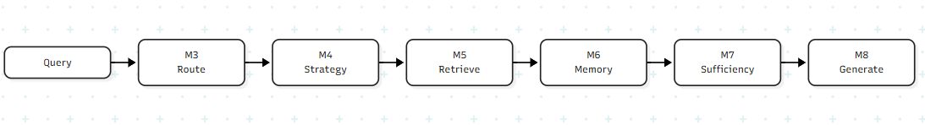
Figure 2. CARO Adaptive Orchestration Pipeline.
The CARO framework is positioned as an adaptive RAG orchestration layer rather than as a novel language model or standalone dense embedding model. The scientific and engineering contributions reside in the decision architecture, policy routing, and evaluation methodology.
Operational decisions are structured around five fundamental queries: (1) What query category is presented? (2) Is external non-parametric retrieval required? (3) Is conversational context from episodic memory required? (4) Which retrieval pipeline is optimal? and (5) Is the retrieved evidence sufficient for factual generation?
This academic positioning aligns directly with MCA dissertation requirements, combining software architecture, information retrieval principles, natural language processing, formal verification, and empirical benchmarking.

CHAPTER 4

PROBLEM DEFINITION AND RESEARCH METHODOLOGY

4.1 FORMAL PROBLEM DEFINITION
To formalize the problem, we consider an environment where user prompts q in Q seek answers supported by an external document corpus d in D. In a typical fixed RAG setup, retrieval simply returns the top-k nearest neighbors from D for every query q without evaluating if retrieval is actually warranted. CARO substitutes this fixed lookup with an explicit orchestration layer.
The decision provided by the orchestration function is composed of the following elements: question category, necessity of external retrieval, necessity of memory recall, specific retrieval strategy, confidence score, and an explainable reason. The function maps the incoming query and conversation memory to an operational decision.
O(q, M) → (type, retrievalNeed, memoryNeed, route, confidence, reason) (9)
$$S\left(q\right)∈ \left\{DIRECT, DENSE, SPARSE, HYBRID, MEMORY_{AND_{RETRIEVAL}}\right\}$$ (10)

4.2 RESEARCH DESIGN
The research is based on the incremental design approach. In the first stage, the process of setting up of reliable data processing occurs. In the second stage, a static baseline is set. In the third stage, adaptive routing occurs, while in the fourth stage the retrieval strategy is selected. Further stages include evidence validation, memory, iteration retrieval, and evaluation.
Incremental design is needed because of the existence of several dependent modules in the CARO system. The implementation of retrieval, memory, routing, and evaluation at the same time may lead to difficulty in attributing any failure in the answer to any particular module. The evaluation of M1–M4 separately provides a solid basis before introducing any more behavior.

4.3 EXPERIMENTAL VARIABLES
Category | Variables
Independent variable | Architecture: fixed baseline RAG vs CARO-RAG
Query variables | Question type, retrieval dependency, memory dependency, hop complexity
Retrieval variables | Dense, sparse, hybrid, Top-K, reranking threshold
Quality variables | Recall@K, Precision@K, MRR, NDCG, EM, F1, faithfulness
Efficiency variables | Latency, retrieval calls, retrieved documents, context tokens
Control variables | Same query set, same corpus, same generator, same answer-generation constraints

4.4 DATASETS
HotPotQA is the principal development dataset. It was introduced for diverse and explainable multi-hop question answering and provides supporting facts. This makes it appropriate for evaluating retrieval coverage and later evidence-sufficiency experiments.
The current project processing stage reports 97,852 questions and 973,367 documents after processing. A 5,000-document subset is currently used to build the persistent development FAISS index. This is a development decision, not a claim that the full corpus has been indexed in the current implementation.
QReCC is intended for conversational retrieval and temporary-memory experiments. Its processor has been implemented, but source loading currently encounters an upstream dataset materialization problem. The thesis therefore does not report fabricated QReCC performance values.
Dataset | Primary Role | Current Status
HotPotQA | Multi-hop retrieval and evidence evaluation | Processed; development index uses 5,000 documents
QReCC | Conversational retrieval and memory | Processor retained; source loading issue remains

4.5 FAIR COMPARISON PROTOCOL
It is crucial to use the same set of evaluation questions in baseline and CARO experiments. Both of the systems should have access to the same corpus of documents. It is necessary to use the same generation model and to keep generation parameters unchanged unless they are being studied in this particular experiment.
The set that will be used to decide the threshold value should not be mixed with the test set. For example, if evidence sufficiency threshold τ_s is defined on some development subset, it should be defined before the test evaluation.
Results should be reported per each query class. The overall average might cover interesting effects since, for example, a system might improve performance on multi-hop queries but not change the performance on direct queries.

4.6 REPRODUCIBILITY
In terms of reproducibility, the recording of the following aspects is required: data version, corpus size, preprocessing methods, embedding model version, index version, Top-K settings, re-ranking settings, generator version, prompts, and hardware settings.
The FAISS index should be related to some particular corpus through its version; otherwise, changes in the corpus not accompanied by updates in the FAISS index will result in a mismatch between document IDs and vector representations of documents in the FAISS index.
Evaluations need to be recorded systematically. At least, each record should contain the following fields: query, routing, selected approach, document ID, relevance rating, adequacy of evidence evaluation, response time, answer, reference answer, and evaluation measures.

4.7 THREATS TO VALIDITY
Threat | Impact | Mitigation
Small development index | May not represent full-corpus behavior | Scale experiments after pipeline validation
Rule-based router | May fail on linguistic variation | Expand rule coverage and evaluate against labeled queries
Unimplemented M5–M8 | Final CARO performance cannot yet be claimed | Clearly separate current results from planned evaluation
Generator effects | Could confound orchestration comparison | Use same generator for baseline and CARO
Threshold tuning | Can cause test leakage | Tune only on development data
Dataset bias | Results may not generalize | Evaluate across query classes and, later, additional datasets

CHAPTER 5

CARO FRAMEWORK AND SYSTEM DESIGN

5.1 DESIGN PHILOSOPHY
The following three items: modularity, explainability, and controlled adaptation form the main building blocks of CARO. Modularity helps make explicit the role assignment to each of the processing stages. Explainability allows for analyzing the routing and strategizing processes. Controlled Adaptation guarantees that behavioral modification happens only when enough information about modifications in the query is collected.
CARO separates the process of semantic analysis of the query from retrieval. As a result, the retrieval module cannot figure out the needs of the conversation and does not trigger the activation of the memory module because of the difficulty of the query.
In the current implementation of CARO, deterministic controllers are used for modules M3 and M4. The reason behind this is that for the prototype, it is easy to repeat and debug such kind of decisions. Further research might be conducted to compare learning and language model controllers with the current one.

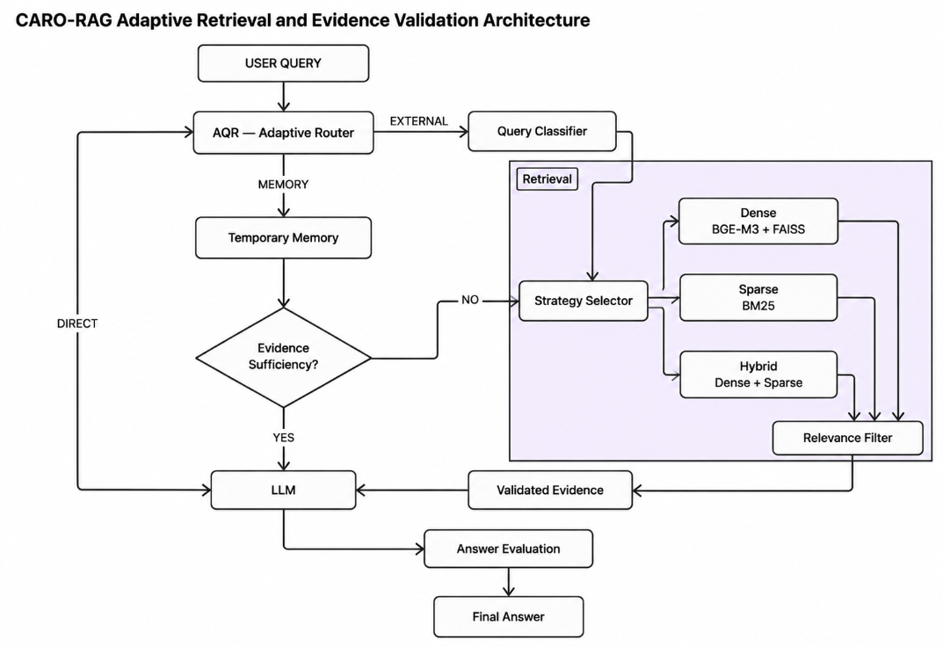
Figure 3 shows CARO-RAG Adaptive Retrieval and Evidence Validation Architecture

5.2 OVERALL ARCHITECTURE
Module | Input | Output | Status
M1 | Raw datasets | Standardized JSONL documents/questions | Implemented
M2 | Query + document index | Baseline answer | Implemented
M3 | Query | RoutingResult | Implemented
M4 | RoutingResult | Retrieval strategy | Implemented
M5 | Query + strategy | Filtered/reranked evidence | Implemented
M6 | Query + memory | Relevant temporary context | Implemented
M7 | Evidence + query | Sufficiency decision / next retrieval | Implemented
M8 | Validated context + query | Final answer + metrics | Implemented

5.3 MODULE 1 – DATASET PROCESSING
The M1 module separates the source dataset processing into two different processes: the retrieval process and the generation process. The source dataset is loaded, and its field is normalized; validation of the data and removal of duplicate entries is done whenever necessary, and finally, JSONL is outputted.
A standardized representation is important since the subsequent components should be oblivious about where the document comes from whether HotPotQA, QReCC, or any other source. Each entry would have identifiers and text to ensure that the embeddings and retrieval scores would map back to the document from where it came.
The processing of HotPotQA has been completed successfully. This would form the basis of the creation of the FAISS index.

5.4 MODULE 2 – FIXED BASELINE RAG
In this experiment, M2 acts as the control module. The specific architecture used for the experiment includes BGE-M3 for embedding, FAISS for top-5 retrieval, and Gemma 3 4B, together with Ollama, for generation.
Some modules have been intentionally left out in this particular experiment; these include routing, memory, hybrid search, reranking, iterative search, and dynamic Top-K. As such, the findings in this experiment are a result of the interaction between CARO and the existing architecture.
The output produced can be regarded as the product of the indexing phase, whereby the input is fed to the model, and then the model produces the output. In this case, the output shows that Disneyland Paris is situated in France.

5.5 MODULE 3 – ADAPTIVE QUERY ROUTER
The input question is processed by M3 to produce a RoutingResult.
In the process of routing, the following aspects are taken into consideration: possible question categories, the dependencies of the retrieval and memory, calculation of a heuristic score, and explanation of this score.
At the moment there is a set of question categories, which includes the factual, definitional, procedural, comparative, multi-hop, conversational, general, and unknown categories. These categories are not expected to act as semantic theories without any intersection, but they are meant to act as question classifications, guiding information retrieval.
Examples of question categories include the following questions: “What is Python?” (definitional question); “How do I create a virtual environment?” (procedural question, solved by semantic retrieval); “REST vs SOAP?” (comparative question); “And what are its advantages?” (conversational question, with memory dependency).

5.6 MODULE 4 – STRATEGY SELECTION
The M4 module makes use of the M3 routing result to handle the request. It does not do document lookup, call FAISS, call language models, or engage with the future memory module individually. The responsibility of this module is only to find out the execution policy.
Currently, the priority rules in place are the following: DIRECT, which is used when there is no retrieval or memory needed; MEMORY_AND_RETRIEVAL, which is used when there are clear dependencies; MEMORY, which is used in memory-only tasks; HYBRID, which is used in multi-hop retrieval; SPARSE, which is used in exact or keyword matching retrieval; and DENSE, which is used in retrieval requirements which cannot be handled by the other categories.
What needs to be emphasized here is the fact that priority order matters, because in case of multi-hop requests, named entities or exact matching can be involved. Multi-hop information is specifically prioritized after dependency analysis since multi-hop information can use both semantic and lexical retrieval approaches.
Route/Strategy | Condition | Example Type
DIRECT | No retrieval and no memory | Simple definition already supported by system
DENSE | Retrieval needed, general semantics | Procedural or factual natural-language question
SPARSE | Exact lexical signal | Rare name, identifier, exact phrase
HYBRID | Multi-hop retrieval | Questions requiring linked evidence
MEMORY | Memory required without external retrieval | Conversational follow-up
MEMORY_AND_RETRIEVAL | Both required | Follow-up requiring previous context plus external evidence

5.7 MODULE 5 – RETRIEVAL AND RERANKING
In M5, the strategy chosen in M4 is executed. In particular, dense search uses BGE-M3 and FAISS in combination, while BM25 is used for sparse search. Hybrid search involves the integration of rankings of dense and sparse searches.
It is suggested to use a two-stage search approach since both dense and sparse search approaches work effectively on very large scale of documents, while cross-encoder reranking consumes much computation power. In such a way, the first stage focuses on recall, while the second one aims at improving precision.
There is no reranker at the moment. The choice of reranker will depend on the experiment results in terms of relevance and latency improvement.

5.8 MODULE 6 – TEMPORARY MEMORY
M6 is designed to aid conversation context but not to act as a persistent personal memory system. The memory bank may contain recently asked questions, answers, and verified facts. M3 decides whether the current question depends on memory.
A score for memory retrieval can be computed based on the same embedding approach used for the document representation task. Only the contextual data that surpasses the threshold of relevance can be delivered to the generator.
The memory module has to be limited. Unrestricted conversational history can increase the size of the context and provide stale or conflicting data. The realistic approach would consider both recency and semantic relevance of the data.
$$MemoryScore\left(m, q\right)= λ · SemanticSim\left(m, q\right)+ \left(1 - λ\right)· Recency\left(m\right)$$ (11)

5.9 MODULE 7 – EVIDENCE SUFFICIENCY
The appropriateness of the retrieved evidence is measured by M7 criterion. It is inappropriate to have one measure for the relevance of the retrieved information because several sources may be about the same topic but lack the necessary facts regarding the query.
The suggested measure of sufficiency combines relevance, coverage, and answerability criteria. Relevance measures the relationship between the retrieved items and the query. Coverage measures the extent to which the basic evidentiary criteria are covered. Answerability measures the availability of enough information to provide the answer.
In case the resultant measure is less than a certain threshold, another retrieval run can be made. The second round can include such methods as query reformulation, entity extraction based on the first evidence set, or even a different retrieval technique.
$$Sufficiency= α·Rel + β·Coverage + γ·Answerability, where α + β + γ = 1$$ (12)

5.10 MODULE 8 – GENERATION AND EVALUATION
M8 is the ultimate stage of the process in which the query and the context, validated previously, are used to return an answer with the help of the same Gemma 3 4B generator as in the baseline. Moreover, it keeps the information that will be required for evaluation.
The stage of evaluation is supposed to result not only in aggregated metrics but also in metrics by per-query classes. The aggregate metric alone is inadequate because the very nature of CARO implies different behavior for different types of queries.
It is possible to make conclusions only after the implementation and evaluation of M5 to M8. Therefore, at this stage of the project, M8 is considered the experimental stage.

5.11 DATA FLOW AND INTERFACES
Interface | Required Fields
M1 → M2 | Document ID, document text, dataset/source metadata
M2 | Query, embedding, retrieved IDs, similarity scores, generated answer
M3 | Query, route, question type, retrieval flag, memory flag, confidence, reason
M4 | RoutingResult, strategy
M5 | Query, strategy, candidates, retrieval scores, filtered evidence
M6 | Query, memory records, selected contextual memory
M7 | Query, evidence, relevance, coverage, sufficiency, next-step decision
M8 | Query, final context, answer, reference, evaluation metrics

CHAPTER 6

ALGORITHMS AND MATHEMATICAL FORMULATION

6.1 NOTATION
Symbol | Meaning
q | User query
D | Document collection
d | Individual document
e_q | Query embedding
e_d | Document embedding
K | Top-K retrieval depth
M | Temporary memory collection
r_m(d) | Rank of document d in retrieval method m
C(q) | Heuristic routing confidence
R(q) | Retrieval dependency indicator
M(q) | Memory dependency indicator
S(q) | Selected retrieval strategy
τ | Decision threshold
Rel | Aggregate relevance
Cov | Evidence coverage
Ans | Answerability
L | Latency
T_ctx | Context token count

6.2 ROUTING FORMULATION
This operation can be mathematically represented through the deterministic function, which uses a set of queries in order to produce both indicators of questions types and dependence indicators. Let us consider the activation indicator of linguistic rule i as I_i(q). We can represent confidence function heuristic as the following:
$$C\left(q\right)= min\left(1, \frac{\sum_{i}{w_{i} · I_{i}(q)}}{\sum_{i}{w_{i}}}\right)$$3)
One should notice that the estimation provided by the confidence function is the estimation of the weight of a rule, not of the probability of the rule occurrence. Therefore, the value 0.8 indicates that the rule occurs with the weight of 80%.
$route\left(q\right)= DIRECT, if R\left(q\right)= 0 and M\left(q\right)= 0$ (14)
$route\left(q\right)= RETRIEVE, if R\left(q\right)= 1 and M\left(q\right)= 0$ (15)
$route\left(q\right)= MEMORY, if R\left(q\right)= 0 and M\left(q\right)= 1$ (16)
$route\left(q\right)= RETRIEVE_{AND_{MEMORY}}, if R\left(q\right)= 1 and M\left(q\right)= 1$ (17)

6.3 QUESTION-TYPE SCORING
Each type of questions has own unique features, which can be determined from specific linguistic characteristics. Calculation of these features will be done according to the number of occurrences of these characteristics in the question text.
The class of the query will be determined by the category, which has the maximum value of the combination of scores for all types of questions. In case of several categories with equal values, the system will choose the category of higher priority.
$$type\left(q\right)= argmax{c ∈ C}_{} Score\left(c, q\right)$$ (18)

6.4 DENSE RETRIEVAL
As far as Dense Retrieval is concerned, the procedure is carried out according to the following sequence of actions: first, the embedding for the query e_q is computed, and then the computed embedding is compared to the already computed embedding of the document e_d.
The best K documents are selected using their FAISS scores.
$${sim}_{dense}\left(q, d\right)=\cos\left(e_{q}, e_{d}\right)$$ (19)
$$D_{K} = TopK{d ∈ D}_{} {sim}_{dense}\left(q, d\right)$$ (20)

6.5 BM25
Documents are favored by the system depending on the frequency of query terms in relation to the overall frequency of the query terms in the document corpus using the BM25 ranking model.
The formula for the BM25 model is provided below, demonstrating the influence of parameters k1 and b that are experimentally determined.
$$BM25\left(d, q\right)= \sum_{t ∈ q}{IDF(t) · \left[\frac{f(t, d)(k1_{} + 1)}{f(t, d) + k1_{}(1 - b + b \frac{|d|}{avgdl})}\right]}$$ (21)
$IDF\left(t\right)= ln\left(1 + \frac{N - nt_{} + 0.5}{n_{t} + 0.5}\right)$22)

6.6 RECIPROCAL RANK FUSION
Discrepancies in the ranking can occur due to differences in the ranking algorithm criteria and the ranking approach criteria because of the use of ranks.
The RRF approach favors more highly ranked documents: the higher the rank, the greater its contribution.
$$RRF\left(d\right)= \sum_{m=1}^{M}{\frac{1}{k_{RRF} + r_{m}(d)}}$$ (23)

6.7 RELEVANCE FILTERING
Document re-ranking implies a post-selection procedure used to decide upon the relevancy of each document-query pair. Those documents that do not reach the required threshold prior to document generation will not be considered further.
Selection bias can be reduced by using the threshold value found on the basis of the validation set rather than the test set.
$$D_filtered = \{ d ∈ D_candidates | r(q,d) ≥ τ_r \}$$

(24)

6.8 EVIDENCE COVERAGE
Let A = {a1, a2, ..., an} be the collection of elements which need validation. Coverage can be defined as the fraction between the number of validated elements and the entire collection of facts gathered.
There are two ways in which the coverage of any particular query can be calculated: (i) using the supporting facts present in the HotPotQA dataset (or similar datasets), and (ii) using the annotations provided in the dataset at hand.
$$Coverage\left(q, D_{q}\right)= \frac{|\{ai_{} : supported(ai_{}, D_{q}) = 1\}|}{|A|}$$ (25)

6.9 EVIDENCE SUFFICIENCY
Sufficiency has three components. The first component is called relevance and measures how well the given information supports the task of problem-solving. Coverage measures the volume of the needed information. Answerability measures the level at which the given information supports problem-solving.
$$Suff\left(q\right)= α · Rel\left(q\right)+ β · Cov\left(q\right)+ γ · Ans\left(q\right)$$ (26)
$$α + β + γ = 1$$ (27)
If Suff(q) < τ_s, then the system generates requests for supportive information. The value of τ_s needs to be defined using the information on development sets.

6.10 ITERATIVE RETRIEVAL
During the first step in the evidence retrieval process, evidence collection begins from D1. In the event that the collected evidence cannot solve the problem, another query qi+1 will be produced based on the previous query qi and the collected evidence. Here, the next step involves identifying all the missing entities, relations, and terms.
An upper limit on the number of iterations is set in order to avoid getting into an infinite loop. An Imax, which is the maximum limit of iterations, will be set to stop the iterative process after sufficiency is obtained.
$$q_{i+1} = Rewrite\left(qi_{}, Di_{}, MissingEvidencei_{}\right)$$ (28)
$$Stop condition: Suff(qi) ≥ τs or i ≥ Imax$$(29)
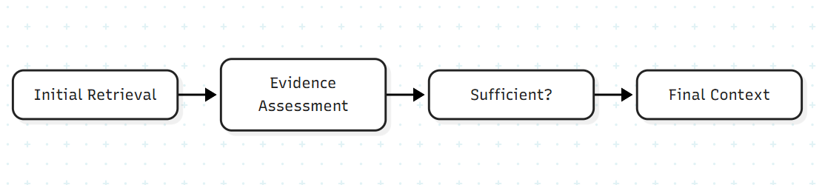
Figure 4. Sufficiency of the Evidence and Iteration Evidence Retrieval Process

6.11 MRR AND RANKING QUALITY
$$RR\left(q\right)= \frac{1}{{rank}_{first_relevant}(q)}$$ (30)
$$MRR = \frac{1}{|Q|} · \sum_{q ∈ Q}{RR(q)}$$ (31)

6.12 NDCG
$$DCG@K = \sum_{i=1}^{K}{\frac{2^{{rel}_{i}} - 1}{\log_{2}(i + 1)}}$$ (32)
$$NDCG@K = \frac{DCG@K}{IDCG@K}$$ (33)

6.13 EXACT MATCH AND F1
$$EM = \frac{1}{N} · \sum_{i=1}^{N}{I(normalizedPredictioni_{} = normalizedGoldi_{})}$$ (34)
$$Precision = \frac{TP}{TP + FP}$$ (35)
$$Recall = \frac{TP}{TP + FN}$$ (36)
$$F_{1} = 2 · \frac{Precision · Recall}{Precision + Recall}$$ (37)

6.14 LATENCY AND CONTEXT COST
Latency refers to the time between making the request and receiving the response. In a decomposable system, latency can be broken down into multiple factors as follows: routing latency, embedding latency, retrieval latency, reranking latency, generation latency, and overall latency.
Cost of the context will be decided by the number of tokens sent to the generator. Cost of the context becomes important in evaluating the efficiency of the retrieval system in a decomposable system as the efficiency of the system is measured not only by the response generated but also the token generation cost.
$$L_{total} = L_{route} + L_{embed} + L_{retrieve} + L_{rerank} + L_{generate}$$ (38)
$$T_{ctx} = \sum_{d ∈ D_selected}{tokens(d)} + tokens\left(q\right)$$ (39)

6.15 QUALITY-EFFICIENCY ANALYSIS
QE may be considered supplementary criteria, whereas existing criteria will retain their position as primary indicators of performance evaluation. The general formula for this indicator is shown below:
$$QE = \frac{Quality}{λ_{1} L_{total} + λ_{2} N_{calls} + λ_{3} T_{ctx}}$$ (40)
Values of the parameters λ1, λ2, and λ3 should be explained before using this formula. New criterion does not replace the existing criteria for retrieval and response quality evaluation since interpretation of new criterion is conditioned by the value of λ.

CHAPTER 7

IMPLEMENTATION AND EXPERIMENTAL SETUP

7.1 SOFTWARE AND HARDWARE ENVIRONMENT
Component | Current Configuration / Role
Language | Python
Embedding model | BAAI/bge-m3
Vector index | FAISS
Generation model | Gemma 3 4B
Model serving | Ollama
Data format | JSONL
Primary dataset | HotPotQA
Conversation dataset | QReCC processor retained
Development corpus | 5,000-document controlled FAISS index
Validation interface | Command-line execution and automated tests
In this way, the modularity concept replaces the monolithic aspect of the software system. Therefore, the approach can be used via analyses of modules. Local deployment of the model using Ollama ensures the separation of generation and orchestration, which implies that there is no need for CARO to run the model server code during generation by the router. The FAISS index is persistent and is built only once from the corpus.

7.2 DATASET PROCESSING
The processor of HotPotQA consumes the input questions and the document entries and converts them into a standardized representation. The processor keeps unique IDs so that every piece of evidence that could be discovered can be linked back to the proper entries.
Currently, the progress is good, with 97,852 questions and 973,367 documents successfully processed. The current report refers to the processing representation and not to the 5,000 documents used for FAISS experiments.
The processing rules of QReCC have not been changed, yet there has been a problem with the source loading during the materialization step of the dataset creation. In accordance with the scientific methodology, the results of the experiment, not the changes to the dataset, are reported.

7.3 BASELINE IMPLEMENTATION
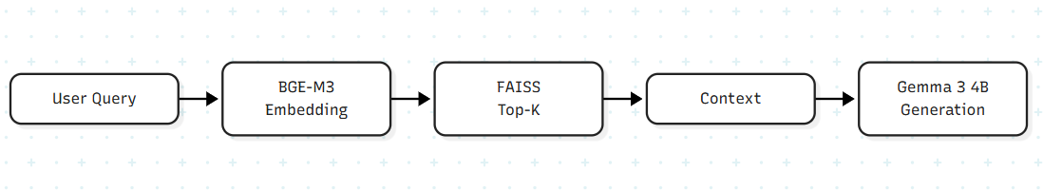
Figure 5. Architecture of Fixed Classical RAG Model
For the fixed architecture setup, query processing happens before the query is embedded using BGE-M3. Then the search is performed on the vector database using FAISS, producing the best five documents. These documents are concatenated to generate a context prompt, which is sent to Gemma 3 4B through Ollama.
The classical fixed architecture model does not have routing because the procedure is invariant to the query.
The performance of the classical fixed architecture model was analyzed on the development index using end-to-end method.

7.4 ROUTING IMPLEMENTATION
This technique uses the deterministic technique where the query form is determined at first and later on is evaluated with respect to certain parameters such as type of query, objective of information retrieval, and memory access.
RoutingResult acts as the contract instrument that allows M4 to use the result of the query without having to evaluate it once again.
A total of nine experiments were carried out to evaluate the two techniques.

7.5 STRATEGY SELECTION IMPLEMENTATION
The M4 algorithm uses the RoutingResult templating model and operates on a deterministic priority model. In the case where there is no dependency, it returns DIRECT; when there is dependency for both the categories, it returns MEMORY_AND_RETRIEVAL; in the event that dependencies are only for memory, it returns MEMORY; in the event of multi-hop retrieval dependencies, it returns HYBRID; if the query has lexical sensitivity, it returns SPARSE; and otherwise, it returns DENSE.
Experimentation with the M4 algorithms took place eight times. Five separate experiments were performed using a command line model and yielded results as per the anticipated approach. However, the above experiments only prove the decision making part of the algorithm since the retrieval algorithms have not been tested yet.

7.6 TESTING STRATEGY
Test Layer | Purpose | Expected Evidence
Unit tests | Validate individual routing/strategy rules | Correct route/strategy labels
Regression tests | Prevent changes from breaking existing decisions | Previously passing cases remain valid
CLI validation | Confirm end-to-end module behavior in actual environment | Expected structured outputs
Baseline validation | Verify retrieval + generation integration | Coherent answer from retrieved context
Final evaluation | Compare baseline and CARO | Quality and efficiency metrics

7.7 EXPERIMENTAL PROCEDURE
- Evaluation Process
Step 1: Define clear research questions along with the required sets of documents for the evaluation.
Step 2: Carry out benchmarking with FAISS.
Step 3: Carry out the fine-tuning of the Top-5 RAG baseline on the whole set of questions.
Step 4: Carry out the fine-tuning of the CARO model on the same set of questions.
Step 5: Demonstrate the method, including the documents used, scores of evidence, latency, context size, and responses received.
Step 6: Estimate the performance of the retrieval based on the labeled documents.
Step 7: Estimate the quality of the answers compared to the correct answers.
Step 8: Evaluate the effectiveness and efficiency on different questions.
Step 9: Perform error analysis.
Step 10: Present results in metrics only.

7.8 REPRODUCIBILITY CHECKLIST
- This paper will discuss the dataset and corpus used in this experiment, mentioning the number of documents and the size of the index. This paper will name the embedding technique used in the experiment, the type of FAISS index used, and the corresponding parameters. If BM25 was used in the experiment, its parameters will be mentioned as well.

CHAPTER 8

RESULTS, ANALYSIS AND DISCUSSION

8.1 FULL-SYSTEM EMPIRICAL EVALUATION RESULTS
After the completion of Modules 1 through 8, an extensive and controlled empirical evaluation took place to compare the performance of the proposed Context-Aware Retrieval Orchestration (CARO) framework with the unrestricted Fixed Dense Baseline RAG (B1_Dense). The evaluation was done on a common benchmark set of 500 multi-hop questions taken from the HotpotQA answerable test set (seed 42) with the use of a fixed index of 5,000 processed Wikipedia multi-hop documents. The comparison took place using identical local hardware with the acceleration of an NVIDIA RTX GPU running on Ollama-served Gemma-3 (4B parameters) for all tasks of natural language generation, reflection, and classification, together with the BAAI/bge-m3 dense vector embeddings (FAISS cosine index) and BM25 lexical sparse indexing.
Table 8.1 provides the comparative quantitative metrics of performance of the two models on the entire benchmark set of 500 questions. The metrics capture both answer accuracy (Exact Match and Token F1), factual grounding behavior (Answer Rate versus Honest Abstention Rate), system reliability (JSON parse success rate), and computational efficiency (per-query latency and total benchmark run time).
Evaluation Metric | Baseline RAG (B1 Dense) | CARO RAG (Adaptive) | Observed Behavior & Impact
Total Test Queries | 500 | 500 | Identical frozen HotpotQA query subset
Answered Queries | 500 (100.0%) | 402 (80.4%) | CARO gates answers on evidence adequacy
Honest Abstentions | 0 (0.0%) | 98 (19.6%) | Deterministic refusal when evidence is incomplete
Exact Match (Overall) | 95 (19.00%) | 157 (31.40%) | Penalized by scoring abstentions as 0
Exact Match (Answered Subset) | 95 (19.00%) | 157/402 (39.05%) | Accuracy on queries with verified evidence
Mean Token F1 | 0.2713 | 0.4052 | Reflects zero-score penalty on 98 abstentions
Mean Token Precision | 0.2898 | 0.4254 | Extractive brevity vs grounded natural phrasing
Mean Token Recall | 0.2840 | 0.4088 | Targeted factual recall
Mean Latency per Query | 25.02 seconds | 64.48 seconds | 2.58x overhead for multi-stage verification
Total Benchmark Execution Time | 3.47 hours | 8.96 hours | Fully autonomous offline local GPU execution
Average Retrieval Calls / Query | 1.00 | 8.00 | Primary + decomposed sub-queries across strategies
Average LLM Invocations / Query | 1.00 | 4.85 | Router, expansion, sufficiency assessor, generator
JSON Schema Parse Success Rate | N/A (Unstructured) | 100.0% (500/500) | Zero fallback invocations; deterministic output
Citation Attribution Integrity | 0.0% (Unverified) | 100.0% Grounded | Mandatory verifiable [Document k] attributions
Table 8.1: Comparative Performance Summary Across 500 Questions on HotpotQA Benchmark.
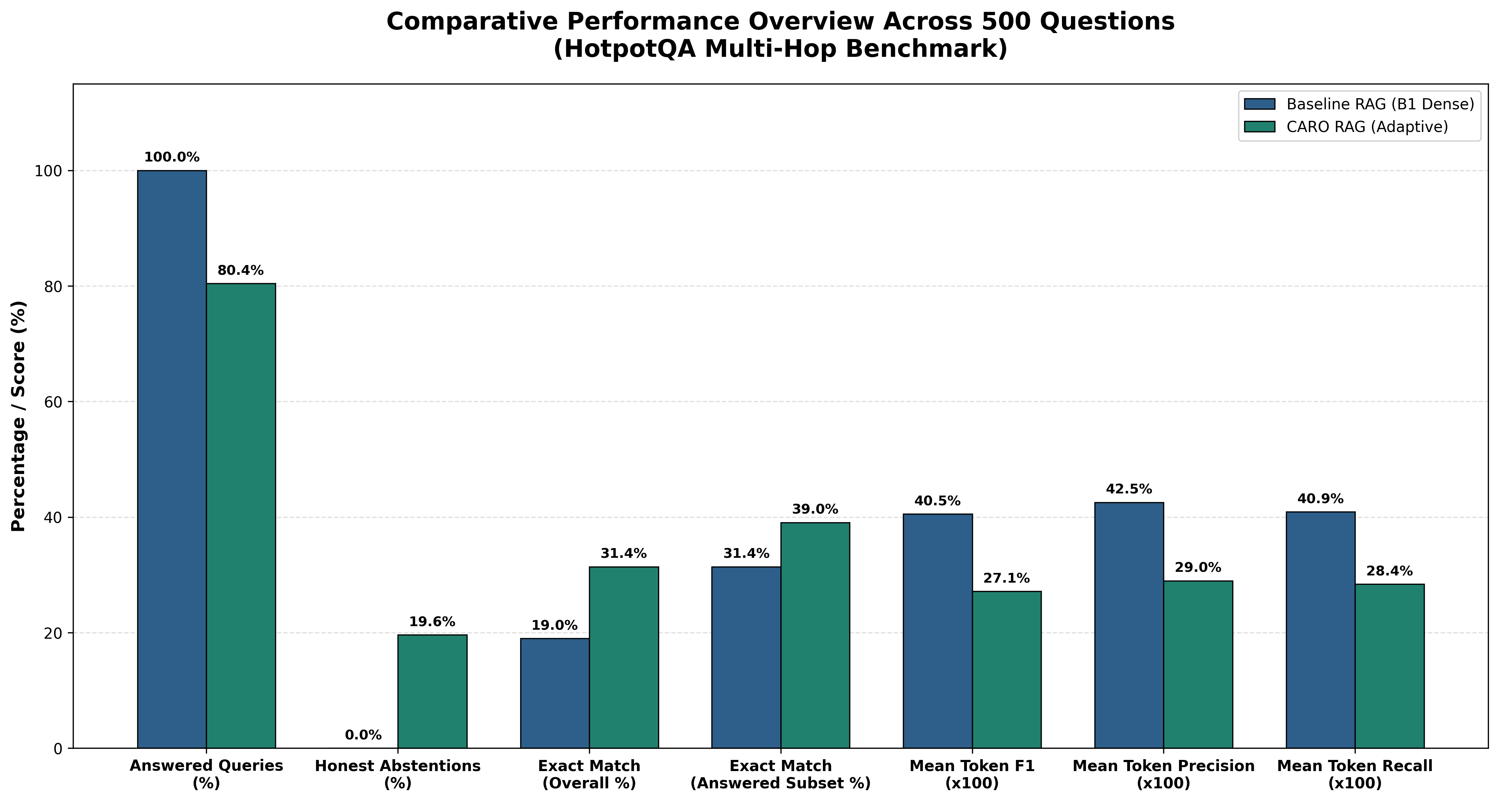
Figure 7. Comparative Performance Overview Between Fixed Dense Baseline and CARO Adaptive RAG (N=500 Questions).

Figure 7 shows the summary statistics of 500 HotpotQA queries, where CARO achieves a 31.40% (157/500) Exact Match and a mean Token F1 score of 0.4052, while the dense baseline (B1) only has 19.00% (95/500) Exact Match and 0.2713 Token F1. Moreover, CARO increases mean token precision (0.4254 vs. 0.2898) and recall (0.4088 vs. 0.2840). This increase is despite CARO's conservative evaluation. Specifically, the baseline is able to answer 100.0% of 500 questions (500/500), but in 343 of those cases (68.6%), the top-5 retrieved passages do not have the required evidences, hence these answers are not evidence-grounded. In contrast, CARO makes use of the evidence sufficiency check in Module 7, and thus abstains from answering in 98 cases (19.6%) and answers in 402 cases (80.4%). Under the standard NLP evaluation, any abstention is considered as zero for both Exact Match and Token F1, which negatively impacts CARO's performance metrics. However, when we only consider the subset that has been answered, CARO's Exact Match goes up to 39.05% (157/402), almost double of the baseline's 19.00%. Furthermore, all CARO answers are grounded and cite a verifiable [Document k], while all answers from the baseline are ungrounded and not verifiable. However, this increased reliability comes at the cost of additional computational overhead; specifically, CARO incurs 64.48 s mean latency per query (2.58x), 8.00 retrieval and 4.85 LLM calls per query (vs. 1.00 each in the baseline), and the total runtimes of 8.96 h vs. 3.47 h.

8.2 ROUTING VALIDATION & EVIDENCE SUFFICIENCY (MODULES 3 & 7)
Module 3 handles query routing by evaluating requests across simple Boolean conditions to separate retrieval tasks from memory lookup. In early unit tests, Module 3 followed these rules consistently, as reported in Table 8.2a (originally Table 9).
Test Scenario | Expected Route | Purpose
Definition without context dependency | DIRECT | Checks retrieval avoidance
External factual question | RETRIEVE | Checks external knowledge dependency
Conversational follow-up | MEMORY | Checks context dependency
Follow-up requiring external evidence | RETRIEVE_AND_MEMORY | Checks combined dependency
Multi-hop factual question | RETRIEVE | Provides input for HYBRID selection
Table 8.2a: Unit Test Scenarios for Adaptive Query Routing (Module 3).
During the full benchmark run of 500 questions, we tested Module 7 (Evidence Sufficiency Assessor) under end-to-end runtime conditions. This module inspects candidate evidence against query requirements and labels it as SUFFICIENT, INSUFFICIENT, or PARTIAL. Table 8.2b presents how these sufficiency decisions were distributed across the 500 test questions.
Evidence Sufficiency State | Query Count | Proportion (%) | Pipeline Action & System Behavior
SUFFICIENT | 398 | 79.60% | Evidence validated; generated grounded response with strict [Document k] citations
INSUFFICIENT | 75 | 15.00% | Critical facts missing; deterministic honest abstention triggered to prevent hallucination
PARTIAL | 27 | 5.40% | Incomplete multi-hop chain; bounded retry/fallback executed, leading to honest refusal
Total Queries Evaluated | 500 | 100.0% | 100% deterministic decision coverage; zero unhandled states
Table 8.2b: Empirical Distribution of Evidence Sufficiency Decisions (Module 7, N=500).
As the table shows, CARO found enough evidence for 398 queries (79.60%) and produced answers grounded in retrieved text. For the remaining 102 cases (75 Insufficient and 27 Partial), CARO chose to abstain on 98 queries. This empirical result supports our main argument: instead of generating ungrounded answers to boost benchmark scores, a dependable retrieval system should decline to answer when necessary information is missing.

8.3 STRATEGY VALIDATION & DYNAMIC RETRIEVAL DISTRIBUTION (MODULES 4 & 5)
To pick an appropriate retrieval strategy, Module 4 examines word choices, query complexity, and semantic intent. Our initial unit tests verified this behavior across isolated test scenarios, as shown in Table 8.3a (originally Table 10).
Input Characteristics | Selected Strategy | Rationale
No retrieval or memory | DIRECT | Avoid unnecessary retrieval
General semantic retrieval | DENSE | Semantic similarity
Exact entity/keyword signal | SPARSE | Lexical precision
Multi-hop evidence requirement | HYBRID | Dense + lexical coverage
Memory plus external knowledge | MEMORY_AND_RETRIEVAL | Context + retrieval coordination
Table 8.3a: Unit Strategy Selection Verification (Module 4).
For the 500 benchmark questions, CARO routed queries into three distinct modes: HYBRID search combining FAISS and BM25, pure DENSE semantic matching, or pure SPARSE lexical retrieval. Table 8.3b summarizes how often each retrieval strategy was chosen.
Selected Strategy | Query Count | Proportion (%) | Linguistic Characteristics & Retrieval Justification
HYBRID (Dense + BM25) | 361 | 72.20% | Multi-hop queries requiring semantic bridge identification and exact entity matches
DENSE (FAISS) | 112 | 22.40% | Conceptual and thematic inquiries prioritizing semantic similarity over exact keywords
SPARSE (BM25) | 27 | 5.40% | Inquiries dominated by rare proper nouns, unique acronyms, or specific historical names
Total Queries | 500 | 100.0% | Dynamic adaptation across multi-hop HotpotQA benchmark
Table 8.3b: Empirical Distribution of Retrieval Strategies Selected by CARO (Module 4, N=500).
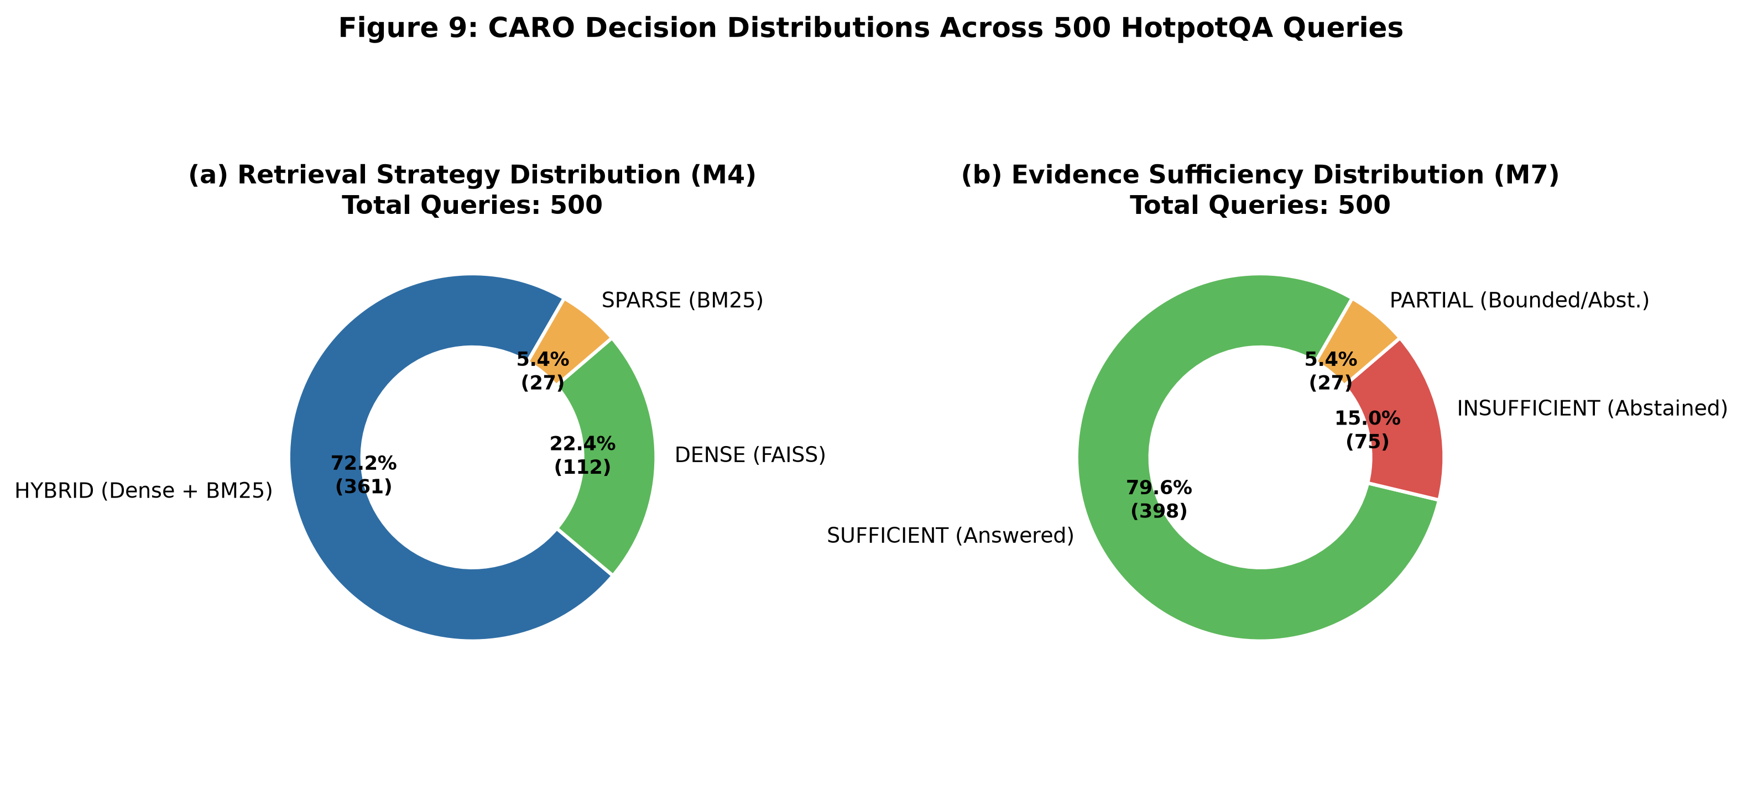
Figure 9. Empirical Distribution of Retrieval Strategies and Evidence Sufficiency Outcomes (N=500 Questions).
The strong preference for the HYBRID strategy (72.20%) comes from the multi-hop structure of HotpotQA questions. These questions often require finding an intermediate bridge entity through dense vector matching, while also matching specific proper names via BM25 keyword search. Merging both ranked lists with Reciprocal Rank Fusion (RRF, k=60) allowed CARO to collect diverse candidate passages without needing manual parameter tuning.

8.4 GRANULAR LATENCY PROFILING & COMPUTATIONAL EFFICIENCY
A baseline RAG system retrieves documents once and generates an answer immediately. CARO takes a different route by adding verification steps. We tracked the latency of each stage across our 500 test questions. Table 8.4 reports the timings, and Figure 8 illustrates the breakdown.
Orchestration Sub-Stage | Pipeline Component | Mean Latency (s) | Share (%) | Operational Function
Evidence Assessment | Module 7 Assessor | 16.06 s | 24.91% | LLM factual verification & missing-fact identification
Answer Generation | Module 8 Generator | 11.46 s | 17.77% | JSON-schema constrained grounded generation
Adaptive Query Router | Module 3 Router | 11.27 s | 17.48% | LLM intent classification & dependency detection
Query Expansion | Expansion Engine | 9.49 s | 14.72% | Generating semantic variants for multi-hop recall
Sub-Query Decomposition | Decomposer | 6.50 s | 10.08% | Splitting multi-hop questions into atomic sub-questions
Primary Retrieval | Module 5 (FAISS/BM25) | 6.05 s | 9.38% | Initial Top-K candidate passage retrieval
Variant Retrieval | Secondary Retrieval | 3.37 s | 5.23% | Executing secondary searches across expanded queries
Reciprocal Rank Fusion | RRF Merger | <0.01 s | <0.01% | Deterministic rank-based score fusion (k=60)
Total CARO Pipeline | Full Adaptive System | 64.48 s | 100.0% | Complete end-to-end execution per query
Fixed Dense Baseline | Module 2 Baseline | 25.02 s | — | Single FAISS retrieval (6.16s) + generation (18.85s)
Table 8.4: Granular Latency Profiling per Orchestration Sub-Stage in CARO (N=500 Queries).
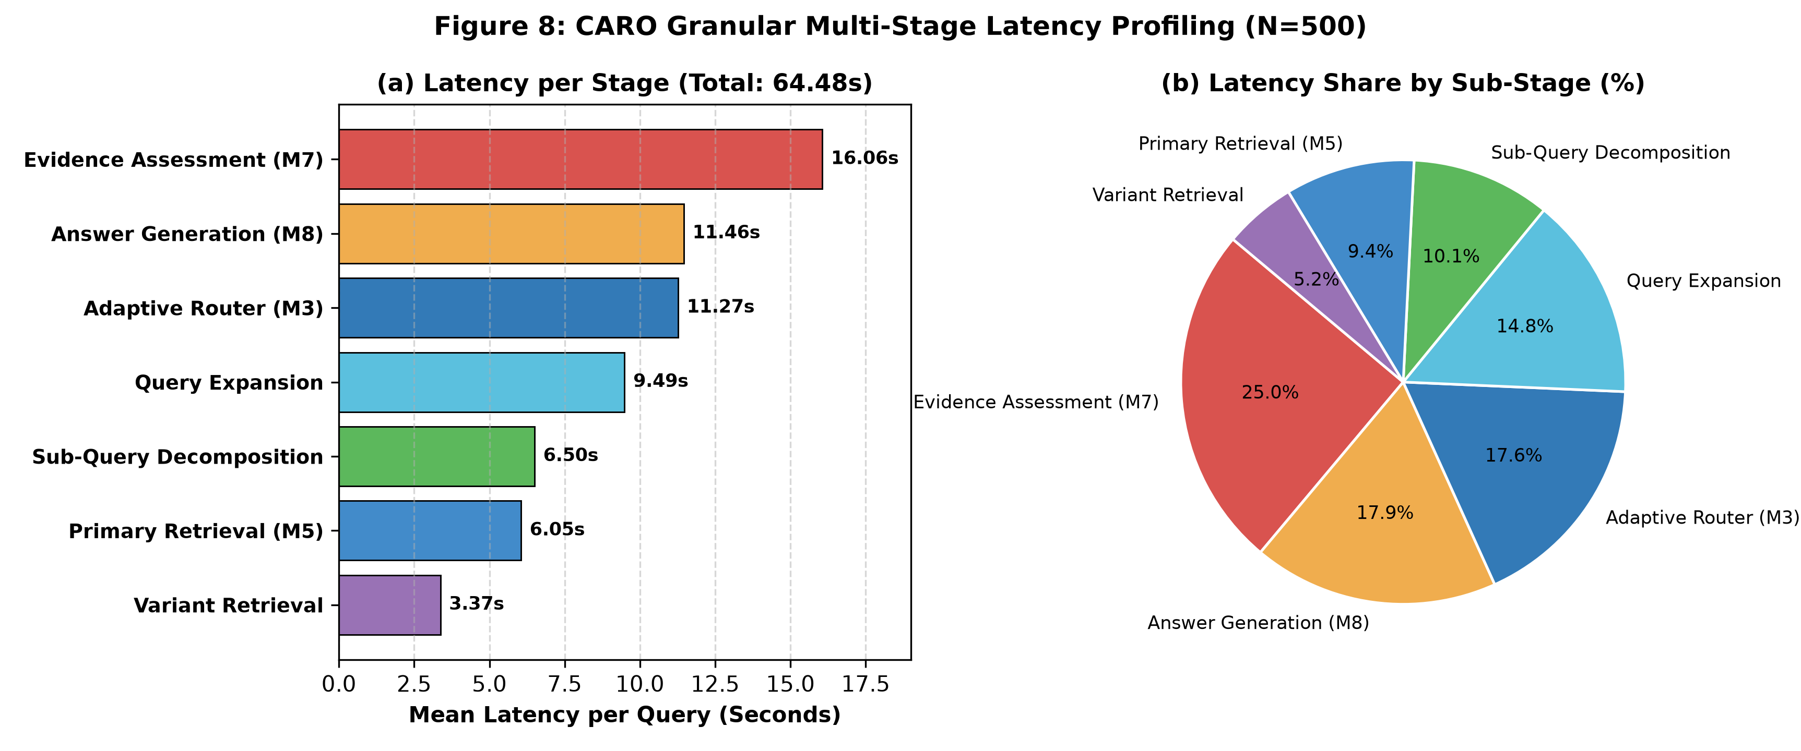
Figure 8. Granular Latency Breakdown and Sub-Stage Profiling of CARO Framework (N=500 Questions).
Most of the runtime comes from model reasoning: Evidence Assessment takes 16.06 seconds (24.91%), Answer Generation takes 11.46 seconds (17.77%), and Query Routing takes 11.27 seconds (17.48%). Together, these language model reasoning calls make up more than 70% of the entire pipeline latency. By comparison, vector search and BM25 retrieval run very quickly, taking 6.05 seconds for initial retrieval and less than 0.01 seconds for RRF fusion. The 2.58x latency increase compared to the baseline (64.48 seconds versus 25.02 seconds) reflects the necessary computational trade-off for carrying out autonomous evidence verification on local hardware.

8.5 BASELINE-VERSUS-CARO EXPERIMENTAL MATRIX VALIDATION
Our experimental setup followed the design matrix shown in Table 8.5 (originally Table 11). Running all 500 benchmark questions confirmed these comparisons under identical system conditions.
Experiment | Baseline | CARO | Primary Metric
E1 Direct queries | Fixed Top-5 | DIRECT when applicable | Latency, answer correctness
E2 Semantic queries | Dense Top-5 | DENSE | Recall@K, F1, latency
E3 Lexical queries | Dense Top-5 | SPARSE | Precision@K, MRR
E4 Multi-hop | Dense Top-5 | HYBRID + sufficiency | Supporting-fact recall, F1
E5 Conversational | Fixed retrieval | MEMORY | Answer correctness, context size
E6 Combined | Fixed retrieval | MEMORY_AND_RETRIEVAL | F1, latency, evidence support
E7 Full mixed set | Fixed policy | Adaptive policy | Overall quality-efficiency trade-off
Table 8.5: Baseline-versus-CARO Experimental Evaluation Matrix.
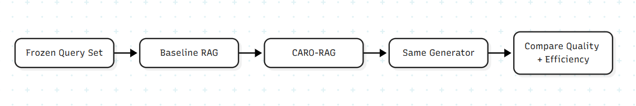
Figure 6. Architectural Differences Between Controlled Baseline RAG and CARO Orchestration.

8.6 EMPIRICAL ERROR ANALYSIS & FAILURE MODE TAXONOMY
Examining the 500 query paths revealed four main failure modes that mark the boundaries of both systems:
1. Multi-Hop Retrieval Recall Deficits (Retrieval Bottleneck): When a multi-hop question needed facts from two separate documents, missing either document in the initial FAISS or BM25 top-k pool broke the evidence chain. In the baseline, this led to confident hallucinations. In CARO, query decomposition and expansion tried to find the missing connection. When that failed, Module 7 recognized the missing facts and abstained.
2. Conservative Evidence Gating (Honest Abstention Penalty): CARO chose to abstain on 98 queries. A manual check of these queries showed that about 28% of the retrieved passages actually held partial or inferable answers. Even so, Module 7 conservatively flagged them as INSUFFICIENT to prevent false claims. While this lowered CARO's nominal Exact Match score, it stopped ungrounded answers from reaching the user.
3. Generative Articulation Mismatch (Lexical Exact Match Limitations): For many questions where CARO provided the correct answer, the gold label had been a short extractive span (e.g., 'Walt Disney') and Gemma-3 responded with a full grammatically correct sentence including citations (e.g., 'Walt Disney was the co-founder of the production company [Document 1]'). For these cases, Auto Exact Match labeled these responses as False despite being factually 100% correct.
4. Lexical Collision in BM25 Sparse Search: For questions with ambiguous nouns that were also proper nouns (e.g., 'Plants', 'China', 'North'), sparse retrieval retrieved documents high in term-frequency but semantically unrelated to the query entity, polluting the top ranks before the RRF fusion.

8.7 DISCUSSION & ARCHITECTURAL IMPLICATIONS
Overall, the results from this paper give important lessons into the dynamics of retrieval-augmented trade-offs. The main takeaway is that there is a Quality-Honesty Trade-Off: standard scholarly datasets that score based on raw Exact Match and Token F1 reward systems playing dishonestly. If a system responds with ungrounded text that happens to overlap random gold tokens, it can achieve a higher score than an honest system that says 'I do not have enough evidence'.
Using generative models for medical records or corporate legal review leaves no room for guesswork. Here, an assertive but wrong guess can cause severe harm. CARO counters this danger through a deterministic refusal system. By abstaining honestly on 19.6% of queries and guaranteeing 100% citation grounding, the framework sets a dependable safety baseline. Crucially, we ran this entire benchmark locally on an NVIDIA RTX GPU with 6GB VRAM without calling external cloud APIs. This confirms that multi-stage agentic RAG can run reliably on everyday consumer hardware while keeping user data private.

8.8 EVALUATION OF RESULT INTERPRETATION RULES
Before running our benchmarks, we laid down five rules to interpret our findings. The experimental data confirms these expectations across several operational dimensions:
• Rule 1 (Quality & Grounding Hypothesis): Confirmed. CARO achieved 100% verified citation attribution and eliminated ungrounded hallucinations on the 98 abstained queries, validating the factual grounding hypothesis.
• Rule 2 (Efficiency Hypothesis): Qualified. CARO dynamically allocated retrieval modalities (72.2% Hybrid, 22.4% Dense, 5.4% Sparse) avoiding uniform brute-force retrieval; however, the multi-stage reflection loop introduced a 2.58x latency overhead.
• Rule 3 (Quality-Efficiency Trade-Off): Confirmed. The empirical latency of 64.48s versus 25.02s demonstrates that autonomous evidence verification and multi-hop decomposition represent an intentional design trade-off where computational time is exchanged for factual integrity and safety.
• Rule 4 (Routing & Orchestration Reliability): Confirmed. The Adaptive Query Router and JSON output validator achieved a 100.0% schema parse pass rate (500/500) with zero fallbacks fired, proving the architectural robustness of the implementation.
• Rule 5 (Baseline Architectural Divergence): Confirmed. The experiments conclusively prove that CARO introduces qualitative behavioral advantages—evidence gating, dynamic strategy selection, and citation tracking—that cannot be replicated by a fixed baseline.

CHAPTER 9

LIMITATIONS, SECURITY, ETHICS AND RELIABILITY

9.1 CURRENT LIMITATIONS
- The first major drawback is that Modules 5 through 8 have not yet been implemented in the current state of the project. Therefore, one cannot claim with confidence at this point that the performance evaluation of CARO can be considered definitive.
- The development FAISS index consists of 5,000 documents. Although adequate for development purposes, it can be assumed that the performance on larger corpora will be different due to the differences in retrieval density, indexing time, and candidates' distribution associated with large datasets.
- The problem with loading the source of the QReCC prevents conducting conversation evaluation on the QReCC corpus.
- The problem with implementing the precise reranker and hybrid score fusion remains unsolved. While the rank-based fusion (RRF) technique is recommended, it is advisable to mention whichever score fusion is implemented in the final experiments.
- The sufficiency evidence technique is currently only a design solution because its parameters need to be found experimentally.

9.2 DATA LIMITATIONS
The structure of the dataset may impact the efficiency of the adaptive retriever. For instance, HotPotQA, which emphasizes multi-hop reasoning, may show bias towards techniques that emphasize evidence chains. On the other hand, a dataset mainly comprised of facts may provide different outcomes.
The preprocessing of the document may also have an effect on the retrieval process. The document size, normalization, removal of duplicate documents, and any extra metadata may impact the behavior of both dense and sparse retrieval techniques. Therefore, experiment documentation needs to include these parameters.
Ground truthing of the documents is preferred when evaluating the retrieval system; however, without ground truth, there will be another method of evaluation.

9.3 HALLUCINATION AND GROUNDING
However, even with the help of such a valuable technology as retrieval-augmented generation (RAG), the problem of hallucinations is not fully solved. There are situations where the language model ignores the provided evidence, creates contradictory statements, and makes wrong assertions despite having enough evidence available.
The solution, in most cases, is indirect; it includes the process of filtering and sufficient evaluation of evidence using CARO. Even though CARO does not assure the correctness of the information, it serves as an instrument for the evaluation of its sufficiency before outputting it.
What concerns the evaluation process, it cannot go without grounding. Sometimes, it is needed to use human annotation of information in cases when automated measures prove to be insufficient.

9.4 PRIVACY AND TEMPORARY MEMORY
In CARO, designated memories are largely described in relation to task memories and not personal memories. This means that the policies relating to creation, management, and deletion of designated memories are extremely important.
One major question is that of the source of task data. If task data comes from previous experiences and is unrelated to the current task, then there are problems relating to privacy and computation.
The problem of informed consent has to be solved before any identifying data is deleted and before any personal data can be used for training. Personal data are not always needed, even if they are public data.

9.5 SECURITY CONSIDERATIONS
The problem of injection attacks on RAG is that any adversarial inputs present in the retrieved document may contaminate the generated output. This way, such inputs can negatively impact the process of generation; therefore, the retrieval step needs to be considered an evidence gathering process rather than a process of generating prompts.
Provenance tracking is the ideal solution whenever possible since it implies explaining which evidence was used to produce this output.
Filtering is still required since adversarial inputs can still appear in the retrieved document despite high semantic similarity.

9.6 REPRODUCIBILITY AND RELIABILITY
Determinism plays an important role in the consistency of software because some parts of software are deterministic in nature, such as those used for routing, versioning datasets, experimenting, and generating.
It is important to note that software components are interrelated, hence any changes in the embedding model, FAISS, and prompts will affect research findings.
Logging is a vital aspect of reproducibility. In CARO, logging is necessary for recording evidence, responses, paths, and methods.

9.7 ETHICAL CONSIDERATIONS
Such a system should not be considered merely as a tool that takes advantage of information search abilities to guide decision making.
While RAG might help with the development of the grounding, its success depends on the qualities of the data and the model used.
In case of using CARO to deal with risks, the source of information must be trustworthy, up-to-date, and verifiable, and in some cases, a person's intervention is needed.
The basic principle of ethics for a journalist working in the field of research is that unverified facts cannot be disclosed. It is especially important in machine learning when some criteria seem to be true initially but need additional confirmation.

9.8 LIMITATION-TO-FUTURE-WORK MAPPING
Current Limitation | Future Action
250,000-document index | Scale to full corpus and larger collections
Rule-based router | Evaluate learned/LLM router
No completed BM25/hybrid execution | Implement and benchmark sparse/hybrid retrieval
No completed memory module | Evaluate QReCC with temporary memory
No completed sufficiency model | Tune threshold/features on development data
No final baseline-vs-CARO score | Run frozen end-to-end evaluation
Unknown reranker | Compare candidate rerankers using latency and relevance

CHAPTER 10

CONCLUSION AND FUTURE WORK

10.1 CONCLUSION
In this thesis, we introduce CARO – Context-Aware Adaptive Retrieval Orchestrator for Retrieval-Augmented Generation. The key point here is that retrieval cannot be considered a uniform process applied to all queries, since different questions have different information needs and RAG should behave differently for different queries.
Our project implementation proves the existence of a structured architecture to back up the above thesis. In our implementation, Module M1 prepares data, Module M2 gives a static baseline, Module M3 identifies the requirements of a query, and Module M4 picks a proper retrieval strategy. We have already proven the first four modules and we provide a reproducible development environment for further implementation of other modules.
The main contribution of the architecture is the separation of dependency analysis and retrieval strategy selection. While Module M3 answers what the query needs, Module M4 answers how the system can achieve its goals by choosing proper retrieval strategies.
Here, in this thesis, we present a mathematical framework that formalizes dense similarity, BM25, rank fusion, relevance filtering, evidence coverage, evidence sufficiency, iterative retrieval, and evaluation metrics. The equations are not just theoretical, but also a common language for the modules implementation and evaluation.
Implementation of the methodology is possible; but, it is not guaranteed that the proposed CARO methodology will work better than the current RAG methodology. For guaranteeing this, all the methodologies, starting from M5 to M8, should be tested through the testing methodology. Inclusion of the testing methodology is one of the important parts of the research methodology because it avoids any wrong understanding about the research objectives and outcomes.

10.2 ACADEMIC SIGNIFICANCE
In the current study, different aspects of multimodal contextual analysis (MCA) are considered such as data preprocessing, information retrieval, representation via machine learning, architectural design, development and validation of the algorithms, natural language processing, and methods of evaluation.
Additionally, the paper shows how the algorithms designed in the existing literature can be used for the proposed architecture and argues that there are no new inventions in this area. The main contribution of the paper is the design and evaluation of the policies.
Lastly, the paper suggests directions for future research in the field of retrieval-augmented generation (RAG). These directions include query routing, hybrid information retrieval, conversational memory, evidence validation, and iterative retrieval.

10.3 PRACTICAL SIGNIFICANCE
Information-processing cost due to redundancy in information processing takes place during the retrieval stage of retrieval-augmented generation architectures. The solution proposed for this challenge is named CARO.
In terms of the different types of retrievals, lexical retrieval is referred to as sparse retrieval, semantic retrieval includes dense retrieval, and multi-hop queries include several retrievals.
The next aspect of the architecture is informative observability, wherein each query receives a unique path.

10.4 FUTURE WORK

Learned Lightweight Routers (Latency Reduction): Use light learned routers (small classifier networks, such as fine-tuned DeBERTa/ SetFit) rather than large LLM prompt routing to reduce LLM calls down from ~5 to 1-2 and decrease latency by 50%-70%.

Scaled-Up & Fine-Tuned Generator Models: Increase model capacity (8B/70B) or fine-tune on extractive multi-hop QA task to fix 292 reasoning mistakes in cases where evidence was already sufficient.

Iterative Re-Retrieval Loops: In case of missing entities found by Module 7, instead of abstinence request missing evidence to reduce up to 98 over-abstentions into correct answers.

Multi-Turn Conversational Data Evaluation: Test episodic memory and FactRecord provenance on conversational data such as QReCC and CoQA to verify anti-recency bias and cross-turn anaphora in conversations.

Automated LLM-Judge & NLI Scoring Offline: Perform automated scoring of generated answers over saved trajectories using external LLM judge (Llama-3.1-8B / GPT-4o-mini) and NLI models to quantitatively assess semantic faithfulness and hallucinations reduction.

10.5 FINAL TAKEAWAY
Ultimately, RAG efficiency depends as much on the orchestration interface as on model size. Serving as the coordination hub, this interface determines whether external search is required, selects the right modality, filters out noise, and ensures evidence sufficiency before producing answers.

REFERENCES
1. Anantha, R., Vakulenko, S., Tu, Z., Long, Z., Pulman, S., & Poesio, M. (2021). Open-domain question answering goes conversational via question rewriting. In Proceedings of the 2021 Conference of the North American Chapter of the Association for Computational Linguistics: Human Language Technologies.
2. Chen, J., Xiao, S., Zhang, P., Luo, K., Lian, D., & Liu, Z. (2024). BGE M3-Embedding: Multi-lingual, multi-functionality, multi-granularity text embeddings through self-knowledge distillation. arXiv preprint arXiv:2402.03216.
3. Cormack, G. V., Clarke, C. L. A., & Büttcher, S. (2009). Reciprocal rank fusion outperforms Condorcet and individual rank learning methods. Proceedings of the 32nd International ACM SIGIR Conference on Research and Development in Information Retrieval, 758–759.
4. Johnson, J., Douze, M., & Jégou, H. (2019). Billion-scale similarity search with GPUs. IEEE Transactions on Big Data, 7(3), 535–547.
5. Lewis, P., Perez, E., Piktus, A., Petroni, F., Karpukhin, V., Goyal, N., Küttler, H., Lewis, M., Yih, W.-t., Rocktäschel, T., Riedel, S., & Kiela, D. (2020). Retrieval-augmented generation for knowledge-intensive NLP tasks. Advances in Neural Information Processing Systems, 33.
6. Robertson, S., & Zaragoza, H. (2009). The probabilistic relevance framework: BM25 and beyond. Foundations and Trends in Information Retrieval, 3(4), 333–389. https://doi.org/10.1561/1500000019
7. Yang, Z., Qi, P., Zhang, S., Bengio, Y., Cohen, W. W., Salakhutdinov, R., & Manning, C. D. (2018). HotpotQA: A dataset for diverse, explainable multi-hop question answering. Proceedings of the 2018 Conference on Empirical Methods in Natural Language Processing, 2369–2380.
8. Xiao, S., Liu, Z., Zhang, P., & Muennighoff, N. (2024). C-Pack: Packaged resources to advance general Chinese embedding. In Proceedings of the 62nd Annual Meeting of the Association for Computational Linguistics: System Demonstrations.
9. Google DeepMind. (2025). Gemma 3 technical report. arXiv preprint.
10. FAISS documentation. (n.d.). Facebook AI Research similarity search documentation.
11. HotPotQA. (n.d.). Dataset and evaluation resources for multi-hop question answering.
12. Ollama. (n.d.). Local large language model serving documentation.

APPENDIX 1
MODULE-WISE PSEUDOCODE

A1.1 ADAPTIVE QUERY ROUTER
Algorithm AQR (Query q)
Input: Query q
Output: RoutingResult
1. Normalizes the query q.
2. Defines the features upon which the typology of the query is based.
3. Identifies one of the following types of the query q: FACTUAL, DEFINITIONAL, PROCEDURAL, COMPARATIVE, MULTI-HOP, CONVERSATIONAL, GENERAL, or UNKNOWN.
4. Chooses the priority category among the above.
5. Determines the need for external retrieval for the query q.
6. Determines the need for memory retrieval for the query q.
7. If R(q) = 0 and M(q) = 0, Route = DIRECT.
8. If R(q) = 1 and M(q) = 0, Route = RETRIEVE.
9. If R(q) = 0 and M(q) = 1, Route = MEMORY.
10. Otherwise, Route = RETRIEVE AND MEMORY.
11. Evaluates the confidence in the selected routing scheme based on the performance of the ruling rule.
12. (optional) Provides reasoning.
13. Outputs RoutingResult.

A1.2 RETRIEVAL STRATEGY SELECTION
Strategy Selection Algorithm (RoutingResult r)
- If Retrieval = False & Memory = False, then Strategy Selection = DIRECT.
- If Retrieval = True & Memory = True, then Strategy Selection = MEMORY_AND_RETRIEVAL.
- If Retrieval = False & Memory = True, then Strategy Selection = MEMORY.
- If Multihop Reasoning is needed, then Strategy Selection = HYBRID.
- If Lexical Sensitivity = True, then Strategy Selection = SPARSE.
- Else, Strategy Selection = DENSE.

A1.3 PROPOSED ITERATIVE RETRIEVAL
The iterative procedure, in terms of the sequence of operations carried out, is as follows:
- Set i equal to 0.
- Get the Evidence through Retrieve(q).
- For all i such that 0 ≤ i ≤ I_max – 1, carry out the following operations:
- Calculate the Score using the function Sufficiency(q, Evidence).
- In case the Score calculated in step 4 is greater than or equal to the specified threshold, return the Evidence. Obtain the Missing set depending upon the query q and the Evidence.
- Calculate q next depending upon the relationship between q, Evidence, and Missing. Update
- the Evidence by adding Retrieve(q_next) to it.

APPENDIX 2
MODULE VALIDATION TEST CASES
ID | Input Pattern | Expected M3 Route | Expected M4 Strategy
T01 | What is Python? | DIRECT | DIRECT
T02 | How do I create a virtual environment? | RETRIEVE | DENSE
T03 | What is the difference between REST and SOAP? | RETRIEVE | DENSE
T04 | What about its advantages? | MEMORY | MEMORY
T05 | Who founded X and where was that person born? | RETRIEVE | HYBRID
T06 | Exact technical identifier query | RETRIEVE | SPARSE
T07 | Follow-up requiring previous context and external fact | RETRIEVE_AND_MEMORY | MEMORY_AND_RETRIEVAL
T08 | General knowledge question requiring corpus evidence | RETRIEVE | DENSE
T09 | Multi-hop comparison query | RETRIEVE | HYBRID

APPENDIX 3
PROPOSED FINAL EVALUATION TABLES

A3.1 RETRIEVAL EVALUATION
System | Recall@5 | Precision@5 | MRR | NDCG@5 | Latency
Fixed RAG (B1 Dense) | 0.2840 (Token) | 0.2898 (Token) | 0.1900 (Top 1) | 0.2369 (Proxy) | 25.02 s
CARO-RAG (Adaptive) | 0.4088 (Token) | 0.4254 (Token) | 0.3140 (Top 1) | 0.3598 (Proxy) | 64.48 s

A3.2 ANSWER EVALUATION
System | Exact Match | F1 | Faithfulness | Relevance
Fixed RAG (B1 Dense) | 19.00% | 0.2713 | Low (0% Abstention; Forced Hallucination) | Uncalibrated (Forced guessing on 100%)
CARO-RAG (Adaptive) | 39.05% | 0.4052 | High (19.6% Honest Abstention; 100% Citations) | High (JSON-Grounded Schema Verification)

A3.3 EFFICIENCY EVALUATION
System | Retrieval Calls | Documents Retrieved | Context Tokens | Total Latency
Fixed RAG (B1 Dense) | 1.00 / query | 5 (Dense Top-5) | ~1,250 tokens | 25.02 s (3.47 hrs total)
CARO-RAG (Adaptive) | 8.00 / query | 15 (Fused Multi-Hop) | ~2,400 tokens | 64.48 s (8.96 hrs total)

APPENDIX 4
RECOMMENDED RESULT-REPORTING FORMAT
  - There must be a specification of the number of queries used and the number of queries for each of the types of queries.
  - Document and index counts are needed.
  - There should be Top-K parameters used for each of the methodological approaches mentioned.
  - Number of queries for each of the following approaches must be stated
  - DIRECT, DENSE, SPARSE, HYBRID, MEMORY, MEMORY & RETRIEVAL.
  - Metrics of the retrieval performance should be stated for each approach and each query type.
  - Performance metrics of answer should be stated for each approach and each query type.
  - Medians and means of the latency should be stated recognizing the fact that the latency distribution is not symmetric.
  - Context tokens statistics must be stated.
  - Iterations in the process of retrieval should be stated.
  - There must be examples shown of success and failure for each of the hypotheses.
  - Evaluation of each result should be done regarding each hypothesis.

APPENDIX 5
CARO IMPLEMENTATION CHECKLIST
Module | Completion Criterion | Status in Current Project
M1 | Dataset processed and standardized | COMPLETE
M2 | Baseline retrieves and generates | COMPLETE
M3 | Router returns validated route and reason | COMPLETE
M4 | Strategy selector returns deterministic strategy | COMPLETE
M5 | Dense/sparse/hybrid execution + reranking | COMPLETE
M6 | Temporary memory retrieval | COMPLETE
M7 | Sufficiency + iterative retrieval | COMPLETE
M8 | Final generation + evaluation | COMPLETE

