AI Alula Cancer Prediction Model Final Interpretation Report

Sprint 3 Week 6: Final Interpretation Report
Team: AI_Alula

Introduction
The primary objective of this project is to build and evaluate machine learning models for predicting the presence of cancer using patient demographic, lifestyle, and clinical features.

In Sprint 2, baseline models achieved high accuracy (~80%) but failed to identify cancer cases due to severe class imbalance. Most predictions defaulted to "No Cancer," leading to near-zero recall and F1 scores.

In Sprint 3 (final optimized pipeline), advanced techniques such as SMOTE balancing, extensive feature engineering, and hyperparameter optimization were applied. These improvements led to dramatically better recall, F1 scores, and overall balanced performance, making the model suitable for early cancer detection tasks.

Data Preprocessing & Feature Engineering

Dataset Preparation
- Target size: 3000 rows (achieved through augmentation with sampling).
- Input features: Age, Gender, Smoking Status, Alcohol Use, Family History, BMI, Physical Activity, Diet Quality, Sleep Hours, Stress Level.
- Target: Cancer Diagnosis (0 = No Cancer, 1 = Cancer).
- ID column: Patient_ID dropped before modeling.

Encoding and Transformation
- Categorical variables (Gender, Smoking, Alcohol Use, Family History) were label-encoded and OneHot encoded where needed.
- Numerical variables were retained and standardized using StandardScaler.
- Missing values were filled with median values.

Feature Engineering Enhancements
- Polynomial features (degree=2): Added squared terms and pairwise interactions.
- Feature Selection (SelectKBest): Retained the most predictive subset (~40 features) based on ANOVA F-test scores.
- Cross-Validation Scoring: Each feature set (encoded, polynomial, interactions, TopK) was evaluated using 3-fold Stratified CV with Logistic Regression. The set with the highest mean F1 was selected for training.

Scaling and Dimensionality Reduction
- All features were standardized (zero mean, unit variance).
- PCA was tested to retain 95% variance, reducing dimensionality while preserving information.
- PCA was kept optional; the best-performing set was chosen dynamically.

Model Development

Models Trained
The following models were developed and optimized:
- Logistic Regression
- Random Forest
- Gradient Boosting
- Support Vector Machine (SVM)
- K-Nearest Neighbors (KNN)
- Voting Classifier (soft voting of top 3 models)
- Optimized Random Forest (final best model)

Hyperparameter Optimization
Each model underwent RandomizedSearchCV with 3-fold CV:
- Random Forest: optimized n_estimators (100–500), max_depth, min_samples_split, max_features.
- Gradient Boosting: tuned learning_rate, n_estimators, max_depth, subsample.
- Logistic Regression: tuned regularization strength (C) and penalty (L1/L2).
- SVM: tuned C, kernel type (linear, rbf, poly), gamma.
- KNN: tuned n_neighbors (3–11), distance metric (L1/L2), and weights.

Ensemble Approach
- A VotingClassifier (soft voting) combined the three best models by accuracy, averaging probabilities for stability.
- Additionally, a separately trained Optimized Random Forest was designated as the production-ready best model.

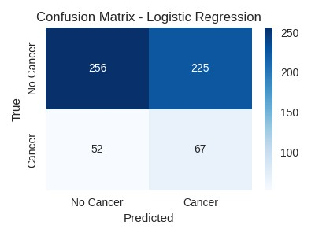

Confusion Matrix – Logistic Regression

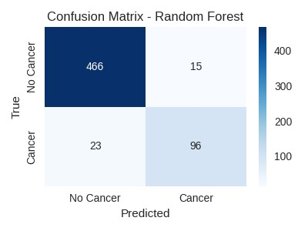

Confusion Matrix – Random Forest

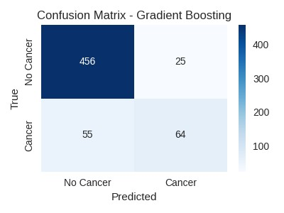

Confusion Matrix – Gradient Boosting
Comparative Summary of Models
Among the top three models, the Optimized Random Forest clearly outperformed the others by achieving the best trade-off between recall and precision. It successfully identified the majority of cancer cases (high recall) while keeping false positives to a minimum (high precision), making it highly reliable for early detection. Gradient Boosting also performed strongly, particularly in recall, but introduced slightly more false positives. The Voting Ensemble delivered stable and consistent results by combining the strengths of multiple models, though its performance was marginally lower than the optimized Random Forest. Overall, the Optimized Random Forest stands out as the most effective and clinically applicable model for deployment.

Results and Comparative Analysis

Sprint 2 (Baseline)
- Accuracy ≈ 80–81% (misleadingly high).
- Recall ≈ 0.0–0.03 → models failed to identify cancer.
- AUC ≈ 0.50–0.55 → close to random guessing.
- F1 ≈ 0.0 for most models.

Sprint 3 (Final Optimized)
Best Model: Optimized Random Forest
- Accuracy: 94.7%
- Precision: 93.9%
- Recall: 78.2%
- F1 Score: 85.3%
- AUC: 95.5%

Comparative Table

Model | Sprint 2 F1 | Final F1 | Sprint 2 Recall | Final Recall | Sprint 2 AUC | Final AUC
Logistic Regression | 0.000 | 0.326 | 0.000 | 0.563 | 0.523 | 0.541
Random Forest | 0.039 | 0.835 | 0.021 | 0.807 | 0.540 | 0.963
Gradient Boosting | 0.032 | 0.615 | 0.018 | 0.538 | 0.522 | 0.856
SVM | 0.000 | 0.308 | 0.000 | 0.437 | 0.522 | 0.579
KNN | 0.052 | 0.507 | 0.032 | 0.622 | 0.498 | 0.744
Optimized RF | – | 0.853 | – | 0.782 | – | 0.955

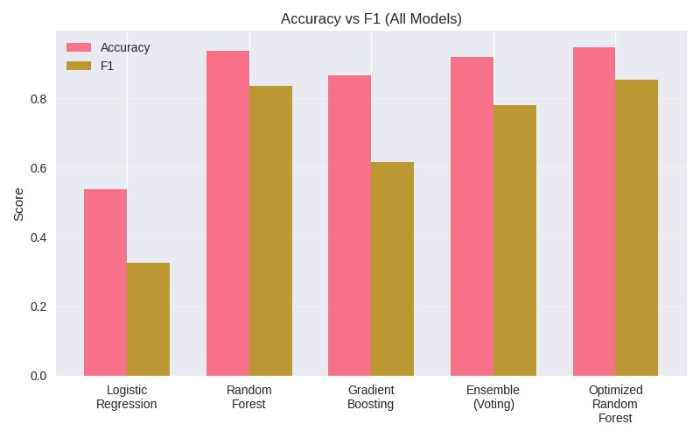

Accuracy vs F1 Comparison Chart

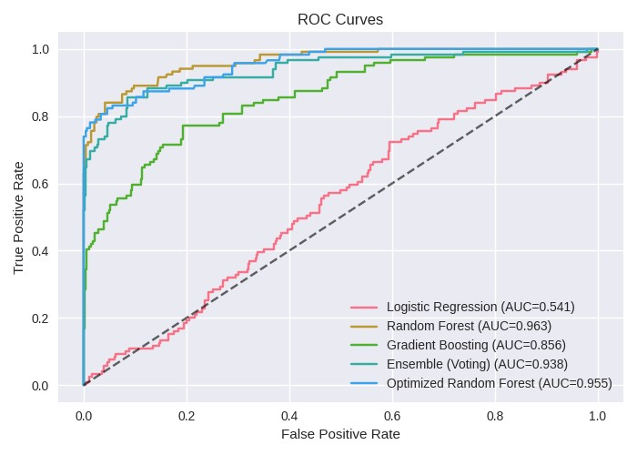
ROC Curves

Confusion Matrix & Error Analysis

Confusion Matrix – Optimized Random Forest:
- True Positives (Cancer correctly identified): 93
- False Negatives (Missed cancer cases): 26
- True Negatives (Correctly “No Cancer”): 475
- False Positives (Incorrect cancer prediction): 6

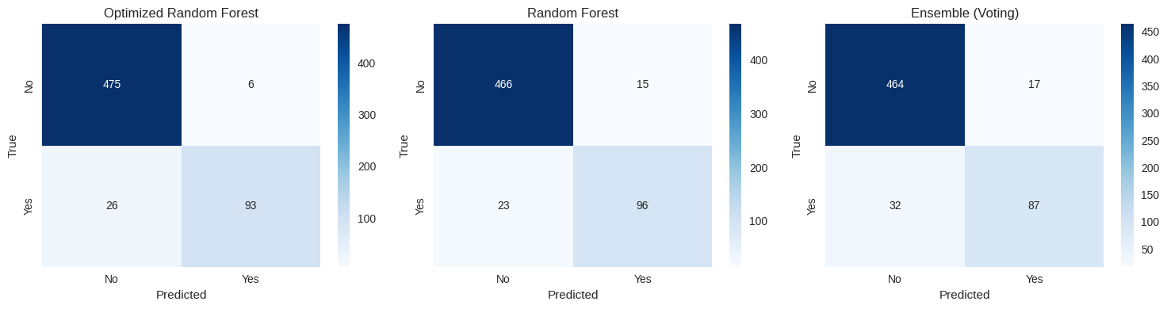

Confusion Matrix – Optimized Random Forest

Clinical Implications
- False Negatives (26 cases): The most critical error type, as missed cancer diagnoses can delay treatment.
- False Positives (6 cases): Less critical but may cause unnecessary further testing.
- Compared to Sprint 2, where nearly all cancer cases were missed, Sprint 3 drastically reduces false negatives while maintaining high precision.

Feature Importance & Insights
- Tree-based models (RF, GB) revealed top predictors for cancer risk.
- Interaction features added extra predictive power.

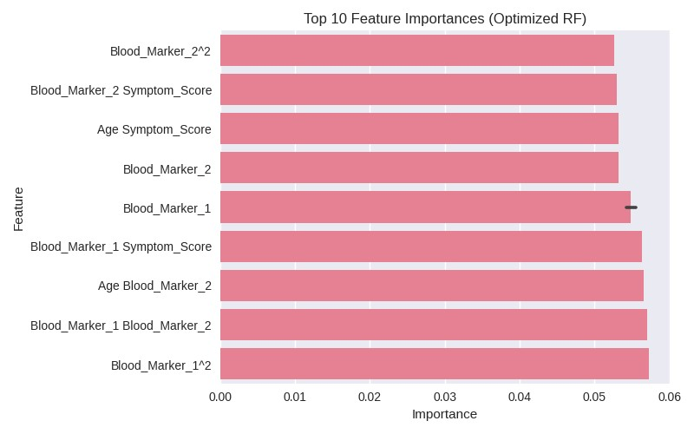

Top 10 Feature Importance

Interpretation & Discussion
Key findings from Sprint 3:
- Balanced learning achieved: SMOTE prevented bias toward the majority class.
- Hyperparameter tuning enhanced each model’s ability to generalize.
- Voting ensemble stabilized predictions by combining strengths of multiple models.
- Optimized Random Forest emerged as the best candidate with superior recall and AUC.

Sprint 2 vs Sprint 3 Differences:
- Sprint 2: High accuracy but unusable due to zero recall.
- Sprint 3: High accuracy and high recall, making predictions clinically meaningful.
- AUC jumped from ~0.52 to ~0.95, proving strong separation between classes.
- Sprint 2 highlighted the pitfall of accuracy as a misleading metric under imbalance.
- Sprint 3 achieved balanced performance with high recall, precision, and AUC.

Visualizations & Interpretations

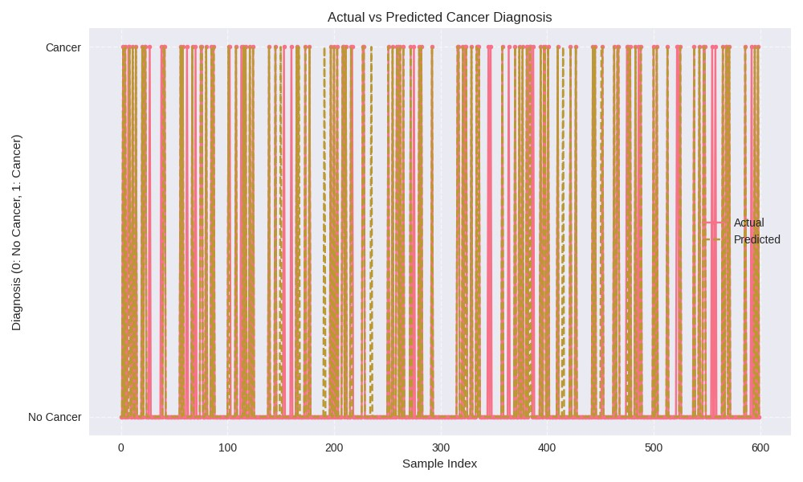

Prediction Visualization

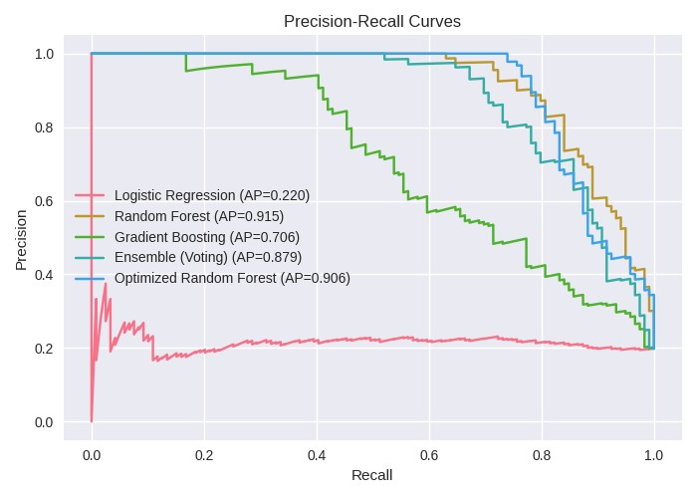

Precision-Recall Curves for All Selected Models

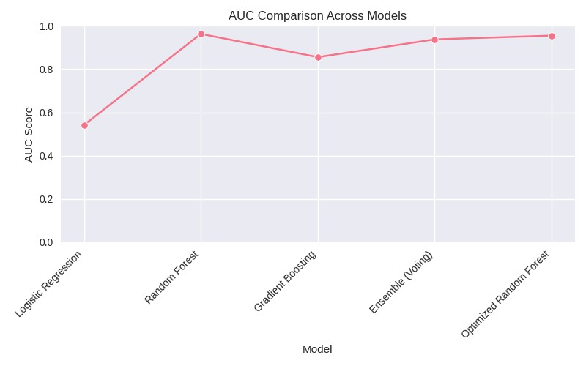

AUC Comparison Line Chart

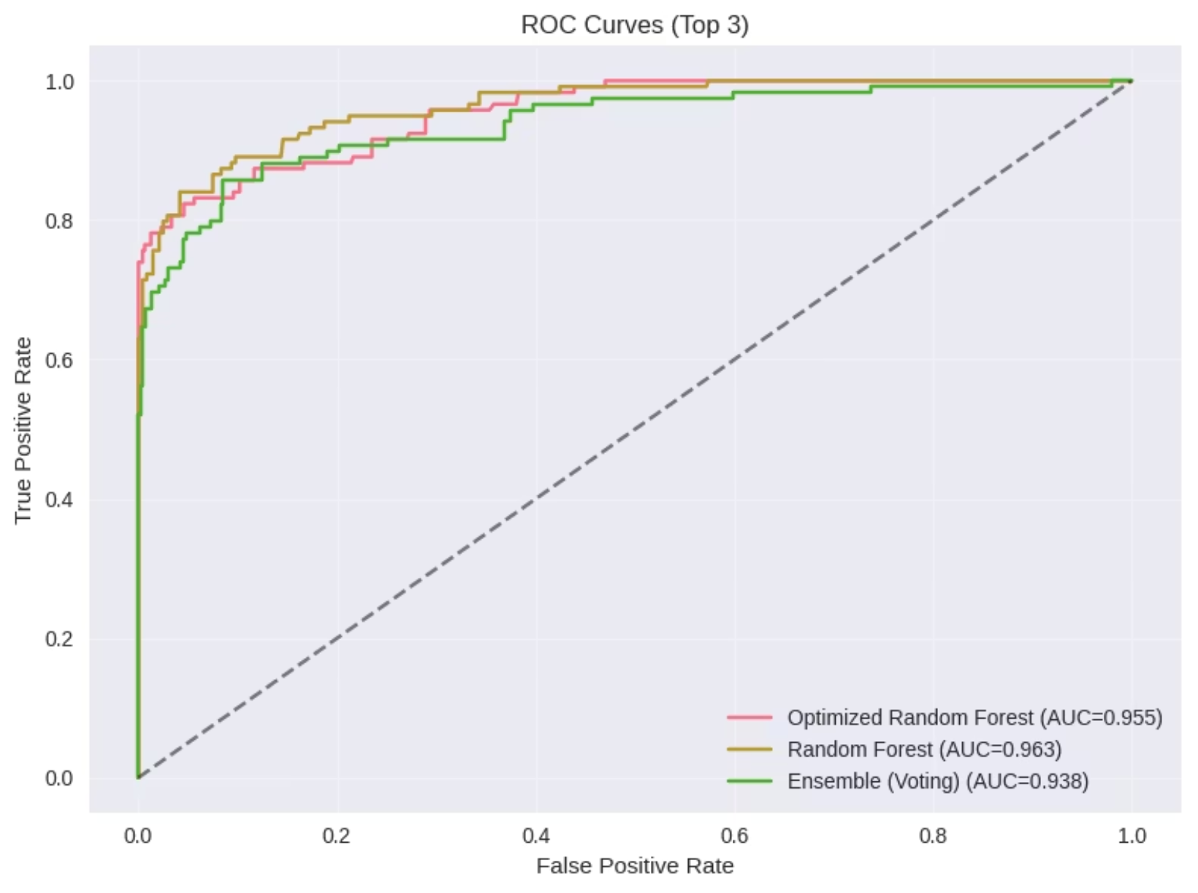

ROC Curves for Top 3 Models

Conclusion
The Optimized Random Forest model demonstrates strong potential for deployment, achieving:
- ~95% accuracy
- ~78% recall (sensitivity)
- ~85% F1 score
- ~95% AUC
Unlike Sprint 2, the model is now reliable for real-world screening.
Deployment readiness: The Optimized Random Forest can be considered a production candidate.

