

**VIRGINIA COMMONWEALTH UNIVERSITY**

**Statistical analysis and modeling (SCMA 632)**

**A5: Visualization - Perceptual Mapping for Business.**

**SAMPREETH S SHETTY**

**V01107634**

**Date of Submission: 15-07-2024**

**CONTENTS**

|  |  |  |
| --- | --- | --- |
| **Sl. No.** | **Title** | **Page No.** |
| **1.** | Introduction | **1** |
| **2.** | Objectives | **1** |
| **3.** | Business Significance | **1** |
| **4.** | Results and Interpretation in R | **2-9** |
| **5.** | Results and Interpretation in Python | **10-11** |
| **6.** | Recommendations and conclusion | **12-13** |

**Introduction**

The NSSO (National Sample Survey Office) collected the dataset used in this project. The National Sample Survey Office (NSSO), headed by a Director General, is India’s premier data collection agency responsible for conducting large-scale sample surveys across diverse fields on an all-India basis. The NSSO is involved in significant surveys such as Socio-economic Surveys, Annual Surveys of Industries, and Agricultural Surveys. It takes full responsibility for the socio-economic survey from its design to the release of survey reports and collects field data for other surveys. The data collected through nationwide household surveys cover various socio-economic subjects, including housing conditions and basic amenities like drinking water, bathrooms, sewerage, lavatories, lighting, and more.

The particular data set in hand deals with the consumption of products, mainly food products, by the households of India. The households can be categorized based on the state and whether they belong to the rural or the urban sector.

The state that was assigned was Uttar Pradesh. The data was cleaned, and only the data of Uttar Pradesh was taken for analysis. The null values after viewing were imputed with the mean values of the variable, the variables with a considerably more significant null value were dropped, and the only variable whose null values were imputed was ‘Meals_AT_Home.’

**Objectives**

* To analyze the distribution of the total consumption across different districts in Uttar Pradesh.
* To visualize the consumption patterns per district with district names.
* To map a specific variable of interest on the Uttar Pradesh state map.
* To provide actionable insights based on the analysis for better decision-making.

**Business Significance**

Visualization, particularly perceptual mapping, holds significant business value as it visually represents how consumers perceive various brands, products, or services within a specific market. By plotting these perceptions on a two-dimensional grid, businesses can quickly identify competitive positioning, uncover market gaps, and understand consumer preferences. This visual tool facilitates strategic decision-making by highlighting areas where a company can differentiate itself, optimize its marketing strategies, or innovate to meet unmet needs. Perceptual mapping also aids in tracking changes in consumer perceptions over time, enabling businesses to adapt proactively to market dynamics. Perceptual mapping enhances a company's ability to align its offerings with consumer expectations, driving better customer satisfaction and competitive advantage.

**Results and Interpretation in R**

1. Histogram of Total Consumption Across different districts of UP

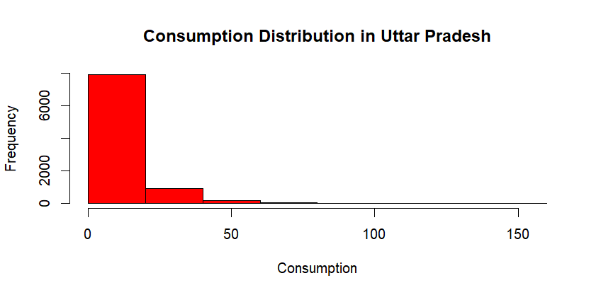

The histogram suggests a high frequency at low consumption. As the consumption increases, the frequency of the observation sharply decreases, indicating that higher consumption levels are much less common. The histogram is right-skewed, meaning most data points are concentrated on the left side, with a long tail extending to the right.

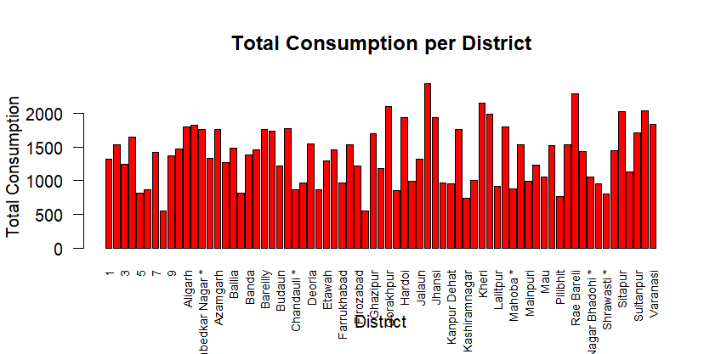

The bar plot suggests no drastic differences between the consumption levels across the state's districts.

|  | **District** | **total_consumption** |
| --- | --- | --- |
|  |  |  |
| **1** | 1 | 1323.4529 |
| **2** | 2 | 1526.9603 |
| **3** | 3 | 1246.6620 |
| **4** | 4 | 1643.0603 |
| **5** | 5 | 820.3324 |
| **6** | 6 | 869.4083 |
| **7** | 7 | 1425.1838 |
| **8** | 8 | 556.4580 |
| **9** | 9 | 1369.8996 |
| **10** | Agra | 1474.7513 |
| **11** | Aligarh | 1790.8586 |
| **12** | Allahabad | 1824.6012 |
| **13** | Ambedkar Nagar * | 1753.0909 |
| **14** | Auraiya * | 1333.1789 |
| **15** | Azamgarh | 1755.6274 |
| **16** | Bahraich | 1274.8595 |
| **17** | Ballia | 1487.5866 |
| **18** | Balrampur * | 819.8265 |
| **19** | Banda | 1385.5542 |
| **20** | Barabanki | 1455.0278 |
| **21** | Bareilly | 1763.7083 |
| **22** | Basti | 1738.4398 |
| **23** | Budaun | 1213.5654 |
| **24** | Bulandshahar | 1766.3287 |
| **25** | Chandauli * | 873.4860 |
| **26** | Chitrakoot * | 973.1948 |
| **27** | Deoria | 1547.6721 |
| **28** | Etah | 867.1361 |
| **29** | Etawah | 1299.2615 |
| **30** | Faizabad | 1455.2204 |
| **31** | Farrukhabad | 965.2729 |
| **32** | Fatehpur | 1536.0801 |
| **33** | Firozabad | 1220.4787 |
| **34** | Gautam Buddha Nagar * | 550.1271 |
| **35** | Ghazipur | 1693.2956 |
| **36** | Gonda | 1176.7358 |
| **37** | Gorakhpur | 2092.7989 |
| **38** | Hamirpur | 854.0724 |
| **39** | Hardoi | 1929.8680 |
| **40** | Hathras * | 992.5084 |
| **41** | Jalaun | 1314.5576 |
| **42** | Jaunpur | 2436.8556 |
| **43** | Jhansi | 1939.6731 |
| **44** | Kannauj * | 971.7455 |
| **45** | Kanpur Dehat | 950.9865 |
| **46** | Kanpur Nagar | 1753.9841 |
| **47** | Kashiramnagar | 742.9392 |
| **48** | Kaushambi * | 1007.5615 |
| **49** | Kheri | 2150.1705 |
| **50** | Kushinagar * | 1986.1962 |
| **51** | Lalitpur | 911.8348 |
| **52** | Lucknow | 1799.3589 |
| **53** | Mahoba * | 885.3589 |
| **54** | Mahrajganj | 1535.6026 |
| **55** | Mainpuri | 997.6432 |
| **56** | Mathura | 1225.3029 |
| **57** | Mau | 1058.9130 |
| **58** | Mirzapur | 1516.7403 |
| **59** | Pilibhit | 771.4963 |
| **60** | Pratapgarh | 1526.1330 |
| **61** | Rae Bareli | 2285.3132 |
| **62** | Sant Kabir Nagar * | 1433.4619 |
| **63** | Sant Ravidas Nagar Bhadohi * | 1049.7687 |
| **64** | Shahjahanpur | 952.4278 |
| **65** | Shrawasti * | 808.5572 |
| **66** | Siddharthnagar | 1441.0583 |
| **67** | Sitapur | 2020.3341 |
| **68** | Sonbhadra | 1133.2586 |
| **69** | Sultanpur | 1710.7458 |
| **70** | Unnao | 2037.8909 |
| **71** | Varanasi | 1838.3644 |

Showing 1 to 15 of 71 entries, 2 total columns

The above table consists of all the district wise total consumption.

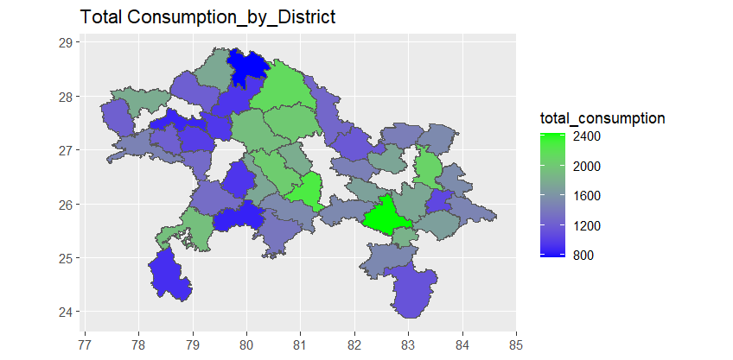

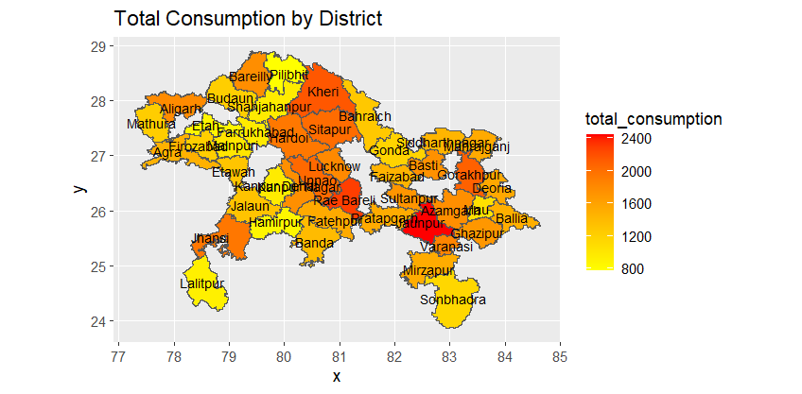

The above heat map signifies the total consumption across the districts of Uttar Pradesh.

**Results and Interpretation in Python**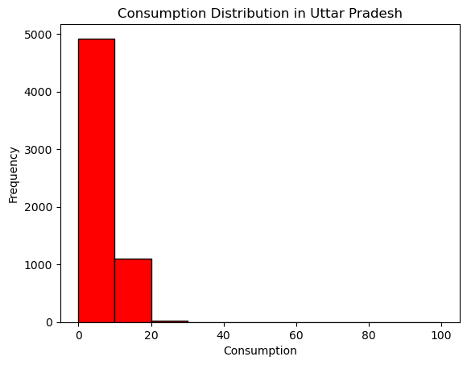

The histogram suggests a high frequency at low consumption. As the consumption increases, the observation frequency sharply decreases, indicating that higher consumption levels are much less common. The histogram is right-skewed, meaning most data points are concentrated on the left side, with a long tail extending to the right.

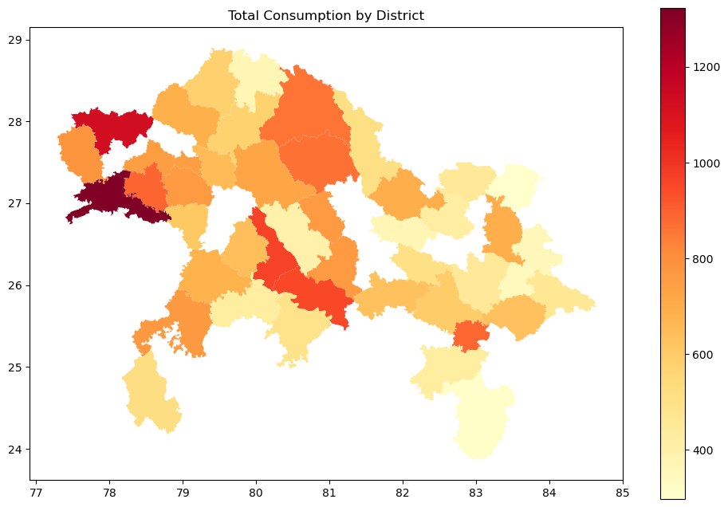

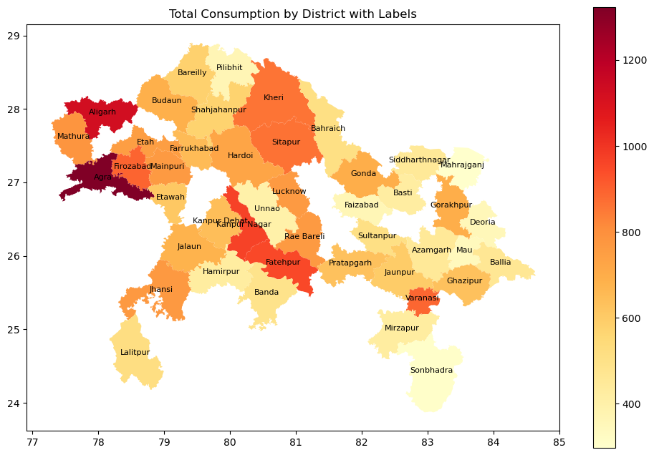

**Recommendations**

Based on the consumption pattern analysis of Uttar Pradesh, recommendations that can be made to improve food security, business operations, and policy effectiveness:

**Targeted Nutritional Programs:**

Implement targeted nutritional programs in districts with low consumption levels to address potential food security issues. These programs should provide essential food items and educate residents about balanced diets.

**Strategic Marketing and Supply Chain Adjustments:**

Based on consumption patterns, businesses should adjust their marketing strategies and supply chain logistics. High-consumption districts can be targeted for promotional activities, while low-consumption areas might need improved distribution channels to increase product availability.

**Enhanced Inventory Management:**

Use consumption data to optimize inventory management. By understanding which products are in high demand in specific districts, businesses can reduce waste and ensure that popular items are always in stock.

**Regional Product Customization:**

Develop and market products tailored to regional preferences. For example, if a particular district shows a higher rice consumption, companies can introduce rice-based products that cater to local tastes.

**Policy Interventions for Food Scarcity:**

Policymakers should investigate underlying causes such as food scarcity or economic constraints for districts identified as outliers with low consumption. Interventions could include subsidies, food aid programs, or economic development initiatives.

**Improved Distribution Networks:**

Strengthen the distribution networks in remote or low-consumption areas to ensure consistent and reliable access to food products. This might involve improving infrastructure such as roads and storage facilities.

**Conclusion**

This analysis of the NSSO68 data for Uttar Pradesh provides critical insights into the consumption patterns across districts. By understanding these patterns, businesses and policymakers can make informed decisions that promote better food security, efficient resource allocation, and economic development. The visualizations and geographical mapping further enhance the comprehension of the data, making it easier to identify trends and outliers. Continuous analysis and adaptation are essential for sustaining these efforts and achieving long-term benefits.