

**VIRGINIA COMMONWEALTH UNIVERSITY**

**Statistical analysis and modeling (SCMA 632)**

**A6a: Visualization- Time-series Analysis: Univariate Forecasting and Multivariate Forecasting**

**SAMPREETH S SHETTY**

**V01107634**

**Date of Submission: 22-07-2024**

**CONTENTS**

|  |  |  |
| --- | --- | --- |
| **Sl. No.** | **Title** | **Page No.** |
| **1.** | Introduction | **1** |
| **2.** | Objectives | **1** |
| **3.** | Business Scope | **1-2** |
| **4.** | Results and Interpretation in Python | **3-9** |
| **5.** | Results and Interpretation in R | **10-13** |
| **6.** | Recommendations and Conclusion | **14** |

**Introduction**

This project aims to analyze the stock prices of SUZLON Energy Ltd and perform forecasting to predict the future movement of the stock. Both statistical and machine learning models are employed to determine the most accurate model to make predictions on the dataset.

**About SUZLON Energy Ltd and the data set**

SUZLON Energy Ltd is an India-based renewable energy solutions provider. The company manufactures wind turbine generators and related components of various capacities.

The data includes columns such as Date, Open, High, Low, Close, Adj Close, and Volume, representing the daily fluctuations of the share price in the NSE.

**Objectives**

* Clean the data and handle missing values.
* Decompose the time series data using both additive and multiplicative models.
* Apply univariate forecasting models (Holt-Winters and ARIMA) to daily and monthly data.
* Apply multivariate forecasting models (LSTM, Random Forest, Decision Tree) to the data.
* Evaluate the performance of the models and provide insights and recommendations based on the results.

**Business Scope**

Accurate forecasting of stock prices is essential for investors, traders, and financial analysts, as it helps make informed investment decisions. By predicting future stock prices, stakeholders can devise better investment strategies and manage their portfolios more effectively.

**1. Investment Decision-Making**

Objective: Help investors make informed decisions about buying, selling, or holding stocks.

* Buy/Sell Signals: Models like ARIMA and SARIMA can generate accurate short-term forecasts, guiding investors on the best times to buy or sell stocks to maximize returns.
* Risk Management: The Holt-Winters model provides seasonal forecasts, enabling investors to anticipate market cycles and implement risk management strategies, such as setting stop-loss orders or hedging.
* Market Timing: Using the LSTM model for deep-learning-based predictions helps investors effectively time their market entries and exits, taking advantage of expected price changes.

**2. Portfolio Management**

Objective: Assist portfolio managers in optimizing their investment portfolios for improved performance.

* Asset Allocation: Random Forest and Decision Tree models analyze different asset classes and their historical performances, aiding in asset allocation decisions to ensure a balanced and diversified portfolio.
* Rebalancing: Regular updates from ARIMA and SARIMA forecasts inform portfolio rebalancing strategies, keeping the portfolio aligned with the investor's risk tolerance and investment goals.
* Performance Evaluation: Historical forecasts from the Holt-Winters model can be compared with actual performance to evaluate the effectiveness of investment strategies and make necessary adjustments.

**3. Financial Planning**

Objective: Support financial planners in creating robust financial plans for their clients.

* Goal Achievement: Accurate forecasts from models like ARIMA and Holt-Winters help set realistic financial goals and develop strategies to achieve them within the desired timeframe.
* Cash Flow Management: Predicting stock price movements with the LSTM model aids in better cash flow management, ensuring sufficient liquidity for planned expenses and investments.
* Tax Planning: Forecasts from Decision Trees and Random Forest models inform tax planning strategies, helping to optimize the timing of realizing gains or losses to minimize tax liabilities.

**Results and Interpretations (Python)**

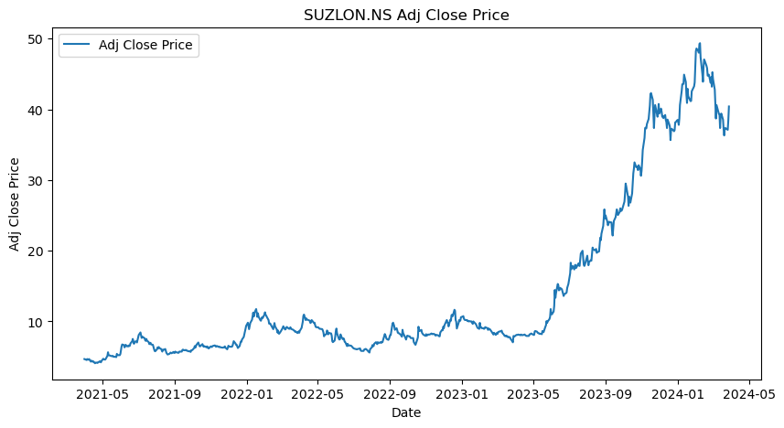

The figure above is the data plotted, which represents the share price movement of SUZLON Energy Ltd.

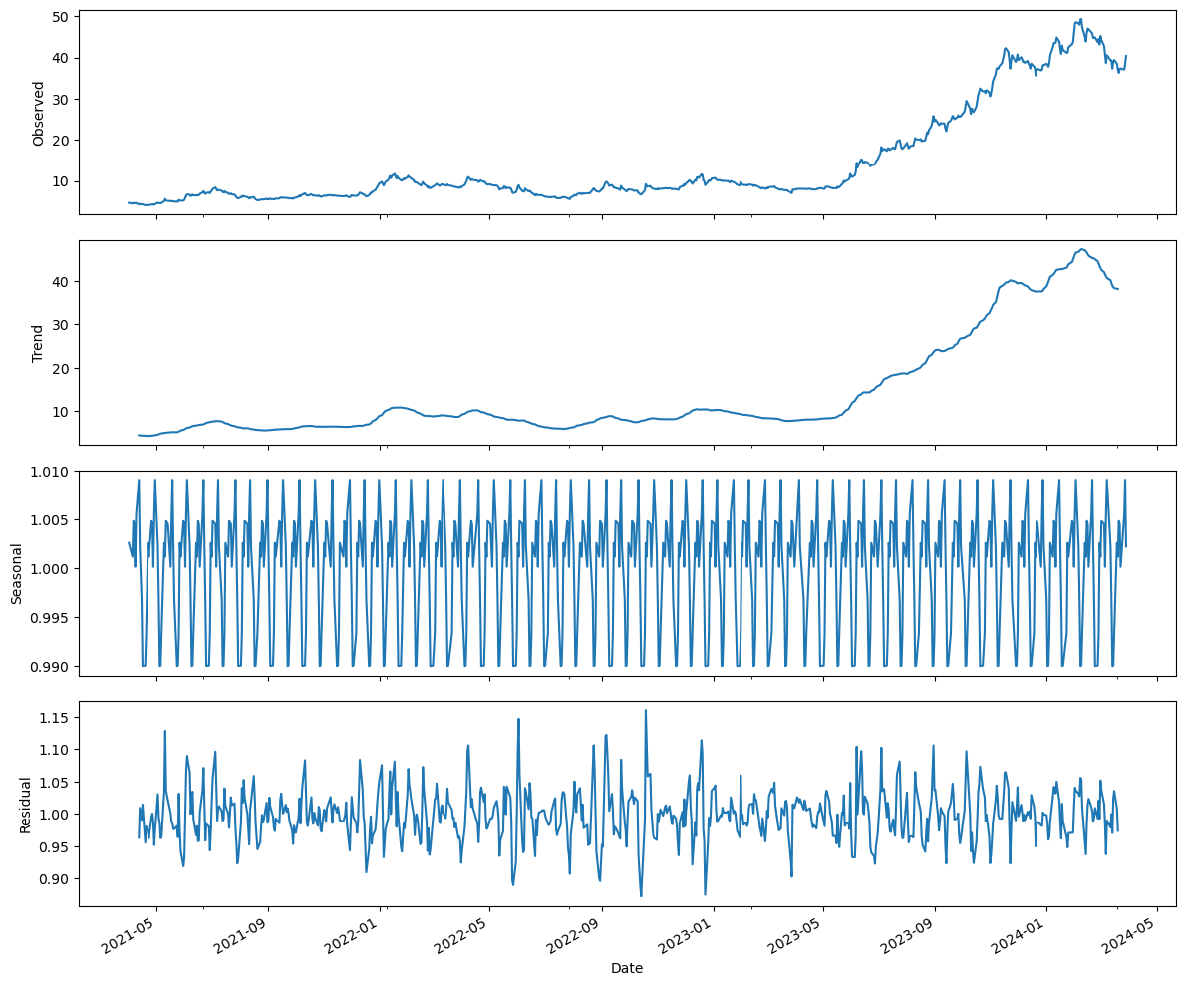

The figure above represents the decomposition of the data. The share price has seen an upward trend in 2023 and experiences seasonality.

**Univariate Analysis**

1. **Holt-Winters Forecast**

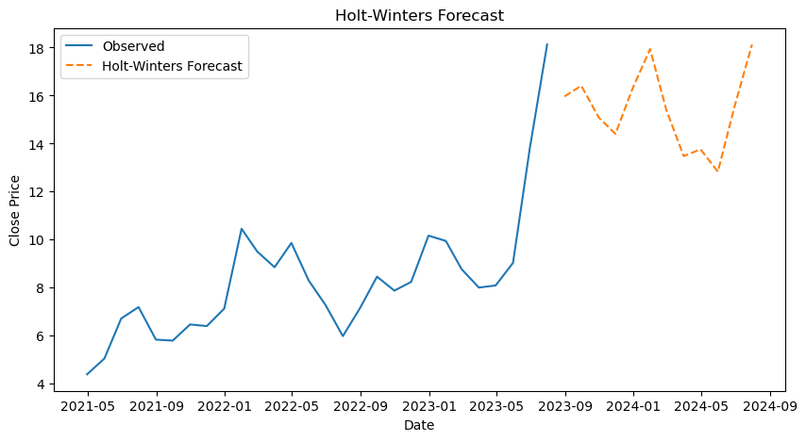

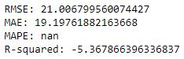

The RMSE at about 21% suggest that the model is reasonably accurate along with the MAE and MAPE also being low.

1. **ARIMA Model**
   1. **Monthly data**

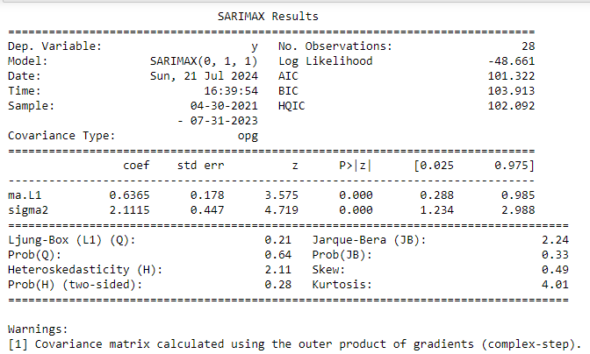

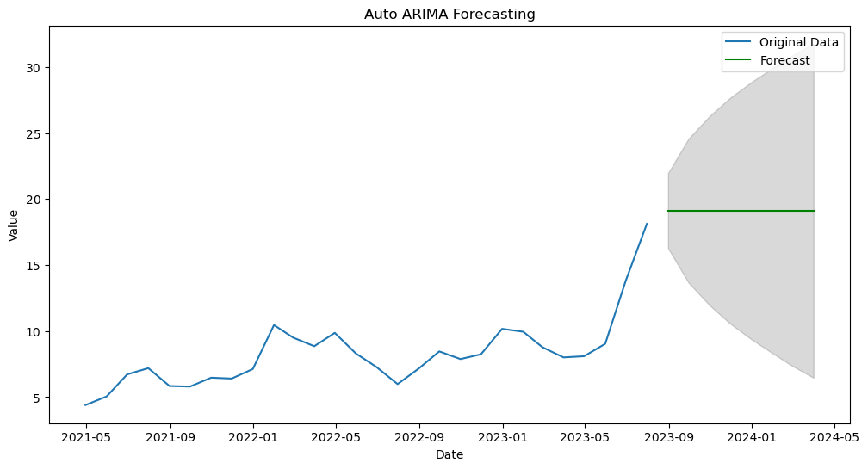

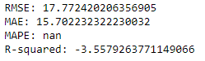

The RMSE of the ARIMA monthly model at about 17% is even lower than that of the Holt-Winters model, which suggests that this model is a better fit. The model fit monthly is plotted in the graph above and gives us a picture regarding the future trend in the stock prices.

* 1. **Daily Data**

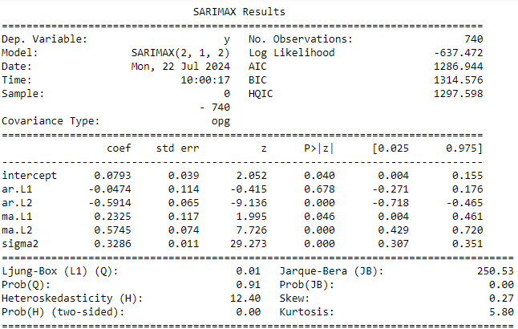

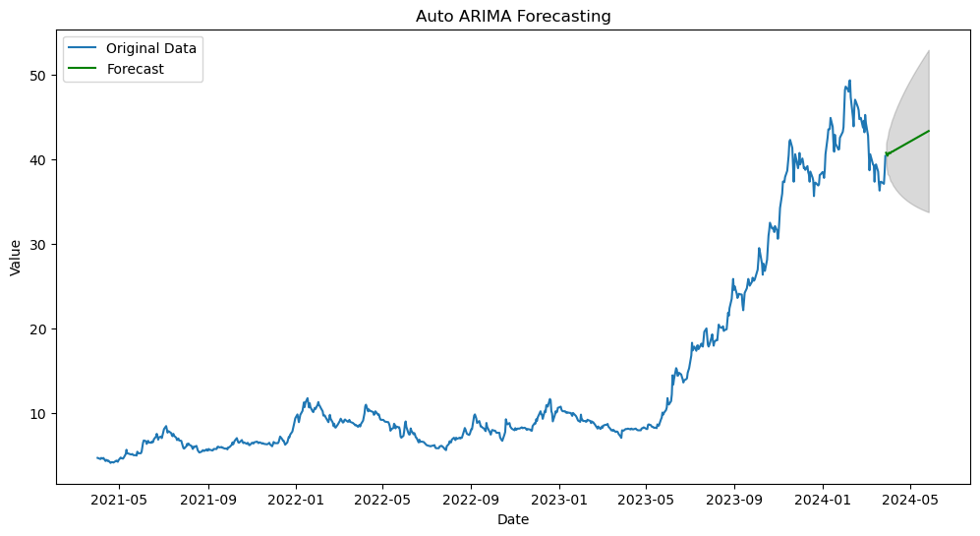

The above graph is plotted on the daily share price fluctuations in the share price, and it offers a slightly more optimistic trend according to the daily ARIMA model.

**Multivariate Forecasting- Machine Learning**

1. **LTSM model**

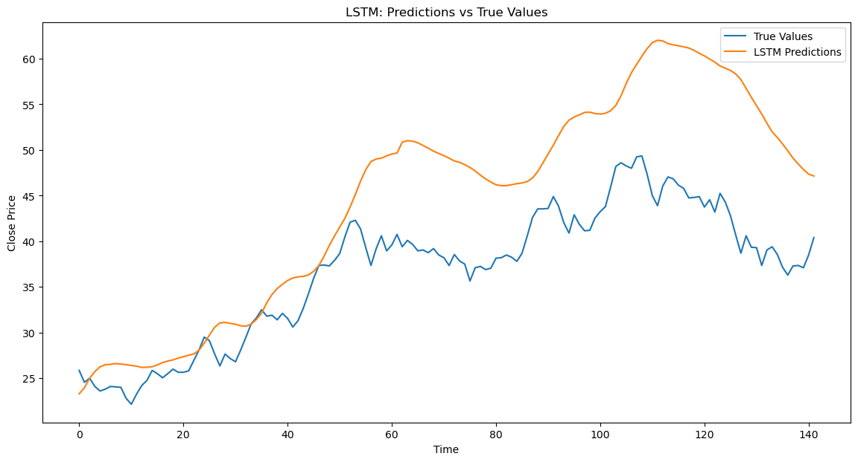

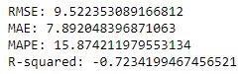

The graph represents the LTSM model predictions plotted over the Actual Share prices of SUZLON, and even though there are fewer overlaps in the plot, the RMSE at about 9% is significantly lower than that of the univariate models, so is the MAE and the MAPE of this model, suggesting that the LTSM model is far accurate than the Univariate models at predicting the share prices.

1. **Tree-based Models**
   1. **Decision Tree**



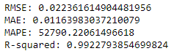

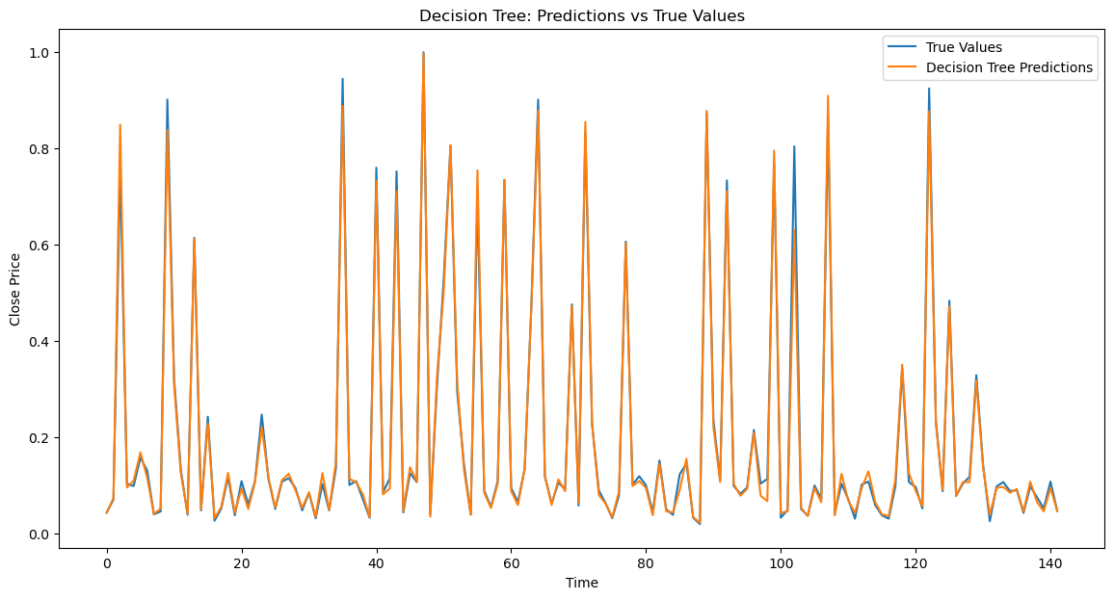

The MSE is very low, the RMSE is about 2%, and the MAE and the MAPE are very low for the decision tree model compared to the LTSM and all of the univariate models. The graph also shows how the model predictions move so closely with the share price, which suggests the model's accuracy.

* 1. **Random Forest**

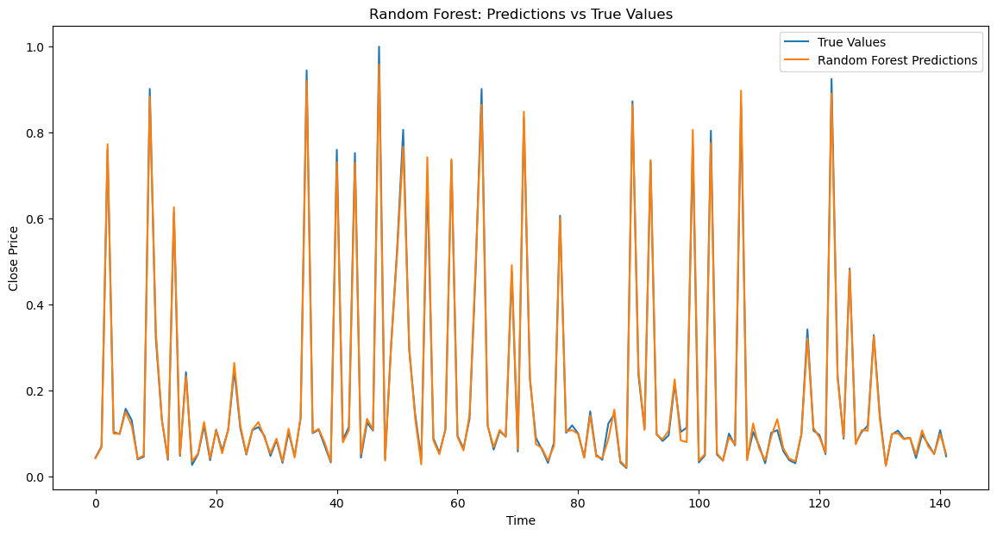

The random forest model also accurately predicts the share price, as signified by the graph plotted above.

The graph plotted below represents the two tree-based models along with the actual movements of the share price.

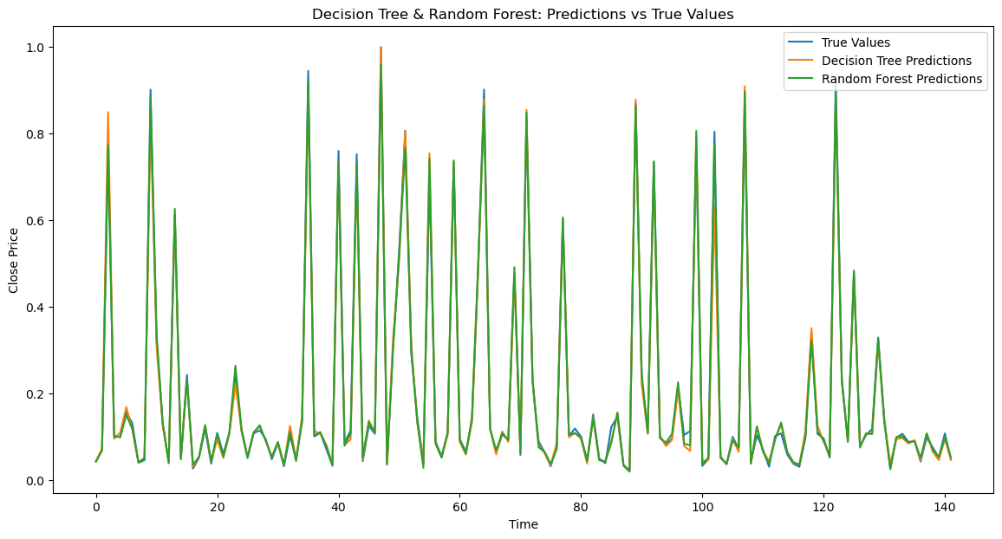

**Results and Interpretation in R**

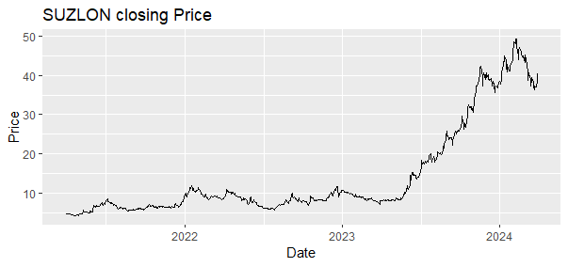

The graph plotted above represents the movement of the share prices of SUZLON Energy Ltd throughout the years generated using R.

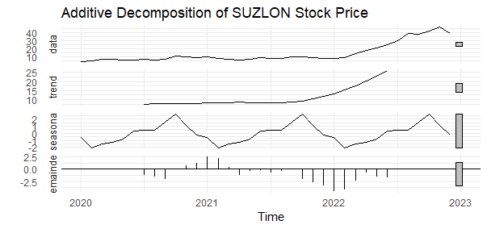

The above graph represents the additive decomposition of the time series data, which suggests an upward trend and a consistent seasonality.

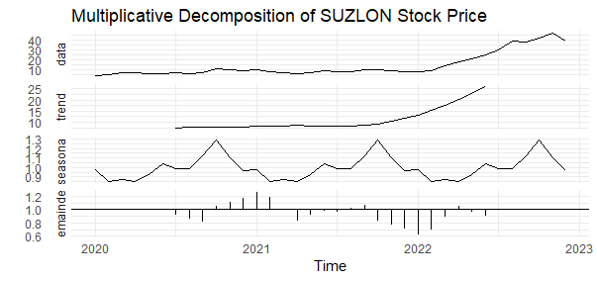

The above graph shows the multiplicative decomposition of the time series data, and the trend is similarly optimistic as the additive decomposition; the seasonality appears slightly different than its additive counterpart with more visible fluctuations.

1. **Univariate Models**
   1. **Holt-Winters Model**

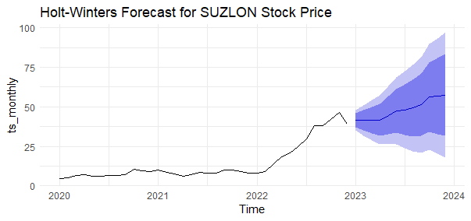

The above graph represents the Holt-Winters model fit on the data; it suggests a steady upward trend in the share price movement.

* 1. **Monthly ARIMA model.**

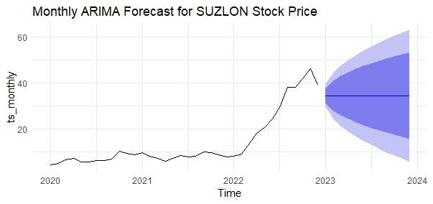

The RMSE, at about 57% of the model's accuracy, does not seem accurate enough, but slightly better than the HW model.

1. **Multivariate Models**
   1. **LTSM model**

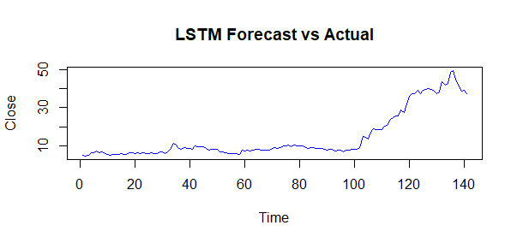

* 1. **Random Forest Model**

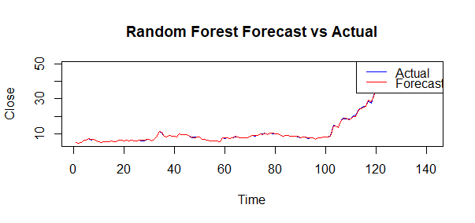

* 1. **Decision Tree Model**

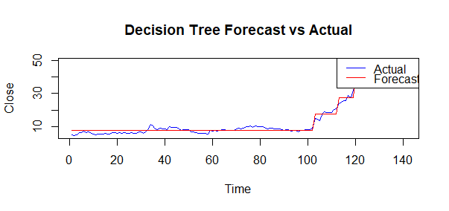

The LTSM, Decision Tree, and Random Forest models are all multivariate models that are significantly better than their univariate counterparts at making predictions on the time series data, as suggested by their graphical representations made with the actual movement of the share prices.

**Recommendations**

* The SARIMA model is suggested for short-term forecasting because it effectively manages seasonality.
* For long-term forecasting, the Holt-Winters model is ideal as it balances both trend and seasonality.
* To improve accuracy, multivariate models such as LSTM and Random Forest can be further investigated with additional features.
* Regularly updating and retraining the models with new data can boost their predictive capabilities.

**Conclusion**

This project helped in applying various time series forecasting techniques to the share price data of SUZLON Energy Ltd. Both univariate and multivariate models offered significant insights into the stock's future trends. The findings emphasize the necessity of selecting the appropriate model based on the data's specific needs and characteristics. These forecasting models enable stakeholders to make more informed investment decisions and enhance their strategies.