

**VIRGINIA COMMONWEALTH UNIVERSITY**

**Statistical analysis and modeling (SCMA 632)**

**A6b: Time Series Analysis (Multivariate)**

**SAMPREETH S SHETTY**

**V01107634**

**Date of Submission: 25-07-2024**

**CONTENTS**

|  |  |  |
| --- | --- | --- |
| **Sl. No.** | **Title** | **Page No.** |
| **1.** | Introduction | **1** |
| **2.** | Business Applications | **1-2** |
| **3.** | Part A Results and Interpretations (Python) | **3-4** |
| **4.** | Part A Results and Interpretations (R) | **5-6** |
| **5.** | Part B Results and Interpretations (Python) | **7-8** |
| **6.** | Part B Results and Interpretations (R) | **9** |
| **7.** | Conclusion | **10** |

**Introduction**

**Vector Error Correction Model (VECM)**

**Overview**

The Vector Error Correction Model (VECM) is a type of econometric model used to analyze the long-run and short-run dynamics of multivariate time series data that are cointegrated. Cointegration indicates a long-term equilibrium relationship among multiple time series, despite short-term deviations. The VECM extends the Vector Autoregression (VAR) model by incorporating cointegration relationships, making it suitable for non-stationary data.

**Key Features**

* **Long-Run Equilibrium:** VECM includes error correction terms that capture the long-term equilibrium relationships among the variables.
* **Short-Run Dynamics:** It also models the short-term dynamics, capturing how variables adjust to deviations from the long-term equilibrium.
* **Multivariate Approach:** VECM can handle multiple interrelated time series simultaneously, making it useful for analyzing complex economic systems.

**Business Applications**

* **Macroeconomic Analysis:** VECM is widely used to study relationships among macroeconomic variables like GDP, inflation, interest rates, and exchange rates.
* **Financial Markets:** It helps in understanding the dynamics between different financial instruments, such as stocks, bonds, and interest rates.
* **Policy Analysis:** VECM assists policymakers in evaluating the impact of policy changes on the economy by analyzing how different variables interact over time.

**Generalized Autoregressive Conditional Heteroskedasticity (GARCH) Model**

**Overview**

The Generalized Autoregressive Conditional Heteroskedasticity (GARCH) model is used to model and forecast time series data with time-varying volatility. It extends the ARCH model by allowing the conditional variance to depend not only on past squared observations but also on past conditional variances. This makes GARCH particularly suitable for financial time series, which often exhibit volatility clustering—periods of high volatility followed by periods of low volatility.

**Key Features**

* **Volatility Clustering:** GARCH models capture the phenomenon where large changes in a time series are likely to be followed by large changes (of either sign), and small changes by small changes.
* **Conditional Variance:** It models the variance of the current error term as a function of past errors and past variances.
* **Flexibility:** GARCH can be extended to include more lags (GARCH(p,q)), asymmetric effects (EGARCH, GJR-GARCH), and different distributions of errors.

**Business Applications**

* **Risk Management:** GARCH models are extensively used in financial risk management to estimate Value at Risk (VaR) and forecast future volatility.
* **Option Pricing:** Volatility forecasts from GARCH models are used in the pricing of options and other derivative securities.
* **Portfolio Management:** Portfolio managers use GARCH models to optimize asset allocation by forecasting different asset risk and return profiles.
* **Market Analysis:** Analysts use GARCH models to study the impact of news and events on market volatility and to understand the behavior of asset returns.

**Part A**

**Results and interpretation (Python)**

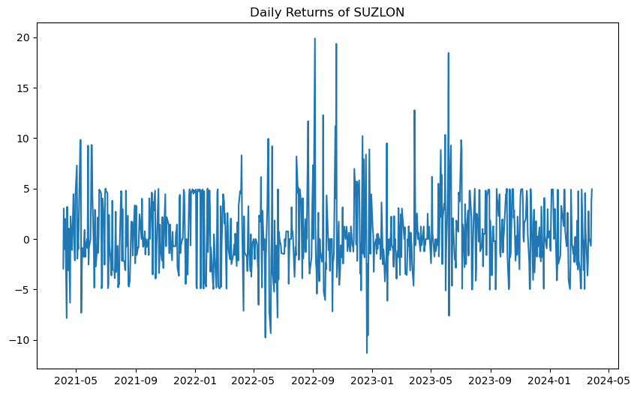

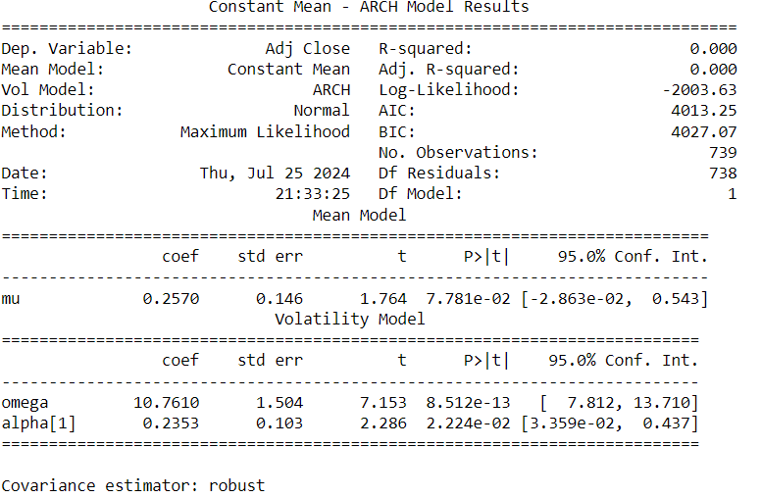

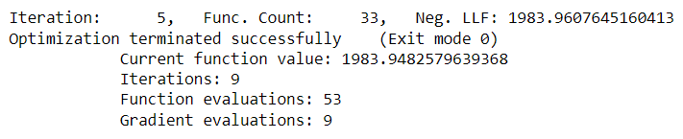

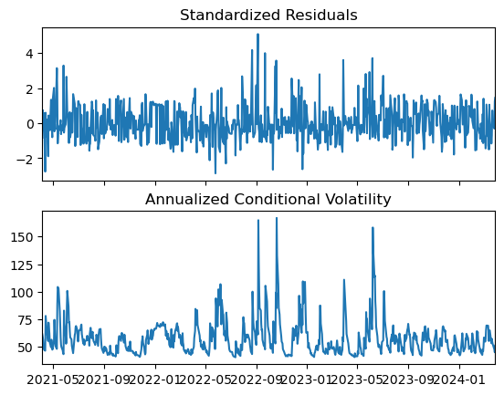

The first plot shows the daily returns of SUZLON, revealing periods of varying volatility with notable spikes in returns, particularly around early 2022 and mid-2022. The second set of plots includes the standardized residuals and the annualized conditional volatility from the fitted GARCH model. The standardized residuals appear relatively stable, with no significant autocorrelation, indicating that the GARCH model effectively captures the volatility clustering in the returns. The annualized conditional volatility plot demonstrates high volatility periods corresponding to the return plot spikes. This analysis suggests that the GARCH model has successfully modelled the volatility dynamics of SUZLON's daily returns, capturing both stable and volatile periods.

**Results and interpretation in R**

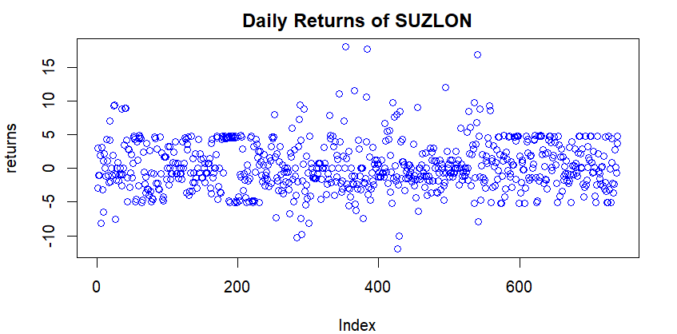

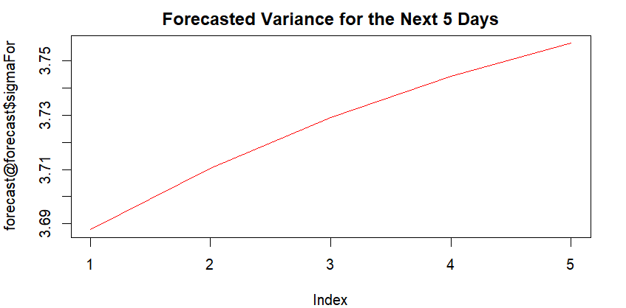

The GARCH model fit results for the SUZLON daily returns indicate a significant volatility clustering effect, captured by the parameters α1\alpha_1α1​ and β1\beta_1β1​, both statistically significant at conventional levels. The conditional variance dynamics show a steady increase in forecasted variance over the next five days, suggesting rising uncertainty in future returns. The standardized residuals appear free from serial correlation, as indicated by the Weighted Ljung-Box tests. In contrast, the ARCH LM tests confirm no remaining ARCH effects, validating the model's adequacy. The Nyblom stability test suggests that the model's parameters are stable over time. These insights are crucial for financial risk management and investment strategies, highlighting the model's effectiveness in forecasting volatility.

**Part B**

**Results and Interpretation in Python**

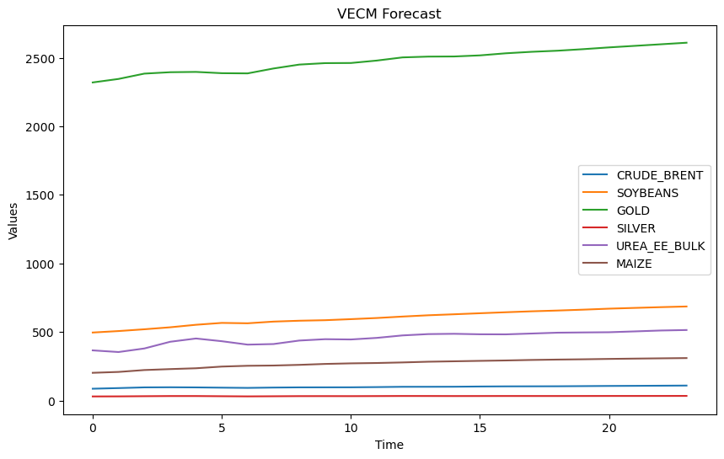

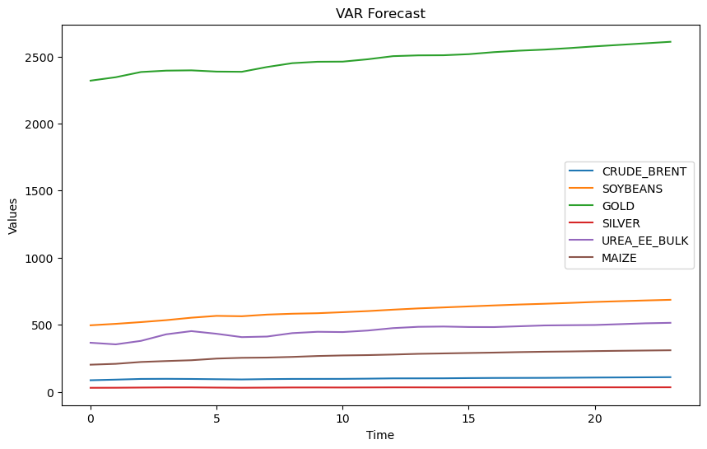

1. **CRUDE_BRENT**: The p-value of 0.53 suggests that we fail to reject the null hypothesis, indicating that the CRUDE_BRENT series is non-stationary.
2. **SOYBEANS**: With a p-value of 0.14, we again fail to reject the null hypothesis, implying non-stationarity for the SOYBEANS series.
3. **GOLD**: The high p-value of 0.99 confirms non-stationarity for the GOLD series.
4. **SILVER**: Similarly, the SILVER series remains non-stationary with a p-value of 0.58.
5. **UREA_EE_BULK**: The p-value of 0.11 indicates non-stationarity for the UREA_EE_BULK series.
6. **MAIZE**: Lastly, the MAIZE series is also non-stationary, as indicated by the p-value of 0.12.

In summary, none of the examined commodities exhibit stationarity based on the ADF test.

**Results and interpretation in R**

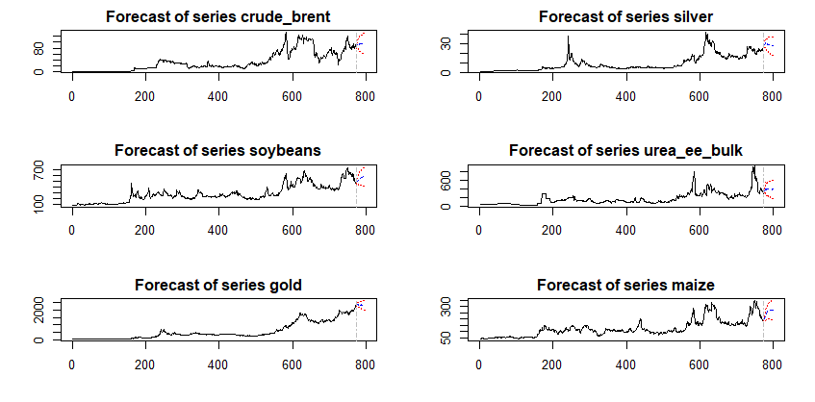

1. **CRUDE_BRENT**: The p-value of 0.53 suggests that we cannot reject the null hypothesis, indicating that the CRUDE_BRENT series is non-stationary.
2. **SOYBEANS**: With a p-value of 0.14, we again fail to reject the null hypothesis, implying non-stationarity for the SOYBEANS series.
3. **GOLD**: The high p-value of 0.99 confirms non-stationarity for the GOLD series.
4. **SILVER**: Similarly, the SILVER series remains non-stationary with a p-value of 0.58.
5. **UREA_EE_BULK**: The p-value of 0.11 indicates non-stationarity for the UREA_EE_BULK series.
6. **MAIZE**: Lastly, the MAIZE series is also non-stationary, as indicated by the p-value of 0.12.

In summary, none of the examined commodities exhibit stationarity based on the ADF test.

**Conclusion:**

ARCH/GARCH Models focus on modeling the variance of time series data, particularly in financial contexts. The ARCH model introduces an error correction term for deviations from equilibrium values. The GARCH extension adds persistence to volatility modeling. These models help understand and predict changing volatility patterns. VECMs, closely related to VAR models, address cointegration. They capture both short-term deviations and long-run equilibrium relationships among variables. VECMs include an error correction term, allowing us to estimate how variables converge to their equilibrium values. These models are valuable for economic analysis and forecasting.