Advanced Excel Project Report
Electricity Bill & Energy Consumption
Analyzer
――――――――――――――――――――――――――――――――――――――――――――――――――――――――――
――――――――――――――――――――――――――――――――――――――――――――――――――――――――――
An Excel-Based Data Analysis and Interactive Dashboard Project
――――――――――――――――――――――――――――――――――――――――――――――――――――――――――

Project Title | Electricity Bill & Energy Consumption Analyzer
Project Duration | 4 Days
Team Member 1 | Harekrishna Adhikary
AF Code 1 | AF05308345
Team Member 2 | Harsha Guchhait
AF Code 2 | AF05310291
Team Member 3 | Samprit Ganguly
AF Code 3 | AF05321198
Trainer Name | Sayan Sau
Submission Date | 28 August 2026
GitHub Username | Samprit01
GitHub Repository | https://github.com/your-username/Electricity-Bill-Energy-Consumption-Analyzer
Submitted By
Harekrishna Adhikary, Harsha Guchhait, Samprit Ganguly
Advanced Excel Data Analysis Project

ELECTRICITY BILL & ENERGY CONSUMPTION ANALYZER
Data Analytics Documentation
Prepared from: Electricity_Bill_Energy_Consumption_Analyzer_Dashboard_V5macroenabled.xlsm
1. Purpose & Scope
This document describes the Electricity Bill & Energy Consumption Analyzer Dashboard using the electricity billing and energy-consumption data supplied in the workbook. It explains the source data, calculated fields, dashboard workflow, formulas, key metrics, findings, and recommendations. The analysis covers 180 electricity bill records from 03 January 2025 to 27 December 2025.
2. Data Source
The supplied Energy_Data sheet contains one record for each electricity bill. The main fields used for the analysis are:
Field | Type | Meaning
Bill ID | Text | Unique identifier for each electricity bill.
Date | Date | Date on which the bill/consumption record was recorded.
Month | Text | Month associated with the electricity record.
Consumer Name | Text | Name of the consumer.
Consumer Type | Text | Consumer classification, such as Residential or Commercial.
City | Text | City associated with the consumer.
Appliance | Text | Main appliance associated with the consumption record.
Units Consumed (kWh) | Number | Electricity consumed in kilowatt-hours.
Rate per Unit (₹) | Number | Electricity rate applied per kWh.
Fixed Charge (₹) | Number | Fixed charge added to the energy cost.
Total Bill (₹) | Calculated | Total bill calculated from consumption, rate, and fixed charge.
Payment Status | Text | Payment state of the bill, such as Paid or Pending.
Consumption Category | Calculated | Classifies consumption as Low, Medium, or High.
3. Data Model & Calculated Fields
The analysis uses Bill ID as the transaction-level identifier. The principal calculations are:
Metric | Formula / Logic | Purpose
Total Bill (₹) | Units Consumed (kWh) × Rate per Unit (₹) + Fixed Charge (₹) | Calculates the electricity bill amount.
Consumption Category | IF(Units<150,"Low",IF(Units<=300,"Medium","High")) | Groups consumption into Low, Medium, and High categories.
Total Energy Consumed | SUM(Units Consumed (kWh)) | Measures total electricity consumption.
Average Daily Consumption | Total Energy Consumed ÷ Number of days in the data period | Measures average energy usage per day.
Average Bill | Total Bill ÷ Number of records | Measures average bill value per record.
4. Dashboard Development — Step by Step
1. Prepare the Energy_Data sheet in a clean tabular structure with one row per bill and one column per field.
2. Convert the source range into an Excel Table so that formulas and PivotTables can be refreshed consistently when records are added.
3. Use a formula for Total Bill instead of manually entering the bill amount.
4. Use a formula for Consumption Category so each record is automatically classified from its kWh usage.
5. Create PivotTables for city-wise consumption, city-wise bill amount, monthly consumption and bill trends, consumer-type comparison, consumer-level distribution, payment status, and top appliances.
6. Create KPI cards for total energy consumed, total estimated bill, average daily consumption, and other important summary measures.
7. Create a dedicated dashboard sheet using the PivotTables and KPI values.
8. Use charts to display consumption by city, monthly consumption and cost trend, consumer-type comparison, consumer-level distribution, payment status, and top appliance consumption.
9. Use slicers or filters where required so that the dashboard can be interactively analyzed.
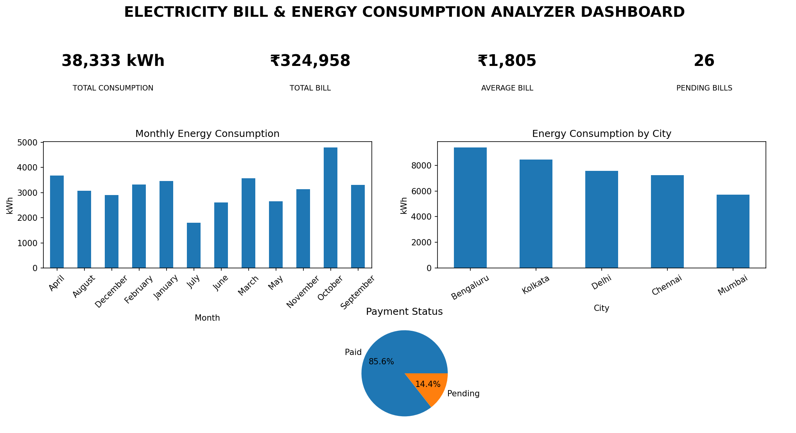
Figure 1. Electricity Bill & Energy Consumption Analyzer Dashboard
Dashboard Screenshot
The screenshot above provides a visual view of the dashboard KPIs and charts used for energy consumption, billing, city-wise analysis, monthly trends, and payment monitoring.
5. Key Metrics & Consumption Bands
Category | Consumption Range | Interpretation
Low | Below 150 kWh | Lower electricity consumption.
Medium | 150–300 kWh | Moderate electricity consumption.
High | Above 300 kWh | High electricity consumption requiring closer monitoring.
6. Overall Findings
Metric | Result
Total bill records | 180
Total energy consumed | 38,333 kWh
Total estimated bill | ₹324,958.00
Average consumption per record | 212.96 kWh
Average bill per record | ₹1,805.32
Minimum consumption | 27 kWh
Maximum consumption | 1,014 kWh
Paid bills | 154
Pending bills | 26
Low consumption records | 74
Medium consumption records | 67
High consumption records | 39
The workbook contains 180 electricity billing records with total consumption of 38,333 kWh and a calculated total bill of ₹324,958.00. The average consumption per record is 212.96 kWh and the average bill is ₹1,805.32. There are 154 paid records and 26 pending records. Consumption is classified into 74 Low, 67 Medium, and 39 High records.
7. Monthly Energy Consumption & Cost Analysis
Month | Energy Consumed (kWh) | Total Bill (₹)
January | 3,467 | ₹26,198.00
February | 3,328 | ₹29,584.50
March | 3,574 | ₹30,713.00
April | 3,683 | ₹32,008.50
May | 2,662 | ₹21,148.00
June | 2,606 | ₹22,705.00
July | 1,794 | ₹16,745.50
August | 3,075 | ₹24,911.50
September | 3,310 | ₹30,026.50
October | 4,791 | ₹41,116.50
November | 3,134 | ₹25,840.00
December | 2,909 | ₹23,961.00
October has the highest monthly energy consumption at 4,791 kWh and also records the highest monthly bill at ₹41,116.50. July has the lowest monthly consumption at 1,794 kWh.
8. City-Wise Analysis
City | Energy Consumed (kWh) | Total Bill (₹)
Bengaluru | 9,375 | ₹77,661.50
Kolkata | 8,457 | ₹71,486.50
Delhi | 7,552 | ₹63,952.00
Chennai | 7,234 | ₹63,017.00
Mumbai | 5,715 | ₹48,841.00
Bengaluru is the highest-consuming city with 9,375 kWh and the highest city-level bill of ₹77,661.50. Mumbai has the lowest consumption among the five cities at 5,715 kWh.
9. Consumer Type Comparison
Consumer Type | Energy Consumed (kWh) | Share of Total
Residential | 22,381 | 58.4%
Commercial | 15,952 | 41.6%
Residential consumers account for 22,381 kWh, while Commercial consumers account for 15,952 kWh. Residential consumption is therefore the larger share of the dataset's total energy usage.
10. Appliance Consumption Analysis
Appliance | Energy Consumed (kWh) | Share of Total
AC | 18,153 | 47.4%
Water Heater | 7,653 | 20.0%
Refrigerator | 5,752 | 15.0%
Washing Machine | 3,150 | 8.2%
TV | 2,220 | 5.8%
Microwave | 1,405 | 3.7%
AC is the largest consuming appliance in the supplied data with 18,153 kWh. Microwave has the lowest consumption among the listed appliances with 1,405 kWh.
11. Payment Status Analysis
Payment Status | Number of Bills | Share of Records
Paid | 154 | 85.6%
Pending | 26 | 14.4%
Most records are marked Paid (154 records), while 26 records are Pending. Pending bills should be monitored through the dashboard for follow-up.
12. Top Consumers by Total Bill
Consumer Name | Total Bill (₹)
Nisha Paul | ₹41,350.00
Raj Das | ₹33,632.50
Sneha Paul | ₹32,234.50
Ananya Sen | ₹21,475.00
Riya Ghosh | ₹20,998.50
Nisha Paul has the highest total bill in the supplied data at ₹41,350.00. The Top 5 Consumer PivotTable can be used to focus attention on consumers contributing the largest bill amounts.
13. Student-Wise Report Equivalent / Record-Level Report
For this electricity dataset, the equivalent of a student-wise report is a consumer/bill-level report. It should contain Bill ID, Date, Month, Consumer Name, Consumer Type, City, Appliance, Units Consumed (kWh), Rate per Unit (₹), Fixed Charge (₹), Total Bill (₹), Payment Status, and Consumption Category. Formula-driven fields should be maintained wherever possible so that changes in consumption or rate automatically update the calculated bill and category.
14. Recommendations for Ongoing Use
• Update the Energy_Data sheet whenever new electricity records become available and refresh all PivotTables and dashboard objects.
• Keep Total Bill and Consumption Category formula-driven to reduce manual calculation errors.
• Monitor pending payment records and use the Payment Status dashboard to track outstanding bills.
• Pay special attention to high-consumption records and high-consumption appliances, especially AC usage.
• Use monthly trend charts to identify unusual increases or decreases in electricity consumption and cost.
• Use city-wise and consumer-type analysis to compare consumption patterns across locations and customer segments.
• Keep the dashboard, KPI sheet, PivotTables, and source Energy_Data table connected to the same source so that all outputs remain consistent.
15. Conclusion
The Electricity Bill & Energy Consumption Analyzer dataset contains 180 records covering the period from 03 January 2025 to 27 December 2025. The records represent 38,333 kWh of electricity consumption and a calculated total bill of ₹324,958.00. The dashboard provides a combined view of energy consumption, bill amounts, cities, consumer types, appliances, payment status, and monthly trends. The analysis shows that October is the peak month for consumption and cost, Bengaluru has the highest city-level consumption, AC is the largest consuming appliance, and most bills are marked Paid. The dashboard should be refreshed whenever the source data changes so that the KPIs and charts remain current.

16. Dashboard Screenshots
The following screenshot is included for visual reference of the dashboard created from the supplied workbook.
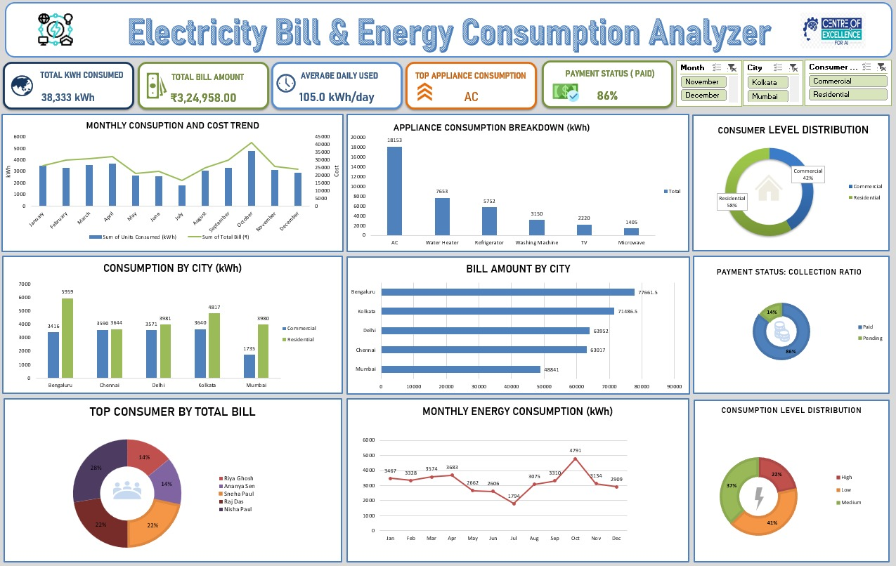
Figure 2. Dashboard visual reference

