POWER BI PROJECT REPORT
Healthcare Analytics Dashboard
――――――――――――――――――――――――――――――――――――――――
A Power BI-Based Healthcare Data Analysis and Interactive Dashboard Project
――――――――――――――――――――――――――――――――――――――――
Project Information | Details
Project Title | Healthcare Analytics Dashboard
Project Duration | 7 days
Team Member 1 | Harekrishna Adhikary
AF Code 1 | AF05308345
Team Member 2 | Harsha Guchhait
AF Code 2 | AF05310291
Team Member 3 | Samprit Ganguly
AF Code 3 | AF05321198
Trainer Name | Sayan Sau
Submission Date | 01 October 2026
GitHub Username | Samprit01
GitHub Repository | https://github.com/Samprit01/Health-Care-Analytics-Dashboard.git

Submitted By
Harekrishna Adhikary, Harsha Guchhait, Samprit Ganguly
Power BI Data Analytics Project

HEALTHCARE ANALYTICS DASHBOARD
Data Analytics Documentation
Prepared from: Healthcare_Analytics_1200_Patients_Cleaned.xlsx and the supplied Health Care Analytics Dashboard.pbix file.
1. Purpose & Scope
This document describes the Healthcare Analytics Dashboard developed in Microsoft Power BI using the supplied healthcare dataset. The project contains 1,200 patient/admission records covering the admission years 2024, 2025, and 2026. The dashboard is designed to summarize patient volume, hospital and department distribution, diagnoses, treatment cost, length of stay, outcomes, gender distribution, and other healthcare indicators through interactive visuals and filters.
2. Data Source
The supplied Healthcare_Data_Cleaned sheet contains one record for each patient/admission. The principal fields used in the analysis are:
Field | Type | Meaning
Patient_ID | Text | Unique identifier for the patient record.
Patient_Name | Text | Name associated with the patient record.
Age | Number | Patient age.
Gender | Text | Gender recorded for the patient.
Hospital | Text | Hospital where the patient was treated.
Department | Text | Hospital department associated with the admission.
Doctor | Text | Doctor associated with the patient record.
Diagnosis | Text | Diagnosis recorded for the admission.
Admission_Date | Date | Date of admission.
Discharge_Date | Date | Recorded or estimated discharge date.
Admission_Type | Text | Elective, Urgent, or Emergency admission.
Bed_Type | Text | General Ward, Semi-Private, Private Room, or ICU.
Length_of_Stay | Number | Number of days in the hospital.
Treatment_Cost | Number | Treatment cost associated with the record.
Insurance_Provider | Text | Insurance or payment provider.
Patient_Status | Text | Current record status such as Discharged or Active.
Outcome | Text | Recorded outcome such as Recovered, Improved, Stable, Complication, or Deceased.
Readmission | Text | Indicates whether the patient was readmitted.
Patient_Satisfaction | Number | Patient satisfaction score.
Admission_Year | Number | Year of admission.
Admission_Month_Name | Text | Month name used for time-based analysis.

3. Data Model & Power BI Measures
The Power BI report uses the Healthcare_Data_Cleaned table as its main analytical source. Measures and fields are used to convert row-level healthcare records into summary KPIs and visual comparisons. The supplied PBIX contains measures/fields for Total Patients, Total Admissions, Total Treatment Cost, Average Stay, Recovery Rate, Stay Group, and Patient Satisfaction.
Measure / Field | Logic | Purpose
Total Patients | COUNT/COUNTROWS of patient records | Shows the number of healthcare records represented in the dashboard.
Total Admissions | Count of admission records/unique patient records | Summarizes the admission volume.
Total Treatment Cost | SUM of Treatment_Cost | Shows the total treatment expenditure represented by the dataset.
Average Stay | AVERAGE of Length_of_Stay | Shows the average number of hospital-stay days.
Recovery Rate | Recovered records ÷ total records × 100 | Shows the share of records whose Outcome is Recovered.
Patient Satisfaction | Patient_Satisfaction field | Represents the satisfaction score; for an overall score, average aggregation is the meaningful interpretation.
Stay Group | Grouped length-of-stay classification used in the report | Allows patients to be compared by hospital-stay duration.

4. Important Power BI Topics Explained
Topic | Explanation
Power BI | A business-intelligence platform used to import, transform, model, visualize, and interactively analyze data.
Data Cleaning | Preparing the healthcare table so fields have consistent types and usable values before analysis.
DAX Measures | Calculations created in Power BI to dynamically summarize data, such as total cost, patient count, average stay, and recovery rate.
KPI Cards | Visual cards that present important summary numbers at the top of the dashboard.
Slicers / Filters | Interactive controls that allow the report user to filter the analysis by Hospital, Admission Year, or Department.
Categorical Analysis | Comparing groups such as departments, outcomes, diagnoses, hospitals, and gender.
Time Analysis | Grouping admissions by year/month to observe how the patient dataset is distributed across time.
Dashboard Visualization | Charts and KPI elements arranged on one report page so several aspects of the dataset can be reviewed together.

5. Dashboard Development — Step by Step
1. Load the cleaned Healthcare_Data_Cleaned dataset into Power BI.
2. Confirm data types for dates, numerical measures, and categorical fields.
3. Build the main patient-count, treatment-cost, average-stay, recovery-rate, admission, and satisfaction calculations.
4. Create categorical visuals for Department, Outcome, Diagnosis, Hospital, Gender, and Stay Group.
5. Add interactive slicers for Hospital, Admission Year, and Department.
6. Arrange KPI cards and charts into a single healthcare analytics dashboard page.
7. Format titles, labels, values, and layout so the dashboard can be read as a summary report.
8. Validate dashboard values against the underlying healthcare dataset.

6. Dashboard Screenshot

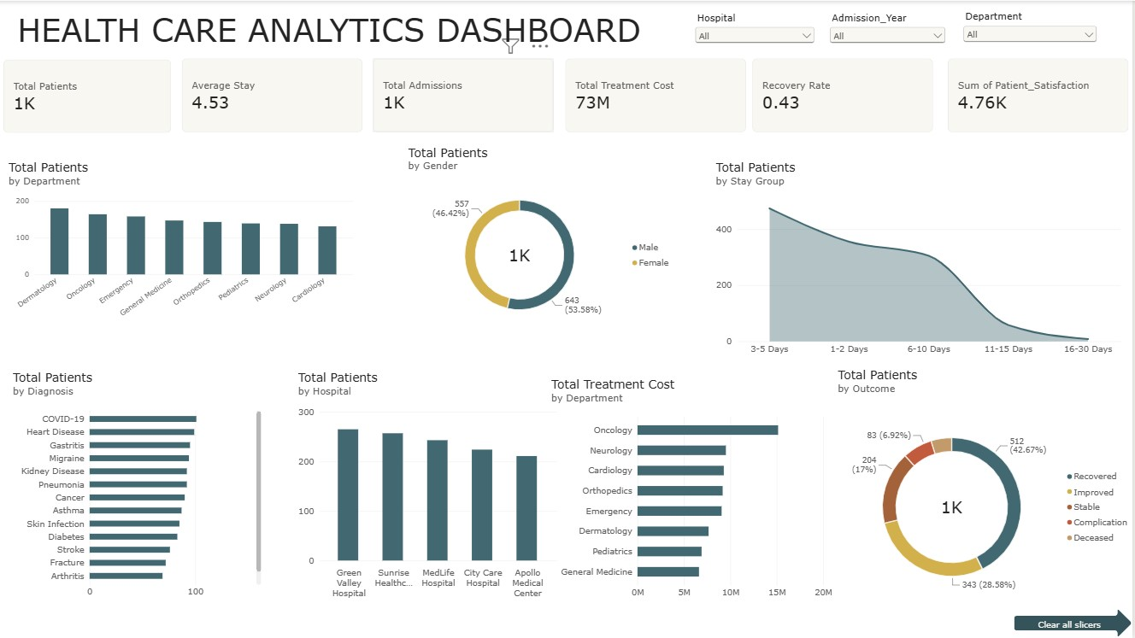

7. Overall Findings
Metric | Result
Total patient records | 1,200
Total treatment cost | ₹73,380,200.00
Average length of stay | 4.53 days
Average patient satisfaction | 3.97 / 5
Recovered records | 512
Recovery rate | 42.7%
Readmissions | 127
Deceased outcome records | 58
Admission years | 2024, 2025, 2026

8. Hospital-Wise Analysis
Hospital | Patients | Treatment Cost | Average Stay
Green Valley Hospital | 265 | ₹16,510,400.00 | 4.65
Sunrise Healthcare | 257 | ₹15,496,900.00 | 4.61
MedLife Hospital | 243 | ₹14,957,800.00 | 4.54
City Care Hospital | 224 | ₹13,645,100.00 | 4.51
Apollo Medical Center | 211 | ₹12,770,000.00 | 4.28

9. Department-Wise Analysis
Department | Patients | Treatment Cost
Dermatology | 180 | ₹7,657,100.00
Oncology | 164 | ₹15,147,000.00
Emergency | 158 | ₹9,059,700.00
General Medicine | 147 | ₹6,623,600.00
Orthopedics | 143 | ₹9,173,100.00
Pediatrics | 139 | ₹6,902,400.00
Neurology | 138 | ₹9,520,800.00
Cardiology | 131 | ₹9,296,500.00

10. Outcome & Diagnosis Analysis
Outcome | Patients | Share
Recovered | 512 | 42.7%
Improved | 343 | 28.6%
Stable | 204 | 17.0%
Complication | 83 | 6.9%
Deceased | 58 | 4.8%

Diagnosis | Patients | Share
COVID-19 | 101 | 8.4%
Heart Disease | 99 | 8.2%
Gastritis | 95 | 7.9%
Migraine | 94 | 7.8%
Kidney Disease | 92 | 7.7%
Pneumonia | 92 | 7.7%
Cancer | 90 | 7.5%
Asthma | 87 | 7.2%
Skin Infection | 85 | 7.1%
Diabetes | 83 | 6.9%
Stroke | 76 | 6.3%
Fracture | 72 | 6.0%
Arthritis | 69 | 5.8%
Hypertension | 65 | 5.4%

11. Gender, Admission Type & Bed Type
Gender Distribution
Gender | Patients | Share
Male | 643 | 53.6%
Female | 557 | 46.4%

Admission Type Distribution
Admission_Type | Patients | Share
Elective | 527 | 43.9%
Emergency | 365 | 30.4%
Urgent | 308 | 25.7%

Bed Type Distribution
Bed_Type | Patients | Share
General Ward | 515 | 42.9%
Semi-Private | 308 | 25.7%
Private Room | 217 | 18.1%
ICU | 160 | 13.3%

12. Readmission & Patient Status
Readmission | Patients | Share
No | 1,073 | 89.4%
Yes | 127 | 10.6%

Patient Status | Patients | Share
Discharged | 856 | 71.3%
Active | 234 | 19.5%
Transferred | 83 | 6.9%
Deceased | 27 | 2.2%

13. Time-Based Admission Analysis
Admission Year | Patients | Share
2024 | 440 | 36.7%
2025 | 441 | 36.8%
2026 | 319 | 26.6%

Admission Month | Patients
January | 121
February | 120
March | 109
April | 125
May | 130
June | 96
July | 110
August | 107
September | 70
October | 75
November | 69
December | 68

14. Key Insights from the Supplied Dataset
• The dataset contains 1,200 patient/admission records across five hospitals and eight departments.
• Total treatment cost represented in the supplied data is ₹73,380,200.00.
• The average hospital stay is 4.53 days.
• 512 records have a Recovered outcome, corresponding to 42.7% of the dataset.
• Patient satisfaction averages 3.97 on the supplied 5-point scale.
• There are 127 records marked as readmissions.
• The dashboard enables the user to narrow the analysis through Hospital, Admission Year, and Department filters.
• The PBIX includes visual analysis by department, outcome, diagnosis, treatment cost, stay group, hospital, and gender.
15. Recommendations for Ongoing Use
• Refresh the Power BI dataset whenever new patient records are added.
• Keep numerical fields such as Treatment_Cost, Length_of_Stay, and Patient_Satisfaction correctly typed so measures remain reliable.
• Use the Hospital, Admission Year, and Department slicers to investigate specific subsets of the dataset.
• Monitor treatment cost and average stay together when reviewing departmental or hospital-level patterns.
• Review readmission and outcome distributions regularly as new records become available.
• Use the dashboard as a reporting and exploration tool rather than treating aggregated values as a substitute for individual clinical records.
16. Conclusion
The Healthcare Analytics Dashboard converts 1,200 patient/admission records into an interactive Power BI report covering patient volume, treatment cost, length of stay, outcomes, diagnoses, hospitals, departments, gender, admission patterns, readmission, and satisfaction. The supplied dataset records ₹73,380,200.00 in treatment cost and an average stay of 4.53 days. The dashboard structure combines KPI cards, categorical charts, and interactive filters so users can move from an overall healthcare summary to hospital-, department-, and year-specific views.

