Bridge Girder Behavior Analysis through Load Test with Instrumentation
Bridge Girder 36 & 36A

1. Project Information
Parameter | Value
Project ID | BRIDGE_36
Client | Bharat Petroleum Corporation Limited
Site Location | Batalala, Jammu & Kashmir
Structure | Railway Bridge
Test Type | Static Load Test
Sampling | 1 second
Data Start | 2026-09-27 00:00:00
Data End | 2026-09-27 01:59:59

2. Sensor Summary
Sensor | Type | Location | Minimum | Maximum | Average
DEF-01 | Deflection | Span 36, Mid-span | -0.0470 | 2.0463 | 1.0001
DEF-02 | Deflection | Span 36A, Mid-span | -0.0470 | 2.0468 | 1.0000
TEMP-01 | Temperature | Span 36, Mid-span | 25.7002 | 28.3000 | 27.1718
TEMP-02 | Temperature | Span 36A, Support A | 25.7004 | 28.2999 | 27.1719
VIB-01 | Vibration | Span 36, Mid-span | 0.8218 | 1.8799 | 1.3499
VIB-02 | Vibration | Span 36A, Mid-span | 0.8201 | 1.8781 | 1.3499

3. Sensor Trend Charts
TEMP-01
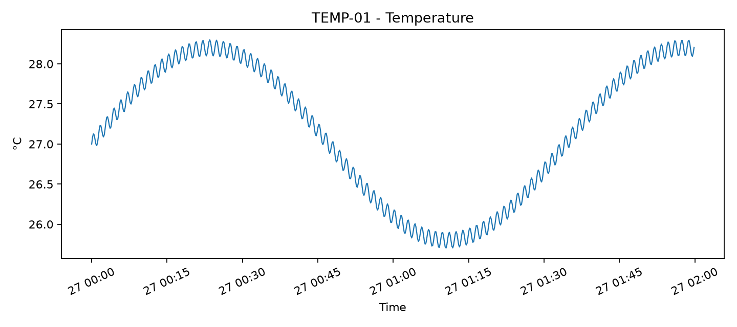
TEMP-02
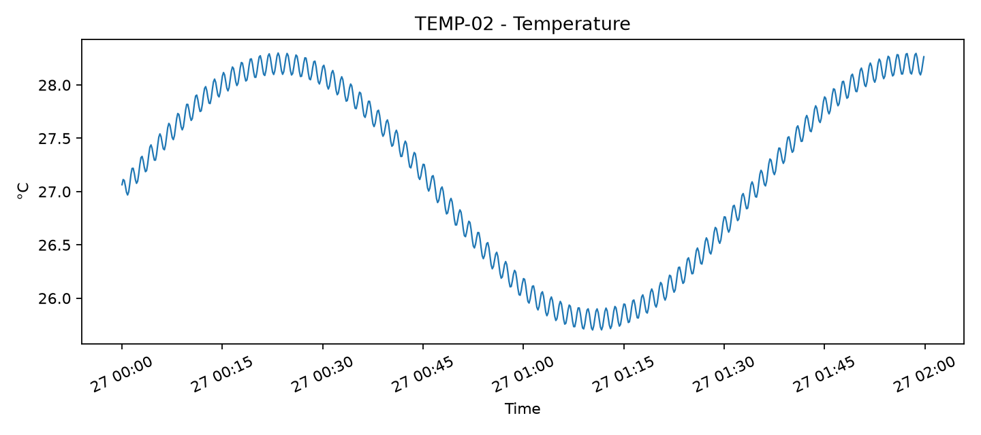
DEF-01
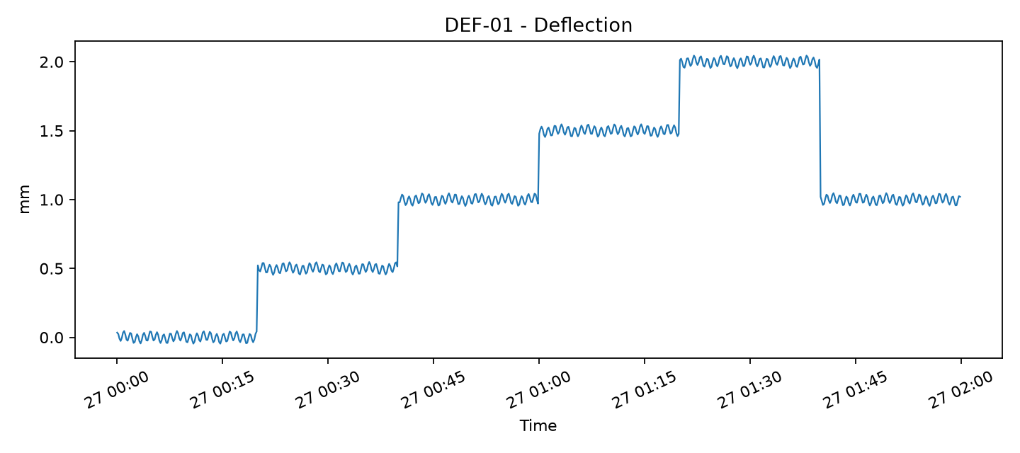
DEF-02
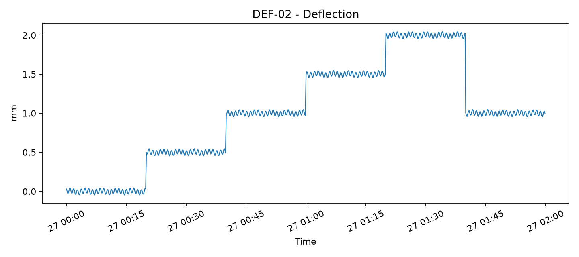
VIB-01
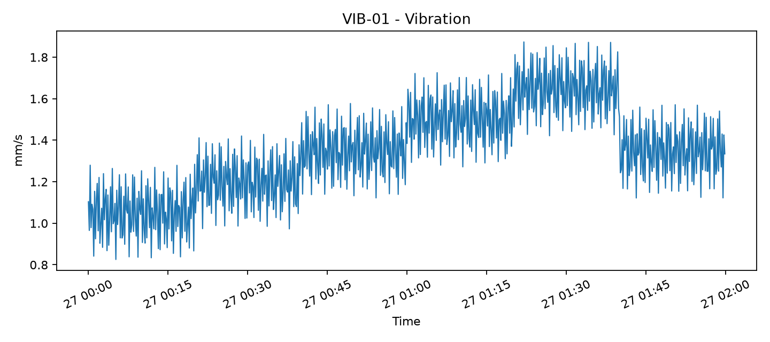
VIB-02
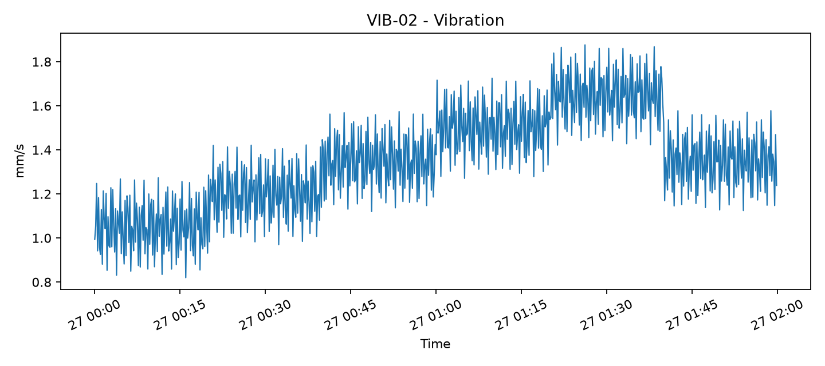

4. Observation
This prototype report is generated automatically from one-second synthetic sensor telemetry. Final design values, acceptance criteria, temperature correction, recovery calculations and engineering interpretation will be configured from the approved project methodology.

