**Collection Name : BOOKS**

**INSERTING DATA INTO COLLECTION : BOOKS**

**Document1:**

db.Books.insertOne({"Book_Title":"Java","Author":"Horstmann","Publisher":"prentice","edition":11,"Year_of_pub":2011,"ISBN":0-345-24223-8});

**Document2:**

db.Books.insertOne({"Book_Title":"Line of Fire","Author":"Brian Paddick","Publisher":"Simon ","edition":3,"Year_of_pub":2008,"ISBN":979-82-7213-496-0});

**Document3:**

db.Books.insertOne({"Book_Title":"Line of Fire","Author":"Brian Paddick","Publisher":"Simon ","edition":3,"Year_of_pub":2008,"ISBN":978-82-7213-496-0});

**Document4:**

db.Books.insertOne({"Book_Title":"A Game of Thrones","Author":"Martin","Publisher":"Bantam Spectra ","edition":9,"Year_of_pub":2016,"ISBN":968-82-7223-496-0});

**Document5:**

db.Books.insertOne({"Book_Title":"The girl in room 105","Author":"chetan Bhagat","Publisher":"Westland","edition":3,"Year_of_pub":2018,"ISBN":978-82-7223-497-0});

**Document6:**

db.Books.insertOne({"Book_Title":"python","Author":"matthes","Publisher":"john","edition":3,"Year_of_pub":2019,"ISBN":978-82-7223-498-0});

**Document 7:**

db.Books.insertOne({"Book_Title":"Alchemist","Author":"panlo coelno","Publisher":"harper","edition":3,"Year_of_pub":2018,"ISBN":978-81-7223-498-0});

**Document 8:**

db.Books.insertOne({"Book_Title":"python","Author":"john Zelle","Publisher":"Rossum","edition":3,"Year_of_pub":2012,"ISBN":0-332-24223-9});

**Document 9:**

db.Books.insertOne({"Book_Title":"C++","Author":"stanley","Publisher":"jossee","edition":5,"Year_of_pub":2016,"ISBN":0-342-24223-9});

**Document 10:**

db.Books.insertOne({"Book_Title":"Java","Author":"scott","Publisher":"shroff","edition":4,"Year_of_pub":2012,"ISBN":0-343-24223-9});

**Document 11:**

db.Books.insertOne({"Book_Title":"Java","Author":"herbert","Publisher":"McGraw","edition":8,"Year_of_pub":2014,"ISBN":0-344-24223-9});

**Document 12:**

db.Books.insertOne({"Book_Title":"Java","Author":"joshua","Publisher":"wesley","edition":4,"Year_of_pub":2016,"ISBN":0-345-24223-9});

**Document 13:**

db.Books.insertOne({"Book_Title":"Java","Author":"Horstmann","Publisher":"prentice","edition":11,"Year_of_pub":2011,"ISBN":0-345-24223-8});

**Display the documents of collection BOOKS :**

**Db.BOOKS.find()**

**To Update :**

db.Books.updateOne({"Book_Title":"python"},{$set:{edition :4}});

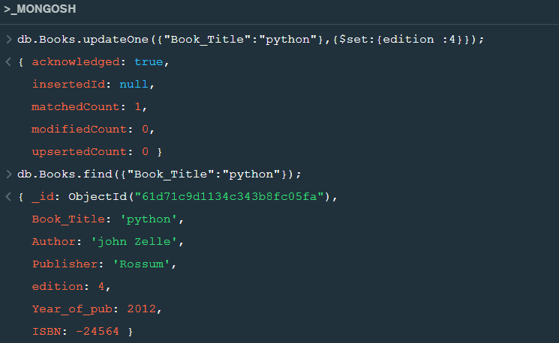

**Delete Operation :**

db.Books.deleteOne({"Author":"Horstmann"});

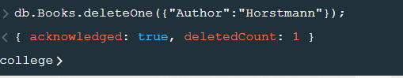

**Queries**

**1 Retrieve the books which contains the title as java(case in-sensitive)**

db.Books.find({"Book_Title" : { '$regex':/^Java$/i}});

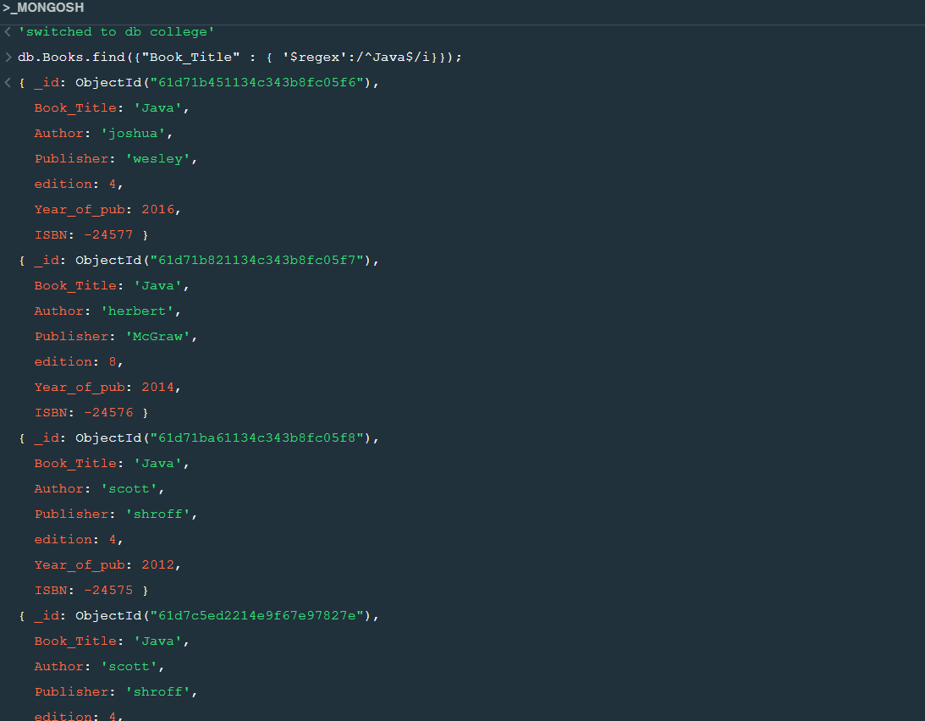

**2. Retrieve the books which contains the title as java and year of publication is greater than 2015**

db.Books.find({Book_Title:"Java",Year_of_pub:{$gt:2015}});

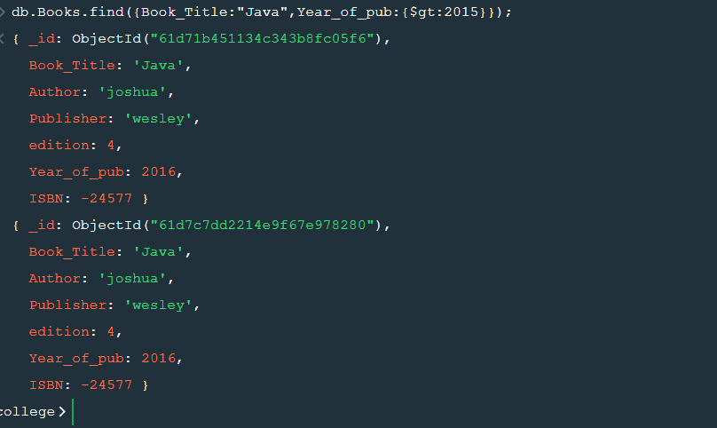

**3. Retrieve the name of the author who has published more than two books.**

**4.Retrieve the books whose edition is between 3rd and 4th**

db.Books.find({edition:{$gte:3,$lte:4}});

