Machine Learning Models for Climate Forecasting, Extreme-Event Detection and Anomaly Identification in the EarthScape Platform
ML Model Paper
October 2026
Table of Contents

Abstract
We present the machine-learning component of EarthScape, a big-data climate analytics platform. Using 39,456 daily readings from 12 stations across six climate zones (2016–2024) with 12 variables from weather stations, environmental sensors and satellite products, we train (i) a next-day temperature forecaster, (ii) a five-class extreme-event classifier, (iii) an anomaly detector and (iv) trend and seasonal models. Station-and-month climatology deviations and temporal lag features are central to performance. With strict time-based validation, the forecaster achieves MAE 1.35 °C (R² 0.94) on a hold-out period, beating persistence (1.71 °C); on an independent 2024 test year the event classifier attains macro-F1 0.91 and the anomaly detector precision 0.79 / recall 0.58. Models are retrained automatically and versioned at runtime.

1. Introduction
Climate services require forecasts, early identification of extreme events and quality control of observations. Classical statistical methods remain strong baselines, while tree ensembles handle non-linear interactions and missing data well. We focus on lightweight models that train in under a minute on a laptop, enabling continuous retraining inside an operational application.

2. Data
Property | Value
Stations | 12 (arid-coastal, arid, semi-arid, humid-subtropical, temperate, cold-arid, cold-desert)
Training | 2016–2023, 35,064 readings
Test | 2024, 4,392 readings
Variables | temperature (mean/max/min), humidity, precipitation, wind, pressure, CO₂, PM2.5, NDVI, land-surface temperature, soil moisture
Labels | event_type (none 97.7%, heatwave 1.3%, smog 0.5%, flood 0.3%, storm 0.2%); is_anomaly
Missing | 2–6% in six variables
Data are simulated with physically motivated seasonality, monsoon, warming trend, regional climate and injected extremes and sensor faults.

3. Methods

3.1 Pre-processing
Type coercion, median imputation inside pipelines, forward-fill for lags, standard scaling, one-hot encoding of climate zone. Station metadata completed from a registry.

3.2 Feature engineering
- Seasonal encoding: sin/cos of day-of-year.
- Climatology deviation: z = (x − μ_station,month) / σ_station,month for temperature, precipitation, wind, PM2.5, humidity and pressure.
- Lag features: temperature at t, t−1, t−2, t−6 and a 7-day rolling mean.

3.3 Models
Task | Candidates | Selection
Next-day temperature | Ridge, Random Forest (120 trees, depth 14), HistGradientBoosting (250 iterations) | lowest TimeSeriesSplit MAE
Extreme event (5 classes) | Random Forest (200 trees, balanced), HistGradientBoosting (balanced) | highest TimeSeriesSplit macro-F1
Anomaly | Isolation Forest (200 trees, contamination 0.03) on deviations, OR max | z
Trend | OLS on annual means per station | –
Seasonal outlook | OLS on time + 12-month harmonics per region | –

3.4 Validation
Four-fold TimeSeriesSplit on the training period for model selection, a chronological 15% hold-out, and an independent 2024 test year. No shuffling, to avoid temporal leakage.

3.5 Explainability
For an input reading, each variable is replaced by its station-month normal and the change in event probability is reported – a model-agnostic, counterfactual explanation that is easy for stakeholders to read.

4. Results
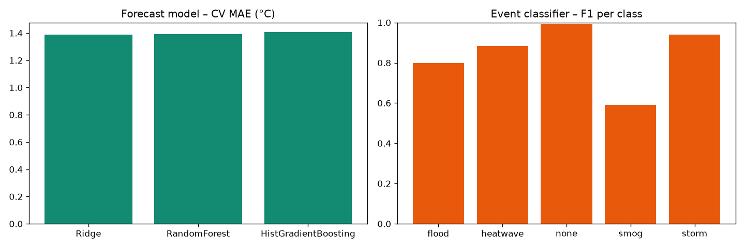
Model results
Model | Metric | Hold-out (2022–23) | 2024 test
Forecast (Ridge) | MAE °C | 1.35 | 1.70
Forecast | R² | 0.94 | –
Persistence baseline | MAE °C | 1.71 | –
Event classifier (RF) | macro-F1 | 0.84 | 0.91
Event classifier | accuracy | 0.99 | –
Anomaly detector | precision / recall | 0.26 / 0.42 | 0.79 / 0.58
Trend | mean warming | +0.41 °C/decade | –
Cross-validated MAE was nearly identical for all three regressors (1.39–1.41 °C), so the simplest model, Ridge, was selected – a sign that lagged temperature and seasonality carry most of the signal. Per-class F1 on the hold-out: storm 0.94, heatwave 0.88, flood 0.80, smog 0.59. Smog is hardest because it overlaps with normal winter pollution in Punjab. Anomaly precision is lower on the short hold-out (winter-heavy) than on the full test year, where heatwave and flood spells dominate the anomalies.

5. Discussion
- Climatology deviations make one model work across very different climates.
- Persistence is a strong baseline for daily temperature; lag features give a 21% improvement.
- Class imbalance (≈2% events) is handled with balanced class weights and macro-F1 selection.
- Automatic retraining every 2,000 readings plus PSI drift monitoring keeps models current as the climate warms.

6. Limitations and Future Work
Simulated data; daily resolution; no spatial modelling. Next steps: gridded reanalysis data (ERA5), spatio-temporal deep learning (ConvLSTM, graph neural networks), probabilistic forecasts and SHAP explanations.

7. Conclusion
Simple, well-engineered models trained at runtime provide accurate, explainable and continuously updated climate predictions suitable for an operational early-warning platform.

References
- Breiman, L. (2001). Random Forests. Machine Learning, 45(1), 5–32.
- Liu, F. T., Ting, K. M., & Zhou, Z.-H. (2008). Isolation Forest. IEEE ICDM.
- Friedman, J. H. (2001). Greedy function approximation: a gradient boosting machine. Annals of Statistics, 29(5).
- Ke, G. et al. (2017). LightGBM: A highly efficient gradient boosting decision tree. NeurIPS.
- Pedregosa, F. et al. (2011). Scikit-learn: Machine Learning in Python. JMLR, 12.
- Rasp, S. et al. (2020). WeatherBench: a benchmark data set for data-driven weather forecasting. JAMES, 12.
- Chandola, V., Banerjee, A., & Kumar, V. (2009). Anomaly detection: a survey. ACM Computing Surveys, 41(3).

