Zero-Shot Image Classification Using CLIP and LLM-Generated Descriptions
ITSOLERA ML Internship – 3rd Project
Samra Mehmood

1. Introduction
Zero-shot image classification (ZSIC) allows a model to recognize categories it has never seen labeled examples of, by transferring knowledge from auxiliary semantic information associated with both seen and unseen classes. Existing ZSIC methods rely heavily on hand-crafted or embedding-based auxiliary information such as manually annotated attributes, which is costly to build and often fails to distinguish visually similar, fine-grained categories. This project investigates whether large language models can automatically generate discriminative auxiliary descriptions that replace manual attribute annotation, and evaluates when this approach helps or hurts zero-shot classification accuracy.

2. Method
The pipeline uses CLIP (ViT-B/32, OpenAI pretrained weights) as a zero-shot image-text matching model. No training or fine-tuning was performed; classification is done purely through cosine similarity between image embeddings and text embeddings, in line with the zero-shot setting described in the reference survey.
Two prompting strategies were compared:
- Baseline: a single plain-text prompt per class in the form “a photo of a {class name}, a type of bird.”
- LLM-enhanced: five discriminative visual descriptions per class, automatically generated by Gemini 3.5 Flash Lite, focused on plumage colour, beak shape, size, and markings that separate each species from similar ones. The five description embeddings were averaged per class to produce a single enhanced text embedding, following the CuPL-style prompting approach.
An intermediate finding required a methodological adjustment. The first version of the enhanced prompts fed Gemini's descriptions directly into CLIP's text encoder and produced a large accuracy drop rather than an improvement (see Section 5). Reformatting each description into a caption-style prompt of the form “a photo of a {class name}, which {description}” recovered and then exceeded baseline accuracy. Both versions were kept as a controlled ablation, since the comparison itself is informative for the project's stated objective of identifying when LLM-generated auxiliary information helps or hurts classification.

3. Experimental Setup
Experiments were run on a 30-class subset of CUB-200-2011, chosen specifically for fine-grained visual similarity rather than at random. The subset covers seven natural groups of visually confusable species: three albatrosses, four auklets, four blackbirds, three buntings, three cormorants, two cowbirds, and two crows, plus several additional single-representative classes (Bobolink, Cardinal, two catbirds, Yellow-breasted Chat, Eastern Towhee, Chuck-will's-widow, and Brown Creeper).
Evaluation used the dataset's official test split, capped at 15 images per class to keep CPU inference time practical, giving 445 test images across 30 classes.

4. Results
Method | Correct / Total | Accuracy | Change vs. Baseline
Baseline (plain prompt) | 259 / 445 | 58.20% | –
LLM description (raw, unformatted) | 179 / 445 | 40.22% | -17.98 pp
LLM description (caption-formatted) | 276 / 445 | 62.02% | +3.82 pp

The caption-formatted LLM descriptions outperform the baseline by 3.82 percentage points, confirming that automatically generated auxiliary descriptions can improve fine-grained zero-shot classification when properly formatted for the text encoder. The raw-description ablation shows this benefit is not guaranteed: the same semantic content, phrased in literary rather than caption-like language, reduced accuracy by nearly 18 points below baseline.
Confusion matrices for the baseline and formatted-enhanced conditions:
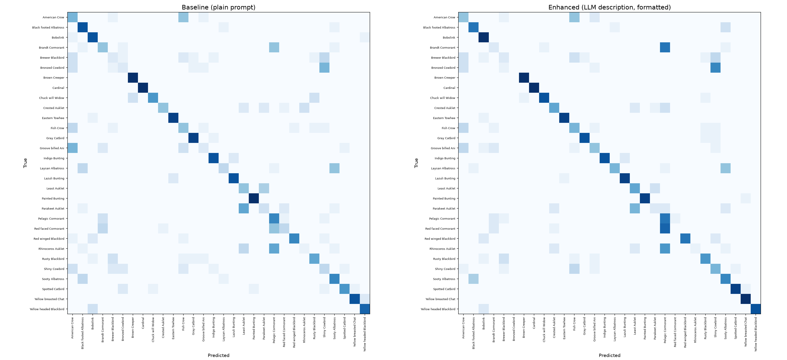

5. Failure Case Analysis
5.1 Why raw LLM descriptions hurt accuracy. CLIP's text encoder was trained on image alt-text and captions, which are short and literal. Gemini's raw descriptions, while accurate, used dense literary phrasing (for example, describing the Sooty Albatross as cutting “a ghostly silhouette across the southern ocean”). This style is far outside the distribution CLIP's text encoder was trained on, so the resulting embeddings drift away from the region of embedding space that image features actually occupy. Reformatting each description into a plain caption template preserved the discriminative content while returning the phrasing to a style CLIP could use effectively, which is why the same underlying information moved from a strong negative result to a positive one.
5.2 Classes that worsened with LLM descriptions. Brandt's Cormorant and Red-faced Cormorant both dropped sharply (-26.7 pp each) and collapsed into “Pelagic Cormorant” predictions; Bronzed Cowbird dropped 13.3 pp into “Shiny Cowbird.” In both groups, the generated descriptions independently used near-identical language across sibling species — “iridescent,” “glossy,” “dark plumage” for the cormorants, and “iridescent,” “glossy blue-black,” “red eye” for the cowbirds. The LLM produced accurate but class-generic descriptions for these groups: it described what a cormorant or cowbird looks like in general, rather than the specific feature that separates one species from its closest relative. This is a direct illustration of the gap identified in the reference survey, where auxiliary information that is class-generic rather than class-discriminative limits performance on fine-grained categories.
5.3 Classes that improved with LLM descriptions. Spotted Catbird improved by 33.3 pp, Groove-billed Ani by 26.7 pp, and Chuck-will's-widow by 26.7 pp. In each case the generated description repeatedly anchored on one rare, highly specific visual feature: the catbird's white-spotted plumage and ivory bill, the ani's ridged bill and shaggy throat, and the nightjar's barred camouflage pattern and wide bristled bill. These features have few or no competitors among the other 29 classes in the subset, so the added text signal had a clear, unambiguous target to shift the embedding toward.
5.4 Guideline. Taken together, these results support a specific, testable guideline: LLM-generated auxiliary descriptions help zero-shot classification most when (1) they are phrased in caption-like rather than literary language, and (2) they name a feature that is rare or unique among the candidate classes rather than a feature shared across an entire taxonomic family. When a class's most visually salient trait is also common to its closest relatives, LLM descriptions tend to reinforce the confusion rather than resolve it, and a manually curated, contrastive description (explicitly stating what distinguishes species A from species B) would likely be needed instead.

6. Limitations
- Evaluation used a capped sample of 15 test images per class (445 total) rather than the full test split, for CPU runtime reasons; results may shift slightly with the full test set.
- The 30-class subset, while chosen for genuine fine-grained difficulty, is not representative of all 200 CUB classes or of other domains; conclusions about LLM description behaviour may not transfer directly to less visually similar categories.
- Description quality depends on the LLM used; Gemini 3.5 Flash Lite was chosen for free-tier accessibility rather than benchmarked against alternative models.
- No hyperparameter search was performed on the number of descriptions per class (fixed at five) or on alternative caption templates beyond the one tested.

7. Conclusion
This project built a working zero-shot bird classification pipeline that replaces manually annotated attributes with LLM-generated visual descriptions, and evaluated it against a plain-prompt CLIP baseline on a deliberately fine-grained 30-class subset of CUB-200-2011. Caption-formatted LLM descriptions improved accuracy by 3.82 percentage points over the baseline (62.02% vs. 58.20%), while the same descriptions in their original literary phrasing reduced accuracy by 17.98 points, demonstrating that prompt formatting is at least as important as the underlying semantic content. Failure case analysis showed that LLM descriptions help most when they surface a rare, class-unique feature, and hurt when the LLM defaults to generic language shared across an entire species group — providing a concrete, evidence-based guideline for when this approach is and is not appropriate for fine-grained zero-shot classification.

