# Read Me:

# Steps of the task:

**Open Street Map Task**:

* Importing packages

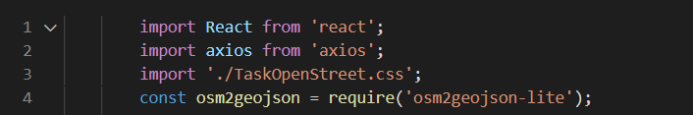

* I have used Nominatim api

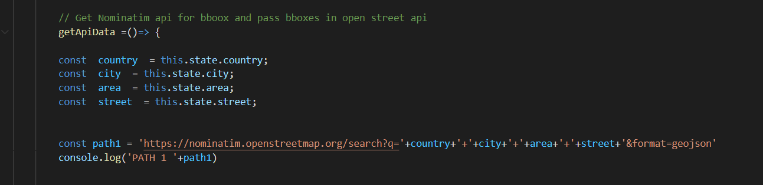

* Example:

[https://nominatim.openstreetmap.org/search?q=Pakistan+Karachi+Gulistan-e-Johar+Long Life Bungalows&format=geojson](https://nominatim.openstreetmap.org/search?q=Pakistan+Karachi+Gulistan-e-Johar+Long%20Life%20Bungalows&format=geojson)

* Get the bbox parameters from the above api, but this api takes parameters that is country, city,area and street. Therefore, I have used form to get the parameters and used the form parameters in nominatim api, the response is in JSON format.
* From the above API I have received BBOX parameters

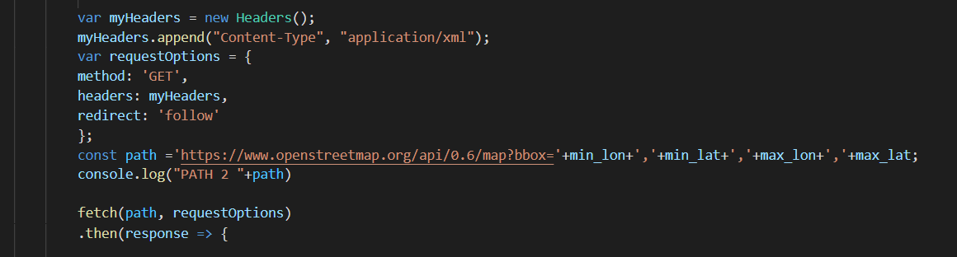

* Used above BBOX parameters in open street map API
* **Example:**

<https://www.openstreetmap.org/api/0.6/map?bbox=67.1187434,24.9102268,67.1188434,24.9103268&Content-Type=application/xml>

* The response of the aboveAPI is in .osm format

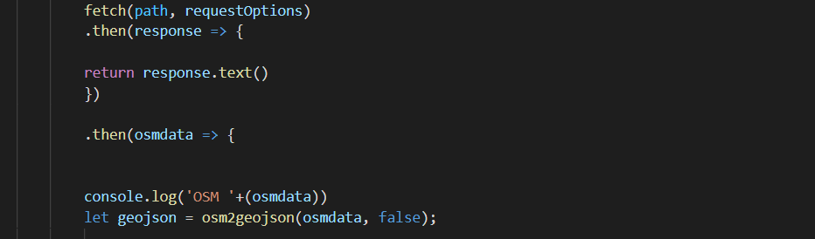

* I have used osm2geojson-lite to convert .osm to .geojson, now the response is in json format

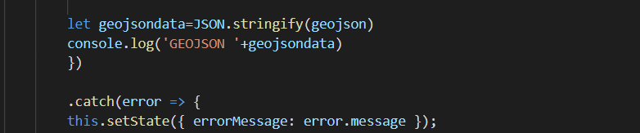

* I have showed the data of the given API response



* I have used states to maintain the states for rendering it on to the page and for using them in the form of html

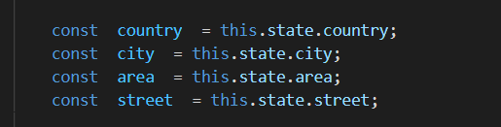

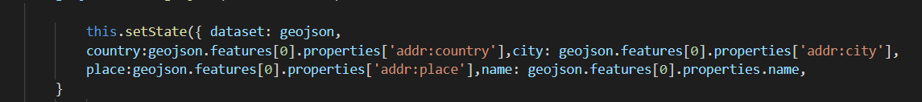

* Hit getApiData method after filling the form and show results

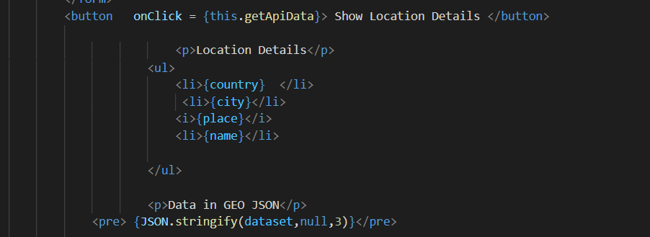

**Data Validations:**

* I have validated my form and its fields
* Validating form data

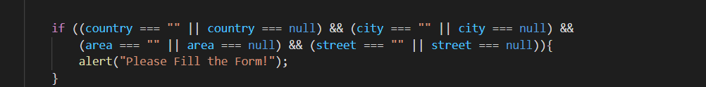

* Error handling for apis

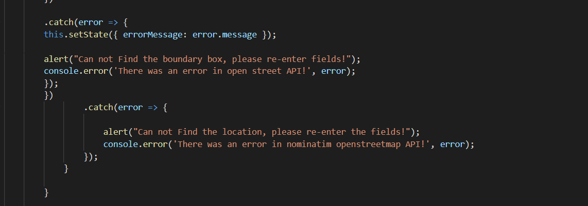

**Unit Testing:**

* I have installed jest package for test cases
* 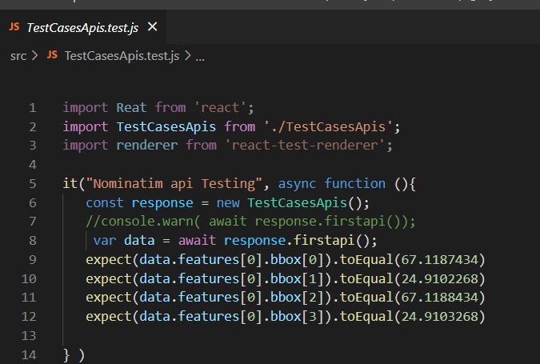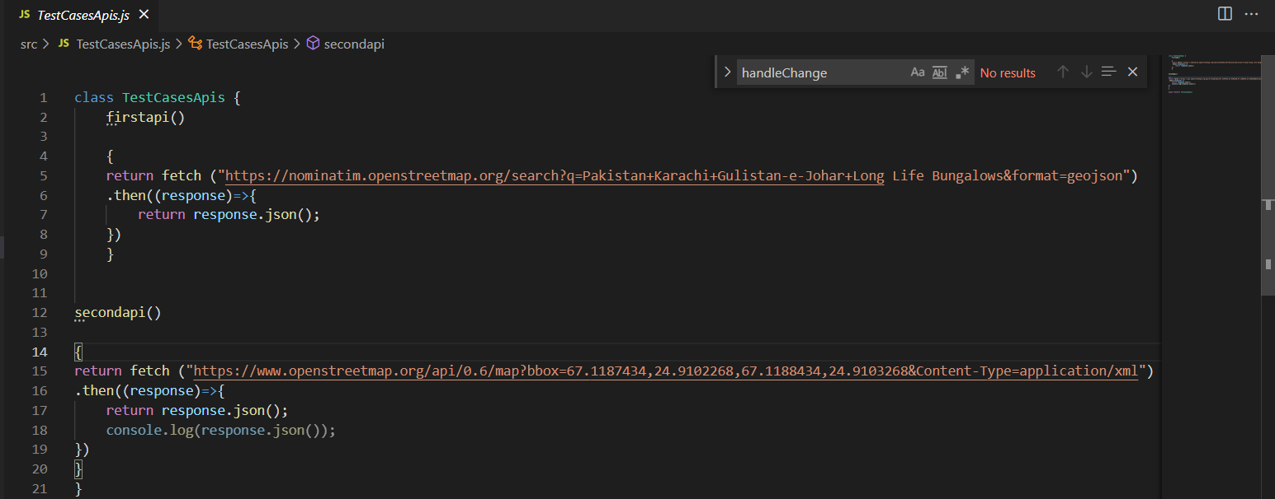I have made the test case of the mocking apis

**Screen shots of the project structure:**

* TaskOpenStreet.js is my main .js file

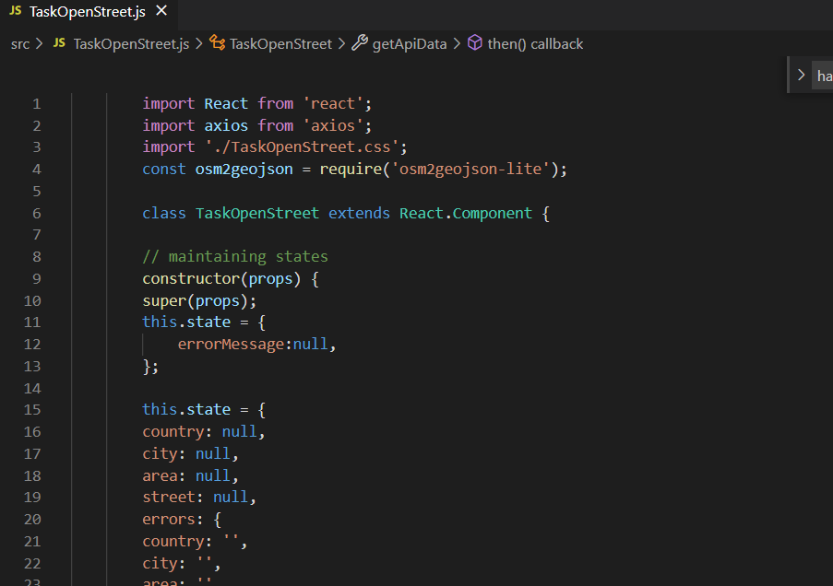

* TaskOpenStreet.css handling my project css

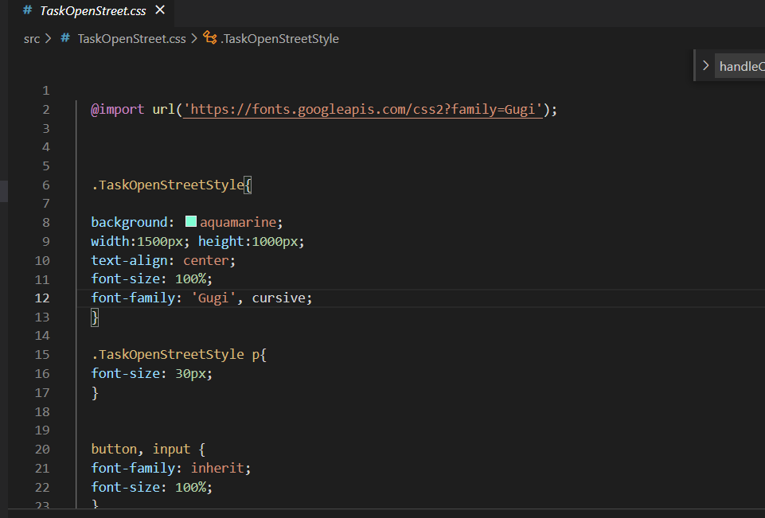

* Calling my main (TaskOpenStreet.js) to render it

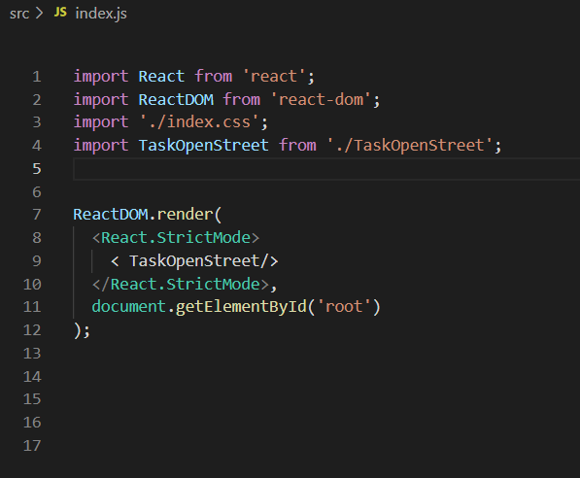

* For Test cases of mock apis (suppose country, city, area and street)



* Test cases of the above mock apis



* Installed packages

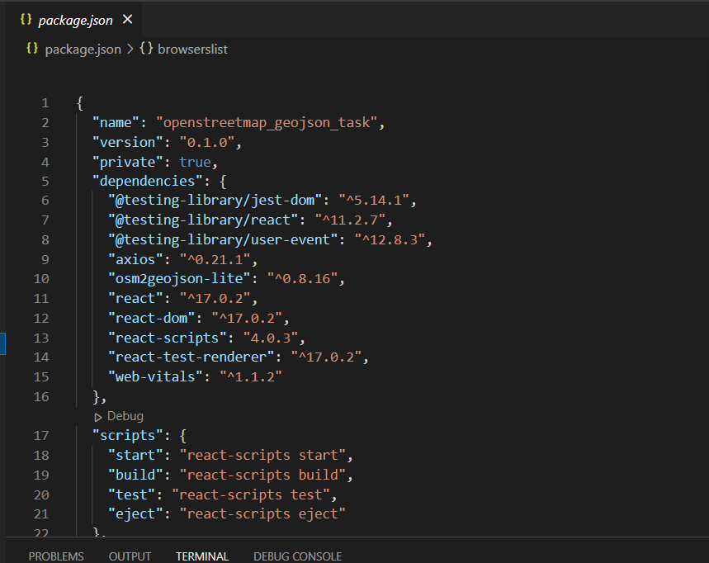

**UI RESULT:**

If node modules won’t uploaded please run:

* **npm install** in the location where you have placed the project to download all the packages



* run **npm start** for starting the server

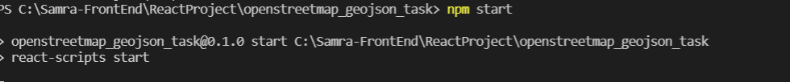

* Localhost:3001

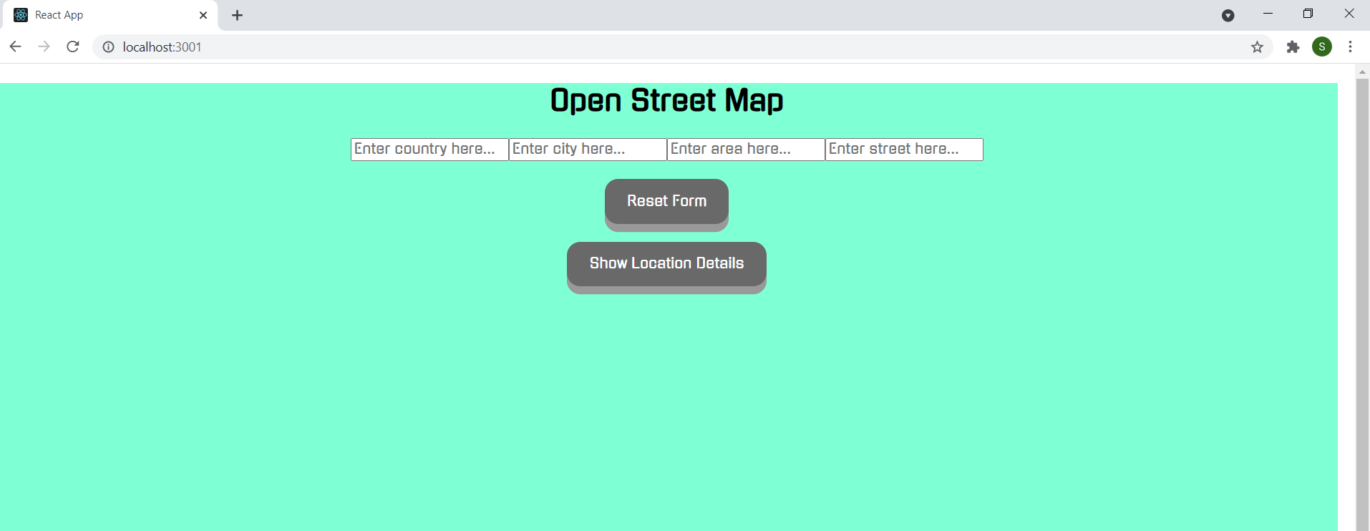

* Not filled any fields give the error

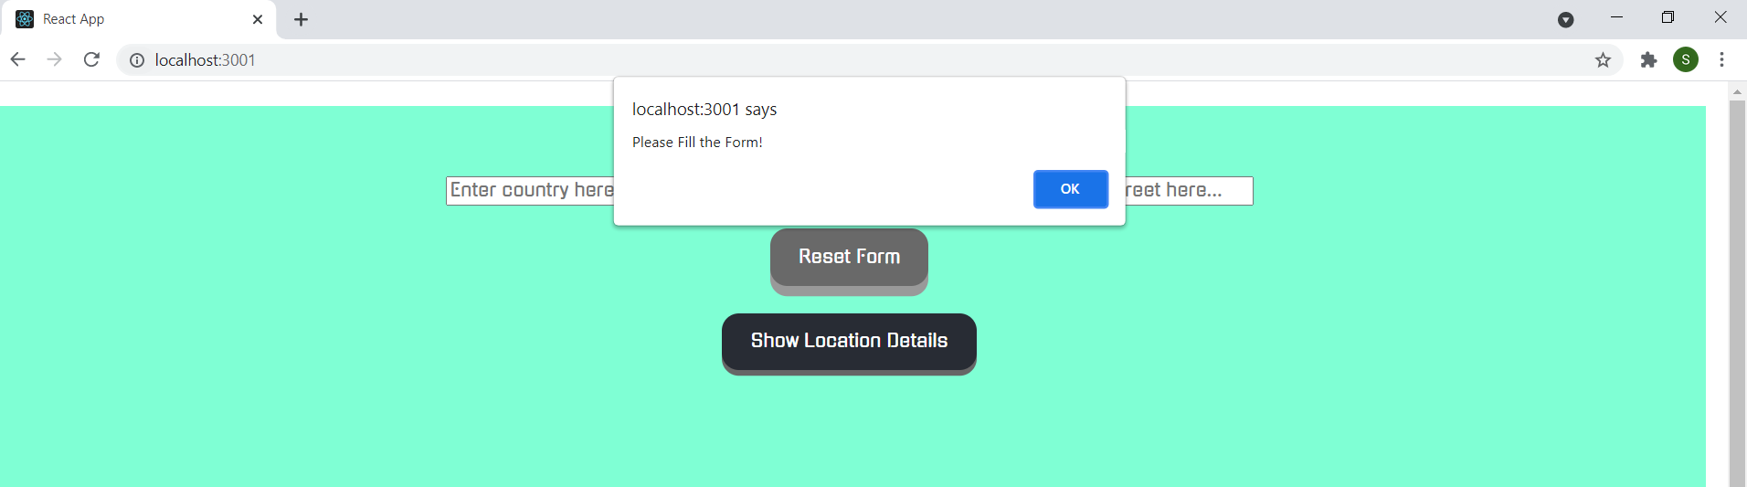

* Not filled other fields give the error

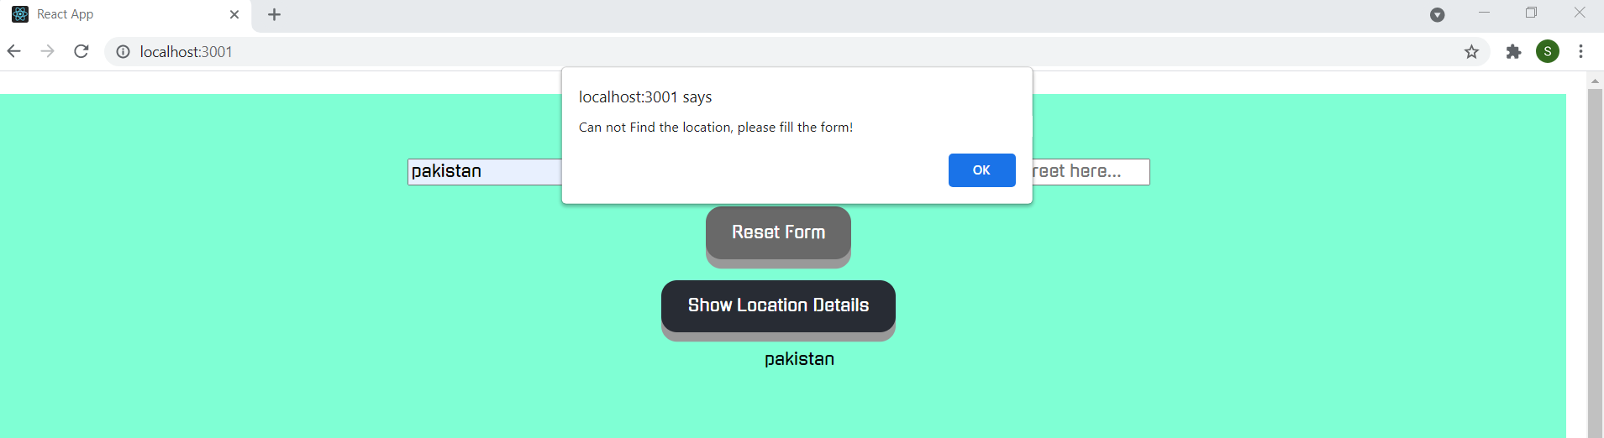

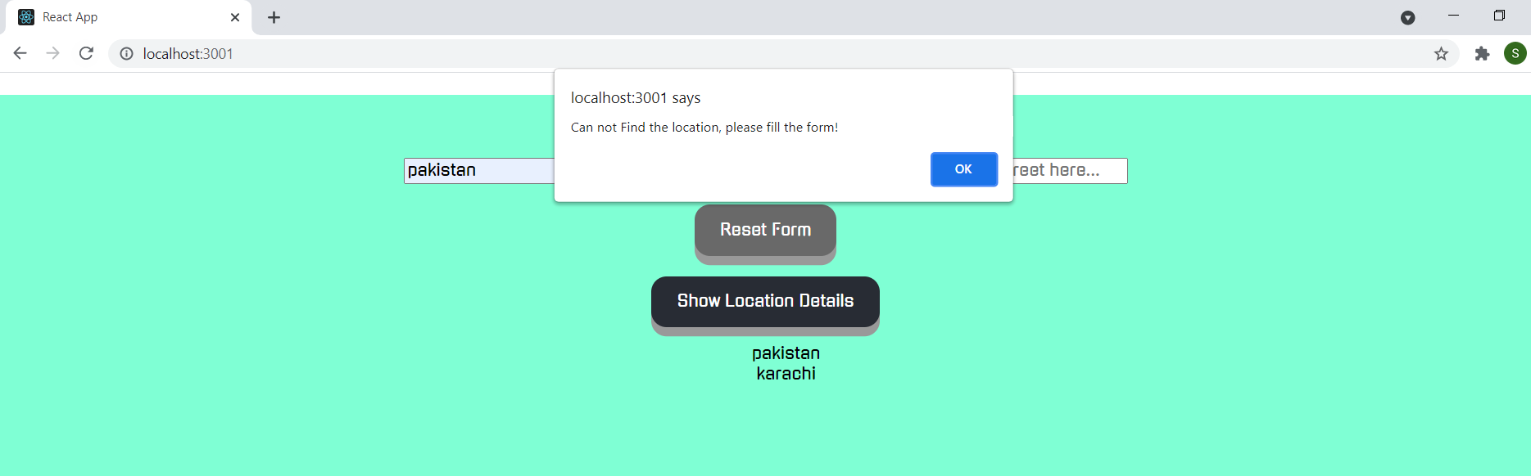

* Showing fields that has entered

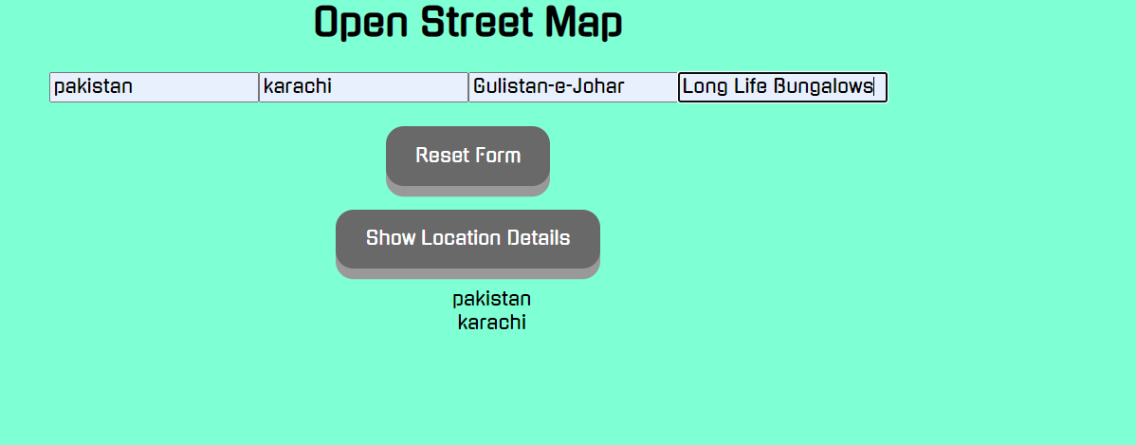

* Click on Show location details gives geojson format data and the some main data in the text form

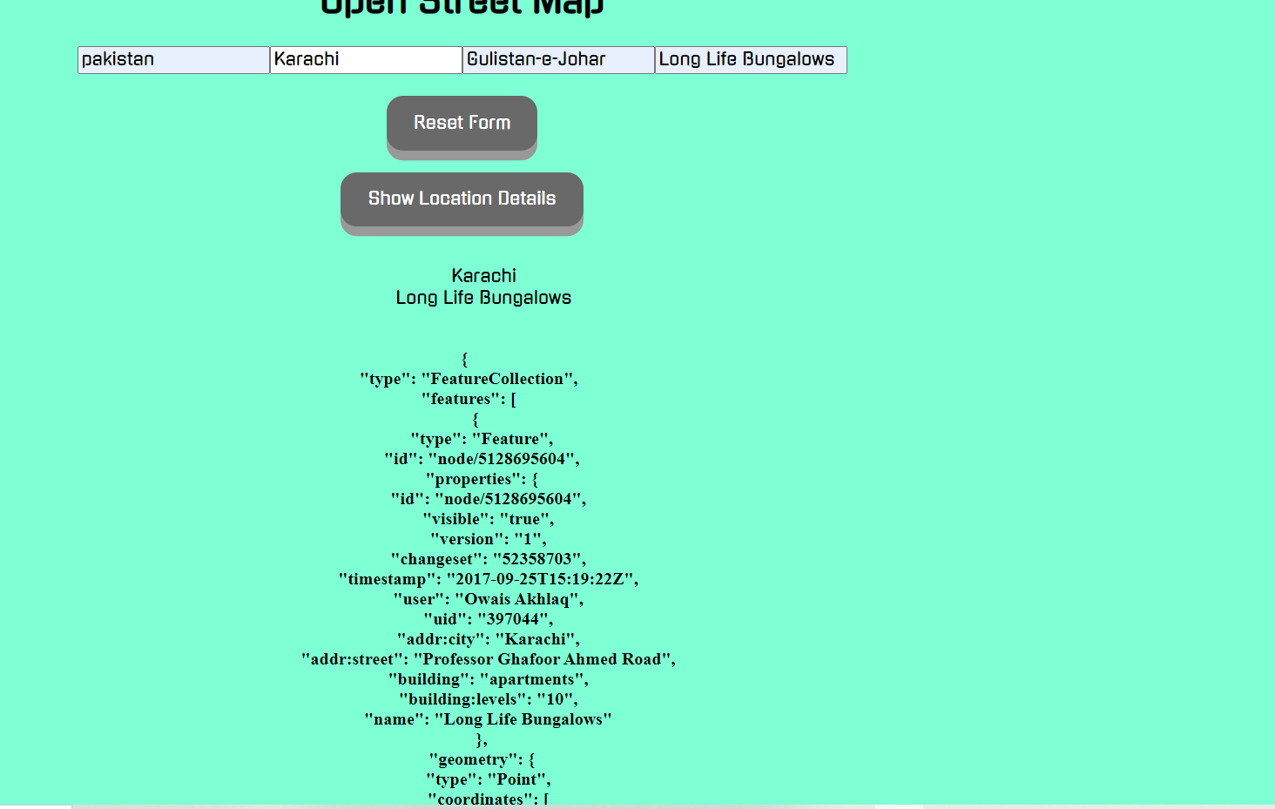

* Click on rest to reset the form

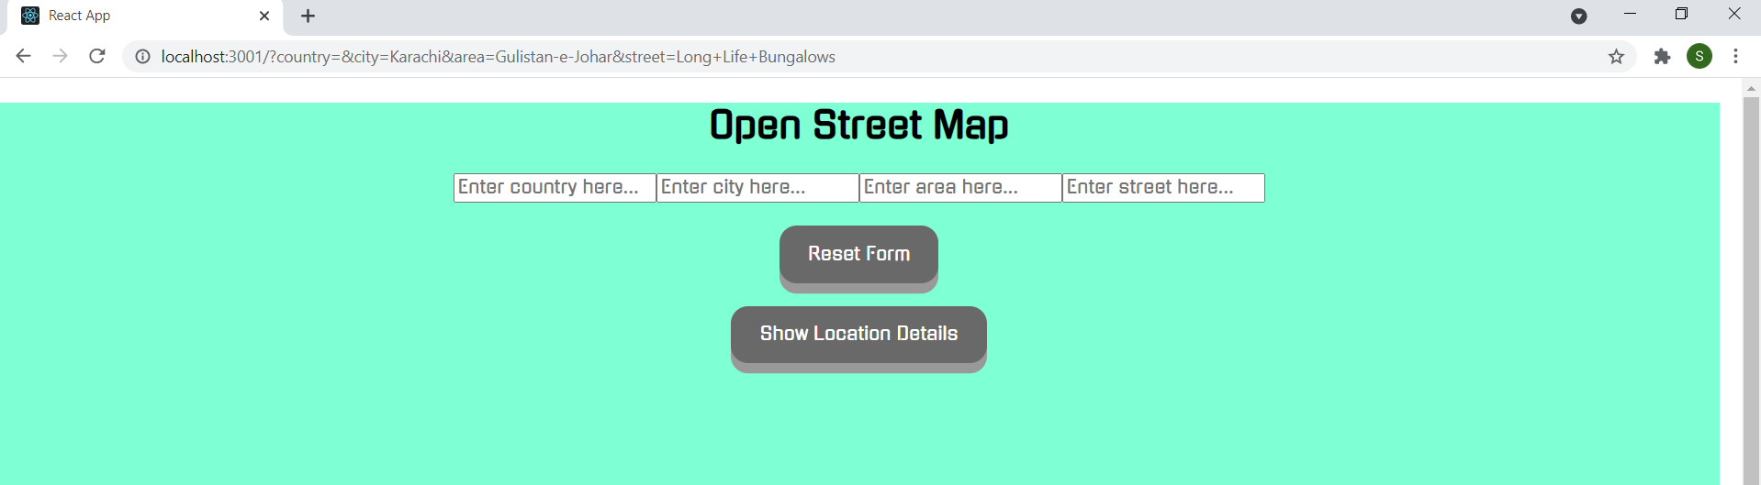

* Click on rest again to reset the query prams

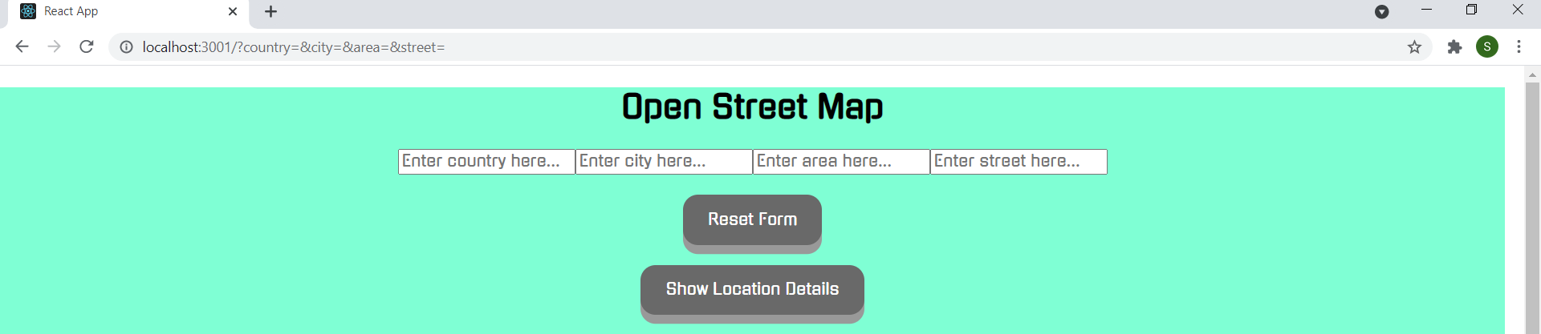

* Entering wrong fields

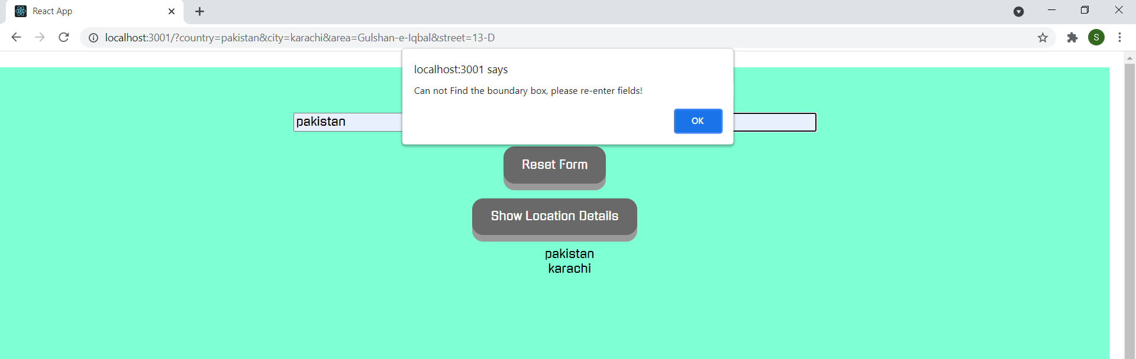

* Enter different details to get the result as it is generic

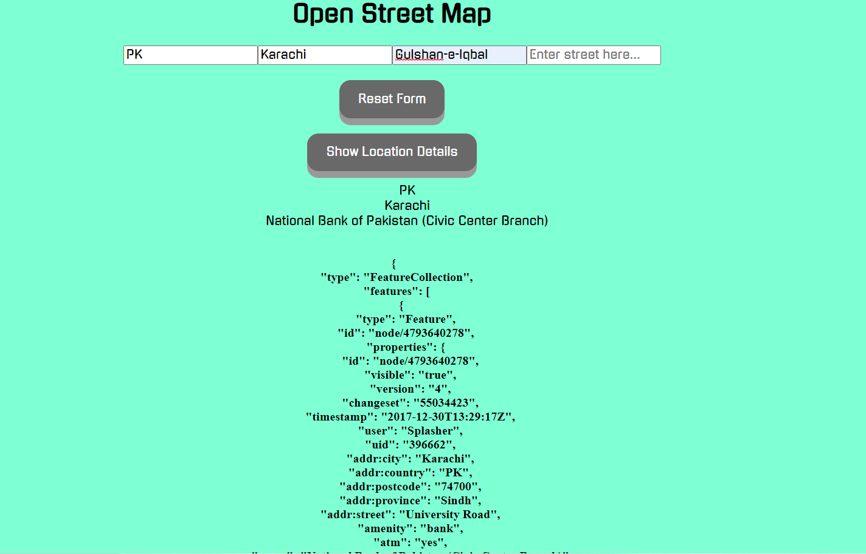

* Entered an other details

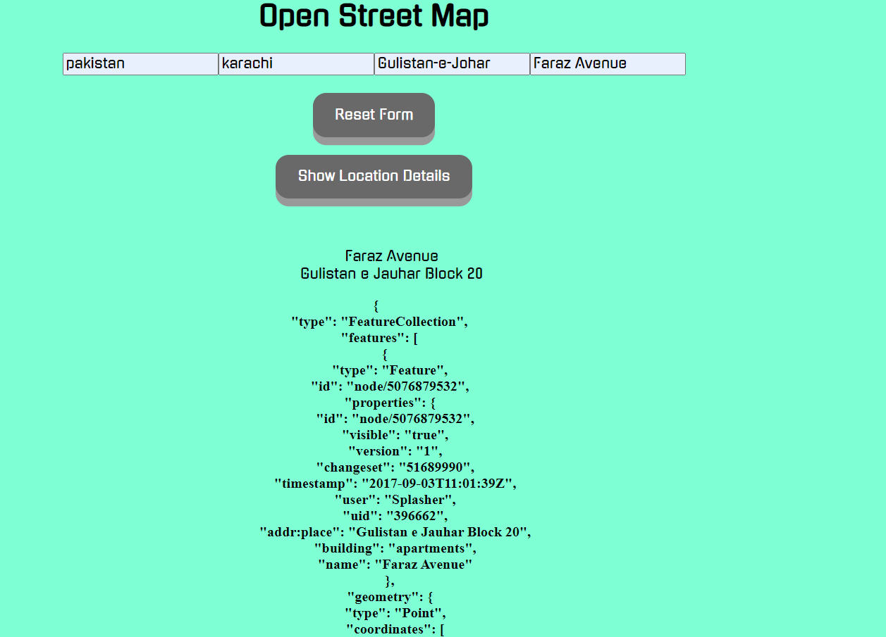

**Test Cases:**

* Run **npm test** to run the test cases



* Test cases pass

