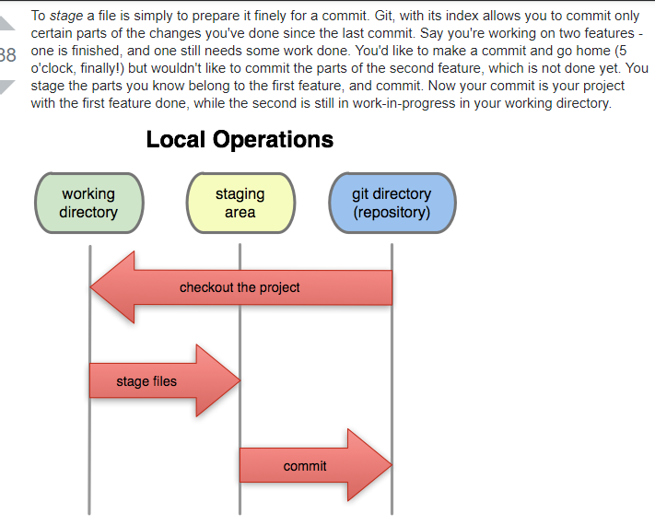

Git pull github pe kpi change hua wa hoga tou idhr ajaega pull se apke local pe

**git fetch** downloads all the changes needed to represent the given remote branch. Typically this is origin/master or similar. **git merge merges** two branches together by creating new commits or fast-forwarding (or a combination).

This example is one of a few **git pull** merging strategies. A **--rebase** option can be passed to **git pull** to use a **rebase** merging strategy instead of a merge commit. ... Instead, the **rebase** has copied the remote commits A**--**B**--**C and appended them to the local origin/master commit history.

Base directory mn rhte hue run this doqnload everything here

git clone <https://github.com/schacon/ticgit>

add file from local

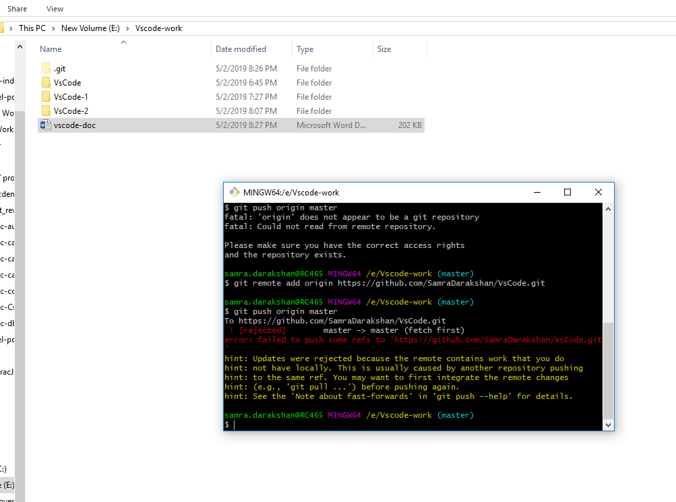

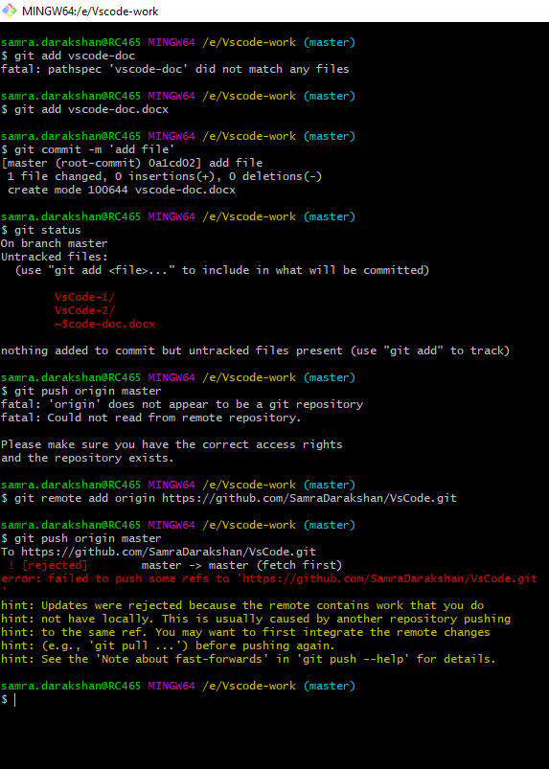

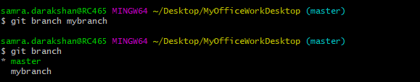

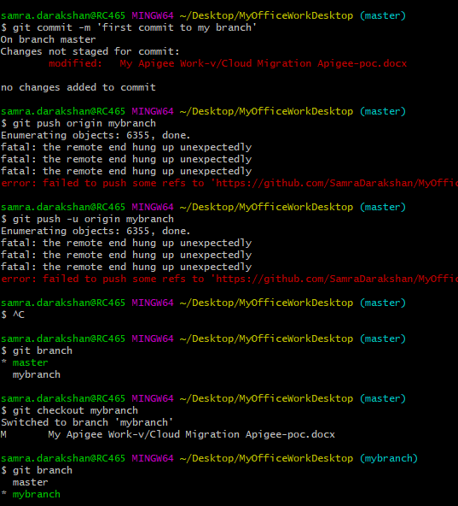

Git rm remote origin

Git add remote origin

$ git remote rm destination

# Remove remote

$ git remote –v

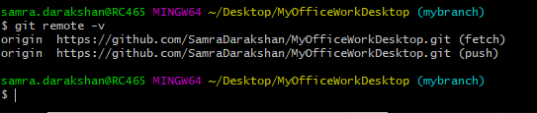

In **Git**, "**origin**" is a shorthand name for the remote repository that a project was originally cloned from. More precisely, it is used instead of that original repository's URL - and thereby makes referencing much easier. Note that **origin** is by no means a "magical" name, but just a standard convention.