**Web Engineering**

**Lab task - 1**

C:\Users\SAMRAS~1\AppData\Local\Temp\ksohtml10812\wps1.png

**Samra Saleem**

**22i-2727**



**Fall 2024**

**Department of Software Engineering**

**FAST – National University of Computer and Emerging Sciences**

**Login page:**





**Sign up pages:**

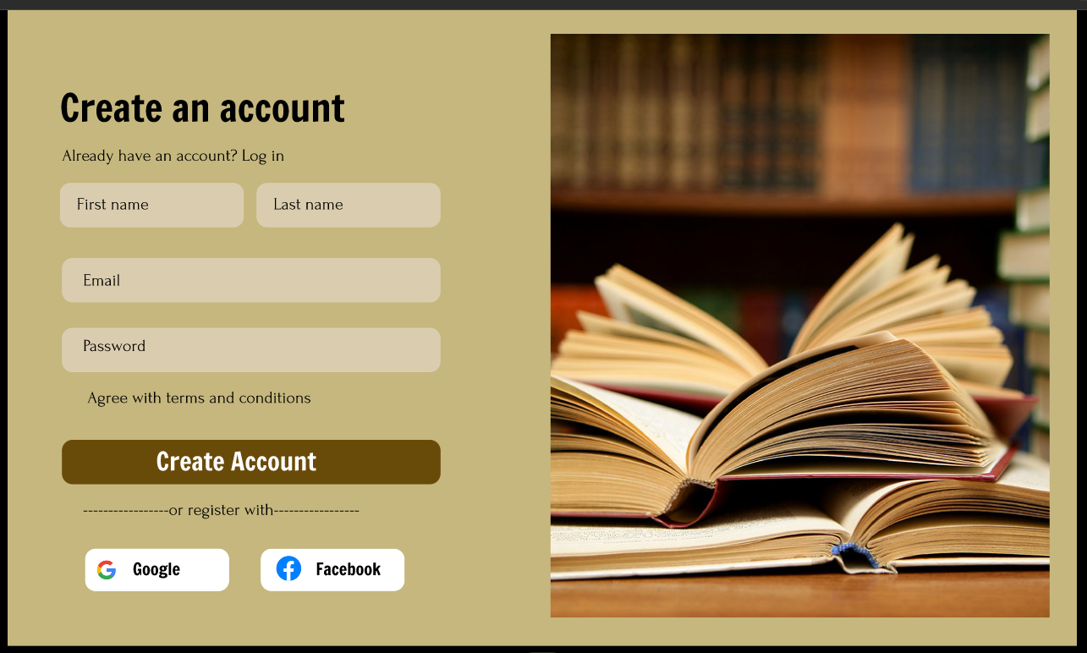

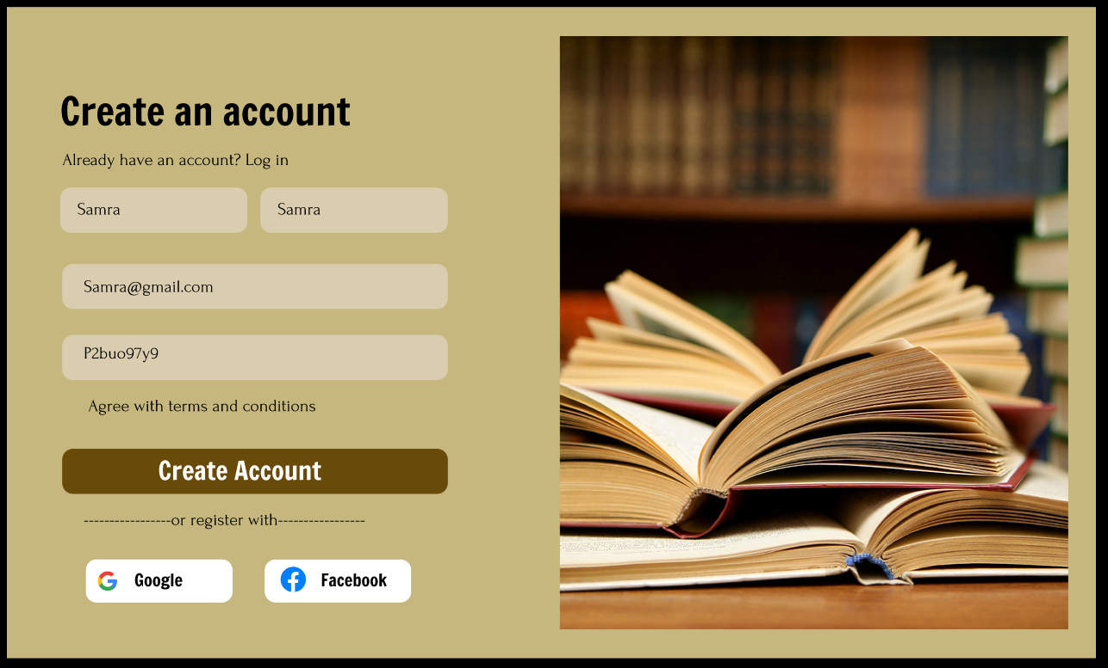

**Order pages:**

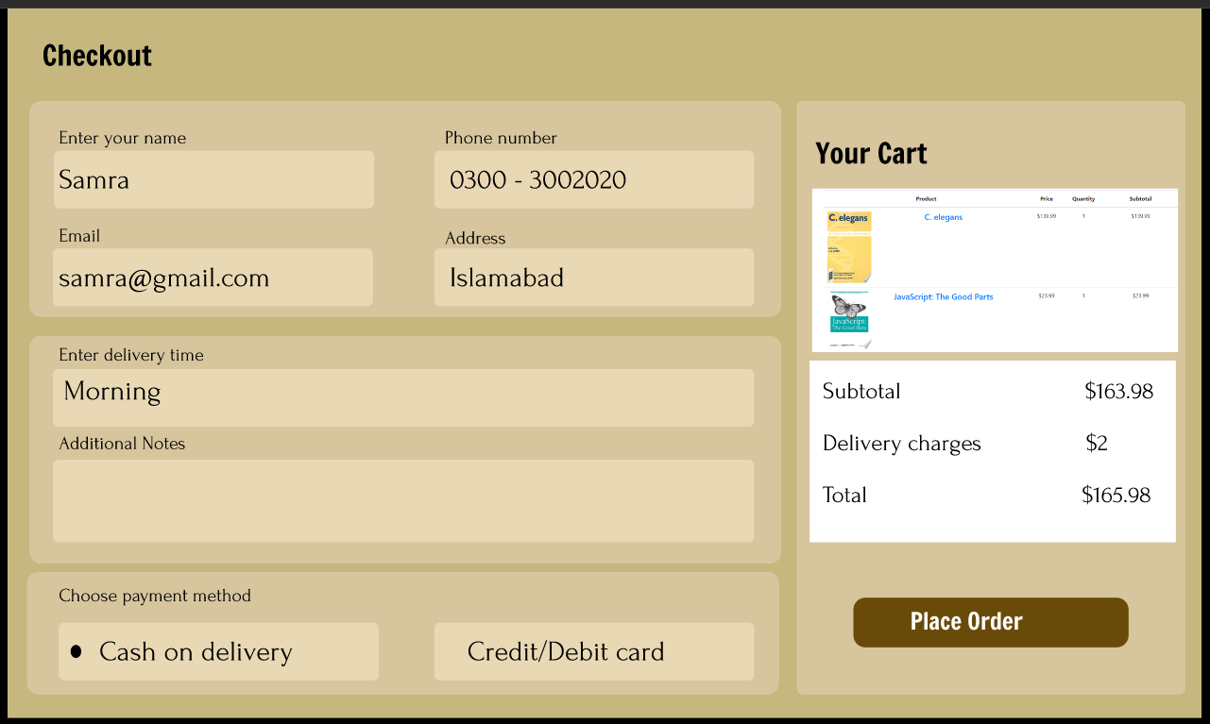

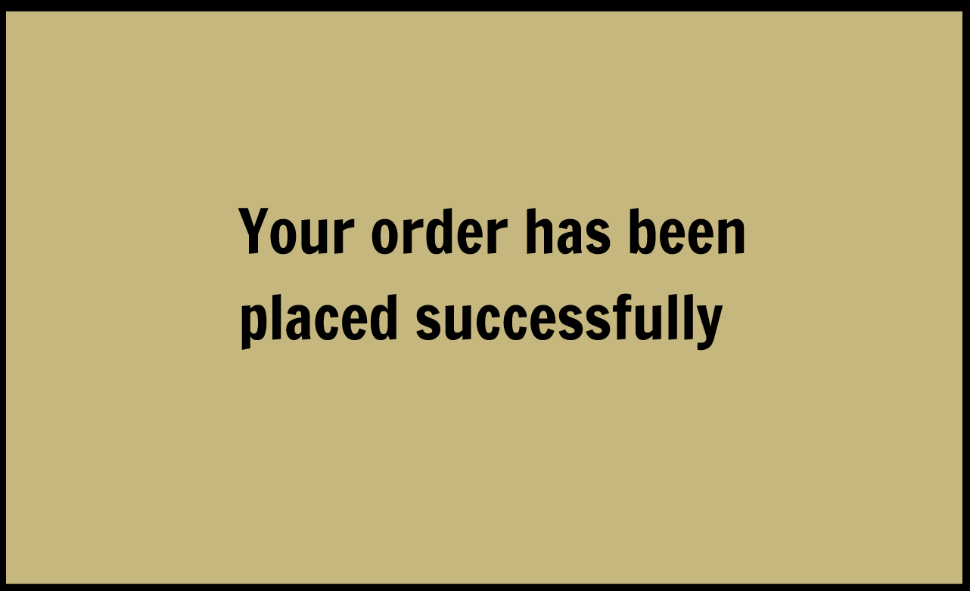

**Links:**

