Marketplace Technical Foundation - Niche E-Commerce

**January 16, 2025**

# Overview

The marketplace has been designed for a single business owner who is both the manufacturer and the seller. The focus is on products, customers, orders, shipping, and reviews, that leverages the product improvements and personalization.

#### Scenario: Handmade Jewelry & Bags Marketplace

The marketplace specializes in selling handmade jewelry and bags. The business owner manages product designing, manufacturing, order processing, and customer engagement.

# Technical Requirements

**Frontend (Next.js):**

* **Homepage:**
  + Highlights featured items and categories (e.g., Best Sellers, New Arrivals).
  + Hero banner showcasing a best-selling product with a "Shop Now" button.
* **Product Listing Page:**
  + Displays products by category, popularity, or new arrivals.
  + Filter options for price range, materials, and ratings.
* **Product Details Page:**
  + Includes product name, price, description, materials, and dimensions.
  + Displays customer reviews with average ratings and individual comments.
  + Buttons for "Add to Wishlist" and "Add to Cart."
* **Cart and Checkout:**
  + Displays selected products with quantities and total price.
  + Options for payment and delivery address entry.
* **Order Tracking:**
  + Allows customers to view the status of their orders.
  + Provides real-time shipment tracking via an integrated API.
* **Reviews Section:**
  + Collects and displays customer feedback for each product.
  + Calculates and shows average ratings.

### 4. System Architecture

* **Components:**

**Frontend (Next.js):**

1. Dynamic rendering for pages like Product Listings, Product Details, and Reviews.
2. Components for displaying and collecting customer feedback.

**Backend (Sanity CMS):**

1. Manage all product information, customer details, and order records.
2. focus entirely on maintaining inventory and orders.

**API Integrations:**

1. Payment Gateway for processing payments (e.g., Stripe, PayPal).
2. Shipping API: Tracks and updates delivery status.

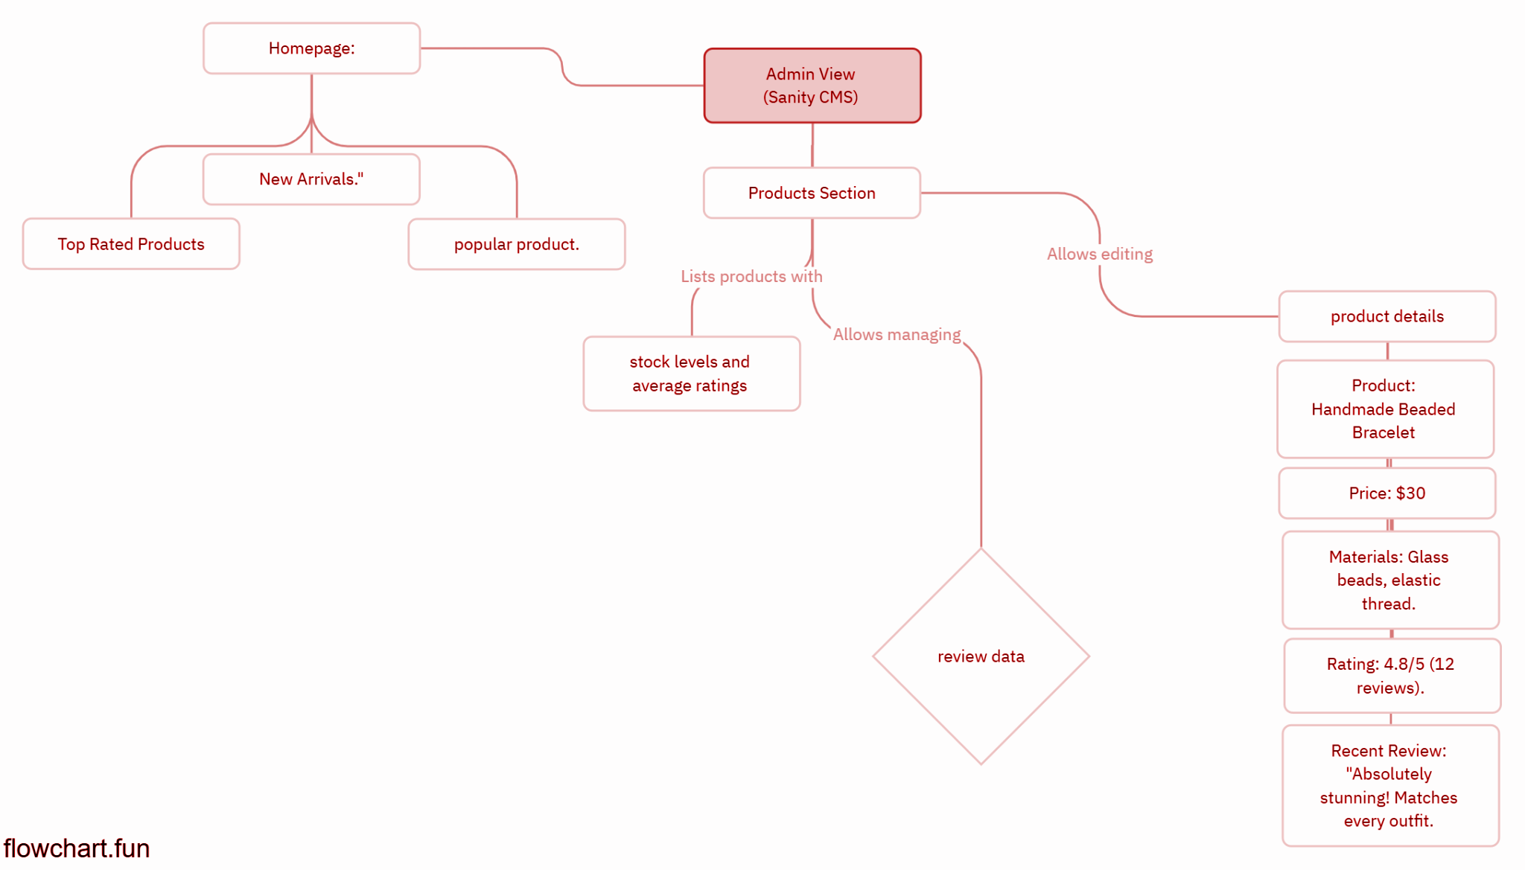

**Data Flow:**

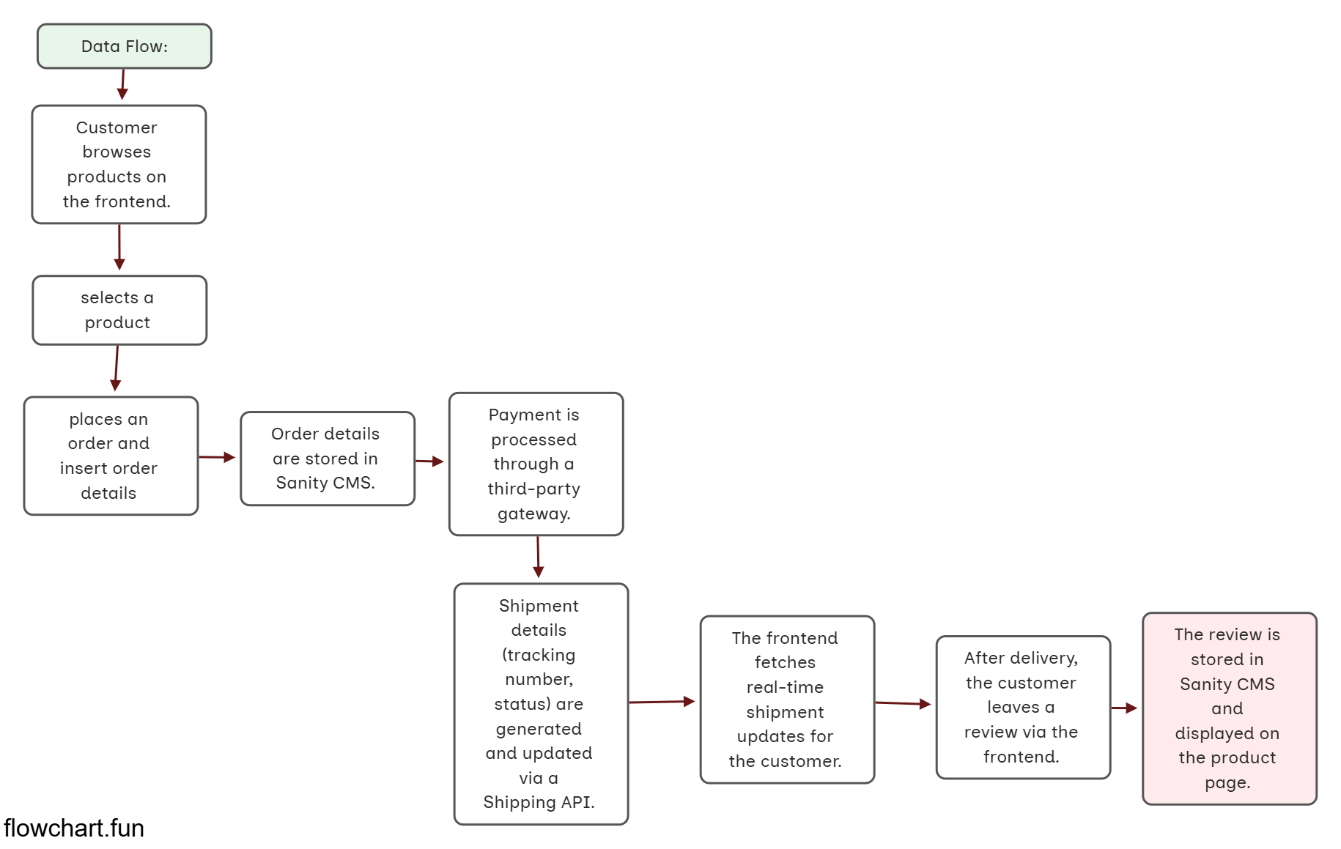

### 5. API Endpoints with Reviews

* **Fetch Product Reviews:**
  + **Endpoint:** /api/reviews/:productId
  + **Method:** GET

**Response:** {

"productId": "101",

"reviews": [

{ "rating": 5, "text": "Loved it!" },

{ "rating": 4, "text": "Great quality." }

]

}

* **Submit a Review:**
  + **Endpoint:** /api/reviews
  + **Method:** POST

**Payload:** {

"productId": "101",

"customerId": "123",

"rating": 5,

"text": "Amazing product!"

}

* + **Response:**{ "status": "success", "message": "Review submitted." }
* .