Project Report

On

**Web designing**

Submitted

In Partial Fulfilments of

**BACHELOR OF COMPUTER APPLICATION(BCA)**

**Submitted by:**

***Name: Samra khan***

***Roll No : 24/SCA/BCA(CS)/014***

**Under the Supervision of:**

**Mr. Sijo Joseph**



**School of Computer Applications**

**ManavRachna International Institute of Research and Studies**

**(DEEMED TO BE UNIVERSITY)**

Sector-43, Aravalli Hills

Faridabad – 121001

**July 2025**

**DECLARATION**

I do hereby declare that this project work entitled “Web Design and Development Internship at Mongoosh Design Studio” submitted by me for the partial fulfillment of the requirement for the award of BACHELOR OF COMPUTER APPLICATIONS (BCA) is a record of my own work. The report embodies the findings based on my study and practical experience during the internship and has not been submitted earlier for the award of any degree or diploma to any Institute or University.

**Date:15/07/2025 Name of Student: Samra khan**

**Certificate from the Guide**

This is to certify that the project report entitled “_________________________________________” submitted in partial fulfillment of the degree of **BACHELOR OF COMPUTER APPLICATIONS** to ManavRachna International Institute of Research and Studies, Faridabad is carried out by Mr./ Ms.______________(Roll No), _______________ under my guidance.

**Signature of the Guide**

Name: Samra khan

Date: 15/07/2025

**ACKNOWLEDGEMENT**

I would like to extend my sincere gratitude to **Prof. (Dr.) SuhailJavedQuraishi – HOD, Prof. (Dr.) Rashmi Agrawal – Associate Dean and Prof. (Dr.) Brijesh Kumar – Dean**for their valuable teachings and advice. I want to thank allthe department faculty members for their cooperation and support. I want to thank non-teaching staff of the department for their cooperation and support.

This opportunity is a big milestone in my career development. I will strive to use gained skills and knowledge in the best possible way, and I will continue to work on their improvement, to attain desired career objectives. I hope to continue cooperation with all of you in the future.

**INDEX**

|  |  |  |  |
| --- | --- | --- | --- |
| TOPIC | PG.NO | SIGHN | REMARK |
| Abstract | 8 |  |  |
| LIST OF SYMBOLS, ABBREVIATIONSANDNOMENCLATURE | 9 |  |  |
| Introduction | 10 |  |  |
| About Section | 11 |  |  |
| Mongoosh’s key services include: | 12 |  |  |
| Objectives of Mongoosh Design Studio | 13 |  |  |
| Challenges Faced During Internship | 15 |  |  |
| Significance of the Internship | 17 |  |  |
| Sample Work | 18 |  |  |
| Feasibility Study | 19 |  |  |
| System Analysis | 21 |  |  |
| System Study | 23 |  |  |
| Use of Figma | 23 |  |  |
| Use of WordPress | 23 |  |  |
| Use of Shopify | 24 |  |  |
| Technical Skills Acquired | 25 |  |  |
| Professional & Soft Skills Acquired | 26 |  |  |
| REFFERENCE | 27 |  |  |
| CONCLUSION | 29 |  |  |

**ABSTRACT**

This Web Design and Development Internship at Mongoosh Design Studio project is based on Web Development. This is developed using Figma, WordPress and Shopify. Design & Development Tools used for this project is Figma& CMS Tools. It displays the professional background of an individual. It displays brief information about work experiences till date, education, skills and contact details along with social media links. All the elements are rendered distinctively on the website.

**LIST OF SYMBOLS, ABBREVIATIONS AND NOMENCLATURE**

**Abbreviations**

1. IDE – Integrated Development Environment
2. WordPress – Hyper Text Markup Language
3. Shopify – Cascading Styling Sheets
4. JS – CMS Tools
5. Figma& CMS Tools – Visual Studio Code

**INTRODUCTION**

Web Design and Development Internship at Mongoosh Design Studio provides brief information about the professional background of an individual. This project comprises of three files. First is an WordPress file for creating markup of the application on the web. Then Shopify file is used to provide more styles to the website. Then JS file is used to give a proper functionality to the application through CMS Tools.

* 1. **ABOUT SECTION**

Mongoosh Design Studio is a creative digital agency headquartered in Noida, India, with a growing global footprint across the USA, UK, Australia, Canada, Singapore, and UAE. Established in 2021, Mongoosh specializes in UI/UX design, web development, branding, and no-code solutions tailored for startups, small businesses, and enterprises alike.

The studio is known for its innovative and user-centric design approach, having successfully delivered over 340+ projects for more than 130 global brands, achieving a remarkable 97.2% success rate.

Mongoosh thrives on the belief that great design should be accessible to everyone, regardless of business size or budget. Their team of designers, developers, and strategists focus on delivering responsive, accessible, and visually engaging web solutions that convert and connect with users.

**Mongoosh’s key services include:**

Web Design & Development

UI/UX Research & Prototyping (using Figma)

eCommerce Development (Shopify, WooCommerce)

Brand Identity & Logo Design

Website Maintenance & Support

Mongoosh fosters a culture of learning, design excellence, and customer-first delivery. Interns and professionals alike gain hands-on exposure to real-world client work, iterative design processes, and collaborative tool environments like Figma, WordPress, and Shopify.

For more information, visit: [https://mongoosh.com](https://mongoosh.com/)

🎯 **Objectives of Mongoosh Design Studio**

The core objectives of Mongoosh Design Studio reflect its mission to deliver accessible, creative, and results-driven digital solutions**.** These objectives guide every project, process, and collaboration the agency undertakes**:**

1. Deliver User-Centric Designs:

Create intuitive and visually appealing user interfaces that enhance user experience and engagement across all digital platforms.

1. Provide Scalable Web Solutions:

Develop responsive and scalable websites using modern technologies like WordPress, Shopify, and no-code tools to meet varied client needs.

1. Promote Design Accessibility:

Make quality digital design and branding services accessible to startups, individuals, and small businesses, regardless of their scale or budget.

1. Drive Business Growth Through Design:

Use design thinking and branding strategies to help businesses establish a strong digital identity and grow their market presence**.**

**5.** Foster Innovation and Continuous Learning:

Stay ahead of industry trends by encouraging innovation, learning, and collaboration among designers, developers, and interns.

**6.** Ensure Client Satisfaction and Long-Term Partnerships:

Deliver projects on time, exceed expectations, and build lasting relationships through transparent communication and client involvement.

**⚠️ Challenges Faced During Internship**

1. **Platform-Specific Limitations**

While working with WordPress and Shopify, I encountered limitations in customizing certain themes and plugins. Some advanced features required premium tools or code-level editing, which I had to learn and adapt to.

1. **Responsive Layout Adjustments**

Ensuring that every element on the website looked perfect across devices—desktop, tablet, and mobile—was challenging. I had to understand and apply media queries, grid systems, and spacing principles effectively.

1. **Maintaining Design Consistency**

Matching spacing, font sizes, and colors exactly as per the Figma designs required a strong eye for detail. Sometimes even small misalignments had to be fixed with precision.

**4.Time Management in Multi-Tasking**

Managing multiple sections of a website simultaneously (such as header, services, and contact forms) within given timelines helpedme develop time management skills, though it was challenging at first.

**5.Adapting to Design Feedback**

Occasionally, design suggestions from the mentor required quick revisions. I had to learn how to take constructive feedback positively and revise mockups or layouts efficiently.

Here’s a well-written section on the Significance of your internship at Mongoosh Design Studio, which you can include under the heading “Significance of the Internship” in your report:

**✨ Significance of the Internship**

The internship at Mongoosh Design Studio played a vital role in bridging the gap between academic knowledge and real-world application. It gave me a firsthand experience of working in a professional environment and exposed me to industry-standard tools like Figma, WordPress, and Shopify.

This experience was significant in the following ways:

1. **Practical Exposure**

I gained hands-on experience in web design workflows, including layout structuring, component design, responsiveness, and content placement.

1. **Skill Enhancement**

My technical skills in designing responsive websites and understanding user interface principles significantly improved during the internship.

1. **Professionalism and Workflow**

I learned about design iteration, feedback implementation, and following deadlines in a team-based setup. This helped me understand workplace ethics and project cycles.

1. **Confidence Building**

Working on live website projects boosted my confidence in applying what I’ve learned and sparked deeper interest in UI/UX and front-end development.

1. **Career Direction**

The internship helped clarify my career goals. I am now motivated to pursue further learning in front-end frameworks, UI/UX design, and CMS-based development.

SAMPLE WORK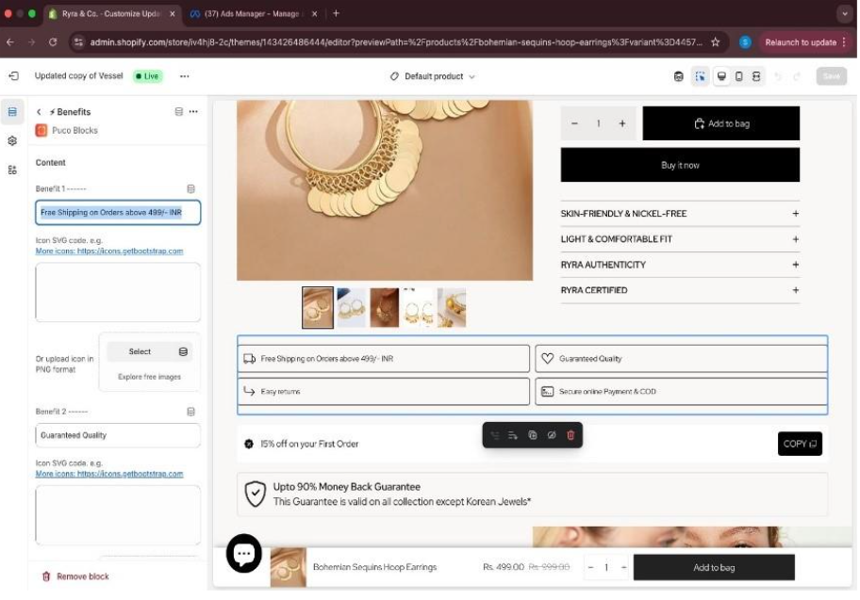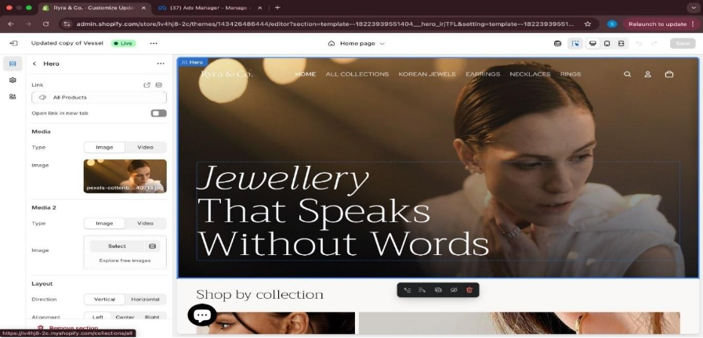

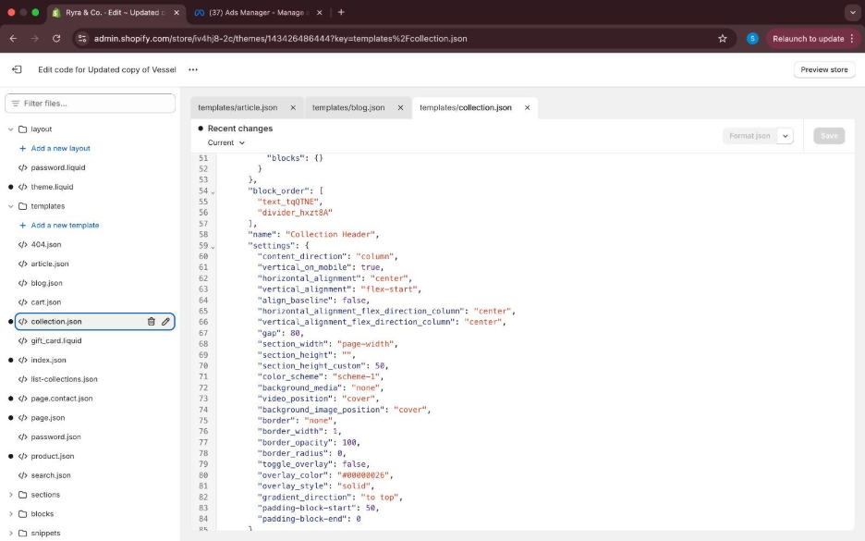

**SYSTEM STUDY**

System study is the initial phase of any project development. During my internship, I studied how Mongoosh Design Studio uses Figma to create wireframes and prototypes, and then implements those using WordPress and Shopify. The system flow from user requirement to deployment was structured and iterative, allowing better flexibility and design precision.

**FEASIBILITY STUDY**

Feasibility Study was crucial before beginning web development tasks. The team analyzed both design and platform feasibility. Using tools like Figma for planning and CMS platforms like WordPress and Shopify, we ensured the designs were scalable, responsive, and suited for real-world usage across various devices and browsers.

**SYSTEM ANALYSIS**

System Analysis involved understanding user flow, navigation logic, and structure. I participated in analyzing different website structures, how users interact with components, and implemented those insights into homepage, services, and contact sections for better user engagement

**USE OF FIGMA**

1. **Understanding the Website Requirements**

Before opening Figma, I first understood what kind of website I was designing. This included knowing the purpose of the site, who the users would be, and what pages were needed (like Home, About, Services, Contact, etc.).

1. **Starting the Design in Figma**

I created a new file in Figma and set up frames for different screen sizes – mainly desktop, tablet, and mobile versions. This helped me make sure the design would be responsive.

1. **Creating Wireframes**

I began by making simple black-and-white wireframes to plan where content like headings, images, and buttons would go. This step focused only on layout – not colors or styling.

1. **Designing the Final Look (UI Design)**

After the wireframe was done, I added proper colors, fonts, images, and icons based on the brand style. I designed sections like:

* Hero banners
* Service cards
* Contact forms
* Navigation bar and footer

1. **Using Components.** To make things easier, I turned repeated elements like buttons or cards into components. This helped keep the design consistent and easy to update.
2. **Using Auto Layout**I used Figma’s Auto Layout feature to arrange items in a neat and flexible way. It made the layout cleaner and saved time when aligning elements or adjusting spacing.
3. **Creating Prototypes**

Once the design looked good, I added links between pages using the Prototype tab. This made the design clickable, so the team could test how the website would work before building it.

1. **Sharing with the Team**

I shared the Figma file with the Mongoosh team so they could view, comment, and give feedback. Based on their suggestions, I made changes and improved the design.

1. **Exporting Assets for Development**

After the design was approved, I exported important assets like icons and banners. These were then handed over to the development team for use in WordPress or Shopify.

1. **Final Review**

Before finishing, I checked all pages for proper spacing, alignment, and visual consistency. I also made sure the design was organized and ready for development.

**USE OF WORDPRESS**

1. **Understanding the Dashboard**

I got familiar with the WordPress admin panel, where I could manage pages, media, plugins, and themes.

2. **Customizing Themes**

I worked with existing WordPress themes and used tools like Elementor or WPBakery to customize the layout. I changed headers, footers, and content blocks to match the Figma designs.

3. **Editing Pages**

I added content to web pages, such as text, images, buttons, and embedded videos. I also managed things like spacing, alignment, and background settings.

4. **Installing and Using Plugins**

I installed useful plugins for features like contact forms (WPForms), image sliders, and SEO (like Rank Math or Yoast).

5. **Website Responsiveness**

I tested how the site looked on different screen sizes and made design changes so it worked well on mobile and tablet devices too.

6. **Media Uploads and SEO Basics**

I uploaded and managed images, added alt texts, and optimized page titles and meta descriptions for better search engine visibility.

**Using Shopify**

1. **Exploring Shopify Admin**

I used Shopify to help build eCommerce websites. I learned how to navigate the dashboard to manage products, themes, and content.

2. **Customizing Shopify Themes**

I edited Shopify themes using their built-in theme editor. I added homepage banners, collections, product grids, and featured sections.

3. **Adding Content and Images**

I uploaded product images, wrote product descriptions, and organized items into collections. I also worked on static pages like "About Us" or "FAQs."

4. **Working with Sections**

Shopify uses a section-based structure, which I used to re-arrange content and create a clean, user-friendly layout.

5. **Checking Mobile Responsiveness**

Just like with WordPress, I tested and adjusted the layout for mobile users to make sure the design was responsive and clean.

**🛠️ Technical Skills**

1. **UI/UX Design Using Figma**

I learned how to create wireframes, use components, maintain design consistency, and build responsive layouts using Figma.

2. **Website Development with WordPress**

I gained experience in customizing themes, using page builders like Elementor, and managing website content through the dashboard.

3. **Shopify Store Setup**

I learned how to build product pages, manage collections, and design homepages using Shopify's section-based editor.

4. **Responsive Design**

I understood how to make designs look good on mobile, tablet, and desktop by adjusting layout, font sizes, and spacing.

5. **Basic SEO Knowledge**

I learned how to add meta tags, alt text, and improve page structure for better visibility in search engines.

**🤝 Professional & Soft Skills**

1. **Team Collaboration**

I worked with a team, shared Figma files for review, and learned how to accept and apply design feedback.

2. **Time Management**

I completed tasks within given timelines and balanced multiple pages or designs in a single day.

3. **Problem-Solving**

I handled challenges like layout issues, plugin limitations, and device-specific bugs through research and feedback.

4. **Adaptability**

I quickly adapted to new tools and software environments and followed the company's design standards.

This internship gave me practical confidence in web designing, and I now feel more prepared to work in professional design and development teams in the future.

**REFFERENCES**

* Coursera Course:

Introduction to Web Development, UC Davis by Daniel Randall – It taught all the three languages Figma, WordPress and Shopify thoroughly.

* W3 Schools: How to give all social media and website interface and responsive sections.
* 1. Mongoosh Design Studio – Official Website

[https://mongoosh.com](https://mongoosh.com/)

* 2. Figma – Collaborative Interface Design Tool

[https://www.figma.com](https://www.figma.com/)

* 3. WordPress – Content Management System

[https://wordpress.org](https://wordpress.org/)

* 4. Shopify – eCommerce Website Builder

[https://www.shopify.com](https://www.shopify.com/)

* 5. Adobe XD vs Figma vs Sketch: UI/UX Design Tools Comparison
* Interaction Design Foundation

<https://www.interaction-design.org/literature/article>

* 6. W3Schools – HTML, CSS & Responsive Design Tutorials

[https://www.w3schools.com](https://www.w3schools.com/)

* 7. MDN Web Docs – Responsive Web Design Basics

<https://developer.mozilla.org/en-US/docs/Learn/CSS/CSS_layout/Responsive_Design>

* 8. Shopify Help Center – Themes and Customization

[https://help.shopify.com](https://help.shopify.com/)

* 9. Elementor – WordPress Page Builder Plugin

[https://elementor.com](https://elementor.com/)

* 10. Google Fonts and Material Icons – UI Resources

[https://fonts.google.com](https://fonts.google.com/)

<https://fonts.google.com/icons>

**CONCLUSION**

At last toconclude, I have developed a simple and basic Web Design and Development Internship at Mongoosh Design Studio using WordPress5, Shopify, CMS Tools using Figma& CMS Tools as IDE which I would continue to maintain in future too.