Samraksh NETMF Emulator Manual

Author: Mukundan Sridharan

Revision | Revision Date
1.0 | May 16, 2012

Table Of Contents

1 Introduction 3
2 Design 3
2.1 Core Emulator 3
2.2 Emulator Control Panel 3
2.3 Network Emulation Framework 4
2.4 GPIO/Interrupt Automation Module 5
2.5 Physical Model 5
2.6 Physical Model Visualization 6
3 Function APIs 7
4 Future Features and Roadmap 7
5 More Documentation and Support 8
6 Reference 8
1 Appendix1 : Advanced User 9

Introduction
The Samraksh's NETMF emulator is designed based by extending Microsofts .NET Emulator. The unique feature of Samraksh's Emulator is, it lets the users write both .NET micro framework applications and the physical world model which interacts with the application, in order to validate the application.

Design

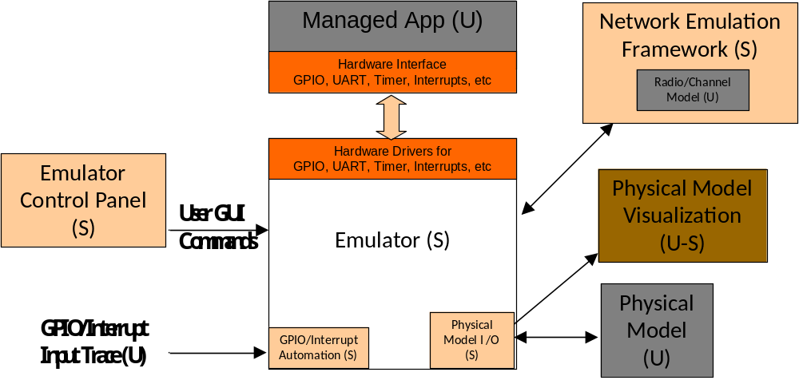
Figure 1: Emulator Design and Modules
Figure 1 shows the design of the emulator and various components.
The Emulator has the following modules

Core Emulator
This is implemented by Samraksh

Emulator Control Panel
This is implemented by Samraksh

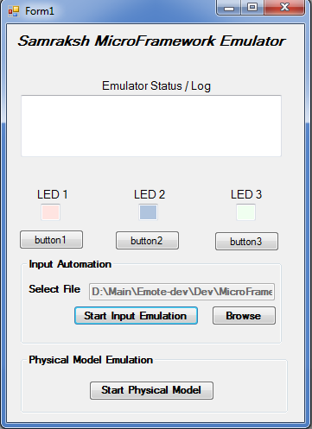
Figure 1: Emulator Design and Modules

Network Emulation Framework
This is implemented by Samraksh

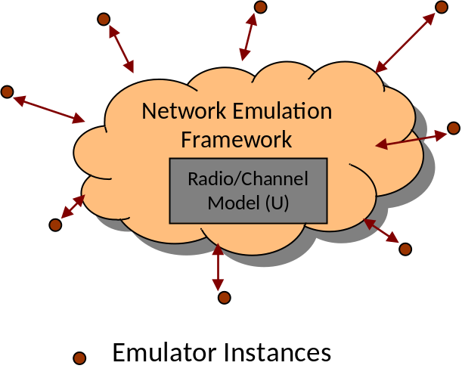
Figure 1: Emulator Design and Modules

GPIO/Interrupt Automation Module
is implemented by Samraksh

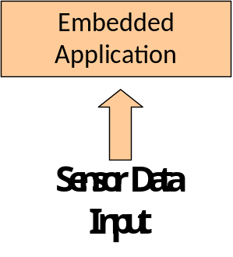
Figure 1: Emulator Design and Modules
Can be used to input sensor data collected in the field
Input is supplied as a text file
Input routed to GPIO or Interrupt pin(s) at appropriate time
File format: Time(ms), Node_ID, GPIO_Pin, Input
Line 1 specifies if it is absolute time or relative time. If Time is relative, the first field is considered as the delay before the next input
Example input file
Time: absolute
10,1,0,0
200,1,1,0
400,1,2,0
1000,1,0,1

This module is provided by Samraksh, but the user will have to collect the sensor data and format it as shown above.

Physical Model
This

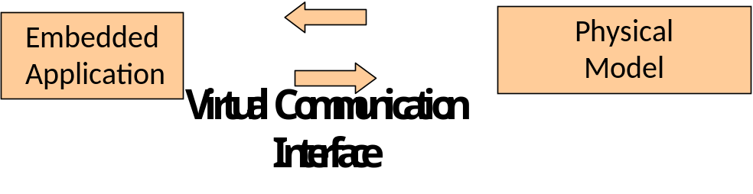
Figure 1: Emulator Design and Modules

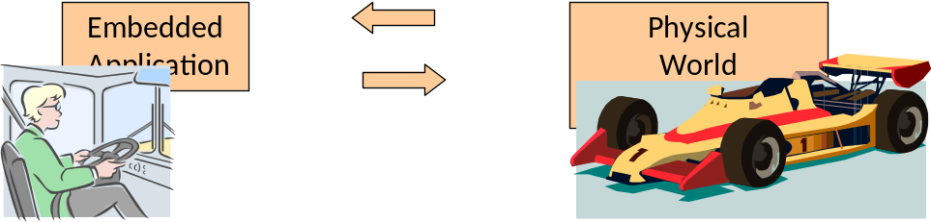
Figure 1: Emulator Design and Modules

This is implemented by Samraksh

Physical Model Visualization
This is implemented by Samraksh
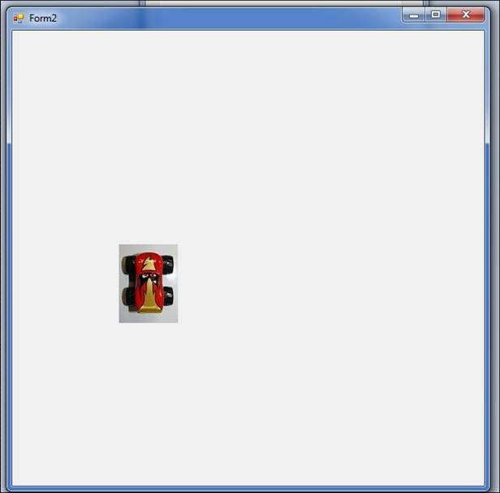
Figure 1: Emulator Design and Modules

is implemented by Samraksh

Function APIs

Future Features and Roadmap

- Hardware
  - GPIO
  - Timer
  - Interrupts
  - Serial Ports
  - ADC (under development, will be part of release 1)
  - SPI (under development, will be part of release 1)
  - Radio (under development, will be part of release 2)

- Emulation Support
  - Interaction with a Physical Model App (written in C# or Matlab)
  - GPIO/Interrupt Input Automation
  - Real time emulation (under development, will be part of release 2)
  - Channel model emulation for radio (under development, will be part of release 2)

- Timeline
  - Release 1: Mid June
  - Release 2: Mid November

More Documentation and Support
A detailed tutorial for writing applications using Samraksh's NETMF Emulator is available from Samraksh's website at www.samraksh.com
For questions about the Emulator email support@samraksh.com

Reference
- Microsoft NETMF Emulator Overview. http://msdn.microsoft.com/en-us/library/cc532990.aspx

Appendix1 : Advanced User

Building the Emulator:
1. Unable to find dll exception: If you get issues about unable to find the emulator dll files, try adding a HintPath to the reference manually in the .csproj file.
2. BadImageFormat Exception: If you use free version of VS C# Express on a 64-bit system, it will not set the build target properly, which will lead to the BadImageFormat exception (Note: The Emulator dlls are 32-bit). You need to do this manually. You'll have to edit your project's .csproj file by hand. Run notepad.exe and open the .csproj file. Locate the property group that looks like this:
<PropertyGroup Condition=" '$(Configuration)|$(Platform)' == 'Debug|AnyCPU' ">
and add this line:
<PlatformTarget>x86</PlatformTarget>
Repeat for the Release configuration group, just below that.

References:
- Microsoft NETMF Emulator Overview. http://msdn.microsoft.com/en-us/library/cc532990.aspx

