**SHOPBRIDGE APPLICATION**

There are different operations a Product Admin can perform using the application such as get the complete list of products in DB, Search for a specified product, Insert new product data, Update a record, Delete a record. All the functionalities are implemented

**DEPLOYMENT STEPS:**

1. Download the application from Github.
2. Execute all the Tables and Stored procedures attached below.



1. Change the connection string source name in the web.config.
2. Open the application right click on solution explorer and select publish as in click 1 and select click 2 and configure path as in click 3 and select click 4.

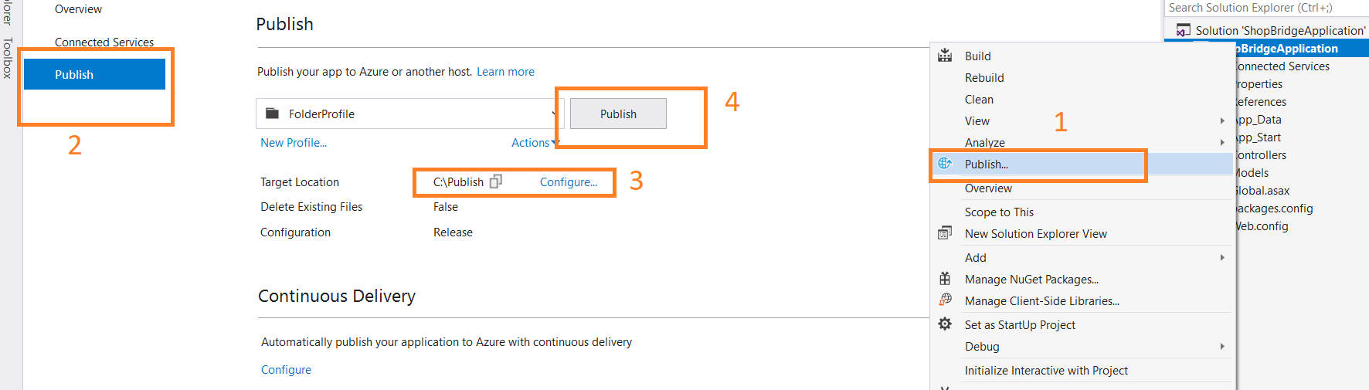

1. After publishing the application host it in IIS and the URL can be used in the any other application as per the requirement.

**ShopBridge Application Implementation:**

There are different operations a Product Admin can perform using the application such GET Method, PUSH METHOD, PUT METHOD and DELETE METHOD.

GET METHOD:

1. Using a Get Method the complete data can be obtained as below:

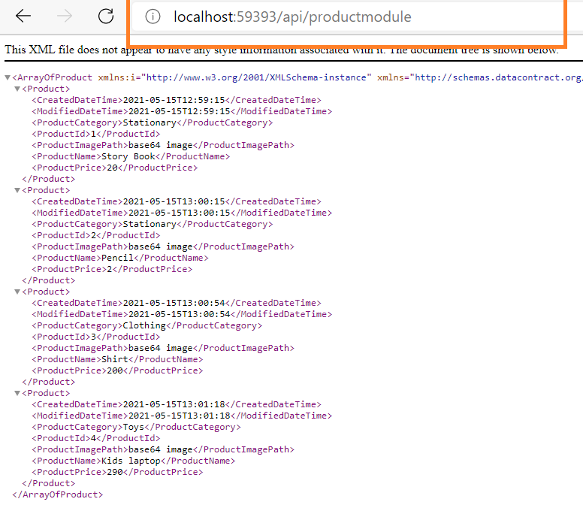

1. By Passing the filter parameters such as Product name / Product Category or any filter to fetch the data based on creation date such as From date and To date the data will be as below:Below Applied a filter on product name as “p” so the datat is filter as contains in linq fetching 2 records as below:

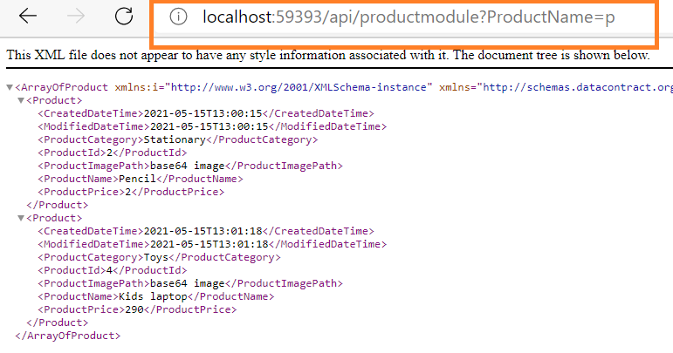

1. By adding productCategory to the above filter will fetch only 1 record as below:

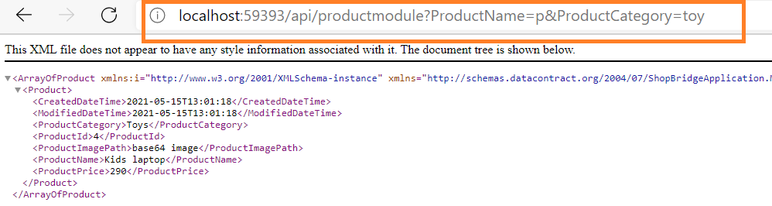

1. By adding from date to the data filter will fetch below records:

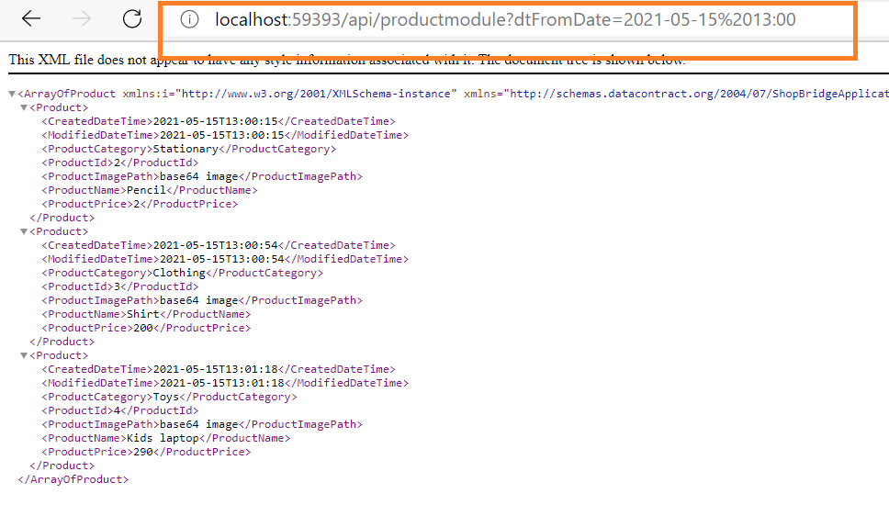

1. By adding to date as well to the date filter will fetch below records:

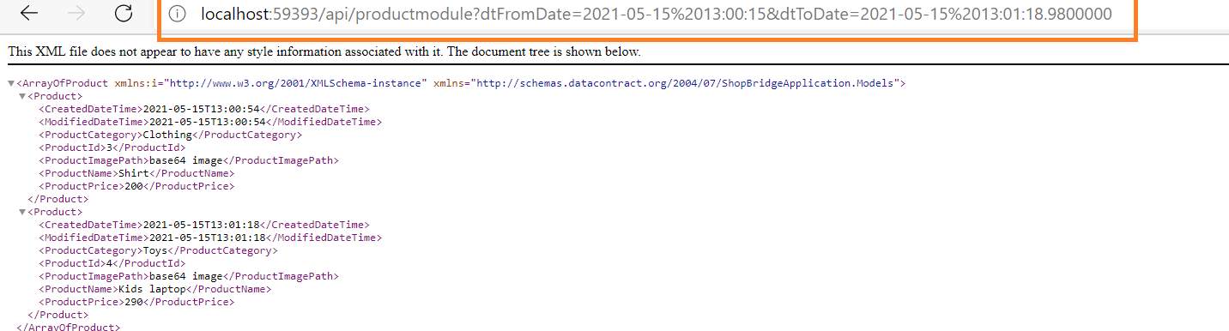

1. By adding productname and productcategory also will fetch below data:

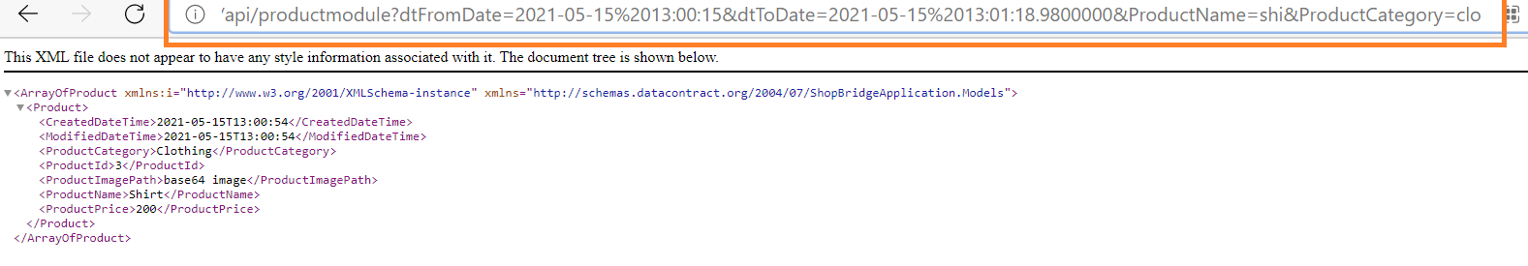

PUSH METHOD:

1. By passing the data for insertion in the fiddler as shown below the data gets inserted successfully:

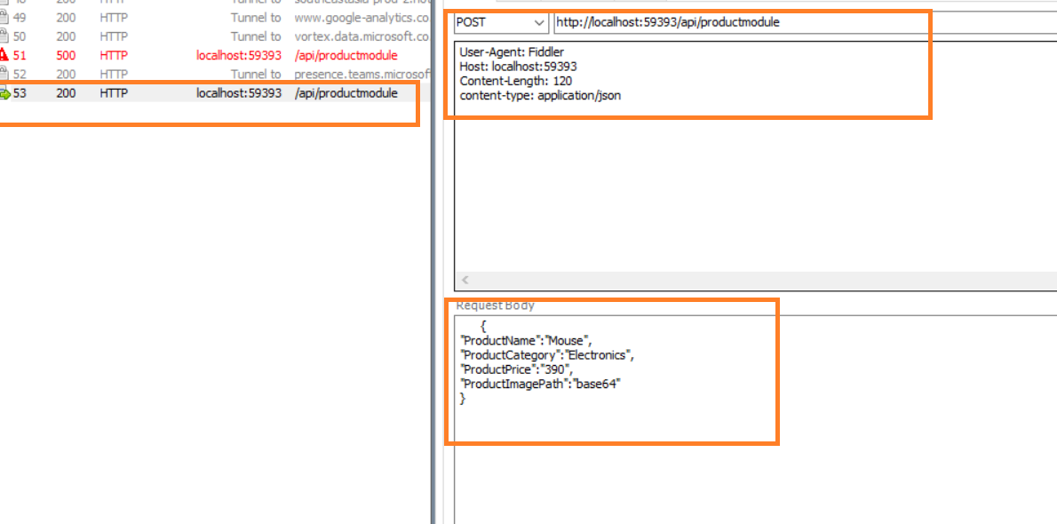

1. Success message of insertion of data to DB:

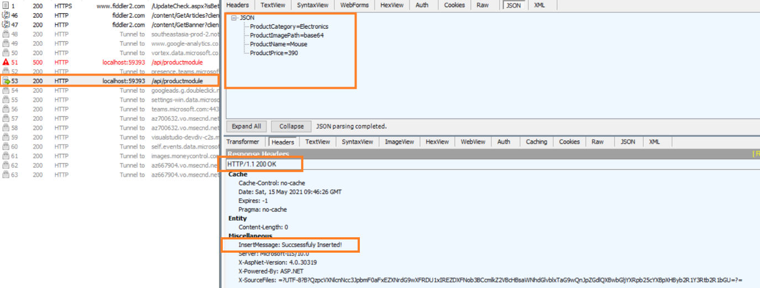

1. DB screen shot with data insertion:

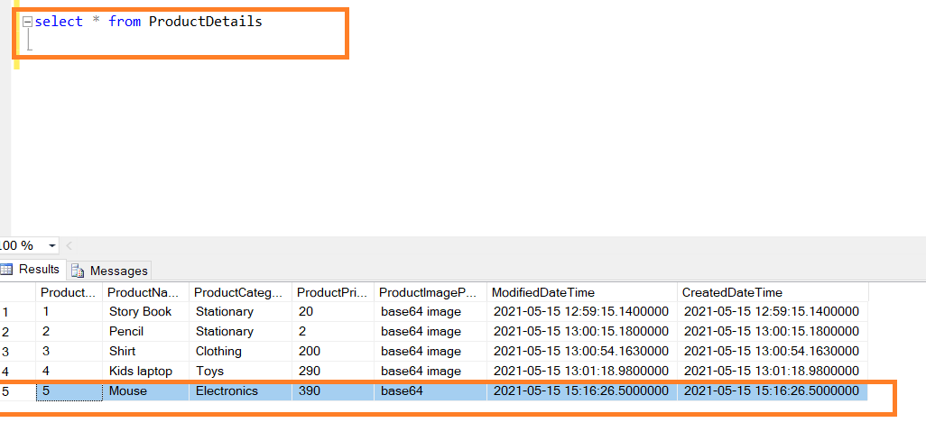

1. Exception for invalid data in Post request:

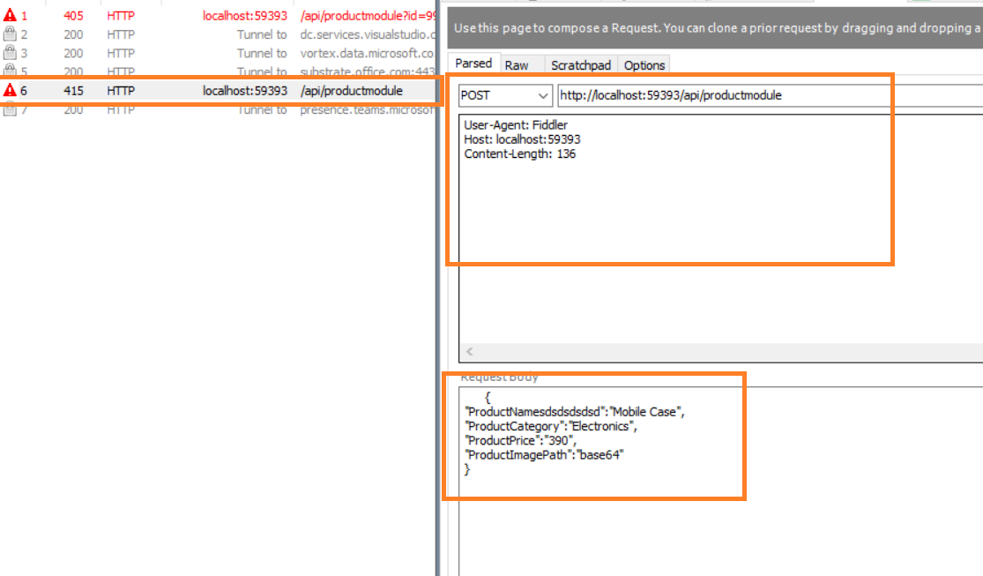

PUT METHOD:

1. By Passing the data for updation in fiddler the data got updated as below:

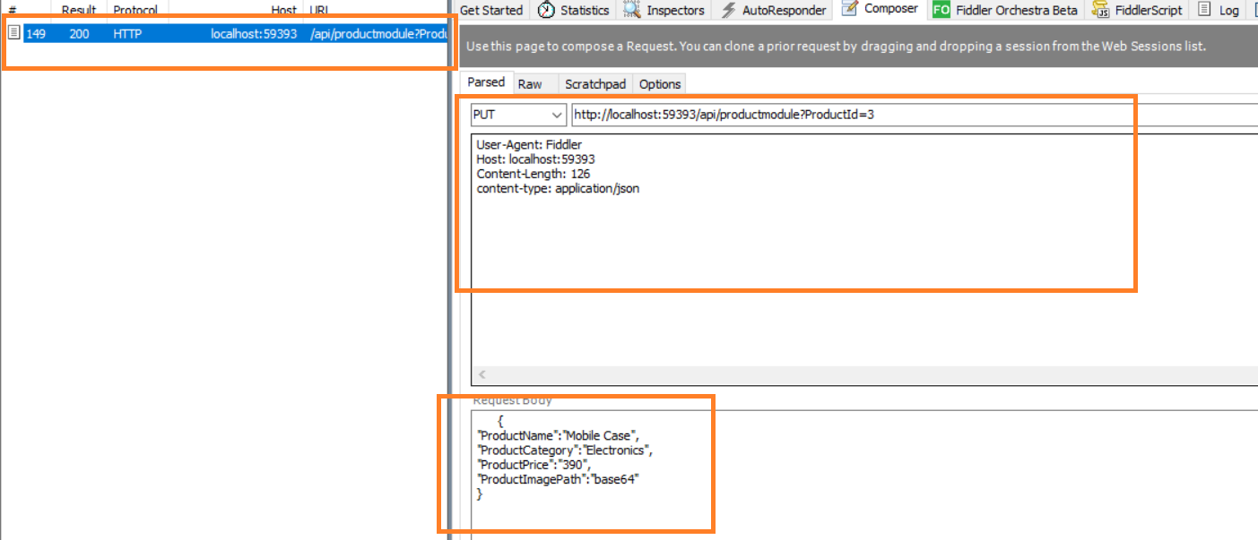

1. Success message of updation to DB:

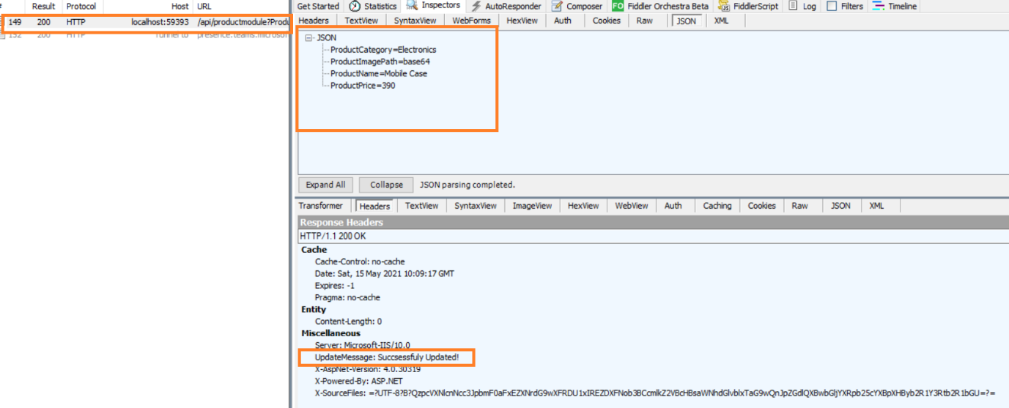

1. DB with data updation as below:

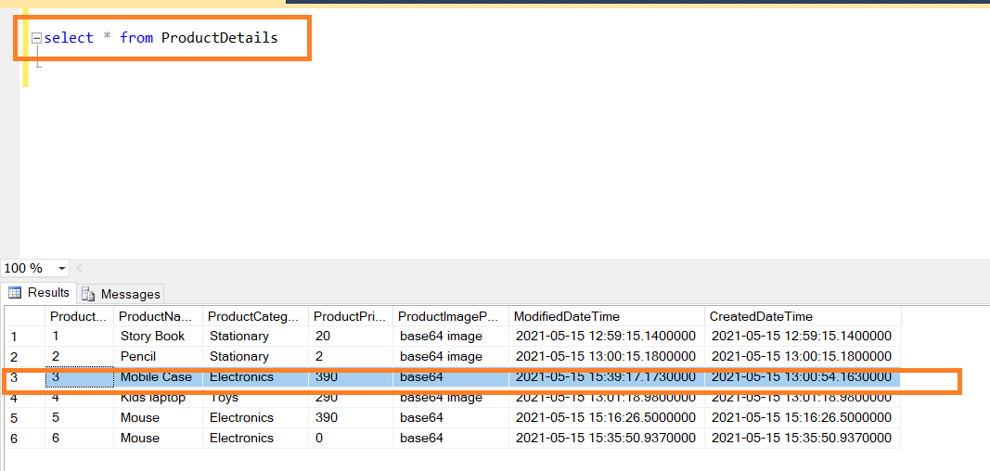

1. When there is an invalid data trying to be updated then failure message:

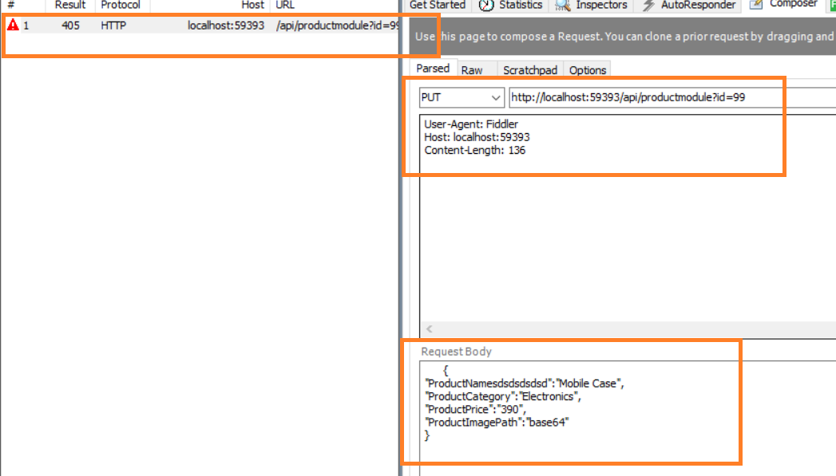

DELETE METHOD:

1. Deleting the data of the specified ID from fiddler as below:

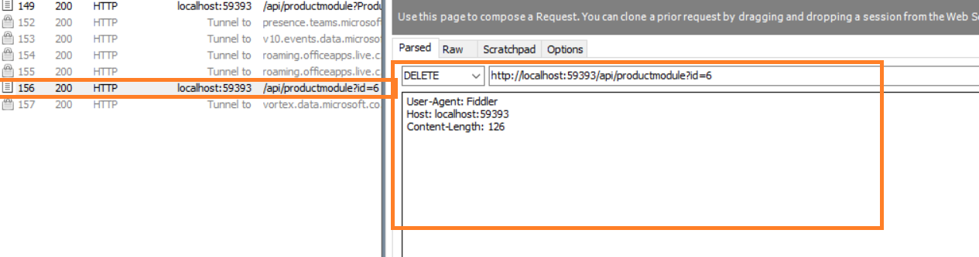

1. The deletion success message in fiddler:

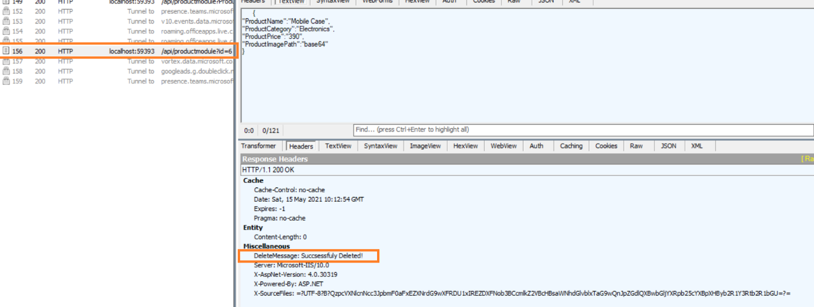

1. DB with the respective ID not found.
2. When there is an invalid data trying to be deleted. Then the error message will be as below:

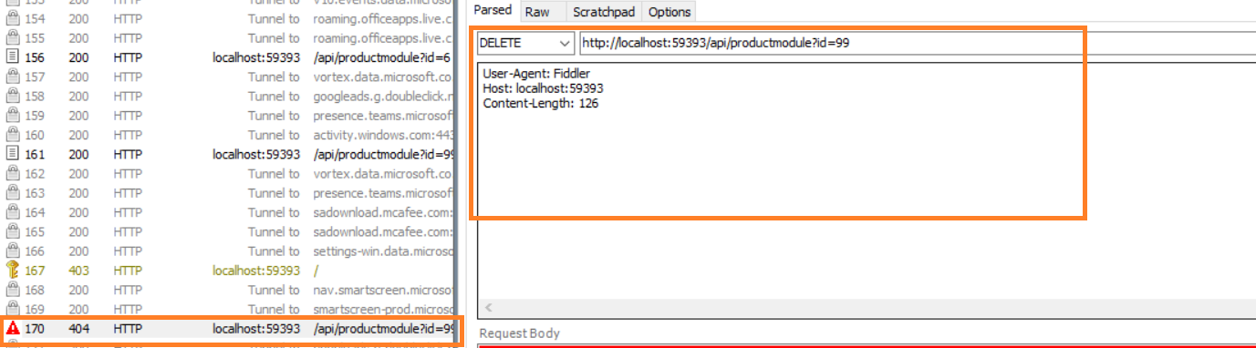

Time Taken for Activities:

1. Analysis – 10 mins
2. Implementation(Code) – 80 mins
3. DB Scripts - 30 mins
4. Unit Testing - 40 mins
5. Exception handling – 30 mins
6. Document creation - 60 mins