ISyE 6740 – Spring 2026
Final Report

  - Team Member: Samrand Toufani
Group: 094
Title: Probabilistic Customer Segmentation Using Gaussian Mixture Models for Online Shopper Behavior Analysis

Executive Summary. This project compares K-means clustering and Gaussian Mixture Models (GMM) on the Online Shoppers Purchasing Intention dataset. K-means with k=3 produced the clearest interpretable segmentation of high-, medium-, and very low-intent shoppers. At the same time, the full-covariance GMM with 6 components achieved the best statistical fit according to BIC. Across models, clusters with higher PageValues, longer product-related browsing, and lower bounce/exit rates consistently showed higher purchase rates.

1. Problem Statement
Online shopping sessions are heterogeneous: some visitors browse casually, some compare products, and others show strong purchase intent. The goal of this project is to identify meaningful behavioral segments among online shoppers using unsupervised learning and to evaluate whether those segments differ in purchasing behavior. I compare K-means clustering and Gaussian Mixture Models (GMM) to determine whether probabilistic clustering can reveal more informative segments than hard clustering. The Revenue variable is excluded from clustering and used only after modeling to evaluate whether the resulting clusters meaningfully separate purchase behavior.

2. Data Source
The analysis uses the Online Shoppers Purchasing Intention dataset from the UCI Machine Learning Repository. The dataset contains 12,330 sessions and 18 columns. Of these, 17 variables describe browsing behavior, traffic source, visitor characteristics, and session timing. The Revenue variable indicates whether a session ended in a purchase and was excluded from clustering; it was then used afterward to evaluate whether the discovered segments differed in purchasing behavior. (Table 1). The original dataset was introduced in a supervised prediction setting by Sakar et al. (2019), while this project studies the same data from an unsupervised segmentation perspective.

Table 1. Dataset attributes
Attribute | Explanation | Example
Administrative | Number of administrative/account-management pages visited | 2
Administrative_Duration | Total time spent on administrative pages | 80.8 seconds
Informational | Number of informational pages visited | 1
Informational_Duration | Total time spent on informational pages | 34.5 seconds
ProductRelated | Number of product-related pages visited | 32
ProductRelated_Duration | Total time spent on product-related pages | 1194.7 seconds
BounceRates | Average bounce rate of pages visited | 0.02
ExitRates | Average exit rate of pages visited | 0.04
PageValues | Average value of pages visited before transaction | 5.89
SpecialDay | Closeness of the session date to a special shopping day | 0.0
Month | Month of the user session | Nov
OperatingSystems | Operating system used by the visitor | 2
Browser | Browser used by the visitor | 2
Region | Region of the visitor | 1
TrafficType | Traffic source that brought the visitor to the site | 2
VisitorType | Type of visitor: new, returning, or other | Returning_Visitor
Weekend | Whether the visit occurred on a weekend | True / False
Revenue | Whether the session ended with a purchase, used only for post-clustering evaluation | True / False

3. Methodology

3.1 Exploratory Data Analysis
I first inspected the dataset structure, missingness, summary statistics, and class balance. The data contained no missing values, and the purchase outcome was highly imbalanced: 15.47% of sessions ended in purchase. Numeric features were right-skewed, with especially large ranges in ProductRelated_Duration, Administrative_Duration, and PageValues. I then compared feature means and correlations by Revenue to understand which browsing habits were most associated with purchasing.

3.2 Preprocessing
For clustering, Revenue was removed from the feature matrix and kept solely for later evaluation. Numeric variables were standardized using StandardScaler so that large-range variables would not dominate distance-based clustering. Categorical variables were one-hot encoded using OneHotEncoder. After preprocessing, the feature matrix expanded from 17 input variables to 75 modeled features.

3.3 Clustering Models
Two clustering families were evaluated. K-means served as the baseline hard clustering method. Candidate values of k from 2 to 8 were compared using silhouette score and the elbow plot. GMM was used as the main probabilistic clustering approach because it allows soft membership and more flexible cluster shapes.

Covariance structures in GMM.
The covariance structure shows how flexible each cluster is allowed to be. Spherical assumes round clusters with equal spread in all directions. Tied allows elliptical clusters but forces all clusters to share the same covariance matrix. Diagonal allows each cluster to have different variances along each feature, but does not model correlations between features. The full covariance structure gives each cluster its own covariance matrix (Bishop, 2006).

4. Evaluation Strategy
K-means models were evaluated using the silhouette score and the elbow method. GMM models were evaluated using Bayesian Information Criterion (BIC), Akaike Information Criterion (AIC), silhouette score, and interpretability of the resulting segments. To assess practical relevance, I compared models using cluster-level purchase rates, cluster profiles of the main behavioral features, soft membership strengths for GMM, and PCA visualizations.

5. Evaluation and Final Results

5.1 Key EDA Findings
Purchasing sessions differed substantially from non-purchasing sessions. Buyers had much higher ProductRelated_Duration, Administrative_Duration, Informational_Duration, ProductRelated page counts, and PageValues. They also had lower BounceRates and ExitRates. Among numeric features, PageValues had the strongest positive correlation with Revenue (0.49), while ExitRates (-0.21) and BounceRates (-0.15) were the strongest negative correlates. Among the categorical variables, November, October, September, and New_Visitor sessions had purchase rates higher than the overall average.

5.2 K-means Results
I first evaluated K-means using the silhouette score and inertia for k=2 through k=8. The silhouette score was highest when k=2 (0.302), while the elbow plot showed a large reduction in inertia from k=2 to k=3, followed by smaller improvements afterward (Table 2).
Table 2. K-means results
k | Inertia | Silhouette Score
2 | 151104.40 | 0.302
3 | 131368.17 | 0.285
4 | 120979.25 | 0.243
5 | 113218.79 | 0.212
6 | 106283.66 | 0.215
7 | 100414.55 | 0.212
8 | 96676.03 | 0.130

Although k=2 achieved the highest silhouette score (0.302) (Figure 1), k=3 remained competitive (0.285) and was easier to interpret because it separated shoppers into high-, medium-, and low-intent groups. The elbow plot also suggests that improvement in inertia began to flatten after three clusters (Figure 2 and Table 2).
Figure 1. K-means silhouette scores for different values of k.
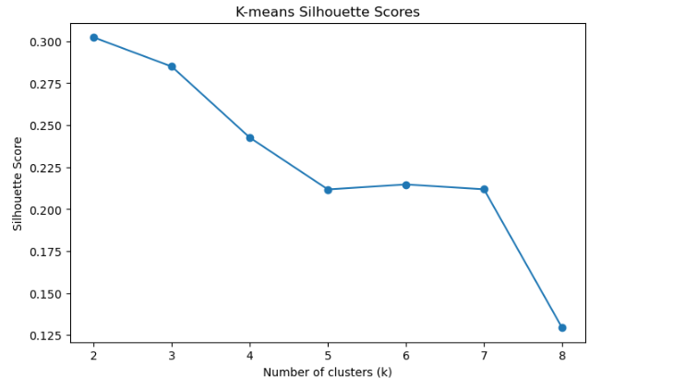

Figure 2. K-means elbow plot using inertia
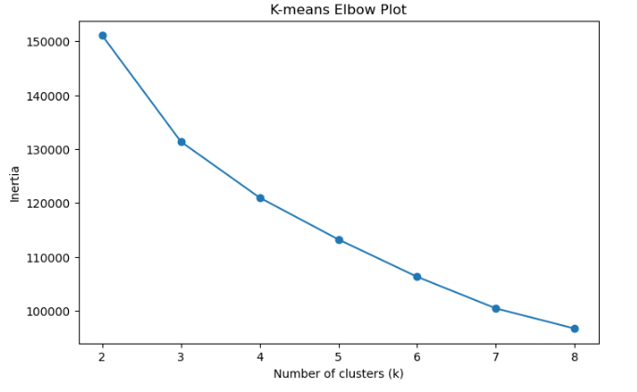
The k=3 solution separated a high-intent group, a medium-intent group, and a very low-intent group. The high-intent cluster had the highest PageValues, the longest product-related duration, and a purchase rate of 28.26% ( Table 3). The medium-intent cluster had a purchase rate of 14.95%, close to the dataset average. The low-intent cluster showed almost no effective engagement, much higher exit behavior, and a purchase rate of only 0.57%.

Table 3. k=3 revenue by cluster
Cluster | Size | Revenue Rate | Interpretation
0 | 1,628 | 28.26% | High-intent / deep engagement
1 | 9,647 | 14.95% | Moderate/ordinary browsing
2 | 1,055 | 0.57% | Very low-intent / shallow visitors

5.3 GMM Model Selection
For GMM, I evaluated component counts from 2 to 6 under spherical, tied, diagonal, and full covariance forms (Table 4). The full covariance model with 6 components achieved the lowest BIC and AIC, while the tied covariance model produced a stronger silhouette score and more interpretable separation. I used BIC as the primary selection criterion because it penalizes model complexity more strongly than AIC. Based on BIC, the best-fitting GMM was the full covariance model with 6 components.
Table 4. GMM model selection table
Covariance Type | Components | BIC | AIC | Silhouette Score
Full | 6 | -4.599e6 | -4.729e6 | -0.006
Full | 5 | -4.417e6 | -4.526e6 | -0.010
Diag | 5 | -3.593e6 | -3.598e6 | -0.035
Tied | 6 | -1.818e6 | -1.842e6 | 0.245
Spherical | 4 | 5.889e5 | 5.866e5 | 0.231

The best BIC was achieved by the full-covariance GMM with 6 components, indicating the strongest tradeoff between statistical fit and complexity (Figure 3 and Table 4). This suggests that online shopper behavior is not well represented by simple spherical clusters and instead contains more complex segment shapes and covariance patterns. However, the tied-covariance GMM with 6 components showed a much stronger silhouette score and produced highly interpretable segments, so both were examined in detail.

Figure 3. GMM model selection by BIC
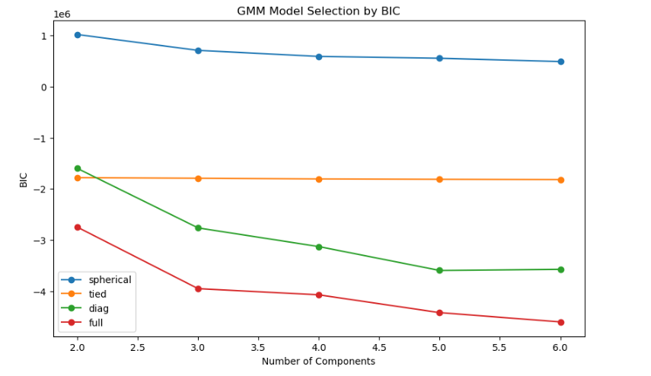

5.4 GMM Segment Interpretation
The full-covariance GMM produced a smooth range of segments, from very low-intent to higher-intent shoppers (Table 5). Its strongest purchasing cluster had a purchase rate of 27.06%, while the weakest had a purchase rate of 0.65%. The tied-covariance GMM produced even sharper separation: one cluster had a purchase rate of 82.68%, while another had a purchase rate of only 0.54%.
Table 5. GMM full-6 revenue by cluster
Cluster | Size | Revenue Rate
0 | 1,849 | 8.65%
1 | 151 | 20.53%
2 | 6,983 | 15.78%
3 | 308 | 0.65%
4 | 787 | 27.06%
5 | 2,252 | 17.76%

Across the clustering results, high-intent segments generally showed higher PageValues, more product-related browsing, and lower bounce and exit rates. Table 6 focuses on the K-means k=3 clusters because this solution produced the clearest behavioral interpretation.

Table 6. Behavioral profile of K-means clusters
Model / Cluster | Revenue Rate | PageValues | ProductRelated | ProductRelated  _Duration | BounceRates | ExitRates | Interpretation
K-means C0 | 28.26% | 9.75 | 96.82 | 3835.19 | 0.006 | 0.019 | High-intent shoppers
K-means C1 | 14.95% | 5.88 | 23.88 | 873.46 | 0.009 | 0.032 | Moderate browsers
K-means C2 | 0.57% | 0.00 | 3.09 | 58.12 | 0.166 | 0.180 | Shallow visitors

This profile table shows that the highest-conversion segment was also the most engaged behaviorally, with the highest product-related browsing activity and the lowest bounce and exit rates. The low-intent cluster showed the opposite pattern, with almost no page value and much higher exit behavior.

5.5 Soft Membership Strength
A key motivation for using GMM was its ability to assign probabilistic membership rather than forcing each session into a single hard cluster. In practice, the fitted models produced very high average maximum membership probabilities (approx. 0.999 for full-6 and 0.993 for tied-6), which indicates that most sessions were assigned with high confidence. Although GMM allows soft clustering, the high membership probabilities suggest that most sessions were assigned to one dominant segment.
5.6 PCA Visualization
The first two principal components explained approximately 36.2% of the total variance. In the 2D PCA view, K-means with k=3 showed the clearest visible separation (Figure 4).
Figure 4. PCA plot for K-means k=3
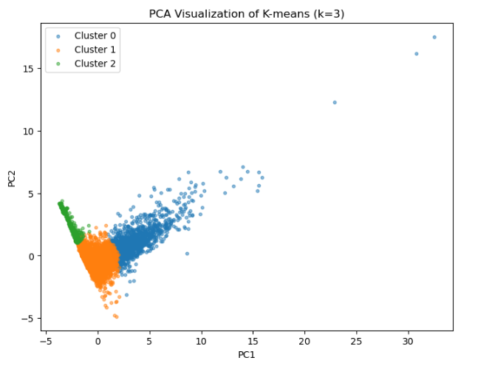
The GMM solutions showed greater overlap in two dimensions, especially in the full-covariance model (Figures 5 and 6).
Figure 5. PCA visualization of GMM full-covariance clusters with 6 components.
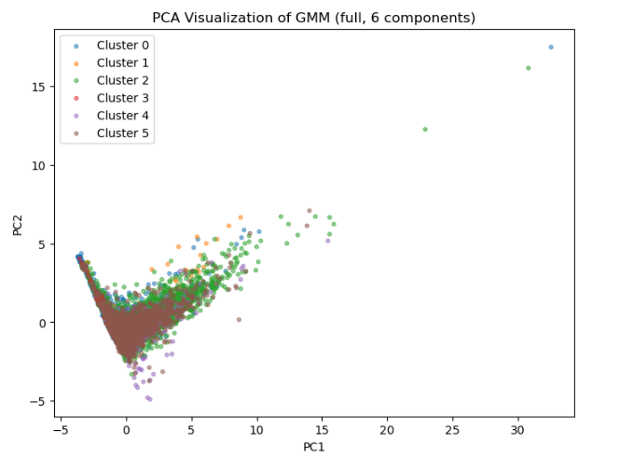
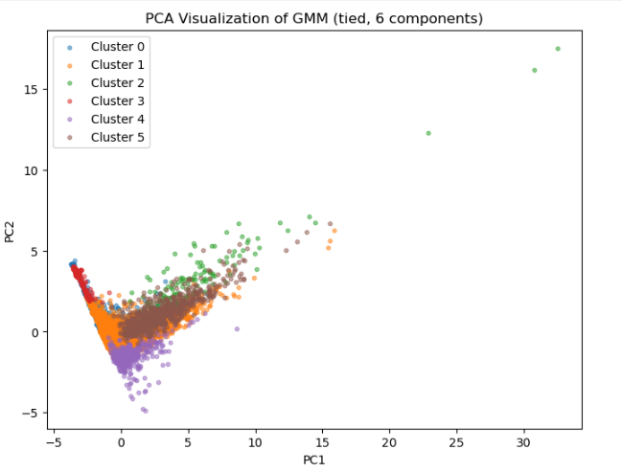
Figure 6. PCA visualization of GMM tied-covariance clusters with 6 components.

This does not contradict the BIC results, because the PCA projection captures only part of the total variation and the full-covariance GMM is fitting structure in the full 75-dimensional space (Table 7).

Table 7. Model Comparison Summary
Model | Selection basis | Metric value | Interpretation
K-means (k=2) | Highest silhouette among K-means | Silhouette = 0.302 | Best-separated K-means solution
K-means (k=3) | Elbow support + interpretability | Silhouette = 0.285 | Most interpretable K-means segmentation
GMM (full, 6) | Lowest BIC among GMM models | BIC = -4.599e6 | Best statistical fit overall
GMM (tied, 6) | Higher silhouette than full GMM + interpretability | BIC = -1.818e6; Silhouette = 0.245 | More interpretable GMM comparison model

6. Conclusion
This project shows that unsupervised clustering can recover meaningful behavioral segments from online shopping session data. K-means offered a simple, visually clear segmentation, especially at k=3, while GMM provided a more flexible, probability-driven framework. The full-covariance GMM with 6 components delivered the strongest statistical fit by BIC, suggesting that shopper behavior is more complex than simple spherical clusters. At the same time, the tied-covariance GMM provided highly interpretable segments with large differences in purchase rate. Overall, the findings show that online shopper behavior can be segmented into groups that meaningfully differ in engagement depth and conversion likelihood, with PageValues, product-related browsing, and bounce/exit behavior serving as the clearest indicators of intent.

References
Bishop, C. M. (2006). Pattern Recognition and Machine Learning. Springer.
Sakar, C. O., Polat, S. O., Katircioglu, M., & Kastro, Y. (2019). Real-time prediction of online shoppers’ purchasing intention using multilayer perceptron and LSTM recurrent neural networks. Neural Computing and Applications, 31, 6893–6908.

