Practical-02

C Program:
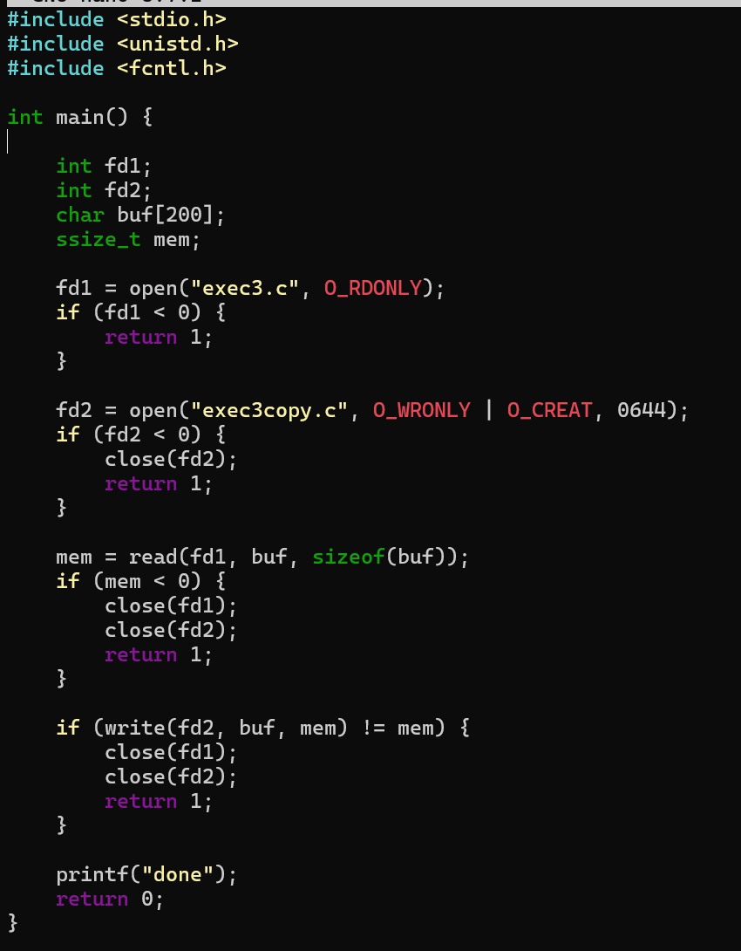

Output:
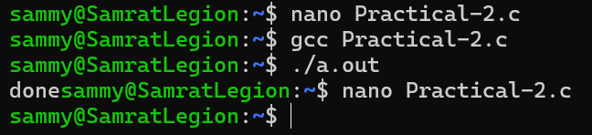

Original File to Be Copied:
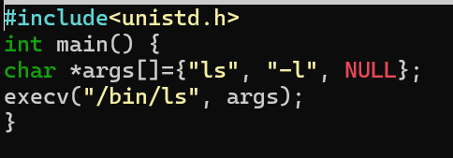

Output:
