1. Pattern matching/regular expression:

Write a java program that will check valid email address. Input can be anything, can be null, can be empty string can be numbers. Program will display – “<[12345@tcs.com](mailto:12345@tcs.com)> is a valid email” for success scenario and for failure it is to display “given input 123-456 is an invalid email”

1. Inheritance and OOPs concept problem 2:

Design and implement below by using concepts of oops,

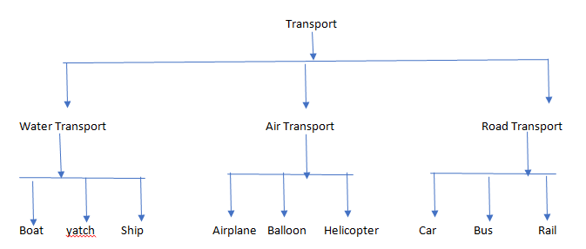

* Transport should have basic methods like, move(), modeTransport(), transportType(), driverType() . maxAllowedRide() , saftyMeasure() , color(), owner() etc.
* Water Transport , Road Transport , Air Transport should introduce specific behaviors. For example, Air Transport to include maxFlyHight(), whereas Road Transport to include distanceCovered().
* Boat, Airplane , Car etc. to have its own specific methods, like for , wheels() where as Airplane to have wings().
* **Feel free to add more methods as needed, above ones are just basics.**
* Child classes should have the implementation of parent abstract methods, printing one liner statement should be enough. For example, ship.move() will print “I travel in water” whereas car.move() should print “I travel via roads”.
* Same way, car.wheels() will print “I have 4 wheels” and train.wheel will print “I have many wheels”