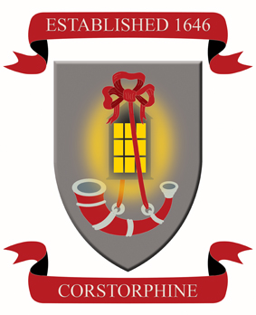 | Corstorphine Primary School  Corstorphine High Street  EDINBURGH  EH12 7SY  Tel 0131 334 3865 / Fax 0131 538 7274  Head Teacher - Mrs Briggs  www.corstorphine.ik.org   |   admin@corstorphine.edin.sch.uk

Dear Parents/Carers,

On Friday 21st December, Nursery will be holding a Christmas Party for all children who attend nursery. This is for part-time, morning and afternoon children.

The party is at 8.35 – 11.15 and will be held in the Lantern Hall. We ask that you bring your child straight to the Lantern Hall on this day.

The party will have games, food, a special visitor and a Magic Show.

There will be no afternoon nursery on Friday 21st December as the school closes for the Christmas Holidays.

All children return from the holidays on Wednesday 9th January 2019.

If your child is able to make the Christmas Party on Friday 21st December, please fill in the slip below and return to a member of the nursery team or email Mrs Gaffney on ruth.gaffney@corstorphine.edin.sch.uk.

Many Thanks

The Nursery Team

------------------------------------------------------------------------------------------------

Name _______Soumak Dhar____________________
Yes
Will be at the party

Will not be at the party

Parent/Carer Signature _____Soumita Dhar____________________________

