1.Introduction 1

1.1 Introduction of the college 1

1.2 Current Business Activities and Operations 1

1.3 Business Rules 2

1.4 Creating of entities and attributes 3

1.5 INITIAL ERD 4

Figure 1. INITIAL ERD 4

# 1.Introduction

## 1.1 Introduction of the college

Berklee College of Music is a private music college in Boston, Massachusetts. It is the largest independent college of contemporary music in the world. Known for the study of jazz and modern American music, it also offers college-level courses in a wide range of contemporary and historic styles, including rock, hip hop, reggae, salsa, heavy metal and bluegrass. (wikipedia, 2020)

Founded on jazz, the music of the African diaspora, and a dedication to contemporary music, Berklee is a singular institution for the study of the performing arts. The institution continues to integrate and find connections between its historical roots and the contemporary worlds of music, dance, and theatre. Berklee is a place where artists come together to innovate and collaborate, and where artistic and cultural diversity is embraced and celebrated. This ethos permeates all aspects of Berklee—from teaching and learning to administration and governance—and is fundamental to the Berklee experience. (berklee, 2020)

## 1.2 Current Business Activities and Operations

i. This college focuses on music education, it offers degrees and diplomas on both graduate and undergraduate level. It also provides various other online degrees, certificates and courses.

ii. The records of instructors and students are handled in completely digital way in database by the IT department.

iii. Classes are carried out according to the curriculum made by the instructors and the academic department.

iv. The timing are set according to the routine made by the academic department and module instructors.

v. There are various type of instructors in the college, most of them are expert in a musical field such as mixing/mastering or a musical instrument, their role in college is to help the students in their related courses, some experienced instructors help make curriculum, review the assignment submitted by the students etc.

vi. Courses are divided according to different types of music genres and different aspects of music for e.g. performance, song writing, jazz composition etc.

## 1.3 Business Rules

1. The college should store all the important information about all the people associated with the college activity.

2. The college should have very detailed information on the address of all the person in case of the person missing.

3. The college provides courses for students, a student can study a specification from the course, a specification has many modules.

4. Each course has a course leader who plays major role in daily activities of the students taking that course.

5. The college also provides different scholarship facilities for deserving students, differently abled students and student from poorer part of the world.

6. The college has meal facilities for all the student, a student can choose to have meal of any time of day i.e. breakfast, lunch, dinner.

7. College should keep record of all scholarship and meal consumption details of particular student.

8. College also provides extra-curricular activities for interested students, college also keep track of students taking part in those activities.

## 1.4 Creating of entities and attributes

Entity can be defined as a single unique object in the real world that is being mastered. Examples of an entity are a single person, single product, or single organization. (ibm, 2019)

A characteristic or trait of an entity type that describes the entity, for example, the Person entity type has the Date of Birth attribute. (ibm, 2019)

|  |  |
| --- | --- |
| Entities | Attributes |
| Person | Person_id(PK), first_name, last_name, age, sex, DOB, Address_id |
| Address | Address_id(PK), country, provience, city, street, house_number, address's phone_numbers, address's_fax_numbers, |
| Student | Student_id(PK), accommodation_id(FK), scholarship_id(FK), meal_id(FK), eca_id(FK), course_id(FK) |
| Instructor | Instructor_id, Person_id(FK), course_id(FK) exp_year,salary |
| ECA_info | Eca_id(PK), eca_type |
| Courses | Course_id(PK), course_name, course_price, course_type,leader_id(FK) |
| Specification_id | Specification_id, course_id, specification_name |
| Meal_info | Meal_id(FK), meal_info |
| Module_info | Module_id(FK), module_name |
|  |  |

## 1.5 INITIAL ERD

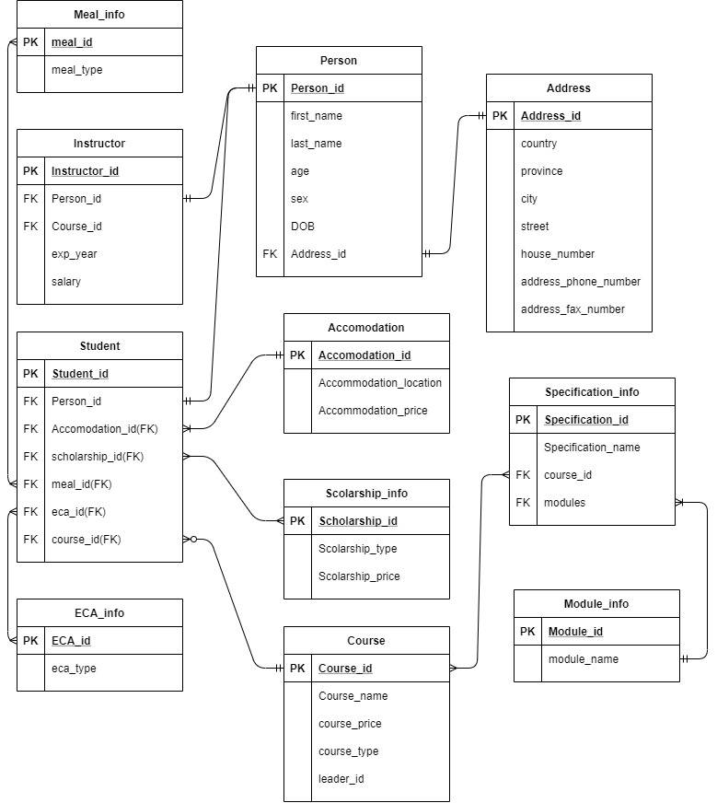

Figure . INITIAL ERD

Problems in the initial erd:

There are many many-many relationship which will create many type of anomalies like insertion anomalies, update anomalies and deletion anomalies. There are also many transitive dependency which is not good in a rdms.

2. Normalization

## 2.1 Assumption

i. Any person needs to have his first name, last name, age, sex, DOB and address id.

ii. Student and instructor both are person.

iii. A student can enrol in a course.

iv. Each course has a specification and a student can take a specification.

v. Each specification consists of different modules.

vi. Each course has a module leader.

vii. A student can have one accommodation at max. Each accommodation has different price.

viii. A student can have one or more scholarship and each scholarship has different price.

ix. A student can take part in different eca activities.

## 2.2. Normalization

Normalization is the process of minimizing redundancy from a relation or set of relations. Redundancy in relation may cause insertion, deletion and updation anomalies. So, it helps to minimize the redundancy in relations. (Tuteja, 2020)

### 2.2.1 UNF

In the UNF or unnormalized form, the database is in a primitive stage. The normalisation process is done sequentially. The data are separated according to their repetition. The repeating groups are separated by curly brackets.

Showing repeating groups:

Person -(person_id, name, age, DOB, sex, mobile_number, email_id, country,provience,city,street,house_number, address's phone_numbers, address's_fax_numbers, course_id, course_name,course_price, course_type,specificaton_id,specificaton_name,leader_id, accomodation_id,accomodation_type,accomodation_location,{email,email_id},{module_id,module_name}, {TA_id,TA_name,status,ex},

{clas_id,class_name , class_capacity,class_type},{meal_id,meal_type, meal_price},{scholarship_id, scholarship_type, scholarship_price},

{eca_id, eca_type,grade_id})

### 2.2.2 1NF (First normal form)

First normal form (1NF) is a property of a relation in a relational database. A relation is in first normal form if and only if the domain of each attribute contains only atomic (indivisible) values, and the value of each attribute contains only a single value from that domain (wikipedia, 2020)

In unf we have identified repeating groups and put them in curly brackets, to make all the attributes atomic we have separated all the repeating groups into new table.

Entities:

**Person1** (person_id(PK),first_name,last_name,age,DOB,sex, mobile_number, country,provience,city,street,house_number, address's phone_numbers, address's_fax_numbers)

**Student_info1** (student_id, person_id ,meal_id, accomodation_id, accomodation_type, accomodation_price, accomodation_location, meal_id,scholarship_id,eca_id,course_id, course_name,course_price, course_type,specificaton_id,specificaton_name,leader_id,leader_name,leader_salary,module_grade)

**Module_info1** (module_id, module_name)

**Email_info1** (email_id, email, person_id)

**instructor_info1** (instructor_id ,person_id(FK), course_id(FK), exp_year, salary)

**Meal_info1** (meal_id,meal_type,meal_price)

**scholarship_info1**(scholarship_id, scholarship_type, scholarship_price)

ECA_info1 (eca_id, eca_type,eca_grade)

### 2.2.3 2NF (Second normal form)

A relation is in the second normal form if it fulfills the following two requirements:

It is in first normal form.

It does not have any non-prime attribute that is functionally dependent on any proper subset of any candidate key of the relation. A non-prime attribute of a relation is an attribute that is not a part of any candidate key of the relation. (wikipedia, 2020)

To keep all the relationship in 2NF we need to first find the partial dependency and remove it using another table or making a bridge entity table.

Partial dependencies:

1. the salary of instructor depends upon the module they teach.

2. the status of instructor depends upon the module they teach.

3. the price of scholarship depens upon the student_id.

4. the ecs grades depends upon the student_id.

5. module_grade depends upon module_id and student_id

Tables:

**Person2** (person_id(PK),first_name,last_name,age,DOB,sex, mobile_number, country,provience,city, street,house_number, address's phone_numbers, address's_fax_numbers,

**Student_info2** (student_id(PK), person_id(FK), meal_id, accomodation_id, accomodation_type, accomodation_price, accomodation_location,meal_id, scholarship_id,eca_id,course_id, course_name,course_price, course_type, specificaton_id, specificaton_name,leader_id,leader_name,leader_salary)

**Module_info2** (module_id, module_name)

**Email_info2** (email_id(FK), email, person_id(FK))

**instructor_info2** (instructor_id,person_id(FK),exp_year)

**Meal_info2** (meal_id ,meal_type,meal_price)

**scholarship_info2**(scholarship_id, scholarship_type)

**ECA_info2** (eca_id, eca_type)

**student-scholarship2** (scholarship_id(FK), student_id(FK), scholarship_price)

**student-eca2** (eca_id(FK), student_id(FK), eca_grade)

**student-meal2** (meal_id(FK), student_id(FK))

**module-instructor2** (instructor_id(Fk),module_id(FK), salary, status)

**module-specificaton2** (specificaton_id(FK), module_id(FK))

**course_instructor2** (course_id(FK), instructor_id(FK))

module_marks2 (module_id,student_id(FK),grade)