Assignment Part 1: Installing gem5 and Running a Hello World Program (x86)

Samrat Kafle
University of the Cumberlands
2026 Spring - Computer Architecture and Design (MSCS-531-A01) - First Bi-term
Vanessa Cooper
January 25, 2026

Assignment Goals
This report documents the setup of a gem5 development environment in Windows using VS Code with WSL (Ubuntu), building gem5 for the x86 ISA, and running a simple compiled program in system-emulation (SE) mode. The deliverable focuses on showing repeatable steps, evidence of successful builds/runs, and brief troubleshooting notes.
Environment Setup (Windows + VS Code + WSL Ubuntu)
I used VS Code connected to WSL (Ubuntu). Inside the WSL terminal, I installed the core dependencies needed to build gem5 (Python 3, SCons, GCC/G++, Git, and related development libraries).
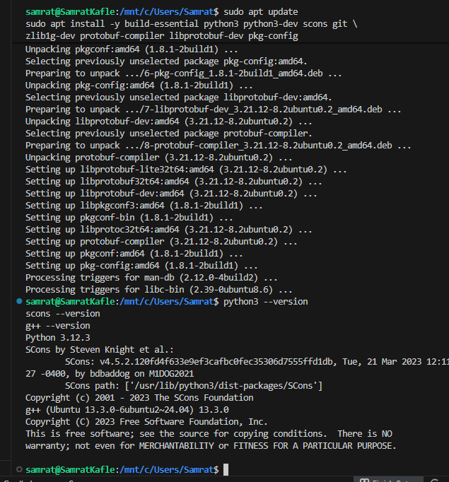
Figure 1. Installing and validating key build dependencies in WSL (Ubuntu).
Cloning the gem5 Repository
From a projects directory in WSL, I cloned the official gem5 repository and moved into the gem5 directory to begin building.
Clone command used: git clone https://github.com/gem5/gem5.git
Repository link (placeholder for submission): https://github.com/REPLACE_WITH_PRIVATE_REPO_LINK
Building gem5 for x86
I built the optimized x86 binary using SCons. The build output produced the executable at build/X86/gem5.opt.
Build command used: scons build/X86/gem5.opt -j"$(nproc)"
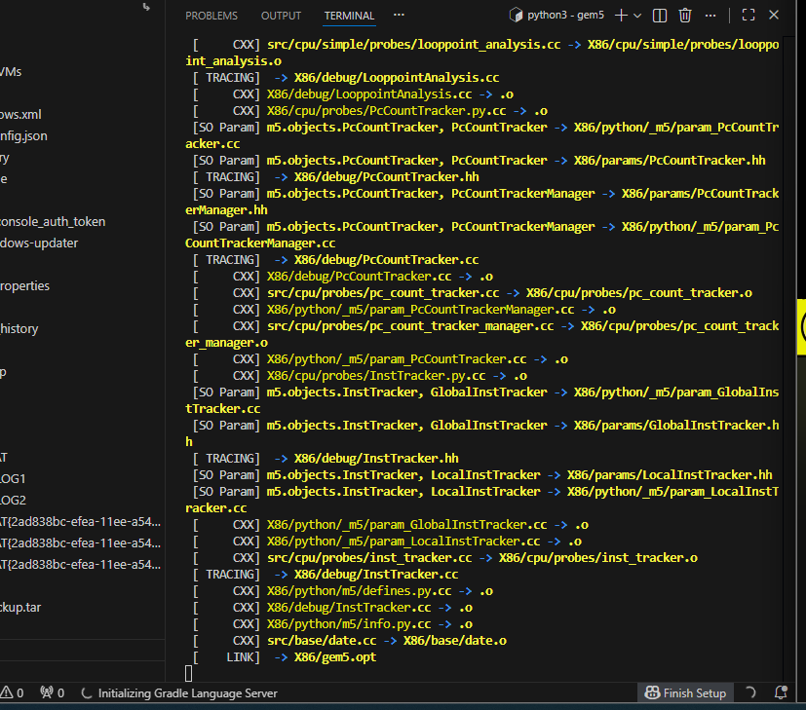
Figure 2. gem5 build output showing compilation and link stage for build/X86/gem5.opt.
Compiling and Running Hello World in gem5 (SE Mode)
I created a small C program (hello.c), compiled it with GCC into an x86 Linux executable, and ran it in gem5 using the SE example script.
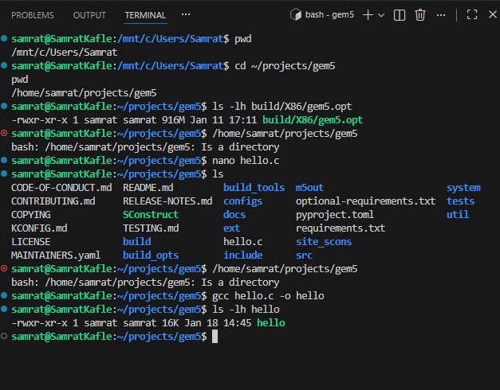
Figure 3. Creating hello.c and compiling it to an executable (hello).
Initial run attempt used configs/example/se.py, which printed a deprecation message for this script. To address this, I re-ran the program using the recommended deprecated path for the example script.
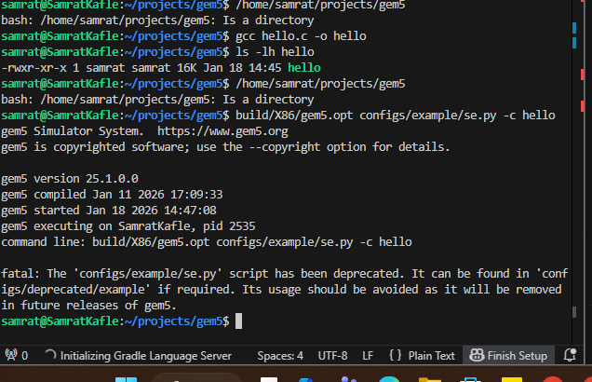
Figure 4. Initial run showing se.py deprecation notice.
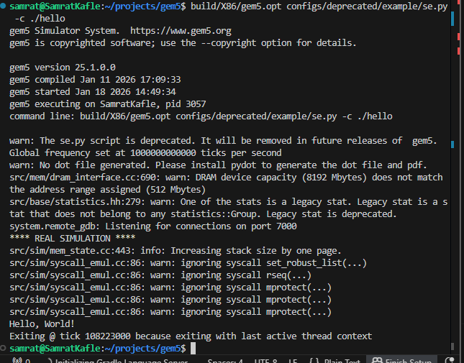
Figure 5. Successful simulation output showing the program message printed in gem5.
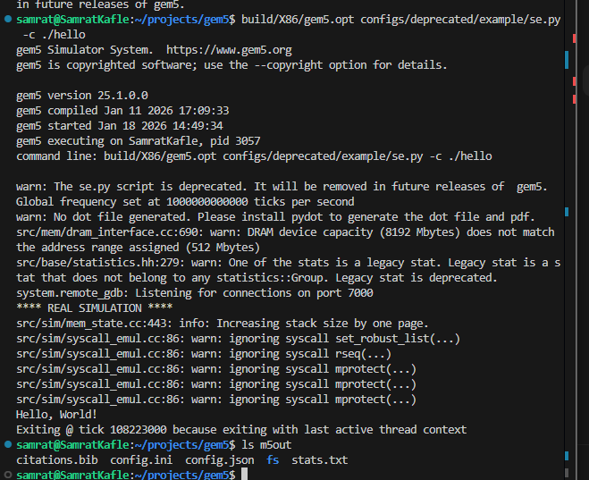
Figure 6. Output directory (m5out) created after a successful run, including stats.txt.
Troubleshooting Notes
1) Deprecated script warning: configs/example/se.py produced a deprecation warning. I switched to configs/deprecated/example/se.py.
2) Optional library warnings (PNG/HDF5/capstone): These warnings did not block the build. They indicate optional features are disabled when libraries are missing.
3) Where to find statistics: After each run, gem5 writes results into the output directory (default: m5out). The main file used for metrics is m5out/stats.txt.
References
Hennessy, J. L., & Patterson, D. A. (2019). Computer architecture: A quantitative approach (6th ed.). Morgan Kaufmann.
gem5 Project. (2019). Running gem5. (Project documentation).

