Assignment Part 2: Cache Configuration Experiments and Virtual Memory Exploration in gem5 (x86)

Samrat Kafle
University of the Cumberlands
2026 Spring - Computer Architecture and Design (MSCS-531-A01) - First Bi-term
Vanessa Cooper
January 25, 2026

Assignment Goals
This report documents cache configuration experiments in gem5 using an x86 SE-mode setup. The work includes a baseline run, targeted cache parameter changes, a comparison of collected cache metrics, and a focused look at virtual memory behavior through TLB-related statistics.
Memory Hierarchy Considerations
Memory hierarchy exists because fast storage is expensive and small, while large storage is slower but cheaper. Caches reduce average access time by keeping recently used instructions and data close to the CPU. In practice, the benefits depend on locality in the workload, cache size, associativity, and block size. These choices also affect power, because larger and more associative caches usually require more energy per access (Hennessy & Patterson, 2019).
Cross-Cutting Issues
Designing a hierarchy involves trade-offs across cost, power, and complexity. For example, increasing cache size can reduce misses, but it increases area and leakage power. Increasing associativity can reduce conflict misses, but it increases hit latency and hardware complexity. Workload matters too: a program with streaming accesses may respond differently than one with tight loops. At a system level, energy efficiency often requires coordinated choices across hardware and software layers (Muralidhar et al., 2022).
Experimental Setup
Simulator: gem5 (x86 optimized build: build/X86/gem5.opt). Mode: System Emulation (SE).
Benchmark: gem5 test-prog 'threads' (x86 Linux binary located under tests/test-progs/threads/bin/x86/linux/threads).
Output management: Each run produced a fresh m5out folder, which I saved into a runs/ folder (baseline, size, assoc, block).
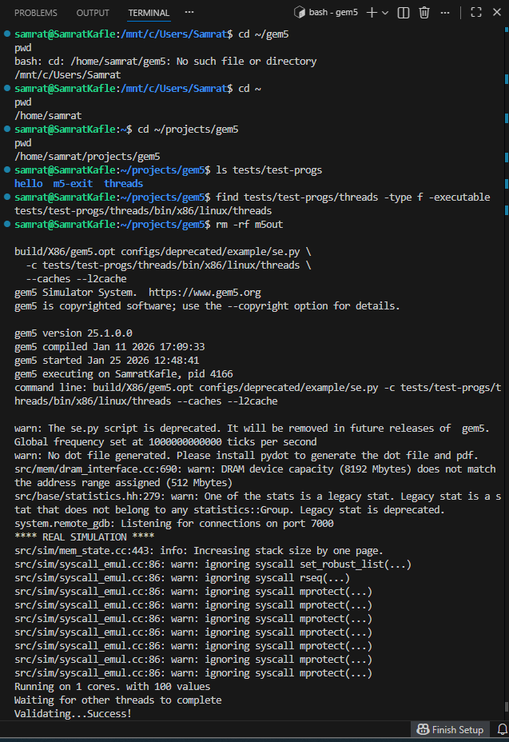
Figure 1. Running the threads test program in gem5 with cache options enabled.
Baseline Cache Configuration
I first ran the workload with cache support enabled to establish a baseline. The key metrics used in this report were demand hits/misses and miss rate for the instruction cache (I-cache) and data cache (D-cache), taken from stats.txt.
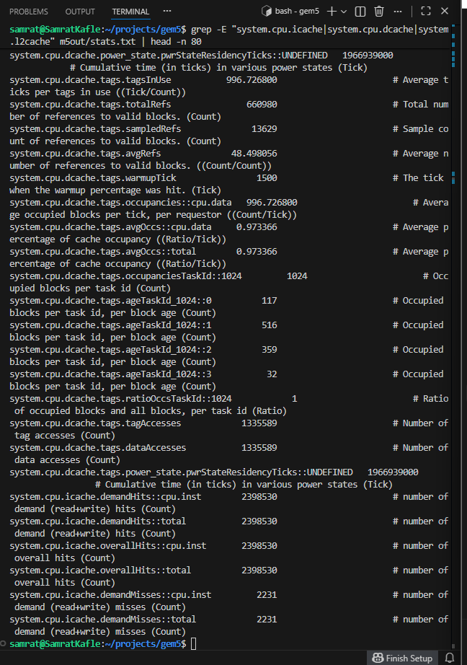
Figure 2. Baseline cache statistics extracted from m5out/stats.txt (I-cache and D-cache).
Optimizing Cache Parameters
I then modified cache parameters in separate runs. Because the assignment focuses on size, associativity, and block size, I ran each change independently and saved the output directory for later comparison.
A) Cache size change: L1 I/D set to 64kB each and L2 set to 1MB.
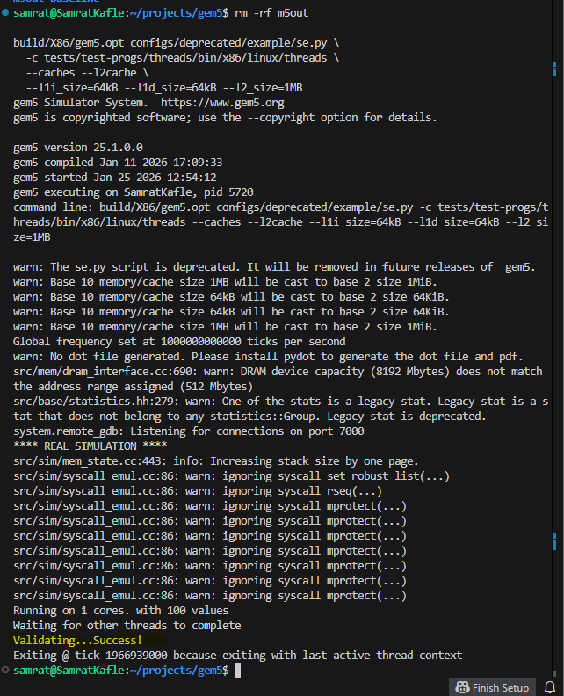
Figure 3. Cache size run command and successful completion.
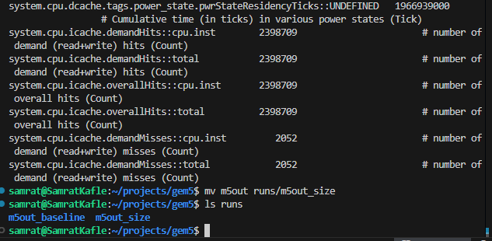
Figure 4. Saving the output directory into runs/m5out_size for comparison.
B) Associativity change: L1 I/D associativity set to 4; L2 associativity set to 8.
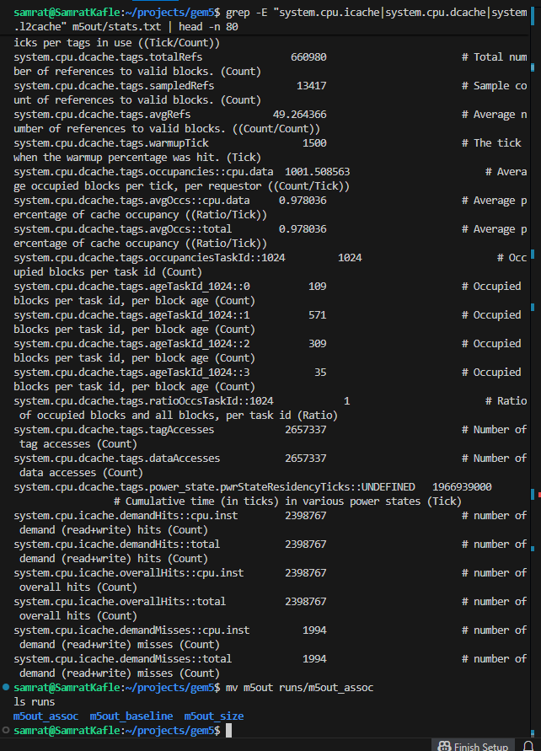
Figure 5. Associativity run and extracted cache statistics.
C) Block size change: My first attempt used unrecognized options. I corrected this by using the supported option --cacheline_size=128.
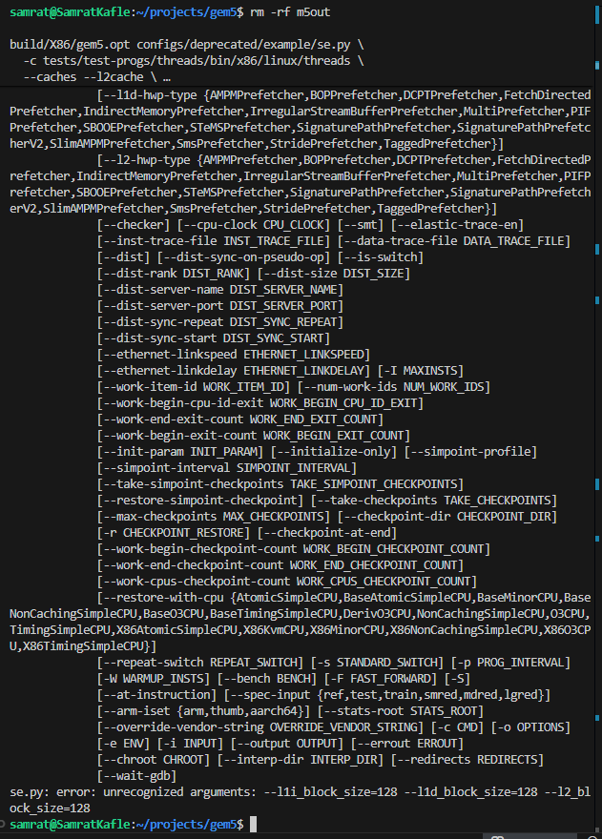
Figure 6. Error caused by unsupported block size arguments in se.py.
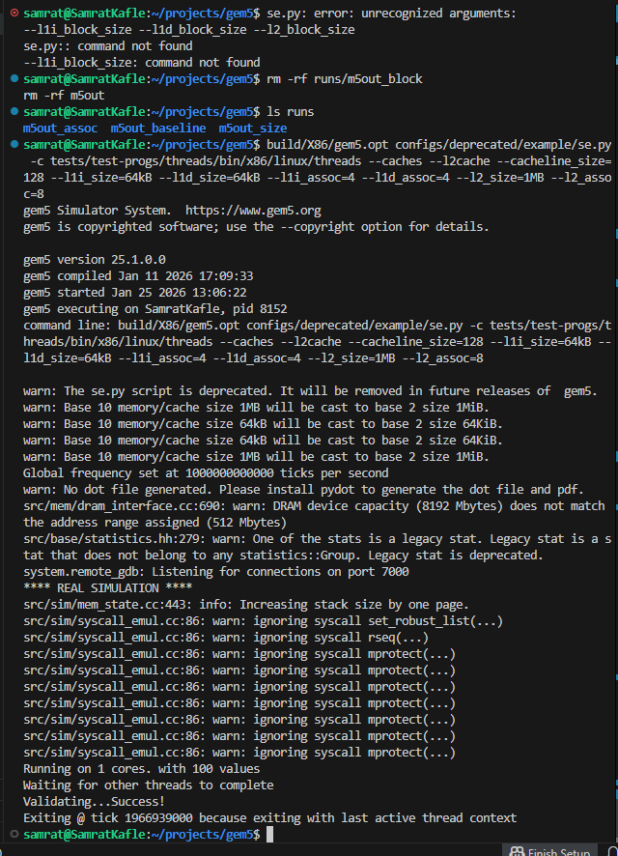
Figure 7. Corrected run using --cacheline_size=128 and saving output.
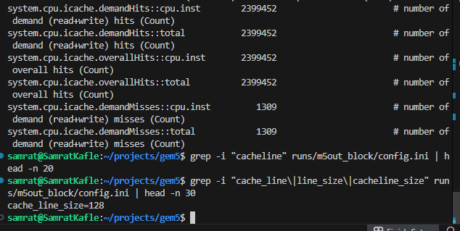
Figure 8. Cache statistics from the block size run (cacheline size = 128B).
Performance Comparison
Configuration | I-cache demand misses (count) | D-cache demand misses (count) | D-cache demand miss rate
Baseline (default caches) | 2231 | 13626 | 0.020620
Size tuned (L1 64kB/64kB, L2 1MB) | 2052
Associativity tuned (L1 assoc 4, L2 assoc 8) | 1994
Block size tuned (cacheline 128B) | 1309 | 9534 | 0.014428
Table 1 summarizes the metrics that were directly captured from stats.txt in the provided runs. Not every metric was captured for every run in the screenshots, so blank cells indicate values not recorded in the current evidence set.
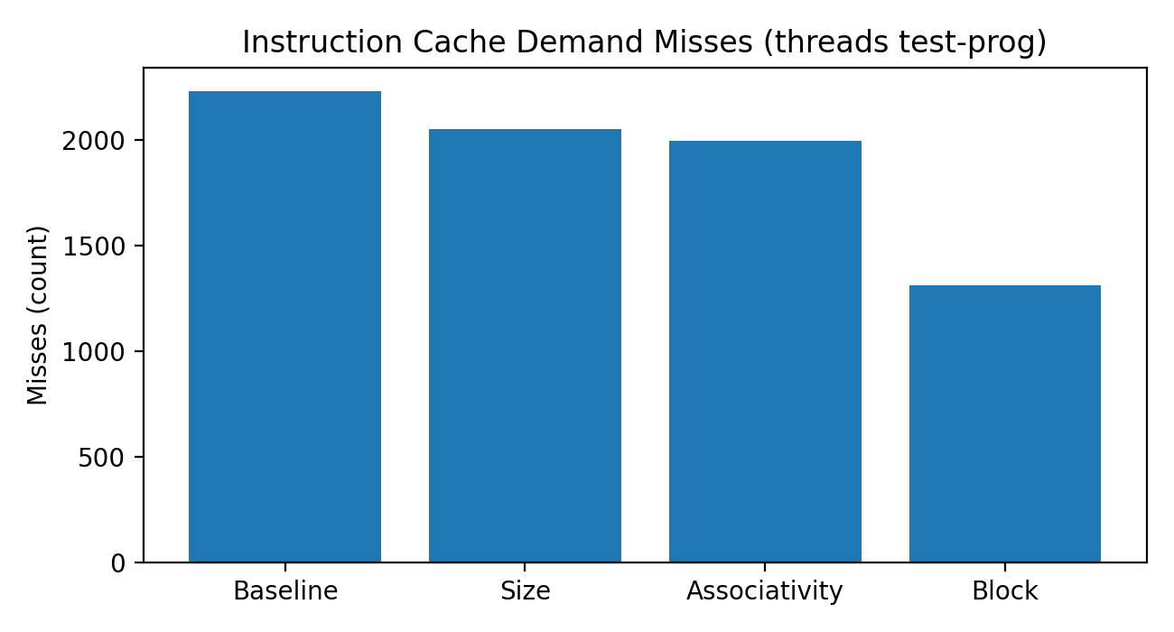
Figure 9. Instruction cache demand misses across cache configurations (threads).
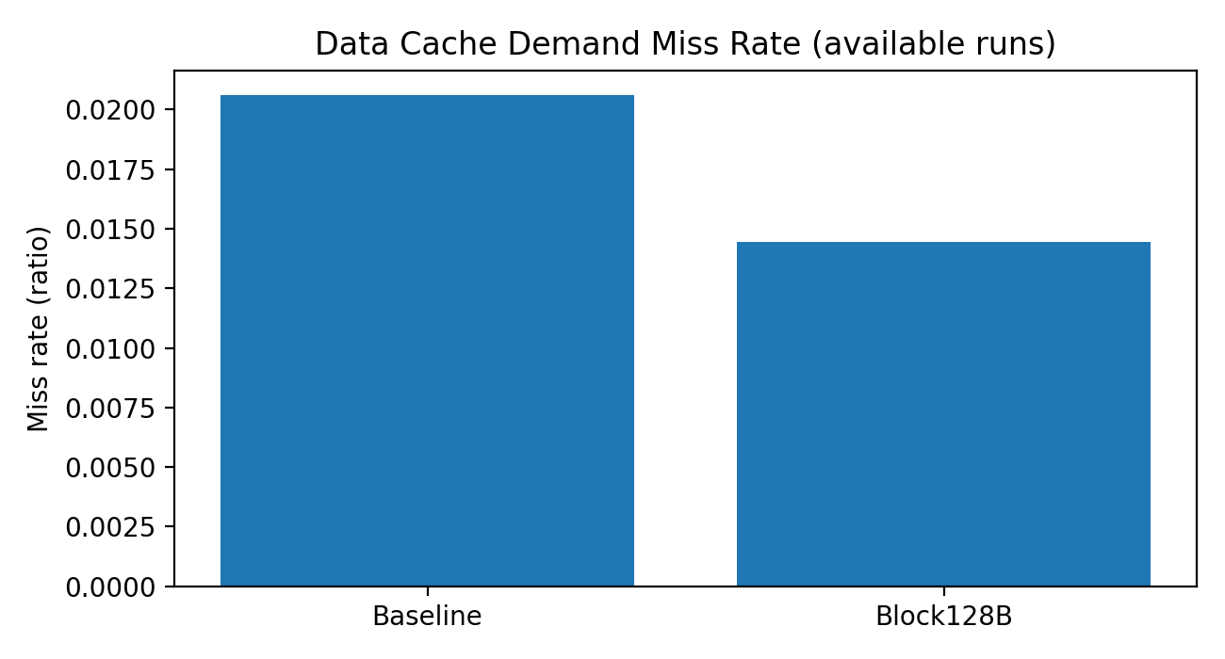
Figure 10. Data cache demand miss rate for runs where the value was captured.
Analysis
Across these runs, the instruction cache demand misses decreased as I changed cache parameters, with the lowest I-cache misses observed in the 128B cacheline run. For data cache behavior, the block-size run showed a lower demand miss rate than the baseline in the captured stats. A practical interpretation is that a larger cacheline can improve spatial locality for this workload, but the trade-off is that bigger cachelines can waste bandwidth when the workload has poor spatial locality. This is one example of why workload matters when tuning caches (Hennessy & Patterson, 2019).
Virtual Memory Exploration (TLB and Address Translation)
Virtual memory uses page tables to translate virtual addresses used by a process into physical addresses used by memory. The Translation Lookaside Buffer (TLB) speeds this up by caching recent translations. In gem5 SE mode, the simulation still models address translation and reports TLB-related events in stats.txt.
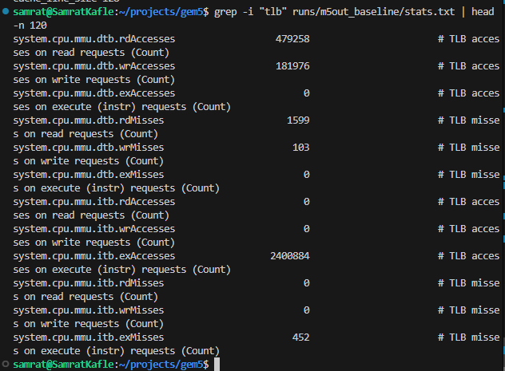
Figure 11. Baseline TLB-related statistics from runs/m5out_baseline/stats.txt.
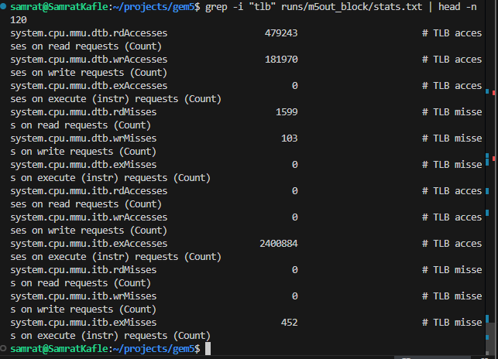
Figure 12. TLB-related statistics from runs/m5out_block/stats.txt.
In the evidence collected here, the shown TLB read/write accesses and misses were similar between the baseline and block-size runs. This makes sense because changing cacheline size does not directly change page table structure or the TLB configuration. To go further, the next step would be to explicitly vary TLB size/associativity (where supported by the configuration script) and compare the TLB miss rate and any downstream stall behavior. Virtual machines add another layer by mapping guest virtual addresses through guest physical addresses to host physical memory, which increases translation work and makes TLB behavior and page size choices even more important in practice (Hennessy & Patterson, 2019).
Troubleshooting
1) Incorrect cache block size arguments: The se.py script rejected --l1i_block_size/--l1d_block_size/--l2_block_size. I fixed this by using the supported --cacheline_size option.
2) Deprecated script warning: I used configs/deprecated/example/se.py because the non-deprecated path printed a deprecation message.
3) Optional warnings (pydot/DRAM capacity mismatch/legacy stats): These warnings did not stop the simulation. I recorded them as part of the run output.
GitHub Repository Link
Private repository link (placeholder): https://github.com/REPLACE_WITH_PRIVATE_REPO_LINK
Note: The repository should include your run commands (or a README), any scripts used, and the saved output directories needed for grading evidence.
References
Hennessy, J. L., & Patterson, D. A. (2019). Computer architecture: A quantitative approach (6th ed.). Morgan Kaufmann.
Muralidhar, R., Borovica-Gajic, R., & Buyya, R. (2022). Energy efficient computing systems: Architectures, abstractions and modeling to techniques and standards. ACM Computing Surveys, 54(11s), Article 236. https://doi.org/10.1145/3511094
gem5 Project. (2019). Running gem5. (Project documentation).

