**LCMS Identification using LipidSearch 5.0 Documentation**

LipidSearch is designed to process LCMS data and perform lipid identification using data-dependent MS2 data.

**1.1 Product Search(LCMS) Overview**

LipidSearch 5.0 performs lipid identification using the following procedure.

1. Processes the Extracted Ion Chromatogram [EIC] and detects peaks [Separated Peak Area: SPA] for each lipid ion.
2. Collects the MS2 spectra contained in the EIC region.
3. Calculates the Product Ion Chromatogram [PIC] of the product ion peak in each MS2 spectrum and calculates the virtual spectrum [Deconvoluted MS2 Spectrum: DMS] distributed from the shape belonging to the SPA.
4. Lists lipid ions with matching DMS and peak patterns as candidates.

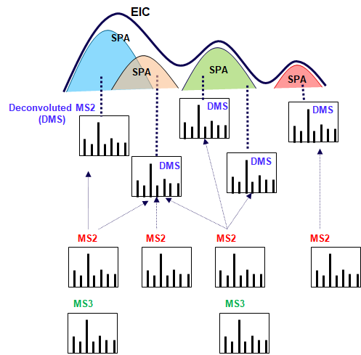

**1.2 Identification Metrics**

Two types of indicators are used to ensure the certainty of identification.

**1.2.1 Grade**

Grade is calculated as follows using the product ion Category specified in the Database.

* [Category]

| **Category** | **Description** |
| --- | --- |
| C0 | Head group specific ions |
| C01 | Head group-derived or substituent-derived ions specific to lipid class |
| C1 | Substituent-specific ions |
| C2 | Ions that do not identify structure |

* [Condition]

| **Condition** | **Description** |
| --- | --- |
| H1 | C0 and C01 (or more than one C0) (or C01 for all substituents) are assigned |
| H2 | C0 or C1 are assigned |
| S1 | C01 or C1 are assigned for all substituents |
| S2 | C01 or C1 are assigned for some substituents |

* [Grade Assignment]

| **Grade** | **Description** |
| --- | --- |
| A | (H1 and S1) |
| B | (H2 and S1) or (H1 and S2) |
| C | H2 or S1 |
| D | Other |

**1.2.2 IDScore**

The identification score indicates to what degree the product ion peaks are assigned to a given identification. The more a peak of high intensity in [DMS](http://localhost:36080/html/LCProductSearch_en.html#product_search_lcms_summary) is specifically associated with lipid candidates, the higher the score. If all the peaks in DMS are assigned to only one lipid candidate, the score is 1.0, and if there are many peaks that are assigned across multiple candidates, the score is lower. In some cases, if there are many peaks that are only assigned for one lipid among multiple candidates, it exceeds 1.0.

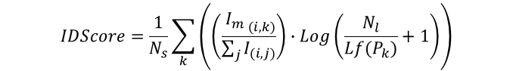  
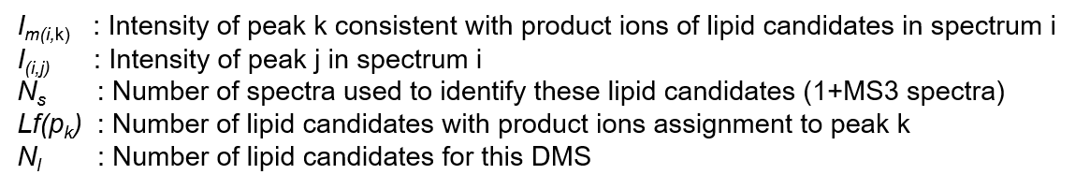

Here are the parameters used for identification

