This is the login form for the system, which controls access and keeps the library data secure. Only registered users can log in to manage books, members, and borrow records. This helps protect the data from unauthorized use. The login process is simple and straightforward to ensure easy access for users.

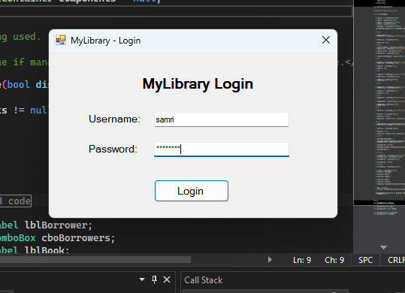

The Book Management section allows users to add new books, update existing book details, and remove books from the library database. It also provides search functionality to quickly find books by title, author, or genre. This helps keep the library’s collection organized and up-to-date, making it easier to manage available resources.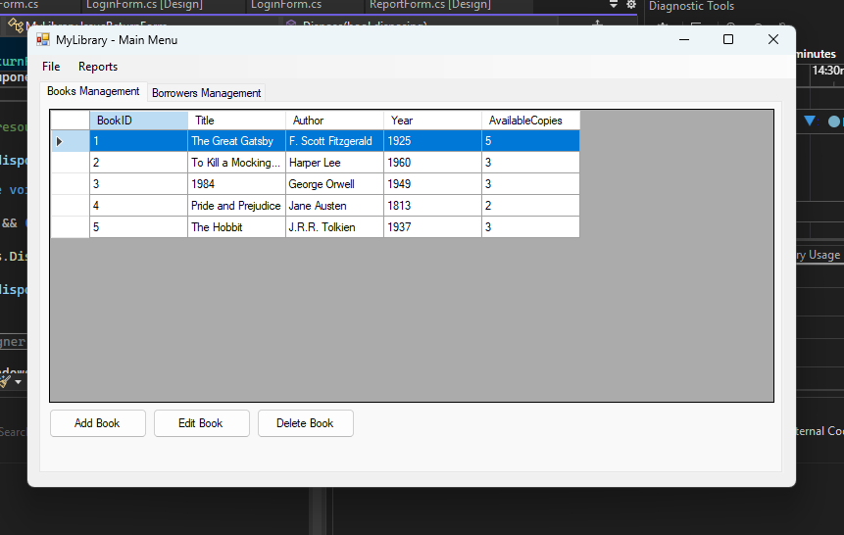

The Borrower Management part of the system lets users add new members, update their information, and remove members when needed. It also helps track which members have borrowed books and manages their borrowing history. This makes it easier to keep member records organized and monitor book loans effectively

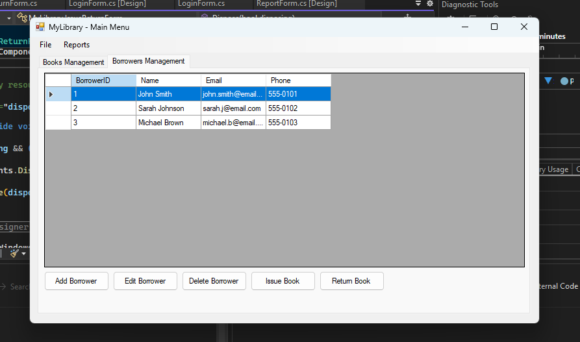

The system allows users to easily update borrower information whenever needed. Whether it’s changing contact details or correcting personal data, the edit feature ensures member records stay accurate and up-to-date. Keeping borrower info current helps the library maintain clear communication and efficient management.

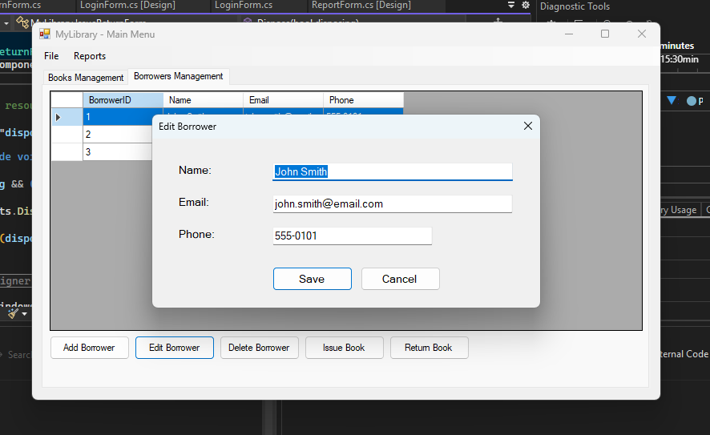

The system provides the option to delete borrower records when they are no longer needed. This helps keep the database clean and organized by removing outdated or inactive members. Deleting borrowers ensures that only current and active members are maintained in the system for efficient management.

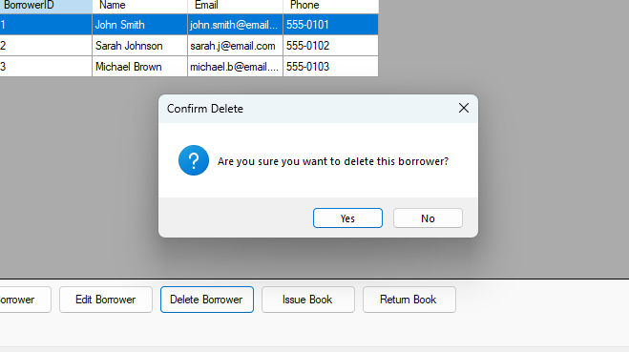

The Issue Book feature allows users to lend books to members by recording the borrowing details in the system. It tracks who borrowed which book and the date it was issued, helping to manage loan periods and due dates. This function makes it easy to monitor book circulation and ensures that loans are properly documented

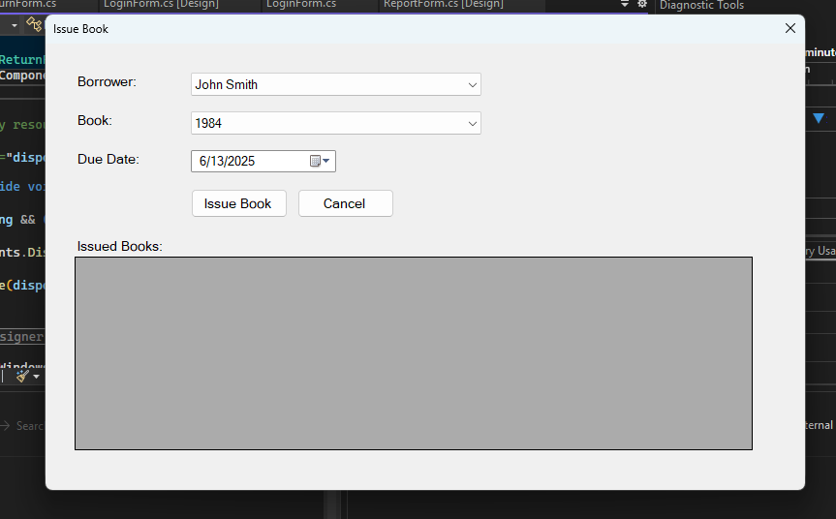

The system lets users update important book details like the author’s name and the number of available copies. This helps maintain accurate records so the library knows who wrote each book and how many copies can be borrowed. Keeping this information current ensures smooth management of the library’s collection.

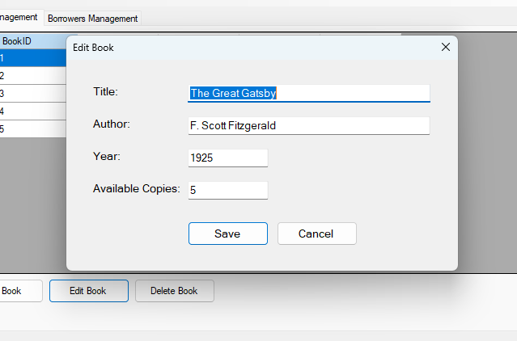

The system allows users to add new books by entering important details such as the title, author, publication year, genre, and the number of available copies. This feature helps keep the library’s collection up-to-date by making it easy to include new materials. Adding complete and accurate information ensures users can search and find books quickly.

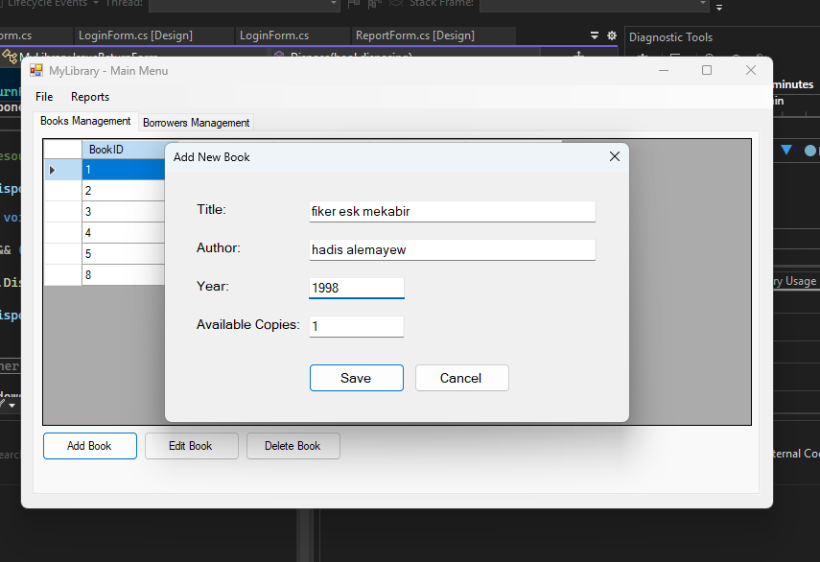

This is an example of a book that has been added to the system, including all key details like title, author, publication year, genre, and available copies. It shows how new books are stored and displayed in the library database.

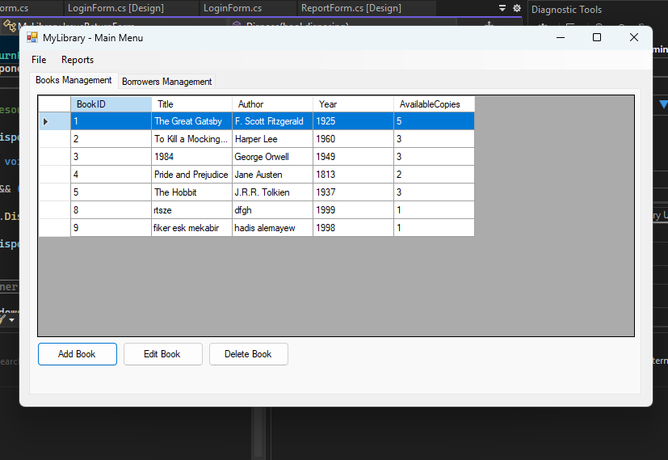

The exit feature allows users to safely close the application when they are done using it. It ensures that all data is saved properly before the program closes, preventing any loss of information. This provides a smooth and secure way to exit the system.

