COMSATS UNIVERSITY ISLAMABAD ATTOCK CAMPUS


Mad Theory;
Assignment No 4;

Name : | Bibi Samreen
Reg.no : | Fa23-bse-015
Date of Submission : | 21 May2026
Submitted To : | Sir Kamran

Question 1:
Index.js:
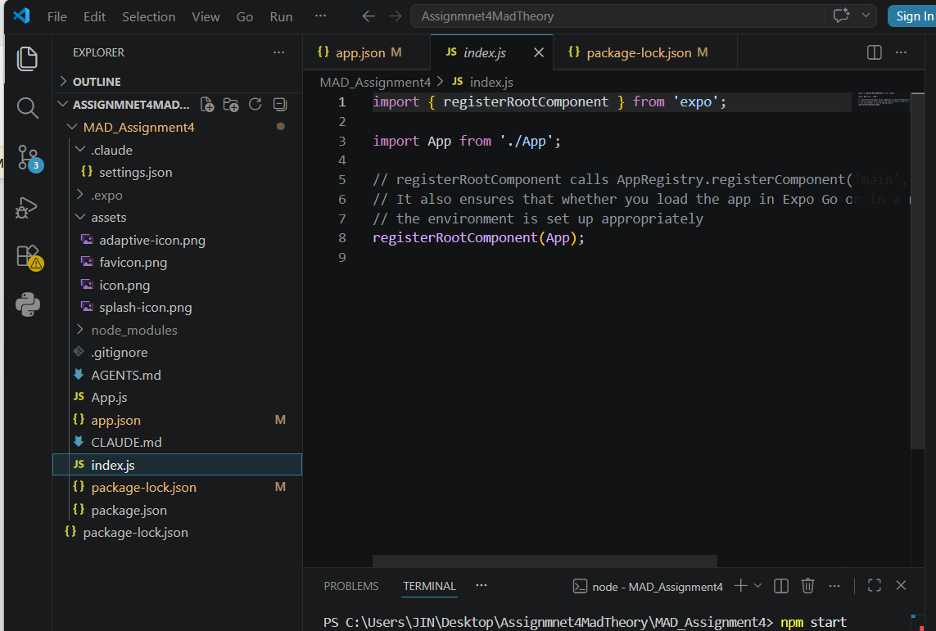

Package-lock.json:
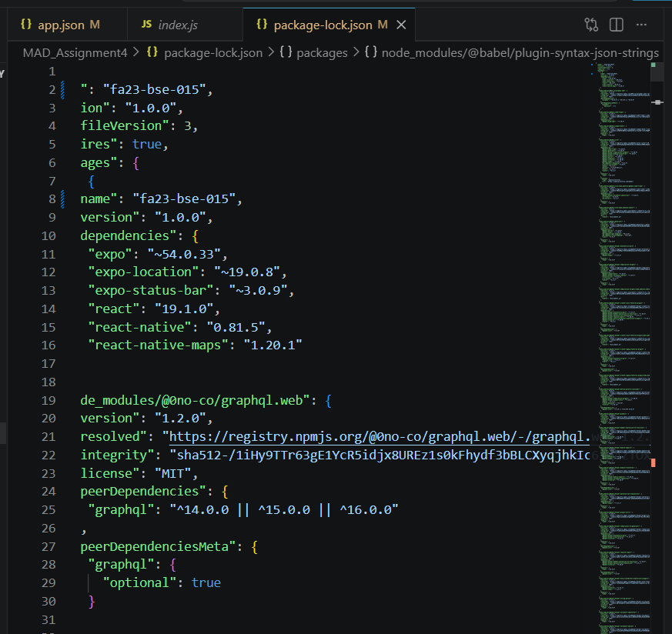
Package.json:
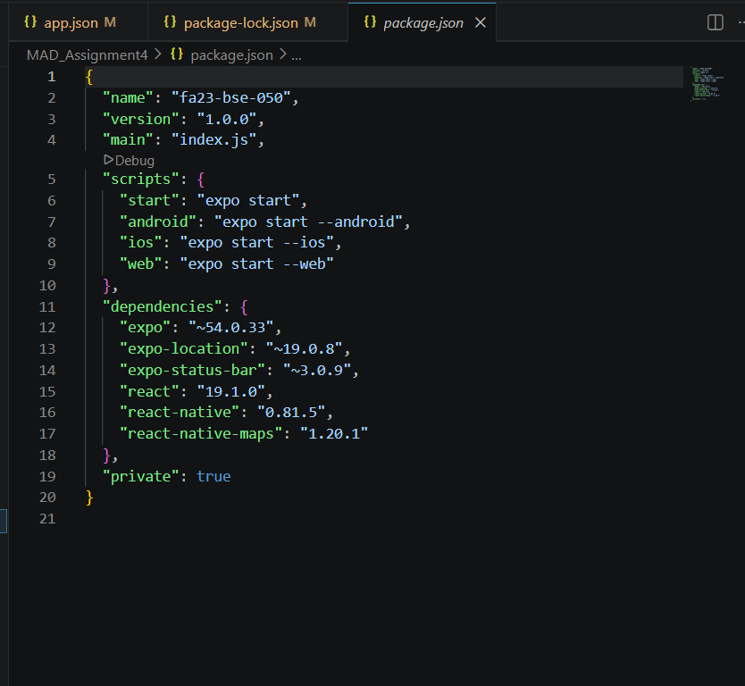
App.json:
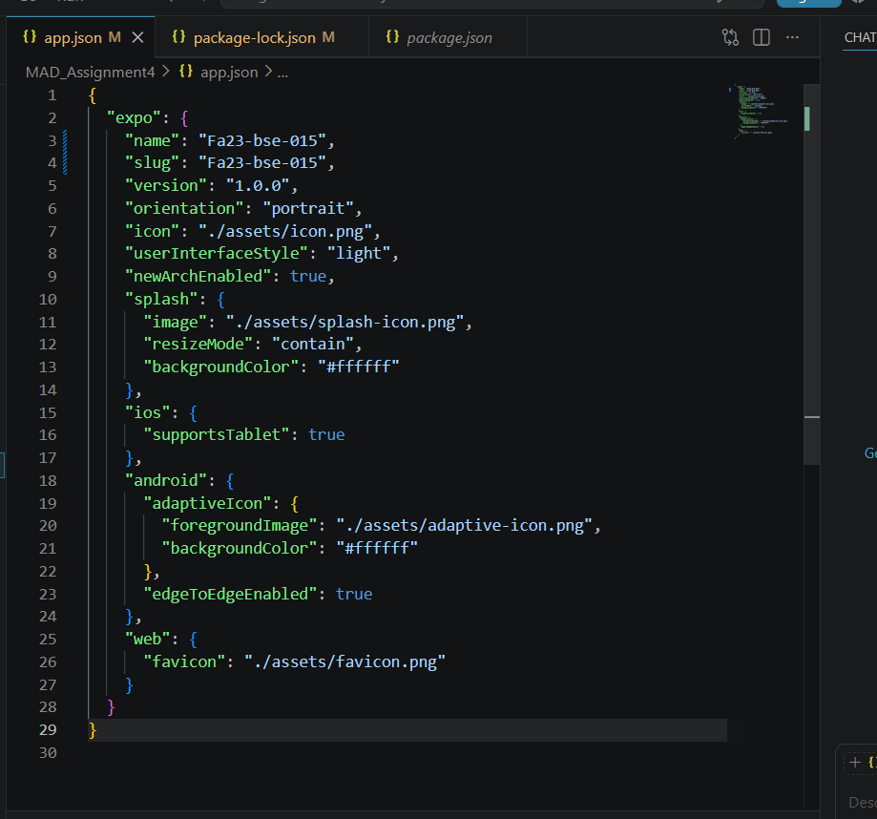
Running App:
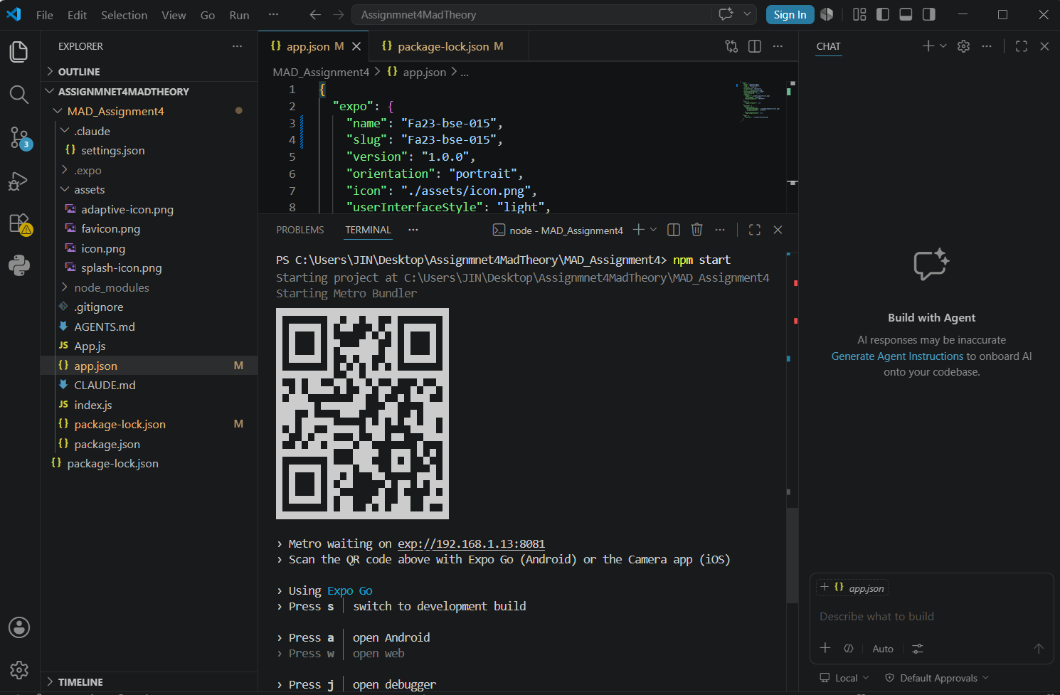

Exploring Different Components
Polygon:
Used to highlight specific geographic areas, territories.

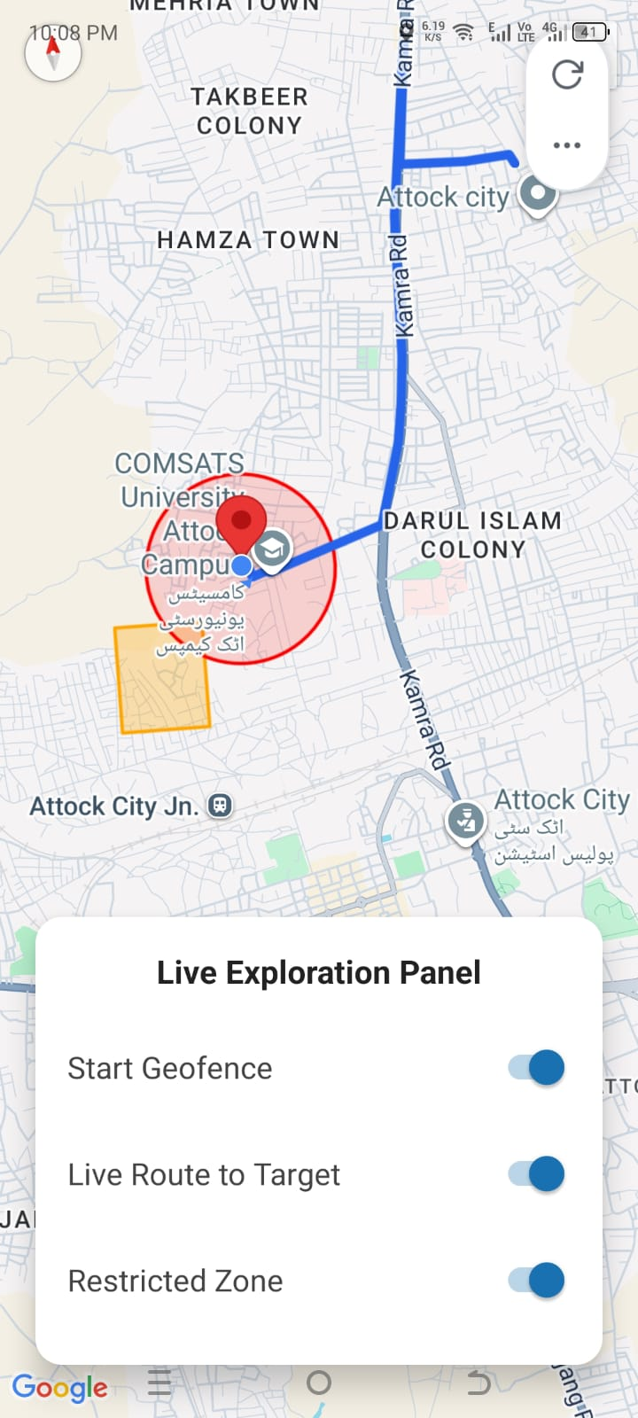

Polyline:
Use for route to specific area:
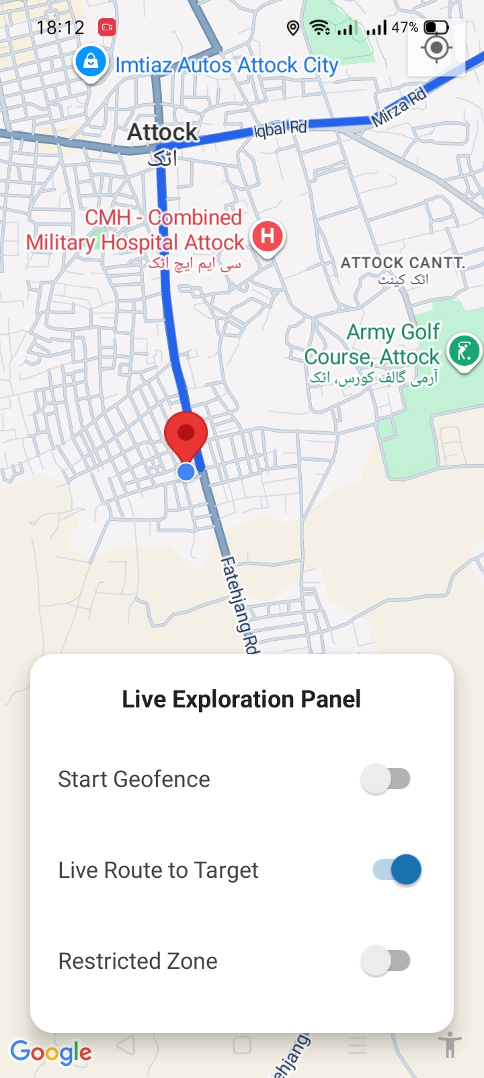

Red Circle (Geofence):
- The Purpose: A Geofence defines a specific, measurable radius around a central point.
