COMSATS UNIVERSITY ISLAMABAD ATTOCK CAMPUS


SQE Lab ;
Terminal Project;

Name : | Samreen,Sawira,Hadia,Shayan,Hasnain.
Reg.no : | Fa23-bse-015,024,046,052,035
Date of Submission : | 17 May-2026
Submitted To : | Mam Munazza

Library Management System

Introduction:
The Library Management System is a Python-based desktop application developed to automate basic library operations. The purpose of this project is to provide a simple and efficient system for managing books, users, borrowing records, and return transactions. The project was developed as part of the Software Quality Engineering (SQE) Lab assignment to demonstrate software development practices along with software testing, debugging, static code analysis, security analysis, and version control.
The system allows users to register and log into the application. After logging in, users can view available books, search for books, borrow books, and return borrowed books. The system also includes admin functionalities such as adding books, removing books, and viewing transactions.
Data storage is managed through JSON files, which store user information, book details, and transaction records. The project also includes testing using Python unittest, code quality analysis using SonarQube, security analysis using Snyk, and version control using GitHub.
The project helped in understanding practical concepts of software quality engineering such as test case design, bug identification, maintainability analysis, security vulnerabilities, and collaborative software management.

Objectives:
- To develop a Python-based Library Management System.
- To implement user registration and login functionality.
- To provide book management operations such as viewing, searching, borrowing, and returning books.
- To perform manual testing and unit testing of the system.
- To identify bugs and software quality issues.
- To analyze code quality using SonarQube.
- To identify security vulnerabilities using Snyk.
- To maintain project version control using GitHub.
- To improve software maintainability and reliability.

Project Structure:
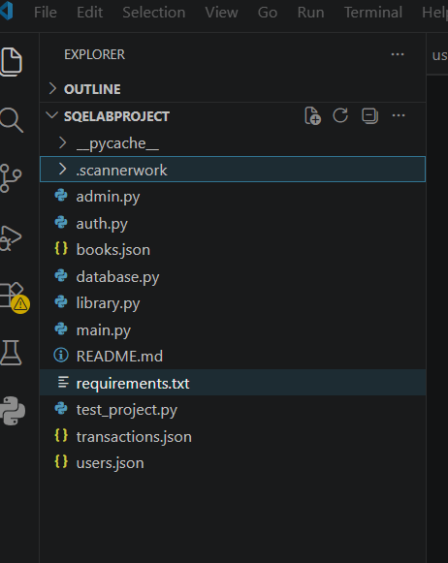

Main.py:
This is the main entry point of the application. It contains the main menu and controls the overall flow of the system. It allows users to register, log in, and access library operations.
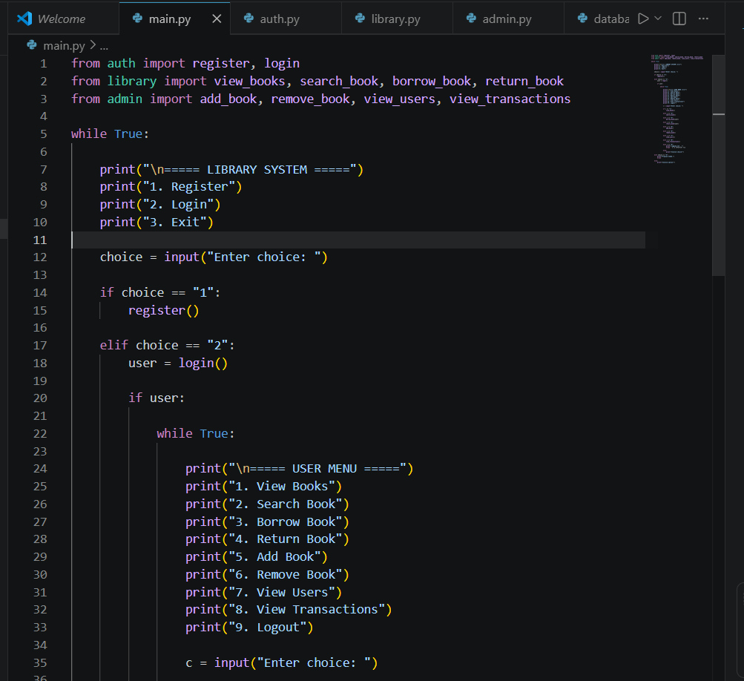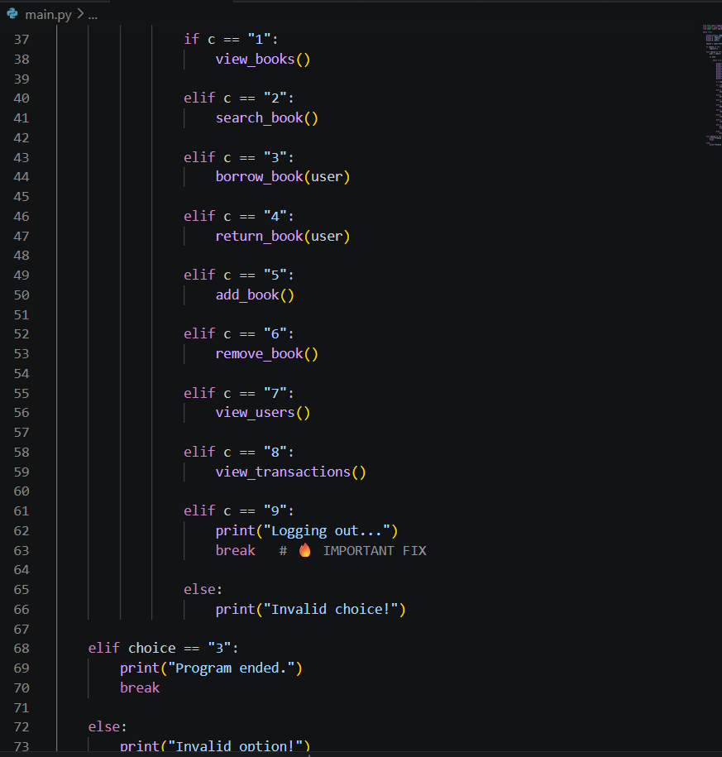

Auth.py:
This file handles user authentication functionalities such as registration and login. It verifies usernames and passwords and stores user data in JSON format.

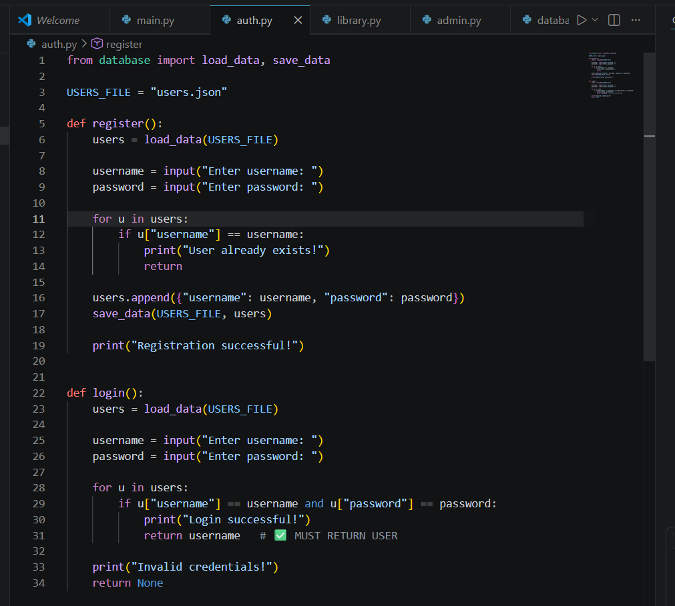

Library.py:
This module contains all library-related operations including viewing books, searching books, borrowing books, and returning books.
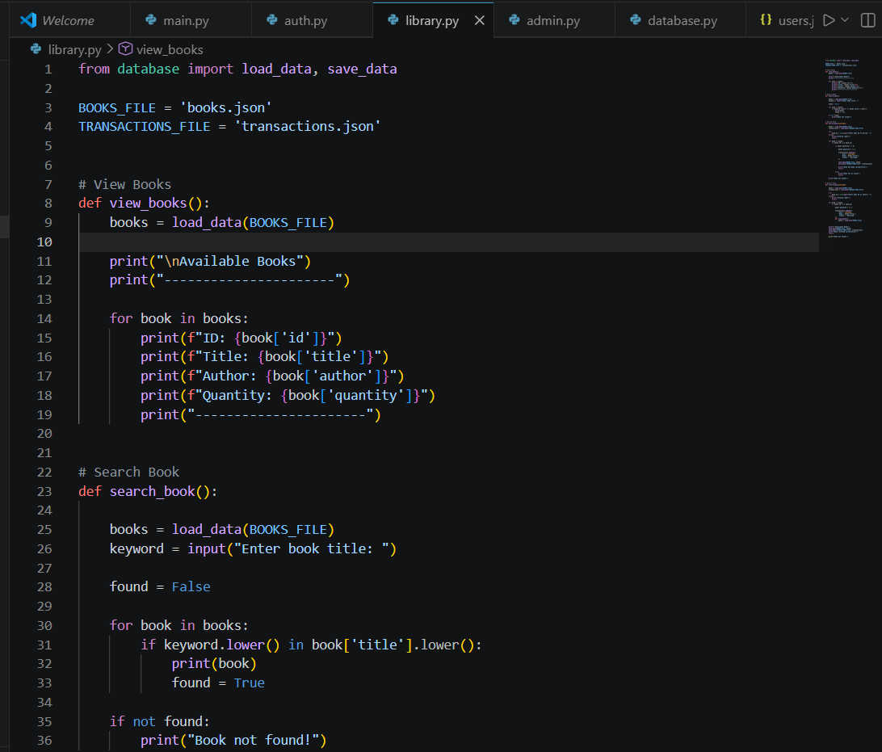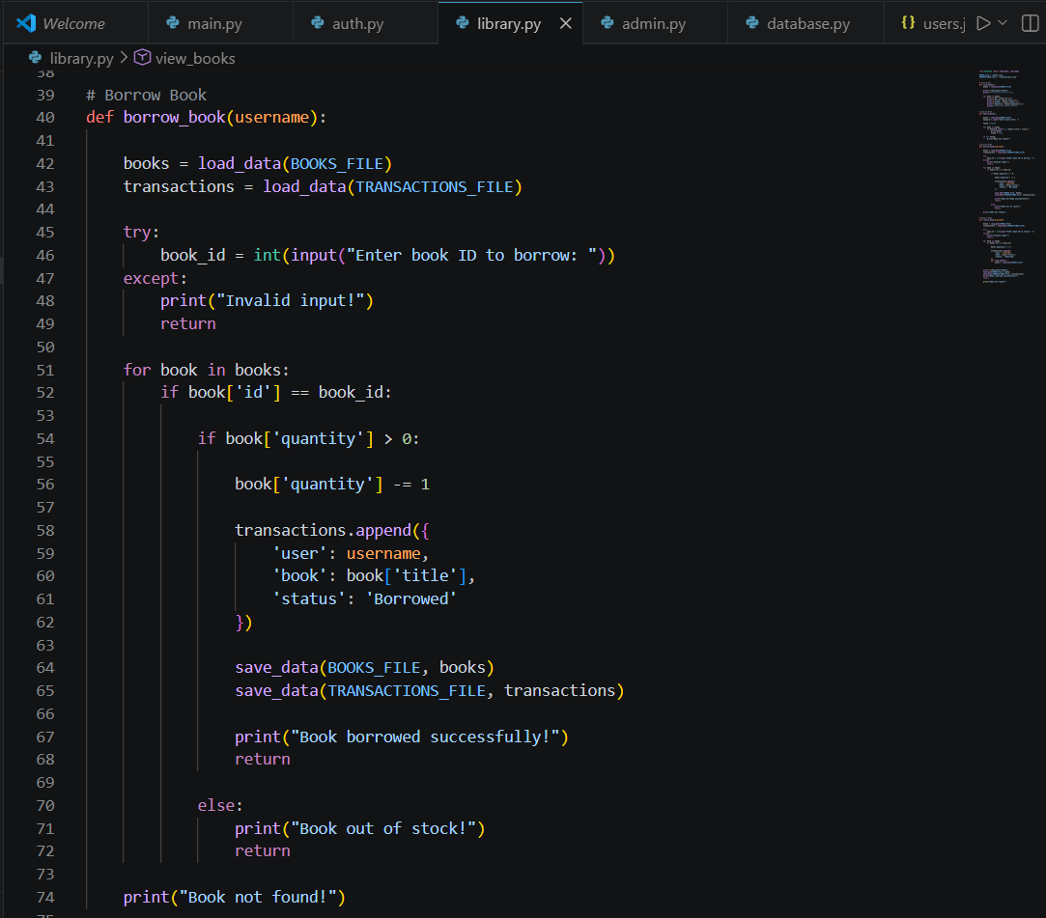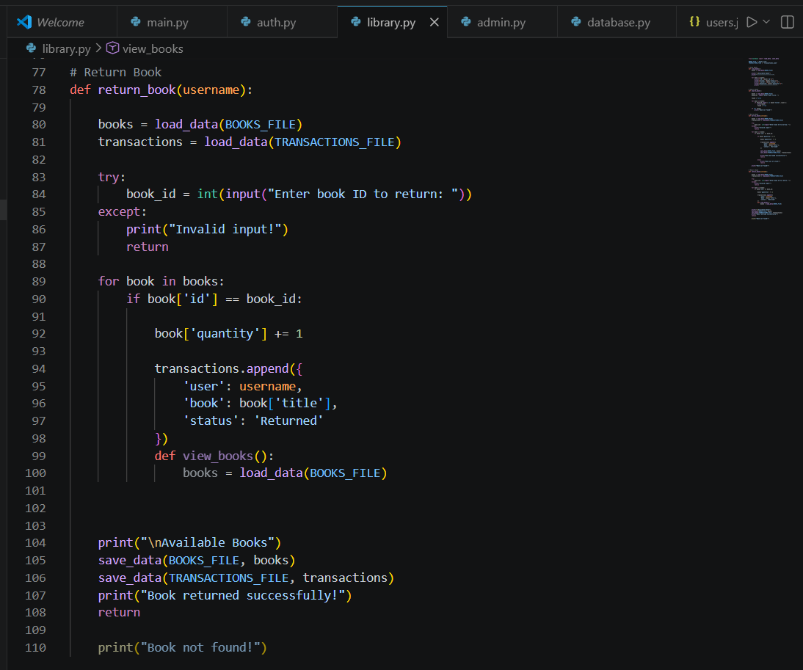

Admin.py:
This module contains admin functionalities such as adding new books, removing books, and viewing transaction history.
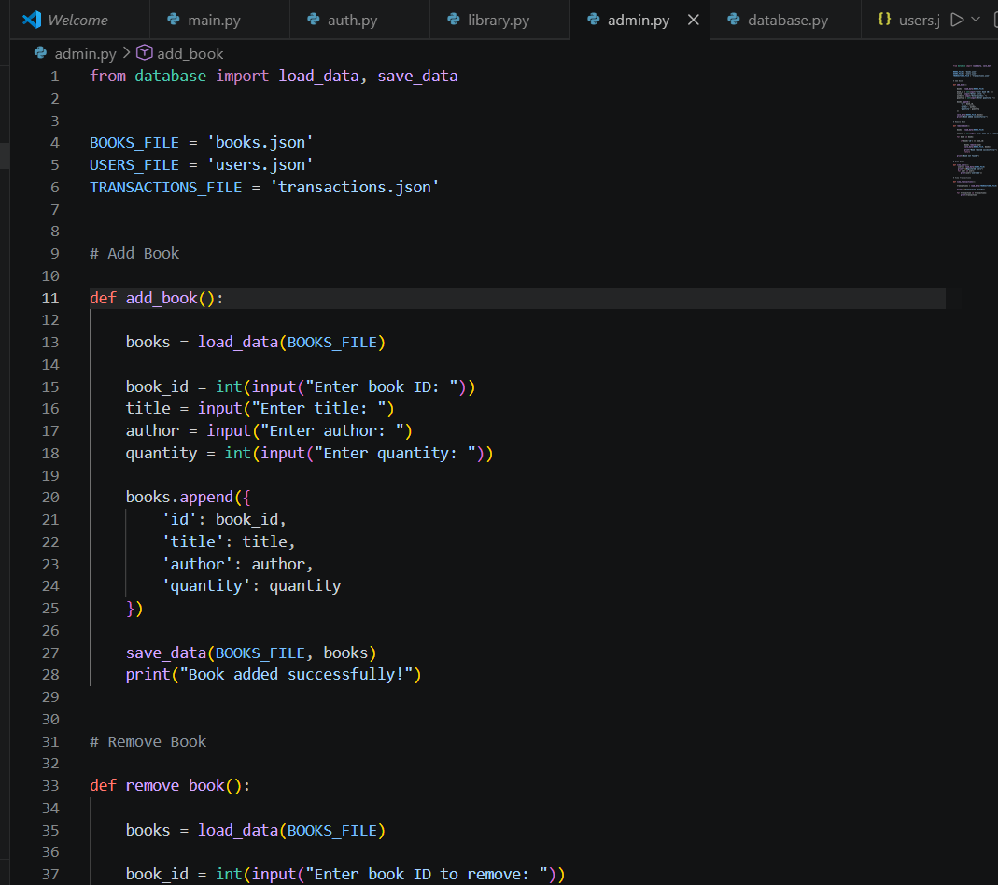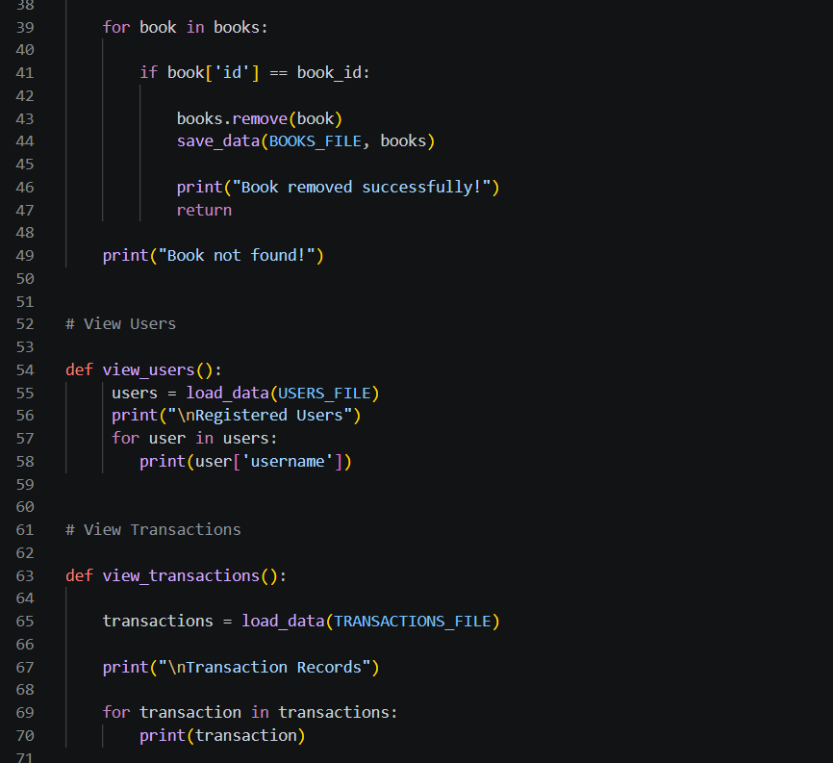

Database.py:
This file manages reading and writing data from JSON files. It acts as the data handling layer of the project.
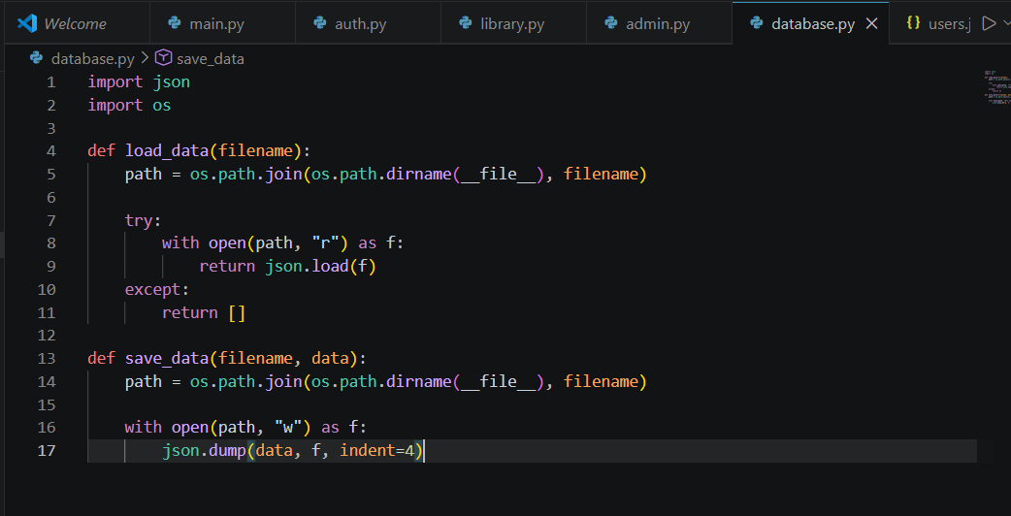

Users.json:
This JSON file stores registered users and passwords.
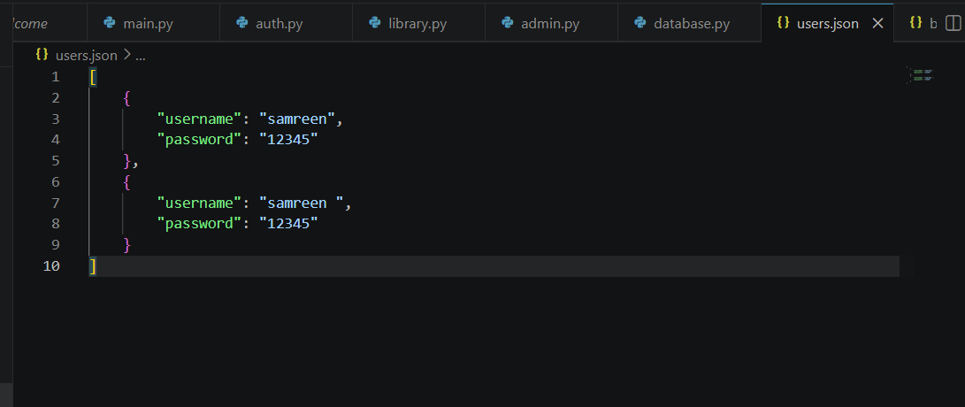

Books.json:
This file stores all book records including title, author, and quantity.
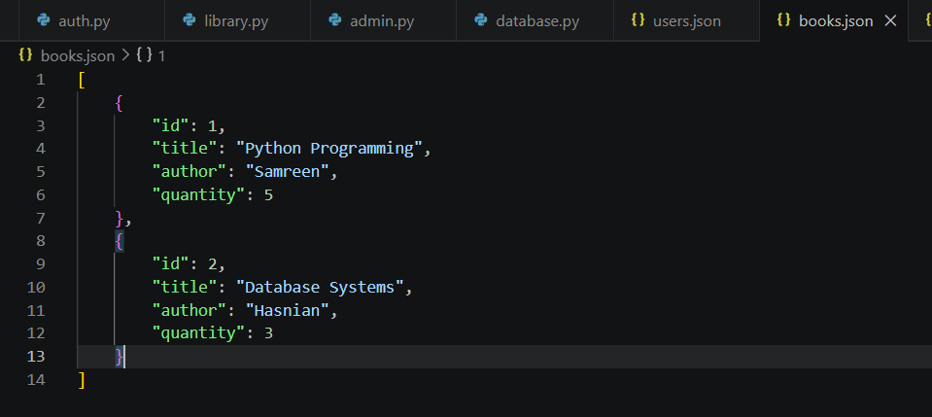

Transactions.json:
This file stores borrowing and returning transaction records.

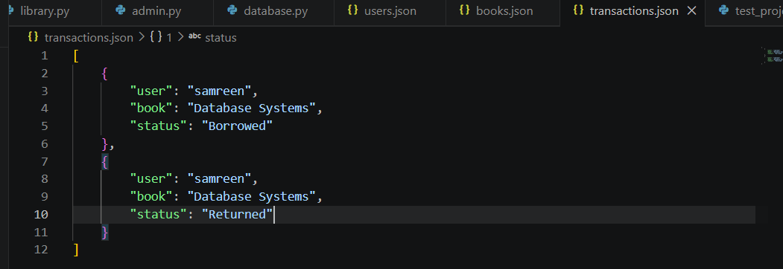

5. System Features
The Library Management System provides several important functionalities.
User Registration:
The registration feature allows a new user to create an account by entering a username and password. The system checks whether the username already exists. If the username is unique, the data is stored in users.json.
This feature ensures that every user has a unique account in the system.
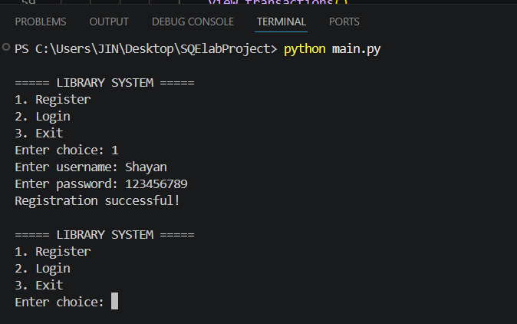
User Login
The login feature verifies user credentials entered by the user. The system checks the username and password against the data stored in users.json.
If the credentials are correct, the user successfully logs into the system. Otherwise, an invalid credentials message is displayed.
This functionality ensures secure access to the system.
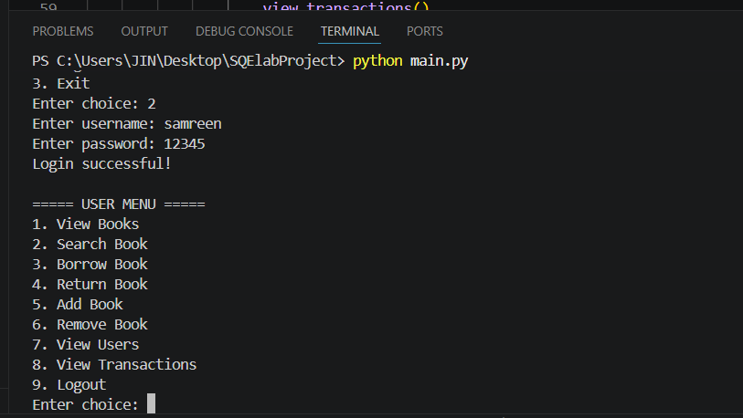
View Books
The view books feature displays all available books stored in books.json. The user can see details such as book ID, title, author name, and quantity.
This functionality helps users browse all available library books.
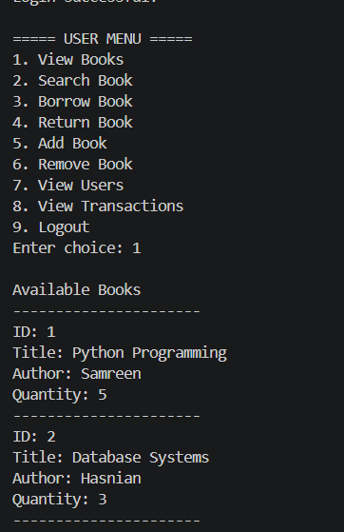
Search Book:
The search functionality allows users to search for books using the book title. If the entered title matches an existing book, the details are displayed.If the book does not exist, the system displays a “Book not found” message.
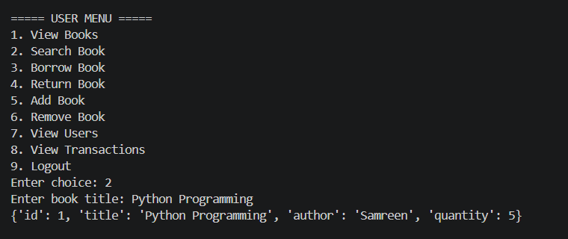
Borrow Book
The borrow functionality allows users to borrow books using the book ID. When a valid book is borrowed, the quantity of the book decreases by one.
The transaction is also recorded in transactions.json.
This feature ensures proper management of library inventory.
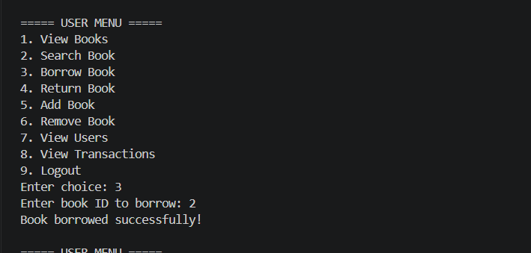
Return Book
The return functionality allows users to return previously borrowed books. When a book is returned, the quantity is increased again.
This operation updates the transaction records and keeps inventory accurate.
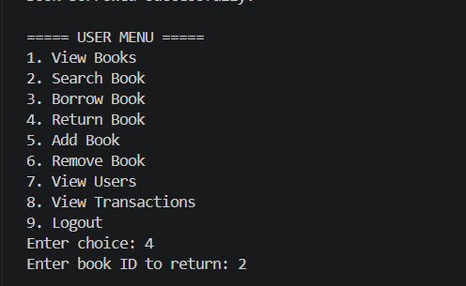

Admin Features
The system includes admin operations such as:
- Adding new books
- Removing books
- Viewing transactions
These functionalities help in managing the library database efficiently.
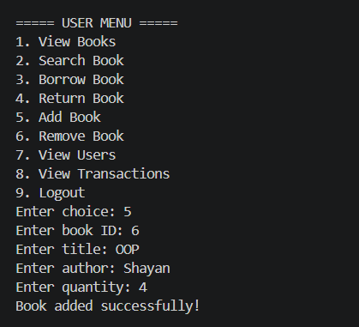
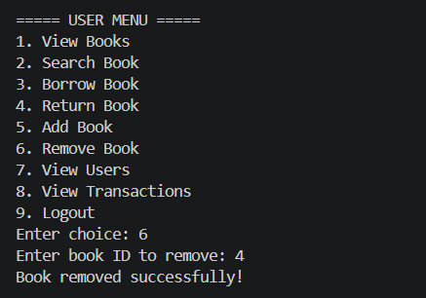
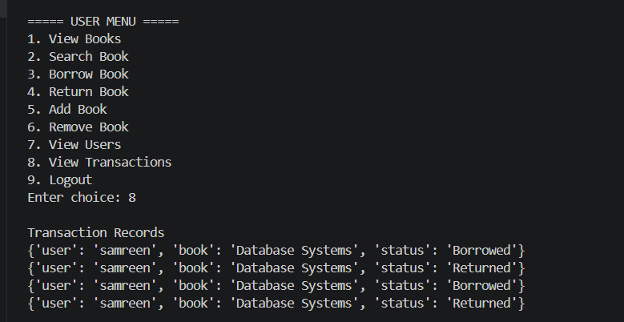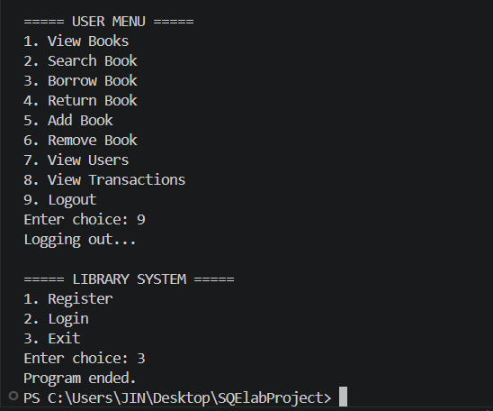

Phase 2: Manual Testing:
Part A — Manual Test Cases Table :
Test Case ID | Function | Input | Expected Output | Actual Output | Pass/Fail
TC01 | Register | New username + password | "Registration successful!" | Registration successfull | Pass
TC02 | Register | Already existing username | "User already exists!" | Registration fail | Fail
TC03 | Login | Correct username + password | "Login successful!" | Login Successfully | Pass
TC04 | Login | Wrong password | "Invalid credentials!" | Inavlid | Fail
TC05 | View Books | No input | List of all books | List of Books | Pass
TC06 | Search Book | "Python" | Shows Fundamental Programmingbook | Found | Pass
TC07 | Search Book | "xyz" (not exist) | "Book not found!" | Not Found | Fail
TC08 | Borrow Book | Valid book ID (1) | "Book borrowed successfully!" | Books borrowed successfully | Pass
TC09 | Borrow Book | Invalid input ("abc") | "Invalid input!" | Invalid Id | Fail
TC10 | Return Book | Valid book ID (1) | "Book returned successfully!" | Books returned successfully | Pass

Part(b):Student must implement selected test cases using the Python unittest framework and execute them on their system.
Unit_test File:
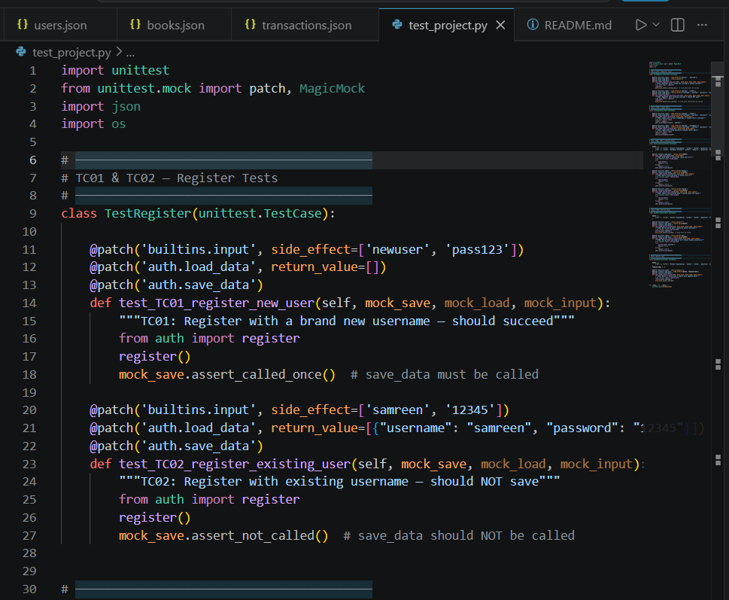
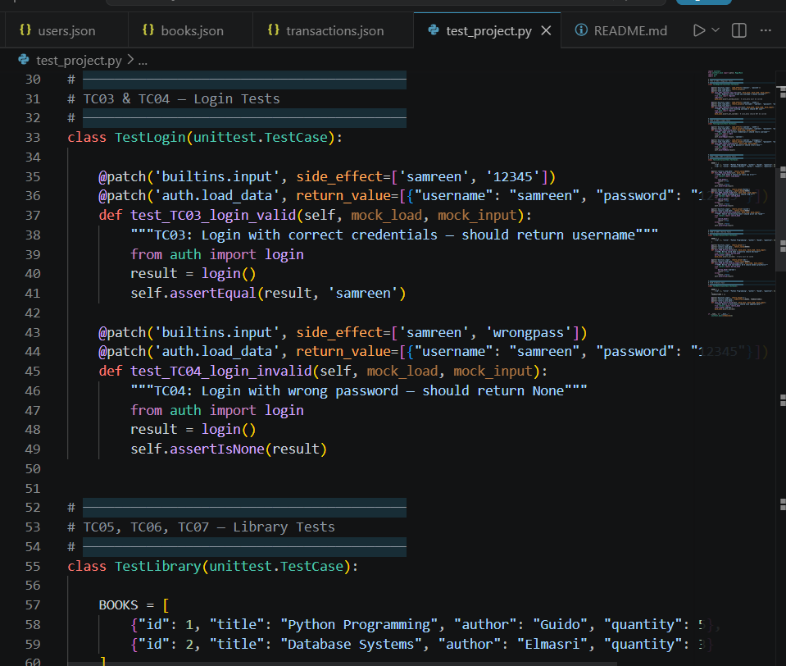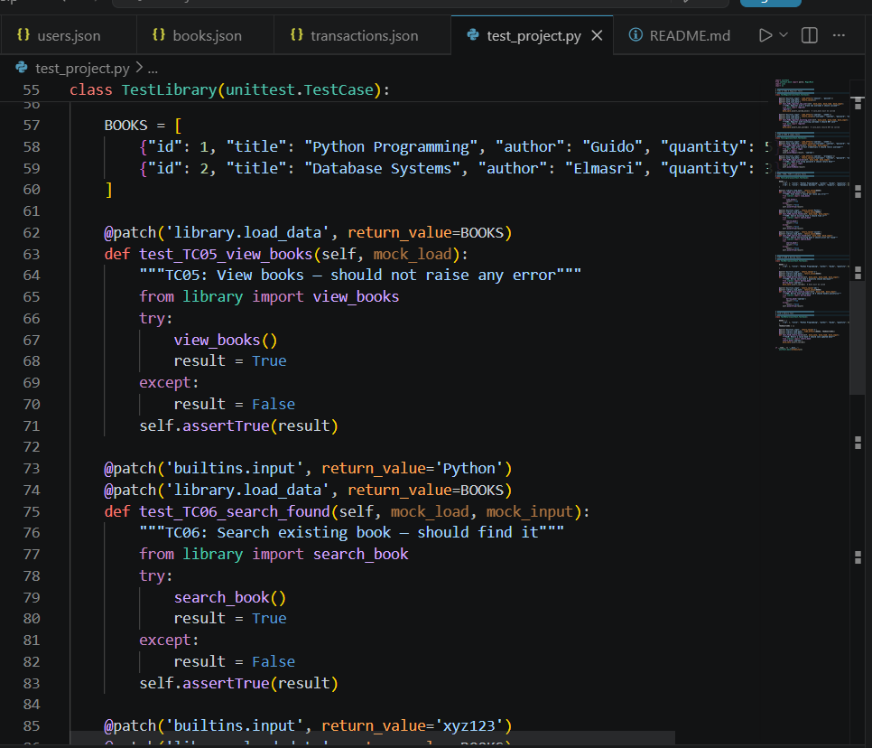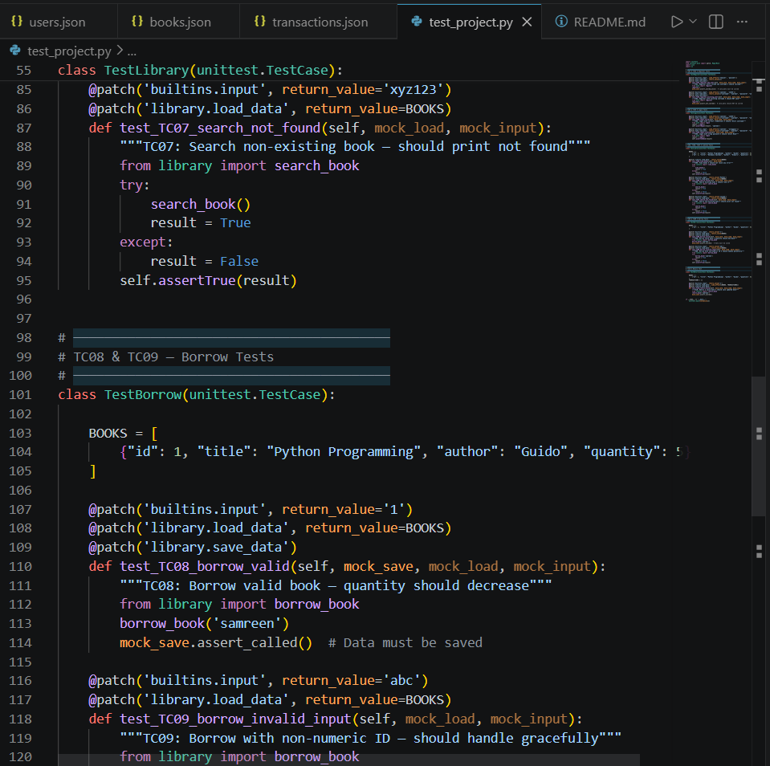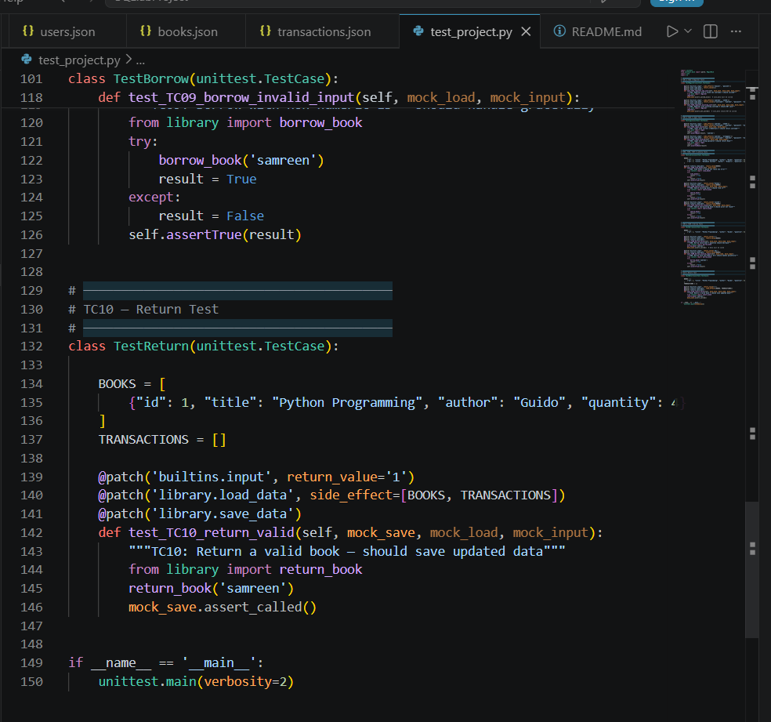
In terminal:
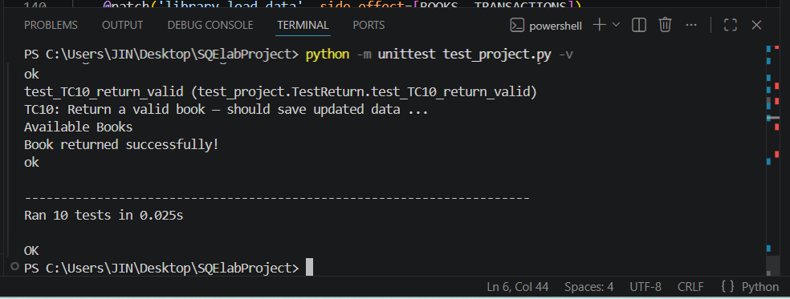

PHASE 3 — Bug Report:
Bug ID | Bug Title | File | Line | Description | Severity | Fix
BUG-01 | Nested function inside loop | library.py | ~45 | view_books() accidentally defined inside return_book() | High | Remove the nested def
BUG-02 | Unreachable code | library.py | last line | print("Book not found!") comes after return — never executes | Medium | Move before return
BUG-03 | Plain text passwords | users.json | all | Passwords stored as plain text — security risk | Critical | Use hashlib to hash
BUG-04 | No input validation in add_book | admin.py | ~5 | int(input()) crashes if letters typed | Medium | Wrap in try/except
BUG-05 | No admin role check | main.py | menu | Any logged-in user can Add/Remove books | High | Add role field to users

Phase 4: Code Quality Analysis:
SonarQube:
Tool Used: SonarQube Community Edition (Local Installation)
Project Scanned: Library Management System (Python)

For Token:
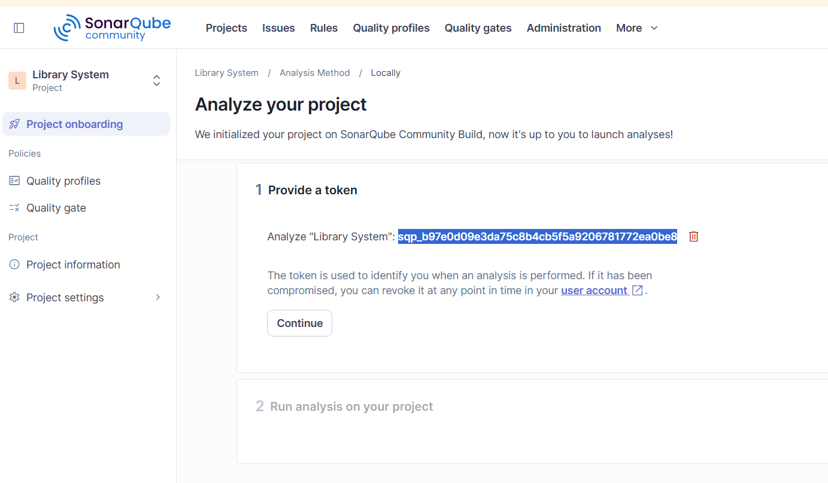
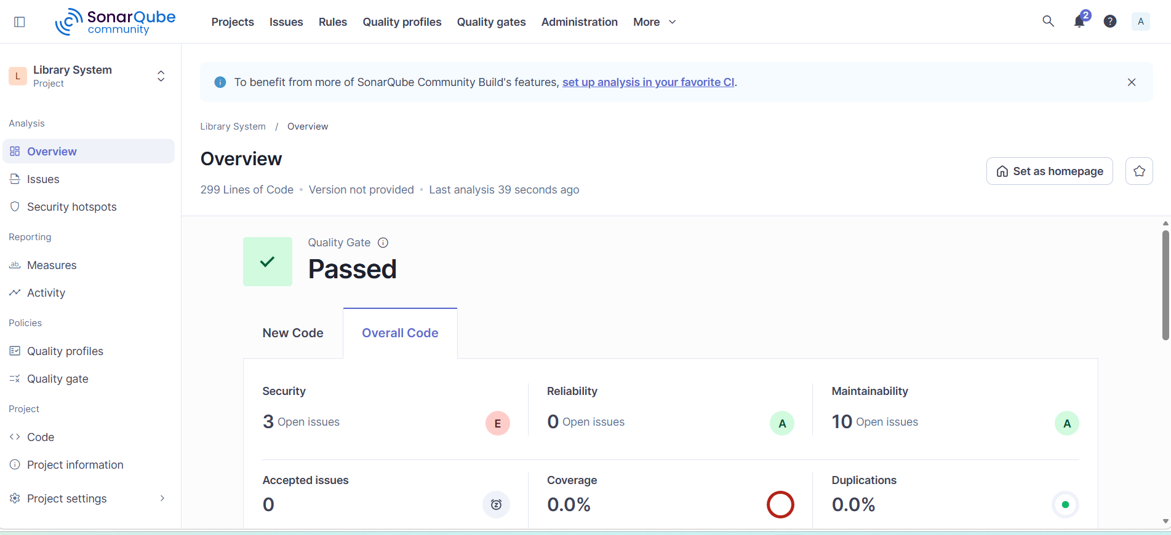
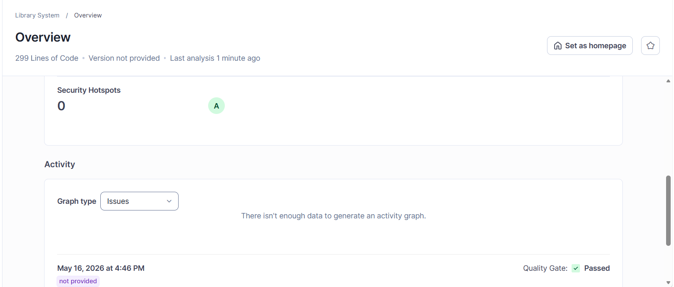
Maintainability rating:
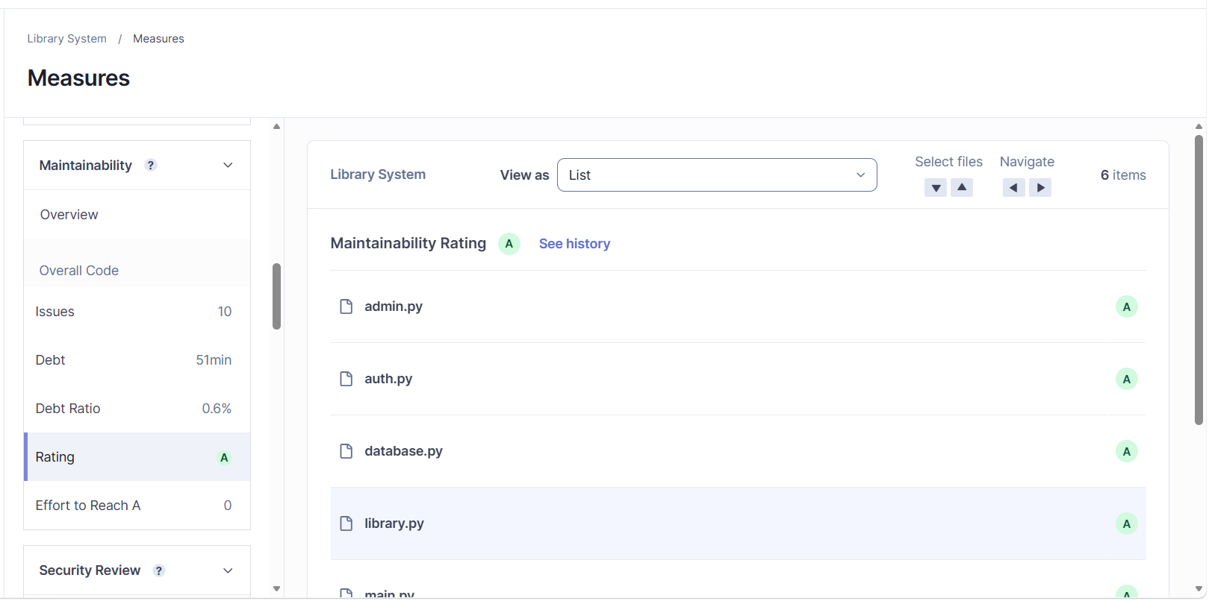
Issues:
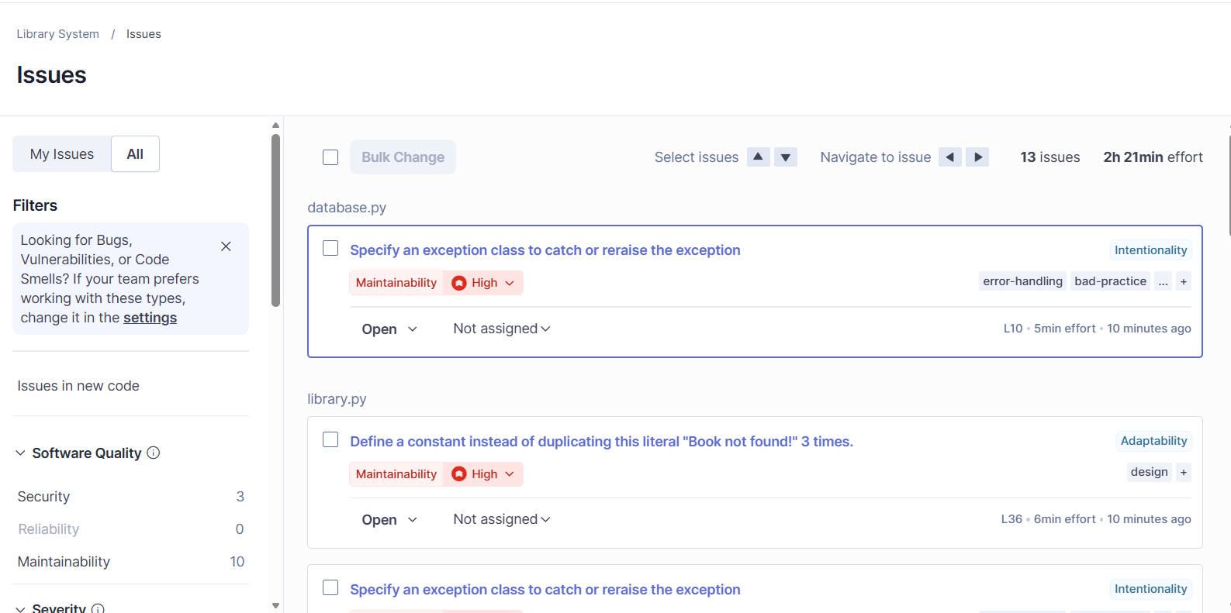
4.1 Overview Dashboard Results
The following table summarizes all metrics shown on the SonarQube Overview dashboard:
Category | Open Issues | Rating | Status
Security | 3 | E (Critical) | Needs Fix
Reliability | 0 | A (Best) | Passed
Maintainability | 10 | A (Best) | Acceptable
Duplications | 0.0% | — | Clean
Coverage | 0.0% | — | No Tests Linked

4.2 Security Issues (Rating: E — Critical)
SonarQube detected 3 security open issues with an overall Security Rating of E (lowest/worst). This means the code has serious security vulnerabilities that must be fixed before deployment.

# | Issue Description | File / Location | Suggested Fix | Severity
1 | Passwords stored in plain text — readable by anyone who opens users.json | auth.py / users.json | Use hashlib.sha256() to hash passwords before saving | Critical
2 | No input validation on book ID — int(input()) crashes if letters are entered | library.py / admin.py | Wrap all int(input()) inside try/except ValueError | High
3 | No role-based access control — any user can access admin functions | main.py | Add a 'role' field (admin/user) in users.json and check it before admin menu | High

4.3 Maintainability Issues / Code Smells (Rating: A)
SonarQube found 10 maintainability issues (code smells). Despite the high count, the overall Maintainability Rating is A, meaning the effort required to fix them is relatively low. Top 5 code smells identified:

# | Code Smell | File | How to Fix
1 | Nested function defined inside another function (view_books inside return_book) | library.py | Move view_books() outside to module level
2 | Unreachable code — print statement placed after return statement | library.py | Move the print before the return statement
3 | Magic numbers used directly in code without named constants | library.py | Define constants at top: MAX_BORROW = 3
4 | Long functions doing multiple things — violates Single Responsibility Principle | main.py | Split large functions into smaller focused ones
5 | Missing docstrings/comments — functions have no documentation | All files | Add docstrings: '''This function does X''' under each def

4.4 Reliability (Rating: A — Excellent)
SonarQube found 0 reliability bugs. This means the code logic is stable and there are no detected runtime crash risks according to static analysis. Rating: A (Best possible).

4.5 Analysis Summary
Analysis Item | Result
Tool Used | SonarQube Community Edition (Local)
Project Name | Library System
Language | Python
Security Rating | E — 3 security issues found (Critical)
Reliability Rating | A — 0 bugs found (Excellent)
Maintainability Rating | A — 10 code smells found (Acceptable)
Code Duplication | 0.0% — No duplicate code

4.6 Conclusion
The SonarQube analysis reveals that the Library Management System has:
- Excellent reliability — no bugs found by static analysis
- Good maintainability overall (Rating A) but 10 code smells need attention
- Critical security concerns — Rating E due to plain text passwords and missing access controls. These must be fixed before real-world deployment.
Phase 5: Security Analysis
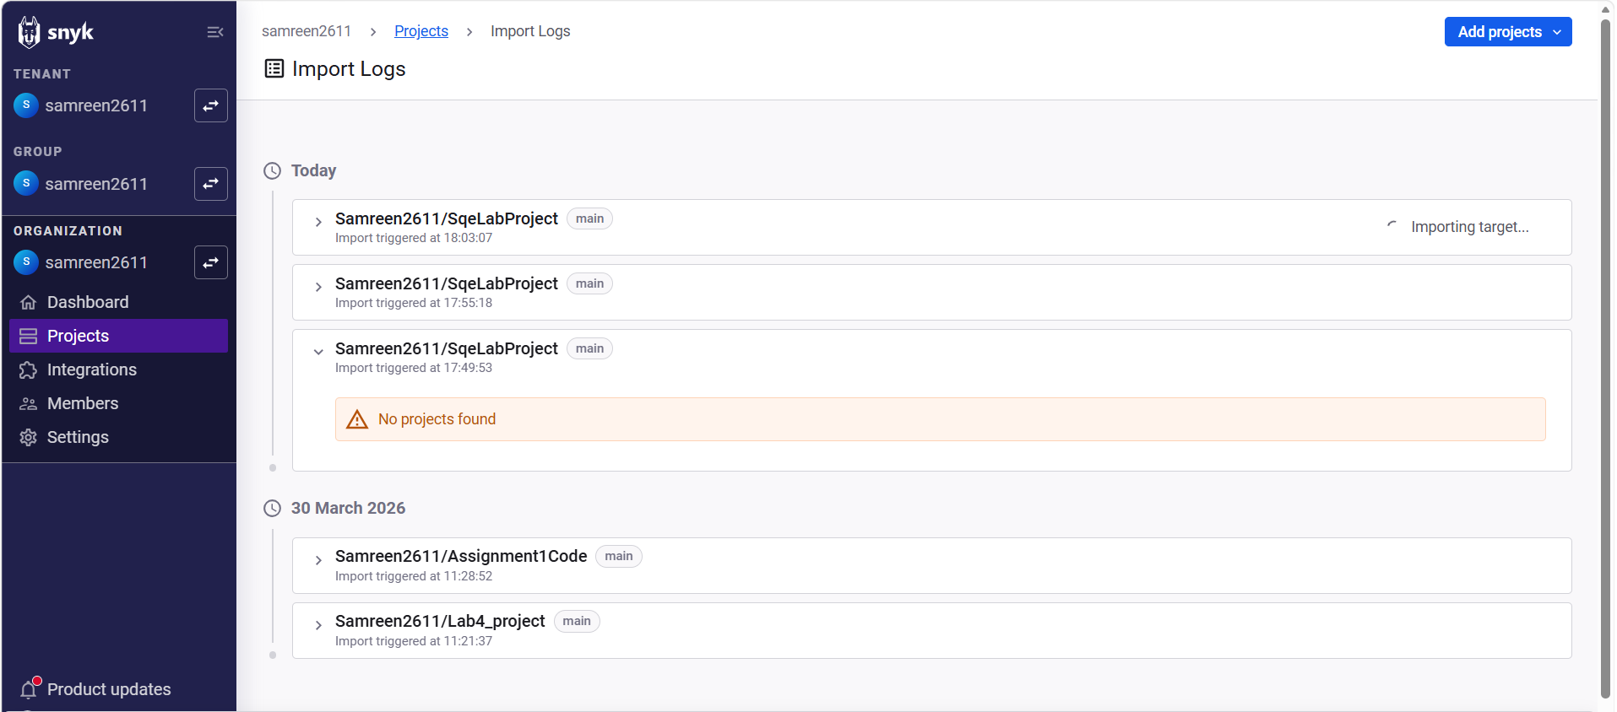
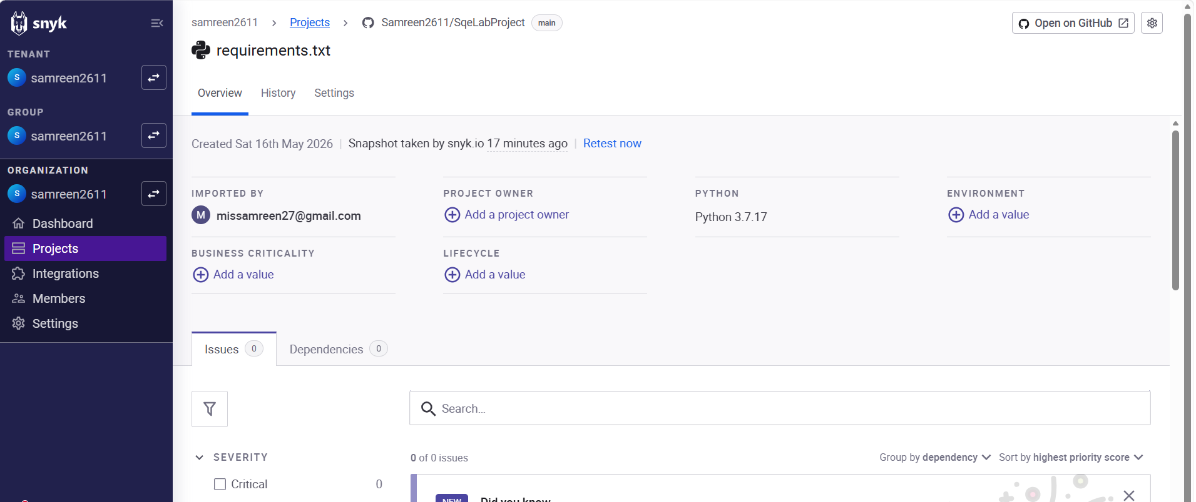
WE haven’t use external dependency that why there is no issue ifound in the project.
5.1 Manual Security Issues Identified
Although Snyk found no dependency vulnerabilities, a manual code review revealed the following 5 security issues in the source code that must be addressed:

# | Issue ID | File | Description | Severity | Fix
1 | SEC-01 | auth.py / users.json | Passwords stored in plain text. Anyone who opens users.json can read all passwords directly. | CRITICAL | Use hashlib.sha256() to hash passwords before saving.
2 | SEC-02 | library.py / admin.py | No input validation. int(input()) crashes the program if user types letters instead of numbers. | HIGH | Wrap int(input()) in try/except ValueError.
3 | SEC-03 | main.py | No role-based access control. Any user can access admin functions like Add/Remove Book. | HIGH | Add role field (admin/user) in users.json and check before admin menu.
4 | SEC-04 | auth.py | No login attempt limit. Attacker can try unlimited passwords — brute force vulnerability. | MEDIUM | Lock account after 3 failed login attempts.
5 | SEC-05 | database.py / *.json | JSON data files have no encryption or access control. Anyone can open and manually edit users.json to gain admin access. | MEDIUM | Replace JSON with SQLite database which supports proper access control.

5.2 Detailed Explanation of Security Issues
SEC-01: Plain Text Password Storage (CRITICAL)
In auth.py, when a user registers, their password is saved directly into users.json without any hashing. For example, password '12345' is stored as '12345'. Any person who accesses the file can immediately read all passwords. Fix: Use hashlib.sha256(password.encode()).hexdigest() to hash the password before saving.
SEC-02: Missing Input Validation — Crash Risk (HIGH)
int(input()) is used in library.py and admin.py without any error handling. If user types letters, Python raises ValueError and the program crashes immediately. Fix: Wrap all int(input()) calls inside try/except ValueError and display a friendly error message.
SEC-03: No Role-Based Access Control (HIGH)
After login, any user can access admin functions such as Add Book and Remove Book. There is no admin/user role check. Fix: Add a 'role' field (admin/user) to users.json. After login, check role before showing the admin menu.
SEC-04: No Login Attempt Limit — Brute Force Risk (MEDIUM)
There is no limit on failed login attempts in auth.py. An attacker can write a script to try thousands of passwords until the correct one is found. Fix: Add a counter and lock the account after 3 consecutive failed attempts.
SEC-05: Unprotected Data Files (MEDIUM)
The files users.json, books.json, and transactions.json are stored as plain readable text files with no encryption. Anyone can open them in Notepad and manually edit data. Fix: Replace JSON with SQLite which provides built-in access control and is harder to tamper with.
Summary
- Snyk Tool Result: 0 dependency vulnerabilities — project is dependency-safe
- Manual Review Result: 5 code-level security issues found
- Highest Priority Fix: SEC-01 (plain text passwords) must be resolved before deployment
- Overall Security Rating from SonarQube: E (due to same code-level issues above)

Phase 6: Version Control
• Create a GitHub repository
• Upload: Source code, Test cases, Bug report, Documentation
• Maintain: Proper commits and README file
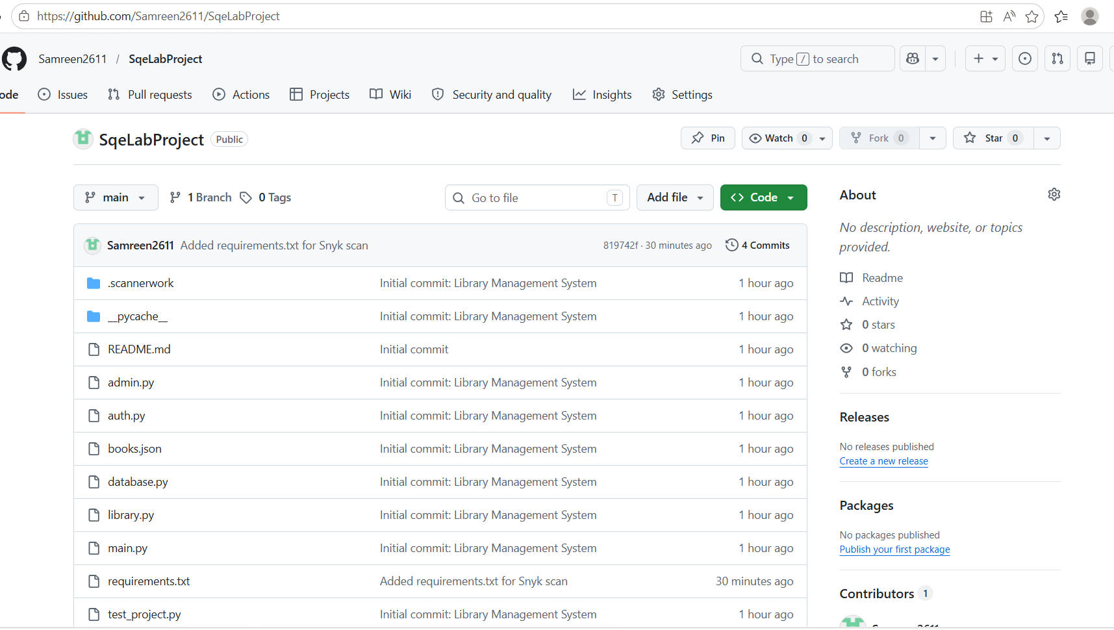
ReadmeFile:
