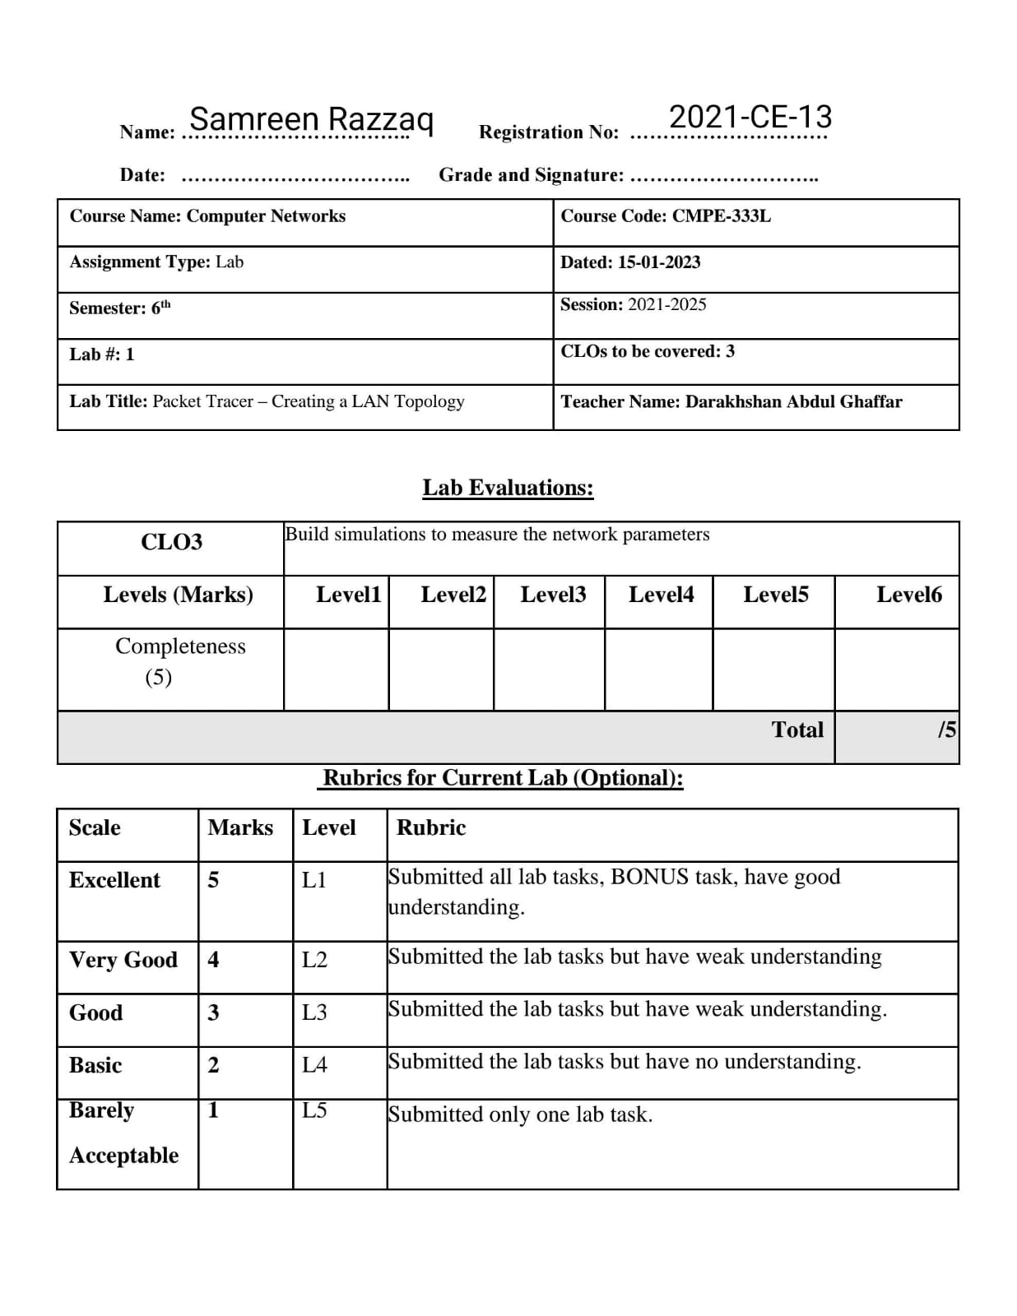

**Lab Task:**

1. Perform all the 9 steps mentioned above and save screenshot for each step.

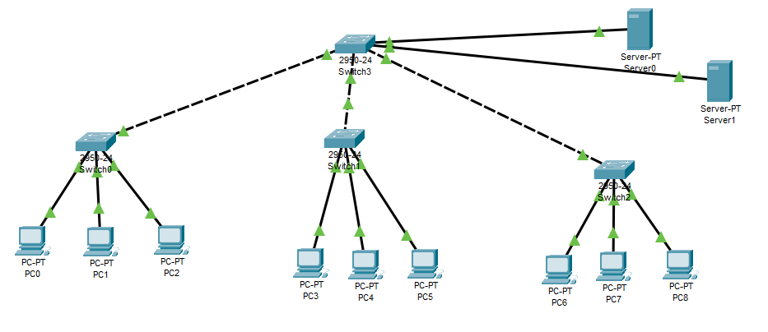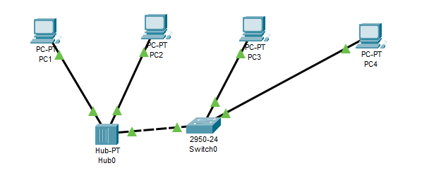2. Draw an Institutional network in Packet Tracer and check the connectivity between devices