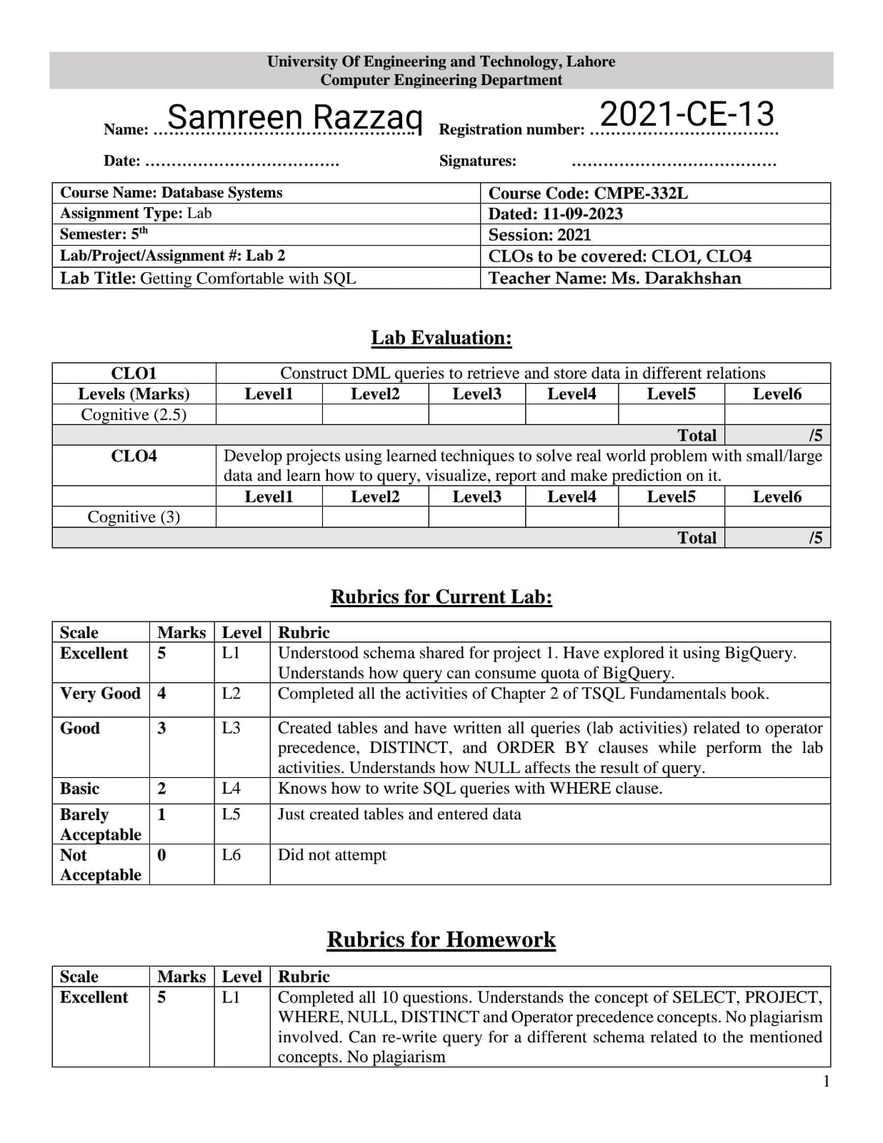

**Homework Questions:**

All the given tasks should be performed in the context of Northwind schema.

1. **Write a query to report orders which were delayed shipped.**

SELECT * FROM Orders

WHERE ShippedDate > RequiredDate

1. **Our employees belong to how many countries. List the names.**

SELECT DISTINCT Country FROM Employees

1. **Is there any employee whose is not accountable?**

SELECT * FROM Employees

WHERE ReportsTo IS NULL

1. **List the names of products which have been discontinued.**

SELECT ProductName FROM Products

WHERE Discontinued = 1

1. **List the IDs the orders on which discount was not provided.**

SELECT OrderID FROM [Order Details]

WHERE Discount=0

1. **Enlist the names of customers who have not specified their region.**

SELECT ContactName FROM Customers

WHERE Region IS NULL

1. **Enlist the names of customers along with contact number who either belongs to UK or USA.**

SELECT ContactName, Phone FROM Customers

WHERE Country IN ('UK','USA')

1. **Report the names of companies who have provided their web page.**

SELECT CompanyName FROM Suppliers

WHERE HomePage IS NOT NULL

1. **In which countries, products were sold in year 1997.**

SELECT ShipCountry FROM Orders

WHERE OrderDate BETWEEN '1997-01-02' AND '1997-12-31'

1. **List the ids of customers whose orders were never shipped.**

SELECT CustomerID FROM Orders

WHERE ShipRegion IS NULL