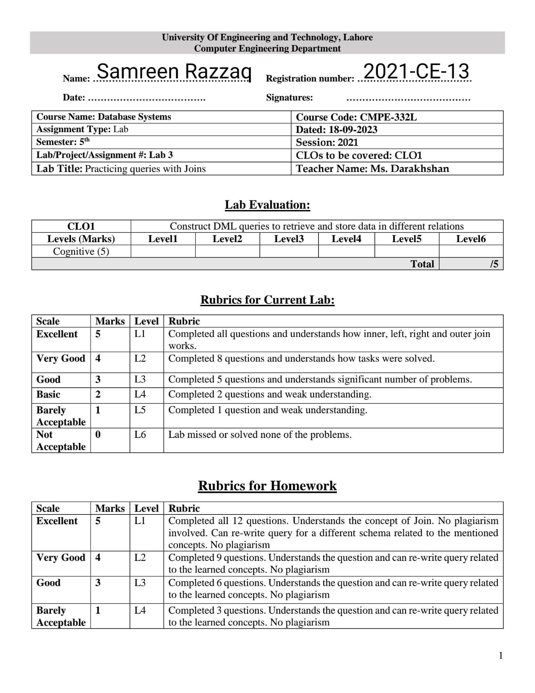

**Homework Questions:**

Answer these queries in the context of Northwind schema.

1. Give the names of customers whose orders were delayed. Your answer should have the following schema.

Customers(CustomerId, CustomerName)

SELECT Customers.CustomerID, Customers.ContactName

FROM Customers

INNER JOIN Orders

ON Customers.CustomerID=Orders.CustomerID

WHERE ShippedDate>RequiredDate

1. Give the products details with its supplier company. Products(ProductName, SupplierName)

SELECT Products.ProductName,Suppliers.ContactName,Suppliers.CompanyName

FROM Products

INNER JOIN Suppliers

ON Products.SupplierID=Suppliers.SupplierID

1. Give the name of top products which have highest sale in the year 1998.

SELECT TOP 10 Products.ProductName, SUM([Order Details].Quantity) AS TotalSales

FROM Products

INNER JOIN [Order Details]

ON Products.ProductID = [Order Details].ProductID

INNER JOIN Orders

ON [Order Details].OrderID = Orders.OrderID

WHERE YEAR(Orders.OrderDate) = 1998

GROUP BY Products.ProductName

ORDER BY TotalSales DESC

1. Give the name of employees with its manager name. Schema should have the following schema. (EmployeeName, ManagerName)

SELECT CONCAT(Employees.FirstName, ' ', Employees.LastName) AS EmployeeName,

CONCAT(m.FirstName, ' ', m.LastName) AS ManagerName

FROM Employees

LEFT JOIN Employees m

ON Employees.ReportsTo = m.EmployeeID

ORDER BY EmployeeName

5. Give the full names of managers who have less than two employees.

SELECT CONCAT(Managers.FirstName, ' ', Managers.LastName) AS ManagerName

FROM Employees AS Managers

LEFT JOIN Employees AS Employees

ON Managers.EmployeeID = Employees.ReportsTo

GROUP BY Managers.EmployeeID, Managers.FirstName, Managers.LastName

HAVING COUNT(Employees.EmployeeID) < 2

6.List all the products whose price is more than average price.

SELECT PRODUCTID, Productname, UnitPrice

FROM Products

WHERE UnitPrice > (SELECT AVG(UnitPrice) FROM Products)

7. Find second highest priced product without using TOP statement

SELECT ProductName, UnitPrice

FROM Products

WHERE UnitPrice = (SELECT MAX(UnitPrice)

FROM Products

WHERE UnitPrice < (SELECT MAX(UnitPrice)

FROM Products))

8. Are there any employees who are elder than their managers? List that names of those employees. Schema should look like this Employees(EmployeeName,ManagerName,EmployeeAge,ManagerAge)

SELECT CONCAT(Employees.FirstName, ' ', Employees.LastName) AS EmployeeName,

CONCAT(Managers.FirstName, ' ', Managers.LastName) AS ManagerName,

Employees.BirthDate AS EmployeeAge,

Managers.BirthDate AS ManagerAge

FROM Employees

INNER JOIN Employees AS Managers

ON Employees.ReportsTo = Managers.EmployeeID

WHERE Employees.BirthDate > Managers.BirthDate

9. List the names of products which were ordered on 8th August 1997.

SELECT DISTINCT Products.ProductName

FROM Products

INNER JOIN [Order Details]

ON Products.ProductID=[Order Details].ProductID

INNER JOIN Orders

ON [Order Details].OrderID=Orders.OrderID

WHERE CONVERT(DATE,Orders.OrderDate) = '1997-08-08'

10. List the names of suppliers whose supplied products were ordered in 1997.

SELECT DISTINCT Suppliers.CompanyName

FROM Suppliers

INNER JOIN Products

ON Suppliers.SupplierID = Products.SupplierID

INNER JOIN [Order Details]

ON Products.ProductID = [Order Details].ProductID

INNER JOIN Orders

ON [Order Details].OrderID = Orders.OrderID

WHERE YEAR(Orders.OrderDate) = 1997

11. How many employees are assigned to Eastern region. Give count.

SELECT COUNT(*) AS EmployeeCount

FROM Employees

INNER JOIN Region

ON Employees.Region = Region.RegionDescription

WHERE Region.RegionDescription = 'Eastern'

12. Give the name of products which were not ordered in 1996.

SELECT ProductName

FROM Products

WHERE ProductID NOT IN (SELECT DISTINCT ProductID FROM [Order Details]

WHERE OrderID IN (SELECT OrderID FROM Orders

WHERE YEAR(OrderDate) = 1996))