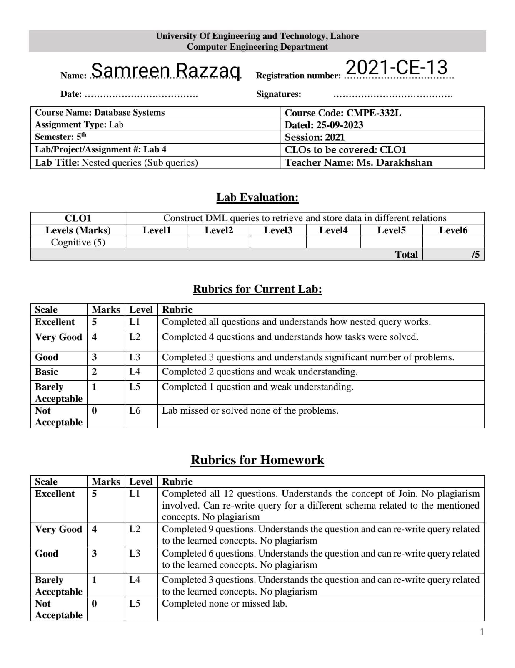

**Homework Questions:**

Answer these queries in the context of Northwind schema and solve them using subqueries only.

1. Give the names of customers whose orders were delayed. Your answer should have the following schema.

SELECT CustomerID, ContactName

FROM Customers

WHERE CustomerID IN (SELECT CustomerID

FROM Orders

WHERE ShippedDate > RequiredDate)

1. Give the products details with its supplier company. Products(ProductName, SupplierName)

SELECT ProductName, ContactName, CompanyName

FROM Products,Customers

WHERE SupplierID IN (

SELECT SupplierID

FROM Suppliers)

1. Give the name of top products which have highest sale in the year 1998.

SELECT TOP 10 Products.ProductName,

(

SELECT SUM([Order Details].Quantity)

FROM [Order Details]

WHERE [Order Details].ProductID = Products.ProductID

) AS TotalSales

FROM Products

WHERE Products.ProductID IN (

SELECT [Order Details].ProductID

FROM [Order Details]

WHERE [Order Details].OrderID IN (

SELECT Orders.OrderID

FROM Orders

WHERE YEAR(Orders.OrderDate) = 1998))

ORDER BY TotalSales DESC

1. Give the name of employees with its manager name. Schema should have the following schema. (EmployeeName, ManagerName) University Of Engineering and Technology, Lahore Computer Engineering Department

SELECT CONCAT(Employees.FirstName, ' ', Employees.LastName) AS EmployeeName,

(

SELECT CONCAT(Manager.FirstName, ' ', Manager.LastName)

FROM Employees AS Manager

WHERE Manager.EmployeeID = Employees.ReportsTo

) AS ManagerName

FROM Employees

ORDER BY EmployeeName

1. Give the full names of managers who have less than two employees.

SELECT CONCAT(Managers.FirstName, ' ', Managers.LastName) AS ManagerName

FROM Employees AS Managers

WHERE Managers.EmployeeID NOT IN (

SELECT DISTINCT ReportsTo

FROM Employees AS Employees

WHERE ReportsTo IS NOT NULL)

1. List all the products whose price is more than average price.

SELECT PRODUCTID, Productname, UnitPrice

FROM Products

WHERE UnitPrice > (

SELECT AVG(UnitPrice)

FROM Products)

1. Find second highest priced product without using TOP statement

SELECT ProductName, UnitPrice

FROM Products

WHERE UnitPrice = (

SELECT MAX(UnitPrice)

FROM Products

WHERE UnitPrice < (

SELECT MAX(UnitPrice)

FROM Products))

1. Are there any employees who are elder than their managers? List that names of those employees. Schema should look like this Employees(EmployeeName,ManagerName,EmployeeAge,ManagerAge)

SELECT CONCAT(Employees.FirstName, ' ', Employees.LastName) AS EmployeeName,

(

SELECT CONCAT(Manager.FirstName, ' ', Manager.LastName)

FROM Employees AS Manager

WHERE Manager.EmployeeID = Employees.ReportsTo

) AS ManagerName,

Employees.BirthDate AS EmployeeAge,

(

SELECT Manager.BirthDate

FROM Employees AS Manager

WHERE Manager.EmployeeID = Employees.ReportsTo

) AS ManagerAge

FROM Employees

WHERE Employees.BirthDate > (

SELECT Manager.BirthDate

FROM Employees AS Manager

WHERE Manager.EmployeeID = Employees.ReportsTo)

1. List the names of products which were ordered on 8th August 1997.

SELECT DISTINCT Products.ProductName

FROM Products

WHERE Products.ProductID IN (

SELECT [Order Details].ProductID

FROM [Order Details]

WHERE [Order Details].OrderID IN (

SELECT Orders.OrderID

FROM Orders

WHERE CONVERT(DATE, Orders.OrderDate) = '1997-08-08'))

1. List the names of suppliers whose supplied products were ordered in 1997.

SELECT DISTINCT Suppliers.CompanyName

FROM Suppliers

WHERE Suppliers.SupplierID IN (

SELECT Products.SupplierID

FROM Products

WHERE Products.ProductID IN (

SELECT [Order Details].ProductID

FROM [Order Details]

WHERE [Order Details].OrderID IN (

SELECT Orders.OrderID

FROM Orders

WHERE YEAR(Orders.OrderDate) = 1997)))

1. How many employees are assigned to Eastern region? Give count.

SELECT COUNT(*) AS EmployeeCount

FROM Employees

WHERE Region IN (

SELECT RegionDescription

FROM Region

WHERE RegionDescription = 'Eastern')

1. Give the name of products which were not ordered in 1996.

SELECT ProductName

FROM Products

WHERE ProductID NOT IN (

SELECT DISTINCT ProductID

FROM [Order Details]

WHERE OrderID IN (

SELECT OrderID

FROM Orders

WHERE YEAR(OrderDate) = 1996 ))